resig-global

2022-07-08

install/load pkgs

#install.packages(c("ggplot2", "dplyr", "tidyverse"))  
lapply(c("ggplot2", "tidyverse", "dplyr"), require, character.only = TRUE)

## [[1]]  
## [1] TRUE  
##   
## [[2]]  
## [1] TRUE  
##   
## [[3]]  
## [1] TRUE

## Note

working age population OECD: 15 to 64

prime-working-age population US: 25 to 54

Age group difference, young workers usually have higher unemployment To control the effects, I set age group 20/25 +

Can’t find labor force participation rate by ethnicity

# labor force participation rate, 2020-2021 annual, age 25-54

library(readr)  
# Read data, OECD lfpr data by gender  
oecd_lfpr_m <- as_tibble(read.csv("~/Desktop/great resignation/OECD datasets/lfpr men 25-54.csv"))  
oecd_lfpr_w <- as_tibble(read.csv("~/Desktop/great resignation/OECD datasets/lfpr women 25-54.csv"))

# OECD lfpr by gender 2020-2021 annual, age 25-54  
## subset data  
library(dplyr)  
o_l_m <- oecd_lfpr_m %>% filter(Time >2018) %>% dplyr::select(Country, Time, Value) %>% filter(Country %in% c("United States","Canada", "United Kingdom","Germany", "France", "Italy", "Spain", "Netherlands", "Switzerland", "Sweden", "Belgium", "Ireland", "Norway", "Denmark", "Finland"))  
  
o_l_w <-oecd_lfpr_w %>% filter(Time >2018) %>% dplyr::select(Country, Time, Value) %>% filter(Country %in% c("United States","Canada", "United Kingdom","Germany", "France", "Italy", "Spain", "Netherlands", "Switzerland", "Sweden", "Belgium", "Ireland", "Norway", "Denmark", "Finland"))  
  
## only include US, Canada, Germany, France, United Kingdom, Italy, Spain, Netherlands, Switzerland, Sweden, Poland, Belgium, Austria, Ireland, Norway, Denmark, Finland, United States, Canada, Australia, New Zealand  
  
## or exclude countries: Australia, Czech, Japan, Korea, Mexico, New Zealand, Slovak, Turky, OECD, Israel, Chile, Slovenia, Estonia, Lithuania, Latvia, columbia, Costa Rica

library(ggplot2)  
library(viridis)

## Loading required package: viridisLite

#install.packages("hrbrthemes")  
library(hrbrthemes)

## NOTE: Either Arial Narrow or Roboto Condensed fonts are required to use these themes.

## Please use hrbrthemes::import_roboto_condensed() to install Roboto Condensed and

## if Arial Narrow is not on your system, please see https://bit.ly/arialnarrow

### men plot

# MALE  
o_l_m$Time <- as.factor(o_l_m$Time) # convert integer to factor  
plot.men.labor <-ggplot(o_l_m, aes(x=Time, y=Value, fill= Time)) +  
 geom_bar(position = "dodge", stat = "identity", width = 0.6) +  
 ggtitle("men age 25-54 labor force participation rate") +  
 scale_fill_viridis(discrete = T, option = "E") +  
 facet_wrap(~Country, nrow = 3, ncol = 5) +  
 theme_bw() +  
 theme(legend.position="none") +  
 xlab("Year")+  
 ylab("Labor force participation rate")+  
 coord_flip(ylim = c(85, 100))  
plot.men.labor

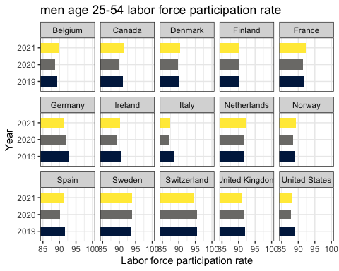

#### comment:

In general, men’s lfprs are above 85. Switzerland has the highest men’s lfprs, around 95. some countries’ lfprs in 2021 are higher than of that in 2020 even 2019. But Germany, Italy, UK, US, Spain, Finland, Ireland are lower than it in 2019.

notes: other factor, migrant labor. lower participation. US, Spain, Italy. look migrant labor dependence. Eurostats migrant flows. childcare provision Netherlands (private, vouchers), market of childcare increased, opening of private childcare centers. Germany(local government), public support on childcare. modality, the ways of childcare provision.

### women plot

# FEMALE  
o_l_w$Time <- as.factor(o_l_w$Time) # convert integer to factor  
plot.women.labor <- ggplot(o_l_w, aes(x=Time, y=Value, fill= Time)) +  
 geom_bar(position = "dodge", stat = "identity", width = 0.6) +  
 ggtitle("women age 25-54 labor force participation rate") +  
 scale_fill_viridis(discrete = T, option = "E") +  
 facet_wrap(~Country, nrow = 3, ncol = 5) +  
 theme_bw() +  
 theme(legend.position="none") +  
 xlab("Year")+  
 ylab("Labor force participation rate")+  
 coord_flip(ylim = c(60, 90))  
plot.women.labor

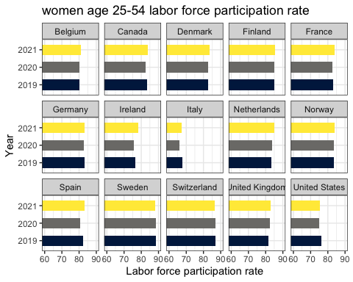 #### comment: All women’s lfprs are below 90. Sweden, Switzerland, Finland are higher than 85. Italy has the lowest, between 65-70. US, Switzerland, Germany, and Italy’s rates in 2021 are lower than in 2019.

### gender comparison plot

#merge men and women data  
o_l_all <- merge(o_l_m, o_l_w, by=c("Country", "Time"))  
names(o_l_all)[3] <- 'men'  
names(o_l_all)[4] <- 'women'  
  
#install.packages("reshape2")  
library(reshape2)

##   
## Attaching package: 'reshape2'

## The following object is masked from 'package:tidyr':  
##   
## smiths

o_l_all_m <- melt(o_l_all, id.vars = c('Country', 'Time'))  
names(o_l_all_m)[3] <- 'gender'

# gender comparison  
o_l_all_m$Time <- as.factor(o_l_m$Time) # convert integer to factor  
ggplot(o_l_all_m, aes(x=Time, y=value, fill= gender)) +  
 geom_bar(position = "dodge", stat = "identity", width = 0.6) +  
 ggtitle("age 25-54 labor force participation rate") +  
 scale_fill_manual(values = c("men"="cornflowerblue", "women"="coral"))+   
 facet_wrap(~Country, nrow = 3, ncol = 5) +  
 theme_bw() +  
 theme(legend.title = element_blank()) +  
 xlab("Year")+  
 ylab("Labor force participation rate")+  
 coord_flip(ylim = c(50, 100))

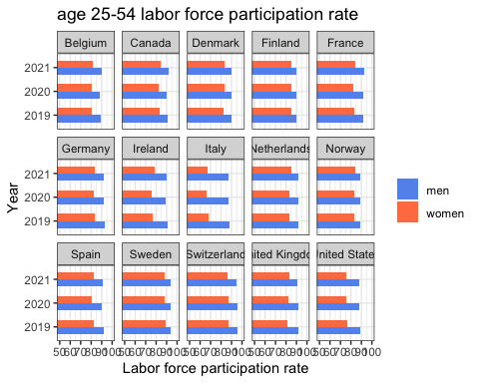 #### comment: Women’s lfprs are generally lower than men’s. Italy has the largest gender gap, then US, Ireland.

# export dataset  
write.csv(o_l_m,"~/Desktop/great resignation/OECD datasets/lfprmen.csv", row.names = FALSE)  
write.csv(o_l_w,"~/Desktop/great resignation/OECD datasets/lfprwomen.csv", row.names = FALSE)

## other age: labor force participation rate, age 15-64 working age population

comment: the lfpr of population age 15-64 is generally lower than that of age 25-54

# read oecd data 15-64 lfpr  
  
oecd_lfpr_m1 <- as_tibble(read.csv("~/Desktop/great resignation/OECD datasets/lfpr men 15-64.csv"))  
oecd_lfpr_w1 <- as_tibble(read.csv("~/Desktop/great resignation/OECD datasets/lfpr women 15-64.csv"))  
  
# select countries  
o_l_m1 <- oecd_lfpr_m1 %>% filter(Time >2018) %>% dplyr::select(Country, Time, Value) %>% filter(Country %in% c("United States","Canada", "United Kingdom","Germany", "France", "Italy", "Spain", "Netherlands", "Switzerland", "Sweden", "Belgium", "Ireland", "Norway", "Denmark", "Finland"))  
  
o_l_w1 <-oecd_lfpr_w1 %>% filter(Time >2018) %>% dplyr::select(Country, Time, Value) %>% filter(Country %in% c("United States","Canada", "United Kingdom","Germany", "France", "Italy", "Spain", "Netherlands", "Switzerland", "Sweden", "Belgium", "Ireland", "Norway", "Denmark", "Finland"))  
  
# merge data  
o_l_all1 <- merge(o_l_m1, o_l_w1, by=c("Country", "Time"))  
names(o_l_all1)[3] <- 'men'  
names(o_l_all1)[4] <- 'women'  
  
o_l_all_m1 <- melt(o_l_all1, id.vars = c('Country', 'Time'))  
names(o_l_all_m1)[3] <- 'gender'

###plot1

# gender comparison  
o_l_all_m1$Time <- as.factor(o_l_m1$Time) # convert integer to factor  
ggplot(o_l_all_m1, aes(x=Time, y=value, fill= gender)) +  
 geom_bar(position = "dodge", stat = "identity", width = 0.6) +  
 ggtitle("age 15-64 labor force participation rate") +  
 scale_fill_manual(values = c("men"="cornflowerblue", "women"="coral"))+   
 facet_wrap(~Country, nrow = 3, ncol = 5) +  
 theme_bw() +  
 theme(legend.title = element_blank()) +  
 xlab("Year")+  
 ylab("Labor force participation rate")+  
 coord_flip(ylim = c(50, 100))

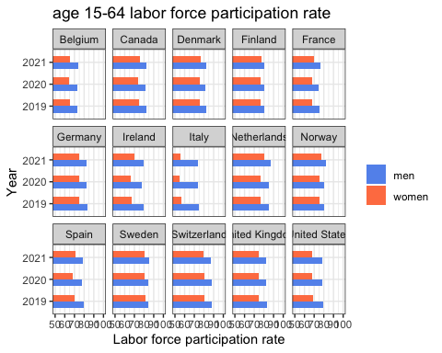

###plot2

# gender comparison  
o_l_all1$Time <- as.numeric(o_l_all1$Time) # convert to numeric  
  
ggplot(o_l_all1, aes(x=Time)) +  
 geom_line(aes(y=men), color = "cornflowerblue")+  
 geom_line(aes(y=women), color = "coral") +  
 ggtitle("age 15-64 labor force participation rate") +  
 facet_wrap(~Country, nrow = 3, ncol = 5) +  
 theme_bw() +  
 theme(legend.title = element_blank()) +  
 xlab("Year")+  
 ylab("Labor force participation rate")

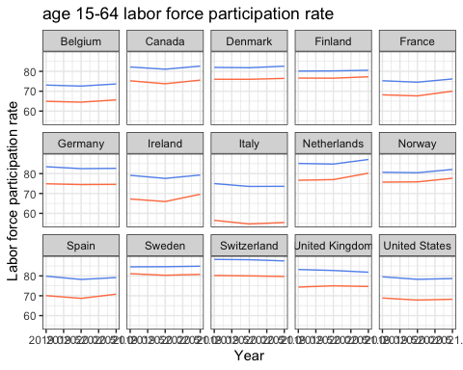 # net child cost definitions: <https://data.oecd.org/benwage/net-childcare-costs.htm>

This indicator measures the net childcare costs for parents using full-time centre-based childcare, after any benefits designed to reduce the gross childcare fees. Childcare benefits can be received in the form of childcare allowances, tax concessions, fee rebates and increases in other benefit entitlements. Net childcare costs are calculated for both couples and lone parents assuming two children aged 2 and 3. For couples, one parent earns 67% of the average wage whereas the other earns either minimum wage, 67% or 100% of the average wage.

# 67 average  
oecd_chdcost <- as_tibble(read.csv("~/Desktop/great resignation/OECD datasets/net childcare cost 67average 2004-2021.csv"))   
  
oecd_chdcost_sub <- oecd_chdcost %>% dplyr::select(LOCATION, TIME, Value) %>% filter(LOCATION %in% c("USA","CAN", "GBR","DEU", "FRA", "ITA", "ESP", "NLD", "CHE", "SWE", "BEL", "IRL", "NOR", "DNK", "FIN"))  
  
# "United States","Canada", "United Kingdom","Germany", "France", "Italy", "Spain", "Netherlands", "Switzerland (CHE)", "Sweden", "Belgium", "Ireland", "Norway", "Denmark", "Finland"  
  
#rename columns  
colnames(oecd_chdcost_sub) <- c('country', 'year', 'childcare_costs')  
  
# replace country names  
oecd_chdcost_sub$country[oecd_chdcost_sub$country == 'USA'] <- "United States"  
oecd_chdcost_sub$country[oecd_chdcost_sub$country == 'CAN'] <- "Canada"  
oecd_chdcost_sub$country[oecd_chdcost_sub$country == 'GBR'] <- "United Kingdom"  
oecd_chdcost_sub$country[oecd_chdcost_sub$country == 'DEU'] <- "Germany"  
oecd_chdcost_sub$country[oecd_chdcost_sub$country == 'FRA'] <- "France"  
oecd_chdcost_sub$country[oecd_chdcost_sub$country == 'ITA'] <- "Italy"  
oecd_chdcost_sub$country[oecd_chdcost_sub$country == 'ESP'] <- "Spain"  
oecd_chdcost_sub$country[oecd_chdcost_sub$country == 'NLD'] <- "Netherlands"  
oecd_chdcost_sub$country[oecd_chdcost_sub$country == 'CHE'] <- "Switzerland"  
oecd_chdcost_sub$country[oecd_chdcost_sub$country == 'SWE'] <- "Sweden"  
oecd_chdcost_sub$country[oecd_chdcost_sub$country == 'BEL'] <- "Belgium"  
oecd_chdcost_sub$country[oecd_chdcost_sub$country == 'IRL'] <- "Ireland"  
oecd_chdcost_sub$country[oecd_chdcost_sub$country == 'NOR'] <- "Norway"  
oecd_chdcost_sub$country[oecd_chdcost_sub$country == 'DNK'] <- "Denmark"  
oecd_chdcost_sub$country[oecd_chdcost_sub$country == 'FIN'] <- "Finland"

### plots

# 2004-2021  
plot_cost <- ggplot(oecd_chdcost_sub, aes(year, childcare_costs, group = country)) +  
 geom_line(aes(color = country))+  
 ggtitle("2004-2021 child costs") +  
 facet_wrap(~country, nrow = 3, ncol = 5) +  
 theme_bw() +  
 theme(legend.title = element_blank()) +  
 xlab("Year")+  
 ylab("Child costs")  
plot_cost

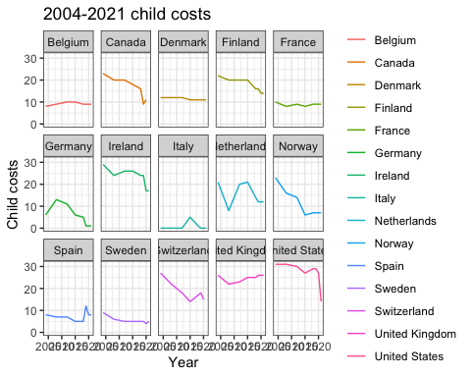

# 2018-2021  
plot_cost1 <- ggplot(oecd_chdcost_sub[which(oecd_chdcost_sub$year>2017),], aes(year, childcare_costs, group = country)) +  
 geom_line(aes(color = country))+  
 ggtitle("2018-2021 child costs") +  
 facet_wrap(~country, nrow = 3, ncol = 5) +  
 theme_bw() +  
 theme(legend.title = element_blank()) +  
 xlab("Year")+  
 ylab("Child costs")  
plot_cost1

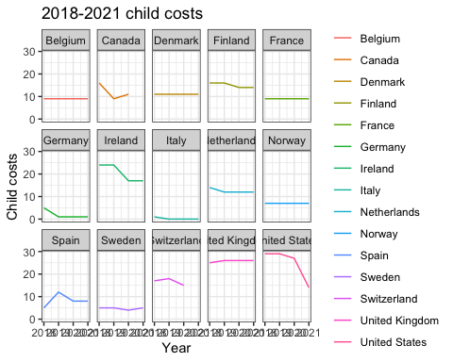

### comment

Germany’s child costs have remained high (above 25) from 2018 to 2021

Nordic countries’ child costs have remained low (below 20) from 2018 to 2021

Before COVID, the US has highest child cost level nearly 30, but droped significant since 2020. 15 at 2021

# 67 average / household income  
oecd_chdincome <- as_tibble(read.csv("~/Desktop/great resignation/OECD datasets/net childcare 67average_income 2004-2021.csv"))   
  
oecd_chdincome_sub <- oecd_chdincome %>% dplyr::select(LOCATION, TIME, Value) %>% filter(LOCATION %in% c("USA","CAN", "GBR","DEU", "FRA", "ITA", "ESP", "NLD", "CHE", "SWE", "BEL", "IRL", "NOR", "DNK", "FIN"))   
  
colnames(oecd_chdincome_sub) <- c('country', 'year', 'childcare_costs_percent')  
  
  
# replace country names  
oecd_chdcost_sub$country[oecd_chdcost_sub$country == 'USA'] <- "United States"  
oecd_chdcost_sub$country[oecd_chdcost_sub$country == 'CAN'] <- "Canada"  
oecd_chdcost_sub$country[oecd_chdcost_sub$country == 'GBR'] <- "United Kingdom"  
oecd_chdcost_sub$country[oecd_chdcost_sub$country == 'DEU'] <- "Germany"  
oecd_chdcost_sub$country[oecd_chdcost_sub$country == 'FRA'] <- "France"  
oecd_chdcost_sub$country[oecd_chdcost_sub$country == 'ITA'] <- "Italy"  
oecd_chdcost_sub$country[oecd_chdcost_sub$country == 'ESP'] <- "Spain"  
oecd_chdcost_sub$country[oecd_chdcost_sub$country == 'NLD'] <- "Netherlands"  
oecd_chdcost_sub$country[oecd_chdcost_sub$country == 'CHE'] <- "Switzerland"  
oecd_chdcost_sub$country[oecd_chdcost_sub$country == 'SWE'] <- "Sweden"  
oecd_chdcost_sub$country[oecd_chdcost_sub$country == 'BEL'] <- "Belgium"  
oecd_chdcost_sub$country[oecd_chdcost_sub$country == 'IRL'] <- "Ireland"  
oecd_chdcost_sub$country[oecd_chdcost_sub$country == 'NOR'] <- "Norway"  
oecd_chdcost_sub$country[oecd_chdcost_sub$country == 'DNK'] <- "Denmark"  
oecd_chdcost_sub$country[oecd_chdcost_sub$country == 'FIN'] <- "Finland"

write.csv(oecd_chdcost_sub,"~/Desktop/great resignation/OECD datasets/oecd_chdcost_sub.csv", row.names = FALSE)

same as the previous net childcare costs

# 2018-2021  
plot_income1 <- ggplot(oecd_chdincome_sub[which(oecd_chdincome_sub$year>2017),], aes(year, childcare_costs_percent, group = country)) +  
 geom_line(aes(color = country))+  
 ggtitle("2018-2021 child costs as percentage of household income") +  
 facet_wrap(~country, nrow = 3, ncol = 5) +  
 theme_bw() +  
 theme(legend.title = element_blank()) +  
 xlab("Year")+  
 ylab("Child costs percent of income")  
  
plot_income1

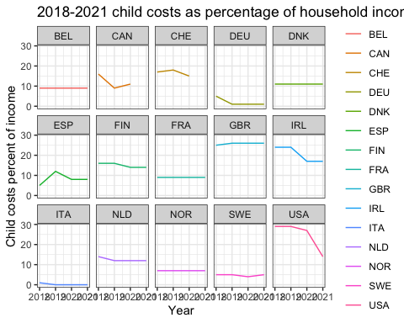

# Financial disincentive to enter employment with childcare costs

<https://data.oecd.org/benwage/financial-disincentive-to-enter-employment-with-childcare-costs.htm#indicator-chart>

This indicator measures the percentage of earnings lost to either higher taxes or lower benefits when a parent of two children takes up full-time employment and uses centre-based childcare. Calculations refer to a couple with two children aged 2 and 3 where the other parent works full-time at 67% of the average wage.

disincent <- as_tibble(read.csv("~/Desktop/great resignation/OECD datasets/financial disincent with childcare costs.csv"))  
  
disincent_sub <- disincent %>% dplyr::select(LOCATION, TIME, Value) %>% filter(LOCATION %in% c("USA","CAN", "GBR","DEU", "FRA", "ITA", "ESP", "NLD", "CHE", "SWE", "BEL", "IRL", "NOR", "DNK", "FIN"))  
  
colnames(disincent_sub) <- c('country', 'year', 'disincentive')  
  
disincent_sub$country[disincent_sub$country == 'USA'] <- "United States"  
disincent_sub$country[disincent_sub$country == 'CAN'] <- "Canada"  
disincent_sub$country[disincent_sub$country == 'GBR'] <- "United Kingdom"  
disincent_sub$country[disincent_sub$country == 'DEU'] <- "Germany"  
disincent_sub$country[disincent_sub$country == 'FRA'] <- "France"  
disincent_sub$country[disincent_sub$country == 'ITA'] <- "Italy"  
disincent_sub$country[disincent_sub$country == 'ESP'] <- "Spain"  
disincent_sub$country[disincent_sub$country == 'NLD'] <- "Netherlands"  
disincent_sub$country[disincent_sub$country == 'CHE'] <- "Switzerland"  
disincent_sub$country[disincent_sub$country == 'SWE'] <- "Sweden"  
disincent_sub$country[disincent_sub$country == 'BEL'] <- "Belgium"  
disincent_sub$country[disincent_sub$country == 'IRL'] <- "Ireland"  
disincent_sub$country[disincent_sub$country == 'NOR'] <- "Norway"  
disincent_sub$country[disincent_sub$country == 'DNK'] <- "Denmark"  
disincent_sub$country[disincent_sub$country == 'FIN'] <- "Finland"

### plot

plot_disincent1 <- ggplot(disincent_sub[which(disincent_sub$year>2017),], aes(year, disincentive, group = country)) +  
 geom_line(aes(color = country))+  
 ggtitle("2018-2021 Financial disincentive to enter employment with childcare costs") +  
 facet_wrap(~country, nrow = 3, ncol = 5) +  
 theme_bw() +  
 theme(legend.title = element_blank()) +  
 xlab("Year")+  
 ylab("Financial disincentive")  
  
plot_disincent1

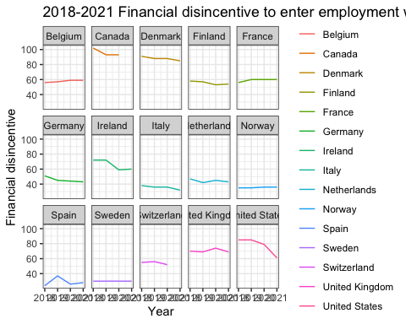

### Notes:

Canada, Denmark, and the US financial disincentive are over 80, higher than other European countries. Sweden, Norway, Spain, and Italy are below 80, lower than other European countries.

# Job leavers & starters

Eurostat report: <https://ec.europa.eu/eurostat/web/products-eurostat-news/-/ddn-20200422-2> database: <https://ec.europa.eu/eurostat/web/lfs/data/database>

I choose two datasets: two age groups: 20-64, 15-74. I choose 20-64 due to childcare considerations

1. Recent job leavers by sex and age 2018 Q1-2022 Q2 quarterly, seasonally adjusted <https://ec.europa.eu/eurostat/databrowser/view/LFSI_LEA_Q__custom_3611506/default/table?lang=en> Recent job leavers are those persons who report to have left their job in the last 3 months before the interview
2. Recent job starters by sex and age 2018 Q1-2022 Q2 quarterly, seasonally adjusted <https://ec.europa.eu/eurostat/databrowser/view/LFSI_STA_Q__custom_3621184/default/table?lang=en> Recent job starters are those persons who have started their employment in the last 3 months before the interview.

leaveall <- as_tibble(read.csv("~/Desktop/great resignation/eurostat/new/leaveall.csv"))  
leaveall <- leaveall[2:256,]  
colnames(leaveall)[3] <- "total_leavers"  
  
leavemale <- as_tibble(read.csv("~/Desktop/great resignation/eurostat/new/leavemale.csv"))   
leavemale <- leavemale[2:256,]  
colnames(leavemale)[3] <- "male_leavers"  
m <- leavemale[3]  
  
leavefemale <- as_tibble(read.csv("~/Desktop/great resignation/eurostat/new/leavefemale.csv"))   
leavefemale <- leavefemale[2:256,]  
colnames(leavefemale)[3] <- "female_leavers"  
w <-leavefemale[3]  
  
a <- cbind(leaveall,m)  
b <- cbind(a,w)  
  
leavedt <-b

leavedt$total_leavers<-as.numeric(leavedt$total_leavers)

## Warning: NAs introduced by coercion

leavedt$male_leavers <-as.numeric(leavedt$male_leavers)

## Warning: NAs introduced by coercion

leavedt$female_leavers <-as.numeric(leavedt$female_leavers)

## Warning: NAs introduced by coercion

plot_leave <- ggplot(data=leavedt, aes(x=Time, group = Country)) +  
 geom_line(aes(y=male_leavers), color = "cornflowerblue")+  
 geom_line(aes(y=female_leavers), color = "coral")+  
 ggtitle("2018 Q1-2022 Q1 job leavers") +  
 facet_wrap(~Country, nrow = 3, ncol = 5) +  
 theme_bw() +  
 theme(legend.title = element_blank()) +  
 xlab("Time")+  
 ylab("Number of leavers (thousand)")+  
 scale_y_continuous(limits =c(0,500), breaks = c(10,100, 200, 400))  
   
plot_leave

## Warning: Removed 7 row(s) containing missing values (geom_path).  
## Removed 7 row(s) containing missing values (geom_path).

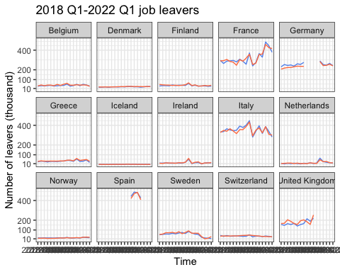

### job leavers 2021 euro countries

#since great resignation beginning in early 2021, I only show 2021  
library(stringr)  
library(dplyr)  
leavedt_s <- leavedt %>% filter(str_detect(Time, "2021"))  
  
plot_leave1 <- ggplot(data=leavedt_s, aes(x=Time, group = Country)) +  
 geom_line(aes(y=male_leavers, color = "male"))+  
 geom_line(aes(y=female_leavers, color = "female"))+  
 ggtitle("2021 Q1-Q4 job leavers") +  
 facet_wrap(~Country, nrow = 3, ncol = 5) +  
 theme_bw() +  
 xlab("Time")+  
 ylab("Number of leavers (thousand)")+  
 scale_y_continuous(limits =c(0,500), breaks = c(50,100, 200, 400))+  
 scale_x_discrete(labels=c("2021-Q1" = "Q1", "2021-Q2" = "Q2",  
 "2021-Q3" = "Q3", "2021-Q4" = "Q4"))+  
 scale_color_manual(breaks=c("male", "female"),  
 values=c("male"="cornflowerblue", "female"="coral"))  
  
plot_leave1

## Warning: Removed 6 row(s) containing missing values (geom_path).  
## Removed 6 row(s) containing missing values (geom_path).

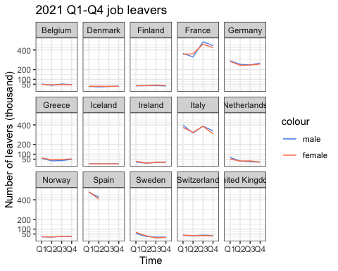 ### comment France, Italy, and Germany have a much higher number of job leavers. France and Italy have an obvious increase of job leavers from 2021 Q2 to 2021 Q3. Not see a very significant gender difference.

# Euro area - 19 countries (from 2015)  
euro <- as_tibble(read.csv("~/Desktop/great resignation/eurostat/euro_leave.csv"))  
euro$male <- as.numeric(euro$male)  
euro$female <- as.numeric(euro$female)

### General Euro job leavers

plot_euro <-ggplot(data=euro)+  
 geom_line(aes(x=Time, y=male, group = 1, color = "male"))+  
 geom_line(aes(x=Time, y=female,group = 1, color = "female"))+  
 ggtitle("2020 Q1-2021 Q4 job leavers in Euro Area") +  
 theme_bw() +  
 theme(legend.title = element_blank()) +  
 xlab("Time")+  
 ylab("Number of leavers (thousand)")+  
 scale_y_continuous(limits =c(1400, 2800), breaks = c(1800, 2200, 2600))+  
 scale_x_discrete(labels=c("2021-Q1" = "21Q1", "2021-Q2" = "21Q2",  
 "2021-Q3" = "21Q3", "2021-Q4" = "21Q4",  
 "2020-Q1" = "20Q1", "2020-Q2" = "20Q2",  
 "2020-Q3" = "20Q3", "2020-Q4" = "20Q4"))+  
 scale_color_manual(breaks=c("male", "female"),  
 values=c("male"="cornflowerblue", "female"="coral"))  
  
  
plot_euro

## Warning: Removed 9 row(s) containing missing values (geom_path).  
## Removed 9 row(s) containing missing values (geom_path).

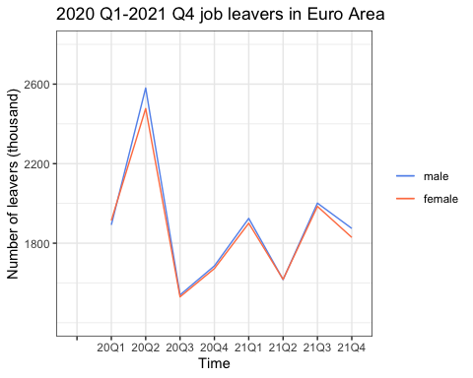 ### comment I don’t find a solid statistical evidence that women are more likely than men to leave the job market in Euro Area (15 countries in Euro stat survey). This plot actually shows more men left than women.

# relationship between childcare cost and labor force participation

OECD dataset

chdcost <- as_tibble(read.csv("~/Desktop/great resignation/OECD datasets/oecd_chdcost_sub.csv")) %>% subset(year > 2018)  
colnames(chdcost)[1] <- "Country"  
colnames(chdcost)[2] <- "Time"  
colnames(chdcost)[3] <- "cost"  
  
womenlfpr <- as_tibble(read.csv("~/Desktop/great resignation/OECD datasets/lfprwomen.csv"))   
colnames(womenlfpr)[3] <- "female_lfpr"  
menlfpr <- as_tibble(read.csv("~/Desktop/great resignation/OECD datasets/lfprmen.csv"))   
colnames(menlfpr)[3] <- "male_lfpr"

# emerge dataset by time and country  
child_labor <- merge(chdcost, womenlfpr, by = c("Country", "Time"))  
child_labor_all <- merge(child_labor, menlfpr, by = c("Country", "Time"))

#install.packages("ggpubr")  
library("ggpubr")  
  
# female  
female <- ggscatter(child_labor_all , x = "cost", y = "female_lfpr",   
 add = "reg.line", conf.int = TRUE,   
 cor.coef = TRUE, cor.method = "pearson",  
 xlab = "child cost", ylab = "female labor force participation rate")  
female

## `geom_smooth()` using formula 'y ~ x'

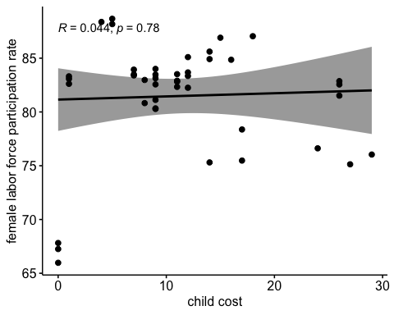

#male  
male <- ggscatter(child_labor_all , x = "cost", y = "male_lfpr",   
 add = "reg.line", conf.int = TRUE,   
 cor.coef = TRUE, cor.method = "pearson",  
 xlab = "child cost", ylab = "male labor force participation rate")  
male

## `geom_smooth()` using formula 'y ~ x'

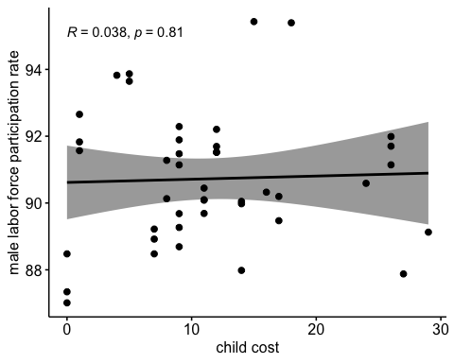 ## comment: correlation test does not show that childcost is correlated to female/male labor force participation.