preliminary analysis, US resignation

2022-07-05

## Job openings, hires, employment

### comment:

the number of overall employment experienced a sharp drop in April 2020, since then it has been recovering, close to the pre-pandemic level. “Job Openings as all positions that are open (not filled) on the last business day of the month.” (<https://www.bls.gov/jlt/jltdef.htm#2>)

Job openings haven been increasing while hires had a brief rise in May, then decreased later on, maintaining at a relatively stable level till now. That means, employment recovery is slow, and many available jobs have been not filled. This is called tight labor market: low unemployment, plentiful jobs, high quits, scarce workers.

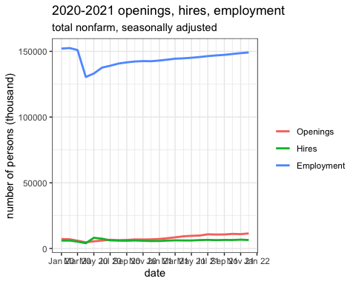

## quits

### quits overall level

## Quits and layoffs and discharges, total nonfarm, seasonally adjusted, December 2019–December 2021 (in thousands)

#### comment:

the number of layoffs peaked in April 2020, whereas quits reached lowest at the same time. But later, the number of quits have been increasing while layoffs decreasing. That means more and more workers voluntarily left the workplace and a decreasing number of people have experienced involuntary leaving since May 2020. Till May 2022, this tendency has not changed much. Clearly, there is “great resignation” during recovery.

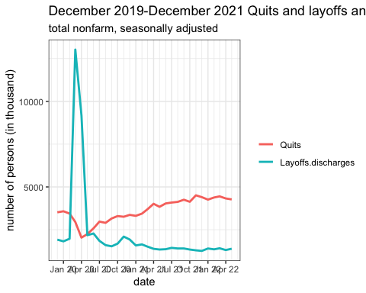

### Number of quits by industry

comment: Noticeably, the number of quits almost in all industries (except mining and logging) drop to the lowest level in either April, May, or June 2020, but later peaked in the end of 2021 or the beginning of 2022. In general, trade.transportation.utilities, leisure.hospitality, professional activities, education and health services experienced a very large number of quits during recovery.

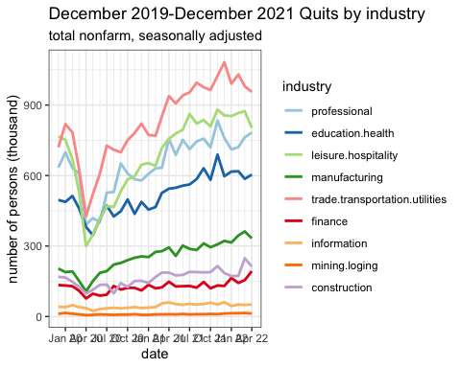

#### Quit rate by gender, cite Gusto

https://gusto.com/company-news/a-real-time-look-at-the-great-resignation#Quits_by_Gender

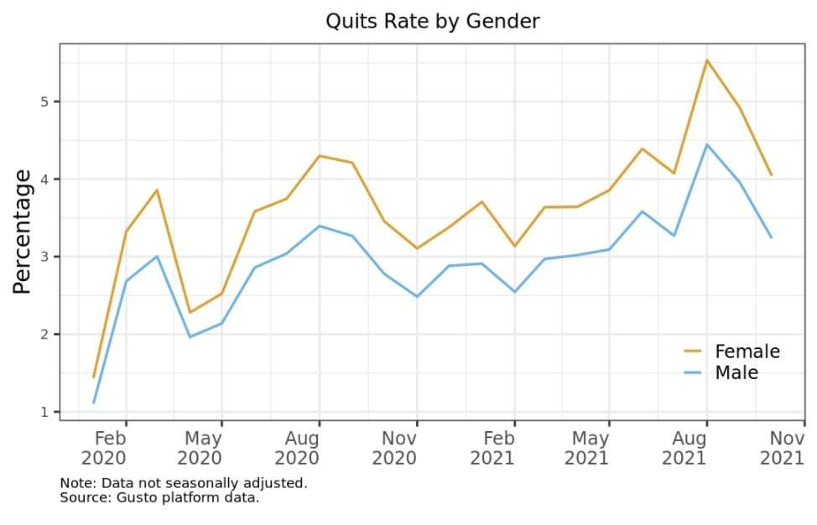

## Number of hires by industry

### comment:

Except for mining, logging, and information, most industries increased the number of hires after the peak of pandemic (April 2020) in May, June, and July. In particular, leisure and hospitality were the highest but later they drop significantly. The change scale is the largest. The education and health services also experienced a large scale of reduction.

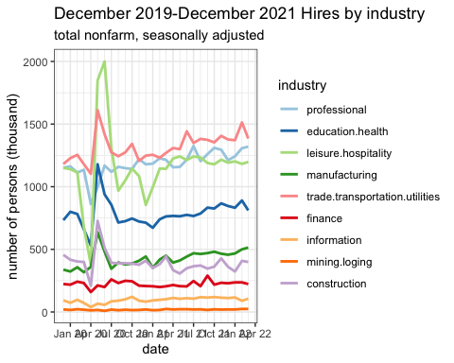

## labor force participation rate by gender and race (>16, unadjusted)

only black and white groups have seasonally adjusted data. So in order to keep data consistent, I choose unadjusted data.

Comment:

Age 16 and over population’s labor force participation rate shows a significant gender difference but not much expected ethnic difference.

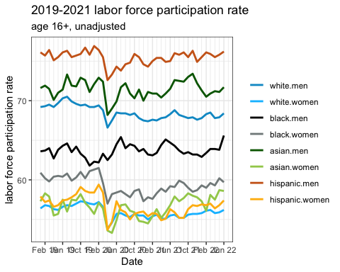

### comment:

Other age 25-54

25-54 prime working-age population lfprs (the core of the US workforce), men’s lbfr is very similar except that black men’s lbfr is the lowest. Black women lbfr is the highest, white women is slightly lower, but they are pretty close. These two goups’ lbfrs are much higher than other female groups.

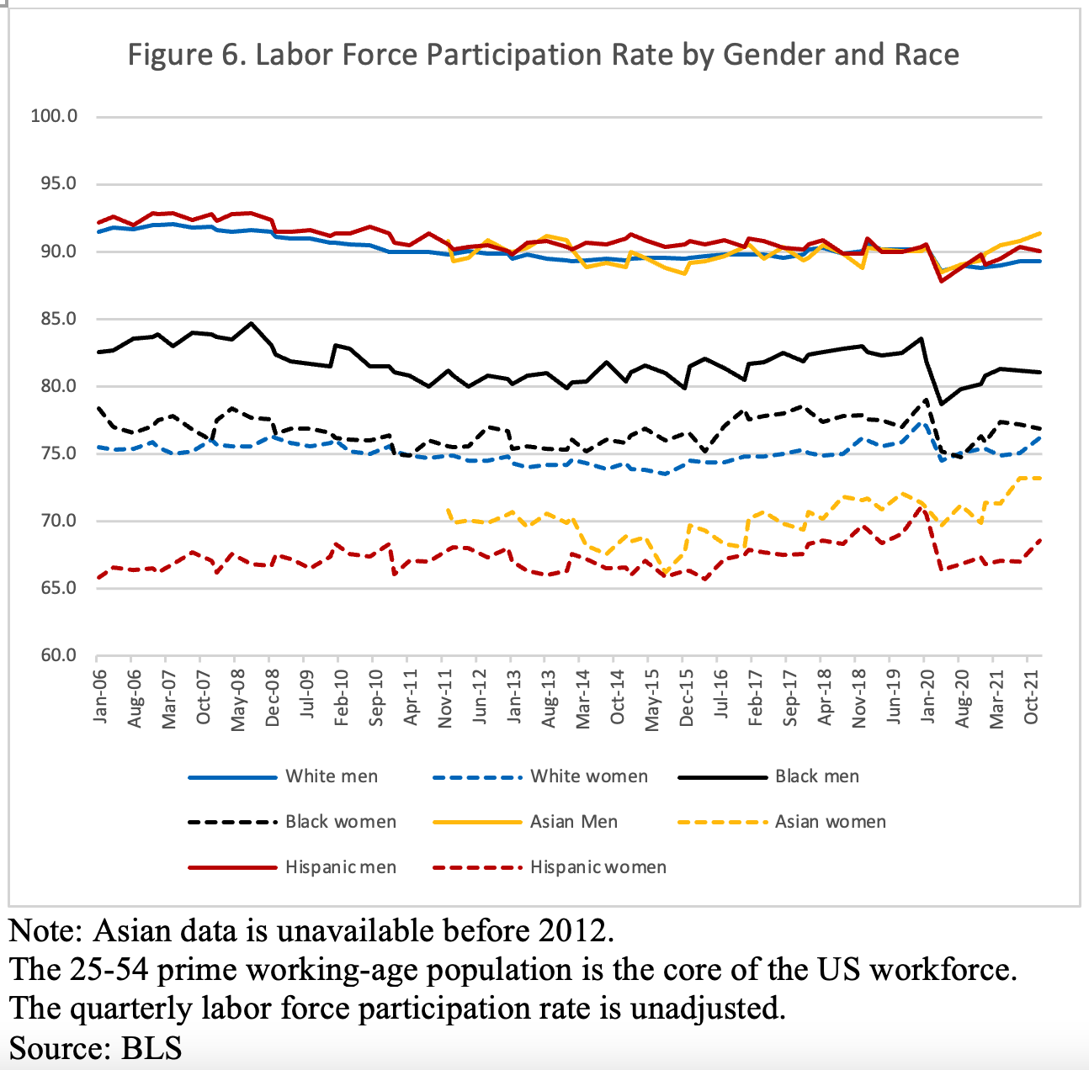

## employment rate (16+, unadjusted)

### comment:

the employment rates of women in all ethical groups are lower than that of men. In recovery, Hispanic men’s employment rate is highest while black men’s rate is the lowest.

