**Air University Multan campus**

**Name: Muhammad Rayyan Javed**

**Roll No: 233532**

**Subject: Visual Programming_lab**

**Submitted to: Mam Atka**

**Submission Date: 24/09/2024**

**--(Task 1)—**

**Make A Directory:**

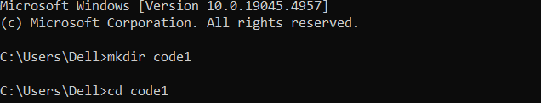

**DOT.NET New Console:**

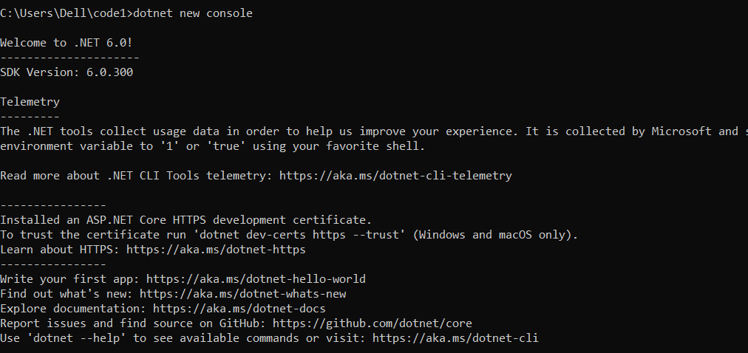

**DOT.NET Restore:**

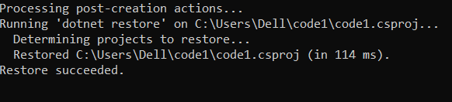

**DOT.NET Run:**

