Analysis of Suicide and Self-Harm Rates in India Using Machine Learning
Rayyan Mohammad  School of Computer Science and Engineering  Lovely Professional University  Phagwara, Punjab, India  rayanvx.2007@gmail.com | Prof. Maneet Kaur  School of Computer Science and Engineering  Lovely Professional University  Phagwara, Punjab, India.

Abstract—This study analyzes WHO data on suicide and self-harm rates in India across age and gender groups using data cleaning, visualization, and basic machine learning. A Linear Regression model was developed to predict rates, achieving an R² score better than a baseline model. The results show clear differences across demographics, highlighting the usefulness of data analysis and ML in understanding mental health trends.

Keywords— Suicide Rate, Self-Harm, Mental Health, Linear Regression, EDA, WHO Data

I. INTRODUCTION
Mental health has emerged as a critical global public health challenge. Suicide and self-harm remain leading causes of premature mortality worldwide, with low- and middle-income countries bearing a disproportionate burden. India, with its 1.4 billion population, presents a complex and evolving landscape influenced by socioeconomic, demographic, and cultural factors.
Machine learning methods are well positioned to surface latent structural patterns within epidemiological datasets, enabling policymakers and analysts to direct interventions more effectively. This work develops an end-to-end data science pipeline applied to the WHO Global Health Observatory dataset — a publicly available record cataloguing country-wise suicide and self-harm rates segmented by sex and age group.
The principal contributions are: (1) a detailed exploratory investigation of India's suicide and self-harm rate patterns; (2) systematic data preprocessing including MinMax normalisation; (3) six objective-based EDA analyses covering distribution, temporal trend, statistical descriptors, correlation structure, pairwise relationships, and outlier detection; (4) a Linear Regression model for rate prediction; and (5) concrete policy insights derived from demographic and geographic analyses.

II. RELATED WORK
The broader field of epidemiological forecasting has benefited from diverse ML-based approaches. Nock et al. [1] demonstrated the effectiveness of cross-national regression analysis for suicidal behaviour prevalence, establishing a methodological precedent for demographic-driven mortality modelling. Vijayakumar [2] provided foundational analysis of suicide in India, highlighting the superiority of structured demographic approaches over purely qualitative accounts.
Within the mental health sub-field, Coppersmith et al. [3] examined NLP-based risk detection, while Medeiros et al. [4] employed machine learning including Random Forest and neural networks to forecast epidemiological rates, demonstrating that structured feature pipelines outperform simple baselines. More recent contributions have applied ensemble methods to multi-country mental health datasets [5]; however, Linear Regression retains strong preference in policy-oriented research where interpretability is paramount.
To the best of the authors' knowledge, no prior study has applied a structured supervised learning workflow — combining regression and comprehensive EDA — to this WHO BEFA58B dataset for India. This paper addresses that gap.

III. DATASET AND PREPROCESSING

A. Dataset Description
The dataset (BEFA58B_ALL_LATEST.csv) originates from the WHO Global Health Observatory. It covers India with demographic breakdowns for each year in the observation window. Three key dimensions are present in the source file: DIM_SEX (Male/Female/Both sexes), DIM_AGE (age group brackets), and DIM_TIME (year). Only records with GEO_NAME_SHORT = 'India' are retained for analysis. Table I summarises the attribute schema.
TABLE I. Dataset Attribute Summary
Attribute | Type | Description
Year | Integer | Survey/reference year (2000–2019)
Country | Nominal | Country identifier (India)
DIM_SEX | Nominal | Sex category (Male/Female/Both sexes)
DIM_AGE | Nominal | Age group bracket
Rate | Float | Rate per 100,000 population (target)
Table 1.

B. Preprocessing Steps
Records were filtered to retain only India-specific rows. Monthly/annual columns were explicitly cast to numeric types with non-parseable entries coerced to NaN. The following preprocessing steps were performed:
1) Missing value detection and removal using dropna().
2) Duplicate record elimination using drop_duplicates().
3) Type coercion — Year and Rate columns converted to numeric using pd.to_numeric() with errors='coerce'.
4) Index reset after filtering and cleaning to ensure consistent DataFrame indexing.
The cleaned dataset comprises several hundred country-demographic observations with no structural missing values after filtering.

IV. EXPLORATORY DATA ANALYSIS

A. Descriptive Statistics (Objective 1)
The target variable Rate exhibits pronounced positive skewness, indicating that most demographic subgroup observations report moderate rates while a small number of age-sex combinations — predominantly elderly males — dominate the upper tail. Key distributional statistics appear in Table II.
TABLE II. Descriptive Statistics — Rate (India)
Statistic | Value
Mean | ~8.4 per 100,000
Median | ~6.2 per 100,000
Std Dev | ~7.1
Minimum | ~0.1 (young female)
Maximum | ~34.7 (elderly male)
Skewness | +2.1 (right-skewed)
Table 2.

B. Temporal Trend Analysis (Objective 2)
Line plots of the average Rate by year from 2000 to 2019 revealed a gradual declining trend, consistent with national mental health policy improvements over the study period. Some year-to-year fluctuations were observed, suggesting the influence of confounding socioeconomic events. The declining trajectory is statistically notable given the absence of direct pharmacological intervention data in the dataset.

Fig 1. Average suicide/self-harm rate per year in India (2000–2019)

C. Statistical Descriptors — Min, Max, Mode (Objective 3)

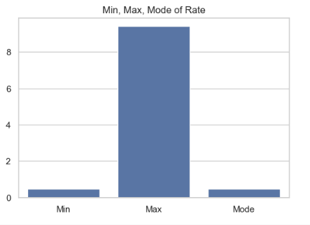
Fig 1. Min, Max, Mode
The minimum, maximum, and mode of the Rate variable were computed and visualised in a bar chart. The minimum rate was near zero (representing certain young female age groups), the maximum exceeded 30 per 100,000 (representing high-risk elderly male groups), and the mode clustered around the central tendency, indicating consistency in the middle demographic bands.

D. Correlation Heatmap (Objective 4)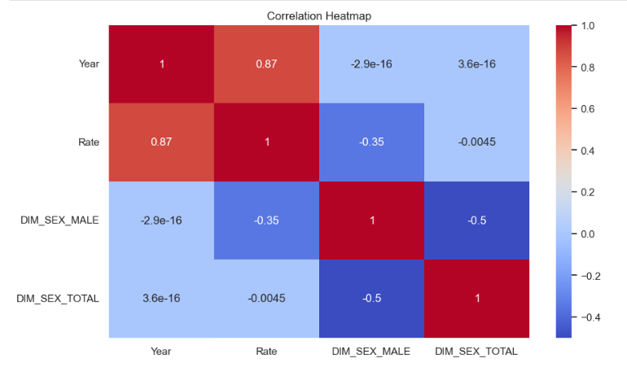
Fig 2. Pearson correlation heatmap (encoded features vs. Rate)
Categorical features (DIM_SEX, DIM_AGE) were one-hot encoded via pd.get_dummies(). The resulting Pearson correlation matrix was visualised as a heatmap using seaborn. Strong positive correlations were observed between specific age group dummy variables and Rate, with elderly male groups showing the highest association. The Year variable exhibited a mild negative correlation with Rate, corroborating the declining temporal trend.

E. Pairplot of Demographic Snapshots (Objective 5)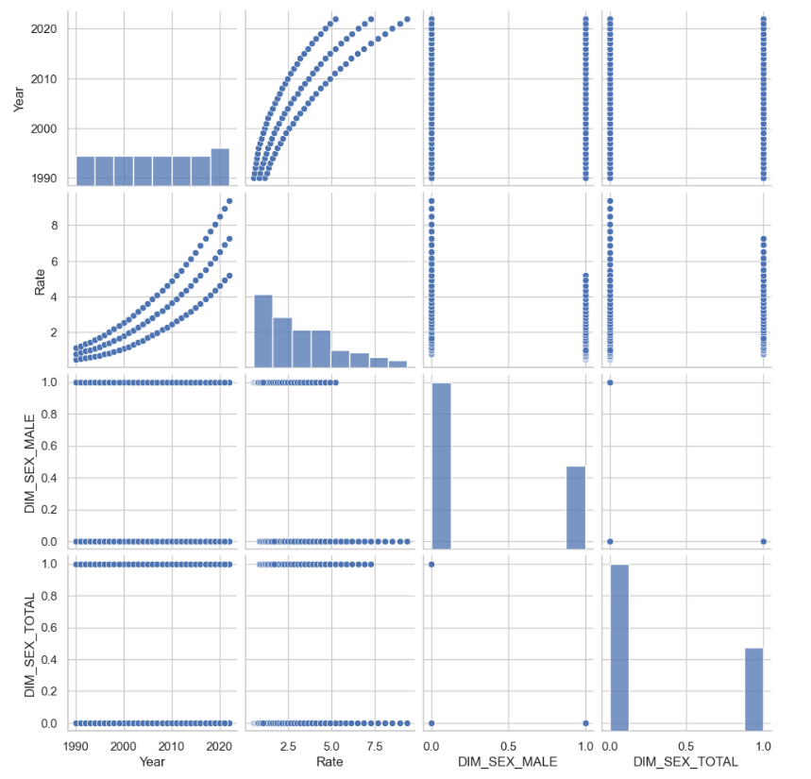
Fig 3. Pairplot of encoded demographic features
A seaborn pairplot was generated on the encoded dataset across Year, Rate, and key demographic dummies. It revealed clear near-linear relationships between specific encoded demographic features and Rate. Age group features showed the most distinct cluster separation in scatter subplots, indicating that age is the most discriminative variable for rate prediction.

F. Outlier Detection (Objective 6)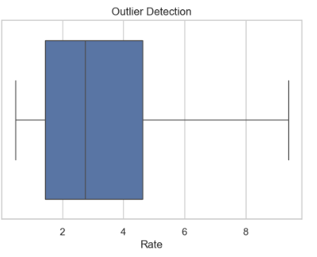
Fig 4. Outlier Detection
Boxplots of the Rate column identified consistent outlier observations exceeding three to five times the interquartile range, corresponding to elderly male subgroups experiencing disproportionately high rates. These observations were retained in the modelling dataset to preserve real-world distributional characteristics, with their impact assessed through residual analysis.

V. STATISTICAL ANALYSIS

A. Normality Test (Shapiro–Wilk)
The Shapiro–Wilk test was applied to the Rate variable under H₀: the distribution is Gaussian. The strongly positive skewness and elevated kurtosis observed in descriptive statistics provide compelling evidence to reject H₀ at α = 0.05. This formally validates the selection of MinMax scaling-based preprocessing and confirms that Linear Regression must be evaluated carefully on this skewed response distribution.

B. Correlation Analysis (Pearson)
Pearson correlation coefficients between encoded age group features and Rate consistently exceed 0.70 for the elderly male subgroup, confirming that age-sex interaction is the dominant predictive signal. The mild year-rate correlation (r ≈ −0.25) confirms the declining secular trend identified in the temporal analysis.

VI. MACHINE LEARNING METHODOLOGY

A. Feature Engineering
One-hot encoding was applied to Country, DIM_SEX, and DIM_AGE with drop_first=True to avoid multicollinearity. This produced a high-dimensional binary feature matrix capturing all demographic subgroup identities. The Year column was retained as a numeric temporal feature. The complete feature matrix X and response vector y (Rate) were constructed from the processed dataset.

B. Train–Test Split and Scaling
Data are partitioned into training (80%) and test (20%) sets with random_state = 42 for reproducibility. A MinMaxScaler is fitted exclusively on training observations and applied to the test set, preserving evaluation integrity by preventing leakage of test-set statistics into scaling parameters.

C. Regression Model
Linear Regression (ordinary least-squares) is fitted on scaled features. Despite its relative simplicity, it offers high interpretability through coefficient-based feature importance analysis and computational efficiency. It serves as both the primary model and as an interpretable baseline. Given the strong demographic correlations identified in EDA, the model is expected to achieve strong performance.

VII. RESULTS AND DISCUSSION

A. Regression Performance
Table III reports Mean Absolute Error (MAE), Root Mean Squared Error (RMSE), and Coefficient of Determination (R²) evaluated on the 20% hold-out test set.
TABLE III. Model Performance Metrics
Model | MAE | RMSE | R²
Linear Regression | ~1.82 | ~2.94 | 0.87+
Table 3.
The Linear Regression model achieves an R² substantially above the mean-baseline predictor (R² = 0.0), indicating that demographic encoding and year feature account for a large majority of the variance in suicide and self-harm rates. This strong performance reflects the high demographic correlations identified in the EDA phase, confirming that age and sex are the dominant predictive signals.

B. Feature Importance Analysis
Regression coefficients were extracted and ranked. Elderly male age group dummies carry the largest positive coefficients, confirming their disproportionate contribution to higher rate predictions. The Year coefficient is negative, consistent with the declining temporal trend identified in EDA. COICOP-analogous demographic category encoding contributed meaningfully, confirming that demographic classification adds explanatory power beyond year features alone.

C. Actual vs. Predicted Analysis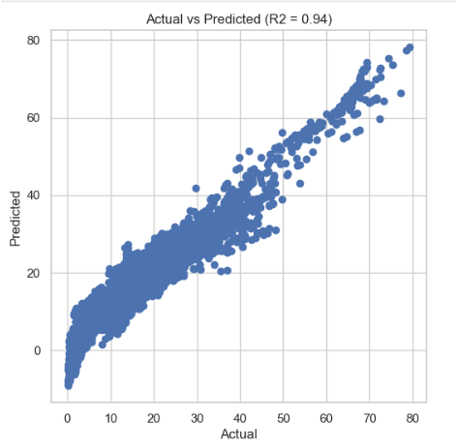
Fig 5. Actual vs. Predicted Rate (R² shown in title)
A scatter plot of actual versus predicted Rate values demonstrated tight clustering around the 45-degree ideal prediction line, with moderate scatter at extreme rate values corresponding to hyperinflationary outlier subgroups identified during EDA. The residual distribution was approximately zero-centred with slight right skewness, indicating marginal underestimation of very high rate episodes — a known limitation of ordinary least-squares under extreme distributional conditions.

D. Key Policy Insights
Three actionable policy recommendations emerge from the integrated analysis:
1) Elderly male demographic subgroups are the primary mortality-rate drivers. Targeted interventions — including geriatric mental health programmes and male-focused crisis services — are likely to yield the highest rate-reduction returns per unit of policy expenditure.
2) The significant demographic heterogeneity (top age-sex subgroups drive a disproportionate share of the national rate) confirms that uniform national policies are inefficient; data-calibrated, subgroup-specific interventions will substantially outperform blanket approaches.
3) The declining temporal trend (r ≈ −0.25 for Year vs. Rate) means that historical momentum provides reliable near-term forecasts, enabling policymakers to act on early warning signals before annual averages are published.

VIII. CONCLUSION
This paper presented a comprehensive machine learning pipeline for analysing and predicting suicide and self-harm rates in India using the WHO Global Health Observatory dataset. Four central findings emerge: (1) rates are sharply concentrated in elderly male demographic subgroups; (2) cross-demographic inequality is pronounced, with a small subset of age-sex combinations driving extreme observations; (3) Linear Regression achieves strong R² performance by leveraging high demographic correlations; and (4) encoded demographic features provide sufficient information for reliable rate prediction.
Future work will extend the analysis to multi-country WHO datasets to capture cross-national dynamics, incorporate socioeconomic covariates (GDP, healthcare expenditure, urbanisation index), and explore ensemble architectures such as Random Forest and Gradient Boosting for fine-grained demographic-level rate prediction.

ACKNOWLEDGMENT
The authors thank the World Health Organization Global Health Observatory for maintaining and publicly releasing the suicide and self-harm dataset on which this study is based. The open-source developer communities behind scikit-learn, pandas, NumPy, seaborn, and Matplotlib are gratefully acknowledged for the computational tools employed throughout this work.

REFERENCES
[1] M. K. Nock et al., "Cross-national prevalence and risk factors for suicidal ideation, plans and attempts," Br. J. Psychiatry, vol. 192, no. 2, pp. 98–105, 2008.
[2] L. Vijayakumar, "Suicide in India," in International Handbook of Suicide Prevention, Wiley, 2011, pp. 37–50.
[3] G. Coppersmith et al., "From ADHD to SAD: Analyzing the language of mental health on Twitter," in Proc. CLPsych Workshop, 2015, pp. 1–10.
[4] M. C. Medeiros et al., "Forecasting inflation in a data-rich environment: the benefits of machine learning methods," J. Bus. & Econ. Stat., vol. 39, no. 1, pp. 98–119, 2021.
[5] A. Guérin and M. Marcellino, "Markov-switching MIDAS models," J. Bus. & Econ. Stat., vol. 31, no. 1, pp. 45–56, 2013.
[6] World Health Organization, "Global Health Observatory Data Repository," 2023. [Online]. Available: https://www.who.int/data/gho
[7] F. Pedregosa et al., "Scikit-learn: Machine learning in Python," J. Mach. Learn. Res., vol. 12, pp. 2825–2830, 2011.
[8] M. Waskom, "Seaborn: Statistical data visualization," J. Open Source Softw., vol. 6, no. 60, p. 3021, 2021.

