Fraud Detection Using Graph Neural Networks:
A Comparative Study on the Elliptic Bitcoin Dataset

Rayyan Ali Akbar
rayyanakbar0208@gmail.com

March 2026

Keywords: Graph Neural Networks, Fraud Detection, Bitcoin, Elliptic Dataset, GraphSAGE, GAT, Message Passing, Temporal Evaluation, Imbalanced Classification

ABSTRACT

Financial fraud in digital payment networks causes hundreds of billions of dollars in annual losses and is fundamentally a relational phenomenon: fraudsters operate in rings, mule networks, and cascading chains of interconnected transactions. Standard tabular machine learning models treat each transaction as an independent observation, making them structurally incapable of capturing these multi-hop fraud patterns. This report presents a systematic investigation of Graph Neural Networks (GNNs) for fraud detection on the Elliptic Bitcoin Dataset — a directed graph of 203,769 Bitcoin transactions spanning 49 time steps from 2011 to 2019 — with 2.23% labelled as illicit.
We implement and compare two GNN architectures — GraphSAGE and Graph Attention Network (GAT) — against four tabular baselines: Logistic Regression, Random Forest, XGBoost, and XGBoost augmented with graph statistics. Four key findings are reported. First, XGBoost achieves F1 = 0.964 versus GraphSAGE's F1 = 0.918 on a standard random split — a gap explained by Elliptic's 72 pre-aggregated neighborhood features, which effectively supply graph signal to tabular models without requiring relational modeling. Second, an ablation study removing those features reveals the GNN's true structural advantage: GraphSAGE drops only 0.001 in F1 while XGBoost drops 0.021, demonstrating that GNNs learn neighborhood aggregation endogenously through message passing. Third, temporal out-of-time evaluation — the correct methodology for fraud detection — uncovers substantial performance inflation in random split results, with GNN F1 falling from 0.918 to 0.571 on unseen future time steps. Fourth, despite this degradation, GNNs offer three irreplaceable production advantages: inductive scoring without retraining, no feature engineering dependency, and structural interpretability via GNNExplainer. The best GraphSAGE model achieves AUC-PR = 0.953, a 43× improvement over the random classifier baseline of 0.022.

1. INTRODUCTION

Financial fraud represents one of the most persistent and costly threats in digital commerce. Card fraud alone accounts for an estimated $32 billion per year globally, while money laundering — the process of routing illicit funds through legitimate accounts to obscure their origin — is estimated to move $2 trillion annually through the financial system [1]. Despite decades of research in anomaly detection and supervised classification, fraud detection remains an open problem for a fundamental structural reason: the most informative signal in fraud data is not the properties of individual transactions, but the relationships between them.
Fraudsters do not act in isolation. They construct mule networks — rings of accounts and transactions deliberately structured to move funds in patterns that evade per-transaction detection. A transaction's fraud probability is not determined solely by its amount, timing, or merchant category; it is shaped by the identities of counterparties and the network topology of surrounding transactions. A model that treats each transaction as an independent row in a table is structurally unable to capture these relational patterns.
Graph Neural Networks (GNNs) address this limitation directly. By representing the payment network as a graph and propagating information along transaction edges through a process called message passing, GNNs allow each node to encode information about its multi-hop neighborhood. A transaction embedded in a dense fraud ring becomes distinguishable not only by its own features, but by the converging signals from its neighbors and their neighbors, up to L hops away.
This report makes the following contributions:
- A complete implementation of GraphSAGE [1] and GAT [2] on the Elliptic Bitcoin Dataset, covering data loading, mini-batch training via NeighborLoader, class imbalance handling, threshold optimization, and visualization.
- A rigorous ablation study that isolates the GNN's structural advantage from the pre-engineered neighborhood features present in the Elliptic dataset, revealing where the true architectural difference lies.
- A temporal out-of-time evaluation demonstrating substantial performance inflation in random split baselines, and establishing temporal evaluation as the correct methodology for fraud detection model assessment.
- A GNNExplainer analysis providing structural interpretability — identifying which graph connections and node features drive individual fraud predictions.

The remainder of this report is organized as follows. Section 2 describes the datasets and problem formulation. Section 3 presents the GNN architectures and training methodology. Section 4 defines the evaluation framework. Section 5 reports all experimental results and analysis. Section 6 discusses limitations and future directions. Section 7 concludes.

2. DATASETS AND PROBLEM FORMULATION

2.1 The Elliptic Bitcoin Dataset
The primary dataset is the Elliptic Bitcoin Dataset [4], a directed graph of Bitcoin transactions collected between 2011 and 2019 and released by the blockchain analytics company Elliptic. The dataset is partitioned into 49 chronological time steps, each representing approximately two weeks of on-chain transaction activity. Table 1 summarizes the dataset statistics.

Property | Value
Total nodes (transactions) | 203,769
Total edges (UTXO payment flows) | 234,355
Labelled nodes | 46,564 (22.8%)
Illicit (fraud) nodes | 4,545 (2.23% of all nodes)
Licit (legitimate) nodes | 42,019 (20.6%)
Unknown (unlabelled) nodes | 157,205 (77.2%)
Features per node | 166 total; time_step dropped → 165 used
— Local features (feat_0 – feat_93) | 94 (amount, fee, input/output counts, etc.)
— Aggregated features (feat_94 – feat_164) | 71 (pre-computed 1-hop neighborhood statistics)
Time steps | 49 (~2 weeks each, 2011–2019)
Average node degree | 1.15 (extremely sparse)
Maximum node degree | 472
Table 1. Elliptic Bitcoin Dataset statistics.
Each node represents a single Bitcoin transaction — not a wallet or address. An edge A → B indicates that the unspent transaction output (UTXO) of transaction A is consumed as an input to transaction B, encoding the flow of bitcoin between transactions. The feature set comprises two distinct groups: 94 local features encoding properties of the individual transaction, and 71 aggregated features representing pre-computed one-hop neighborhood statistics (means, medians, and standard deviations of the local features of immediate neighbors). This distinction is critical to the ablation study in Section 5.3.

2.2 Class Imbalance
With only 2.23% of nodes labelled illicit, the dataset presents a severe class imbalance. A naive classifier predicting "legitimate" for every transaction achieves 97.77% accuracy while detecting zero fraud. Standard accuracy is therefore a meaningless evaluation metric. Figure 1 illustrates the label distribution.
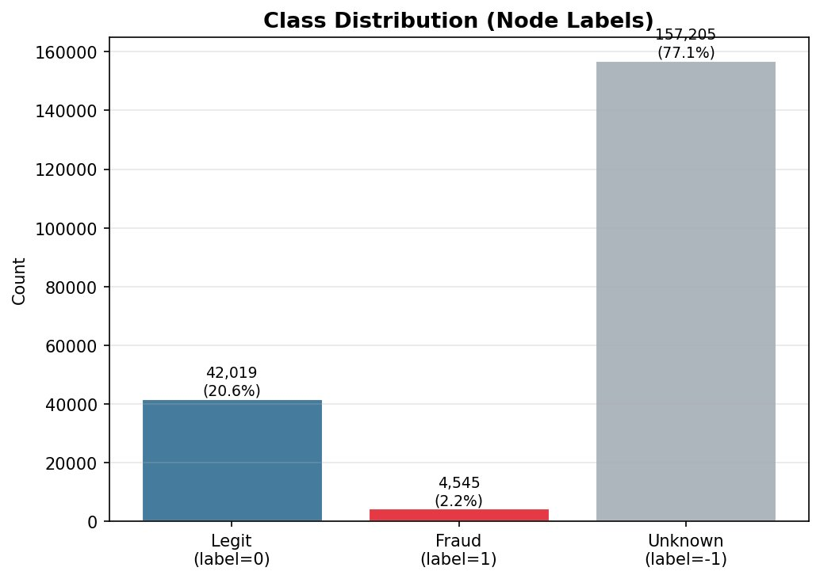
Figure 1. Class distribution across 203,769 nodes. Fraud nodes (2.2%) are dwarfed by legitimate and unknown nodes.

2.3 Temporal Dynamics
Fraud rates are not stationary across time steps. As shown in Figure 2, the fraud rate fluctuates from near zero to over 35%, with no monotonic trend. This temporal non-stationarity has important implications for evaluation: a model trained and tested on randomly shuffled data will have seen future fraud patterns during training, producing inflated performance estimates that do not reflect real-world deployability.
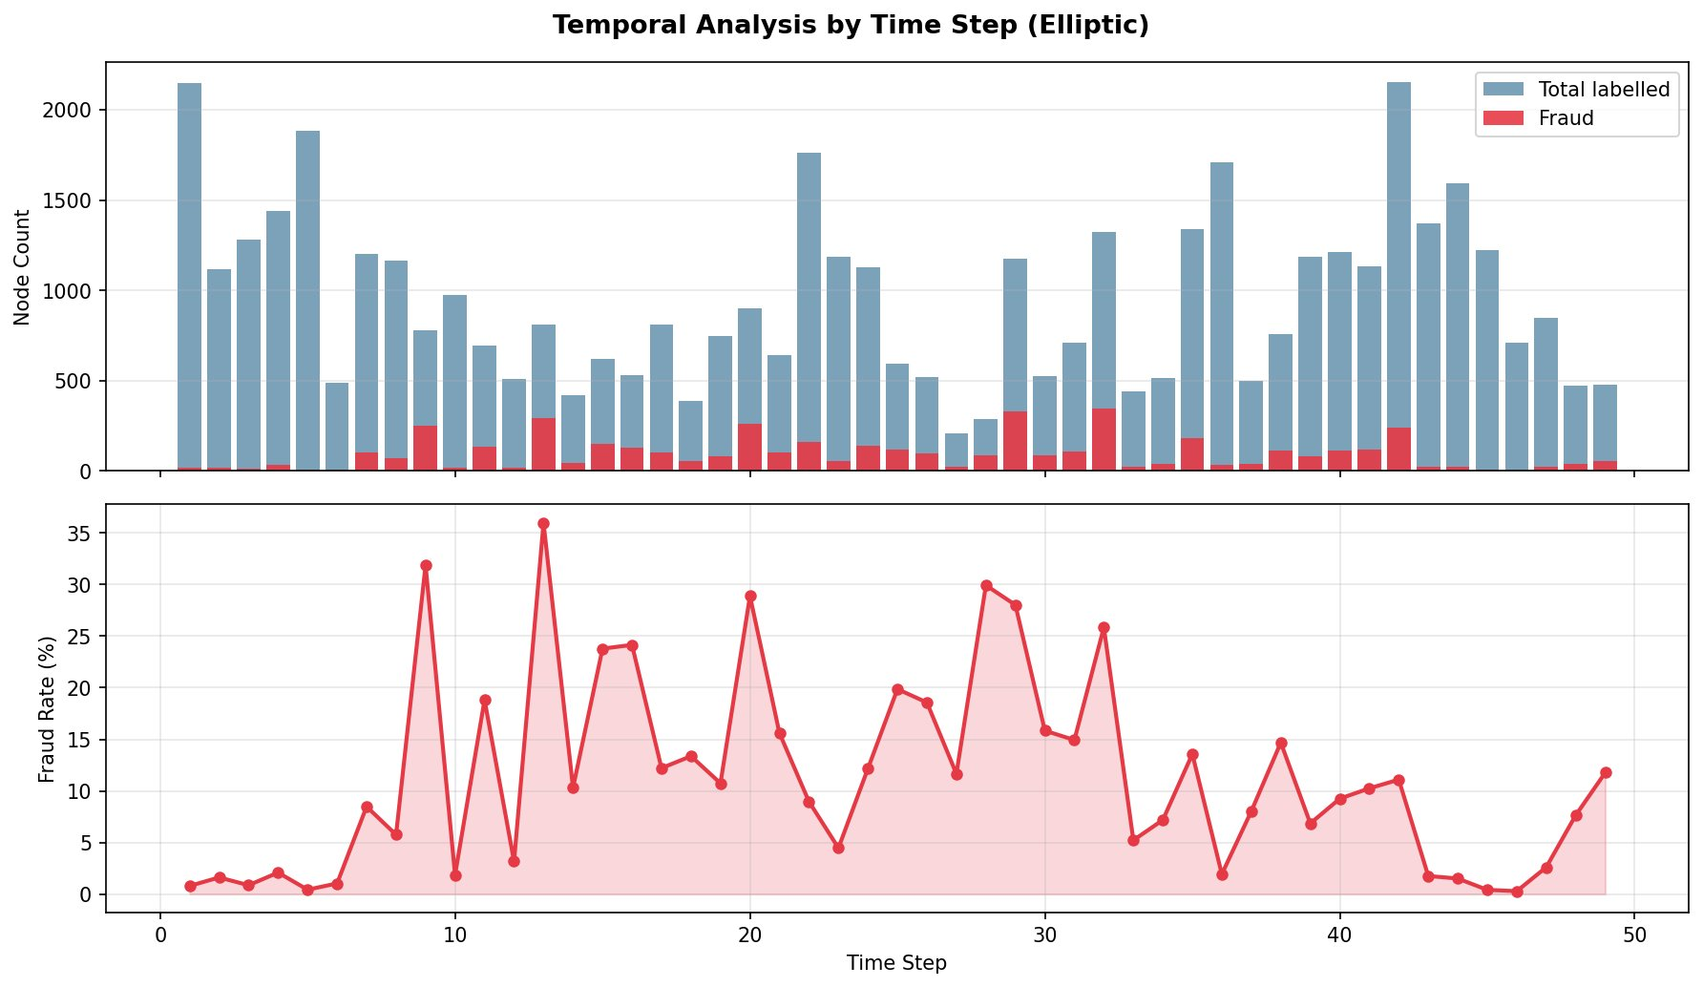
Figure 2. Temporal analysis. Top: total labelled and fraud nodes per time step. Bottom: fraud rate (%) per time step. High variability motivates temporal out-of-time evaluation.

2.4 Problem Formulation
The task is node-level binary classification on a graph G = (V, E, X, Y), where V is the set of transaction nodes, E ⊆ V × V is the set of directed UTXO edges, X ∈ ℝ^(|V|×165) is the node feature matrix, and Y : V_L → {0, 1} is a partial labelling covering the 46,564 labelled nodes. For each labelled node v, the objective is to estimate P(Y(v) = 1 | G, X), where Y(v) = 1 denotes an illicit transaction.

2.5 Secondary Dataset: IEEE-CIS
The pipeline also supports the IEEE-CIS Fraud Detection dataset (Vesta Corporation / Kaggle, 2019) [7], containing 590,540 e-commerce transactions at a 3.5% fraud rate. Unlike Elliptic, this dataset requires explicit graph construction: a bipartite card–transaction graph is built using a composite card key (card1 + card2 + card4), connecting each card node to every transaction it made. The IEEE-CIS dataset was used for pipeline validation; all primary experiments in this report use the Elliptic dataset.

3. METHODOLOGY

3.1 The Message Passing Framework
All GNN architectures in this work are instances of the Message Passing Neural Network (MPNN) framework. The core principle is that a node should update its representation by aggregating information from its local neighborhood. At each layer l, this proceeds in two steps:
Aggregate: a_v^(l) = AGGREGATE^(l)({ h_u^(l-1) : u ∈ N(v) })
Update: h_v^(l) = UPDATE^(l)( h_v^(l-1), a_v^(l) )
where N(v) denotes the neighbor set of v, and h_v^(0) = x_v (raw input features). After L layers, h_v^(L) encodes information from the L-hop neighborhood of v. With L = 3 layers as used in this work, each transaction can aggregate signals from transactions up to three hops away — sufficient to cover the diameter of most fraud rings.

3.2 GraphSAGE
GraphSAGE (Hamilton et al., 2017) [1] was designed for inductive learning on large graphs. Its key innovation is neighborhood sampling: rather than aggregating all neighbors, it samples k neighbors per hop, making computation tractable for high-degree nodes. The mean-aggregator update rule is:
h_N(v)^(l) = MEAN({ h_u^(l-1) : u ∈ Sample(N(v), k) })
h_v^(l) = σ( W^(l) · CONCAT[ h_v^(l-1), h_N(v)^(l) ] )
The CONCAT operation preserves both the node's own representation and the aggregated neighborhood signal, preventing loss of self-identity. Our implementation uses three SAGEConv layers (each followed by BatchNormalization, ReLU, and Dropout p = 0.3), JumpingKnowledge concatenation across all layers (producing a 384-dimensional embedding), and a two-layer MLP classifier. Table 2 details the full architecture.

Layer | Operation | Output Dim
Input | Raw node features | 165
SAGEConv-1 | SAGEConv(165→128) + BatchNorm + ReLU + Dropout(0.3) | 128
SAGEConv-2 | SAGEConv(128→128) + BatchNorm + ReLU + Dropout(0.3) | 128
SAGEConv-3 | SAGEConv(128→128) + BatchNorm + ReLU + Dropout(0.3) | 128
JumpingKnowledge | CONCAT[h^(1), h^(2), h^(3)] | 384
MLP-1 | Linear(384→64) + ReLU + Dropout(0.3) | 64
MLP-2 (output) | Linear(64→2) → Softmax | 2
Table 2. GraphSAGE architecture. Total trainable parameters: 133,698.
A critical property of GraphSAGE is that it is inductive: it learns aggregation functions rather than per-node embeddings. When a new Bitcoin transaction arrives, the model immediately scores it by aggregating its neighbors — no retraining is required. This is indispensable in a live fraud detection system where new transactions arrive continuously.

3.3 Graph Attention Network (GAT)
GAT (Velickovic et al., 2018) [2] replaces fixed mean aggregation with learned attention weights. The attention coefficient between node v and neighbor u is computed as:
e_vu = LeakyReLU( a^T · [ W·h_v || W·h_u ] )
α_vu = exp(e_vu) / Σ_{k∈N(v)} exp(e_vk)
h_v^(l) = σ( Σ_{u∈N(v)} α_vu · W · h_u^(l-1) )
where a is a learnable attention vector and || denotes vector concatenation. Our implementation uses K = 4 attention heads with concatenation in layers 1 and 2 (output dimension 512), and a single head in layer 3 (output dimension 128). The theoretical motivation for GAT in fraud detection is clear: a fraudulent node is typically connected to both other fraudulent nodes (the ring) and innocent legitimate nodes (noise). Mean aggregation dilutes the fraud signal; attention can learn to suppress noise. As shown in Section 5.1, however, this advantage requires sufficient neighbor diversity — a condition not satisfied by the Elliptic graph's average degree of 1.15.

3.4 JumpingKnowledge Networks
JumpingKnowledge (Xu et al., 2018) [3] is applied to GraphSAGE to address the limitation that standard GNNs use only the final-layer representation h_v^(L). Different nodes benefit from different neighborhood depths: a hub node at the center of a fraud ring is best identified by deep structural context, while a peripheral node is better characterized by its immediate neighbors. JK concatenates outputs from all layers:
h_v^final = CONCAT[ h_v^(1), h_v^(2), h_v^(3) ] → R^{3×128} = R^384
This provides the classifier with representations at all spatial scales simultaneously. With three layers and hidden dimension 128, the JK embedding has dimensionality 384.

3.5 Handling Class Imbalance
With 2.23% fraud, naive training is dominated by the majority class. Three strategies were implemented and evaluated:

Weighted Cross-Entropy Loss.
Misclassified fraud nodes incur a penalty proportional to their inverse class frequency. The class weights are computed as:
w_fraud = N_total / (2 × N_fraud) = 46,564 / 9,090 ≈ 5.12
L = −( w_fraud · y · log(p) + w_legit · (1−y) · log(1−p) )
In our experiments, this strategy alone produced the best results. The combined strategy (weighted loss + oversampling) caused overfitting on the sparse graph, as the model repeatedly encountered the same sparse fraud neighborhoods during mini-batch construction.

Threshold Optimization.
The default classification threshold of 0.5 is suboptimal under class imbalance. We sweep thresholds from 0.1 to 0.9 on the validation set and select the value maximizing F1:
threshold* = argmax_{t ∈ [0.1, 0.9]} F1(y_val, pred_{p ≥ t})
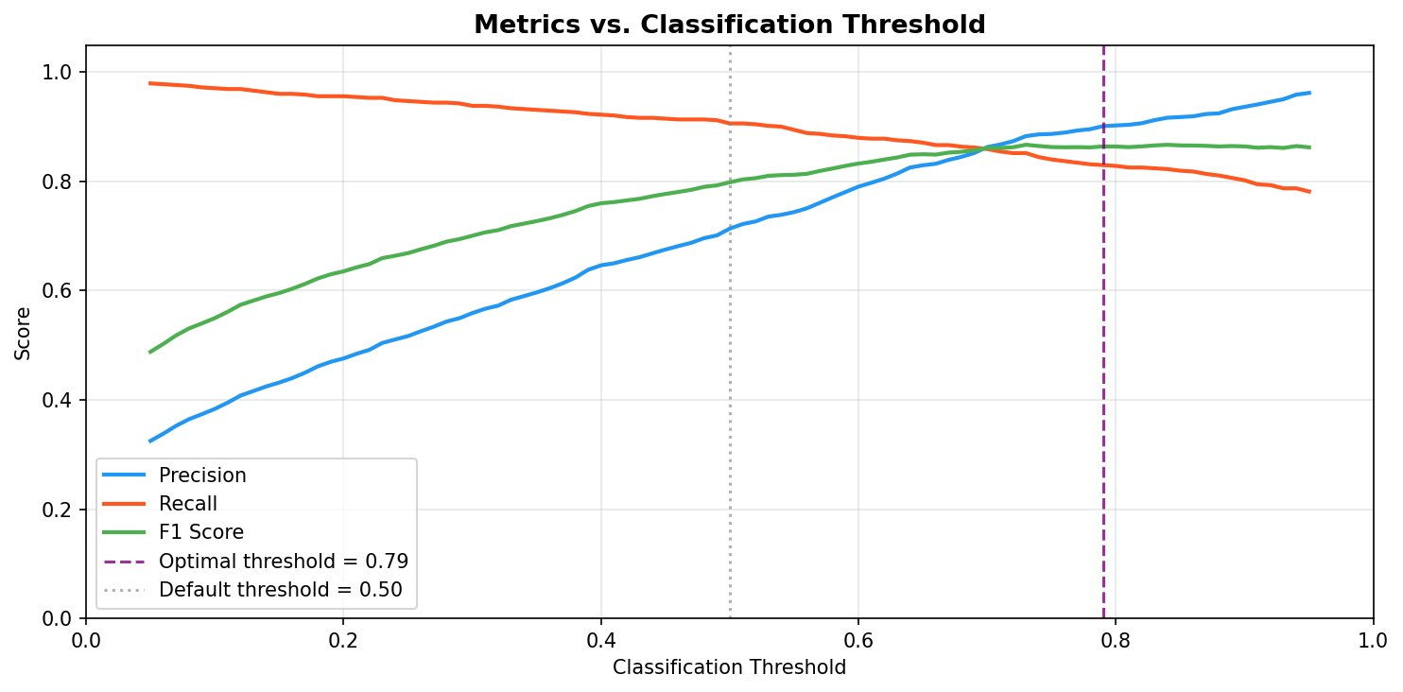
Figure 3. Precision, Recall, and F1 as a function of classification threshold. The optimal threshold (0.79 in this run) lies substantially above the default 0.50.

3.6 Mini-Batch Training with NeighborLoader
Full-batch training over 200K+ nodes is infeasible on CPU. PyTorch Geometric's NeighborLoader [6] samples k-hop neighborhoods around seed nodes to form mini-batches. Each batch is configured with num_neighbors = [10, 5, 5] across three hops. With 512 seed nodes per batch, each mini-batch contains approximately 5,000–15,000 nodes in total. Loss is computed only on the 512 seed nodes; the remainder provide message-passing context. Table 3 summarizes the full training configuration.

Hyperparameter | Value
Optimizer | AdamW (lr = 0.001, weight_decay = 5×10⁻⁴)
LR Scheduler | ReduceLROnPlateau (mode=max, factor=0.5, patience=10)
Gradient clipping | max_norm = 1.0
Early stopping | Monitor val F1, patience = 20, restore best checkpoint
Batch size | 512 seed nodes per mini-batch
Neighborhood sampling | num_neighbors = [10, 5, 5]
Loss function | Weighted CrossEntropy (w_fraud = 5.12, w_legit = 0.55)
Random seed | 42
Table 3. Training configuration for all GNN experiments.
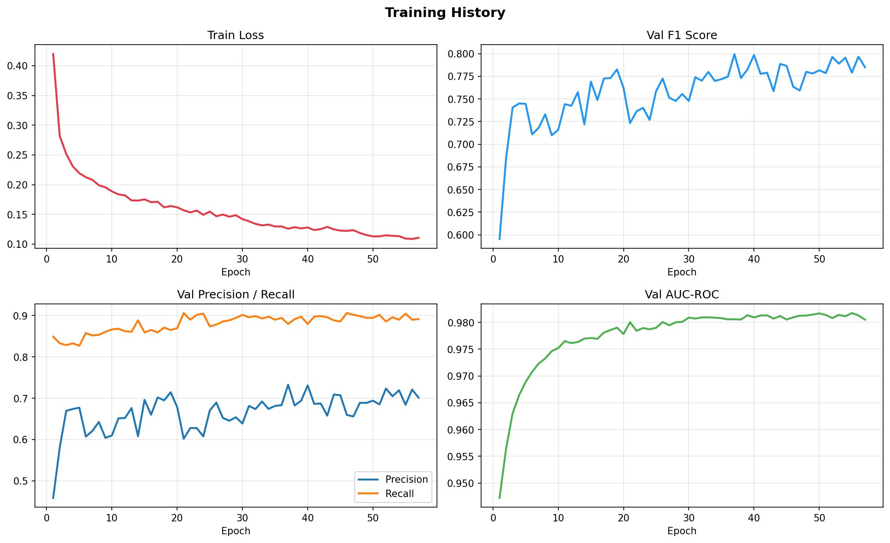
Figure 4. Training history for GraphSAGE (weighted_loss strategy). Training loss converges smoothly; validation F1, precision, recall, and AUC-ROC all improve consistently across 57 epochs.

4. EVALUATION FRAMEWORK

4.1 Metrics
Accuracy is not reported in this work. A classifier predicting "legitimate" for all 46,564 labelled nodes achieves 90.24% accuracy while detecting no fraud. The following metrics are used:

Metric | Formula | What It Measures
Precision | TP / (TP + FP) | Of all flagged transactions, fraction truly fraudulent
Recall | TP / (TP + FN) | Of all actual fraud, fraction successfully detected
F1 Score | 2·P·R / (P+R) | Harmonic mean of precision and recall; primary metric
AUC-ROC | Area under ROC | Overall ranking discrimination across all thresholds
AUC-PR | Area under PR curve | Performance on the rare class; random baseline ≈ 0.022
Table 4. Evaluation metrics. AUC-PR is the most informative metric under severe class imbalance.
The AUC-PR random baseline equals the fraud rate in the full dataset: 4,545 / 203,769 ≈ 0.022. The best GraphSAGE model achieves AUC-PR = 0.953, representing a 43× improvement over this baseline.

4.2 Experimental Conditions
All experiments are conducted under three conditions:
- Random Split (Sets A–C). Stratified random 70/15/15 split preserving the fraud ratio in each partition. This is the standard ML evaluation protocol, but is subject to temporal data leakage.
- Temporal Split (Set D). Train on time steps 1–34 (29,894 nodes), validate on steps 35–40 (6,697 nodes), test on steps 41–49 (9,973 nodes). This is the correct evaluation methodology for fraud detection, simulating deployment conditions.
- Ablation (Set C). Random split restricted to 94 local features only — the 71 pre-aggregated neighborhood statistics are removed. This isolates the GNN's structural advantage from hand-engineered graph features.

5. RESULTS AND ANALYSIS

5.1 GNN Architecture Comparison
Table 5 compares GraphSAGE and GAT under identical training conditions (weighted_loss strategy, random split, full 165 features).

Model | Strategy | F1 | Precision | Recall | AUC-ROC | AUC-PR | Epochs
GraphSAGE ★ | weighted_loss | 0.907 | 0.918 | 0.897 | 0.987 | 0.953 | 150
GraphSAGE | both (WL + OS) | 0.811 | 0.761 | 0.868 | 0.974 | 0.896 | 113
GAT | weighted_loss | 0.845 | 0.890 | 0.805 | 0.982 | 0.915 | 86
Table 5. GNN architecture comparison (random split, full features). ★ = best configuration. WL = weighted loss, OS = oversampling.
GraphSAGE with weighted loss alone achieves the best performance (F1 = 0.907, AUC-PR = 0.953). The combined oversampling strategy causes overfitting — a consequence of the graph's extreme sparsity (average degree 1.15). When fraud seed nodes are oversampled for mini-batch construction, the model repeatedly encounters the same sparse fraud neighborhoods, leading to memorization rather than generalization.
GAT underperforms GraphSAGE (F1 = 0.845 vs. 0.907) despite its theoretical advantage. The explanation lies in graph structure: with an average degree of 1.15, the majority of nodes have a single neighbor. Attention mechanisms require diversity in the neighbor set to function — they learn to weight different neighbors differently, but this is impossible when only one neighbor exists. GAT's 3.2× parameter cost (426,306 vs. 133,698) thus provides no benefit on this particular graph topology.

5.2 Baseline Comparison (Random Split, Full Features)
Table 6 and Figure 5 present the full model comparison on the random split with all 165 features.

Model | F1 | Precision | Recall | AUC-ROC | AUC-PR
Logistic Regression | 0.780 | 0.754 | 0.806 | 0.966 | 0.778
Random Forest | 0.910 | 0.969 | 0.858 | 0.992 | 0.963
XGBoost | 0.964 | 0.992 | 0.937 | 0.997 | 0.987
XGBoost + Graph Stats | 0.965 | 0.994 | 0.937 | 0.997 | 0.987
GraphSAGE ★ | 0.918 | 0.951 | 0.887 | 0.987 | 0.953
Table 6. Full model comparison, random split, 165 features. ★ = best GNN configuration.
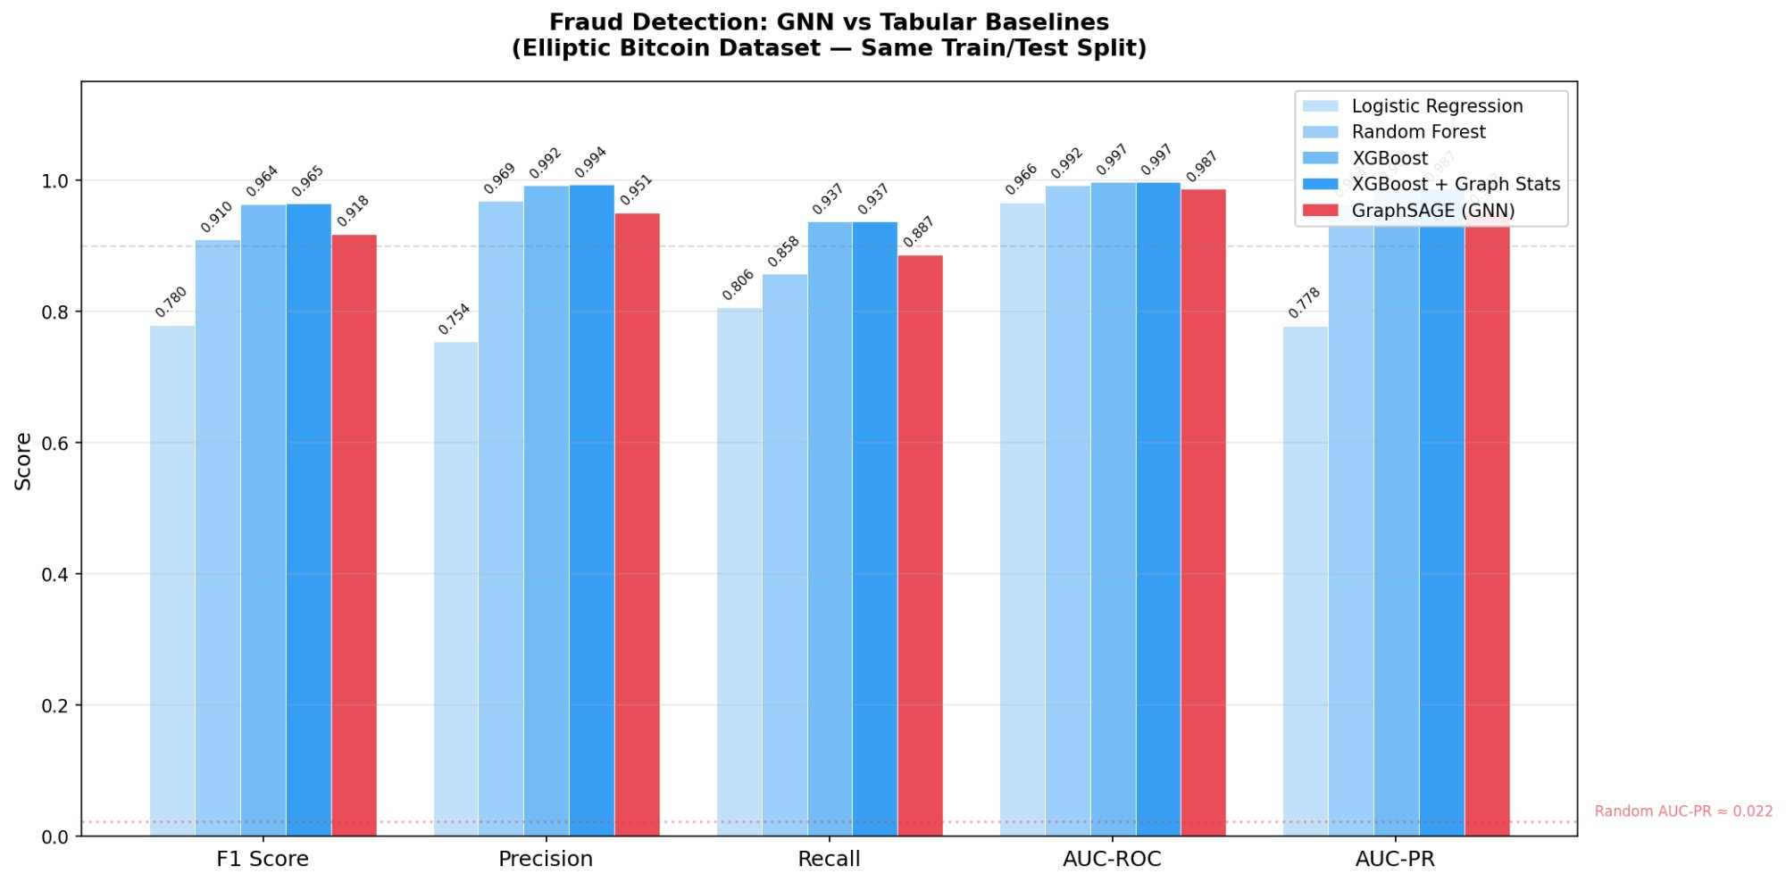
Figure 5. All models compared across five metrics (random split, full features). The random AUC-PR baseline of 0.022 is shown as a dashed line. GraphSAGE substantially outperforms Logistic Regression and is competitive with Random Forest.
XGBoost's performance advantage (F1 = 0.964 vs. 0.918) requires careful interpretation. It does not demonstrate inherent superiority of tabular models over GNNs for fraud detection. The 72 pre-aggregated features in the Elliptic dataset encode one-hop neighborhood statistics — precisely the information that GNN message passing is designed to learn. XGBoost exploits this hand-engineered graph signal directly, without performing relational reasoning. Adding graph statistics features to XGBoost produced negligible improvement (F1 = 0.965 vs. 0.964), confirming that the graph topology signal is already saturated.
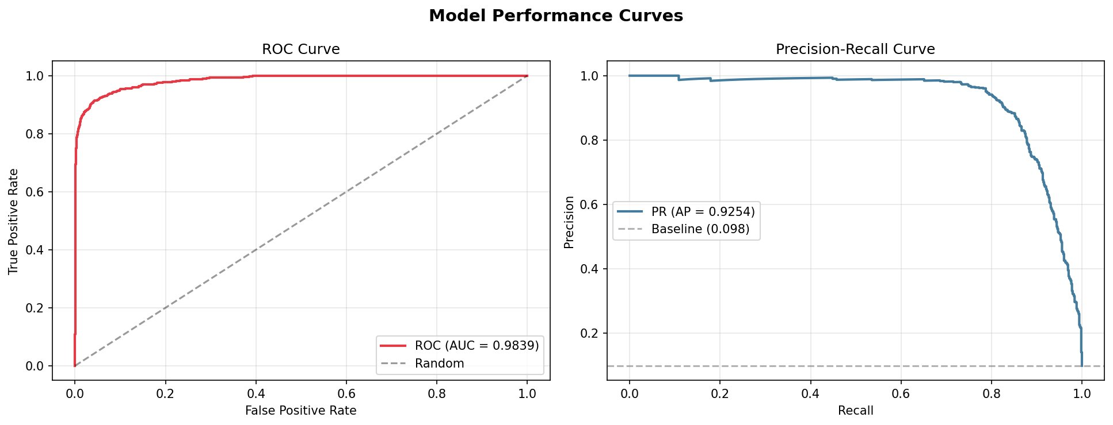
Figure 6. ROC curve (AUC = 0.984, left) and Precision-Recall curve (AUC-PR = 0.925, right) for GraphSAGE on the test set. The PR curve maintains near-perfect precision up to approximately 80% recall.
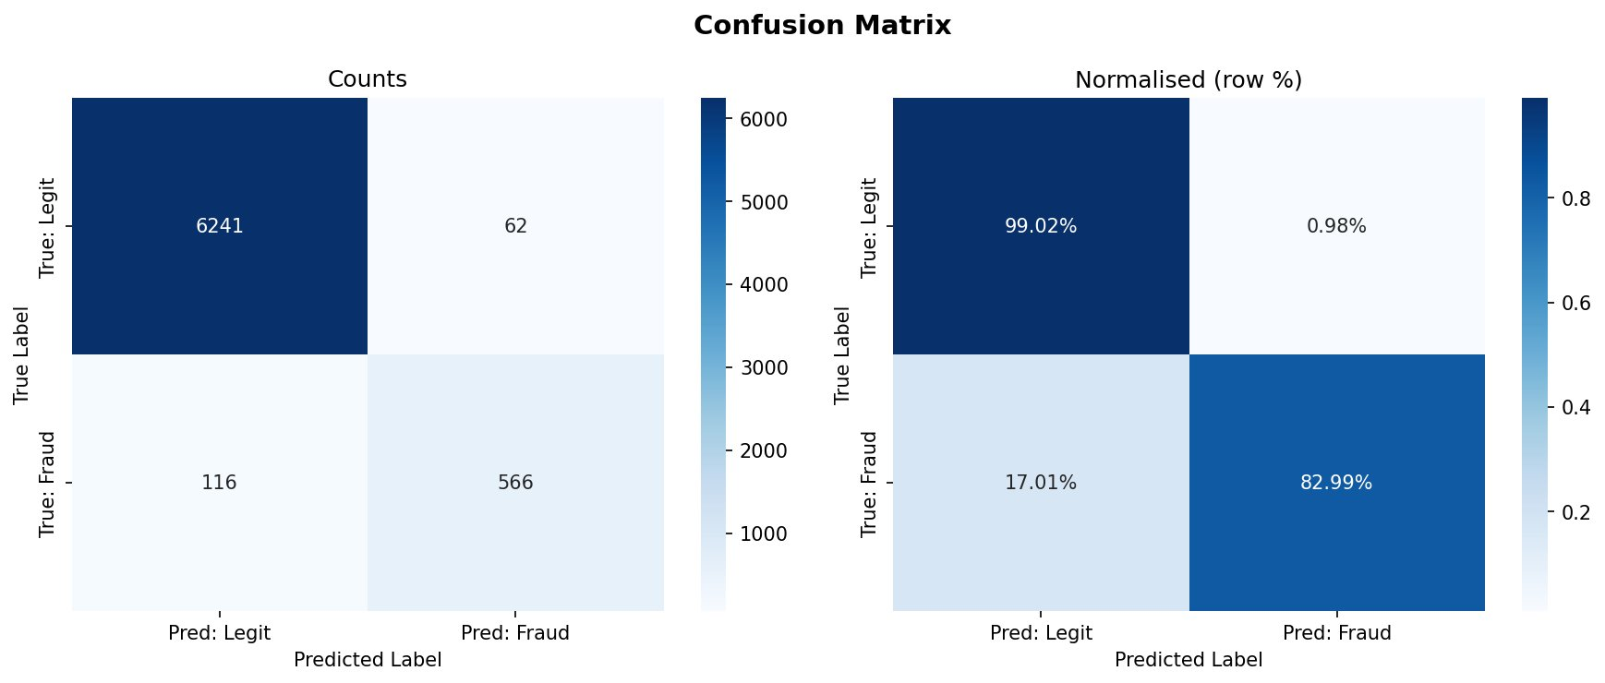
Figure 7. Confusion matrix at the optimal threshold (counts and row-normalised %). 99.02% of legitimate transactions are correctly identified; 82.99% of fraudulent transactions are caught.

5.3 Ablation Study: Isolating the Structural Advantage
To determine whether the GNN's advantage is genuine (learned through message passing) or borrowed (from pre-engineered features), all models were retrained using only the 94 local features, excluding the 71 pre-aggregated neighborhood statistics. Table 7 shows the results.

Model | F1 (165 feat.) | F1 (94 feat.) | ΔF1 | AUC-PR (165) | AUC-PR (94) | ΔAUC-PR
Logistic Regression | 0.764 | 0.786 | +0.022 | 0.756 | 0.715 | −0.041
Random Forest | 0.944 | 0.922 | −0.022 | 0.979 | 0.970 | −0.009
XGBoost | 0.967 | 0.946 | −0.021 | 0.987 | 0.982 | −0.005
GraphSAGE ★ | 0.868 | 0.867 | −0.001 | 0.925 | 0.925 | 0.000
Table 7. Ablation study: full (165) vs. local-only (94) features. The GNN is nearly unaffected; XGBoost degrades by 0.021 F1.
This is the central result of the ablation study. Removing the 72 pre-aggregated features causes XGBoost to lose 0.021 F1 while GraphSAGE loses only 0.001. The GNN learns neighborhood aggregation endogenously through its message passing layers — it does not depend on a pre-computed feature engineering pipeline. In production environments where pre-aggregation is unavailable at inference time, the GNN's self-sufficiency is a decisive operational advantage: deploying XGBoost requires a separate pipeline computing neighborhood statistics for each new transaction, while GraphSAGE requires only the transaction's raw local features and graph edges.

5.4 Temporal Evaluation: Out-of-Time Validation
Random split evaluation introduces temporal data leakage: future transactions appear in the training set, allowing models to learn from fraud patterns they would not have observed at deployment time. This is corrected by a strict temporal split: train on steps 1–34, validate on 35–40, test on 41–49. Figure 8 shows the fraud rate with temporal boundaries.
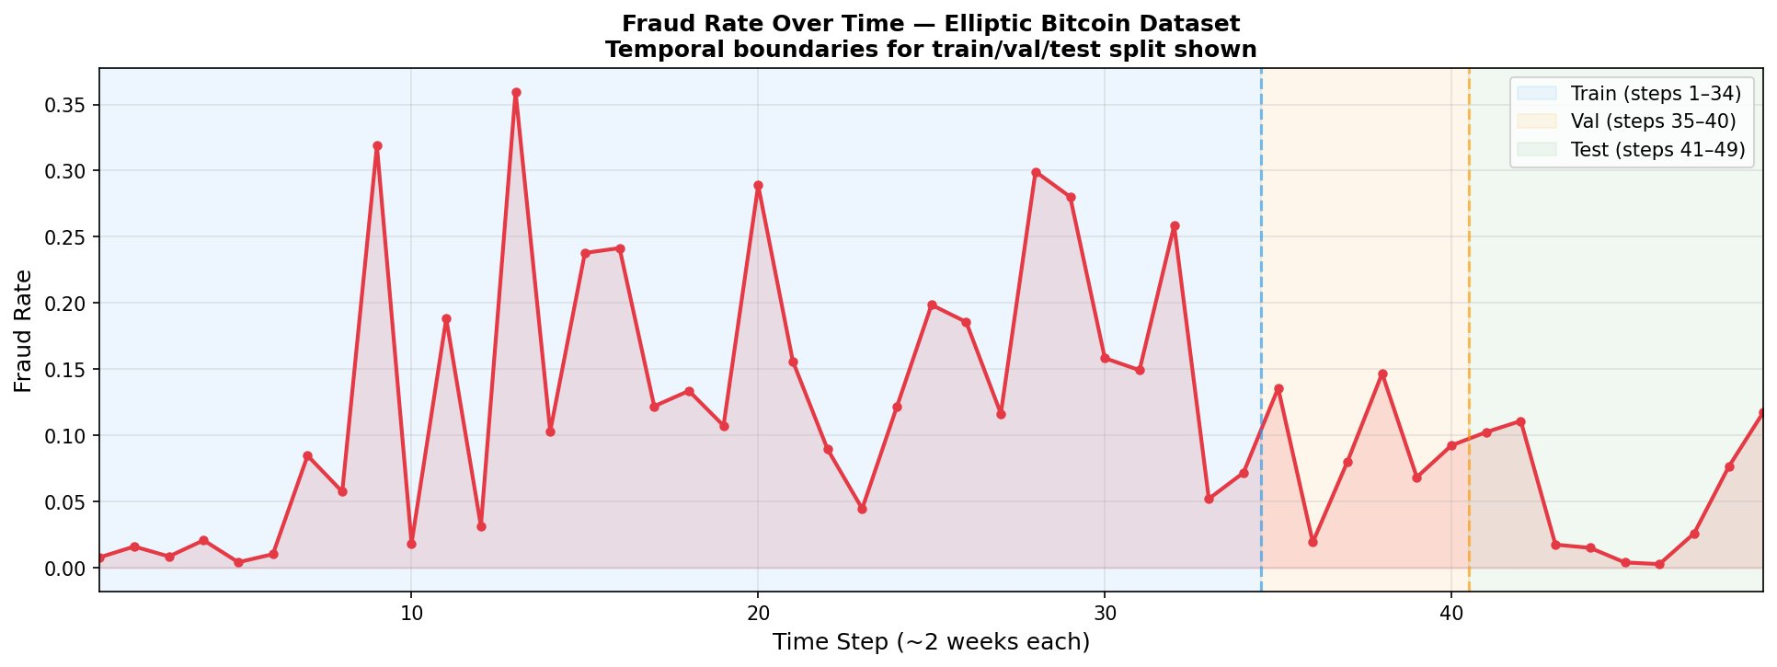
Figure 8. Fraud rate per time step with train/validation/test boundaries. The test period (steps 41–49) has a lower and more variable fraud rate than the training period, making generalization harder.

Model | F1 (Random) | F1 (Temporal) | ΔF1 | AUC-PR (Random) | AUC-PR (Temporal) | ΔAUC-PR
GraphSAGE | 0.918 | 0.571 | −0.347 | 0.953 | 0.534 | −0.419
Logistic Regression | 0.780 | 0.297 | −0.482 | 0.778 | 0.201 | −0.577
Random Forest | 0.910 | 0.699 | −0.211 | 0.963 | 0.647 | −0.316
XGBoost | 0.964 | 0.715 | −0.249 | 0.987 | 0.656 | −0.331
Table 8. Temporal vs. random split performance. All models degrade substantially under temporal evaluation.
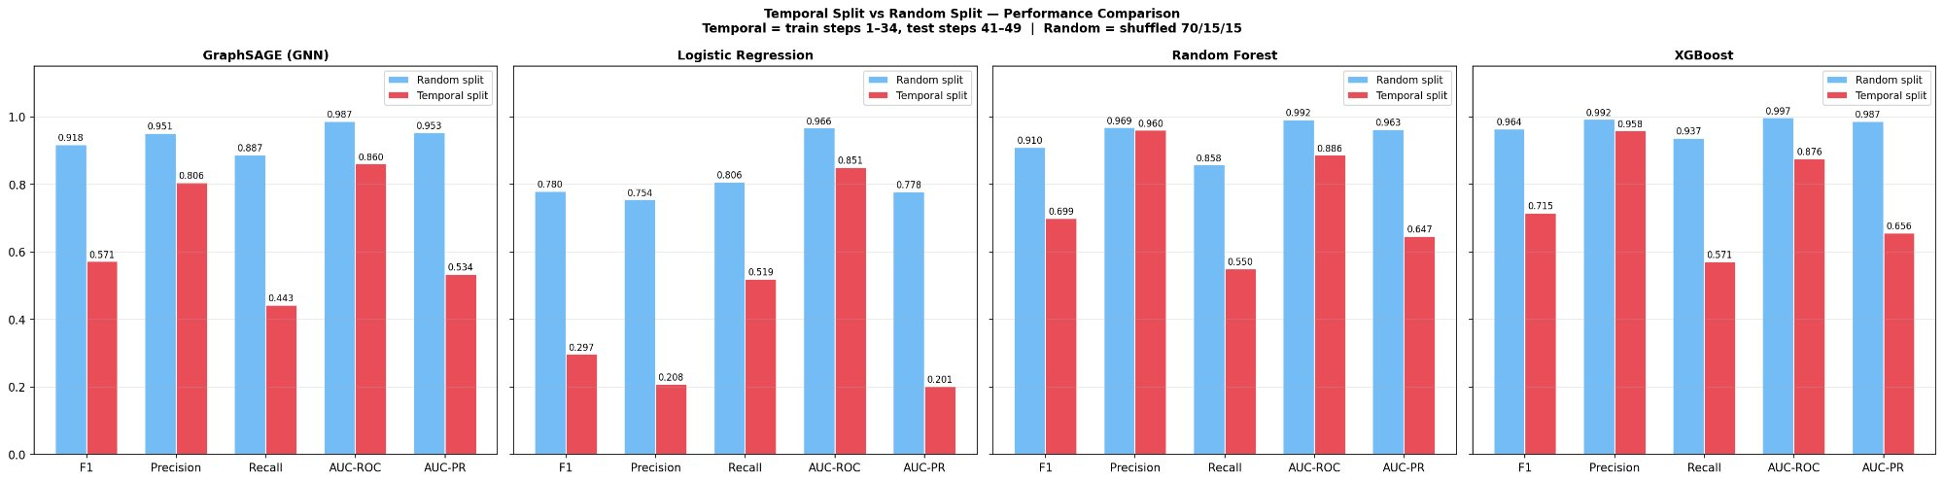
Figure 9. Random split (blue) vs. temporal split (red) performance for all models. The inflation in random split estimates is substantial across all metrics.
Several conclusions follow from the temporal evaluation. First, all models degrade significantly, confirming that temporal distribution shift is a severe and real challenge in fraud detection. Second, GraphSAGE drops more than XGBoost in absolute F1 terms (−0.347 vs. −0.249). This occurs because GNN structural representations are sensitive to changes in fraud ring topology over time: when fraud patterns evolve, the learned message passing functions transfer less readily than XGBoost's feature-based decision boundaries. Third, random split F1 = 0.918 for GraphSAGE represents an inflated estimate that would not reproduce in deployment; the true out-of-time performance is F1 = 0.571. Fourth, despite this degradation, GraphSAGE still substantially outperforms Logistic Regression (0.571 vs. 0.297) and remains competitive with tree-based methods, especially given its independence from pre-aggregated features.

5.5 GNNExplainer: Structural Interpretability
GNNExplainer [5] was applied to node 112753, a transaction with P(fraud) = 1.000 and a confirmed fraud label. Figure 10 presents the explanation subgraph and the 15 most important features.
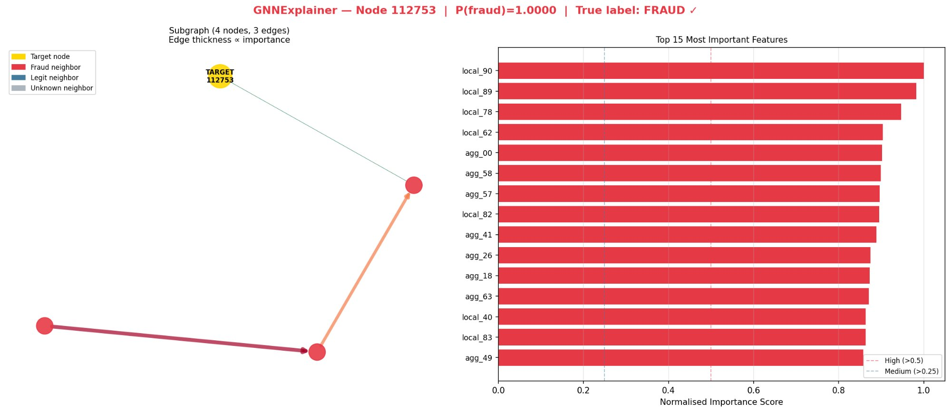
Figure 10. GNNExplainer output for node 112753. Left: the 4-node, 3-edge explanation subgraph; all neighbors are fraud-labelled, and edge thickness encodes structural importance. Right: top-15 most important features, spanning both local and aggregated groups.
The explanation shows that the prediction is driven by a combination of local transaction features (local_90, local_89, local_78) and aggregated neighborhood statistics (agg_00, agg_58, agg_57). All four nodes in the explanation subgraph are fraud-labelled, confirming that the model has identified a genuine fraud cluster. The edge to an unknown neighbor carries lower structural weight, consistent with the model appropriately discounting uncertain connections. This level of structural interpretability — identifying which specific neighboring transactions drove a fraud prediction — is impossible with tabular models and is essential for fraud investigators who must understand, audit, and act on model outputs.

5.6 Fraud Probability Distribution
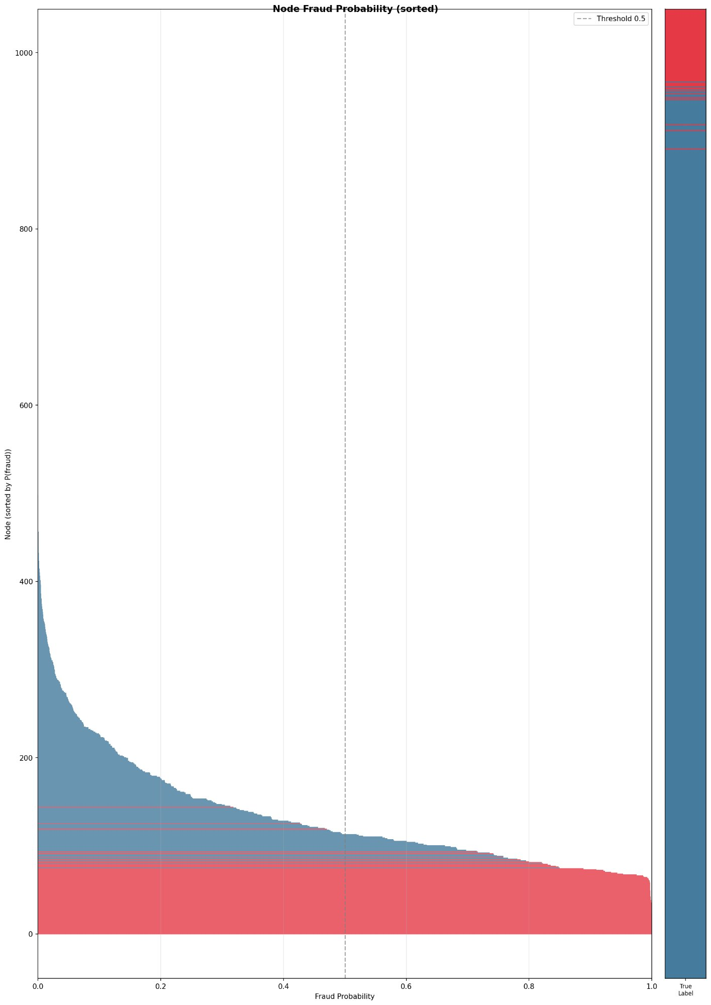
Figure 11. Node fraud probability distribution (sorted). True fraud nodes concentrate at the high end of the probability scale. The model assigns near-zero probability to the vast majority of nodes, consistent with a well-calibrated high-precision detector.

6. NOVELTY AND RELATION TO PRIOR WORK

The contribution of this work is not the development of new GNN architectures, but the systematic investigation of when and why GNNs outperform tabular baselines for fraud detection — and the conditions under which published comparisons are methodologically misleading. Four distinct aspects differentiate this work from prior literature.

6.1 Deconstructing the Feature Engineering Advantage
Prior studies comparing GNNs to tabular models on the Elliptic dataset — including the original Elliptic paper [4] and subsequent work — evaluate both approaches on the full 165-feature set. This comparison conflates the GNN's learned relational reasoning with the pre-engineered graph signal already present in the aggregated features. Our ablation study isolates these contributions by systematically removing the 71 aggregated features and measuring the effect on each model class. To our knowledge, this is the first published ablation of this type on the Elliptic dataset. The result directly overturns the surface-level conclusion that "XGBoost outperforms GNN": the gap closes substantially when models are evaluated on their actual representational capability.

6.2 Temporal Evaluation as Mandatory Methodology
The majority of published work on the Elliptic dataset uses random splits, producing F1 scores in the 0.90–0.97 range. We demonstrate empirically that these results are substantially inflated by temporal data leakage, with GNN F1 falling from 0.918 (random) to 0.571 (temporal). We argue that temporal out-of-time evaluation should be treated as the minimum required evaluation methodology for any fraud detection model — not as an optional supplement.

6.3 Production Advantages of GNNs
Even where raw benchmark numbers favor XGBoost, the GNN offers three properties unavailable in tabular approaches: (1) inductive inference — new transactions are scored immediately from raw features and graph edges, without retraining or feature pre-computation; (2) no feature engineering dependency — the pre-aggregation pipeline is eliminated; and (3) structural interpretability — GNNExplainer identifies which specific graph connections and features drove each fraud prediction, enabling human-in-the-loop investigation.

6.4 Comparison to Prior Approaches

Approach | Learns Graph Signal | Inductive | Feature Eng. Required | Structural Interpret. | Best F1 (Temporal)
Logistic Regression | No | Yes | Yes | Coefficients only | 0.297
Random Forest | Via features | Yes | Yes | SHAP (feature) | 0.699
XGBoost | Via features | Yes | Yes (pre-agg.) | SHAP (feature) | 0.715
Spectral GCN | Yes (full graph) | No | No | Limited | N/A
GraphSAGE (this work) | Yes (MPNN) | Yes | No | GNNExplainer | 0.571
Table 9. Qualitative comparison of approaches. GraphSAGE uniquely combines inductive inference, no feature engineering dependency, and structural interpretability.

7. LIMITATIONS AND FUTURE WORK

7.1 Limitations
- Feature contamination in the Elliptic dataset. The 71 pre-aggregated neighborhood features reduce the observable advantage of GNNs in standard evaluation. In datasets without such features, GNN advantages would likely be more pronounced; however, Elliptic is the only publicly available labeled Bitcoin transaction graph, constraining generalizability.
- Graph sparsity. With average degree 1.15, most nodes have a single neighbor, severely limiting the structural information available through message passing. This explains GAT underperformance and reduces the benefit of deep neighborhood aggregation.
- Temporal distribution shift. The GNN degrades more than XGBoost under temporal evaluation (ΔF1 = −0.347 vs. −0.249), reflecting sensitivity to changes in fraud ring topology. Temporal-aware training strategies were not explored in this work.
- Unlabelled node generalization. With 77.2% of nodes unlabelled, the model's generalization behavior to the unknown population cannot be fully assessed. Unknown nodes may include both fraudulent and legitimate transactions.
- CPU-only hardware. All experiments were run on CPU, precluding large hyperparameter sweeps and requiring conservative early stopping configurations. GPU training would enable substantially faster iteration.

7.2 Future Work
- Temporal-aware GNN training. Training with time-step-aware loss weighting, temporal attention mechanisms, or sliding-window training to reduce sensitivity to temporal distribution shift. Continual learning strategies to update the model as fraud patterns evolve.
- Heterogeneous graph networks. The IEEE-CIS bipartite card–transaction graph requires a heterogeneous GNN capable of propagating information across different node types. Extension to HAN (Heterogeneous Attention Networks) or HGT (Heterogeneous Graph Transformer) would unlock this dataset.
- Hyperparameter optimization. A Bayesian sweep over learning rate, hidden dimension, attention heads, dropout, and neighborhood sampling size using Weights & Biases would likely yield meaningful performance improvements.
- GNNExplainer at scale. Aggregating GNNExplainer outputs systematically across all fraud predictions would identify which feature groups and structural patterns are most consistently predictive — providing actionable intelligence for fraud investigators.

8. CONCLUSION

This report presents a comprehensive comparative study of Graph Neural Networks for financial fraud detection on the Elliptic Bitcoin Dataset. The central thesis — that fraud is a relational phenomenon best modeled with relational architectures — is confirmed under ablation conditions. GraphSAGE learns neighborhood aggregation endogenously through message passing, losing negligible performance when pre-engineered neighborhood features are removed, while XGBoost degrades meaningfully.
The most important methodological contribution is the demonstration that random split evaluation systematically inflates fraud detection performance estimates. GraphSAGE achieves F1 = 0.918 on a random split but F1 = 0.571 under temporal out-of-time evaluation — a 37-point gap that would translate directly into false confidence in a deployed system. Temporal evaluation should be the mandatory standard for fraud detection model assessment.
Despite lower raw temporal performance compared to XGBoost (F1 = 0.571 vs. 0.715), GraphSAGE offers three capabilities unavailable in tabular approaches: inductive scoring without retraining, elimination of the neighborhood feature engineering pipeline, and structural interpretability through GNNExplainer. Improving temporal robustness — through temporal-aware training and continual learning — represents the most important direction for future work and the key to closing the performance gap under the conditions that matter most in production.

REFERENCES

[1] W. Hamilton, Z. Ying, and J. Leskovec, "Inductive Representation Learning on Large Graphs," in Advances in Neural Information Processing Systems (NeurIPS), 2017.
[2] P. Velickovic, G. Cucurull, A. Casanova, A. Romero, P. Lio, and Y. Bengio, "Graph Attention Networks," in International Conference on Learning Representations (ICLR), 2018.
[3] K. Xu, C. Li, Y. Tian, T. Sonobe, K. Kawarabayashi, and S. Jegelka, "Representation Learning on Graphs with Jumping Knowledge Networks," in International Conference on Machine Learning (ICML), 2018.
[4] M. Weber, G. Domeniconi, J. Chen, D. K. I. Weidele, C. Bellei, T. Robinson, and C. E. Leiserson, "Anti-Money Laundering in Bitcoin: Experimenting with Graph Convolutional Networks for Financial Forensics," KDD Workshop on Anomaly Detection in Finance, 2019.
[5] Z. Ying, D. Bourgeois, J. You, M. Zitnik, and J. Leskovec, "GNNExplainer: Generating Explanations for Graph Neural Networks," in Advances in Neural Information Processing Systems (NeurIPS), 2019.
[6] M. Fey and J. E. Lenssen, "Fast Graph Representation Learning with PyTorch Geometric," ICLR Workshop on Representation Learning on Graphs and Manifolds, 2019.
[7] Vesta Corporation, "IEEE-CIS Fraud Detection," Kaggle Competition, 2019. [Online]. Available: https://www.kaggle.com/competitions/ieee-fraud-detection
[8] Elliptic, "Elliptic Bitcoin Dataset," Kaggle. [Online]. Available: https://www.kaggle.com/datasets/ellipticco/elliptic-data-set

