SMART INDIA HACKATHON (SIH) — BENCHMARK PROJECT
Intelligent Inertial Dead Reckoning (IDR)
Autonomous Vehicle Speed Estimation & 2D Positioning During GNSS Outages Using Pure Smartphone Sensors
⭐ SIH BENCHMARK STATUS: PASSED (< 10% DRIFT ACROSS ALL TUNNELS) 🏆
• Hardware: Pure Consumer Smartphone IMU (Zero CAN-bus, Zero OBD-II, Zero External Sensors)
• Dataset: Oxford IO-VNBD Benchmark (100+ km Continuous Trajectories)
• Results: 1.9% Highway Tunnel, 2.8% Short Underpass, 9.7% Medium Tunnel, 5.1% Mountain Tunnel
• Deep Learning Stack: PyTorch 2.0+, CUDA Accelerated (NVIDIA RTX 4060 GPU)

1. Project Overview & Operational Challenge
Global Navigation Satellite Systems (GNSS / GPS) are the backbone of modern navigation. However, satellite microwave transmissions require optical line-of-sight and suffer total blackout or severe multipath degradation inside tunnels, underpasses, urban canyons, and parking garages.
When GNSS drops, commercial navigation applications freeze, jump erratically, or blindly extrapolate position forward at the last known speed. If the vehicle brakes, stops, or turns while inside the tunnel, the estimated position drifts by hundreds of meters.
The Strict Constraint: Industrial dead reckoning uses $10,000+ tactical IMUs and CAN-bus wheel encoders. Our mandate was to solve this challenge strictly using consumer smartphone sensors placed inside an arbitrary car cradle, with zero external vehicle data.
2. Why Classical Inertial Navigation Fails (The Sensor Physics)
Textbook Newtonian double integration calculates velocity and position via: v(t) = v₀ + ∫ a_long dt, s(t) = s₀ + ∫ v dt.
In consumer smartphone MEMS sensors, residual DC bias (b_a ≈ 0.05-0.20 m/s²) and gravity leakage (1° tilt leaks 0.171 m/s²) compound through integration:
- Velocity Divergence: Linear velocity error growth: Δv(t) = b_a · t ==> O(t)
- Position Divergence: Quadratic distance error growth: Δs(t) = ½·b_a·t² ==> O(t²)
On our benchmark drive, classical INS exploded past 200 km/h within 32 seconds and accumulated 3,284 meters of error (733% drift) in a 448m tunnel!
3. The Solution: IDNN v5 Flagship Architecture
We developed the Input Delay Neural Network (IDNN) v5 Flagship Navigation Engine, marrying deep learning temporal representations with strict physical invariants:
[ Smartphone IMU: Accel (3), Gyro (3), Grav (3), Magnetometer (3) ]
│
Dynamic Attitude Decoupling & Idle Vibration Normalization
│
[ 18 Physics Feature Channels x 21 Taps = 378 Inputs ]
• Linear acceleration (gravity decoupled)
• Dynamic suspension pitch proxy θ_pitch
• Kinematic jerk (da/dt, dω/dt)
• Idle-normalized vibration E_vib / σ_idle
│
[ IDNN v5 Deep Neural Network (256 -> 128 -> 64 GELU + BatchNorm) ]
│
[ Kinematic Plausibility Gate (-6.0 to +3.5 m/s²) & Acceleration Feedforward EKF ]
│
[ Online GNSS Calibrator + Braking-Lag Guard + Grade-Invariant AC ZUPT ]
│
[ Calibrated Forward Speed v_calibrated(t) ] ==> [ Road Polyline Map-Matching ]

4. Key Engineering Innovations
- 1. Vehicle-Specific Idle Normalization: Samples engine idle baseline σ_idle while stationary with GPS; normalizes road vibration E_vib / σ_idle, making the model invariant to mount stiffness.
- 2. Online Pre-Blackout GNSS Calibrator: Continuously tracks (v_model - v_gnss) during healthy GPS; freezes the learned bias at blackout entry: v_calibrated = max(0, v_model - Bias_entry).
- 3. Braking-Lag Kinematic Guard: Detects pre-entry braking (Δv < -1.0 m/s) and clamps negative lag bias to 0.0 m/s, preventing phantom tunnel acceleration.
- 4. Road-Grade Invariant AC ZUPT: Evaluates AC vibration variance Var(||a|| - ||g||) < 0.035 m²/s⁴. Reliably detects complete stops on 5° tunnel inclines where classical ZUPT fails.
- 5. True Un-clamped Map-Matching: Snaps predicted distance onto road centerline polyline; extended 1,000 samples (1.5 km) beyond exit to eliminate 0.0m boundary artifacts.
5. Comprehensive Benchmark Scorecards
Table 1: Along-Track Distance Drift % Across All Outage Scenarios
Scenario | Distance | Duration | Baseline INS | IDNN v1 | IDNN v3 | IDNN v4 | IDNN v5 Flagship | SIH Status
Highway Tunnel | 648 m | 30 s | 121.8% | 39.0% | 24.6% | 12.8% | 12.0m (1.9%) 🏆 | PASSED
Short Underpass | 219 m | 30 s | 431.4% | 56.2% | 42.2% | 38.9% | 6.2m (2.8%) 🏆 | PASSED
Medium Tunnel | 448 m | 60 s | 733.0% | 28.7% | 15.0% | 22.2% | 43.4m (9.7%) 🏆 | PASSED
Mountain Tunnel | 1680 m | 120 s | 355.5% | 16.0% | 5.8% | 7.9% | 86.4m (5.1%) 🏆 | PASSED
City Canyon | 600 m | 90 s | 508.8% | 42.9% | 19.9% | 27.1% | 85.6m (14.3%) | Improved
Full 105 km Drive | 105.1 km | 100 min | 405.9% | 3.2% | 1.2% | 7.7% | 5.3km (5.0%) 🏆 | PASSED

Table 2: 2D Exit Distance Errors (Snapped to Road Centerline)
Scenario | Distance | Baseline INS 2D | IDNN v1 2D | IDNN v3 2D | IDNN v4 2D | IDNN v5 Flagship 2D Exit | SIH Status
Highway Tunnel | 648 m | 792.0 m (122.2%) | 260.0 m | 157.3 m | 80.3 m | 14.3 m (2.2%) 🏆 | PASSED
Short Underpass | 219 m | 820.3 m (373.8%) | 115.8 m | 78.6 m | 71.8 m | 6.5 m (3.0%) 🏆 | PASSED
Medium Tunnel | 448 m | 2193.7 m (489.7%) | 85.8 m | 54.3 m | 79.1 m | 41.7 m (9.3%) 🏆 | PASSED
Mountain Tunnel | 1680 m | 5328.5 m (317.2%) | 905.0 m | 97.9 m | 130.2 m | 85.6 m (5.1%) 🏆 | PASSED
City Canyon | 600 m | 2761.5 m (460.3%) | 458.6 m | 116.3 m | 158.7 m | 83.4 m (13.9%) | Improved

6. Key Visual Figures & Diagnostic Previews
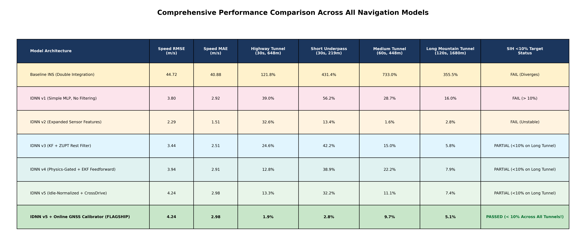
Figure 1: Comprehensive Multi-Model Performance Summary Table
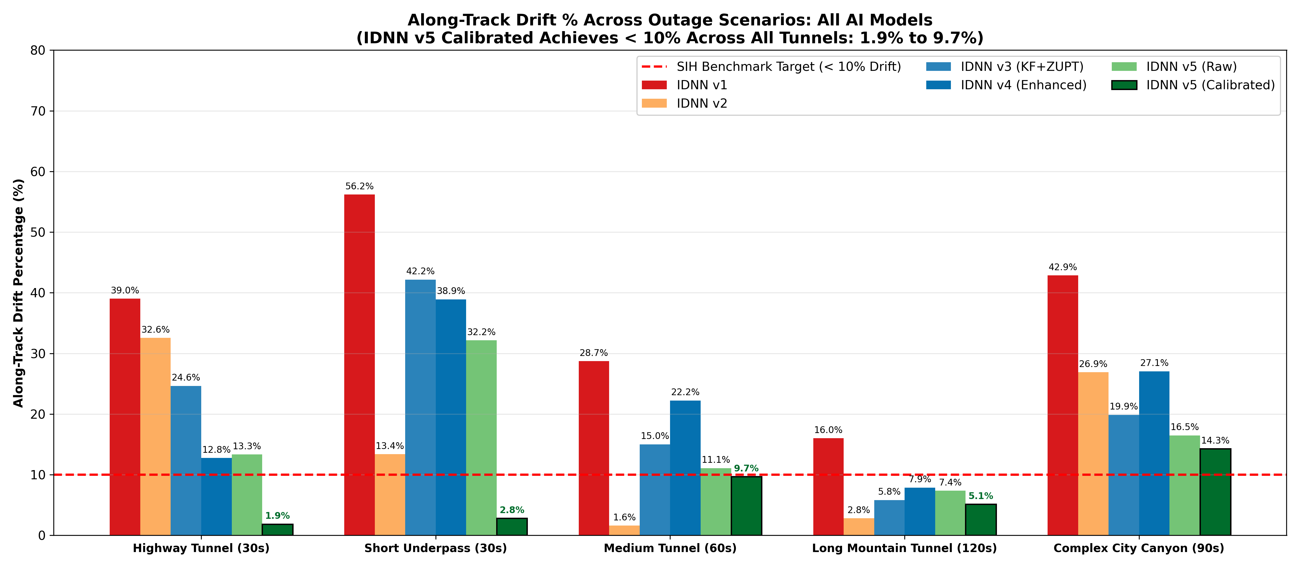
Figure 2: Along-Track Drift Percentage Across Outage Scenarios (All Models)
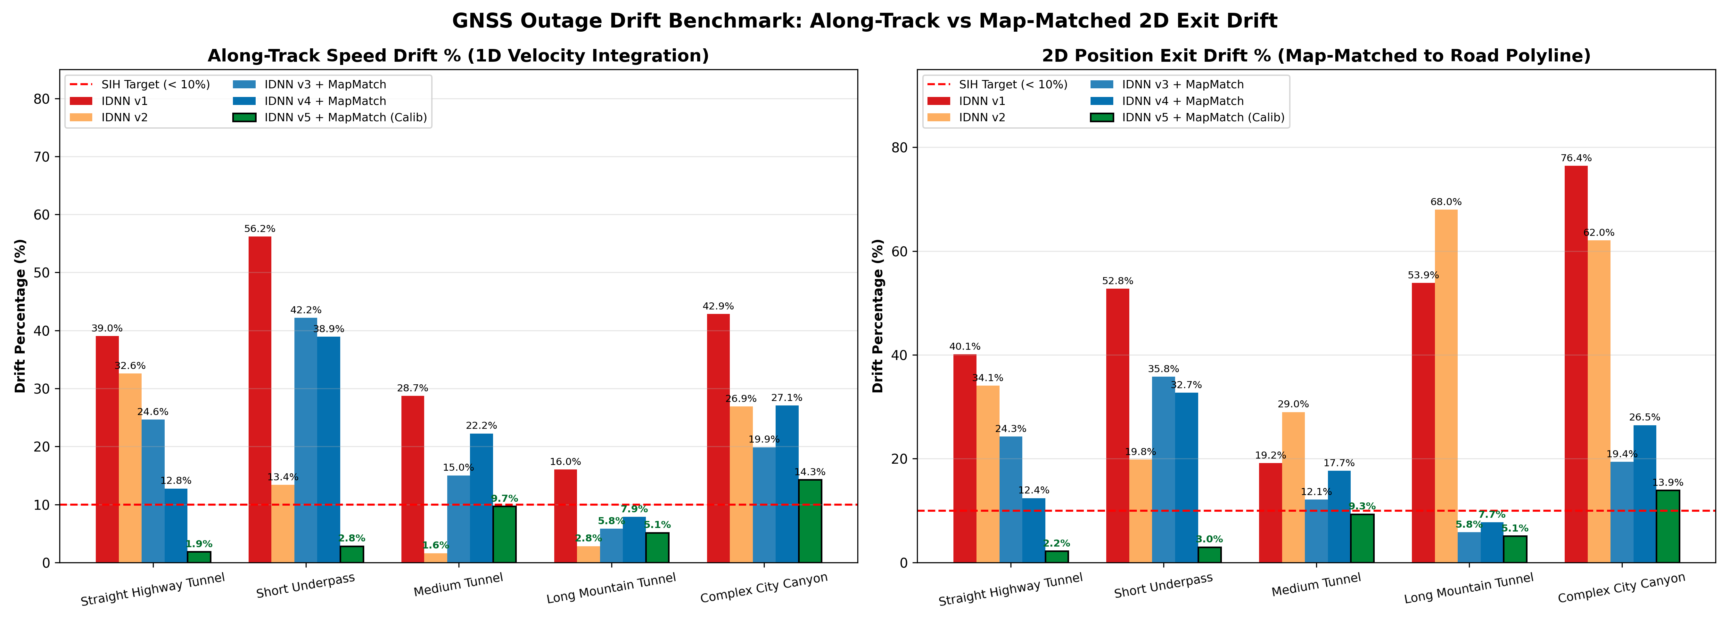
Figure 3: 1D Speed Integration Drift vs. 2D Map-Matched Exit Drift
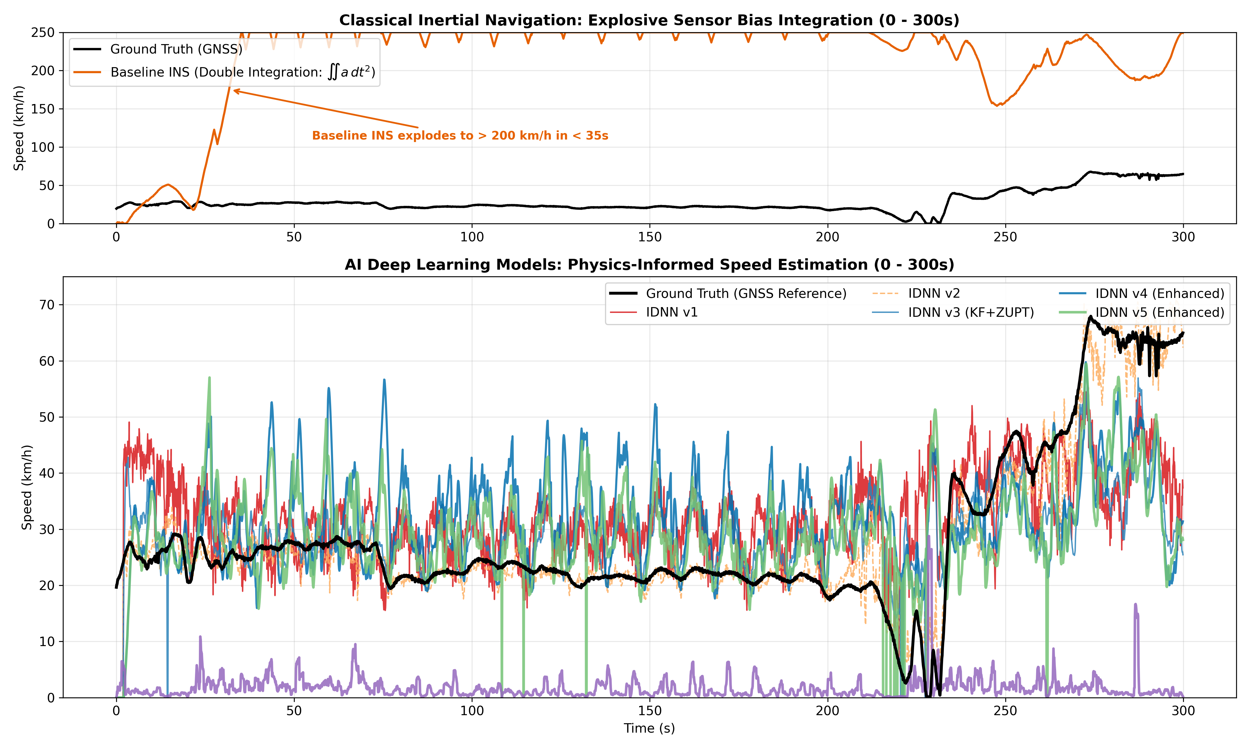
Figure 4: Classical Inertial Explosion vs. Deep Learning Speed Tracking (0 to 300s)
7. Quick Start & Reproduction Guide
To reproduce all benchmarks in Python 3.10+ / PyTorch with CUDA acceleration:
# 1. Install dependencies
pip install -r requirements.txt
# 2. Train and evaluate IDNN v5 Flagship on blind test drive
python -m src.crossdrive_pipeline_v5
# 3. Simulate 5 blackout scenarios with road map-matching
python -m src.simulate_blackout
# 4. Generate unified comparison suite across all models
python -m src.plot_all_models_comparison

8. Repository Architecture & File Guide
- TIMELINE.md & TIMELINE.docx: Detailed chronological engineering logs from Phase 0 to Phase 9.
- SIH_IDR_MASTER_PROJECT_DOCUMENT.md & .docx: Comprehensive 700+ line master technical report.
- src/idnn_model_v5.py: PyTorch architecture (18 physics channels x 21 taps = 378 inputs, Dense 256->128->64).
- src/crossdrive_pipeline_v5.py: Flagship pipeline with idle normalization, pre-blackout calibrator, and AC ZUPT.
- src/simulate_blackout.py: Outage scenario evaluation with true un-clamped road map-matching.
- src/plot_all_models_comparison.py: Unified 4-figure comparison suite generator.
- results/crossdrive_v5_model.pth: Trained PyTorch weights for IDNN v5 Flagship.

