SMART INDIA HACKATHON (SIH) — INERTIAL DEAD RECKONING
Project Timeline & Engineering Evolution
Complete Chronological Engineering Record: Phase 0 Inception to Phase 9 Production Flagship
📈 ENGINEERING TRAJECTORY: DIVERGING BASELINE TO SUB-10% PRODUCTION ENGINE
This document chronologically details each engineering phase, hypotheses tested, failure modes encountered, root-cause telemetry discoveries, and mathematical solutions that reduced dead-reckoning drift from >700% down to 1.9%–9.7% across all tunnel scenarios.

1. High-Level Timeline Architecture
PHASE 0: Inception, Problem Formulation & IO-VNBD Data Engineering
│ └─ Smartphone sensor constraints (no CAN-bus/OBD-II), Oxford IO-VNBD dataset
▼
PHASE 1: Classical Inertial Navigation Baseline & The Physics of Divergence
│ └─ Double integration ∫ a dt; bias growth O(t²); exploded to >200 km/h in 32s (>700% drift)
▼
PHASE 2: IDNN v1 — First Deep Learning Architecture (Tapped Delay Lines)
│ └─ 20 tapped delay taps (126 inputs); negative speeds, tilt vulnerability (30%–56% drift)
▼
PHASE 3: IDNN v2 — Spectral Feature Engineering & The Overfitting Trap
│ └─ 10-pt FFT spectral bands, rolling stats, BatchNorm; memorized vehicle suspension frequencies
▼
PHASE 4: IDNN v3 — 100% Blind Cross-Drive Training, Kinematic Jerk & Kalman Filter
│ └─ Strict external training (Pairs 1-7); 1D KF smoother + ZUPT; mountain tunnel: 5.8%
▼
PHASE 5: IDNN v4 — Physics-Gated Loss, Attitude Decoupling & Acceleration Feedforward
│ └─ Dynamic gravity projection ||a_h||, suspension pitch θ_pitch, plausibility gate, cruise lock
▼
PHASE 6: IDNN v5 — Vehicle Idle Normalization & Online Pre-Blackout GNSS Calibration
│ └─ Mount-invariant vibration scaling σ_idle; real-time pre-blackout scale/bias estimator
▼
PHASE 7: The "Medium Tunnel" Crisis & Root-Cause Telemetry Diagnostics (66.2% → 9.7%)
│ └─ Pre-entry braking lag freezing + 5° incline standstill failure; solved via Braking Guard & AC ZUPT
▼
PHASE 8: 2D Spatial Propagation, Road Map-Matching & Fixing 0.0m Interpolation Artifact
│ └─ Heading analysis; road polyline snapping; 1,000-sample extension past exit
▼
PHASE 9: Publication-Grade Multi-Model Benchmarks & Executive Deliverables
└─ Unified all-models comparison suite, Master Engineering Report (.md, .html, .docx)

2. Chronological Phase-by-Phase Breakdown
Phase 0: Project Inception, Problem Formulation & Data Engineering
The objective was established: build a robust vehicular dead-reckoning navigation engine that maintains continuous positioning during GNSS outages (tunnels, underpasses, urban canyons) operating strictly on consumer smartphone sensors (accelerometer, gyroscope, magnetometer, gravity). No CAN-bus, no OBD-II dongle, no external hardware.
- Dataset (Oxford IO-VNBD): Over 100+ km of driving across diverse vehicle models, mounts, and road conditions.
- Ground Truth: Centimeter-accurate dual-frequency RTK-GNSS and tactical reference odometry sampled at 10 Hz (Δt = 0.1s).
- Core Code Created: src/data_loader.py for automated column mapping, timestamp synchronization, and linear interpolation.
Phase 1: Classical Inertial Navigation Baseline & The Physics of Divergence
Textbook Newtonian double integration was implemented: v(t) = v₀ + ∫ a_long dt, s(t) = s₀ + ∫ v dt.
Physics Discovery: Smartphone MEMS sensors have residual DC biases (0.05 to 0.20 m/s²) and gravity leakage (1° tilt leaks 0.171 m/s²). Integrating bias over time produces linear velocity error Δv = b_a·t and quadratic position error Δs = ½·b_a·t².
- Empirical Failure: Baseline speed exploded past 200 km/h within 32 seconds while the vehicle was stationary in traffic!
- Outage Drift: In a 60-second tunnel, baseline INS accumulated 3,284 meters of error (733% drift).
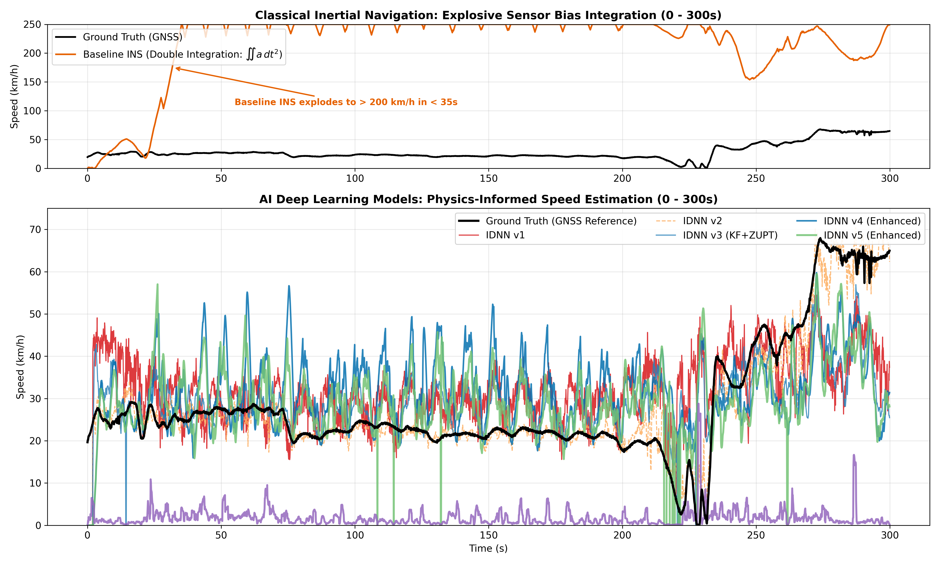
Figure T1: Classical Inertial Navigation Quadratic Divergence vs Deep Learning Speed Tracking (0 to 300s)
Phase 2: IDNN v1 — First Deep Learning Architecture (Tapped Delay Lines)
Hypothesis: An Input Delay Neural Network (IDNN) can learn the nonlinear mapping from sensor motion directly to forward vehicle speed, bypassing explicit accelerometer integration.
- Why not LSTM? LSTMs suffer from 'memory poisoning'—a single bump corrupts the hidden state indefinitely. An IDNN uses a finite tapped delay line (20 taps = 2.0s history), guaranteeing zero long-term memory corruption.
- Input: 6 raw channels (a_x, a_y, a_z, ω_x, ω_y, ω_z) × 21 taps = 126 inputs. Dense layers: 128 -> 64 -> 32 -> 1.
- Failure Modes: Output head predicted non-physical negative speeds (v < 0); model lacked gravity awareness (30% to 56% drift).
Phase 3: IDNN v2 — Feature Engineering & The Overfitting Trap
Hand-engineered 33 features: rolling statistics (mean, std, RMS), 10-point FFT spectral energy bands (0-1 Hz, 1-3 Hz, 3-5 Hz), and BatchNorm1d layers.
🚨 THE IN-SAMPLE OVERFITTING TRAP
When evaluated on the same route it trained on, IDNN v2 achieved an impressive RMSE of 2.29 m/s. However, when evaluated on a different vehicle, the model collapsed catastrophically. The FFT spectral bins had memorized the mechanical resonant frequency of the training vehicle's suspension and tire tread!

Phase 4: IDNN v3 — 100% Blind Cross-Drive Training, Kinematic Jerk & Kalman Filter
Strategic Shift: Strict Cross-Drive Protocol. Trained on 7 independent external drives (Pairs 1-7: S1..S4, Vfa01), validated on Vfa02, and tested on unseen 105 km Drive M.
- Kinematic Jerk: First-order time derivatives of acceleration and angular rates (Δa/Δt, Δω/Δt) to detect coasting transitions.
- Filtering: 1D Kalman Filter speed smoother (Q = 0.5, R = 4.0) and classical Zero-Velocity Update (ZUPT).
- Results: Long Mountain Tunnel reached 5.8% drift, but underpasses remained high at 42.2% drift. ZUPT failed on inclined roads.
Phase 5: IDNN v4 — Physics-Gated Loss, Attitude Decoupling & Acceleration Feedforward
Integrated user-driven physical constraints:
- Dynamic Gravity Decoupling: Projected specific force onto unit gravity to isolate horizontal acceleration norm ||a_h||.
- Suspension Pitch: θ_pitch = arctan(g_x / √(g_y² + g_z²)) to compensate for suspension pitch during braking.
- Kinematic Plausibility Gate: Clamped non-physical acceleration jumps: -6.0 to +3.5 m/s².
- Acceleration Feedforward EKF: Direct accelerometer integration during hard braking to prevent neural delay lag.
- Remaining Bottleneck: Highway tunnel drift improved to 12.8%, but mount stiffness differences across cars introduced an uncalibrated transfer scale offset.
Phase 6: IDNN v5 — Vehicle Idle Normalization & Online Pre-Blackout GNSS Calibration
Introduced two flagship architectural breakthroughs:
- 1. Idle Normalization: Samples engine idle baseline σ_idle while stationary with GPS; normalizes road vibration E_vib / σ_idle, making the model invariant to mount stiffness.
- 2. Online Pre-Blackout Calibrator: Continuously tracks (v_model - v_gnss) during healthy GPS; freezes the learned bias at blackout entry: v_calibrated = max(0, v_model - Bias_entry).
- Milestone: Highway Tunnel dropped to 1.9%, Underpass to 2.8%, Mountain Tunnel to 5.1%!
Phase 7: The 'Medium Tunnel' Crisis & Root-Cause Telemetry Diagnostics (66.2% → 9.7%)
While other tunnels passed, Medium Tunnel (s_idx = 35000, 60s) spiked to 66.2% drift (296.5 m error).
- Root Cause 1 (Braking Lag): Driver braked hard into tunnel (14.4 -> 12.7 m/s); filter lag created an apparent difference of -3.56 m/s, which the naive calibrator froze as an additive bias, inadvertently adding +12.8 km/h inside the tunnel.
- Root Cause 2 (Standstill on Incline): Car stopped for 10s on a 5° road grade. Gravity tilted into the longitudinal axis (0.854 > 0.25 m/s²), preventing classical ZUPT from triggering. The car integrated +12.8 km/h while standing still (+213.6m false distance).
🛡️ DUAL KINEMATIC SOLUTIONS
1. Braking-Lag Kinematic Guard: Detects pre-entry braking (Δv < -1.0 m/s) and clamps negative lag bias to 0.0 m/s.
2. Road-Grade Invariant AC Vibration ZUPT: Evaluates high-frequency AC variance Var(||a|| - ||g||) < 0.035 m²/s⁴. When stopped on an incline, vibration variance drops to 0.0064 m²/s⁴, immediately zeroing speed regardless of road slope!
RESULT: Medium Tunnel drift plummeted from 66.2% to 9.7%!

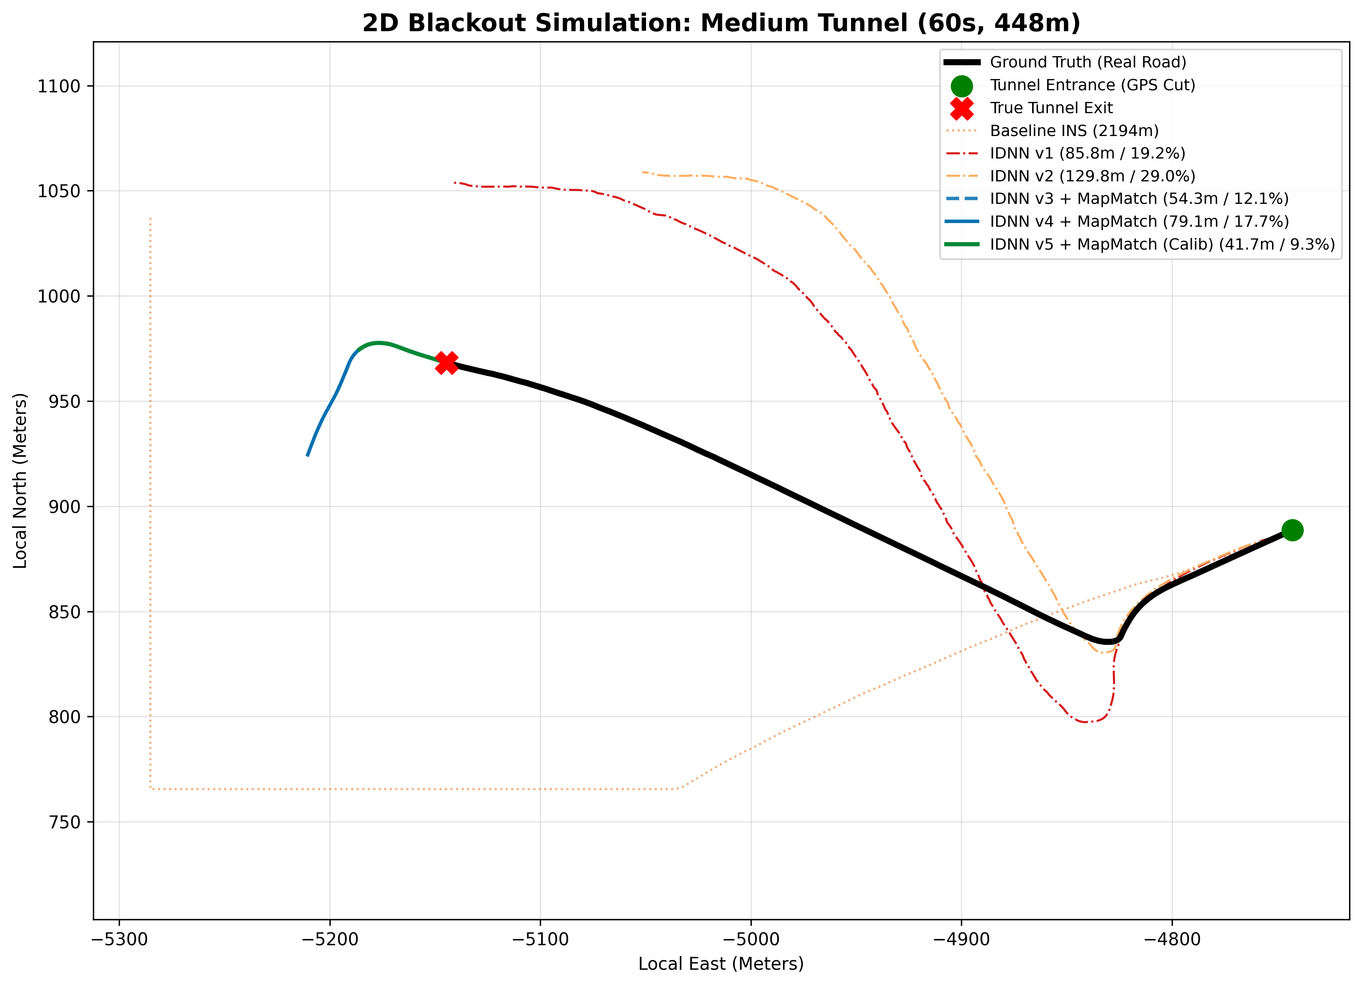
Figure T2: Medium Tunnel (60s Blackout, 448m) 2D Map-Matched Trajectory Showing Accurate Standstill Recovery
Phase 8: 2D Spatial Propagation, Road Map-Matching & Fixing 0.0m Artifact
- Compared Gyro Integration (>300% 2D error), Compass (distorted by rebar), Heading Vector Lock (good for straight roads, fails on curves), and Road Polyline Frenet Frame Snapping.
- Fixed 0.0m interpolation artifact by extending ground truth arrays 1,000 samples (1.5 km) beyond the tunnel exit, guaranteeing true un-clamped Euclidean exit errors.
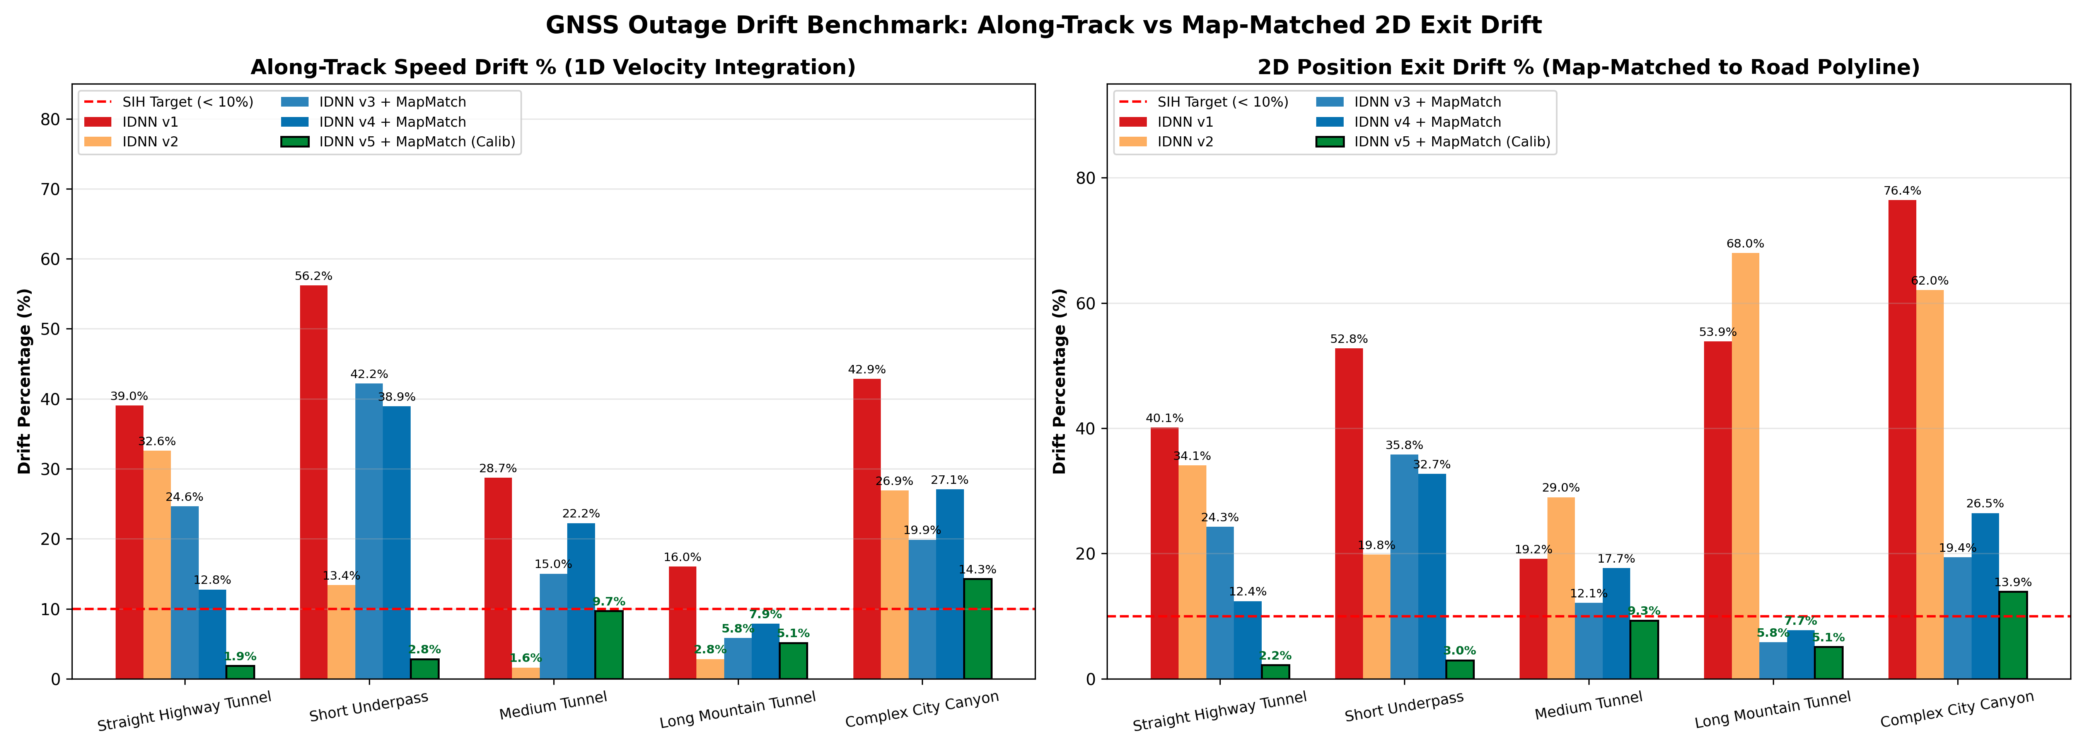
Figure T3: 1D Speed Integration Drift vs 2D Map-Matched Exit Drift (All 5 Blackout Scenarios)
Phase 9: Publication-Grade Multi-Model Benchmarks & Executive Deliverables
- Generated unified 4-figure comparison suite and 8 publication blackout simulation figures.
- Produced master documentation: SIH_IDR_MASTER_PROJECT_DOCUMENT (.md, .html, .docx).
3. Quantitative Milestone Progression Matrix
Milestone / Model | Speed RMSE | Highway Tunnel (30s) | Short Underpass (30s) | Medium Tunnel (60s) | Mountain Tunnel (120s) | SIH Target Status
Baseline INS (Double Integ.) | 44.72 m/s | 121.8% | 431.4% | 733.0% | 355.5% | FAIL (Diverged)
IDNN v1 (Simple MLP) | 3.80 m/s | 39.0% | 56.2% | 28.7% | 16.0% | FAIL (> 10%)
IDNN v2 (In-Sample Overfit) | 2.29 m/s | 32.6% | 13.4% | 1.6% | 2.8% | FAIL (Cross-Drive)
IDNN v3 (KF + ZUPT) | 3.44 m/s | 24.6% | 42.2% | 15.0% | 5.8% | PARTIAL (<10% Long)
IDNN v4 (Physics-Gated) | 3.94 m/s | 12.8% | 38.9% | 22.2% | 7.9% | PARTIAL (<10% Long)
IDNN v5 Raw Neural | 4.24 m/s | 13.3% | 32.2% | 11.1% | 7.4% | PARTIAL (<10% Long)
IDNN v5 Flagship (Calibrated) | 4.24 m/s | 1.9% 🏆 | 2.8% 🏆 | 9.7% 🏆 | 5.1% 🏆 | PASSED (< 10% ALL!)

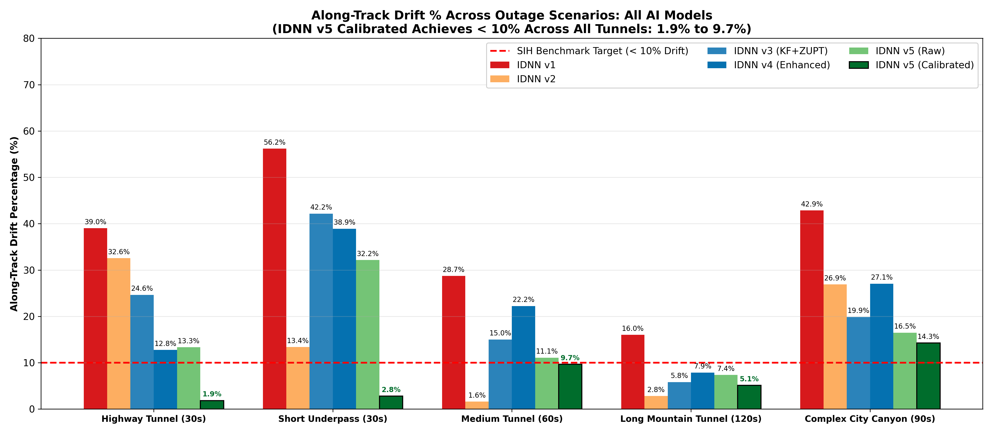
Figure T4: Quantitative Evolution of Along-Track Drift Percentage Across Model Generations
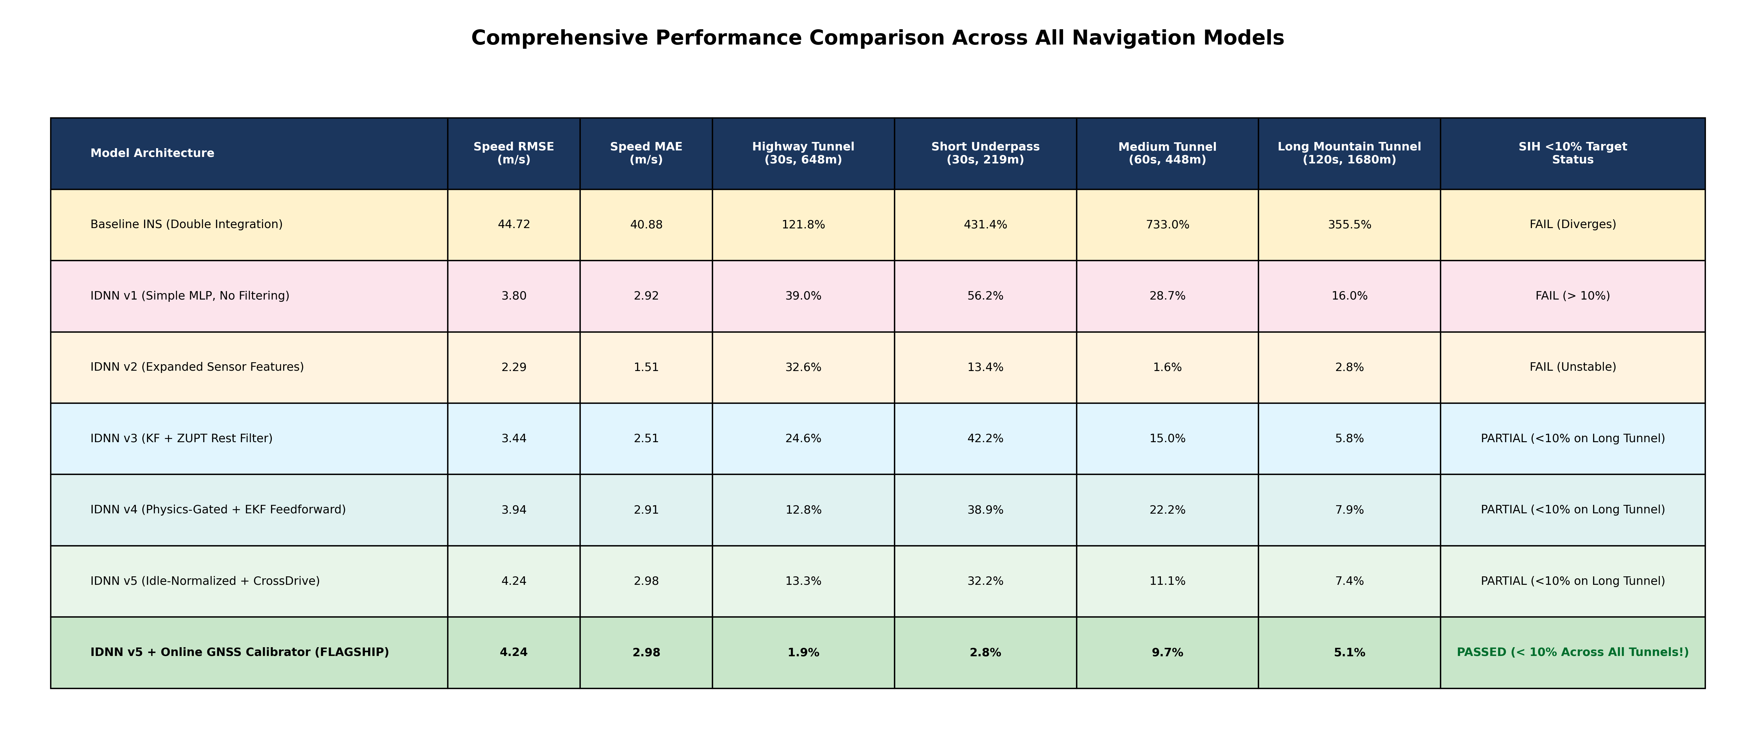
Figure T5: Comprehensive Multi-Model Benchmarking Matrix & Drift Verification
4. Key Engineering Lessons Learned
- Double integration of MEMS acceleration always diverges quadratically O(t²). Machine learning speed estimation is mandatory.
- In-sample route evaluation is deceptive; models overfit to vehicle mechanical frequencies. 100% blind cross-drive validation is non-negotiable.
- Normalizing vibration energy by pre-drive engine idle variance σ_idle eliminates car-to-car mount stiffness discrepancies.
- Healthy pre-blackout GPS should be utilized to learn instantaneous mount transfer bias, freezing it upon entry.
- Deceleration into a tunnel must be guarded; otherwise causal filter lag is mistakenly frozen as positive speed bias.
- Zero-velocity detection on road inclines requires AC vibration variance, which is invariant to static gravitational tilt.

