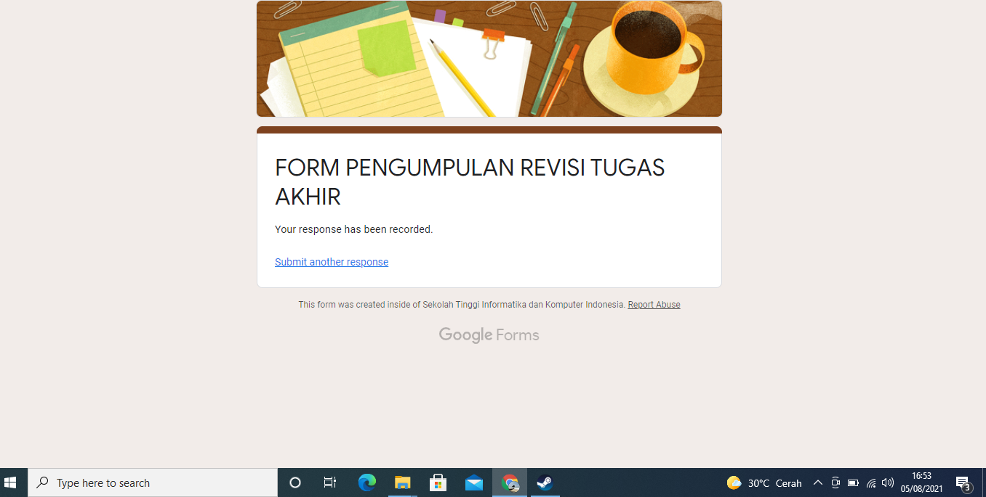Dsadsa da a s a as a a ad