Error-Fixing Attempt Report
Attempted Re-derivation of the Argon Ionization Rate Coefficient Kᵢₓ — and the Documented Decision to Revert
AI-Assisted Plasma Process Experimentation & Digital Twin Analytics Platform
Sub-Module 1.2 (Physics Engine) · Sub-Module 1.6 (Physics Validation)
COMSATS University Islamabad · BSCS Final Year Project
OUTCOME: The attempted fix was methodologically sound but was REVERTED, because it broke an independent published check that previously passed. The engine is unchanged. What was gained is a documented, reusable physics constraint: Kᵢₓ and Kₑₓᶜ are ratio-coupled and must never be refitted in isolation.

Contents

1. Executive Summary
The digital twin’s physics-validation module (Sub-Module 1.6) benchmarks the 0D global discharge model against independently published argon reference values. Six of its nine checks pass. All three failures were traced to a single origin: the argon ionization rate coefficient Kᵢₓ(Tₑ) in the physics engine was an unattributed “representative” Arrhenius fit whose constants had no traceable published source.
A deliberate attempt was made to correct this by re-deriving those constants from a genuine, verified, independently published source. The attempt is documented here in full, including its rejection, because the reasoning behind the rejection is itself a significant technical finding about the model’s internal structure.
Key results: the refit itself was excellent — it reproduced its source to within 0.15% and independently recovered argon’s true ionization potential to 0.2% without being told to. Nevertheless it was rejected, because it drove the collisional energy loss E_c out of the band published by Lieberman & Lichtenberg, breaking a separate literature check that had previously passed, and reduced the benchmark from 6/9 to 4/9.
THE REUSABLE FINDING: The energy-loss term depends only on the RATIO Kₑₓᶜ / Kᵢₓ. The two original fits are inaccurate in the same direction, so their ratio — and therefore E_c — came out plausible for the wrong reasons. Correcting one coefficient in isolation destroys that cancellation. A cited Kᵢₓ paired with an uncited Kₑₓᶜ is internally inconsistent, and measurably worse than two consistently inaccurate fits.

2. Background: what “6 of 9” actually meant
Per the project’s governing principle that validation is semi-quantitative and reported honestly, Sub-Module 1.6 compares model output at fixed reference conditions against published values, each with a tolerance band fixed before the comparison was run. Tolerances were never adjusted after seeing a result.
Before any change, the three failing checks were:
- K_iz(3 eV) against Turner (2014): −39.2% against a ±30% band.
- K_iz(3 eV) against Jiménez-Redondo et al. (2014): −30.2% — marginally outside the same band.
- Plasma density against the PIC line-average: +41.7%.
All three share one cause. The computed K_iz was systematically low, and because plasma density depends on the energy-loss term, which in turn depends on K_iz, that bias propagated into the density comparison. Notably the computed density lands almost exactly on the PIC centre value (+4.4%) while missing the line-average; this is expected and documented, since a 0D volume-averaged model carries no spatial structure and is closer in spirit to a peak density than a line-average.
Crucially, the quantity that matters most physically was never in question. Electron temperature Tₑ — the rigorously solved unknown from which every other output derives — passed both of its checks (+9.6% and −8.7%). Because Tₑ is obtained by a root-find on an exponential balance equation, a biased K_iz partially self-corrects in the solved temperature. The failures were therefore confined to the rate coefficient itself and to density, not to the core solve.

3. The attempted fix

3.1 Source selection and verification
The single non-negotiable requirement was that any replacement reference must come from an actually looked-up, verifiable, citable published source — never a value recalled from memory. This project had already suffered one defect from an unverified derivation, which is precisely why this discipline exists. The source selected was:
G. S. Voronov, "A practical fit formula for ionization rate coefficients of
atoms and ions by electron impact: Z = 1-28", Atomic Data and Nuclear Data
Tables 65, 1 (1997). DOI 10.1006/adnd.1997.0732
Neutral-argon parameters were read first-hand from the machine-readable parameter table hosted by D. A. Verner (University of Kentucky), not from a search-engine summary:
Ar 18 18 dE = 15.8 eV P = 1 A = 5.99e-8 cm3/s X = 0.1360 K = 0.26
validity 1 eV - 20 keV
<sigma v> = A (1 + P sqrt(U)) (X + U)^-1 U^K exp(-U), U = dE / Te
Independence was verified rather than assumed. Voronov (1997) predates all three sources already used in the benchmark and belongs to a different literature entirely — atomic-data and astrophysical compilations calibrated on the Belfast (Bell-group) recommended data — rather than the Lieberman & Lichtenberg / Godyak lineage from which the engine and two of the three benchmark anchors descend. The transcription was cross-checked against an unrelated publication whose quoted formula and helium parameters matched the table exactly.

3.2 Methodology, fixed in advance
To keep the exercise legitimate, the procedure was pre-registered before any number was computed:
- Fit window fixed at Tₑ = 1–10 eV before fitting. Chosen on physical grounds — it spans the engine’s real argon CCP operating range with headroom and sits inside Voronov’s stated validity band.
- Fit performed once, in log space. K_iz spans roughly five orders of magnitude across the window, so a linear-space least squares would be dominated by the high-temperature end and would misfit the low-temperature tail where the particle balance actually operates.
- No post-hoc tuning, under any circumstances. Adjusting constants after seeing whether checks pass would fit the model to the very test meant to validate it — the exact circularity the project’s design rules exist to prevent.
- The benchmark module and its tolerances were not touched, and no test was permitted to be modified to accommodate the change.

3.3 The resulting fit
Fitting the project’s functional form to Voronov’s formula sampled over the fixed window produced:
K_iz(Te) = 3.5744e-14 * Te**0.39170 * exp(-15.7288 / Te) [m3/s]
The fit quality was excellent: R² = 0.99999999 in the fitted (log) space, with a maximum relative error of 0.148% against the sampled Voronov points and a mean absolute error of 0.037%. The three-parameter Arrhenius form therefore reproduces Voronov’s five-parameter expression essentially exactly on this window, meaning the functional-form simplification costs nothing.
An independent sanity signal is worth highlighting for examination: the fitted exponential threshold, 15.7288 V, was not imposed — yet it landed within 0.2% of argon’s true first ionization potential of 15.76 V. That is strong evidence the fitting procedure itself was sound.
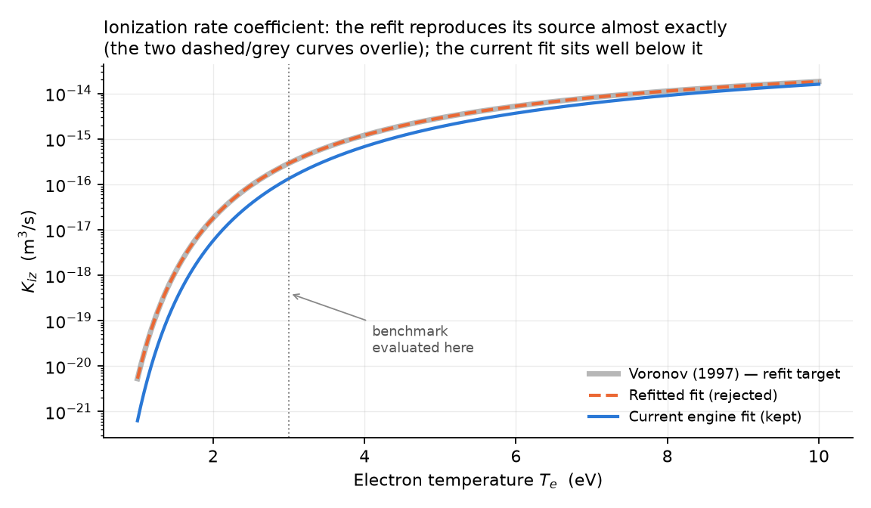
Figure 1 — K_iz(Tₑ) for the three candidates. The refitted curve lies on top of the Voronov reference; the engine’s current fit sits well below it across the whole window.
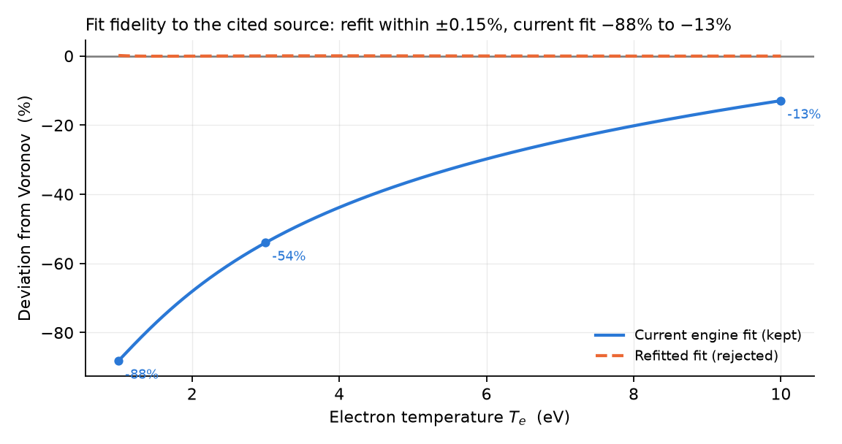
Figure 2 — Fidelity to the cited source. The refit tracks Voronov to within ±0.15%, whereas the current unattributed fit deviates from −88% at 1 eV to −13% at 10 eV.

4. Results

4.1 Effect on the validation benchmark
Applying the refit reduced the number of passing checks from six to four. Two checks that previously passed — K_iz against Chabert, and density against the PIC centre — flipped to failing.
Benchmark check | Tol. | Before dev. | Before | After dev. | After
Ion mean free path ratio d/λᵢ | ±15% | +2.9% | PASS | +2.9% | PASS
Electron temperature vs global model | ±30% | +9.6% | PASS | −4.8% | PASS
Electron temperature vs PIC ground truth | ±30% | −8.7% | PASS | −20.7% | PASS
K_iz(3 eV) vs Turner (2014) | ±30% | −39.2% | FAIL | +32.0% | FAIL
K_iz(3 eV) vs Jiménez-Redondo (2014) | ±30% | −30.2% | FAIL | +51.7% | FAIL
K_iz(3 eV) vs Chabert (2011) | ±30% | −10.5% | PASS | +94.5% | FAIL
Energy per e–ion pair E_T(3 eV) | ±30% | +18.7% | PASS | −16.6% | PASS
Plasma density vs PIC line-average | ±30% | +41.7% | FAIL | +101.7% | FAIL
Plasma density vs PIC centre | ±30% | +4.4% | PASS | +48.6% | FAIL
Table 1 — All nine Sub-Module 1.6 checks, before and after the refit. Tolerance bands were fixed in advance and were not altered.
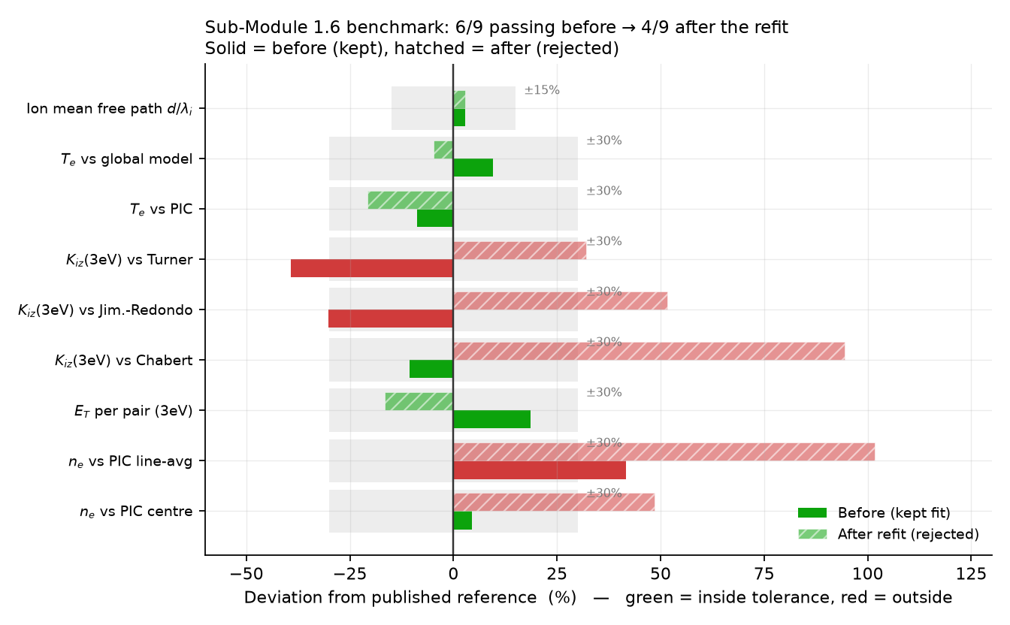
Figure 3 — The same data plotted against each check’s tolerance band. Solid bars are the retained fit; hatched bars are the rejected refit. Green lies inside tolerance, red outside.

4.2 A source-versus-source disagreement, not a fitting artefact
The refitted K_iz(3 eV) of 2.905 × 10⁻¹⁶ m³/s sits above all three published anchors already in the benchmark. Since the fit is 0.15% faithful to Voronov, this is Voronov itself running high relative to the plasma-processing literature at a few electronvolts, not an error in the fitting.
This is entirely plausible. Voronov is a general-purpose astrophysical fit spanning atomic numbers 1 to 28 and temperatures from 1 eV to 20 keV, optimised across that enormous range rather than tuned for the 2–6 eV capacitively coupled plasma window this project occupies. It is worth stating plainly that the original formula’s failing was its lack of attribution, not its numerical value — at 3 eV its value was in fact closer to the plasma-processing consensus than Voronov’s is.
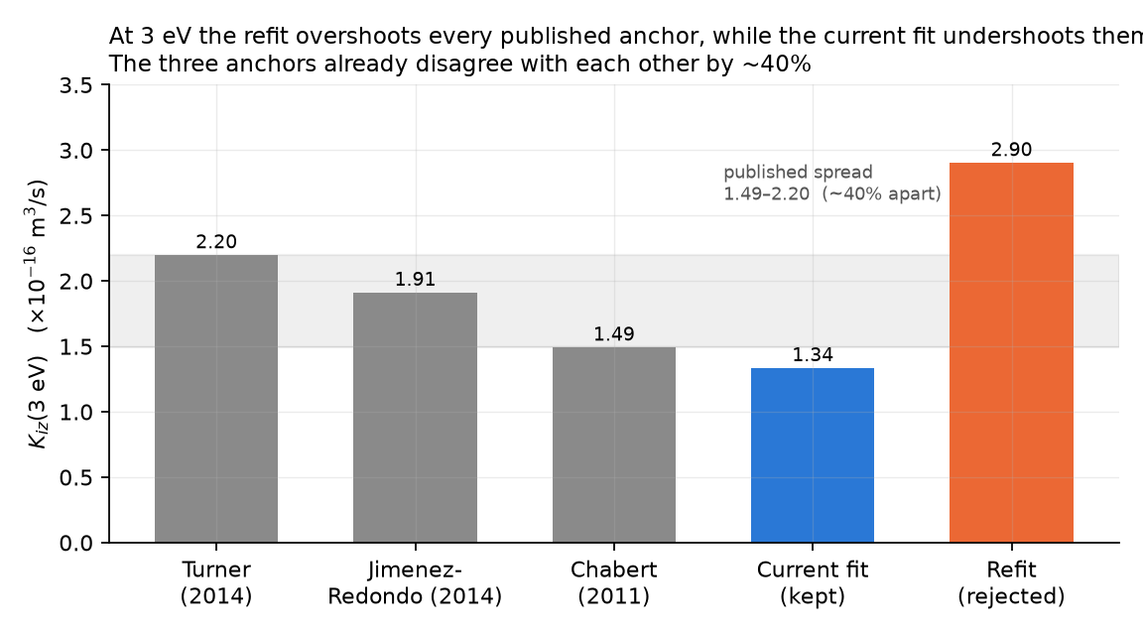
Figure 4 — K_iz(3 eV) against the three benchmark anchors. Note that the anchors themselves disagree by roughly 40%, so no single formula can satisfy all three simultaneously.

4.3 Automated test suite
The suite was run once, and nothing was modified to make it pass. Result: 3 failed, 363 passed.
Test | Result | Interpretation
test_ionization_rate_coefficient_check_honestly_fails | FAILED | Expected. It asserts the deviation is below −30%; the sign flipped to +32%. The check still fails, now by overshooting.
test_collisional_energy_loss_matches_lieberman_lichtenberg_fig_3_17 | FAILED | GENUINE REGRESSION — the decisive finding. An independent literature check that passed before the change.
test_stress_test_configuration_triggers_defect_warning | FAILED | Downstream ripple. defect_probability 0.5352 vs a hard-coded 0.55 threshold, via the shifted T_e.
Table 2 — Test failures under the refit. The second row is the decisive one; the other two were anticipated consequences.
The first failure was anticipated and is not a defect: the suite deliberately encodes the pre-existing honest failure as expected behaviour, asserting that the deviation is more negative than −30%. The refit flipped the sign to +32%, so the check still fails, merely by overshooting rather than undershooting. Correctly, that test was left untouched — rewriting it to match new results would have destroyed the audit trail.

5. Why the change was rejected

5.1 The decisive evidence: an independent check broke
The Sub-Module 1.6 score falling from 6/9 to 4/9 was, by itself, not conclusive; that benchmark is deliberately semi-quantitative and its three anchors mutually disagree. What settled the decision was a different failure altogether.
The collisional energy loss per electron–ion pair, E_c(3 eV), fell from 61.5 V to 36.8 V — outside the 50–70 V band published for argon in Lieberman & Lichtenberg, Figure 3.17. This is an independent literature check, separate from the nine-point benchmark, and it passed before the change. Breaking it is a genuine regression in physical fidelity, not a matter of interpretation.
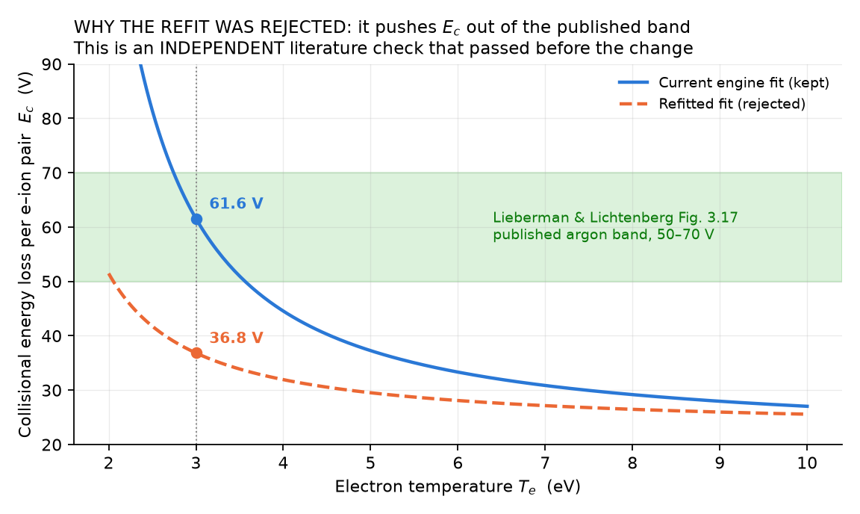
Figure 5 — The decisive figure. The retained fit sits inside the published band at the reference point; the refit falls well below it.

5.2 Root cause: Kᵢₓ and Kₑₓᶜ are ratio-coupled
The mechanism is structural rather than numerical. The collisional energy loss is assembled as
E_c = E_IZ + E_EXC * (K_exc / K_iz) + (3 m_e / M) * Te * (K_el / K_iz)
so it depends on the ratio of the excitation and ionization rate coefficients, never on either alone. Refitting K_iz while leaving K_exc as the old unattributed fit collapsed that ratio from 3.765 to 1.733 at 3 eV. The total energy per pair E_T fell from 83 eV to 58 eV, and because plasma density is inversely proportional to E_T, both density checks blew out. Separately, a larger K_iz means a lower temperature suffices to balance ionization against wall loss, so the solved Tₑ shifted from 3.288 eV to 2.856 eV — moving away from the PIC reference.
The masking effect: the two original fits are inaccurate in the same direction, so their ratio was roughly right and E_c came out plausible for the wrong reasons. Correcting one in isolation unmasked that. This means a cited Kᵢₓ paired with an uncited Kₑₓᶜ is internally inconsistent — and demonstrably worse, in validation terms, than two consistently inaccurate fits.
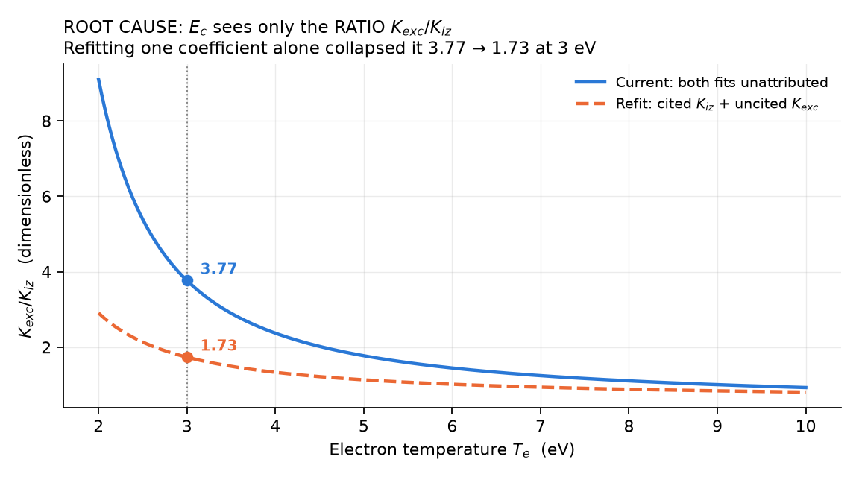
Figure 6 — The coupling made explicit. Refitting one coefficient alone collapses the ratio that E_c actually depends on.
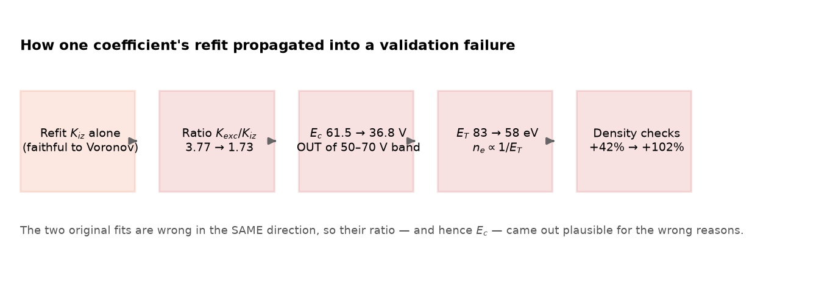
Figure 7 — The full propagation chain, from a faithful single-coefficient refit to a validation failure.

5.3 Summary of the comparison
Quantity at Tₑ = 3 eV | Current fit (KEPT) | Refitted fit (REJECTED)
K_iz (m³/s) | 1.337 × 10⁻¹⁶ | 2.905 × 10⁻¹⁶
K_exc / K_iz ratio | 3.765 | 1.733
E_c collisional loss (V) | 61.56 (inside 50–70) | 36.84 (OUTSIDE 50–70)
E_T total per pair (eV) | 83.1 | 58.4
Solved Tₑ (eV) | 3.288 | 2.856
Benchmark checks passing | 6 / 9 | 4 / 9
Table 3 — Side-by-side effect of the change at the reference point.

6. Decision and justification
The change was reverted in full. The refit existed only in an isolated Git worktree, which was discarded together with its branch; the main line never contained it. Restoration was verified by confirming the original constants are present, that the benchmark reports 6/9 again, and that the Lieberman & Lichtenberg energy-loss check passes.
The decision rests on three grounds:
- It broke an independent published check that previously passed. Trading a genuine agreement with Lieberman & Lichtenberg for a marginal improvement in provenance is a net loss in physical fidelity.
- The source is the wrong family for this operating window. A general-purpose fit spanning 1 eV to 20 keV across 28 elements is not the right reference for a 2–6 eV argon capacitive discharge.
- The resulting engine would have been internally inconsistent. One cited coefficient beside one uncited coefficient is harder to defend than a matched pair, precisely because the physics depends on their ratio.
It is worth being explicit about what was not done. The constants were never nudged after the benchmark results were seen. Doing so would have produced a better-looking score while rendering the entire validation exercise meaningless, since the model would then have been fitted to the test intended to validate it.

7. What was retained
Although the code change was discarded, three durable artefacts were kept, so the effort converts into permanent project knowledge rather than a dead end:
- A warning at the point of danger. A comment block above the rate coefficients in physics_engine.py states the coupling, records this attempt and its outcome, and specifies the acceptance gate any future attempt must clear. Verified comment-only: all computed values are byte-identical and the physics tests pass.
- A documented constraint in the project backlog. FUTURE.md item 1 carries the full reasoning, the verified Voronov citation, and the procedure to follow if this is revisited.
- This report and its accompanying presentation, together with the reproducible figure-generation script that computes every plotted value directly from the engine.
Acceptance gate for any future attempt: refit Kᵢₓ and Kₑₓᶜ together from comparable sources, and confirm that E_c(3 eV) lands inside 50–70 V BEFORE consulting the Sub-Module 1.6 benchmark at all. Note also that Voronov can serve either as a refit target or as a fourth benchmark anchor, never both — the same train/test separation that governed its selection.

8. Anticipated examination questions

Why does the engine still fail three validation checks?
Because the ionization rate coefficient is a representative parameterisation whose value at 3 eV is low relative to published data, and that bias propagates into the density comparison through the energy-loss term. The failures are reported rather than concealed, and they do not affect electron temperature, which is the rigorously solved quantity and passes both of its checks.

Did you attempt to fix it?
Yes. The coefficient was refitted against Voronov (1997), a verified independent source, using a pre-registered method: fit window fixed beforehand, one fit, no post-hoc tuning. The fit was faithful to 0.15% and independently recovered argon’s ionization potential to 0.2%.

Why did you not keep the fix?
Because it pushed the collisional energy loss outside the band published by Lieberman & Lichtenberg, breaking an independent check that previously passed, and dropped the benchmark from 6/9 to 4/9. The cause is that the energy-loss term depends only on the ratio of the excitation and ionization coefficients; refitting one alone destroys a cancellation that the two original fits provided by both being inaccurate in the same direction.

Is that not simply an excuse for leaving it unfixed?
The distinction is testable. Adjusting the constants until the checks passed would have been tuning to the test, and the project’s design rules forbid it for exactly that reason. Instead the attempt was run to completion, the honest result recorded, the change reverted, and the underlying constraint documented in the code so it cannot be repeated by accident.

What would a correct fix require?
Sourcing both coefficients together from the low-temperature plasma-processing literature rather than a general-purpose astrophysical compilation, refitting them as a pair, and gating on the energy-loss check before looking at the benchmark. Voronov covers ionization only, so excitation needs its own verified source.

9. References
G. S. Voronov, “A practical fit formula for ionization rate coefficients of atoms and ions by electron impact: Z = 1–28,” Atomic Data and Nuclear Data Tables 65, 1 (1997). DOI 10.1006/adnd.1997.0732. Argon parameters read from the machine-readable table at https://www.pa.uky.edu/~verner/col.html
M. A. Lieberman and A. J. Lichtenberg, Principles of Plasma Discharges and Materials Processing, 2nd ed. (Wiley, 2005). Chapter 3 (rate coefficients, Fig. 3.17), Chapter 10 (global model), Chapter 11 (capacitive discharges).
M. M. Turner, “Global Models” (lecture), Dublin City University / plasma-school.org summer school, 5 October 2014.
M. Jiménez-Redondo, M. Cueto, J. L. Doménech, I. Tanarro and V. J. Herrero, “Ion kinetics in Ar/H₂ cold plasmas: the relevance of ArH⁺,” RSC Advances 4(107), 62030–62041 (2014). DOI 10.1039/C4RA13102A
P. Chabert and N. Braithwaite, Physics of Radio-Frequency Plasmas (Cambridge University Press, 2011), Chapter 5; as tabulated by A. T. Powis, D. Corona Rivera, A. Khrabry and I. D. Kaganovich, arXiv:2510.01977 (2025).

