COMSATS University Islamabad (CUI)

Project Proposal
for
AI-Assisted Plasma Process Experimentation & Digital Twin Analytics Platform
Scope Document — Version 1.0
By
Muhammad Rayyan Taimoor Khan | CIIT/FA23-BCS-072/ISB
Sadeem Ur Rehman | CIIT/FA23-BCS-127/ISB
Supervisor
Dr. Majid Iqbal
Bachelor of Science in Computer Science (2023–2027)
Department of Computer Science
COMSATS University Islamabad, Islamabad Campus
October 2026

Revision History
The table below records every released version of this scope document.
Version | Date | Description of change | Author(s)
1.0 | 25-Oct-2026 | First scope document of the project: a three-stage plasma digital twin (low-pressure argon plasma with optical emission spectroscopy; underwater oxygen plasma for disinfection; Langmuir probe diagnostics), defined from the supervisor's written questionnaire answers. | M. Rayyan Taimoor Khan, Sadeem Ur Rehman

Abstract
Rationale: Plasma physics students need to practise optical emission spectroscopy (OES) and Langmuir probe diagnostics, but laboratory plasma systems are expensive, shared and slow to operate, so hands-on time is scarce.
Existing Systems: Commercial multiphysics simulators such as the COMSOL Plasma Module are costly and need finite-element expertise, while free tools such as BOLSIG+, SPECAIR, MassiveOES and vendor probe software each cover only one step (electron kinetics, spectrum synthesis or curve fitting). None of them connects discharge settings to a solved plasma state, to the resulting diagnostic signals and to their validation.
Targeted Challenges: A student cannot see how a change in RF power, pressure or gas flow propagates through the plasma into the measured spectrum and probe curve, and there is no simple, tolerance-based way to check two diagnostics against each other or against measured data. For underwater plasma disinfection, discharge settings are rarely linked quantitatively to the reactive species produced and the resulting bacterial log reduction.
Grey Area: No low-cost, physics-based tool links discharge settings, plasma state, synthetic diagnostics and validation for both a low-pressure plasma and an underwater disinfection plasma in one environment.
Objectives: The platform will simulate a 13.56 MHz capacitively coupled argon plasma (10–100 W, 0.1–0.5 mbar, Ar 100–500 sccm, with optional N₂ and O₂) whose electron temperature, electron density and gas temperature come from particle and power balance equations. It will generate and analyse virtual OES spectra and virtual Langmuir probe curves for that plasma and compare them with the model within a fixed ±30 % tolerance. It will also model an underwater pulsed-DC oxygen bubble discharge whose reactive species drive a Hom-model prediction of E. coli inactivation, with validation against published and measured data and an optional AI module.
Significance: The result is a free, repeatable virtual plasma laboratory in which students and researchers can rehearse experiments, interpret diagnostics and validate measurements before and after using the real laboratory.
Table of Contents
1. Introduction 1
2. Problem Statement 1
3. Problem Solution / Objectives of the Proposed System 2
3.1 Primary Objectives 2
3.2 Secondary Objectives 3
4. Related System Analysis / Literature Review 3
5. Vision Statement 4
6. Scope 5
7. System Modules 6
7.1 Module 1: Home, Configuration and Session Management 6
7.2 Module 2: Low-Pressure Plasma Digital Twin (Stage 1) 6
7.3 Module 3: Virtual Optical Emission Spectroscopy 6
7.4 Module 4: Virtual Langmuir Probe (Stage 3) 7
7.5 Module 5: Underwater Plasma Disinfection Twin (Stage 2) 7
7.6 Module 6: Measured Data Import and Validation (Researcher) 7
7.7 Module 7: Visualisation, Reporting and Export 8
7.8 Module 8 (Optional): AI-Assisted Parameter Inference 8
8. System Limitations / Constraints 8
9. Data Gathering Approach 9
10. Project Contribution 9
11. Relevance to Course Modules 10
12. Tools and Technologies 10
13. Project Stakeholders and Roles 11
14. Module-Based Work Division 11
15. Work Breakdown Structure and Gantt Chart 12
16. Interface Mockups 13
17. References 16
18. Plagiarism / Originality Statement 18

List of Tables
Table 4.1: Related system analysis with proposed project solution 4
Table 11.1: Relevance of the project to course modules 10
Table 12.1: Tools and technologies 10
Table 13.1: Project stakeholders and roles 11
Table 14.1: Module-based work division 12
Table 15.1: Work breakdown structure 12
Table 15.2: Proposed Gantt chart (October 2026 – June 2027) 13

List of Figures
Figure 16.1: Stage 1 low-pressure chamber configuration (SRS Mockup M2) 14
Figure 16.2: OES analysis: Boltzmann plot and temperatures (SRS Mockup M5) 15
Figure 16.3: Stage 2 underwater plasma configuration (SRS Mockup M8) 15

1. Introduction
Plasma diagnostics are how physicists learn what a plasma is doing. Optical emission spectroscopy reads the light emitted by excited atoms and molecules to infer temperatures and densities, and a Langmuir probe, a small electrode inserted into the plasma, measures a current–voltage curve from which the electron temperature, the electron density and the electron energy distribution are extracted. Learning to use and interpret these techniques requires many repeated experiments, which are hard to obtain on shared laboratory equipment.
This project builds a software digital twin of the experiments defined by the supervisor, a plasma physicist whose research idea the project is. It has three stages. Stage 1 is a low-pressure argon plasma generated in a 13.56 MHz capacitively coupled (CCP) chamber and diagnosed by OES. Stage 2 is an underwater, high-pressure oxygen plasma generated inside gas bubbles by a pulsed DC supply and used to disinfect municipal waste water; OES is applied to it as well. Stage 3 is Langmuir probe diagnostics, applied to the Stage 1 plasma only. Stage 1 is the most important stage, but all three are mandatory.
For each stage, the user sets the controls that exist on the real equipment, the platform solves physics-based models for the plasma state, and it then produces the signal a real instrument would record: an emission spectrum, a probe current–voltage curve or a bacterial survival curve. These signals are analysed with the same methods used in the laboratory, compared with each other and with the model, and validated against published data and, when available, against measurements from the laboratory. An optional AI module infers plasma parameters directly from a spectrum.
The platform is developed in Python with Streamlit for the user interface, Plotly for interactive charts, NumPy and SciPy for the numerical models and SQLite for storing sessions. It runs on an ordinary laptop with no laboratory hardware, and it demonstrates how software engineering, numerical computing, databases and human–computer interaction combine to model a real physical process.

2. Problem Statement
Plasma diagnostics are learned by doing, but doing is expensive. A low-pressure RF plasma system needs a vacuum chamber, pumps, gas controllers, an RF generator with a matching network, a spectrometer and a probe system, and the laboratory is shared between many users. A student therefore gets only a few hours of operating time, often without being able to repeat a run or explore the full range of power, pressure and gas flow.
Interpreting the results is also hard. The emission spectrum depends on the electron temperature, the electron density and the electron energy distribution through a chain of atomic processes, and a probe curve is distorted by the RF sheath oscillation. Students who see only the final spectrum or curve cannot tell which physical cause produced which feature, and they rarely check one diagnostic against another.
Existing software does not close this gap. General multiphysics packages are costly and require expertise in finite-element modelling, while free tools each address one step and must be joined by hand in spreadsheets. The same problem exists for underwater plasma disinfection, where the link from pulse voltage, frequency and gas flow to reactive species and finally to bacterial log reduction is usually explored only by trial and error.
Finally, when measured data become available, there is no consistent, tolerance-based way to compare them with theory and with the other diagnostic, so errors in either the experiment or the analysis can go unnoticed. This project addresses all of these problems with one integrated, physics-based virtual laboratory.

3. Problem Solution / Objectives of the Proposed System
The proposed system provides a digital twin for each plasma and a virtual instrument for each diagnostic, all connected through one solved plasma state. For Stage 1, a volume-averaged (0D) global model solves the particle balance for the electron temperature and the power balance for the electron density [1, 2], extended with gas flow, gas temperature, Ar/N₂/O₂ chemistry, a Druyvesteyn electron energy distribution and a 1D axial profile. The virtual OES uses a collisional-radiative (CR) model of the argon 1s and 2p levels [3] and NIST line data [4]. The virtual Langmuir probe computes an RF-distorted current–voltage curve and analyses it with orbital-motion-limited (OML) theory and the Druyvesteyn method [5, 6]. For Stage 2, a gas-phase global model of the oxygen–water-vapour bubble discharge feeds an empirical transfer of reactive species into the water and a Hom disinfection model [7]. A comparison function checks every diagnostic against the model with a fixed ±30 % tolerance, and measured data are imported for validation only.

3.1 Primary Objectives
BO-1: Provide a virtual low-pressure argon CCP experiment that covers the whole supervisor-defined operating envelope (10–100 W, 0.1–0.5 mbar, Ar 100–500 sccm, N₂ and O₂ admixtures) and whose computed T_{e}, n_{e} and T_{gas} agree with published reference values within ±30 % at no fewer than three reference operating points.
BO-2: Allow a student to configure a Stage 1 run and obtain a synthetic OES spectrum and a Langmuir probe analysis for it in under 5 minutes, with every derived quantity (T_{e}, n_{e}, T_{gas}, T_{exc}) reported with its uncertainty and method.
BO-3: Demonstrate diagnostic consistency: OES- and probe-derived values shall agree with the model within ±30 % for at least 90 % of a pre-registered grid of Stage 1 test configurations.
BO-4: Predict the E. coli log reduction of the underwater oxygen discharge within ±30 % of published reference data at no fewer than one reference operating point, together with the D-value and energy yield.
BO-5: Allow a researcher to import a measured OES spectrum (.txt) or probe I-V curve (.csv) and obtain a validation report in under 10 minutes, without measured data ever being used to tune model parameters.

3.2 Secondary Objectives
BO-6: (Optional AI module) Infer T_{e}, n_{e} and T_{gas} from a spectrum with 90 % prediction intervals whose empirical coverage on held-out synthetic spectra is at least 85 %.
BO-7: Deliver the complete platform as a standalone Python application that installs from one pinned requirements file and runs without laboratory hardware on standard university computers.
BO-8: Make every result reproducible and defensible: fixed random seeds, a model version stored with every session, and every constant and reference value stored with its published source.

4. Related System Analysis / Literature Review
Global discharge models. For a low-pressure discharge, the particle balance between volume ionization and wall loss fixes the electron temperature independently of power, and the power balance then fixes the electron density [1]. This approach has been extended to argon–oxygen mixtures with negative ions [2], and published benchmarks for capacitive discharges provide reference values [8]. Global models are fast enough for interactive use, which is why they are chosen instead of fluid or particle-in-cell codes.
Electron energy distribution. At tens of pascals the distribution in an RF argon discharge departs from a Maxwellian [9]; the Druyvesteyn form is the supervisor's choice for low pressure. Rate coefficients are integrated from LXCat cross-sections [10] over the chosen distribution, as in the BOLSIG+ solver [11].
Optical emission spectroscopy. Collisional-radiative models of the argon 1s and 2p levels [3] and line-ratio methods for argon–nitrogen plasmas [12] show that the 2p levels are not in Boltzmann equilibrium, so an excitation temperature must not be reported as the electron temperature. N₂ rotational temperatures in argon-rich plasmas can be distorted by metastable energy transfer [13], which is why the (1,0) band at 315.9 nm with an NH overlap check is used. For the dense underwater plasma, H-alpha Stark broadening gives the electron density [14].
Langmuir probes and the local laboratory. OML theory and RF distortion are described by Chen [5]. A study from the COMSATS Plasma Research Laboratory used a single tungsten probe of radius 0.195 mm and 5 mm length swept from −20 to +50 V and obtained the EEDF by the Druyvesteyn method [15]; these values are the defaults.
Underwater plasma disinfection. Discharges in and in contact with water produce O₃, H₂O₂, OH and UV, which transfer into the liquid [16, 17]. A COMSATS-linked underwater discharge study reported OH, H-alpha and atomic oxygen lines and the reduction of E. coli [18]. Typical municipal waste-water properties are taken from Metcalf & Eddy [19].
Table 4.1 compares existing systems with the proposed platform.
Table 4.1: Related system analysis with proposed project solution
Application / System | Weaknesses / Limitations | Proposed Platform Solution
COMSOL Multiphysics Plasma Module [20] | Expensive licence; needs finite-element expertise; no built-in synthetic OES or probe workflow; slow for teaching sweeps. | Free, interactive global model with integrated virtual OES and probe; runs in seconds on a laptop.
BOLSIG+ [11] | Computes the EEDF and rate coefficients only; no plasma state, spectrum or probe curve. | Uses the same cross-section approach inside a complete plasma-to-diagnostic chain.
SPECAIR [21] | Synthesises spectra from user-supplied temperatures; does not compute the plasma state. | Spectrum is computed from the solved plasma state through a CR model.
MassiveOES [22] | Fits temperatures to measured molecular spectra; no plasma model or probe. | Combines spectrum analysis with a forward model and a probe cross-check.
Impedans probe software [23] | Tied to vendor hardware; analyses measured curves only. | Generates RF-distorted synthetic curves and analyses synthetic and imported curves with open methods.
PlasmaPy [24] | Library of plasma formulas; no user interface or experiment workflow. | Guided point-and-click workflow with saved sessions and reports for students.

5. Vision Statement
For plasma physics students and researchers at COMSATS University Islamabad who need to practise and understand plasma diagnostics without waiting for scarce laboratory time, the Plasma Digital Twin Platform is a physics-based virtual plasma laboratory that lets them configure a low-pressure argon plasma and an underwater oxygen plasma, obtain the resulting plasma state, generate and analyse realistic OES spectra and Langmuir probe curves, predict disinfection performance, and validate every result against published and measured data. Unlike specialist commercial simulators and single-purpose analysis programs, which are expensive or cover only one step of the chain, our product connects discharge settings, plasma physics, synthetic diagnostics and validation in one free, transparent and repeatable environment in which every number shown can be traced back to a published equation or data source.

6. Scope
The scope of the project is a single-user, locally installed software platform that simulates and analyses two laboratory plasmas and two diagnostic techniques. The platform simulates a low-pressure argon plasma in a 13.56 MHz capacitively coupled chamber of 40 cm by 40 cm with electrodes 14 cm in diameter and 4.5 cm apart. The user controls RF power from 10 to 100 W, pressure from 0.1 to 0.5 mbar, argon flow from 100 to 500 sccm and the gas mixture, where nitrogen and oxygen are each added as 5 % of the argon flow by default. The Stage 1 model is a volume-averaged global model that solves particle and power balance for the electron temperature and electron density and an energy balance for the gas temperature, with a Druyvesteyn electron energy distribution and an optional one-dimensional axial profile. A virtual OES module produces the emission spectrum of this plasma from a collisional-radiative model, adds the effect of the spectrometer resolution and noise, and analyses the spectrum with a Boltzmann plot, the excitation temperature, the excited-level population distribution and the gas temperature from Doppler broadening or the nitrogen rotational band. A virtual Langmuir probe produces the current–voltage curve of a cylindrical tungsten probe in the same plasma, including RF sheath distortion, and analyses it with orbital-motion-limited theory to obtain the floating and plasma potentials, electron temperature, electron density, Debye length and the electron energy distribution. A comparison function shows model, OES and probe values side by side and marks each as inside or outside a fixed ±30 % tolerance.
The platform also simulates an underwater oxygen plasma generated inside bubbles by a pulsed DC supply of up to 10 kV at 5 to 10 kHz and 100 W average power across a pin-to-pin gap of 1 to 3 mm at 1 atm. For this plasma it computes the bubble plasma state with a Maxwellian distribution, the concentrations of ozone, hydrogen peroxide and hydroxyl radicals in the water, the change in pH, oxidation–reduction potential, conductivity and temperature, and the survival of E. coli and other listed organisms with the Hom model. Its virtual OES shows the OH, H-alpha and atomic oxygen lines and estimates the electron density from H-alpha Stark broadening.
In researcher mode, the user can import measured spectra and probe curves, attach the required metadata, and validate the models against these files and against published benchmarks, while measured data stay non-citable unless permission is given. All runs can be saved, reopened, compared and exported as tables, figures or a PDF report. An optional AI module, built only after the physics stages are complete, infers plasma parameters from a spectrum with prediction intervals.
The scope explicitly excludes control of, or data acquisition from, real laboratory hardware; feed gases other than argon with nitrogen and oxygen admixtures; two- and three-dimensional fluid or particle-in-cell simulation; full plasma–liquid reaction–transport modelling; multi-user accounts and cloud deployment; and certified engineering accuracy beyond the stated ±30 % semi-quantitative tolerance.

7. System Modules
The platform is organised into eight modules. Modules 2 and 3 implement the supervisor's Stage 1, Module 4 implements Stage 3 (the Langmuir probe, applied to the Stage 1 plasma only), Module 5 implements Stage 2, and Modules 1, 6 and 7 provide sessions, measured-data validation and visualisation for all stages. Module 8 is optional and is built only after the physics modules are complete. The module order below is also the build order, with Stage 1 first.

7.1 Module 1: Home, Configuration and Session Management
Gives one entry point to all stages and stores every run so it can be reopened and compared.
FE-1.1: Select the usage role (Student or Researcher) without login.
FE-1.2: Start a default experiment in one action from the quick-start list.
FE-1.3: Save, list, search, reopen, compare and delete sessions (configuration plus results).
FE-1.4: Show the load status of every reference data set.

7.2 Module 2: Low-Pressure Plasma Digital Twin (Stage 1)
The core physics engine. Electron temperature comes from the particle balance by root finding, electron density from the power balance, and every other output is derived from these two values, never set independently.
FE-2.1: Configure RF power, pressure, argon flow, gas mixture, chamber geometry and model options within the supervisor envelope.
FE-2.2: Solve the 0D global model: particle balance for T_{e} and power balance for n_{e}.
FE-2.3: Compute the gas temperature from an energy balance and the species densities for Ar, N₂ and O₂ mixtures, including metastable and stepwise processes.
FE-2.4: Use a Druyvesteyn (default) or Maxwellian EEDF with rate coefficients integrated from published cross-sections.
FE-2.5: Compute 1D axial profiles between the electrodes.
FE-2.6: Run parameter sweeps of up to 200 points.

7.3 Module 3: Virtual Optical Emission Spectroscopy
Turns the solved plasma state into the spectrum a spectrometer would record, then analyses it as in the laboratory.
FE-3.1: Compute excited-level populations with a collisional-radiative model.
FE-3.2: Synthesise an emission spectrum with instrument resolution, wavelength range and noise.
FE-3.3: Build a Boltzmann plot and report the excitation temperature.
FE-3.4: Display excited-level populations against the Boltzmann distribution.
FE-3.5: Determine the gas temperature by N₂ rotational band or Doppler broadening.
FE-3.6: Estimate T_{e} by CR-model line ratios and analyse imported measured spectra.

7.4 Module 4: Virtual Langmuir Probe (Stage 3)
Generates and analyses the probe curve of the same plasma, giving an independent check on the OES and the model.
FE-4.1: Generate a synthetic I-V curve for a cylindrical tungsten probe with RF sheath distortion and noise.
FE-4.2: Analyse the curve with OML theory for V_{f}, V_{p}, T_{e}, n_{e} and λ_{D}, including an OML validity check.
FE-4.3: Extract the EEPF with the Druyvesteyn second-derivative method.
FE-4.4: Compare model, OES and probe values within the ±30 % tolerance.

7.5 Module 5: Underwater Plasma Disinfection Twin (Stage 2)
Links pulsed-discharge settings to reactive species in the water and to bacterial survival.
FE-5.1: Configure the pulsed DC supply, electrode gap, oxygen flow, bubble gas, water properties and target organism.
FE-5.2: Check pulse consistency (duty cycle and energy per pulse).
FE-5.3: Solve the bubble gas-phase global model with a Maxwellian EEDF.
FE-5.4: Transfer O₃, H₂O₂ and OH into the liquid with empirical coefficients and compute pH, ORP, conductivity and temperature change.
FE-5.5: Predict survival with the Hom model and report log reduction, D-value and energy yield.
FE-5.6: Synthesise the underwater OES and estimate n_{e} from H-alpha Stark broadening.

7.6 Module 6: Measured Data Import and Validation (Researcher)
Brings laboratory measurements in for validation only; measured data never tune the models.
FE-6.1: Import measured OES spectra (.txt) and probe I-V curves (.csv) with column mapping and units.
FE-6.2: Record mandatory metadata and the citation permission for each file.
FE-6.3: Run literature benchmarks and measured-data comparisons with the fixed ±30 % tolerance.
FE-6.4: Generate a validation report.

7.7 Module 7: Visualisation, Reporting and Export
Presents every result clearly and exports it for reports.
FE-7.1: Show every result as an interactive chart with labelled axes and SI units.
FE-7.2: Export results tables, figures and raw spectra or I-V data as PDF, CSV or PNG.
FE-7.3: Exclude non-citable measured data from every export.
FE-7.4: Provide a user guide and a glossary of plasma terms.

7.8 Module 8 (Optional): AI-Assisted Parameter Inference
Learns to read plasma parameters directly from a spectrum. Training uses only synthetic spectra from the twin, and tree-ensemble models are used rather than deep learning because they perform better on tabular data [25]; conformal prediction supplies the intervals [26].
FE-8.1: Infer T_{e}, n_{e} and T_{gas} from a spectrum with 90 % prediction intervals.
FE-8.2: Check that the input lies inside the training range.
FE-8.3: Show the physics-based analysis next to every AI estimate.
FE-8.4: Publish a model card with the training data size and held-out error.

8. System Limitations / Constraints
LI-1: The platform is software-only. It does not control or acquire data directly from laboratory hardware; measured data enter only as exported files.
LI-2: Stage 1 is limited to argon with nitrogen and/or oxygen admixtures of 1–10 % of the argon flow each; other feed gases are not modelled.
LI-3: Stage 1 uses a volume-averaged (0D) model with an optional 1D axial profile; radial non-uniformity, 2D/3D fluid and particle-in-cell effects are not modelled.
LI-4: When oxygen is present the plasma becomes electronegative; the global model includes negative ions, but the OML probe analysis assumes an electropositive plasma, so probe results with O₂ are flagged as approximate.
LI-5: Stage 2 uses a gas-phase global model with empirical transfer of species into the liquid. It does not solve full plasma–liquid reaction–transport equations or bubble dynamics.
LI-6: Hom disinfection parameters come from published time-resolved data until validated measurements exist. An organism without published parameters cannot be simulated and is shown as unavailable.
LI-7: Measured data supplied by the laboratory may not be cited or published (supervisor decision); report validation therefore relies on published literature, and measured data are used privately for validation only.
LI-8: Agreement is targeted at ±30 % (semi-quantitative). The platform is a learning and pre-experiment planning tool, not a certified predictive instrument.
LI-9: The platform is single-user and runs on one computer; there are no user accounts, so the Student and Researcher roles are usage modes, not security boundaries.

9. Data Gathering Approach
- Supervisor questionnaires: the operating envelopes, diagnostic methods, organisms, tolerance and data rules were collected from the supervisor through written questionnaires; his answers are authoritative, and every value is recorded with its source.
- Literature review: plasma physics, spectroscopy, probe and disinfection literature (IEEE Xplore, ScienceDirect, IOP, arXiv) supplies the models, the reference benchmarks and any value the supervisor left blank.
- Local laboratory publications: published work from the COMSATS Plasma Research Laboratory provides chamber, probe and spectrometer details so that defaults match the real set-up.
- Published reference data: NIST atomic line data, LXCat cross-sections, N₂ band constants and published survival data are installed with the application and cited.
- Measured laboratory data (planned): the supervisor will provide sample OES text files and probe .csv files. They are held out for validation only and are not cited.
- Prototype walkthroughs and usability feedback: a clickable mockup prototype is reviewed with the supervisor and fellow students to refine the workflow before and during development.

10. Project Contribution
- One plasma state for every diagnostic: the spectrum, the probe curve and the comparison are all computed from the same solved plasma state, so any feature in a diagnostic signal can be traced to its physical cause.
- Physics instead of curve fitting: electron temperature and density come from particle and power balance equations, and every other output is derived from them.
- Built-in cross-validation: OES, probe and model values are compared automatically against a tolerance fixed before the comparison.
- Honest treatment of non-equilibrium: the excitation temperature and CR-model populations are shown together with an explanation of why the excitation temperature is not the electron temperature.
- Two plasmas in one tool: the same diagnostic framework covers a low-pressure argon plasma and an underwater disinfection plasma, linking discharge settings to bacterial log reduction and energy yield.
- Responsible use of measured data: measured files are used for validation only and non-citable data are removed from every export automatically.
- Local-laboratory defaults: probe dimensions, sweep settings and chamber geometry follow the COMSATS Plasma Research Laboratory, so students can rehearse the real experiment.

11. Relevance to Course Modules
Table 11.1 shows how the project applies the BS Computer Science course modules.
Table 11.1: Relevance of the project to course modules
Course Module | Application in This Project
Software Engineering / Requirements Engineering | Supervisor questionnaires, mockup-based requirements, event–response tables, traceability, modular design and SDLC management.
Human-Computer Interaction | User classes, clickable prototype, usability and accessibility requirements, guided workflows.
Database Systems | SQLite schema for sessions, imported-file metadata and validation results; transactions and parameterised queries.
Numerical Computing | Root finding for the particle balance, ODE integration of species kinetics, numerical differentiation of probe curves, convolution of spectra.
Calculus, Linear Algebra and Differential Equations | Rate-coefficient integrals over the EEDF, balance equations, 1D diffusion profile.
Probability and Statistics | Least-squares fits with uncertainty, noise models, tolerance-based validation, prediction intervals.
Applied Physics | Plasma physics, atomic spectroscopy and electrostatics behind every model.
Artificial Intelligence / Machine Learning (optional) | Tree-ensemble regression from spectra with conformal uncertainty.
Software Quality Engineering | pytest unit and regression tests, continuous integration, measurable non-functional requirements.

12. Tools and Technologies
Table 12.1 lists the tools. Exact versions are not fixed here: they are recorded with pip freeze in requirements.txt when the environment is first created, because library versions change quickly.
Table 12.1: Tools and technologies
Category | Tool / Technology | Version | Rationale
Programming language | Python | 3.12+ | Scientific ecosystem; current XGBoost and SHAP require Python ≥ 3.12.
User interface | Streamlit | Pinned at setup | Interactive scientific dashboards in pure Python, served locally.
Visualisation | Plotly | Pinned at setup | Interactive spectra, I-V curves, profiles and survival curves.
Numerical computing | NumPy, SciPy | Pinned at setup | Arrays; root finding (brentq); ODE integration; curve fitting; signal smoothing.
Data handling | pandas | Pinned at setup | Parsing of measured .txt/.csv files and table export.
Database | SQLite (sqlite3) | Bundled with Python | Serverless single-file database for sessions and validation records.
Reference data | NIST ASD, LXCat | Snapshot date recorded | Authoritative, citable atomic and cross-section data, installed locally.
Testing | pytest | Pinned at setup | One test file per module; regression grid tests for the solver.
Continuous integration | GitHub Actions (optional) | — | Runs the test suite on every push; seeds fixed for reproducibility.
Version control | Git | 2.44+ | One commit per working sub-module, in this project's own repository.
Optional AI | scikit-learn, XGBoost, MAPIE | Pinned at setup | Tree-ensemble regression with conformal prediction intervals.
Prototyping | HTML, CSS, JavaScript | — | Clickable mockup prototype for requirement walkthroughs.
Documentation | Microsoft Word, python-docx | — | Scope document, SRS and report generated in the department format.

13. Project Stakeholders and Roles
Table 13.1 lists the project stakeholders and their responsibilities.
Table 13.1: Project stakeholders and roles
Stakeholder | Role | Responsibilities
Muhammad Rayyan Taimoor Khan (FA23-BCS-072) | Lead developer — digital twin and physics core | Stage 1 global model, EEDF and rate data, virtual OES, virtual Langmuir probe, Stage 2 underwater model, optional AI module, physics tests.
Sadeem Ur Rehman (FA23-BCS-127) | Lead developer — dashboard and analytics | Streamlit screens, Plotly visualisation, SQLite session management, measured-data import and validation screens, export and reports, UI/UX.
Dr. Majid Iqbal (Supervisor) | Academic supervisor and domain expert | Defines the experiments and operating envelopes, answers domain questions, supplies sample measured data, reviews milestones.
Students and researchers | Primary end users | Use the platform to rehearse experiments, interpret diagnostics and validate measurements.
FYP evaluation committee | Assessment panel | Assess originality, technical depth, implementation quality, documentation and demonstration.

14. Module-Based Work Division
Table 14.1 assigns primary and supporting ownership for each module.
Table 14.1: Module-based work division
Module / Component | Rayyan (072) | Sadeem (127) | Status
Phase 0: repository, environment, SQLite schema, pytest set-up | Both | Both | Planned
Module 1: Home, configuration and session management | Support | Primary | Planned
Module 2: Low-pressure plasma digital twin (Stage 1) | Primary | Review | Planned
Module 3: Virtual optical emission spectroscopy | Primary | Support | Planned
Module 4: Virtual Langmuir probe and diagnostics comparison (Stage 3) | Primary | Support | Planned
Module 5: Underwater plasma disinfection twin (Stage 2) | Primary | Review | Planned
Module 6: Measured data import and validation | Support | Primary | Planned
Module 7: Visualisation, reporting and export | Support | Primary | Planned
Module 8 (optional): AI-assisted parameter inference | Primary | Support | Optional
Testing and integration | Both | Both | Ongoing
Documentation, report and viva preparation | Both | Both | Ongoing

15. Work Breakdown Structure and Gantt Chart
Table 15.1 breaks the work into deliverable tasks, and Table 15.2 places them on a proposed timeline. The final submission deadline has not yet been confirmed, so the timeline is a plan to be agreed with the supervisor. Each module is built and tested on its own before the next one starts, and is committed with the module named in the commit message.
Table 15.1: Work breakdown structure
WBS | Work package | Main tasks | Deliverable
1 | Requirements | Supervisor questionnaires; scope document; SRS with mockups | Scope v1.0, SRS v1.0
2 | Phase 0 set-up | Repository, virtual environment, pinned requirements, SQLite schema, pytest and CI | Running empty app with tests
3 | Stage 1 twin (Module 2) | Global model, EEDF/rates, gas temperature, mixtures, 1D profile, sweeps | Tested physics engine
4 | Virtual OES (Module 3) | CR model, spectrum synthesis, Boltzmann plot, gas temperature, line ratio | Tested OES module
5 | Langmuir probe (Module 4) | Synthetic I-V, OML analysis, EEPF, comparison screen | Tested probe module
6 | Stage 1 screens (Modules 1, 7) | Home, configuration, results, OES, probe, comparison, sessions | Usable Stage 1 application
7 | Stage 2 twin (Module 5) | Bubble global model, liquid transfer, Hom model, underwater OES | Tested Stage 2 module and screens
8 | Validation (Module 6) | Import, metadata, benchmarks, validation report | Validation results within ±30 %
9 | Optional AI (Module 8) | Synthetic training set, tree-ensemble models, intervals, model card | AI module (if time allows)
10 | Testing and report | Full test pass, final report, presentation and viva preparation | Final submission

Table 15.2: Proposed Gantt chart (October 2026 – June 2027)
WBS | Work package | Oct | Nov | Dec | Jan | Feb | Mar | Apr | May | Jun
1 | Requirements
2 | Phase 0 set-up
3 | Stage 1 twin (Module 2)
4 | Virtual OES (Module 3)
5 | Langmuir probe (Module 4)
6 | Stage 1 screens (Modules 1, 7)
7 | Stage 2 twin (Module 5)
8 | Validation (Module 6)
9 | Optional AI (Module 8)
10 | Testing and report

Shaded cells mark the months in which each work package is active. FYP-I covers October 2026 to January 2027 (Stage 1 and its diagnostics), and FYP-II covers February to June 2027 (Stage 2, validation, optional AI and the final report).

16. Interface Mockups
The full set of twelve screen mockups, with the functional requirements derived from each, is given in the SRS [27] and in its clickable HTML prototype. Figure 16.1, Figure 16.2 and Figure 16.3 show three representative screens: the Stage 1 chamber configuration, the OES analysis and the Stage 2 underwater configuration. Values shown are illustrative placeholders, not results.
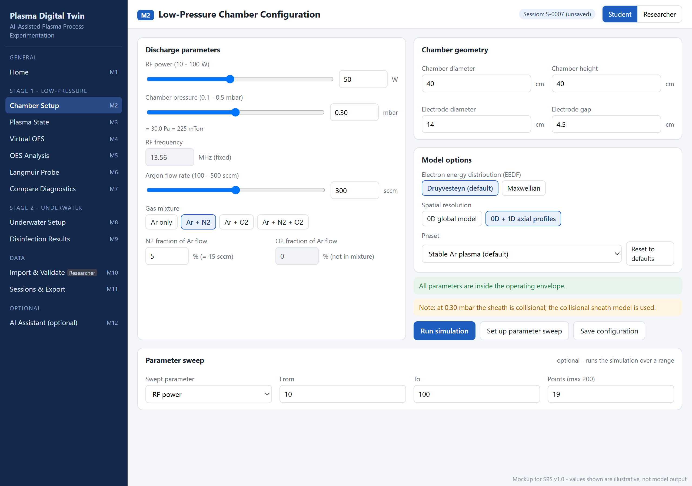
Figure 16.1: Stage 1 low-pressure chamber configuration (SRS Mockup M2)
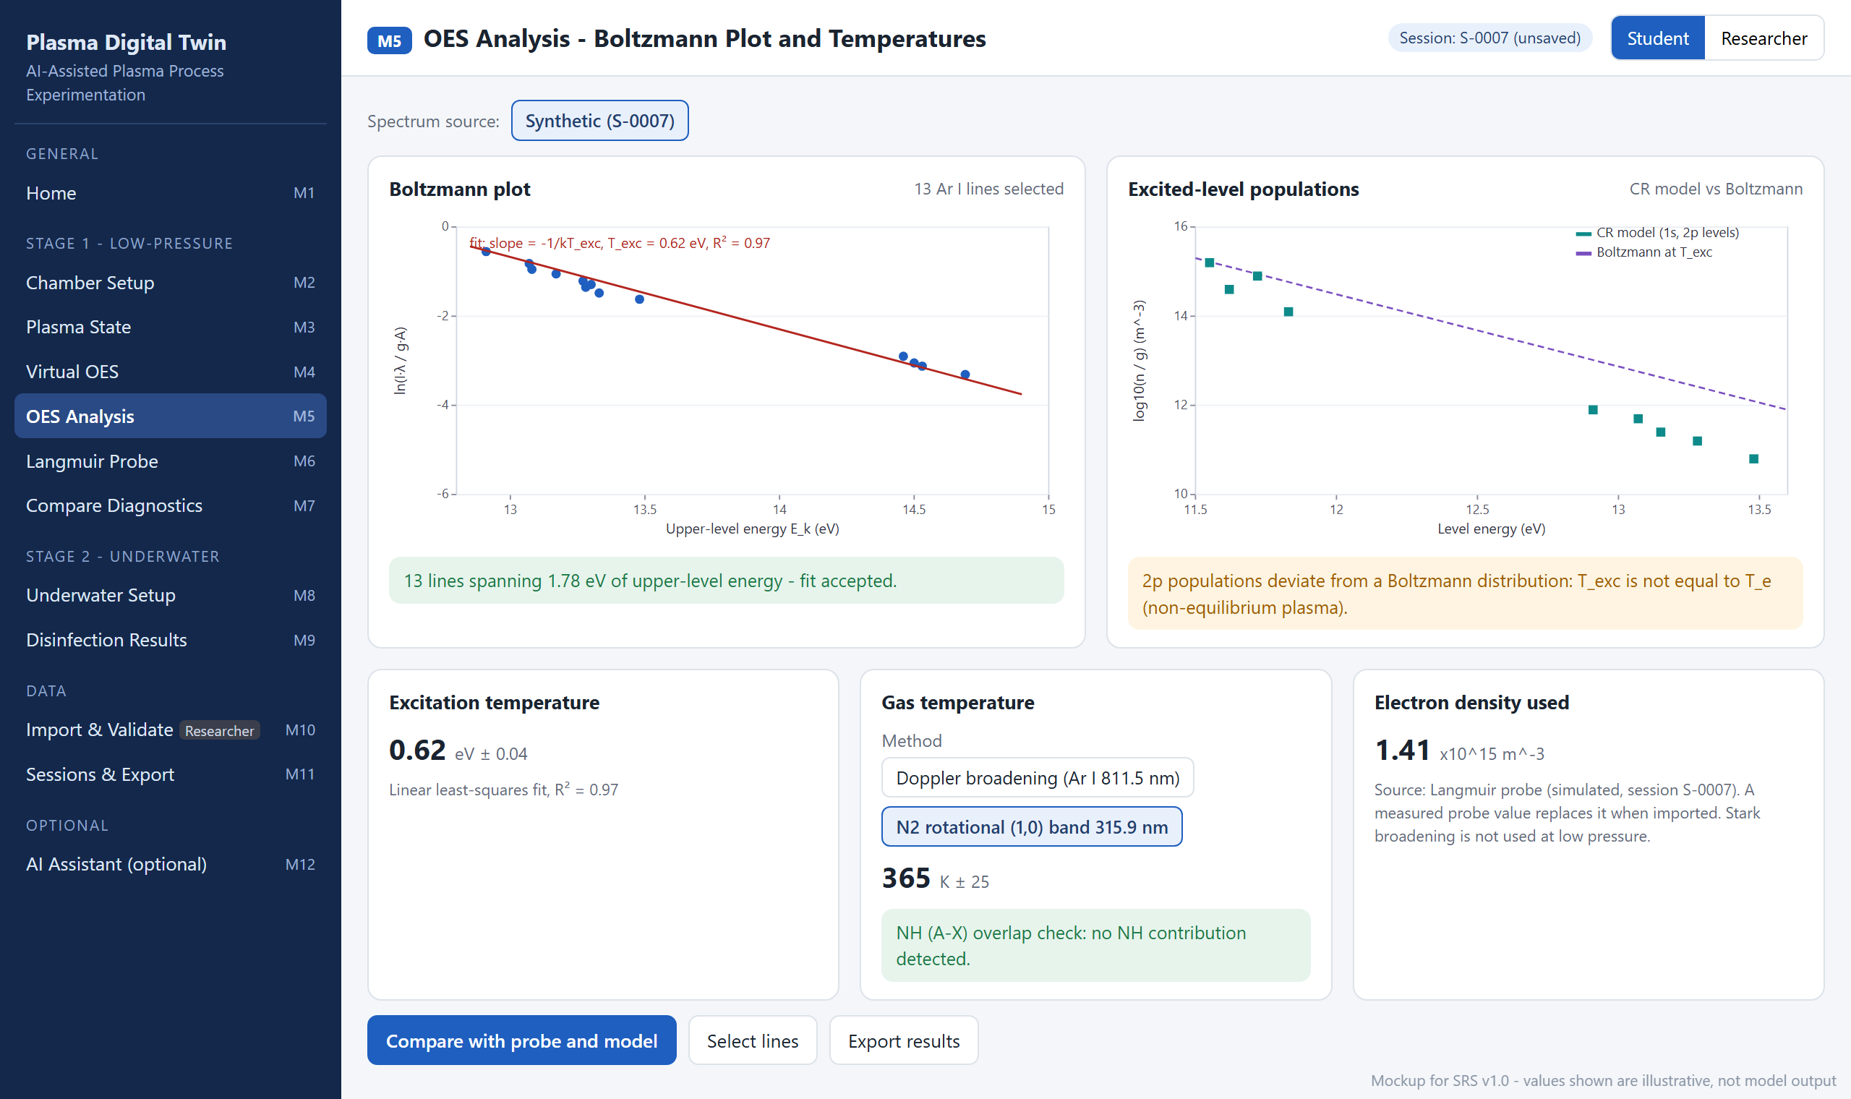
Figure 16.2: OES analysis: Boltzmann plot and temperatures (SRS Mockup M5)
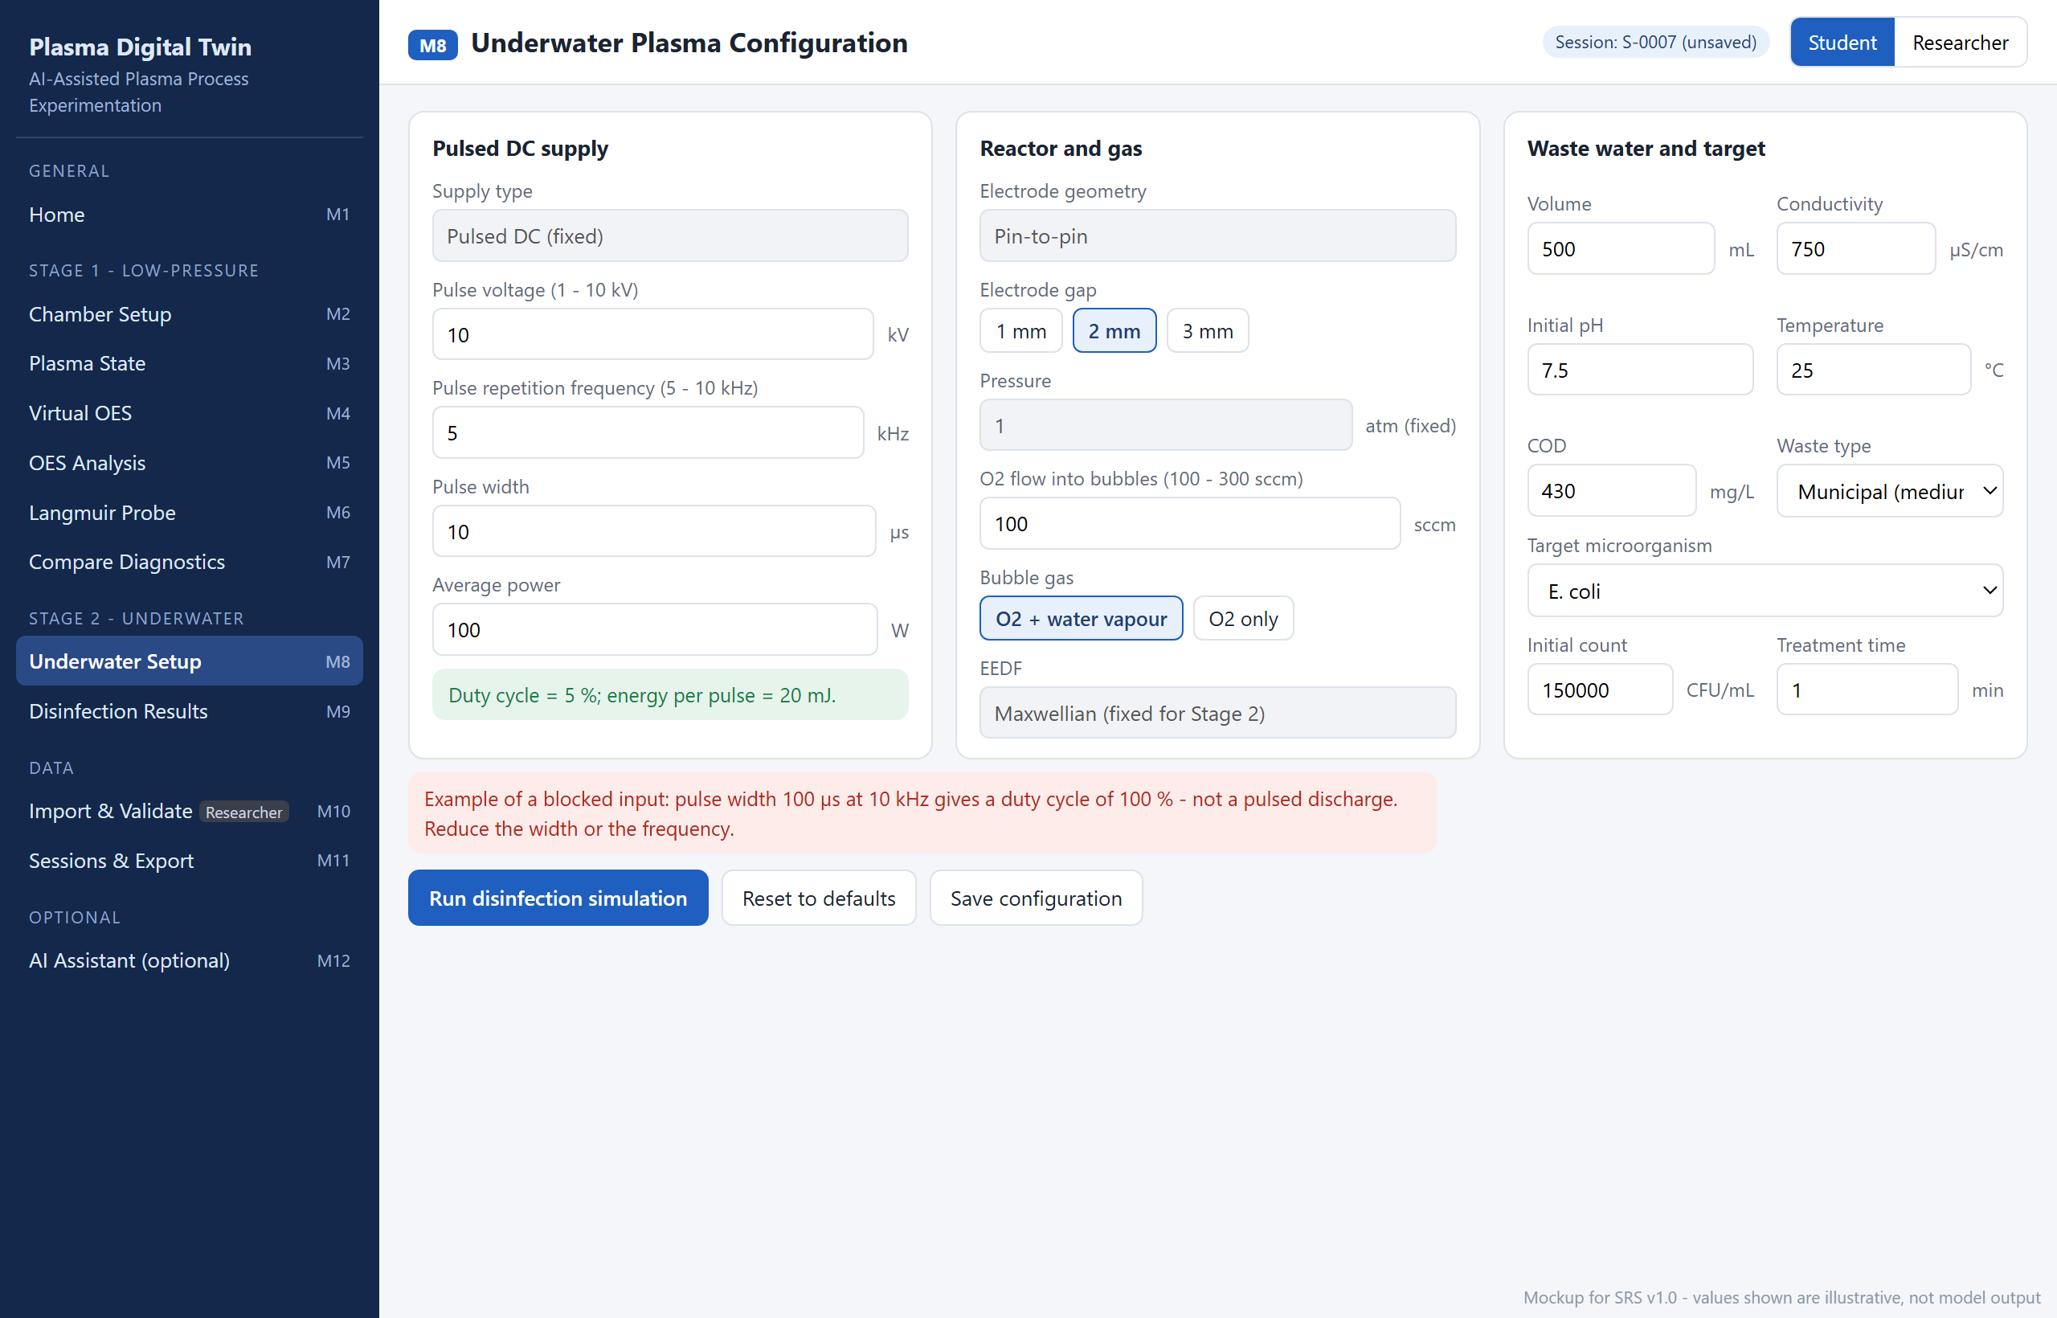
Figure 16.3: Stage 2 underwater plasma configuration (SRS Mockup M8)

17. References
[1] M. A. Lieberman and A. J. Lichtenberg. Principles of Plasma Discharges and Materials Processing, 2nd ed. Hoboken, NJ: Wiley-Interscience, 2005.
[2] C. Lee and M. A. Lieberman. “Global model of Ar, O₂, Cl₂, and Ar/O₂ high-density plasma discharges.” Journal of Vacuum Science & Technology A, vol. 13, no. 2, pp. 368–380, 1995.
[3] X.-M. Zhu and Y.-K. Pu. “A simple collisional–radiative model for low-temperature argon discharges with pressure ranging from 1 Pa to atmospheric pressure: kinetics of Paschen 1s and 2p levels.” Journal of Physics D: Applied Physics, vol. 43, no. 1, 015204, 2010.
[4] A. Kramida, Yu. Ralchenko, J. Reader, and NIST ASD Team. “NIST Atomic Spectra Database.” Internet: https://physics.nist.gov/asd, [Oct. 25, 2026].
[5] F. F. Chen. “Langmuir probe diagnostics,” in Mini-Course on Plasma Diagnostics, IEEE-ICOPS Meeting, Jeju, Korea, 2003.
[6] M. J. Druyvesteyn. “Der Niedervoltbogen.” Zeitschrift für Physik, vol. 64, pp. 781–798, 1930.
[7] L. W. Hom. “Kinetics of chlorine disinfection in an ecosystem.” Journal of the Sanitary Engineering Division (ASCE), vol. 98, no. 1, pp. 183–194, 1972.
[8] M. M. Turner, A. Derzsi, Z. Donkó, et al. “Simulation benchmarks for low-pressure plasmas: capacitive discharges.” Physics of Plasmas, vol. 20, no. 1, 013507, 2013.
[9] V. A. Godyak, R. B. Piejak, and B. M. Alexandrovich. “Measurement of electron energy distribution in low-pressure RF discharges.” Plasma Sources Science and Technology, vol. 1, no. 1, pp. 36–58, 1992.
[10] LXCat Project. “Plasma Data Exchange Project – electron scattering cross sections.” Internet: https://www.lxcat.net, [Oct. 25, 2026].
[11] G. J. M. Hagelaar and L. C. Pitchford. “Solving the Boltzmann equation to obtain electron transport coefficients and rate coefficients for fluid models.” Plasma Sources Science and Technology, vol. 14, no. 4, pp. 722–733, 2005.
[12] X.-M. Zhu and Y.-K. Pu. “Optical emission spectroscopy in low-temperature plasmas containing argon and nitrogen: determination of the electron temperature and density by the line-ratio method.” Journal of Physics D: Applied Physics, vol. 43, no. 40, 403001, 2010.
[13] P. J. Bruggeman, N. Sadeghi, D. C. Schram, and V. Linss. “Gas temperature determination from rotational lines in non-equilibrium plasmas: a review.” Plasma Sources Science and Technology, vol. 23, no. 2, 023001, 2014.
[14] M. A. Gigosos, M. Á. González, and V. Cardeñoso. “Computer simulated Balmer-alpha, -beta and -gamma Stark line profiles for non-equilibrium plasmas diagnostics.” Spectrochimica Acta Part B, vol. 58, no. 8, pp. 1489–1504, 2003.
[15] N. Wali, Q. U. Din, N. U. Rehman, et al. “Preliminary exploration on the low-pressure Ar-O₂ plasma generated by low-frequency AC power supply.” arXiv preprint arXiv:2405.05739, 2024.
[16] B. R. Locke, M. Sato, P. Sunka, M. R. Hoffmann, and J.-S. Chang. “Electrohydraulic discharge and nonthermal plasma for water treatment.” Industrial & Engineering Chemistry Research, vol. 45, no. 3, pp. 882–905, 2006.
[17] P. J. Bruggeman, M. J. Kushner, B. R. Locke, et al. “Plasma–liquid interactions: a review and roadmap.” Plasma Sources Science and Technology, vol. 25, no. 5, 053002, 2016.
[18] Ahmed et al. “DNA reduction of waterborne E. coli by underwater capillary discharge.” Jordan Journal of Physics, vol. 15, no. 2, 2022.
[19] Metcalf & Eddy, Inc. Wastewater Engineering: Treatment and Reuse, 4th ed. New York: McGraw-Hill, 2003.
[20] COMSOL AB. “Plasma Module – COMSOL Multiphysics.” Internet: https://www.comsol.com/plasma-module, [Oct. 25, 2026].
[21] C. O. Laux. “SPECAIR – radiation code for air, nitrogen and other plasmas.” Internet: https://www.specair-radiation.net, [Oct. 25, 2026].
[22] J. Voráč, P. Synek, L. Potočňáková, J. Hnilica, and V. Kudrle. “Batch processing of overlapping molecular spectra as a tool for spatio-temporal diagnostics of power modulated microwave plasma jet.” Plasma Sources Science and Technology, vol. 26, no. 2, 025010, 2017.
[23] Impedans Ltd. “Langmuir Probe – plasma measurement system.” Internet: https://www.impedans.com, [Oct. 25, 2026].
[24] PlasmaPy Community. “PlasmaPy: an open source community-developed Python package for plasma research and education.” Internet: https://www.plasmapy.org, [Oct. 25, 2026].
[25] L. Grinsztajn, E. Oyallon, and G. Varoquaux. “Why do tree-based models still outperform deep learning on typical tabular data?” in Proc. NeurIPS Datasets and Benchmarks Track, 2022.
[26] A. N. Angelopoulos and S. Bates. “Conformal prediction: a gentle introduction.” Foundations and Trends in Machine Learning, vol. 16, no. 4, pp. 494–591, 2023.
[27] M. R. T. Khan and S. U. Rehman. “Software Requirements Specification, version 1.0, AI-Assisted Plasma Process Experimentation & Digital Twin Analytics Platform.” COMSATS University Islamabad, Oct. 2026.

18. Plagiarism / Originality Statement
This document has been written by the project team specifically for this final year project. All plasma physics models, data sources and methods are taken from the published literature and data sets cited in Section 17, and the operating parameters come from the supervisor's written answers. No part of this document has been submitted for any other degree or qualification.

