COMSATS University Islamabad, Pakistan

AI-Assisted Plasma Process Experimentation & Digital Twin Analytics Platform
Software Requirements Specification (SRS)
Version 1.1
By
Muhammad Rayyan Taimoor Khan | CIIT/FA23-BCS-072/ISB
Sadeem Ur Rehman | CIIT/FA23-BCS-127/ISB
Supervisor
Dr. Majid Iqbal
Bachelor of Science in Computer Science (2023–2027)
Department of Computer Science
COMSATS University Islamabad, Islamabad Campus
October 2026

Revision History
The table below records every released version of this Software Requirements Specification. A new row is added whenever the document is changed after review, so evaluators can see what was changed, when and why.
Version | Date | Description of change | Author(s)
1.0 | 25-Oct-2026 | Initial SRS for the revised three-stage scope (low-pressure argon plasma with OES and Langmuir probe; underwater oxygen plasma for disinfection). Supersedes the requirements implied by Scope Document v2.0, following the supervisor's redirection of the project (Section 1.6.2). | M. Rayyan Taimoor Khan, Sadeem Ur Rehman
1.1 | 29-Oct-2026 | AI made the second core module (no longer optional): Core Module 1 Digital Twin and Core Module 2 AI. Added objectives BO-6 to BO-9, sub-modules 2.1–2.5, mockups M13–M16 and their requirements, use cases UC-24 to UC-28, backend events E23–E27, AI model-quality requirements AIQ-1 to AIQ-6 and constraint CON-12; updated the architecture, traceability and Plagiarism Report chapter. Event requirements renumbered FR13.x → FR17.x. | M. Rayyan Taimoor Khan, Sadeem Ur Rehman

Abstract
Plasma diagnostics such as optical emission spectroscopy (OES) and Langmuir probes are central to plasma physics teaching and research, yet students can rarely practise them because laboratory plasma systems are expensive, shared and slow to operate. At present, students either wait for limited time on real equipment or use separate specialist programs, each of which covers only one piece of the problem, such as electron kinetics, spectrum synthesis or probe-curve fitting. Two challenges follow: a student cannot see how a change in RF power, pressure or gas flow propagates through the plasma state into the measured spectrum and probe curve, and there is no simple way to check those diagnostics against each other or against measured data. The same gap exists for underwater plasma disinfection, where discharge settings are rarely connected quantitatively to the reactive species produced and the resulting bacterial log reduction. No single, low-cost, physics-based tool links discharge settings, plasma state, synthetic diagnostics and validation for both a low-pressure and an underwater plasma. This project will build a software digital twin of a 13.56 MHz capacitively coupled argon plasma (10–100 W, 0.1–0.5 mbar, 100–500 sccm, with optional N₂ and O₂) whose electron temperature, electron density and gas temperature come from particle and power balance equations. It will generate and analyse virtual OES spectra (Boltzmann plot, excitation and gas temperature) and virtual Langmuir probe curves (OML theory, Druyvesteyn EEDF), and it will model an underwater pulsed-DC oxygen bubble discharge whose reactive species drive a Hom-model prediction of E. coli inactivation. All diagnostics will be cross-checked against the model and against published or measured data within a fixed ±30 % tolerance. A second core module applies AI to the twin: it infers plasma parameters from spectra with stated uncertainty, detects runs that break the expected physics, explains the twin through a fast surrogate, and recommends settings whose outcome is re-simulated by the twin. The result is a free, repeatable virtual plasma laboratory that lets students and researchers rehearse experiments, interpret diagnostics and validate measurements before and after using the real laboratory.
Table of Contents
Chapter 1: Introduction and Problem Definition 1
1.1 Overview of the Project 1
1.2 Vision Statement 1
1.3 Problem Statement 2
1.4 Problem Solution 2
1.5 Objectives of the Proposed System 3
1.6 Scope 3
1.6.1 Limitations/Constraints 4
1.6.2 Scope Evaluation Feedback and Improvements 5
1.7 Modules 6
1.7.1 Core Module 1: Digital Twin (physics engine) 6
1.7.2 Core Module 2: AI Module 7
1.7.3 Supporting Components 8
1.8 Related System Analysis/Literature Review 9
1.8.1 Literature Review 9
1.8.2 Related System Analysis 10
1.9 Tools and Technologies 11
1.10 Project Contribution 12
1.11 Relevance to Course Modules 13
Chapter 2: Requirement Analysis 14
2.1 User Classes and Characteristics 14
2.2 Operating Environment 14
2.3 Design and Implementation Constraints 15
2.4 Use Case Diagram 16
2.5 Requirement Identifying Technique 19
2.6 Functional Requirements 19
2.6.1 Mockup M1 – Home Screen 19
2.6.2 Mockup M2 – Low-Pressure Chamber Configuration 21
2.6.3 Mockup M3 – Low-Pressure Plasma State Results 22
2.6.4 Mockup M4 – Virtual OES – Synthetic Spectrum 24
2.6.5 Mockup M5 – OES Analysis – Boltzmann Plot and Temperatures 25
2.6.6 Mockup M6 – Virtual Langmuir Probe 26
2.6.7 Mockup M7 – Diagnostics Comparison (Model vs OES vs Probe) 28
2.6.8 Mockup M8 – Underwater Plasma Configuration 29
2.6.9 Mockup M9 – Underwater Plasma and Disinfection Results 30
2.6.10 Mockup M10 – Measured Data Import and Validation 32
2.6.11 Mockup M11 – Session History and Export 33
2.6.12 Mockup M12 – AI Parameter Inference from Spectra 34
2.6.13 Mockup M13 – AI Physics-Relationship Anomaly Detection 35
2.6.14 Mockup M14 – AI Recommendations (Inverse Design) 37
2.6.15 Mockup M15 – AI Surrogate Model and Explainability 38
2.6.16 Mockup M16 – AI Training, Evaluation and Model Registry 39
2.6.17 Backend Event–Response Table 41
2.6.18 Functional Requirements Derived from Events 45
2.7 Non-Functional Requirements 46
2.7.1 Reliability 46
2.7.2 Usability 47
2.7.3 Performance 47
2.7.4 Security 48
2.7.5 Accuracy and Scientific Validity 49
2.7.6 AI Model Quality 49
2.7.7 Maintainability and Portability 50
2.8 External Interface Requirements 50
2.8.1 User Interfaces Requirements 50
2.8.2 Software Interfaces 51
2.8.3 Hardware Interfaces 51
2.8.4 Communications Interfaces 52
Chapter 3: Design and Architecture 53
3.1 System Architecture Overview 53
3.1.1 Purpose 53
3.1.2 Technologies and Services 54
3.2 Architecture Style and Support for Non-Functional Requirements 55
References 57
Appendix A: Interactive Mockup Prototype 60
A.1 How to Use the Prototype 60
A.2 Screen Index 60
Appendix B: Requirements Traceability Matrix 62
Appendix C: Resolved Parameter Values and Sources 63
Plagiarism Report 64

List of Figures
Figure 2.1: Use case diagram of the Plasma Digital Twin Platform 17
Figure 2.2: Mockup M1 – Home Screen 20
Figure 2.3: Mockup M2 – Low-Pressure Chamber Configuration 21
Figure 2.4: Mockup M3 – Low-Pressure Plasma State Results 23
Figure 2.5: Mockup M4 – Virtual OES – Synthetic Spectrum 24
Figure 2.6: Mockup M5 – OES Analysis – Boltzmann Plot and Temperatures 25
Figure 2.7: Mockup M6 – Virtual Langmuir Probe 27
Figure 2.8: Mockup M7 – Diagnostics Comparison (Model vs OES vs Probe) 28
Figure 2.9: Mockup M8 – Underwater Plasma Configuration 29
Figure 2.10: Mockup M9 – Underwater Plasma and Disinfection Results 31
Figure 2.11: Mockup M10 – Measured Data Import and Validation 32
Figure 2.12: Mockup M11 – Session History and Export 33
Figure 2.13: Mockup M12 – AI Parameter Inference from Spectra 34
Figure 2.14: Mockup M13 – AI Physics-Relationship Anomaly Detection 36
Figure 2.15: Mockup M14 – AI Recommendations (Inverse Design) 37
Figure 2.16: Mockup M15 – AI Surrogate Model and Explainability 39
Figure 2.17: Mockup M16 – AI Training, Evaluation and Model Registry 40
Figure 3.1: Conceptual architecture of the Plasma Digital Twin Platform 54

List of Tables
Table 1.1: Scope evaluation feedback and resulting improvements 5
Table 1.2: Related system analysis with proposed project solution 10
Table 1.3: Tools and technologies for the proposed project 11
Table 2.1: User classes and external actors 14
Table 2.2: Use case summary and traceability 18
Table 2.3: Functional requirements derived from Mockup M1 – Home Screen 20
Table 2.4: Functional requirements derived from Mockup M2 – Low-Pressure Chamber Configuration 21
Table 2.5: Functional requirements derived from Mockup M3 – Low-Pressure Plasma State Results 23
Table 2.6: Functional requirements derived from Mockup M4 – Virtual OES – Synthetic Spectrum 24
Table 2.7: Functional requirements derived from Mockup M5 – OES Analysis – Boltzmann Plot and Temperatures 26
Table 2.8: Functional requirements derived from Mockup M6 – Virtual Langmuir Probe 27
Table 2.9: Functional requirements derived from Mockup M7 – Diagnostics Comparison (Model vs OES vs Probe) 28
Table 2.10: Functional requirements derived from Mockup M8 – Underwater Plasma Configuration 30
Table 2.11: Functional requirements derived from Mockup M9 – Underwater Plasma and Disinfection Results 31
Table 2.12: Functional requirements derived from Mockup M10 – Measured Data Import and Validation 32
Table 2.13: Functional requirements derived from Mockup M11 – Session History and Export 34
Table 2.14: Functional requirements derived from Mockup M12 – AI Parameter Inference from Spectra 35
Table 2.15: Functional requirements derived from Mockup M13 – AI Physics-Relationship Anomaly Detection 36
Table 2.16: Functional requirements derived from Mockup M14 – AI Recommendations (Inverse Design) 38
Table 2.17: Functional requirements derived from Mockup M15 – AI Surrogate Model and Explainability 39
Table 2.18: Functional requirements derived from Mockup M16 – AI Training, Evaluation and Model Registry 40
Table 2.19: Identified backend events 41
Table 2.20: Event–response table for backend processes 41
Table 2.21: Functional requirements derived from the event–response table 45
Table 2.22: Reliability requirements 46
Table 2.23: Usability requirements 47
Table 2.24: Performance requirements 47
Table 2.25: Security requirements 48
Table 2.26: Accuracy and scientific validity requirements 49
Table 2.27: AI model-quality requirements 49
Table 2.28: Maintainability and portability requirements 50
Table 3.1: Technologies, components and security mechanisms used in the system architecture 54
Table 3.2: Architectural support for the non-functional requirements 55
Table A.1: Screens of the interactive prototype 60
Table B.1: Requirements traceability matrix 62
Table C.1: Resolved parameter values and their sources 63

Abbreviations
The table below lists the abbreviations and symbols used in this document.
Abbreviation / Symbol | Meaning
0D / 1D | Zero-dimensional (volume-averaged) / one-dimensional (axial) model
AIQ | AI model-quality requirement
BO | Business Objective
BR | Business Rule
CCP | Capacitively Coupled Plasma
CFU | Colony-Forming Unit
COD | Chemical Oxygen Demand
CR model | Collisional-Radiative model
CSV | Comma-Separated Values
DC | Direct Current
EEDF / EEPF | Electron Energy Distribution / Probability Function
FE | Feature
FR | Functional Requirement
FWHM | Full Width at Half Maximum
I-V | Current–voltage characteristic of a Langmuir probe
LXCat | Plasma Data Exchange Project (electron cross-section database)
M1 … M16 | Mockup identifiers
MAE | Mean Absolute Error
ML | Machine Learning
NFR | Non-Functional Requirement
NIST ASD | NIST Atomic Spectra Database
n_{e} | Electron density (m⁻³)
OES | Optical Emission Spectroscopy
OML | Orbital Motion Limited (probe theory)
ORP | Oxidation–Reduction Potential
RF | Radio Frequency
sccm | Standard cubic centimetres per minute
SHAP | SHapley Additive exPlanations
SRS | Software Requirements Specification
T_{e} | Electron temperature (eV)
T_{exc} | Excitation temperature (eV)
T_{gas} | Gas (neutral) temperature (K)
UC | Use Case
V_{f} / V_{p} | Floating potential / plasma potential (V)
λ_{D} | Electron Debye length
1 lac | 100 000 (used for colony counts)

Chapter 1: Introduction and Problem Definition
This chapter introduces the Plasma Digital Twin Platform. It states the vision, the problem and the proposed solution, sets measurable business objectives, defines the scope and its limits, records how the scope was revised after supervisor review, lists the modules and their features, reviews related systems and literature, and closes with the tools, the contribution of the project and its relevance to the BSCS course modules.

1.1 Overview of the Project
The AI-Assisted Plasma Process Experimentation & Digital Twin Analytics Platform is a desktop, browser-based virtual plasma laboratory for plasma physics students and researchers. It reproduces, in software, the three experimental stages defined by the supervisor: Stage 1, a low-pressure argon plasma generated in a 13.56 MHz capacitively coupled (CCP) chamber and diagnosed by optical emission spectroscopy (OES); Stage 2, an underwater high-pressure oxygen plasma generated inside gas bubbles by a pulsed DC supply and used to disinfect municipal waste water; and Stage 3, Langmuir probe diagnostics, which are applied to the Stage 1 plasma only. For each stage the user sets the same controls that exist on the real equipment (RF power, pressure, gas flow and mixture, or pulse voltage, frequency and electrode gap), the platform solves physics-based models for the plasma state, and it then produces the signals a real instrument would record: an emission spectrum, a probe current–voltage (I-V) curve, or a bacterial survival curve. These signals are analysed with the same methods used in the laboratory, compared with each other and with the model, and validated against published or measured data. The platform has two core modules: Core Module 1, the Digital Twin, which holds all of this physics, and Core Module 2, the AI Module, which learns from data generated by the twin to infer plasma parameters from spectra, detect physics-relationship anomalies, explain the twin through a fast surrogate, and recommend operating settings that are verified by re-running the twin.

1.2 Vision Statement
For plasma physics students and researchers at COMSATS University Islamabad who need to practise and understand plasma diagnostics without waiting for scarce laboratory time, the Plasma Digital Twin Platform is a physics-based virtual plasma laboratory that lets them configure a low-pressure argon plasma and an underwater oxygen plasma, obtain the resulting plasma state, generate and analyse realistic OES spectra and Langmuir probe curves, predict disinfection performance, and validate every result against published and measured data. Unlike specialist commercial simulators and single-purpose analysis programs, which are expensive or cover only one step of the chain, our product connects discharge settings, plasma physics, synthetic diagnostics and validation in one free, transparent and repeatable environment in which every number shown can be traced back to a published equation or data source.

1.3 Problem Statement
Plasma diagnostics are learned by doing, but doing is expensive. A low-pressure RF plasma system needs a vacuum chamber, pumps, gas controllers, an RF generator with a matching network, a spectrometer and a probe system, and the laboratory is shared between many users. A student therefore gets only a few hours of operating time, often without being able to repeat a run or explore the full range of power, pressure and gas flow. Interpreting the results is also hard. The emission spectrum depends on the electron temperature, the electron density and the electron energy distribution through a chain of atomic processes, and a probe curve is distorted by the RF sheath oscillation; students who see only the final spectrum or curve cannot tell which physical cause produced which feature. Existing software does not close this gap. General multiphysics packages are costly and require expertise in finite-element modelling, while free tools each address one step (electron kinetics, spectrum synthesis or probe fitting) and must be stitched together by hand in spreadsheets. The same problem exists for underwater plasma disinfection, where the link from pulse voltage, frequency and gas flow to reactive species and finally to bacterial log reduction is usually studied only by trial and error. Finally, when measured data become available, there is no consistent, tolerance-based way to check them against theory and against the other diagnostic, so errors in either the experiment or the analysis can go unnoticed.

1.4 Problem Solution
The proposed system solves the problem with a digital twin for each plasma and a virtual instrument for each diagnostic, all connected through one plasma state. For Stage 1, a volume-averaged (0D) global model solves the particle balance for the electron temperature and the power balance for the electron density [1, 2], extended with gas flow, gas temperature, Ar/N₂/O₂ chemistry, a Druyvesteyn electron energy distribution and a 1D axial profile. The virtual OES uses a collisional-radiative (CR) model of the argon 1s and 2p levels [3] and NIST line data [4] to synthesise a spectrum, which is then analysed with a Boltzmann plot, line-ratio methods and rotational or Doppler gas-temperature methods. The virtual Langmuir probe computes an RF-distorted I-V curve and analyses it with OML theory and the Druyvesteyn method [5, 6]. For Stage 2, a gas-phase global model of the oxygen–water-vapour bubble discharge feeds an empirical transfer of reactive species into the water and a Hom disinfection model [7]. A comparison screen places model, OES and probe values side by side with a fixed ±30 % tolerance, and a researcher can import measured OES and probe files for validation only. Every run can be saved, compared and exported. The second core module, the AI module, learns from data generated by the twin: tree-ensemble models infer plasma parameters from a spectrum with conformal prediction intervals, an Isolation Forest flags runs whose diagnostics break the expected physics relationship, a surrogate with SHAP explains which inputs drive each output, and a recommendation engine proposes settings for a goal and re-simulates each one through the twin before showing it.

1.5 Objectives of the Proposed System
The business objectives below are measurable so that the final product can be evaluated against them. Each objective is traced to modules, use cases and requirements in Appendix B.
BO-1: Provide a virtual low-pressure argon CCP experiment that covers the whole supervisor-defined operating envelope (10–100 W, 0.1–0.5 mbar, Ar 100–500 sccm, N₂ and O₂ admixtures) and whose computed T_{e}, n_{e} and T_{gas} agree with published reference values within ±30 % at no fewer than three reference operating points.
BO-2: Allow a student to configure a Stage 1 run and obtain a synthetic OES spectrum and a Langmuir probe analysis for it in under 5 minutes, with every derived quantity (T_{e}, n_{e}, T_{gas}, T_{exc}) reported with its uncertainty and method.
BO-3: Demonstrate diagnostic consistency: OES- and probe-derived values shall agree with the model within ±30 % for at least 90 % of a pre-registered grid of Stage 1 test configurations.
BO-4: Predict the E. coli log reduction of the underwater oxygen discharge within ±30 % of published reference data at no fewer than one reference operating point, together with the D-value and energy yield.
BO-5: Allow a researcher to import a measured OES spectrum (.txt) or probe I-V curve (.csv) and obtain a validation report in under 10 minutes, without measured data ever being used to tune model parameters.
BO-6: Infer T_{e}, n_{e} and T_{gas} from an emission spectrum with an AI model whose error is significantly lower than a ridge-regression baseline (paired bootstrap, p < 0.05) and whose 90 % prediction intervals reach at least 85 % coverage on held-out synthetic spectra.
BO-7: Detect physics-relationship faults injected by the twin (probe contamination, wavelength shift, air leak, power-meter error, RF compensation failure) with at least 90 % recall at no more than 5 % false alarms, significantly better than a range-check baseline.
BO-8: Provide a surrogate of the twin with R² ≥ 0.98 and median relative error ≤ 5 % on held-out twin runs, at least 100 times faster than the twin, with SHAP explanations of its outputs.
BO-9: Recommend operating settings for a user goal such that 100 % of recommendations are re-simulated by the twin and the twin confirms the goal is met for at least 90 % of a benchmark set of goals.

1.6 Scope
The scope of the project is a single-user, locally installed software platform that simulates and analyses two laboratory plasmas and two diagnostic techniques. The platform simulates a low-pressure argon plasma in a 13.56 MHz capacitively coupled chamber of 40 cm by 40 cm with electrodes 14 cm in diameter and 4.5 cm apart. The user controls RF power from 10 to 100 W, pressure from 0.1 to 0.5 mbar, argon flow from 100 to 500 sccm and the gas mixture, where nitrogen and oxygen are each added as 5 % of the argon flow by default. The Stage 1 model is a volume-averaged global model that solves particle and power balance for the electron temperature and electron density and an energy balance for the gas temperature, with a Druyvesteyn electron energy distribution and an optional one-dimensional axial profile. A virtual OES module produces the emission spectrum of this plasma from a collisional-radiative model, adds the effect of the spectrometer resolution and noise, and analyses the spectrum with a Boltzmann plot, the excitation temperature, the excited-level population distribution and the gas temperature from Doppler broadening or the nitrogen rotational band. A virtual Langmuir probe produces the current–voltage curve of a cylindrical tungsten probe in the same plasma, including RF sheath distortion, and analyses it with orbital-motion-limited theory to obtain the floating and plasma potentials, electron temperature, electron density, Debye length and the electron energy distribution. A comparison function shows model, OES and probe values side by side and marks each as inside or outside a fixed ±30 % tolerance. The platform also simulates an underwater oxygen plasma generated inside bubbles by a pulsed DC supply of up to 10 kV at 5 to 10 kHz and 100 W average power across a pin-to-pin gap of 1 to 3 mm at 1 atm. For this plasma it computes the bubble plasma state with a Maxwellian distribution, the concentrations of ozone, hydrogen peroxide and hydroxyl radicals in the water, the change in pH, oxidation–reduction potential, conductivity and temperature, and the survival of E. coli and other listed organisms with the Hom model. Its virtual OES shows the OH, H-alpha and atomic oxygen lines and estimates the electron density from H-alpha Stark broadening. In researcher mode, the user can import measured spectra and probe curves, attach the required metadata, and validate the models against these files and against published benchmarks, while measured data stay non-citable unless permission is given. All runs can be saved, reopened, compared and exported as tables, figures or a PDF report. The AI module, the second core module, is trained only on synthetic data generated by the twin. It infers electron temperature, electron density and gas temperature from a spectrum with prediction intervals, flags runs and measured files whose diagnostics break the expected physics relationship, offers a fast surrogate with SHAP explanations, and recommends settings for a user goal, each of which is re-simulated by the twin. Control of real laboratory hardware, other gases, multi-dimensional fluid or particle simulations and multi-user accounts are outside the scope.

1.6.1 Limitations/Constraints
LI-1: The platform is software-only. It does not control or acquire data directly from laboratory hardware; measured data enter only as exported files.
LI-2: Stage 1 is limited to argon with nitrogen and/or oxygen admixtures of 1–10 % of the argon flow each; other feed gases are not modelled.
LI-3: Stage 1 uses a volume-averaged (0D) model with an optional 1D axial profile; radial non-uniformity, 2D/3D fluid and particle-in-cell effects are not modelled.
LI-4: When oxygen is present the plasma becomes electronegative; the global model includes negative ions, but the OML probe analysis assumes an electropositive plasma, so probe results with O₂ are flagged as approximate.
LI-5: Stage 2 uses a gas-phase global model with empirical transfer of species into the liquid. It does not solve full plasma–liquid reaction–transport equations or bubble dynamics.
LI-6: Hom disinfection parameters come from published time-resolved data until validated measurements exist. An organism without published parameters cannot be simulated and is shown as unavailable.
LI-7: Measured data supplied by the laboratory may not be cited or published (supervisor decision); report validation therefore relies on published literature, and measured data are used privately for validation only.
LI-8: Agreement is targeted at ±30 % (semi-quantitative). The platform is a learning and pre-experiment planning tool, not a certified predictive instrument.
LI-9: The platform is single-user and runs on one computer; there are no user accounts, so the Student and Researcher roles are usage modes, not security boundaries.

1.6.2 Scope Evaluation Feedback and Improvements
The earlier scope (Scope Document v2.0) described a semiconductor-processing digital twin centred on machine-learning analytics. During scope evaluation, the supervisor, whose original research idea the project is, redirected it toward plasma diagnostics and environmental application, and confirmed the new parameters in written answers to two questionnaire rounds. Table 1.1 summarises the feedback and the resulting change in this SRS.
Table 1.1: Scope evaluation feedback and resulting improvements
Area | Previous scope (v2.0) | Supervisor feedback | Improvement in this SRS
Application framing | Semiconductor processing: etch rate, uniformity, process quality index, defect probability. | Remove the semiconductor framing entirely. | Platform targets plasma diagnostics and water disinfection; all semiconductor indices removed.
Plasma systems | One low-pressure Ar CCP, 1–20 mTorr. | Two plasmas: low-pressure Ar chamber and underwater high-pressure O₂ plasma. | Stage 1 (0.1–0.5 mbar, 10–100 W, 13.56 MHz) and Stage 2 (pulsed DC, 1 atm) twins.
Diagnostics | None; outputs read directly from the model. | OES on both plasmas; Langmuir probe on the low-pressure plasma. | Virtual OES (sub-module 1.2), virtual Langmuir probe (sub-module 1.3) and comparison screen M7.
Gas inputs | Gas flow and gas temperature were not physics inputs. | Ar flow 100–500 sccm; N₂ and O₂ each 5 % of the Ar flow. | Flow enters the particle balance (residence time); T_{gas} is computed; mixture modes added.
Electron energy distribution | Maxwellian rate coefficients only. | Druyvesteyn for low pressure, Maxwellian for underwater. | EEDF selectable for Stage 1 (Druyvesteyn default); Maxwellian fixed for Stage 2.
Spatial fidelity | 0D only. | 1D needed for some quantities. | 1D axial profiles for Stage 1; 0D elsewhere.
Role of AI | Core of the project, aimed at semiconductor process classification (classifiers vs. baseline, anomaly detection, SHAP, recommendations). | AI optional, decided later. | Team decision (29-Oct-2026): AI kept as Core Module 2, retargeted to the new plasmas: spectrum inference, physics-anomaly detection, surrogate with SHAP and twin-verified recommendations.
Data and validation | Synthetic dataset with hidden confounders for ML; reference benchmarks. | Import measured OES/probe data for validation; data not citable; ±30 % tolerance. | Validation-only import with citation flag (sub-module 1.5); fixed ±30 % band on every comparison.

1.7 Modules
The system is a single desktop web application with two core modules. Core Module 1, the Digital Twin, holds all the physics: sub-modules 1.1 and 1.2 implement the supervisor's Stage 1, sub-module 1.4 implements Stage 2 and sub-module 1.3 implements Stage 3 (the Langmuir probe, which is applied to the Stage 1 plasma only, so its screens sit in the low-pressure group of the navigation). Core Module 2, the AI Module, learns from data generated by the twin and always calls the twin to verify what it proposes; the twin never depends on the AI. Two supporting components provide sessions, visualisation and export for both.

1.7.1 Core Module 1: Digital Twin (physics engine)

Sub-module 1.1 Low-Pressure Plasma Model (Stage 1)
FE-1.1.1: Configure RF power, pressure, argon flow, gas mixture, chamber geometry and model options within the supervisor envelope.
FE-1.1.2: Solve the 0D global model: particle balance for T_{e} and power balance for n_{e}.
FE-1.1.3: Compute the gas temperature from an energy balance and the species densities for Ar, N₂ and O₂ mixtures, including metastable and stepwise processes.
FE-1.1.4: Use a Druyvesteyn (default) or Maxwellian EEDF with rate coefficients integrated from published cross-sections.
FE-1.1.5: Compute 1D axial profiles between the electrodes.
FE-1.1.6: Run parameter sweeps of up to 200 points.

Sub-module 1.2 Virtual Optical Emission Spectroscopy
FE-1.2.1: Compute excited-level populations with a collisional-radiative model.
FE-1.2.2: Synthesise an emission spectrum with instrument resolution, wavelength range and noise.
FE-1.2.3: Build a Boltzmann plot and report the excitation temperature.
FE-1.2.4: Display excited-level populations against the Boltzmann distribution.
FE-1.2.5: Determine the gas temperature by N₂ rotational band or Doppler broadening.
FE-1.2.6: Estimate T_{e} by CR-model line ratios and analyse imported measured spectra.

Sub-module 1.3 Virtual Langmuir Probe and Diagnostics Comparison (Stage 3)
FE-1.3.1: Generate a synthetic I-V curve for a cylindrical tungsten probe with RF sheath distortion and noise.
FE-1.3.2: Analyse the curve with OML theory for V_{f}, V_{p}, T_{e}, n_{e} and λ_{D}, including an OML validity check.
FE-1.3.3: Extract the EEPF with the Druyvesteyn second-derivative method.
FE-1.3.4: Compare model, OES and probe values within the ±30 % tolerance.

Sub-module 1.4 Underwater Plasma Disinfection Model (Stage 2)
FE-1.4.1: Configure the pulsed DC supply, electrode gap, oxygen flow, bubble gas, water properties and target organism.
FE-1.4.2: Check pulse consistency (duty cycle and energy per pulse).
FE-1.4.3: Solve the bubble gas-phase global model with a Maxwellian EEDF.
FE-1.4.4: Transfer O₃, H₂O₂ and OH into the liquid with empirical coefficients and compute pH, ORP, conductivity and temperature change.
FE-1.4.5: Predict survival with the Hom model and report log reduction, D-value and energy yield.
FE-1.4.6: Synthesise the underwater OES and estimate n_{e} from H-alpha Stark broadening.

Sub-module 1.5 Validation and Measured Data (Researcher)
FE-1.5.1: Import measured OES spectra (.txt) and probe I-V curves (.csv) with column mapping and units.
FE-1.5.2: Record mandatory metadata and the citation permission for each file.
FE-1.5.3: Run literature benchmarks and measured-data comparisons with the fixed ±30 % tolerance.
FE-1.5.4: Generate a validation report.

1.7.2 Core Module 2: AI Module

Sub-module 2.1 Spectrum-to-Parameter Inference
FE-2.1.1: Infer T_{e}, n_{e} and T_{gas} from a synthetic or imported spectrum with Random Forest or XGBoost regressors.
FE-2.1.2: Give 90 % conformal prediction intervals and withhold estimates outside the training range.
FE-2.1.3: Show the physics-based analysis next to every AI estimate.
FE-2.1.4: Compare every model with a ridge-regression baseline using a paired bootstrap test.

Sub-module 2.2 Physics-Relationship Anomaly Detection
FE-2.2.1: Compute residuals between the twin's prediction and the observed diagnostics of a run or measured file.
FE-2.2.2: Score the residuals with an Isolation Forest and assign Normal, Warning or Critical severity.
FE-2.2.3: Name the residual that contributed most as the likely cause.
FE-2.2.4: Report detection quality on held-out injected faults against a range-check baseline.

Sub-module 2.3 Surrogate Model and Explainability
FE-2.3.1: Train fast surrogates of the Stage 1 and Stage 2 twins for large explorations.
FE-2.3.2: Explain outputs with global and local SHAP values.
FE-2.3.3: Check any surrogate value with the twin and show the twin value if they disagree.

Sub-module 2.4 Counterfactual Recommendation (Inverse Design)
FE-2.4.1: Accept a goal (for example, a target log reduction with the least energy) and fixed settings.
FE-2.4.2: Search the operating envelope on the surrogate and re-simulate the best candidates with the twin.
FE-2.4.3: Rank candidates by their twin-verified outcome and report what-if counterfactuals.
FE-2.4.4: State clearly when no setting inside the envelope can reach the goal.

Sub-module 2.5 AI Training, Evaluation and Model Registry
FE-2.5.1: Generate training data with the twin, with noise, faults and seed fixed before training.
FE-2.5.2: Evaluate every model on random and region-based (extrapolation) splits.
FE-2.5.3: Log every training run with MLflow and publish a model card.
FE-2.5.4: Stamp each model with the twin version and flag models trained on an older version.

1.7.3 Supporting Components

Sub-module S.1 Home, Configuration and Session Management
FE-S.1.1: Select the usage role (Student or Researcher) without login.
FE-S.1.2: Start a default experiment in one action from the quick-start list.
FE-S.1.3: Save, list, search, reopen, compare and delete sessions (configuration plus results).
FE-S.1.4: Show the load status of every reference data set and AI model.

Sub-module S.2 Visualisation, Reporting and Export
FE-S.2.1: Show every result as an interactive chart with labelled axes and SI units.
FE-S.2.2: Export results tables, figures and raw spectra or I-V data as PDF, CSV or PNG.
FE-S.2.3: Exclude non-citable measured data from every export.
FE-S.2.4: Provide a user guide and a glossary of plasma terms.

1.8 Related System Analysis/Literature Review

1.8.1 Literature Review
Global (0D) discharge models. Lieberman and Lichtenberg show that, for a low-pressure discharge, the particle balance between ionization in the volume and ion loss at the walls fixes the electron temperature independently of the absorbed power, and the power balance then fixes the electron density [1]. Lee and Lieberman extended this approach to argon and oxygen mixtures, including negative ions [2], and simulation benchmarks for capacitive discharges by Turner et al. provide reference values for testing models [8]. These models are fast enough for interactive use, which is why they are chosen here instead of fluid or particle-in-cell codes; their weakness is the lack of spatial information, which this project addresses with a 1D axial profile for Stage 1 as requested by the supervisor.
Electron energy distribution and rate data. At pressures of tens of pascals the electron energy distribution in an RF argon discharge departs from a Maxwellian, and Godyak et al. measured such distributions directly [9]. The Druyvesteyn form, which falls faster at high energy, is the supervisor's choice for low pressure, and the Druyvesteyn second-derivative method [6] is also the standard way to extract the distribution from a probe curve. Rate coefficients are obtained by integrating LXCat cross-sections [10] over the chosen distribution, the approach used by the BOLSIG+ solver [11].
Optical emission spectroscopy. Zhu and Pu developed a collisional-radiative model of the argon 1s and 2p levels valid from 1 Pa to atmospheric pressure [3] and a line-ratio method for T_{e} and n_{e} in argon–nitrogen plasmas [12]. Their work shows that 2p populations in such plasmas are not in Boltzmann equilibrium, so an excitation temperature from a Boltzmann plot must not be reported as the electron temperature; the system therefore shows both and explains the difference. Bruggeman et al. reviewed gas-temperature methods and warned that N₂ rotational temperatures in argon-rich plasmas can be distorted by energy transfer from argon metastables [13], which is why the system uses the N₂ (1,0) band at 315.9 nm with an NH overlap check and offers Doppler broadening only when the instrument resolution allows it. For dense underwater plasmas, Stark broadening of H-alpha gives n_{e} through the Gigosos–González–Cardeñoso relation [14].
Langmuir probes. Chen's review gives the OML theory for thin cylindrical probes and its validity limits, the effect of RF potential oscillation and practical analysis steps [5]. A COMSATS Plasma Research Laboratory study of a low-pressure Ar–O₂ discharge used a single tungsten probe of radius 0.195 mm and 5 mm length swept from −20 to +50 V and obtained the EEDF by the Druyvesteyn method [15]; these probe dimensions and sweep settings are used as defaults because the supervisor did not specify a probe type.
Underwater plasma disinfection. Reviews by Locke et al. and Bruggeman et al. describe how discharges in and in contact with water produce O₃, H₂O₂, OH and UV, and how these species transfer into the liquid [16, 17]. A COMSATS-linked underwater capillary discharge study reported the OH (309 nm), H-alpha (656 nm) and atomic oxygen (777 and 844 nm) lines and DNA reduction of E. coli [18]. The Hom model [7], chosen by the supervisor, describes survival curves with shoulders or tails that a single-exponential model cannot fit. Typical municipal waste-water properties are taken from Metcalf & Eddy [19].
Machine learning on simulation data. Tree ensembles, such as Random Forests and gradient-boosted trees like XGBoost [20, 21], remain stronger than deep networks on tabular data of this kind [22], which is why the AI module uses them. Conformal prediction turns any regressor into one with prediction intervals of stated coverage [23]. Isolation Forest finds anomalies by random partitioning and needs no labelled faults [24]. SHAP attributes each prediction to its inputs with Shapley values [25], and differential evolution searches a bounded design space without gradients [26]. Because the training data come from the twin, every AI output can be checked against a known physical answer, and simple baselines (ridge regression, range checks) show whether the learning adds real value.
Gap addressed. The literature provides each model separately, but no reviewed source connects discharge settings, a solved plasma state, synthetic OES and probe signals, their analysis and a tolerance-based validation in one environment, applies the same chain to an underwater disinfection plasma, or couples it to AI that learns from the physics and is verified by it. This project fills that gap.

1.8.2 Related System Analysis
Table 1.2 compares existing systems that address parts of the problem with the proposed platform.
Table 1.2: Related system analysis with proposed project solution
Application | Weakness | Proposed Project Solution
COMSOL Multiphysics Plasma Module [27] | Expensive licence; needs finite-element expertise; no built-in synthetic OES or probe analysis workflow; slow for teaching sweeps. | Free, interactive global model with integrated virtual OES and probe; runs in seconds on a laptop.
BOLSIG+ [11] | Computes the EEDF and rate coefficients only; no plasma state, spectrum or probe curve. | Uses the same cross-section data approach inside a complete plasma-to-diagnostic chain.
SPECAIR [28] | Synthesises molecular spectra from user-supplied temperatures; does not compute the plasma state; argon CR kinetics not its focus. | Spectrum is computed from the solved plasma state through a CR model, so a parameter change can be followed to the spectrum.
MassiveOES [29] | Fits rotational and vibrational temperatures to measured molecular spectra; no plasma model or probe. | Combines spectrum analysis with a forward model and cross-checks with probe and model values.
Impedans Langmuir probe software [30] | Tied to vendor hardware; analyses measured curves only; cannot generate curves for teaching. | Generates RF-distorted synthetic curves and analyses both synthetic and imported curves with open methods.
PlasmaPy [31] | Python library of plasma formulas; no user interface, no integrated experiment workflow. | Point-and-click interface with guided workflow, saved sessions and reports for students.

1.9 Tools and Technologies
Table 1.3 lists the tools and technologies chosen for the project, the purpose of each, and why it was selected.
Table 1.3: Tools and technologies for the proposed project
Tool / Technology | Purpose | Rationale
Python 3.12 or later | Programming language for all models and the application | Rich scientific ecosystem; current XGBoost and SHAP releases require Python ≥ 3.12.
NumPy, SciPy | Numerical arrays; root finding (brentq), ODE integration, curve fitting, signal smoothing, differential evolution, statistical tests | Standard, well-tested numerical libraries; SciPy root finding is required for the global model.
Streamlit | Browser-based user interface served locally | Fast development of interactive scientific dashboards in pure Python.
Plotly | Interactive charts (spectra, I-V curves, profiles, survival curves) | Zoom, hover and export built in; works natively with Streamlit.
SQLite | Local storage of sessions, imported data metadata and validation results | Serverless, single-file, transactional database suited to a single-user desktop tool.
pandas | Tabular handling of imported files and results | Reliable CSV/text parsing and table export.
pytest, GitHub Actions | Unit, integration and regression tests; continuous integration | One test file per module; every requirement can be verified automatically.
Git / GitHub | Version control and collaboration | Traceable history; one commit per working sub-module.
NIST ASD, LXCat data files | Atomic line data and electron cross-sections | Authoritative, citable published data sources.
scikit-learn, XGBoost, MAPIE, SHAP | AI module: tree-ensemble regression, Isolation Forest, conformal intervals, SHAP explanations | Tree ensembles outperform deep learning on tabular data [22]; conformal intervals give coverage guarantees [23].
MLflow (local file store) | Logs every AI training run: data version, seed, hyperparameters, metrics | Reproducible, queryable training history with no server [32].
HTML, CSS, JavaScript | Interactive mockup prototype used for requirement analysis | Clickable prototype opens in any browser with no installation.

1.10 Project Contribution
The project contributes the following, compared with existing manual practice and separate tools:
- One plasma state for every diagnostic. The spectrum, the probe curve and the comparison table are all computed from the same solved plasma state, so the user can trace any feature in a diagnostic signal back to its physical cause.
- Physics instead of curve fitting. Electron temperature and density come from particle and power balance equations, and every other output is derived from them; no output is set independently or fitted to look right.
- Built-in cross-validation. OES, probe and model values are compared automatically against a tolerance fixed before the comparison, which teaches that two diagnostics measuring the same quantity must agree.
- Honest treatment of non-equilibrium. The system shows the excitation temperature and the CR-model populations together and explains why the excitation temperature is not the electron temperature.
- Two plasmas in one tool. The same diagnostic framework covers a low-pressure argon plasma and an underwater disinfection plasma, linking discharge settings to bacterial log reduction and energy yield.
- Responsible use of measured data. Measured files are used for validation only, never for tuning, and non-citable data are removed from every export automatically.
- AI that learns from physics and is checked by it. The AI module is trained only on twin-generated data, every AI estimate is shown beside the physics result, and every recommendation is re-simulated by the twin before it is displayed.
- Honest AI evaluation. Every model is compared with a simple baseline using a statistical test, evaluated on a held-out region of the envelope as well as a random split, and dataset settings are fixed before training.
- Anomalies defined by physics. The anomaly detector looks for diagnostics that disagree with the twin, so it catches faults that a range check cannot see.
- Local-laboratory defaults. Probe dimensions, sweep settings and chamber geometry follow the COMSATS Plasma Research Laboratory, so a student can rehearse the real experiment before entering the laboratory.

1.11 Relevance to Course Modules
- Software Engineering and Software Requirements Engineering: requirement elicitation by supervisor questionnaires, mockup-based requirement analysis, event–response modelling and traceability.
- Human-Computer Interaction: user classes, interactive prototype, usability and accessibility requirements.
- Database Systems: session and validation data model in SQLite with transactions and parameterised queries.
- Numerical Computing, Calculus and Differential Equations: root finding for the particle balance, ODE integration for species kinetics, numerical differentiation of probe curves.
- Probability and Statistics: least-squares fits with uncertainty, noise models, tolerance-based validation and prediction intervals.
- Applied Physics: plasma physics, atomic spectroscopy and electrostatics behind every model.
- Artificial Intelligence and Machine Learning (Core Module 2): tree-ensemble regression, unsupervised anomaly detection, conformal uncertainty, SHAP explainability, surrogate modelling and optimisation-based inverse design.
- Software Quality Engineering: pytest unit and regression tests, continuous integration and measurable NFRs.

Chapter 2: Requirement Analysis
This chapter specifies what the system must do and how well it must do it. It describes the user classes, the operating environment and the design constraints, presents the use case diagram, explains the mockup-based and event–response techniques used to identify requirements, lists the functional requirements screen by screen together with their business rules and backend events, and finally states measurable non-functional and external interface requirements. All values shown in mockups are illustrative placeholders, not computed results.

2.1 User Classes and Characteristics
Table 2.1 describes the user classes (human actors) and the external actors that interact with the system. There is no login: the two human classes are usage roles selected on the Home screen.
Table 2.1: User classes and external actors
User class / Actor | Description and characteristics
Student (Learner) | An undergraduate or graduate physics student learning plasma diagnostics, the primary and most frequent user. Has basic plasma physics knowledge but limited laboratory time and little programming experience. Uses Stage 1 and Stage 2 simulations, virtual OES and probe, comparison, AI inference, anomaly checks, the surrogate and recommendations, sessions and export. Needs guided defaults, clear units and explanations of every symbol.
Researcher | A faculty member, laboratory engineer or research student (including the supervisor) who has, or will have, measured data. Inherits every Student capability and additionally imports measured OES and probe files, manages citation permission, runs validation against measured data and literature benchmarks, and trains and evaluates the AI models. Expects transparent methods and exportable validation reports.
OES Spectrometer (external) | The laboratory high-resolution spectrometer (better than 0.01 nm). It does not connect to the system; its vendor software exports spectra as text files that a Researcher imports.
Langmuir Probe System (external) | The laboratory probe and its acquisition software. It exports I-V curves as .csv files that a Researcher imports.
Reference Data Source (external) | Published data sets shipped with the application: NIST atomic line data, LXCat cross-sections, N₂ band constants and published benchmark and disinfection data. Read at start-up and during validation.

2.2 Operating Environment
OE-1: The system shall run on a 64-bit desktop or laptop computer with Windows 10/11 or Ubuntu 22.04 LTS or later, at least 4 GB RAM (8 GB recommended), 2 GB free disk space and a display of at least 1366 × 768 pixels.
OE-2: The system shall run on Python 3.12 or later with the exact package versions pinned in requirements.txt.
OE-3: The user interface shall be served locally and shall work in the two most recent major versions of Google Chrome, Microsoft Edge and Mozilla Firefox.
OE-4: The system shall operate without an internet connection; all reference data are installed with the application.
OE-5: Measured instrument data shall reach the system only as files (.txt or .csv) copied from the instrument computers by USB drive or network share.
OE-6: Each installation shall serve one user at a time and shall store its data in a local SQLite file inside the application data folder.

2.3 Design and Implementation Constraints
CON-1: The system shall be implemented in Python 3.12+ with Streamlit, Plotly, SQLite, NumPy and SciPy, and, for the AI module, scikit-learn, XGBoost, MAPIE, SHAP and MLflow (local tracking only); no substitute technology or new dependency may be introduced without supervisor approval.
CON-2: The Stage 1 plasma model shall be a volume-averaged global model solved by particle and power balance, using SciPy root finding for T_{e} and then solving for n_{e}; every derived output shall be computed from T_{e} and n_{e} and never set independently.
CON-3: Operating envelopes are fixed by the supervisor: Stage 1 — 10–100 W, 0.1–0.5 mbar, 13.56 MHz CCP, Ar 100–500 sccm, N₂ and O₂ at 5 % of the Ar flow by default; Stage 2 — pulsed DC up to 10 kV, 5–10 kHz, 100 W average, pin-to-pin gap 1–3 mm, 1 atm, O₂ 100–300 sccm.
CON-4: The Stage 1 EEDF shall default to Druyvesteyn (Maxwellian selectable); the Stage 2 EEDF shall be Maxwellian.
CON-5: Low-pressure n_{e} for OES analysis shall be taken from the Langmuir probe value (simulated, or measured when imported); underwater n_{e} shall be obtained from H-alpha Stark broadening.
CON-6: Measured data shall be used for validation only and shall never be used to fit or tune model parameters; measured data are non-citable unless the Researcher records permission.
CON-7: The agreement tolerance shall be ±30 % and shall be fixed in a versioned configuration file before any comparison is run.
CON-8: One-dimensional modelling shall be used only for Stage 1 spatial profiles; all other models are 0D.
CON-9: Atomic data, cross-sections, rate coefficients and benchmark values shall come from published sources whose citation is stored with the data.
CON-10: The AI module is a core module. Its models shall be tree ensembles (Random Forest, XGBoost) or Isolation Forest, with no deep learning, trained only on synthetic data generated by the digital twin, with dataset noise, fault settings and seed fixed before training. Measured data may be used to test AI outputs but never to train them.
CON-11: The system shall not drive or communicate with laboratory hardware.
CON-12: Every AI recommendation shall be re-simulated through the digital twin before it is shown, and every AI or surrogate value shall be labelled as such and displayed next to the physics result.

2.4 Use Case Diagram
Figure 2.1 shows the use case diagram. The Student is the primary actor; the Researcher specialises the Student and adds measured-data import and validation. The OES Spectrometer and Langmuir Probe System are external actors that supply files, and the Reference Data Source supplies published data. «include» marks a step that always happens inside the base use case (for example, validation of the configuration before every run, or re-simulating a recommendation with the digital twin), and «extend» marks optional behaviour (a parameter sweep). The AI module's use cases form their own group; training and evaluating AI models is a Researcher use case. Table 2.2 summarises every use case and traces it to its mockup and functional requirements.
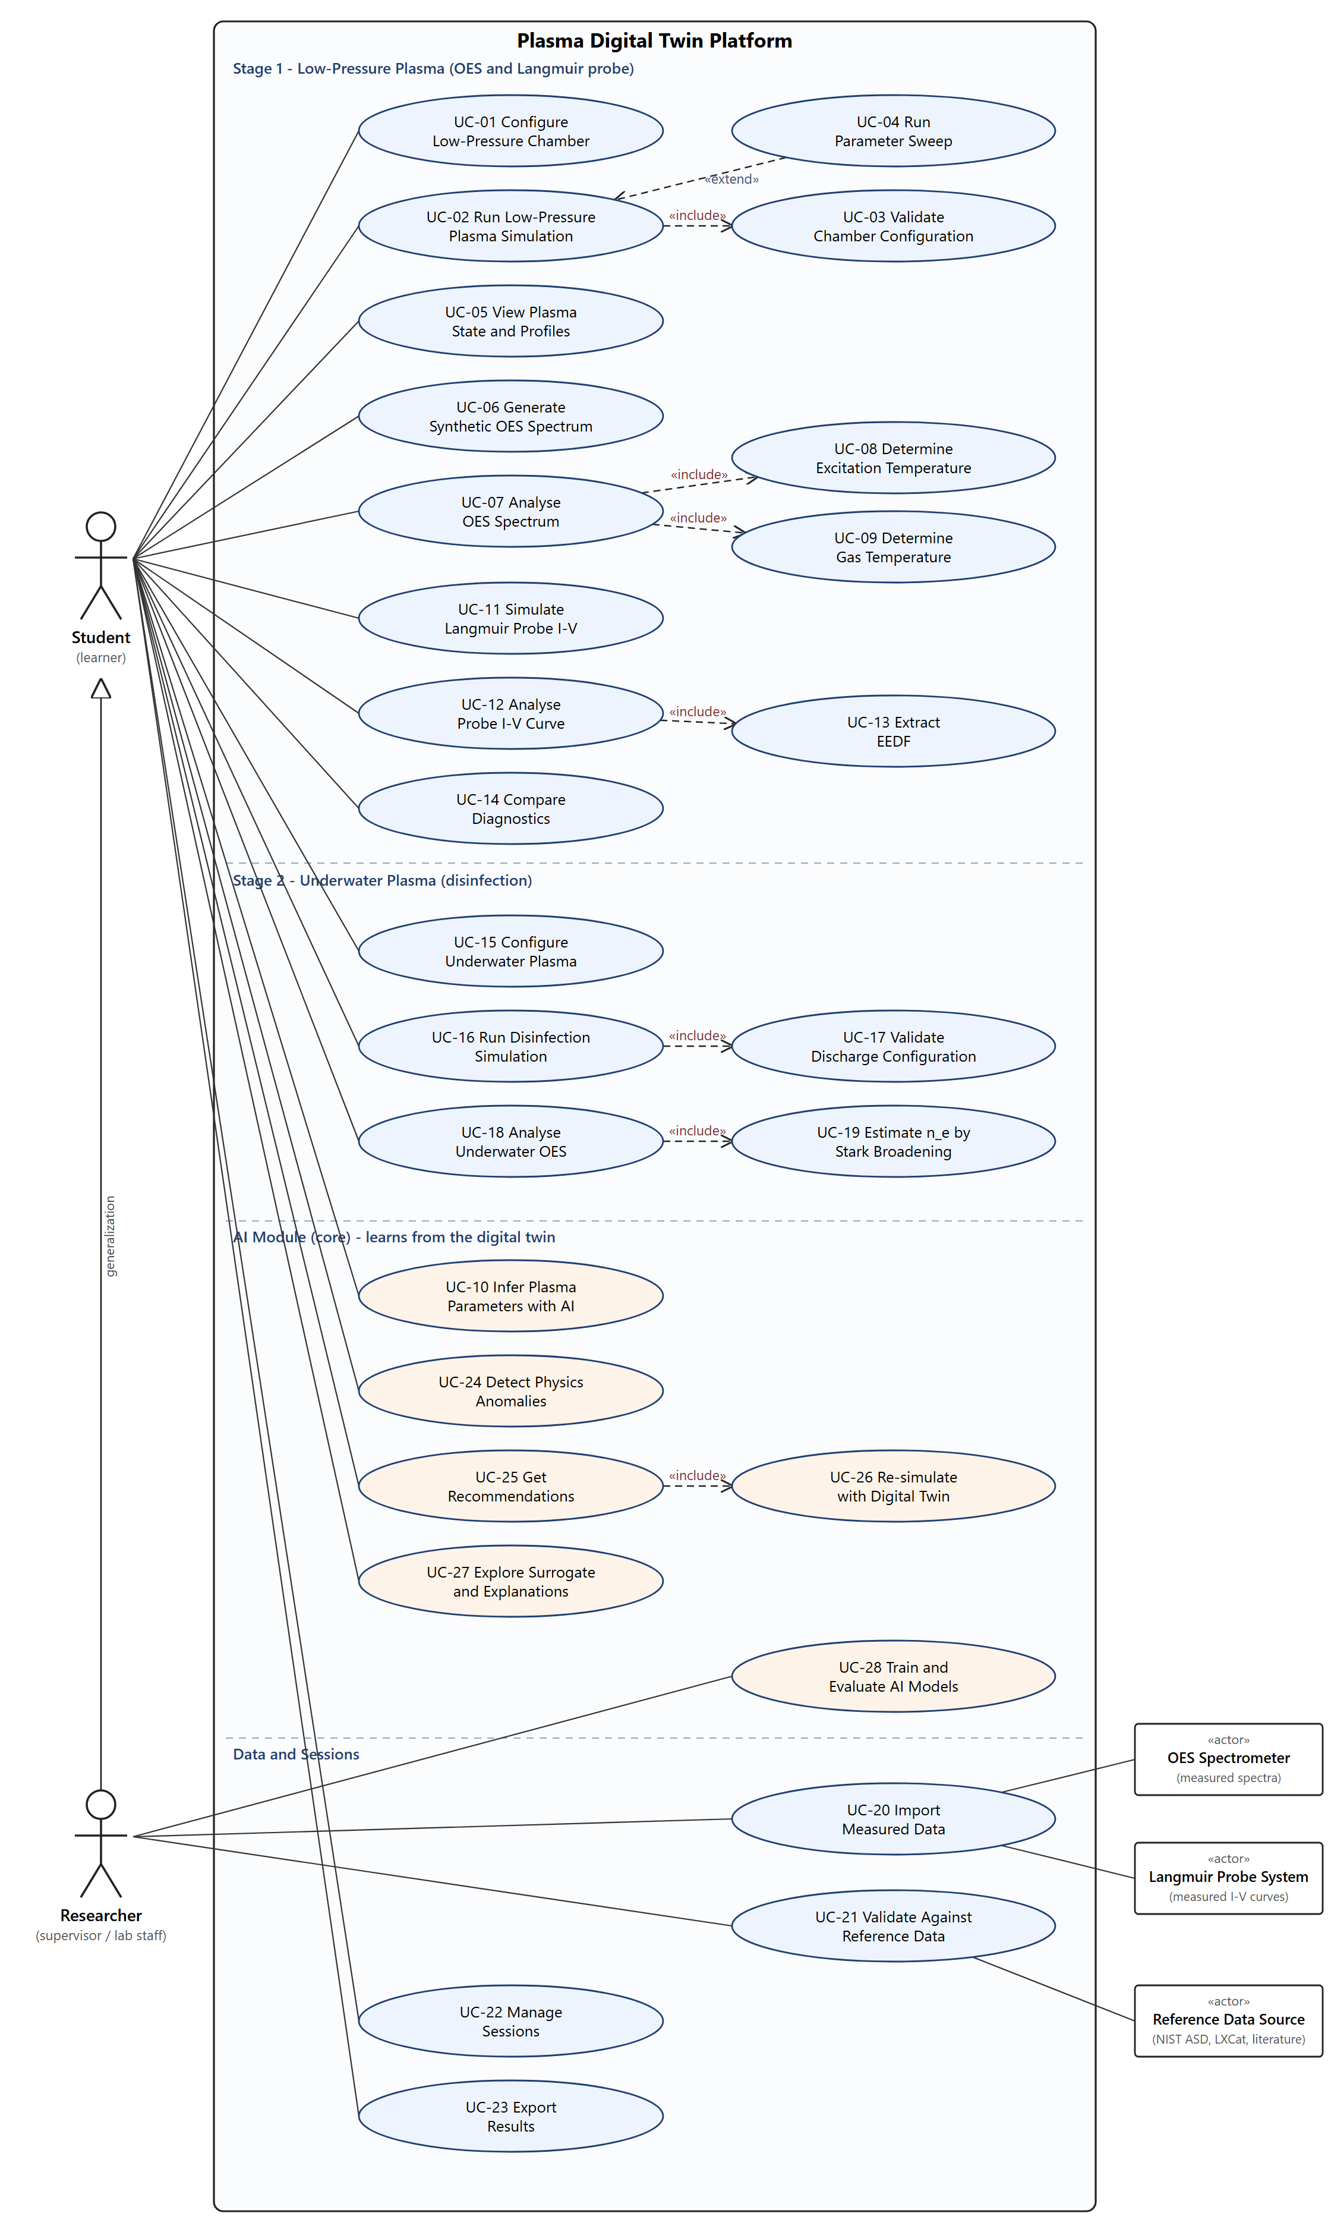
Figure 2.1: Use case diagram of the Plasma Digital Twin Platform
Table 2.2: Use case summary and traceability
UC-ID | Use case | Primary actor | Goal | Mockup | FRs
UC-01 | Configure Low-Pressure Chamber | Student | Set power, pressure, flow, mixture, geometry and model options. | M2 | FR2.1–FR2.10, FR2.13
UC-02 | Run Low-Pressure Plasma Simulation | Student | Solve the Stage 1 model for the current configuration. | M2, M3 | FR2.11, FR17.2
UC-03 | Validate Chamber Configuration (include) | — | Check every input against the envelope before a run. | M2 | FR2.10, FR17.3
UC-04 | Run Parameter Sweep (extend UC-02) | Student | Repeat the simulation over a range of one parameter. | M2, M3 | FR2.12, FR3.7, FR17.14
UC-05 | View Plasma State and Profiles | Student | Read T_{e}, n_{e}, T_{gas}, species, EEDF, profile and balances. | M3 | FR3.1–FR3.6
UC-06 | Generate Synthetic OES Spectrum | Student | Compute the spectrum with instrument settings. | M4 | FR4.1–FR4.5, FR4.7
UC-07 | Analyse OES Spectrum | Student | Analyse a synthetic or imported spectrum. | M5 | FR5.1, FR5.5, FR5.7–FR5.10
UC-08 | Determine Excitation Temperature (include) | — | Boltzmann plot and T_{exc}. | M5 | FR5.2–FR5.4
UC-09 | Determine Gas Temperature (include) | — | N₂ rotational or Doppler T_{gas}. | M5 | FR5.6, FR17.8
UC-11 | Simulate Langmuir Probe I-V | Student | Generate an RF-distorted I-V curve. | M6 | FR6.1–FR6.5
UC-12 | Analyse Probe I-V Curve | Student | OML analysis for V_{f}, V_{p}, T_{e}, n_{e}, λ_{D}. | M6 | FR6.6, FR6.7, FR6.10
UC-13 | Extract EEDF (include) | — | Druyvesteyn second-derivative EEPF. | M6 | FR6.8
UC-14 | Compare Diagnostics | Student | Model vs OES vs probe within ±30 %. | M7 | FR7.1–FR7.6
UC-15 | Configure Underwater Plasma | Student | Set pulse, gap, gas, water and organism. | M8 | FR8.1–FR8.12
UC-16 | Run Disinfection Simulation | Student | Solve Stage 2 and predict survival. | M8, M9 | FR8.13, FR9.1–FR9.3, FR9.5
UC-17 | Validate Discharge Configuration (include) | — | Duty cycle and envelope checks. | M8 | FR8.4, FR17.5
UC-18 | Analyse Underwater OES | Student | Underwater spectrum with OH, H-alpha, O I lines. | M9 | FR9.4
UC-19 | Estimate n_{e} by Stark Broadening (include) | — | n_{e} from H-alpha Stark width. | M9 | FR9.4
UC-20 | Import Measured Data | Researcher; OES Spectrometer; Langmuir Probe System | Upload, map and describe measured files. | M10, M4, M6 | FR10.1–FR10.5, FR4.6, FR6.9
UC-21 | Validate Against Reference Data | Researcher; Reference Data Source | Benchmarks and measured-data comparisons. | M10 | FR10.6–FR10.8
UC-22 | Manage Sessions | Student | Save, list, reopen, compare, delete sessions. | M11, M1 | FR11.1–FR11.4, FR1.3, FR3.9
UC-23 | Export Results | Student | Export tables, figures and data. | M11 | FR11.5, FR3.10, FR4.7, FR9.6
UC-10 | Infer Plasma Parameters with AI | Student | AI estimate of T_{e}, n_{e}, T_{gas} with intervals. | M12 | FR12.1–FR12.6, FR17.18
UC-24 | Detect Physics Anomalies | Student | Flag runs whose diagnostics break the physics. | M13 | FR13.1–FR13.7, FR17.20
UC-25 | Get Recommendations | Student | Settings for a goal, ranked by twin outcome. | M14 | FR14.1–FR14.8, FR17.21
UC-26 | Re-simulate with Digital Twin (include) | — | Verify each candidate with the twin. | M14 | FR14.3, FR14.6
UC-27 | Explore Surrogate and Explanations | Student | Fast maps and SHAP explanations. | M15 | FR15.1–FR15.6, FR17.22
UC-28 | Train and Evaluate AI Models | Researcher | Train, evaluate and register models. | M16 | FR16.1–FR16.5, FR17.19

2.5 Requirement Identifying Technique
Two complementary techniques were used. The first is mockup-based requirement analysis. Acting as UI/UX designers for a separate implementation team, the authors broke each feature into screens, gave every screen a mockup identifier (M1 to M16), and built them as a clickable HTML prototype (Appendix A) so the supervisor could walk through the workflow. Each interactive element on each screen (input, toggle, button, chart, table or message) was then turned into a feature-level functional requirement, and the policy that governs its behaviour was recorded as a business rule. Domain values in the business rules come from the supervisor's written questionnaire answers; where the supervisor left an item blank, a published source is cited (Appendix C lists every value and its source).
The second technique is the event–response table. Much of this system's behaviour happens behind the screens: solving the plasma models, checking convergence, loading reference data, parsing files, applying the citation filter and enforcing the tolerance. These backend behaviours were identified as events, and for each event the trigger, source, system state before, response, system state after and exception handling were recorded (Section 2.6.17). Functional requirements were then derived from the events (Section 2.6.18).
Requirement identifiers follow the pattern FRm.n, where m is the mockup number (1–16) and n the requirement on that screen; m = 17 is used for requirements derived from backend events. Every requirement is written so that it can be tested, and the traceability matrix in Appendix B links business objectives, modules, use cases, mockups and requirements.

2.6 Functional Requirements
The functional requirements are listed below by mockup. Each subsection shows the mockup screen as a figure, followed by the requirements derived from it in the department's recommended format (Feature | FR-ID: Statement | Business Rule).

2.6.1 Mockup M1 – Home Screen
The Home screen is the entry point. It offers the four work areas (Stage 1, Stage 2, Diagnostics & Data and the AI Module), a one-step quick start, the most recent sessions, the usage role, the status of the reference data and AI models, and help. Figure 2.2 shows the mockup and Table 2.3 lists the functional requirements derived from it.
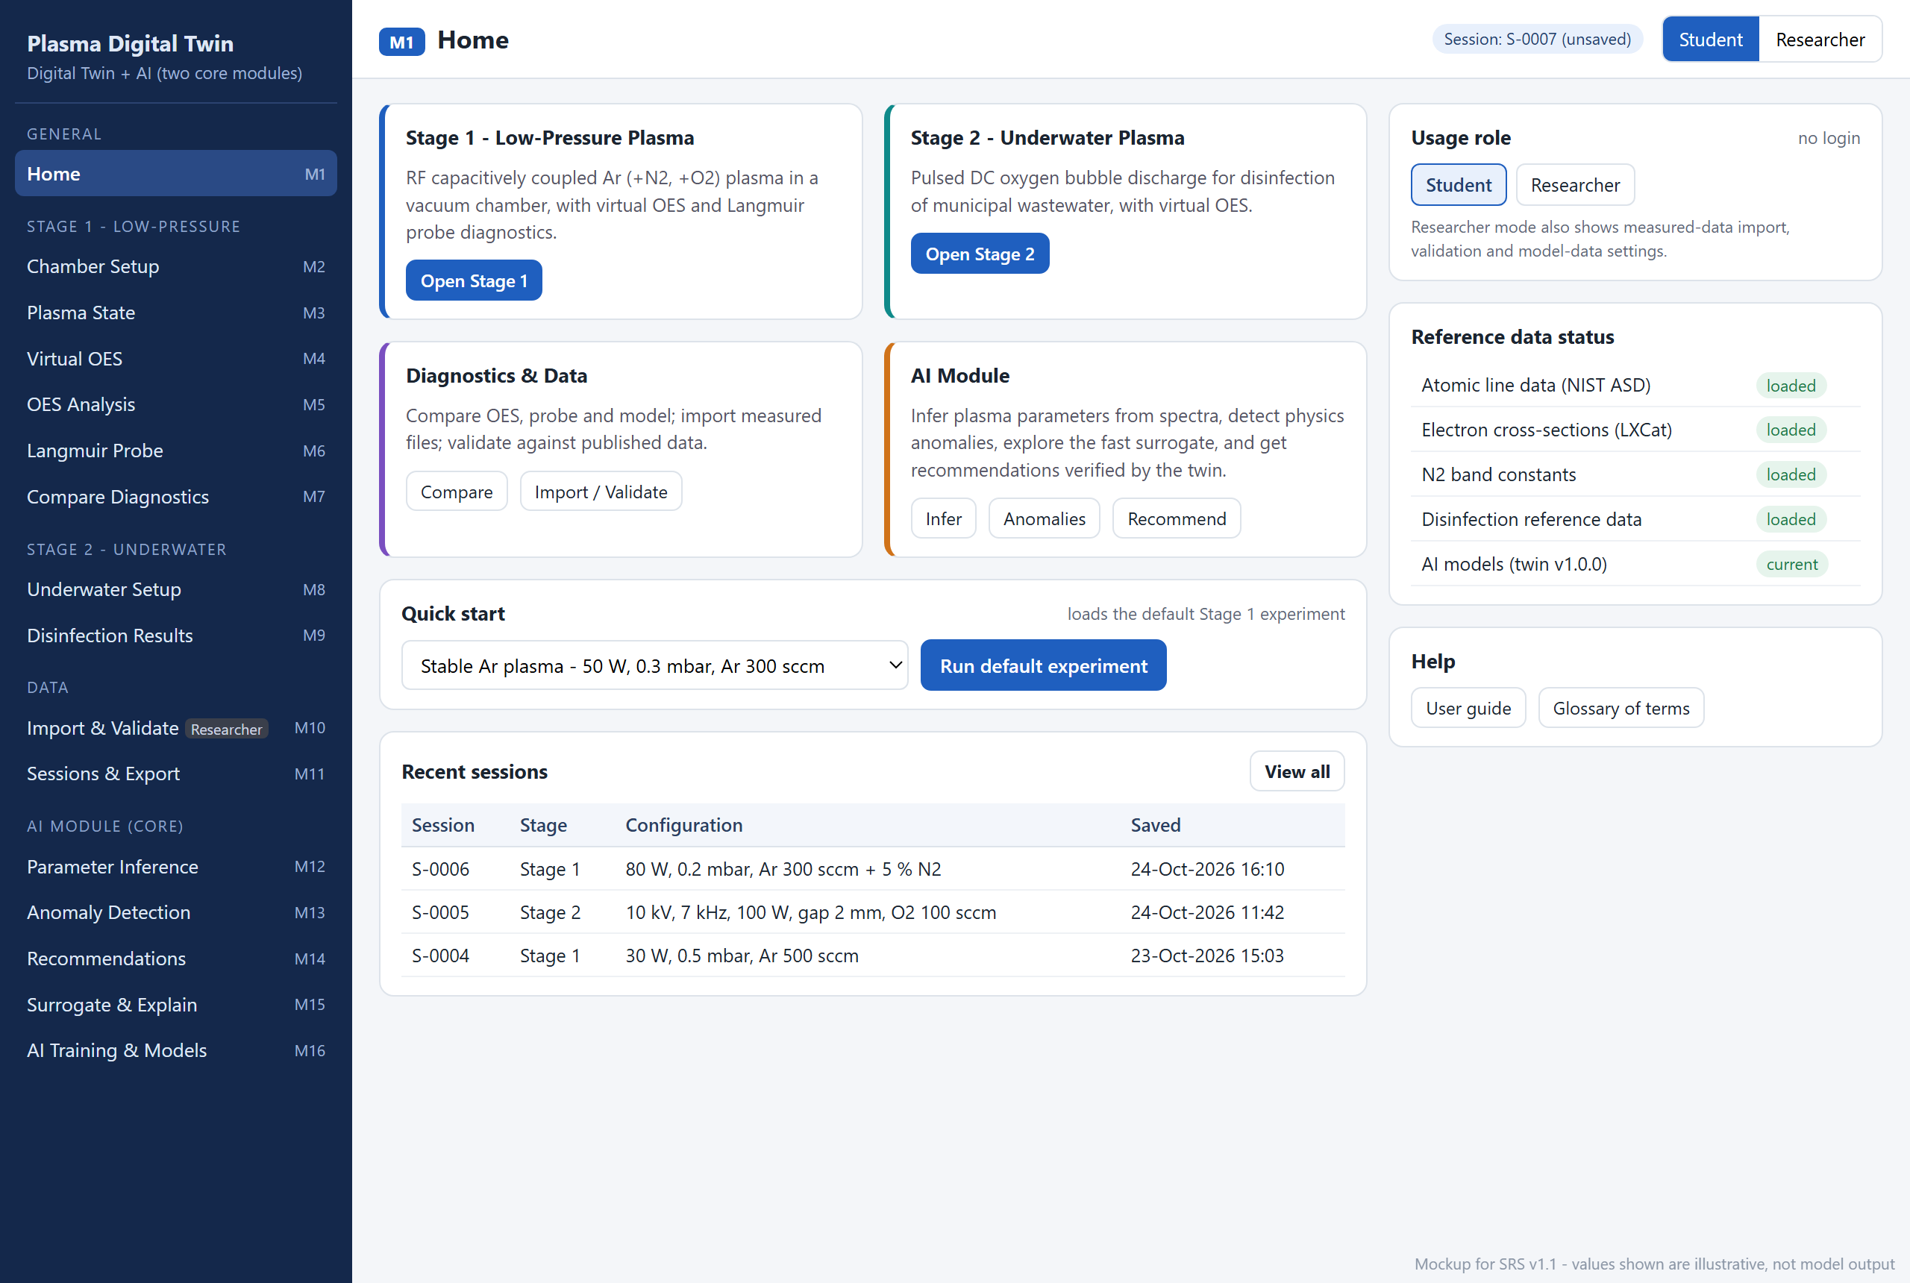
Figure 2.2: Mockup M1 – Home Screen
Table 2.3: Functional requirements derived from Mockup M1 – Home Screen
Feature (derived from UI) | Functional Requirement (FR-ID: Statement) | Business Rule
Stage navigation | FR1.1: The system shall display entry points to Stage 1 (Low-Pressure Plasma), Stage 2 (Underwater Plasma), Diagnostics & Data and the AI Module, each opening its first screen. | Stage 1 is listed first because the supervisor ranks it as the most important stage.
Quick start | FR1.2: The system shall allow the user to choose a predefined example experiment and run it in a single action. | Every quick-start configuration shall lie inside the operating envelope; the default is 50 W, 0.3 mbar, Ar 300 sccm.
Recent sessions | FR1.3: The system shall list the most recently saved sessions with session ID, stage, configuration summary and save time. | At most three sessions, newest first; "View all" opens M11.
Usage role | FR1.4: The system shall allow the user to switch between the Student and Researcher roles without logging in. | Researcher mode additionally shows measured-data import, overlays and validation; the role is a usage mode, not a security control (LI-9).
Reference data status | FR1.5: The system shall display the load status of each reference data set (NIST atomic lines, LXCat cross-sections, N₂ band constants, disinfection reference data) and of the AI models. | A data set marked missing or corrupt disables every feature that depends on it (event E6); an out-of-date AI model is shown as such (event E22).
Help | FR1.6: The system shall provide a user guide and a glossary of the plasma terms and symbols used on the screens. | The glossary shall define every symbol displayed anywhere in the application.

2.6.2 Mockup M2 – Low-Pressure Chamber Configuration
This screen configures the Stage 1 discharge, the chamber geometry and the model options, and optionally a parameter sweep. Figure 2.3 shows the mockup and Table 2.4 lists the functional requirements derived from it.
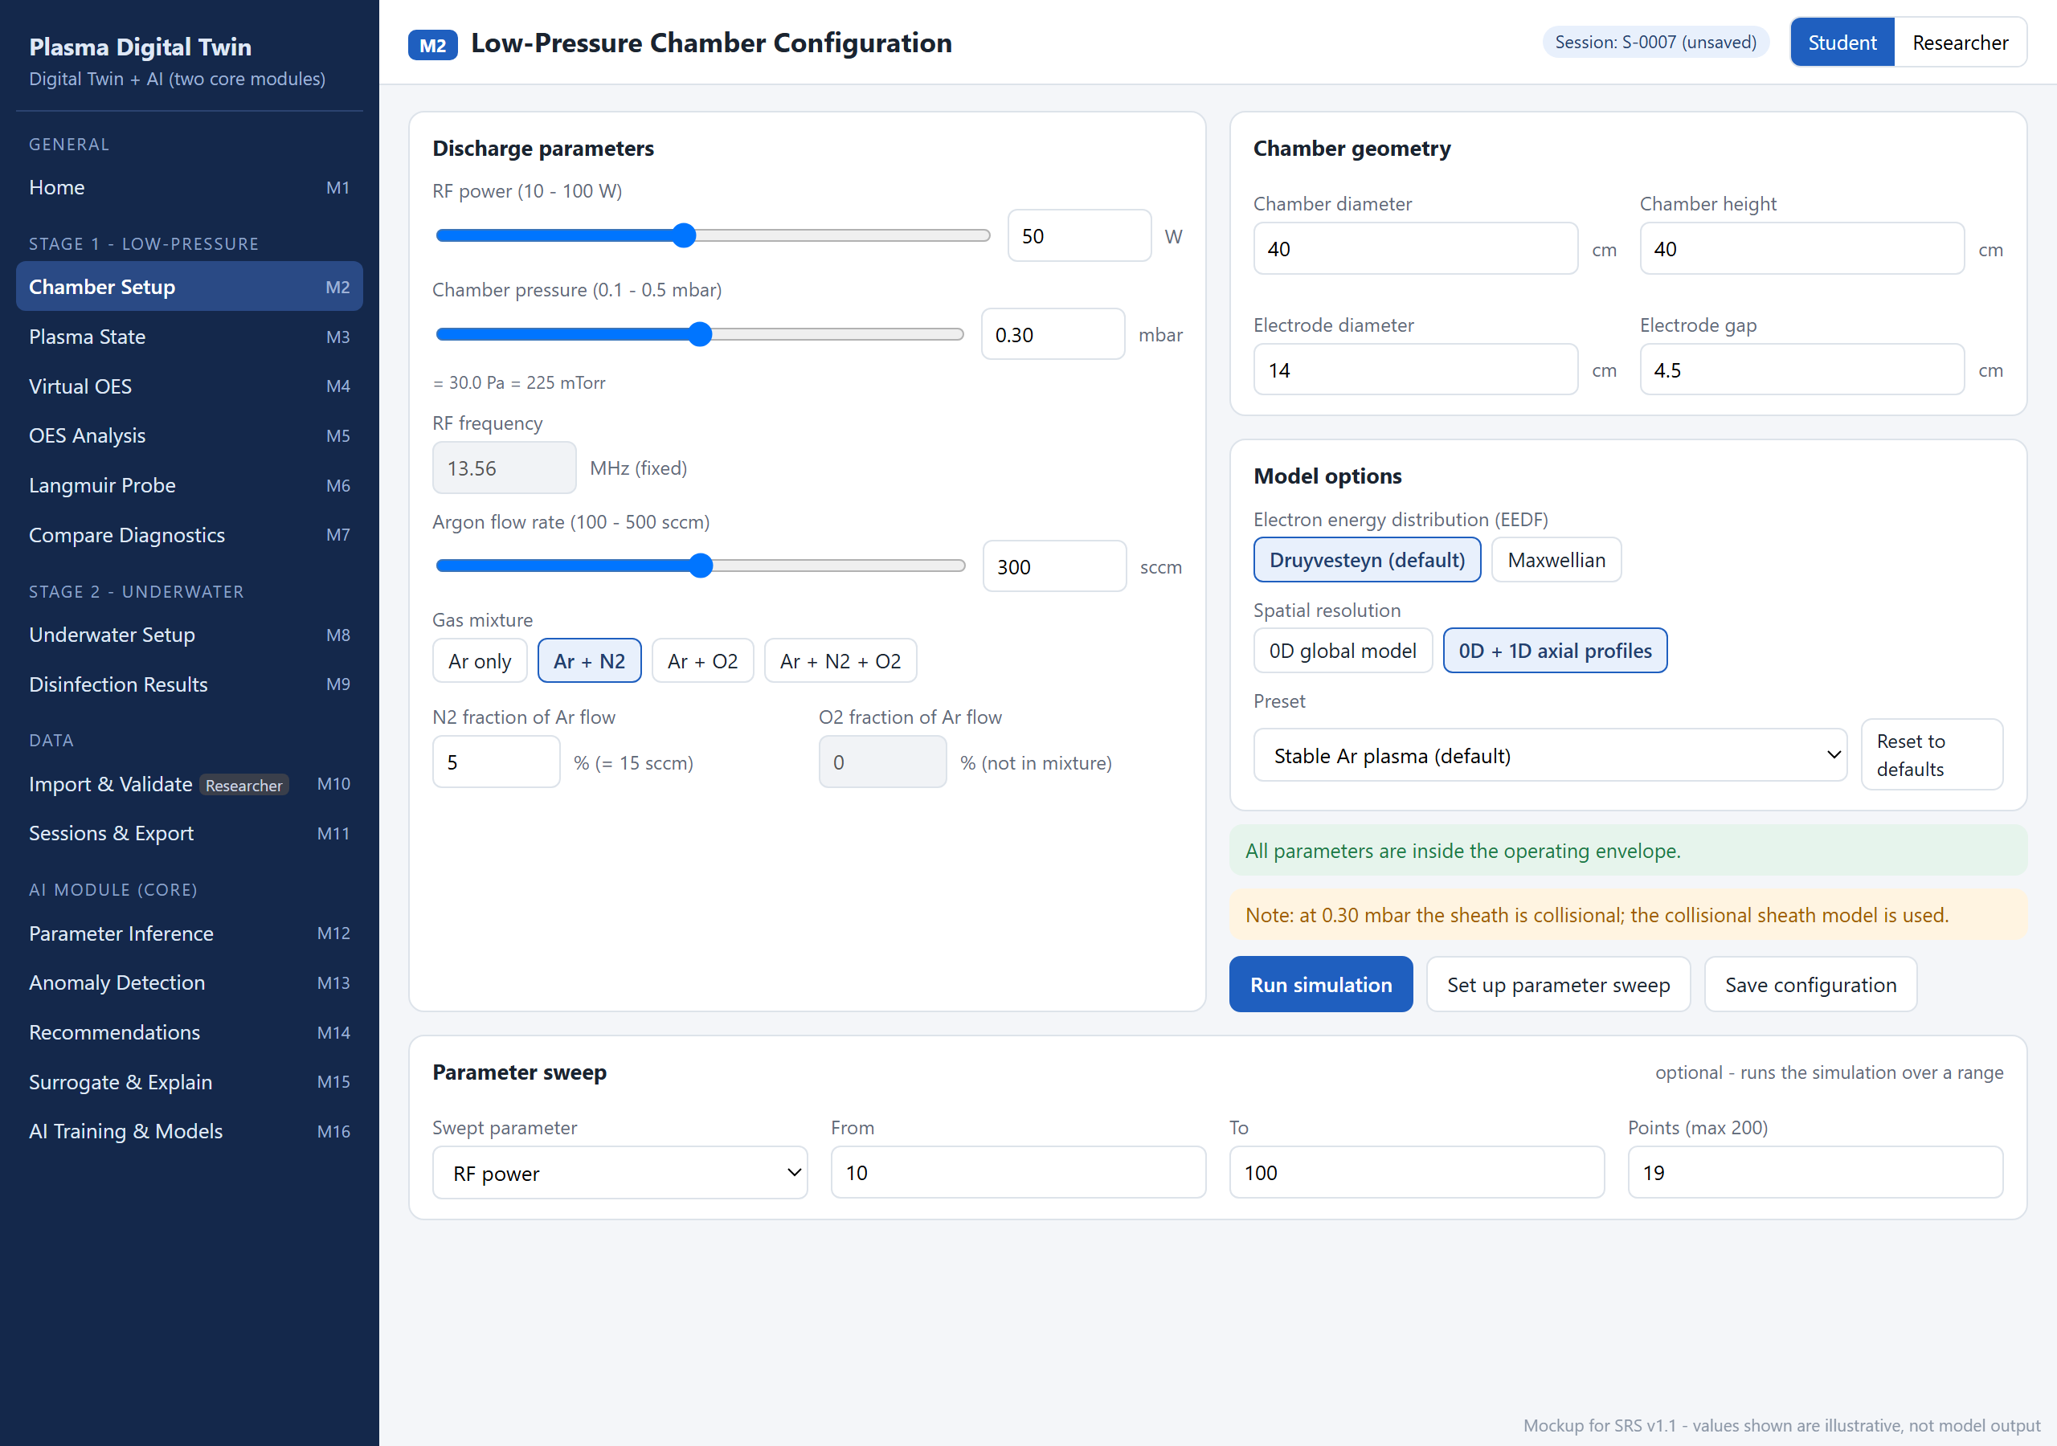
Figure 2.3: Mockup M2 – Low-Pressure Chamber Configuration
Table 2.4: Functional requirements derived from Mockup M2 – Low-Pressure Chamber Configuration
Feature (derived from UI) | Functional Requirement (FR-ID: Statement) | Business Rule
RF power | FR2.1: The system shall accept the RF power through a linked slider and numeric field. | Range 10–100 W, step 1 W (supervisor envelope).
Chamber pressure | FR2.2: The system shall accept the chamber pressure in mbar and display the equivalent value in Pa and mTorr. | Range 0.1–0.5 mbar; 1 mbar = 100 Pa = 750.06 mTorr.
RF frequency | FR2.3: The system shall display the RF frequency as a fixed, non-editable value. | 13.56 MHz for the CCP (supervisor).
Argon flow rate | FR2.4: The system shall accept the argon flow rate through a linked slider and numeric field. | Range 100–500 sccm (supervisor).
Gas mixture | FR2.5: The system shall allow the user to choose the mixture mode (Ar only, Ar + N₂, Ar + O₂, Ar + N₂ + O₂) and to enter each admixture as a percentage of the argon flow, showing the resulting flow in sccm. | Default 5 % of the Ar flow for each admixture (supervisor); allowed 1–10 %; fields of gases not in the mixture are disabled and set to 0.
Chamber geometry | FR2.6: The system shall accept the chamber diameter and height, electrode diameter and electrode gap. | Defaults 40, 40, 14 and 4.5 cm; electrode diameter < chamber diameter; gap < chamber height; all values > 0.
EEDF | FR2.7: The system shall allow the user to select a Druyvesteyn or Maxwellian electron energy distribution. | Druyvesteyn is the default for Stage 1 (supervisor).
Spatial resolution | FR2.8: The system shall allow the user to choose the 0D global model or the 0D model with 1D axial profiles. | 1D is offered only for Stage 1 (CON-8).
Preset and reset | FR2.9: The system shall load a named preset and shall reset all fields to their defaults on request. | Presets are fixed, documented configurations inside the envelope.
Input validation | FR2.10: The system shall validate every parameter when it changes and display the envelope status and any model-regime note (for example, collisional sheath). | Run is disabled while any input is invalid; messages state the allowed range (event E3).
Run simulation | FR2.11: The system shall run the Stage 1 simulation for the current configuration and open the results screen (M3). | Runs only after FR2.10 passes.
Parameter sweep | FR2.12: The system shall allow the user to define a sweep by choosing the swept parameter (RF power, pressure, argon flow or admixture fraction), the start and end values and the number of points. | Start < end, both inside the envelope; at most 200 points; all other parameters held constant.
Save configuration | FR2.13: The system shall save the current configuration under a user-given name for later reuse. | Names must be unique; saving does not run the model.

2.6.3 Mockup M3 – Low-Pressure Plasma State Results
This screen presents the solved Stage 1 plasma state, the distribution and profile used, the energy balance and any sweep results. Figure 2.4 shows the mockup and Table 2.5 lists the functional requirements derived from it.
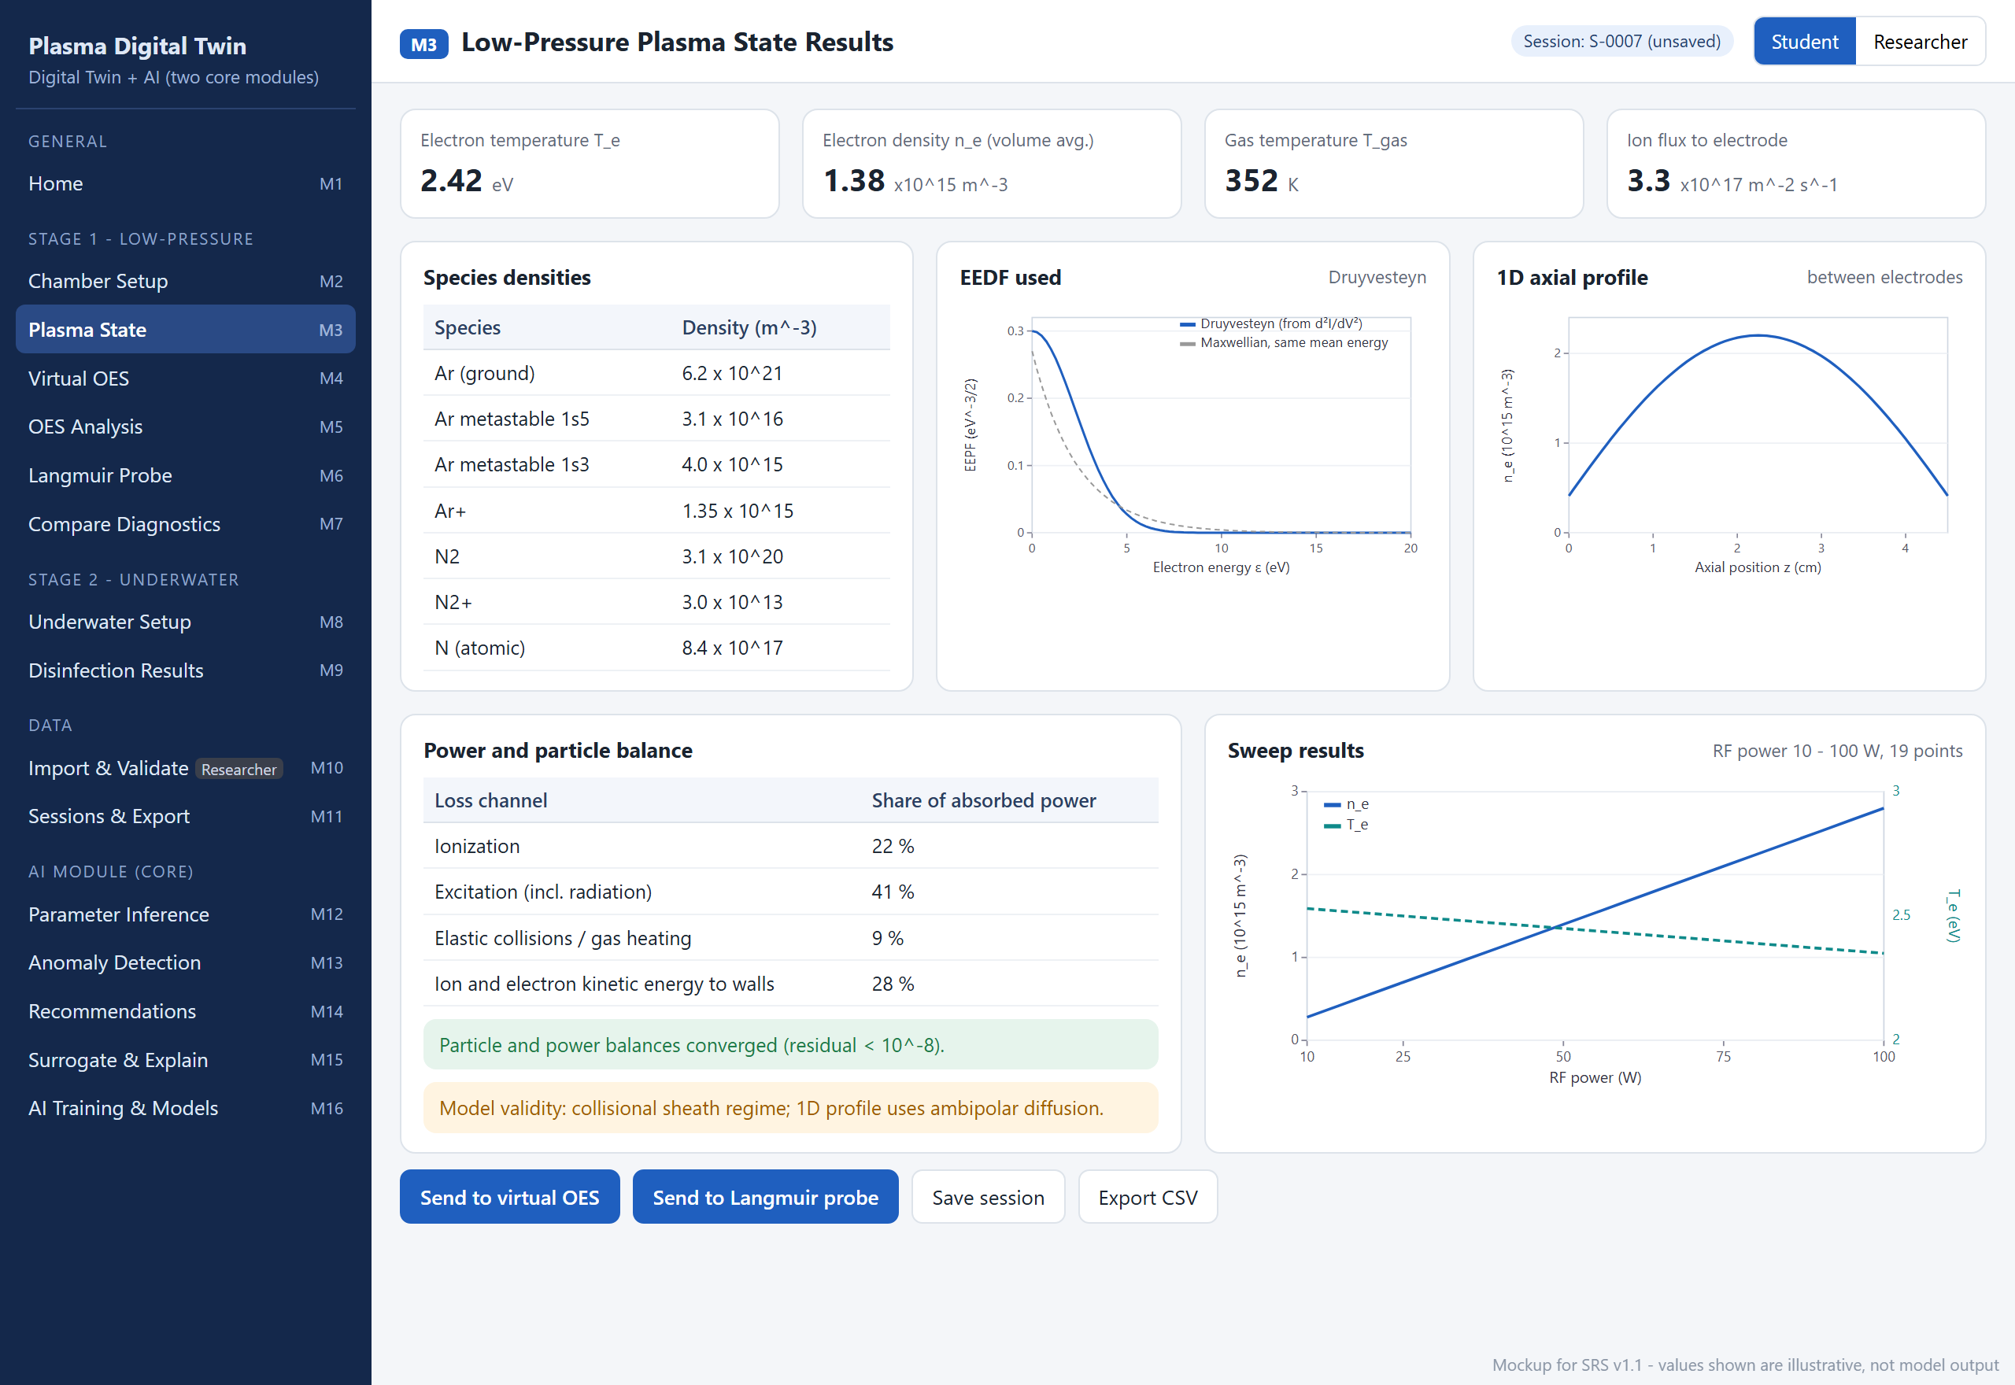
Figure 2.4: Mockup M3 – Low-Pressure Plasma State Results
Table 2.5: Functional requirements derived from Mockup M3 – Low-Pressure Plasma State Results
Feature (derived from UI) | Functional Requirement (FR-ID: Statement) | Business Rule
Key results | FR3.1: The system shall display T_{e}, volume-averaged n_{e}, T_{gas} and the ion flux to the electrode with units. | All values derive from the solved T_{e} and n_{e} (CON-2); none is set independently.
Species densities | FR3.2: The system shall display the densities of ground-state Ar, Ar metastables (1s₅, 1s₃), Ar⁺ and the admixture species present in the selected mixture. | Species of gases not in the mixture are not shown.
EEDF plot | FR3.3: The system shall plot the electron energy distribution used in the run. | Shows the selected form (FR2.7).
1D profile | FR3.4: The system shall plot the axial n_{e} profile between the electrodes when 1D profiles were selected. | Hidden for 0D-only runs.
Power and particle balance | FR3.5: The system shall display the share of absorbed power lost through each channel and the convergence status of the balances. | Shares sum to 100 ± 0.5 %; a run is accepted only if the residual is below 10⁻⁸ (ACC-3).
Model validity | FR3.6: The system shall display the regime assumptions used in the run (sheath model, diffusion model). | Assumptions are generated from the configuration, not typed by hand.
Sweep results | FR3.7: The system shall plot n_{e} and T_{e} against the swept parameter after a sweep. | Dual axes, each labelled with symbol and unit.
Send to diagnostics | FR3.8: The system shall pass the current plasma state to the virtual OES (M4) and the virtual Langmuir probe (M6). | Diagnostics always use the state of the open session, whose ID is displayed.
Save session | FR3.9: The system shall save the configuration and results as a session with a unique ID. | IDs are sequential (S-0001, S-0002, …) and never reused.
Export CSV | FR3.10: The system shall export the results of the run as a CSV file. | The file header records the session ID, configuration and software version.

2.6.4 Mockup M4 – Virtual OES – Synthetic Spectrum
This screen synthesises the emission spectrum of the current Stage 1 plasma and lists the identified lines. Figure 2.5 shows the mockup and Table 2.6 lists the functional requirements derived from it.
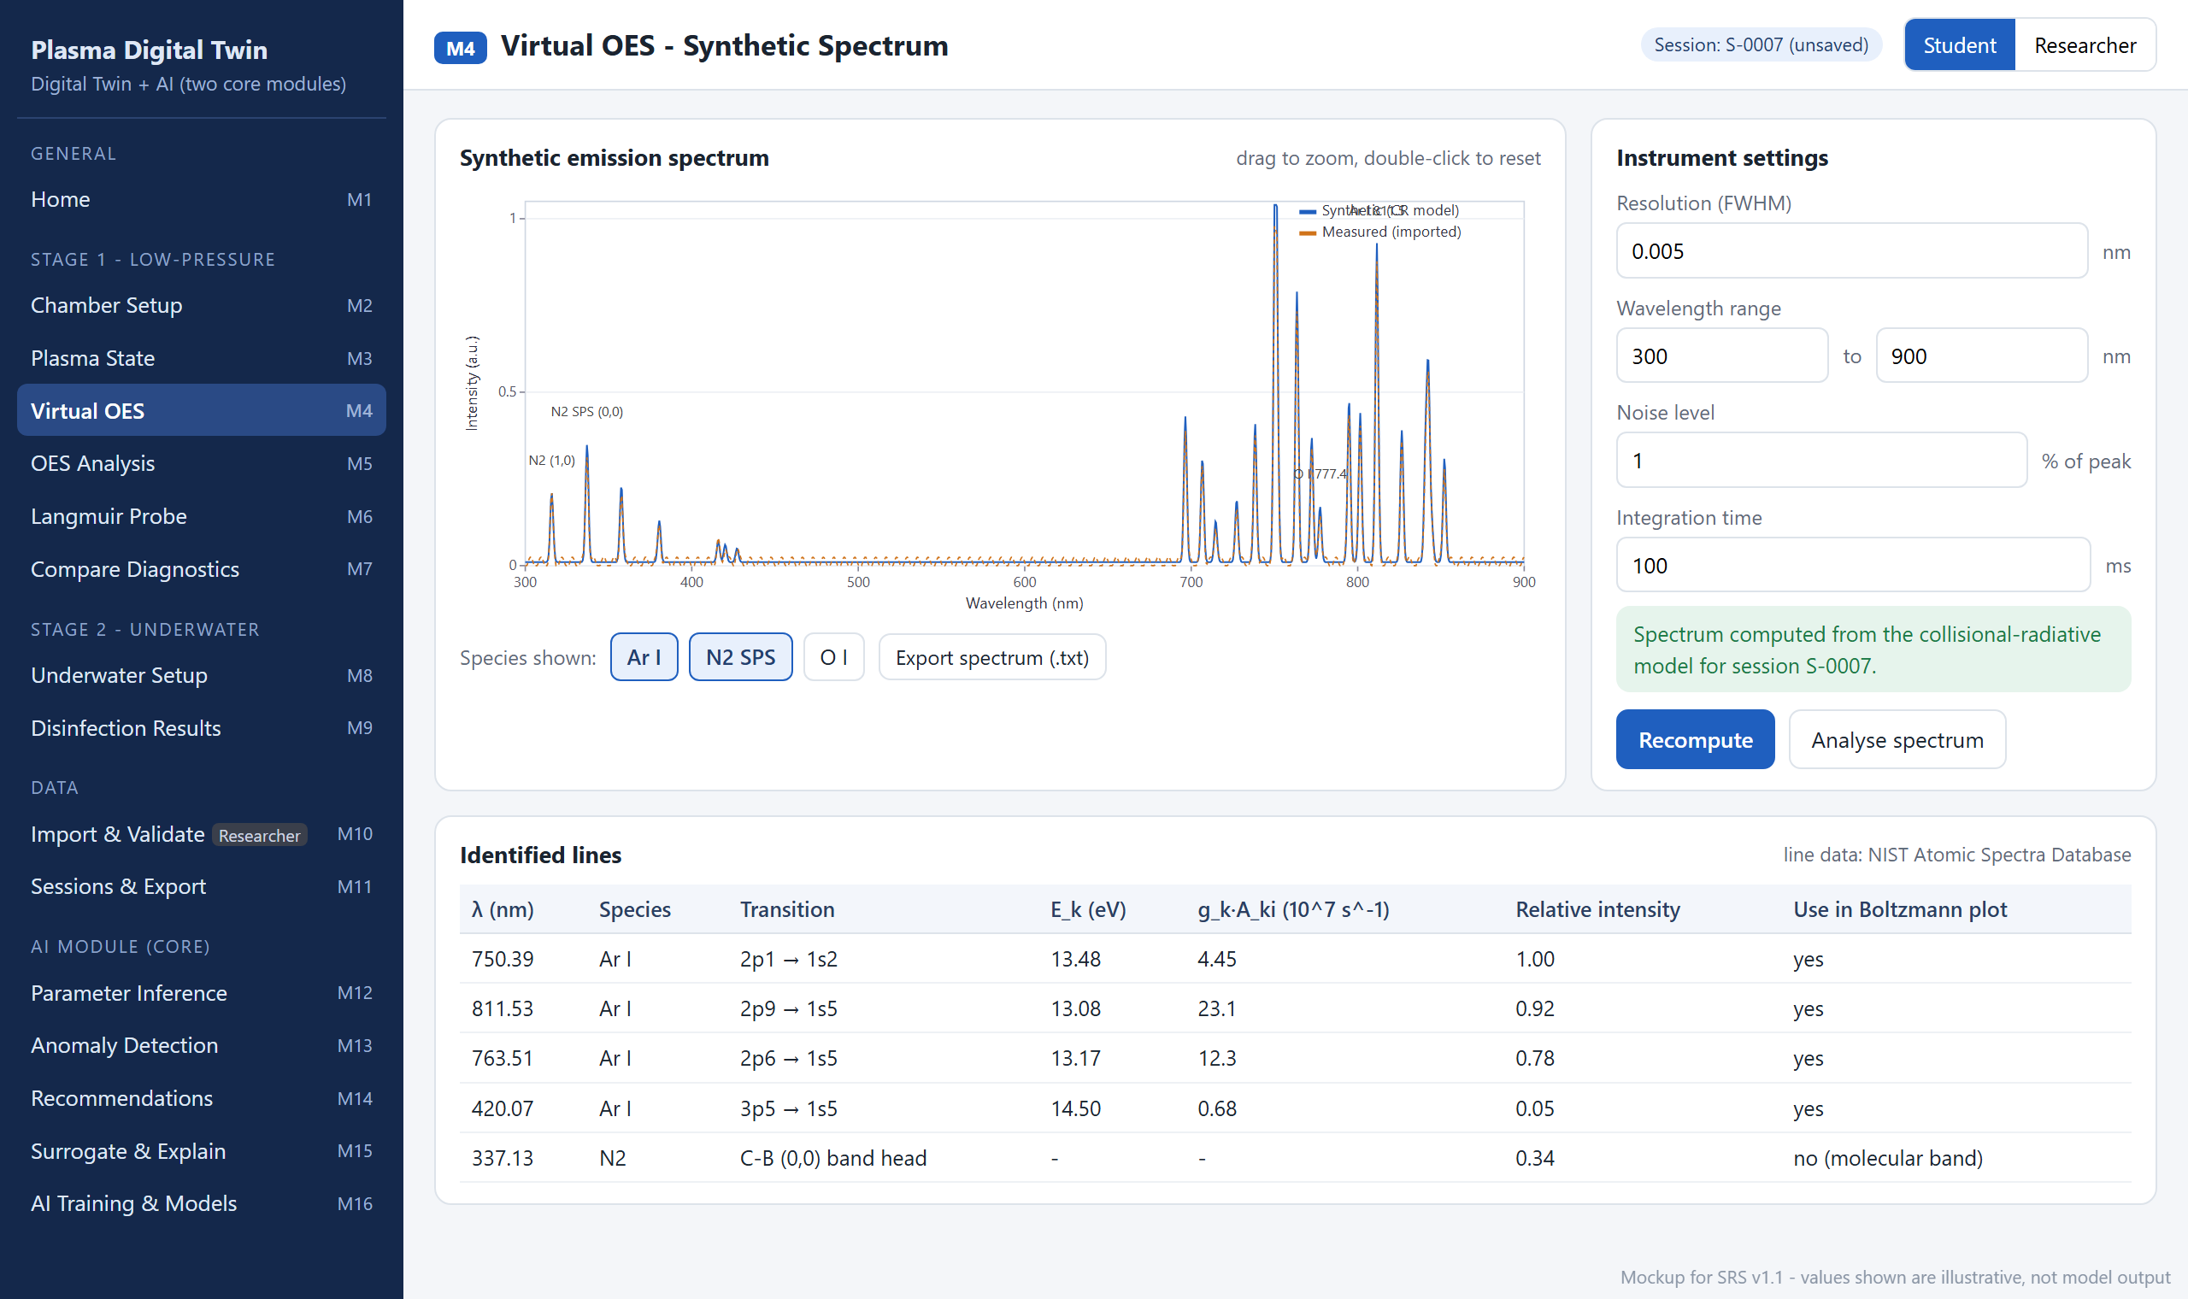
Figure 2.5: Mockup M4 – Virtual OES – Synthetic Spectrum
Table 2.6: Functional requirements derived from Mockup M4 – Virtual OES – Synthetic Spectrum
Feature (derived from UI) | Functional Requirement (FR-ID: Statement) | Business Rule
Synthetic spectrum | FR4.1: The system shall compute and display the emission spectrum of the current plasma state from collisional-radiative level populations, with interactive zoom. | Intensity of each line is proportional to the upper-level population × A_{ki} / λ; line data from NIST ASD.
Species toggles | FR4.2: The system shall allow the user to show or hide the Ar I, N₂ second positive system and O I contributions. | Only species present in the mixture can be enabled.
Instrument settings | FR4.3: The system shall accept the instrument resolution (FWHM), wavelength range, noise level and integration time. | Resolution 0.001–2 nm (default 0.005 nm; the laboratory instrument is better than 0.01 nm); range within 200–1000 nm; noise 0–20 % of peak.
Recompute | FR4.4: The system shall recompute the spectrum when the user changes the instrument settings and requests it. | The plasma state is not re-solved; only the instrument model is reapplied.
Identified lines | FR4.5: The system shall list the identified lines with wavelength, species, transition, upper-level energy, g_{k}A_{ki}, relative intensity and whether each line is used in the Boltzmann plot. | Molecular bands are excluded from the Boltzmann plot.
Overlay measured | FR4.6: The system shall allow a Researcher to overlay an imported measured spectrum on the synthetic spectrum. | Only Stage 1 spectra imported through M10; both spectra normalised to the same reference line.
Export spectrum | FR4.7: The system shall export the spectrum as a two-column text file (wavelength, intensity). | Header records session ID and instrument settings.
Analyse spectrum | FR4.8: The system shall open the OES analysis screen (M5) with the current spectrum. | —

2.6.5 Mockup M5 – OES Analysis – Boltzmann Plot and Temperatures
This screen analyses a synthetic or imported spectrum to obtain the excitation temperature, the level populations, the gas temperature and the electron density used. Figure 2.6 shows the mockup and Table 2.7 lists the functional requirements derived from it.
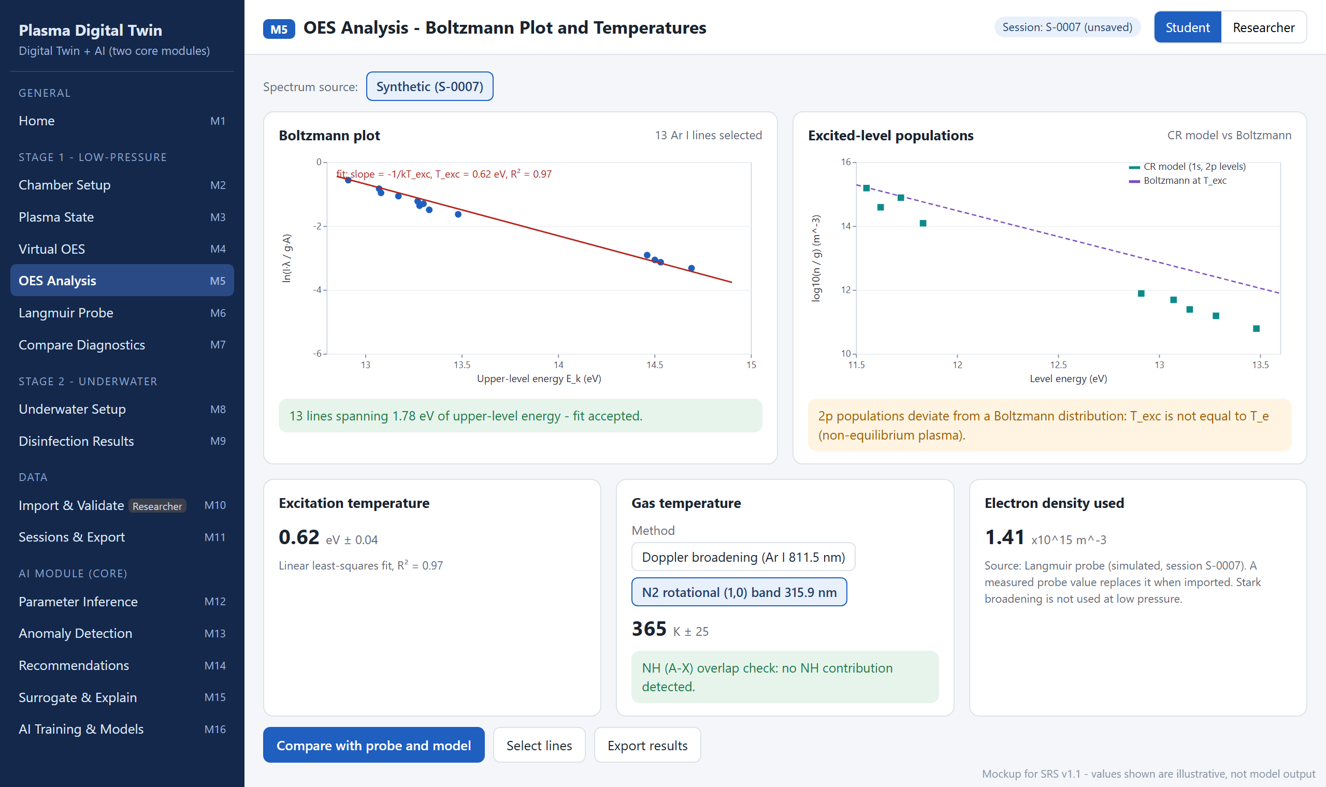
Figure 2.6: Mockup M5 – OES Analysis – Boltzmann Plot and Temperatures
Table 2.7: Functional requirements derived from Mockup M5 – OES Analysis – Boltzmann Plot and Temperatures
Feature (derived from UI) | Functional Requirement (FR-ID: Statement) | Business Rule
Spectrum source | FR5.1: The system shall allow the user to analyse either the synthetic spectrum of the open session or (Researcher) an imported measurement. | Imported spectra must have complete metadata (FR10.2).
Boltzmann plot | FR5.2: The system shall plot ln(Iλ/g_{k}A_{ki}) against upper-level energy for the selected Ar I lines and fit a straight line. | At least 4 lines spanning at least 1.0 eV are required; otherwise the fit is not reported (event E9).
Excitation temperature | FR5.3: The system shall report T_{exc} = −1/slope with its standard error and the R² of the fit. | A fit with R² < 0.90 is flagged as unreliable.
Level populations | FR5.4: The system shall display the CR-model populations of the excited levels against a Boltzmann distribution and state when the plasma is not in equilibrium. | T_{exc} is never presented as T_{e}.
T_{e} by line ratio | FR5.5: The system shall estimate T_{e} by matching measured line-intensity ratios to CR-model predictions. | Result is displayed in the comparison screen (M7).
Gas temperature | FR5.6: The system shall determine T_{gas} by the method selected: N₂ rotational temperature from the (1,0) band at 315.9 nm, or Doppler broadening of the Ar I 811.5 nm line. | N₂ method only when N₂ is in the mixture, with an NH (A–X) overlap check; Doppler only when the instrument FWHM ≤ expected Doppler FWHM (event E8).
Electron density used | FR5.7: The system shall display the n_{e} used in the OES analysis and its source. | Source is the Langmuir probe value — simulated, or measured when imported (supervisor); Stark broadening is not used at low pressure.
Select lines | FR5.8: The system shall allow the user to include or exclude individual lines and shall refit immediately. | Excluded lines are listed in the export.
Compare | FR5.9: The system shall open the comparison screen (M7) with the analysis results. | —
Export results | FR5.10: The system shall export the analysis results and the fitted line list. | CSV with method and uncertainty columns.

2.6.6 Mockup M6 – Virtual Langmuir Probe
This screen generates the I-V curve of a cylindrical probe in the current Stage 1 plasma and analyses it. Figure 2.7 shows the mockup and Table 2.8 lists the functional requirements derived from it.
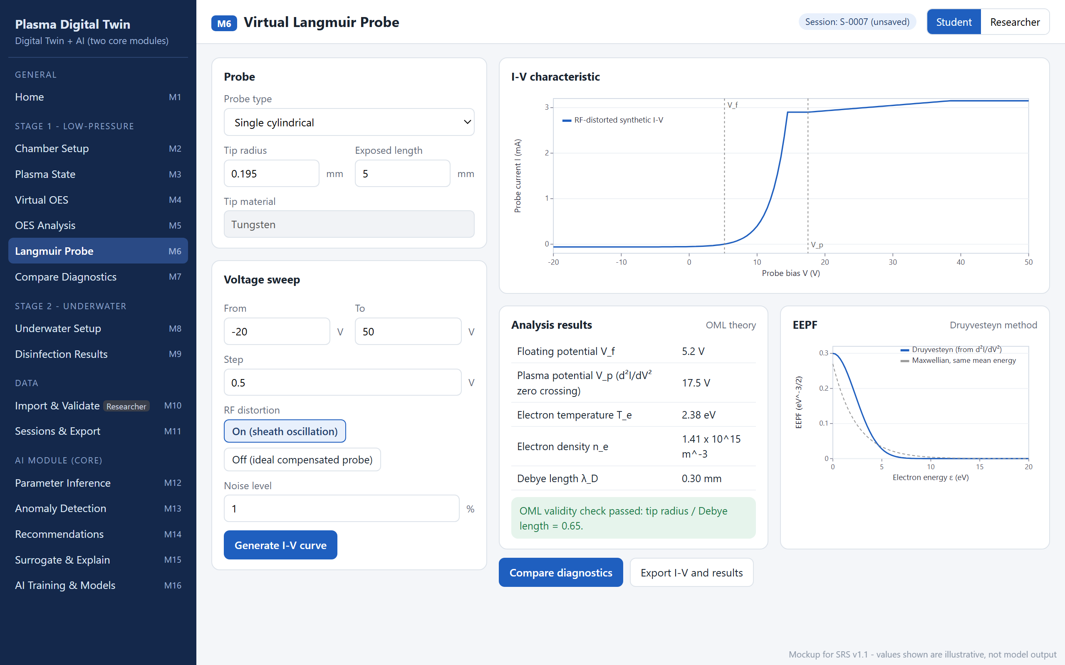
Figure 2.7: Mockup M6 – Virtual Langmuir Probe
Table 2.8: Functional requirements derived from Mockup M6 – Virtual Langmuir Probe
Feature (derived from UI) | Functional Requirement (FR-ID: Statement) | Business Rule
Probe geometry | FR6.1: The system shall accept the probe type, tip radius and exposed length; the tip material is shown as tungsten. | Single cylindrical probe; defaults 0.195 mm and 5 mm (COMSATS laboratory probe); radius 0.05–1 mm; length 1–20 mm.
Voltage sweep | FR6.2: The system shall accept the sweep start, end and step voltages. | Defaults −20 V to +50 V in 0.5 V steps; limits −100 to +100 V; step 0.1–2 V; at most 2001 points.
RF distortion | FR6.3: The system shall allow RF sheath-oscillation distortion of the I-V curve to be switched on or off. | On = time average over the 13.56 MHz oscillation of the plasma potential (supervisor); Off = ideal compensated probe.
Noise level | FR6.4: The system shall accept a noise level for the synthetic current. | 0–10 % of the electron saturation current; seeded for reproducibility.
Generate I-V curve | FR6.5: The system shall generate the synthetic I-V curve from the current plasma state and display it. | Uses T_{e}, n_{e} and the EEDF of the open session.
Analysis results | FR6.6: The system shall determine V_{f} (zero current), V_{p} (zero crossing of d²I/dV²), T_{e} (slope of ln I_{e} in the retardation region), n_{e} (OML ion current) and λ_{D}. | OML theory (supervisor); results flagged as approximate when O₂ is present (LI-4).
OML validity check | FR6.7: The system shall compute r_{p}/λ_{D} and report whether the OML assumption holds. | OML accepted when r_{p}/λ_{D} ≤ 1; otherwise a warning is shown (event E12).
EEPF | FR6.8: The system shall extract the EEPF from the second derivative of the I-V curve and plot it with a Maxwellian of the same mean energy. | Druyvesteyn method; the smoothing window is shown with the result.
Import measured I-V | FR6.9: The system shall allow a Researcher to analyse an imported measured I-V curve with the same method. | Only .csv files imported through M10.
Compare / export | FR6.10: The system shall open the comparison screen (M7) and export the I-V curve and results. | CSV with V, I and analysis summary.

2.6.7 Mockup M7 – Diagnostics Comparison (Model vs OES vs Probe)
This screen places the model, OES and probe values side by side and judges their agreement. Figure 2.8 shows the mockup and Table 2.9 lists the functional requirements derived from it.
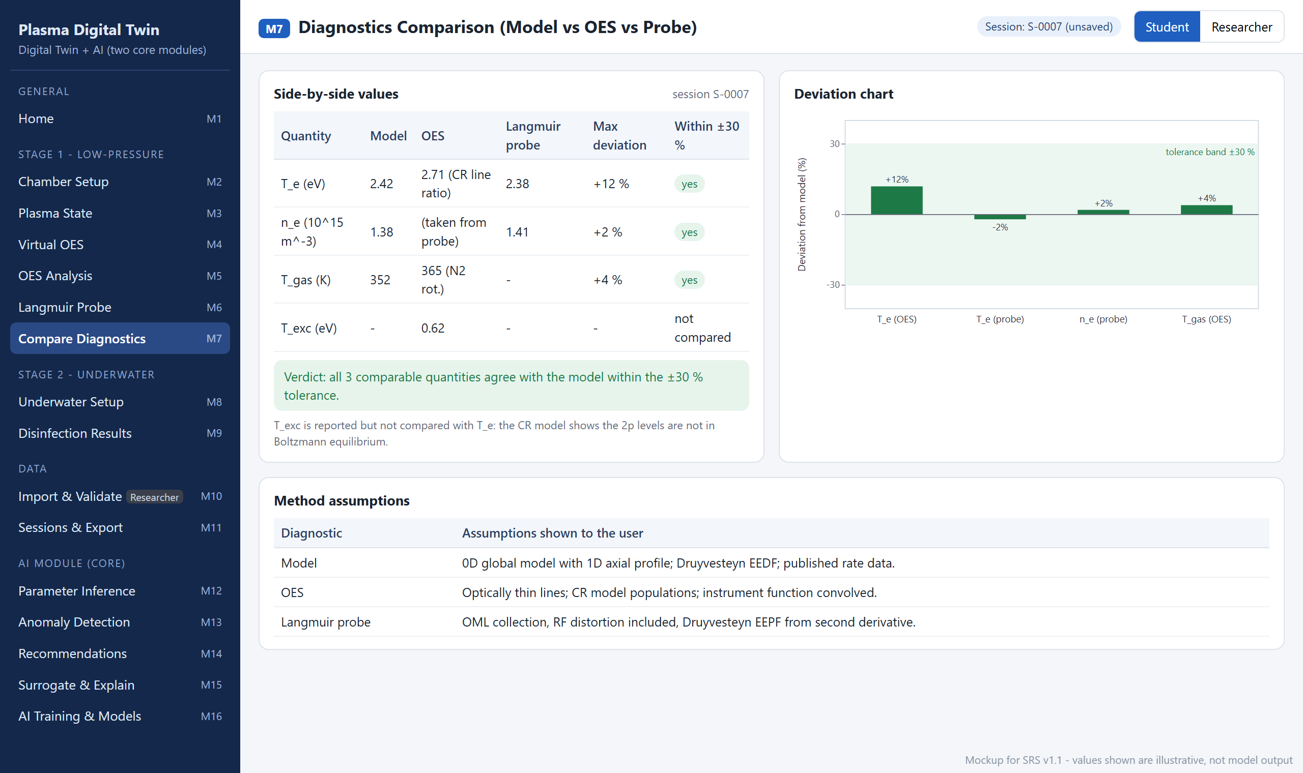
Figure 2.8: Mockup M7 – Diagnostics Comparison (Model vs OES vs Probe)
Table 2.9: Functional requirements derived from Mockup M7 – Diagnostics Comparison (Model vs OES vs Probe)
Feature (derived from UI) | Functional Requirement (FR-ID: Statement) | Business Rule
Side-by-side values | FR7.1: The system shall display T_{e}, n_{e} and T_{gas} from the model, OES and probe with the maximum deviation and a pass/fail flag. | Deviation = (diagnostic − model)/model; pass when |deviation| ≤ 30 % (supervisor); the tolerance is not editable on screen.
Dependent values | FR7.2: The system shall mark a value that one diagnostic takes from another (n_{e} in OES taken from the probe) and exclude it from the independent comparison. | Prevents a value being counted as agreeing with itself.
Verdict | FR7.3: The system shall show an overall verdict stating how many comparable quantities agree within tolerance. | Text label as well as colour (USE-5).
Deviation chart | FR7.4: The system shall plot the deviation of each diagnostic value with the ±30 % band. | —
Excitation temperature | FR7.5: The system shall display T_{exc} but exclude it from the comparison with T_{e} and explain why. | Non-equilibrium 2p populations (FR5.4).
Method assumptions | FR7.6: The system shall list the assumptions of each method (model, OES, probe). | Generated from the settings actually used.

2.6.8 Mockup M8 – Underwater Plasma Configuration
This screen configures the Stage 2 pulsed DC bubble discharge, the waste water and the target organism. Figure 2.9 shows the mockup and Table 2.10 lists the functional requirements derived from it.
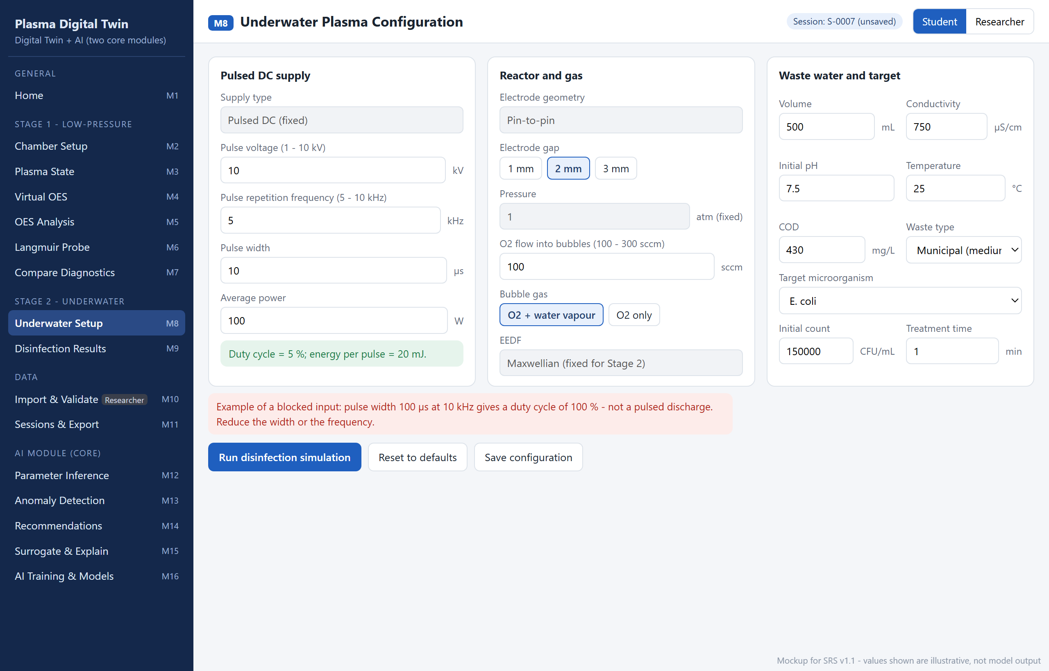
Figure 2.9: Mockup M8 – Underwater Plasma Configuration
Table 2.10: Functional requirements derived from Mockup M8 – Underwater Plasma Configuration
Feature (derived from UI) | Functional Requirement (FR-ID: Statement) | Business Rule
Supply type | FR8.1: The system shall display the supply type as pulsed DC (fixed). | Supervisor.
Pulse voltage | FR8.2: The system shall accept the pulse voltage. | Range 1–10 kV; default 10 kV (supervisor).
Pulse repetition frequency | FR8.3: The system shall accept the pulse repetition frequency. | Range 5–10 kHz (supervisor).
Pulse width and duty cycle | FR8.4: The system shall accept the pulse width in µs and shall compute and display the duty cycle. | Duty cycle = pulse width × frequency must be < 1, otherwise the run is blocked (event E5); a warning is shown above 0.5. Default 10 µs.
Average power and energy per pulse | FR8.5: The system shall accept the average power and display the energy per pulse. | Energy per pulse = power ÷ frequency; power 10–100 W, default 100 W (supervisor).
Electrode gap | FR8.6: The system shall show the pin-to-pin electrode geometry (fixed) and allow a gap of 1, 2 or 3 mm. | Supervisor.
Pressure | FR8.7: The system shall display the pressure as 1 atm (fixed). | Supervisor.
Oxygen flow | FR8.8: The system shall accept the O₂ flow into the bubbles. | Range 100–300 sccm; default 100 sccm (supervisor).
Bubble gas | FR8.9: The system shall allow the bubble gas to be O₂ with water vapour or O₂ only. | Default O₂ + water vapour, which is required for OH, H₂O₂ and H-alpha; O₂-only mode disables Stark n_{e}.
EEDF | FR8.10: The system shall display the Stage 2 EEDF as Maxwellian (fixed). | Supervisor.
Waste water properties | FR8.11: The system shall accept the water volume, conductivity, initial pH, temperature, COD and waste type. | Defaults for medium-strength municipal waste water: 500 mL, 750 µS/cm, pH 7.5, 25 °C, COD 430 mg/L; volume 50–5000 mL; pH 2–12; 5–60 °C.
Target organism | FR8.12: The system shall allow the user to select the target organism (E. coli, S. aureus, bacterial spores) and enter the initial count and treatment time. | Default E. coli, 1.5 × 10⁵ CFU/mL (1–2 lac, supervisor), 1 min; time 0.1–30 min; organisms without published Hom parameters are unavailable (LI-6).
Run / reset / save | FR8.13: The system shall run the disinfection simulation, reset all fields to defaults, or save the configuration on request. | Run only when all checks pass.

2.6.9 Mockup M9 – Underwater Plasma and Disinfection Results
This screen presents the Stage 2 results: disinfection performance, reactive species, survival curve, underwater OES and water chemistry. Figure 2.10 shows the mockup and Table 2.11 lists the functional requirements derived from it.
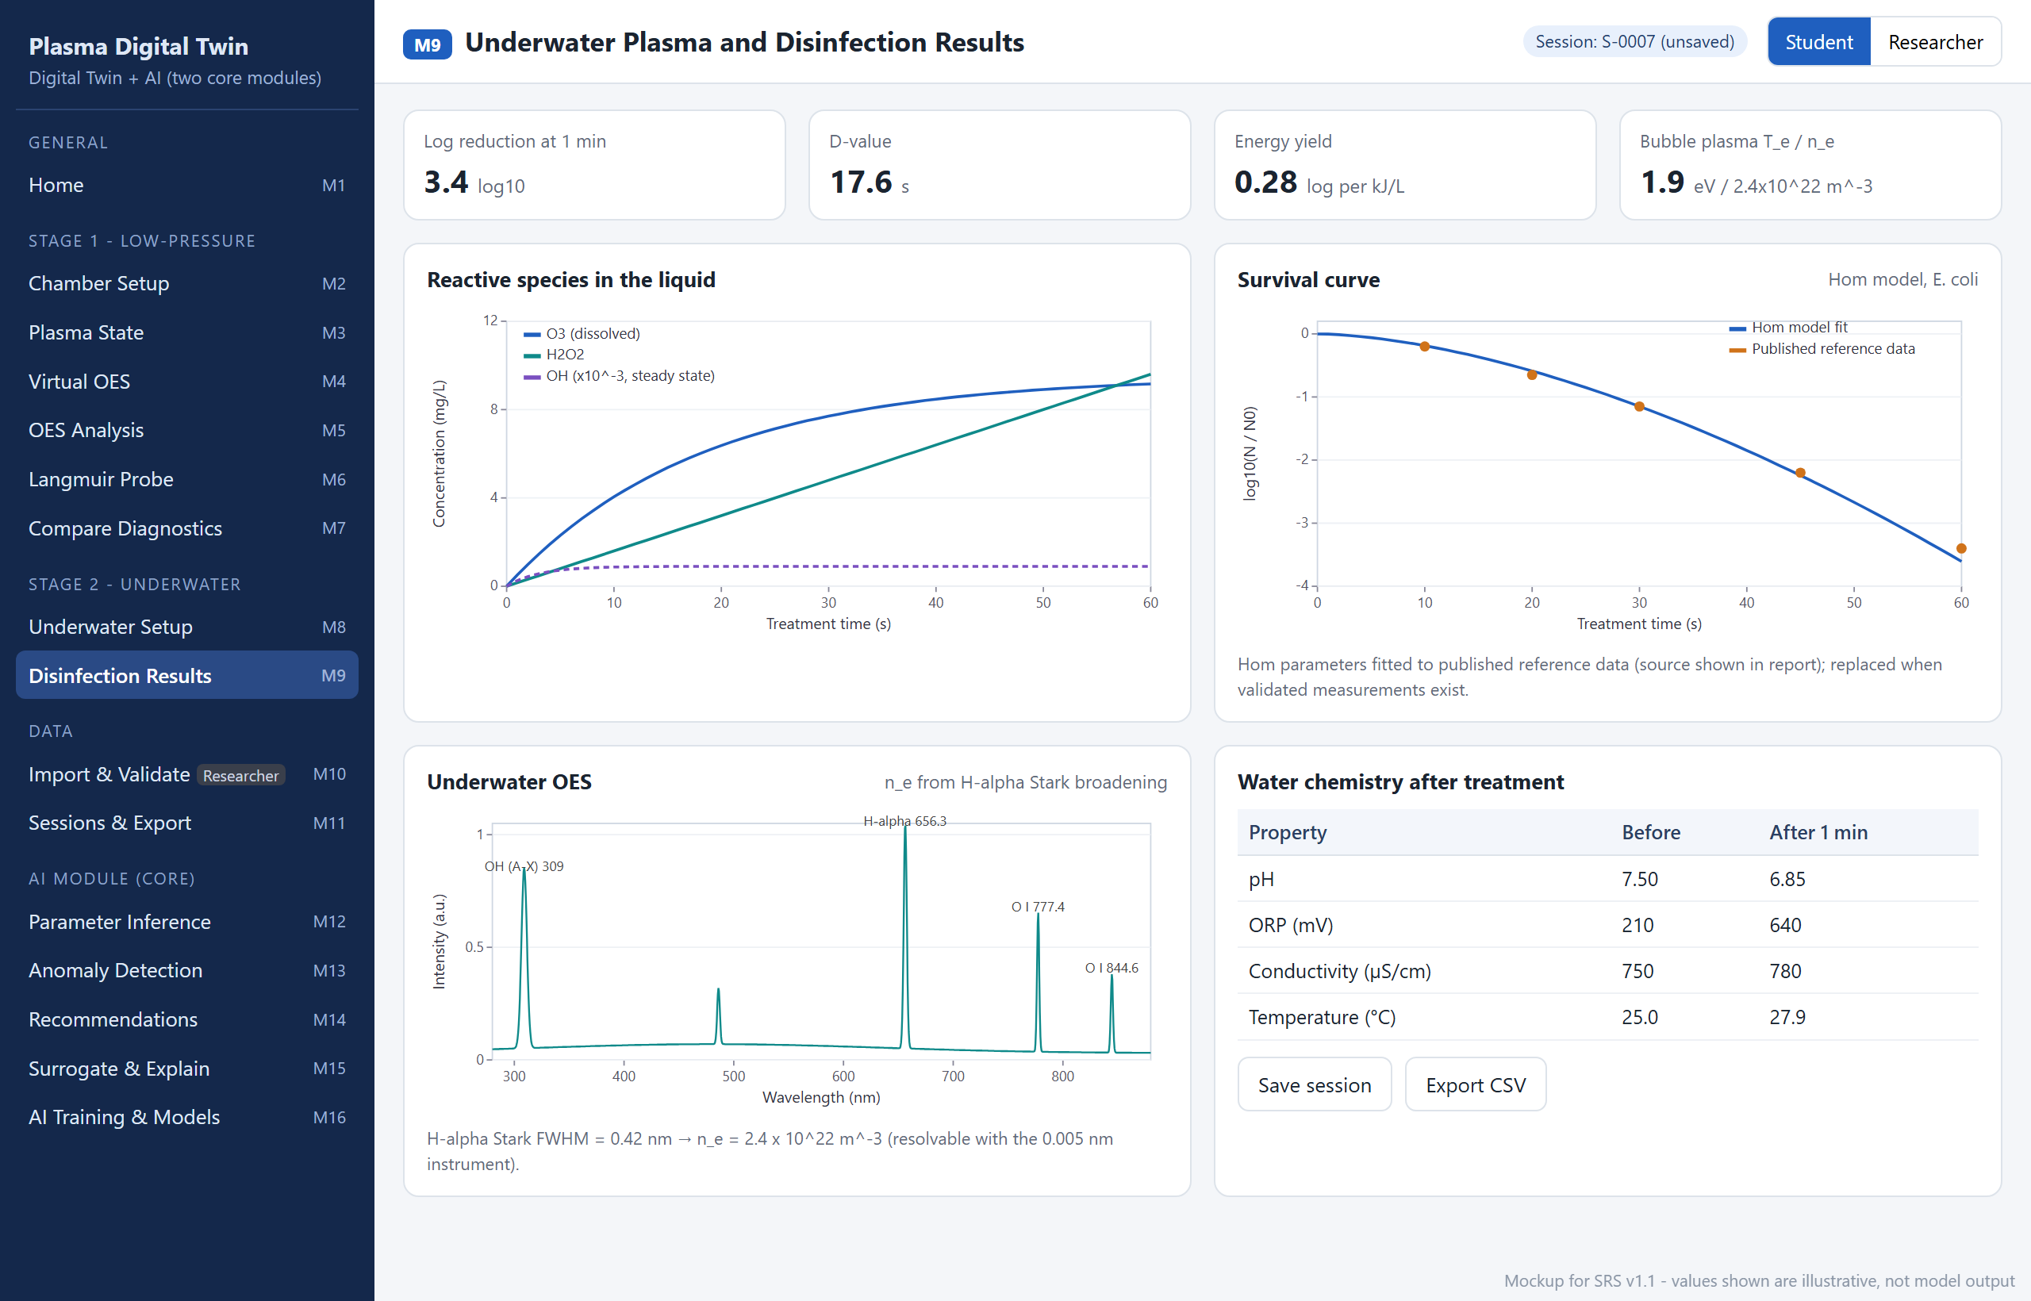
Figure 2.10: Mockup M9 – Underwater Plasma and Disinfection Results
Table 2.11: Functional requirements derived from Mockup M9 – Underwater Plasma and Disinfection Results
Feature (derived from UI) | Functional Requirement (FR-ID: Statement) | Business Rule
Key results | FR9.1: The system shall display the log reduction at the treatment time, the D-value, the energy yield and the bubble plasma T_{e} and n_{e}. | D-value = treatment time ÷ log reduction; energy yield = log reduction ÷ (power × time ÷ volume) in log per kJ/L.
Reactive species | FR9.2: The system shall plot the concentrations of O₃, H₂O₂ and OH in the liquid against treatment time. | Gas-phase global model plus empirical transfer into the liquid (supervisor).
Survival curve | FR9.3: The system shall plot log₁₀(N/N₀) from the Hom model against time, with published reference points. | log₁₀(N/N₀) = −k C^{n} t^{m}; k, n and m fitted to published time-resolved data until validated measurements exist; source shown.
Underwater OES | FR9.4: The system shall display the synthetic underwater spectrum (OH 309 nm, H-alpha 656.3 nm, O I 777 and 844 nm) and n_{e} from the H-alpha Stark width. | Stark n_{e} only when the instrument FWHM is smaller than the Stark FWHM (supervisor: H-alpha Stark method).
Water chemistry | FR9.5: The system shall display pH, ORP, conductivity and temperature before and after treatment. | Temperature rise = deposited energy ÷ (water mass × specific heat).
Save / export | FR9.6: The system shall save the Stage 2 session and export its results as CSV. | Same session rules as FR3.9.

2.6.10 Mockup M10 – Measured Data Import and Validation
This Researcher screen imports measured files, records their metadata and use, and runs literature and measured-data validation. Figure 2.11 shows the mockup and Table 2.12 lists the functional requirements derived from it.
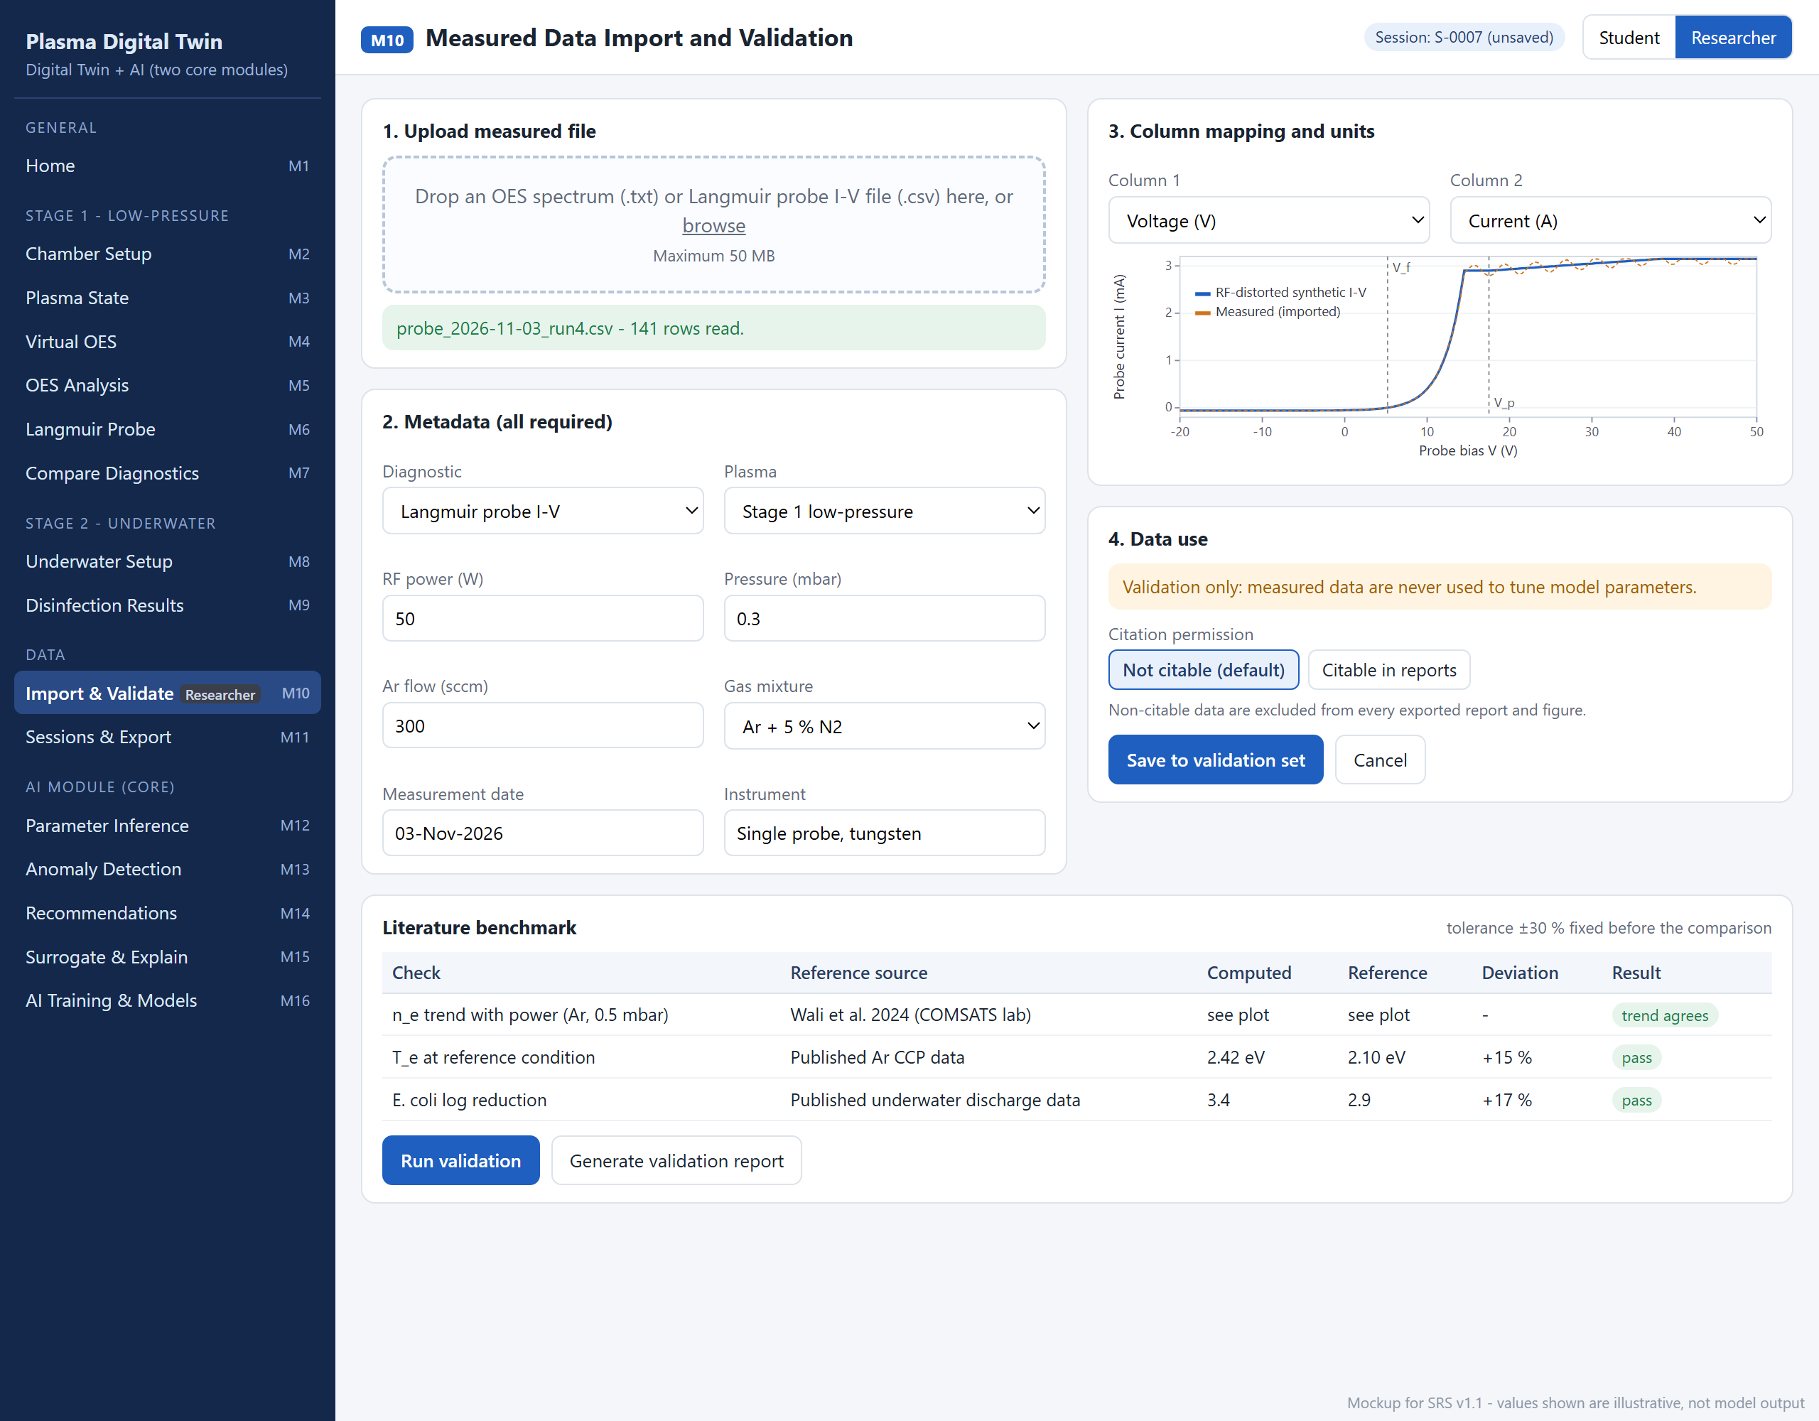
Figure 2.11: Mockup M10 – Measured Data Import and Validation
Table 2.12: Functional requirements derived from Mockup M10 – Measured Data Import and Validation
Feature (derived from UI) | Functional Requirement (FR-ID: Statement) | Business Rule
Upload file | FR10.1: The system shall allow a Researcher to upload a measured OES spectrum (.txt) or Langmuir probe I-V curve (.csv) and report the number of rows read. | Maximum 50 MB; formats as stated by the supervisor; only visible in Researcher mode.
Metadata | FR10.2: The system shall require the diagnostic, plasma stage, operating conditions, gas mixture, measurement date and instrument for every file. | All fields mandatory; operating conditions must lie inside the envelope of the chosen stage.
Column mapping and units | FR10.3: The system shall allow the Researcher to map file columns to quantities and units and shall show a preview plot. | OES: wavelength (nm) and intensity (a.u.); probe: voltage (V) and current (A, mA or µA, converted to A).
Data use and citation | FR10.4: The system shall state that measured data are used for validation only and shall record a citation permission for each file. | Default "Not citable" (supervisor); non-citable data are excluded from every export; measured data never tune model parameters (CON-6).
Save / cancel | FR10.5: The system shall save the file to the validation set or discard it on cancel. | Saved files are read-only.
Literature benchmark | FR10.6: The system shall list each benchmark check with its reference source, computed value, reference value, deviation and result. | Tolerance ±30 % fixed before the comparison (CON-7); reference values stored with citation.
Run validation | FR10.7: The system shall run all benchmark and measured-data comparisons on request. | Results are recorded with date and software version.
Validation report | FR10.8: The system shall generate a validation report of all checks. | Non-citable data appear only as anonymised pass/fail entries.

2.6.11 Mockup M11 – Session History and Export
This screen lists saved sessions, compares them and exports results. Figure 2.12 shows the mockup and Table 2.13 lists the functional requirements derived from it.
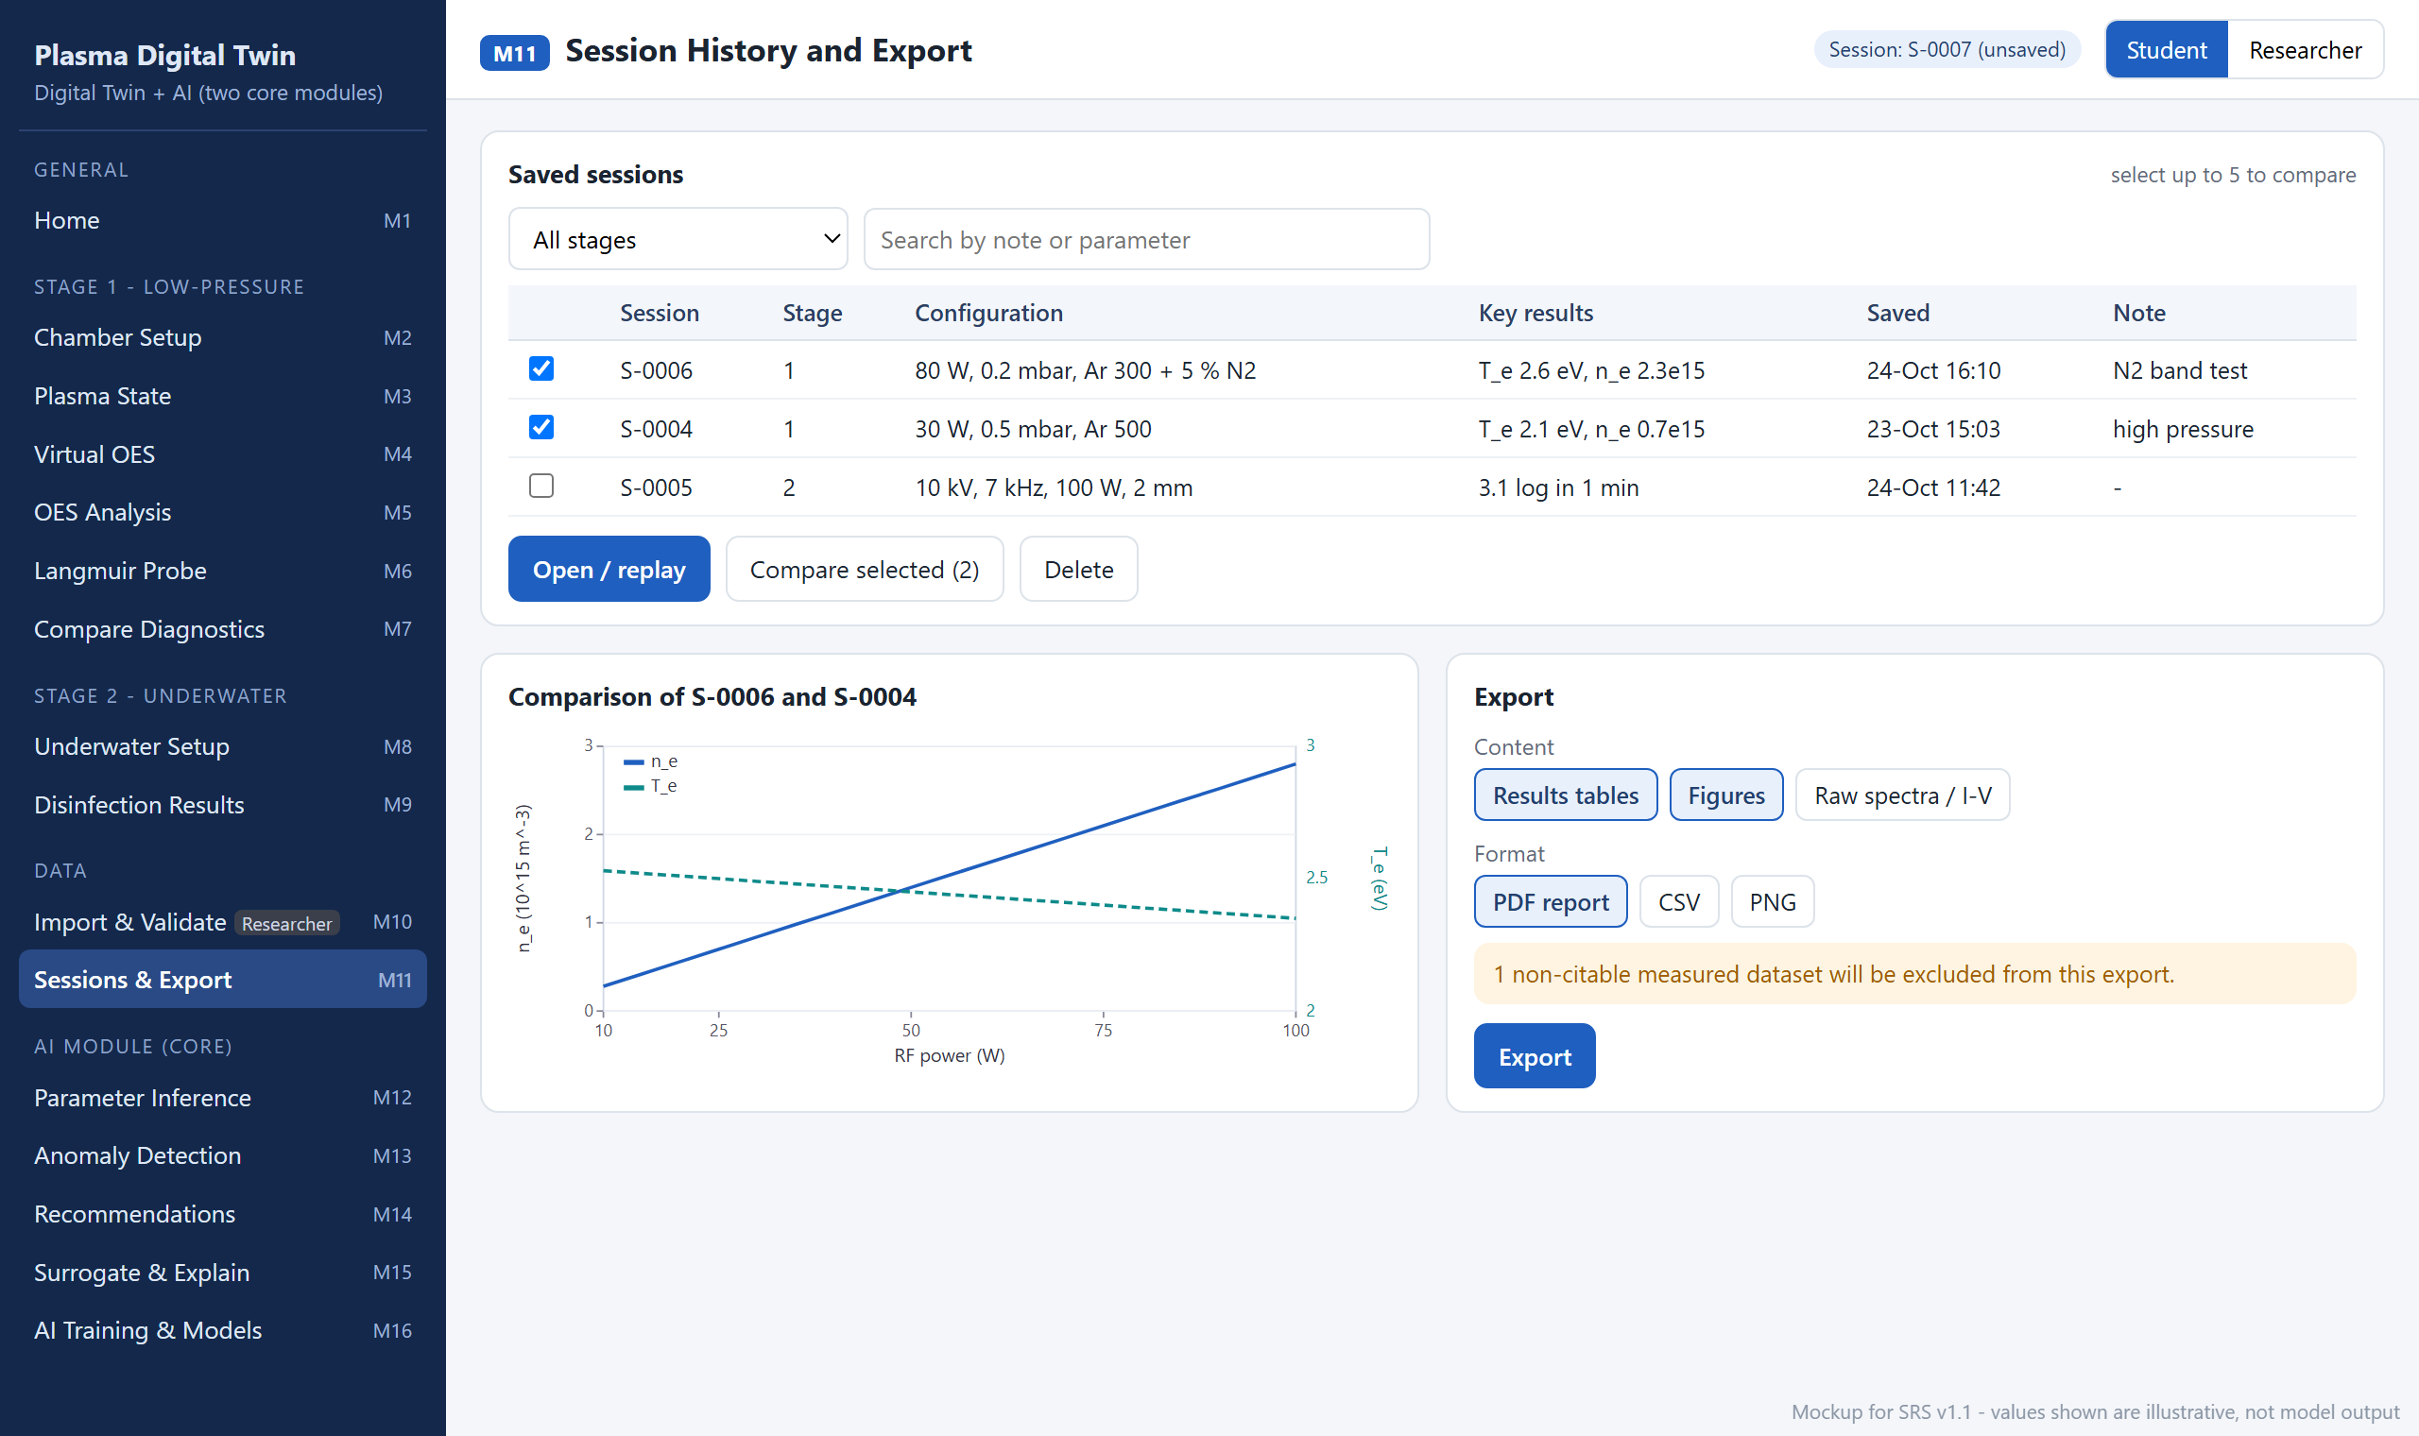
Figure 2.12: Mockup M11 – Session History and Export
Table 2.13: Functional requirements derived from Mockup M11 – Session History and Export
Feature (derived from UI) | Functional Requirement (FR-ID: Statement) | Business Rule
Session list | FR11.1: The system shall list saved sessions with ID, stage, configuration, key results, save time and note, filtered by stage and text search. | Newest first.
Compare sessions | FR11.2: The system shall allow the user to select sessions and overlay their results in one chart. | Between 2 and 5 sessions of the same stage.
Open / replay | FR11.3: The system shall reopen a saved session, restoring its configuration and results. | If the model version has changed since saving, the user is told and offered a re-run.
Delete | FR11.4: The system shall delete selected sessions after confirmation. | Deletion is permanent and requires explicit confirmation.
Export | FR11.5: The system shall export the selected content (results tables, figures, raw spectra or I-V data) as a PDF report, CSV or PNG. | Non-citable measured data are excluded and the number excluded is shown before export (event E19).

2.6.12 Mockup M12 – AI Parameter Inference from Spectra
This AI screen (sub-module 2.1) infers plasma parameters from a spectrum with a model trained on synthetic spectra from the twin. Figure 2.13 shows the mockup and Table 2.14 lists the functional requirements derived from it.
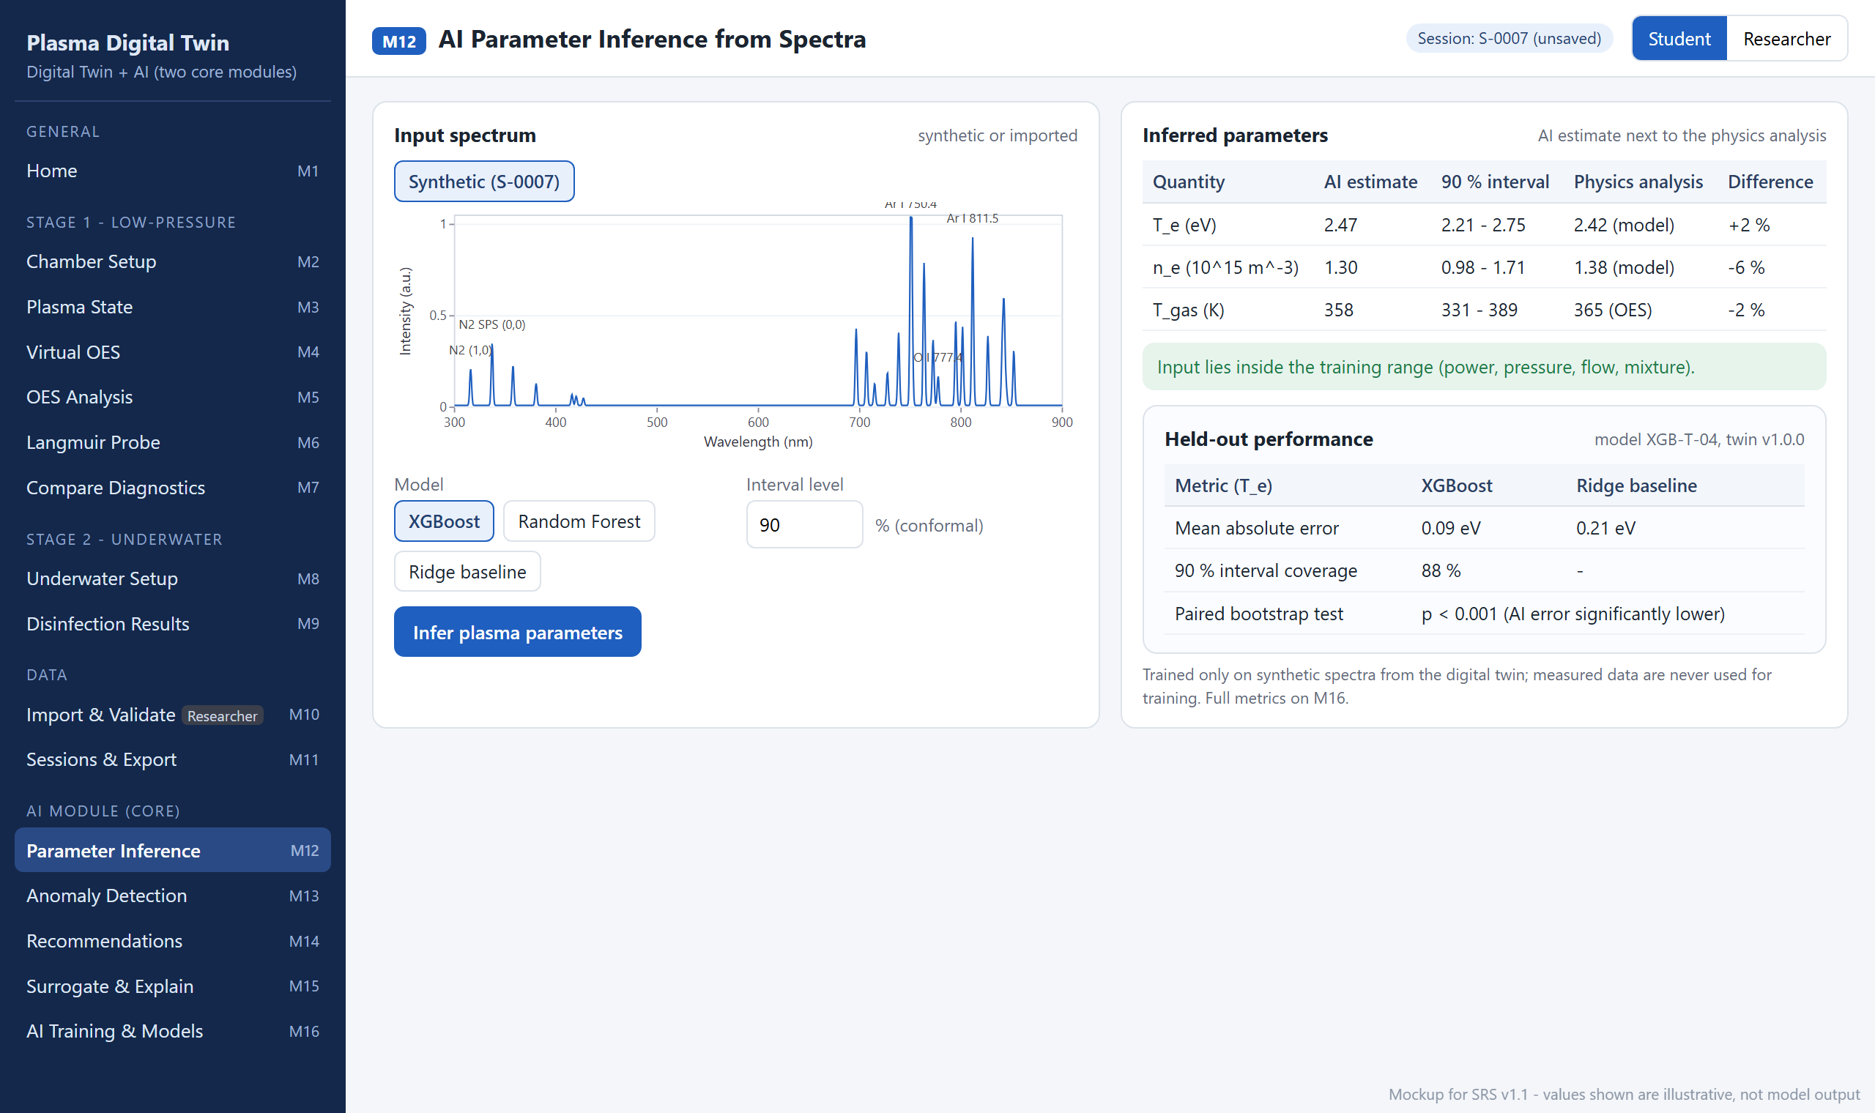
Figure 2.13: Mockup M12 – AI Parameter Inference from Spectra
Table 2.14: Functional requirements derived from Mockup M12 – AI Parameter Inference from Spectra
Feature (derived from UI) | Functional Requirement (FR-ID: Statement) | Business Rule
Input spectrum | FR12.1: The system shall allow the user to choose the synthetic spectrum of the open session or (Researcher) an imported spectrum as input. | Imported spectra must have complete metadata (FR10.2).
Model selection | FR12.2: The system shall allow the user to choose an XGBoost model, a Random Forest model or the ridge-regression baseline. | Tree ensembles only, no deep learning (CON-10).
Infer parameters | FR12.3: The system shall estimate T_{e}, n_{e} and T_{gas} with 90 % conformal prediction intervals. | Trained only on synthetic spectra from the twin; measured data are never used for training (CON-10).
Physics comparison | FR12.4: The system shall show the physics-based value and the percentage difference next to each AI estimate. | AI never replaces the physics result (CON-12).
Training-range check | FR12.5: The system shall check that the input lies inside the training range of power, pressure, flow and mixture. | Outside the range, the estimate is withheld (event E21).
Held-out performance | FR12.6: The system shall display the held-out error of the selected model, the baseline error, the interval coverage and the result of the significance test. | Paired bootstrap of absolute errors (scipy.stats), p < 0.05; reported honestly whatever the outcome (AIQ-1).

2.6.13 Mockup M13 – AI Physics-Relationship Anomaly Detection
This AI screen (sub-module 2.2) flags runs and measured files whose diagnostics disagree with the physics predicted by the twin. Figure 2.14 shows the mockup and Table 2.15 lists the functional requirements derived from it.
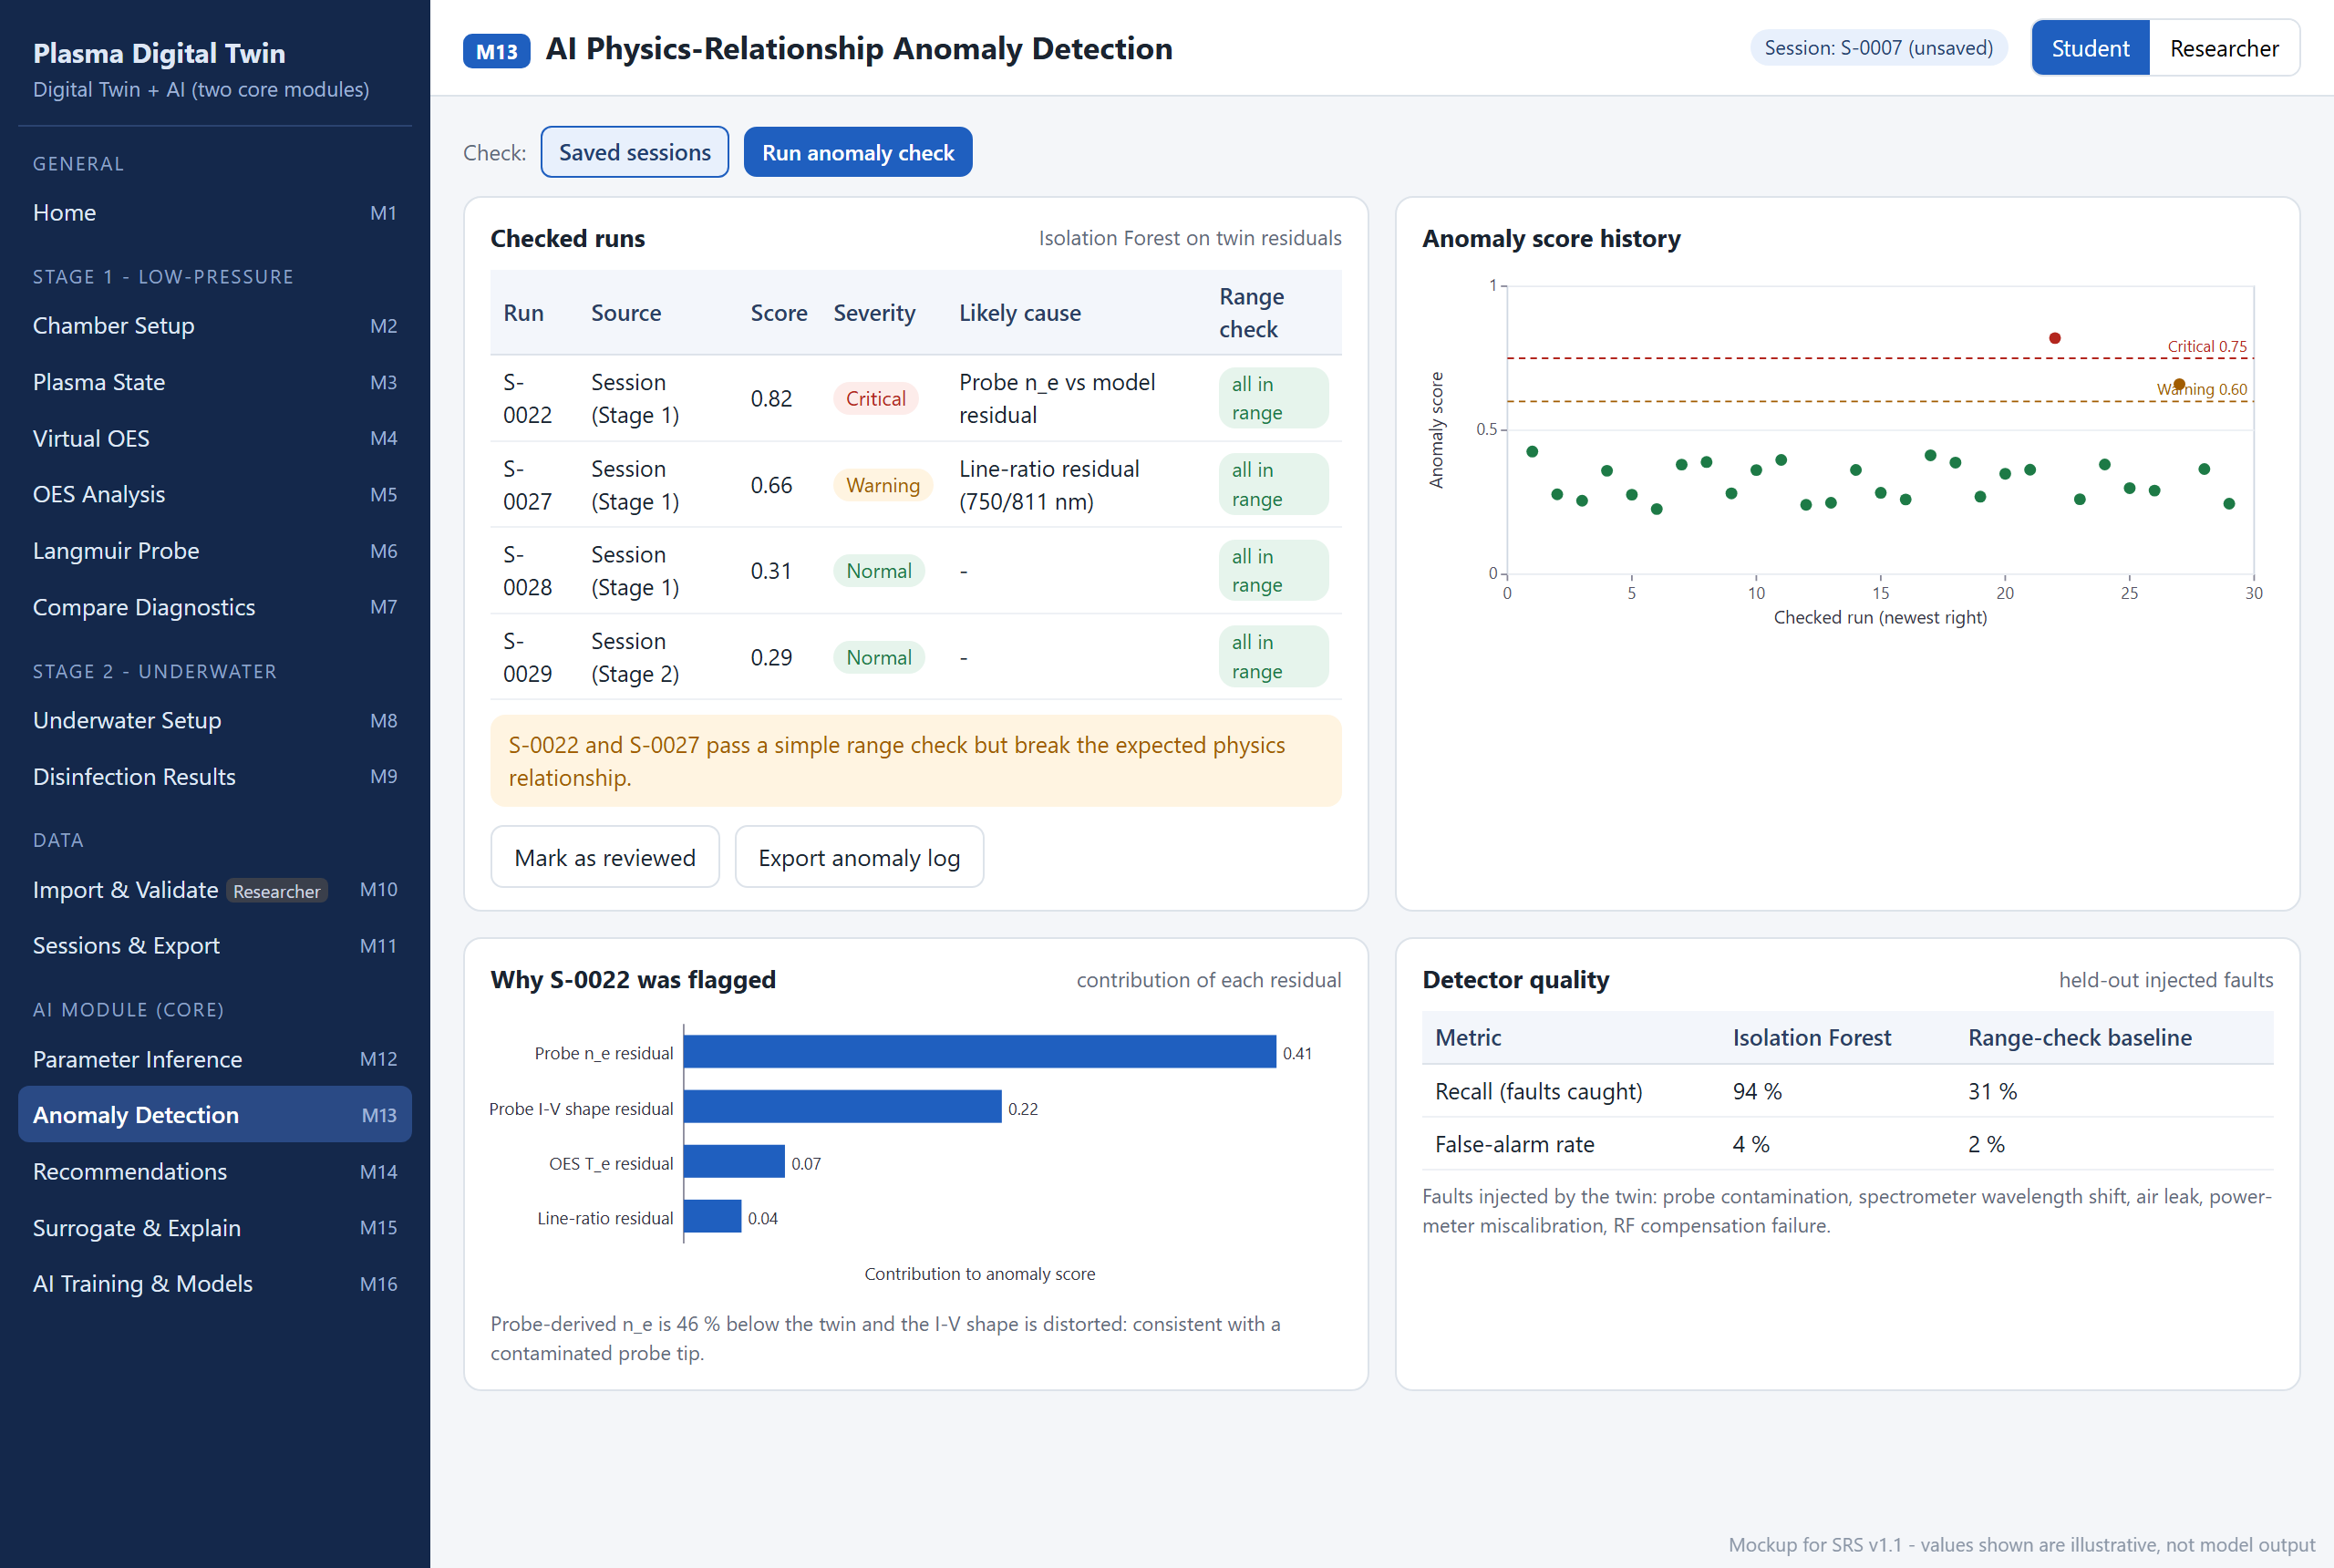
Figure 2.14: Mockup M13 – AI Physics-Relationship Anomaly Detection
Table 2.15: Functional requirements derived from Mockup M13 – AI Physics-Relationship Anomaly Detection
Feature (derived from UI) | Functional Requirement (FR-ID: Statement) | Business Rule
Check source | FR13.1: The system shall allow the user to check saved sessions or (Researcher) imported measured files. | Imported files must have complete metadata so the twin can predict the expected diagnostics.
Run anomaly check | FR13.2: The system shall compute residuals between the twin's predictions and the observed diagnostics and score them with an Isolation Forest. | Features are physics residuals, not raw input values; a plain range check is not treated as anomaly detection.
Checked runs | FR13.3: The system shall list each checked run with its anomaly score, severity, likely cause and the result of a simple range check. | Normal < 0.60 ≤ Warning < 0.75 ≤ Critical; thresholds stored in the versioned configuration (event E24).
Score history | FR13.4: The system shall plot anomaly scores over the checked runs with the warning and critical thresholds. | —
Explanation | FR13.5: The system shall show how much each residual contributed to a flagged run's score. | The largest contribution is reported as the likely cause.
Detector quality | FR13.6: The system shall display recall and false-alarm rate on held-out injected faults for the detector and for the range-check baseline. | Faults injected by the twin: probe contamination, wavelength shift, air leak, power-meter error, RF compensation failure (AIQ-2).
Review and export | FR13.7: The system shall allow the user to mark a flagged run as reviewed and to export the anomaly log. | The log is stored in SQLite with time stamps and session IDs.

2.6.14 Mockup M14 – AI Recommendations (Inverse Design)
This AI screen (sub-module 2.4) proposes settings for a user goal and verifies every proposal with the digital twin. Figure 2.15 shows the mockup and Table 2.16 lists the functional requirements derived from it.
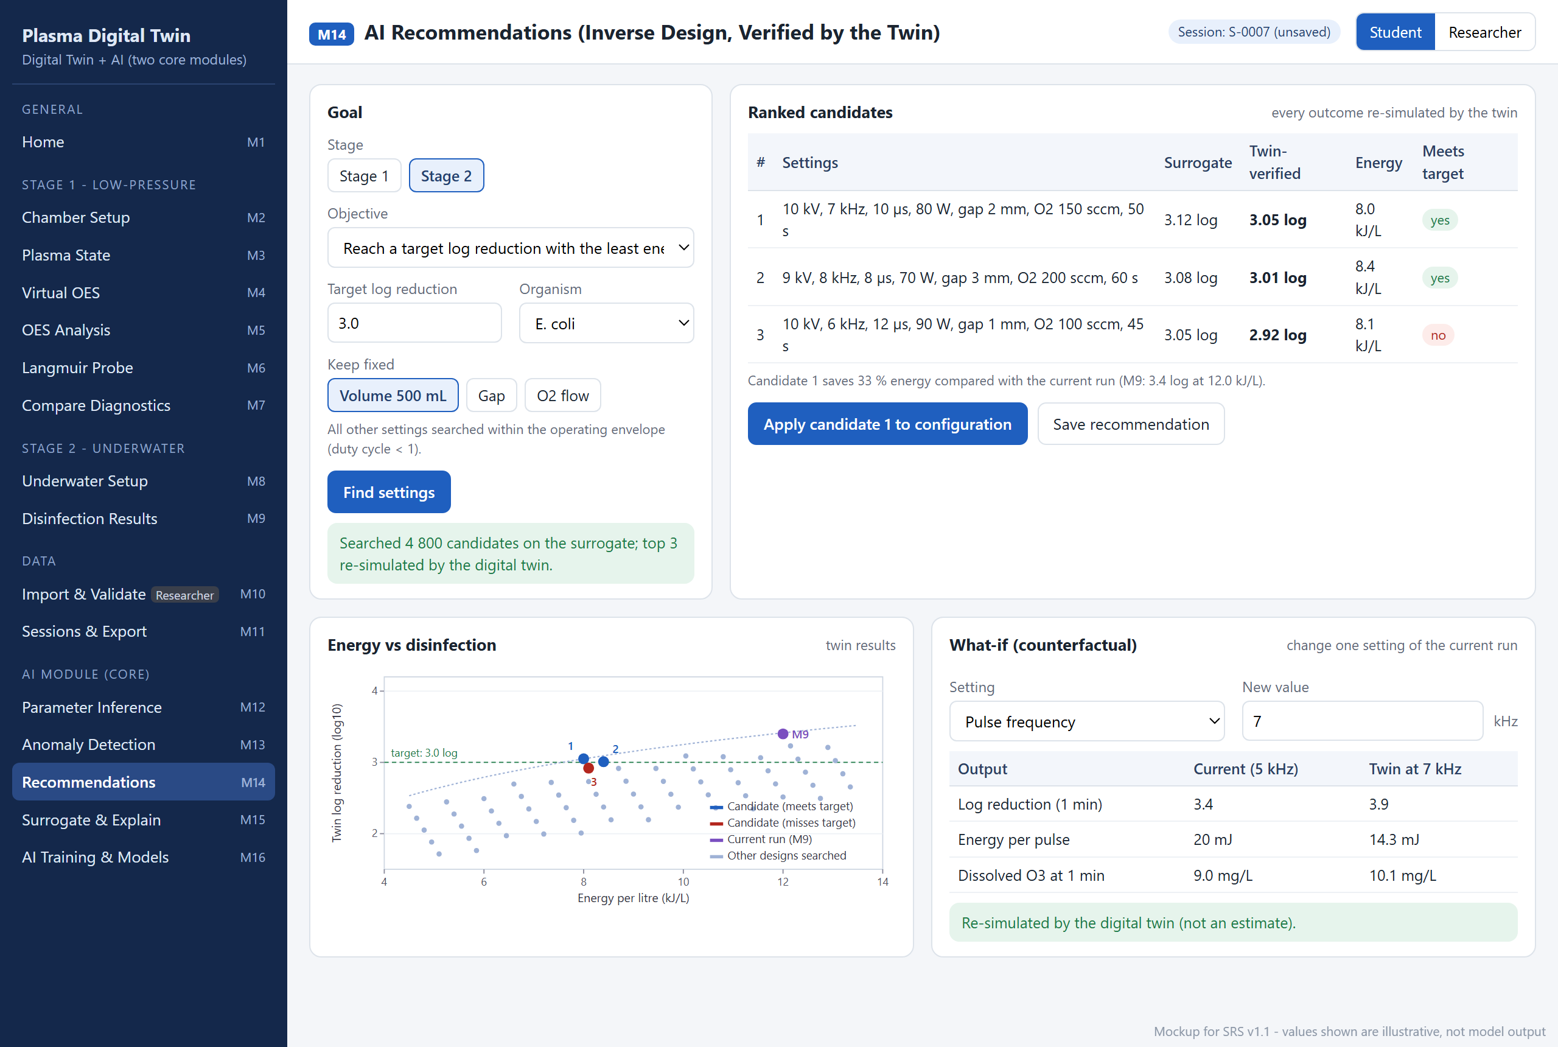
Figure 2.15: Mockup M14 – AI Recommendations (Inverse Design)
Table 2.16: Functional requirements derived from Mockup M14 – AI Recommendations (Inverse Design)
Feature (derived from UI) | Functional Requirement (FR-ID: Statement) | Business Rule
Goal | FR14.1: The system shall allow the user to choose the stage, an objective and a target value. | Stage 2: target log reduction with least energy, or maximum log reduction within an energy budget; Stage 1: target n_{e}, target T_{gas} or strongest chosen line.
Fixed settings | FR14.2: The system shall allow the user to keep chosen settings fixed during the search. | All other settings are searched only inside the operating envelope, with duty cycle < 1.
Find settings | FR14.3: The system shall search the envelope on the surrogate and re-simulate the best three candidates with the digital twin (event E25). | No recommendation is shown without its twin re-simulation (CON-12).
Ranked candidates | FR14.4: The system shall list each candidate's settings, surrogate prediction, twin-verified outcome, energy per litre and whether the goal is met. | Candidates are ranked by the twin-verified outcome, not by the surrogate.
Energy chart | FR14.5: The system shall plot the twin outcomes of the candidates and the current run against energy per litre. | —
What-if | FR14.6: The system shall let the user change one setting of the current run and show the twin's re-simulated outputs. | Values come from the twin, not from an estimate.
Apply or save | FR14.7: The system shall apply a chosen candidate to the configuration screen or save the recommendation. | Applying fills M2 or M8; nothing runs until the user presses Run.
Unreachable goal | FR14.8: The system shall state when no setting inside the envelope reaches the goal and show the closest twin-verified option. | Event E26.

2.6.15 Mockup M15 – AI Surrogate Model and Explainability
This AI screen (sub-module 2.3) uses a fast surrogate of the twin for large explorations and explains its outputs with SHAP. Figure 2.16 shows the mockup and Table 2.17 lists the functional requirements derived from it.
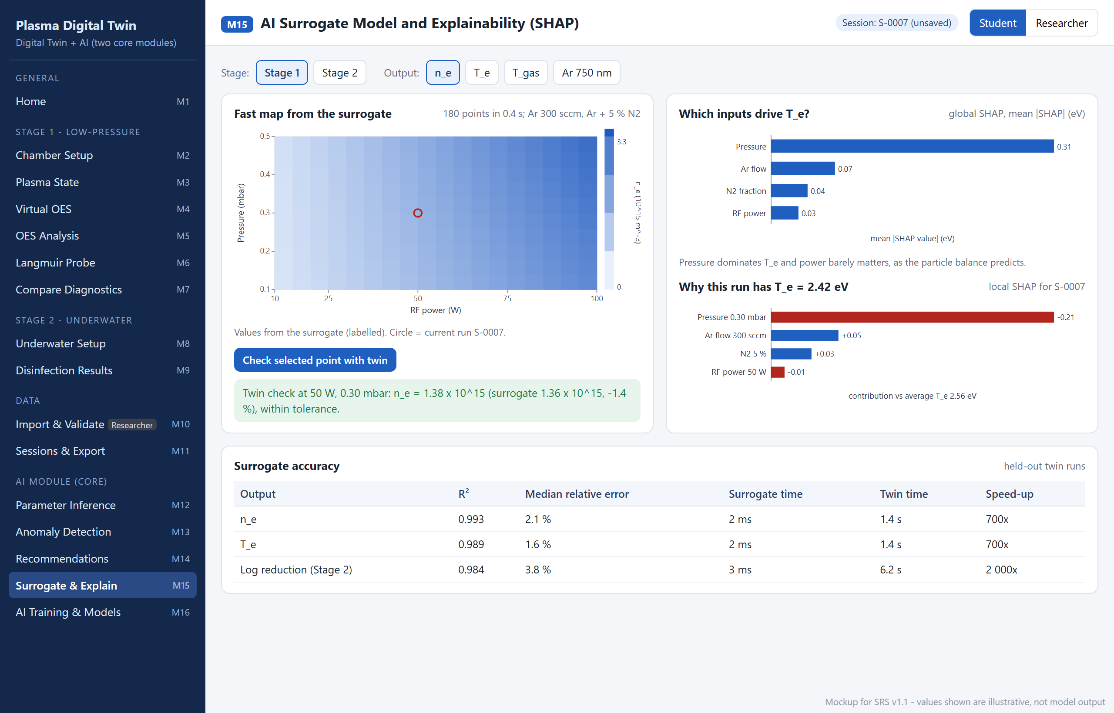
Figure 2.16: Mockup M15 – AI Surrogate Model and Explainability
Table 2.17: Functional requirements derived from Mockup M15 – AI Surrogate Model and Explainability
Feature (derived from UI) | Functional Requirement (FR-ID: Statement) | Business Rule
Stage and output | FR15.1: The system shall allow the user to choose the stage and the output to explore. | —
Fast map | FR15.2: The system shall draw a map of the chosen output over two inputs using the surrogate. | Every surrogate value is labelled "surrogate" (CON-12).
Check with twin | FR15.3: The system shall re-run a selected point through the twin and show both values. | If they differ by more than 5 %, the twin value is shown and the region is flagged (event E27).
Global explanation | FR15.4: The system shall show global SHAP importance of each input for the chosen output. | —
Local explanation | FR15.5: The system shall show the SHAP contribution of each input for the current run. | Local SHAP values add up to the prediction minus the average prediction.
Surrogate accuracy | FR15.6: The system shall display R², median relative error and speed-up against the twin for each output. | Acceptance: R² ≥ 0.98, median relative error ≤ 5 %, at least 100 times faster (AIQ-3).

2.6.16 Mockup M16 – AI Training, Evaluation and Model Registry
This AI screen (sub-module 2.5) shows the training data, trains models (Researcher) and lists every registered model. Figure 2.17 shows the mockup and Table 2.18 lists the functional requirements derived from it.
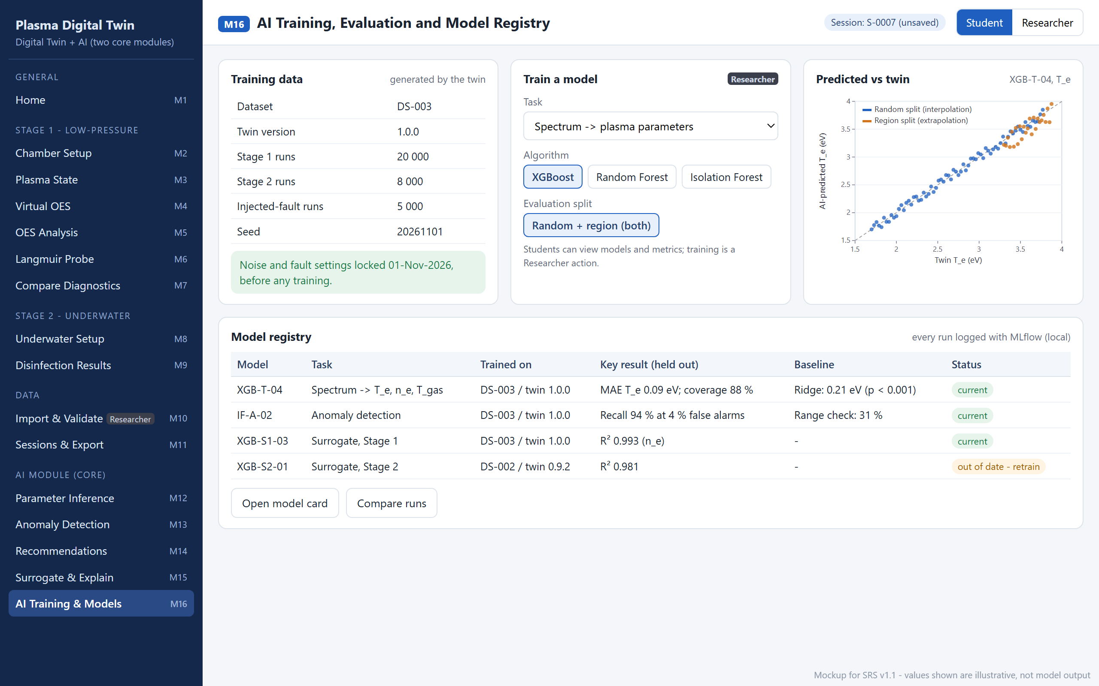
Figure 2.17: Mockup M16 – AI Training, Evaluation and Model Registry
Table 2.18: Functional requirements derived from Mockup M16 – AI Training, Evaluation and Model Registry
Feature (derived from UI) | Functional Requirement (FR-ID: Statement) | Business Rule
Training data | FR16.1: The system shall display the dataset ID, twin version, number of runs per stage and fault type, and the seed. | Noise and fault settings are locked before any training; the lock date is shown (AIQ-5).
Train a model | FR16.2: The system shall allow a Researcher to train a model by choosing the task, the algorithm and the evaluation split. | Researcher only; Students can view models and metrics (event E23).
Evaluation | FR16.3: The system shall evaluate every model on a random split and a region-based split and plot predicted against twin values. | Both results are always reported; the region split tests extrapolation.
Model registry | FR16.4: The system shall list every model with its task, dataset, twin version, key held-out result, baseline result and status. | A model stamped with an older twin version is marked out of date and is not used (event E22, AIQ-6).
Model card and runs | FR16.5: The system shall open a model's card and compare logged training runs. | Every run is logged with MLflow in a local file store (SI-7).

2.6.17 Backend Event–Response Table
The following events capture backend processing that is not visible as a screen element. Events E1–E27 were identified for the Stage 1 simulation, the diagnostics, Stage 2, data import, sessions, export and the AI module. Table 2.19 records the event list, and Table 2.20 records the trigger, source, states, response and exception handling of each event.
Table 2.19: Identified backend events
ID | Event | ID | Event
E1 | Application start-up | E15 | Validation run requested
E2 | Stage 1 simulation requested | E16 | Validation tolerance exceeded
E3 | Configuration outside envelope | E17 | Parameter sweep completed
E4 | Solver non-convergence | E18 | Session save failure
E5 | Inconsistent Stage 2 pulse settings | E19 | Export with non-citable data
E6 | Reference data missing or corrupt | E20 | Stage 2 disinfection simulation requested
E7 | Synthetic spectrum requested | E21 | AI input outside training range
E8 | Doppler method below instrument resolution | E22 | AI model missing or out of date
E9 | Insufficient Boltzmann-plot lines | E23 | AI training run requested
E10 | Probe I-V generation requested | E24 | Anomaly detected
E11 | Probe analysis failure | E25 | Recommendation requested
E12 | OML validity violated | E26 | Recommendation target unreachable
E13 | Measured file uploaded | E27 | Surrogate–twin disagreement
E14 | File rejected (format, size or parse failure)

Table 2.20: Event–response table for backend processes
Event Name | Trigger | Source | System State (Before) | Response | System State (After) | Exception Handling
E1 Application start-up | User starts the application | Student / Researcher (launcher) | Not running | 1. Load and checksum reference data files  2. Open or create the SQLite database and apply schema migrations  3. Show Home with data status | Home displayed; ready | Missing file → E6; unreadable database → back it up, create a new one, notify user
E2 Stage 1 simulation requested | Run simulation (M2) or quick start (M1) | Student | Valid configuration | 1. Compute configuration hash; return cached result if present  2. Compute rate coefficients for the chosen EEDF  3. Solve particle balance for T_{e} (bracketed root finding)  4. Solve power balance for n_{e} and energy balance for T_{gas}  5. Compute species, sheath and 1D profile if selected | Results shown in M3; unsaved session | Non-convergence → E4
E3 Configuration outside envelope | Input changed to an out-of-range or inconsistent value | Configuration Validator | Editing | 1. Highlight the field  2. Show allowed range and unit  3. Disable Run | Configuration invalid; Run disabled | None needed; restored when corrected
E4 Solver non-convergence | Root not bracketed or iteration limit reached | Simulation Orchestrator | Computing | 1. Retry once with a widened bracket  2. If still failing, stop and log inputs and residual  3. Show message with nearest valid configuration | Previous results kept; no partial results shown | Logged for regression testing (REL-1)
E5 Inconsistent Stage 2 pulse settings | Duty cycle ≥ 1 (pulse width × frequency) | Configuration Validator | Editing M8 | 1. Block Run  2. Show computed duty cycle and corrective action | Configuration invalid | Warning only when 0.5 < duty < 1
E6 Reference data missing or corrupt | File absent or checksum mismatch | Reference Data Source | Start-up or on demand | 1. Mark data set "missing" in M1  2. Disable dependent features (e.g., OES without line data) | Degraded mode | Instruct user to reinstall the data package
E7 Synthetic spectrum requested | Send to OES (M3) or Recompute (M4) | Student | Solved plasma state available | 1. Solve CR model for 1s and 2p populations  2. Compute line intensities from NIST data  3. Convolve with instrument function; add seeded noise | Spectrum and line table shown | No plasma state → prompt to run a simulation first
E8 Doppler below resolution | Doppler method selected and instrument FWHM > expected Doppler FWHM | OES Analysis | Analysing | 1. Disable Doppler option with explanation  2. Offer N₂ rotational method | Alternative method used | If no N₂ in mixture, T_{gas} reported from model only, marked
E9 Insufficient Boltzmann lines | < 4 usable lines or energy span < 1.0 eV | OES Analysis | Analysing | 1. Do not report T_{exc}  2. Show which condition failed | T_{exc} unavailable | User may add lines or widen range
E10 Probe I-V requested | Generate I-V curve (M6) | Student | Solved plasma state available | 1. Compute ion and electron currents (OML)  2. Apply RF averaging if enabled; add seeded noise  3. Run analysis automatically | Curve and results shown | No plasma state → prompt to run a simulation
E11 Probe analysis failure | V_{f} or V_{p} cannot be found (no zero crossing) | Probe Analysis | Analysing | 1. Keep the raw curve  2. Report the failed step  3. Suggest a wider sweep | Partial results only | Logged
E12 OML validity violated | r_{p}/λ_{D} > 1 | Probe Analysis | Analysis complete | 1. Show warning  2. Mark n_{e} as approximate | Results flagged | None
E13 Measured file uploaded | Researcher drops or browses a file (M10) | Researcher (from OES Spectrometer or Probe System) | Researcher mode | 1. Check type and size  2. Detect delimiter; parse; show rows read and preview  3. Request metadata | File pending metadata | Failure → E14
E14 File rejected | Wrong type, > 50 MB, or unparsable | Import & Parsing | Upload in progress | 1. Reject file  2. Show exact reason (line number if parse error) | Nothing stored | None
E15 Validation run requested | Run validation (M10) | Researcher | Benchmarks and/or measured files present | 1. Load tolerance (±30 %) from versioned file  2. Compute each deviation  3. Record pass/fail with date and version | Validation results stored | Missing reference → check skipped and listed
E16 Tolerance exceeded | |deviation| > 30 % | Validation & Benchmark | Validation running | 1. Mark check as fail  2. Keep the result in the report | Fail recorded | Parameters are never adjusted automatically (CON-6)
E17 Parameter sweep completed | Last sweep point solved | Simulation Orchestrator | Sweep running with progress | 1. Store series  2. Plot results in M3 | Sweep results available | Failed points listed, others kept
E18 Session save failure | Database locked or disk full | Session Manager | Save requested | 1. Retry once after 1 s  2. Keep results in memory  3. Offer CSV export | Session unsaved; results kept | User notified with cause
E19 Export with non-citable data | Export requested while selection includes non-citable data | Export & Report | Export dialog | 1. Remove non-citable datasets  2. Show how many were excluded  3. Add an exclusion note | Export file created without them | None
E20 Stage 2 simulation requested | Run disinfection simulation (M8) | Student | Valid Stage 2 configuration | 1. Solve bubble global model (Maxwellian)  2. Transfer species to liquid  3. Integrate Hom survival and water chemistry  4. Synthesise underwater OES and Stark n_{e} | Results shown in M9 | Non-convergence → E4 handling
E21 AI input outside training range | Input conditions outside training data | AI Inference | Inference requested | 1. Withhold the estimate  2. Show the out-of-range parameters | Physics result only | None
E22 AI model missing or out of date | Model file missing, or model stamped with an older twin version | AI Training & Registry | Start-up or twin version changed | 1. Mark the affected AI screens "retrain required"  2. Never use an out-of-date model for a result  3. Offer training (Researcher) | That AI task disabled until retrained | Physics results unaffected
E23 AI training run requested | Start training (M16) | Researcher | Dataset settings locked | 1. Generate or load the twin dataset with the recorded seed  2. Train the model and its baseline  3. Evaluate on random and region splits  4. Log the run in MLflow; write the model card | New model registered with twin version | Training failure → previous model kept; error logged
E24 Anomaly detected | Anomaly score ≥ warning threshold | AI Anomaly Detector | Anomaly check running | 1. Assign Warning or Critical severity  2. Name the largest contributing residual  3. Add the run to the anomaly log | Run flagged for review | None
E25 Recommendation requested | Find settings (M14) | Student | Valid goal and constraints | 1. Search the envelope on the surrogate  2. Re-simulate the top 3 candidates with the twin  3. Rank by twin-verified outcome | Ranked candidates shown | Twin fails for a candidate → candidate dropped and listed
E26 Recommendation target unreachable | No twin-verified candidate meets the goal | Recommendation Engine | Search complete | 1. State that the goal cannot be reached inside the envelope  2. Show the closest twin-verified candidate | Closest option shown | None
E27 Surrogate–twin disagreement | |surrogate − twin| > 5 % at a checked point | AI Surrogate | Twin check requested | 1. Show the twin value  2. Flag the region as unreliable  3. Log the point for retraining | Twin value used | None

2.6.18 Functional Requirements Derived from Events
Table 2.21 lists the functional requirements derived from the event–response table.
Table 2.21: Functional requirements derived from the event–response table
Event | Functional Requirement (FR-ID: Statement) | Business Rule
E1 | FR17.1: The system shall verify the presence and checksum of every reference data file and open or create the session database at start-up. | Checksums are stored in a manifest shipped with the data.
E2 | FR17.2: The system shall compute the Stage 1 plasma state by solving the particle balance for T_{e} and then the power balance for n_{e}, reusing a cached result for an identical configuration. | Cache key = hash of all inputs and the model version.
E3 | FR17.3: The system shall block a run while any input is outside its allowed range and shall state the allowed range. | Ranges come from one configuration file shared by UI and validator.
E4 | FR17.4: The system shall retry a non-converged solve once with a widened bracket and otherwise report failure without showing partial results. | Convergence residual < 10⁻⁸.
E5 | FR17.5: The system shall block a Stage 2 run whose duty cycle is 1 or more. | Warning when duty cycle > 0.5.
E6 | FR17.6: The system shall disable features whose reference data are missing or corrupt and show this on the Home screen. | No silent fallback to built-in guesses.
E7 | FR17.7: The system shall synthesise spectra from CR-model populations and NIST line data with a seeded instrument noise model. | Same seed and inputs give the same spectrum.
E8 | FR17.8: The system shall disable Doppler gas-temperature analysis when the instrument FWHM exceeds the expected Doppler FWHM. | Doppler FWHM computed for argon at the model T_{gas}.
E9 | FR17.9: The system shall not report T_{exc} unless at least 4 lines spanning at least 1.0 eV are used. | —
E10, E11 | FR17.10: The system shall generate and automatically analyse probe curves and report the step at which an analysis fails. | Raw curve is always kept.
E12 | FR17.11: The system shall flag probe-derived n_{e} as approximate when r_{p}/λ_{D} > 1. | —
E13, E14 | FR17.12: The system shall parse uploaded files and reject wrong-type, oversized or unparsable files with the exact reason. | Maximum 50 MB; nothing stored on rejection.
E15, E16 | FR17.13: The system shall evaluate every validation check against the ±30 % tolerance loaded from the versioned file and record failures without changing model parameters. | Tolerance fixed before comparison (CON-7).
E17 | FR17.14: The system shall show sweep progress and keep all solved points when some points fail. | Progress updated at least every 2 s (PER-4).
E18 | FR17.15: The system shall keep results in memory and offer CSV export when a session cannot be saved. | One automatic retry.
E19 | FR17.16: The system shall exclude non-citable measured data from every export and report the number excluded. | Citation permission recorded per file (FR10.4).
E20 | FR17.17: The system shall compute the Stage 2 bubble plasma, liquid species, Hom survival, water chemistry and underwater spectrum in one run. | Maxwellian EEDF (CON-4).
E21, E22 | FR17.18: The system shall withhold AI estimates outside the training range and shall not use any AI model that is missing or trained on an older twin version. | AI outputs never come from an out-of-date model (AIQ-6).
E23 | FR17.19: The system shall train each AI model together with its baseline on twin-generated data, evaluate both on random and region splits, and log the run with MLflow. | Dataset settings and seed fixed before training (CON-10).
E24 | FR17.20: The system shall flag runs whose anomaly score reaches the warning threshold and record the likely cause. | Thresholds come from the versioned configuration.
E25, E26 | FR17.21: The system shall verify every recommendation candidate with the twin and report when a goal cannot be reached inside the envelope. | Counterfactual principle: no unverified advice (CON-12).
E27 | FR17.22: The system shall prefer the twin value whenever the surrogate differs from it by more than 5 %. | The twin is the reference; the surrogate is only a fast approximation.

2.7 Non-Functional Requirements
The non-functional requirements below are written in measurable terms following Wiegers and Beatty [33]. Each table gives the target, the reason the target was chosen, and how the architecture in Chapter 3 supports it. Performance targets refer to a reference computer with a 4-core 2.0 GHz or faster CPU and 8 GB RAM.

2.7.1 Reliability
Table 2.22 lists the reliability requirements. A failure is defined as a crash, an unhandled exception shown to the user, a lost saved session or a result that differs from the reference regression value.
Table 2.22: Reliability requirements
ID | Requirement (measurable) | Justification | Architectural support
REL-1 | The Stage 1 solver shall converge for 100 % of a pre-registered grid of at least 500 configurations spanning the full envelope. | A non-converging run blocks learning; the grid exposes edge cases before users do. | Bracketed root finding with retry (E4); grid test in pytest CI.
REL-2 | No unhandled exception shall reach the user for any of the 27 events; every exception path in the event–response table shall produce a message. | Students must always see a cause and a corrective action. | Central error handler in the application-services layer; one test per event.
REL-3 | Zero saved sessions shall be lost in 50 forced-termination tests during saving. | Sessions are the user's experimental record. | SQLite transactions with write-ahead logging.
REL-4 | Re-running a saved configuration with the same seed and model version shall reproduce every numeric result to a relative difference below 10⁻⁹. | Scientific results must be reproducible for defence and validation. | Seeded noise; model version stored with each session.

2.7.2 Usability
Table 2.23 lists the usability requirements for a learner with little software experience.
Table 2.23: Usability requirements
ID | Requirement (measurable) | Justification | Architectural support
USE-1 | A first-time user shall run the default Stage 1 experiment from the Home screen with no more than 2 interactions. | Immediate success motivates learning. | Quick-start list on M1 calls the same run service as M2.
USE-2 | At least 80 % of at least 5 student test users shall configure a stated Stage 1 run and read T_{gas} within 5 minutes without help. | Directly supports BO-2. | Stage-grouped navigation; defaults from the laboratory set-up.
USE-3 | 100 % of input fields shall show the allowed range and unit, and 100 % of error messages shall state the cause and a corrective action. | Prevents invalid runs and frustration. | Ranges and messages generated from one configuration file.
USE-4 | Every plotted axis shall show a symbol and SI unit, and the glossary shall cover 100 % of displayed symbols. | Physics results are meaningless without units. | Shared chart helper enforces axis labels.
USE-5 | Status shall never be conveyed by colour alone, and text contrast shall be at least 4.5:1. | WCAG 2.1 AA accessibility [34]. | Status component always renders a text label.

2.7.3 Performance
Table 2.24 lists the performance requirements. The targets follow Nielsen's response-time limits: about 1 s keeps the user's flow of thought and 10 s is the limit for keeping attention without a progress indicator [35].
Table 2.24: Performance requirements
ID | Requirement (measurable) | Justification | Architectural support
PER-1 | 95 % of Stage 1 0D runs shall complete within 2 s, and 0D + 1D runs within 5 s. | Close to the 1 s limit so students can explore parameters interactively. | Cached results keyed on configuration hash; vectorised NumPy; compiled SciPy root finding.
PER-2 | A synthetic spectrum for 300–900 nm at 0.005 nm resolution (120 000 points) shall be recomputed within 3 s. | Instrument settings are changed repeatedly while learning. | Instrument convolution by FFT; plasma state not re-solved (FR4.4).
PER-3 | Probe I-V generation and analysis for up to 2001 points shall complete within 2 s. | Same interactive limit as PER-1. | Analytic OML currents; vectorised smoothing and differentiation.
PER-4 | A 200-point sweep shall complete within 120 s, with progress updated at least every 2 s. | Beyond 10 s a progress indicator is required. | Each point reuses the cached rate tables; progress callback.
PER-5 | A Stage 2 disinfection run for a 1 min treatment shall complete within 10 s. | Within the attention limit. | Stiff ODE solver for species kinetics.
PER-6 | Validation feedback after an input change shall appear within 0.5 s. | Immediate feedback prevents invalid runs. | Validation runs before, and separately from, the model.
PER-7 | A 50 MB file shall be parsed and previewed within 15 s. | Largest allowed file. | Streaming CSV parser; preview of a downsampled curve.
PER-8 | The Home screen shall be ready within 15 s of starting the application. | Users judge the tool at first launch. | Reference data loaded once and cached.
PER-9 | One AI parameter inference shall complete within 1 s. | Within the 1 s flow limit. | Trained model loaded once and cached.
PER-10 | A recommendation, including twin re-simulation of three candidates, shall complete within 60 s, with progress shown. | Long search; progress indicator required beyond 10 s. | Search runs on the fast surrogate; only the top candidates use the twin.

2.7.4 Security
Table 2.25 lists the security requirements. The system is a single-user local application, so the main assets are the user's measured data and the integrity of results.
Table 2.25: Security requirements
ID | Requirement (measurable) | Justification | Architectural support
SEC-1 | The application shall accept connections only on the loopback interface; a port scan from another computer shall find no open application port. | Measured laboratory data must not be exposed on the network. | Server bound to 127.0.0.1.
SEC-2 | 100 % of uploaded files shall be treated as data only: no content is executed, and files of the wrong type or over 50 MB are rejected. | Imported files come from other computers. | Import & Parsing service with type, size and schema checks (E14).
SEC-3 | Non-citable measured data shall appear in 0 exported files, figures or reports in automated export tests. | Supervisor forbids citing the data (LI-7). | Citation filter inside the Export & Report service (E19).
SEC-4 | 100 % of database statements shall use parameterised queries; injection test strings in notes and search fields shall have no effect. | Free-text fields are stored in SQLite. | Session Manager data-access functions.
SEC-5 | The application shall make no outbound network connection at run time. | Works offline; no data leave the computer. | Reference data shipped locally (OE-4).

2.7.5 Accuracy and Scientific Validity
Table 2.26 lists the requirements that make the results scientifically defensible.
Table 2.26: Accuracy and scientific validity requirements
ID | Requirement (measurable) | Justification | Architectural support
ACC-1 | Model T_{e}, n_{e} and T_{gas} shall agree with published reference values within ±30 % at no fewer than 3 Stage 1 operating points, and the log reduction at no fewer than 1 Stage 2 point. | Supervisor-accepted tolerance; semi-quantitative validation (BO-1, BO-4). | Validation & Benchmark service with versioned reference values.
ACC-2 | Analysis of a noise-free synthetic probe curve shall recover the model T_{e} and n_{e} within ±10 %; OES line-ratio T_{e} shall agree within ±30 %. | A virtual instrument must return what was put in; this tests the analysis code. | Domain modules tested in isolation in pytest.
ACC-3 | Power-balance shares shall sum to 100 ± 0.5 % and the particle-balance residual shall be below 10⁻⁸ for every accepted run. | Energy and particle conservation are physical laws. | Checks inside the Simulation Orchestrator before results are accepted.
ACC-4 | Every reference value and the tolerance shall be fixed in a versioned file before a comparison is run; 0 changes are allowed after results are seen without a new version entry. | Prevents tuning to the answer. | Reference data store under version control.

2.7.6 AI Model Quality
Table 2.27 lists the quality requirements for the AI module. They make the AI results measurable and honest: every model is compared with a simple baseline, tested on data it has not seen, and checked against the twin.
Table 2.27: AI model-quality requirements
ID | Requirement (measurable) | Justification | Architectural support
AIQ-1 | Spectrum inference shall have a significantly lower error than the ridge baseline (paired bootstrap, p < 0.05) and 90 % interval coverage ≥ 85 % on held-out synthetic spectra, reported for random and region splits. | BO-6; a model must beat a simple alternative to justify itself. | Registry stores baseline and model results side by side.
AIQ-2 | Anomaly detection shall reach recall ≥ 90 % at a false-alarm rate ≤ 5 % on held-out injected faults, with recall significantly above the range-check baseline. | BO-7; detects faults a range check cannot see. | Fault injection in the twin dataset generator.
AIQ-3 | Surrogates shall reach R² ≥ 0.98 and median relative error ≤ 5 % on held-out twin runs and be at least 100 times faster than the twin. | BO-8; fast exploration without misleading values. | Twin check on demand (E27).
AIQ-4 | 100 % of recommendations shall carry a twin-verified outcome, and the twin shall confirm the goal for ≥ 90 % of a benchmark set of goals. | BO-9; advice must be quantified and verified. | Recommendation engine must call the twin before returning.
AIQ-5 | Dataset noise, fault settings and seed shall be fixed before training, every training run shall be logged, and 0 models shall be trained on measured data. | Prevents tuning the data until the numbers look good. | Locked dataset configuration; MLflow registry.
AIQ-6 | 0 AI results shall be produced by a model stamped with a twin version other than the current one. | AI must stay consistent with the physics it learned from. | Twin-version stamp checked at load (E22).

2.7.7 Maintainability and Portability
Table 2.28 lists the maintainability and portability requirements.
Table 2.28: Maintainability and portability requirements
ID | Requirement (measurable) | Justification | Architectural support
MNT-1 | Each domain module shall have its own pytest file, and line coverage of the domain layer shall be at least 80 %. | Students must defend and change the code safely. | Layered design isolates domain code from the UI.
MNT-2 | 100 % of physical constants and reference data shall be stored in data files with a citation, not hard-coded in functions. | Every number must be traceable to a source. | Reference data store (data layer).
MNT-3 | 100 % of public functions shall have type hints and a docstring that explains the physics or statistics reason. | Code is defended live before the committee. | Checked in CI.
POR-1 | The system shall install from one pinned requirements file and start with one command on Windows 10/11 and Ubuntu 22.04+. | Laboratory and student computers differ. | Pure-Python stack; no compiled project code.

2.8 External Interface Requirements

2.8.1 User Interfaces Requirements
The mockups in Section 2.6 communicate the intended interaction; they are not the committed screen designs. The user interface shall follow these conventions:
- A left navigation panel groups screens as General, Stage 1 – Low-Pressure, Stage 2 – Underwater, Data and AI Module (Core), and shows each screen's mockup ID; Researcher-only items carry a "Researcher" badge.
- AI and surrogate values are always labelled as such and shown next to the physics result.
- A role switch (Student / Researcher) and the current session ID are visible on every screen.
- Fonts are sans-serif at no less than 12 px for labels; every numeric field shows its unit and allowed range.
- Messages use three levels with an icon and text: success (green), warning (amber) and blocking error (red).
- Primary actions (Run, Generate, Analyse, Export) appear at the bottom of each screen as filled buttons.
- Charts are interactive (zoom, hover values, reset by double-click, PNG download).
- Layouts work from 1366 × 768 upwards; all controls are reachable with the keyboard in a logical tab order.
- Help and the glossary are reachable from the Home screen; every symbol links to its glossary entry.

2.8.2 Software Interfaces
SI-1: NIST Atomic Spectra Database. The system shall read an installed snapshot of argon, oxygen and hydrogen line data (wavelength, A_{ki}, g_{k}, E_{k}) in CSV form, with the retrieval date recorded.
SI-2: LXCat cross-sections. The system shall read electron–argon, nitrogen and oxygen cross-section files in LXCat text format and integrate them over the selected EEDF to obtain rate coefficients.
SI-3: SQLite 3. The system shall store sessions, configurations, imported-file metadata and validation results through Python's sqlite3 interface.
SI-4: Measured OES files. The system shall read text files with two numeric columns (wavelength in nm and intensity) separated by spaces, tabs or commas; lines starting with # are treated as comments.
SI-5: Measured probe files. The system shall read .csv files with voltage and current columns, with a header row optional.
SI-6: Exports. The system shall write PDF reports, UTF-8 comma-separated CSV files and PNG figures at 300 dpi.
SI-7: MLflow (local). The system shall log AI training runs (parameters, metrics, model files) to a local MLflow file store through the classic tracking API; no tracking server is used.

2.8.3 Hardware Interfaces
HI-1: The system has no direct hardware interface. Spectrometer and probe data are produced by the instruments' own software and reach the system only as files (OE-5, CON-11).

2.8.4 Communications Interfaces
CI-1: The browser and the local application server shall communicate over HTTP and WebSocket on the loopback interface only (default port 8501).
CI-2: The system shall not send e-mail, messages or any network traffic outside the local computer (SEC-5).

Chapter 3: Design and Architecture
This chapter gives a short architecture overview. Its purpose in this SRS is to show how the chosen structure supports the non-functional requirements of Section 2.7; detailed design models will follow in the design phase.

3.1 System Architecture Overview

3.1.1 Purpose
Figure 3.1 shows the conceptual architecture. The whole system runs on the user's computer. The browser talks to a local Streamlit server over HTTP on the loopback interface. Requests pass from the presentation layer to an application-services layer, which validates inputs, orchestrates and caches simulations, manages sessions, parses imported files, runs validation, trains and registers AI models and builds exports. The services call the domain layer, which holds the two core modules and has no user-interface code: Core Module 1, the Digital Twin, and Core Module 2, the AI Module. The AI module learns from data generated by the twin and calls the twin to verify its recommendations; the twin never depends on the AI. The data layer holds the SQLite database, the read-only reference data files, the imported measured files, the trained AI models with their MLflow records, and the exported outputs.
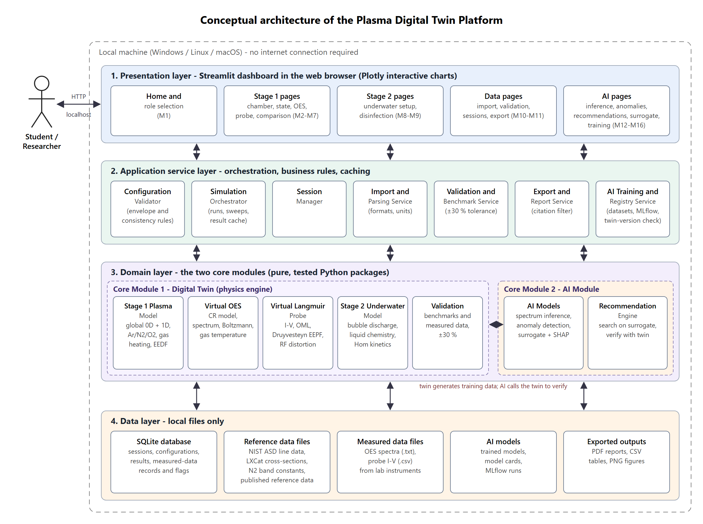
Figure 3.1: Conceptual architecture of the Plasma Digital Twin Platform

3.1.2 Technologies and Services
Table 3.1 lists the components, their technologies and their security mechanisms.
Table 3.1: Technologies, components and security mechanisms used in the system architecture
Component | Description | Technology used | Security mechanism
Presentation layer | Screens M1–M16, navigation, charts | Streamlit, Plotly | Bound to 127.0.0.1; input widgets restrict type and range
Configuration Validator | Envelope and consistency checks (E3, E5) | Python, shared range file | Rejects out-of-range inputs before any computation
Simulation Orchestrator | Runs, caches and checks models; sweeps (E2, E4, E17, E20) | Python, Streamlit cache | Accepts results only after conservation checks
Session Manager | Save, list, open, compare, delete sessions | SQLite (sqlite3) | Transactions; parameterised queries
Import & Parsing | Reads measured .txt and .csv files (E13, E14) | pandas | Type, size and schema checks; data never executed
Validation & Benchmark | ±30 % checks against literature and measured data (E15, E16) | Python | Tolerance and references read from versioned file
Export & Report | PDF, CSV and PNG exports (E19) | Plotly static export, pandas | Citation filter removes non-citable data
AI Training & Registry | Twin datasets, training, evaluation, model cards, twin-version check (E22, E23) | scikit-learn, XGBoost, MAPIE, MLflow | Dataset settings locked before training; models never trained on measured data
Core Module 1: Digital Twin | Stage 1 model, EEDF/rates, virtual OES, virtual probe, Stage 2 model, validation | NumPy, SciPy | No file or network access; pure functions
Core Module 2: AI Module | Inference, anomaly detection, surrogate with SHAP, recommendation engine | scikit-learn, XGBoost, SHAP, SciPy | Read-only access to the twin; outputs labelled as AI
Data layer | SQLite database, reference data, measured files, outputs | SQLite, CSV/text files | Checksums for reference data; measured files read-only

3.2 Architecture Style and Support for Non-Functional Requirements
The system uses a layered architecture with four layers (presentation, application services, domain and data), in which each layer calls only the layer below it. This style was chosen because it keeps the physics code free of user-interface code, so each model can be tested alone and explained alone; because a desktop tool for one user does not need the deployment complexity of client–server or microservice styles; and because the same domain layer can later serve another front end without change. Inside the domain layer, the dependency between the two core modules runs one way only: the AI module calls the twin, but the twin never imports the AI code, so the physics can always be tested and defended on its own. Table 3.2 shows how the architecture supports the non-functional requirements.
Table 3.2: Architectural support for the non-functional requirements
Quality attribute | Requirements | Architectural decision
Reliability | REL-1 to REL-4 | Central error handling in the services layer maps every exception to an event response; SQLite transactions protect sessions; seeds and model versions are stored.
Usability | USE-1 to USE-5 | One configuration file drives ranges, units, messages and validation in every screen; shared chart and status components.
Performance | PER-1 to PER-10 | Simulation results are cached by configuration hash; the instrument model is separate from the plasma model so it can be reapplied without re-solving; vectorised numerical code.
Security | SEC-1 to SEC-5 | Loopback-only server; import and export pass through single services that apply type checks and the citation filter; parameterised data access.
Accuracy | ACC-1 to ACC-4 | Domain layer isolated and fully unit-tested; conservation checks before acceptance; versioned reference data and tolerance.
AI model quality | AIQ-1 to AIQ-6 | One-way dependency from AI to twin; every model stamped with the twin version and logged in the registry; the recommendation engine cannot return a result without a twin call.
Maintainability, portability | MNT-1 to MNT-3, POR-1 | One module per physical model with its own test file; constants in data files; pure-Python dependencies pinned in one requirements file.

References
[1] M. A. Lieberman and A. J. Lichtenberg. Principles of Plasma Discharges and Materials Processing, 2nd ed. Hoboken, NJ: Wiley-Interscience, 2005.
[2] C. Lee and M. A. Lieberman. “Global model of Ar, O₂, Cl₂, and Ar/O₂ high-density plasma discharges.” Journal of Vacuum Science & Technology A, vol. 13, no. 2, pp. 368–380, 1995.
[3] X.-M. Zhu and Y.-K. Pu. “A simple collisional–radiative model for low-temperature argon discharges with pressure ranging from 1 Pa to atmospheric pressure: kinetics of Paschen 1s and 2p levels.” Journal of Physics D: Applied Physics, vol. 43, no. 1, 015204, 2010.
[4] A. Kramida, Yu. Ralchenko, J. Reader, and NIST ASD Team. “NIST Atomic Spectra Database.” Internet: https://physics.nist.gov/asd, [Oct. 25, 2026].
[5] F. F. Chen. “Langmuir probe diagnostics,” in Mini-Course on Plasma Diagnostics, IEEE-ICOPS Meeting, Jeju, Korea, 2003.
[6] M. J. Druyvesteyn. “Der Niedervoltbogen.” Zeitschrift für Physik, vol. 64, pp. 781–798, 1930.
[7] L. W. Hom. “Kinetics of chlorine disinfection in an ecosystem.” Journal of the Sanitary Engineering Division (ASCE), vol. 98, no. 1, pp. 183–194, 1972.
[8] M. M. Turner, A. Derzsi, Z. Donkó, et al. “Simulation benchmarks for low-pressure plasmas: capacitive discharges.” Physics of Plasmas, vol. 20, no. 1, 013507, 2013.
[9] V. A. Godyak, R. B. Piejak, and B. M. Alexandrovich. “Measurement of electron energy distribution in low-pressure RF discharges.” Plasma Sources Science and Technology, vol. 1, no. 1, pp. 36–58, 1992.
[10] LXCat Project. “Plasma Data Exchange Project – electron scattering cross sections.” Internet: https://www.lxcat.net, [Oct. 25, 2026].
[11] G. J. M. Hagelaar and L. C. Pitchford. “Solving the Boltzmann equation to obtain electron transport coefficients and rate coefficients for fluid models.” Plasma Sources Science and Technology, vol. 14, no. 4, pp. 722–733, 2005.
[12] X.-M. Zhu and Y.-K. Pu. “Optical emission spectroscopy in low-temperature plasmas containing argon and nitrogen: determination of the electron temperature and density by the line-ratio method.” Journal of Physics D: Applied Physics, vol. 43, no. 40, 403001, 2010.
[13] P. J. Bruggeman, N. Sadeghi, D. C. Schram, and V. Linss. “Gas temperature determination from rotational lines in non-equilibrium plasmas: a review.” Plasma Sources Science and Technology, vol. 23, no. 2, 023001, 2014.
[14] M. A. Gigosos, M. Á. González, and V. Cardeñoso. “Computer simulated Balmer-alpha, -beta and -gamma Stark line profiles for non-equilibrium plasmas diagnostics.” Spectrochimica Acta Part B, vol. 58, no. 8, pp. 1489–1504, 2003.
[15] N. Wali, Q. U. Din, N. U. Rehman, et al. “Preliminary exploration on the low-pressure Ar-O₂ plasma generated by low-frequency AC power supply.” arXiv preprint arXiv:2405.05739, 2024.
[16] B. R. Locke, M. Sato, P. Sunka, M. R. Hoffmann, and J.-S. Chang. “Electrohydraulic discharge and nonthermal plasma for water treatment.” Industrial & Engineering Chemistry Research, vol. 45, no. 3, pp. 882–905, 2006.
[17] P. J. Bruggeman, M. J. Kushner, B. R. Locke, et al. “Plasma–liquid interactions: a review and roadmap.” Plasma Sources Science and Technology, vol. 25, no. 5, 053002, 2016.
[18] Ahmed et al. “DNA reduction of waterborne E. coli by underwater capillary discharge.” Jordan Journal of Physics, vol. 15, no. 2, 2022.
[19] Metcalf & Eddy, Inc. Wastewater Engineering: Treatment and Reuse, 4th ed. New York: McGraw-Hill, 2003.
[20] L. Breiman. “Random forests.” Machine Learning, vol. 45, no. 1, pp. 5–32, 2001.
[21] T. Chen and C. Guestrin. “XGBoost: a scalable tree boosting system,” in Proc. 22nd ACM SIGKDD Int. Conf. Knowledge Discovery and Data Mining, 2016, pp. 785–794.
[22] L. Grinsztajn, E. Oyallon, and G. Varoquaux. “Why do tree-based models still outperform deep learning on typical tabular data?” in Proc. NeurIPS Datasets and Benchmarks Track, 2022.
[23] A. N. Angelopoulos and S. Bates. “Conformal prediction: a gentle introduction.” Foundations and Trends in Machine Learning, vol. 16, no. 4, pp. 494–591, 2023.
[24] F. T. Liu, K. M. Ting, and Z.-H. Zhou. “Isolation forest,” in Proc. 8th IEEE Int. Conf. Data Mining (ICDM), 2008, pp. 413–422.
[25] S. M. Lundberg and S.-I. Lee. “A unified approach to interpreting model predictions,” in Advances in Neural Information Processing Systems 30 (NeurIPS), 2017.
[26] R. Storn and K. Price. “Differential evolution – a simple and efficient heuristic for global optimization over continuous spaces.” Journal of Global Optimization, vol. 11, no. 4, pp. 341–359, 1997.
[27] COMSOL AB. “Plasma Module – COMSOL Multiphysics.” Internet: https://www.comsol.com/plasma-module, [Oct. 25, 2026].
[28] C. O. Laux. “SPECAIR – radiation code for air, nitrogen and other plasmas.” Internet: https://www.specair-radiation.net, [Oct. 25, 2026].
[29] J. Voráč, P. Synek, L. Potočňáková, J. Hnilica, and V. Kudrle. “Batch processing of overlapping molecular spectra as a tool for spatio-temporal diagnostics of power modulated microwave plasma jet.” Plasma Sources Science and Technology, vol. 26, no. 2, 025010, 2017.
[30] Impedans Ltd. “Langmuir Probe – plasma measurement system.” Internet: https://www.impedans.com, [Oct. 25, 2026].
[31] PlasmaPy Community. “PlasmaPy: an open source community-developed Python package for plasma research and education.” Internet: https://www.plasmapy.org, [Oct. 25, 2026].
[32] M. Zaharia, A. Chen, A. Davidson, et al. “Accelerating the machine learning lifecycle with MLflow.” IEEE Data Engineering Bulletin, vol. 41, no. 4, pp. 39–45, 2018.
[33] K. E. Wiegers and J. Beatty. Software Requirements, 3rd ed. Redmond, WA: Microsoft Press, 2013.
[34] World Wide Web Consortium. “Web Content Accessibility Guidelines (WCAG) 2.1.” Internet: https://www.w3.org/TR/WCAG21/, Jun. 5, 2018 [Oct. 25, 2026].
[35] J. Nielsen. Usability Engineering. San Francisco, CA: Morgan Kaufmann, 1993, ch. 5.

Appendix A: Interactive Mockup Prototype
The mockups in Section 2.6 were produced as a single clickable HTML prototype so that the supervisor and evaluators can walk through the workflow in any web browser without installing anything.
Prototype file submitted with this SRS: mockups/interactive_mockups.html. Use case and architecture diagrams: mockups/diagrams.html.

A.1 How to Use the Prototype
- Open the file in Chrome, Edge or Firefox. The left panel lists all screens grouped by stage, each with its mockup ID.
- Buttons such as Run simulation, Send to virtual OES and Compare diagnostics navigate along the real workflow.
- The Student / Researcher switch at the top right shows or hides Researcher-only elements (import, overlays, validation).
- A screen can be opened directly by adding its ID to the address, for example interactive_mockups.html#M5.

A.2 Screen Index
Table A.1 lists every screen in the prototype with its figure and requirement range.
Table A.1: Screens of the interactive prototype
ID | Screen | Stage / group | Figure | Requirements
M1 | Home Screen | General | Figure 2.2 | FR1.1–FR1.6
M2 | Low-Pressure Chamber Configuration | Stage 1 | Figure 2.3 | FR2.1–FR2.13
M3 | Low-Pressure Plasma State Results | Stage 1 | Figure 2.4 | FR3.1–FR3.10
M4 | Virtual OES – Synthetic Spectrum | Stage 1 | Figure 2.5 | FR4.1–FR4.8
M5 | OES Analysis – Boltzmann Plot and Temperatures | Stage 1 | Figure 2.6 | FR5.1–FR5.10
M6 | Virtual Langmuir Probe | Stage 3 (on Stage 1 plasma) | Figure 2.7 | FR6.1–FR6.10
M7 | Diagnostics Comparison | Stage 1 / 3 | Figure 2.8 | FR7.1–FR7.6
M8 | Underwater Plasma Configuration | Stage 2 | Figure 2.9 | FR8.1–FR8.13
M9 | Underwater Plasma and Disinfection Results | Stage 2 | Figure 2.10 | FR9.1–FR9.6
M10 | Measured Data Import and Validation | Data (Researcher) | Figure 2.11 | FR10.1–FR10.8
M11 | Session History and Export | Data | Figure 2.12 | FR11.1–FR11.5
M12 | AI Parameter Inference from Spectra | AI Module | Figure 2.13 | FR12.1–FR12.6
M13 | AI Physics-Relationship Anomaly Detection | AI Module | Figure 2.14 | FR13.1–FR13.7
M14 | AI Recommendations (Inverse Design) | AI Module | Figure 2.15 | FR14.1–FR14.8
M15 | AI Surrogate Model and Explainability | AI Module | Figure 2.16 | FR15.1–FR15.6
M16 | AI Training, Evaluation and Model Registry | AI Module | Figure 2.17 | FR16.1–FR16.5

Appendix B: Requirements Traceability Matrix
Table B.1 traces each business objective to the modules, use cases, mockups, functional requirements and non-functional requirements that deliver it, so that any feature can be followed from objective to requirement.
Table B.1: Requirements traceability matrix
Objective | Sub-modules | Use cases | Mockups | Functional requirements | NFRs
BO-1 Stage 1 twin within ±30 % | 1.1, S.1 | UC-01–UC-05 | M1–M3 | FR1.2, FR2.1–FR2.13, FR3.1–FR3.10, FR17.1–FR17.4, FR17.6, FR17.14 | PER-1, PER-4, REL-1, ACC-1, ACC-3
BO-2 OES and probe in < 5 min | 1.2, 1.3, S.1, S.2 | UC-06–UC-09, UC-11–UC-13 | M1, M4–M6 | FR1.1, FR1.4–FR1.6, FR4.1–FR4.8, FR5.1–FR5.10, FR6.1–FR6.10, FR17.7–FR17.11 | PER-2, PER-3, USE-1–USE-5
BO-3 Diagnostic consistency | 1.2, 1.3 | UC-14 | M7 | FR7.1–FR7.6, FR5.5 | ACC-2
BO-4 Disinfection within ±30 % | 1.4 | UC-15–UC-19 | M8, M9 | FR8.1–FR8.13, FR9.1–FR9.6, FR17.5, FR17.17 | PER-5, ACC-1
BO-5 Validation report in < 10 min | 1.5, S.1, S.2 | UC-20, UC-21, UC-22, UC-23 | M1, M10, M11 | FR1.3, FR10.1–FR10.8, FR11.1–FR11.5, FR17.12, FR17.13, FR17.15, FR17.16 | PER-7, SEC-2, SEC-3, ACC-4
BO-6 AI spectrum inference | 2.1, 2.5 | UC-10, UC-28 | M12, M16 | FR12.1–FR12.6, FR16.1–FR16.5, FR17.18, FR17.19 | PER-9, AIQ-1, AIQ-5, AIQ-6
BO-7 Physics anomaly detection | 2.2 | UC-24 | M13 | FR13.1–FR13.7, FR17.20 | AIQ-2
BO-8 Surrogate with SHAP | 2.3 | UC-27 | M15 | FR15.1–FR15.6, FR17.22 | AIQ-3
BO-9 Twin-verified recommendations | 2.4 | UC-25, UC-26 | M14 | FR14.1–FR14.8, FR17.21 | PER-10, AIQ-4

The remaining non-functional requirements (REL-2 to REL-4, PER-6, PER-8, SEC-1, SEC-4, SEC-5, MNT-1 to MNT-3 and POR-1) are cross-cutting and apply to every objective.

Appendix C: Resolved Parameter Values and Sources
The domain values used in the business rules were collected from the supervisor's written answers to two questionnaire rounds. Where the supervisor left an item blank, a published source was used, and where an answer needed interpretation, the design decision is stated. Table C.1 lists each value and its source so that every business rule can be defended.
Table C.1: Resolved parameter values and their sources
Item | Value used in this SRS | Source
Stage 1 discharge | 13.56 MHz CCP; 10–100 W; 0.1–0.5 mbar (75–375 mTorr) | Supervisor
Stage 1 chamber | 40 × 40 cm; electrodes 14 cm, gap 4.5 cm | Supervisor (size); COMSATS laboratory paper [15] (electrodes)
Stage 1 gases | Ar 100–500 sccm; N₂ and O₂ each 5 % of the Ar flow | Supervisor
Gas mixing scheme | Four selectable modes (Ar, Ar+N₂, Ar+O₂, Ar+N₂+O₂) | Design decision (answer did not state whether gases are added together)
Stage 1 EEDF | Druyvesteyn (Maxwellian selectable) | Supervisor
Stage 1 n_{e} for OES | Langmuir probe value; model value until a measured probe value is imported | Supervisor; interpretation to avoid circularity
Gas temperature | N₂ (1,0) band at 315.9 nm with NH check; Doppler when resolution allows | Supervisor; [13]
Spectrometer | High resolution, better than 0.01 nm (default 0.005 nm) | Supervisor
Langmuir probe | Single cylindrical tungsten, 0.195 mm × 5 mm, −20 to +50 V, 0.5 V steps; OML; RF distortion | Supervisor (OML, RF); [15] (dimensions, sweep)
Stage 2 discharge | Pulsed DC, up to 10 kV, 5–10 kHz, 100 W, pin-to-pin 1/2/3 mm, 1 atm | Supervisor
Stage 2 pulse width | Configurable in µs with duty cycle < 1 (default 10 µs) | Design decision (100 µs at 10 kHz gives 100 % duty)
Stage 2 gas | O₂ 100–300 sccm (default 100 sccm) with water vapour | Supervisor; water vapour [17]
Stage 2 EEDF and n_{e} | Maxwellian; H-alpha Stark broadening | Supervisor; [14]
Waste water | Municipal, medium strength: COD 430 mg/L, pH 7.5, 25 °C, ≈ 750 µS/cm | Supervisor (municipal); [19] (values)
Organisms and dose | E. coli (also S. aureus, bacterial spores); 1–2 × 10⁵ CFU/mL; 1 min | Supervisor
Disinfection kinetics | Hom model, parameters from published time-resolved data | Supervisor; [7]
Tolerance and 1D | ±30 %; 1D only for Stage 1 profiles | Supervisor (accepted default)
Measured data | Validation only; not citable; probe .csv, OES text | Supervisor
AI module | Core Module 2: inference, anomaly detection, surrogate with SHAP, recommendations | Team decision, 29-Oct-2026 (the supervisor's Round 3 answer had been "optional, decide later")

Plagiarism Report
The plagiarism (similarity) report for this Software Requirements Specification is generated with Turnitin by the library staff of COMSATS University Islamabad, as required by the department. The official report issued by the library is attached on the pages that follow.
Details below are copied from the library's report when it is received.
Document submitted | SRS v1.1
Submission date
Submission ID
Overall similarity index
Checked by (library staff)

