Case Study: A Visibility-Driven Strategy for Non-Medication Purchases in an Online Pharmacy

Contents

Background: 1

Objective: 2

Baseline Data Analysis: 2

Overview: 2

Key Metrics: 2

Revenue Overview: 2

Customer Count: 3

Order ID Count: 3

Trends Observed: 4

Analysis of Potential Impact: 4

Conversion rate Impact: 4

Average Order Value Impact: 5

Revenue Impact: 5

Bounce rate Impact: 5

Operational impact: 5

Evaluation on proposed change: 6

A/B Testing: 6

Feature Flags Analysis: 6

Behavioral Analytics: 6

Success testing: 6

Operational efficiency: 7

Future Considerations: 7

# Background:

The company is an online pharmacy that provides customers with the convenience of ordering prescription medications through a user-friendly app. It allows customers to add items to a shopping cart, proceed to checkout, and finalize their orders. Recently, the company introduced a feature that enables customers to add non-medication items—such as vitamins or Band-Aids—to their cart during the checkout process. These additional items are then delivered along with the prescription medications. The goal of this feature is to enhance customer convenience by offering complementary products.

Objective:

In February 2024, the Product Team aims to increase the visibility of this feature during the checkout process. The expectation is that 20% of customers who complete the checkout process will also add non-medication items to their cart. As the analyst supporting this initiative, my role is to evaluate the potential impact of this change and assess its success post-implementation.

# Baseline Data Analysis:

## Overview:

Exploratory data analysis was conducted on customer purchase behavior from November 2023 to January 2024, following the implementation of a new checkout feature allowing for non-medication item additions.

False (non-medication items added)

True (non-medication items added)

Null (no detail whether non-medication added or not)

## Key Metrics:

* Total Records: 11,992
* Total Distinct Users: 6,624

## Revenue Overview:

* False: $128,220.25
* True: $11,770.16
* Null: $7,122.38

## Customer Count:

* False: 4,612 unique customers out of 6,425 total customers
* True: 383 unique customers out of 391 total customers
* Null: 3,923 unique customers out of 5,176 total customers

## Order ID Count:

* Null: 340 orders
* Cancelled Orders: 491 out of 7,156 orders were canceled

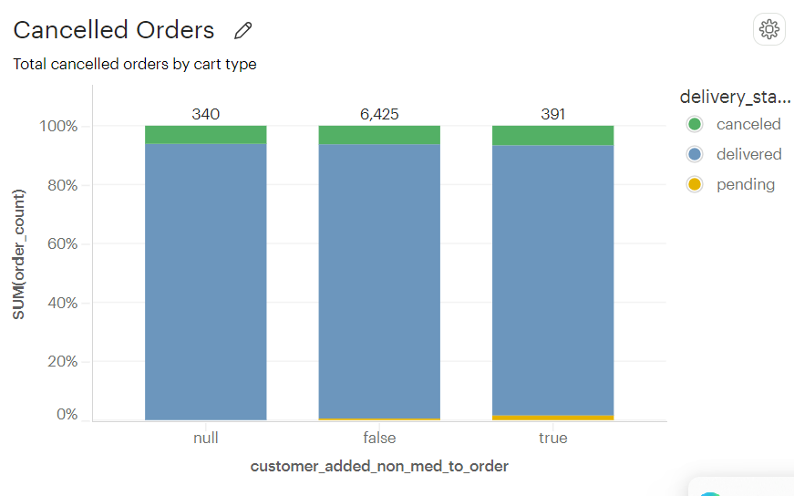

## Trends Observed:

**Revenue Increase:** There was a notable increase in revenue during December 2023 ($58,640) compared to November 2023 ($53,659). However, revenue decreased in January 2024 ($34,814).

**Customer Count Shifts:** In November 2023, 41.04% of customers did indicate whether they added non-medication items or not, whereas 58.96% did not added those products. In December 2023, the percentage of customers adding non-medication items decreased to 4.60%, with an increase in the following month as well.

**Customer Behavior:** The drop in revenue and customer count in January 2024 could indicate a shift in customer behavior or satisfaction, it could be regarding the non-medication items feature.

**Feature Adoption**: The adoption rate of the non-medication items feature was zero in November, however showed an increase over time, which may suggest a positive launch of the current feature. Despite evidence of purchases, a portion of customers were misidentified as 'null' within the dataset. This systemic error prevented their contribution to the month's total revenue, which was resolved later for the month of January 2024.

**Order value distribution:** Medication-only orders have a lower range ($8.22 - $35.62) compared to non-medication orders ($13.52 - $50.7). The peak for medication-only orders is around $19.18, indicating that lower-value orders are more common. Non-medication orders peak around $33.8.

Medication orders are more concentrated in a narrower range, with a clear peak and a gradual decline. Non-medication orders are more spread out across a wider range, with a more balanced distribution. Customers are likely to spend more on orders having non-medication items than on medication-only orders.

# Analysis of Potential Impact:

## Conversion rate Impact:

Total distinct users mentioned in the dataset from November 2023 to January 2024 are 6624. 4612 chose not to add non-med medications and 383 customers added those products to their cart. Only unique customer ids were considered for this formulation.

The overall Conversion rate of customers currently adding non-medication items during checkout is 5.78%.

* There were no customers in November 2023, who added non-med medications in their cart.
* In December 2023, the conversion rate jumped from 0% to 5.10%.
* In January 2024, there was a slight increase in the conversion rate from 5.10% to 6.86%.

## Average Order Value Impact:

Average Checkouts Per Month for given period in the dataset is 2400. On Average, 2400 customers complete the checkout process monthly.

* The total revenue generated that includes non-medication items for the given timeframe is 11771$ with total 391 numbers of orders.
* Average Order Value (AOV) for Non-Medication Items from November 2023 to January 2024 is 30.10$.

## Revenue Impact:

The product team proposed a 20% increment in total checkout orders. The projected non-medication orders based on the current average monthly order is 480 orders.

However, incremented orders would be based on current conversion rates. Considering the 5.78% conversion rate on current monthly orders, there will be an additional 340 orders per month.

Additional revenue based on incremental orders and checkouts should be 10234$.

## Bounce rate Impact:

There is a total of 11992 records in the dataset for the given period from November 2023 to January 2024. A total of 4836 times no transactions were generated, which indicates customers who start the checkout process abandon it without completing their purchase. The overall bounce rate is 40.32%.

The bounce rate for each month is respectively 41%, 40.31% and 39.15%, showing the application is having continuous high bounce rates.

This is a critical metric that needs attention, especially in the context of the recent feature implementation to increase the visibility of non-medication items during checkout.

## Operational impact:

The average screentime spent between checkout started and checkout completed was calculated and compared for non-medication and only medication orders by each month. There was no significant difference visible. The Average screentime varied between 7.4 to 7.7 minutes.

The average delivery time was calculated and compared for non-medication and only medication orders by each month. There was no significant difference visible in any situation. The Average delivery time was between 1-2 days.

# Evaluation on proposed change:

## A/B Testing:

**Scenario:** two or more versions of a feature can help determine which performs better based on specific metrics, one with the increased visibility and one without (control group).

**Evaluation:** testing two different layouts for a checkout page to see which one reduces cart abandonment rates. Test different pricing tiers or discount offers to see which generates more sales or better customer retention.

## Feature Flags Analysis:

**Scenario:** Gradual rollouts will release a feature to a small segment of users first and expand it over time. This approach will help manage risk by monitoring the feature’s performance and impact before full-scale deployment.

**Evaluation:** Apply these incremented visibility rollouts in specific cities or states or for specific groups of people having medical issues. These will exhibit higher conversion rates for non-medication items without negatively impacting other metrics. For more advanced testing, the combination of A/B testing and Feature flag analysis implementation will roll out more strategic metric evaluation criteria.

## Behavioral Analytics:

**Scenario:** Closely examine users' interactions with the checkout page, track the sequence of clicks or actions on the non-medication item section, time spent browsing these items, and the frequency of adding non-medication items to the cart.

**Evaluation:** If the visibility change is successful, there should be a noticeable increase in clicks and time spent on the non-medication section, ultimately leading to a higher conversion rate for these items. Also, it will share insights on which specific functions or tracks are successful or not.

## Success testing:

**Scenario:** Track the conversion rates, revenue, and any changes in customer behavior weekly.

**Evaluation:** Apply above testing methods over different groups of users and keep monitoring all the KPIs to match projected success. Did the percentage of customers adding non-medication items reach or exceed the projected 20%? Was the projected additional revenue of $15,000 achieved or exceeded?

## Operational efficiency:

**Scenario**: Evaluation of effects on internal processes, such as delivery times or resource utilization, helps in understanding if the feature improves efficiency or creates additional overhead.

**Evaluation**: Assess whether the increased visibility or number of items affects delivery times, courier costs or the effect on processing times and error rates in billing operations after implementing the change.

# Future Considerations:

The current Case study was constructed based on the given dataset. However, there are some key questions to consider for future analysis and strategy regarding the non-medication items feature in the app:

* Are there specific user segments that are more likely to use this feature?
* What patterns can we identify among customers who add non-medication items versus those who do not?
* Are there specific non-medication items that are more popular?
* What additional product categories could be introduced that would appeal to the existing customer base?
* How should inventory management adapt to an expanded range of products?
* Which regional area shows more correlation with conversion rate?

If successful, the company could explore further personalization of the suggested non-medication items or introduce bundled offers to further enhance sales.

This case study outlines a strategic approach to evaluating and implementing a product change within the online pharmacy, focusing on maximizing customer engagement and revenue while maintaining high levels of operational efficiency.