* **Store Table**

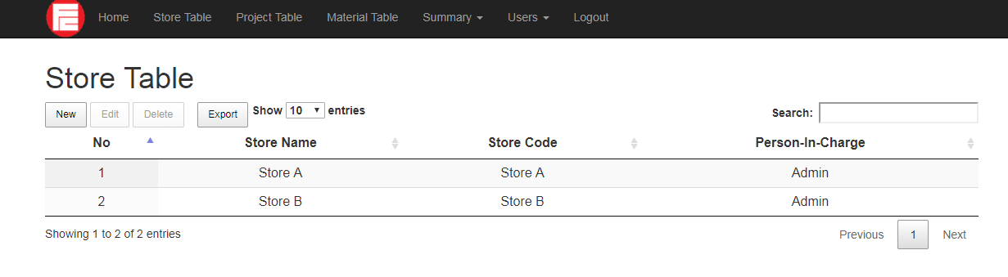

This is a Store Table page, where it applies to add on new stores.

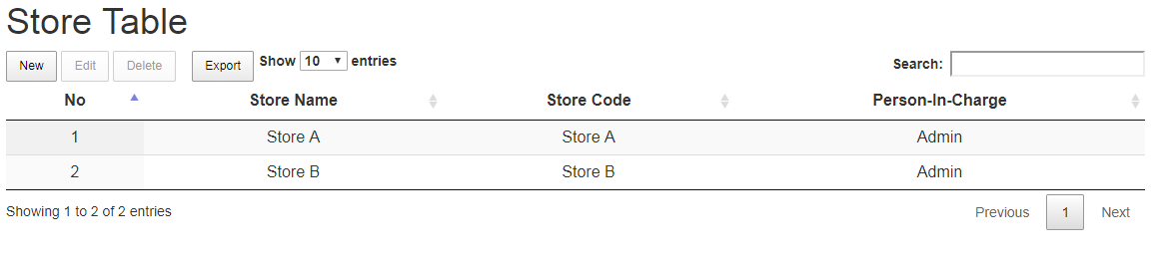

1. Click **New**, to add on the details

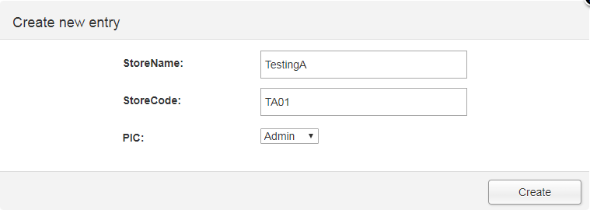

1. Fill in those details and click **Create**

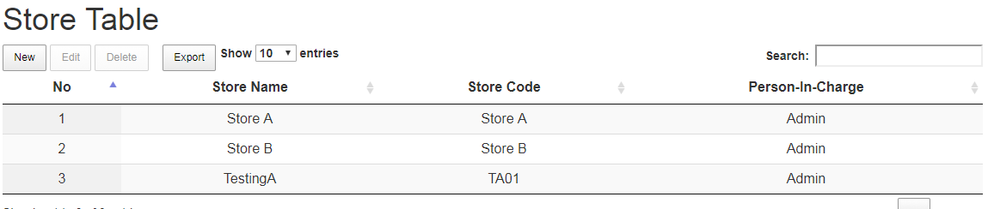

1. Details been added into the list.

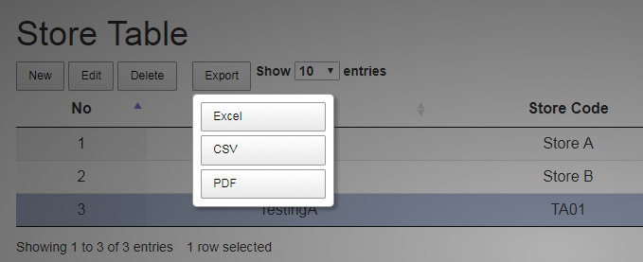

1. Click **Export** to save into Excel, CSV or PDF

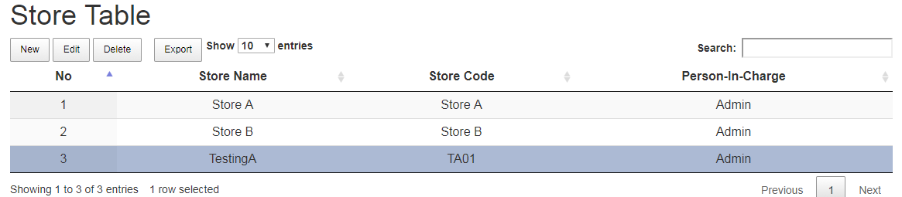

1. **Select** any row by clicking on the **No** of the row
2. Then click **Edit**, to edit information

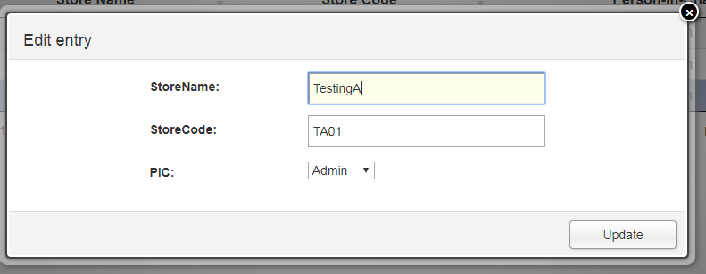

1. And click **Update**



1. **Select** any row by clicking on the **No** of the row
2. Then click **Delete**

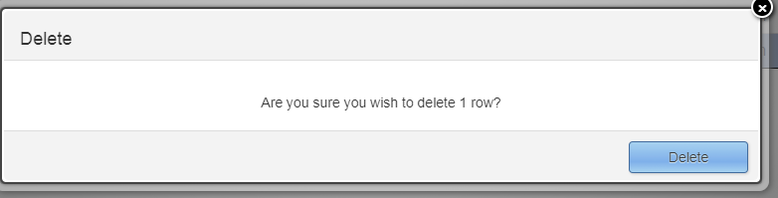

1. Click **Delete** to confirmed deletion

* **Project Table**

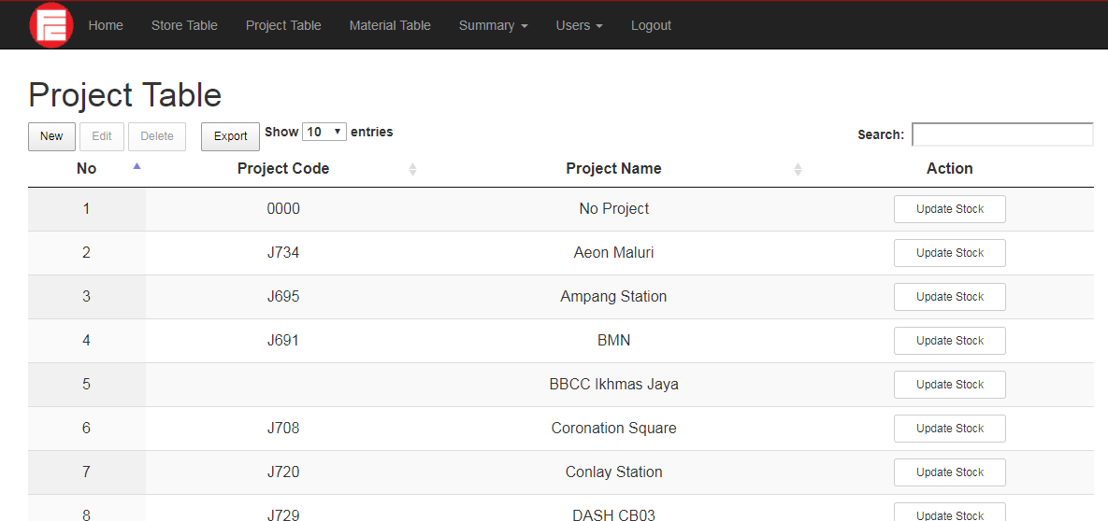

This is a Project Table page, where it used to create new project

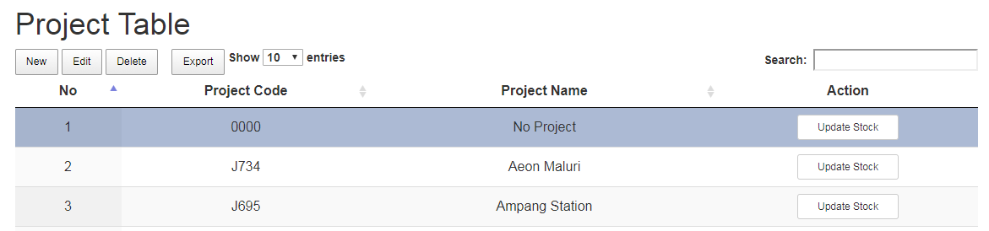

1. Click **New** to add on new project into list

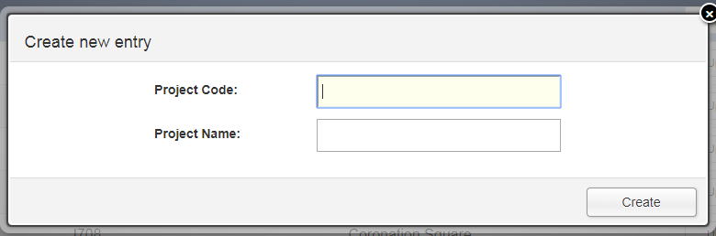

1. Fill in details
2. Click **Create**

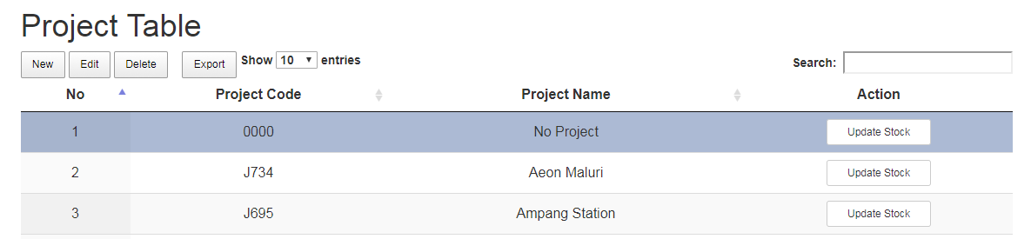

1. **Select** on the specific row by clicking on the **No** of each row

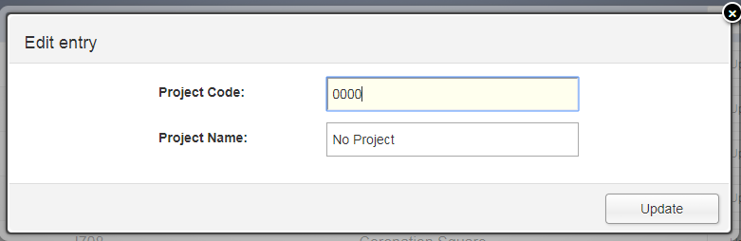

1. Click **Edit** to edit information
2. Fill in details
3. And click **Update**



1. **Select** on the specific row by clicking on the **No** of each row
2. Click **Delete** to delete a specific row

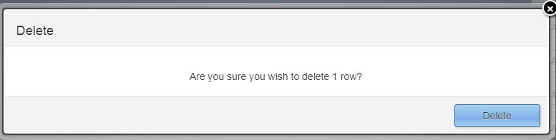

1. Click **Delete** to confirmed deletion

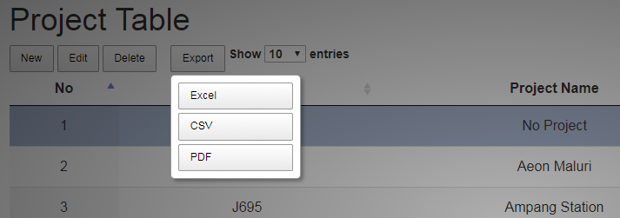

1. Click **Export** to save into Excel, CSV or PDF

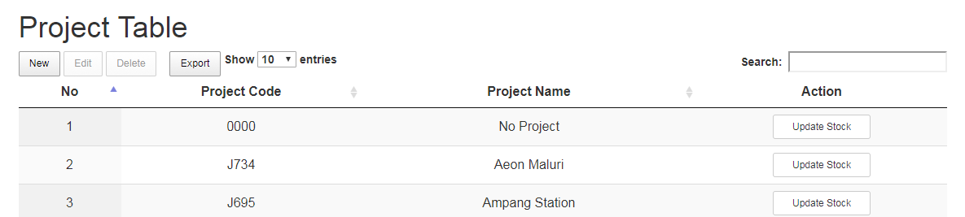

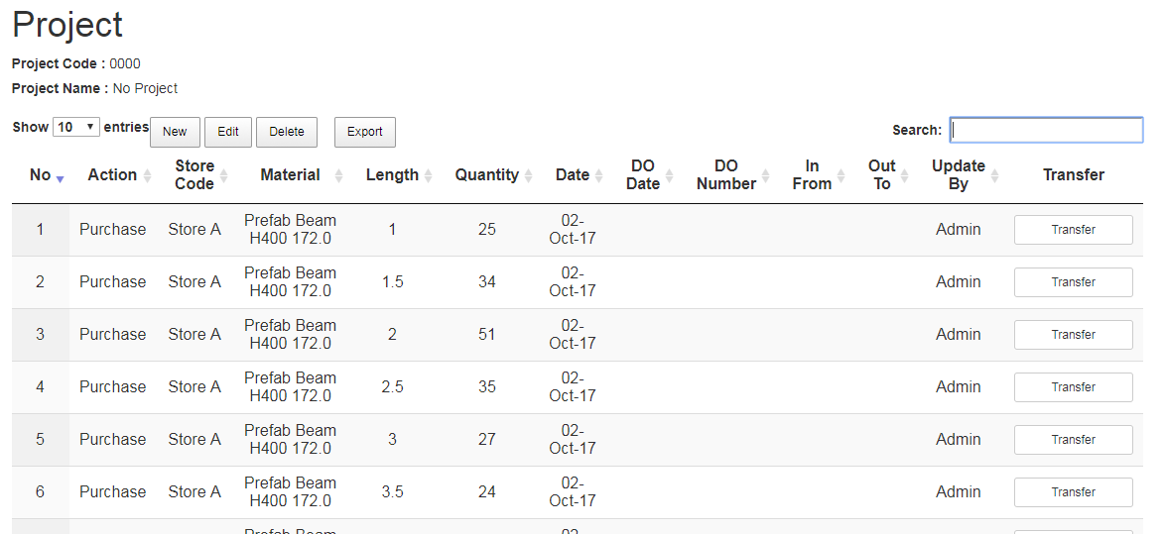

1. To update stock details, click **Update Stock**
2. This will redirect to a new page

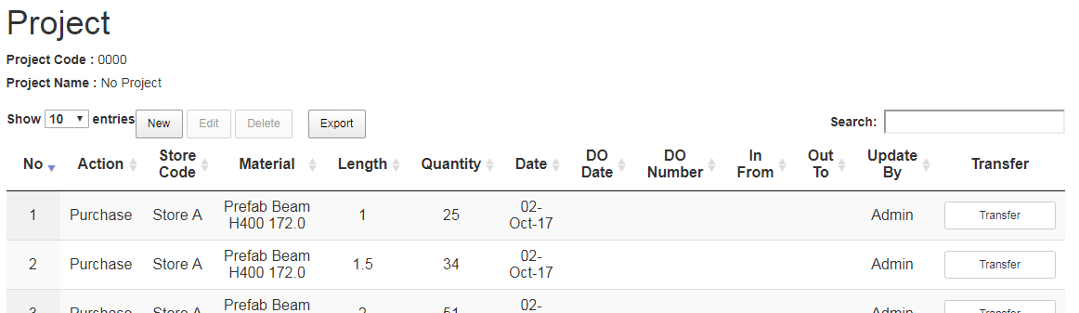

1. To insert new entry of the stock allocation, click **New**

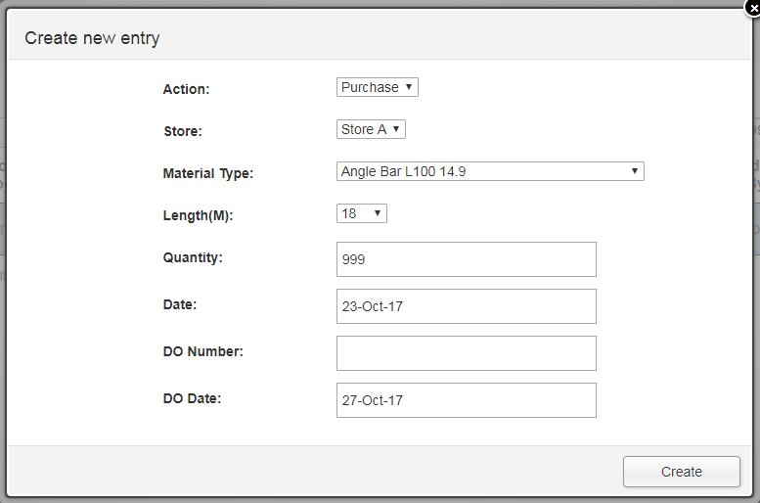

1. Fill in those details and click **Create**
   * **Action –** There is three options for this column:

**a) Purchased:** This is for newly purchased material

1. **Allocated:** This is to allocate material from store to project
2. **Omit:** This is to keep count if the material is missing from project
   * **Store –** Choose which store should the stock be updated.

E.g. Store A or Store B

* + **Material Type –** Choose on what type material u want to

update the stock for

* + **Length (M) –** Choose the available length of the material
  + **Quantity -**  Fill in the quantity of the material
  + **Date –** Enter today’s date
  + **DO Number –** Enter deliver order number
  + **DO Date –** Enter deliver order date

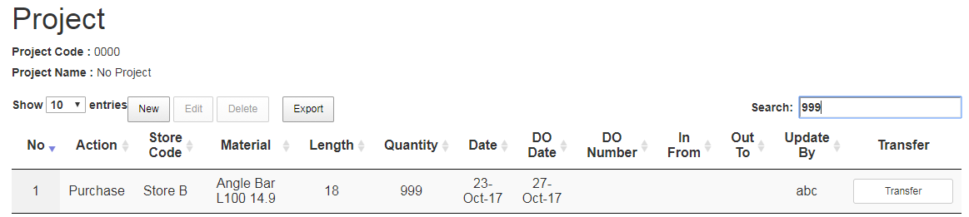

1. Details are successfully inserted.

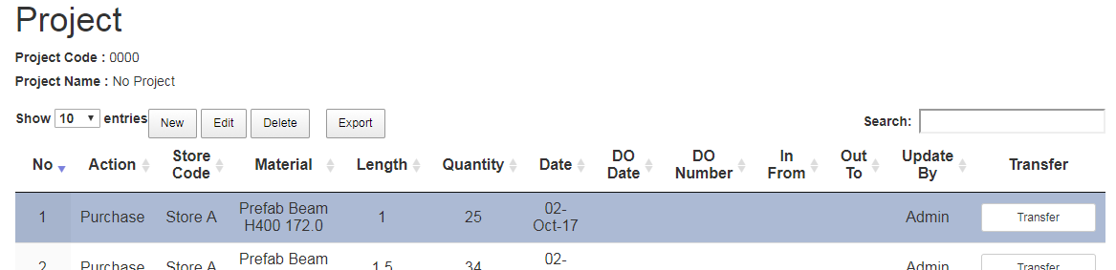

1. **Select** on the specific row by clicking on the **No** of each row
2. Click **Edit** to edit

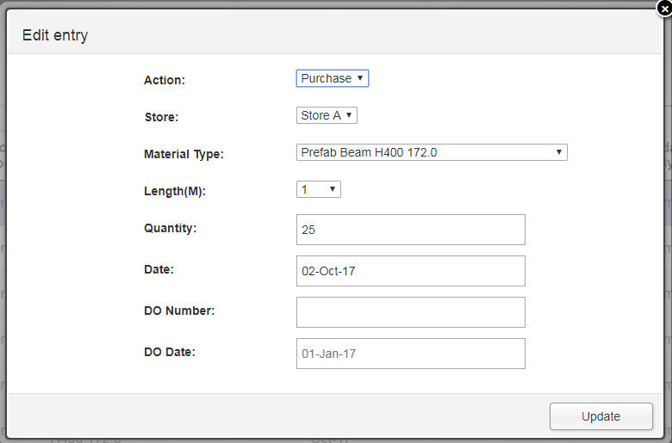

1. Fill in those details and click **Update**



1. **Select** on the specific row by clicking on the **No** of each row
2. Click **Delete** to delete the specific row

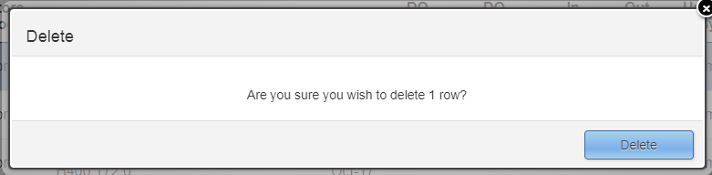

1. Click **Delete** confirmed deletion

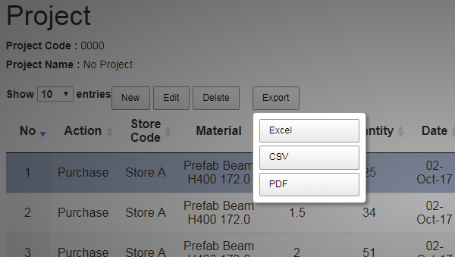

1. Click **Export** to save into PDF, CSV and Excel

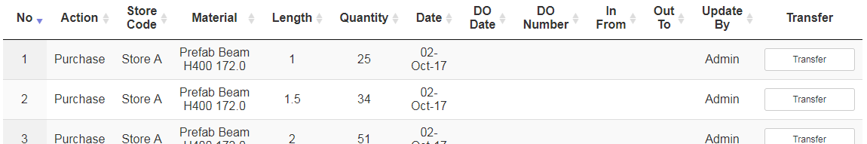

1. Click **Transfer** in order to transfer the material from existing project to another project. This will redirect to another page.

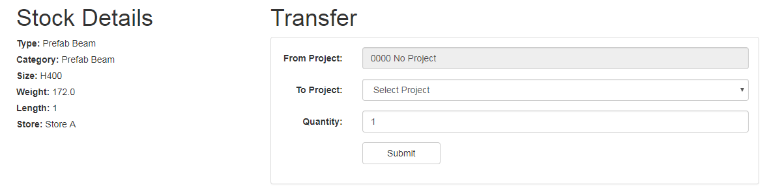

1. Fill in those details
2. Click **Submit** to confirm transfer
3. Material will be allocated to **To Project** and deducted from **From Project**

* **Material Table**

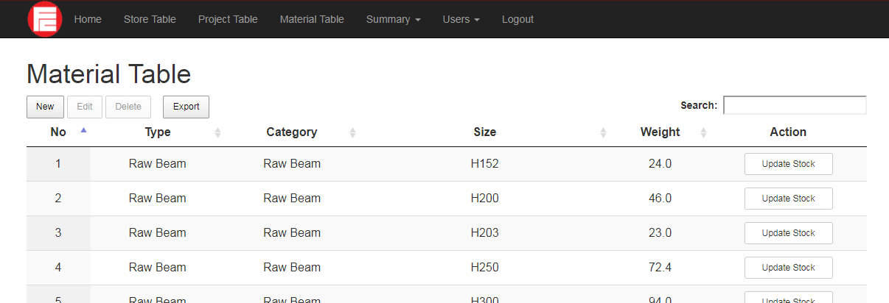

This is a Material Table page, where it applies to add on new material with specific details.

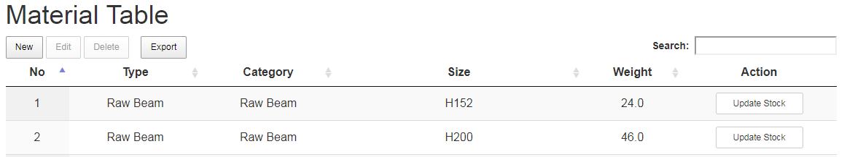

1. Click **New** to add on new project into list

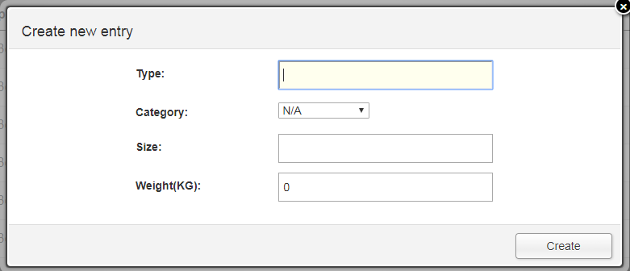

1. Fill in those details
2. Finally click **Create**

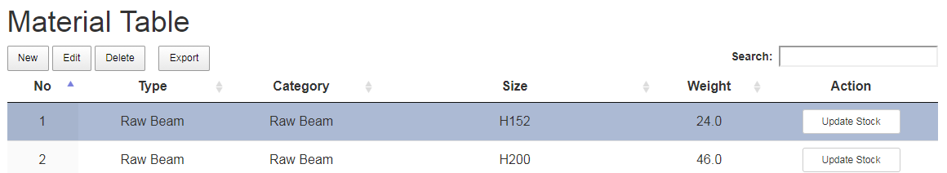

1. **Select** on the specific row by clicking on the **No** of each row
2. Click **Edit** to edit

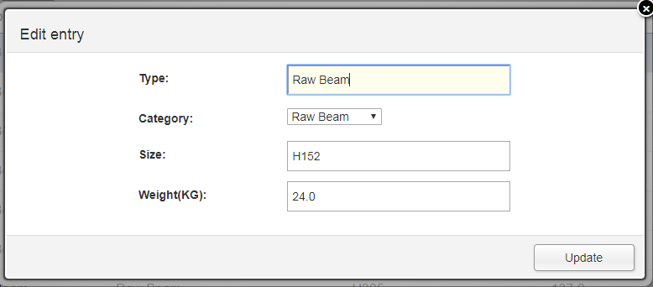

1. **Fill** in those details
2. And click **Update**



1. **Select** on the specific row by clicking on the **No** of each row
2. Click **Delete** to delete a specific row

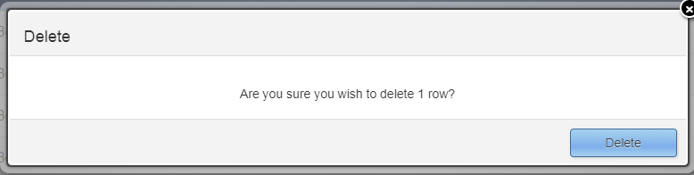

1. Click **Delete** to confirmed deletion

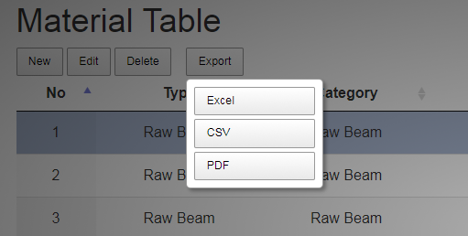

1. Click **Export** to save into Excel, CSV or PDF

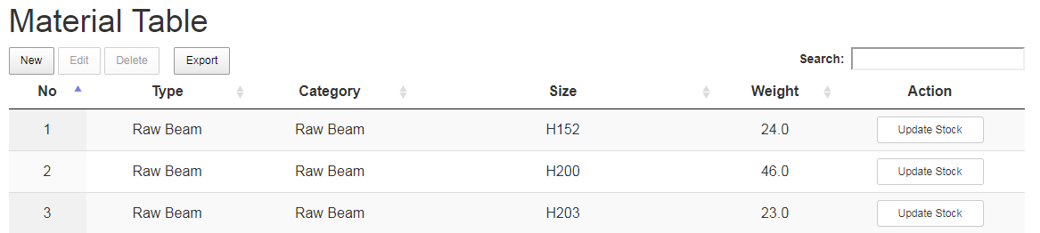

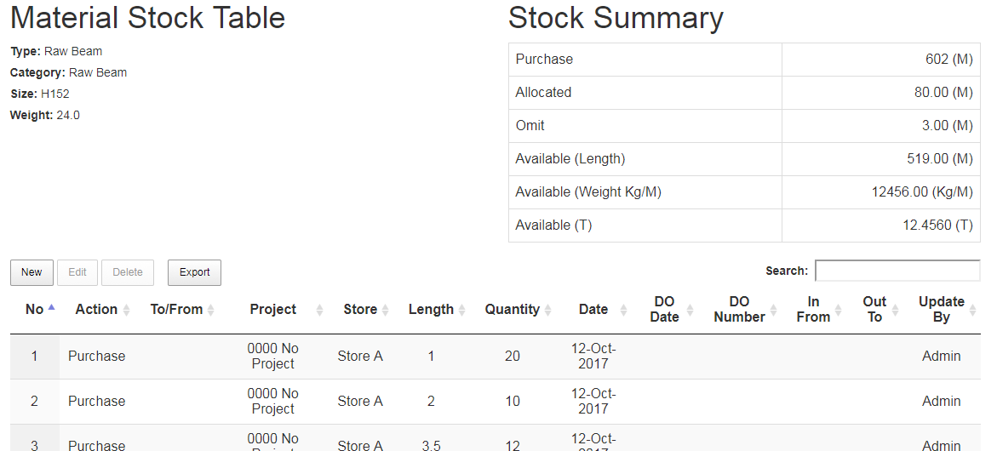

1. To update stock details, click **Update Stock**
2. This will redirect to a new page



1. To insert new entry of the project, click **New**

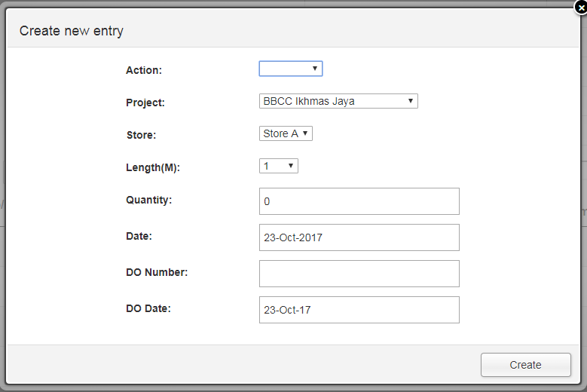

1. **Fill** in those details and click **Create**
   * **Action –** There is three options for this column:
2. **Purchased:** This is for newly purchased material
3. **Allocated:** This is to allocate material from store to project
   * **Project –** Choose on which project the material allocated
   * **Store –** Choose which store should the stock be updated.

E.g. Store A or Store B

* + **Length (M) –** Choose the available length of the material
  + **Quantity -**  Fill in the quantity of the material
  + **Date –** Enter today’s date
  + **DO Number –** Enter deliver order number
  + **DO Date –** Enter deliver order date

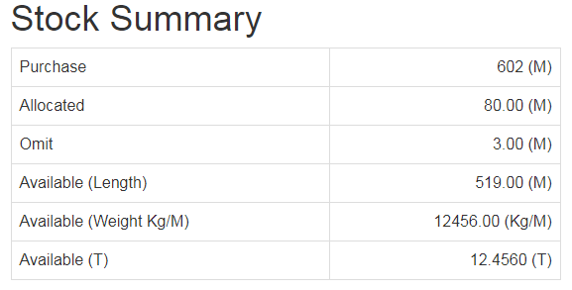

1. Each time a new entry is there, regardless the **Action; purchased, allocated.** The count in **Stock Summary** will be vary and updated accordingly.

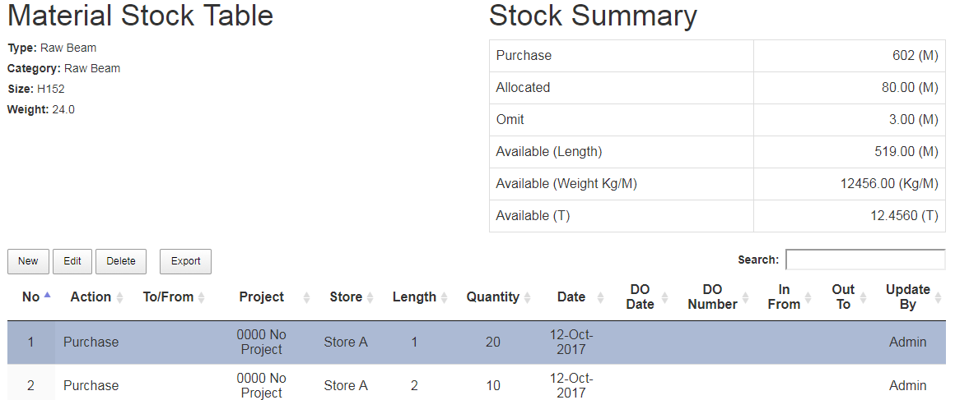

1. **Select** on the specific row by clicking on the number of each row
2. Click **Edit** to edit

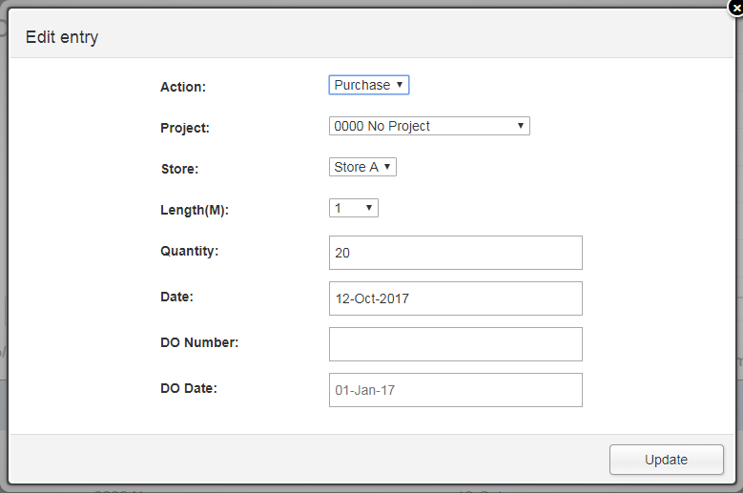

1. **Fill** in those details and click **Update**



1. **Select** on the specific row by clicking on the **No** of each row
2. Click **Delete** to delete the specific row

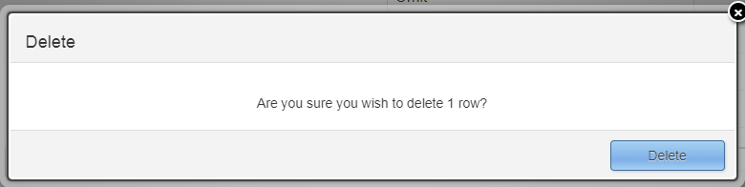

1. Click **Delete** to confirmed deletion

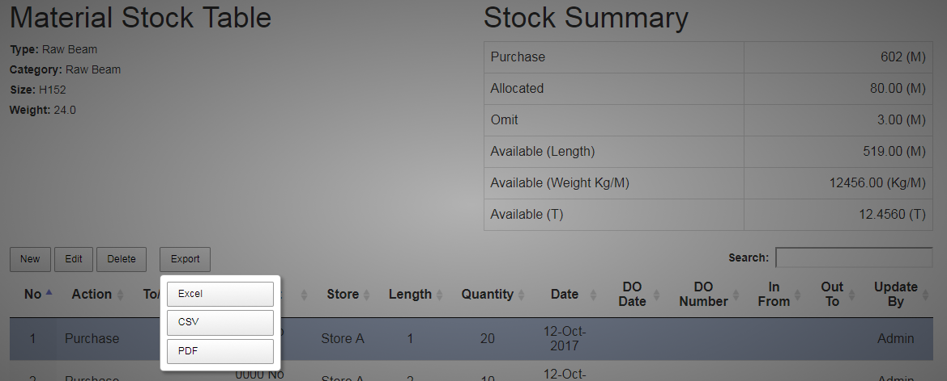

1. Click **Export** to save into PDF, CSV and Excel

* **Users**

This is a User’s page, where it applies to create new user, view user list and MyProfile to update details.

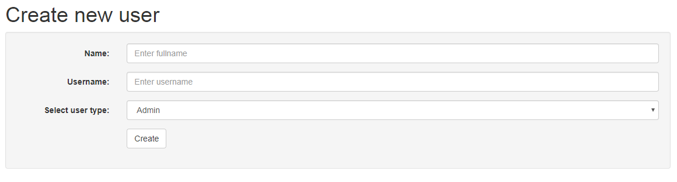

1. **Fill** in those details and click **Create** to create a new user.

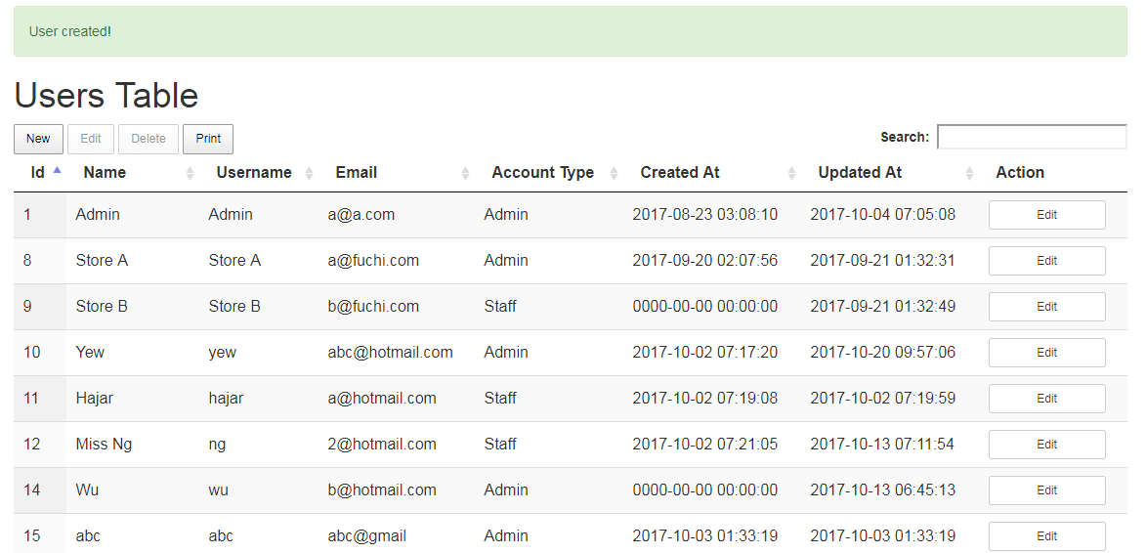

1. **Green color** success prompt will appear on **top** of the page
2. Page will be redirected to list of the user.

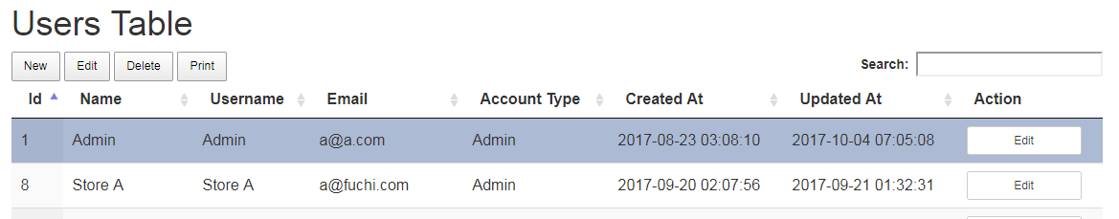

1. At the page **Users table**
2. You can even add new user here by clicking **New**

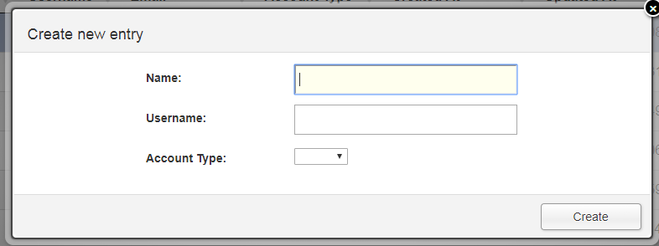

1. **Fill** in those details and click **Create**



1. **Select** on the specific row by clicking on the number of each row
2. Click **Edit** to edit

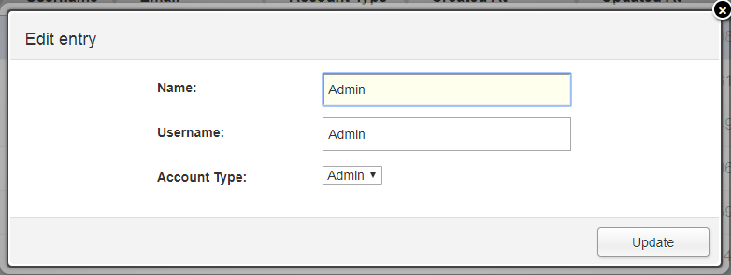

1. **Fill** in those details
2. And click **Update**



1. **Select** on the specific row by clicking on the number of each row
2. Click **Delete** to delete the specific user

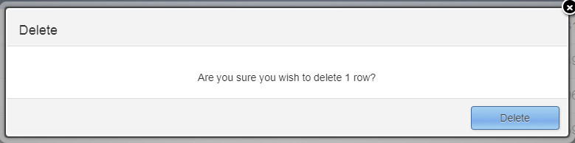

1. Click **Delete** to confirmed deletion

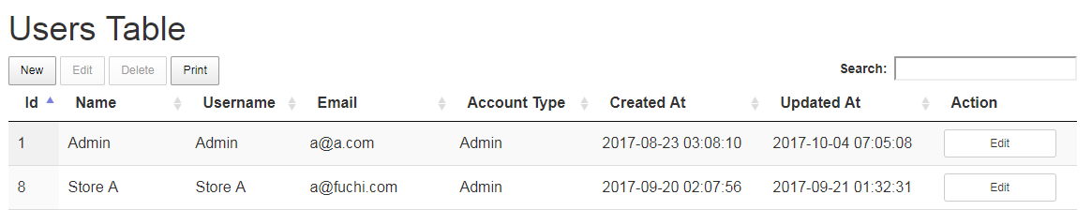

1. Click **Edit**, this will be directed to **My Profile** page

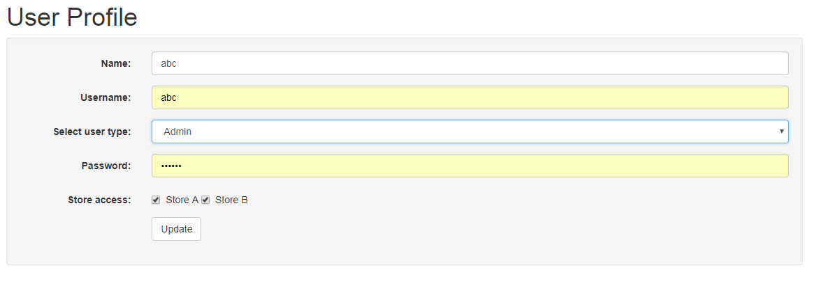

1. In this page, you can

* **Edit** details (**Name, Username and User Type**)
* **Assigned** user to store that can be accessed
* **Reset password** incase user forgot their password

1. Fill the required details then click **Update**