## Summary of the Methodology:

1. Collect images of different categories based on the Affective image classification theory used in Psychology an Art. (The 8 emotion categories are listed below.)
2. Record a minimum of 100 seconds (1600 samples) of EEG data from Interaxon Muse, and converting it into Matlab format.
3. Recordings are then imported into Matlab, and analyzed using Neural Network Toolbox (nntool) [Figure 1]. The detailed specification is detailed below.

8 emotion categories are the defined as:

1. Amusement
2. Anger
3. Awe
4. Contentment
5. Disgust
6. Excitement
7. Fear
8. sad

## Classification Method:

43 features are being used as the input: including alpha, beta, theta and gamma band, alpha/beta ratio, beta/alpha ratio, alpha relative power/beta relative power ratio, Blink frequency, concentration levels (based on gamma classification,) relaxation level (based on relative alpha power and beta level comparison), as well as other combinations of the basic features. These input are then imported into a 20 layer perceptron, 8 output Neural Network, the Scaled Conjugate Gradient is the classification method, and cross entropy is used as the performance evaluation method. The classification accuracy is 99% based on the Confusion Matrix [Figure 3]. This intuitively makes sense as EEG spectrums/bands are inversely correlated (if alpha band increases, beta decreases, and vice versa). Distinct emotion content is likely to trigger distinct spectrums. Although this classification rate is higher than any known researches, given that the data size and subject involved (myself only,) this does not indicate the performance of the classification method. This, however, suggests the potential of designing a highly reliable, yet **personalized** emotion classifier, and incorporating it into the real-time computation of Man-fit System in the final project.

## Discussion/Future Decision

Future projects will be guided under the philosophy of **personalized classification**. As portable EEG device/toy such as Muse becomes more commonly used, Instead of using data mining technique to classify a general population (i.e. Big Data,) we focus on the data analysis of each individual (i.e. Small Data). Personalized classification would allow better performance of the algorithm, fewer variance of the data points.

|  |  |  |  |  |  |  |  |  |  |  |  |  |
| --- | --- | --- | --- | --- | --- | --- | --- | --- | --- | --- | --- | --- |
|  |  |  |  |  |  |  | concentration | mellow | gamma_absolute | gamma_relative | theta_absolute | theta_relative |

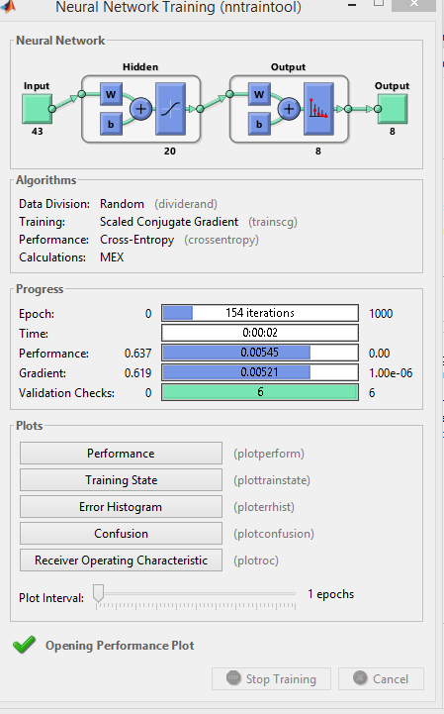

Figure 1: Neural Network Training tool.

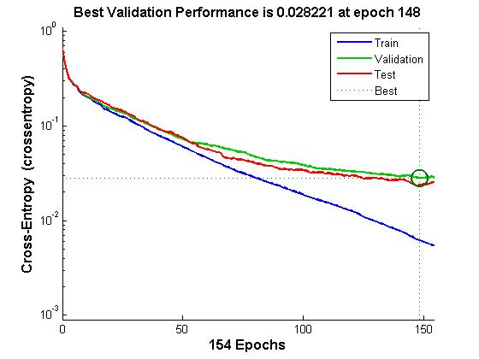

Figure 2: Validation Performance

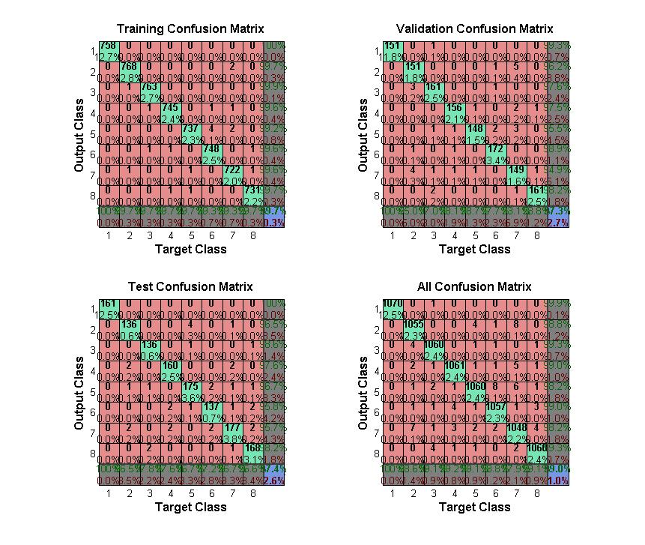

Figure 3: Table of Confusion

