**HW5 – PPL**

**Submitting:**

Raz Monsonego: 313292120

Almog Zemach: 205789001

**Question 1 – CPS**

1.1.

** In the following proof, ‘a-e’ stands for ‘applicative-eval’ (as in the practical session).

b.

**Claim**: append$ is CPS – equivalent to append

i.e. :

$$\left(append\$ lst1 lst2 cont\right)=(cont \left(append lst1 lst2\right))$$

**Proof by induction:** (on length of the first list)

**Base: $lst1='()$**

$a-e\left[\left(append\$ '() lst2 cont\right)\right]⇒$ $a-e\left[\left(cont lst2\right)\right]=$ $a-e\left[\left(cont (append '() lst2)\right)\right]$

**Assumption: $∀i∈N s.t i≤n, \left|lst1\right|=i :$**

$$a-e\left[\left(append\$ lst1 lst2 cont\right)\right]=a-e\left[(cont \left(append lst1 lst2)\right)\right]$$

**Step: $let n+1∈N s.t \left|lst1\right|=n+1, then:$**

$a-e\left[\left(append\$ lst1 lst2 cont\right)\right]⇒$

$a-e\left[\left(append\$ \left(cdr lst1\right) lst2 \left(lambda \left(res\right)\left(cont \left(cons \left(car lst1\right) res\right)\right)\right)\right)\right]$

Denote: $cont'= \left(lambda \left(res\right)\left(cont \left(cons \left(car lst1\right) res\right)\right)\right)$

Notice that $\left|\left(cdr lst1\right)\right|=n$ and therefore by our assumption,

$$a-e\left[\left(append\$ \left(cdr lst1\right) lst2 cont'\right)\right]=a-e[\left(cont' \left(append \left(cdr lst1\right) lst2\right)\right)]$$

$$⇒a-e\left[\left(cont \left(cons \left(car lst1\right) \left(append \left(cdr lst1\right) lst2\right)\right)\right)\right]=\left(*\right)$$

$a-e\left[\left(cont \left(append \left(cons \left(car lst1\right) \left(cdr lst1\right)\right) lst2\right)\right)\right]=$

$a-e[\left(cont \left(append lst1 lst2\right)\right)]$

Proof of $\left(*\right):$

Claim: $\left(cons x \left(append lst1 lst2\right)\right)=(append \left(cons x lst1\right) lst2)$

**Proof by induction:** (on length of first list)

**Base: $lst1='()$**



$a-e\left[\left(cons x \left(append '() lst2\right)\right)\right]⇒a-e\left[(cons x lst2)\right]$

$a-e[\left(append \left(cons x '()\right) lst2\right)]= a-e[\left(append '\left(x\right) lst2\right)]$

$$=a-e[\left(cons x lst2\right)]$$

As we can see $1 = 2$

**Assumption: $∀i∈N s.t i≤n, \left|lst1\right|=i :$**

$$a-e\left[\left(cons x \left(append lst1 lst2\right)\right)\right]=a-e\left[(append \left(cons x lst1\right) lst2)\right]$$

**Step: $let n+1∈N s.t \left|lst1\right|=n+1, then:$**

$a-e\left[\left(cons x \left(append lst1 lst2\right)\right)\right]⇒$

$a-e\left[\left(cons x \left(append (cons \left(car lst1\right) \left(cdr lst1\right)) lst2\right)\right)\right]$

Notice that $\left|\left(cdr lst1\right)\right|=n$ and therefore by our assumption,

$$⇒a-e\left[\left(cons x (cons \left(car lst1\right) \left(append \left(cdr lst1\right) lst2\right))\right)\right]$$

$$⇒a-e\left[\left(cons (cons x '(\left(car lst1\right)) \left(append \left(cdr lst1\right) lst2\right))\right)\right]$$

$$⇒a-e\left[\left(append (cons (cons (cons x '\left(car lst1\right)) \left(cdr lst1\right)) lst2\right))\right]$$

$$⇒a-e\left[\left(append \left(cons x lst1\right) lst2\right)\right]$$

**Question 2 – Lazy lists**

d. ***reduce1-lzl:***

We would like to use *reduce1-lzl* when we have a constructed lazy list with **finite size**, without a recursive construction that could cause an infinite loop.

For example:

$$(cons-lzl 3 (lambda () (cons-lzl 8 (lambda () ‘()))))$$

Is a relatively small (and finite) lazy list without recursion and therefore will be the optimal choice for *reduce1-lzl*.

On the other hand,

$$(integers-from 1)$$

will not be a good choice, it will cause an infinite loop.

***reduce2-lzl*:**

*reduce2-lzl* is a good choice when we want to compute a predefined number of components of a lazy-list, i.e.:

$$(reduce2-lzl + 0 (integers-from 1) 5)$$

This is especially useful when we want to calculate the reduce of some number of components of an infinite lazy-list (also good for a finite one, just will make the computation stop for an infinite one, which won’t happen if we use reduce1-lzl for instance).

***reduce3-lzl*:**

We will use *reduce3-lzl* for computing a reduce of a lazy-list one component at a time, meaning that we use it as an Iterator of the reduce of the lazy-list, i.e., to make a delayed computation of reduce of a lazy-list (*reduce1-lzl* and *reduce2-lzl* basically acts like a regular reduce on a regular list and disable the application of delayed computation). Overall, this gives us the general advantage of a lazy-list, just here we get the reduce of the lazy-list relative to some reducer (function that operates on the components of the lazy-list).

g.

**Advantages**: First of all, in generate-pi-sum, we can decide ‘live’ whether we want a more accurate approximation or not, and apply the lazy-list again to get it, where in pi-sum we must decide up-front what is the accuracy we want, and just get the first approximation that satisfies this accuracy (difference w.r.t b).

**Dis-advantages**: In order to get a very good approximation, we will have to apply the lazy-list function allot of times, where in pi-sum we just give a different b that result in better resolution of the approximation. Even if we use take on the generate-pi-approximations, we will get a huge array in return (size as the amount of the times we applied the lazy-list).

(3.1) We perform the unification algorithm as written in [link](https://bguppl.github.io/interpreters/class_material/5.1RelationalLogicProgramming.html).

We seek to find a unifier between:

$$A=t\left(s\left(s\right), G, s, p, t\left(K\right), s\right) \\ B=t\left(s\left(G\right), G, s, p, t\left(K\right), U\right)$$

We do so by performing the unifying algorithm (link above).

**Step 1:**

|  |  |
| --- | --- |
| Equation | Substitution |
| $$t\left(s\left(s\right), G, s, p, t\left(K\right), s\right)=t\left(s\left(G\right), G, s, p, t\left(K\right), U\right)$$ | $$\{ \}$$ |
|  |  |

**Step 2:**

|  |  |
| --- | --- |
| Equation | Substitution |
| $$s\left(s\right)=s(G)$$ | $$\{ \}$$ |
| $$G=G$$ |  |
| $$s=s$$ |  |
| $$p=p$$ |  |
| $$t\left(K\right)=t(K)$$ |  |
| $$s=U$$ |  |

**Step 3:**

|  |  |
| --- | --- |
| Equation | Substitution |
| $$G=G$$ | $$\{ \}$$ |
| $$s=s$$ |  |
| $$p=p$$ |  |
| $$t\left(K\right)=t(K)$$ |  |
| $$s=U$$ |  |
| $$s=G$$ |  |

**Step 4:**

|  |  |
| --- | --- |
| Equation | Substitution |
| $$s=s$$ | $$\{ \}$$ |
| $$p=p$$ |  |
| $$t\left(K\right)=t(K)$$ |  |
| $$s=U$$ |  |
| $$s=G$$ |  |

**Step 5:**

|  |  |
| --- | --- |
| Equation | Substitution |
| $$p=p$$ | $$\{ \}$$ |
| $$t\left(K\right)=t(K)$$ |  |
| $$s=U$$ |  |
| $$s=G$$ |  |

**Step 6:**

|  |  |
| --- | --- |
| Equation | Substitution |
| $$t\left(K\right)=t(K)$$ | $$\{ \}$$ |
| $$s=U$$ |  |
| $$s=G$$ |  |

**Step 7:**

|  |  |
| --- | --- |
| Equation | Substitution |
| $$s=U$$ | $$\{ \}$$ |
| $$s=G$$ |  |
| $$K=K$$ |  |

**Step 7:**

|  |  |
| --- | --- |
| Equation | Substitution |
| $$s=G$$ | $$\{U=s\}$$ |
| $$K=K$$ |  |

**Step 7:**

|  |  |
| --- | --- |
| Equation | Substitution |
| $$K=K$$ | $$\{U=s, G=s\}$$ |

**Step 7:**

|  |  |
| --- | --- |
| Equation | Substitution |
|  | $$\{U=s, G=s\}$$ |

We get that the unifier of the expressions is $\{U=s, G=s\}$.Now we seek to find a unifier between:

$$A=p\left( [ v \right| \left[ V \right| W ] ] ) \\ B=p\left( \left[ \left[ v \right| V\right] \right| W ] )$$

We do so by performing the unifying algorithm (link above).

**Step 1:**

|  |  |
| --- | --- |
| Equation | Substitution |
|  |  |
|  |  |

**Step 2:**

|  |  |
| --- | --- |
| Equation | Substitution |
|  |  |
|  |  |

The algorithm returns ‘FAIL’ here, since we get that $v=\left[v \right| V]$, which is cannot be true. A symbol cannot be equal to a list (this list also encapsulates that symbol).

**This is the algorithm:**

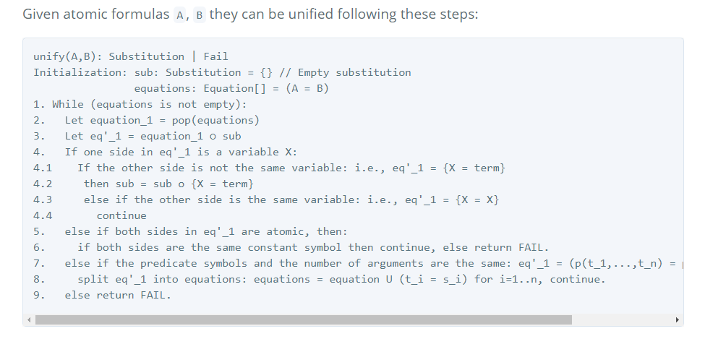

(3.3) Proof tree.

We draw the proof-tree for:

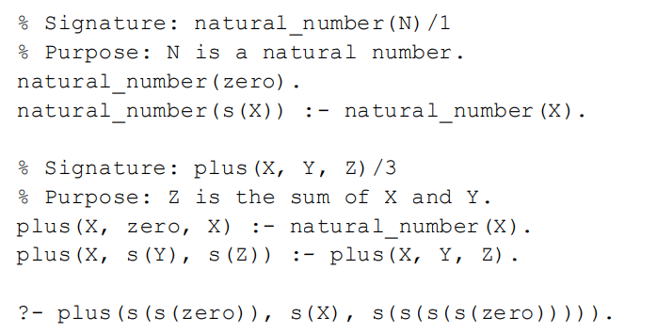

We denote the first rule of ‘natural_numbers’ as N1, and the second N2.

In the same manner we denote the first rule of ‘plus’ as P1, and the second P2.

$$plus\left(s\left(s\left(zero\right)\right), s\left(X\right), s\left(s\left(s\left(s\left(zero\right)\right)\right)\right)\right)$$

$$X_{1}=s\left(s\left(zero\right)\right), \\ Y_{1}=X \\ Z_{1}=s\left(s\left(s\left(zero\right)\right)\right)$$

P2

$$plus\left(s\left(s\left(zero\right)\right), X,s\left(s\left(s\left(zero\right)\right)\right)\right)$$

P2

$$X_{2}=s\left(s\left(zero\right)\right)$$

$$X=s\left(Y_{2}\right)$$

$$Z_{2}=s\left(s\left(zero\right)\right)$$

$$natural-number\left(zero\right)$$

$$natutal-number\left(s\left(zero\right)\right)$$

$$natural-number\left(s\left(s\left(zero\right)\right)\right)$$

$$X_{3}=s\left(s\left(zero\right)\right) \\ s\left(Y_{3}\right)=X \\ Z_{3}=s\left(zero\right)$$

$$plus\left(s\left(s\left(zero\right)\right),Y_{2}, s\left(s\left(zero\right)\right)\right)$$

$$Y_{2}=zero \\ X_{3}=s\left(s\left(zero\right)\right)$$

P1

N1

N2

$$X_{5}=zero$$

N2

$$X_{4}=s\left(zero\right)$$

P2

P2

$$fail$$

$$X_{4}=s\left(s\left(zero\right)\right) \\ X=s\left(Y_{4}\right) \\ Z_{4}=zero$$

$$plus\left(s\left(s\left(zero\right)\right), Y_{4}, zero\right)$$

$$true$$

$$plus\left(s\left(s\left(zero\right)\right), X, s\left(zero\right)\right)$$

$$\left\{X_{1}=s\left(s\left(zero\right)\right), { Y}_{1}=X { Z}_{1}=s\left(s\left(s\left(zero\right)\right)\right)\right\}∘$$

$$\left\{ X_{2}=s\left(s\left(zero\right)\right), X=s\left(Y_{2}\right), Z_{2}=s\left(s\left(zero\right)\right)\right\}∘$$

$$\left\{Y_{2}=zero, X_{3}=s\left(s\left(zero\right)\right)\right\}∘$$

$$\left\{ X_{4}=s\left(zero\right) \right\}∘$$

$$\{ X_{5}=zero \}$$

$$= \left\{X_{1}=s\left(s\left(zero\right)\right), { Y}_{1}=s\left(Y_{2}\right), { Z}_{1}=s\left(s\left(s\left(zero\right)\right)\right) , X_{2}=s\left(s\left(zero\right)\right), X=s\left(Y_{2}\right), Z_{2}=s\left(s\left(zero\right)\right)\right\}∘$$

$$\left\{Y_{2}=zero, X_{3}=s\left(s\left(zero\right)\right)\right\}∘$$

$$\left\{ X_{4}=s\left(zero\right) \right\}∘$$

$$\{ X_{5}=zero \}$$

$$= \left\{X_{1}=s\left(s\left(zero\right)\right), { Y}_{1}=s\left(zero\right) { Z}_{1}=s\left(s\left(s\left(zero\right)\right)\right) , X_{2}=s\left(s\left(zero\right)\right), X=s(zero), Z_{2}=s\left(s\left(zero\right)\right),Y_{2}=zero, X_{3}=s\left(s\left(zero\right)\right)\right\}∘$$

$\left\{ X_{4}=s\left(zero\right) \right\}∘\{ X_{5}=zero \}$

= $\{X_{1}=s\left(s\left(zero\right)\right), { Y}_{1}=s\left(zero\right) { Z}_{1}=s\left(s\left(s\left(zero\right)\right)\right) , X_{2}=s\left(s\left(zero\right)\right), X=s\left(zero\right),$

$Z_{2}=s\left(s\left(zero\right)\right),Y_{2}=zero, X_{3}=s\left(s\left(zero\right)\right), X_{4}=s\left(zero\right)\}∘ \{ X_{5}=zero \}$

= $\{X_{1}=s\left(s\left(zero\right)\right), { Y}_{1}=s\left(zero\right) { Z}_{1}=s\left(s\left(s\left(zero\right)\right)\right) , X_{2}=s\left(s\left(zero\right)\right), X=s\left(zero\right),$

$Z_{2}=s\left(s\left(zero\right)\right),Y_{2}=zero, X_{3}=s\left(s\left(zero\right)\right), X_{4}=s\left(zero\right),X_{5}=zero \}$

We take only the variables in the query, which in this case is only $X$, and get:

$$\left\{X=s\left(zero\right)\right\}$$