Assignment 3 - Technical Report
Edge Computing & Intelligent Systems | Model quantization (PTQ, QAT) and pruning (unstructured, structured) of ResNet-18 on CIFAR-10
Name: rana raza ahmed roll no: 23i-0060 section:ai-b date: 13-nov-2026

1. Overview and setup
This report documents a complete PyTorch compression pipeline for one image classifier. A single FP32 ResNet-18 is trained on CIFAR-10 (Q1.1 / Q2.1) and then compressed four ways: post-training static quantization (PTQ), quantization-aware training (QAT), iterative unstructured magnitude pruning and structured channel pruning with physical architecture reconstruction. All five models are served by one inference pipeline, evaluated by automated benchmark scripts and exported to ONNX for CPU deployment.
Item | Value
Dataset | CIFAR-10: 50,000 train / 10,000 test images, 10 classes, 32x32 RGB
Model | ResNet-18 for 32x32 input: 3x3 stride-2 stem, no max-pool, 4 stages x 2 BasicBlocks (64-128-256-512), 11,173,962 parameters, 138.9 M MACs
Hardware | CPU only (2 vCPU, no GPU); all latency numbers are CPU numbers
Software | Python 3.13, PyTorch 2.15, torchvision 0.29, ONNX 1.23, ONNX Runtime 1.29
Quantization backend | fbgemm (x86); the code falls back to qnnpack on ARM
Seed | 42 for all scripts
Test set use | Used only for reporting; no model selection or tuning was done on it

Design note. Because training had to run on a 2-core CPU, the stem uses stride 2 (feature maps 16-8-4-2 instead of 32-16-8-4), which cuts compute about 4x versus the usual CIFAR ResNet-18. The baseline was trained for only 8 epochs, so it is deliberately an under-trained model (86.33%); this matters for interpreting results in Section 3.4.

2. Baseline FP32 model (Deliverable 1)
Script: src/train_baseline.py. SGD (Nesterov, momentum 0.9), batch 128, one-cycle LR schedule with peak 0.1, weight decay 5e-4, random-crop (pad 4) + horizontal-flip augmentation, 8 epochs (about 47 min on CPU). Final test accuracy: 86.33%. Checkpoint: checkpoints/fp32_resnet18.pth (44.8 MB).
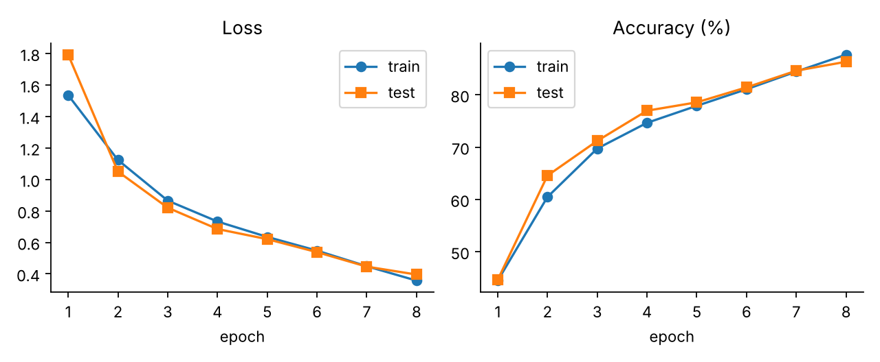
Figure 1 - Baseline training curves
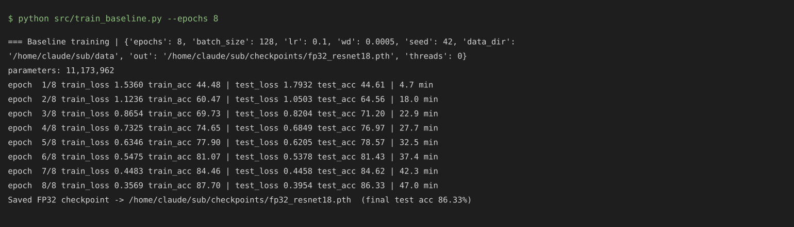
Screenshot 1 - Baseline training console output

3. Question 1 - Quantization

3.1 Model preparation
The ResNet was written to be quantization-friendly: QuantStub/DeQuantStub at the input/output, and the residual add+ReLU is done with FloatFunctional.add_relu so that it can be quantized in eager mode. Conv+BN(+ReLU) groups are fused (fuse_model in common.py): stem, both convs of each block and the 1x1 shortcut convs. Fusion was verified to leave FP32 outputs unchanged.

3.2 Post-training static quantization (Deliverable 2)
Script: src/ptq.py. Steps: load the FP32 checkpoint, fuse, select the backend (torch.backends.quantized.engine = "fbgemm"), attach the default fbgemm qconfig (per-channel INT8 weights, histogram observers for activations), insert observers with prepare, run the calibration pipeline over 1,000 randomly chosen training images (no augmentation, forward-only), then convert to a real INT8 model. The model is saved as TorchScript (checkpoints/ptq_int8_resnet18.pt, 11.4 MB) and re-loaded to confirm identical accuracy.
Result: 86.30% vs 86.33% FP32 (-0.03 points) at 3.9x smaller size. A calibration-size sweep (10 to 5,000 images) gave 86.23-86.41% in every case, so PTQ accuracy is insensitive to calibration size for this model; 1,000 images is therefore a safe default.
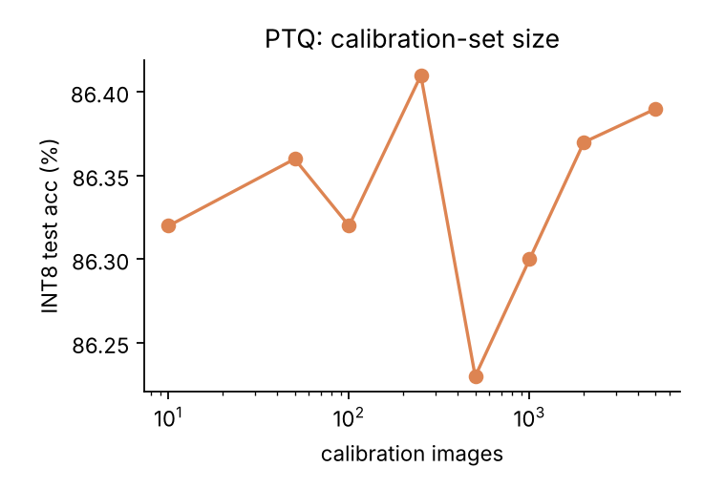
Figure 2 - PTQ accuracy vs calibration-set size
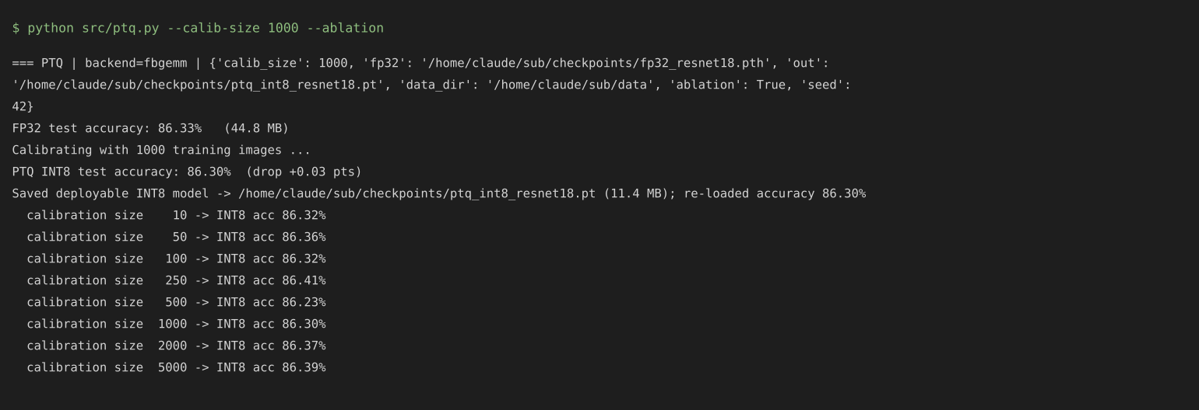
Screenshot 2 - PTQ console output

3.3 Quantization-aware training (Deliverable 3)
Script: src/qat.py. The FP32 checkpoint initialises the model, which is fused with the QAT-aware fusion and prepared with prepare_qat (51 fake-quant modules inserted: weights per-channel, activations per-tensor). It is fine-tuned for 2 epochs (780 steps) with SGD, LR 0.01 cosine-annealed, weight decay 1e-4. Following the standard recipe, BatchNorm statistics are frozen after 60% of the steps and observers after 80%. The model is then converted to INT8 and exported as TorchScript (checkpoints/qat_int8_resnet18.pt, 11.4 MB).
Result: fake-quant model 87.18%, converted INT8 model 87.30%.
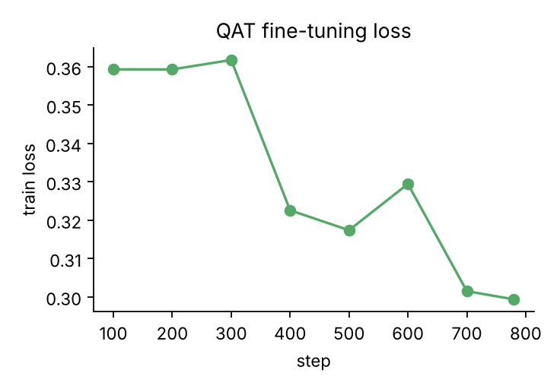
Figure 3 - QAT fine-tuning loss
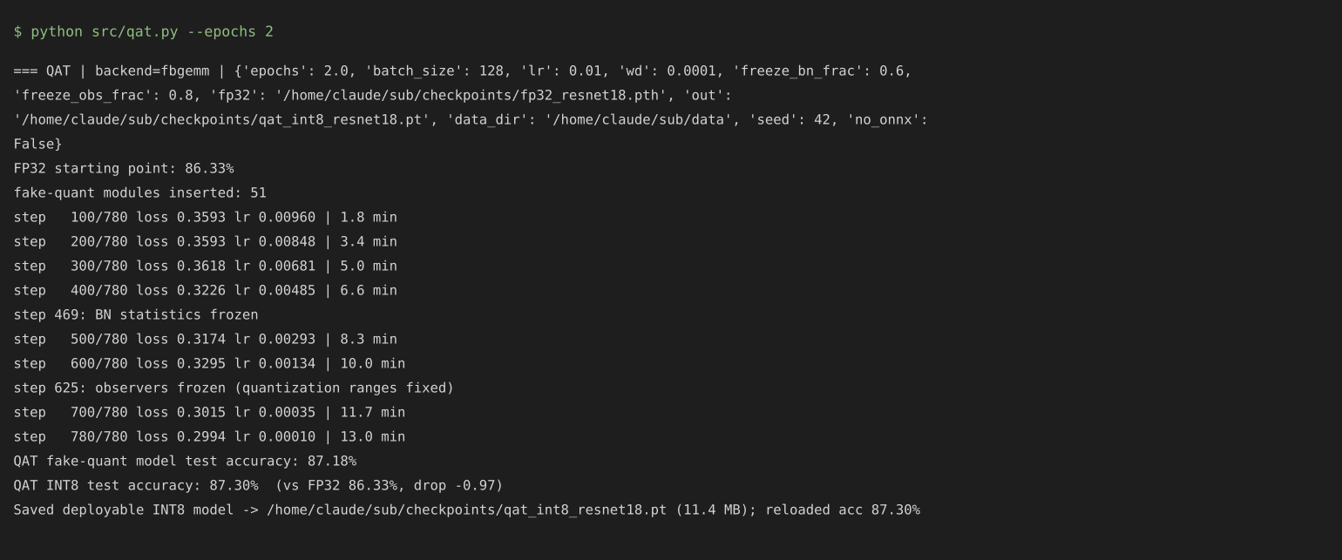
Screenshot 3 - QAT console output

3.4 Inference pipeline and benchmark (Q1.4, Q1.5, Deliverables 6-7)
src/inference.py exposes one Predictor class for all models and backends (CLI: --model fp32|ptq|qat|unstructured|structured|all --backend torch|onnx, optionally on a custom image). src/benchmark_q1.py evaluates FP32, PTQ and QAT on the full 10,000-image test set and writes results/q1_benchmark.csv (metrics) and results/q1_predictions.csv (per-image prediction, confidence and correctness for each model). Latency is batch-1 on one thread (200 timed runs after warm-up); throughput is batch-256 on both cores.
Model | Test acc (%) | Size (MB) | Latency b=1 (ms) | Throughput (img/s) | Agreement with FP32
FP32 | 86.33 | 44.78 | 6.37 | 861.5 | 100%
PTQ-INT8 | 86.30 | 11.43 | 1.16 | 2695.4 | 98.99%
QAT-INT8 | 87.30 | 11.43 | 1.29 | 2735.1 | 95.64%

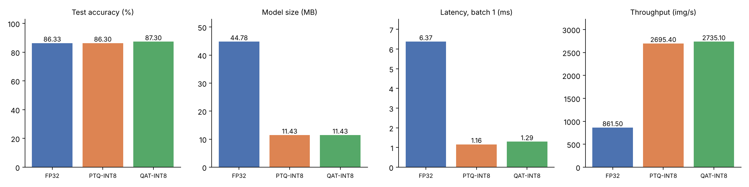
Figure 4 - Q1 comparison of FP32, PTQ-INT8 and QAT-INT8
Analysis. Both INT8 models are 3.9x smaller, about 5x faster per image and 3.1x faster in batch throughput than FP32. PTQ is essentially lossless here. QAT scores about 1 point higher than FP32, but this should not be read as quantization improving accuracy: the 8-epoch baseline is still improving, and QAT gives it two further epochs of low-LR training. A fair statement is that QAT lost nothing relative to the (fine-tuned) float model, while PTQ lost 0.03 points without any retraining. The lower agreement of QAT with FP32 predictions (95.6%) reflects that QAT has moved the weights, not that it is less accurate. PTQ was already near-lossless on this network, so the advantage QAT is designed to give (recovering accuracy on models that are fragile under PTQ) cannot be demonstrated cleanly on it.
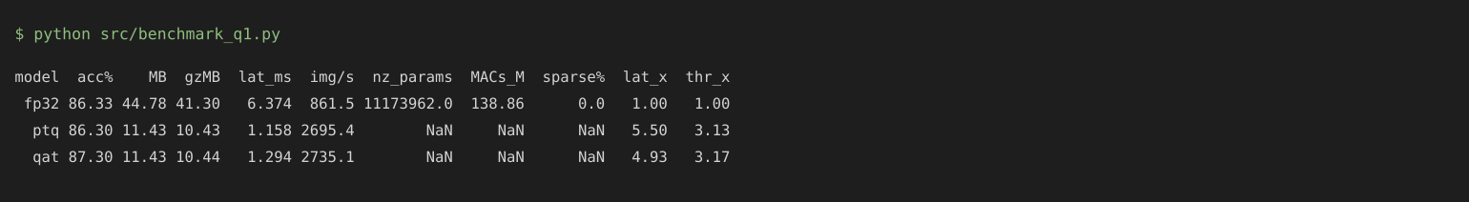
Screenshot 4 - Q1 benchmark output

4. Question 2 - Pruning

4.1 Unstructured pruning (Deliverable 4)
Script: src/prune_unstructured.py. Every Conv2d and the final Linear layer is a target. Weights are ranked globally by L1 magnitude with torch.nn.utils.prune.global_unstructured. Pruning is iterative: 5 rounds on a cubic sparsity schedule (41.5%, 66.6%, 79.6%, 84.3%, 85.0%); after each round the network is fine-tuned for 0.4 epoch, followed by a final 1-epoch fine-tune with the final mask. Weight masking is done by the pruning re-parametrisation (weight_orig and weight_mask, re-applied in every forward pass so pruned weights stay zero during fine-tuning). At the end prune.remove makes pruning permanent: the mask is folded into the weight tensor and the script asserts that no masks remain and that sparsity and accuracy are unchanged.
Round | Target / actual sparsity | Acc right after pruning | Acc after fine-tune
1 | 41.5% | 86.37 | 86.41
2 | 66.6% | 86.47 | 86.44
3 | 79.6% | 85.92 | 86.49
4 | 84.3% | 85.99 | 86.70
5 | 85.0% | 86.18 | 86.80
final fine-tune | 85.0% | - | 86.97

Final model: 85.0% of conv/FC weights are zero (1,684,263 of 11,173,962 parameters remain, 15.1%), 86.97% accuracy (+0.64 over baseline; again partly the extra fine-tuning epochs). Two files are exported: a dense-format checkpoint that loads into the normal ResNet18 (pruned_unstructured_resnet18.pth, 44.8 MB, 10.0 MB after gzip) and a genuinely compact bit-mask-plus-values file (..._sparse_compact.pth, 8.2 MB) with a loader whose reloaded accuracy was checked to be identical.
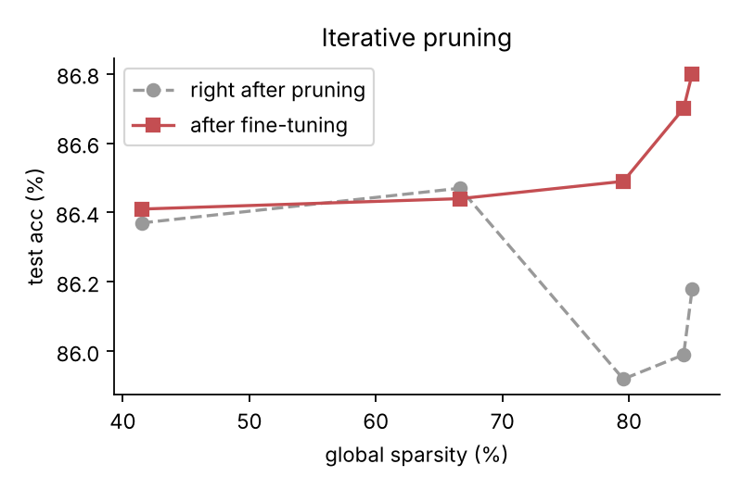
Figure 5 - Accuracy through the iterative pruning schedule
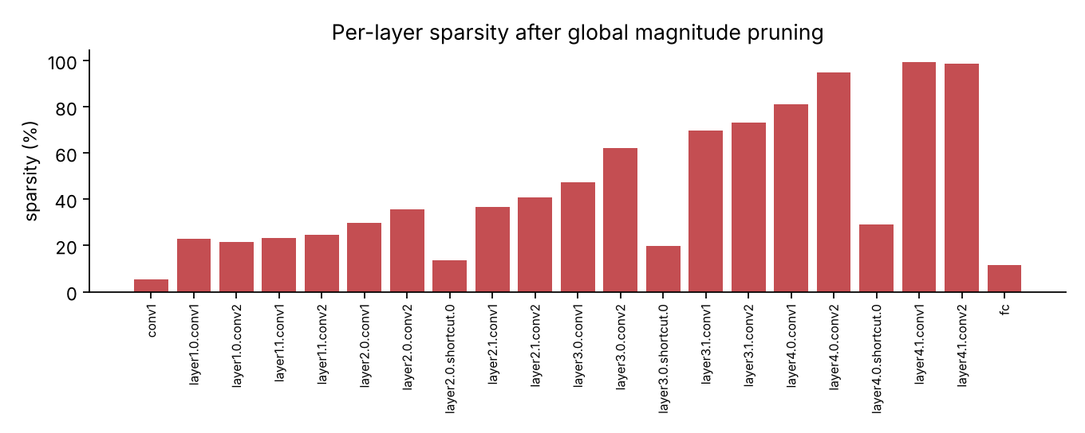
Figure 6 - Per-layer sparsity: global ranking prunes the large late layers hardest and spares the small early ones
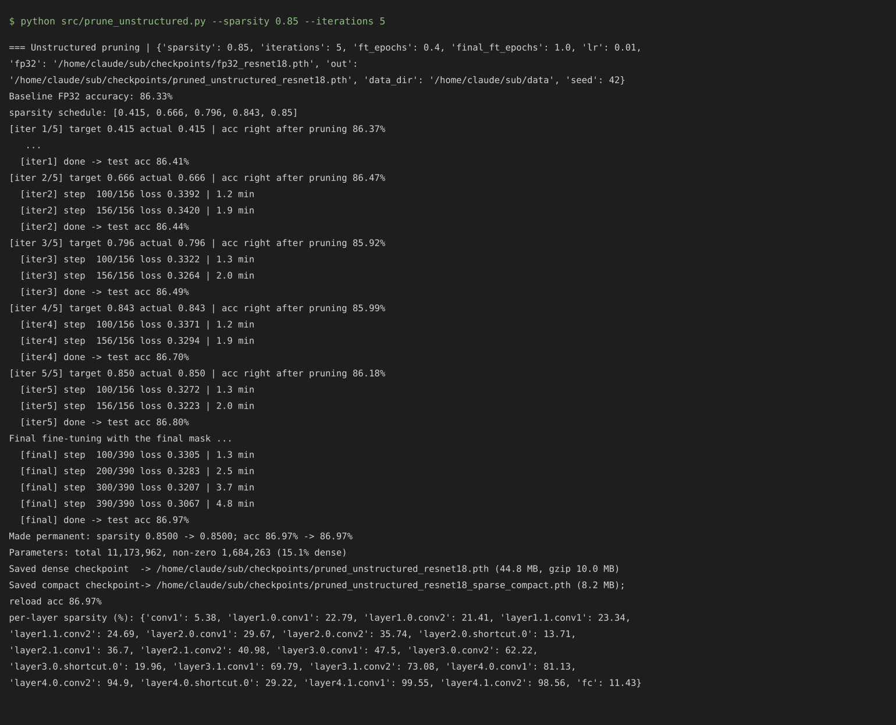
Screenshot 5 - Unstructured pruning console output

4.2 Structured channel pruning (Deliverable 5)
Script: src/prune_structured.py. Inside each BasicBlock the hidden layer conv1 -> bn1 -> ReLU -> conv2 can be thinned freely, whereas the block output channels are tied to the residual stream (identity or 1x1 shortcut) and are therefore kept. Importance of a hidden channel is the L1 norm of its conv1 filter, normalised by the layer mean so that one global threshold works across layers; every layer keeps at least 25% of its channels. 50% of hidden channels are removed globally.
Keeping dimensions valid. For every pruned channel k three tensors are sliced consistently: conv1.weight[k] (output filter), bn1 weight/bias/running mean/running var at k, and conv2.weight[:, k] (the matching input slice). Hence conv1.out = bn1.channels = conv2.in in every block.
Reconstruction. A new, physically smaller ResNet18(inner_channels=[...]) is instantiated and the surviving weights are copied in; no masks or zero channels exist at run time, and the channel configuration is stored in the checkpoint so it can be rebuilt anywhere. Correctness is asserted: the logits of the rebuilt network match the original network with the pruned channels zeroed to within 7e-7.
Block | Original hidden channels | Kept | Pruned
layer1.0 | 64 | 22 | 65.6%
layer1.1 | 64 | 27 | 57.8%
layer2.0 | 128 | 63 | 50.8%
layer2.1 | 128 | 57 | 55.5%
layer3.0 | 256 | 125 | 51.2%
layer3.1 | 256 | 122 | 52.3%
layer4.0 | 512 | 235 | 54.1%
layer4.1 | 512 | 309 | 39.6%

Directly after pruning (no training) accuracy falls to 23.39%, with parameters at 53.2% and MACs at 47.3% of the original. Fine-tuning for 3 epochs (LR 0.02, cosine) recovers it to 86.82%. Checkpoint: pruned_structured_resnet18.pth (23.9 MB).
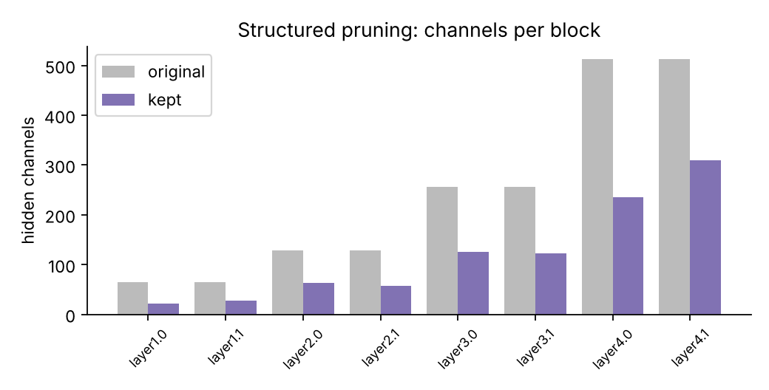
Figure 7 - Hidden channels per block before and after pruning
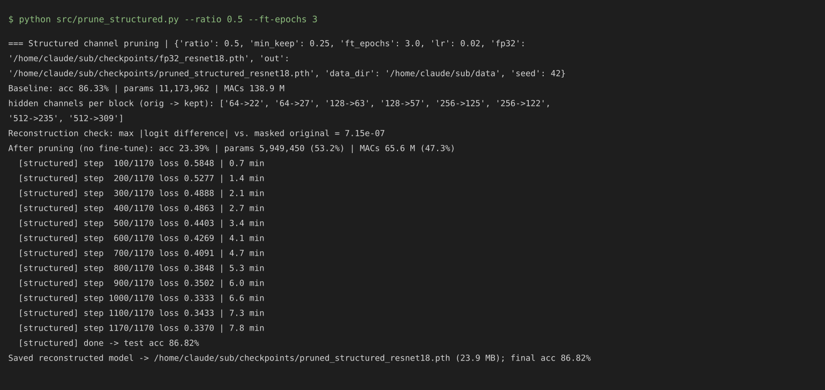
Screenshot 6 - Structured pruning console output

4.3 Fine-tuning pipeline (Q2.4)
src/finetune.py provides the shared routine (SGD + cosine decay, fractional epochs) used after every unstructured round and after structured pruning; it works both on masked models and on rebuilt smaller models and can also be run stand-alone on any float checkpoint.

4.4 Benchmark (Q2.6)
Model | Acc (%) | Non-zero params | Effective MACs (M) | File (MB) | gzip (MB) | Latency b=1 (ms) | Throughput (img/s)
Original FP32 | 86.33 | 11.17 M | 138.9 | 44.78 | 41.30 | 6.39 | 818.8
Unstructured 85% | 86.97 | 1.68 M | 64.6 (sparse-aware) | 44.78 | 9.95 | 7.36 | 894.5
Structured 50% | 86.82 | 5.95 M | 65.6 | 23.87 | 21.99 | 4.20 | 1453.6

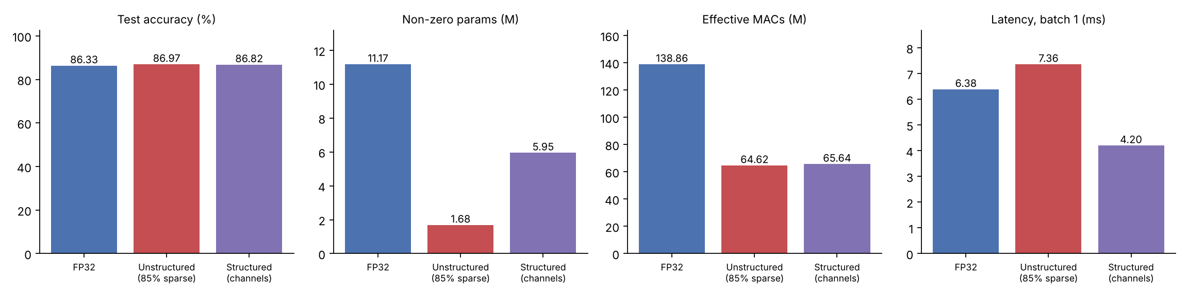
Figure 8 - Q2 comparison of the original, unstructured-pruned and structured-pruned models
Analysis. The two methods deliver very different kinds of benefit. Unstructured pruning reaches far higher compression (85% of weights are zero; 4.1x smaller after gzip and 5.5x smaller in the compact format) but the zeros are scattered, so dense CPU kernels do the same work: latency (7.4 ms) was no better than the original (6.4 ms) and slightly worse within measurement noise. Its saving is in storage and in the MACs a sparse-aware engine could skip, not in measured speed. Structured pruning removes whole channels, so the network is simply smaller and the speed-up is real on ordinary hardware: 1.5x lower batch-1 latency and 1.8x higher throughput, with 1.9x smaller files and 47% of the MACs. Its predictions agree with the original less often (92.6% vs 95.1% for unstructured), which is expected given the larger change to the architecture. Both recovered to at or slightly above baseline accuracy after fine-tuning; part of that gain is the additional training given to an under-trained baseline.
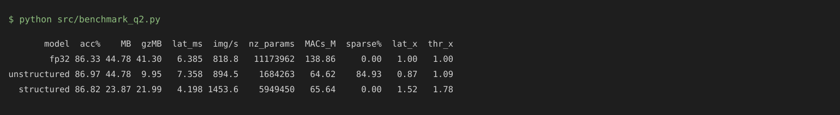
Screenshot 7 - Q2 benchmark output

5. ONNX deployment (Deliverable 8)
Script: src/export_onnx.py (and the QAT export inside qat.py); CPU inference and benchmarking: src/onnx_inference.py with ONNX Runtime (CPUExecutionProvider).
- FP32, unstructured, structured: direct torch.onnx.export (opset 13, dynamic batch). ONNX Runtime outputs match PyTorch to about 2e-6.
- PTQ-INT8: the FP32 ONNX graph is statically quantized with ONNX Runtime (QDQ format, per-channel INT8 weights, the same 1,000-image calibration subset). PyTorch eager INT8 modules use fbgemm packed ops that have no ONNX equivalent, so this is the standard route to an INT8 ONNX file.
- QAT: the trained fake-quant model is exported with BatchNorm folded into the conv weights and every fake-quant turned into QuantizeLinear/DequantizeLinear (51 pairs). The 0-127 "reduce_range" activation grid used by fbgemm is re-expressed on the 0-255 range (same real-valued clip range) because ONNX cannot express 7-bit grids. Its ONNX accuracy is 87.18%, equal to the fake-quant model.
ONNX model | Acc (%) | Size (MB) | Latency b=1 (ms) | Throughput (img/s)
FP32 | 86.33 | 44.69 | 3.01 | 658.0
PTQ-INT8 | 86.35 | 11.29 | 0.87 | 2224.9
QAT (QDQ) | 87.18 | 44.74 | 0.86 | 2276.5
Unstructured | 86.97 | 44.69 | 3.28 | 701.1
Structured | 86.82 | 23.79 | 2.01 | 854.6

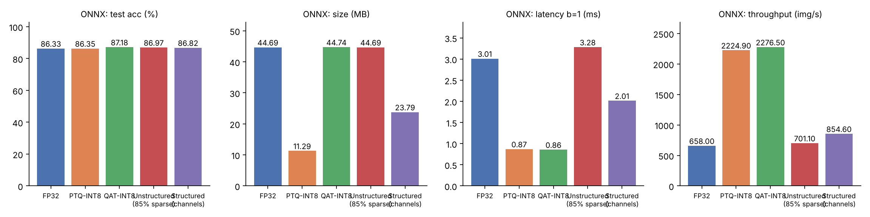
Figure 9 - ONNX Runtime CPU results
Notes. ONNX Runtime batch-1 FP32 latency (3.0 ms) is lower than PyTorch eager (6.4 ms), so ONNX speed-ups of INT8 are relative to a faster float baseline (3.5x). The QAT ONNX file keeps float weights inside QDQ nodes and so is 44.7 MB; the 11.4 MB INT8 form of the QAT model is the TorchScript file. The ONNX numbers come from a different runtime than Q1/Q2 and should not be mixed with them.
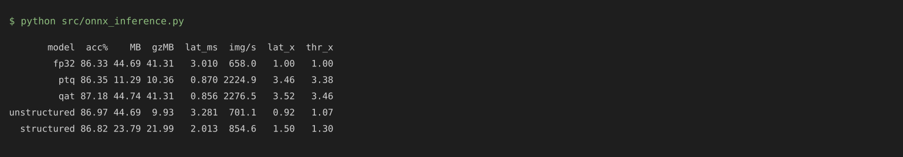
Screenshot 8 - ONNX benchmark output
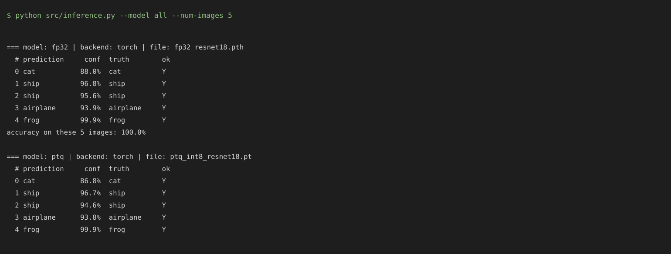
Screenshot 9 - Inference pipeline demo (all five models)

6. Summary and limitations
Model | Acc (%) | Size | Main benefit
FP32 baseline | 86.33 | 44.8 MB | reference
PTQ-INT8 | 86.30 | 11.4 MB | 3.9x smaller, 5.5x faster b=1, no retraining
QAT-INT8 | 87.30 | 11.4 MB | 3.9x smaller, 4.9x faster b=1, trained for INT8
Unstructured 85% | 86.97 | 8.2 MB compact | 4-5x smaller storage, no speed-up on dense kernels
Structured 50% | 86.82 | 23.9 MB | 1.9x smaller, 1.5x faster b=1, 53% of MACs

- The baseline is intentionally short-trained (8 epochs, stride-2 stem) because of CPU-only training; accuracies are therefore below the ~94-95% of a fully trained CIFAR ResNet-18. The relative comparisons are what this report supports.
- Accuracy gains of QAT and the pruned models over FP32 are largely due to their extra fine-tuning epochs and should not be attributed to compression.
- Each configuration was run once with seed 42, so differences of a few tenths of a point (such as between the PTQ calibration sizes) are within run-to-run noise.
- Structured pruning removes only block-internal channels; residual-stream channels are kept. Pruning those would need dependency-group handling across blocks and is a natural extension.
- Eager-mode quantization in torch.ao is deprecated in newer PyTorch in favour of torchao, but remains functional in the tested version.

7. Reproduction
See README.md. In short: pip install -r requirements.txt then ./run_all.sh (about 2 hours on 2 CPU cores; QUICK=1 ./run_all.sh runs a few-minute smoke test).

