The Returning Days
  - The Ark Beyond the Stars
  - Book Two · Illustrated edition
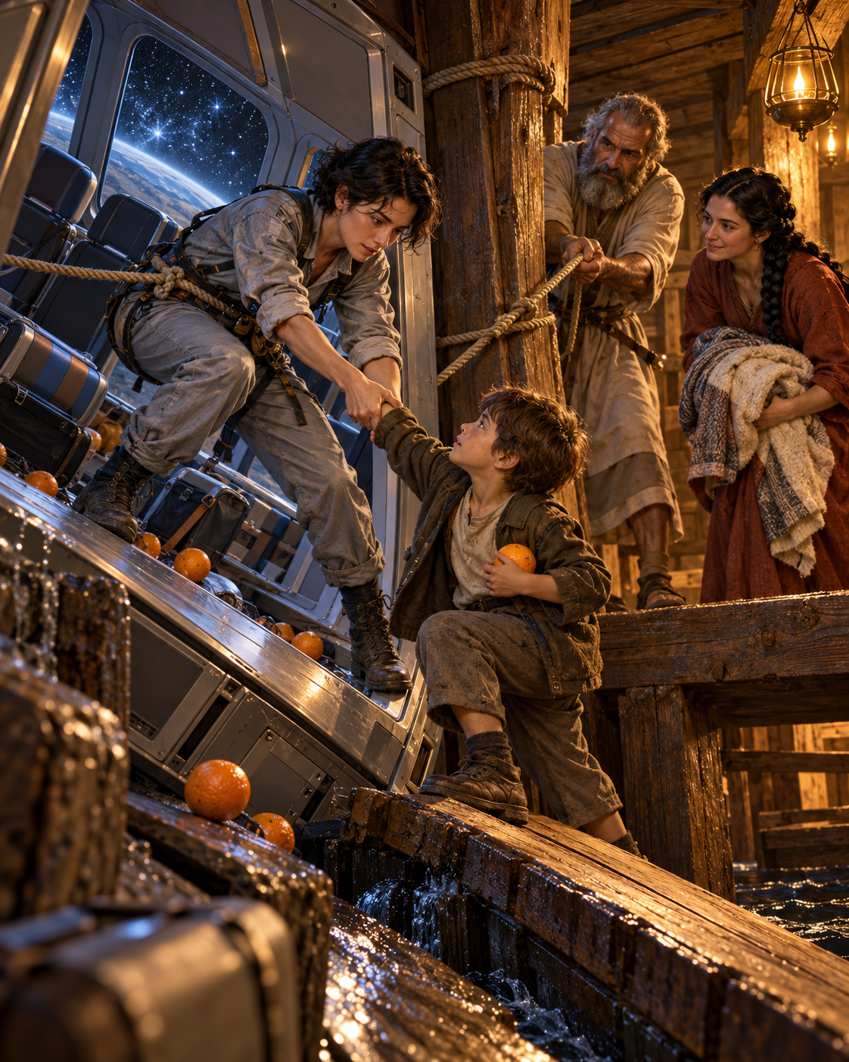
  - By BRIAN CHAPMAN SR MSP A+ CIW

Introduction
20 chapters
An original twenty-chapter fantasy sequel
This book continues The Ark Beyond the Stars, following Elian Voss, Tirzah and Japheth, their daughter Sela’s legacy, and the settlement of Haven. The gateways and technologies are fictional. The phrase “the Son of man” in Matthew 24 and Luke 17 refers to Jesus; a character’s alternative interpretation below is part of the story’s conflict, not a claim about scripture or real technology. The narrative begins in an imagined 2026 and reaches the generations beyond it.

Contents
1 The Scar in the Wood
2 A Garden Without a Door
3 The Man Who Called It Return
4 The Door That Opened Empty
5 A Minute They Had Not Lived
6 The Passenger From Tomorrow
7 The Corridor of Borrowed Hours
8 Sela’s Missing Page
9 The Company at the End of the Road
10 Hands Across the Years
11 The Animal That Would Not Rise
12 What the Verse Could Not Carry
13 The Repair Before the Photograph
14 A Future With No Guarantee
15 The Missing Husband
16 The Last Departure Order
17 What Had to Stay Closed
18 The Door Within the Door
19 The Days That Followed
20 The Garden Beyond the Last Journey
  - Chapter 1

The Scar in the Wood
On the evening of November 25, 2026, six weeks after she first opened the hatch aboard Meridian, Elian Voss found her own handwriting in a photograph of a ship that had been built before she was born.
The garden where Sela would find her mother’s pencil still lay in Tirzah’s future. So did the ships that would carry Haven’s bell toward other suns. Elian had returned to Earth; aboard the ark, the waters had not yet finished their work.
The picture lay inside the evidence archive from Meridian. Someone had taken it during an early inspection of the ark: a timber brace, a smear of pitch, and three small marks scratched beneath a fastening.
E V. Beside them, a crooked star.
She knew the star. She drew it on repairs she wanted to inspect again, one point shorter than the others, a private habit older than her professional training.
She had never marked the ark.
Outside her apartment, traffic hissed on wet streets. Her dinner cooled beside a stack of interview transcripts. After Meridian, she had learned to mistrust discoveries that arrived wrapped in excitement.
She enlarged the photograph until individual fibers filled the screen.
The repair was not the patch Japheth and his brothers had fitted during Vale’s forced transfer. It lay farther uphill. A different wound. A different visit.
The original file’s date preceded her rescue by seventeen years.
Elian called Ada’s temporary number.
Her granddaughter answered from the borrowed room where an engineer who had traveled from 2091 was waiting to discover how to live in 2026.
Ada had come through Meridian with Elian when the ancient route closed. She had never intended to settle in her grandmother’s year. With her own route disconnected, however, there had been no honest promise of a journey home. She had spent the intervening weeks helping preserve the evidence and looking for a way back that would endanger no one.
“I think,” Elian said, “we have misunderstood what closing meant.”
Ada listened to the rain through the call.
“Tell me you haven’t built anything.”
“I’ve opened a photograph.”
“Sometimes that is how it starts.”
  - Chapter 2

A Garden Without a Door
In Haven, the first independent harvest came in lighter than predicted.
Tomas stood beside the weighing station while the figures settled. Enough grain for survival. Too little for confidence. The council would continue rationing through another growing cycle.
Anet watched her mother divide roots into storage baskets. She no longer had a light behind her ear. The little scar remained, and sometimes she covered it when unfamiliar adults entered the greenhouse.
The tree above them had grown from the Founding Garden’s descendants. Nearby, Tirzah’s last gift was still a fragile seedling.
“Why keep the little one?” Anet asked. “The big tree already works.”
“Because a living thing doesn’t have to be the best one to have a place,” her mother said.
That evening the replica bell sounded without anyone touching it.
Tomas climbed a stool and checked its bracket. No wind moved inside the dome. Beyond the glass, a red sun sank behind the ridge.
In the old supply room, a sealed collar began sweating water.
He knew its casing. He had watched it go dark. He had signed the report confirming that the network was disconnected.
A drop fell onto the floor.
It smelled of pitch.
Tomas called the council chair before reaching for a tool. He had learned at least that much.
  - Chapter 3

The Man Who Called It Return
Dr. Corin Hale met Elian in an ordinary conference room above an ordinary parking garage.
He had requested her testimony for a review of Meridian’s remaining equipment. On the table, he placed a sensor the size of a dinner plate.
“No transport field,” he said. “No extraction. We compare residual signals. That is all.”
Elian left it untouched.
Hale had recovered route records with machine-learning systems that found recurring structures the founders had overlooked. His quantum sensors were experimental instruments with severe limitations. Neither device could open a passage by itself. But together with the confiscated collars, he believed they could locate something still active.
“There is a destination beneath every destination,” he said.
“There were people beneath every shipment too.”
He accepted the rebuke without becoming less excited.
Then he showed her his working title: THE RETURN OF MAN.
He had underlined a passage about the days of Noah.
“What if return means our species learning to enter its own history?”
“The passage calls Jesus the Son of man,” Elian said.
“I know the traditional reading.”
“You’ve chosen the reading that names your project important.”
Hale folded the paper.
For a moment he looked wounded rather than ambitious.
“Come see the signal,” he said. “Then tell me what I am allowed to call it.”
  - Chapter 4

The Door That Opened Empty
Elian agreed to inspect the sensor under conditions she wrote herself.
No living subjects. No automatic transfer. Every operator present. Independent shutdown hardware. Public preservation of the records.
Ada came carrying a cloth tool bag and an expression Hale immediately disliked.
The inspection chamber held a recovered Meridian collar. It had been disconnected from the freight system and mounted in a concrete frame. Behind it stood a plain wall.
Hale energized only the instruments.
For eleven minutes, nothing happened.
Then the wall became a wooden door.
Elian struck the mechanical disconnect. Every indicator died.
The door remained.
Water ticked somewhere behind it. A lamp flame showed through a split in the grain.
“Your sensor didn’t make that,” Ada whispered.
Someone on the other side lifted a latch.
Tirzah appeared with her hair bound back and a strip of cloth tied around one wrist. She looked tired enough to make Elian forget her fear.
“You left,” Tirzah said.
“Yes.”
“Then why is your machine speaking again?”
Behind her lay the module Elian and Ada had disconnected and left to avoid carrying live equipment through the failing field. Its empty socket glowed.
Its display was counting upward.
  - Chapter 5

A Minute They Had Not Lived
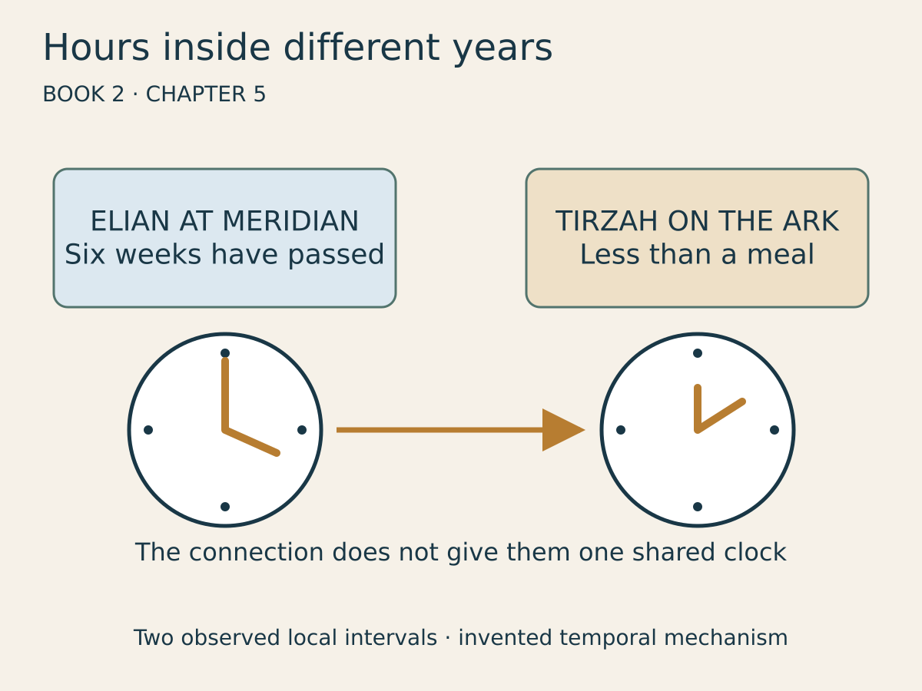
Visual 2 — Six weeks have passed for Elian; aboard the ark, less than a meal has passed.
They entered with lamps and hand tools. Hale followed despite Elian’s order to remain at the threshold.
Japheth was examining the module. The repaired lower passage was dry. His brothers had returned to their work, and the household was trying to recover its ordinary rhythm after the strangers’ departure.
“How long?” Elian asked.
“Since you went? Less than a meal,” Tirzah answered.
For Elian, six weeks had passed. She had given evidence, returned to her apartment, and begun expecting an ordinary morning again. Tirzah had scarcely had time to put away the bowls.
Ada checked the module’s clock against her watch. The nineteen ark-hours they had once counted had been a measure of the accessible interval, not a countdown that destroying one connection could erase. The first rescue had consumed much of it. Their shutdown had cut Meridian’s access before the rest was spent. Between the two visits, the ark had continued forward slowly against the clocks on Earth.
“We have not gone back to an earlier moment,” Ada told Elian. “Look at the patch. They have finished it. This is later for them too.”
Another branch was now drawing on the same surviving interval. Its field reached the collars from the far side, waking the disconnected module as a receiver. Hale’s instruments had located that activity; they had not supplied the power. Closing their laboratory breaker could silence his equipment without stopping a network operated in another century.
Ada wrote three headings on a sheet: ARK, EARTH, HAVEN. Then she added a fourth for the unknown branch. She would measure each rate before promising a deadline. Nothing in the readings allowed them to recover a moment already passed.
Hale smiled before he understood the room.
“A shared temporal reservoir.”
Japheth looked up.
“Is that your name for our home?”
The smile vanished.
Noah arrived carrying the measuring cord he had used at their first meeting. He listened while Ada explained the difference between a disconnected door and an inaccessible destination.
Tirzah went to stand beside him. “Father,” she said, then caught Hale’s questioning glance. “My husband’s father. Mine by marriage.” Noah gave her the lamp while he examined the newly lit socket. Elian remembered the first words Tirzah had used about the ship and understood the household name at last.
“Then finish the work,” he said.
He did not raise his voice. That made Hale’s elaborate explanation of research opportunities sound especially small.
Outside the hull, the waters moved with their own weight and purpose.
They had no interest in the names people gave the rooms within.
  - Chapter 6

The Passenger From Tomorrow
The next doorway opened before they had decided how to close the first.
A woman stumbled through carrying a child wrapped in a coat with unfamiliar fastenings. Her face was gray with exhaustion.
“Haven?” she asked.
Tirzah took the child’s weight only after the woman nodded.
“You have reached a ship,” she said. “Sit down.”
The woman’s name was Mara Den. She came from 2246, from a station called Orison built beyond Haven’s system. Her people had never depended on ancient harvests. Their ships traveled through ordinary space, slowly enough that farewells mattered.
Then a navigation service offered faster routes.
It called them heritage corridors. Safe, tested, environmentally responsible. Passengers boarded without knowing their journey crossed a wooden vessel in Earth’s distant past.
Mara’s transit compartment had lost its floor. She had seen water beneath the baggage racks and heard animals beyond a wall.
“There were others,” she said. “My husband. A school party.”
Elian knelt beside her.
“How many?”
“I don’t know.”
From the doorway came a child’s voice calling a name.
Tirzah handed Mara water, then turned toward it.
  - Chapter 7

The Corridor of Borrowed Hours
Beyond the door, the passenger compartment stood crooked in a darkness that behaved like water without flowing.
Elian tied a rope around her waist. Japheth tested the knot himself.
The compartment held sixteen people. Its far window looked onto stars; its near window showed the ark’s timber from the wrong side. Between them, spilled oranges rolled uphill.
A boy sat beside an unconscious teacher, pressing a folded jacket against her head. He had been told to keep pressure there. He had kept doing it even after the adults began arguing.
Elian spoke his name when he gave it. Davin. He released the jacket only when Ada took his place.
One passenger refused to leave his case.
“Our permits are inside.”
Mara, back at the threshold, looked at him.
“I have no permit. They still gave my child water.”
He left the case.
Japheth and Elian moved the teacher onto a sling. Two passengers helped carry her. The boy followed holding one orange, as though he needed proof that the interrupted journey had been real.
When the last person reached the ark, the compartment folded away with a sound like a breath drawn through clenched teeth.
The rope came back wet.
  - Chapter 8

Sela’s Missing Page
Hale searched the family archive while the rescued passengers rested.
He found a page omitted from Meridian’s official transcription. Its original catalog described it as a later interpolation because it mentioned impossible visitors.
Ada read it aloud to Elian, stopping before Tirzah could hear details of her daughter’s future.
Mother said the strangers returned after leaving. The second time they brought people who had mistaken the road for the destination. Father said a road can be honestly built and dishonestly sold.
Below that, Sela had copied a drawing of a brace.
Three marks. A crooked star.
Elian closed her eyes.
The archive had contained the second journey all along. The photograph and the page had waited through generations of readers who explained away what they did not understand.
“Does that mean we cannot fail?” Hale asked.
Ada looked at the teacher resting nearby.
“It means someone wrote about a repair. It doesn’t tell us who was hurt before it held.”
Elian put the page down.
She would not use a future memory as permission to be careless in the present.
  - Chapter 9

The Company at the End of the Road
Orison’s transit administrator appeared on Hale’s display as a pleasant face inside a clean office.
Her name was Director Senn. She thanked them for recovering the passengers and requested that they restore route service immediately.
Elian described the ark.
Senn said the historic substrate was protected by compensating fields.
Ada showed her the wet rope.
“Your fields have passengers crawling out of a broken floor.”
Senn’s pleasantness tightened.
The network linked eleven settlements. Freighters were already traveling. Hospitals expected supplies. Families expected arrivals. An abrupt shutdown would kill people.
Elian believed that part. She had learned how destructive it could be to discover exploitation without planning for those made dependent upon it.
“Send the traffic list,” she said. “Stop new departures. We will help the people already inside.”
“The list is commercially sensitive.”
Mara moved into the camera’s view.
“My husband is commercially sensitive?”
Senn looked away, briefly.
Then the traffic list arrived.
There were far more journeys than her assurances had suggested.
  - Chapter 10

Hands Across the Years
Tomas answered the new connection from Haven’s old supply room.
He saw Tirzah and sat down hard on a crate.
Behind him, Anet’s mother continued working. Surprise no longer stopped every necessary task.
Elian explained the stranded passengers. Haven could receive some, but not everyone. The settlement was still rationing food.
“We will say what we have,” the council chair told her. “We won’t promise what we wish we had.”
Ada divided the traffic map into groups: compartments near stable doors, those needing tow fields, those still reachable from their departure stations. Each destination received its own clock and instructions. Her measured limit was just under four hours aboard the ark. The corresponding deadlines differed elsewhere, and each crossing shortened the estimate. She put the ark clock where everyone moving through the passage could see it.
Receiving crews prepared exits while Elian reached the stranded compartments. Haven could have days between requests that reached the ark minutes apart.
Tirzah organized the ark passage as she would a household under strain. Water here. Blankets there. A place for the injured away from the frightened animals. Nobody carrying equipment past a lamp without warning.
Noah required travelers to cross directly toward receiving settlements. The eight members of his household would continue tending their vessel.
Hale asked to record the remarkable meeting of centuries.
Tirzah put a bucket into his hands.
“First make it less remarkable that they are thirsty.”
He carried it without answering.
  - Chapter 11

The Animal That Would Not Rise
The freight compartment arrived with six handlers and an animal whose front legs would not obey it.
The creature resembled the trembling survivor Renn had once helped rescue. Its collar carried a remote-control receiver. A handler held a tablet and kept increasing the command strength.
Japheth stepped between him and the animal.
“Stop.”
“It must clear the doorway.”
“Then help it.”
The handler called the animal dangerous. The animal was lying on its side, trying to breathe beneath a harness too tight around its chest.
Renn arrived from 2026 when Elian called him. He recognized the old research system’s descendants in the receiver’s design.
Nobody needed to combine species to inherit cruelty. Sometimes they merely improved the equipment.
Renn asked the handler for the release code. When the man refused, Mara took the tablet from him and placed it on the floor.
“You can argue after it breathes.”
Together they loosened the harness and laid boards beneath the animal. The handler finally knelt to help lift.
In Haven, Anet waited beside an empty enclosure with a bucket of water.
  - Chapter 12

What the Verse Could Not Carry
Hale found Noah alone near a stack of feed baskets.
He had brought the printed passage and a translation device. He wanted an ancient witness to confirm the greatness of his discovery.
Noah listened to the explanation, then asked what Hale had done when the first passengers arrived.
“I documented the event.”
“And after that?”
“I brought water.”
Noah nodded toward the empty bucket.
“That was useful.”
Hale tried again. He spoke of humanity returning, of a species crossing its own beginning, of predictions becoming engineering.
Tirzah entered before Noah answered.
“You keep asking whether these words describe your machine,” she said. “Have you asked what they require of you?”
Hale looked down at the page.
Elian later found him sitting beside the injured teacher. He was reading the surrounding verses instead of his underlined sentence. Ordinary life continuing. People unaware. An arrival they did not control.
“I wanted the text to name us,” he admitted.
“You can still let it question you,” Elian said.
He folded the page and put it away.
  - Chapter 13

The Repair Before the Photograph
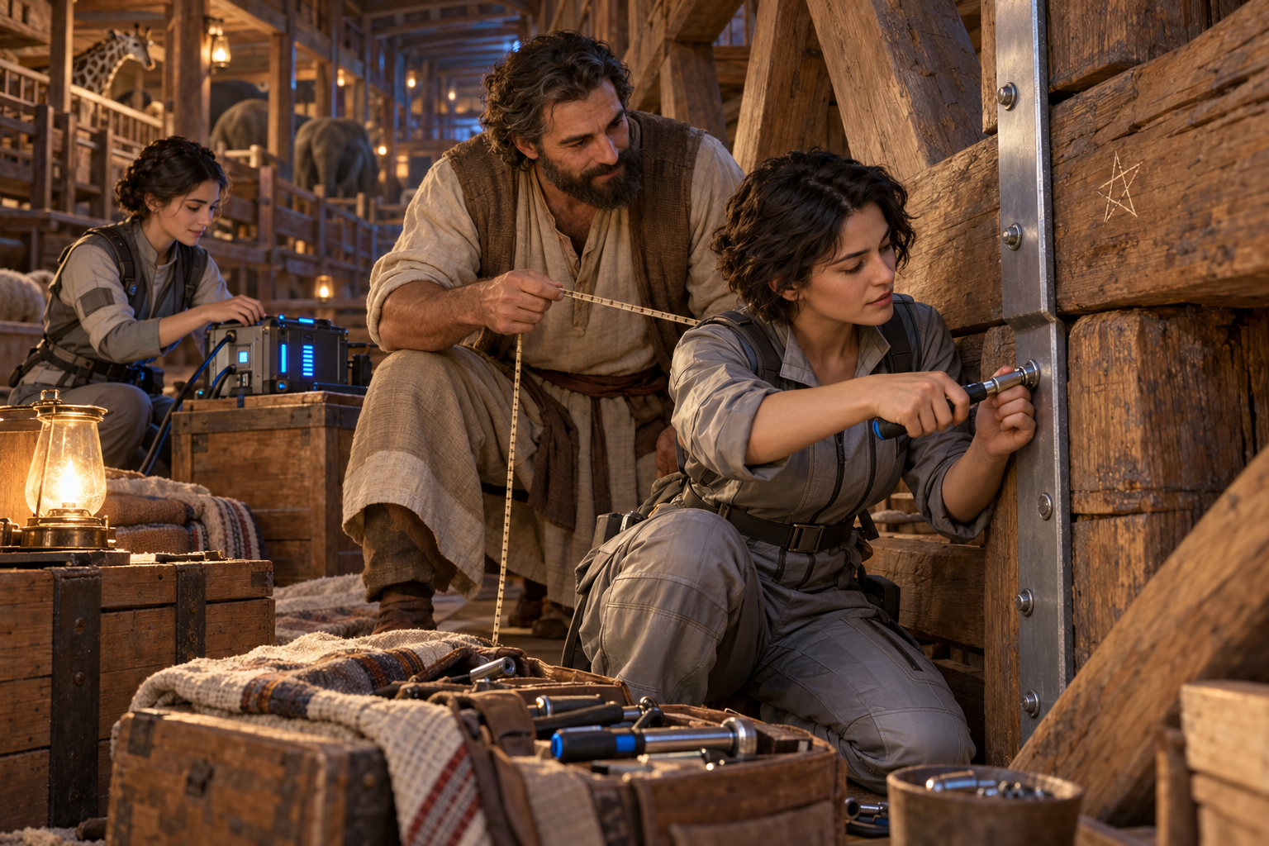
The repair before the photograph
The upper brace split while they were moving the seventh compartment’s passengers.
A field pulse struck the wall. A fastening shifted. Japheth caught the falling lamp before its oil could spill across the bedding.
Elian saw the place from the photograph.
There was no crooked star yet.
For one bewildering second, she felt she was standing inside a sentence somebody had finished writing.
Then a child cried out behind her, and the feeling became irrelevant.
Shem brought seasoned wood. Japheth measured. Ada set the collar to its lowest holding field. Elian fitted a modern reinforcing strip into the ancient brace, drilling only where Japheth marked.
Her hand shook. She stopped, steadied it against the timber, and resumed.
When the repair held, she scratched her initials beneath the strip. Beside them, she drew the star so she could find the place during a final inspection.
She had not marked it to fulfill the photograph.
She had marked it because she was tired and responsible for a repair.
History, she realized, was full of actions that felt ordinary to the people doing them.
  - Chapter 14

A Future With No Guarantee
Ada’s communicator received a message from 2091.
It was Ada’s mother—Elian’s daughter, grown older in a life Elian had not yet lived. Until that moment, Elian had known this future child only through Ada’s family records. Hearing her voice was a different kind of knowledge, intimate enough to make her turn away.
Elian withdrew before the private words began. The future was becoming crowded enough without treating a family’s conversation as evidence.
Later Ada found her beside the repaired brace.
“They can receive me,” she said.
The route home would remain stable for twenty-three minutes in Ada’s clock. After that, no instrument could promise its return.
Elian wanted to ask her to stay. She wanted years of answers. She wanted proof of the children and birthdays waiting somewhere beyond her present uncertainty.
Ada saw the desire and did not make her ashamed of it.
“You don’t have to earn every good thing by losing it first.”
“Then stay.”
“My mother is waiting.”
Elian laughed once, painfully.
They embraced beside the beam. Ada left her tool bag, taking only what she needed for the crossing.
At the threshold she turned.
“Don’t mistake knowing I existed for knowing how you should live.”
Then her own year received her.
  - Chapter 15

The Missing Husband
Mara’s husband was in a service compartment nobody had included on the first traffic list.
It carried maintenance workers dispatched to hold failing intersections open while paying passengers passed through.
Senn called it necessary stabilization.
Elian asked how the workers were expected to leave.
There was a long silence.
Hale built a temporary tow field from the recovered collar components. He explained its limits twice and refused to call it safe merely because they needed it.
Japheth anchored their rope to the repaired brace.
Elian and Renn crossed into the service compartment. Four workers were alive. A fifth had died before they arrived. Mara’s husband, Iven, had given his oxygen reserve to a younger technician and was barely conscious.
They brought the living back first, then returned for the dead.
Mara met Iven without a speech. She knelt beside him and touched the place on his wrist where a familiar scar crossed the skin.
Their child slept through the reunion against Tirzah’s shoulder.
Later, when someone asked whether the rescue had succeeded, Elian gave the full count.
She would not let relief erase the fifth worker.
  - Chapter 16

The Last Departure Order
Senn’s board authorized another launch.
The freighter held fuel, valuable equipment, and thirty-two passengers whose fares had already been collected. Canceling it would expose how long the company had concealed its failing routes.
Senn called Elian privately.
“If I release the full records, the company collapses.”
“If you launch, the passage may collapse.”
“People lose livelihoods either way.”
Elian thought of Haven’s ration books and Meridian’s confiscated cultures. There was no clean decision that spared everyone the consequences of years of bad ones.
“Tell them the truth before they board.”
Senn ended the call.
For several minutes the traffic map showed the launch preparing.
Then its status changed: DELAYED.
A new broadcast reached every connected settlement. Senn’s voice was unsteady. She gave the actual route condition, the missing safety reports, and the names of the maintenance workers.
The board removed her access before she finished.
But the passengers had heard enough to leave the departure gate.
Across eleven settlements, people began making decisions with information someone had finally stopped withholding.
  - Chapter 17

What Had to Stay Closed
Only two occupied compartments remained. The ark clock showed less than half an hour, and Ada’s departure had left Elian checking the figures herself. Haven’s receiving crews were ready; the passengers would have to come through in immediate succession.
Hale could keep the route open long enough to retrieve them, or preserve the instruments that made reopening possible. The same components could not do both.
He stared at the machine he had spent years imagining.
Elian did not hurry his grief. She knew what it meant to surrender work that had once seemed to justify a life.
Then Tirzah arrived with the schoolboy Davin.
He was returning the orange he had carried out of the broken compartment.
“I didn’t know if it belonged to somebody,” he said.
Hale took it, then placed it beside the instrument controls.
He dismantled the sensor array himself.
Its expensive elements became sacrificial stabilizers. The first compartment arrived scorched along one wall. The second came with every passenger holding hands because someone had told them not to separate.
When the last traveler crossed into Haven’s receiving room, Hale burned out the remaining interface.
The map went blank.
No archive vanished. No suffering was undone. What ended was their ability to make another person’s world into an unseen shortcut.
  - Chapter 18

The Door Within the Door
Elian’s route to 2026 weakened as the other collars died.
She could cross immediately. Hale was already through. Renn stood beside him with the records.
Behind her, Tirzah held the lamp.
“Will your daughter write this too?” Elian asked.
“If I tell her. If she chooses.”
For the first time, Elian understood the family account as something more fragile than an anchor in time. It depended on a woman speaking, a daughter listening, and strangers centuries later deciding the words were worth preserving.
She gave Tirzah no new prophecy about the garden. No list of future births. She checked the brace one final time.
Japheth pressed Ada’s smallest hand tool into her palm.
“This belongs to your household.”
“She left it with us.”
“Then keep it for her return, if there is one.”
Elian crossed.
Through the narrowing light, she saw Tirzah lift the wooden latch. The ordinary door inside the impossible one closed first.
The last thing Elian heard was Japheth asking where they had put the feed basket.
Then concrete stood before her again.
  - Chapter 19

The Days That Followed
December arrived in 2026 without announcing itself as the beginning of a legend.
Elian bought groceries. Renn gave evidence. Hale withdrew his paper claiming that a biblical phrase named humanity’s technological return.
His replacement report described measurements, limits, failures, and people harmed by conclusions made too quickly.
He kept the folded passage in his notebook. He no longer wrote his project’s name above it.
At Haven, the refugees dispersed slowly among settlements able to receive them. Mara and Iven chose to remain for a season. Their child learned the greenhouse paths before understanding how she had reached them.
Senn testified before Orison’s public inquiry. Her decision to stop the launch did not exempt her from explaining the earlier ones.
Tomas added the dead worker’s name to the garden record beside the rescued passengers. Anet watered the little tree.
Far behind them, after the waters, Sela listened while Tirzah described a second visit from the woman in moonlight-colored clothes.
“Did she know everything?” Sela asked.
Tirzah shook her head.
“She knew some things that would happen. She still had to decide what to do.”
Sela considered that for a long time before she began writing.
  - Chapter 20

The Garden Beyond the Last Journey
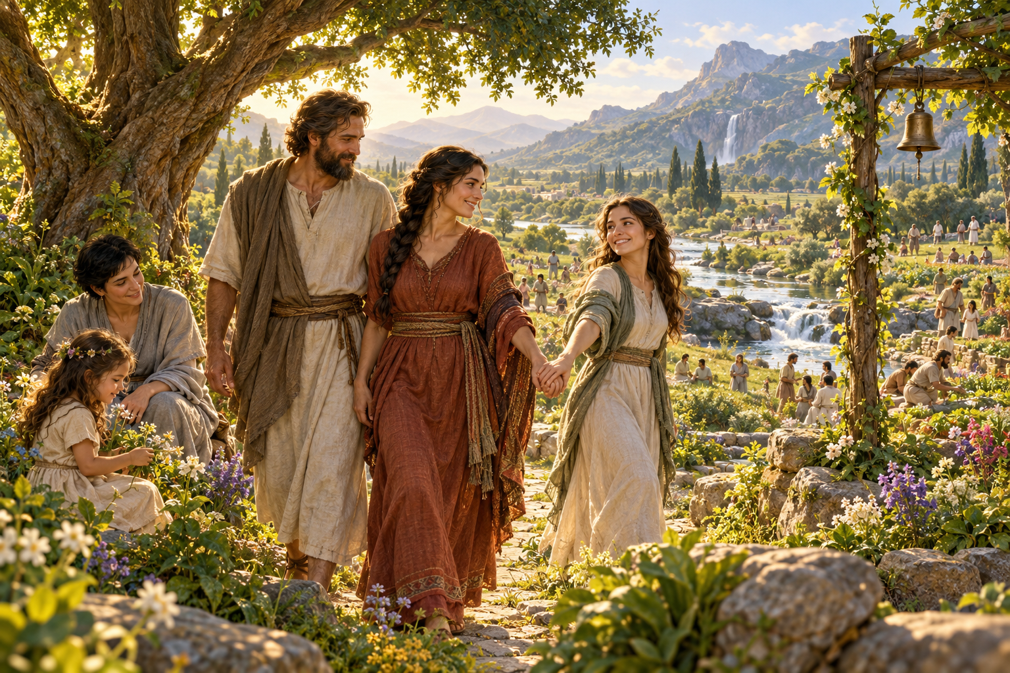
The garden beyond the last journey
Generations passed before Haven’s ships reached the next inhabited system without using a doorway.
The journey took years. Children grew aboard. Friends died. Crews repaired pumps, celebrated small harvests, and learned how much patience a promise could require.
They carried Sela’s account in several languages. They carried seeds with records of soil, disease, and failed plantings. Above the common growing room hung a brass bell cast from an old pattern.
The commander read Tirzah’s story aloud when the ship approached its destination. She did not call the voyage a fulfillment of prophecy. She asked what kind of neighbors they intended to become.
Much later still, when the book’s imagined history reached the return it had long anticipated, no navigation office issued a boarding pass for it.
No machine called Christ across a threshold. No corporation owned the arrival. The people who had traveled farthest stood beside those who had never left home, and distance gave neither group a greater claim to mercy.
The final vision opened onto renewed creation.
Tirzah walked without the weariness she had carried through the ark. Japheth came beside her. Sela was ahead, turning at the sound of the familiar bell.
Elian saw Anet beneath a tree, her hands empty of identification bands. Nearby stood the worker they had brought back too late from the service compartment.
For a moment Elian reached for words that might explain what she was seeing. Then she let them go.
The garden had room for lives she had never met, for histories no archive had kept, for griefs whose names had been spoken only once.
Sela took her mother’s hand.
“Is this the garden you were trying to plant?”
Tirzah looked toward the river and the living branches beyond it.
“I was planting the little one,” she said.
They went farther together.
Behind them there was no hidden door to guard, no borrowed century to exhaust, and no child waiting to learn whether freedom would be withdrawn.
The bell sounded once more.
This time nobody hurried to leave.
The End

Biblical threads
Biblical frame
Matthew 24:37–39 and Luke 17:26–30 connect the days of Noah with the coming or revealing of the Son of man, emphasizing ordinary life and unpreparedness. Revelation 21–22 supplies the imagery of renewed creation, the end of death and sorrow, the river of life, and the tree of life. The final chapter is an original fictional imagining inspired by those passages, not an additional biblical account. The ancient family’s invented names and the entire technological storyline remain fictional.

