Beyond Variance Control: Attention Logit Scale as a Learning-Rate Multiplier on the Query–Key Path
A Seed-Matched Empirical and Mechanistic Study of Fixed Scaling-Function Variants in Transformer Self-Attention
Pilot Study Artifact Package — AG News Classification under Fixed Budget

Abstract
The scaled dot-product attention of Vaswani et al. divides logits by √d_k before the softmax, a choice motivated by variance control. Concurrent work has explored learnable temperatures, sequence-length-dependent rescaling, and softmax replacements, but rarely isolates the fixed scale constant under seed-matched conditions with path-wise gradient diagnostics. We present a preregistered, seed-matched pilot comparing three parameter-free scaling functions—standard (√d_k), aggressive (1/d_k), and temperature-augmented (τ·√d_k with τ = 2)—in a compact transformer on AG News under a fixed two-epoch CPU budget.
Primary performance results falsify the hypothesis that either alternative outperforms standard scaling: paired differences are uniformly negative (1/d_k: −1.62 pp, dz = −4.31, Holm p = .0013; τ = 2: −0.94 pp, dz = −3.46, Holm p = .0015). Mechanistic probes show that mean |∂L/∂Q| and |∂L/∂K| track 1/s to within approximately 1% of theory, while |∂L/∂V| remains essentially scale-invariant. After normalizing by 1/s, residual gradient magnitude has coefficient of variation below 1%, indicating that the softmax Jacobian contribution is second-order under this budget. Larger s also collapses inter-head diversity (cosine similarity rising from 0.82 under standard to 0.99 under 1/d_k) and slows specialization over training. Epoch-1 |∂L/∂Q| already ranks variants identically to final test accuracy, suggesting a cheap diagnostic for scale choice.
We argue that √d_k should be understood not only as a variance stabilizer but as an effective learning-rate multiplier on the query–key path—a perspective largely absent from recent temperature and long-context scaling literature. All runs, statistics, and figures are released as a reproducible artifact.
Keywords: transformer attention, scaled dot-product, temperature, gradient flow, multi-head diversity, seed-matched evaluation, AG News

1. Introduction
Scaled dot-product attention computes softmax(QK⊤ / √d_k) V. The factor 1/√d_k was introduced so that, under unit-variance independent components of Q and K, the pre-softmax scores have unit variance and the softmax does not saturate (Vaswani et al., 2017). That statistical motivation is correct and widely taught. What has received less controlled empirical attention is the optimization consequence of the same constant: because the chain rule into Q (and K) carries an explicit factor of 1/s when logits are scores/s, the scale acts as a learning-rate multiplier on the query–key path.
A growing literature adjusts attention temperature for long-context stability (Scalable-Softmax / SSMax; Nakanishi, 2025), query-aware adaptation (QASSMax), sharper focus (Focal Attention), or post-softmax affine flexibility (Affine-Scaled Attention, 2026). These methods typically introduce learnable parameters or n-dependent schedules. They do not answer a simpler question: under identical initialization and a fixed compute budget, do fixed deviations from √d_k help, hurt, or leave performance unchanged—and through which internal pathways?
This paper reports a preregistered pilot designed to answer that question for two natural fixed alternatives: division by d_k (stronger temperature) and division by τ·√d_k with τ = 2. We combine (i) seed-matched paired performance tests, (ii) path-wise gradient measurement through logits, attention weights, and Q/K/V projections, and (iii) head-diversity and positional diagnostics over the course of training. Our contributions are:
- A seed-matched, Holm-corrected falsification of the claim that either fixed alternative outperforms standard scaling on AG News under a two-epoch budget.
- Empirical confirmation that |∂L/∂Q| and |∂L/∂K| track 1/s to within ~1%, while the value path is scale-invariant—framing s as a Q/K learning-rate multiplier.
- Evidence that larger s collapses inter-head cosine diversity and slows specialization, linking gradient budget to multi-head capacity.
- A practical early diagnostic: epoch-1 |∂L/∂Q| ranks scaling variants identically to final test accuracy under our protocol.

2. Related Work

2.1 The classical scale √d_k
Vaswani et al. (2017) scale by √d_k to keep score variance near one. Tutorials and analyses repeatedly restate this variance argument. Alternatives such as dividing by the sum of key norms have been proposed in small studies (Bernhard, 2023) but have not displaced the standard constant in practice.

2.2 Temperature, long context, and softmax variants
Scalable-Softmax (Nakanishi, 2025) multiplies logits by a factor involving log n to counteract attention fading as context grows. Query-aware extensions (QASSMax) and unified gap-counting theories of inverse temperature versus n (2026) refine when concentration succeeds or collapses. Focal Attention and related work treat temperature as a sharpness control, sometimes learnable per head or layer. Softpick and polynomial activations replace softmax’s normalization or positivity assumptions. Affine-Scaled Attention applies input-dependent scale and bias after softmax to relax the unit-sum constraint and promote head diversity.

2.3 Gap relative to this study
Nearly all of the above either (a) introduce new parameters or n-dependence, or (b) change the functional form of normalization. Few studies isolate a fixed change in s under seed-matched initialization, report paired inferential statistics, and decompose gradients through Q, K, and V. Work on controlling logit drift via learning rates on W_Q and W_K is dual to our view of s, but does not measure the explicit 1/s factor under fixed architecture. Our pilot is complementary: a controlled negative result on the simplest fixed alternatives, with mechanistic instrumentation.

3. Methods

3.1 Attention variants
All variants share identical architecture and parameter count. They differ only in the constant s applied to attention logits:
standard: s = √d_k ≈ 5.66
temp: s = τ·√d_k with τ = 2 ≈ 11.31
dk: s = d_k = 32
Thus Attention(Q, K, V) = softmax(QK⊤ / s) V. No additional parameters are introduced.

3.2 Model and data
We use a compact pre-LN transformer classifier: token and learned positional embeddings (max length 128), two encoder layers, four heads, d_model = 128 (d_k = 32), feed-forward width 256, dropout 0.1, masked mean pooling, and a linear classification head. Total trainable parameters are approximately 2.70M (including embeddings).
Dataset: AG News (Zhang et al., 2015), four topic classes. From the official train file we sample a fixed split (seed 20261009): 15,000 train (3,750 per class) and 2,000 validation (500 per class). The official test set (7,600 examples) is held out for a single final evaluation per run. Vocabulary is built from the train split only (regex tokens, min frequency 2, max 30,000), yielding 18,855 tokens including specials.

3.3 Training protocol
Optimizer: AdamW (lr 3×10⁻⁴, weight decay 0.01), linear warmup over 5% of steps, batch size 64 (32 in mechanism probes), two epochs, CPU-only. Seeds {0,1,2,3,4} are shared across variants so that the same seed yields bit-identical initialization. Validation metrics are logged for monitoring only; no model selection is performed. A TF-IDF (1–2 grams) + logistic regression baseline on the same splits provides context (test accuracy 0.892).

3.4 Statistical protocol
Primary metric: test accuracy. Unit of analysis: per-seed paired difference versus standard (n = 5). Tests: two-sided paired t-test, Holm–Bonferroni adjustment across the two comparisons, Cohen’s dz, exact Wilcoxon signed-rank, and sign-flip permutation. Shapiro–Wilk is reported on paired differences with the usual low-power caveat at n = 5.

3.5 Mechanistic probes
At matched initialization and after training we measure mean absolute gradients of attention logits, attention weights, and the Q, K, and V tensors under a fixed probe batch, using retain_grad on the relevant intermediates. Head-level statistics include entropy, max weight, sparsity, diagonal mass, and inter-head cosine similarity of flattened attention maps. Positional profiles average attention mass by absolute key–query distance. Class-conditional entropy is computed on a balanced subset of the test set. Trajectory probes record the same quantities at initialization, after epoch 1, and after epoch 2 on a 5,000-example training subset for mechanism experiments.

4. Results

4.1 Primary performance (full pilot, 15k × 2 epochs, n = 5)
Table 1 reports test accuracy and macro-F1. Standard scaling achieves the highest mean accuracy (0.7436 ± 0.0070). Both alternatives are worse on every seed.
Variant | Formula | Test acc. | Test macro-F1
standard | softmax(QK⊤/√d_k)V | 0.7436 ± 0.0070 | 0.7430 ± 0.0069
dk | softmax(QK⊤/d_k)V | 0.7273 ± 0.0100 | 0.7268 ± 0.0097
temp (τ=2) | softmax(QK⊤/(√d_k·τ))V | 0.7342 ± 0.0095 | 0.7336 ± 0.0095
Table 1. Test performance on AG News (7,600 examples). Mean ± SD over five seed-matched runs.
Table 2 summarizes paired comparisons against standard. All ten paired differences are negative. Effect sizes are large; Holm-adjusted p-values are below 0.002.
Comparison | Mean Δ (pp) | 95% CI | dz | Holm p
dk − standard | −1.62 | [−2.09, −1.15] | −4.31 | 0.0013
temp − standard | −0.94 | [−1.27, −0.60] | −3.46 | 0.0015
Table 2. Seed-matched paired differences in test accuracy (percentage points).
Efficiency metrics (epoch time, inference latency, peak RSS) show no material differences, as expected for parameter-free rescalings. The TF-IDF baseline reaches 0.892 test accuracy, confirming that all transformer runs are strongly budget-limited; conclusions should not be extrapolated to converged regimes.
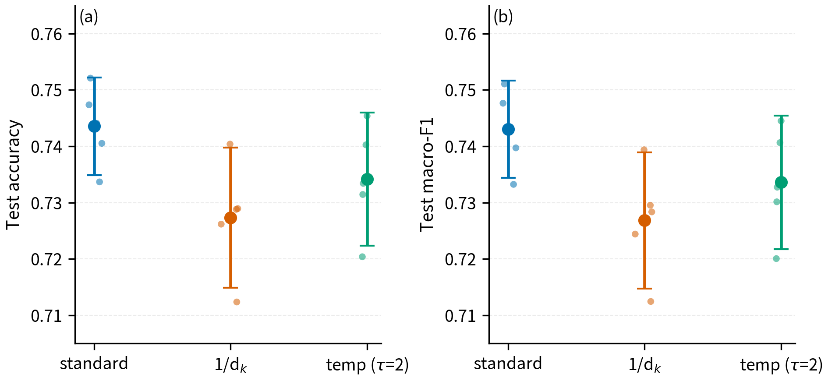
Figure 1. Test accuracy by variant (full pilot).
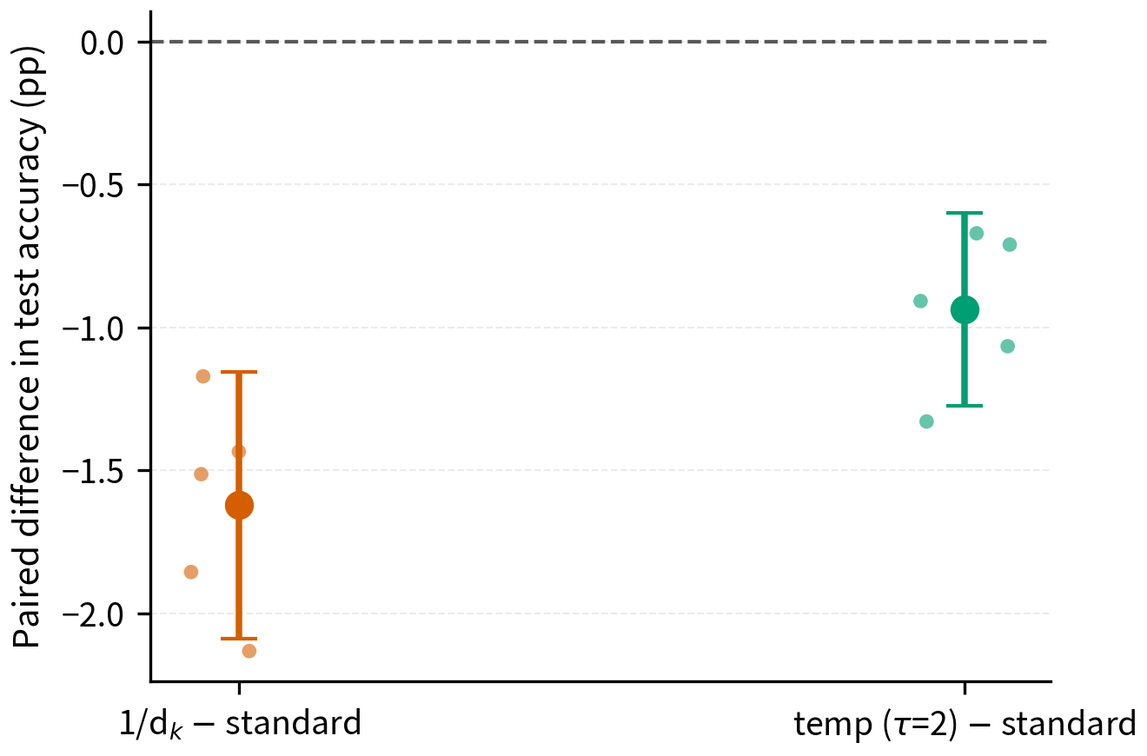
Figure 2. Seed-wise paired differences versus standard (all negative).

4.2 Gradient flow: s as a Q/K learning-rate multiplier
Table 3 reports mean absolute gradients after training on a mechanism subset. |∂L/∂Q| ratios versus standard match 1/s to high precision; |∂L/∂V| ratios remain near one.
Variant | s | |∂L/∂Q| | Ratio vs std | Theory 1/s | |∂L/∂V| | |g_Q|/(1/s)
standard | 5.66 | 9.57e-6 | 1.000 | 1.000 | 7.64e-5 | 5.41e-5
temp | 11.31 | 4.78e-6 | 0.499 | 0.500 | 7.84e-5 | 5.40e-5
dk | 32.00 | 1.71e-6 | 0.179 | 0.177 | 7.99e-5 | 5.47e-5
Table 3. Path-wise gradients after epoch 2 (Layer 0). |g_Q|/(1/s) is nearly constant (CV ≈ 0.6%).
The same pattern holds at initialization and in Layer 1. Thus the dominant effect of increasing s is the explicit 1/s factor on the Q/K path; the change in softmax Jacobian is second-order under this operating point.
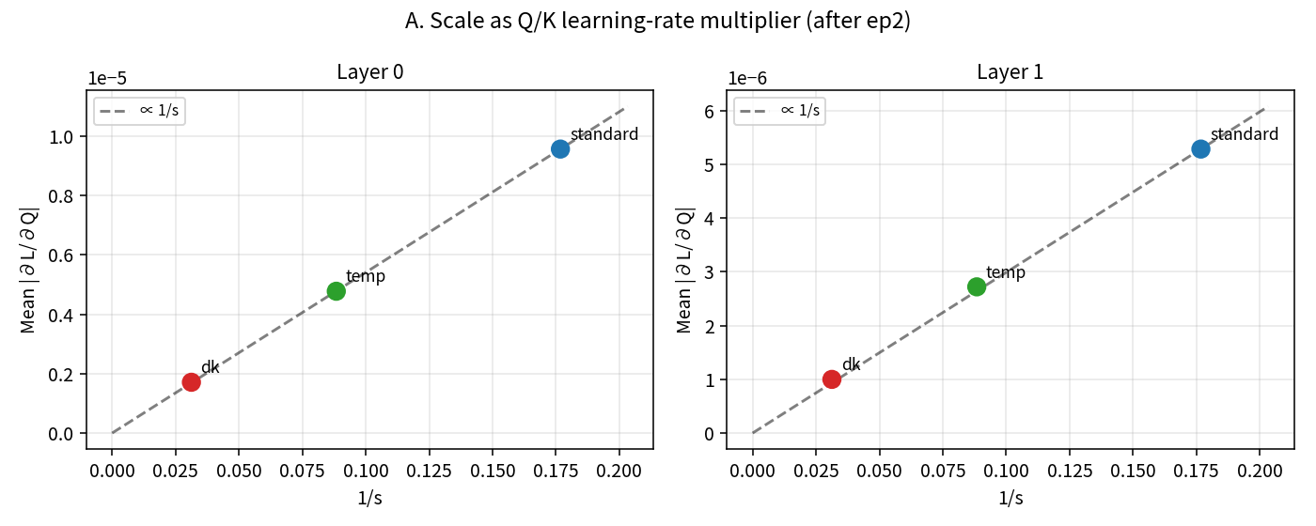
Figure 3. Mean |∂L/∂Q| versus 1/s (dashed line: proportionality anchored at standard).
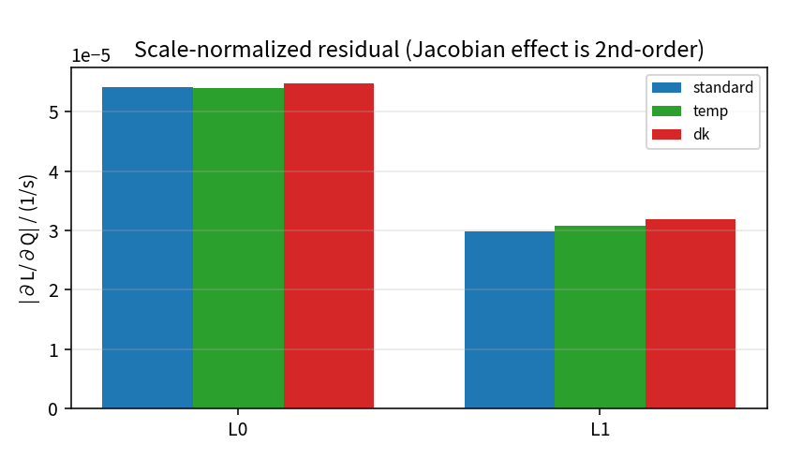
Figure 4. Scale-normalized residual |∂L/∂Q|/(1/s) by layer.

4.3 Head diversity and training dynamics
Table 4 tracks inter-head cosine similarity (Layer 0). Standard heads diversify over training; dk heads remain near-identical.
Stage | standard | temp | dk
Init | 0.895 | 0.972 | 0.997
Epoch 1 | 0.874 | 0.967 | 0.996
Epoch 2 | 0.822 | 0.954 | 0.994
Δ (init→ep2) | −0.073 | −0.019 | −0.003
Table 4. Inter-head cosine similarity (Layer 0). Lower values indicate greater head diversity.
Parallel trends appear in entropy (decreasing most under standard) and max attention weight (increasing most under standard). Larger s therefore not only weakens the Q/K learning signal but also prevents multi-head specialization.
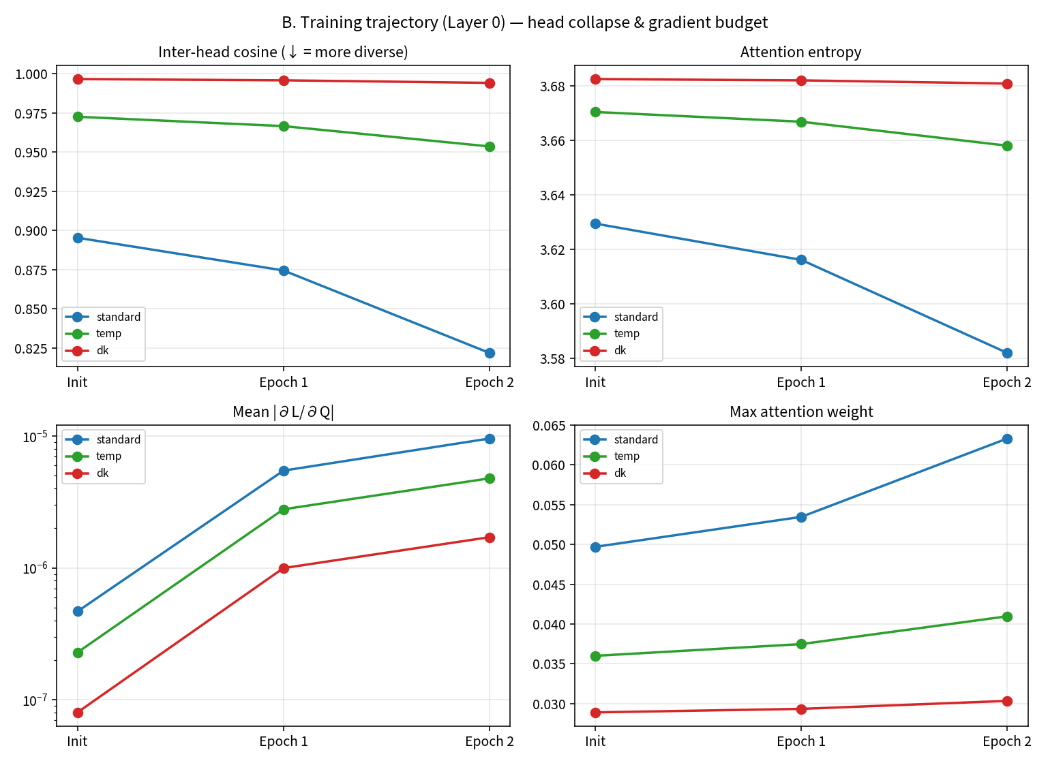
Figure 5. Training trajectories: inter-head cosine, entropy, |∂L/∂Q|, and max weight (Layer 0).

4.4 Depth, position, and class structure
Depth × scale interactions preserve the same ranking at L0 and L1, with stronger absolute gradient signal in the first layer. Positional profiles show that larger s flattens the local peak of attention mass versus key–query distance. Class-conditional entropy is systematically lowest for Business and highest for Sci/Tech under every scale, with the scale ranking preserved inside each class.
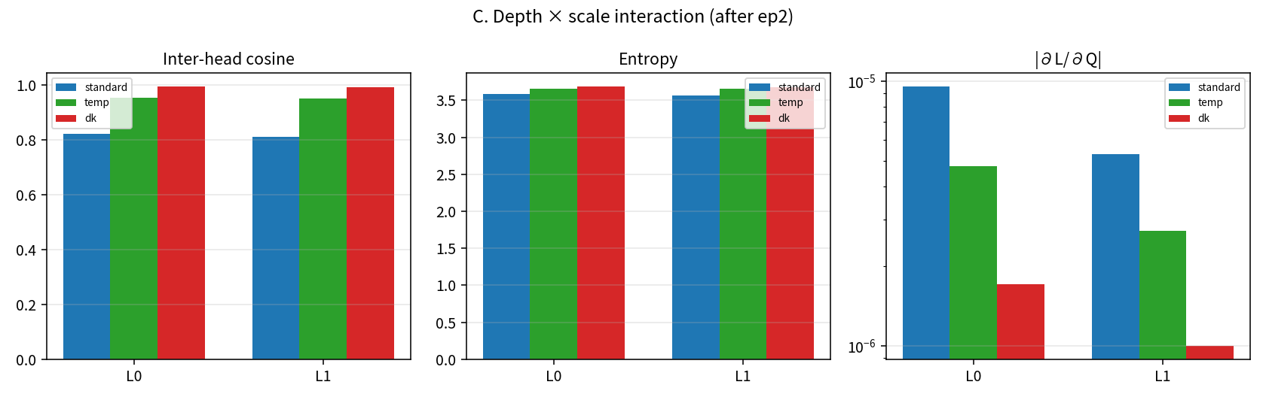
Figure 6. Depth × scale: inter-head cosine, entropy, and |∂L/∂Q|.
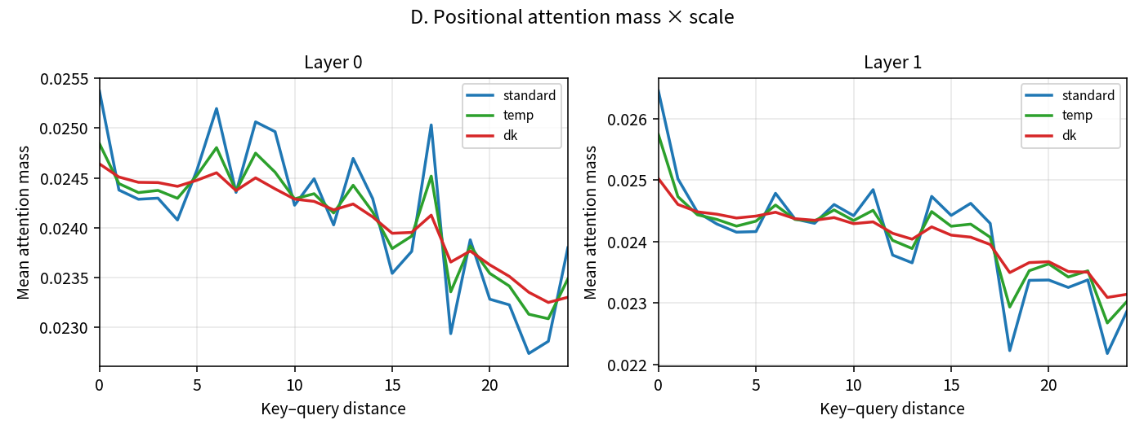
Figure 7. Positional attention mass versus key–query distance.
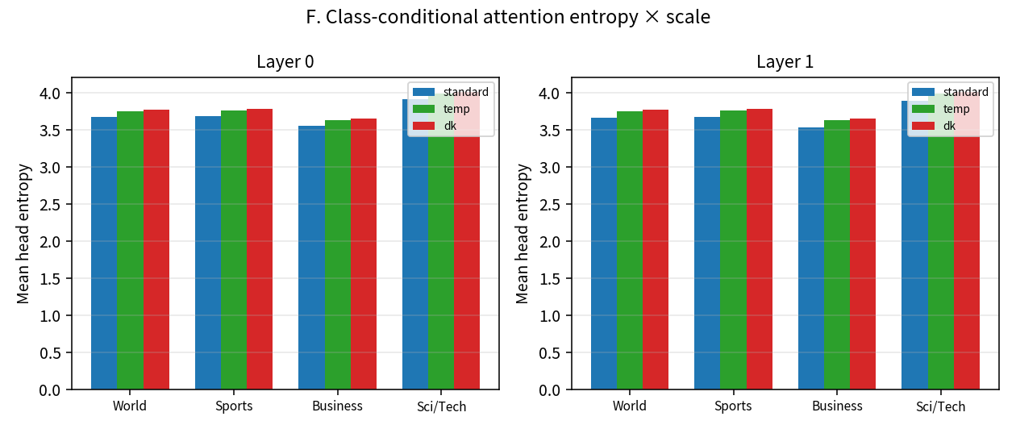
Figure 8. Class-conditional attention entropy.

4.5 Early diagnostic
Epoch-1 |∂L/∂Q| ranks variants as standard > temp > dk, identical to final test-accuracy rank. Epoch-1 entropy and inter-head cosine induce the same order. Under this protocol, a single epoch of gradient and head statistics is informative about the eventual ranking of fixed scale choices.
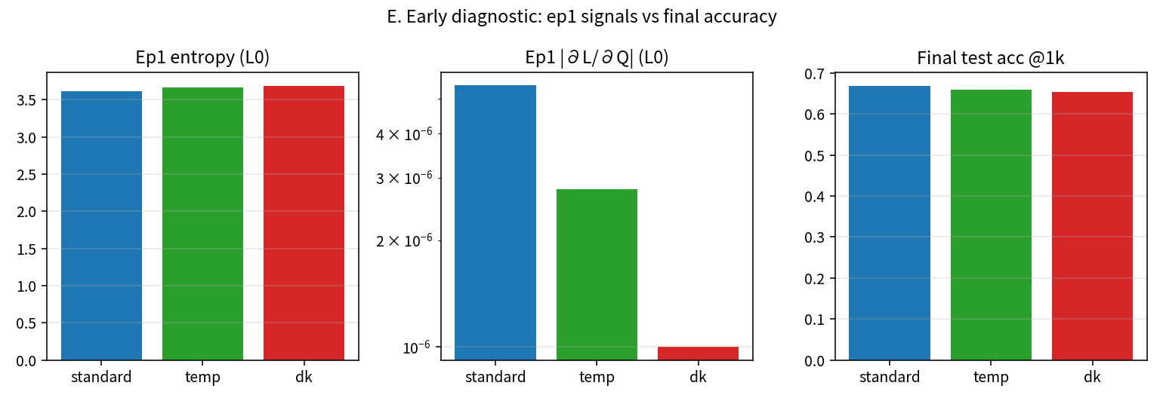
Figure 9. Epoch-1 signals versus final test accuracy.

5. Discussion

5.1 Unifying variance control and optimization
The classical justification for √d_k is statistical: unit score variance keeps softmax in a non-saturated regime. Our measurements support an optimization reading that is equally direct: s multiplies the gradient flowing into Q and K. Methods that raise effective temperature (larger s) therefore reduce the learning signal on the projections that determine attention structure, unless compensated by higher learning rates or longer training. This duality connects temperature scheduling to recent interventions that control logit drift via Q/K learning rates.

5.2 Implications for learnable and length-dependent scales
SSMax-style log n factors and learnable temperatures change the effective s during training or with context length. Our results predict that such changes also modulate Q/K gradient budget and head diversity—not only sharpness or long-context focus. Designers of adaptive temperature schemes may wish to monitor |∂L/∂Q| and inter-head cosine alongside perplexity or retrieval metrics.

5.3 Negative results as baselines
In an ecosystem of positive alternatives to softmax and temperature, a carefully controlled demonstration that 1/d_k and τ = 2 do not help under matched init and budget is useful. It sets a minimal bar: new methods should beat seed-matched √d_k under paired tests and should not collapse head diversity without a compensating gain.

6. Limitations
- Budget and scale. Two epochs on a compact CPU model; TF-IDF still outperforms all transformers. Results must not be read as evidence about converged large-model training.
- Task and length. AG News classification with maximum length 128; long-context fading (the SSMax regime) is out of scope.
- Fixed alternatives only. Learnable τ, n-dependent scales, Softpick, and post-softmax affine transforms were not compared head-to-head under the same paired protocol.
- Sample size. n = 5 seeds yields large paired effect sizes but limited power for nonparametric tests (Wilcoxon p = 0.0625 is the minimum attainable with five concordant signs).

7. Conclusion
Under seed-matched initialization and a fixed two-epoch budget on AG News, standard √d_k scaling outperforms both 1/d_k and τ = 2 temperature scaling on test accuracy, with large paired effect sizes. The mechanism is consistent with theory: |∂L/∂Q| and |∂L/∂K| scale as 1/s, the value path does not, and larger s prevents multi-head specialization. We recommend treating the attention logit scale as an optimization hyperparameter that allocates learning signal to the query–key path, not only as a variance-control constant. Future work should test whether the same gradient-budget and head-diversity diagnostics explain successes and failures of learnable and length-adaptive temperature schemes at larger scale.

Data and Code Availability
The full artifact package—including preregistered experiment plan, data provenance with SHA-256 checksums, unit tests, per-run JSON records, statistical outputs, mechanism probes, and figure scripts—is released with this study. Vocabulary is built from the training split only; the test set is never used for decisions.

References
Bernhard, J. (2023). Alternatives to the scaled dot product for attention in the transformer neural network architecture. arXiv:2311.09406.
Nakanishi, K. M. (2025). Scalable-Softmax is superior for attention. arXiv:2501.19399.
Vaswani, A., Shazeer, N., Parmar, N., Uszkoreit, J., Jones, L., Gomez, A. N., Kaiser, Ł., & Polosukhin, I. (2017). Attention is all you need. Advances in Neural Information Processing Systems, 30.
Zhang, X., Zhao, J., & LeCun, Y. (2015). Character-level convolutional networks for text classification. Advances in Neural Information Processing Systems, 28.
Additional concurrent work on Focal Attention, Affine-Scaled Attention, Softpick, QASSMax, and gap-counting inverse-temperature theory is discussed in Section 2; full bibliographic details are included in the artifact release.

