Documentation

installation
- download and install mongo database to your computer
( https://docs.mongodb.com/manual/administration/install-community/ )
- download Pharo
- in Pharo tools/catalogBrowser install VoyageMongo
- start app from playground with FilmDatabaseWindow exampleDatabaseReturn
- start app with examples data with FilmDatabaseWindow exampleCleanAndInit

Architecture of our solution

AppDiagram
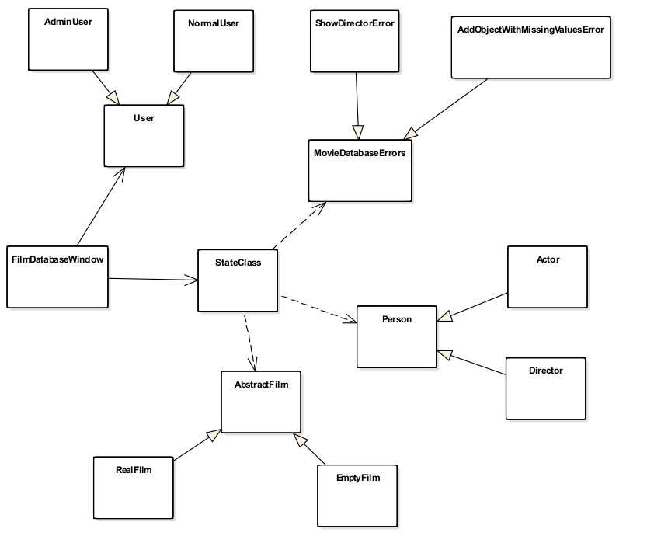

StateDiagram
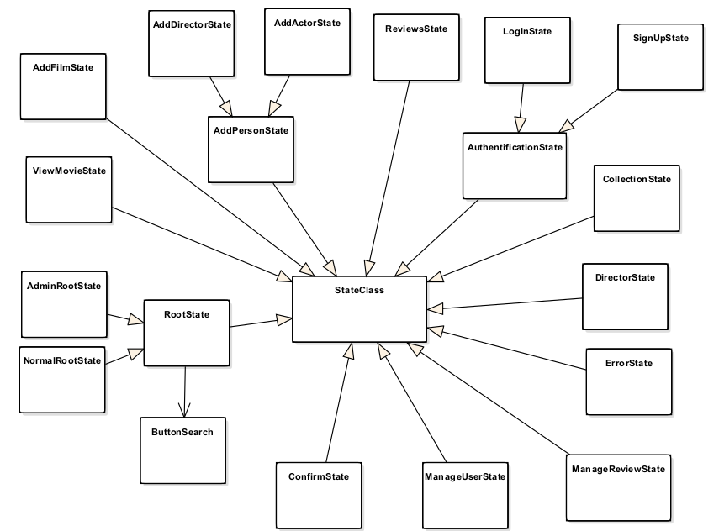

Use case
LogIn SignUp
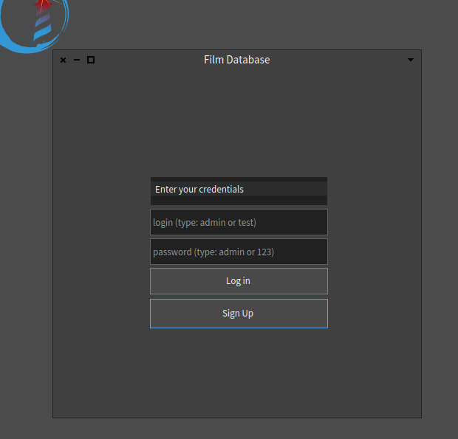
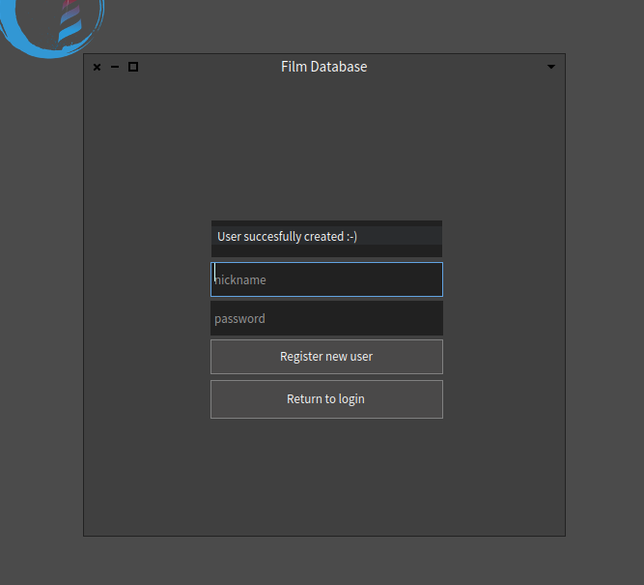

MainAdminView MainUserView
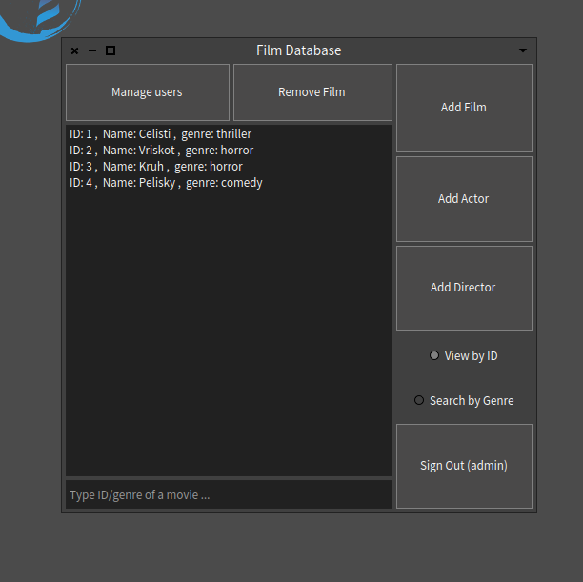
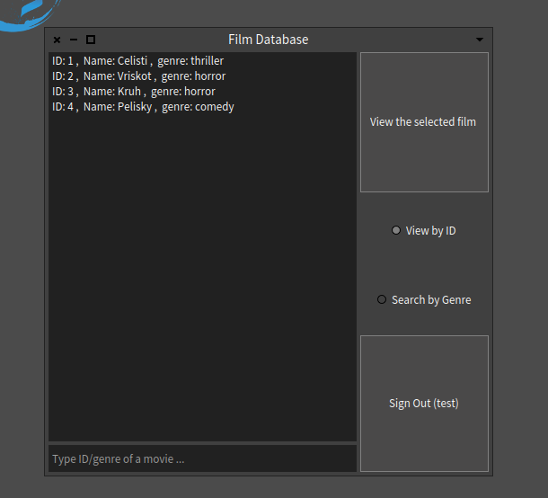

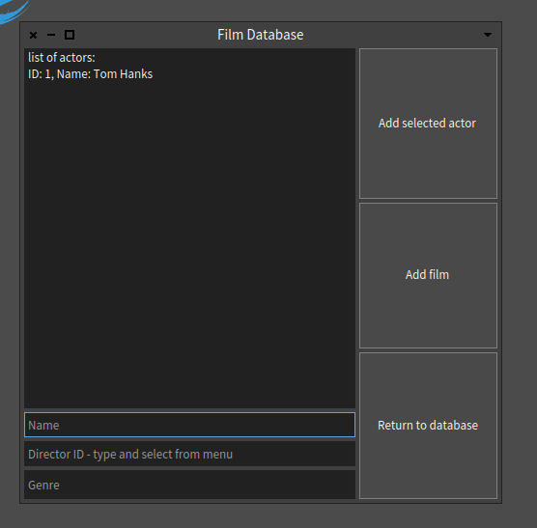
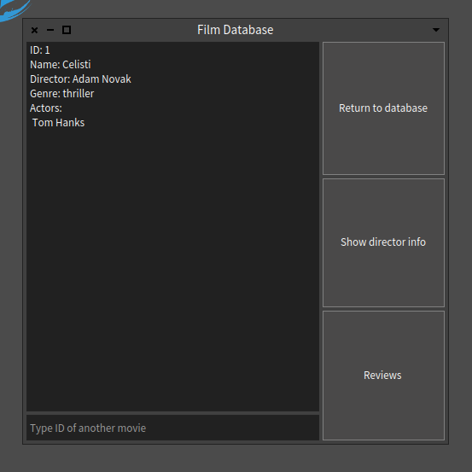

AddingFilm ShowFilmInfo

ShowDirectorInfo ManagingUsers
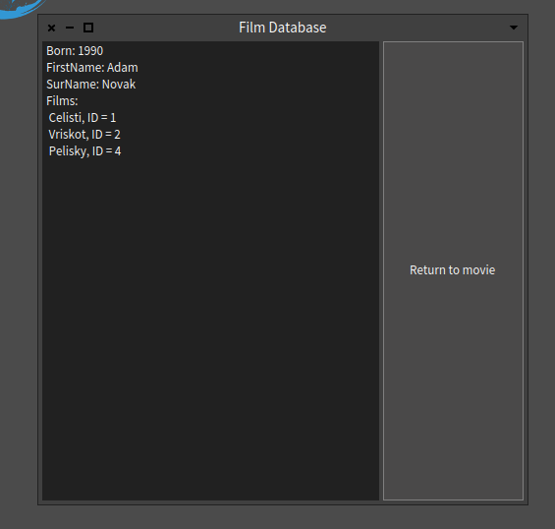
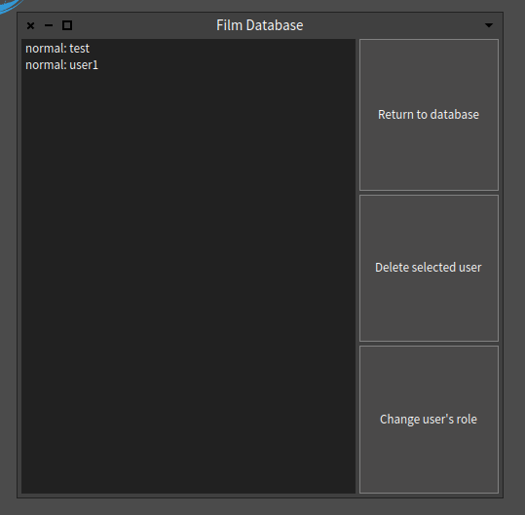

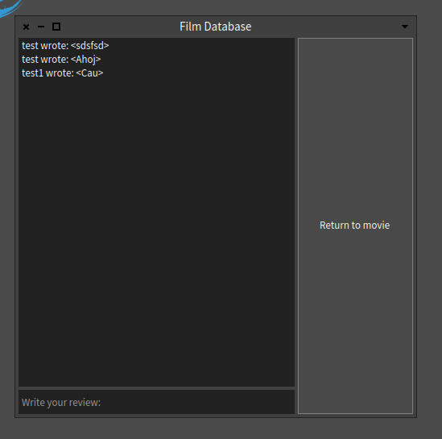

ReviewsOfFilm

Architectural decisions

design patterns

- Polymorfism
- StateClass
- Null Object Pattern
- EmptyFilm
- State pattern
- StateClass
- Custom exceptions
- MovieDatabaseErrors
- throwing and catching : method initializePresenter in classes SingleState, AddPersonState, AddFilmState
- Singleton
- EmptyFilm

