SOC HOME LAB

Threat detection & incident respond project

Prepared by | Mohammed Razal
Contact | razalichuzz@gmail.com
LinkedIn | linkedin.com/in/mohammed-razal-b68ba3384
Domain | soc.local | Subnet: 192.168.50.0/24
Platform | VMware Workstation Pro
Report Date | May 2026
Classification | Personal Lab Project — Portfolio Document

Project Summary: A home-based SOC simulation using 4 virtual machines to replicate an enterprise network. Simulated real-world attacks including RDP brute force and phishing with live malware, with automated threat detection built in Splunk SIEM using Sysmon. All detections mapped to MITRE ATT&CK.

MITRE ATT&CK; | T1566 Phishing | T1204.002 Execution | T1110 Brute Force | T1136 Create Account

Project Objective
During my internship at HTC Global Services as a Project Trainee, I worked in a centrally controlled network where website access, admin privileges, SSH, and RDP were all restricted from a central server. I was curious about what was happening behind the scenes — how one server could control all those devices and enforce those restrictions. That curiosity is what started this project.
I wanted to build something where I could experience how a real SOC environment works — not just read about it theoretically. I also wanted hands-on Splunk experience and to simulate attacks and detect them the way a real SOC analyst would. Being a CCSA student, this project gave me practical foundation to connect theory with real-world application.
# | Goal | Outcome
1 | Build enterprise-like network in a home lab | - 4 VMs on single subnet — soc.local
2 | Experience Active Directory & GPO in practice | - Domain controller, users, DNS, GPO configur
3 | Learn Splunk through hands-on detection | - Real alerts triggered and verified in Splunk
4 | Simulate real attacks and detect them | - RDP brute force + phishing with live malware
5 | Build automated detection engineering | - Scheduled alerts with Critical severity firing

Lab Environment & Infrastructure
The entire lab runs on a single physical machine using VMware Workstation Pro with four virtual machines on a NAT network — isolated subnet with inter-VM communication, similar to an enterprise network behind a firewall. Static IPs assigned across 192.168.50.0/24.
VM | Role | IP Address | Reason
Windows Server 2022 | Domain Controller (soc.local) | 192.168.50.129 | Resource-efficient, widely used in enterpise
Windows 11 (sales) | Domain User mechine | 192.168.50.128 | Simulates end-user workstation
Ubuntu 64-bit | Splunk SIEM Server | 192.168.50.127 | Lower resource usage than Windows for splunk
Kali Linux | Attack Machine | 192.168.50.131 | Industry-standard pentesting distribution

e

ow

Tasks, Responsibilities & Evidence
Active Directory & Domain Configuration
Phase 1
- Installed and promoted Active Directory Domain Services (AD DS) on Windows Server 2022
- Created domain soc.local with 1 Domain Admin and 2 Domain Users: sales and accountant
- Configured DNS, GPO, and RDP access for remote connection simulation
- Enabled Windows Event Log audit policies to capture Events 4624, 4625, 4720, 4740
- Joined Windows 11 (sales user) to the soc.local domain with static IP 192.168.50.128
Splunk SIEM Setup & Log Ingestion
Phase 2
- Installed Splunk Enterprise on Ubuntu, enabled receiving on port 9997
- Deployed Splunk Universal Forwarder on Windows Server 2022 and Windows 11 (sales)
- Installed TA-Windows and TA-Sysmon add-ons for proper log field parsing
- Configured inputs.conf to forward Security, System, and Sysmon logs
- Installed and configured Sysmon64 with custom XML rules for ProcessCreate detection
- Verified log ingestion by searching index=main across both hosts in Splunk
Attack Simulation — RDP Brute Force
Phase 3
- Used Hydra from Kali (192.168.50.131) to brute force domain account passwords
- Used xFreeRDP to simulate RDP connection attempts against Windows Server
- Generated 1,853 failed login events (EventCode 4625) from Kali machine
- Triggered account lockout (EventCode 4740) after exceeding attempt threshold
- Created new admin user via RDP session — captured as EventCode 4720
- Verified successful login (EventCode 4624) after credentials obtained

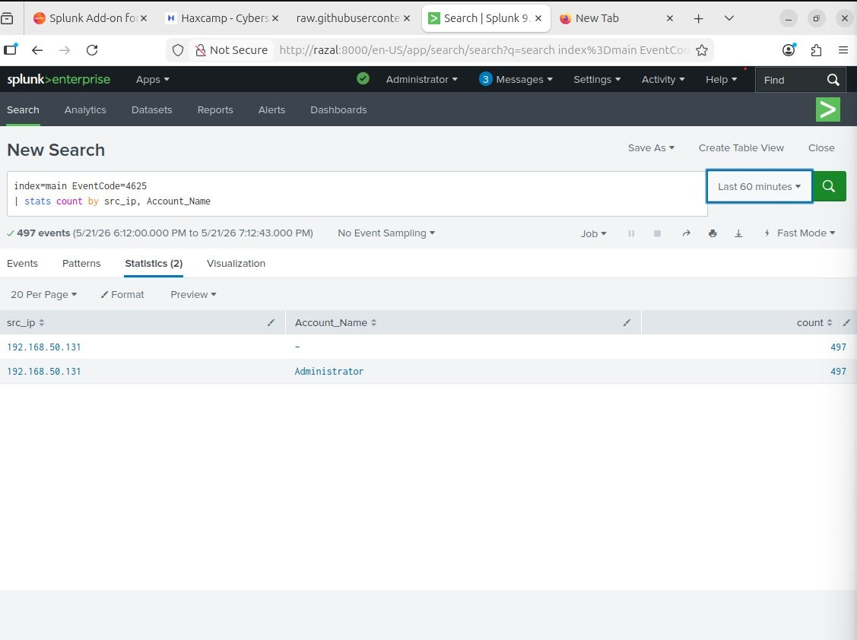
Figure 1: Splunk query showing 497 failed login events (EventCode 4625) from Kali machine 192.168.50.131 targeting Administrator account
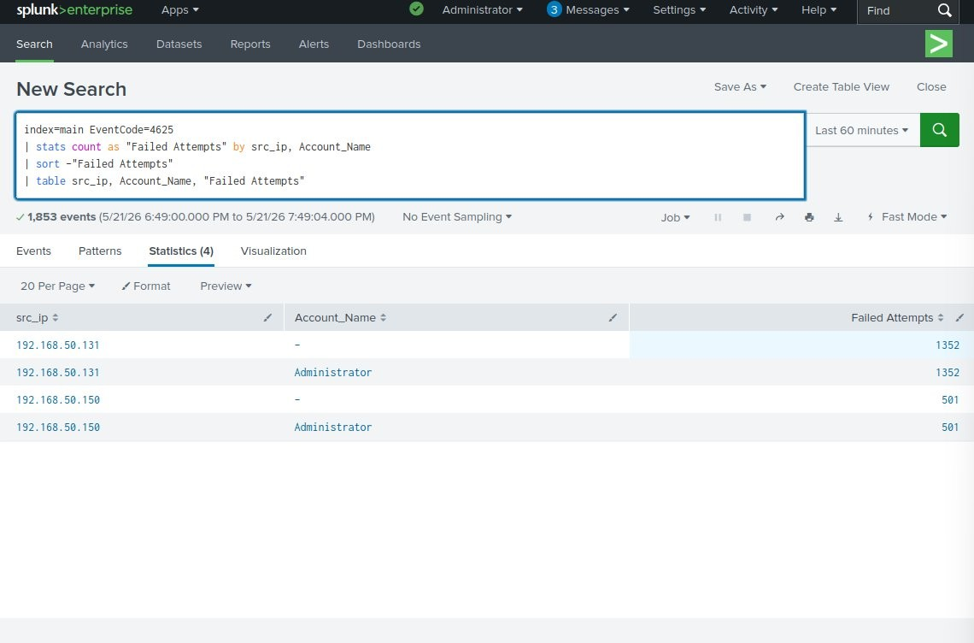
Figure 2: SPL stats query showing 1,853 failed login attempts — top attacking IP 192.168.50.131 (Kali) with 1,352 attempts against Administrator

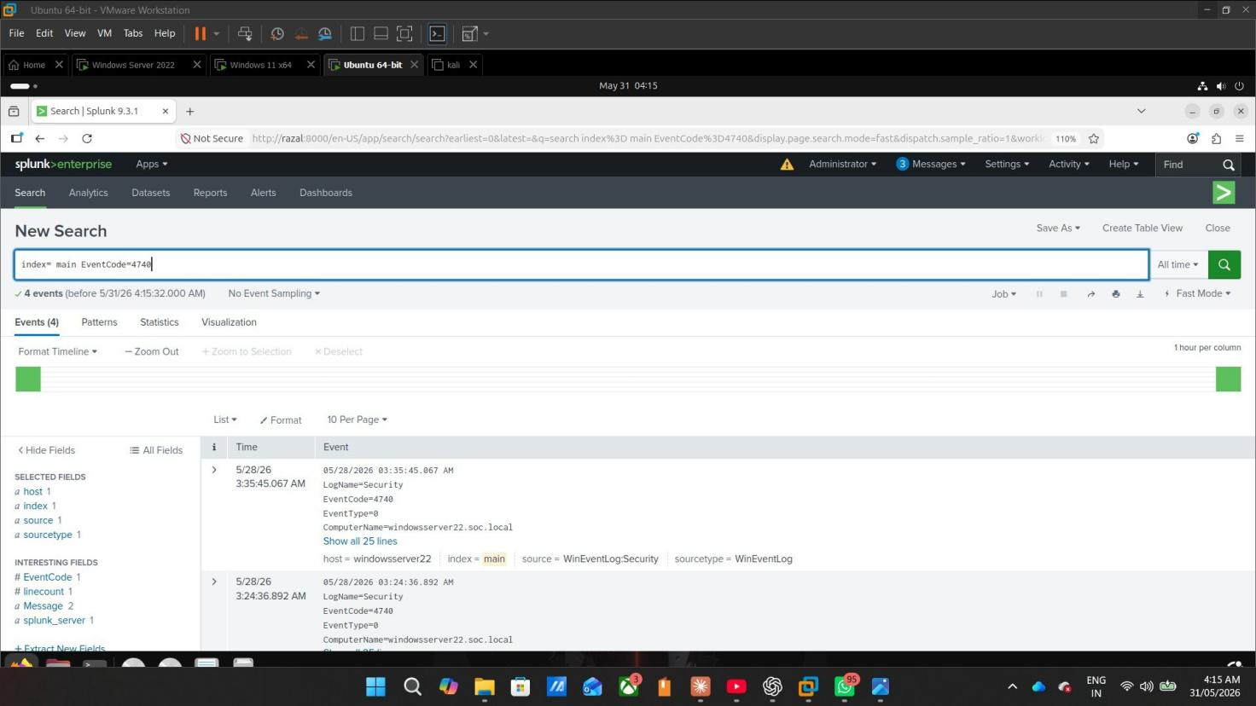
Figure 3: EventCode 4740 — Account Lockout events captured in Splunk from windowsserver22.soc.local (4 lockout events triggered by brute force)
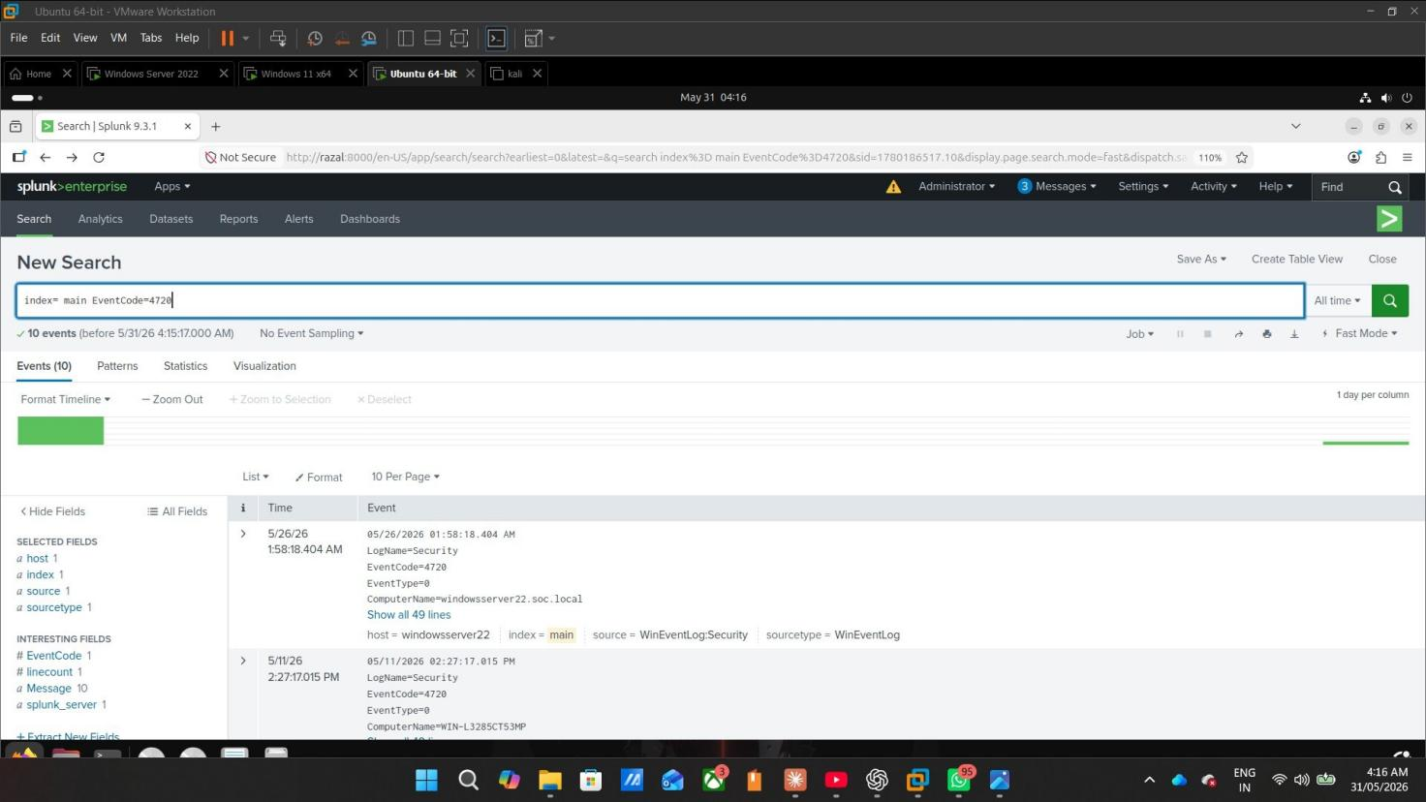
Figure 4: EventCode 4720 — New User Account Created events (10 events on windowsserver22.soc.local, confirming privilege escalation via RDP)

Attack Simulation — Phishing with Live Malware
Phase 4
- Received phishing email with .iso file attachment (quotation.iso) in Thunderbird on Windows 11
- Mounted ISO — appeared as DVD Drive E:\, bypassing Windows Mark-of-the-Web (MOTW) protection
- Executed payload: makave (2)_protected_68A4BB0.exe — real malware confirmed on VirusTotal
- VirusTotal analysis: 61 out of 72 security vendors flagged the file as malicious
- Malware classified as: Trojan/Backdoor — Trojan.Agent.EJZZ, Backdoor:Win32/Injector
- True filename revealed by Sysmon: TRAPFALL.exe — attacker renamed to bypass detection
- SHA256: F74D3364EF9D3E3DF4173A7F12D48348AF44BF150C0FFCD01F0054E86EBB7E0E
- Sysmon EventCode 1 captured full forensic data: parent process, command line, hash, user
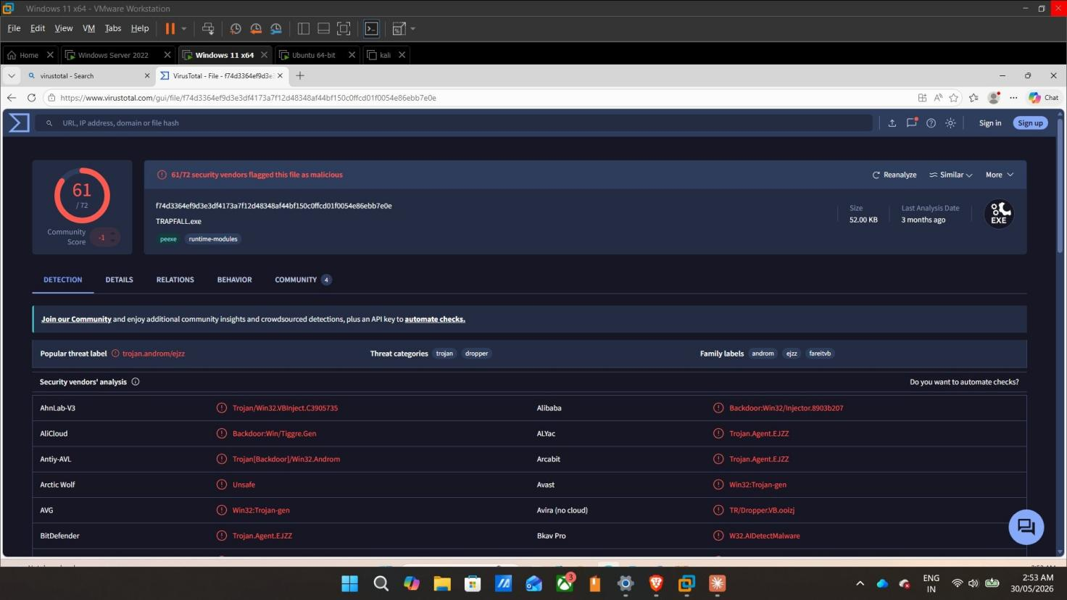
Figure 5: VirusTotal analysis — 61/72 security vendors flagged TRAPFALL.exe as malicious. Classified as Trojan.Agent.EJZZ and Backdoor:Win32/Injector

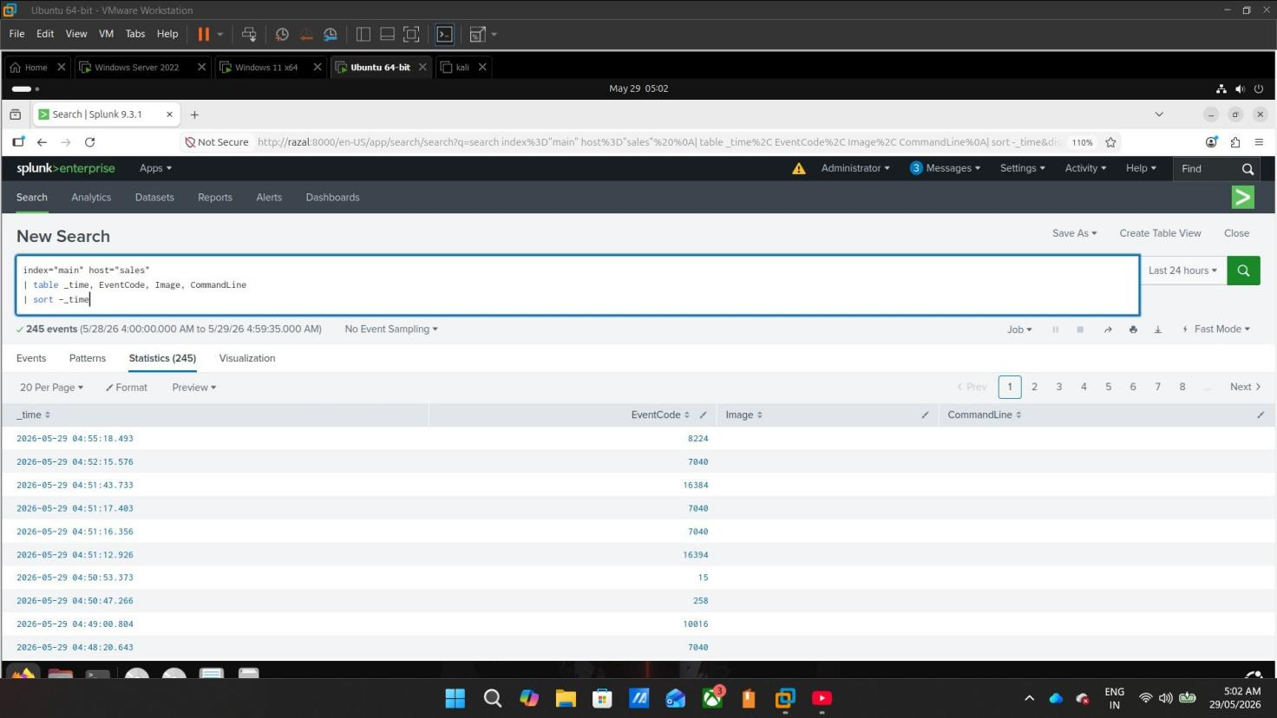
Figure 6: Splunk showing Sysmon events from host 'sales' — EventCode 1 (Process Creation) captured after malware execution from E:\ drive

Behavioral Detection Query (SPL):

index=main source="WinEventLog:Microsoft-Windows-Sysmon/Operational" EventCode=1 Image="E:\\*" | table _time, host, User, ParentImage, Image, CommandLine

Detection Engineering — Automated Alerts
Phase 5
- Converted SPL detection queries into Scheduled Alerts running every hour at :15
- Trigger condition: Number of results greater than 0 — any suspicious execution fires the alert
- Throttle set to 60 minutes to prevent alert fatigue while maintaining coverage
- Phishing alert severity set to Critical — RDP Brute Force set to High
- Phishing alert fired automatically at 04:15:00 on 30/05/2026 — verified in Triggered Alerts
- Chose scheduled over real-time alerts following SOC best practice for resource efficiency
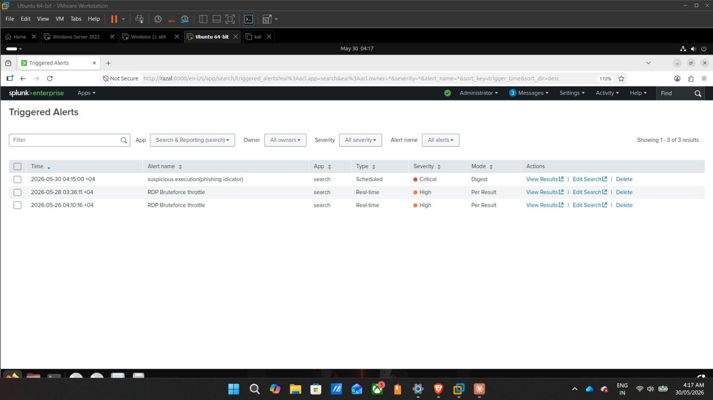
Figure 7: Splunk Triggered Alerts — 'suspicious execution(phishing indicator)' fired at 04:15:00 with Critical severity. RDP Bruteforce throttle alerts also visible (High severity)
Dashboard & Visualization
Phase 6
- Failed Logins Over Time — bar chart showing attack spike on May 21 (~2,000 failed attempts)
- Top Attacking IP — confirms Kali (192.168.50.131) as primary attacker with 1,500+ attempts
- Targeted Accounts — shows which domain accounts were most targeted during the attack
- Attack Chain Summary — visualizes EventCodes 4624, 4625, 4720, 4740 in a single graph

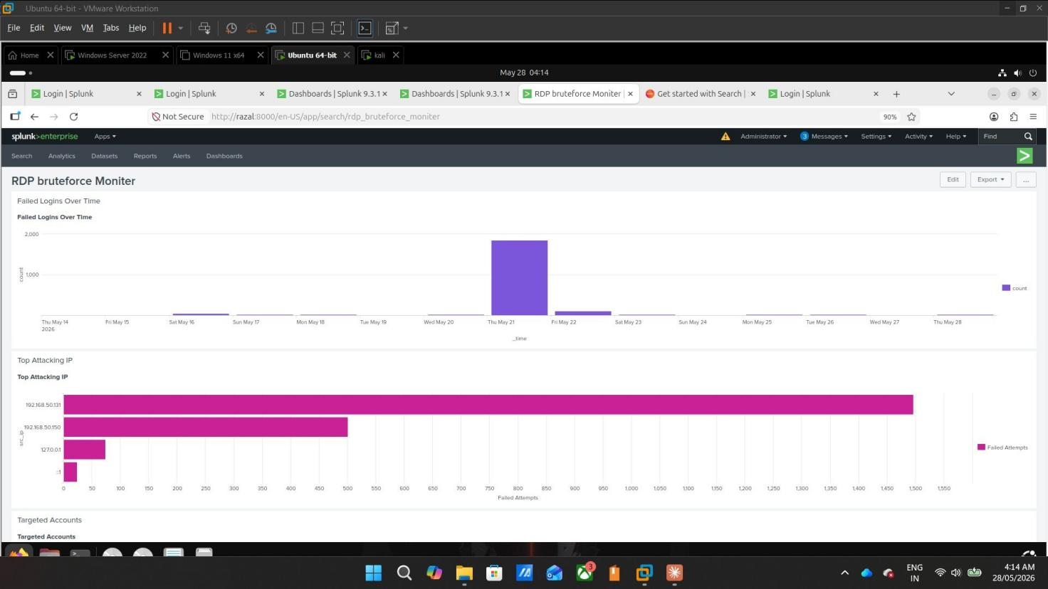
Figure 8: RDP Brute Force Monitor Dashboard — Failed Logins Over Time (spike on May 21) and Top Attacking IP chart confirming Kali as attacker
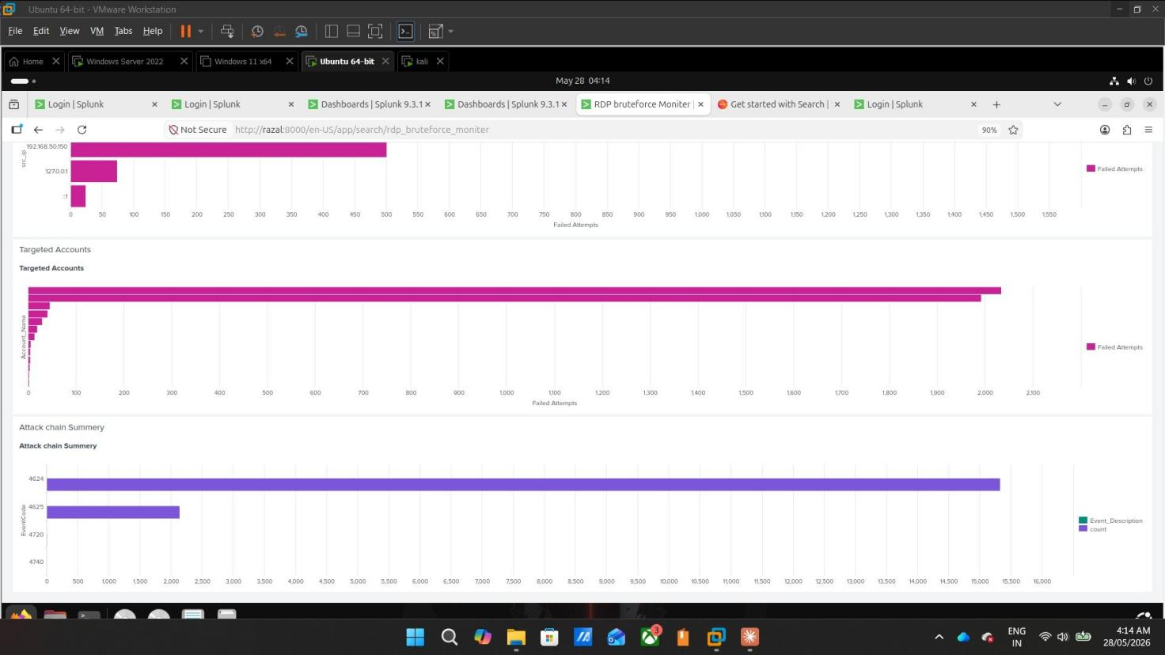
Figure 9: Dashboard continued — Targeted Accounts and Attack Chain Summary showing all 4 EventCodes (4624, 4625, 4720, 4740) visualized together

Skills & Tools Used

Category | Tools / Skills | Application
SIEM | Splunk Enterprise 9.3.1 | Log ingestion, SPL queries, dashboards, alerts
Log Forwarding | Splunk Universal Forwarder | Forwarding Windows & Sysmon logs to Splunk
Endpoint Logging | Sysmon64 | Process creation, network events, full forensics
Splunk Add-ons | TA-Windows, TA-Sysmon | Parsing Windows Event Logs and Sysmon fields
Attack Tools | Hydra, xFreeRDP (Kali) | RDP brute force and connection simulation
Virtualization | VMware Workstation Pro | Running 4 VMs simultaneously on one device
Identity & Access | Active Directory, GPO, DNS | Domain setup, users, policy enforcement
Detection Framework | MITRE ATT&CK | Mapping detections to ATT&CK technique IDs
Threat Intel | VirusTotal | Confirming malware hash — 61/72 vendors flagged
Query Language | Splunk SPL | Behavioral detection queries and correlations
OS | Windows Server 2022, Win 11, Ubuntu, Kali Linux | Infrastructure, victim, SIEM, attack roles
Key Findings & Achievements

- ​ | Behavioral Detection Over Signature Detection  The phishing detection targets any EXE running from a mounted virtual drive (D-Z:) — not a specific filename or hash. Even if the attacker renames the malware, the detection still fires because the behavior stays the same.
- ​ | ISO Files Bypass Windows SmartScreen (MOTW)  Files inside ISO containers bypass Windows Mark-of-the-Web protection. The attacker used this technique to avoid SmartScreen warnings. Our Sysmon-based detection catches execution at the process level instead.
- ​ | Malware Renamed to Evade Detection  Sysmon's OriginalFileName field revealed the true name TRAPFALL.exe while the file was presented as makave (2)_protected_68A4BB0.exe. Classic attacker technique — rename to avoid hash detection while the true identity stays hidden in the PE header.
- ​ | 61/72 Vendors Confirmed Real Malware  VirusTotal analysis confirmed the payload as a Trojan/Backdoor (Trojan.Agent.EJZZ). This was real malware executed in a controlled VM environment — not a simulation tool.

- ​ | Automated Alert Verified End-to-End  Phishing detection alert fired automatically at 04:15:00 on 30/05/2026 with Critical severity — proving the complete detection pipeline works without manual intervention.
MITRE ATT&CK; Framework Mapping

Technique ID | Technique | Tactic | Detection | Event ID
T1566.001 | Spearphishing Attachment | Initial Access | ISO attachment via Thunderbird | —
T1553.005 | MOTW Bypass | Defense Evasion | ISO bypasses SmartScreen | Sysmon EID 1
T1204.002 | Malicious File Execution | Execution | EXE run from E:\ drive | Sysmon EID 1
T1110.001 | Password Guessing | Credential Access | Hydra brute force from Kali | 4625
T1078 | Valid Accounts | Persistence | Successful RDP login | 4624
T1136.001 | Local Account Creation | Persistence | New admin via RDP session | 4720
T1531 | Account Lockout | Impact | Lockout after threshold | 4740
Lessons Learned

1 | Behavioral detection beats signature detection. Attackers change filenames and hashes constantly — but behavior like running from a mounted drive stays the same. Writing rules for behavior catches attacks regardless of what the file is called.
2 | Sysmon transforms Windows logging completely. Default Event Logs miss critical details. With Sysmon, every process creation includes parent process, command line, hash, and user — a full forensic picture.
3 | The difference between a Threat Hunter and a Detection Engineer is automation. Scheduled alerts mean the SOC watches 24/7 without anyone sitting at a screen manually searching.
4 | ISO files are a real and active phishing technique. They bypass Windows SmartScreen and MOTW protection — not a theoretical threat, but something actively used by attackers today.
5 | Log forwarding configuration is where most SOC blind spots start. Misconfigured inputs.conf, wrong add-ons, or incorrect source types mean threats go undetected silently.

Mohammed Razal razalichuzz@gmail.com | linkedin.com/in/mohammed-razal-b68ba3384

