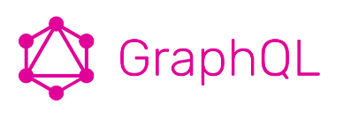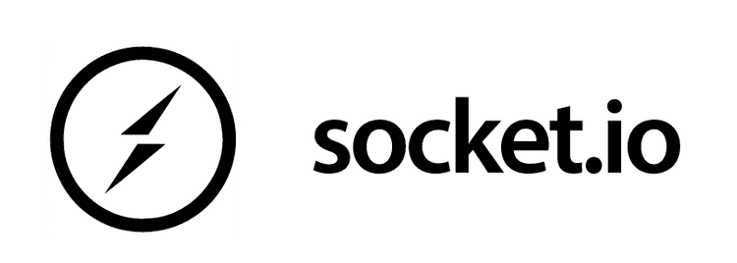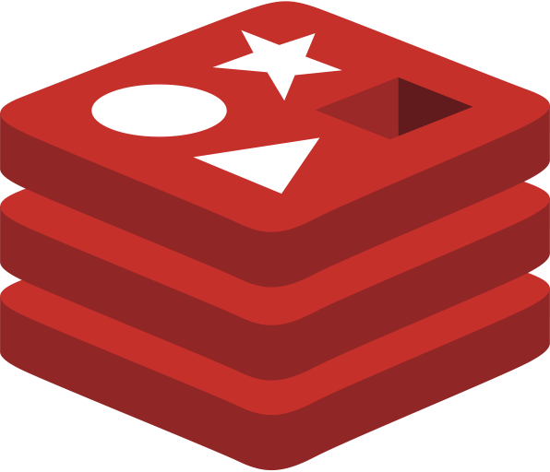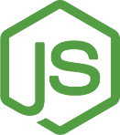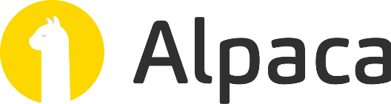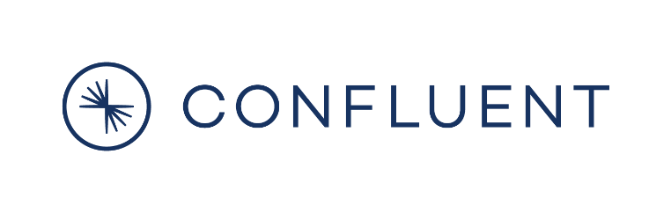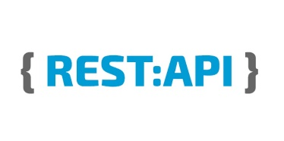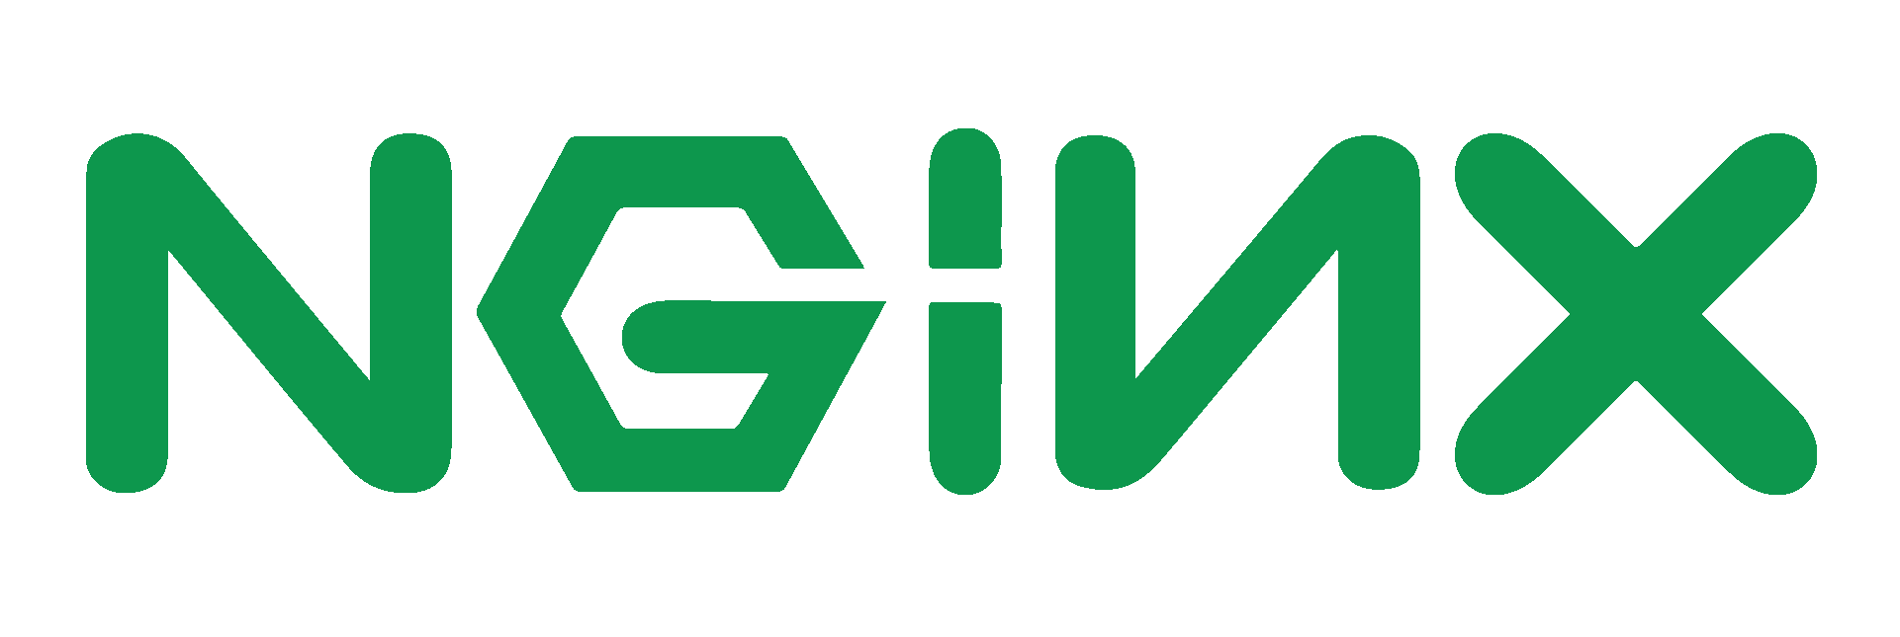

Read-Only Write-Only Read-Write Communication

Login, Logout, Register Service. Token Generation

Stock data API

Central API

VM with firewall allowing only ports 80, 443, 22

Client side React app

Cloud Hosted Redis Labs instance for micro-service state management

Reverse Proxy & SSL Termination

Realtime stock updates Kafka producer

Cloud Hosted Atlas Cluster

Cloud Hosted Apache Kafka

Socket server for chat messages & stock updates