

Palestine Technical University – Kadoorie

College of Engineering and Technology Department of Computer Systems Engineering

Course name:

# Software Engineering

Project title:

DEVELOPING AN INVOICING PLATFORM FOR STUDENT CLUB IN PALESTINE.

By:

Huda Sawalha -202110714 Jad Atout-202110490 Razan Hamad - 202110754 Shahd Eid - 202110734

Supervisor:

Dr.Nael Salman

Dr. Osama Hamed

Tulkarm, Palestine Spring 2023-2024

**Abstract**

A Desktop Application aims to create invoicing system by our software team. In the new era of economics, the need for efficient and reliable invoicing system is paramount. Efficient and reliable invoicing systems are essential in today's modern businesses. In response to this requirements, we present our new desktop application that is tailored for the creation of invoices. Our desktop app simplifies the design and production of invoices with its easy-to-use interface and extensive features, making it essential for financial transactions and businesses.

**CHAPTER 1**

**INTRODUCTION**

## PROBLEM STATEMENT:

The current invoicing system is inefficient due to its manual nature, which causes significant delays:

### Manual Invoice Creation:

Invoices are created by hand, requiring staff to manually enter data from multiple sources into invoice templates. This repetitive and error-prone process is slow and can lead to fatigue, hindering efficiency.

### Limited Information for Decision Making:

The old way of creating invoices can make it hard for people to decide what to do because they don't have enough information. For instance, users might not know everything there is to know about their customers or the goods they sell. This can make it hard for them to set the best prices and offer the best services. When users don't have all the information they need, they might make bad decisions that lose them money.

### Difficulty in Tracking Invoices:

Tracking invoices manually can be troublesome. Invoices are often scattered across various places and formats, making it tricky to find and arrange them in order. This disorganization can cause invoice processing delays, missed payments, and potential financial issues.

### Risk of Data Loss:

When you handle invoices manually, you're more likely to lose or damage data. Without good systems for keeping track of and backing up your data, you could lose valuable financial information. This can cause serious problems for your business, including legal or financial consequences.

Tackling these issues is essential for streamlining invoicing processes, minimizing mistakes, and boosting general business performance

* 1. **OBJECTIVES:**
     1. **Simplify Billing:** We're creating a system that makes it easier to create invoices, with less manual work and faster processing.
     2. **Better Decision-Making Data**: We'll give users all the information they need to make smart decisions about pricing and quality, so they don't miss opportunities and can earn more.
     3. **Easier Invoice Management:** Tracking and managing invoices will be a breeze, with less clutter and better organization. This will save time, prevent delays, and avoid unnecessary costs.
     4. **Protect Data:** We'll keep invoices and data secure, so you don't have to worry about losing them, even in case of technical issues.

## THE TARGET GROUPS OF THE PROJECT:

A student club that organizes events and offers services to its members is seeking to streamline its billing system. The club collects annual subscriptions to provide members with exceptional experiences. By implementing a system that manages and stores invoices efficiently, the club aims to simplify and enhance the member experience. Members can conveniently track their subscription status and receive timely, accurate invoices. This allows them to fully participate in student activities and leverage club services without the hassle of invoice management.

**ER DIAGRAM**

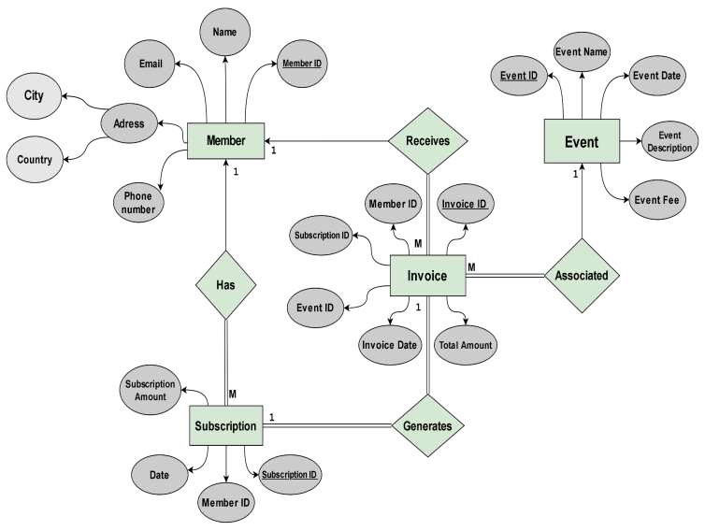

**PROJECT TIMELINE:**

|  |  |
| --- | --- |
| **1 Week** | **ABSTRACT, INTRODUCTION, ERD.** |
| **2-3 Week** | **PROCESS MODEL, USER INTERFACE.** |
| **4-6 Week** | **IMPLEMENTATION, TESTING.** |
| **7 Week** | **REFERENCES, CONCLUSION.** |

