--1.Retrieve the first and last name of all employees along with their gender and birth date.
SELECT FName, LName,Gender , BirthD
FROM EMPLOYEE;
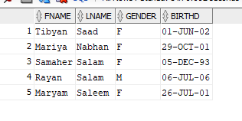

--2.List all employees who work in a specific department.
SELECT FName, LName,Dnum
FROM EMPLOYEE
WHERE Dnum = 14;
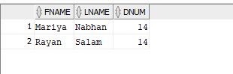

--3.Find the employee who manages each department along with their hire date.
SELECT PN, Loc, City
FROM PROJECT;

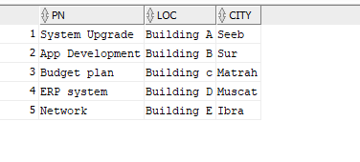

--4.Retrieve all dependents associated with a specific employee.
SELECT E.FName, E.LName,E.HireDate, D.DN AS Department
FROM EMPLOYEE E
JOIN DEPT D ON E.Dnum = D.Dnum
WHERE E.SupperSSN IS NULL;
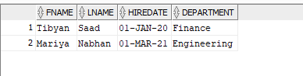

--5.List all employees who work on a specific project along with their working hours.
SELECT Dname, BD,Gender
FROM DEPENDENT
WHERE EmpSSN = '111111';

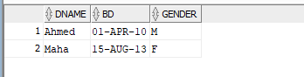

--6.Display all departments along with their locations.
SELECT E.Name, E.LName, W.Hours
FROM EMPLOYEE E
JOIN WORK_ON W ON E.SSN = W.EmpSSN
WHERE W.Pnum =2;
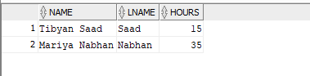

--7.Find all employees supervised by a specific employee.
SELECT DN, Loc
FROM DEPT;
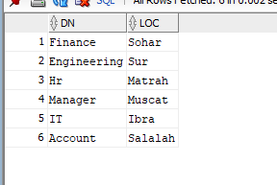

--8.Retrieve all projects assigned to a specific department.
SELECT FName, LName, Dnum
FROM EMPLOYEE
WHERE SupperSSN = '222222';
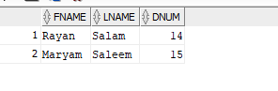

--9.List all female/male dependents along with their birth date.
SELECT PN, Loc,City
FROM PROJECT
WHERE Dnum = 11;
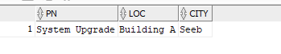

--10. List all female dependents along with their birth date
SELECT Dname, BD , Gender
FROM DEPENDENT
WHERE Gender = 'F';
