About:
CodeReviewAssistant is a Blazor Interactive Server app (targeting .NET 8) that leverages a GROQ-compatible OpenAI endpoint to deliver concise automated code reviews. Users paste source code into a browser editor and configure AI settings (model, temperature, max tokens, counts) in Settings, entering the GROQ API key first. The app builds system and user prompts, sends them via HttpClient to the GROQ chat completions API, and parses responses into Improvements, Positive notes, and optional Refactored Code. Toasts provide UI feedback. The solution favors simplicity: in-memory settings, clear parsing logic, and a Dockerfile for containerized deployment. Extensible for persistent storage and testing.

Github Repo Link: https://github.com/razanaveed/CodeReviewAssistant
Readme Doc: https://github.com/razanaveed/CodeReviewAssistant/blob/master/README.md
Live URL: https://codereviewassistant-raza.fly.dev/

Screenshots:
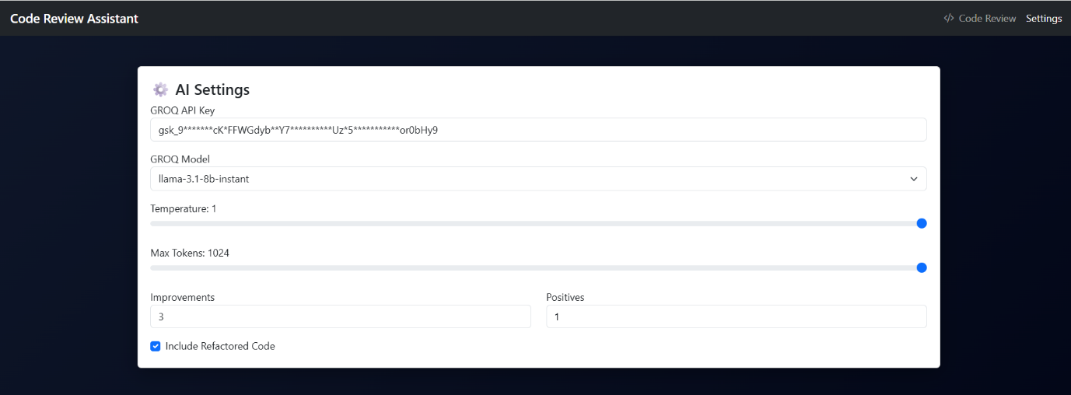
Figure 1: Settings Screen

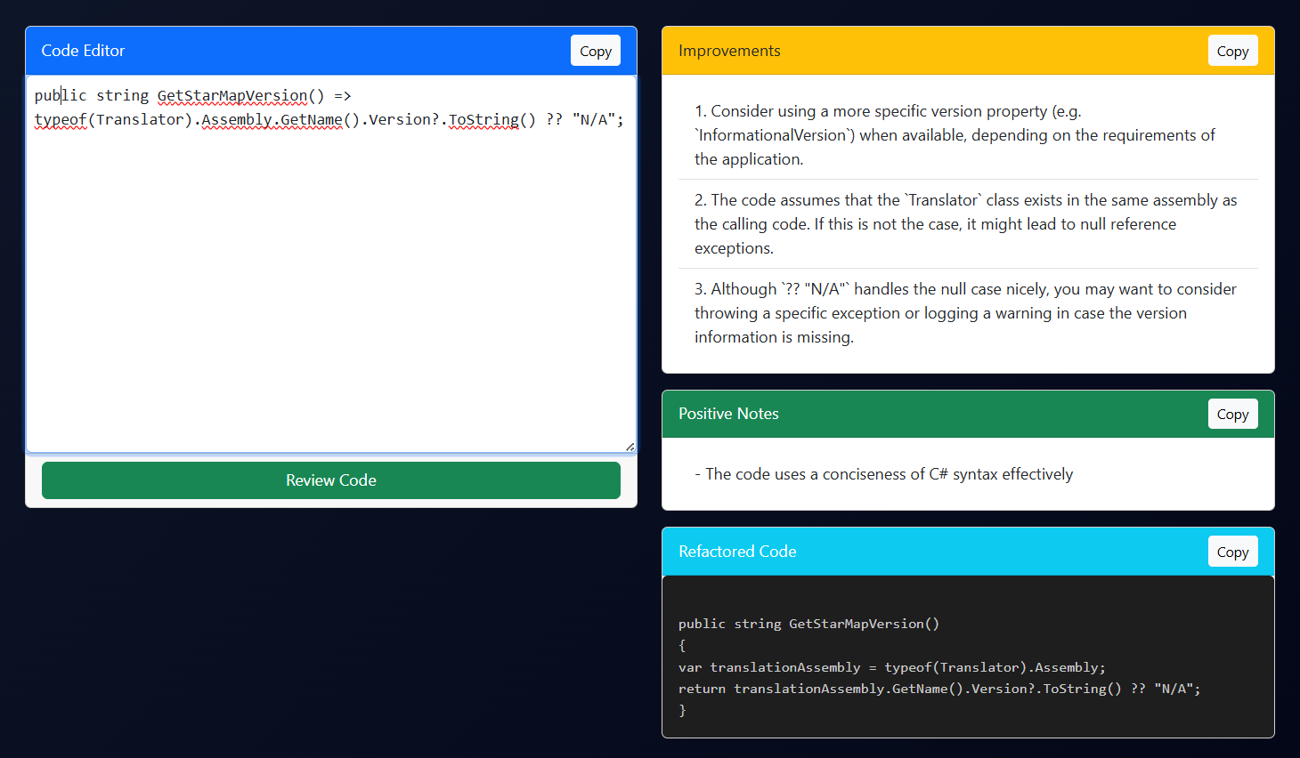
Figure 2: CodeReview Screen

