Assignment 1 - Git & GitHub Fundamentals
Full Name: Razane Souane
Student ID: 163671
Course Code & Section: CSC 3324 01
GitHub Username: razanesouane
Repository: https://github.com/razanesouane/git-session1-razanesouane
1. Repository Setup
I created the folder git-session1-razanesouane, copied the starter files into it and ran git init -b main. My .gitignore ignores local.env (machine-specific settings and secrets) and *.log (runtime files). The rule !important.log makes an exception so that file stays visible to Git. I checked it with git check-ignore -v local.env and git status.
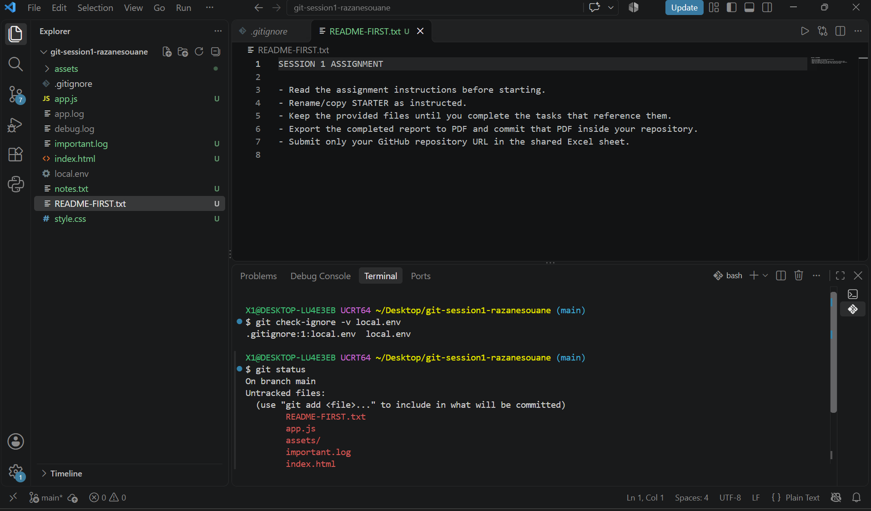2. README & Commit History
My README contains my name, GitHub username, a short description, the technologies, one code block, one link and the provided banner image. I made small commits, one per purpose (.gitignore, index.html, style.css, app.js, important.log and notes, README), each with a message describing the change. The final history has more than 5 commits across more than 3 files.
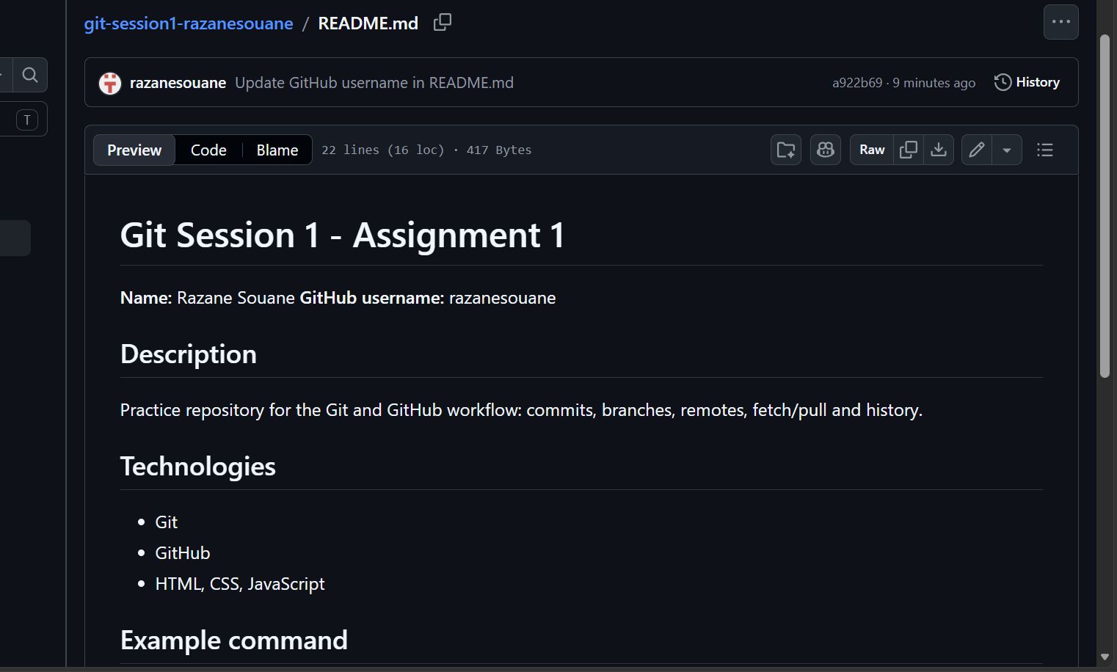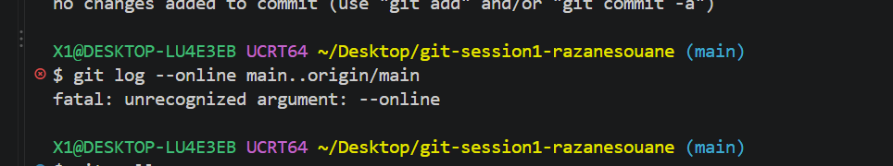
3. Selective Staging
I modified style.css and index.html at the same time. I ran git add style.css and committed only that file. git status then showed index.html as modified but not staged, because git add stages only the files I name. I left index.html modified until the end of the lab.
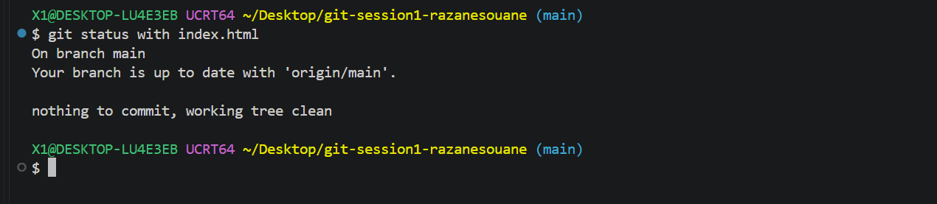4. Branch & Merge
I created the branch feature/about with git switch -c feature/about, added about.html and committed it there. I then returned to main with git switch main and ran git merge --no-ff feature/about. The --no-ff option creates a visible merge commit, so the branch appears in the history.
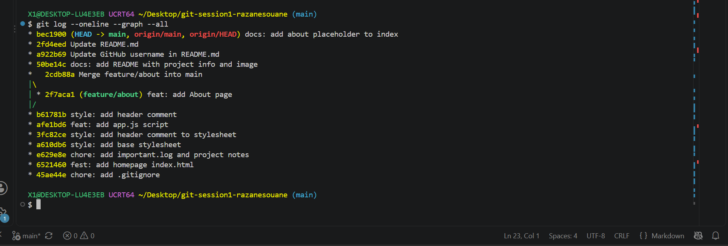5. Remote Changes
A commit saves changes in my local repository only. A push uploads those local commits to GitHub. I created an empty GitHub repository, connected it with git remote add origin and published main with git push -u origin main.
I then edited README.md directly on GitHub. git fetch downloads the remote information and updates origin/main without touching my local files. After the fetch, git status said my branch was behind origin/main by 1 commit. git pull is a fetch followed by a merge, so it brought the change into my working files. I also compared my edits with git diff (unstaged) and git diff --staged (staged).
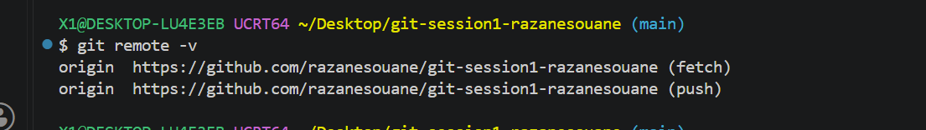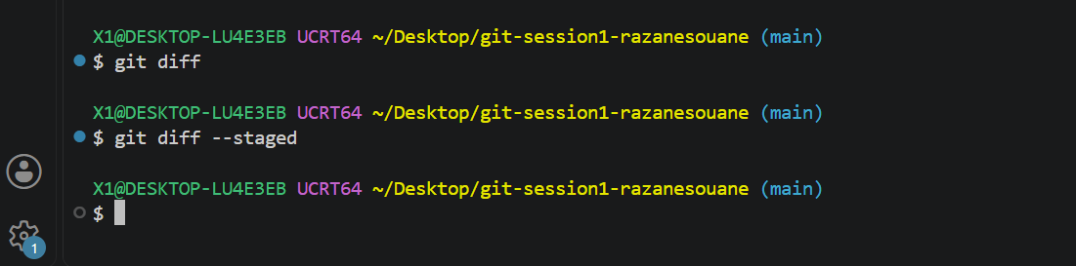

7. Sources & Reflection
Sources: Session 1 slides, the assignment instructions, and the Atlassian .gitignore tutorial linked in the slides (https://www.atlassian.com/git/tutorials/saving-changes/gitignore).
Reflection: The hardest concept was the staging area, because a file can be modified without being staged or committed. If Git behaves unexpectedly, I would first run git status to see my branch and file states, then git log --oneline --graph --all to understand the history.

