Freight Rate Prediction – Validation & Approach Report

1. Problem and key observation
Goal: predict the posted rate of each of the 12,000 loads in validation.csv (Nov–Dec 2025) using 48,000 labelled loads (train_test.csv, Jan–Oct 2025). The key observation that drives the split design: validation.csv is strictly later in time than every labelled row, and 12% of its rows involve 8 cities (Chicago, Charlotte, Knoxville, Jackson, Norfolk, Allentown, Laredo, San Diego) that never appear in training.

2. Data findings and quality issues
- Rate is almost proportional to distance (corr 0.91; 0.97 in logs). $/mile falls from about $2.9 at 100 mi to $1.85 at 3,000 mi; Reefer > Flatbed > Dry Van; market_index and quote_signal add signal; origin/destination region shifts the rate by about ±3%; day of week adds about 1.5%.
- Corrupt labels: about 1.4% of rates are 2–4.5x too high or 2–5x too low versus comparable loads. They are removed from training only (robust 5-sigma rule on a first-pass fit) and I report metrics both on all rows and on non-corrupt rows.
- Weight: 292 negative values (sign errors, fixed with abs), 300 missing, hard cap at 47,500 (values clipped). market_index: 374 missing, filled with that day’s median. Row-level market_index is noisy (daily sd 0.025), the daily aggregate is stable.
- Distance varies about 2% within a lane and up to 1.7x haversine for some rows; rate follows the stated distance, so it is kept as is.
- Slow time drift: after controlling for all features, the daily rate level rises by about 6% from January to October and is not explained by market_index. This is the main source of error for Nov–Dec.
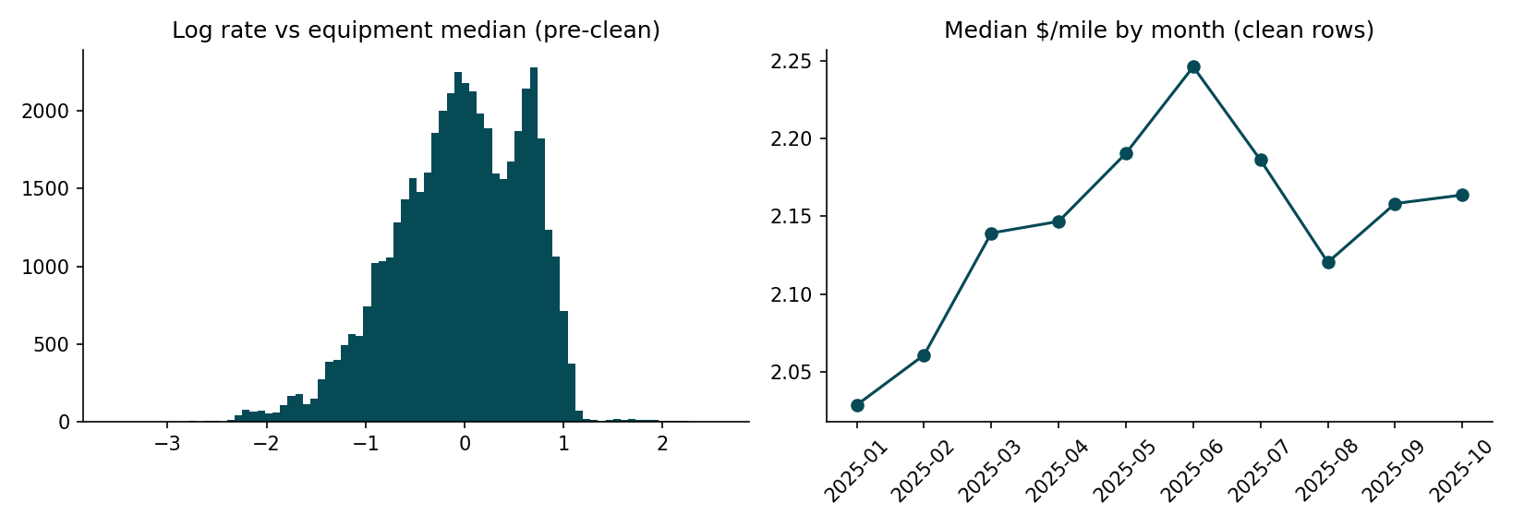

3. Train / validation split approach
A random K-fold would mix future and past days and leak the date-level drift, giving a misleadingly good score. Instead I use forward-chaining folds: each fold trains only on dates strictly before a 2-month test window (Mar–Apr, May–Jun, Jul–Aug, Sep–Oct). A fifth fold additionally hides 8 random cities from training and tests on Sep–Oct loads touching them, which mirrors validation.csv (later dates and unseen cities). Final model: refit on all 48,000 labelled loads.
Results (non-corrupt rows; the first fold has only 2 months of training data):
Fold (train -> test) | Test rows | MAPE % | MAE $ | RMSE $ | Bias %
Train Jan-Feb -> Mar-Apr | 9855 | 6.24 | 128 | 210 | -3.56
Train Jan-Apr -> May-Jun | 9696 | 1.30 | 32 | 49 | +0.16
Train Jan-Jun -> Jul-Aug | 9671 | 2.72 | 69 | 107 | +1.94
Train Jan-Aug -> Sep-Oct | 9523 | 1.56 | 37 | 53 | -0.67
Same, 8 cities unseen -> Sep-Oct | 2124 | 1.69 | 43 | 64 | -0.68

Including corrupt labels, MAPE rises to 3.6–8.6% and RMSE to about $620 because a few loads are mislabeled by 3x; that part is not predictable from features.

4. Model and reasoning
- LightGBM with Huber loss on log(rate): handles the non-linear distance curve and interactions, is robust to residual label noise, and trains in seconds.
- Features: log distance, distance, equipment, weight, market_index, quote_signal, day-level market aggregates (from features only, no labels), day of week, and city coordinates. Coordinates replace city names so unseen cities still get sensible regional effects (error on unseen cities 1.69% vs 1.56% on all).
- Time drift: model A (GBM with a time index) holds the last learned level; model B (linear trend + GBM on residuals) extends the trend. Their errors differ in sign across folds, and the average was the best choice on 3 of 4 realistic folds, so the final prediction is the mean of A and B (3 seeds each).

5. December 2025 prediction chart
Chart produced by the provided score.py (Lexington to Fort Wayne, 360 miles, Dry Van, 32,000 lb). The input file has no market_index / quote_signal, so each day uses that day’s aggregate from validation.csv. Predictions stay between about $826 and $843 ($2.30–$2.34 per mile); the weekly cycle reflects the day-of-week effect seen in training.
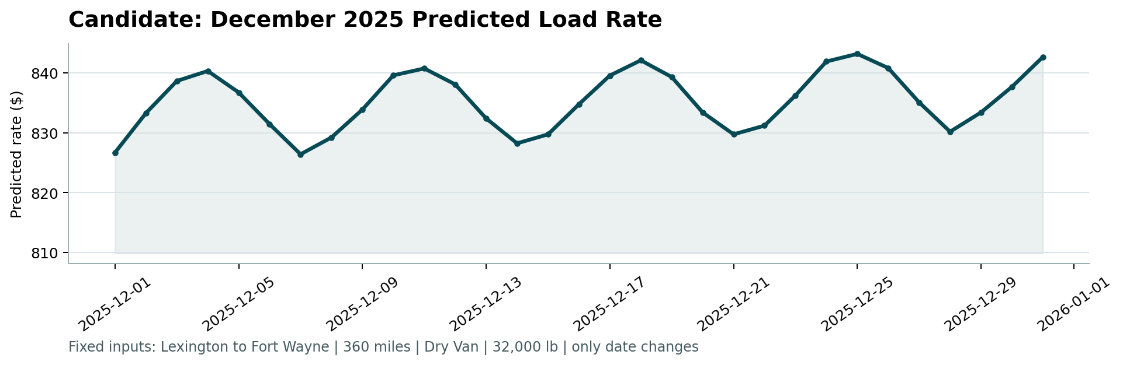

6. Limitations
- Unknown holiday effects in late December and any further market drift cannot be learned from Jan–Oct data; fold bias ranged from -0.7% to +1.9% in the later folds.
- Day-level market aggregates use feature values from validation.csv (no labels), which is allowed in this setup but would require the day’s loads in a live system.

