Lab 2: Identifying ML Problems, Selecting Open Datasets, and Drawing a Methodology Diagram
ARTI 205 – Machine Learning
Academic Year (2025/2026) – 2nd Semester
Student: Razan Alqarni

1. Dataset
Name: Superstore Sales Dataset
Source: Kaggle – https://www.kaggle.com/datasets/rohitsahoo/sales-forecasting
Format: Excel file (train.xlsx), one sheet
Size: 9,800 rows and 18 columns
Content: Sales records from a retail store in the United States (2015–2018). Each row is one order. It shows the order date, shipping method, customer type, location, product, and the sales amount.
Columns: Row ID, Order ID, Order Date, Ship Date, Ship Mode, Customer ID, Customer Name, Segment, Country, City, State, Postal Code, Region, Product ID, Category, Sub-Category, Product Name, Sales.

2. Data Quality Notes
- Only the Postal Code column has missing values (11 out of 9,800 rows).
- The Country column has only one value (United States), so it is not useful.
- Order Date and Ship Date are saved as text. They need to be changed to date format in the preprocessing step.
- ID and name columns (Row ID, Order ID, Customer ID, Customer Name, Product ID, Product Name) do not help the model, so they will be removed.

3. Machine Learning Problem
Learning type: Supervised learning
Problem type: Regression
Target variable: Sales (a number in USD). It goes from 0.44 to 22,638.48. Most orders are small (median 54.49), but a few orders are very large.
Input features: Ship Mode, Segment, Region, State, City, Category, Sub-Category, and features taken from the dates (order month, order year, number of shipping days).
Model output: The expected sales amount of an order.

4. Problem Statement
The goal of this project is to predict how much an order will sell for. The model will use information that is known when the order is made: the shipping mode, the customer type, the region and state, the product category and sub-category, and information from the dates such as the order month and the number of shipping days. The target (Sales) is a number, and every row in the dataset already has this value. This means the problem is supervised learning, and because the target is a number and not a class, it is a regression problem. The model should learn the relationship between the order details and the sales amount. A good model can help the store plan its stock, understand which regions sell more, and estimate future income.

5. Methodology
The project will follow these steps:
- Dataset selection – choose the Superstore Sales dataset from Kaggle.
- Data loading – open train.xlsx with Pandas and check the number of rows, the columns, and the data types.
- Data preprocessing – remove ID columns and columns with one value, fill the missing Postal Code values, change the dates to date format and create new features (order month, shipping days), change text columns to numbers, and scale the numeric columns.
- Train/test split – use 80% of the data for training and 20% for testing.
- Model training – train four models: Linear Regression, Decision Tree, Random Forest, and Gradient Boosting.
- Model evaluation – test each model on the test data using MAE, RMSE, and R².
- Results – compare the models and choose the one with the best results.

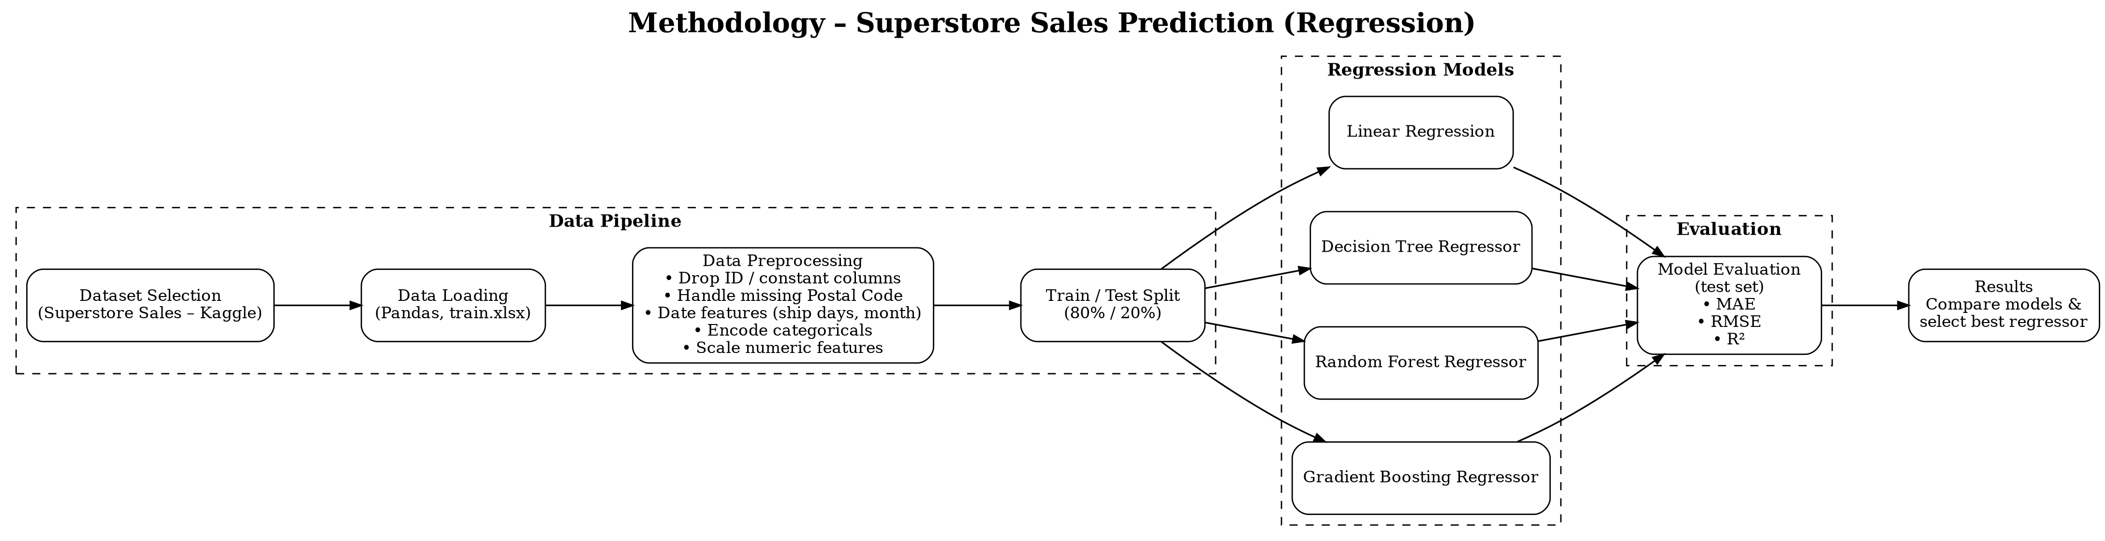
Figure 1 – Methodology diagram

