" بسم الله الرحمن الرحيم "



**Faculty of Engineering and Technology.**

**Electrical and Computer Engineering Department.**

**Linux Laboratory - ENCS3130.**

**Project #1: Manual Generation.**

**_____________________________________________________**

**Student name (Prepared by): Razan Abdalrahman – 1200531.**

**Instructor: Dr.** **Abdel Salam Sayyad.**

**Assistant: Eng. Mazen Amria.**

**Section: 5.**

**Date: January |2024.**

# **Abstract.**

This project automates the generation of Cisco-compliant man pages for specific commands using shell scripting. It ensures documentation accuracy and completeness through three key stages:

* **Automated Generation:** Script extracts vital command details and builds formatted man pages.
* **User-driven Verification:** Users can request verification for any command, triggering a new man page generation and automatic comparison with the existing one. Differences are highlighted for review and potential correction.
* **Continuous Improvement:** Innovative features like search functionality and user-specific command recommendations enhance knowledge accessibility and improve the user experience.

**Table of contents.**

**Abstract.** 2

**1.** **Introduction.** 4

**2.** **Procedure and Discussion.** 5

❖ **Part 1:** 5

❖ **Part 2:** 7

❖ **Part 3:** 9

**3.** **Results.** 11

❖ **First part:** 11

❖ **Second part:** 15

❖ **Third part:** 18

# **Introduction.**

This project addresses is introducing an automated system that generates and verifies Cisco-specific man pages through shell scripting.

This system takes verification to the next level by incorporating user-driven checks. Simply ask about any command, and the script will generate a new man page for comparison. Any discrepancies will be clearly displayed, empowering you to maintain pristine documentation.

And that's not all. The system also includes a built-in search function for efficient information retrieval, along with proactive command recommendations tailored to your specific needs.

# **Procedure and Discussion.**

## **Part 1:**

***1. Initialization and List of Commands:***

- The script starts by showing a friendly welcome message and explaining its purpose: to create manual files for specific Linux/Unix commands.

- It creates an array called "commands" that holds a list of the commands for which manual files will be generated.

***2. Functions for Manipulating Strings***

* add_tabs_to_string Function:

This function takes a string as input and utilizes the sed command to replace newline characters with a newline followed by two tabs. Its purpose is to ensure consistent indentation in the manual files that are generated.

* replace_space_by_newLineWithSpaces Function:

The aim of this function is to format text in a specific manner for the CISCO template. It achieves this by replacing newline characters with a newline followed by two tabs using the sed command.

* delete_spaces Function:

By utilizing the sed command, this function removes leading spaces from a given string. Its purpose is to ensure that lines are free from unnecessary leading spaces.

***3-Commands list:***

By using a for loop, we can go through the commands array and show each command using ANSI escape codes to make it visually appealing. This list of commands will serve as a helpful reference for users, as it indicates which commands will have manual files generated.

***4- User interaction:***

The user is asked if they would like to begin creating manual files for the specified commands through a message displayed by the script. By using the read command, the user's input is captured, and the script then determines the appropriate action to take based on the user's choice.

***5- File generation process:***

When the user decides to continue (Y/y), the script will generate a folder called "GeneratedFiles" by utilizing the mkdir command. This specific folder will be used to store all the manually generated files.

For every command present in the commands array, the script will perform the following actions:

1. Utilize the echo command to create a basic manual template for the command, which includes the command name, description, and usage.

2. Apply the string editing functions to properly format the manual based on the CISCO template.

3. Redirect the formatted content to a file located within the "GeneratedFiles" directory, using the > operator.

***6- Optional verification:***

Ask the user to move on for the second part of this program which is verification, it can verify any command in the generated files.

## **Part 2:**

The second part of the project focuses on validating the accuracy of the generated content.

It involves examining the existing manual files and confirming their correctness by executing the corresponding commands, checking examples, and so on.

***1. String Modification Functions:***

Similar to the first part, the script utilizes three string modification functions (add_tabs_to_string, replace_space_by_newLineWithSpaces, delete_spaces) to ensure consistent formatting.

***2. Continuous Validation Loop:***

The script operates in an ongoing loop (while true) to enable the user to validate multiple commands. It displays a list of available commands for validation.

***3. User Input and File Existence Check:***

The user is prompted to enter the name of the command they wish to validate.

The script checks if the manual file for the entered command exists in the "GeneratedFiles" directory.

***4. File Generation for Validation***:

A new file ("newCommandName.txt") is created in a directory named "newGeneratedFiles" for validation purposes.

Information is extracted from the existing manual files and system commands to populate the new file (same as part 1).

***5. Extracting Information for Validation:***

The script extracts the command description, version history, and examples from the corresponding man pages or system commands.

***6. Comparison and Validation:***

The newly generated file is compared with the existing manual file using the diff command.

The script outputs the differences or confirms the successful validation.

***7. User Interaction for Further Validation:***

The user is asked if they want to validate more commands.

Based on their input, the script either continues the loop or exits.

***8. Conclusion and Optional Enhancement:***

The user is notified when the validation for multiple commands is complete.

They are given the option to improve the usability of the generated manual files using an external script (improve.sh).

## **Part 3:**

The third part of the project introduces two stages: Search Functionality and Command Recommendation. It aims to enhance the existing project by incorporating additional features, improving usability, and extending functionality.

***1. Continuous Loop:***

The script runs in a continuous loop (while true), allowing the user to choose between different options repeatedly.

***2. Search Stage:***

In the search stage, the user has several options:

**Option 1**: Search for Specific Information for a Command:

- Displays the list of available commands for reference using ANSI escape codes for visual enhancement.

- Asks the user to enter the name of the command they want to search for.

- Checks if the manual file for the entered command exists in the "GeneratedFiles" directory.

- If the command exists, prompts the user to choose the type of information they are looking for (Description, Version, Example, Related Commands).

- Displays the relevant information from the manual file based on the user's choice.

**Option 2:** Search for a Specific Topic:

-Asks the user to enter a word related to the topic they want to search for.

-Uses grep to search through all generated files for occurrences of the entered topic.

-Displays the files that contain the topic or informs the user if no files are found.

**Option 3**: Exit Search Stage:

-Exits the search stage if the user chooses option 3.

***3- Command recommendation stage:***

- The user is provided with recommendations based on command history.

- They have the option to display details for specific commands from the list.

- If the user chooses to display details, the available commands are shown, and the user inputs the desired command.

- The script checks if the command exists in the generated files and displays details if it does.

- The user can exit the command recommendation stage when finished.

***4- Invalid Input Handling:***

Handles invalid input with an appropriate error message, prompting the user to enter a number from 1 to 3.

# **Results.**

## **First part:**

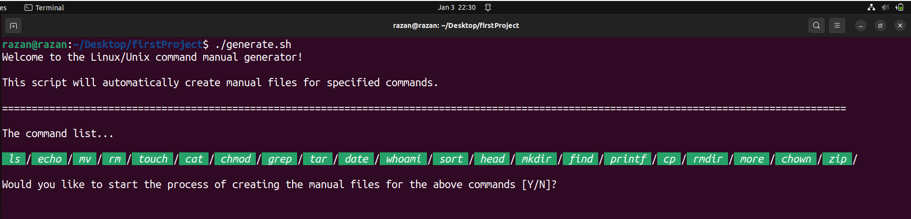When the first script execute” **generate.sh**”, the operation of creating files for the commands started:

Here, there is three option for the user, either Y/y, N/n or other any input:

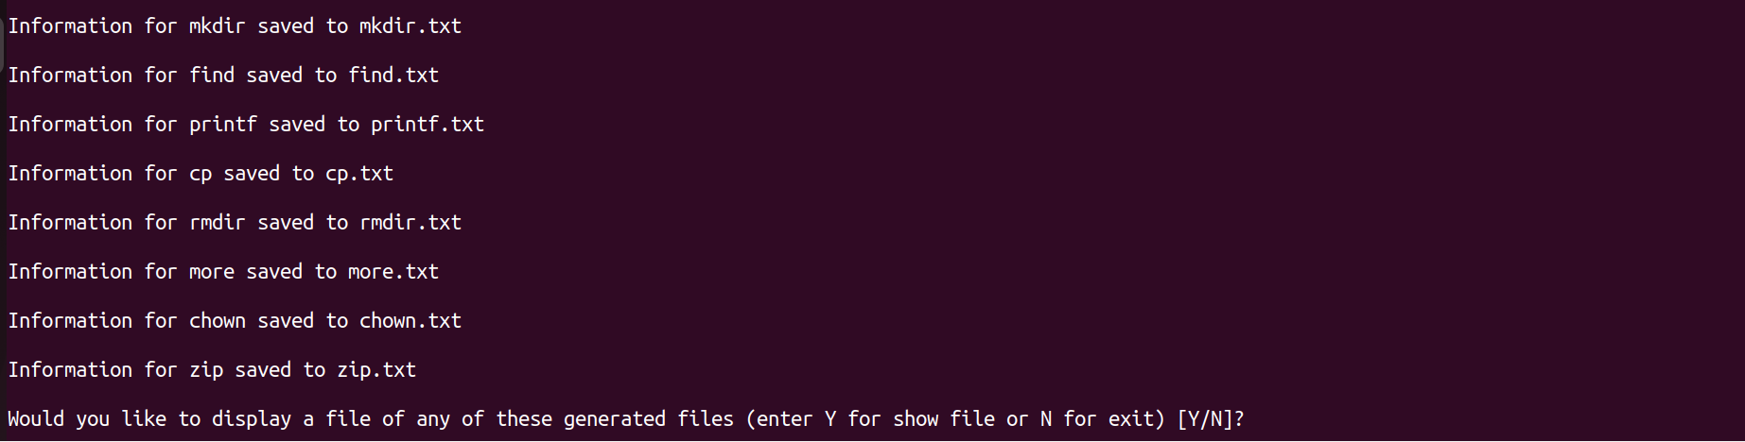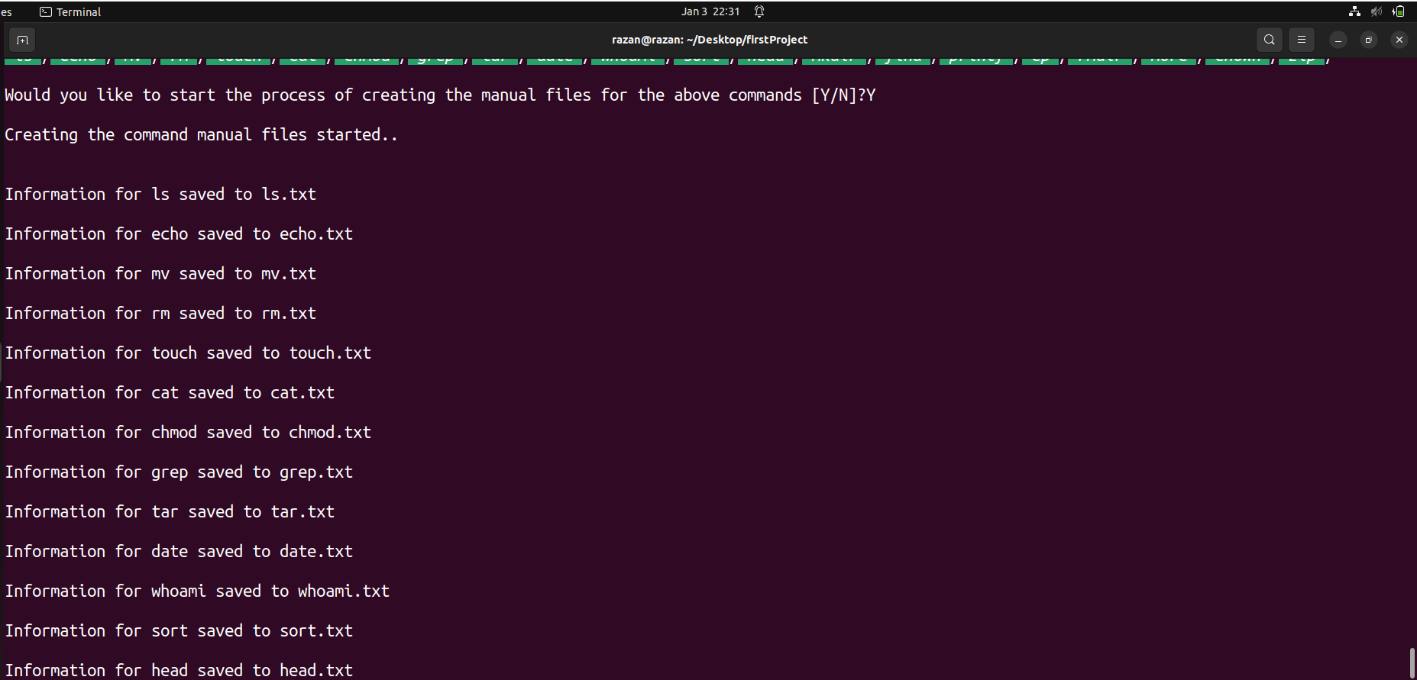If the user input was Y/y:

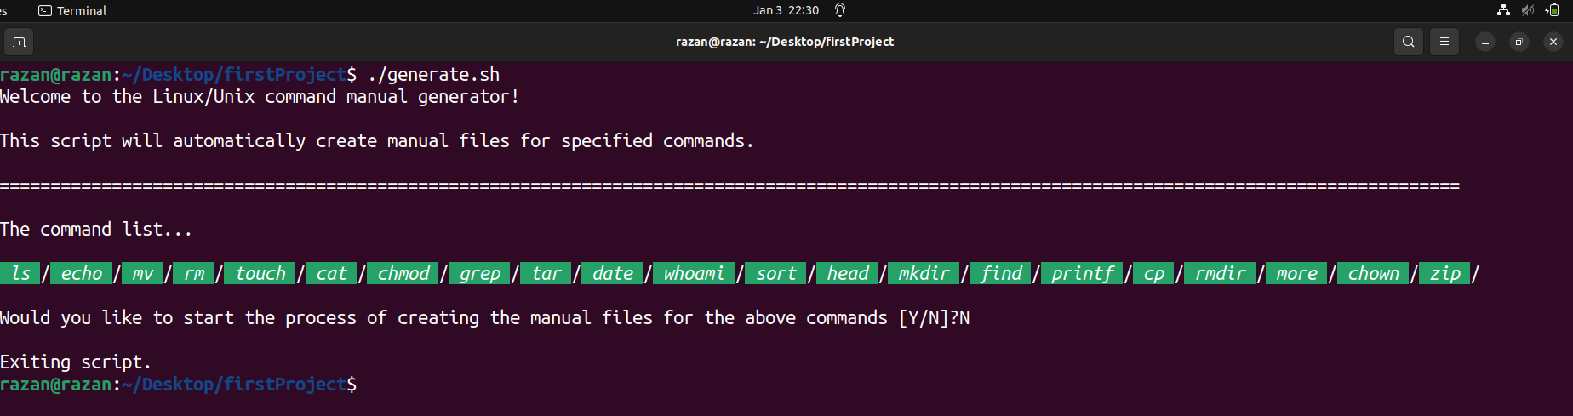If the user input was N/n:

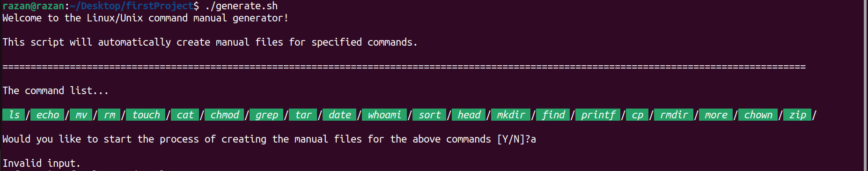Or any other input:

Now, if the user enter Y/y for yes, it mean the generation will start:

First of all, it will ask the user to display any of the generated files:

And here also there’s three option for the user: Y/y, N/n or other input.

If the user input was Y/y, the user will be asked to select the command name:

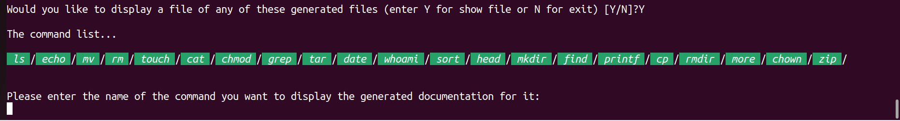

Examples of display some of the files:

* + - 1. First example: echo command.

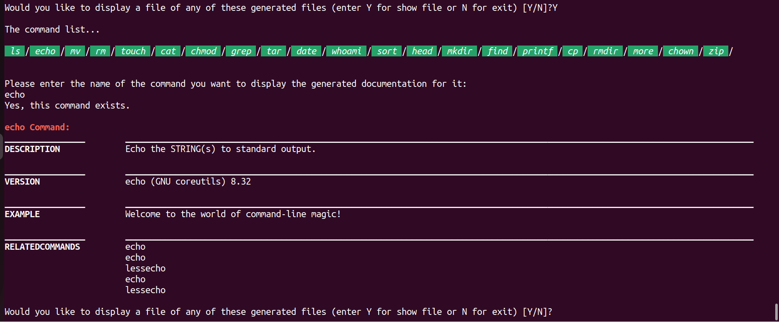

* + - 1. 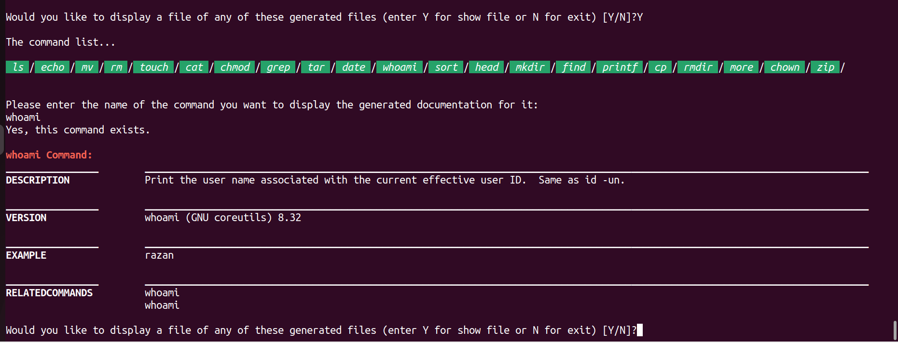Second example: Whoami command.
      2. 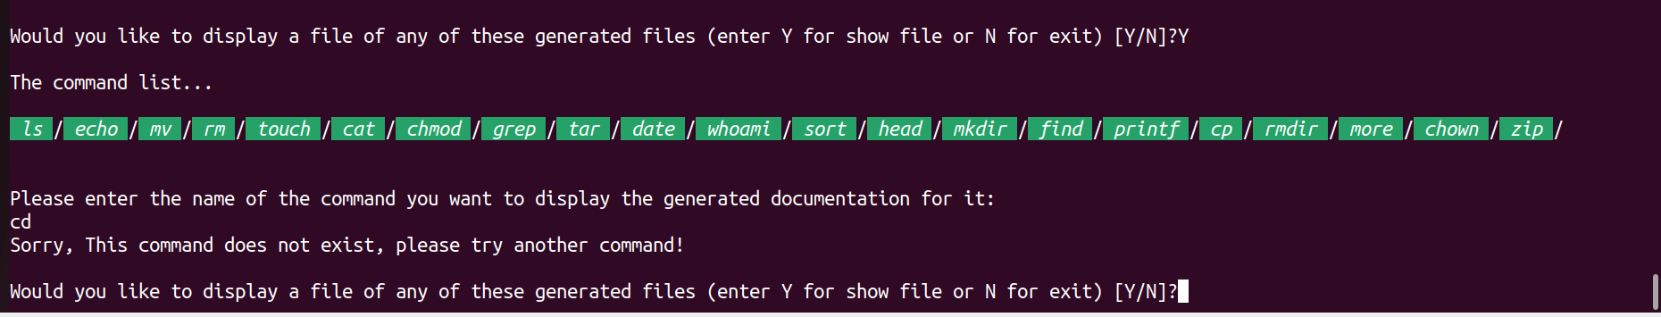Third example: example not found in the generated files.

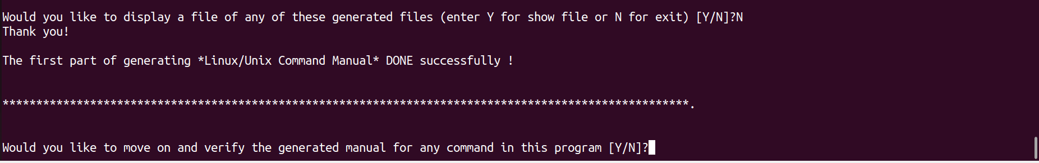If the user input was N/n, then the first part of generation the man is done succesfully!.

If the user input was anything else, it will handled like that:



************************************************************************

## **Second part:**

When the user enter N/n in the first part, that means the generation of man pages for the commands end and the second part which is verification is about to start:

The user will be asked to start the verification, so there three option also: Y/y, N/n or other input:

If the user input was Y/y, the user will asked to enter the name of the command:

Examples of verification some of the files:

1. 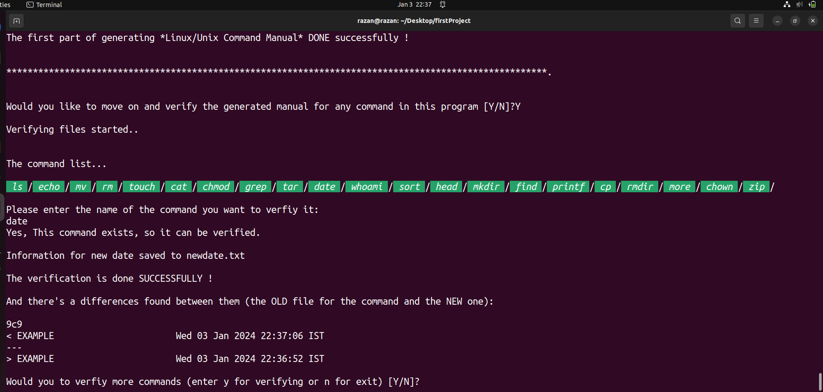The first example: date command, and there’s a differences.
2. 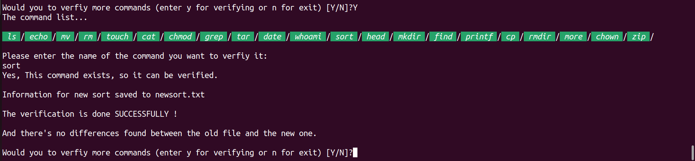The second example: Sort command, and there’s no differences.
3. The third example: command not found in the generated files.

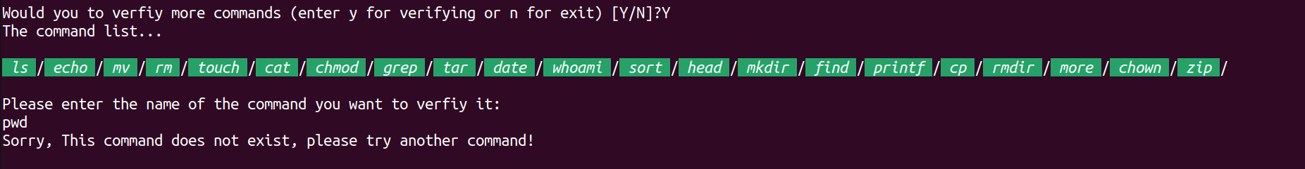

If the user input was N/n:

That means also the verification ended successfully.

And the last part is about to start:

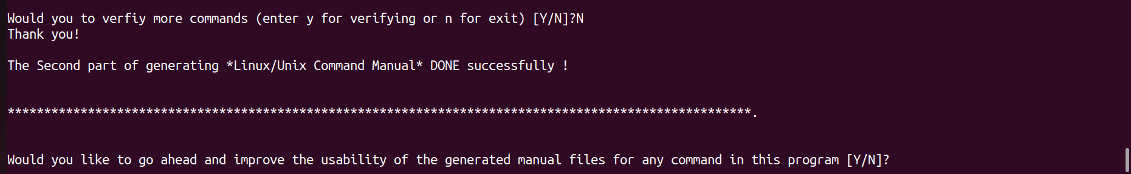

If the user input was anything else:

It will be handled like this:

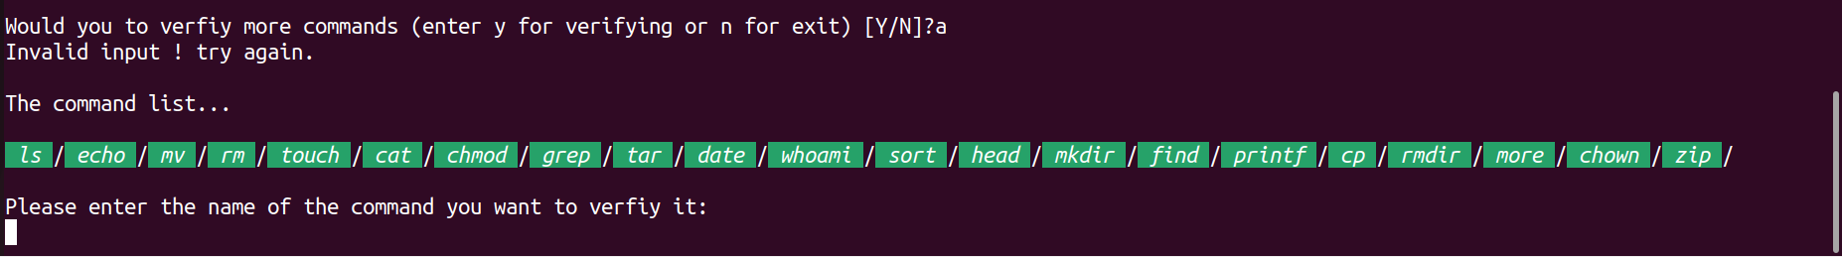

## **Third part:**

If the user input was N/n, so the third part “improvement” is about to start, the user will be asked to start this part:

If the user input was Y/y:

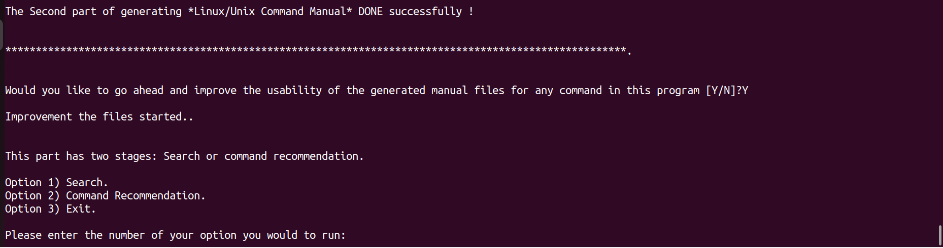

There’s a menu will be shown for the user to display the valid options in this part:

FIRST OPTION:

Search, in the search stage, there’s multiple options either:

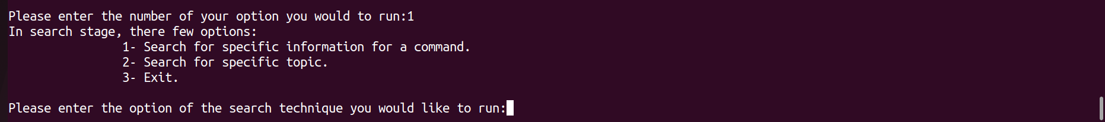

FIRST OPTION IN THE SEARCH:

Examples of search for some of the files:

1. First example: Zip command ask about VERSION:

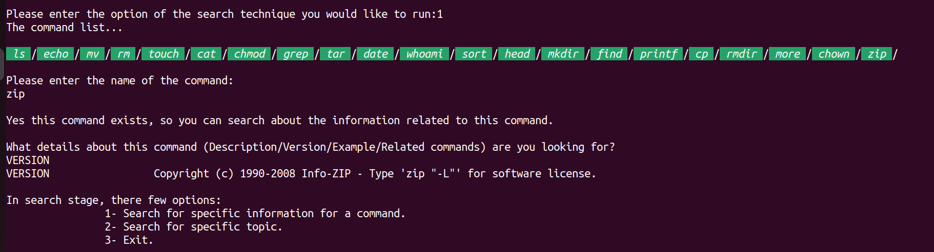

1. 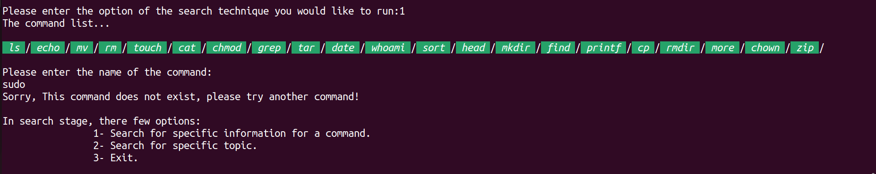Second example: command not found in the generated files.
2. 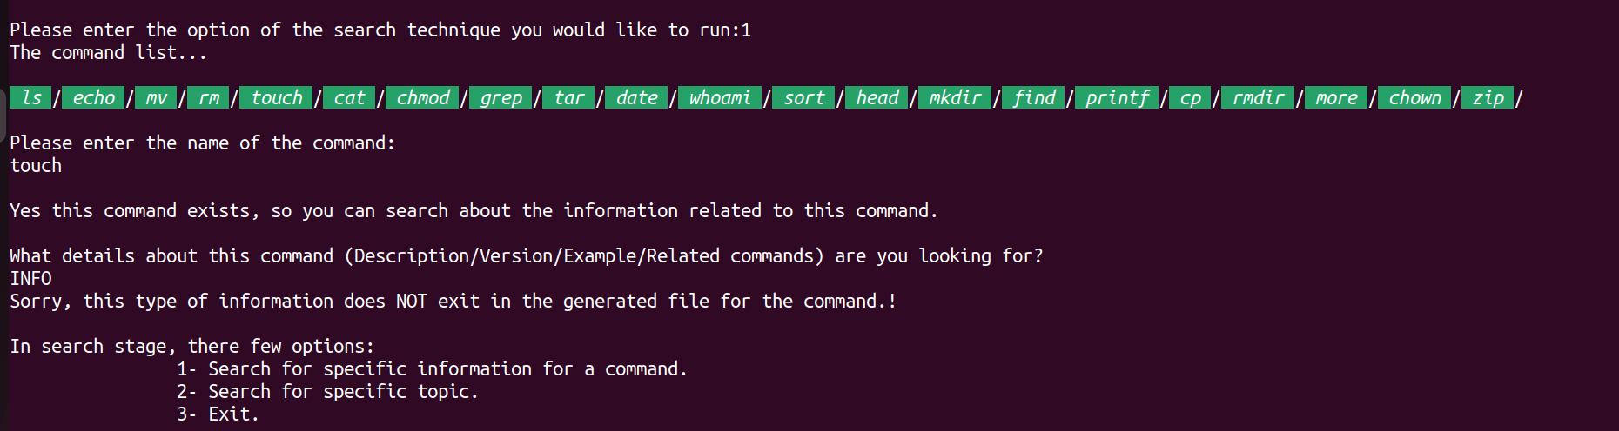Third example: command found, but data type not found.

SECOND OPTION IN THE SEARCH:

Examples of search for some of the files:

1. 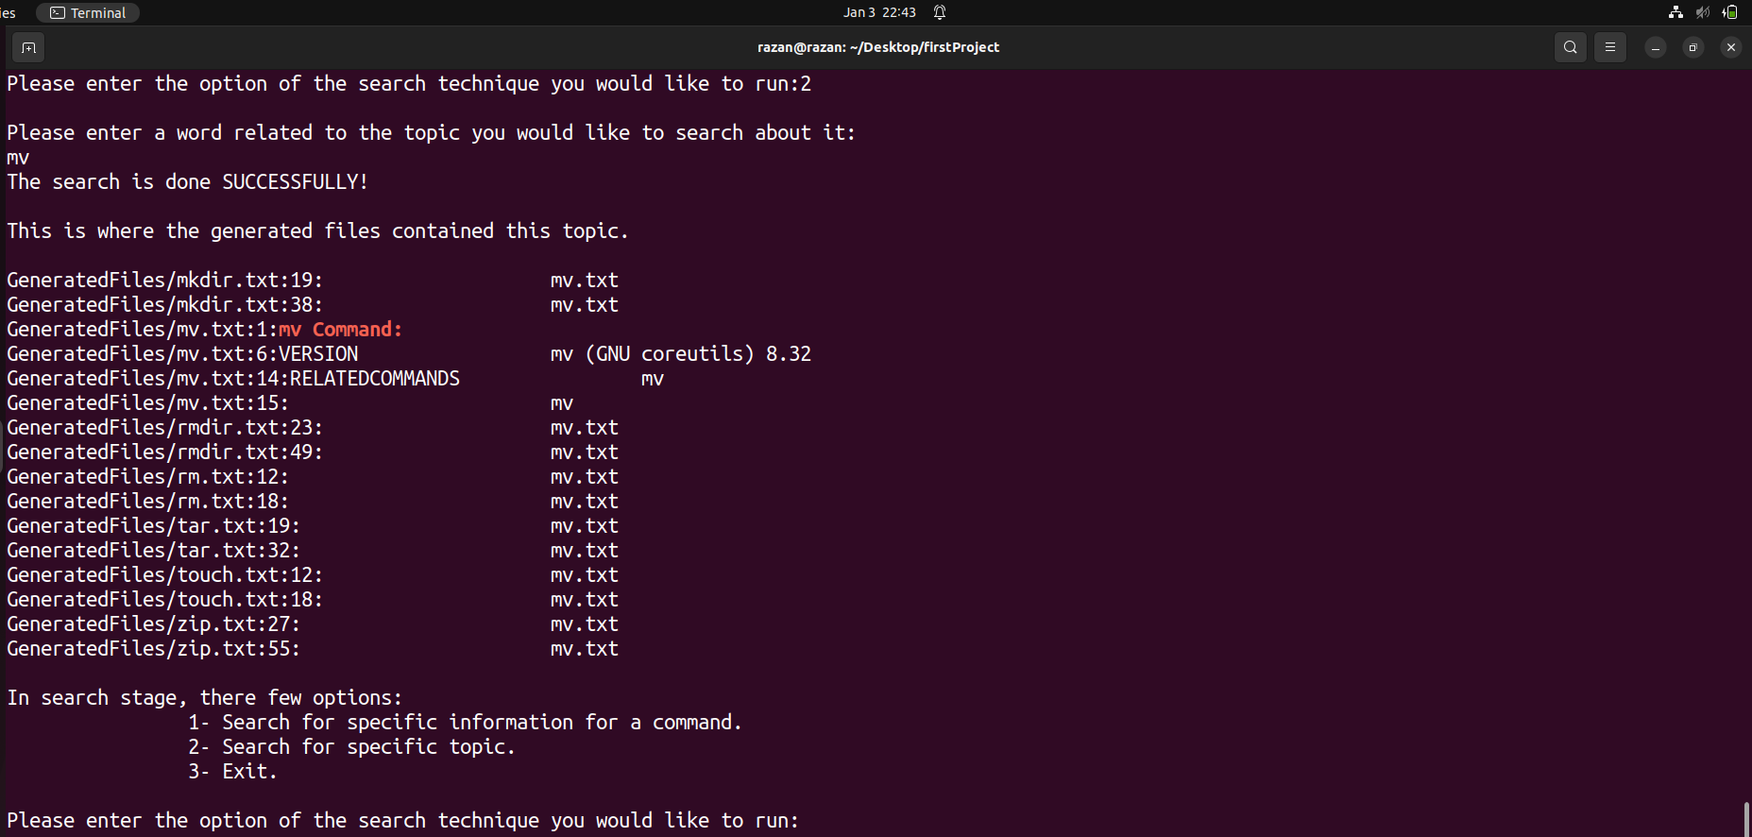First example: topic that founded in the files.
2. 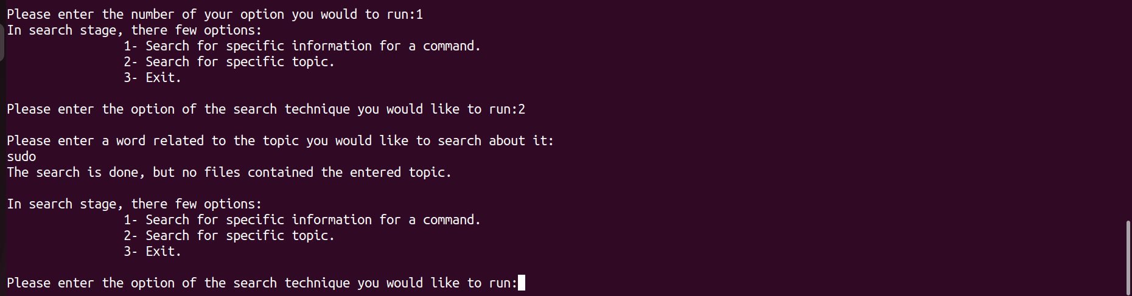Second example: topic not found in the files.

THIRD OPTION IN THE SEARCH:

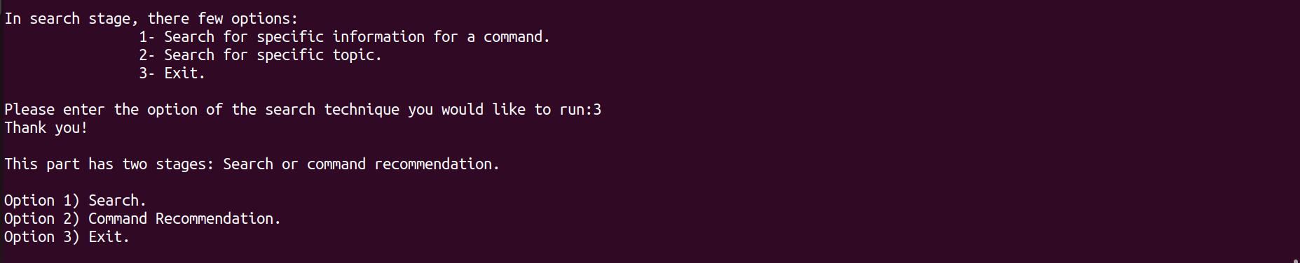

SECOND OPTION:

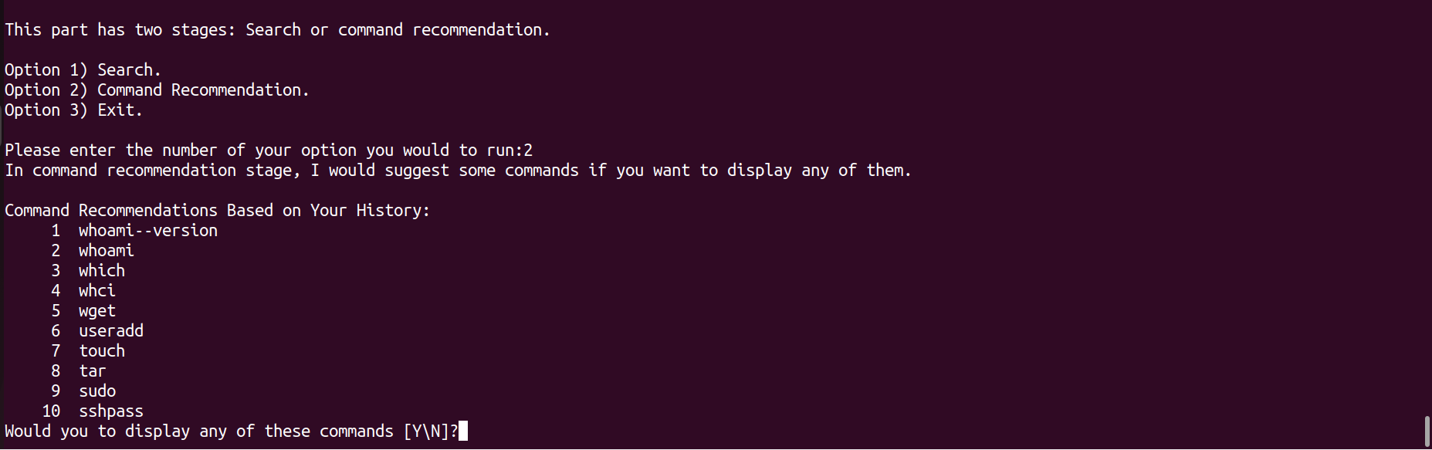The program will ask the user to suggest some commands according to its history:

Here, there’s three options for the user: Y/y, N/n or other input:

If the input user was Y/y,

It will be asked for the command name:

Examples:

1. Command found in the history and the generated files.

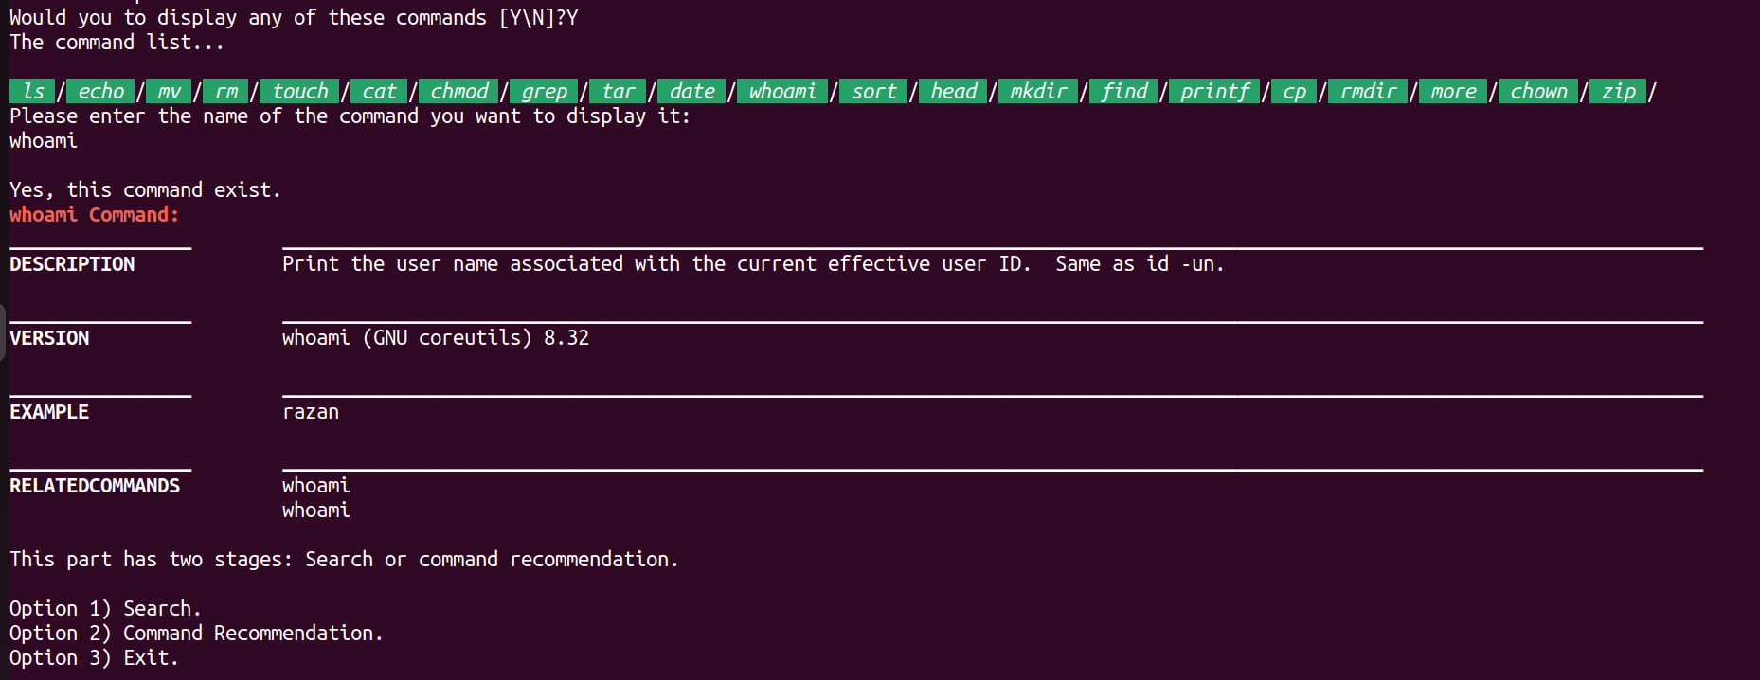

1. Command found in the history but not in the generated files.

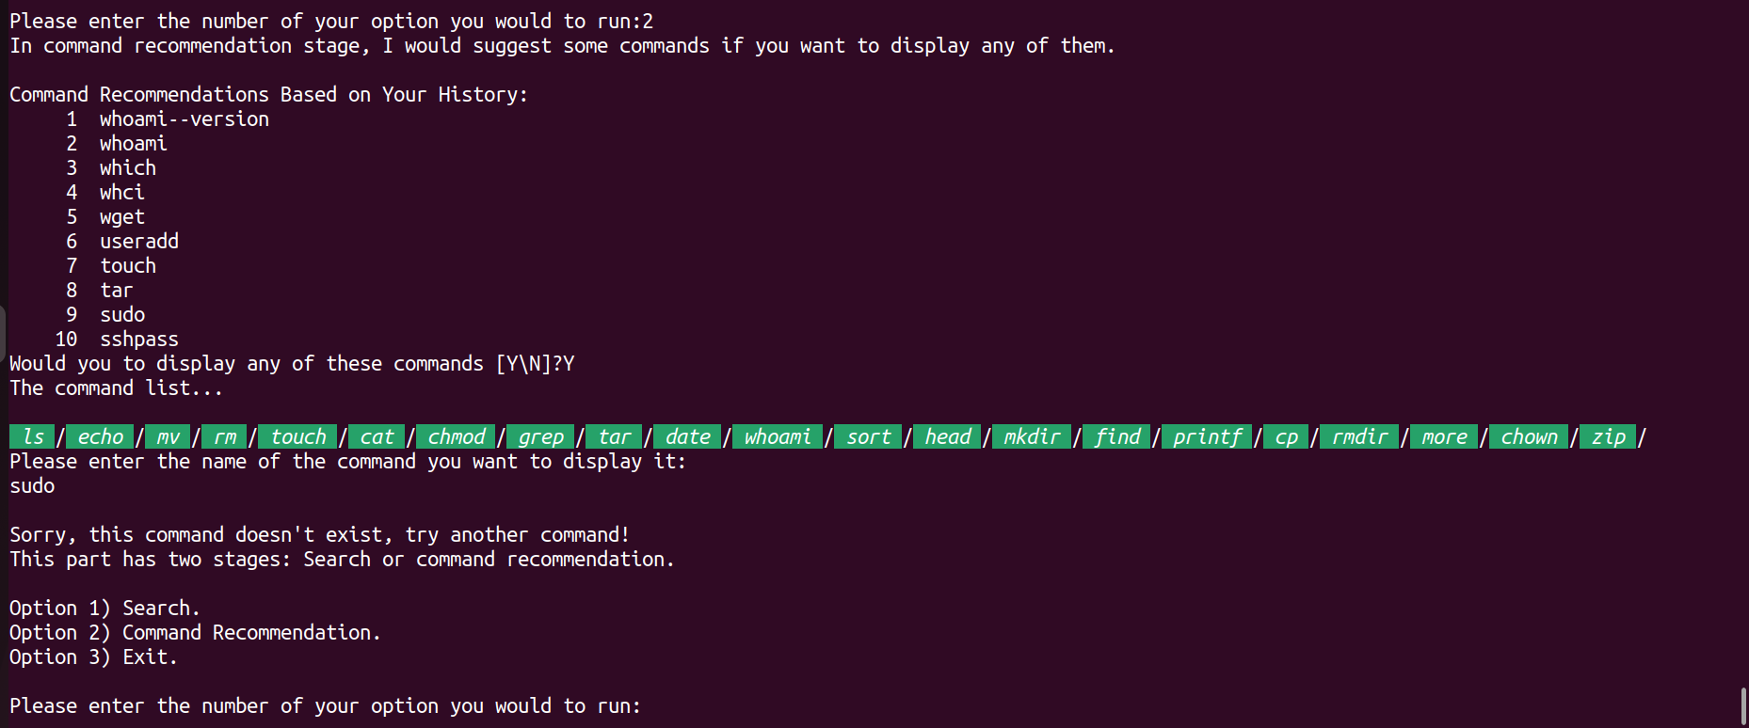

If the user input was N/n:

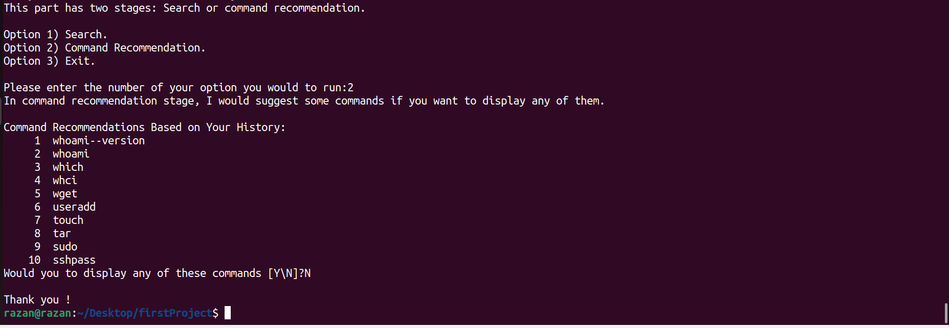

THIRD OPTION:

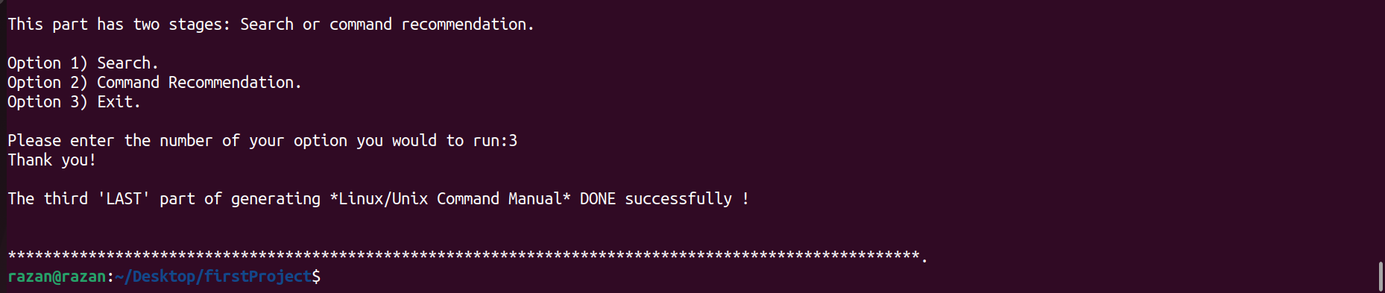

ANY OTHER OPTION:

