" بسم الله الرحمن الرحيم "



Faculty of Engineering and Technology.

Electrical and Computer Engineering Department.

ENCS3320-Computer Networks.

Second Semester – 2022|2023.

Project #2: Packet tracer.

******************************************************

**Students names (Prepared by):**

Razan Abdelrahman - 1200531.

Maisam Alaa - 1200650.

**Instructor name**: Dr. Abdalkarim Awad.

**Section:** 1.

**Date:** 4|July.

# **Abstract.**

This network design project offers a holistic approach to comprehend various aspects of network infrastructure implementation, sub netting, routing protocols, and the vital functions of essential network services. The inclusion of practical demonstrations utilizing Wireshark, ping, and tracert commands enhances the learning experience by providing hands-on exposure to real-world network scenarios.

**Table of Contents:**

➢ **Abstract.** 1

➢ **Part I.** 4

• First part. 4

❖ Function of DHCP, DNS and ICMP. 4

• Second part. 4

**** 5 fields of DHCP, DNS and ICMP. **4**

➢ **Part II.** 8

• Construct the network. 8

• Sub netting. 9

• IP configuration. 10

• OSPF configuration. 16

• DHCP configuration. 18

• Creating a DNS record. 20

• Reachability from one host to another host. 22

• Tracert commands. 24

Table of figures:

Figure 1 DHCP packets. 6

Figure 2 One packet from DHCP. 6

Figure 3 DNS packets. 7

Figure 4 One packet from DNS. 7

Figure 5 ICMP packets. 8

Figure 6 One packet from ICMP. 8

Figure 7 Our network. 9

Figure 8 IP addresses for router 0. 11

Figure 9 IP addresses for router 1. 12

Figure 10 IP addresses for router 2. 12

Figure 11 IP addresses for router 3. 13

Figure 12 DNS server IP configuration. 13

Figure 13 Web server IP configuration. 14

Figure 14 IP configuration for PC0. 14

Figure 15 IP configuration for PC1. 15

Figure 16 IP address for PC2. 15

Figure 17 IP address for PC3. 16

Figure 18 IP address for PC4. 16

Figure 19 OSPF1 configuration for router 0. 18

Figure 20 OSPF configuration for router 1. 18

Figure 21 OSPF configuration for router 2. 19

Figure 22 OSPF configuration for router3. 19

Figure 23 DHCP configuration for router 0. 20

Figure 24 Our web configuration. 21

Figure 25 Accessing our web from pc0. 22

Figure 26 Accessing our web from pc3. 22

Figure 27 PC0 ping other routers. 23

Figure 28 PC0 ping other PC's on the same network. 24

Figure 29 PC0 ping other PC's on diffrent network. 25

Figure 30 Tracert from PC3 to routers. 24

Figure 31 Tracert from PC3 to other PC's. 25

Table of tables:

Table 1 Sub netting. 10

# **Part I.**

## **First part.**

### **Function of DHCP, DNS and ICMP.**

**-DHCP**: (Dynamic Host Configuration Protocol) is responsible for assigning IP addresses and network configuration settings to devices on a network automatically.

**-DNS**: (Domain Name System) translates domain names (e.g., www.example.com) into IP addresses, enabling users to access websites and other network resources using human-readable names.

**-ICMP**: (Internet Control Message Protocol) is used for network diagnostic and error-reporting purposes, including ping requests and responses, to check the connectivity and reachability of devices on a network.

-----------------------------------------------------------------------------------------------------------

## **Second part.**

### **5 fields of DHCP, DNS and ICMP.**

* DHCP:

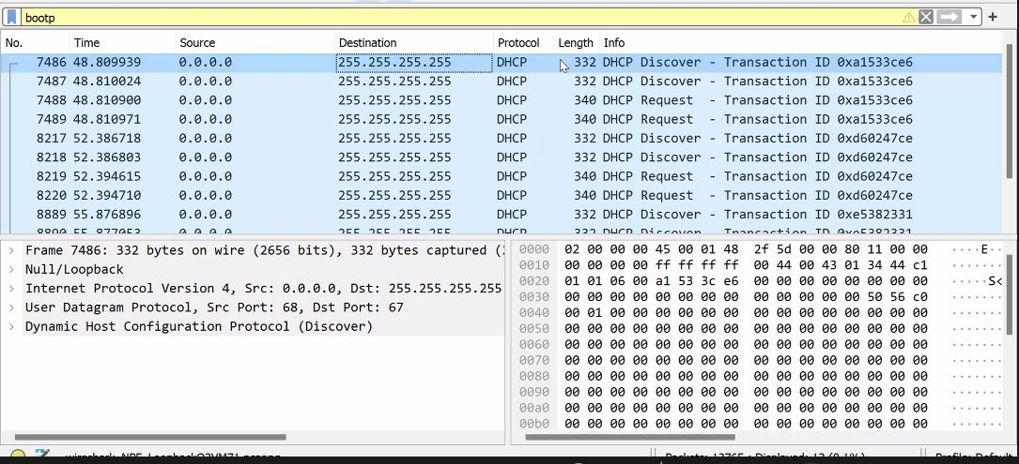

**Figure 1 DHCP packets.**

* Fields of DHCP packet:

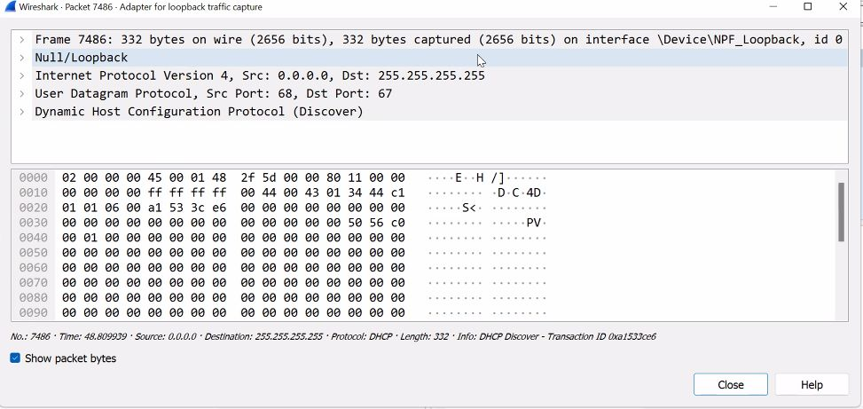

**Figure 2 One packet from DHCP.**

* Source: indicates the IP address of the DHCP client that is initiating the DHCP request or renewal: 0.0.0.0.
* Destination: refers to the destination IP address to which the packet is being sent: 255.255.255.255.
* Protocol: refers to the protocol number used in the IP header to indicate that the encapsulated data is: DHCP.
* Opcode: Specifies the type of DHCP message: DHCP discover.
* Transaction ID: A unique identifier to match requests and responses: 0xa1533ce6.

**********************************************

* DNS:

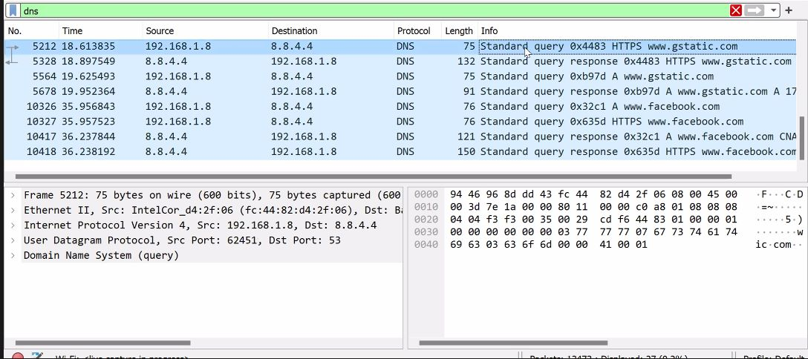

**Figure 3 DNS packets.**

* Fields of DNS packet:

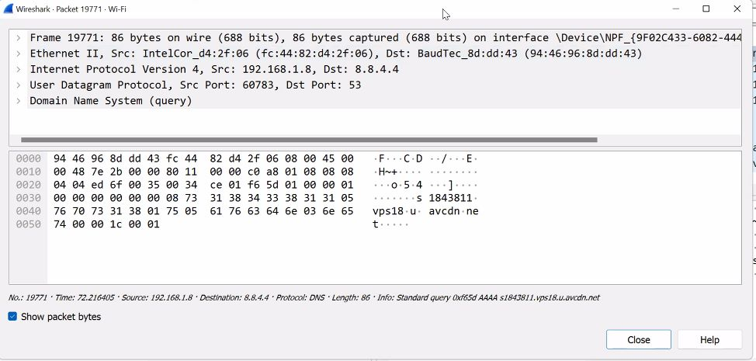

**Figure 4 One packet from DNS.**

* Source: The source IP address, which indicates the network host or device that sends the DNS packet: 192.168.1.8.
* Destination: refers to the destination IP address to which the packet is being sent: 8.8.4.4.
* Protocol: refers to the protocol number used in the IP header to indicate that the encapsulated data is: DNS.
* Src port: refers to the port number used by the sender of the DNS packet: 60783.
* Dst port: refers to the port number to which the DNS packet is being sent: 53.

************************************************

* ICMP:

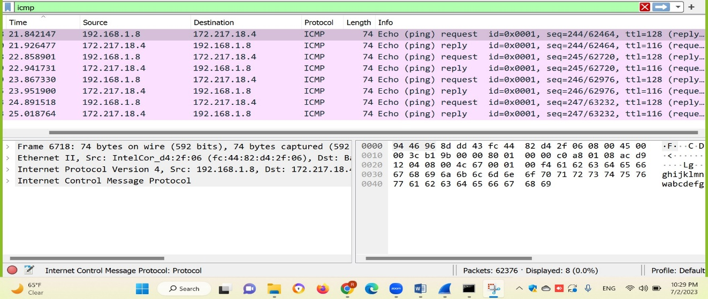

**Figure 5 ICMP packets.**

* Fields of ICMP packet:

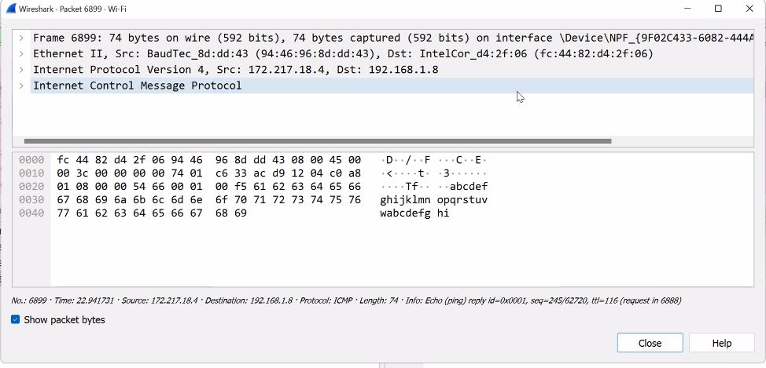

**Figure 6 One packet from ICMP.**

* Source: refers to the source IP address from which the ICMP packet originates: 172.217.18.4.
* Destination: refers to the destination IP address field in the IP header, which identifies the intended recipient of the ICMP packet: 192.168.1.8.
* Protocol: indicates that the encapsulated data follows the ICMP protocol, which is used for various network control and error messaging purposes: ICMP.
* Type: Specifies the type of ICMP message: Echo reply.
* Identifier ID: Used to match Echo Request and Echo Reply messages: 0x0001.

------------------------------------------------------------------------------------------------------------

# **Part II.**

## Construct the network.

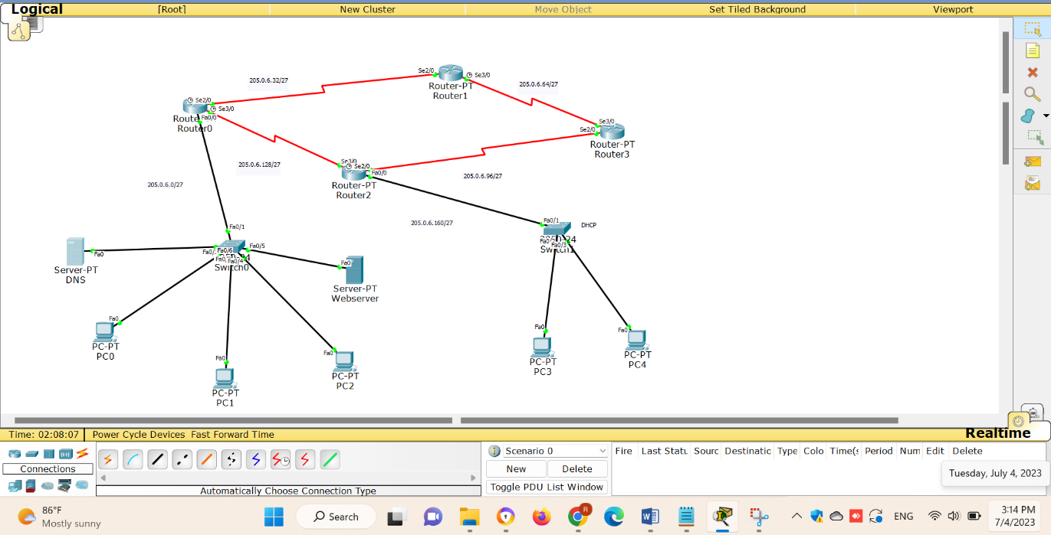

**Figure 7 Our network.**

We have designed a network using Packet Tracer that consists of 4 routers, 2 switches, and 5 PCs. The topology is based on a hierarchical design, which allows for efficient network management and scalability.

* Routers route data packets between networks, making decisions based on IP addresses to ensure efficient and accurate delivery of data.
* Switches facilitate communication within a local network by forwarding data packets to the intended destination based on MAC addresses, allowing for efficient and direct communication between connected devices.
* Web server is to host and distribute web content, such as websites and web applications, to clients both within the network and over the internet.
* DNS is responsible for translating domain names into their corresponding IP addresses.
* PC’s represent end-user devices and serve as the primary interface for users to access and interact with the network resources.

## Sub netting.

The ID that we used for IP addresses: 1200650.

|  |  |  |  |  |
| --- | --- | --- | --- | --- |
| **Subnet.** | **Network.** | **In binary.** | **Range (First IP Address-Last IP Address).** | **Broadcast IP.** |
| **First subnet.** | 205.0.6.0/27 | 205.0.6.00000000 | 205.0.6.1 –  205.0.6.30 | 205.0.6.31 |
| **Second subnet.** | 205.0.6.32/27 | 205.0.6.00100000 | 205.0.6.32 –  205.0.6.62 | 205.0.6.63 |
| **Third subnet.** | 205.0.6.64/27 | 205.0.6.01000000 | 205.0.6.64 –  205.0.6.94 | 205.0.6.95 |
| **Fourth subnet.** | 205.0.6.96/27 | 205.0.6.01100000 | 205.0.6.96 –  205.0.6126 | 205.0.6.127 |
| **Fifth subnet.** | 205.0.6.128/27 | 205.0.6.10000000 | 205.0.6.128 –  205.0.6.159 | 205.0.6.159 |
| **Sixth subnet.** | 205.0.6.160/27 | 205.0.6.10100000 | 205.0.6.160 –  205.0.6.190 | 205.0.6.191 |

**Table 1 Sub netting.**

\***Subnet mask: 255.255.255.224.**

**\*\*\*\*\*\*\*\*\*\*\*\*\*\*\*\*\*\*\*\*\*\*\*\*\*\*\*\*\*\*\*\*\*\*\*\*\*\*\*\*\*\*\*\*\*\*\*\*\*\*\*\*\*\*\*\*\*\*\*\*\*\*\*\*\*\*\*\*\*\*\*\***

## IP configuration.

According to the above sub netting, we gave the routers theses IP’s:

Router0:

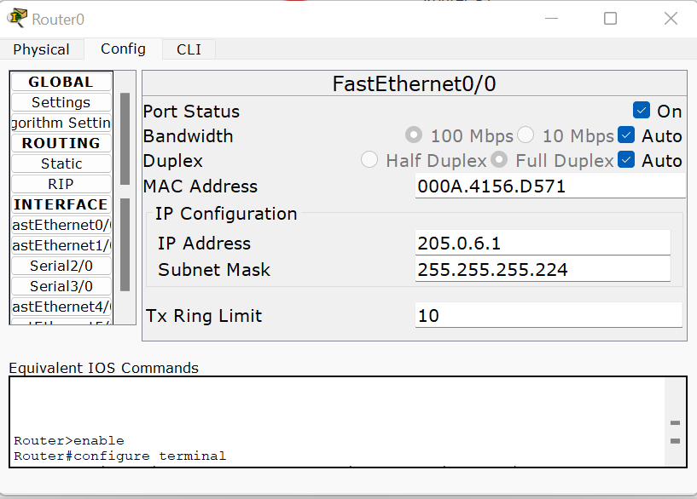 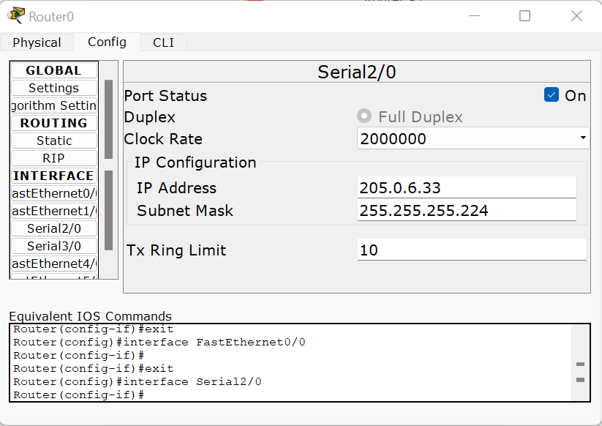

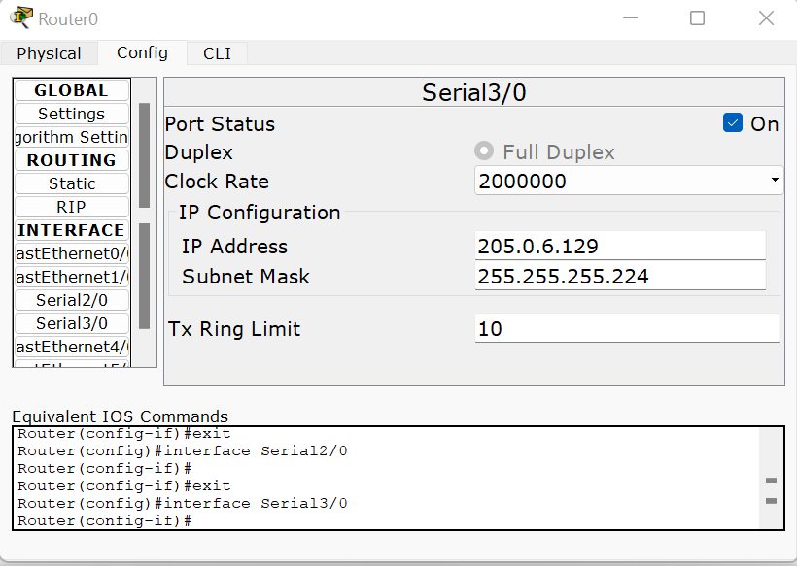

**Figure 8 IP addresses for router 0.**

Router1:

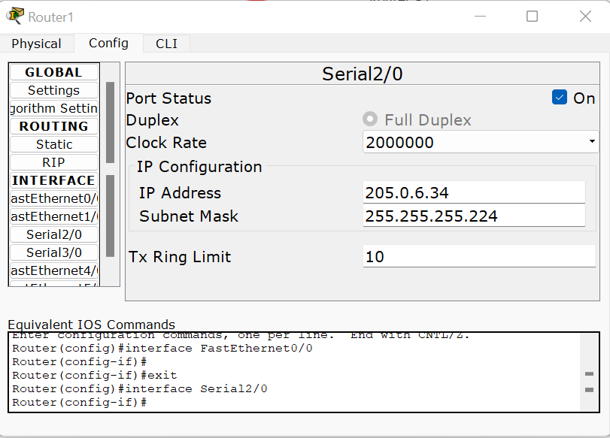 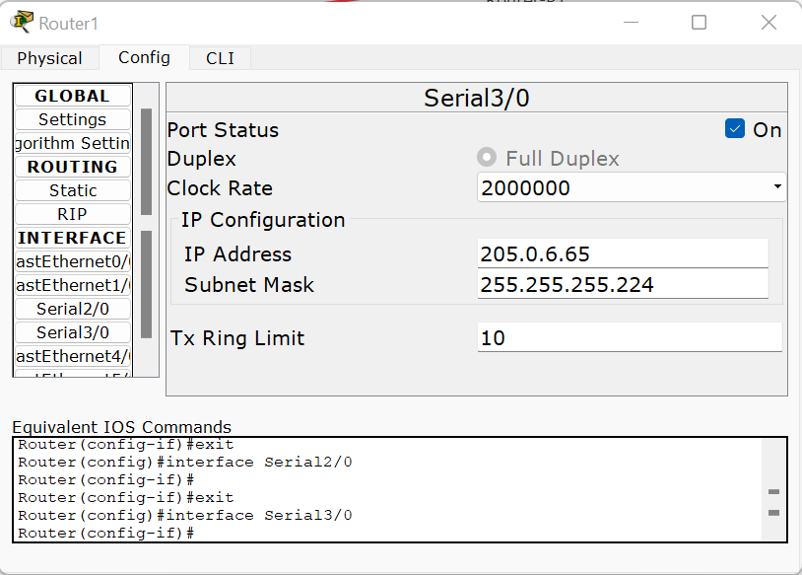

**Figure 9 IP addresses for router 1.**

Router2:

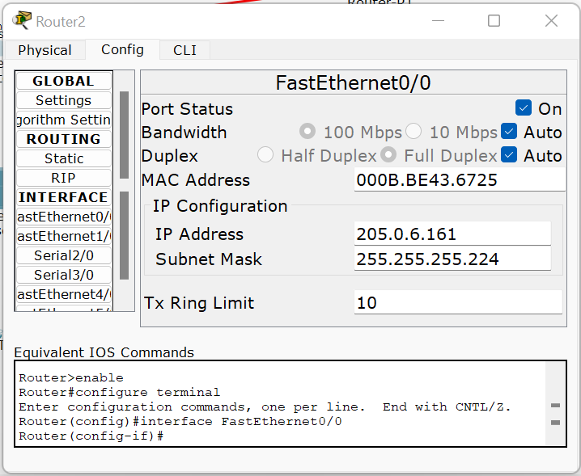 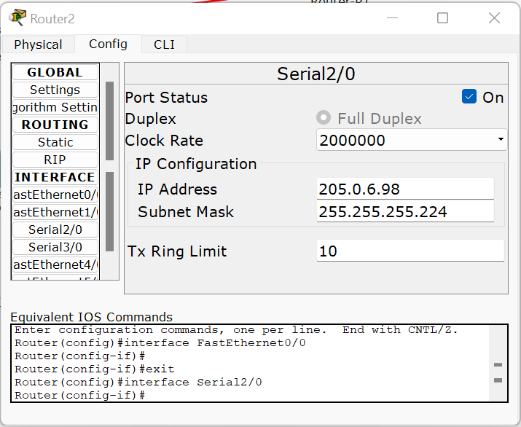

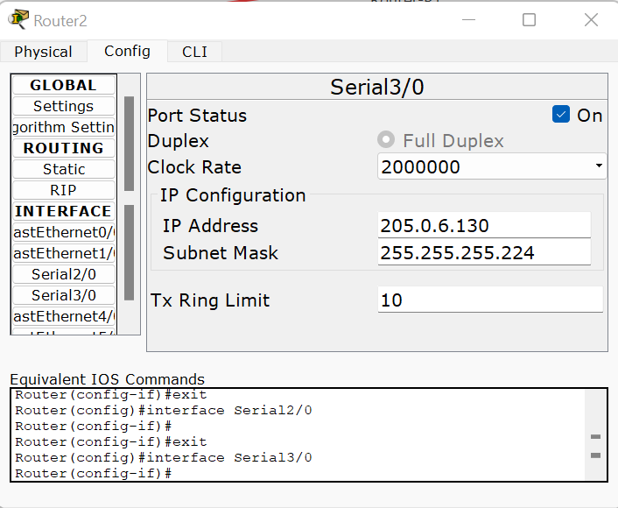

**Figure 10 IP addresses for router 2.**

Router3:

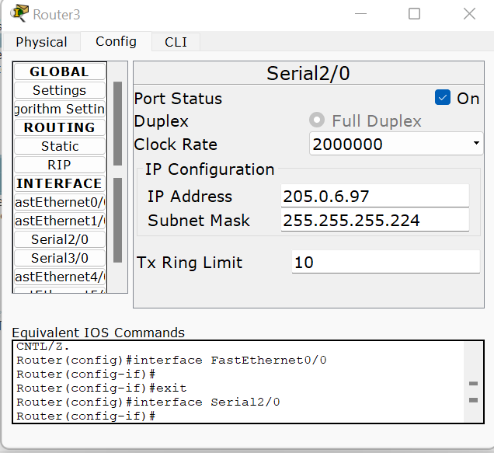 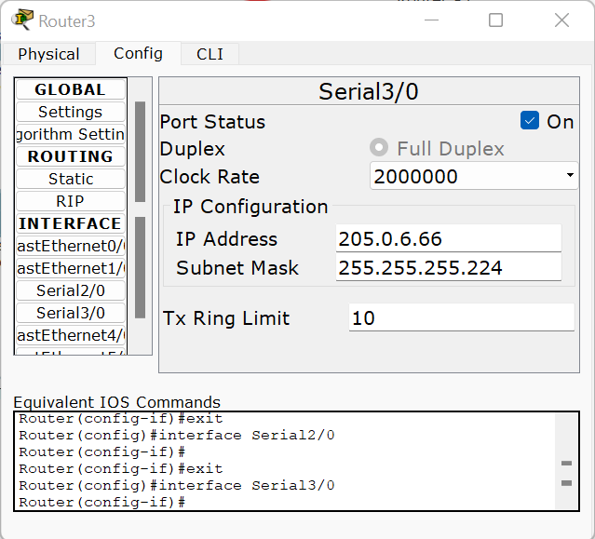

**Figure 11 IP addresses for router 3.**

DNS server:

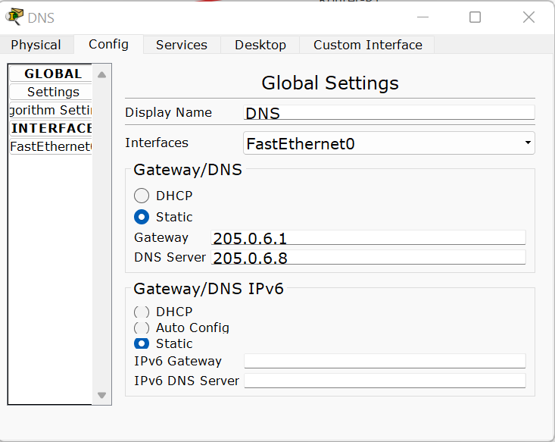

**Figure 12 DNS server IP configuration.**

Web server:

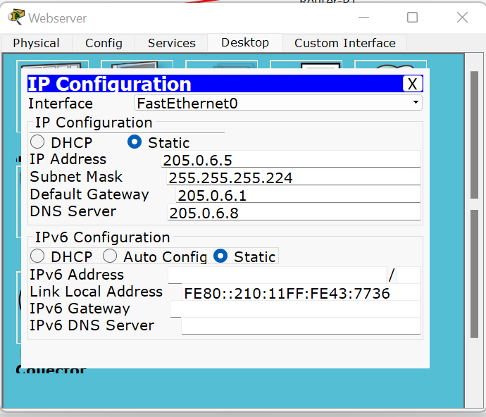

**Figure 13 Web server IP configuration.**

PC0:

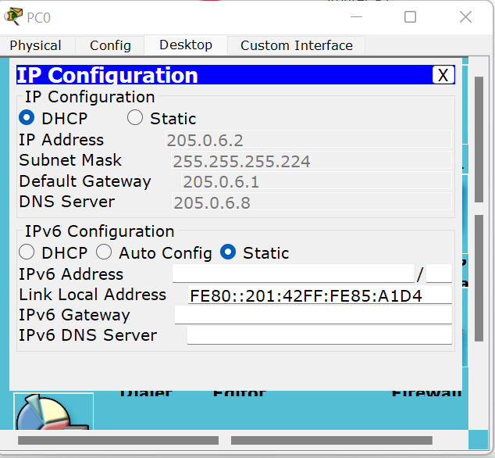

**Figure 14 IP configuration for PC0.**

PC1:

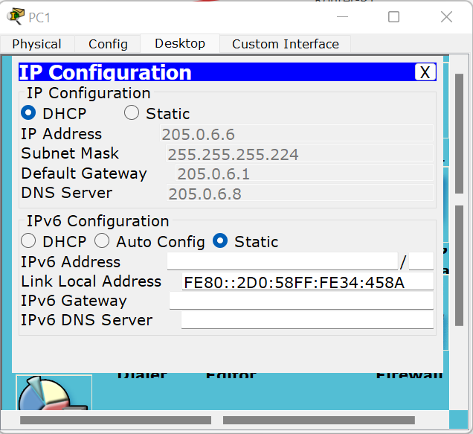

**Figure 15 IP configuration for PC1.**

PC2:

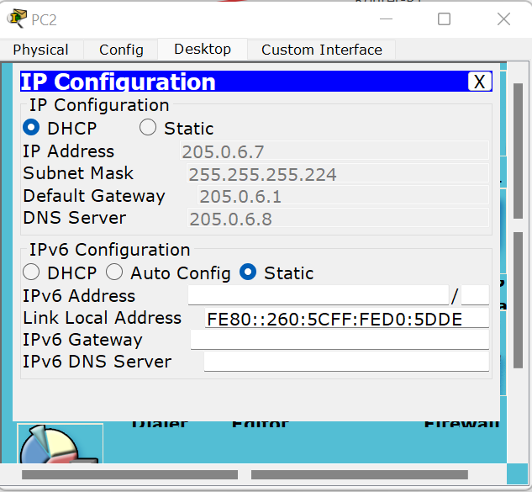

**Figure 16 IP address for PC2.**

PC3:

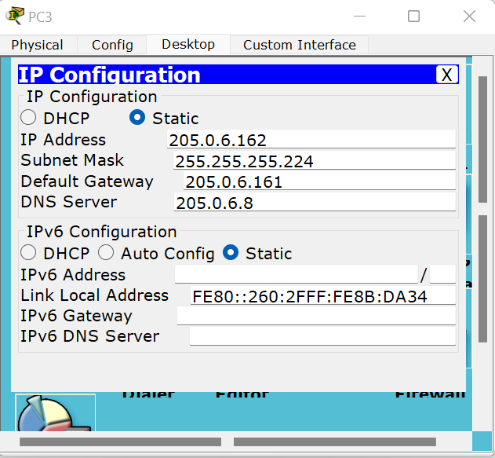

**Figure 17 IP address for PC3.**

PC4:

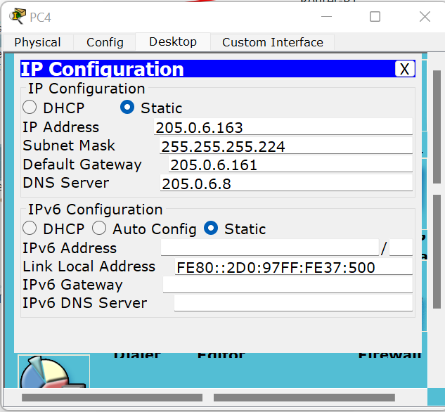

**Figure 18 IP address for PC4.**

******************************************************************************

## OSPF configuration.

OSPF (Open Shortest Path First) is a link-state routing protocol that is widely used in large-scale networks. It is designed to determine the shortest path and calculate the most efficient routing paths for data packets within a network.

The configuration ensures that routers exchange routing information, calculate the shortest path to destination networks, and dynamically update their routing tables based on OSPF's link-state database.

The signature of OSPF configuration:

R(config)#

R(config)#router ospf 1

R(config-router)#network ‘IP adderess’ ‘Wildcard’ area 0

R(config-router)#network ‘IP adderess’ ‘Wildcard’ area 0

For each router, we did the following:

Router0:

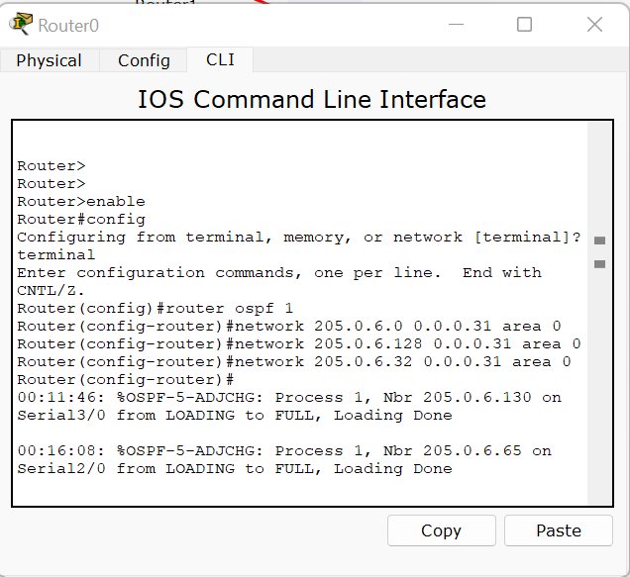

**Figure 19 OSPF1 configuration for router 0.**

Router1:

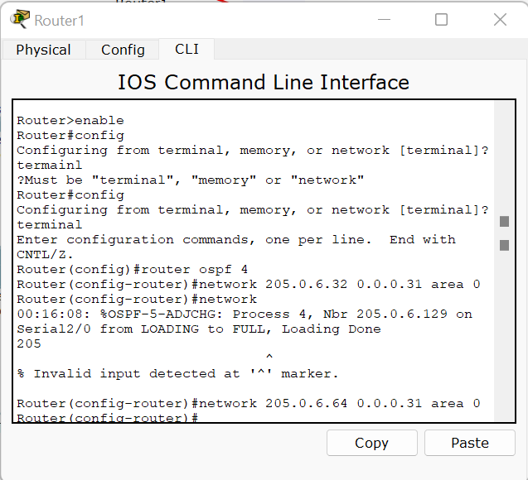

**Figure 20 OSPF configuration for router 1.**

Router2:

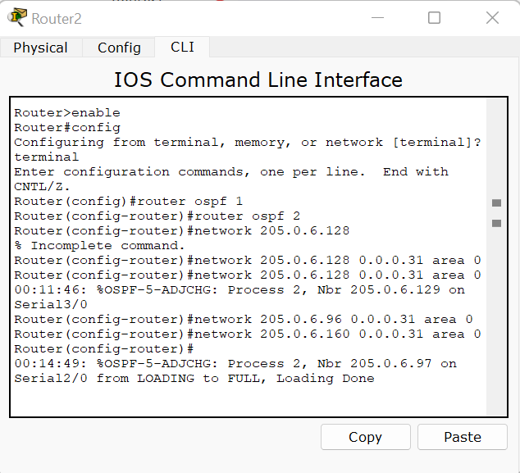

**Figure 21 OSPF configuration for router 2.**

Router3:

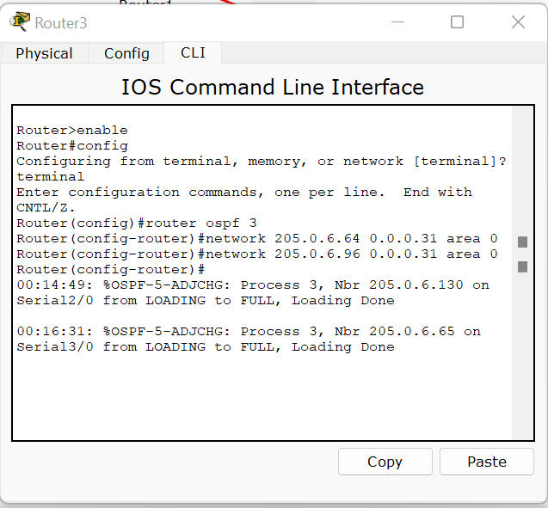

**Figure 22 OSPF configuration for router3.**

## DHCP configuration.

DHCP (Dynamic Host Configuration Protocol) configuration in a network involves setting up a DHCP server to automatically assign IP addresses, subnet masks, default gateways, DNS server addresses, and other network configuration parameters to client devices. The DHCP server manages a pool of available IP addresses and leases them to requesting devices for a specified period.

The DHCP configuration follow this signature:

Router(config)#

Router(config)#ip dhcp pool ‘lan name’

Router(dhcp-config)#network ‘IP address’ ‘Subnet mask’

Router(dhcp-config)#default-router ‘IP address’

Router(dhcp-config)#dns-server ‘IP address for the dns server’

We did the DHCP configuration for router0:

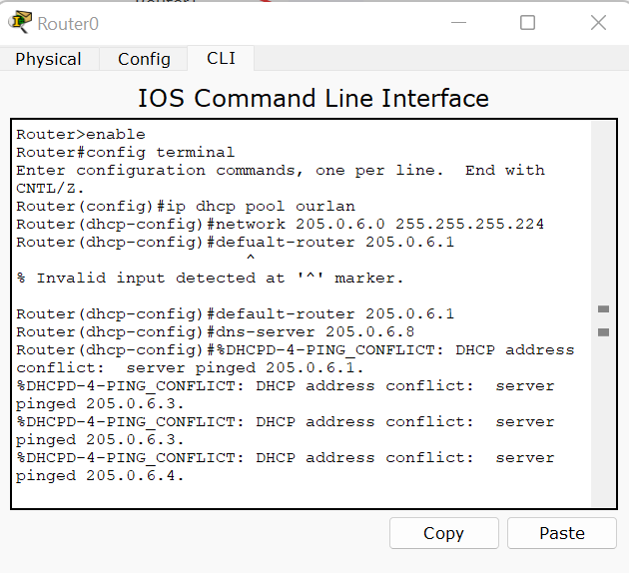

**Figure 23 DHCP configuration for router 0.**

******************************************************************************

## Creating a DNS record.

We added a record on the DNS server called [www.ourweb.com](http://www.ourweb.com) and we made a cname refer to it which was “ourweb.com” to indicate the server the www.ourweb.com same as ourweb.com

And we gave the IP address of webserver as IP address for it.

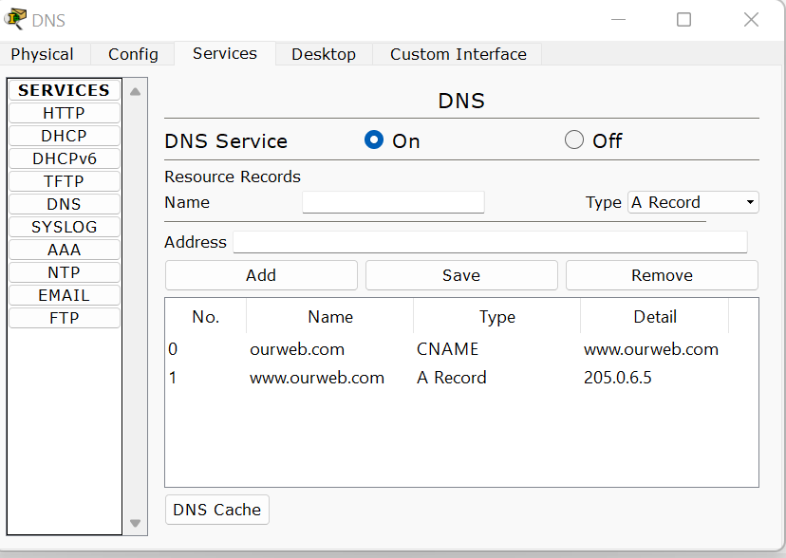

**Figure 24 Our web configuration.**

Then, we check from different PC’s, if we can reach this website correctly.

And we changed in the HTML page for the website, we added the name of the course “ENCS3320” as it shown.

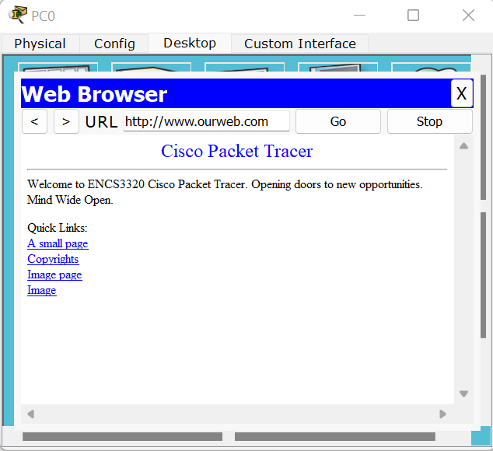

**Figure 25 Accessing our web from pc0.**

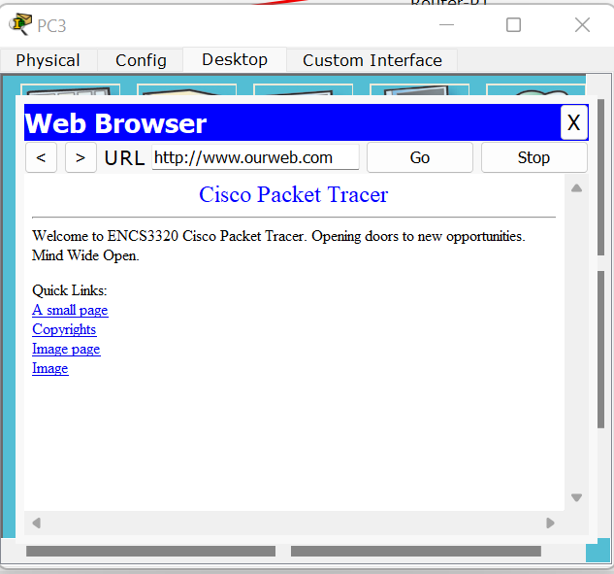

**Figure 26 Accessing our web from pc3.**

******************************************************************************

## Reachability from one host to another host.

* PC0 Ping router0 which has IP address 205.0.6.1 and router2 which has IP address 205.0.6.161.

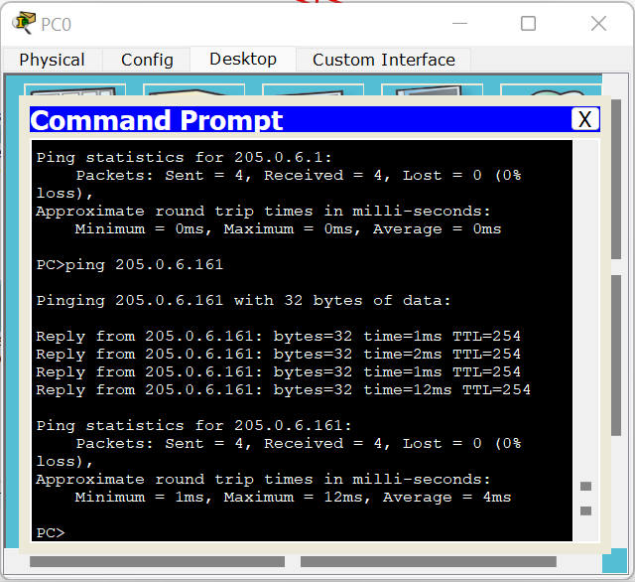

**Figure 27 PC0 ping other routers.**

* PC0 Ping router1 which has IP address 205.0.6.6 and router2 which has IP address 205.0.6.7 (On the same network).

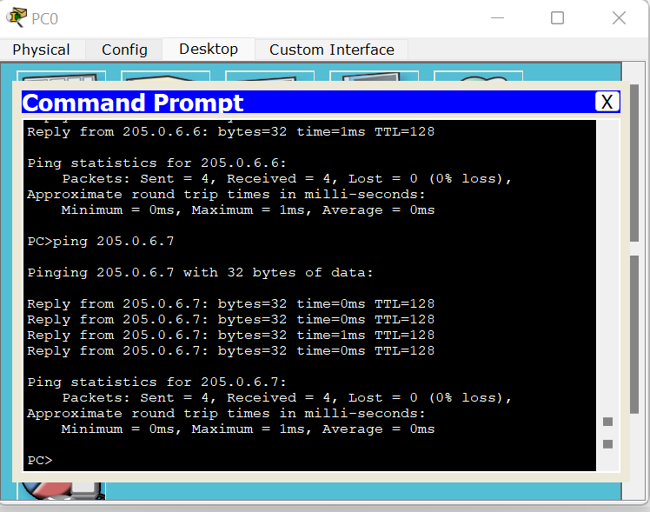

**Figure 28 PC0 ping other PC's on the same network.**

* PC0 Ping PC3 which has IP address 205.0.6.162 and PC4 which has IP address 205.0.6.163 (On different networks).

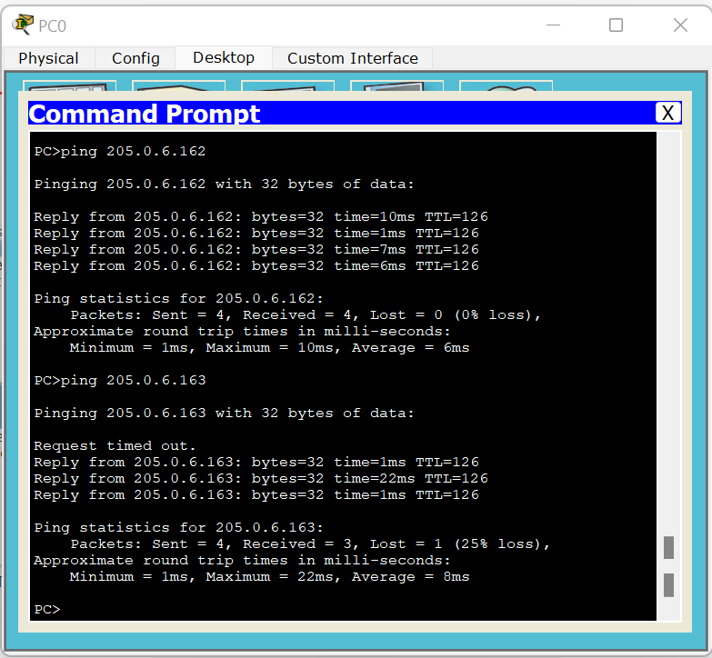

**Figure 29 PC0 ping other PC's on diffrent network.**

******************************************************************************

## Tracert commands.

Tracert command is to show the path a packet traversed to reach its destination from each subnet host to a remote destination.

So we applied this command from PC3 to other devices:

* Tracert from PC3 to router0 which has the IP address 205.0.6.1, then tracert from PC3 to router2 which has IP address 205.0.6.161.

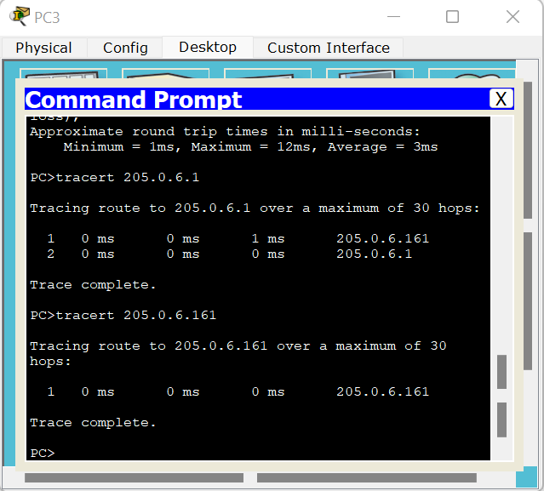

**Figure 30 Tracert from PC3 to routers.**

* Tracert from PC3 to PC0 which has IP address 205.0.6.2 on different network,

Then tracert from PC3 to PC2 which has IP address 205.0.6.4 on different network either,

Then tracert from PC3 to PC4 which has IP address 205.0.6.163 on the same network.

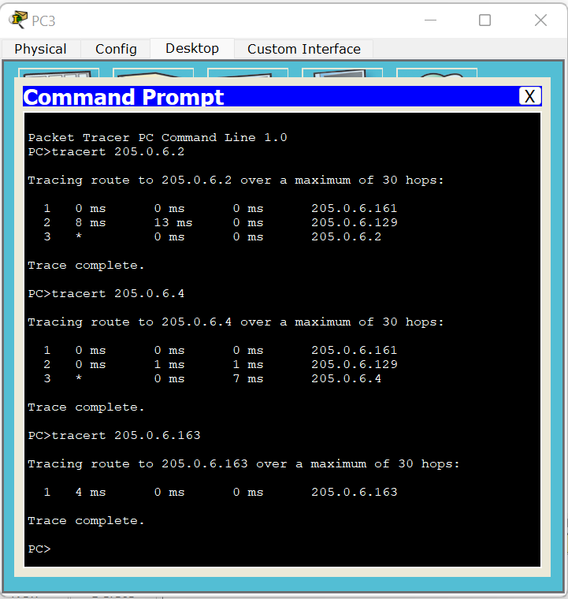

**Figure 31 Tracert from PC3 to other PC's.**

******************************************************************************