Constructors in Java

In [Java](https://www.javatpoint.com/java-tutorial), a constructor is a block of codes similar to the method. It is called when an instance of the [class](https://www.javatpoint.com/object-and-class-in-java) is created. At the time of calling constructor, memory for the object is allocated in the memory.

It is a special type of method which is used to initialize the object.

Every time an object is created using the new() keyword, at least one constructor is called.

It calls a default constructor if there is no constructor available in the class. In such case, Java compiler provides a default constructor by default.

There are two types of constructors in Java: no-arg constructor, and parameterized constructor.

**Note:** It is called constructor because it constructs the values at the time of object creation. It is not necessary to write a constructor for a class. It is because java compiler creates a default constructor if your class doesn't have any.

### **Rules for creating Java constructor**

There are two rules defined for the constructor.

1. Constructor name must be the same as its class name
2. A Constructor must have no explicit return type
3. A Java constructor cannot be abstract, static, final, and synchronized

## **Types of Java constructors**

There are two types of constructors in Java:

1. Default constructor (no-arg constructor)
2. Parameterized constructor

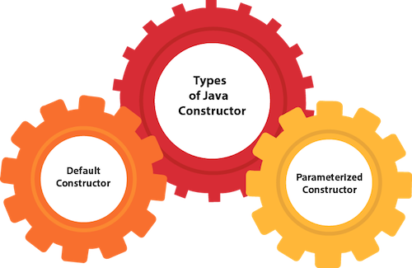

## **Java Default Constructor**

A constructor is called "Default Constructor" when it doesn't have any parameter.

### **Q) What is the purpose of a default constructor?**

The default constructor is used to provide the default values to the object like 0, null, etc., depending on the type.

### **Java Parameterized Constructor**

A constructor which has a specific number of parameters is called a parameterized constructor.

### **Why use the parameterized constructor?**

The parameterized constructor is used to provide different values to distinct objects. However, you can provide the same values also.

## **Constructor Overloading in Java**

In Java, a constructor is just like a method but without return type. It can also be overloaded like Java methods.

Constructor [overloading in Java](https://www.javatpoint.com/method-overloading-in-java) is a technique of having more than one constructor with different parameter lists. They are arranged in a way that each constructor performs a different task. They are differentiated by the compiler by the number of parameters in the list and their types.