Inheritance in Java

**Inheritance in Java** is a mechanism in which one object acquires all the properties and behaviors of a parent object. It is an important part of [OOPs](https://www.javatpoint.com/java-oops-concepts) (Object Oriented programming system).

The idea behind inheritance in Java is that you can create new [classes](https://www.javatpoint.com/object-and-class-in-java) that are built upon existing classes. When you inherit from an existing class, you can reuse methods and fields of the parent class. Moreover, you can add new methods and fields in your current class also.

Inheritance represents the **IS-A relationship** which is also known as a parent-child relationship.

### **Why use inheritance in java**

* For [Method Overriding](https://www.javatpoint.com/method-overriding-in-java) (so [runtime polymorphism](https://www.javatpoint.com/runtime-polymorphism-in-java) can be achieved).
* For Code Reusability.

### **Terms used in Inheritance**

* **Class:** A class is a group of objects which have common properties. It is a template or blueprint from which objects are created.
* **Sub Class/Child Class:** Subclass is a class which inherits the other class. It is also called a derived class, extended class, or child class.
* **Super Class/Parent Class:** Superclass is the class from where a subclass inherits the features. It is also called a base class or a parent class.
* **Reusability:** As the name specifies, reusability is a mechanism which facilitates you to reuse the fields and methods of the existing class when you create a new class. You can use the same fields and methods already defined in the previous class.

### **The syntax of Java Inheritance**

1. **class** Subclass-name **extends** Superclass-name
2. {
3. //methods and fields
4. }

The **extends keyword** indicates that you are making a new class that derives from an existing class. The meaning of "extends" is to increase the functionality.

In the terminology of Java, a class which is inherited is called a parent or superclass, and the new class is called child or subclass.

[**Next →**](https://www.javatpoint.com/aggregation-in-java)[**← Prev**](https://www.javatpoint.com/this-keyword)

# Inheritance in Java

1. [Inheritance](https://www.javatpoint.com/inheritance-in-java)
2. [Types of Inheritance](https://www.javatpoint.com/inheritance-in-java#inheritancetypes)
3. [Why multiple inheritance is not possible in Java in case of class?](https://www.javatpoint.com/inheritance-in-java#inheritancenotmultiple)

**Inheritance in Java** is a mechanism in which one object acquires all the properties and behaviors of a parent object. It is an important part of [OOPs](https://www.javatpoint.com/java-oops-concepts) (Object Oriented programming system).

The idea behind inheritance in Java is that you can create new [classes](https://www.javatpoint.com/object-and-class-in-java) that are built upon existing classes. When you inherit from an existing class, you can reuse methods and fields of the parent class. Moreover, you can add new methods and fields in your current class also.

Inheritance represents the **IS-A relationship** which is also known as a parent-child relationship.

### **Why use inheritance in java**

* For [Method Overriding](https://www.javatpoint.com/method-overriding-in-java) (so [runtime polymorphism](https://www.javatpoint.com/runtime-polymorphism-in-java) can be achieved).
* For Code Reusability.

### **Terms used in Inheritance**

* **Class:** A class is a group of objects which have common properties. It is a template or blueprint from which objects are created.
* **Sub Class/Child Class:** Subclass is a class which inherits the other class. It is also called a derived class, extended class, or child class.
* **Super Class/Parent Class:** Superclass is the class from where a subclass inherits the features. It is also called a base class or a parent class.
* **Reusability:** As the name specifies, reusability is a mechanism which facilitates you to reuse the fields and methods of the existing class when you create a new class. You can use the same fields and methods already defined in the previous class.

### **The syntax of Java Inheritance**

1. **class** Subclass-name **extends** Superclass-name
2. {
3. //methods and fields
4. }

The **extends keyword** indicates that you are making a new class that derives from an existing class. The meaning of "extends" is to increase the functionality.

In the terminology of Java, a class which is inherited is called a parent or superclass, and the new class is called child or subclass.

### **Java Inheritance Example**

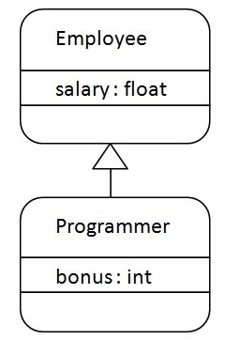

As displayed in the above figure, Programmer is the subclass and Employee is the superclass. The relationship between the two classes is **Programmer IS-A Employee**. It means that Programmer is a type of Employee.

## **Types of inheritance in java**

On the basis of class, there can be three types of inheritance in java: single, multilevel and hierarchical.

In java programming, multiple and hybrid inheritance is supported through interface only.

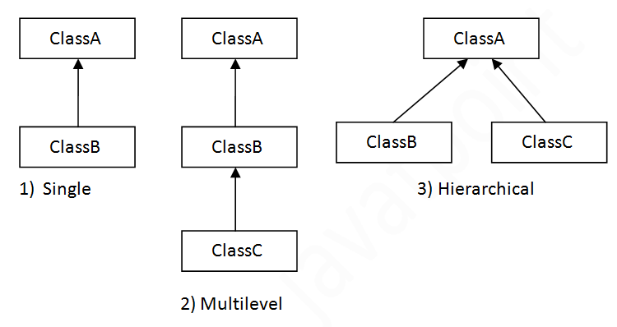

When one class inherits multiple classes, it is known as multiple inheritance. For Example:

