Abstract
CDMS is an experiment [that searches for a hypothetical particle, ] Dark matter. [In most models, Dark Matter will – very rarely – interact with normal matter.] [The CDMS experiment uses ordinary matter – silicon and germanium – as detectors to search for ] Dark Matter. [If Dark Matter interacts with the crystal, sensors detect the resulting motion of the atoms ] and sends back physics signals with noise. [Identifying the types of noise is a time-consuming task that significantly impacts the reach of the CDMS Dark Matter search.] This research aims at using a Machine learning algorithm that forms a bases of identifying the types of signals produced.

Method Used
We are using K-means clustering to group similar type of [time-series] data. The basic principle of k-means involves determining the distances between each data point and grouping them into meaningful clusters. This process is usually demonstrated using two-dimensional data on a plane.

Data set Extraction.
The following code extracts the required data from the detectors to be analyzed and a bases can be formed out of it.

import json
import pandas as pd
import numpy as np
import matplotlib.pyplot as plt
with open('data.json') as json_file:
json_data = json.load(json_file)
data = pd.DataFrame(json_data['data'])
plt.plot(data['PAS1'][1])
plt.show()
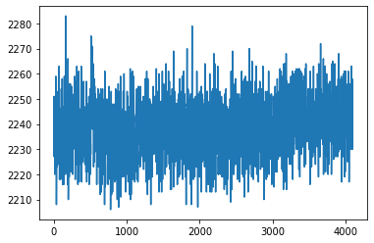

K-means algorithm.
Once the data for each array is extracted, K-means algorithm aims at clustering the time series.The following algorithm is used to form a bases for identifying the signals in the time series and then for clustering them.
https://tslearn.readthedocs.io/en/latest/auto_examples/plot_kmeans.html#sphx-glr-download-auto-examples-plot-kmeans-py.
Result.
The expected result is like the figure attached below. The red curve indicates the bases for clustering and identifying the signal from the detector.
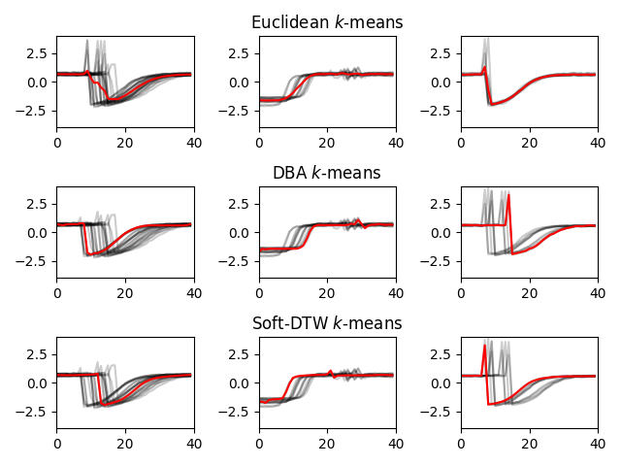
Schedule for the Month of November 2019.

11\8 – Coding to extract the complete data set.
11\15 – Merging the extracted dataset with the given code.
11\22 – Testing the code on the dataset and debugging the errors occurred.
11\29 – Making any further additions to the code, writing an abstract and submitting the result.
12\6 – Discussing any further scope for the research and determining the timeline for the same.

