Part 1)

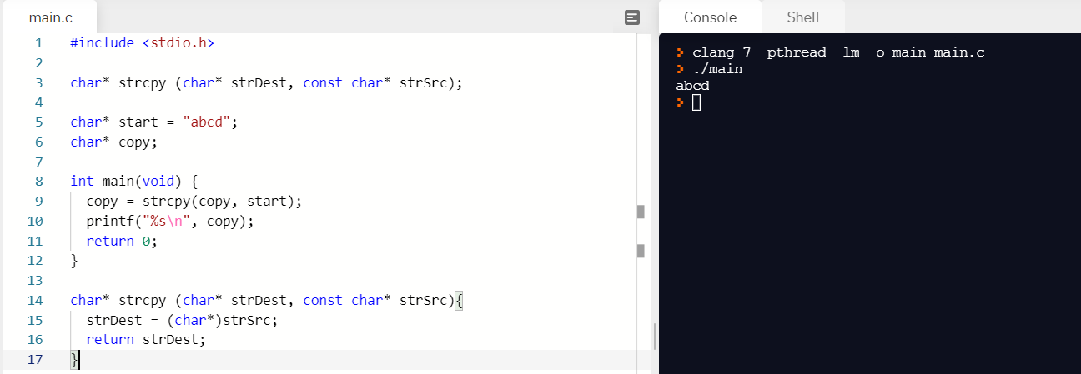

* We use a char\* because that can save a series of chars (like a string) while a char can only save one char or save each char in an array
* 