**ADVANCED SOFTWARE ENGINEERING**

ASSESSMENT -1

GRAPHICAL PROGRAMMING LANGUAGE

***Name : Rajan Shahi***

**Student id - 77202325**

**Version Control**

Version Conrol Commit Summary:

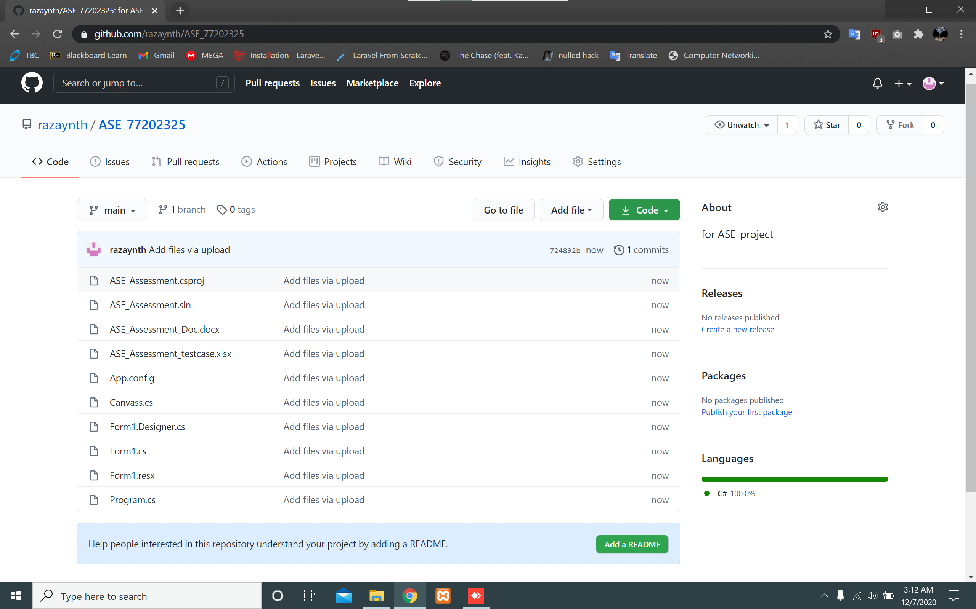

PROGRAM SCREENSHOT:-

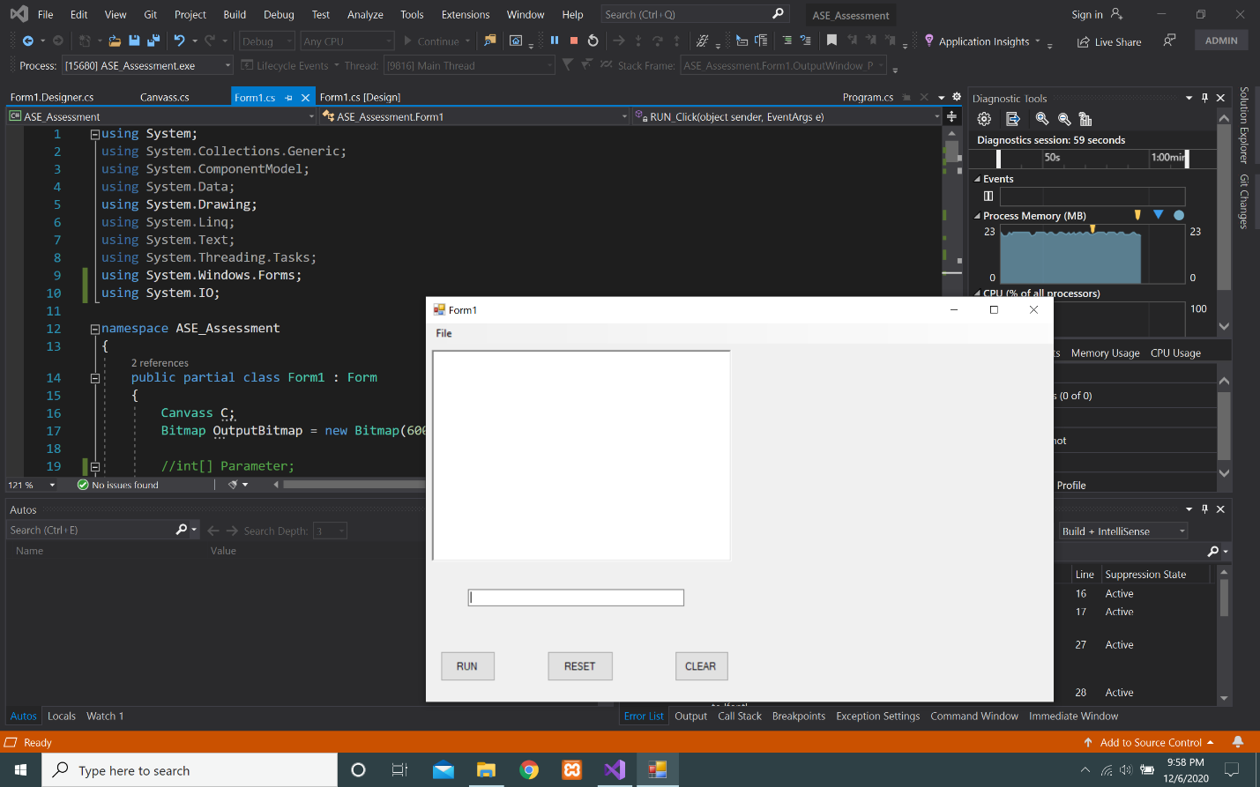

This is the main interface of the program which contains a text box for command line.

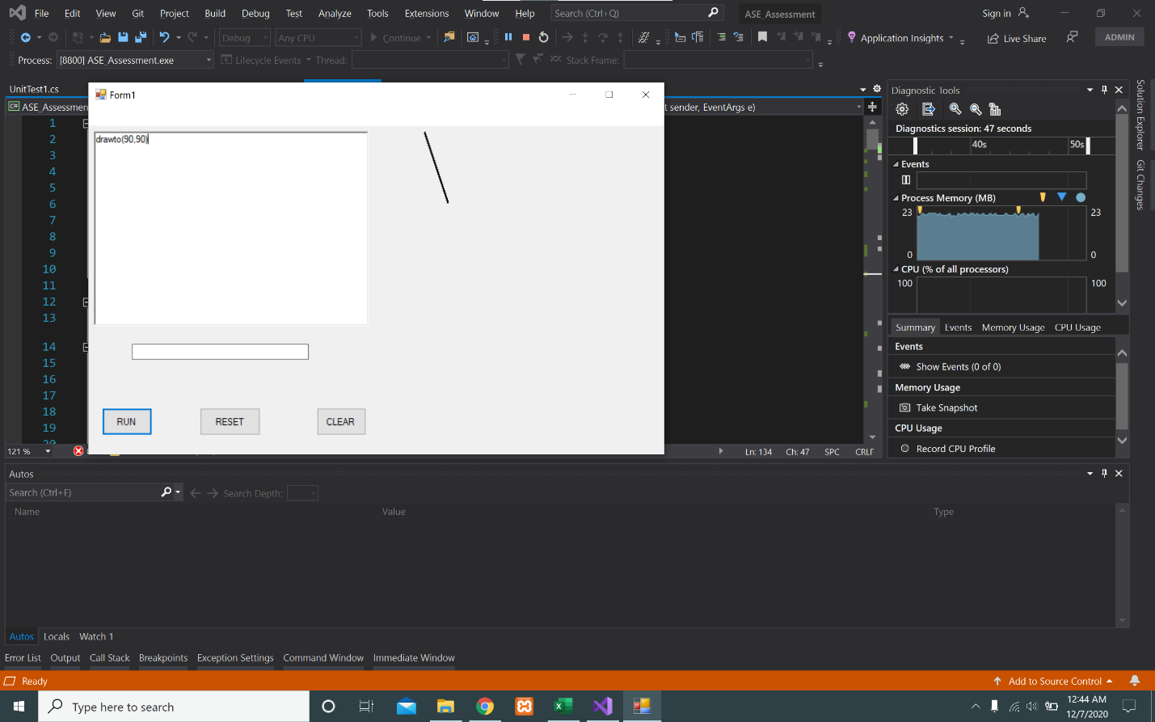

Executing command “drawto(90,90)” to draw a line on the drawing panel.

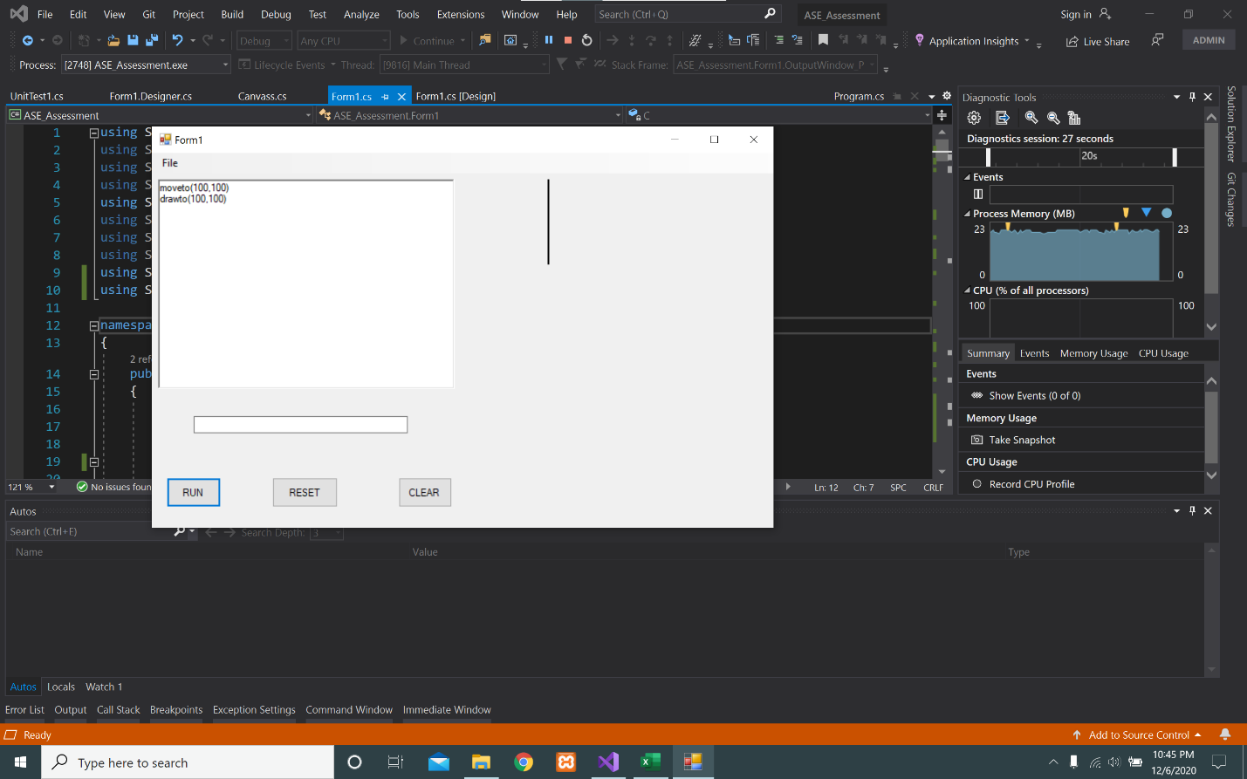

Executing command “moveto(100,100)” to draw a line on the given co-ordinates on the drawing panel.

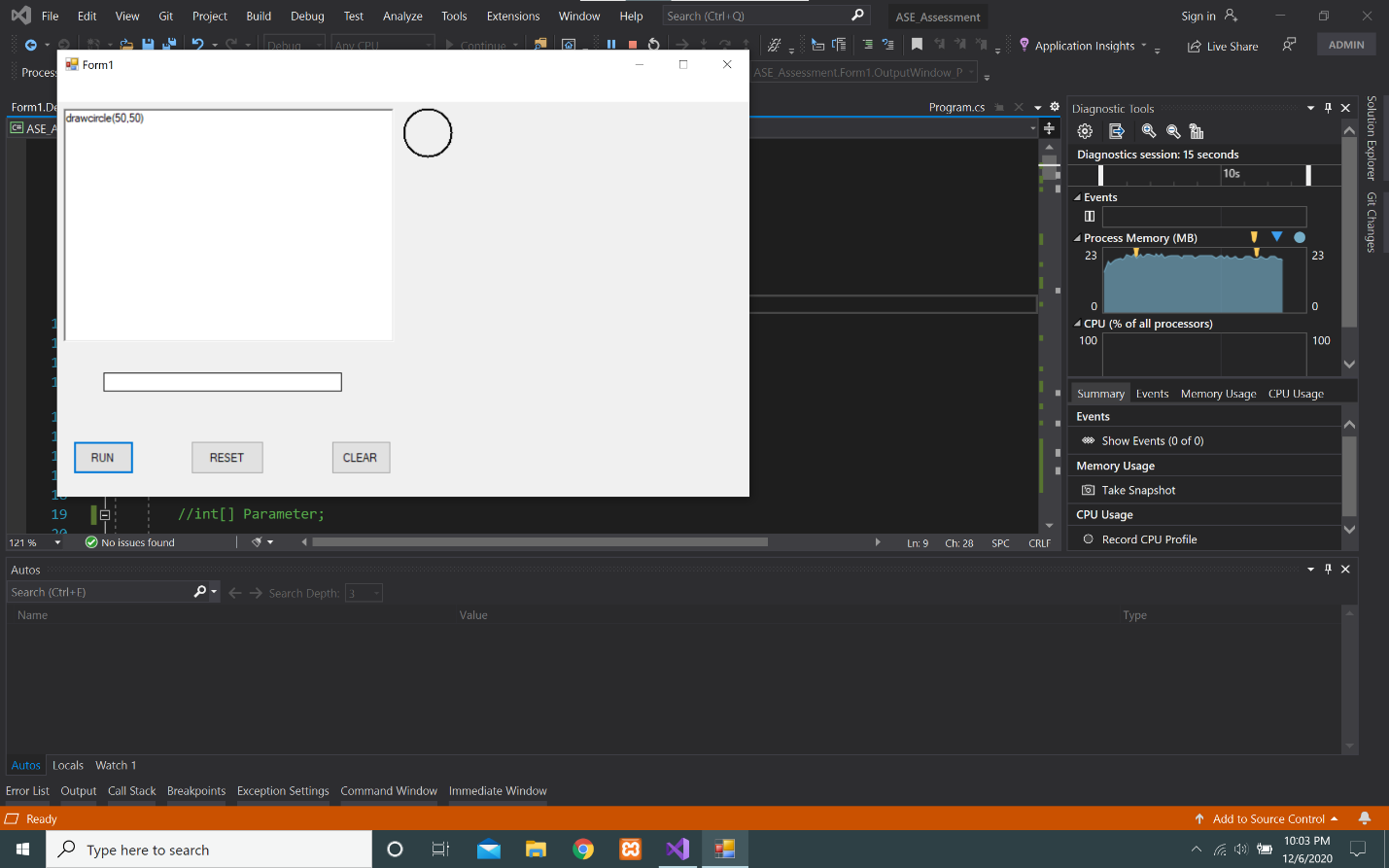

Executing command “drawcircle(50,50)” to draw a circle on the drawing panel.

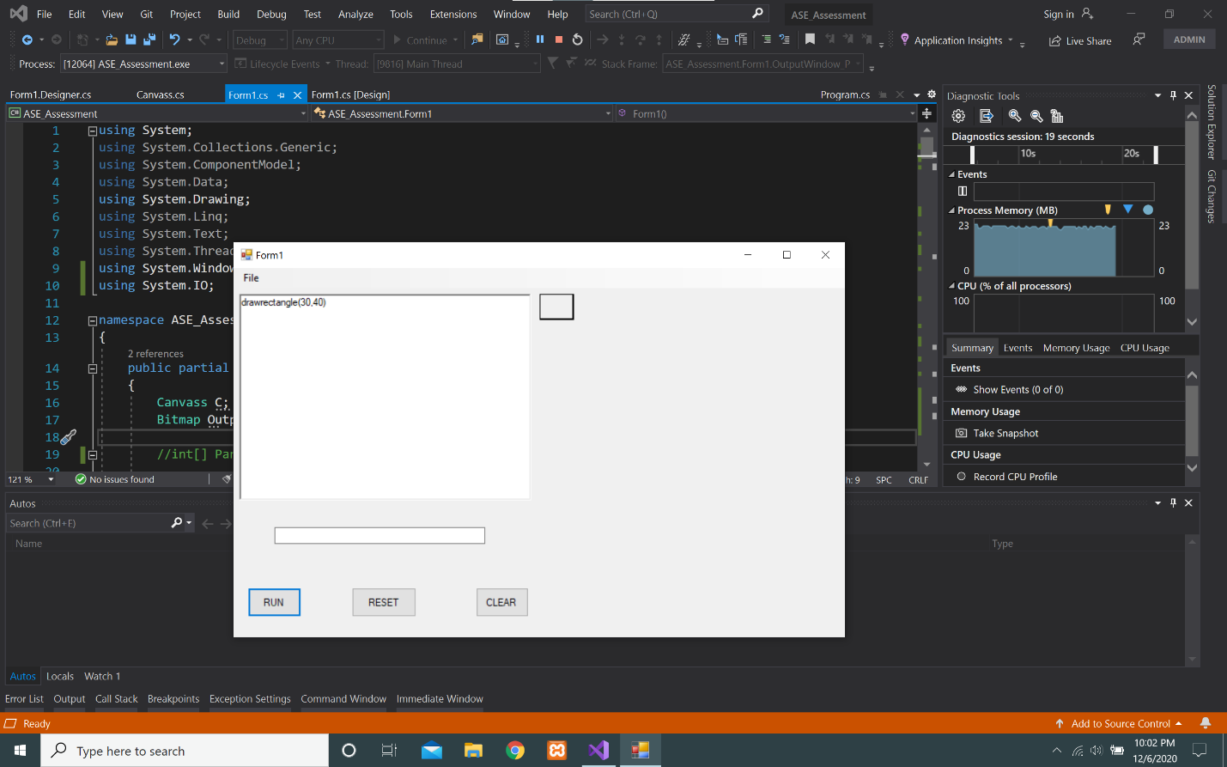

Executing command “drawrectangle(30,40)” to draw a rectangle on the drawing panel.

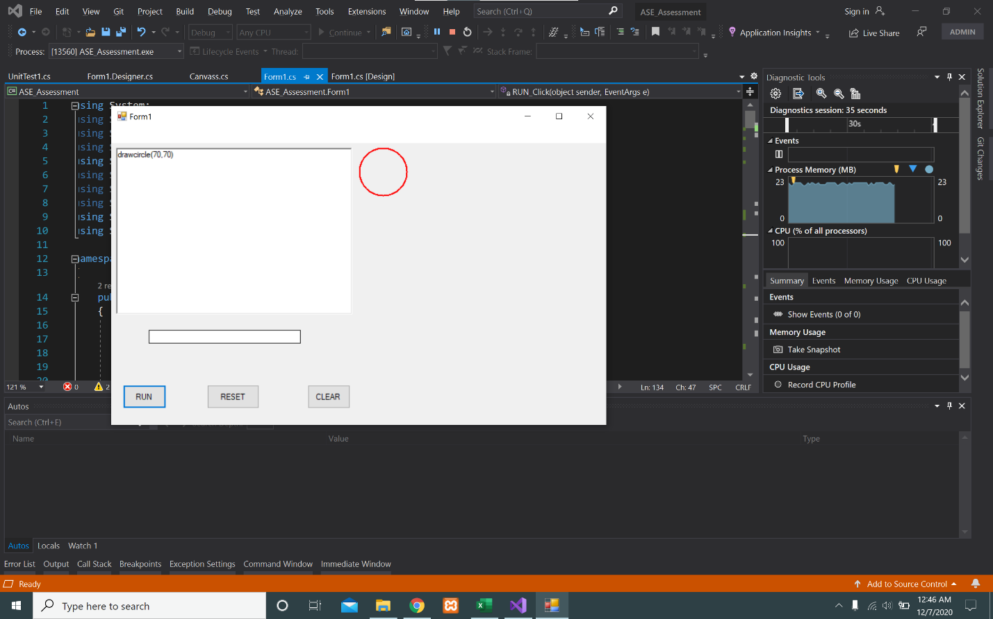

Executing command “pen(red)” to display a red pen in circle on the drawing panel.

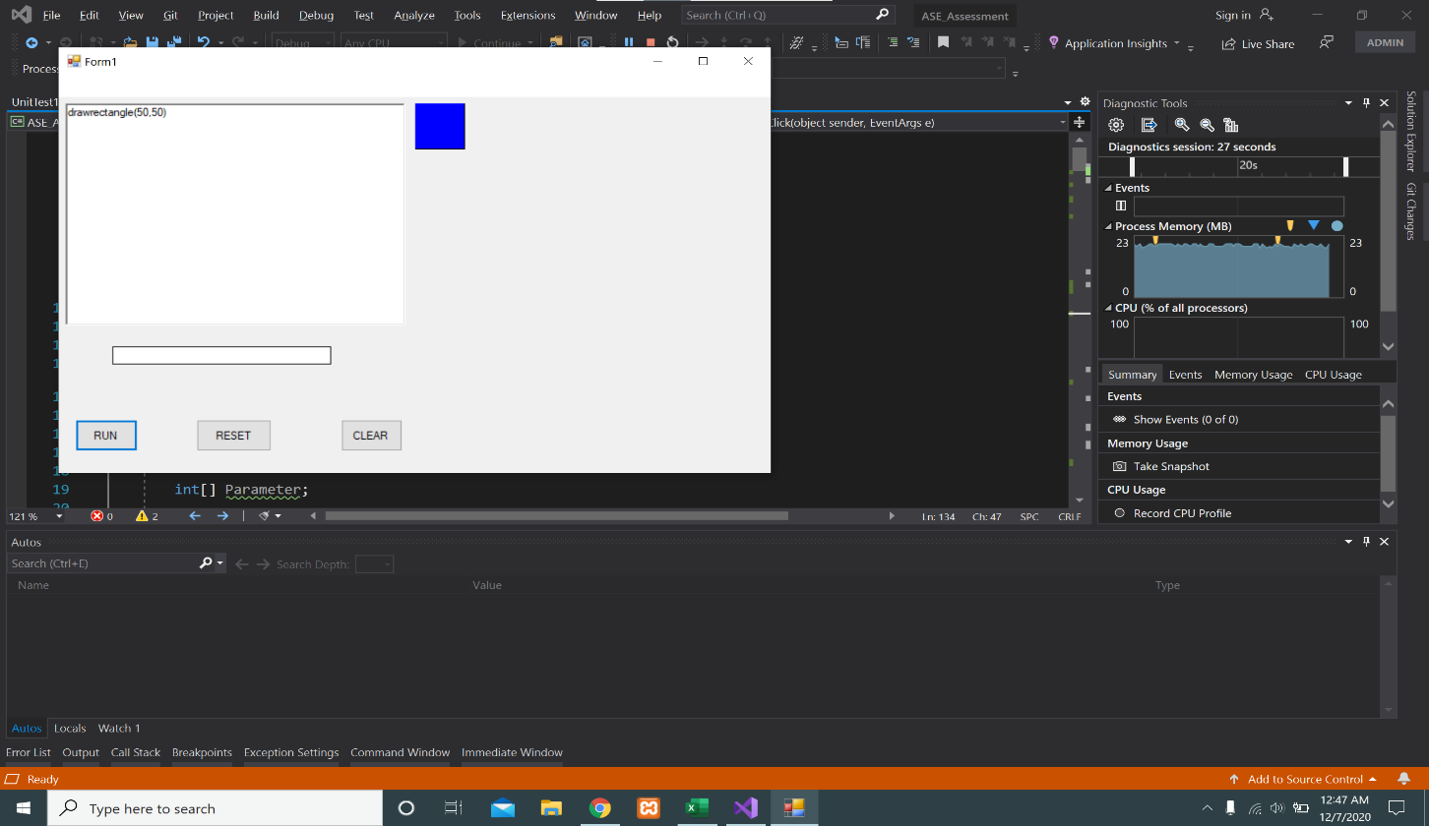 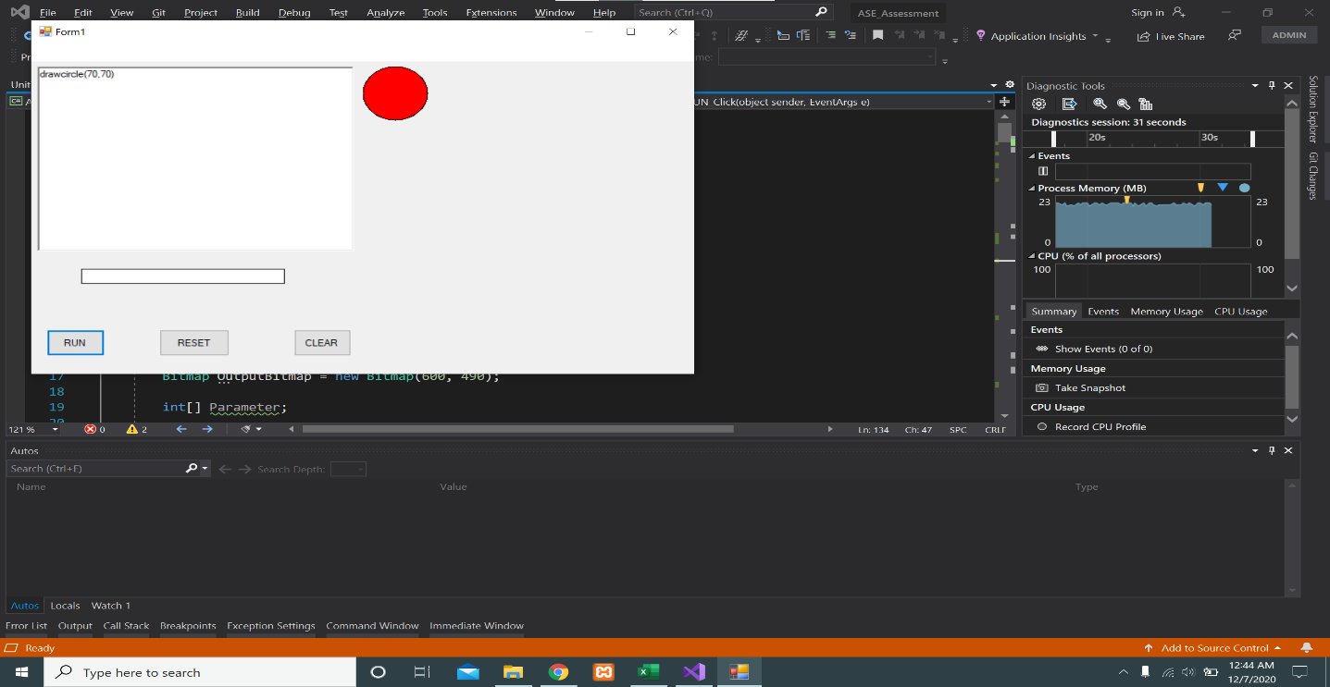

rectangle as well as command “fill(red)” to display a red color on circle as given co-ordinate on the drawing panel.

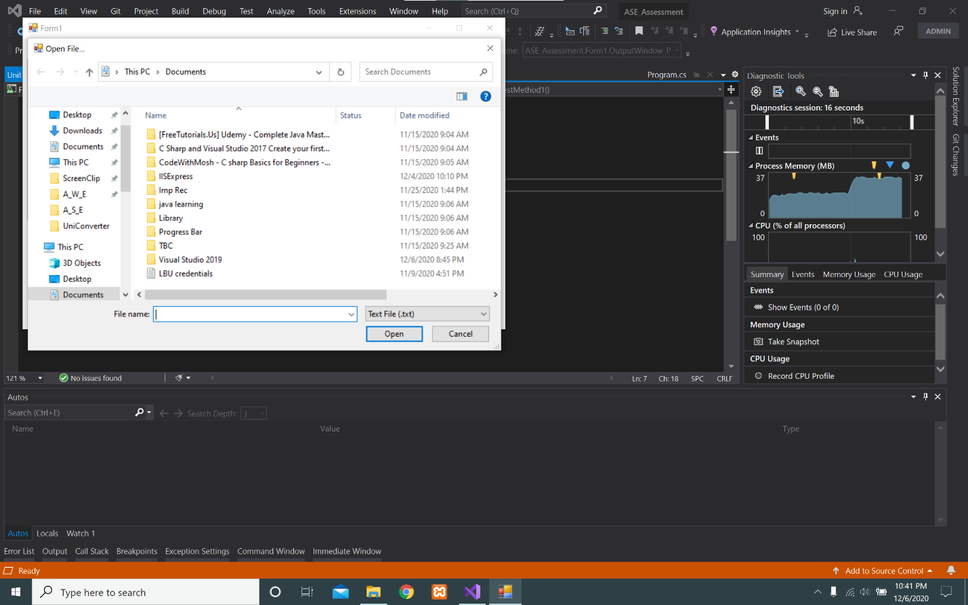

Loading the text file from Local directory

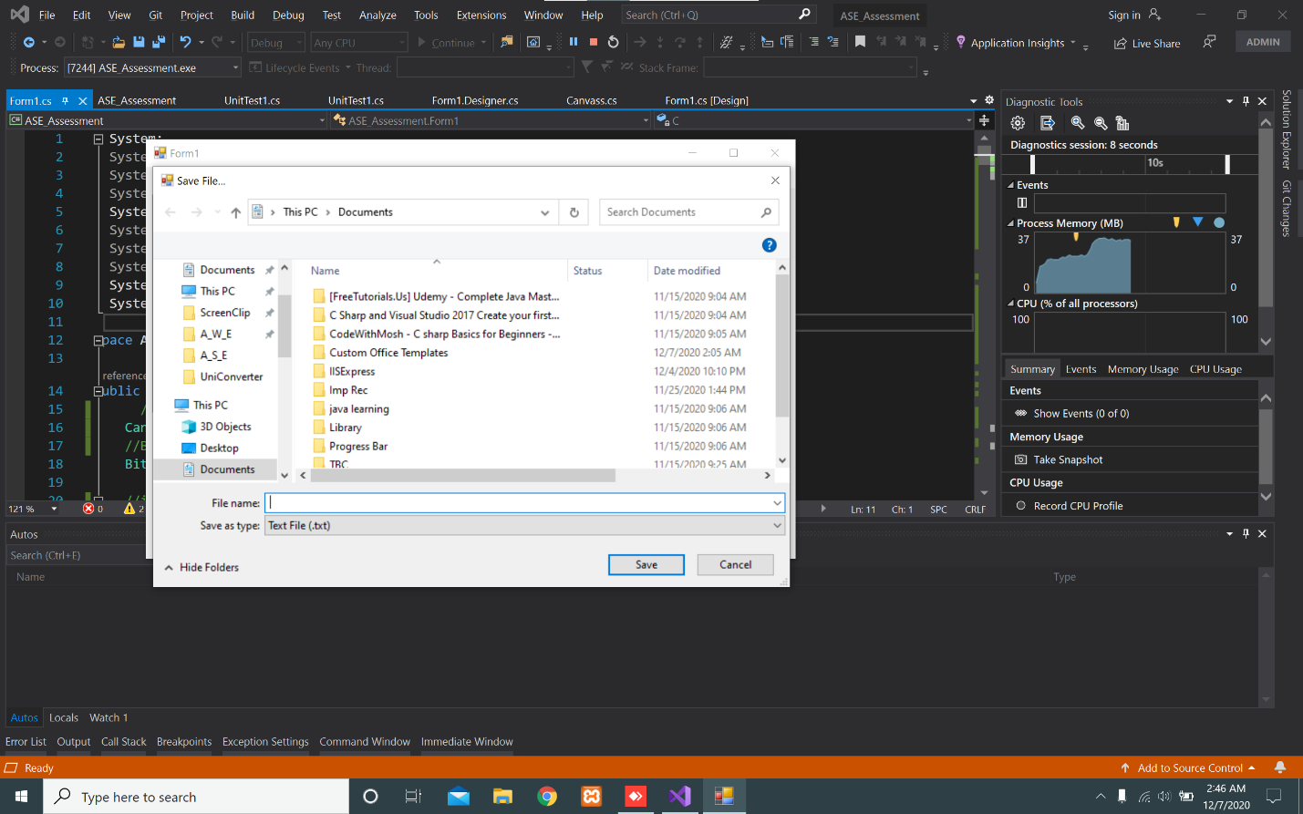

Saving the command to a text file.

***PARAMETER AND SYNTAX VALIDATION:-***

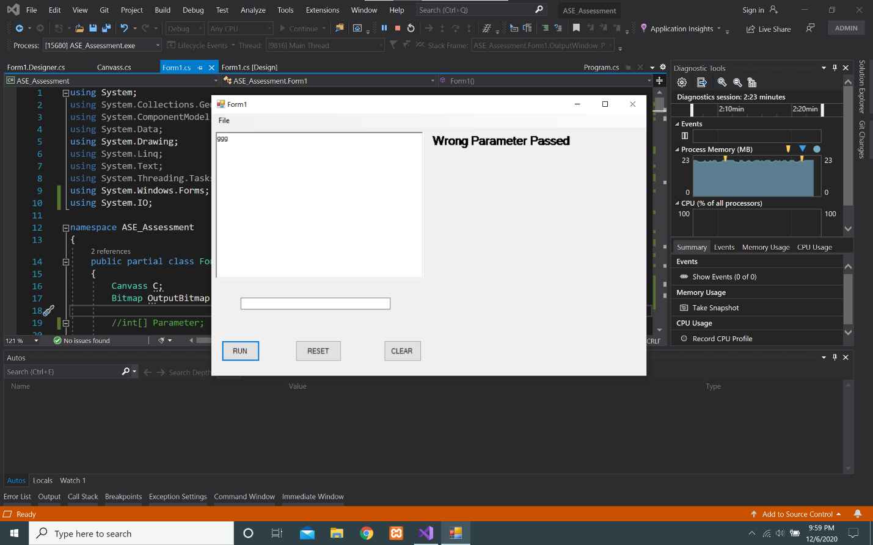

Showing error on console for passing wrong parameter.

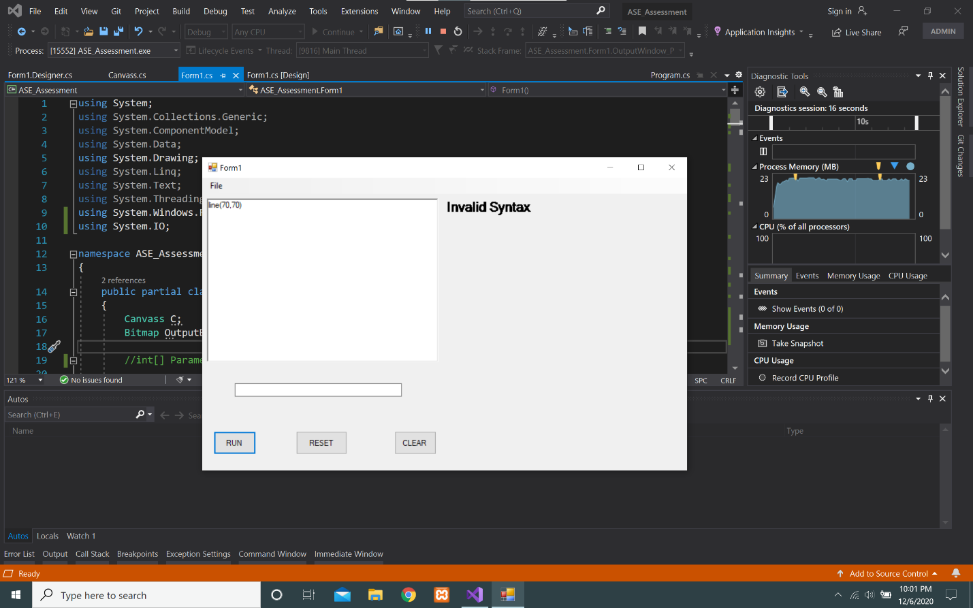

Showing Invalid Syntax on console.

Unit Testing:-

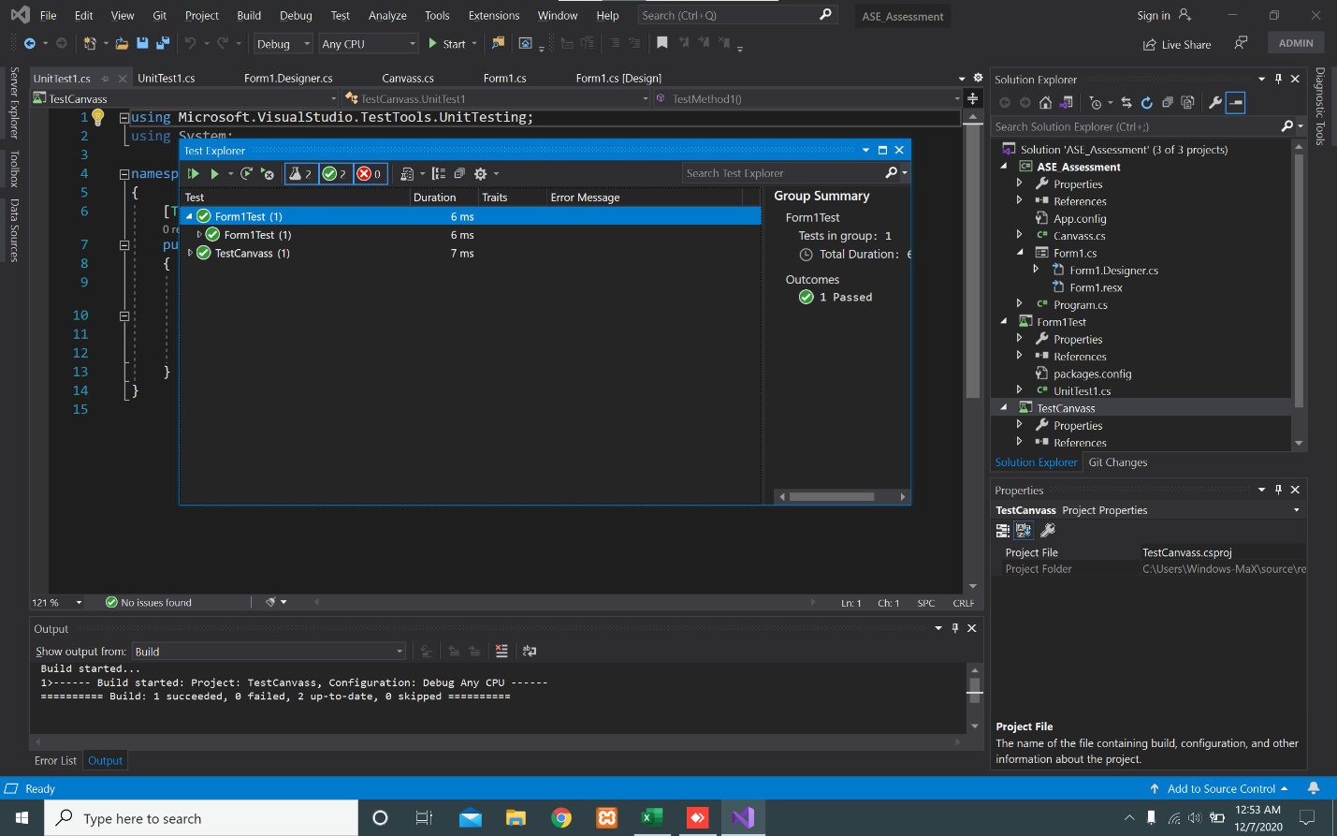

A screenshot of the unit testing performed on Visual Studio 2019.

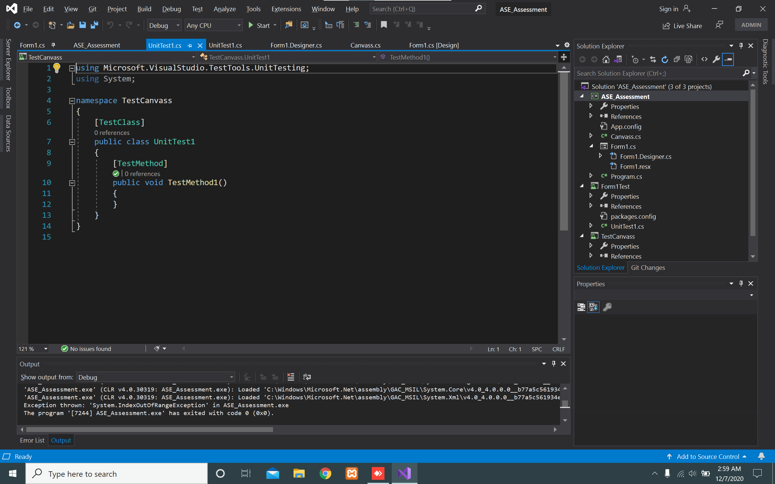

Unit testing for project.

**Test Case:**

