Surgical Tool Detection with Semi-Supervised Learning
Computer Vision — Surgical Applications, HW1
Authors: Raz Ben-Aharon and Shalev Manassen (shalevmanassen@gmail.com)

1. Exploratory Data Analysis
The labeled set contains only 61 training and 10 validation images (<100 total), all native 4K (3840×2160). Each frame comes from a leg-suturing surgery video; every box encloses a gloved hand together with whatever it holds, and the class label is defined by what the hand holds: Empty (no tool), Tweezers, or Needle_driver.

1.1 Visualization of Some Images
Fig. 1 shows a random sample of labeled training frames with their ground-truth boxes drawn (green = Empty, blue = Tweezers, red = Needle_driver).
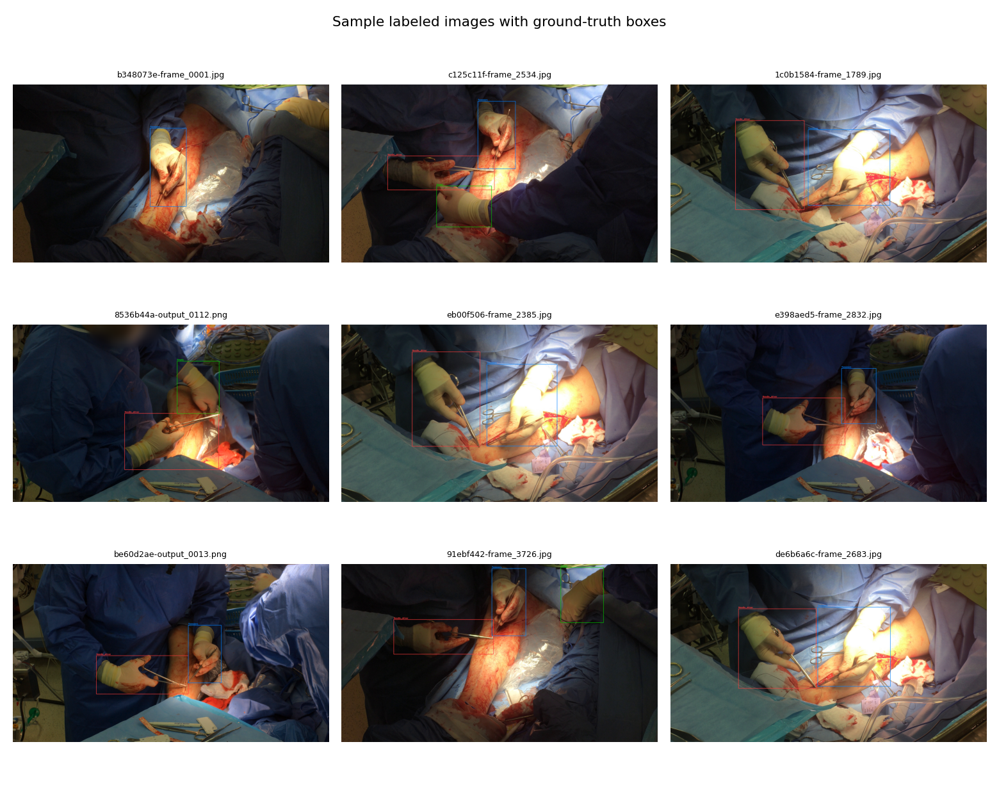
Fig 1. Nine labeled frames with ground-truth boxes overlaid.

1.2 Insights from simply “looking” at the data
Looking through the labeled frames and the raw videos suggests: (i) a static top-down camera view with hands in a consistent region; (ii) large boxes (15–35% of frame width, covering hand-plus-tool); (iii) a visually difficult scene with specular highlights, blood, and similar-coloured drapes; (iv) 1–2 boxes per frame with no background-only images; (v) the OOD video has different lighting/camera.

1.3 Data distribution analysis
Split | Images | Boxes | Empty | Tweezers | Needle_driver | Boxes/img
train | 61 | 135 | 26 | 54 | 55 | 2.21
val | 10 | 22 | 2 | 10 | 10 | 2.20
Empty is the clear minority class (26/135 ≈ 19% of train boxes), while Tweezers and Needle_driver are roughly balanced.
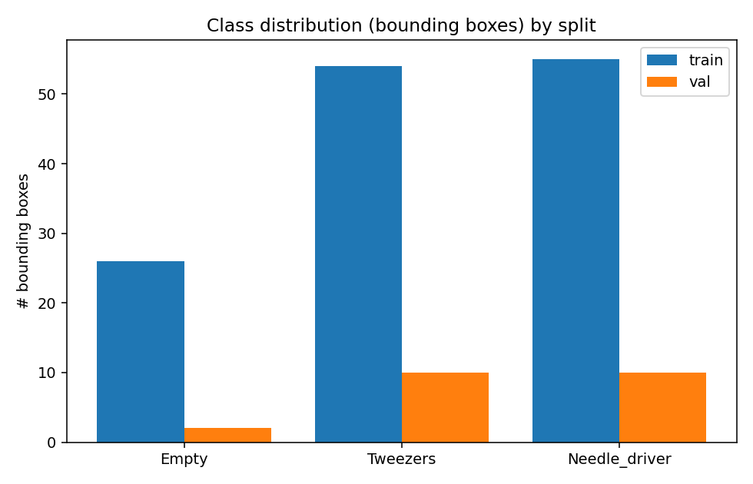
Fig 2. Class distribution by split.
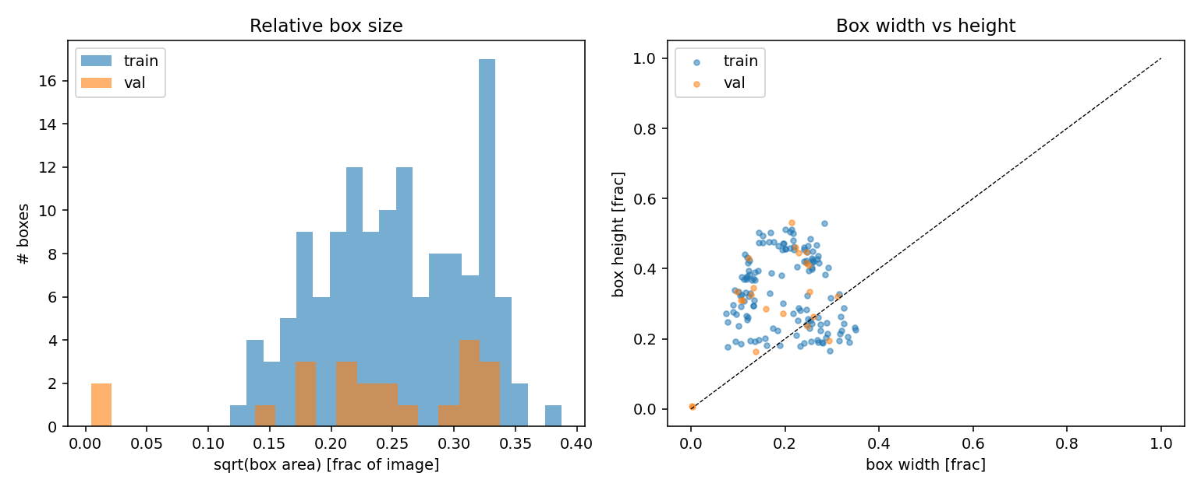
Fig 3. Box size distribution and width vs. height.

2. Experiments
Overview. Following the assignment’s SSL guideline, we: (1) fine-tuned a COCO-pretrained YOLO11s detector on the 61 labeled training images; (2) pseudo-labeled the ID and OOD videos with various filtering policies; (3) retrained and evaluated each variant. Additionally, we ran a supervised hyperparameter sweep over resolution, learning rate and model scale. The result was unexpected: the original supervised Baseline produced the best OOD behavior, while pseudo-label self-training degraded OOD performance through confirmation bias (§3).

2.1 Data loading, pre-processing and cleaning
Loading. Images and YOLO-format labels are read through Ultralytics’ standard dataloader. For SSL rounds, build_ssl_dataset.py combines labeled and pseudo-labeled images while keeping the 10-image validation set unchanged. Pre-processing. Images are letterbox-resized to the target resolution (640×640 default). Split. The original train/val split (61/10 images) was kept as-is.
Validation annotation audit. Manual inspection identified two annotation artifacts in image ff8c22da-output_0182.png: a 14×14-pixel Needle_driver box on dark background (row 2) and a 10×19-pixel Tweezers box at a glove/background boundary (row 4). With only 10 validation images and ≈22 boxes, these represent ≈9% of the evaluation set. Two validation snapshots were created: val_original (byte-identical to official data) and val_clean (only those two removed). Baseline: original mAP50-95 = 0.754, clean mAP50-95 = 0.809. Epoch selection replay still selected epoch 128.

2.2 Training techniques
Transfer learning. All experiments fine-tune YOLO11s (9.4M params) from COCO weights. Optimizer & schedule. optimizer=auto resolved to AdamW (momentum 0.9, weight decay 5e-4) with effective initial LR ≈0.001429 on a cosine-annealed schedule. Note: the reported lr0=0.01 was overridden by the auto-optimizer. Batch 16, imgsz 640, mixed-precision. Data augmentation (moderate): mosaic (p=1.0), HSV jitter, horizontal flip (p=0.5), mild translate (0.1) and scale (0.5). No aggressive augmentation — it caused divergence.
Semi-supervised pseudo-labeling. Original SSL: ID videos yielded 702/720 frames, 1,690 boxes at mean conf 0.876. OOD videos yielded 667/713 frames, 2,147 boxes at mean conf 0.732. 71.7% of the OOD pseudo-label boxes were classified as Needle_driver, revealing a strong class skew. Manual inspection additionally showed recurring false-positive Needle_driver detections on blood-stained gauze and background regions, suggesting that systematic teacher errors were being reinforced during self-training. Combined with 61 real images, the OOD training set had 1,369 pseudo-labeled images (22:1 pseudo:real ratio).

2.3 Regularization
Weight decay 5e-4; early stopping (patience 50); moderate data augmentation; COCO pretrained backbone as prior. Dropout is not used (dropout=0.0).

2.4 Hyperparameter tuning
Systematic supervised sweep: resolution (640/960/1280), model scale (YOLO11s/m), LR (0.001/0.003/0.01), augmentation (moderate/weak). Key findings: LR 0.003/0.01 caused collapse/NaN; only 0.001 was stable. YOLO11m did not improve over YOLO11s. Supervised 960 achieved the highest clean mAP50-95 = 0.854 but showed recurring gauze false positives on OOD video. Higher ID validation mAP did not guarantee better OOD generalization.
Pseudo-label policies tested: confidence-only (P1–P4), sanity constraints, per-frame caps, class-specific thresholds, temporal persistence. P4 retained only 69 frames at mean conf 0.938 — model still produced substantial false positives, showing confidence ≠ correctness. Strict OOD thresholds (box 0.85/frame 0.92) accepted zero OOD frames. Relaxed combined approach retained 123 OOD frames but made the model too conservative (21% empty frames).

2.5 Train + valid loss graph
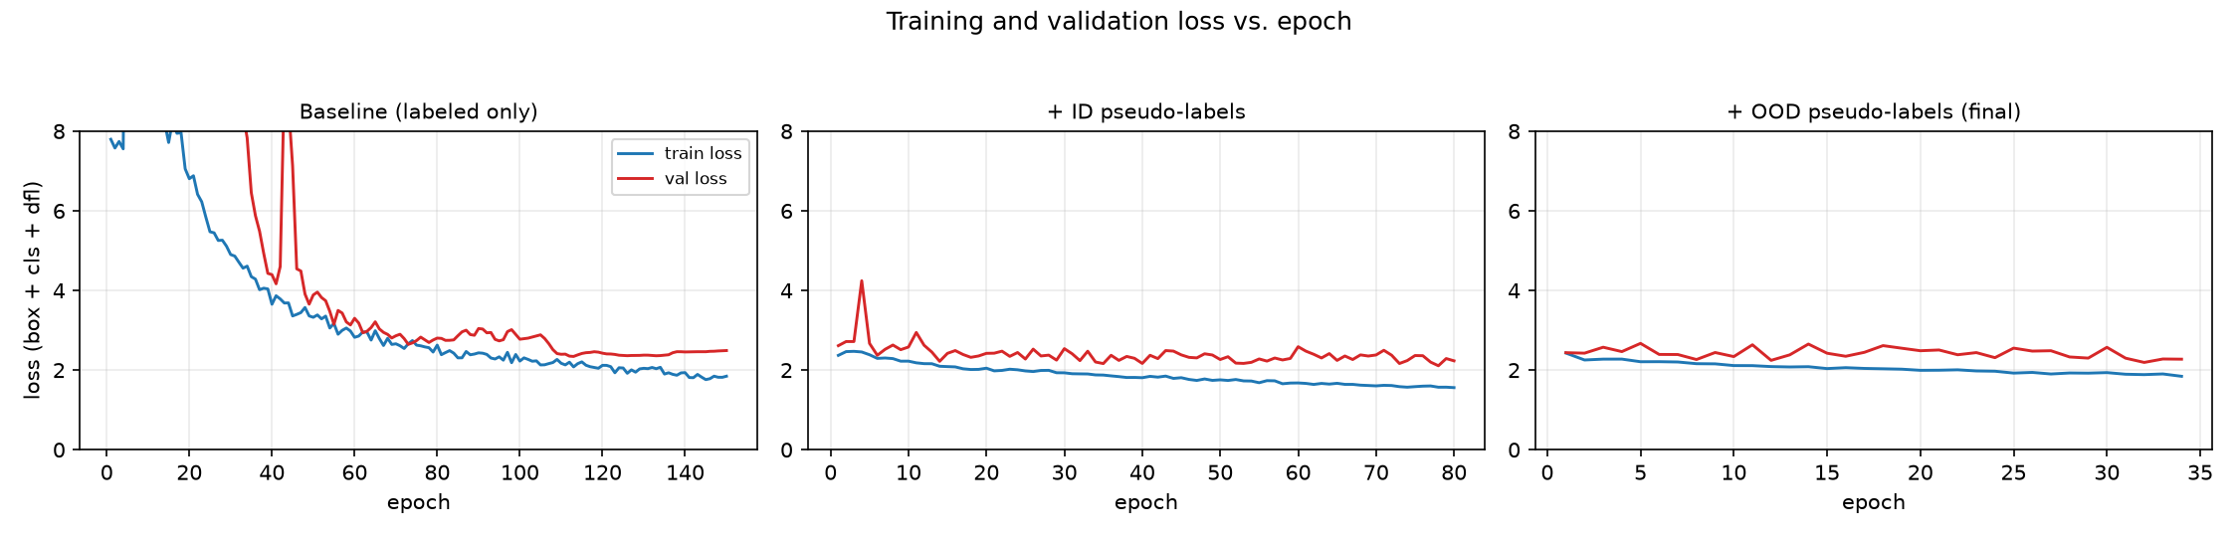
Fig 4. Training and validation loss vs. epoch for the Baseline and SSL rounds.
Baseline shows early instability (epochs 5–31) during LR warmup, then recovers. SSL rounds (warm-started) do not show this instability.

2.6 Train + valid mAP graphs
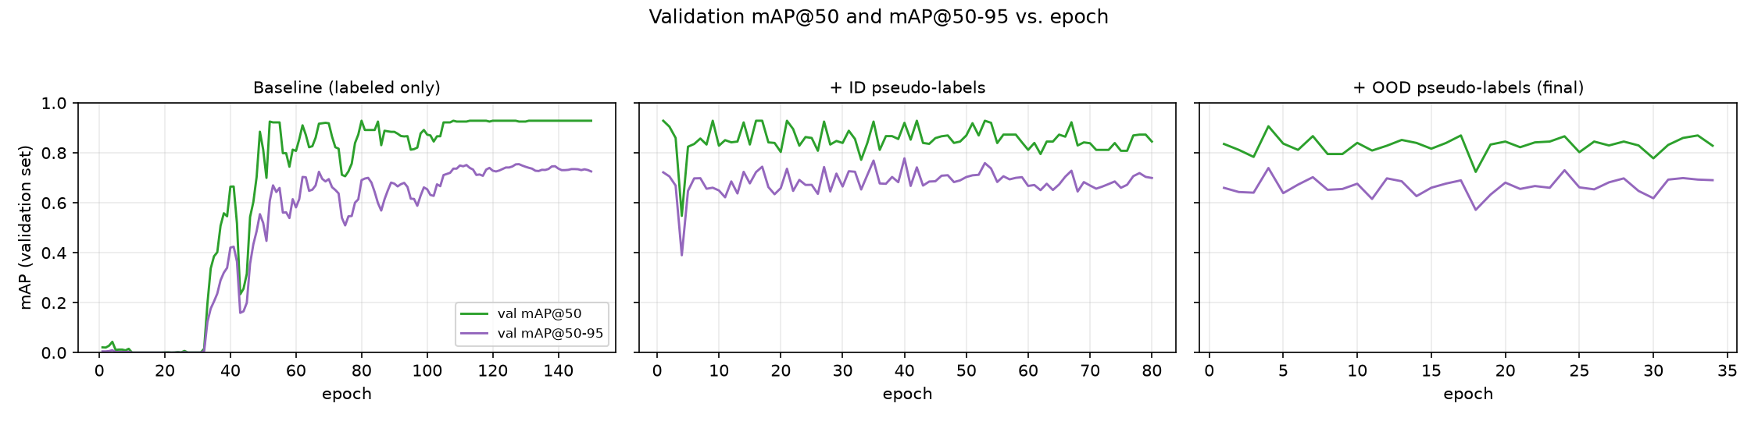
Fig 5. Validation mAP@50 and mAP@50-95 vs. epoch (official val set).
Model | Epoch | Imgs | mAP50-95  orig | mAP50-95  clean | OOD behavior
Baseline (final) | 128 | 61 | 0.754 | 0.809 | Best balance
ssl_id | 40 | 763 | 0.782 | 0.837 | 87% >2 det
ssl_ood | 4 | 1430 | 0.740 | 0.792 | 90% >2 det
Sup. 960 | 103 | 61 | 0.797 | 0.854 | Gauze FP
Sup. 1280 | 76 | 61 | 0.751 | 0.805 | Flicker
ID P4 | 11 | 130 | 0.749 | 0.800 | 81% >2 det
ID temporal | 18 | 627 | 0.767 | 0.820 | 16% empty
ID+OOD comb. | 24 | 750 | 0.721 | 0.775 | 21% empty
Table 1. Key experiment candidates with official and cleaned validation mAP50-95 and OOD video behavior.

3. Discussion and Conclusions
Since the OOD video has no ground-truth labels, OOD performance is assessed using automated diagnostics and manual visual inspection.

Original SSL failure
Naive pseudo-label self-training degraded OOD behavior in our experiments. The OOD pseudo-label boxes were 71.7% classified as Needle_driver, revealing a strong class skew. Furthermore, 1,369 pseudo-labeled images overwhelmed 61 real images. The ssl_ood model (epoch 4, mAP50-95 = 0.740) produced 89.6% of long-video frames with >2 detections (Baseline: 6.6%). The Baseline outperformed the old ssl_ood model on cleaned validation mAP and, more importantly, showed substantially better OOD video behavior.

Pseudo-label policy findings
(i) Confidence alone is insufficient: P4 (69 frames, mean conf 0.938) still produced 81.3% >2 frames. (ii) Temporal consistency helps: P3+sanity+temporal (0.5% >2 frames, 18 class switches) but at recall cost (16% empty frames). (iii) Strict OOD thresholds rejected everything; relaxed approach (123 frames) made the model too conservative.

Finalist comparison and final model selection
Finalist | det/fr | >2 % | empty % | 1-frame tracks | switches
Baseline / 0.60 | 1.70 | 6.6 | 5.9 | 145 | 69
ID temporal / 0.40 | 1.38 | 0.5 | 16.0 | 92 | 18
Sup. 1280 / 0.50 | 1.49 | 5.1 | 10.5 | 288 | 82
Table 2. Diagnostics on full 180s OOD video (5,395 frames) at each finalist’s inference threshold.
Manual review of identical OOD segments focused on false positives, missed detections, class stability, and temporal stability. Baseline (conf=0.60): best overall visual behavior — reliable hand detection without recurring gauze false positives. ID temporal (conf=0.40): very stable but sometimes missed real hands. Sup. 1280 (conf=0.50): reasonable coverage but excessive temporal flicker (288 one-frame tracks). The supervised Baseline at inference confidence 0.60 was selected as the final model.

Key lessons
(1) Pseudo-label quality > quantity — systematic errors were amplified.
(2) Self-training can create confirmation bias — gauze → Needle_driver reinforced.
(3) Confidence ≠ correctness — P4 at mean conf 0.938 still failed.
(4) Temporal consistency useful but insufficient — reduces FP but also recall.
(5) ID validation mAP ≠ OOD quality — Sup. 960 (mAP 0.854) had gauze FP.
(6) Small val sets sensitive to noise — 2 boxes changed mAP by ≈7%.
(7) Simplest model can win — complexity must be validated, not assumed.

Conclusion
The supervised Baseline was selected as the final detector because it produced the best overall OOD video behavior, despite not achieving the highest validation mAP. Naive pseudo-label self-training introduced confirmation bias and severe false positives. Stricter confidence thresholds alone were insufficient, while sanity and temporal filtering improved prediction stability but reduced recall. The experiments therefore show that higher validation metrics and larger pseudo-labeled datasets did not necessarily translate into better OOD generalization.

