Assignment 2
COMP 8005 – Network and Security Applications Development
By Ramzi Chennafi

Table of Contents
Software Design 2
Compiling the Program 5
Logging 5
Program Execution 6
Server Side PseudoCode 6
EpollServer::EpollServer(int port, int threads) 6
EpollServer::setup_server(int type) 6
EpollServer::monitor_connections(int type) 7
EpollServer::create_listener() 7
EpollServer::incoming_connections() 7
incoming_data(int fd) 8
Client Side PseudoCode 8
Client::connect_clients(int port, string hostname, int data_size) 8
start_instance(int port, string host, int data size, ofstream log, mutex mtx) 8
send_echo(int socket, int data_size, mutex mtx, ofstream log) 8
Testing 9

Software Design
In designing the server the level triggered and edge triggered shared their design, while the non-threaded level triggered server was simply modified to remove the thread pooling mechanism.
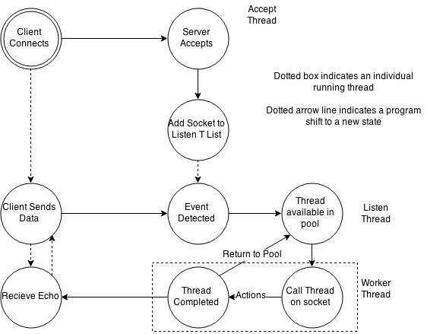
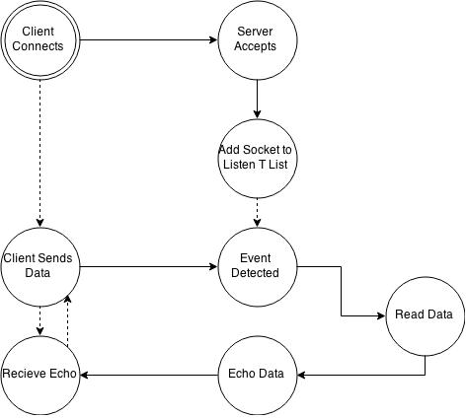
The above diagram shows the process method for the level triggered and edge triggered threaded epoll servers. The diagram below shows the processes of the level triggered non-multi threaded.

This diagram shows how the actual internal software calls behave. This diagram is the same between each server, the only difference which exists is that incoming data is called instead of being placed into a thread pool.
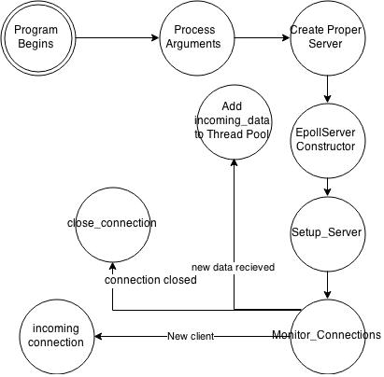

And this diagram below is illustrated to show how the thread pool works. The server starts with a user specified amount of threads for the pool.
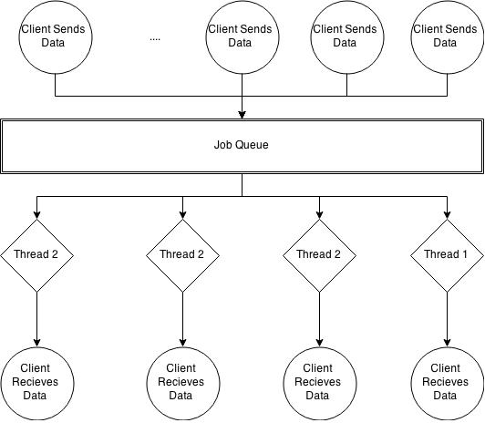

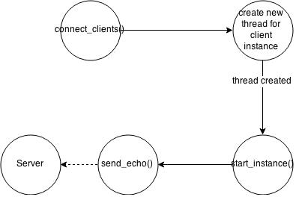
The client created was very simple and can be given arguments which change the port, server ip, data size and number of clients. Below is a diagram for this client.

Compiling the Program

Navigate to the src folder
cd src
Ensure that you have g++ installed, if you do not, execute yum install g++ (varies on distribution)
Compile the program by typing
g++ -pthread -std=c++11 *.cpp -o Server
Now you can execute the program by typing
./Server <command line arguments>

Logging

The server and client both create logs. They will be created within the same directory as the executable under the names server_log and client_log. They track data transfers and connections.

Program Execution

This program has a large amount of command flags, these are:
-p <port> : This sets the port for the server/client to send/recieve on
-h <hostname> : This sets the hostname for the client to connect to
-t <threads> : This sets the amount of threads the server will use
-d <data size> : This sets the data size in bytes for each client to send
-c <clients> : This sets the number of clients for the client instance to run
-C : This sets the program into Client mode.
-w : This sets the program to server non-threaded level triggered mode
-l : This sets the program to server threaded level triggered mode
-e : This sets the program to server threaded edge triggered mode
-p -h -t -d and -c have default arguments, they are respectively: 5001, localhost, 4, 1000 and 1.

To execute, use any of these arguments along with the ./Server command, in the interest of performance most output to the terminal has been removed.

Server Side PseudoCode

EpollServer::EpollServer(int port, int threads)
create_listener()
create a threadpool(threads)

EpollServer::setup_server(int type)
Create the epoll fd
set it respective to server type, if level triggered do not set EPOLLET

EpollServer::monitor_connections(int type)
setup_server(type)
while(true)
wait for an event on epoll fd
if event found, loop through each event
if event is an error, close corresponding fd
if event is a new connection
call incoming_connection()
if event is new data on established connections
if multithreaded
add incoming_data() to thread pool queue
if single threaded
incoming_data()

EpollServer::create_listener()
Create a socket for listening
set sock opt to reuseaddr
bind socket
set socket to listening

EpollServer::incoming_connections()
Accept the incoming connection
set new connection to non blocking
add new connection to epoll queue

incoming_data(int fd)
While still receiving data
add data to buffer
if return value = error, EAGAIN or EAWOULDBLOCK
send data to client
if return value = 0
close client connection

Client Side PseudoCode

Client::connect_clients(int port, string hostname, int data_size)
For each client
execute new thread with start instance

start_instance(int port, string host, int data size, ofstream log, mutex mtx)
Start the client
connect to the server
while(true)
call send_echo

send_echo(int socket, int data_size, mutex mtx, ofstream log)
Send data of size data size
While still receiving data
add data to buffer
if return value = error, EAGAIN or EAWOULDBLOCK
send data to server
if return value = 0

Testing
Test Num | Test Name | Description | Tools Used | Pass/Fail
1 | Level Triggered: Low Load | Runs the level triggered server on low load. | Program | Pass
2 | Level Triggered No Threads: Low Load | Runs the level triggered server no threads on low load. | Program | Pass
3 | Edge Triggered: Low Load | Runs the edge triggerd server on low load. | Program | Pass
4 | Level Triggered:  High Load | Runs the level triggered server on high load. | Program | Pass
5 | Edge Triggered: High Load | Runs the edge triggered server on high load. | Program | Pass
6 | Level Triggered No Threads : High Load | Runs the level triggered no threads server on high load. | Program | Pass
8 | Logging | Check that the client and server both log data. | Program | Pass

Please refer to report for more detailed information on these tests. Attached with this project is also all raw data.

