LxIPS
A Linux Based Intrusion Prevention System
By Ramzi Chennafi

Table of Contents

About the Program
This program was designed as a simple, customizable intrusion prevention system for Linux. Its core function it to watch authentication logs and respond to user specified network events by banning internet addresses from access.
Modification of program rules is done within the “rules.cfg”. Changing the rule file can be done by editing the configuration settings within LxIPS.rb. The changing of log files can also be done here.
The program allows each rule to specify a response done in IPTABLES, an attempt limit, a time to check between each attempts for attempt resetting and a timebanning value. Also included is a response in IPTABLES, which will be placed into the crontab with a time set according to the timeban value. This will eventually remove the ban response from IPTABLES, or whatever you may wish to use.
Several log files may also be watched, and if you refer to the readme, instructions for installing the program so that it does its work in the background after startup is included.

Included Files
Included in this package are the following files.
LxIPS.rb
src/manager.rb
src/user.rb
src/rule.rb
README
rules.config
And this document

Execution
Please refer to the README for directions on usage and installation.

Design
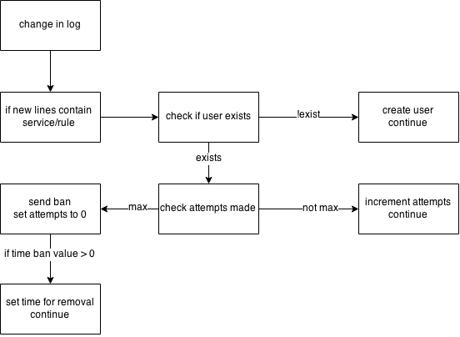

System Overview

This diagram is a simple view of how the rule checking occurs in the program. The times and attempts are checked against the rules.cfg file.

System Diagram

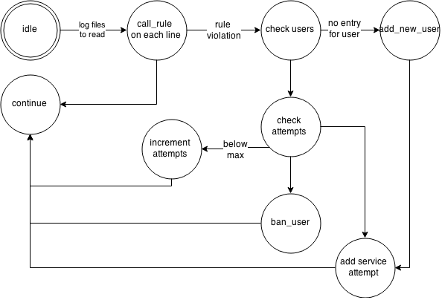
Table1
This is a program flow diagram. Programmatically, the application monitors a log file for changes and responds with a call rule on every new line. This program is single threaded, however at ban_user a sleeping thread is created to unban for time bans. It unbans once its sleep is over and closes.

Testing Setup
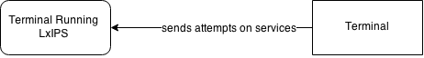

Above is a simple diagram depicting how our test setup ran. The two terminals share a subnet.

PseudoCode
Classes : User, Rule, Manager

Testing
Test Number | Test Name | Test Description | Tools Used | Pass/Fail?
1 | Timed Attempts | Check if an attempt done within the time limit is the only one counted. | * | Pass
2 | Different Attempts | Check if an attempt on one service does not effect another service. | * | Pass
3 | User Banning | Check if a user is banned when they max attempts on a service. | * | Pass
4 | Time Bans | Check if a user banned on a time ban is unbanned. | * | Pass
5 | Logging | Check if the logging for the program works. | * | Pass
6 | Rule Configurability | Check if user can create and change rules. | * | Pass
* = the program itself

Test 1 : Timed Attempts

