RPort Final Assignment
COMP 8005
By Ramzi Chennafi

Table of Contents
About the Program 2
Setting up the Rules 3
Design Diagrams 4
Testing Setup 5
PseudoCode 5
Forward(sourcePort, destinationPort, destinationIP) 5
main body 5
Testing 6
Test 1 – Rule Configurability 6

About the Program

RPort is a simple, configurable port forwarder written in node.js.
To run the program, install node - instructions on installation can be found here.
https://github.com/joyent/node/wiki/Installing-Node.js-via-package-manager#debian-and-ubuntu-based-linux-distributions

On Fedora just execute the following commands as root.
yum install -y nodejs

Setting up the Rules

Rules are placed in the config file in json format as follows:
[
{"fromPort":"7002","toPort":"88","toAddress":"localhost"}
]
Seperate each new entry with a comma like so
[
{"fromPort":"7002","toPort":"88","toAddress":"localhost"},
{"fromPort":"7002","toPort":"88","toAddress":"localhost"}
]
There is no limit on rules, but there may be a performance hit if the amount of rules get excessive.

Design Diagrams
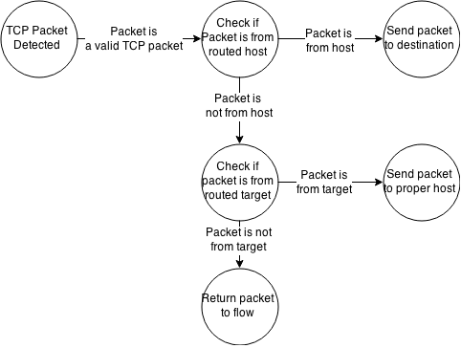

An overview of the program from a more theoretical perspective.
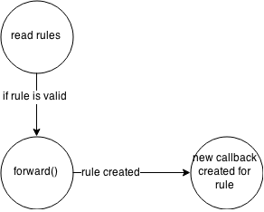

A look at the application programmatically.

Testing Setup
I used both 3 terminals, one terminal hosted the port forwarding program. While another machine tried to connect to a service on the port forwarder, the port forwarder would then forward that connection to the proper destination based on the rule.
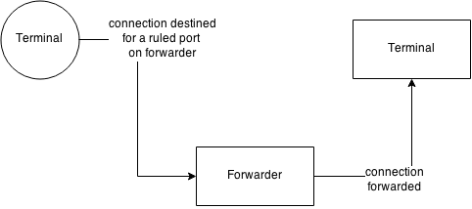

PseudoCode

Forward(sourcePort, destinationPort, destinationIP)
Create a new network server
create a destination connection to destination port and destination ip
create a listen socket on the sourcePort
create callback
if data comes in on listen socket
write to destination connection socket

main body
Read in config file as json
for each entry in json file
forward(file.toPort, file.fromPort, file.toAddress)

Testing
Test Number | Test Name | Test Description | Tools Used | Pass/Fail?
1 | Rule Configurability | A new rule can be placed within the rules config file and followed. | program | Pass
2 | Sending a Forwarded Message | A message sent from a host to be routed is sent properly. | Wireshark, program | Pass
3 | Recieving after a Forwarded Message | A message that was routed results in a response back to the original host. | Wireshark, program | Pass
4 | Packet Data | The packet data matches what it should be. | Wireshark, program | Pass
5 | Handshaking | A TCP handshake can on a forwarded operation. | Wireshark,  program | Pass

Test 1 – Rule Configurability

