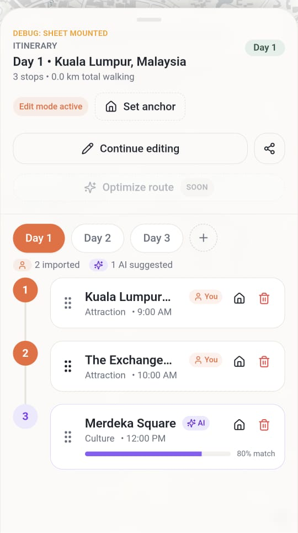 | ## Editing Functionality Issues  - Location drag-and-drop not working in edit mode  - Cannot rearrange locations within same day (current version seems buggy)  - Cannot move locations to different days (e.g., day two)  - Missing "Save Changes" button after editing  - No clear way to confirm/persist edits  - Creates uncertainty about whether changes are saved  Solution:  - Implement drag-and-drop functionality for locations in edit mode (within day and across days)  - Add "Save Changes" button to editing interface  - Auto-minimize itinerary planner when share button is clicked  - Add modal/prompt asking users to choose between manual editing or AI tool when adding places  - Whenever the AI generates the result, the location is always asking the user where or which itinerary plan should the location be saved at?  -Ensure the alignment of the number and the location card is the same. The current one No.1 is not aligned with the centre of the first card.  ## Sharing Workflow Problem  - Share itinerary button doesn't minimize planner view  - Blocks visibility of sharing options  - Need automatic UI adjustment when share is triggered
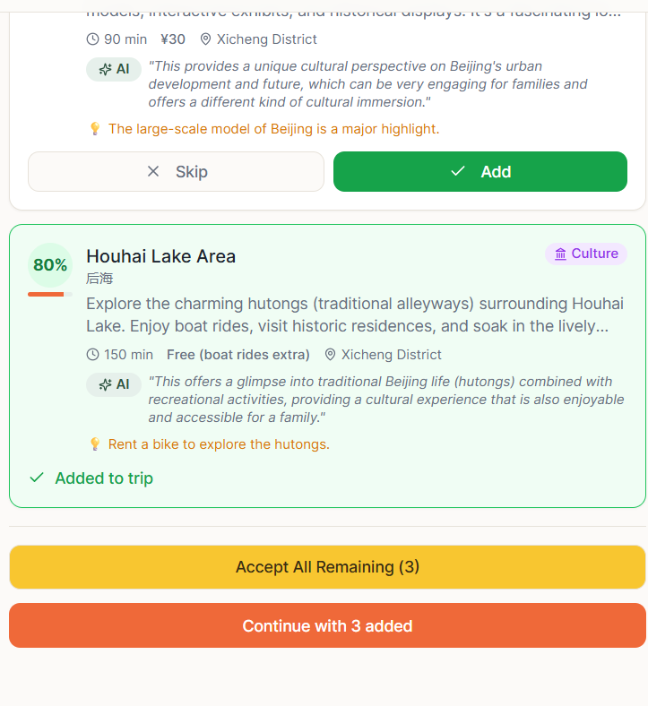 | - Remove the AI similarity/ confidence score eg. 80%  - Delete the accept all remaining button  - Have a small round checklist box beside each itinerary  - If user “click” the tick box to add, user should able choose which day they wanted to add into or choose “Plan with AI” to allow Gemini to determine which location is suitable for which day based on the nearer location cluster  -Fix the UI alignment for "Anchor Location."  Fix the UI state/glitch after the "Share" button is clicked. Make sure each page is visible to the user fully.
1. All locations in the itineraries (location card) should use the same format and contain the element of
- Name of venue
- Google Ratings from Maps API
- You/ AI button to indicate source of location suggestion
- #tags of the place (food/culture/shopping etc)
- Button to redirect in google maps
2. It should have a button to open all the locations in the google map. Like the Open Route icon

3.

On the location card, it should write the starting time of arriving at the location together with the timing of how long the user wants to stay at the location. For the second location card onwards, it should be based on the previous location info. The AI can suggest the staying duration at first draft, but it should also allow users to edit the timing of staying.

Then at the left side of the location card which shows the location number, it should show the commuting duration and distance in between.

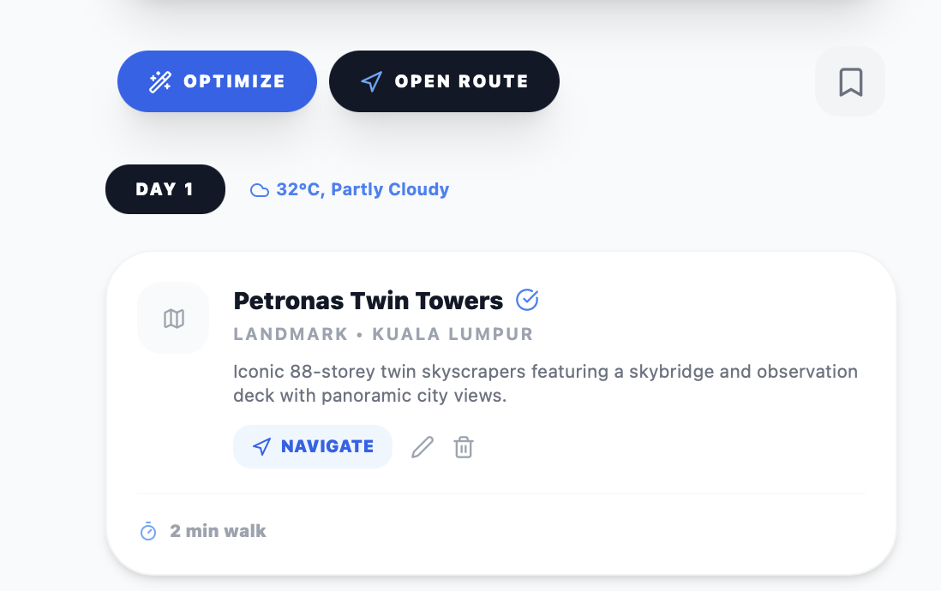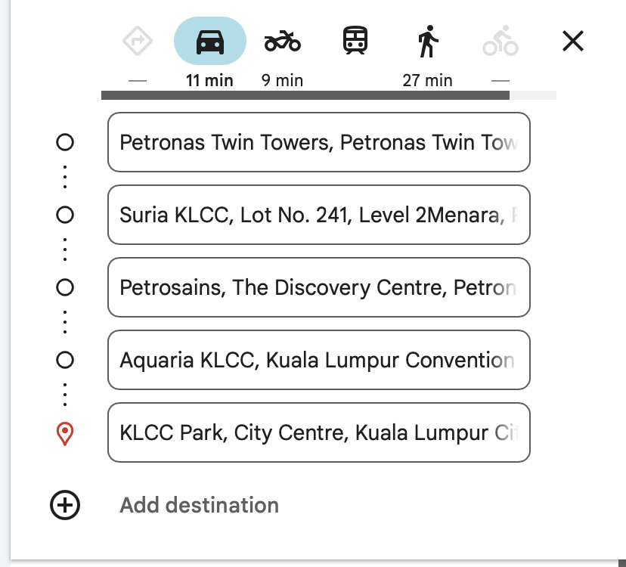
 | To have loading animation  Example:  Analysing destination context  Structuring daily timeline  Thanks for using TravelBetter btw  Finalizing itinerary  
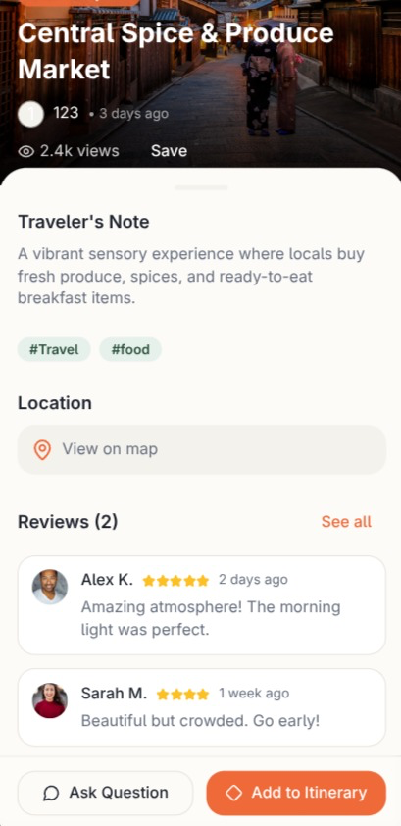 | For the reviews button. It should show the real time top five reviews from Google using the Google maps API. ensure that it is real reviews from Google
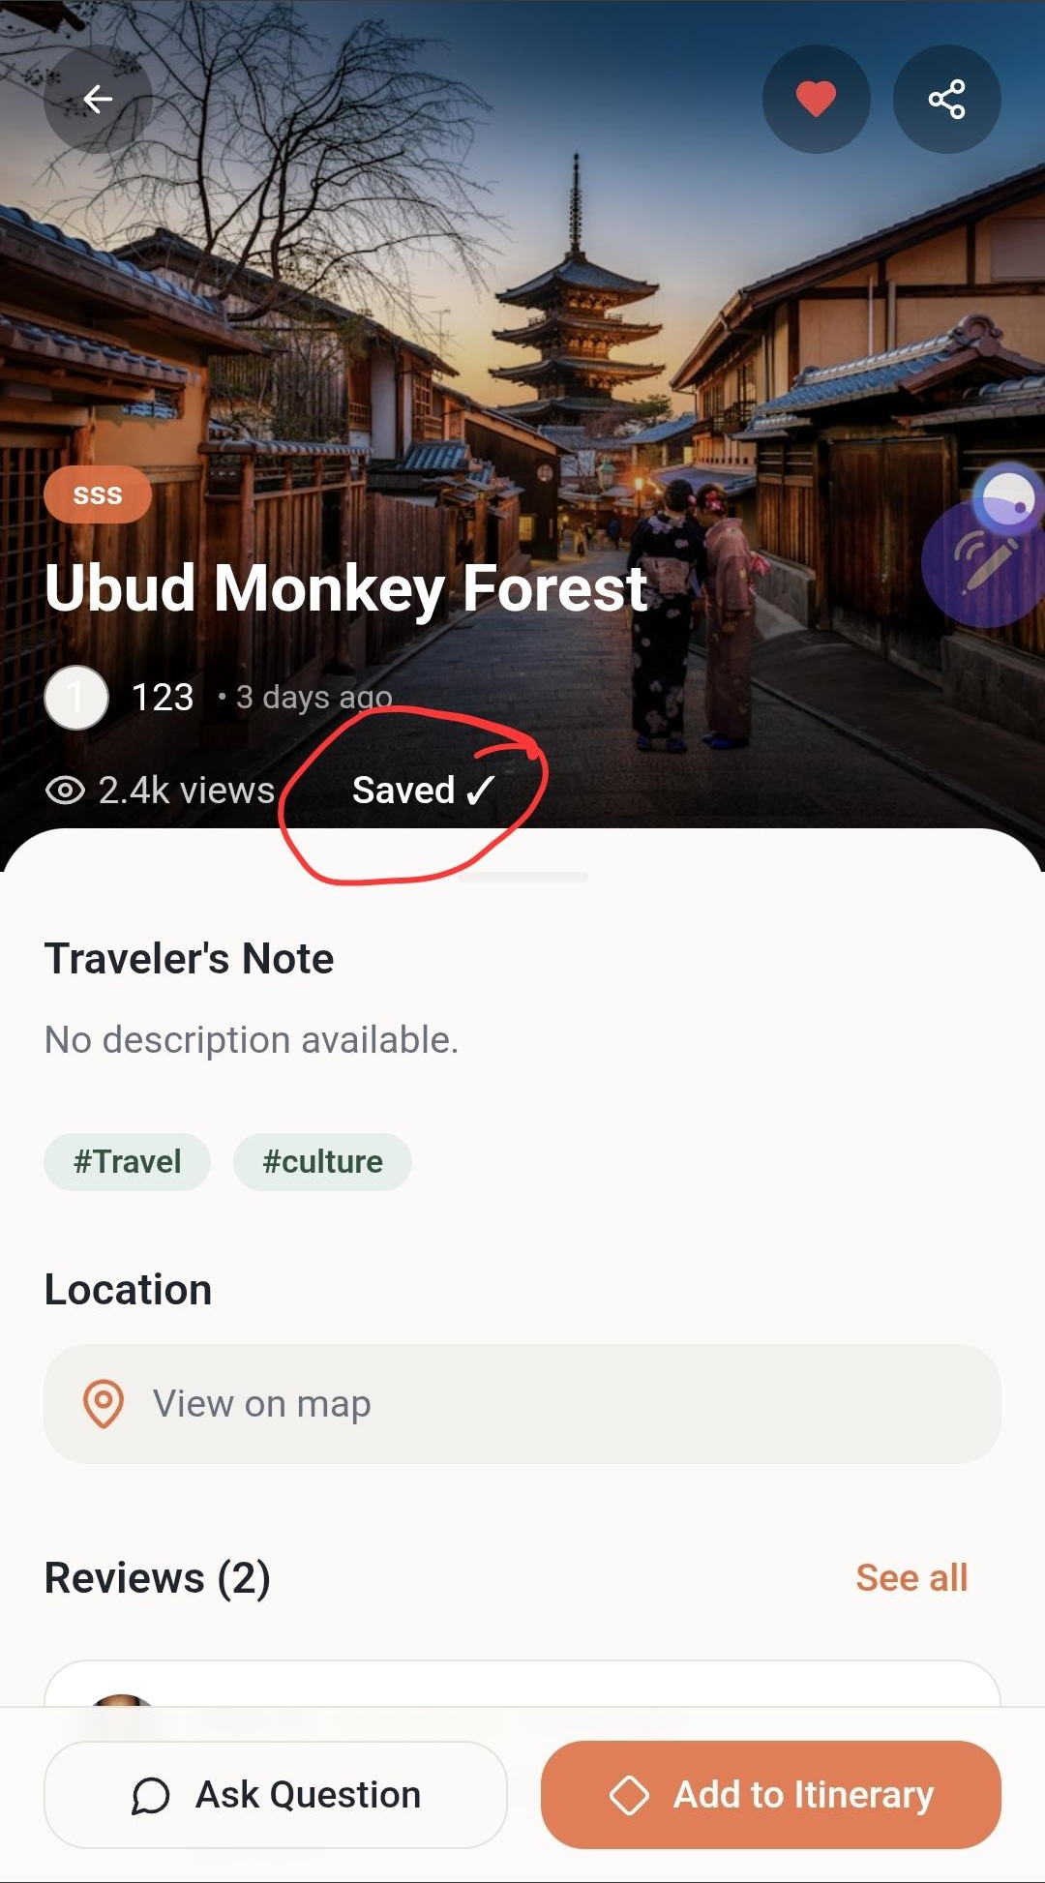 | 1. Remove this “Saved” button as it is similar with the heart shape button function, which is to add the location to the saved tab  2. When click on “View on map” You should open up the Google maps details.
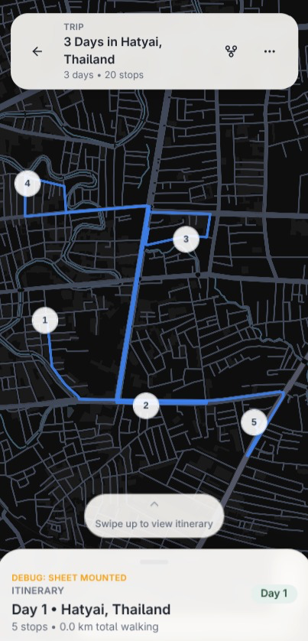 | When click on the number (which represent the location, it should show the location card info, based on the information extracted from the Google map API.
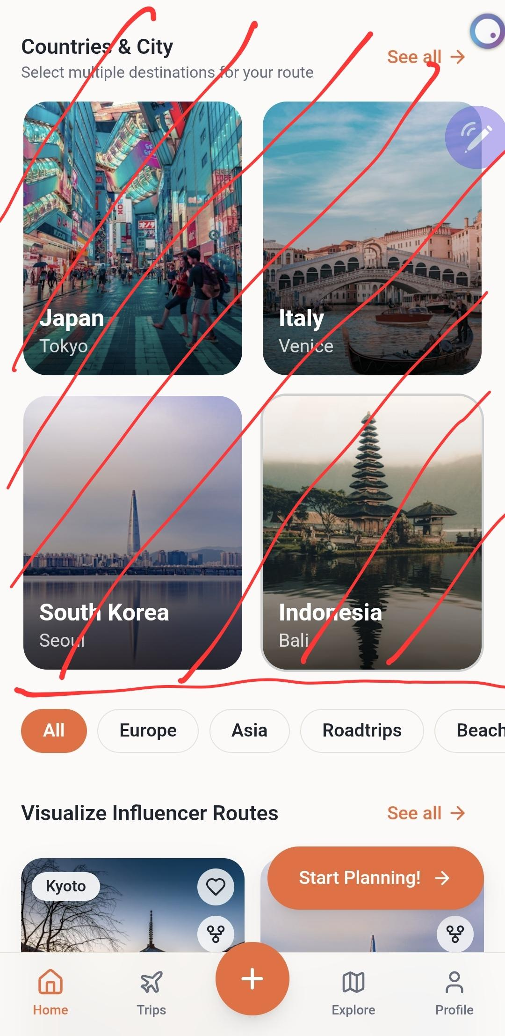 | Remove this section
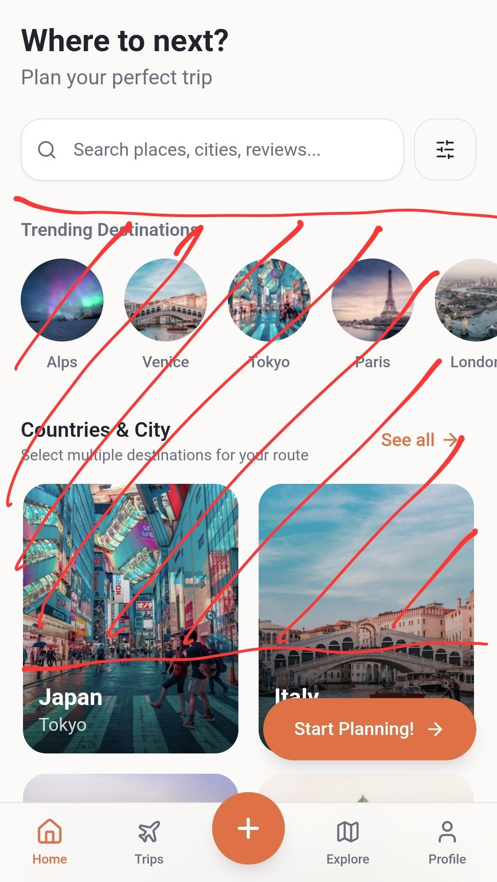 | Remove this sections

Feature to add: OCR + vision AI on screenshots of itineraries or maps
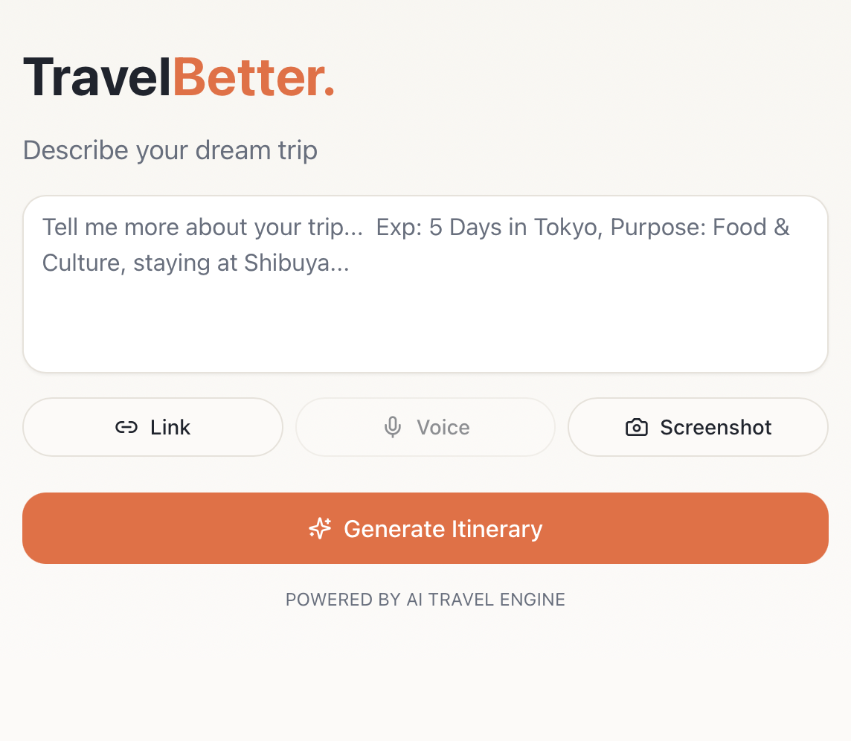
When the user clicks on the Screenshot button. It should prompt the user to provide an image as input, it should allow multiple image uploads, and it could be from their phone gallery or from a laptop device. After the user has uploaded the image, it should have Gemini to OCR and extract the text found on the image. The extracted text from the image will then be used as the input text for the normal text input procedure (which is using the extract-places-from-text.ts — Parses raw pasted itineraries and free-form text), where the text is likely a location name.

