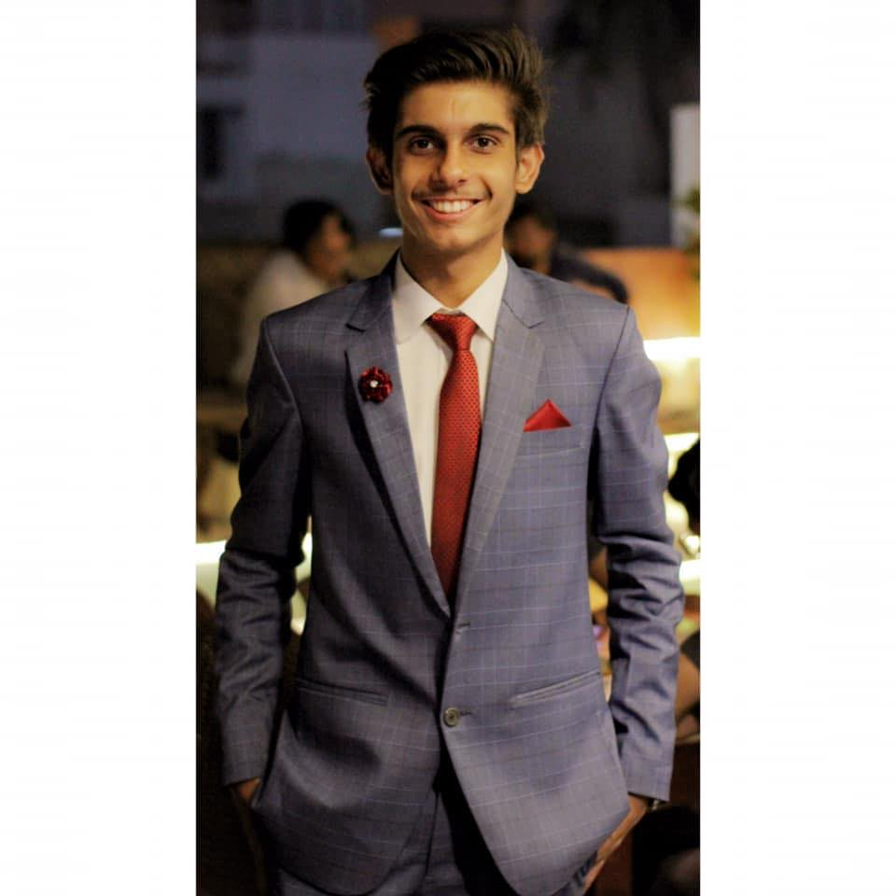Contacts:

* Email: [Razeenvirani01@gmail.com](mailto:Razeenvirani01@gmail.com)
* Contact no: 0331-2628249

Qualification:

* Bachelors in Computer Science, IBA.
* Intermediate from Aga Khan Higher Secondary.
* Matriculation from The City School.

Achievements:

* 11th position in Board of Intermediate Education, Karachi.
* 18th position all over Hyderabad in Kangaroo Mathematics Competition.
* 2nd position in Dawn National Spelling bee Contest.

Hobbies:

* Cricket
* Football
* Badminton
* Reading
* Table tennis