Term Work Index Sheet
Prof. name: Mrs. Jayshreee Patade |  |  | Class/SEM : T.Y.BSC.CS / SEM V (2026-2027)
Course code: Minor - Statistics |  |  | Subject name: Regression Analysis using R - Programming
Sr.  No | Date | Topics |  | Signature
1 |  | Fundamentals of R Programming and Data Handling To practice basic R commands, create common data structures and apply basic statistical functions.
2 |  | Data Import, Pre-processing and Manipulation using R To import, inspect, clean and manipulate a dataset in R.
3 |  | Data Visualization and Exploratory Data Analysis using R To visualize data and perform exploratory analysis before fitting a regression model
4 |  |   Simple  Linear  Regression  using  R  To  fit  a  simple  linear  regression  model,  interpret  its  coefficients  and  predict  response  values.
5 |  | Evaluation and Statistical Testing of Simple Linear  Regression  To fit a simple linear regression model, interpret its coefficients and predict response values.
6 |  | Multiple Linear Regression and Variable Selection using  R  To fit a multiple linear regression model, interpret coefficients and explore variable-selection strategies.
7 |  | Regression Model Validation and Residual Diagnostics To calculate residual measures and use diagnostic plots to assess regression assumptions.
8 |  | Detection and Treatment of Regression Assumption Violations  To test for autocorrelation and heteroscedasticity and consider suitable remedial measures.
9 |  | Advanced Regression Techniques using R  To fit polynomial regression and weighted least squares models and compare model fit.
10 |  | Multicollinearity, Ridge Regression and Regression Case Study  To identify multicollinearity, fit ridge regression and apply a complete regression workflow to a real-world dataset.

Term Work Certification
Certified that Mr/Ms _______________________________________________ Class ___________ Roll No. ________ Course ______________________ has completed the required number of Practicals / Term Work / Sessional in the ____________________ in the Department of ____________ during the academic year ______ successfully.
Signature of Faculty | Signature of HOD | Signature of Principal
Date: | Date: | Date:

Experiment No.— 1: Fundamentals of R Programming and Data Handling
Aim: To practice basic R commands, create common data structures and apply basic statistical functions.
Learning Objective:
To understand the basic concepts of R programming and data handling.
The purpose of this practical is to introduce students to basic R commands, data structures, and statistical functions used for handling and summarizing data.
Theory: R is a programming environment for statistical computing. Variables store values; vectors contain elements of one basic type, matrices are two-dimensional homogeneous structures, and data frames can contain columns of different types. Statistical functions summarize data.
Procedure:
- Open R or RStudio and enter the commands in the script/editor.
- Create variables and the requested data structures.
- Apply statistical functions and observe the results.
R Program:
x <- c(12, 15, 18, 20, 25) mat <- matrix(1:9, nrow=3, ncol=3)
students <- data.frame(id=c(1,2,3), marks=c(78,85,69)) mean(x) sum(x) min(x) max(x) range(x) var(x) summary(x) str(students)
Function Used / Meaning: str() – Displays the internal structure of an R object. summary() – Displays a statistical summary of the data.
var() – Calculates the variance. range() – Returns the minimum and maximum values. max() – Returns the largest value.
min() – Returns the smallest value. sum() – Calculates the total of the values. mean() – Calculates the arithmetic mean (average). data.frame() – Creates a data frame for storing data in rows and columns. matrix() – Creates a matrix with the specified number of rows and columns.
c() – Creates a vector by combining values.
Output:
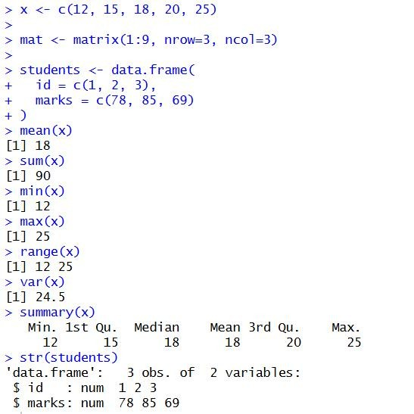
Conclusion: The basic R commands, data structures and statistical functions were successfully practiced. The student learned how to create and summarize data using R.
Course Outcome: After completing this practical, the student will be able to use basic R commands, create common data structures and apply statistical functions.
Viva Questions:
- What is R?
- What is a vector in R?
- How is a data frame different from a matrix?
- What does mean() calculate?
- What is the use of summary()?
For Faculty use:
Correction Parameters | Formative  Assessment[40%] | Timely Completion of Practical[40%] | Attendance Learning Attitude[20%]

Experiment No.— 2: Data Import, Pre-processing and Manipulation using R
Aim: To import, inspect, clean and manipulate a dataset in R.
Learning Objective:
To learn how to import, inspect, clean, and manipulate data using R.
The purpose of this practical is to develop skills in reading datasets, identifying missing values, changing data types, creating variables, renaming or removing variables, and removing duplicate observations.
Theory: Data preprocessing prepares raw data for analysis. Common tasks include importing files, checking structure and summary statistics, handling missing values, converting data types, creating or renaming variables, and removing duplicate observations.
Procedure:
- Set the working directory to the folder containing the dataset.
- Import the CSV file and inspect its structure.
- Handle missing values and duplicates; modify variables as required.
- Export the cleaned dataset.
R Program:
#2A
emp <- data.frame(
EmpID = 1:6,
Name = c("Aarav", "Diya", "Kabir", "Meera", "Diya", "Rohan"),
Age = c(28, 34, NA, 45, 34, 30),
Department = c("IT", "HR", "Finance", "IT", "HR", NA),
Salary = c(55000, 62000, 48000, NA, 62000, 51000)
) emp
write.csv(emp, "employee_data.csv", row.names = FALSE) emp_data <- read.csv("employee_data.csv", stringsAsFactors = FALSE) emp_data class(emp_data) str(emp_data) summary(emp_data)
#2b
emp$Age <- as.numeric(emp$Age) emp$Department <- as.factor(emp$Department) emp$Salary <- as.numeric(emp$Salary)
# Missing values emp$Age[is.na(emp$Age)] <- 0
emp$Department[is.na(emp$Department)] <- "Unknown" emp$Salary[is.na(emp$Salary)] <- 0
# Change variable types emp$Age <- as.numeric(emp$Age) emp$Department <- as.factor(emp$Department)
# Create a variable emp$Bonus <- emp$Salary * 0.10
# Rename a variable
names(emp)[names(emp) == "Name"] <- "EmployeeName"
# Drop a variable emp$EmpID <- NULL
# Remove duplicate observations emp <- emp[!duplicated(emp), ] emp
Important Note: Replace the file name and column names with those in your dataset.
Function Used / Meaning: data.frame() – Creates a data frame from vectors of employee information. write.csv() – Exports a data frame to a CSV file. read.csv() – Imports data from a CSV file into R. class() – Returns the class/type of an R object. str() – Displays the structure and data types of an object. summary() – Provides summary statistics for the dataset. as.numeric() – Converts values to numeric type.
as.factor() – Converts a variable into a factor (categorical) type.
is.na() – Checks whether values are missing (NA).
names() – Gets or changes the names of variables/columns.
duplicated() – Identifies duplicate observations.
data.frame / $ – Creates data and accesses or modifies a particular column.
Output: 1)2A
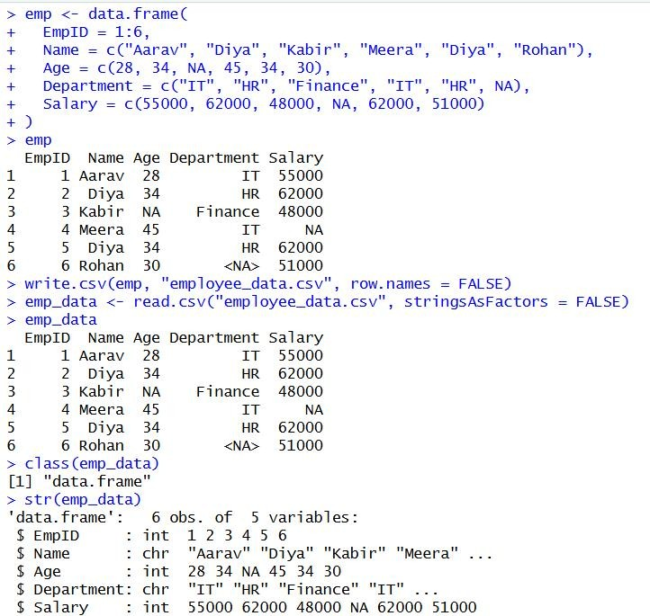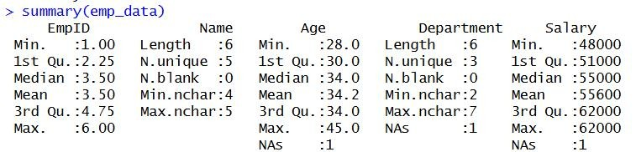
2)2B
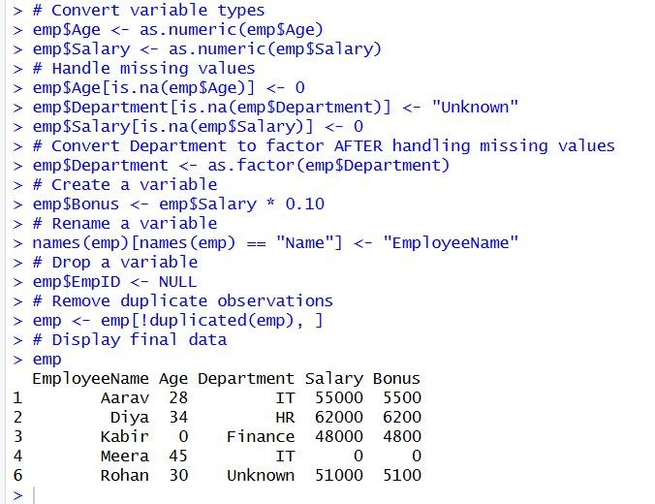
Conclusion: The dataset was imported, inspected, cleaned and exported successfully. Missing values, data types and duplicate observations were handled using R.
Course Outcome: After completing this practical, the student will be able to import, inspect, clean, manipulate and export datasets using R.
Viva Questions:
- What is a CSV file?
- What does str() display?
- How can missing values be identified?
- What is the use of na.omit()?
- Why are duplicate rows removed?
For Faculty use:
Correction Parameters | Formative  Assessment[40%] | Timely Completion of Practical[40%] | Attendance Learning Attitude[20%]

Experiment No.— 3: Data Visualization and Exploratory Data Analysis using R
Aim: To visualize data and perform exploratory analysis before fitting a regression model.
Learning Objective:
To learn how to visualize data and perform exploratory data analysis using R.
The purpose of this practical is to help students understand data distributions, comparisons, category frequencies, proportions, and relationships between numerical variables through graphs.
Theory: Exploratory data analysis uses numerical summaries and graphs to understand distributions, unusual observations and relationships. Histograms show distributions, box plots summarize spread and possible outliers, and scatter plots display relationships between two numerical variables.
Procedure:
- Load a dataset containing numerical and categorical variables.
- Create histogram, box plot, bar chart and pie chart.
- Create a scatter plot for a predictor and response variable.
R Program:
install.packages("ggplot2") # Run once
library(ggplot2)
mtcars head(mtcars) #Histogram
p<- ggplot(mtcars, aes(x = mpg)) +
geom_histogram(
bins = 10, fill = "skyblue",
color = "black"
) +
labs(
title = "Histogram of Miles Per Gallon", x = "Miles per Gallon",
y = "Frequency"
) +
theme_minimal()
ggsave("plot/histogram_mpg.png", plot = p)
#boxplot
b<- ggplot(mtcars, aes(x = factor(cyl), y = mpg)) +
geom_boxplot(fill = "lightgreen", color = "black") + labs(
title = "MPG by Number of Cylinders", x = "Cylinders", y = "Miles per Gallon"
) +
theme_minimal()
ggsave("plot/box_mpg.png", plot = b)
#barDiagram
bar<-ggplot(mtcars, aes(x = factor(cyl))) +
geom_bar(fill = "orange", color = "black") + labs(
title = "Number of Cars by Cylinders", x = "Cylinders",
y = "Number of Cars"
) +
theme_minimal()
ggsave("plot/Bar_cyl.png", plot = b)
#barchar2 data <- data.frame(
category = c("A", "B", "C", "D"),
value = c(25, 40, 30, 20)
)
bar2<-ggplot(data, aes(x = category, y = value)) +
geom_col(fill = "steelblue") +
labs(title = "Category-wise Values", x = "Category", y = "Value") + theme_minimal()
ggsave("plot/bar2_mpg.png", plot = bar2)
#pie Chart pie<- ggplot(data, aes(x = "", y = value, fill = category)) +
geom_bar(stat = "identity", width = 1) + coord_polar("y") +
labs(title = "Category Distribution") + theme_void()
ggsave("plot/pie1_mpg.png", plot = pie)
data$percentage <- round(
data$value / sum(data$value) * 100, 1
)
pie2<-ggplot(data, aes(x = "", y = value, fill = category)) +
geom_bar(stat = "identity", width = 1) +
coord_polar("y") + geom_text(
aes(label = paste0(percentage, "%")),
position = position_stack(vjust = 0.5)
) +
labs(title = "Category Distribution") + theme_void()
ggsave("plot/pie2_mpg.png", plot = pie2)
#Scatter Plot
s<- ggplot(mtcars, aes(x = wt, y = mpg)) +
geom_point(color = "red", size = 3) + labs(
title = "Weight vs Miles per Gallon", x = "Weight",
y = "Miles per Gallon"
) +
theme_minimal()
ggsave("plot/Scatter_mpg.png", plot = s)
Function Used / Meaning: install.packages() – Installs an R package from a repository; normally run once.
library() – Loads an installed package so its functions can be used. ggplot() – Starts a ggplot2 graphics object using the specified data and mappings. aes() – Defines how variables are mapped to visual properties such as x, y and fill.
geom_histogram() – Creates a histogram to display the distribution of a numerical variable. geom_boxplot() – Creates a box plot showing median, spread and possible outliers. geom_bar() – Creates a bar chart based on counts. geom_col() – Creates a bar chart using supplied numerical values. coord_polar() – Converts a bar chart into a circular/pie-style chart. geom_point() – Creates points for a scatter plot. geom_text() – Adds text labels to a graph. labs() – Adds or changes the graph title and axis labels. theme_minimal() – Applies a minimal graphical theme. theme_void() – Removes most non-data elements from a graph. ggsave() – Saves a ggplot graph as an image file. factor() – Converts a variable into a categorical factor.
data.frame() – Creates a data frame for the category-wise example. round() – Rounds numerical values to the specified number of decimal places. sum() – Calculates the total of numerical values. paste0() – Joins text without inserting separators. position_stack() – Controls positioning of stacked graphical elements.
Output:
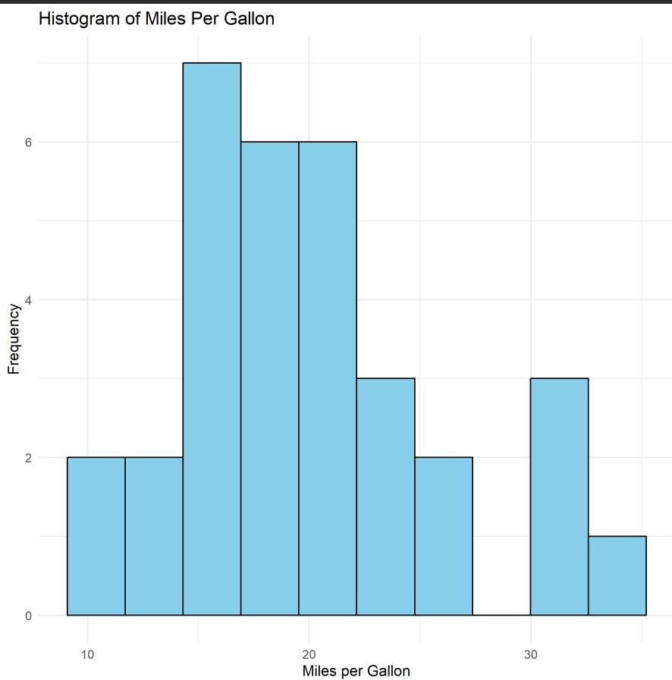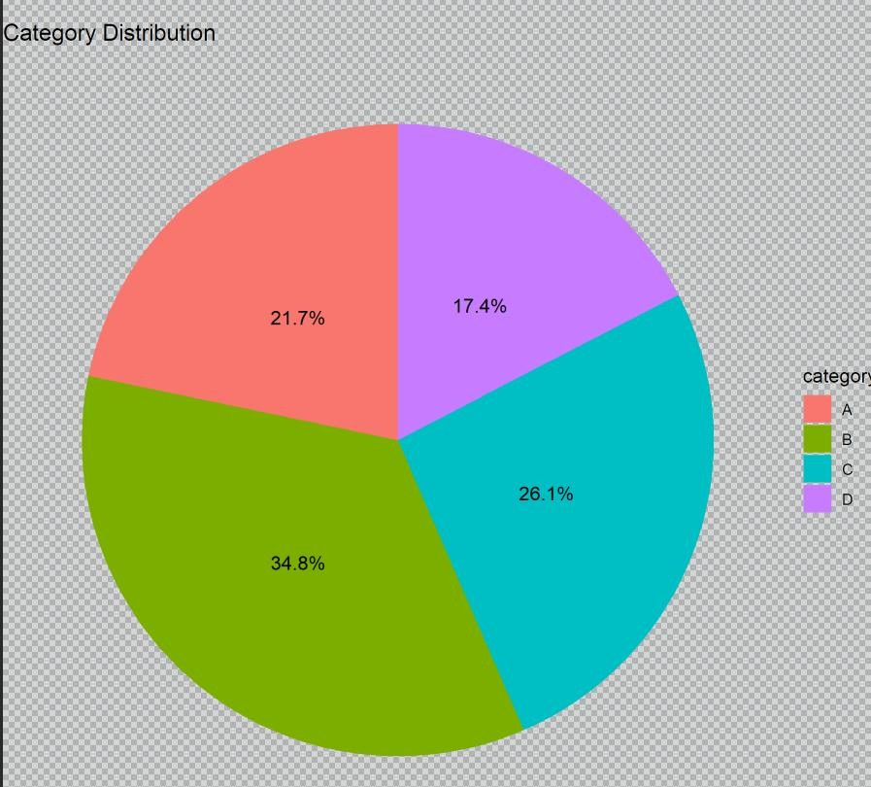
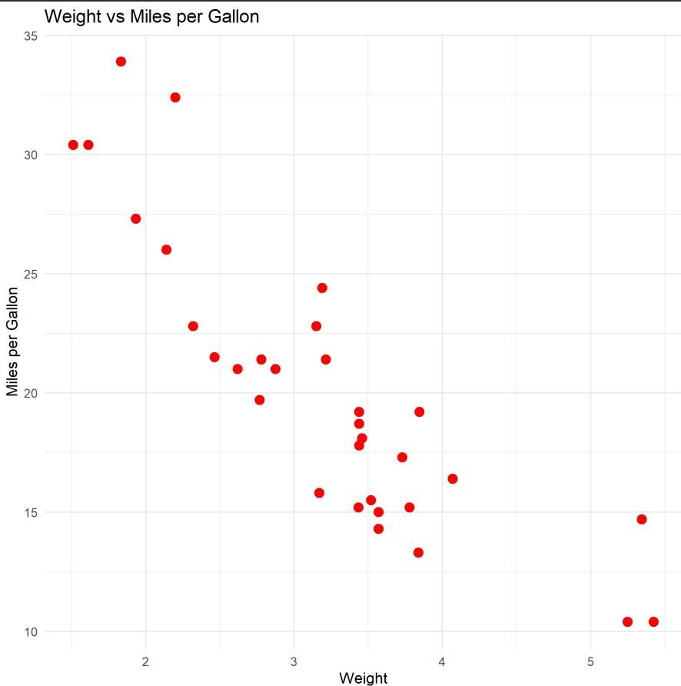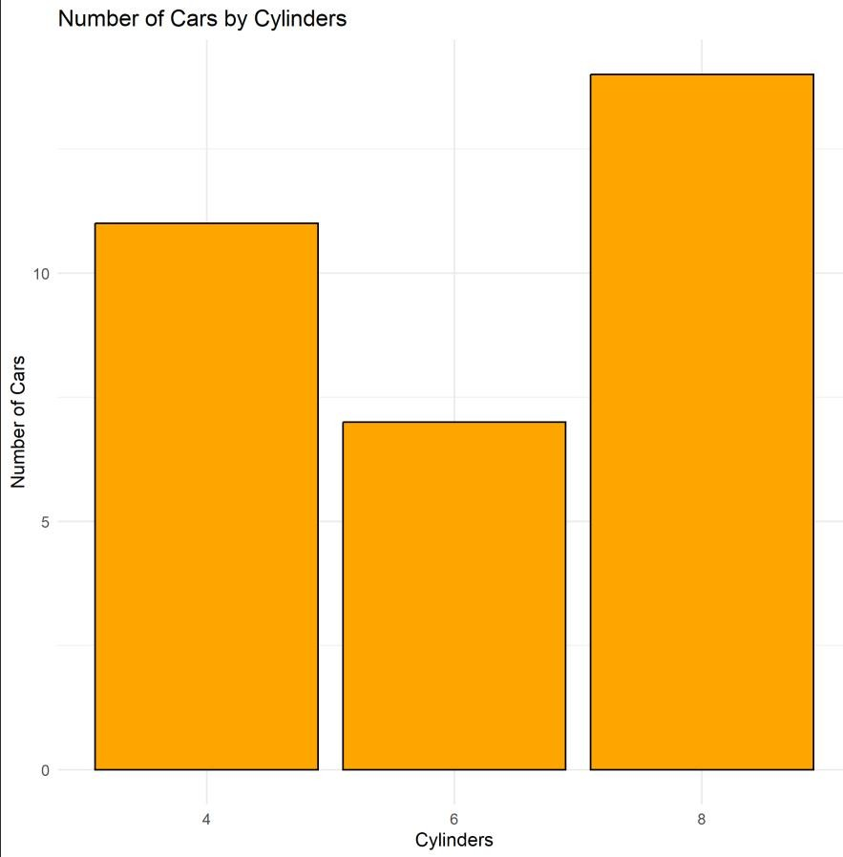
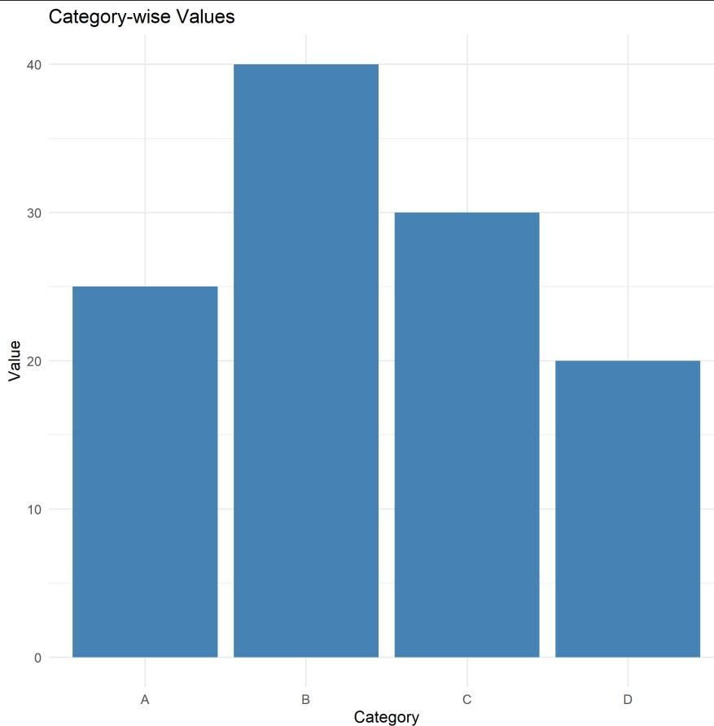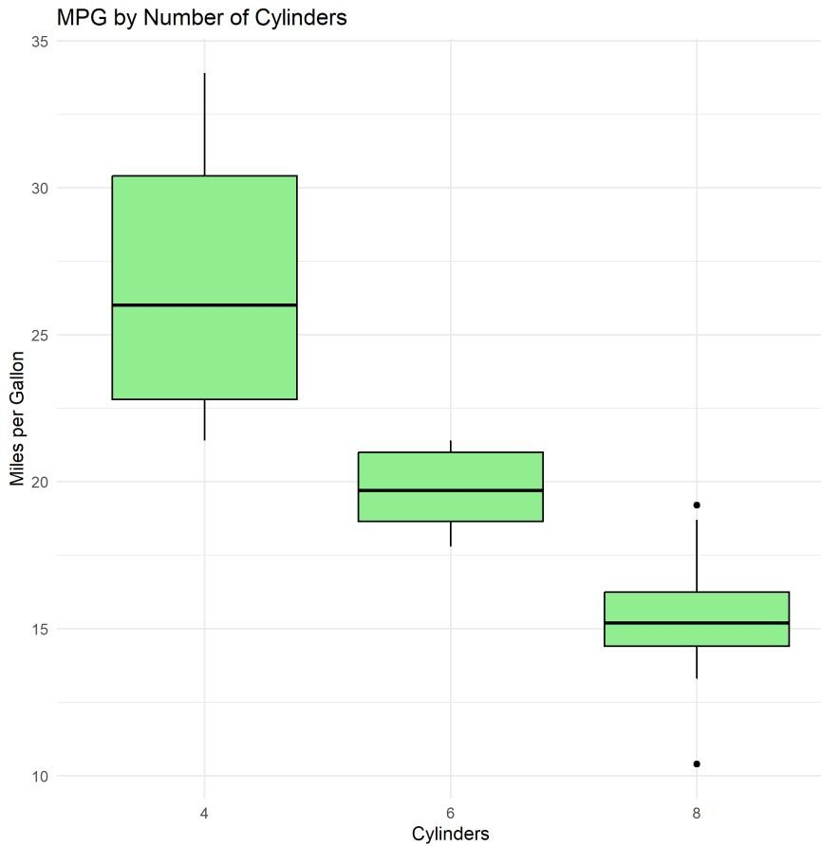
Conclusion: The dataset was explored using numerical summaries and graphical methods. Histograms, box plots, bar charts, pie charts and scatter plots helped understand distributions and relationships.
Course Outcome: After completing this practical, the student will be able to visualize data and perform basic exploratory data analysis using R.
Viva Questions:
- What is exploratory data analysis?
- What does a histogram show?
- What is an outlier?
- Why is a scatter plot useful in regression?
- Name one R package used for visualization.
For Faculty use:
Correction Parameters | Formative  Assessment[40%] | Timely Completion of Practical[40%] | Attendance Learning Attitude[20%]

Experiment No.— 4: Simple Linear Regression using R
Aim: To fit a simple linear regression model, interpret its coefficients and predict response values.
Learning Objective:
To understand and implement simple linear regression using R.
The purpose of this practical is to fit a regression model, obtain the regression equation and coefficients, visualize the relationship between variables, and predict the response for given predictor values.
Theory: Simple linear regression models the relationship between one predictor x and a numerical response y. The fitted line is expressed as predicted y = intercept + slope × x. The lm() function fits the model and predict() generates fitted predictions.
Procedure:
- Create or load a dataset with one predictor and one response variable.
- Fit the model using lm().
- Display coefficients and write the fitted equation.
- Predict the response for selected predictor values.
R Program:
# SIMPLE LINEAR REGRESSION USING mtcars
#Part A
# Step 1: Load dataset data(mtcars)
# Step 2: Display first few rows head(mtcars)
# Step 3: Create linear regression model model <- lm(mpg ~ hp, data = mtcars)
# Step 4: Display model summary summary(model)
# Step 5: Display fitted equation cat("Fitted Regression Equation:\n") cat("mpg =", intercept, "+", slope, "* hp\n")
# Step 8: Plot data
plot(mtcars$hp, mtcars$mpg,
main = "MPG vs Horsepower", xlab = "Horsepower (hp)", ylab = "Miles Per Gallon (mpg)", pch = 19)
# Step 9: Add regression line abline(model)
#Part B
# Step 6: Store coefficients coef(model)
# Step 7: Get regression coefficients intercept <- coef(model)[1] slope <- coef(model)[2]
# Predict MPG for hp = 150 new_car <- data.frame(hp = 150) predict(model, newdata = new_car)
#Predict for multiple horsepower values new_cars <- data.frame(hp = c(100, 150, 200, 250)) predicted_mpg <- predict(model, newdata = new_cars)
#tabluate output result <- data.frame(
Horsepower = new_cars$hp,
Predicted_MPG = predicted_mpg
) print(result)
#practical 5
# R-squared
# Step 1: Create linear regression model
model <- lm(mpg ~ hp, data = mtcars) summary(model) summary(model)$r.squared
# Adjusted R-squared summary(model)$adj.r.squared
# t-test for individual regression coefficients summary(model)$coefficients
# F-test for overall model significance summary(model)$fstatistic # 95% confidence intervals confint(model)
# 99% confidence intervals (optional) confint(model, level = 0.99)
#practical 6
Function Used / Meaning: data() – Loads the built-in mtcars dataset.
head() – Displays the first few rows of a dataset. lm() – Fits a linear regression model. summary() – Displays detailed information about the fitted regression model. cat() – Prints text and values together in the R console.
Execution Note: In the uploaded code, the fitted-equation cat() lines appear before intercept and slope are assigned. Run the coefficient section (Part B) before those cat() lines when executing the program sequentially. coef() – Extracts the regression coefficients from the model. plot() – Creates a graph of horsepower against miles per gallon. abline() – Adds the fitted regression line to a plot. data.frame() – Creates a data frame containing new predictor values for prediction. predict() – Generates predicted response values for new observations.
Output:
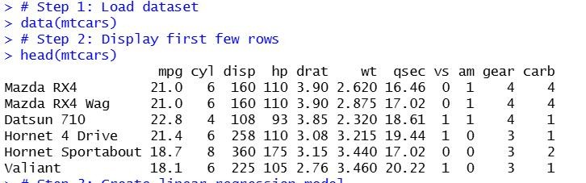
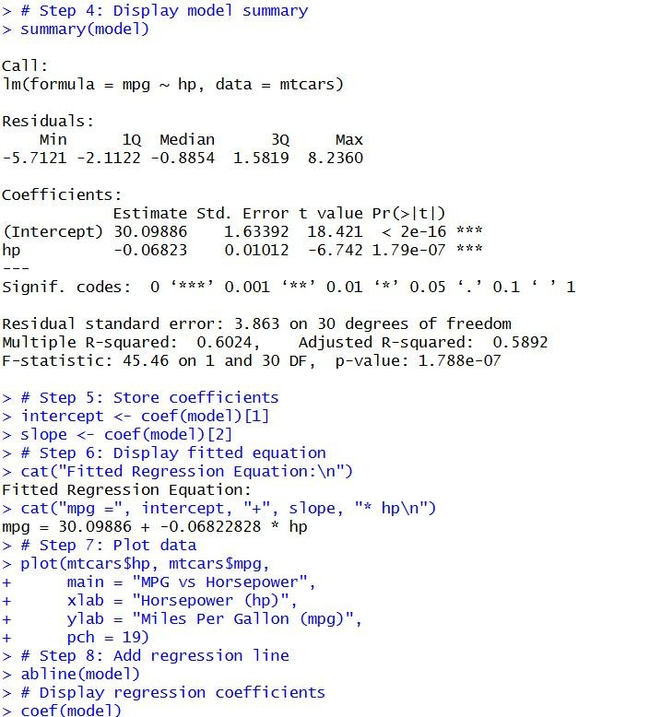
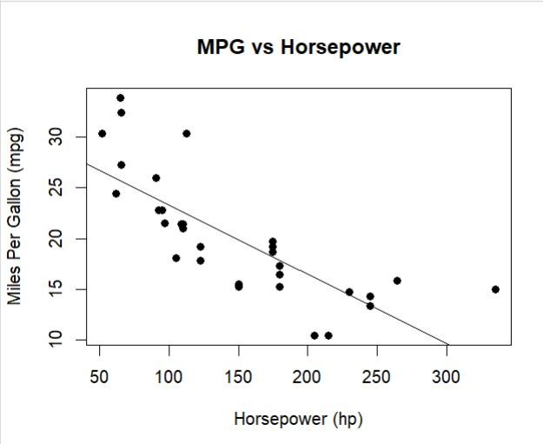
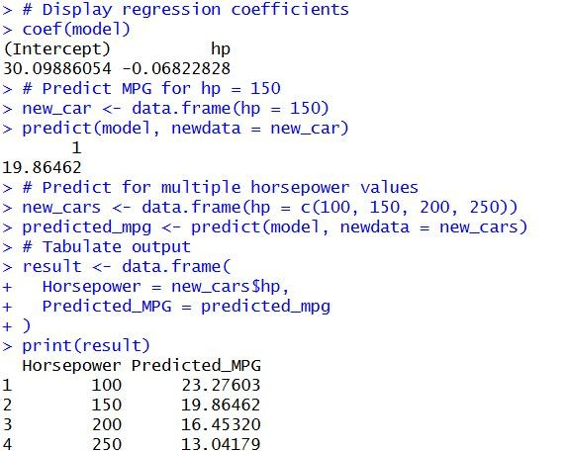
Conclusion: A simple linear regression model was fitted successfully. The regression coefficients were obtained and response values were predicted for selected predictor values.
Course Outcome: After completing this practical, the student will be able to fit a simple linear regression model, interpret coefficients and generate predictions.
Viva Questions:
- What is simple linear regression?
- What is the response variable?
- What does lm() do?
- What is the meaning of the slope?
- What is prediction in regression?
For Faculty use:
Correction Parameters | Formative  Assessment[40%] | Timely Completion of Practical[40%] | Attendance Learning Attitude[20%]

Experiment No.— 5: Evaluation and Statistical Testing of Simple Linear Regression
Aim: To evaluate a simple regression model and perform statistical tests and confidence interval estimation.
Learning Objective:
To evaluate a regression model using statistical measures and tests.
The purpose of this practical is to understand R-squared, adjusted R-squared, coefficient t-tests, the overall F-test, and confidence intervals for assessing a regression model.
Theory: R-squared describes the proportion of response variation explained by the model. Adjusted R-squared accounts for the number of predictors. The coefficient t-tests assess individual coefficients, while the model F-test assesses overall regression significance. Confidence intervals provide a range of plausible parameter values.
Procedure:
- Fit a simple linear regression model.
- Read R-squared and adjusted R-squared from summary().
- Examine coefficient t-tests and the overall F-test.
- Calculate confidence intervals for model coefficients.
R Program:
#practical 5
# R-squared
# Step 1: Create linear regression model model <- lm(mpg ~ hp, data = mtcars) summary(model) summary(model)$r.squared
# Adjusted R-squared summary(model)$adj.r.squared
# t-test for individual regression coefficients summary(model)$coefficients
# F-test for overall model significance
summary(model)$fstatistic # 95% confidence intervals confint(model)
# 99% confidence intervals (optional) confint(model, level = 0.99) Function Used / Meaning:
data() – Loads the built-in mtcars dataset. lm() – Fits simple or multiple linear regression models. summary() – Displays coefficients, R-squared, adjusted R-squared and significance information.
$r.squared – Extracts the R-squared value from a model summary.
$adj.r.squared – Extracts the adjusted R-squared value. anova() – Compares nested regression models using analysis of variance.
step() – Performs stepwise model selection according to the selected direction. par() – Sets graphical parameters such as the number of plots shown together. plot() – Generates diagnostic plots for the selected regression model.
Output:
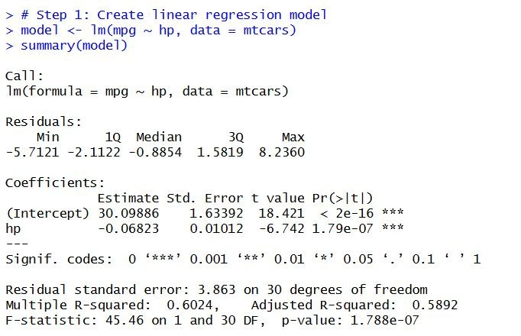
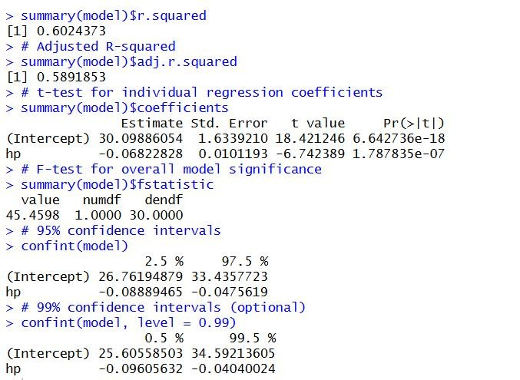
Conclusion: The simple regression model was evaluated using R-squared, adjusted R-squared, coefficient tests, the overall F-test and confidence intervals.
Course Outcome: After completing this practical, the student will be able to evaluate a regression model using R-squared, statistical tests and confidence intervals.
Viva Questions:
- What does R-squared measure?
- What is adjusted R-squared?
- What is a t-test used for in regression?
- What does the F-test assess?
- What is a confidence interval?
For Faculty use:
Correction Parameters | Formative  Assessment[40%] | Timely Completion of Practical[40%] | Attendance Learning Attitude[20%]

Experiment No.— 6: Multiple Linear Regression and Variable Selection using R
Aim: To fit a multiple linear regression model, interpret coefficients and explore variable-selection strategies.
Theory: Multiple linear regression uses two or more predictors to explain a numerical response. Each coefficient describes the expected change in the response for a one-unit increase in that predictor, holding other predictors constant. Model-building strategies should be guided by subject knowledge and diagnostics, not a single statistic alone.
Procedure:
- Load a dataset with several possible predictors.
- Fit a multiple regression model using lm().
- Inspect coefficients, R-squared, adjusted R-squared and significance tests.
- Compare a full model with a reduced model using a justified selection approach.
R Program:
#Multiple Regression # Load data
data(mtcars)
# Model 1
model1 <- lm(mpg ~ wt, data = mtcars)
# Model 2
model2 <- lm(mpg ~ wt + hp, data = mtcars)
# Model 3
model3 <- lm(mpg ~ wt + hp + cyl, data = mtcars)
# Display results summary(model1) summary(model2) summary(model3)
# Compare R-squared summary(model1)$r.squared summary(model1)$adj.r.squared
summary(model2)$r.squared summary(model2)$adj.r.squared
summary(model3)$r.squared summary(model3)$adj.r.squared # Compare nested models anova(model1, model2) anova(model2, model3)
# Full model full_model <- lm(
mpg ~ wt + hp + disp + cyl + drat + qsec + vs + am + gear + carb, data = mtcars
)
# Variable selection
selected_model <- step(full_model, direction = "both") summary(selected_model)
# Diagnostics par(mfrow = c(2, 2)) plot(selected_model)
Function Used / Meaning: lm() – Fits the regression model using the specified response and predictor. residuals() – Returns residuals, calculated as observed values minus fitted values. rstandard() – Calculates standardized residuals by scaling residuals using their estimated standard deviation.
rstudent() – Calculates studentized residuals using an error-variance estimate that excludes the observation being examined.
par() – Sets graphical parameters such as the plotting layout and margins.
plot() – Generates the selected regression diagnostic plots. which = 1 – Selects the Residuals vs Fitted diagnostic plot.
which = 2 – Selects the Normal Q-Q diagnostic plot. which = 3 – Selects the Scale-Location diagnostic plot. which = 5 – Selects the Residuals vs Leverage diagnostic plot.
Output:
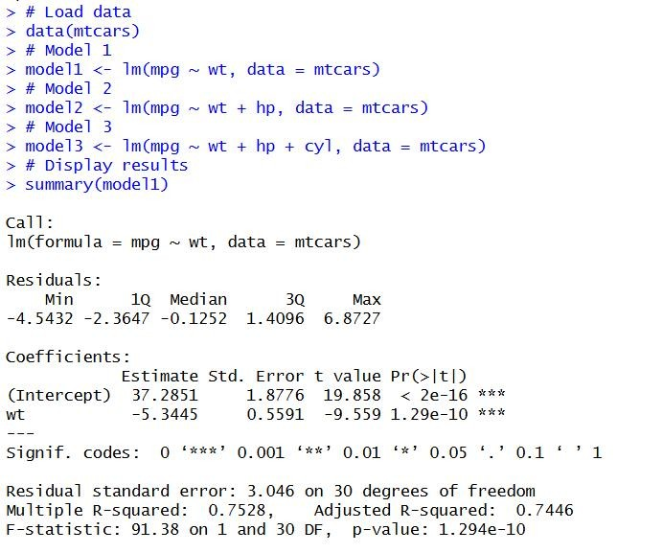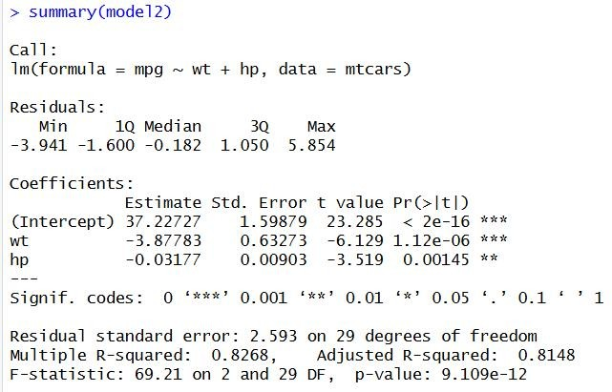
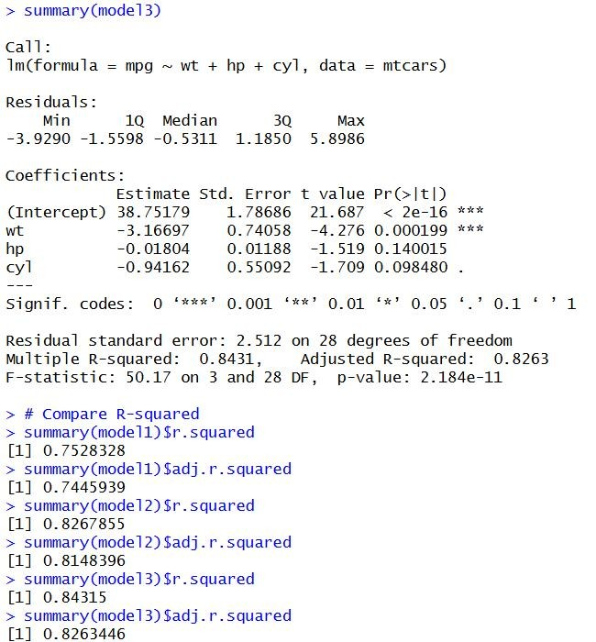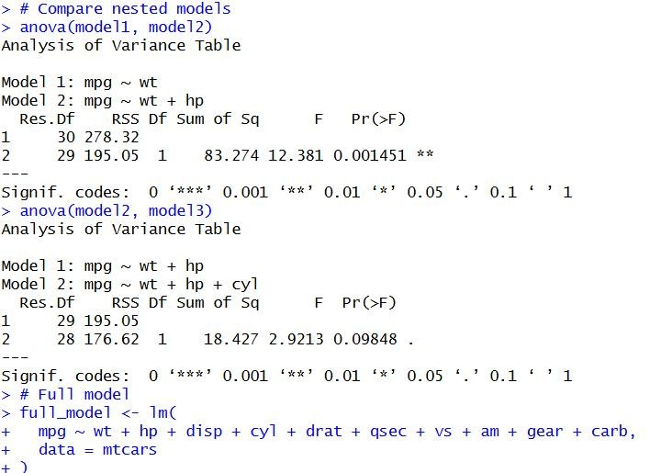
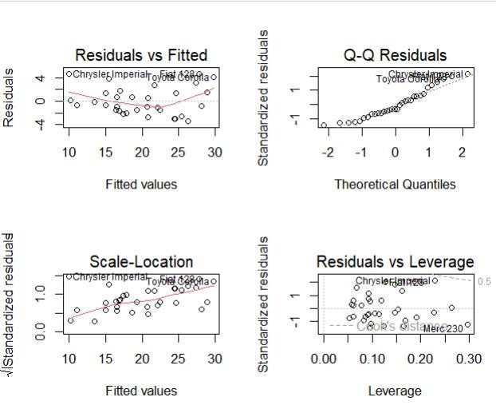
Conclusion: A multiple linear regression model was fitted and compared with a reduced model. Model summaries, ANOVA and AIC were used to support model comparison.
Course Outcome: After completing this practical, the student will be able to fit multiple linear regression models and compare models using appropriate criteria.
Viva Questions:
- What is multiple linear regression?
- What is a predictor variable?
- Why can adjusted R-squared be useful?
- What is forward selection?
- What does a regression coefficient represent?
For Faculty use:
Correction Parameters | Formative  Assessment[40%] | Timely Completion of Practical[40%] | Attendance Learning Attitude[20%]

Experiment No.— 7: Regression Model Validation and Residual Diagnostics
Aim: To calculate residual measures and use diagnostic plots to assess regression assumptions.
Theory: Residuals are differences between observed and fitted response values. Diagnostic plots help identify nonlinearity, unequal variance, non-normality and influential observations. A model should be assessed using plots and context rather than relying only on summary statistics.
Procedure:
- Fit a regression model.
- Extract fitted values and residuals.
- Calculate standardized and studentized residuals.
- Generate and inspect the standard diagnostic plots.
R Program:
#Practical 7 - Regression Model Validation and Residual Diagnostics model1 <- lm(mpg ~ wt, data = mtcars)
#Residual = Actual value − Predicted value residuals(model1)
#Standardized residuals scale the residuals #by their estimated standard deviation. rstandard(model1)
#Studentized residuals are calculated by removing #the observation being examined when estimating #the error variance. rstudent(model1)
par(mfrow = c(2, 2))
plot(model1, which = 1) # Residuals vs Fitted
par(mfrow = c(1, 1)) par(mar = c(4, 4, 2, 2)) plot(model1, which = 2) # Normal Q-Q
plot(model1, which = 3) # Scale-Location plot(model1, which = 5) # Residuals vs Leverage par(mfrow = c(1, 1))
##| Plot | Checks | Good indication
|
# | ------------------------- | ----------------------------- | ---------------------------------- |
# | **Residuals vs Fitted** | Linearity & constant variance | Random scatter around 0 |
# | **Normal Q-Q** | Normality of residuals | Points close to straight line |
# | **Scale-Location** | Constant variance | Horizontal, evenly spread pattern |
# | **Residuals vs Leverage** | Influential observations | No problematic highleverage points |
Function Used / Meaning: plot() – Generates diagnostic plots for the regression model. par() – Sets graphical parameters such as the plotting layout. rstudent() – Calculates studentized residuals. rstandard() – Calculates standardized residuals. residuals() – Returns residuals, i.e. observed values minus fitted values. fitted() – Returns fitted/predicted values from the model. lm() – Fits the regression model.
data() – Loads the mtcars dataset.
Output:
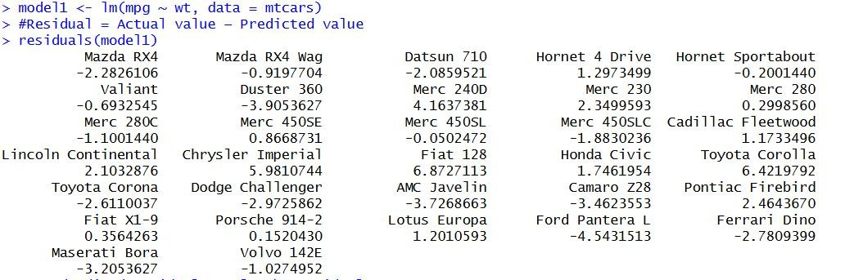
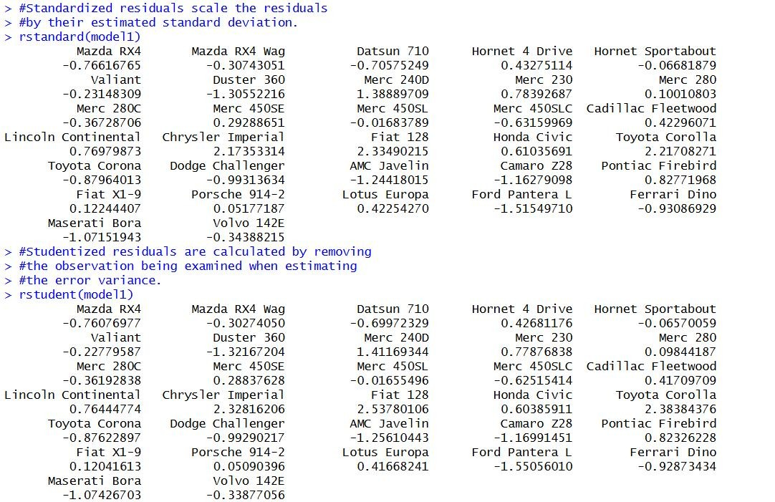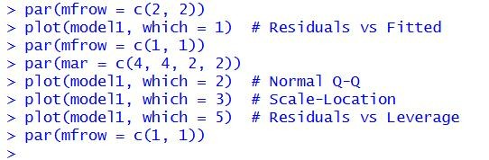
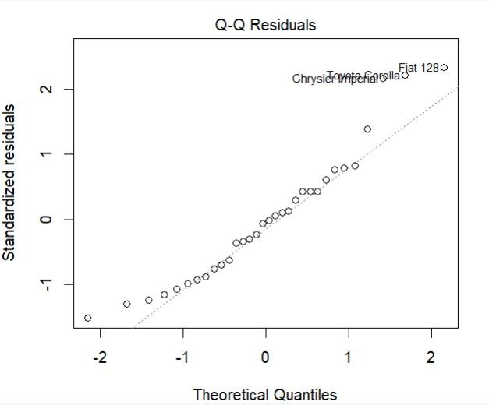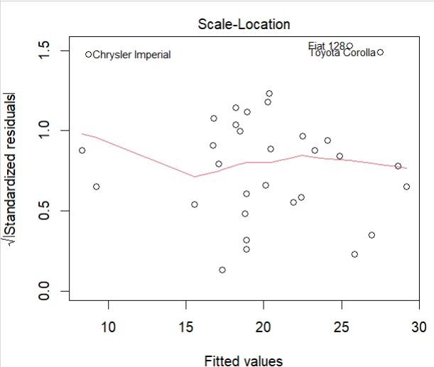
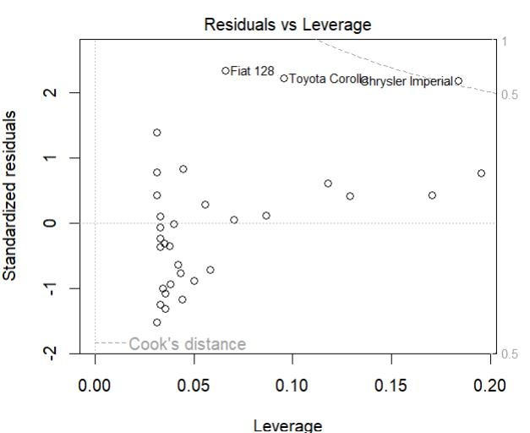
Conclusion: Residual measures and standard diagnostic plots were generated successfully. They can be used to assess linearity, constant variance, normality and influential observations.
Course Outcome: After completing this practical, the student will be able to calculate residual measures and use diagnostic plots for regression model validation.
Viva Questions:
- What is a residual?
- What is a fitted value?
- What does a residual plot help detect?
- Name the four standard diagnostic plots.
- What is normality of residuals?
For Faculty use:
Correction Parameters | Formative  Assessment[40%] | Timely Completion of Practical[40%] | Attendance Learning Attitude[20%]

Experiment No.— 8: Detection and Treatment of Regression Assumption Violations
Aim: To test for autocorrelation and heteroscedasticity and consider suitable remedial measures.
Theory: Autocorrelation refers to dependence among errors, often relevant in ordered or time-series data. Heteroscedasticity means error variance is not constant. The Durbin-Watson test and Breusch-Pagan test are commonly used to investigate these issues. Test conclusions should be interpreted alongside plots and study design.
Procedure:
- Install and load the lmtest package if it is not already installed.
- Fit a regression model to suitable data.
- Run the Durbin-Watson and Breusch-Pagan tests.
- Interpret the test statistics and p-values; discuss an appropriate remedy if an assumption appears violated.
R Program:
# install.packages("lmtest") library(lmtest)
data(mtcars)
model <- lm(mpg ~ wt + hp, data=mtcars) dwtest(model) bptest(model)
plot(fitted(model), residuals(model), xlab="Fitted Values", ylab="Residuals") abline(h=0, lty=2)
Important Note: The Durbin-Watson test is most meaningful when the observation order has substantive meaning.
Function Used / Meaning: abline() – Adds a straight reference line to a graph. plot() – Creates a plot of fitted values against residuals. bptest() – Performs the Breusch-Pagan test for heteroscedasticity. dwtest() – Performs the Durbin-Watson test for autocorrelation. lm() – Fits the regression model. data() – Loads the mtcars dataset. library() – Loads an installed R package for use.
Output:
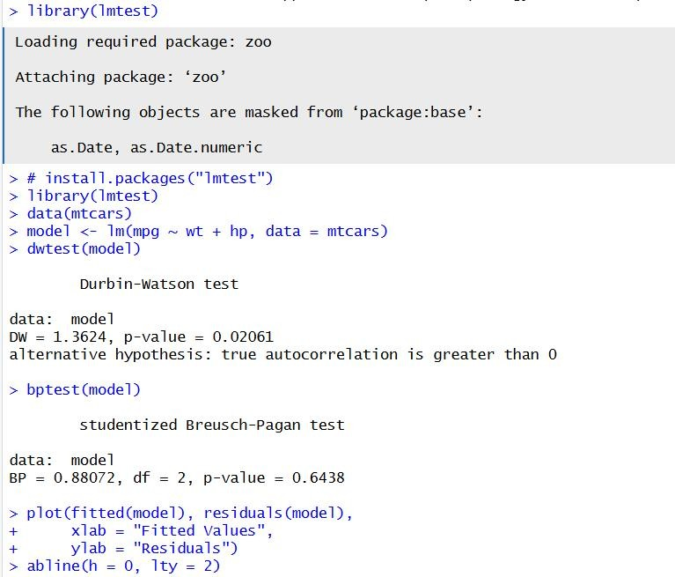
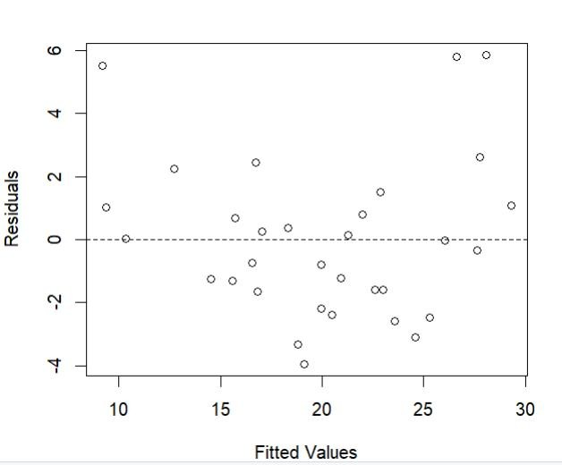
Conclusion: The Durbin-Watson and Breusch-Pagan tests were applied to investigate autocorrelation and heteroscedasticity, supported by residual plots.
Course Outcome: After completing this practical, the student will be able to identify autocorrelation and heteroscedasticity using statistical tests and residual plots.
Viva Questions:
- What is autocorrelation?
- What does the Durbin-Watson test examine?
- What is heteroscedasticity?
- What does bptest() test?
- Name one remedy for non-constant variance.
For Faculty use:
Correction Parameters | Formative  Assessment[40%] | Timely Completion of Practical[40%] | Attendance Learning Attitude[20%]

Experiment No.— 9: Advanced Regression Techniques using R
Aim: To fit polynomial regression and weighted least squares models and compare model fit.
Theory: Polynomial regression adds powers of a predictor to represent curved relationships while remaining linear in the coefficients. Weighted least squares gives observations different weights, often to address a known or modelled variance pattern. Model comparisons should consider assumptions and validation as well as fit.
Procedure:
- Plot the predictor-response relationship and consider whether curvature is plausible.
- Fit linear and polynomial models.
- Compare model summaries and residual plots.
- Fit a weighted least squares model using justified weights.
R Program:
data(cars)
linear_model <- lm(dist ~ speed, data=cars) poly_model <- lm(dist ~ speed + I(speed^2), data=cars) summary(linear_model) summary(poly_model) anova(linear_model, poly_model) plot(poly_model)
# Example weights for demonstration only; choose weights based on the data/model wls_model <- lm(dist ~ speed, data=cars, weights=1/speed^2) summary(wls_model)
Important Note: Weights must be selected based on a defensible variance model; the example is for demonstrating syntax.
Function Used / Meaning: plot() – Creates diagnostic plots for the fitted model. anova() – Compares the linear and polynomial models. summary() – Displays regression model results.
I() – Forces an expression such as speed^2 to be interpreted as a mathematical term in the model formula. lm() – Fits linear, polynomial or weighted least squares regression models. data() – Loads the cars dataset.
Output:
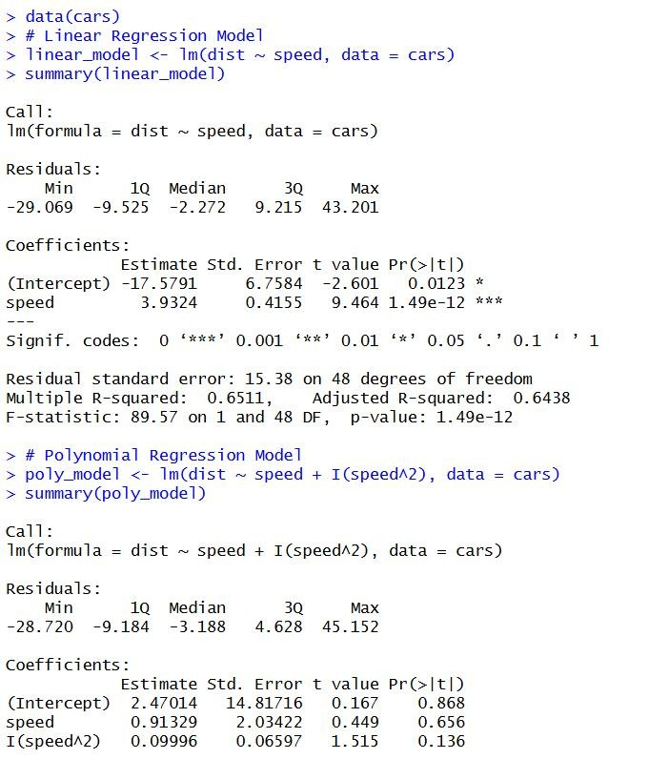
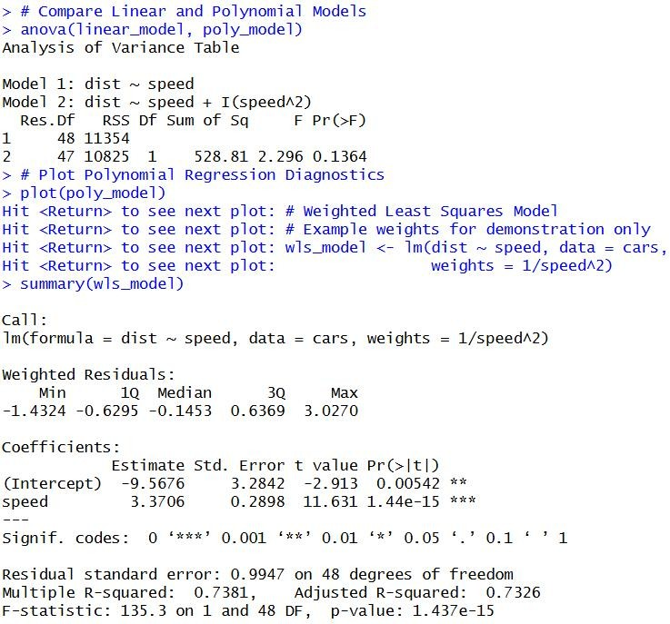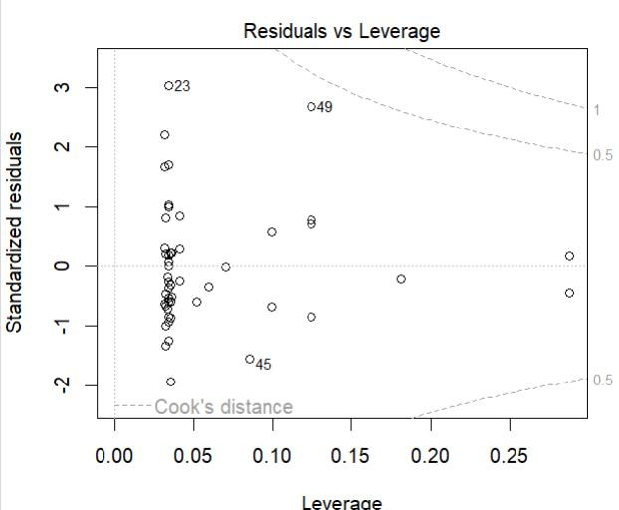
Conclusion: Linear, polynomial and weighted regression models were fitted and compared. The practical demonstrated how model form and justified weights can be used when appropriate.
Course Outcome: After completing this practical, the student will be able to apply polynomial regression and weighted least squares and compare regression models.
Viva Questions:
- What is polynomial regression?
- Why include a squared predictor term?
- What is weighted least squares?
- When might a response transformation help?
- Why compare regression models?
For Faculty use:
Correction Parameters | Formative  Assessment[40%] | Timely Completion of Practical[40%] | Attendance Learning Attitude[20%]

Experiment No.— 10: Multicollinearity, Ridge Regression and Regression Case Study
Aim: To identify multicollinearity, fit ridge regression and apply a complete regression workflow to a real-world dataset.
Theory: Multicollinearity occurs when predictors are strongly related, which can make coefficient estimates unstable. Correlation matrices and variance inflation factors (VIF) help diagnose it. Ridge regression adds an L2 penalty to reduce coefficient variance. Model evaluation should include data inspection, fitting, diagnostics and validation.
Procedure:
- Inspect the predictor correlations and calculate VIF values.
- Fit an ordinary least squares model and note its coefficients.
- Fit a ridge model using a package and select the penalty parameter using cross-validation.
- Compare model performance and summarize the workflow.
R Program:
# PRACTICAL NO. 10
# Multicollinearity, Ridge Regression and Regression Case Study
# Install packages only if not already installed # install.packages(c("car", "MASS", "glmnet"))
library(car) library(MASS) library(glmnet)
# Load dataset data(mtcars)
# ---------------------------------
# PART A: MULTICOLLINEARITY
# ---------------------------------
# Fit multiple linear regression model ols <- lm(mpg ~ wt + hp + disp + qsec, data = mtcars)
# Correlation matrix
cor(mtcars[, c("wt", "hp", "disp", "qsec")])
# Variance Inflation Factor vif(ols)
# ---------------------------------
# PART B: RIDGE REGRESSION
# ---------------------------------
# Prepare predictor matrix and target variable x <- model.matrix(mpg ~ wt + hp + disp + qsec, data = mtcars)[, -1]
y <- mtcars$mpg
# Ridge regression with cross-validation set.seed(123) cv_ridge <- cv.glmnet(x, y, alpha = 0)
# Best regularization parameter cv_ridge$lambda.min
# Ridge regression coefficients coef(cv_ridge, s = "lambda.min")
# Predictions for first five observations predict(cv_ridge, newx = x[1:5, , drop = FALSE], s = "lambda.min")
# ---------------------------------
# PART C: REGRESSION CASE STUDY
# ---------------------------------
# Split data into training and testing sets set.seed(123)
train_rows <- sample(seq_len(nrow(mtcars)), size = floor(0.8 * nrow(mtcars)))
train_data <- mtcars[train_rows, ] test_data <- mtcars[-train_rows, ]
# Fit regression model on training data case_model <- lm(mpg ~ wt + hp + disp + qsec, data = train_data)
# Display model summary summary(case_model)
# Predict on unseen test data actual_mpg <- test_data$mpg
predicted_mpg <- predict(case_model, newdata = test_data)
# Calculate evaluation metrics rmse <- sqrt(mean((actual_mpg - predicted_mpg)^2)) r_squared <- 1 -
sum((actual_mpg - predicted_mpg)^2) / sum((actual_mpg - mean(actual_mpg))^2)
cat("Test RMSE:", rmse, "\n") cat("Test R-squared:", r_squared, "\n")
# Compare actual and predicted values
results <- data.frame(
Actual_MPG = actual_mpg,
Predicted_MPG = as.numeric(predicted_mpg)
) print(results)
Important Note: Install required packages before running. Ridge regression requires numeric model-matrix predictors.
Function Used / Meaning: predict() – Generates predictions from the fitted model. coef() – Extracts model coefficients. cv.glmnet() – Fits a regularized model using cross-validation; alpha=0 specifies ridge regression. set.seed() – Sets the random-number seed so results involving randomness can be reproduced. model.matrix() – Creates the numeric model matrix used by the regression model. vif() – Calculates Variance Inflation Factor to help detect multicollinearity. cor() – Calculates correlations between numerical variables. lm() – Fits the ordinary least squares regression model. data() – Loads the mtcars dataset.
library() – Loads an installed R package.
Output:
1)10A
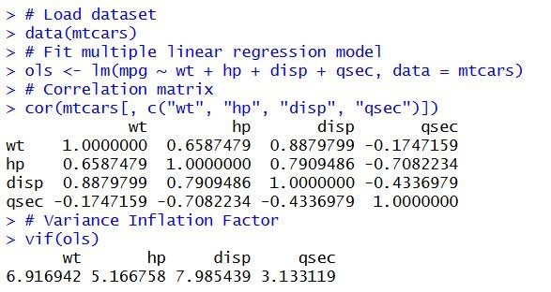
2)10B
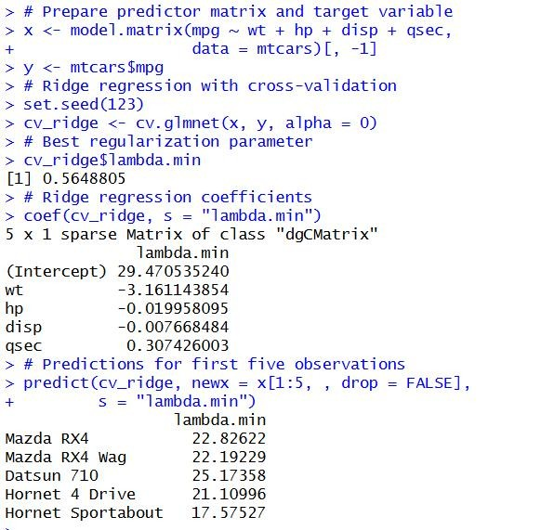
3)10C
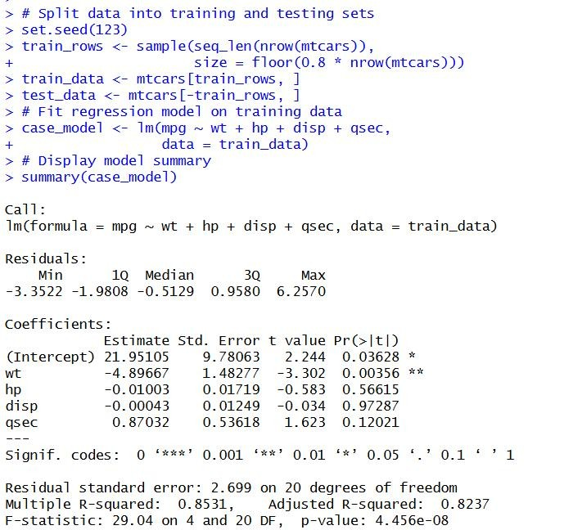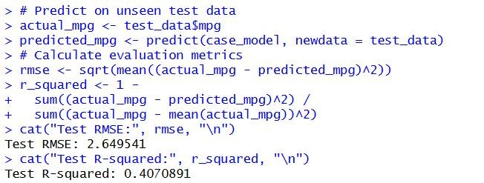
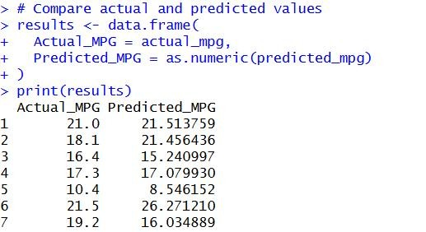
Conclusion: Multicollinearity was examined using correlations and VIF, and ridge regression was fitted with cross-validation. The practical demonstrated a complete regression workflow from inspection to validation.
Course Outcome: After completing this practical, the student will be able to identify multicollinearity, apply ridge regression with cross-validation and follow a complete regression analysis workflow.
Viva Questions:
- What is multicollinearity?
- What does VIF stand for?
- What is ridge regression?
- What does the penalty parameter control?
- Why validate a model on real data?
For Faculty use:
Correction Parameters | Formative  Assessment[40%] | Timely Completion of Practical[40%] | Attendance Learning Attitude[20%]

