**T-REX – Web APP Server**

**The Solar APP provides basic rest API for managing and executing pipeline over solar data associated to the NREL Web Site.**

**The App involves 4 main entities:**

1. **Sites**

Holding information about the site such as location, name and ID

1. **Pipelines**

Holding information about the tasks needs to be executed and the associated site.

1. **Execution**

Represents a single execution of a site with a given pipeline.

User can execute a site with unlimited times on a given pipeline, this as long as the previous pipeline execution is finished.

1. **Execution Result**

Represents the result of running the pipeline, the result is saved by the **“Load”** task.

For now it is supported of saving to either DB or File (CSV/Json)

**Workflow**

The following sequence describes general flow of a successful pipeline running:

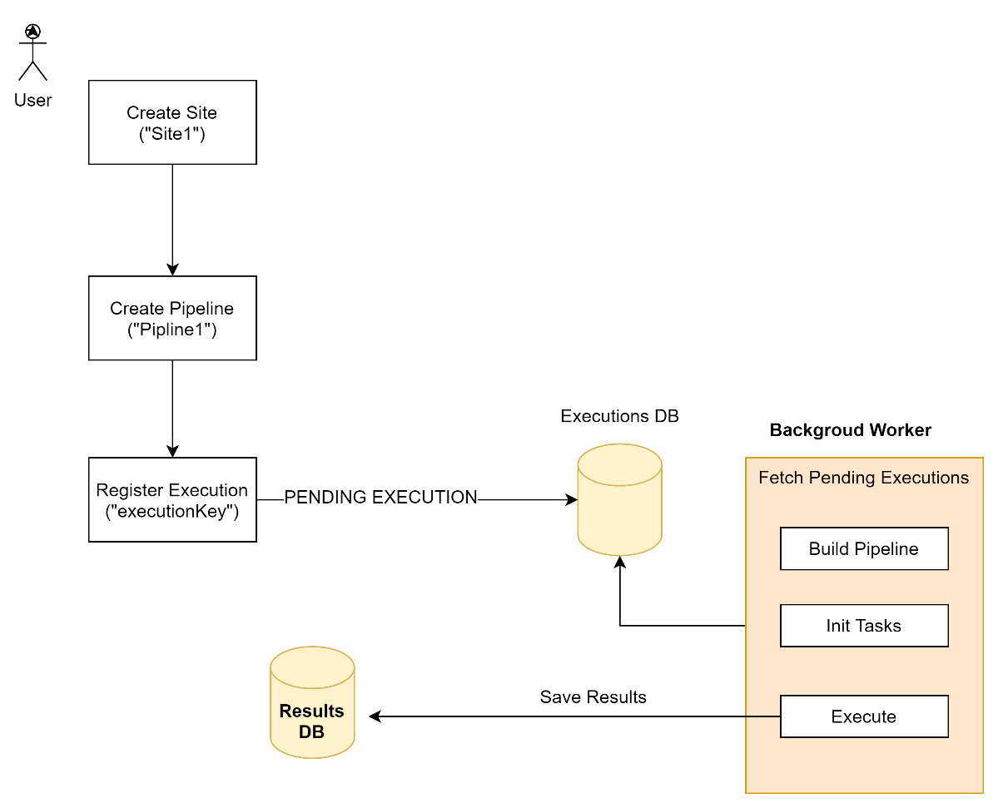

**Available Tasks for use in Pipeline**

Here are the supported tasks implemented for this assignment:

|  |  |  |
| --- | --- | --- |
| Name | Type | Description |
| NrelSolarHttpTaskExtract | Extract | Fetch the Solar Data from NREL Web API |
| NrelSolarFlatTaskTransform | Transform | Transform Solar Data into flatten array of records of type “SolarMetric” |
| NrelSolarDbTaskLoad | Load | Save Results to DB  Currently supporting the local NeDB |
| NrelSolarFileTaskLoad | Load | Saving Results to File  Formats supported: CSV / JSON |

**Examples of REST API supported:**

1. **Adding new Site**

**REQUEST:**

POST <http://127.0.0.1:3000/sites/add>

**BODY**

{

"site": {

"name": "MySite1", // Site Name

"id": 1, // Site ID

"location": {

"lat": 40,

"lon":-120

}

}

}

**RESPONSE:**

{

"id": 1,

"status": "Success",

"message": "Site Added Successfully"

}

1. **Getting Site (Site ID = 1)**

**REQUEST:**

GET <http://127.0.0.1:3000/sites/1>

**RESPONSE**

{

"site": {

"id": 1,

"name": "MySite1",

"location": {

"lat": 40,

"lon": -120

},

"pipeline": {

"id": -1

}

},

"status": "Success"

}

1. **Getting All Sites**

**REQUEST:**

GET [http://127.0.0.1:3000/sites](http://127.0.0.1:3000/sites/1)

**RESPONSE**

{

"sites": [

{

"id": 2,

"name": "MySite2",

"location": {

"lat": 40,

"lon": -120

},

"pipeline": {

"id": -1

}

},

{

"id": 1,

"name": "MySite1",

"location": {

"lat": 40,

"lon": -120

},

"pipeline": {

"id": -1

}

}

],

"status": "Success"

}

1. **Add Pipeline**

**REQUEST:**

POST <http://127.0.0.1:3000/>pipelines/add

{

"pipeline": {

"name": "MyPipeline",

"id": 1,

"tasks": {

"extract": {

"name": "NrelSolarHttpTaskExtract",

"input": {

"uri": "https://developer.nrel.gov/api/solar/solar_resource",

"port": 443,

"version": 1,

"format": "json",

"uriParameters": {

"api_key": "DEMO_KEY"

}

}

},

"transform": {

"name": "NrelSolarFlatTaskTransform",

"input": {}

},

"load": {

"name": "NrelSolarDbTaskLoad",

"input": {

"dbService": "NeDB",

"serviceArgs": {

"dbName": "results"

}

}

}

}

}

}

If needed to output to file replace load task with the following:

"load": {

"name": **"NrelSolarFileTaskLoad",**

"input": {

"outputFile": "D:/result.csv",

"format": "csv"

}

}

* Set the location of the output file
* Set the desired format “csv” or “json”

**RESPONSE:**

{

"id": 1,

"status": "Success",

"message": "Pipeline added Successfully"

}

1. **Get Pipelines(s)**

**REQUEST:**

GET <http://127.0.0.1:3000/pipelines>

**RESPONSE:**

Json Array contains all pipeline definitions

1. **Get Pipeline**

**REQUEST:**

GET <http://127.0.0.1:3000/pipelines>/1

**RESPONSE:**

Pipeline Definition associated with ID “1”

1. **Execute Site with Pipeline**

**REQUEST:**

PUT <http://127.0.0.1:3000/sites/execute>

{

"siteId": 1,

"pipelineId": 1

}

* Will run site with id=1 with pipeline id=1

**RESPONSE:**

The response contains information about the execution, such as the execution key site, pipeline and times.

The initial status is PENDING.

{

"executionInfo": {

"key": "b8e77e6c-f3f7-4d55-92f9-ccb2a3e4eb7d",

"siteId": 1,

"pipelineId": 1,

"status": "PENDING",

"createTime": "2021-05-25T00:53:58.712+03:00",

"updateTime": "2021-05-25T00:53:58.712+03:00",

"createTimeUtc": 1621893238,

"updateTimeUtc": 1621893238

},

"status": "Success",

"message": "Execution added Successfully"

}

1. **Get Last Execution Status**

* Add the “Execution Key” to the URL query params

**REQUEST:**

GET <http://127.0.0.1:3000/executions?key=b8e77e6c-f3f7-4d55-92f9-ccb2a3e4eb7d>

**RESPONSE:**

{

"executions": [

{

"key": "b8e77e6c-f3f7-4d55-92f9-ccb2a3e4eb7d",

"siteId": 1,

"pipelineId": 1,

"status": "COMPLETED",

"createTime": "2021-05-25T00:53:58.712+03:00",

"updateTime": "2021-05-25T00:54:00.019+03:00",

"createTimeUtc": 1621893238,

"updateTimeUtc": 1621893240

}

],

"status": "Success"

}

1. **Get All Executions**

**REQUEST**

**GET** [**http://127.0.0.1:3000/executions**](http://127.0.0.1:3000/executions)

**GET** [**http://127.0.0.1:3000/executions?status=COMPLETED**](http://127.0.0.1:3000/executions?status=COMPLETED)

**RESPONSE:**

{

"executions": [

{

"key": "21329173-aa39-4910-bf0c-6c9d457dbd18",

"siteId": 1,

"pipelineId": 1,

"status": "COMPLETED",

"createTime": "2021-05-24T23:31:08.785+03:00",

"updateTime": "2021-05-24T23:31:34.320+03:00",

"createTimeUtc": 1621888268,

"updateTimeUtc": 1621888294

},

{

"key": "f7cd570c-7da9-4b69-9b06-7bcee186e29e",

"siteId": 1,

"pipelineId": 3,

"status": "COMPLETED",

"createTime": "2021-05-24T23:22:25.316+03:00",

"updateTime": "2021-05-24T23:23:47.365+03:00",

"createTimeUtc": 1621887745,

"updateTimeUtc": 1621887827

}

],

"status": "Success"

}

**Available Query Parameters for Filtering:**

|  |  |
| --- | --- |
| status | COMPLETED  PENDING  RUNNING  FAULTED  CANCELLED |
| key | Specific Execution Key |
| siteId | Executions related to specific Site ID |

1. **Get Execution Result**

// Getting all executions results

GET http://127.0.0.1:3000/executions/results

// Getting specific execution results matches execution key

GET <http://127.0.0.1:3000/executions/results/21329173-aa39-4910-bf0c-6c9d457dbd18>

In case of Load task which writes to File, the result is a metadata record describes the execution info, for example:

**GET http://127.0.0.1:3000/executions/results/438b27c4-b0f6-4282-bf5c-75f713668723**

{

"status": "Success",

"results": [

{

"executionKey": "438b27c4-b0f6-4282-bf5c-75f713668723",

"file": "D:/nrel-result.csv",

"format": "csv",

"status": "COMPLETED",

"createTime": "2021-05-25T01:04:11.612+03:00",

"updateTime": "2021-05-25T01:04:11.612+03:00",

"createTimeUtc": 1621893851,

"updateTimeUtc": 1621893851

}

]

}

**Example of Solar Metric Record Saved to DB**

**GET** [**http://127.0.0.1:3000/executions/results/affbef68-8a27-4300-9f06-7b70b5711393**](http://127.0.0.1:3000/executions/results/affbef68-8a27-4300-9f06-7b70b5711393)

**RESPONSE**

{

"status": "Success",

"results": [

{

"siteName": "MySite1",

"siteId": 1,

"pipelineName": "MyPipeline",

"pipelineId": 1,

"executionKey": "affbef68-8a27-4300-9f06-7b70b5711393",

"source": "Perez-SUNY/NREL, 2012",

"version": "1.0.0",

"type": "avg_lat_tilt",

"period": "February",

"value": 4.89,

"createTime": "2021-05-25T01:08:22.943+03:00",

"updateTime": "2021-05-25T01:08:22.943+03:00",

"createTimeUtc": 1621894102,

"updateTimeUtc": 1621894102

},

{

"siteName": "MySite1",

"siteId": 1,

"pipelineName": "MyPipeline",

"pipelineId": 1,

"executionKey": "affbef68-8a27-4300-9f06-7b70b5711393",

"source": "Perez-SUNY/NREL, 2012",

"version": "1.0.0",

"type": "avg_dni",

"period": "June",

"value": 9.3,

"createTime": "2021-05-25T01:08:22.943+03:00",

"updateTime": "2021-05-25T01:08:22.943+03:00",

"createTimeUtc": 1621894102,

"updateTimeUtc": 1621894102

}

...

]

}

**Running Notes:**

1. It is required to have NodeJS installed with NPM on a computer
2. Once extracted all the files, enter the “server” folder and run:

npm run rebuild

1. Once completed, run the server by running:

npm run start

1. The server listens on port 3000 (default):

App listening on port 3000

25-05-2021 01:12:45.358|INFO| Monitoring Enabled, polling 10 seconds !

25-05-2021 01:12:46.599|INFO| PipelineExecutorWorker, polling executions ...

Found Total 0 Records

25-05-2021 01:12:46.631|INFO| PipelineExecutorWorker, No executions found, will try again in 10 seconds ...

25-05-2021 01:12:46.632|INFO| PipelineExecutorWorker, checking expired executions ...

Found Total 0 Records

25-05-2021 01:12:46.635|INFO| PipelineExecutorWorker, No expired executions found !

1. DB Files are created locally under “database”

If needed to clear you can delete them and they will be created empty.

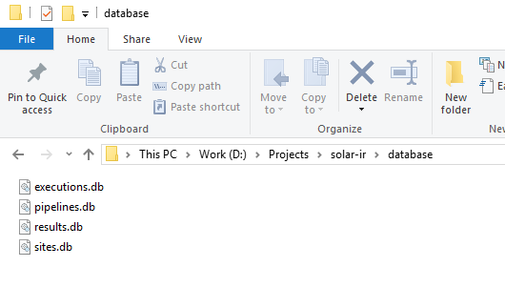

1. Logs are under “logs” folder

**Content Provided:**

1. Application Source Files
2. POSTMAN Files as examples to be used in Chrome (can be imported and use)
3. CSV Result Example
4. JSON Result Example
5. This Briefly Document

Sorry for the delay … had busy time with kids.

Enjoy

Raz