BA9 · A05
Stakeholder Analysis (Power / Interest)

Field | Value
Team name (English — this goes in the file name) | Insurance
Team lead | Administration: Ahmed Eissa / Plan: Asia Al-Jabrine and Jihad Yasser / Policies: Assaad Lutf / Client: Isma Razi
Number of members | 20 (Administration 3, Plan 6, Policies 6, Client 2, Accounting 3)
Scenario / Project | Direct Billing Medical Insurance System (Egypt), all modules: Admin, Plan, Policies, Client, Accounting
Submission date | 27 September 2026

Output levels
Level | What it covers
MUST | At least 6 stakeholders (أصحاب المصلحة), internal and external · Power (النفوذ) and Interest (الاهتمام) rated with justification · correct quadrant (الربع) placement · a handling strategy per quadrant.
SHOULD | Communication channel and frequency per group · potential opponents identified with the reason they would object.
ADVANCED | A RACI matrix for the project's key decisions.

Approved tools
Step | Approved tool | Note
Brainstorming and voting | This document — Section 1 | No separate tool. Voting happens in the same table.
Rating Power and Interest | This document — Section 2 | The ratings and the justifications live here, in writing.
Power/Interest Grid | Miro · Power/Interest Grid | Build it in Miro, export an image, paste it in Section 3.
Strategy and communication | This document — Section 4 | —
Persona (البيرسونا) | This document — Section 5 | Only for the one or two most important people in Manage Closely.
RACI (optional) | Miro · Simple RACI Matrix | Build it in Miro, export an image, paste it in Section 6.
AI usage | ChatGPT, Claude or Gemini | Any of them — record the prompt and who on the team used it.
Reference reading only | MindTools · Mendelow Grid | References for the concept, not tools you submit from.

The grid and the RACI matrix are built in Miro, so this document does not repeat them as tables — it holds the exported images instead. Everything else is filled in here.

Work split
Member | Responsible for exactly what | What they produced
Asia Al-Jabrine : Plan Team lead | Managing the Plan Team's business analysis activities, identifying stakeholders, assessing their power and interest levels | Plan Team stakeholder list and ratings (Sections 1 and 2)
Jihad Yasser : Plan Team co-lead | Co-leading the Plan Team analysis with Asia Al-Jabrine | Plan Team analysis (Sections 1, 2 and 4)
Plan Team members | Worked on the strategy, communication channels, Miro grid and persona checks, and reviewed FRA compliance | Plan Team input to Sections 3, 4, 5
Assaad Lutf : Policies Team lead | Led the Policies analysis: stakeholders, Power/Interest ratings and personas | Policies input to Sections 1, 2, 5, 7 (source of Persona 1)
Other Policies Team members | Ran the brainstorm and vote, wrote the strategy and opponents, built the Miro grid, and checked the personas and FRA rules against the BRD | Policies input to Sections 3, 4, 7
Isma Razi: Client Team lead | Stakeholder identification and analysis, Persona S1, Power/Interest grid for the Client portal | Client stakeholder list, ratings and first Miro grid (Sections 1 to 3 and 5)
Hamdi : Client Team | User Persona S2 and team voting | Persona S2 and the agreed Power/Interest grid
Engy Elyamany : Accounting Team | Accounting module stakeholder analysis | Accounting stakeholders, strategy table, opponents, personas, first RACI draft (input to Sections 4, 6, 7)
Ahmed Eissa , Ali, Amira : Administration Team | Administration module stakeholders and ratings, five persona cards, Administration BRD(draft version) | Administration input to Sections 1, 2, 5 (source of Persona 2)
Consolidation : all team leads | Merged the five analyses, settled the rating conflicts, and built the final Miro grid and RACI | Final Sections 2, 3, 6

1 · Brainstorming and Voting

# | Stakeholder | Role / Entity | Internal / External | Proposed by | Votes | In scope?
1 | Project Sponsor / Senior Management (CEO) | Executive management, funds the programme | Internal | Client, Plan, Accounting, Policies | 4 | Yes
2 | Product Owner / Project Manager | Product and project management | Internal | Admin, Plan | 2 | Yes
3 | Group Super Admin (System Admin) | Administration (entities, users and roles) | Internal | Admin, Client, Accounting | 3 | Yes
4 | Underwriting & Policy Operations Lead | Underwriting / Policy Department | Internal | Policies, Client, Admin, Accounting | 4 | Yes
5 | Finance / Accounting & Billing Manager | Finance & Accounting Department | Internal | Policies, Client, Plan, Accounting, Admin | 5 | Yes
6 | Corporate HR Admin (Client Representative) | Corporate client (buys the policy, runs the portal) | External | Policies, Client, Accounting | 3 | Yes
7 | Financial Regulatory Authority (FRA) | Egyptian government regulator | External | Policies, Plan, Admin | 3 | Yes
8 | IT Security Officer / IT Manager (CISO) | Information Technology & Security | Internal | Admin, Plan | 2 | Yes
9 | Internal Compliance & Risk Manager | Internal Audit, Compliance & Risk | Internal | Admin, Plan | 2 | Yes
10 | Department Heads / Operations Managers | Medical & Insurance Operations | Internal | Admin, Plan | 2 | Yes
11 | Client Account Manager | Client department (renewals) | Internal | Client, Accounting | 2 | Yes
12 | Department System Users (accountants, ops staff) | Daily users in all departments | Internal | Accounting, Admin | 2 | Yes
13 | Insured Member (Employee & Dependents) | End beneficiary of the corporate policy | External | Policies, Client | 2 | Yes
14 | Healthcare Provider Desk (Hospital / Pharmacy) | Hospital and pharmacy admission desks | External | Policies, Client | 2 | Yes
15 | IT Support & System Operations | Technical support / infrastructure | Internal | Client, Policies | 2 | Yes
16 | Insurance Broker / Corporate Agent | Sales intermediary | External | Policies | 1 | No
17 | Claims Manager / Claims Officer | Claims & TPA module (out of scope) | Internal | Plan | 1 | No
18 | Data / Business Analyst | Reporting & statistics | Internal | Client | 1 | No
19 | Customer Support / Call Center | Member support | Internal | Policies | 1 | No
20 | Physical Card Printing Vendor | External supplier (replaced by e-cards) | External | Policies (AI) | 0 | No
21 | Claims Adjudication Doctor | Medical claims review | Internal | Policies (AI), Client (AI) | 0 | No

2 · Rating Power and Interest

Code | Stakeholder | Power | Why this Power score | Interest | Why this Interest score | Quadrant
S01 | Project Sponsor / Senior Management (CEO) | 5 | Owns the budget and signs off each phase gate, so he can pause or stop the whole programme. | 3 | Follows ROI and the go-live date at a high level. He does not work with the screens or the daily workflow. | Keep Satisfied
S02 | Product Owner / Project Manager | 5 | Owns the scope and priorities for all five modules. Nothing goes into a sprint unless they approve it. | 3 | Sets the priorities, then follows progress through sprint reviews and sign-off points. The daily module work is done by the teams. | Keep Satisfied
S03 | Group Super Admin (System Admin) | 4 | Sets up the entities (Underwriter, Subsidiary, Country) and all roles and permissions. Nobody can work until he configures their access. | 5 | Uses the Admin module every day, and any access or audit problem comes to him first. | Manage Closely
S04 | Underwriting & Policy Operations Lead | 5 | Signs off every policy and the approval-authority matrix. A policy cannot go live without his approval. | 5 | Works in the Plan and Policies modules every day (endorsement queue, roster checks, policy status). | Manage Closely
S05 | Finance / Accounting & Billing Manager | 4 | Approves invoices and refunds, and can hold the go-live if premiums and endorsements do not match. | 3 | Gets involved at month-end closing and when invoices or refunds need approval. The daily entries are done by the accountants (S12). | Keep Satisfied
S06 | Corporate HR Admin (Client Representative) | 4 | The client who pays. If the portal is hard to use, they can move the contract to another insurer at renewal. | 5 | Adds and removes employees every month and receives the invoices, so any mistake reaches their staff directly. | Manage Closely
S07 | Financial Regulatory Authority (FRA) | 5 | Has legal power to fine the company or stop its operations if records or National ID checks break the rules. | 2 | Only looks at compliance evidence, such as the audit trail and 10-year data retention. | Keep Satisfied
S08 | IT Security Officer / IT Manager (CISO) | 4 | Can stop a release that fails the security checks (2FA, encryption, data isolation between branches). | 3 | Gets involved at security and infrastructure checkpoints only. | Keep Satisfied
S09 | Internal Compliance & Risk Manager | 4 | Signs off audit and data-privacy readiness and deals with FRA inside the company. A serious finding from them stops go-live. | 3 | Checks the audit log and risk reports from time to time, but is not part of daily operations. | Keep Satisfied
S10 | Department Heads / Operations Managers | 3 | Can request changes and escalate issues for their teams, but others approve the system scope. | 5 | Their teams' daily workflow and access requests change directly with the new system. | Keep Informed
S11 | Client Account Manager | 3 | Manages the client relationship and renewals, but has no say in system decisions. | 4 | Needs clients to onboard easily and get clear invoices so they renew. | Keep Informed
S12 | Department System Users (accountants, ops staff) | 2 | They do their tasks in the system but cannot change its rules or roles. | 5 | They use the system all day for invoices, payments and policy data, so every extra step slows them down. | Keep Informed
S13 | Insured Member (Employee & Dependents) | 2 | A single employee cannot change the policy limits or waiting periods. | 5 | If the e-card is inactive or the limit is wrong, treatment is refused at the hospital. | Keep Informed
S14 | Healthcare Provider Desk (Hospital / Pharmacy) | 2 | Only checks eligibility for direct billing and cannot change policy data. | 4 | Needs a fast, correct eligibility answer at admission to avoid queues and billing disputes. | Keep Informed
S15 | IT Support & System Operations | 2 | Fixes tickets and keeps the platform running, but does not decide on requirements. | 2 | Only involved when there is an incident, downtime or a new release. | Monitor

Quadrant | Meaning | Who is in it
Manage Closely | High Power · High Interest | S03 Group Super Admin, S04 Underwriting & Policy Ops Lead, S06 Corporate HR Admin
Keep Satisfied | High Power · Low Interest | S01 Project Sponsor / Senior Management, S02 Product Owner / Project Manager, S05 Finance / Accounting Manager, S07 FRA, S08 IT Security / IT Manager, S09 Internal Compliance & Risk
Keep Informed | Low Power · High Interest | S10 Department Heads / Operations Managers, S11 Client Account Manager, S12 Department System Users, S13 Insured Member, S14 Healthcare Provider Desk
Monitor | Low Power · Low Interest | S15 IT Support & System Operations

3 · Power / Interest Grid

Miro template · Power/Interest Grid | https://miro.com/app/board/uXjVHhhf5SQ=/?moveToWidget=3458764685095974789

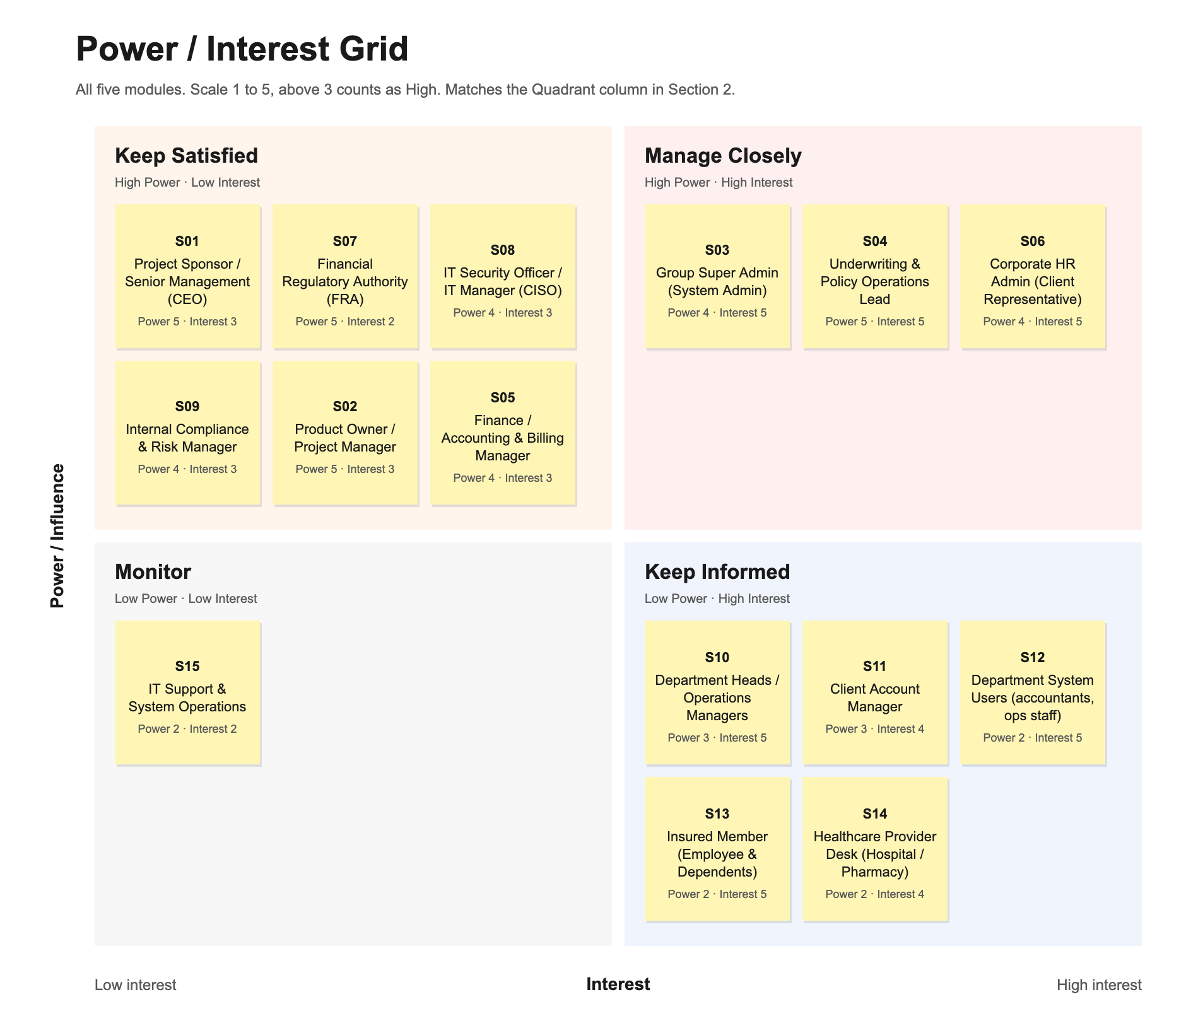

4 · Strategy and Communication

Quadrant | Handling strategy | Channel | Frequency | Core message | Owner
Manage Closely | Consulted before every decision that affects their module. They review the requirements and acceptance criteria and sign off before we build. | Working workshops (face-to-face) + dedicated Teams channel + BRD review comments | Weekly, and before any major decision | What we need you to approve, and the options we have. | Product Owner / Lead BA
Keep Satisfied | Consulted only at formal checkpoints. We show them that budget, security and FRA requirements are covered and keep them out of daily tickets. | Executive brief + formal milestone review + compliance evidence pack (audit-log export) | Monthly + at each phase gate | Your requirements are covered and here is the evidence. We contact you only if a checkpoint is at risk. | Project Manager
Keep Informed | Informed after decisions are made. They test and give feedback, but they do not decide. | Sprint demos, UAT sessions, release notes and user guides; SMS or in-app messages for members and providers | Bi-weekly (each sprint) + at each release | What changed, when it starts, how it affects your work, and where to send feedback. | Change Management / assigned BA
Monitor | No regular messages. We watch the dashboards and contact them only when there is an incident or a release that affects support. | System-health dashboard + incident tickets | Quarterly review / exception-driven | Platform status and any change that affects support. | IT Ops Lead

Potential opponents (SHOULD HAVE)
Stakeholder | Expected reason for objection | How we handle it
S06 Corporate HR Admin | Used to emailing Excel files, so she may push back on required fields like the 14-digit National ID, especially at month-end. | Drag-and-drop Excel upload with an error-preview report that shows exactly which rows to fix before committing.
S04 Underwriting & Policy Ops Lead | Fears losing control if endorsements and activations are automated and a high-risk group is issued without review. | Auto-approve only standard low-risk groups. Anything above the limit or with a waiver goes to an underwriter approval queue.
S05 Finance / Accounting Manager | Does not trust automatic pro-rata premiums yet and worries that mid-term additions and removals will not match the invoices. | Agree a Billing Cut-off Date rule, keep maker-checker approval on refunds, and deliver an endorsement-to-billing reconciliation report each cycle.
S12 Department System Users | Worried about extra work in busy periods and about being blamed when the system makes a mistake. | Include some of them in UAT and give short training plus a pilot period before the full switch.
S10 Department Heads / Operations Managers | Expect the switch to slow down daily work and access approvals for their teams. | Roll out one department at a time, give managers a "My Team" screen for access requests, and demo the process before go-live.
S08 IT Manager / CISO | Concerned about the integrations (Claims/TPA, finance system, FRA portal) and about keeping each branch's data separate. | Share the integration plan and security requirements early, and make security sign-off a step before each release.

5 · Persona (البيرسونا)

Field | Persona 1 | Persona 2
Name / Code | S06: Noha Mansour | S03: Eng. Tarek El-Shenawy
Role and entity | Senior HR Operations Specialist, external (corporate client with about 600 employees) | Group Super Admin, internal (Head of Core Systems)
What he actually cares about | Adding employees and their families without paperwork, and getting a correct invoice every month. | Adding a new branch or user himself, without waiting for the developers.
What worries him about the project | Long data-entry screens during hiring season, and new employees being turned away at the hospital. | A setup mistake that gives someone access to medical data they should not see.
How he measures success | The e-card works from the employee's first day, and the invoice matches her headcount. | A new branch is live in under 3 working days, and a permission change takes less than 5 minutes.
How he decides — and who he listens to | Decides based on what is easy to use and what employees complain about. Listens to payroll and her HR director. | Looks at the data before deciding. Listens to the Product Owner and the CISO.
Preferred channel and available time | Short afternoon calls or email summaries. Busy with payroll in the last week of the month. | Prefers written specs and short working sessions over long meetings.
A sentence that means the project is working | I upload the new hires in two minutes and they see their cards on their phones the same day. | I set up the new branch with the wizard in a few minutes, and the audit log recorded every change.

6 · RACI matrix — optional (ADVANCED)
R = does the work · A = accountable for the outcome (exactly one per row) · C = consulted · I = informed
Miro template · Simple RACI Matrix | https://miro.com/app/board/uXjVHhhf5SQ=/?moveToWidget=3458764685095974790

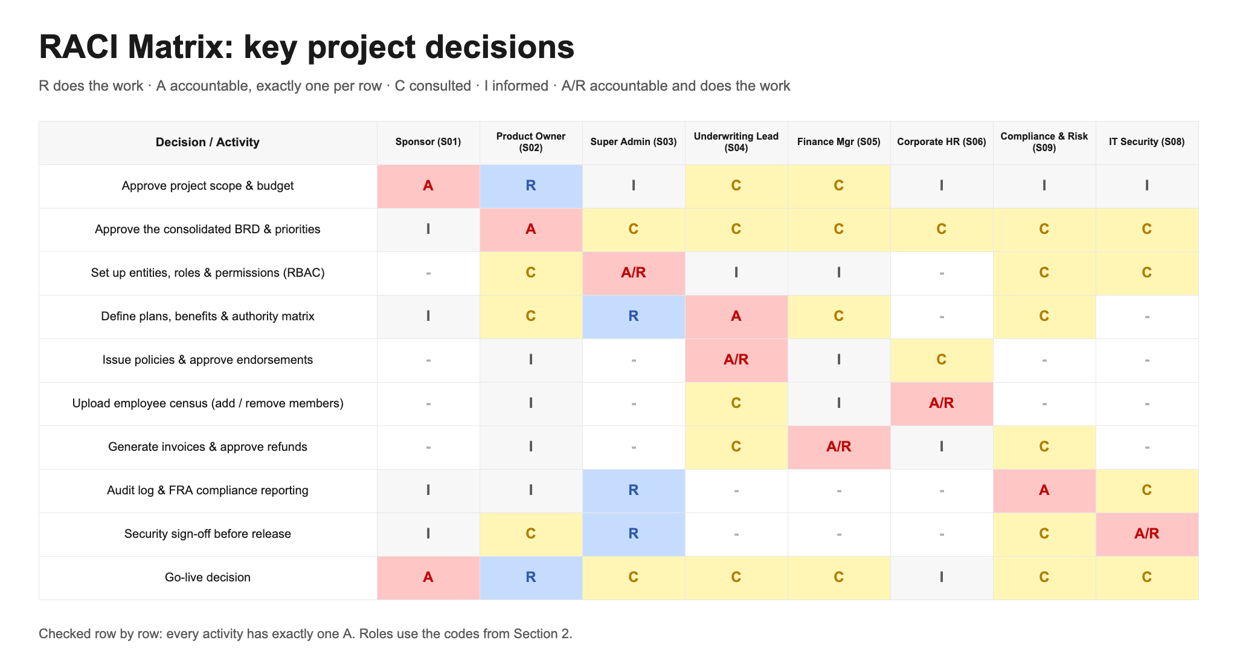

7 · AI Usage
Mandatory. If this section is empty, the submission is rejected.

Stage | Who on the team | The prompt you used | What you accepted and changed — and why | How you verified it
Brainstorming (Policies module) | Assaad Lutf (Policies Team) | Suggest potential stakeholders for the Policies Module of a corporate group health insurance system in Egypt, internal and external. | Accepted 5 roles (Underwriting, HR Admin, Finance, Member, Broker). Dropped Claims Doctor (claims is out of scope) and Card Printing Vendor (digital e-cards). Added FRA and Healthcare Provider Desk from the BRD. | Cross-checked with the Policies feature list and BRD scope boundaries.
Brainstorming & rating (Accounting module) | Accounting Team | Suggest potential stakeholders for an accounting module of a direct-billing medical insurer serving corporates, then rate Power/Interest 1 to 5 for the in-scope names only. | Accepted 7 and dropped 10 that were out of scope or repeated per department. Kept one person per department and adjusted the ratings to match the real accounting flow. | Compared with the business model/flow, the org hierarchy and mentor feedback.
Strategy, opponents & persona (Accounting module) | Accounting Team | Build the Strategy & Communication table (strategies must differ by decision authority), then Potential Opponents, then personas for Manage Closely. | Kept the channels, frequency and owners, rewrote the messages in our own words, and matched each opponent's handling to its quadrant. | Checked against the handling-strategy table and the manual (as-is) process.
Brainstorming (Client portal) | Isma Razi (Client Team) | Suggest stakeholders that might be impacted by or influence the insurance client portal. | Kept the names already identified by the team; rejected the AI's extra names (Brokers, Claims handler) as out of scope. | Referred back to the agreed client-portal scope.
Reviewing & brainstorming (Administration module) | Ahmed Eissa, Ali, Amira (Administration Team) | Review our stakeholder list and Power/Interest ratings for the Administration module of a direct-billing medical insurance system in Egypt. Suggest changes and any stakeholders we missed. | The AI suggested 12 stakeholders. We dropped 8 that were outside the Administration module or the business scope. Our final Administration list has 9 stakeholders (Group Super Admin, Product Owner, CISO, FRA, Chief Underwriter, Subsidiary Admin, Department Heads, Internal Compliance, General System Users). It also helped us with the analysis and research. | Did our own research, asked a second AI model the same question, and compared with example stakeholder analyses.
Consolidating the five teams | Ahmed Eissa | Merge the five team stakeholder analyses into one list for the whole system, remove duplicates, re-rate 1 to 5 with reasons, and draft a RACI with one A per row. | Accepted the merged list of 15. We moved the Underwriter from Keep Satisfied to Manage Closely because it signs off policies, dropped Broker and Claims because only one team chose them, kept Manage Closely to 3 names by moving the Product Owner and Finance Manager to Keep Satisfied, and fixed rows that broke the >3 = High rule. | Checked each quadrant against the scores, checked the RACI row by row, and compared the names with the Admin BRD and each team's file.

