Assignment - 1

Here is a small project assignment on the mtcars dataset that students can complete and submit through GitHub.

Mini Project: Exploratory Data Analysis on mtcars

Title
Car Performance Analysis using the mtcars Dataset

Objective
Use Python and Pandas in Jupyter Notebook to explore the mtcars dataset and generate useful insights about car performance, fuel efficiency, and engine features.

Tools to Use
- Anaconda
- Jupyter Notebook
- Python
- Pandas
- Matplotlib / Seaborn
- Git
- GitHub Desktop or GitHub

Answer::

Problem Statement
The mtcars dataset contains information about different car models and their technical specifications such as mileage, horsepower, weight, number of cylinders, and transmission type.
Your task is to:
- import and inspect the dataset
- clean and understand the data
- perform basic and intermediate analysis
- create charts
- write observations
- upload the work to GitHub

Dataset
Students may use:
from pydataset import data
df = data('mtcars')

Tasks to Complete

Part 1: Load and Understand the Data
- Import the dataset into a Pandas DataFrame.
- Display the first 5 rows.
- Check:
  - shape of the dataset
  - column names
  - data types
  - summary statistics
- Check whether there are any missing values.
Answer : This is the beginning of the Project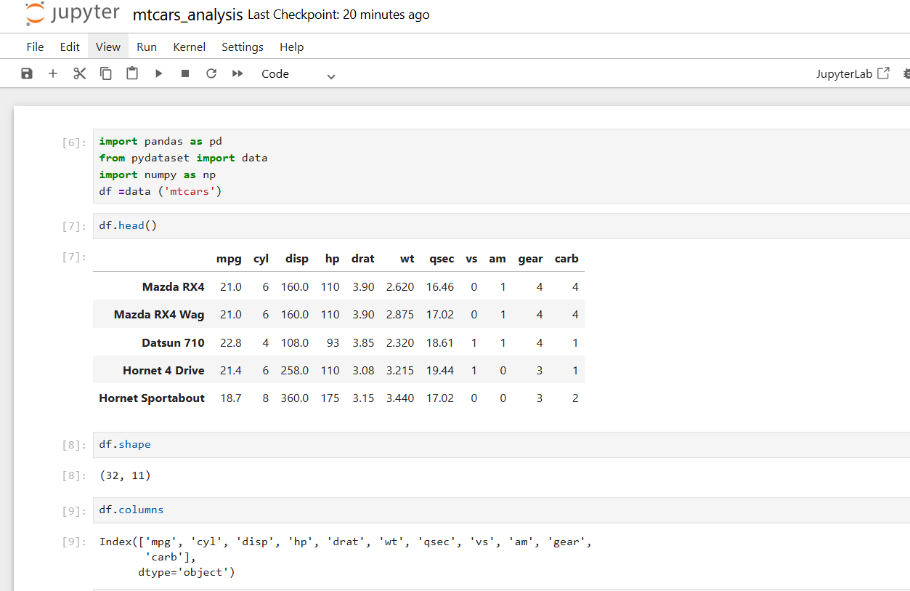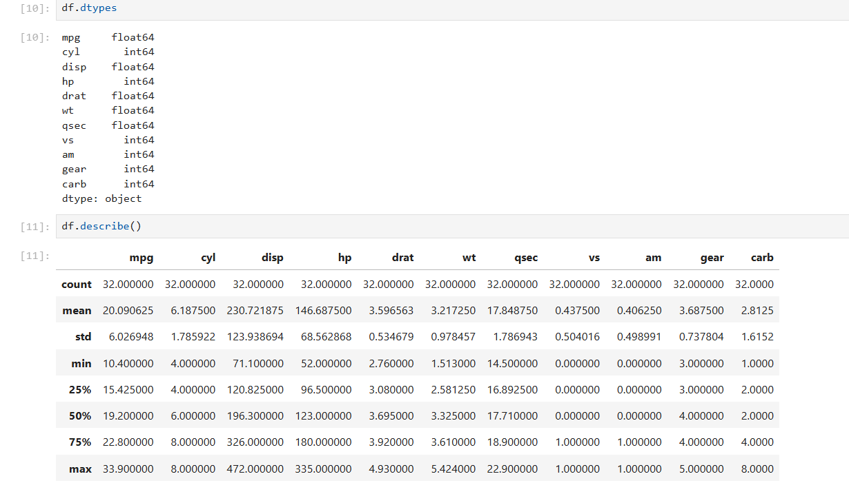
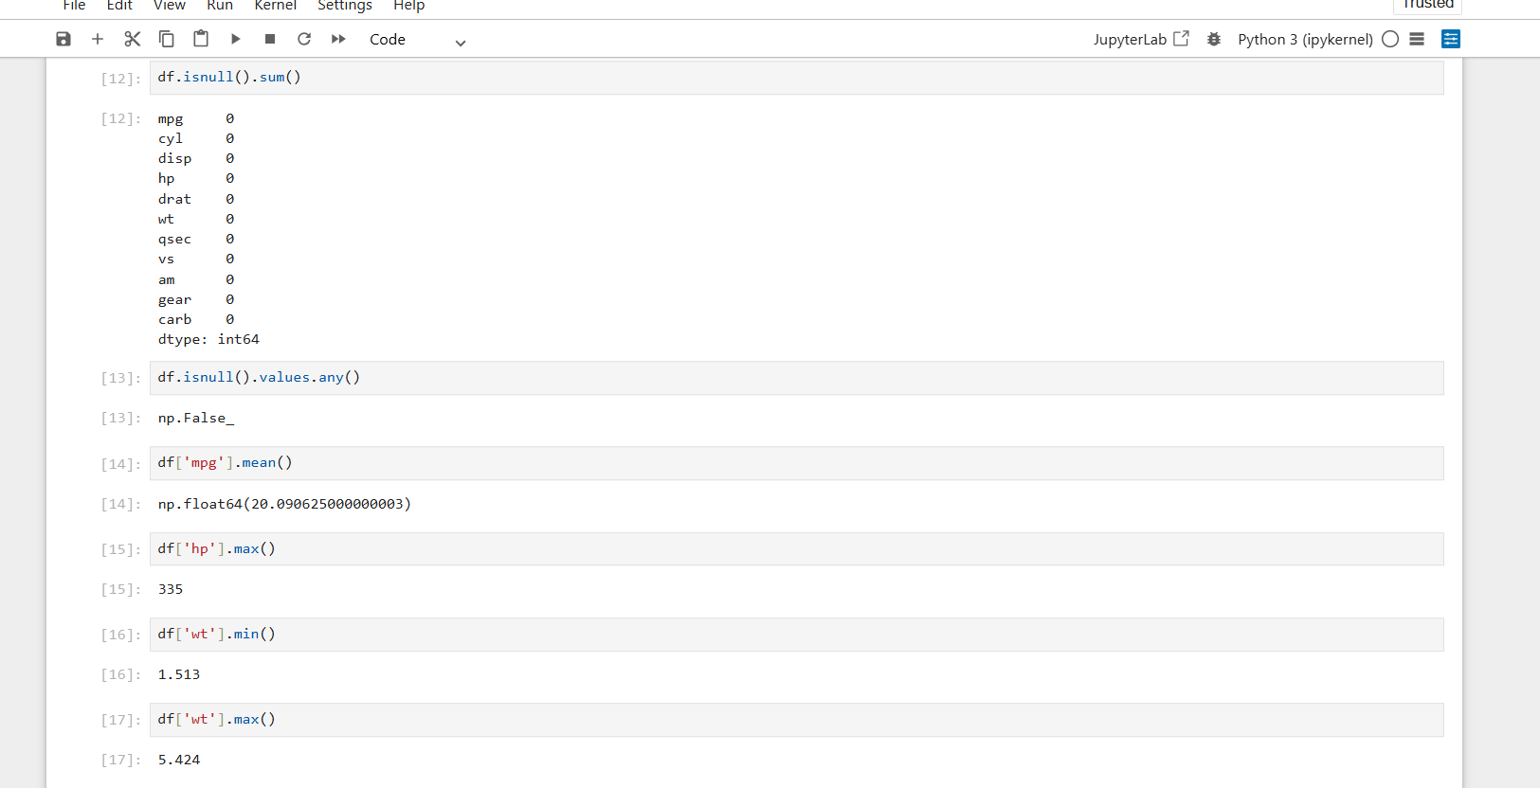

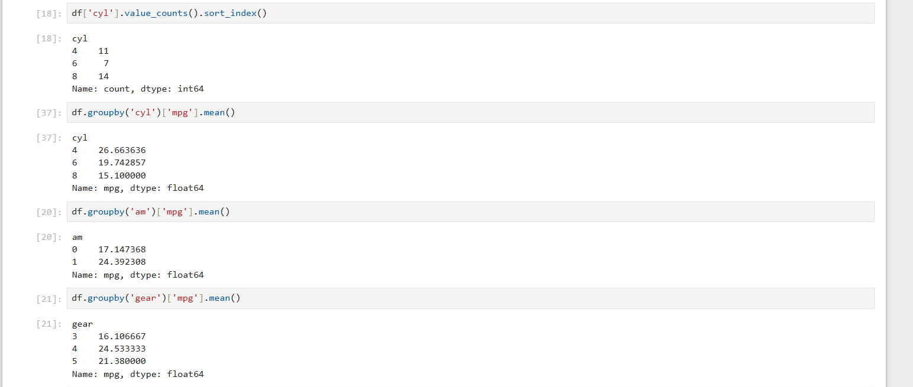

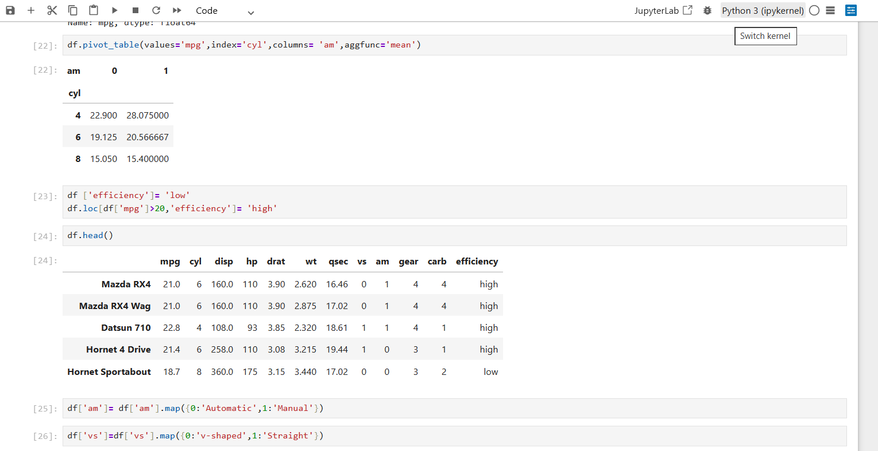

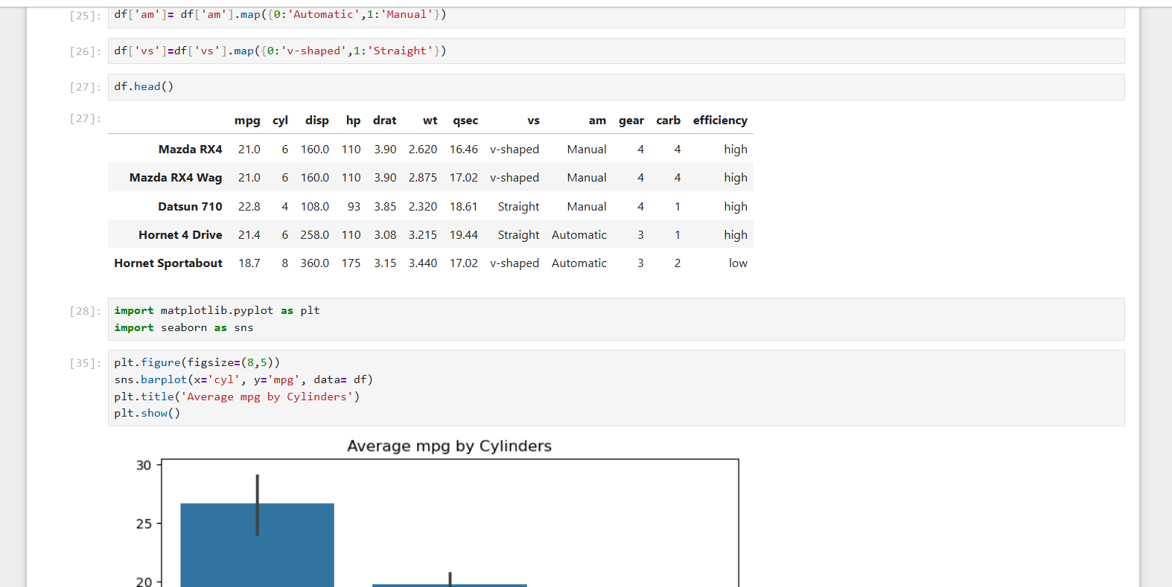

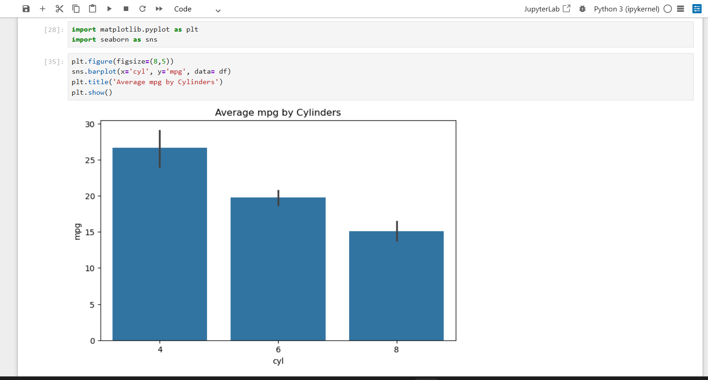

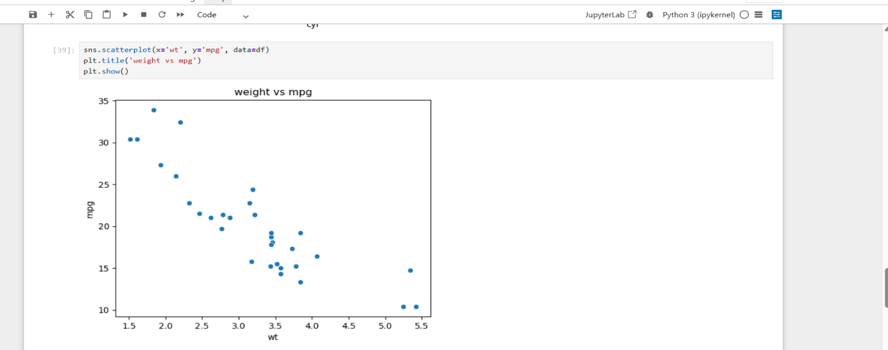

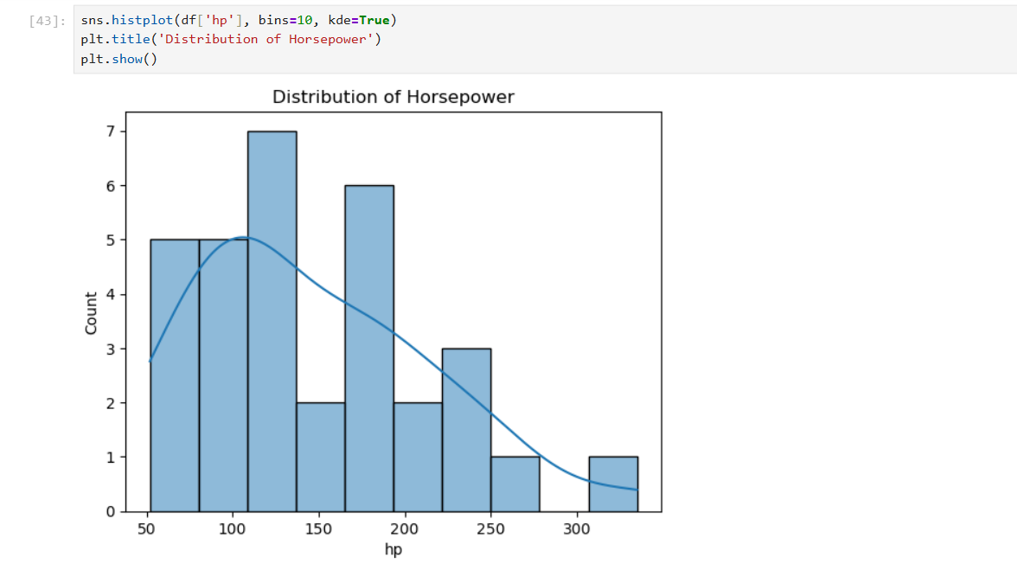
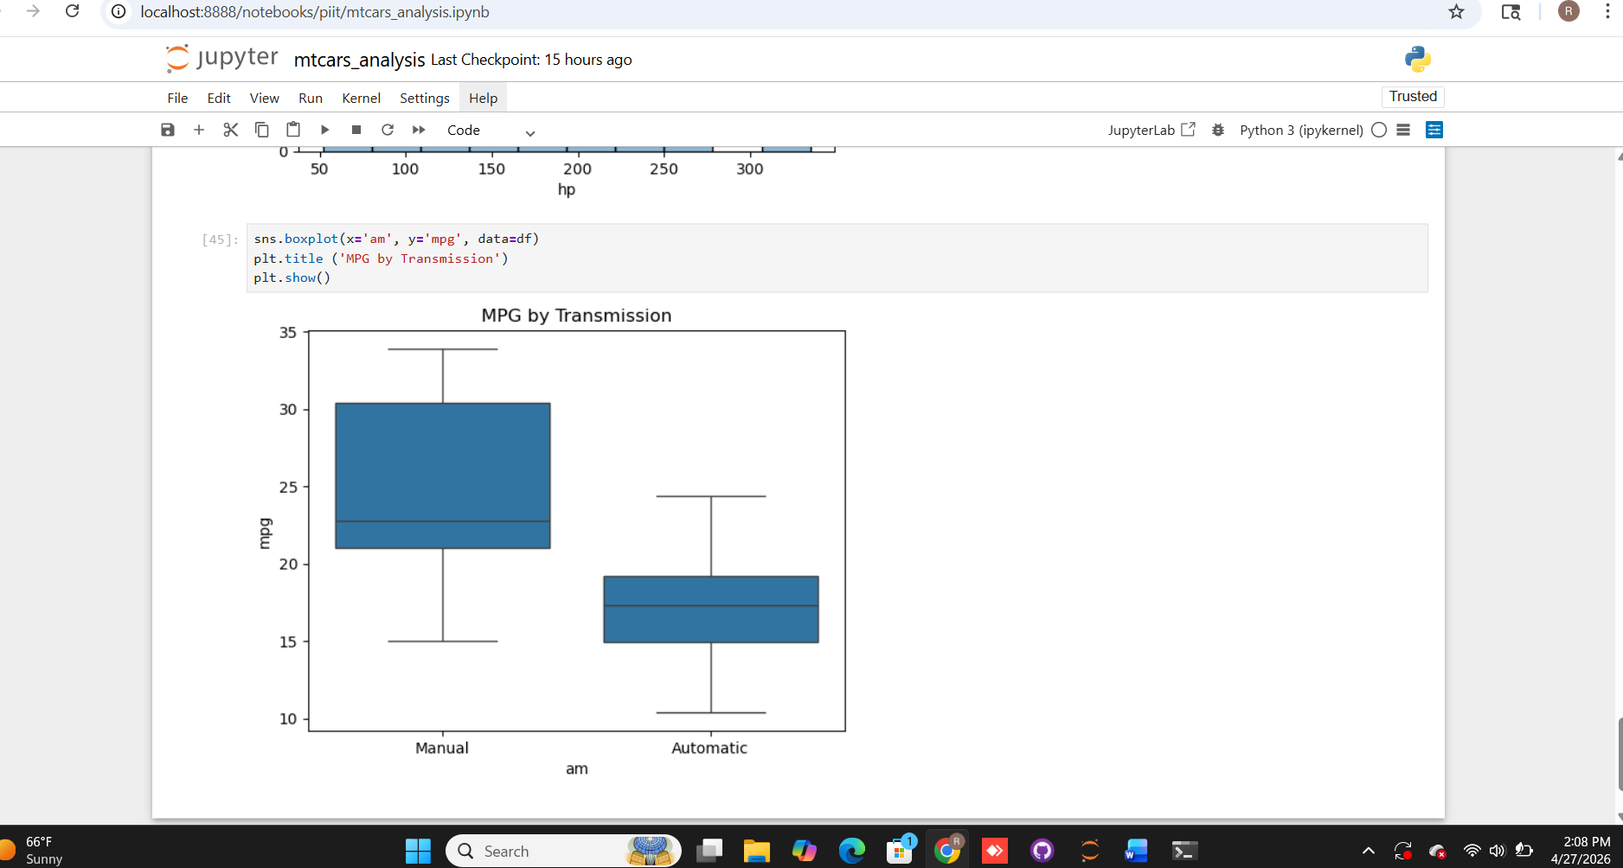

Part 5: Insights and Conclusion
- Lighter cars have significantly better mileage than heavier ones.
- 4-cylinder car are the most fuel-efficient, while 8-cylinder cars are the least.
- Manual cars constantly achieve higher mpg compared to Automatic cars in the dataset.
- Some manual cars reach over 30 mpg, while almost no automatic cars even reach 25 MPG.
- As horsepower and cylinder count go up the Mpg Consistently drops.

Conclusion:

This Analysis shows that smaller cars are more fuel efficient. We found that lighter cars get more miles per gallon (MPG). Cars with 4 cylinders perform better in fuel economy than than 8-cylinder cars. Overall, there is clear trade-off between having high power and saving fuel.
Part 2: Basic Data Analysis
- Find:
  - average mileage (mpg)
  - maximum horsepower (hp)
  - minimum and maximum weight (wt)
- Count how many cars have:
  - 4 cylinders
  - 6 cylinders
  - 8 cylinders
- Find the average mileage for each cylinder category using groupby().

Part 3: Intermediate Analysis
- Compare average mileage by:
  - transmission type (am)
  - number of gears (gear)
- Create a pivot table showing average mpg by cyl and am.
- Create a new column:
- efficiency where cars with mpg > 20 are labeled "High" and others "Low"
- Use map() to convert:
- am: 0 = Automatic, 1 = Manual
- vs: 0 = V-shaped, 1 = Straight

Part 4: Data Visualization
- Create at least 3 charts, such as:
- bar chart of average mpg by cylinders
- scatter plot of wt vs mpg
- histogram of horsepower
- boxplot of mpg by transmission
- Write 1-2 observations below each chart.

Part 5: Insights and Conclusion
- Write at least 5 insights from the dataset.
Examples:
- Do lighter cars have better mileage?
- Do manual cars perform differently from automatic cars?
- Which cylinder category has the best fuel efficiency?
- Write a short conclusion of 5-6 lines.

Submission Requirements
Students must submit the project in a GitHub repository.

Repository Name
piit

Files to Upload
- mtcars_analysis.ipynb → Jupyter Notebook

Evaluation Rubric (20 Marks)
1. Data Loading and Understanding – 4 marks
Correct import, inspection, summary, missing values
2. Basic Analysis – 4 marks
Use of basic Pandas operations correctly
3. Intermediate Analysis – 4 marks
Use of groupby, pivot table, new columns, map
4. Visualization – 4 marks
Relevant charts with proper labels
5. Insights, Conclusion, and GitHub Submission – 4 marks
Clear findings, neat notebook, successful GitHub upload

Suggested GitHub Workflow
- Create a new repository named mtcars-analysis
- Clone the repository to your system
- Create the notebook inside the project folder
- Save your work
- Commit changes with meaningful messages such as:
  - Initial project setup
  - Added data analysis
  - Added visualizations and insights
- Push the repository to GitHub
- Submit the GitHub repository link
Answer: Please post the screenshot

Simple README Format for Students
# mtcars Analysis Project

## Objective
To analyze the mtcars dataset using Python and Pandas.

## Tools Used
- Python
- Pandas
- Jupyter Notebook
- Matplotlib
- GitHub

## Tasks Performed
- Data loading and inspection
- Groupby analysis
- Pivot table creation
- Data mapping
- Visualization
- Insights and conclusion

## Key Findings
- Cars with fewer cylinders tend to have better mileage.
- Lighter cars generally have higher mpg.
- Manual cars often show better mileage than automatic cars.

## Repository Link
(Add your GitHub repository link here)

