**jQuery Work**

|  |  |  |
| --- | --- | --- |
|  |  |  |
|  |  |  |
|  |  |  |
|  |  |  |
|  |  |  |

**jQuery test work**

|  |  |
| --- | --- |
| **1.** |  |
| **2.** |  |
| **3.** |  |
| **4.** |  |
| **5.** |  |
| **6.** |  |

**Javascript work**

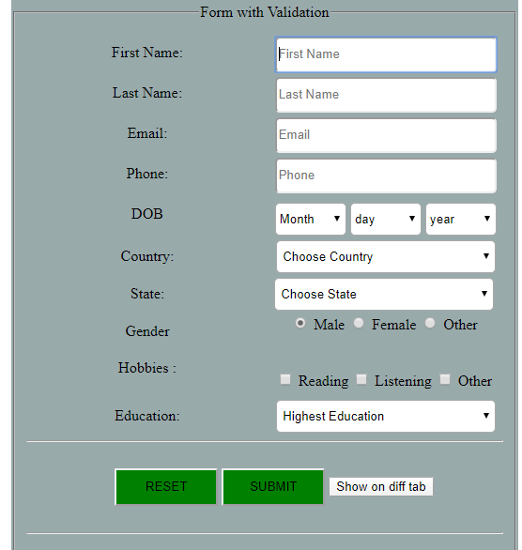

Fig 20

**Multiple email**

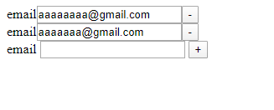

Fig

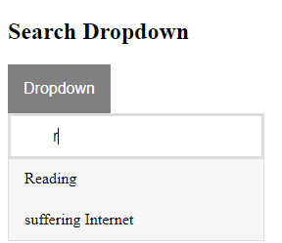

Fig

**Childwindow**

