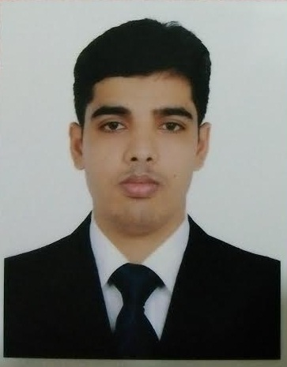

Contact

**Address:**

X-25, Rajia Sulatana Road, Mohammadpur.

**Phone:**

+88 01737 988947

**Email:**

[razibeee2014@gmail.com](mailto:razibeee2014@gmail.com)

**Github:**

https://github.com/razib994

Languages

English

Bangla

Razibur Rahman

Summary

Mid-level Web Developer specializing in front end development. Experienced with all stages of the development cycle for dynamic web projects. Well-versed in numerous programming languages including HTML5, PHP OOP, JavaScript, CSS, MySQL. Strong background in project management and customer relations.

Skills

|  |  |
| --- | --- |
| * Languages: PHP, Javascript * Frameworks: Laravel(API), React js, Vue js * CMS: WordPress |  |

Project Portfolio

* My Portfolio: <https://razibweb.com> (Wordpress)
* <http://inv.razibweb.com/public/admin/login> (Laravel)
* [**http://new-education.cretechbd.com/**](http://new-education.cretechbd.com/) **(PHP)**
* <http://ecommerce.cretechbd.com/public/> (Laravel)
* <http://project14.cretechbd.com/public/login> (Laravel Running )
* [https://cretechbd.com**/**](https://cretechbd.com/%20) **(PHP)**
* [https://www.mvibd.com/](http://new-education.cretechbd.com/) **(PHP)**

Experience

**Web Developer** - 05/2019 to Running

**Cretechbd IT Solition**, Mohamamdpur, Dhaka

**Website:** https://cretechbd.com/

* 3 Years’ Cooperate with designers to create clean interfaces and simple, intuitive interactions and experiences.

**Web Developer and Trainer Web Design** - 10/2016 to 05/2019

**Media Vision Institute**, Mohamamdpur, Dhaka,

**Website:** https://www.mvibd.com/

Education

Bachelor of Science: **Bsc in EEE** - 2016

**Daffodil International University**, Dhaka

Certifications

PHP Framework (certificate): **Laravel , (Codeigniter)**.

Programming Languages: **JavaScript, HTML5, PHP OOP, CSS, SQL, MySQL**.