UNIVERSITY OF RUHUNA – FACULTY OF TECHNOLOGY
ICT2232 Software Engineering · Mini Project
CivicFlow
Public Service Complaint & Resolution System
Final Project Report · SDLC documentation · Group 15
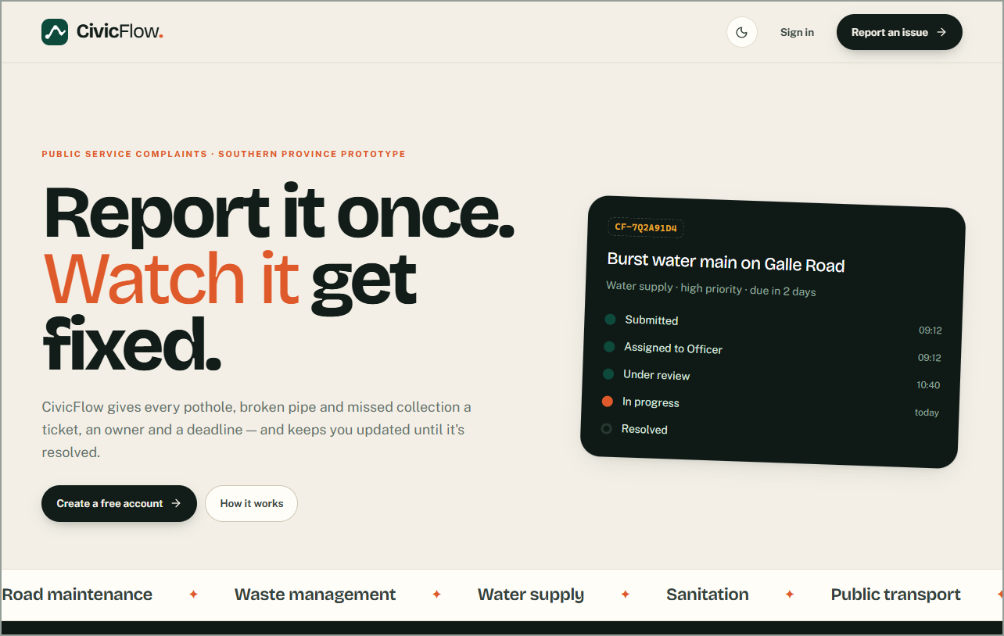
GROUP 15 MEMBERS
TG/2023/1761 | M.S.M. Sharfan
TG/2023/1731 | H.M. Amadi Nethma
TG/2023/1757 | N.M. Razim Mohamed
TG/2023/1710 | M.F. Rishma
TG/2023/1776 | V. Kayaththiry
SUBMISSION
Lecturer: [Lecturer name]
Date: [Submission date]
Live system: https://civic-flow-rho.vercel.app
Repository: https://github.com/razim2003/civic-flow

Declaration
We declare that this report and the CivicFlow software are the work of Group 15 for ICT2232 Software Engineering. Material from other sources is acknowledged in the References. All data shown in this report, in screenshots and in the demonstration is fictional.
Use of AI-assisted tools. In line with Section 4 of the project guidelines, AI-assisted development tools were used to support parts of the coding and documentation. All requirements, design decisions, priorities and trade-offs were made by the team. Every generated output was reviewed by the team, verified with 283 automated tests that run on every commit, and documented. Each member can explain the parts of the system they are responsible for.

Executive summary
Citizens in Sri Lanka report problems with roads, waste collection, water supply, sanitation and public transport through phone calls, office visits and informal channels. Complaints are lost, nobody can see their status, and organisations cannot tell who is responsible or which complaints are overdue.
CivicFlow is a role-based web application that gives every complaint a single, traceable digital lifecycle. A Citizen submits a complaint with a category, description, map location and optional evidence. The system routes it to the right department and automatically assigns the least-busy Officer. Officers review, prioritise, work on and resolve it, and every step is recorded in an append-only history that the Citizen can follow in an Updates inbox. Citizens rate the service after resolution. Administrators manage users, Officer invitations and service categories, dispatch complaints that are stuck in unstaffed departments, and monitor performance with analytics.
The team followed Scrum in five sprints. The result implements all 25 functional requirements (all Must and Should items, the Could item and three requirements added by change request CR-006) and 11 measurable non-functional requirements. It is backed by a PostgreSQL database with Row Level Security, protected server-side business functions and private file storage.
Quality was assured with 283 automated tests (77 unit, 147 database integration and 59 system tests), all passing, plus an automated responsive-layout audit at four screen sizes. 19 defects were recorded, analysed and corrected. Eight security controls address eleven assessed threats. The system is deployed at https://civic-flow-rho.vercel.app.

Table of contents

If page numbers are not shown, right-click the table and choose Update Field.

List of figures

List of tables

1 Introduction and Problem Domain
Public services such as road maintenance, waste management, water supply, sanitation and public transport directly affect the daily life of every citizen. When something goes wrong (a pothole, an overflowing bin, a burst water main or a bus that skips a halt), citizens need a simple way to report it and to know that someone is dealing with it.
Traditional complaint channels are telephone calls, physical visits to a council or divisional office, letters, e-mail and informal contacts. These channels have no shared record, so complaints are easily lost or duplicated. Citizens cannot see progress and must call again to follow up. Service organisations, for their part, cannot reliably record, categorise, prioritise, assign and monitor complaints, or prove how quickly they responded.
This project was allocated the domain "Public Service Complaint & Resolution System: a system for citizens to submit service complaints, track progress and receive resolution updates" (Group 15). The team named the product CivicFlow. This report documents how the product was taken through all ten stages of the Software Development Life Cycle (SDLC), and how the outputs of each stage informed the next.

1.1 Report structure
The report follows the structure recommended in Section 16 of the project guidelines. Chapters 2–5 cover problem definition and process planning (Milestone 1). Chapter 6 covers Agile planning (Milestone 2). Chapter 7 covers requirements engineering (Milestone 3). Chapter 8 covers design (Milestone 4). Chapters 9–10 cover implementation and testing (Milestone 5). Chapter 11 covers deployment (Milestone 6). Chapters 12–13 cover maintenance and security (Milestone 7). Chapter 14 covers project management and individual contributions.

2 Problem Statement
Problem statement
Citizens find it difficult to report public service issues and to follow up on them, because complaint information is handled through separate, manual channels. This leads to poor visibility of complaint status, slow communication, unclear responsibility and difficulty in monitoring unresolved complaints. Public service organisations also lack an organised way to record, categorise, prioritise, assign and monitor complaints. A centralised, role-based Public Service Complaint & Resolution System is therefore required to improve accessibility, transparency, accountability and efficiency.
Table 2.1: Problem analysis
Aspect | Description
Who is affected | Citizens, front-line public service Officers, department managers and public service organisations
Current situation | Phone, walk-in, e-mail and informal reports; no shared record; no status visibility; manual follow-up
Impact | Lost or duplicated complaints, no audit trail, unclear accountability, slow resolution and low public trust
Root causes | No single system of record; no defined workflow or ownership; no notification of progress
Proposed solution | CivicFlow: a web application with a defined complaint lifecycle (Submitted → Under review → In progress → Resolved, or Withdrawn by the owner), automatic assignment, history, updates and feedback
Success measure | Every complaint has a reference, a responsible Officer, a service target and a complete history visible to the Citizen

3 Stakeholders and Objectives

3.1 Stakeholders and their needs
Stakeholders were identified from the problem domain and refined during the proposal. Three of them are application roles: Citizen, Officer and Administrator. Department managers are recognised as stakeholders but deliberately not given a fourth login role. Their needs are met by department-scoped queues and the Administrator analytics.
Table 3.1: Stakeholders, needs and how CivicFlow addresses them
Stakeholder | Type | Needs | How CivicFlow addresses them
Citizen | Primary user (application role) | Easy submission, tracking, status visibility, updates and feedback | Complaint form with map, My Complaints, timeline, Updates inbox, feedback (CF-04…07, 13, 18, 19)
Public Service Officer | Primary user (application role) | Centralised complaints, search/filter, assignment, prioritisation and status management | Department queue, Assigned to me, filters, protected workflow actions (CF-08…12, 17)
Administrator | Primary user (application role) | User and category management, monitoring and secure administration | User management, Officer invitations, Service categories, monitoring overview (CF-14, 20, 21)
Department manager | Secondary stakeholder (not an application role) | Visibility of department complaints, workload and unresolved cases | Served by department-scoped queues and admin monitoring. Not a fourth login role (decision recorded in requirements).
Public service organisations | Indirect stakeholder | Accountability, organised records, monitoring | Immutable history, audit events, data-driven categories and departments
Community | Indirect stakeholder | Transparent, responsive handling | Status and history visible to the complainant; resolution date recorded
Lecturer (ICT2232) | Project stakeholder / reviewer | Evidence of each SDLC stage | This evidence pack

3.2 Project objectives
The ten objectives of the proposal were kept, and each was given evidence that shows whether it was achieved.
Table 3.2: Objectives and evidence of achievement
# | Objective | Evidence of achievement
O1 | Convenient digital complaint submission | UC-03 implemented; browser test TC-SUB-01
O2 | Citizens can track status and progress | UC-04, timeline, Updates inbox; TC-TRK-01, TC-NTF-01
O3 | Officers can manage, assign, prioritise and resolve | UC-05…07; TC-OFF-01
O4 | Accurate, centralised records | Database constraints, atomic history and rollback; TC-DB-SUB-05, TC-DB-OFF-08
O5 | Timely progress and resolution updates | Durable notifications created in the same transaction as every change; TC-NTF-*
O6 | Feedback after resolution | UC-08; TC-FB-*
O7 | Administrators manage users and categories | UC-09, UC-10; TC-ADM-, TC-CAT-
O8 | Transparency, accountability, efficiency | Append-only history, admin audit log, department queues
O9 | Authentication and role-based authorisation | RLS and protected RPCs; security
O10 | Extensible to more public services | Categories and departments are data. CF-20 lets an Administrator add services without a code change.

4 Scope, Assumptions and Constraints

4.1 In scope
- Citizen registration, login, logout and profile management; role-based access for Citizen, Officer and Administrator.
- Complaint submission with category, description, map location (or typed coordinates) and private evidence files.
- Routing to the category's department, automatic workload-balanced assignment, and Administrator dispatch of stuck complaints.
- Officer processing: review, assign, prioritise, transfer, start, progress remarks and resolution, with service-level targets.
- Complaint tracking, an append-only history, an Updates inbox with read state, citizen withdrawal and post-resolution feedback.
- Administration: user management, Officer invitations, service-category management, monitoring and analytics with CSV export.

4.2 Out of scope
- Online payments; real-time GPS tracking of field Officers; AI-based complaint classification.
- Automatic legal case management; emergency response and disaster management; automated field dispatch of crews.
- Integration with every government information system; SMS, e-mail or push notifications for complaint updates (updates are delivered in-system).

4.3 Assumptions
Table 4.1: Assumptions and their validation status
Assumption | Status
Users have an internet-connected device and browser | Accepted; responsive UI tested at 375 px and desktop widths
Citizens provide truthful, sufficient information | Accepted. The system validates form and bounds but can't verify truth. Officers review each complaint.
Officers have access and update complaints | Accepted; Officer accounts are invited by an Administrator
Categories and departments are system data | Implemented as database tables; six prototype categories chosen by the team
Evidence follows supported types and size | Enforced: JPEG/PNG/PDF, ≤ 5 MiB, ≤ 5 files per complaint
Demonstrations use fictional data | Enforced for all automated tests and screenshots
No external government integration | Accepted

4.4 Constraints
- Limited academic duration and a five-member student team.
- No access to real government databases or systems; demonstrations use fictional data only.
- Free-tier hosting (Supabase and Vercel), so no paid services, custom servers or SMS gateways.
- Security and privacy must still be designed in, even though this is a prototype.
- The system cannot represent every organisation's workflow; categories and departments are therefore configuration data.

5 Software Process Model and Justification

5.1 Selected model: Agile with Scrum
The team used an Agile approach with Scrum practices. A prioritised product backlog was refined throughout the project, work was planned in five time-boxed sprints that each delivered a working, demonstrable increment, and every sprint ended with a review and a retrospective that fed changes back into the backlog.
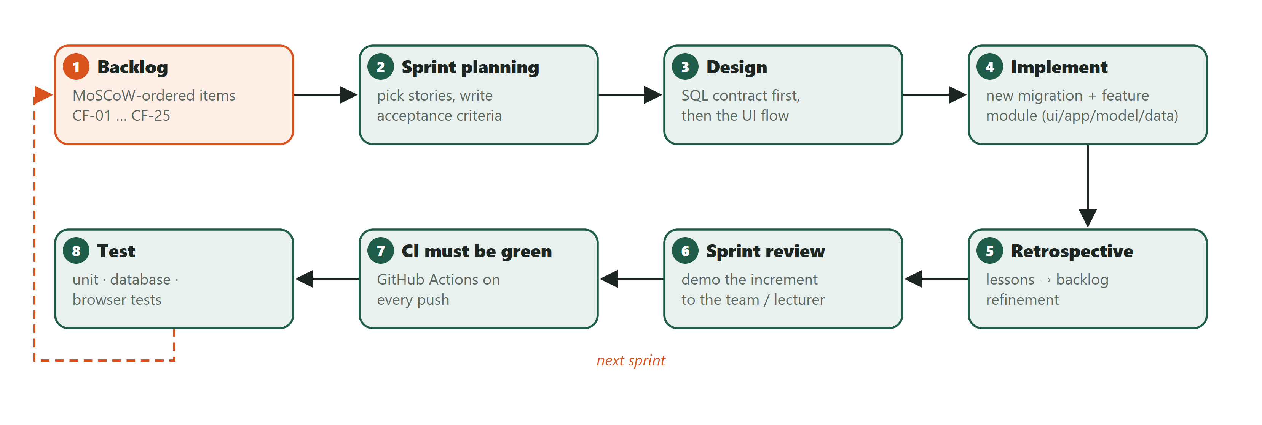
Figure 5.1: Scrum cycle applied in every sprint

5.2 Justification
Table 5.1: Why Scrum fits this project better than a plan-driven model
Project characteristic | Why Scrum fits | Why a plan-driven model (Waterfall/V-model) fits worse
Requirements refined through lecturer and stakeholder feedback | Backlog refinement at the end of every sprint absorbs change. Three changes (CF-22 withdrawal, CF-04 location, CF-14 invitations) were absorbed this way. | Changes after the requirements phase are expensive and need re-baselining
Five-member student team with a fixed deadline | Time-boxed sprints give regular checkpoints and visible progress | One big delivery at the end gives risky feedback very late
Security-sensitive, role-based system | Each sprint adds tests with its features, so defects are found early. The PT409 defect, for example, was found and fixed within Sprint 3. | Testing at the end finds design-level defects late
Needs early demonstrations (Milestones 1–3) | Working increments can be shown at every milestone | Working software appears only near the end

Prototyping alone was rejected because the module requires documented requirements, design and testing artefacts. The Spiral model was rejected as too heavy in formal risk analysis for a five-person, one-semester project.

5.3 Development approach and Definition of Done
Each sprint followed the same engineering workflow. The team first designed the database contract (tables, security rules, function signatures and error codes), then the user-interface flow. Implementation added a new, never-edited SQL migration and a feature module in four layers. Tests were added at three levels, the full verification set was run locally and in continuous integration, and only then was the increment demonstrated.
Table 5.2: Definition of Done used for every backlog item
# | A backlog item is done only when…
1 | its acceptance criteria are demonstrably met;
2 | authorisation is enforced in the database (grants, Row Level Security and function checks), not only in the user interface;
3 | input limits are identical in the client schema and in SQL;
4 | allow and deny tests exist (unit, database and a browser journey where there is UI);
5 | loading, empty and error states are accessible;
6 | lint (0 warnings), strict typecheck, all tests and the build pass locally and in CI;
7 | documentation and traceability are updated.

5.4 Project plan and tooling
Table 5.3: Project plan by SDLC phase
Phase | Main activities | Output | Status
Project definition | Problem, stakeholders, objectives, scope | Approved proposal (Milestone 1) | Done
Process planning | Select and justify Scrum; plan | Chapter 5 | Done
Agile planning | Backlog, user stories, acceptance criteria, sprint plan | Chapter 6 (Milestone 2) | Done, refined
Requirements | FRs, NFRs, use cases, prioritisation, traceability | Chapter 7 (Milestone 3) | Done, refined by CRs
Design | Architecture, UML, database, UI | Chapter 8 (Milestone 4) | Done
Implementation & testing | Sprints 1–5, unit / database / system tests | Working software, Chapter 9–10 | Done
Deployment | Vercel + Supabase, configuration, smoke test | Live URL, Chapter 11 | Done
Maintenance & security | Change requests, threat model, controls | Chapters 12–13 | Done; lecturer CR pending

Table 5.4: Tooling and configuration management
Concern | Tool / practice
Version control | Git and GitHub (https://github.com/razim2003/civic-flow); feature branches merged to main
Continuous integration | GitHub Actions: install → lint → typecheck → unit → database tests → type-drift check → build → Playwright, on every push
Database change control | Ordered, timestamped SQL migrations; never edited after being applied; hosted rollout only after explicit approval with data checksums
Backlog tracking | Product backlog, roadmap and traceability matrix kept in the repository (docs/)
Code quality | ESLint (0 warnings), strict TypeScript, database types generated from the migrations

6 Agile Planning

6.1 Product backlog
The product backlog lists every requirement as a backlog item with its MoSCoW priority, the sprint that delivered it and its final status. Items CF-22 to CF-25 were added during the project through change requests (Chapter 12).
Table 6.1: Product backlog
CF ID | Backlog item | MoSCoW | Sprint | Status (2026-10-29)
CF-01 | User registration (Citizen) | Must | 1 | Done
CF-02 | Secure login/logout | Must | 1 | Done
CF-03 | Role-based access control | Must | 1 | Done
CF-04 | Submit complaint (description, location) | Must | 2 | Done
CF-05 | Complaint category selection | Must | 2 | Done
CF-06 | Unique complaint ID, initial Submitted status | Must | 2 | Done
CF-07 | View submitted complaints / track status | Must | 2 | Done
CF-08 | Officer review and complaint queue | Must | 3 | Done
CF-09 | Assign complaint (officer/department) | Must | 3 | Done
CF-10 | Set complaint priority | Must | 3 | Done
CF-11 | Update status and progress remarks | Must | 3 | Done
CF-12 | Resolve complaint | Must | 4 | Done
CF-13 | Complaint notifications/updates | Must | 4 | Done (inbox and read state added 2026-10-29)
CF-14 | Admin user management | Must | 1 (+3) | Done
CF-15 | Citizen profile management | Should | 1 | Done (display name)
CF-16 | Upload supporting evidence | Should | 2 | Done
CF-17 | Search and filter complaints | Should | 2–3 | Done
CF-18 | Complaint history | Should | 2–3 | Done
CF-19 | Citizen feedback | Should | 4 | Done (2026-10-29)
CF-20 | Complaint category management | Should | 2→4 | Done (2026-10-29)
CF-21 | Dashboard/reports | Could | 4 | Basic monitoring done; enhanced reports not planned
CF-22 | Citizen withdrawal (approved scope extension) | Should (team-assigned) | 2 | Done
CF-23 | Automatic workload-balanced assignment (CR-006) | Must | 5 | Done
CF-24 | Administrator dispatch centre (CR-006) | Must | 5 | Done
CF-25 | Service-level targets and overdue flags (CR-006) | Should | 5 | Done
— | Integration/system testing, security, deployment | Sprint 5 scope | 5 | In progress

6.2 User stories
The proposal's story titles were expanded into 24 user stories in the form "As a ‹role›, I want ‹capability›, so that ‹benefit›". Story points are relative team estimates on a 1–8 scale.
Table 6.2: User stories
ID | User story | CF | MoSCoW | Pts
US-01 | As a citizen, I want to create an account with my name, email and a password, so that I can submit and follow my complaints. | CF-01 | Must | 3
US-02 | As a registered user, I want to log in and log out securely, so that only I can use my account. | CF-02 | Must | 3
US-03 | As any user, I want to see only the pages and data my role allows, so that private information stays protected. | CF-03 | Must | 5
US-04 | As a citizen, I want to describe a public service problem and mark its location on a map or by coordinates, so that the service team can find it. | CF-04 | Must | 8
US-05 | As a citizen, I want to choose a service category, so that my complaint reaches the right department. | CF-05 | Must | 2
US-06 | As a citizen, I want a unique reference and confirmation after submitting, so that I know my complaint was recorded. | CF-06 | Must | 2
US-07 | As a citizen, I want to list, search and open my complaints and see their status, so that I know what is happening. | CF-07, CF-17 | Must | 5
US-08 | As an officer, I want a queue of my department's complaints with filters, so that I can see and pick up work. | CF-08, CF-17 | Must | 5
US-09 | As an officer, I want to assign a complaint to an officer in my department, so that responsibility is clear. | CF-09 | Must | 3
US-10 | As an officer, I want to set a complaint's priority, so that urgent problems are handled first. | CF-10 | Must | 2
US-11 | As an assigned officer, I want to start work and add progress remarks, so that the citizen sees what is being done. | CF-11 | Must | 5
US-12 | As an assigned officer, I want to record resolution details and mark the complaint resolved, so that the case is closed with a record. | CF-12 | Must | 3
US-13 | As a citizen, I want an Updates inbox that shows what changed and which updates I haven't read, so that I don't miss progress on my complaints. | CF-13 | Must | 5
US-14 | As an administrator, I want to view users and change their role, department or active status, and invite officers, so that the team has the right access. | CF-14 | Must | 8
US-15 | As a citizen, I want to change my display name, so that my profile is correct. | CF-15 | Should | 1
US-16 | As a citizen, I want to attach photos or PDF documents privately, so that officers have evidence of the problem. | CF-16 | Should | 8
US-17 | As a citizen or officer, I want to see the full history of a complaint, so that every change is transparent. | CF-18 | Should | 3
US-18 | As a citizen, I want to rate and comment on how my resolved complaint was handled, so that the service can improve. | CF-19 | Should | 3
US-19 | As an administrator, I want to add, rename, route and deactivate service categories, so that the system can grow to new services without code changes. | CF-20 | Should | 5
US-20 | As a citizen, I want to withdraw my unresolved complaint with a reason, so that officers don't spend time on a problem that no longer needs action. | CF-22 | Should* | 5
US-21 | As an administrator, I want summary counts of complaints by status and the average feedback rating, so that I can monitor service performance. | CF-21 | Could | 2
US-22 | As a citizen, I want my complaint to be given to a responsible Officer as soon as I submit it, so that it never waits unnoticed. | CF-23 | Must | 5
US-23 | As an administrator, I want to route and assign complaints that are stuck in departments without Officers, so that every complaint has an owner. | CF-24 | Must | 5
US-24 | As an officer, I want to see which complaints are due soon or overdue, so that I handle urgent work first. | CF-25 | Should | 3

6.3 Acceptance criteria for the major user stories
Acceptance criteria are written in Given/When/Then form and each one is linked to the automated test that checks it.
Table 6.3: Acceptance criteria (major stories)
Story | Acceptance criteria | Verified by
US-04/05/06 Submit complaint | AC1 Given a signed-in Citizen, when a valid category, description (10–5,000 chars), location (1–300) and coordinates are submitted, then the complaint is saved with a unique ID and status Submitted, and a confirmation shows the reference. AC2 Missing or out-of-range input shows field errors and nothing is saved; the database rejects the same input sent directly. AC3 A retried lost request returns the same complaint (no duplicate). AC4 Non-citizens, inactive and anonymous callers are refused. | TC-SUB-01…03, TC-DB-SUB-01…04
US-07 Track complaint | AC1 My Complaints shows only my own complaints with reference, category and status. AC2 Opening one shows progress steps, history and, if resolved, the resolution text and date. AC3 A reference that is not mine shows no details. | TC-TRK-01…03
US-11 Update status | AC1 Only an Officer of the complaint's department can review it; only the assigned Officer can start, add progress or resolve. AC2 Only Submitted → Under review → In progress → Resolved is accepted. AC3 Each change writes the new status, one history event and one Citizen update atomically. AC4 A stale change is rejected and the Officer's input is kept. | TC-DB-OFF-01…05, TC-OFF-03, TC-OFF-05
US-12 Resolve complaint | AC1 Resolution needs 10–5,000 characters and confirmation; status becomes Resolved with date and Officer stored. AC2 The Citizen sees the resolution and receives an update. AC3 Feedback becomes available. AC4 Resolved and withdrawn complaints reject further processing. | TC-OFF-01, TC-DB-OFF-06…07, TC-FB-01
US-13 Updates inbox | AC1 One item per change, newest first, unread items counted in the menu badge. AC2 Mark one or all as read changes only my notifications. AC3 I can never see another user's notifications. | TC-NTF-01, TC-DB-NTF-01…02
US-14 Manage users | AC1 Only an active Administrator can manage users. AC2 Role, department and active state can change; every change is audited. AC3 The last active Administrator cannot be removed, even concurrently. AC4 A deactivated user loses access immediately. | TC-ADM-01…02, TC-DB-ADM-01…04
US-18 Feedback | AC1 On a Resolved complaint the owner submits a 1–5 rating and optional comment once; it is then read-only. AC2 A different second submission is refused. AC3 Feedback on unresolved complaints or by others is refused. | TC-FB-01…02, TC-DB-FB-01…04
US-22/23 Every complaint has an owner | AC1 If the department has active Officers, the least-loaded one is assigned and notified on submission. AC2 Otherwise the complaint is flagged in the Dispatch centre. AC3 An Administrator dispatch with a reason changes route and assignee in one versioned transaction with history and notifications. | TC-DB-DSP-01…07, TC-DSP-01

6.4 Sprint plan and sprint history
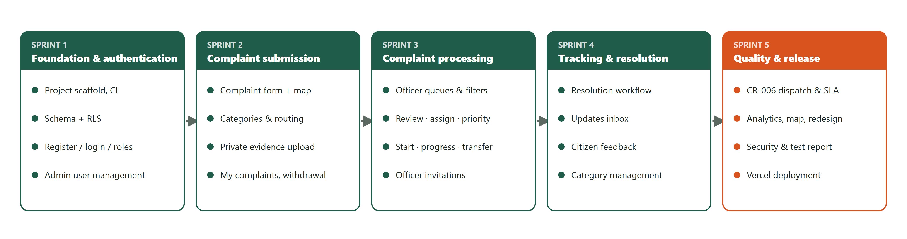
Figure 6.1: Five-sprint roadmap (from the proposal) with the delivered increments
Table 6.4: Sprint plan, delivered increments and review outcomes
Sprint | Goal | Delivered increment | Review / retrospective outcome
1 | Foundation & authentication | React/Vite scaffold; Supabase schema with Row Level Security; sign-up, login, recovery; role workspaces; admin user management; CI | Decided to keep sessions in memory only (security over convenience)
2 | Complaint submission | Complaint form with map; six categories with routing; idempotent submission; private evidence; My Complaints; withdrawal (CR-001) | Empty category list found in the demo → explicit "missing setup" state and a pre-demo database check
3 | Complaint processing | Officer queues and filters; review, assign, priority, start, progress, transfer; Officer invitations (CR-003) | Concurrency test found an endless retry loop (DEF-01) → corrected with a non-retryable conflict code (CR-002)
4 | Tracking & resolution | Resolution; Updates inbox with read state; feedback; category management; monitoring | Inbox work split out explicitly so it was not over-claimed
5 | Quality & release | CR-006 auto-assignment, dispatch centre and service targets; analytics; map; redesign; security and test report; deployment | Hosted use showed 4 of 5 open complaints unowned → CR-006 prioritised above release; responsive audit fixed 4 layout defects

6.5 Task allocation
The task allocation from the proposal was preserved. Each member owned one module end to end and also worked on requirements, design, implementation and testing for it, as required by Section 13 of the guidelines (details in Chapter 14).
Table 6.5: Task allocation by module
Member | Main area | Backlog items owned
TG/2023/1731 H.M. Amadi Nethma | Requirements & Citizen module | CF-01, 02, 04, 07, 13 (UI), 15, 19 (UI), 22
TG/2023/1710 M.F. Rishma | Complaint management module | CF-05, 06, 09, 10, 16, 25
TG/2023/1757 N.M. Razim Mohamed | Officer module | CF-08, 11, 12, 17 (Officer), Officer map
TG/2023/1761 M.S.M. Sharfan | Administration & database | CF-03 (database), 14, 18, 20, 21, 23, 24
TG/2023/1776 V. Kayaththiry | Quality, security & deployment | Test plan and suites, NFRs, security controls, deployment, maintenance CR

7 Requirements Engineering
Requirements were elicited from the allocated domain, the stakeholder analysis and the team's knowledge of how complaints are handled in Sri Lankan local authorities, then refined through sprint reviews and change requests. Each requirement has a stable identifier (CF-xx for functional, NFR-xx for non-functional) that is used in the backlog, design, code, tests and this report.

7.1 Actors
Table 7.1: Actors
Actor | Kind | Description
Citizen | Primary, application role | Registers, submits and tracks own complaints, receives updates, gives feedback, may withdraw an unresolved complaint
Public Service Officer | Primary, application role | Belongs to one department; reviews, assigns, prioritises and transfers its complaints; when assigned, starts work, adds progress and resolves
Administrator | Primary, application role | Manages users and Officer invitations, service categories, dispatch of stuck complaints, monitoring and analytics; does not process complaints
Supabase Auth | Secondary system actor | Stores credentials, verifies e-mail, issues sessions, sends invitation and recovery e-mails
OpenStreetMap | Secondary system actor | Supplies map tiles for location selection

7.2 Functional requirements
The specification contains 25 functional requirements, well above the minimum of 12. Each is atomic and testable, and each lists the test cases that verify it.
Table 7.2: Functional requirements
ID | Requirement ("The system shall …") | Priority | Source | Verified by
CF-01 | … allow a visitor to register a Citizen account with name, email and a password of at least 12 characters, and shall assign the Citizen role only. | Must | p. 11 | TC-AUTH-02, TC-DB-FND-01
CF-02 | … allow registered users to log in and log out, and shall deny protected pages and data after logout. | Must | p. 11 | TC-AUTH-03, TC-AUTH-06
CF-03 | … enforce role-based access to every protected function in the database, independently of the user interface. | Must | p. 11 | TC-AUTH-04, TC-RBAC-01, TC-DB-FND-02…04
CF-04 | … allow a Citizen to submit a complaint with a description (10–5,000 characters), location text (1–300) and a latitude/longitude selected on a map or entered as numbers. | Must | p. 11 | TC-SUB-01, TC-SUB-02, TC-DB-SUB-03
CF-05 | … require the Citizen to select one active service category and shall route the complaint to that category's department. | Must | p. 11 | TC-SUB-04, TC-DB-SUB-01, TC-DB-SUB-07
CF-06 | … generate a unique identifier for each complaint, set its initial status to Submitted and show a confirmation with its reference. | Must | p. 11 | TC-SUB-01, TC-DB-SUB-01
CF-07 | … allow a Citizen to list, open and track only their own complaints, including status, progress and resolution. | Must | p. 11 | TC-TRK-01…03, TC-DB-SUB-06
CF-08 | … allow an active Officer to view and open the complaints of their own department, and complaints assigned to them. | Must | p. 11 | TC-OFF-02, TC-DB-SUB-06
CF-09 | … allow an Officer to assign a department complaint to an active Officer of the same department, and to transfer an unstarted complaint to another department with a reason. | Must | p. 11 | TC-OFF-01, TC-OFF-04, TC-DB-OFF-04, TC-DB-OFF-09
CF-10 | … allow an Officer to set complaint priority to Low, Normal, High or Urgent. | Must | p. 11 | TC-OFF-01, TC-OFF-08
CF-11 | … allow only valid status transitions (Submitted → Under review → In progress → Resolved) and allow only the assigned Officer to start work and record progress remarks. | Must | p. 11 | TC-OFF-01, TC-OFF-05, TC-DB-OFF-05
CF-12 | … allow the assigned Officer to resolve an In progress complaint with resolution details (10–5,000 characters), storing the resolution date and Officer. | Must | p. 11 | TC-OFF-01, TC-DB-OFF-06
CF-13 | … record a durable update for the Citizen with every complaint change, and shall let the Citizen list updates and mark them read. | Must | p. 11 | TC-NTF-01, TC-DB-NTF-01…05
CF-14 | … allow an Administrator to view users, change role, department and active state, and invite Officer accounts. It shall audit every change and protect the last active Administrator. | Must | p. 11 | TC-ADM-01…03, TC-DB-ADM-01…04
CF-15 | … allow every user to change their own display name only. | Should | p. 6 | TC-AUTH-08
CF-16 | … allow a Citizen to attach up to five private JPEG/PNG/PDF files (≤ 5 MiB each) to their Submitted complaint, downloadable only by authorised users. | Should | p. 11 | TC-SUB-01, TC-DB-EV-01…06
CF-17 | … allow searching by reference or description and filtering by status (Citizen), and by status, category, priority and assignment (Officer). | Should | p. 6 | TC-TRK-01, TC-OFF-02, TC-OFF-09
CF-18 | … maintain an append-only history of every complaint change, visible to authorised users. | Should | p. 11 | TC-SUB-01, TC-DB-OFF-01
CF-19 | … allow the owning Citizen to submit exactly one rating (1–5) with an optional comment (≤ 2,000 characters) on a Resolved complaint. | Should | p. 11 | TC-FB-01, TC-FB-02, TC-DB-FB-01…05
CF-20 | … allow an Administrator to create, edit, route and deactivate service categories without deleting them, auditing every change. | Should | p. 11 | TC-CAT-01, TC-CAT-02, TC-DB-CAT-01…06
CF-21 | … provide Administrators with read-only complaint monitoring information (counts by status, average rating). | Could | p. 11 | TC-MON-01, TC-U-MON-01
CF-22 | … allow the owning Citizen to withdraw an unresolved complaint with a 10–2,000 character reason, retaining its record, evidence and history. (approved scope extension) | Should | change record | TC-WD-01…04, TC-DB-WD-01…05
CF-23 | … automatically assign each new complaint to the active Officer with the fewest open assignments in the routed department, and notify that Officer. (CR-006) | Must | CR-006 | TC-DB-DSP-01…03, TC-DSP-03
CF-24 | … allow an active Administrator to dispatch an open complaint: route it to another active department/category and/or assign an active Officer of that department, with a recorded 10–2,000 character reason. (CR-006) | Must | CR-006 | TC-DSP-01, TC-DB-DSP-04…09
CF-25 | … apply a service-level target per priority (urgent 1 day, high 3, normal 7, low 14), flag open complaints that are due soon or overdue, and report on-target resolution. (CR-006) | Should | CR-006 | TC-U-SLA-01, TC-DSP-02, TC-DSP-03

7.3 Non-functional requirements
The proposal's quality goals were refined into eleven measurable non-functional requirements covering performance, usability, security, reliability, integrity, availability, maintainability, scalability and privacy.
Table 7.3: Non-functional requirements
ID | Category | Requirement | Measure / acceptance threshold | Verification method | Status
NFR-01 | Performance | List screens shall load a bounded page of results, never the whole table. | Citizen/Officer lists ≤ 10 rows per request; admin users ≤ 20; ownership, department and status columns indexed | Code review of range() calls; indexes in migration 001 | Verified
NFR-02 | Performance | Common screens should be usable quickly on the demo deployment. | Proposed: first meaningful content ≤ 3 s and page navigation ≤ 1.5 s on a typical broadband connection with demo data | Manual timing in browser DevTools on the deployed URL | Pending (deployment)
NFR-03 | Usability / accessibility | Forms shall be usable by keyboard and screen reader, and pages shall fit a phone screen. | Every input has a programmatic label; errors announced (role="alert"); skip link; no horizontal scroll at 375 px width | Playwright getByLabel/role queries; mobile overflow tests TC-UX-01, TC-TRK-01, TC-OFF-06 | Verified
NFR-04 | Security – authentication | Protected functions shall require an authenticated, active account. | 100% of RPCs deny the anonymous role; inactive accounts denied immediately | TC-DB-FND-03, TC-DB-ADM-04, security advisor | Verified
NFR-05 | Security – authorisation | Users shall access only data and actions permitted by role, ownership and department. | RLS enabled on 9/9 application tables; 0 direct browser INSERT/UPDATE/DELETE grants | TC-DB-FND-02, TC-DB-OFF-03, TC-DB-FB-05 | Verified
NFR-06 | Reliability / integrity | Every complaint change shall be atomic and concurrency-safe. | Each version change writes exactly 1 event and 1 notification, or nothing; stale writes rejected (HTTP 409); retries are idempotent | TC-DB-SUB-05, TC-DB-OFF-08, TC-DB-WD-05, TC-INT-04…06 | Verified
NFR-07 | Data integrity / validation | Invalid or incomplete records shall be rejected in both client and database. | Identical bounds in Zod schemas and SQL CHECK/RPC validation | Unit TC-U- and database TC-DB--bounds tests | Verified
NFR-08 | Availability | The deployed system shall be reachable during the evaluation. | Smoke-test checklist (08 §8.6) passes within 24 h before the demo | Manual smoke test | Pending (deployment)
NFR-09 | Maintainability | Code shall be modular and consistently checked. | Feature modules with ui/application/model/data layers; ESLint 0 warnings; strict TypeScript; CI green on main | CI workflow | Verified
NFR-10 | Scalability / extensibility | New categories, departments and users shall be added without code changes. | Category added via the UI appears in the Citizen form | TC-CAT-01, TC-DB-CAT-02 | Verified
NFR-11 | Privacy | Complaint data and evidence shall be visible only to authorised users; demo data is fictional. | Evidence bucket private; no public complaint feed; tests use fictional identities | TC-DB-EV-01, TC-TRK-03, security review | Verified

7.4 Use case diagram
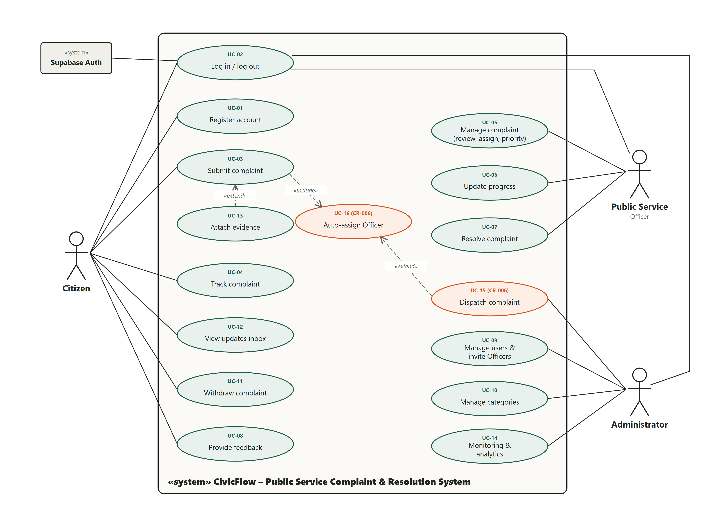
Figure 7.1: UML use case diagram (UC-15 and UC-16 were added by change request CR-006)

7.5 Use case descriptions
Table 7.4: UC-03 Submit complaint (CF-04, 05, 06, 16, 23)
Element | Description
Primary actor | Citizen
Preconditions | Signed in with an active Citizen account; at least one active category exists
Main flow | 1) Open Make a complaint. 2) Select a service category. 3) Describe the issue. 4) Select the location on the map, type coordinates or use "Use my current location", and describe the location. 5) Submit. 6) The system validates the input, routes the complaint to the category's department, assigns the least-loaded active Officer, records history event 1 and updates, and shows the reference. 7) Optionally attach evidence (UC-13).
Alternative flows / exceptions | 3a/4a Invalid or missing fields: field errors, nothing saved. 5a Network failure: the same request key is retried and no duplicate is created. 6a No Officer in the department: the complaint is left unassigned and flagged for dispatch. 7a Upload fails: the complaint stays saved and the file can be retried.
Postcondition | The complaint is Submitted, visible only to its owner, the department's Officers and Administrators.

Table 7.5: UC-04 Track complaint (CF-07, 17, 18)
Element | Description
Primary actor | Citizen
Preconditions | Signed in
Main flow | 1) Open My complaints. 2) Search by reference or description and filter by status. 3) Open a complaint. 4) View the progress line, details, location, evidence, resolution and history.
Alternative flows / exceptions | The reference does not exist or belongs to someone else: "Complaint unavailable" with no details.
Postcondition | No data is changed.

Table 7.6: UC-05 Manage complaint (CF-08, 09, 10)
Element | Description
Primary actor | Officer
Preconditions | Active Officer of an active department; complaint in that department and not closed
Main flow | 1) Open the department queue and filter. 2) Open a complaint. 3) Begin review (Submitted → Under review). 4) Assign an Officer of the department. 5) Set the priority. Each step saves one history event and one Citizen update.
Alternative flows / exceptions | 4a Transfer to another department with a reason (Submitted or Under review only). Exceptions: complaint changed meanwhile (stale-version message, input kept); target Officer inactive or in another department (refused).
Postcondition | Assignment, priority and status are saved with history.

Table 7.7: UC-06/07 Update and resolve complaint (CF-11, 12)
Element | Description
Primary actor | Assigned Officer
Preconditions | Status Under review (to start) or In progress
Main flow | 1) Start work, optionally with a remark. 2) Add progress updates (1–2,000 characters). 3) Resolve with resolution details (10–5,000 characters) and confirmation.
Alternative flows / exceptions | Not the assignee, invalid transition, empty remark or short resolution: refused atomically with no partial update.
Postcondition | Status Resolved; date and Officer stored; the Citizen is notified and can give feedback.

Table 7.8: UC-08 Provide feedback (CF-19)
Element | Description
Primary actor | Citizen (owner)
Preconditions | Complaint Resolved with no feedback yet
Main flow | 1) Open the resolved complaint. 2) Choose a 1–5 rating. 3) Optionally add a comment. 4) Submit.
Alternative flows / exceptions | No rating: client error. Already submitted: "Feedback was already submitted". Not resolved: refused.
Postcondition | Feedback shown read-only to the owner, the department's Officers and Administrators.

Table 7.9: UC-09 Manage users and invite Officers (CF-14)
Element | Description
Primary actor | Administrator
Preconditions | Active Administrator
Main flow | 1) Open User management. 2) Search. 3) Edit role, department or active state, or Create Officer account (name, e-mail, department). 4) Save; the change is audited and the invitee sets their own password.
Alternative flows / exceptions | Removing the last active Administrator: refused. An Officer with open assignments cannot be moved or deactivated until the work is reassigned.
Postcondition | Access changed and audited.

Table 7.10: UC-15 Dispatch complaint (CF-24)
Element | Description
Primary actor | Administrator
Preconditions | Complaint is Submitted, Under review or In progress
Main flow | 1) Open the Dispatch centre; coverage cards show departments with no Officers and the Needs-attention filter lists unstaffed, unassigned or overdue complaints. 2) Choose Dispatch. 3) Select department, category and optionally an Officer. 4) Enter a reason and confirm.
Alternative flows / exceptions | Work in progress cannot change department or lose its assignee. Changed meanwhile: refresh. Closed complaints: refused.
Postcondition | Route and/or assignee changed; history records the Administrator's reason; Citizen and Officer notified.

UC-01 Register, UC-02 Log in/out, UC-10 Manage categories, UC-11 Withdraw complaint, UC-12 View updates inbox, UC-13 Attach evidence and UC-14 Monitoring follow the same pattern and are described in the repository specification (docs/sdlc/04-requirements-specification.md).

7.6 Prioritisation (MoSCoW)
MoSCoW was used because it maps directly onto sprint order: every Must item was scheduled before the Should items of the same sprint, and the Could item was delivered last.
Table 7.11: MoSCoW prioritisation
Priority | Requirements | Rationale
Must have | CF-01 – CF-14, CF-23, CF-24 | Without these the core complaint lifecycle, its security or its ownership does not work
Should have | CF-15 – CF-20, CF-22, CF-25 | Important for usability, evidence, transparency and administration, but the lifecycle works without them
Could have | CF-21 (monitoring and analytics) | Valuable for management; delivered after all Must and Should items
Won't have (this release) | AI classification, GPS Officer tracking, payments, emergency response, broad government integration, SMS/e-mail alerts | Out of scope (Chapter 4) or beyond the free-tier constraints

7.7 Requirements traceability matrix
The matrix connects every requirement to its user story, use case, design artefact, implementation (database migration and frontend module) and tests. Migration numbers are abbreviated: 001 = 20261019000100_foundation.sql … 015 = 20261029000400_dispatch_and_coverage.sql.
Table 7.12: Requirements traceability matrix
Req | Story | Use case | Design | Implementation (DB → frontend) | Tests | Status
CF-01 | US-01 | UC-01 | Auth flow, handle_new_user trigger | 001 trigger → features/auth | TC-AUTH-02, TC-U-AUTH-01, TC-DB-FND-01 | Done
CF-02 | US-02 | UC-02 | Memory-only session decision | Supabase Auth → features/auth/AuthProvider | TC-AUTH-03, TC-AUTH-06, TC-U-AUTH-02 | Done
CF-03 | US-03 | all | Access matrix (DB design) | 001–002 RLS, private.active_role → route guards | TC-AUTH-04, TC-RBAC-01, TC-DB-FND-02…04 | Done
CF-04 | US-04 | UC-03 | Seq. SD-1, shared/location | 004 submit_complaint → complaints/NewComplaintPage | TC-SUB-01…02, TC-LOC-01…02, TC-U-CMP-01, TC-DB-SUB-03 | Done
CF-05 | US-05 | UC-03 | Category routing | 004, 006 → category selector | TC-SUB-04…05, TC-DB-SUB-07 | Done
CF-06 | US-06 | UC-03 | SD-1 | 004 → submission success view | TC-SUB-01, TC-SUB-03, TC-DB-SUB-01…02 | Done
CF-07 | US-07 | UC-04 | Citizen screens | 004 RLS → MyComplaintsPage, ComplaintDetailPage | TC-TRK-01…03 | Done
CF-08 | US-08 | UC-05 | Officer screens | 004 RLS → officer/OfficerQueue | TC-OFF-02, TC-OFF-07 | Done
CF-09 | US-09 | UC-05 | State diagram, SD-2 | 009 assign_complaint, transfer_complaint → OfficerActions | TC-OFF-01, TC-OFF-04, TC-DB-OFF-04, TC-DB-OFF-09 | Done
CF-10 | US-10 | UC-05 | — | 009 set_complaint_priority | TC-OFF-01, TC-OFF-08 | Done
CF-11 | US-11 | UC-06 | Activity diagram, state diagram | 009 review/start/add_progress | TC-OFF-01, TC-OFF-03, TC-OFF-05, TC-DB-OFF-01…05 | Done
CF-12 | US-12 | UC-07 | SD-2 | 010 resolve_complaint | TC-OFF-01, TC-DB-OFF-06…07 | Done
CF-13 | US-13 | UC-12 | notifications table | 004/009 writes, 013 read policy + mark_notifications_read → features/notifications | TC-NTF-01, TC-U-NTF-01, TC-DB-NTF-01…05 | Done
CF-14 | US-14 | UC-09 | Admin audit, Edge Function | 002 admin_update_user, provision-officer → features/admin | TC-ADM-01…03, TC-U-INV-01, TC-DB-ADM-01…04, TC-INT-08 | Done
CF-15 | US-15 | — | — | 002 update_my_profile → features/profiles | TC-AUTH-08 | Done
CF-16 | US-16 | UC-13 | Evidence storage design | 005 bucket, policies, reserve/finalize → features/evidence | TC-SUB-01, TC-U-EV-01, TC-DB-EV-01…06 | Done
CF-17 | US-07, US-08 | UC-04, UC-05 | — | Data adapters (bounded ilike, filters) | TC-TRK-01, TC-OFF-02, TC-OFF-09 | Done
CF-18 | US-17 | UC-04 | complaint_events | 004–011 event writes → timeline | TC-SUB-01, TC-DB-OFF-01 | Done
CF-19 | US-18 | UC-08 | SD-3, complaint_feedback | 012 submit_feedback → features/feedback | TC-FB-01…02, TC-U-FB-01, TC-DB-FB-01…05 | Done
CF-20 | US-19 | UC-10 | Category rules | 014 admin_upsert_category → features/categories | TC-CAT-01…02, TC-U-CAT-01, TC-DB-CAT-01…06 | Done
CF-21 | US-21 | UC-14 | Analytics view | 015 admin_analytics, community_impact → features/analytics, admin/AdminOverview | TC-MON-01, TC-DSP-02, TC-U-MON-01, TC-U-ANL-01, TC-DB-DSP-10…12 | Done (enhanced)
CF-23 | US-22 | UC-03 | SD-4 | 015 submit_complaint, private.pick_officer | TC-DB-DSP-01…03, TC-DSP-03 | Done
CF-24 | US-23 | UC-15 | SD-4 | 015 admin_dispatch_complaint → features/dispatch | TC-DSP-01, TC-U-DSP-01, TC-DB-DSP-04…09 | Done
CF-25 | US-24 | UC-05, UC-15 | SLA table | shared/sla.ts + private.sla_hours | TC-U-SLA-01, TC-DSP-02, TC-DSP-03 | Done
CF-22 | US-20 | UC-11 | State diagram | 007–008, 011 withdraw_complaint → WithdrawalPanel | TC-WD-01…04, TC-U-WD-01, TC-DB-WD-01…05 | Done
NFR-04/05 | US-03 | all | Security | Grants, RLS, definer RPCs | TC-DB-FND-, TC-INT- | Done
NFR-06 | — | — | Lock order, version checks | All workflow RPCs | TC-DB-*-rollback, TC-INT-04…06 | Done

7.8 Requirements validation
Table 7.13: Requirements validation activities
Activity | What was done | Outcome
Proposal review | The proposal (Milestones 1–3) was submitted as the requirements baseline | Accepted as the baseline for development
Stakeholder refinement | The project owner requested withdrawal, Administrator-created Officers and the location refinement; hosted testing revealed unowned complaints | Recorded as change requests CR-001 – CR-006 with impact analysis (Chapter 12)
Prototype walkthroughs | Each increment was demonstrated in the browser and screenshots were reviewed | Defects such as the empty category list were found and fixed
Consistency checks | Client and database input limits compared; tests assert both | No mismatches outstanding
Not yet done | Validation with real citizens or Officers | Labelled as an open assumption

8 System Design

8.1 High-level system architecture
CivicFlow is a three-tier, client–server system: a React single-page application (presentation tier) served from Vercel's CDN, and a managed Supabase backend that provides the application tier (authentication, a REST/RPC API and server-side business functions) and the data tier (PostgreSQL and private file storage).
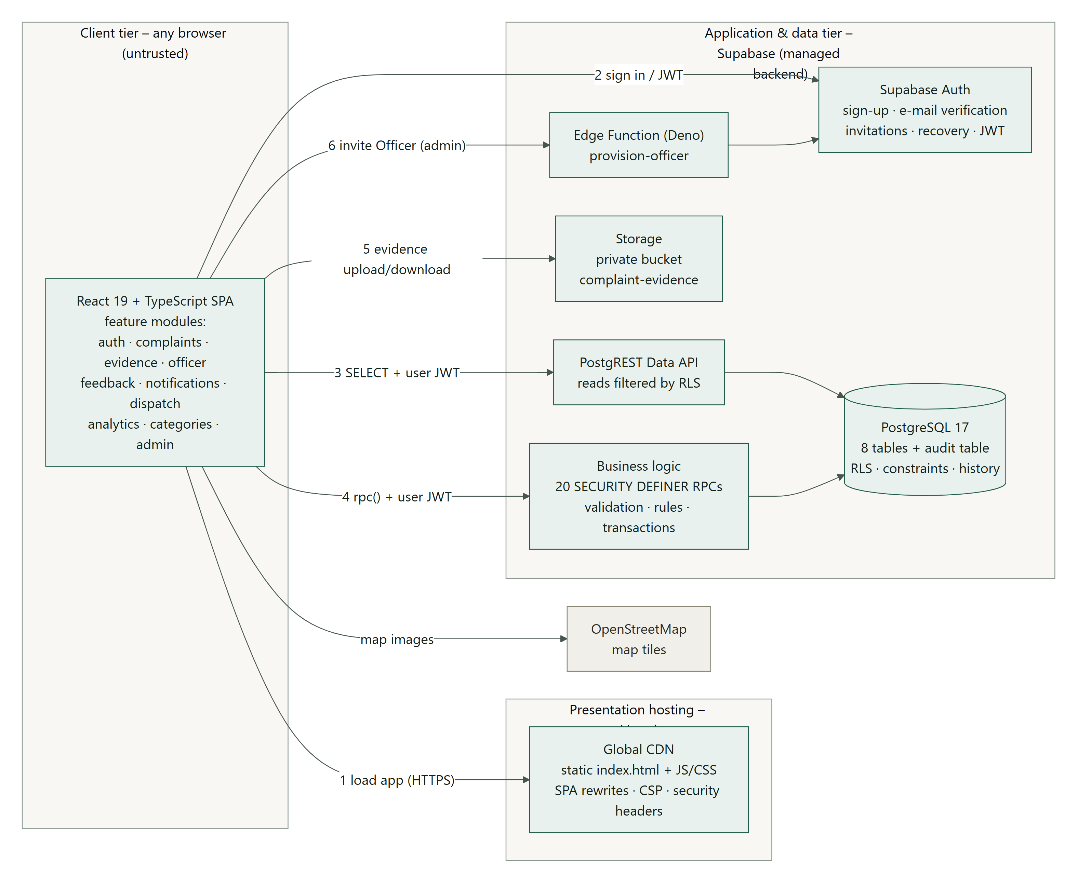
Figure 8.1: High-level system architecture
Trust boundary
The browser is treated as untrusted. Every authorisation decision is made on the server: by PostgreSQL grants, Row Level Security policies, checks inside SECURITY DEFINER functions and Storage policies. Hidden buttons and route guards in the user interface exist only for usability.

8.2 Frontend architecture
The frontend is organised by feature (auth, complaints, evidence, officer, feedback, notifications, dispatch, analytics, categories, admin, landing). Each feature has the same four layers, so the user interface never talks to the backend directly and business rules can be unit-tested without React or a network.
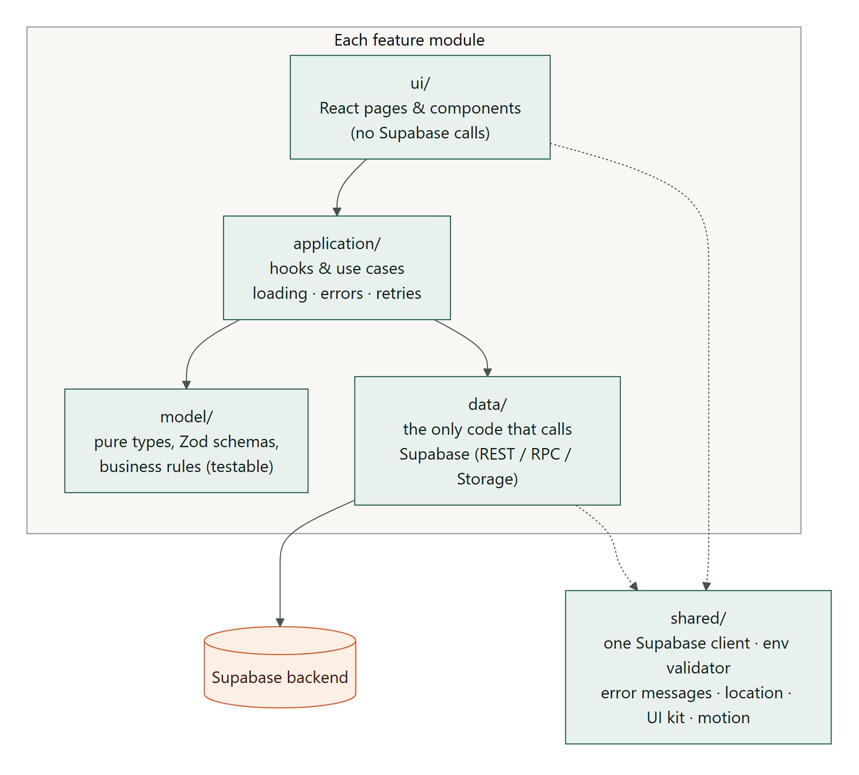
Figure 8.2: Layered structure of every feature module

8.3 Class / domain model
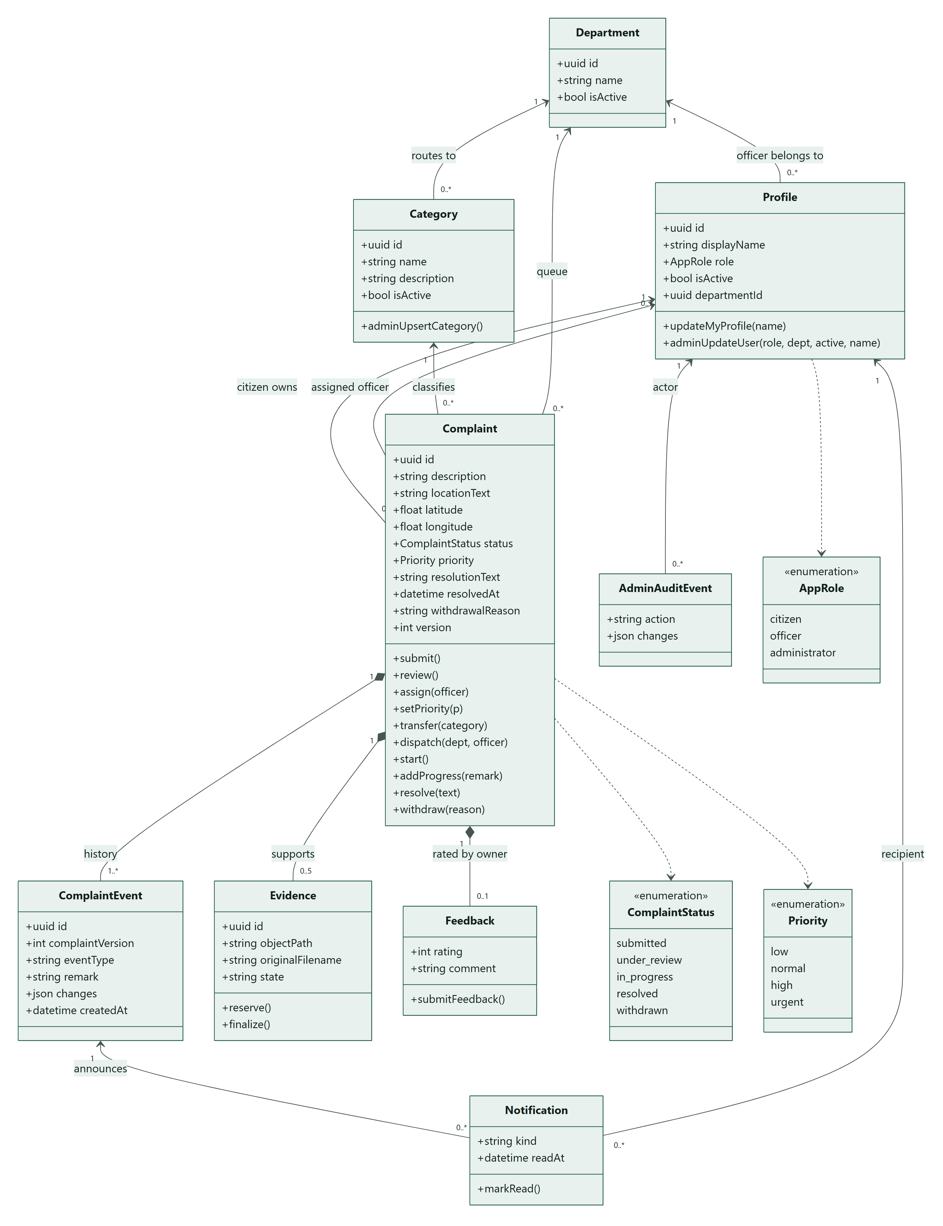
Figure 8.3: UML class diagram of the domain model. Operations are the only write paths; browsers have no direct insert, update or delete.

8.4 Sequence diagrams
Four sequence diagrams describe the most important interactions. SD-1 shows complaint submission with validation, idempotency and automatic assignment. SD-2 shows how an Officer resolves a complaint under row locks and optimistic concurrency. SD-3 shows Administrator dispatch (CR-006). SD-4 shows citizen feedback.
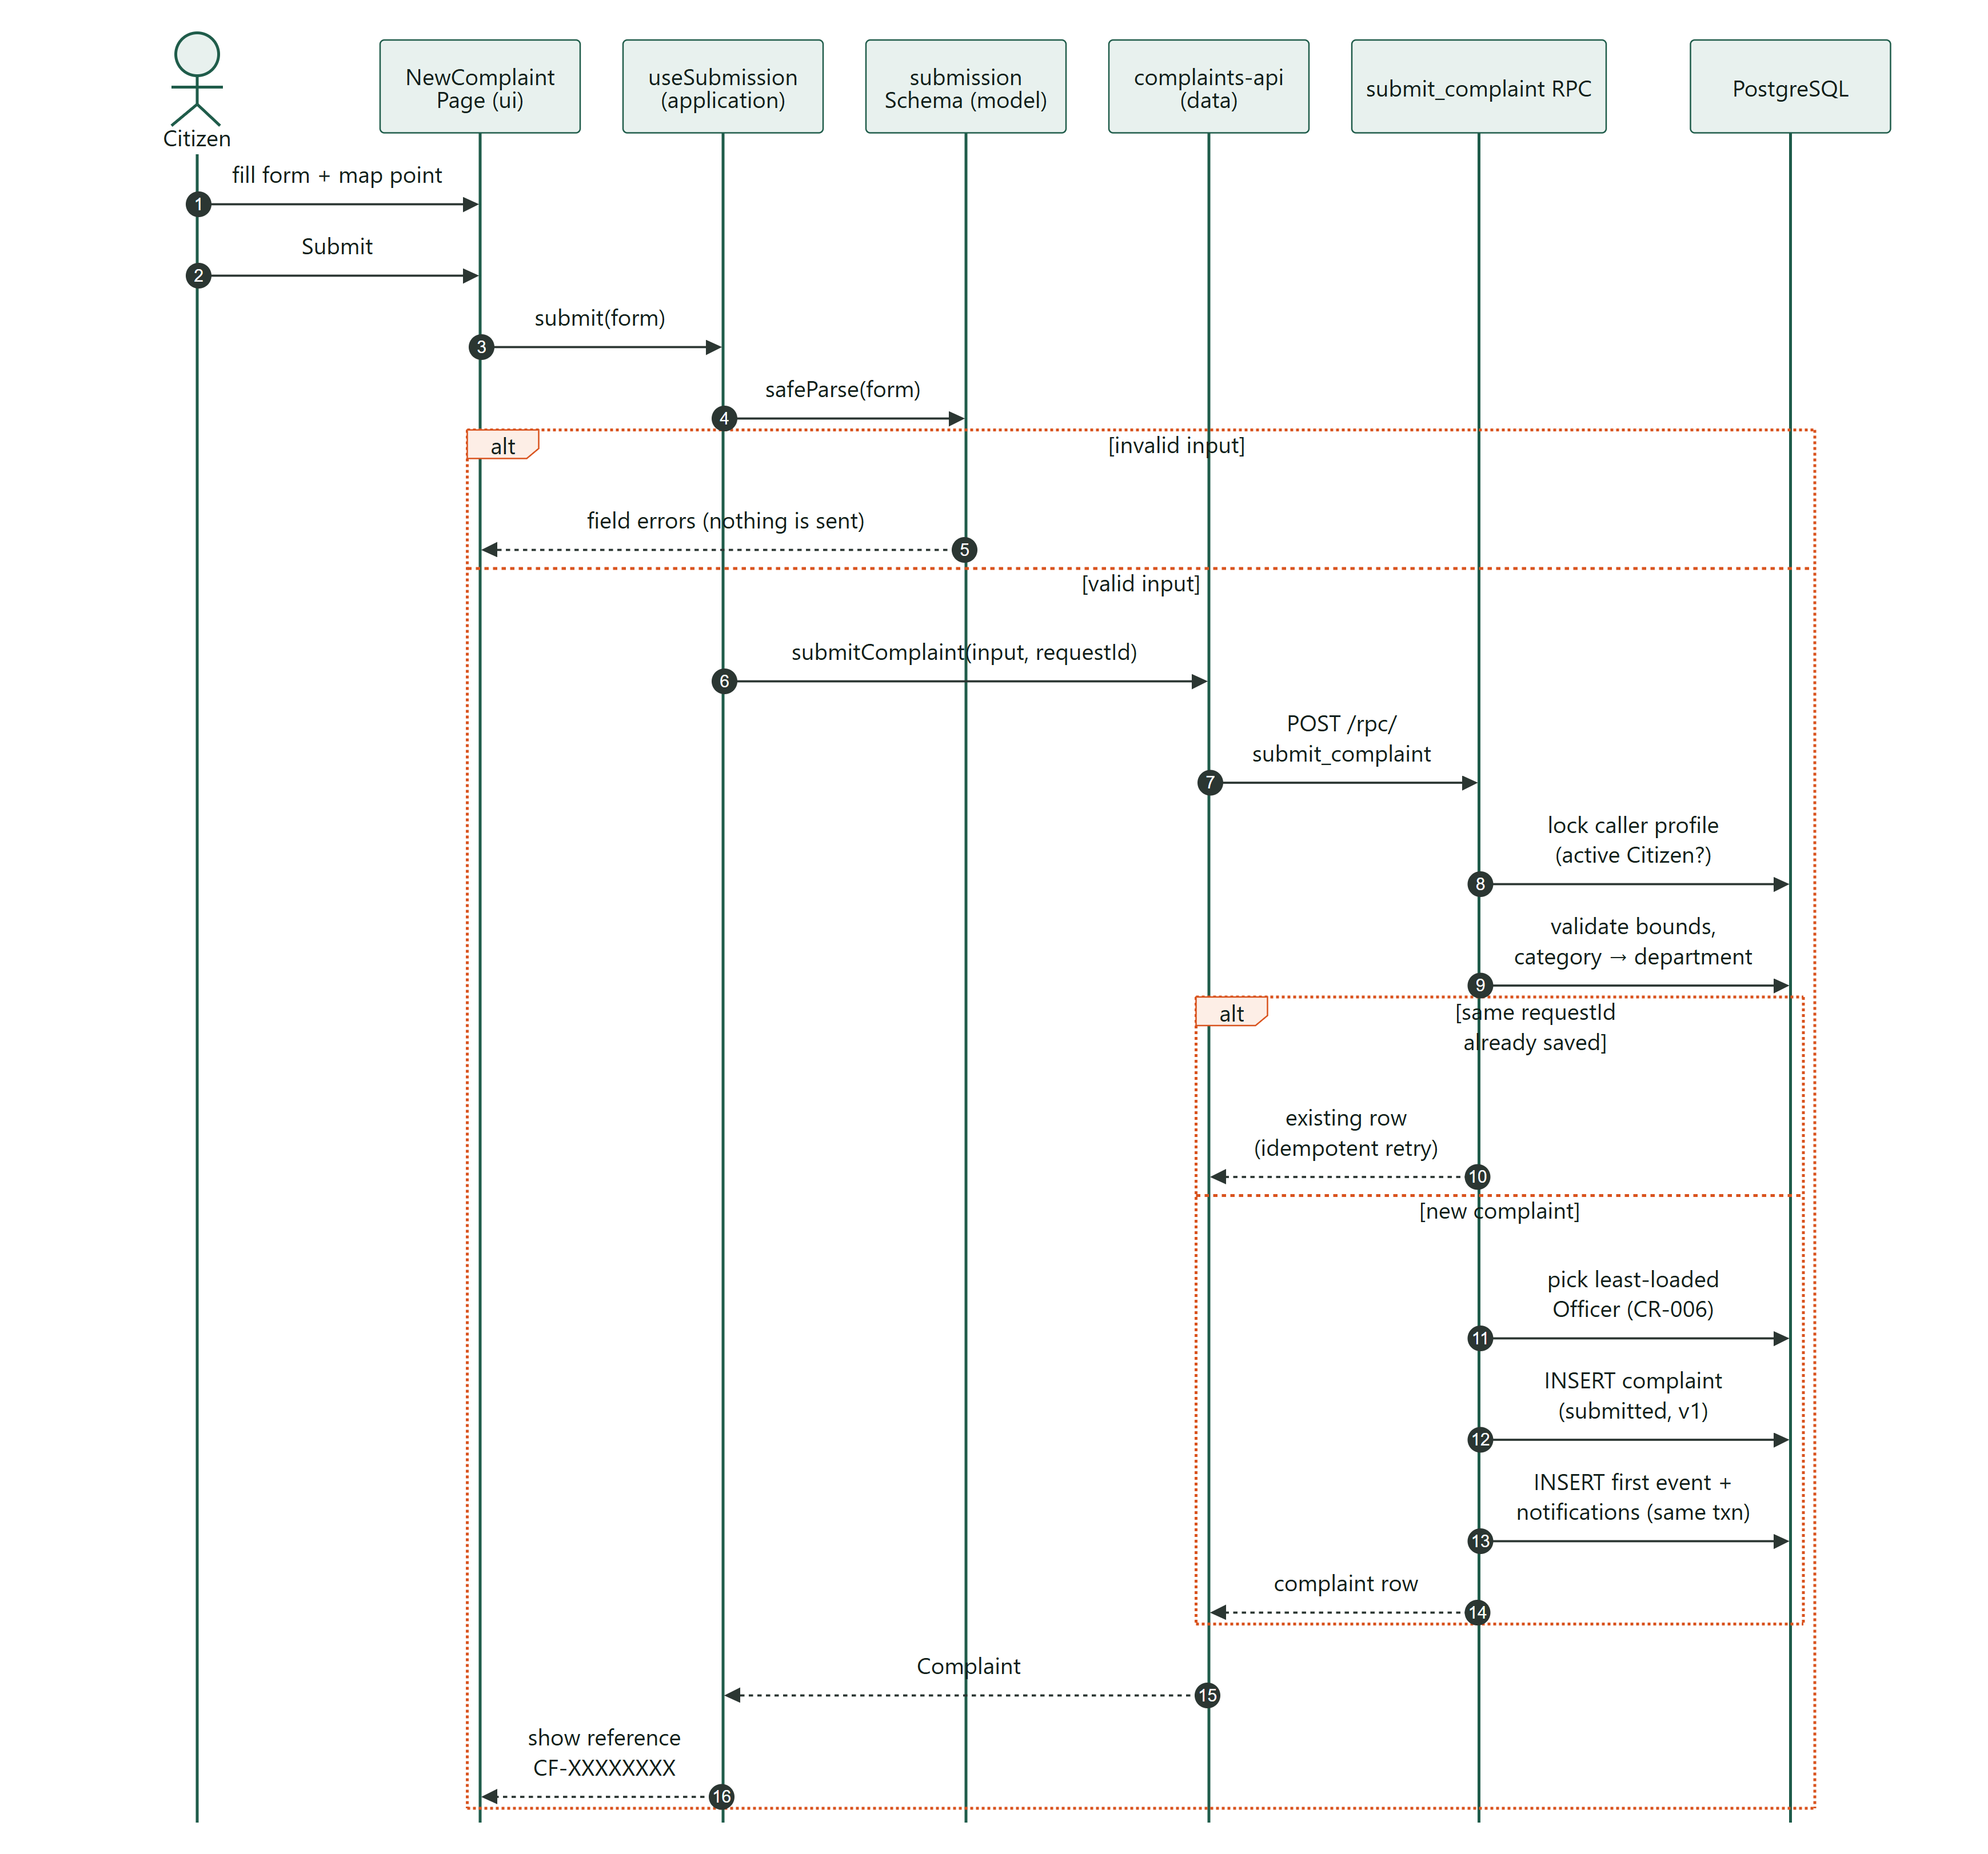
Figure 8.4: SD-1: Citizen submits a complaint (UC-03)
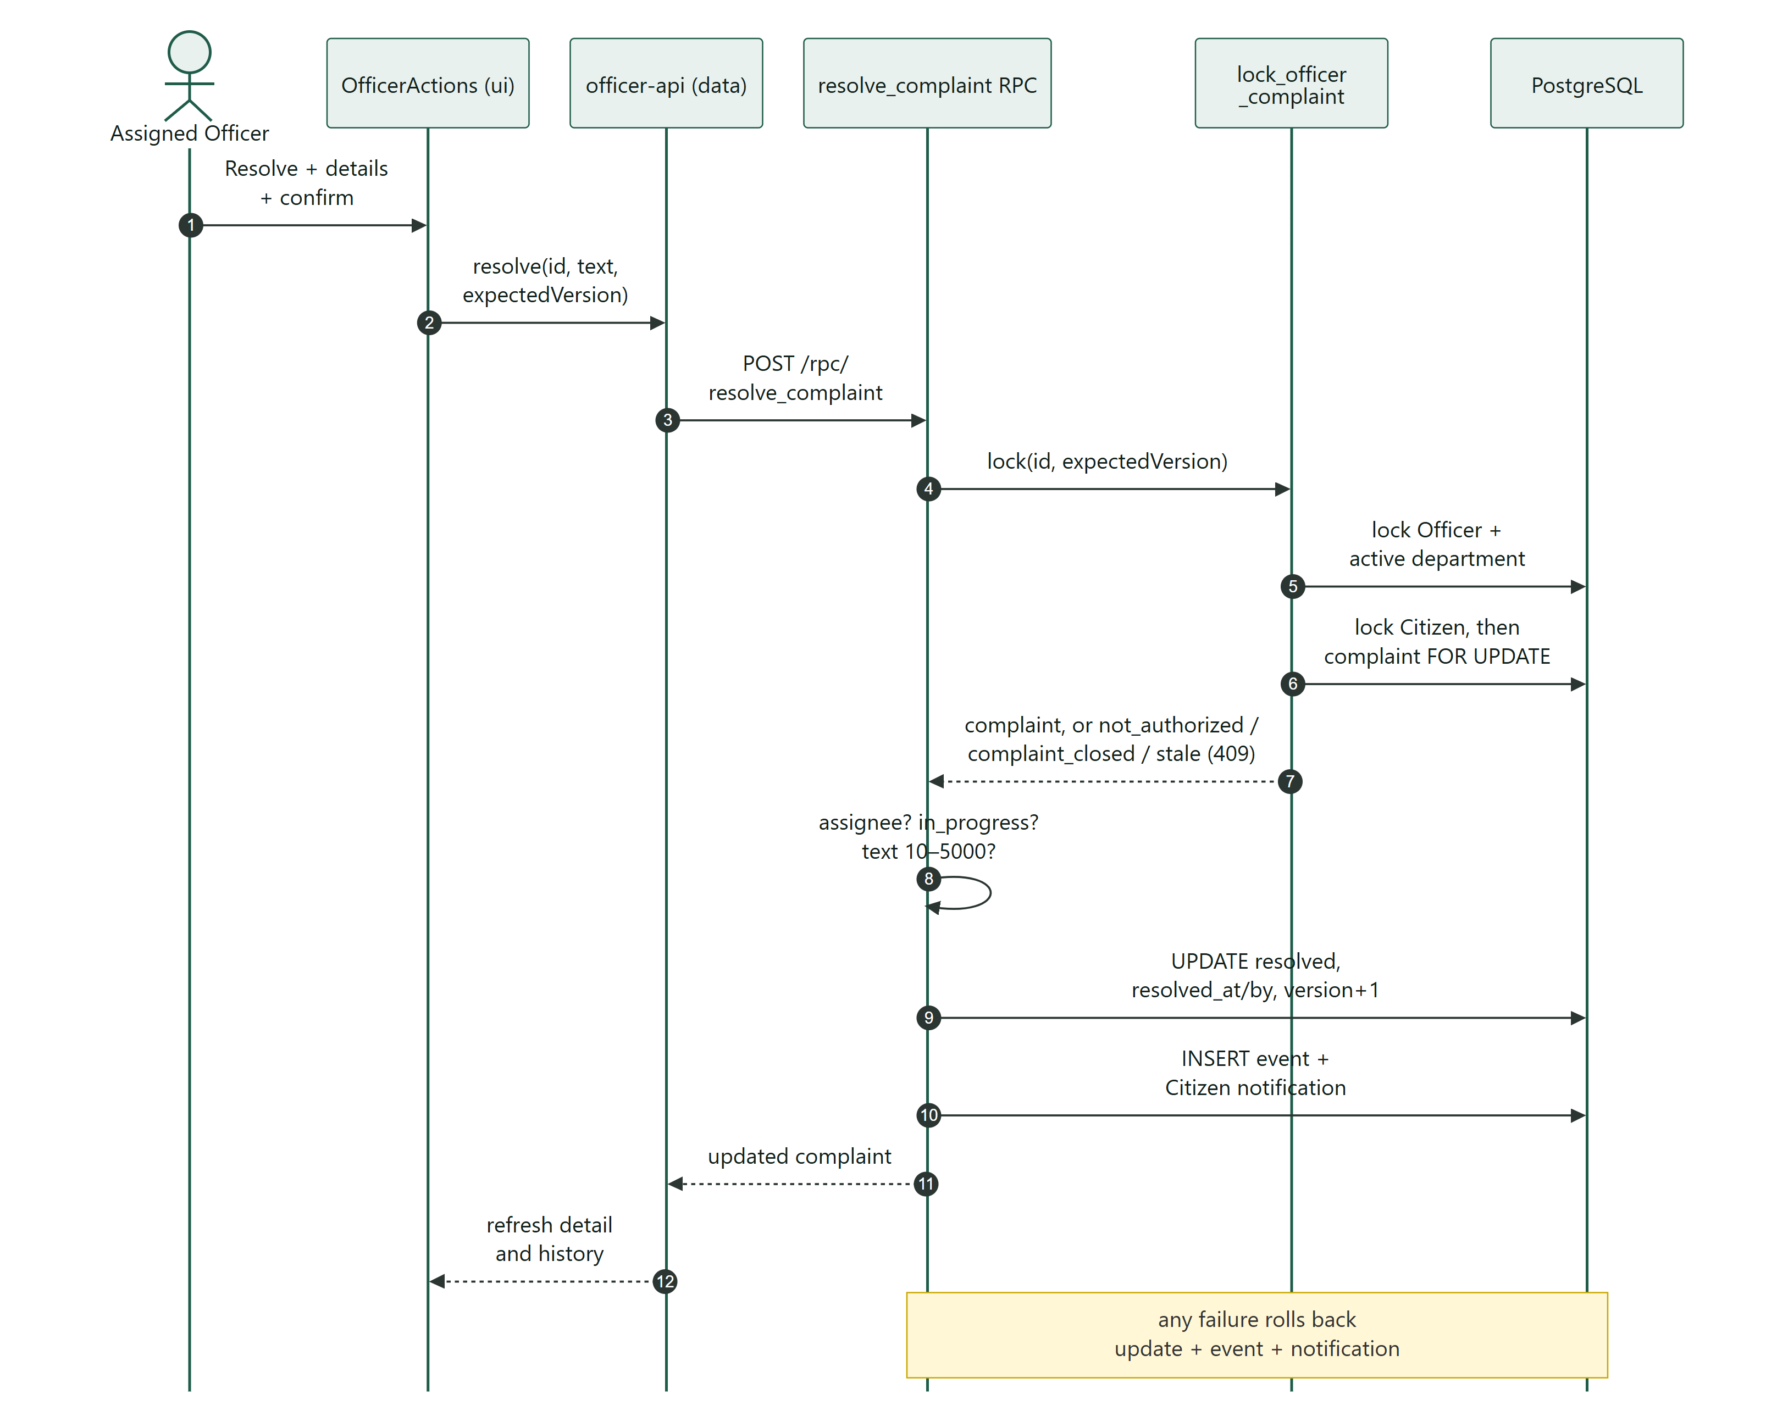
Figure 8.5: SD-2: Assigned Officer resolves a complaint (UC-07)
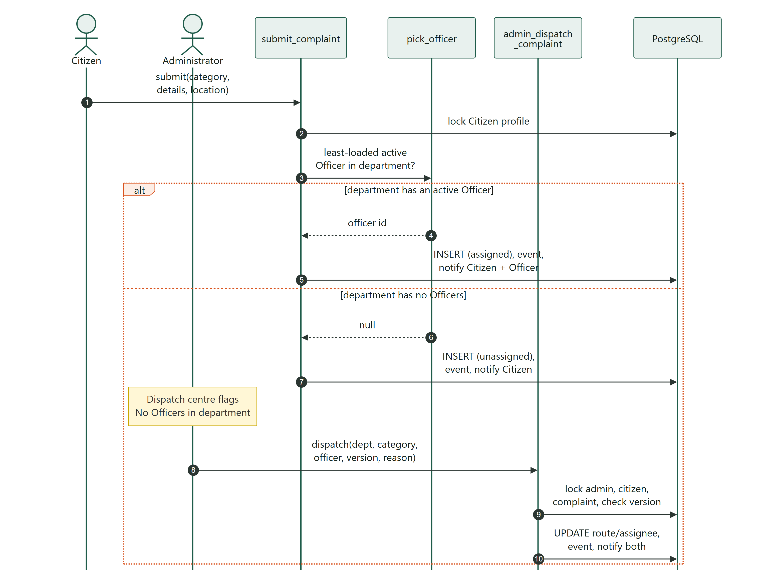
Figure 8.6: SD-3: Automatic assignment and Administrator dispatch (CR-006, UC-15)
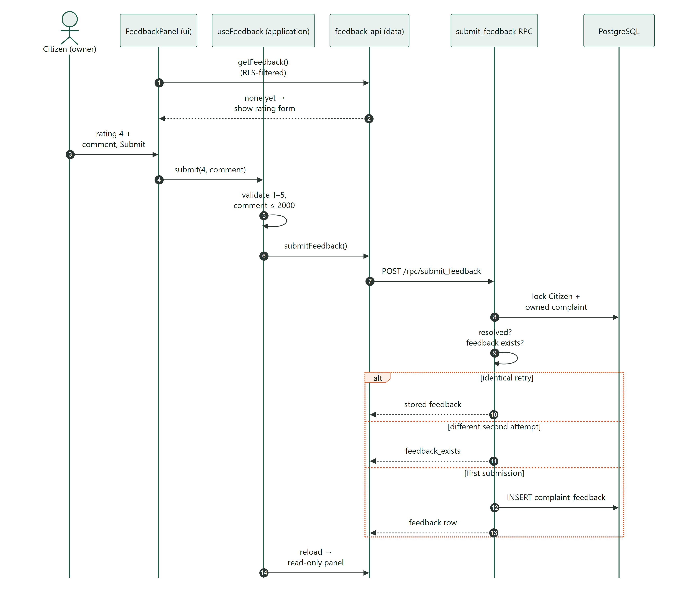
Figure 8.7: SD-4: Citizen gives feedback (UC-08)

8.5 Activity diagram – complaint lifecycle workflow
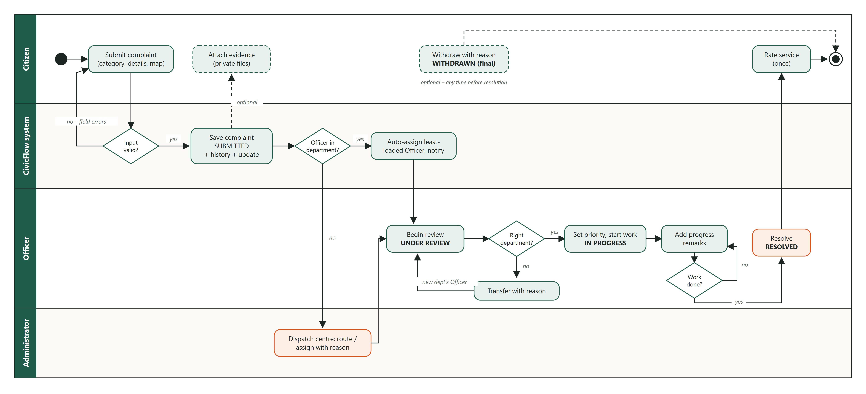
Figure 8.8: UML activity diagram with swimlanes for the complete complaint workflow

8.6 State machine – complaint status
The complaint status follows a strict state machine enforced inside the database functions. Assigning, changing priority and adding progress do not change the status but increase the version number, which is used for optimistic concurrency control.
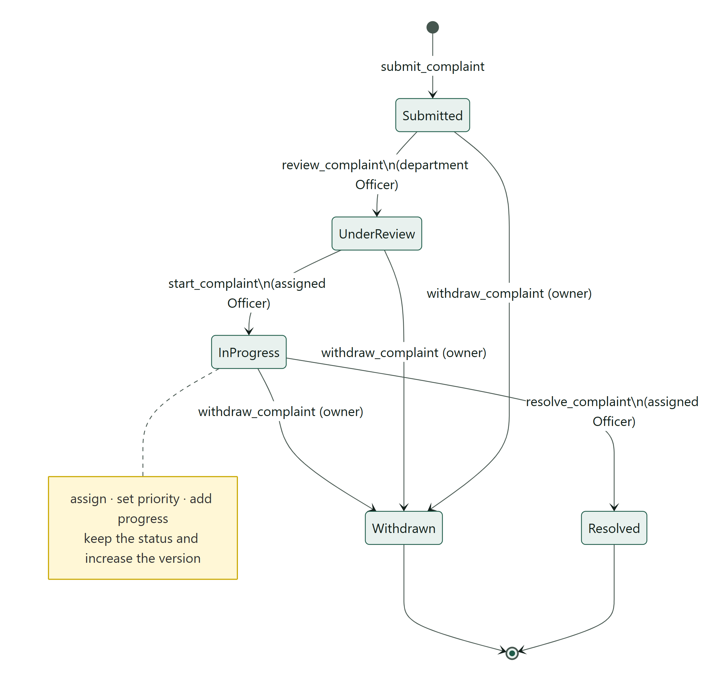
Figure 8.9: UML state machine of the complaint status

8.7 Database design
The database has eight application tables in the public schema and one private audit table. The entity-relationship diagram shows their keys and relationships; the most important integrity rules are listed in the table that follows it.
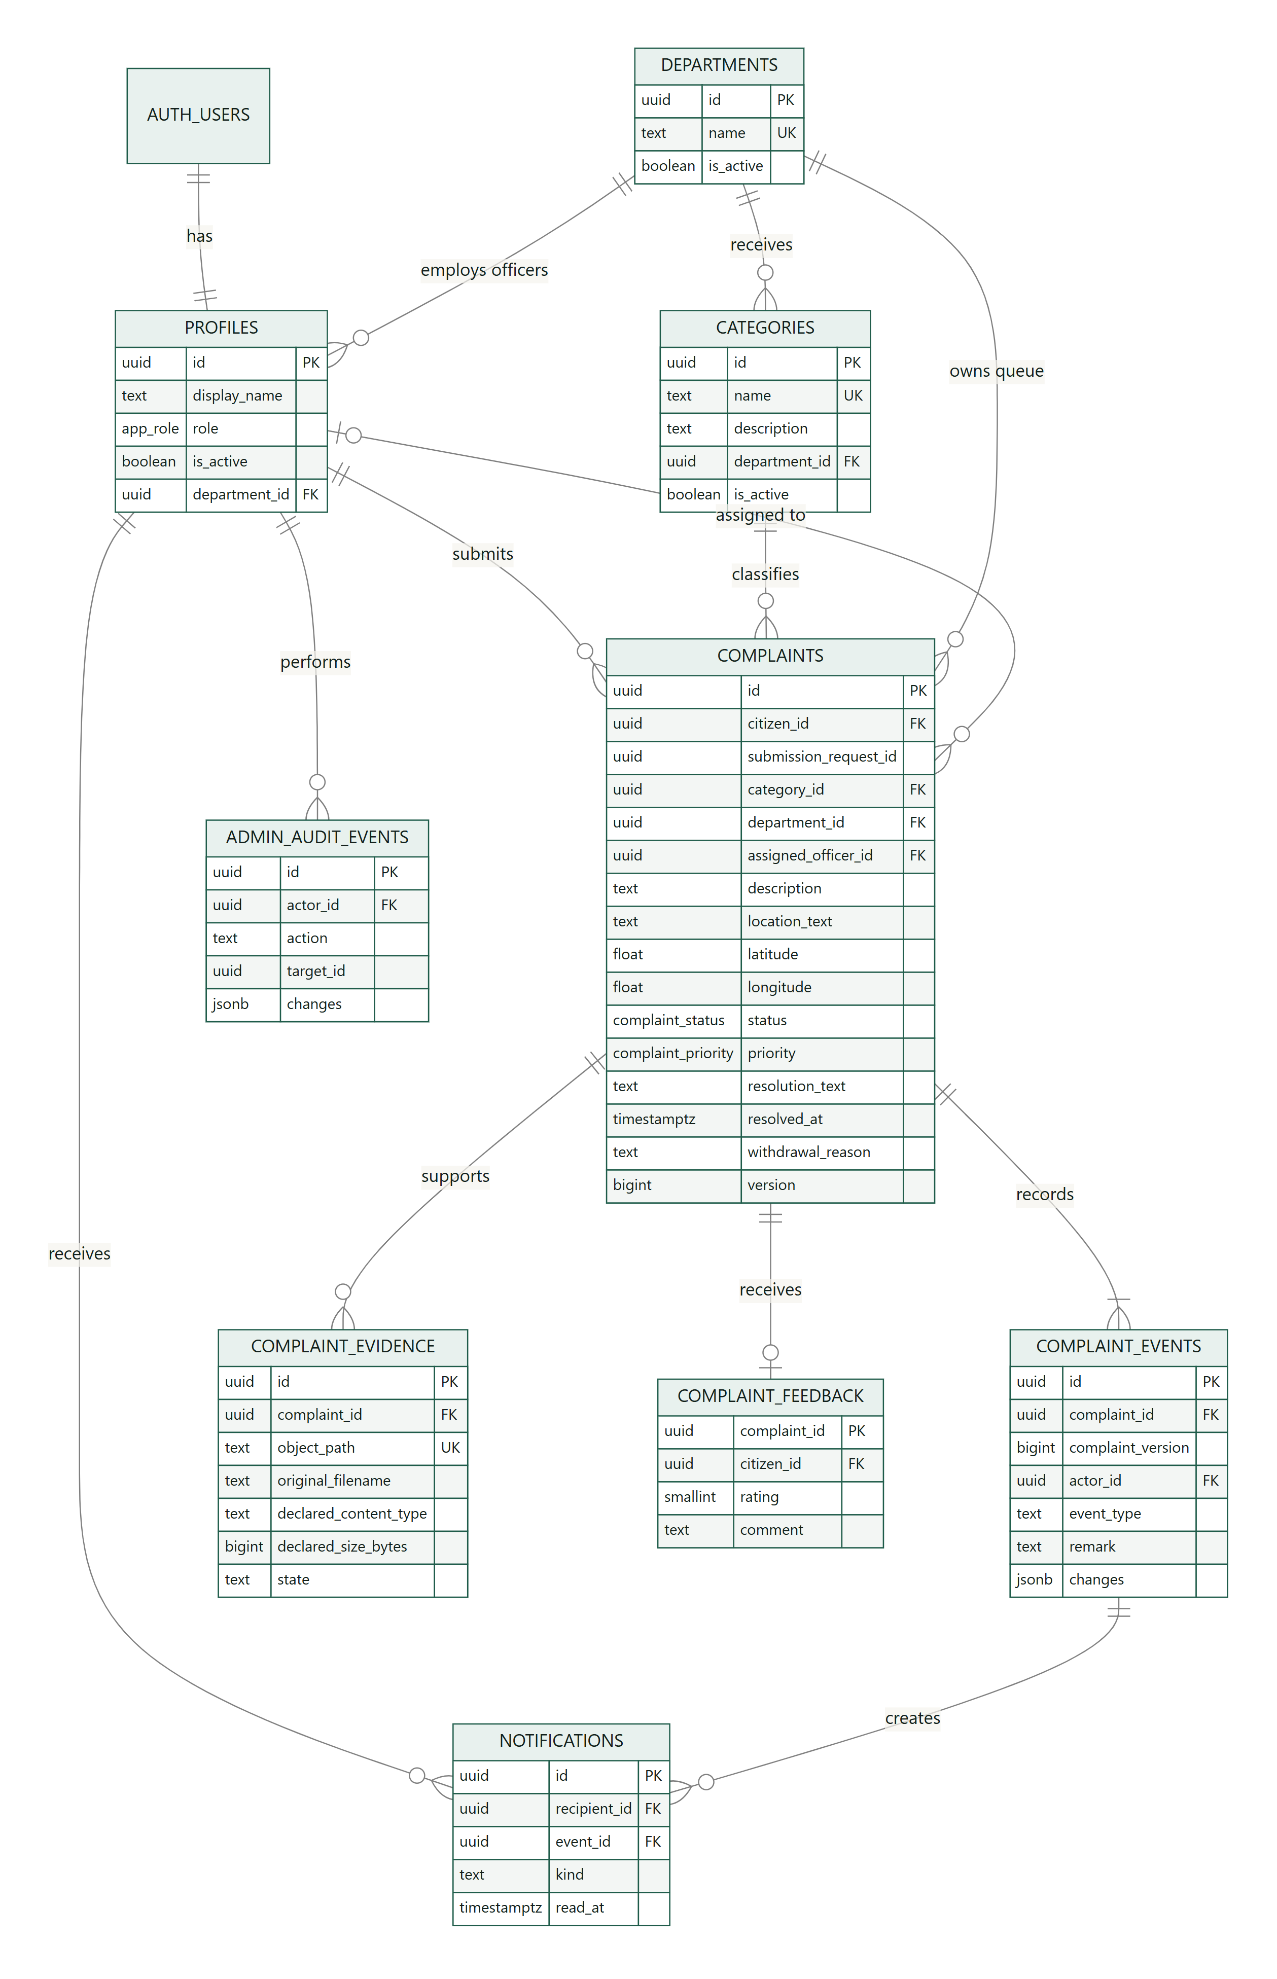
Figure 8.10: Entity-relationship diagram (PostgreSQL 17)
Table 8.1: Major tables and integrity rules
Table | Purpose | Key rules
profiles | One row per Auth user: display name, role, active flag, department | Signup always creates a Citizen; an Officer must have a department and only Officers may have one
departments / categories | Service departments and the categories that route to them | Unique names; categories are deactivated, never deleted; a used category keeps its department
complaints | The complaint and its current state | Description 10–5,000; location 1–300; resolution fields set if and only if Resolved; In progress/Resolved require an assignee; version ≥ 1; (citizen, request id) unique for idempotency
complaint_events | Append-only history | Exactly one event per complaint version (unique complaint_id, complaint_version); progress events need a remark
complaint_evidence | Private file metadata | JPEG/PNG/PDF, 1 byte – 5 MiB, ≤ 5 files; server-reserved unique object path; pending → attached
complaint_feedback | One rating per complaint | Primary key = complaint; rating 1–5; comment ≤ 2,000
notifications | Durable in-system updates | Unique (recipient, event); read_at for the inbox
private.admin_audit_events | Audit of administrative changes | Not exposed to browsers; before/after values in JSON

All foreign keys use ON DELETE RESTRICT, so the application never deletes records. Row Level Security is enabled on every table and browsers have no INSERT, UPDATE or DELETE grant; business changes go through twenty narrowly scoped functions.

8.8 User-interface prototype and wireframes
Low-fidelity wireframes were drawn first to agree the layout of the major screens (below); the working screens were then built and refined through sprint reviews. The final screens are shown in Chapter 9.
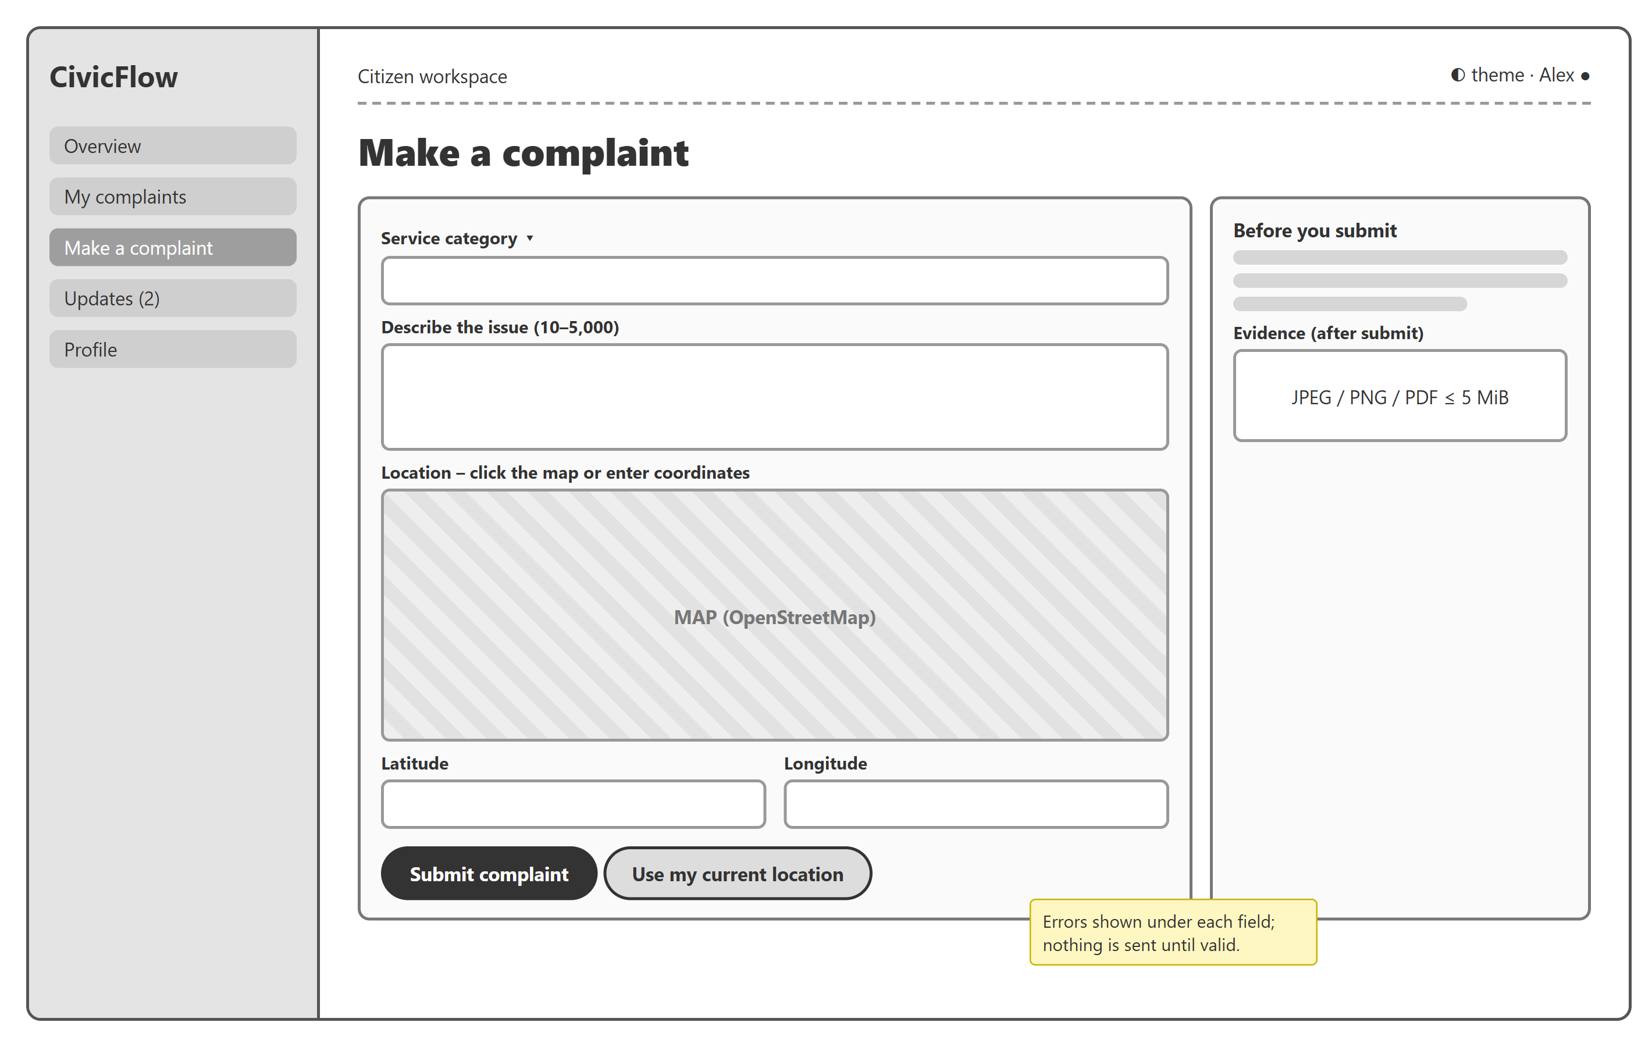
Figure 8.11: Wireframe – Citizen "Make a complaint" screen
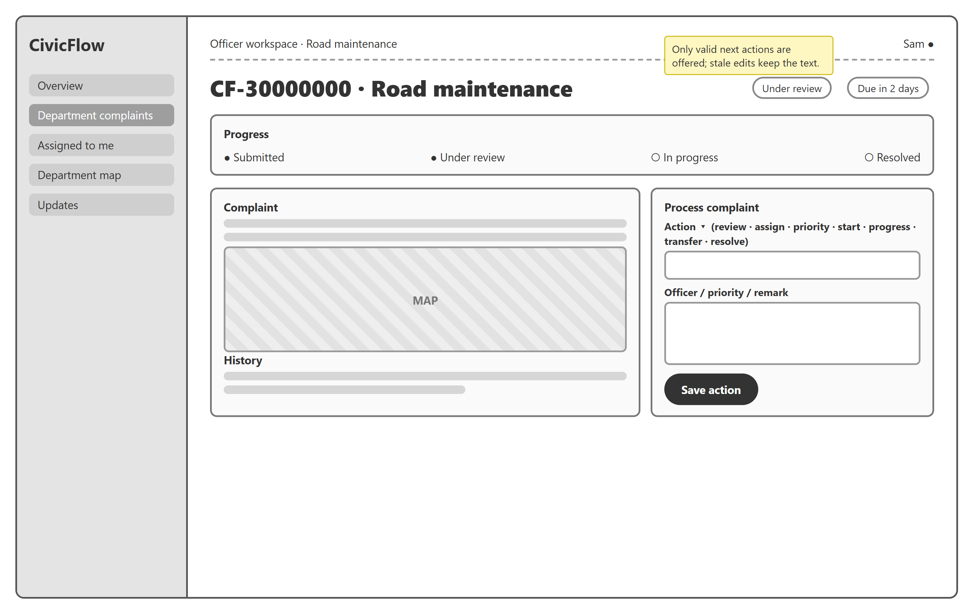
Figure 8.12: Wireframe – Officer complaint processing screen
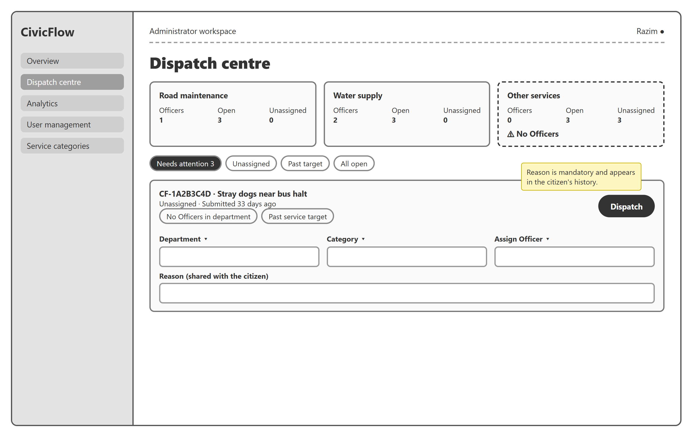
Figure 8.13: Wireframe – Administrator dispatch centre (CR-006)
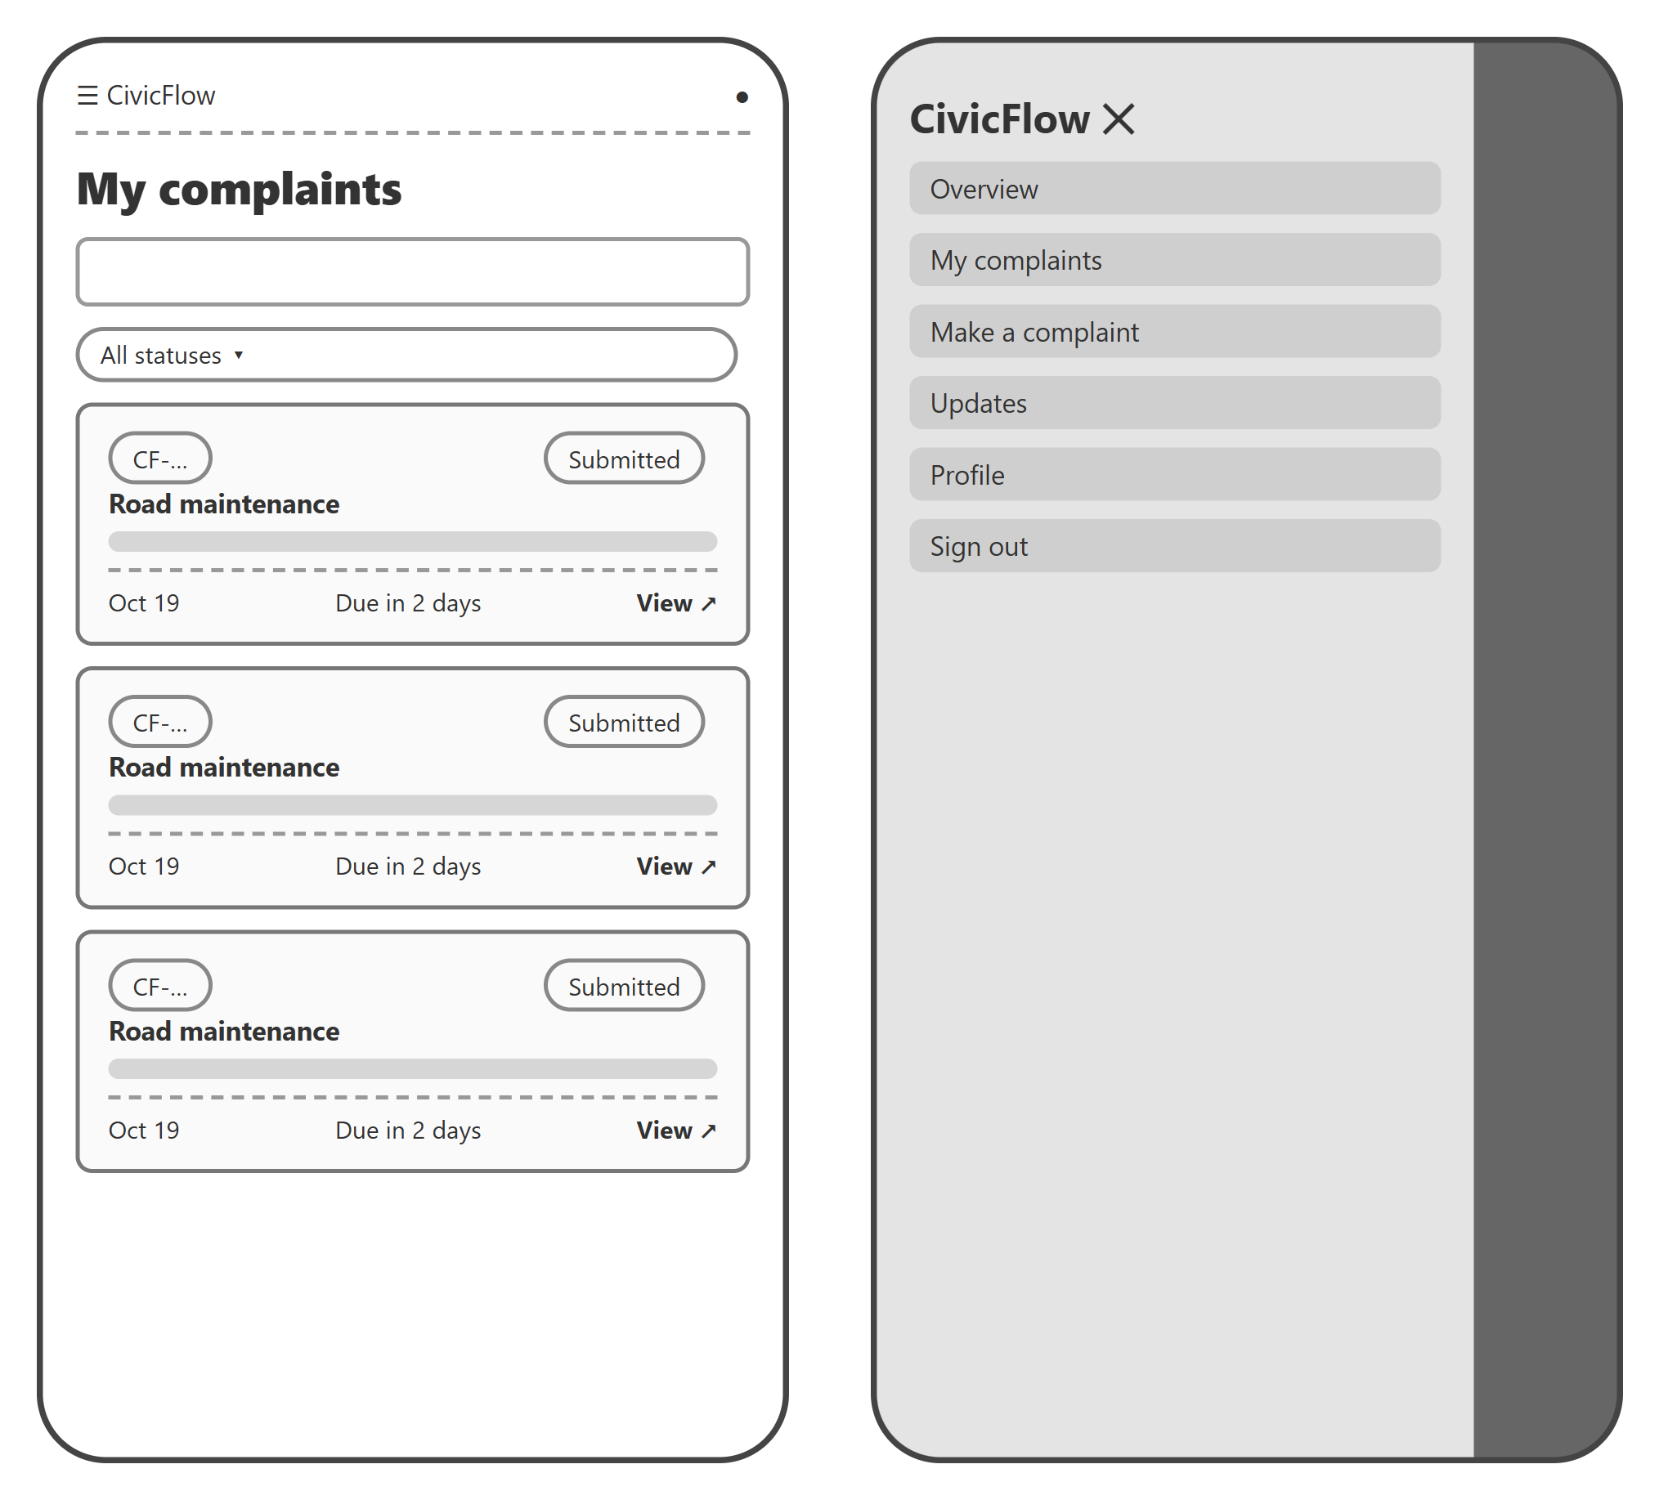
Figure 8.14: Wireframe – mobile list and slide-out menu
UI principles: one primary action per screen; plain-language status names; every form field labelled with its hint and error text; status shown as both text and colour; a skip link and visible focus; light and dark themes; animations disabled when the device requests reduced motion; and every page usable from 360 px phones to desktop.

8.9 Design decisions and justification
Table 8.2: Important design decisions
Decision | Alternatives considered | Reason
React + TypeScript + Vite SPA | Server-rendered (Next.js), plain JS | Typed domain models catch errors at build time. Vite gives fast builds. The team already knew React. An SPA is enough because there is no SEO requirement.
Supabase (PostgreSQL, Auth, Storage) instead of a custom API server | Node/Express + MySQL; Firebase | Relational integrity (FKs, CHECKs, transactions) suits a workflow with history. RLS puts authorisation next to the data. Managed Auth avoids storing passwords ourselves. The free tier fits the project.
Business writes only through SECURITY DEFINER RPCs; direct table DML revoked | Direct table updates with RLS UPDATE policies | A status change must update the complaint, history and notification atomically with transition rules and locks. Generic UPDATE policies can't express "only valid transitions".
Optimistic concurrency (expected_version, error PT409) | Last-write-wins | Two Officers editing the same complaint must not overwrite each other silently. PT409 maps to HTTP 409 without PostgREST retry loops (defect DEF-01).
Append-only history + durable notifications in PostgreSQL | Realtime push, email/SMS | Meets CF-13/18 within the scope constraint on external notifications. History is the audit trail.
Memory-only sessions (persistSession: false) | localStorage tokens | Avoids leaving bearer tokens in persistent storage on shared computers. Trade-off: a page refresh requires signing in again (documented).
Private evidence bucket with server-reserved paths | Public bucket, signed URLs | Complaint evidence may contain personal information. Paths can't be chosen by users, and downloads are authorised per request.
Department-scoped Officers; assigned-Officer-only progress/resolution | Any Officer can edit any complaint | Least privilege and clear accountability, as the problem statement asks ("identifying responsible officers").
Categories deactivated, never deleted; referenced department immutable | Hard delete / free edit | Historic complaints must keep their original routing and meaning.
Leaflet + OpenStreetMap with numeric coordinate fallback | Google Maps | No API key or cost. Accessible fallback when tiles fail. The OSM attribution policy is respected.
Vercel static hosting | Netlify, GitHub Pages | Simple Vite deployment, SPA rewrites and security headers configured in vercel.json.
Auto-assignment + Administrator dispatch (CR-006) | Manual pick-up only; giving Administrators full workflow rights | Guarantees an owner whenever staff exist, and gives a narrow, audited escape hatch when they don't, without making Administrators process complaints.
motion library + CSS tokens | Hand-written CSS only; heavy UI kits | Declarative, interruptible animations that respect reduced motion. Design tokens keep light and dark themes consistent.
Vitest + PGlite + Playwright | Jest only, manual testing | Tests each layer: pure rules, real SQL/RLS inside PostgreSQL, and user journeys in a real browser.

9 Implementation

9.1 Technology stack
Table 9.1: Technology stack as built
Layer | Technology (pinned in package.json)
UI | React 19, React Router 7, Tailwind CSS 4, lucide-react icons
Language / build | TypeScript 6 (strict), Vite 8 (Rolldown)
Validation | Zod 4 (client); SQL CHECK constraints and RPC validation (server)
Maps | Leaflet 1.9 + React Leaflet 5, OpenStreetMap tiles
Backend | Supabase: PostgreSQL 17, Auth, Storage, one Deno Edge Function
Tests | Vitest 5 (unit), PGlite (embedded PostgreSQL for database tests), Playwright (browser)
CI / hosting | GitHub Actions; Vercel configuration (vercel.json)

The technologies were chosen for their fit with the requirements. TypeScript catches errors at build time. PostgreSQL provides relational integrity and transactions for a workflow with history. Row Level Security keeps authorisation next to the data. Managed authentication means the team never stores passwords. Free tiers fit the project constraints. Section 8.9 records the alternatives that were considered.

9.2 Module structure
Table 9.2: Module map
Module | Path | Responsibility | Requirements
App shell | src/app/App.tsx | Routes, role navigation, protected layout, unread badge | CF-02, CF-03
Auth | src/features/auth | Register, login/logout, recovery, invitation password, session/profile loading | CF-01–03
Profiles | src/features/profiles | Own display name | CF-15
Complaints | src/features/complaints | Form, submission, list, detail, withdrawal | CF-04–07, 17, 18, 22
Evidence | src/features/evidence | Private reserve → upload → finalize, download | CF-16
Officer | src/features/officer | Queues, filters, review/assign/priority/start/progress/transfer/resolve | CF-08–12, 17
Feedback | src/features/feedback | Post-resolution rating | CF-19
Notifications | src/features/notifications | Updates inbox, read state, unread badge | CF-13
Categories | src/features/categories | Admin category maintenance | CF-20
Admin | src/features/admin | User management, Officer invitation, monitoring overview | CF-14, 21
Shared | src/shared | One Supabase client, environment validation, errors, location, UI primitives | —
Database | supabase/migrations (15 files) | Schema, RLS, RPCs, Storage policies | All
Edge Function | supabase/functions/provision-officer | Admin-only Officer invitation using the Auth Admin API | CF-14

9.3 Core workflows implemented end to end
Every core use case is implemented end to end, from the screen through the application hook and data adapter to a protected database function, and is covered by tests at each level. Nothing in this report is a mock-up or static screen.
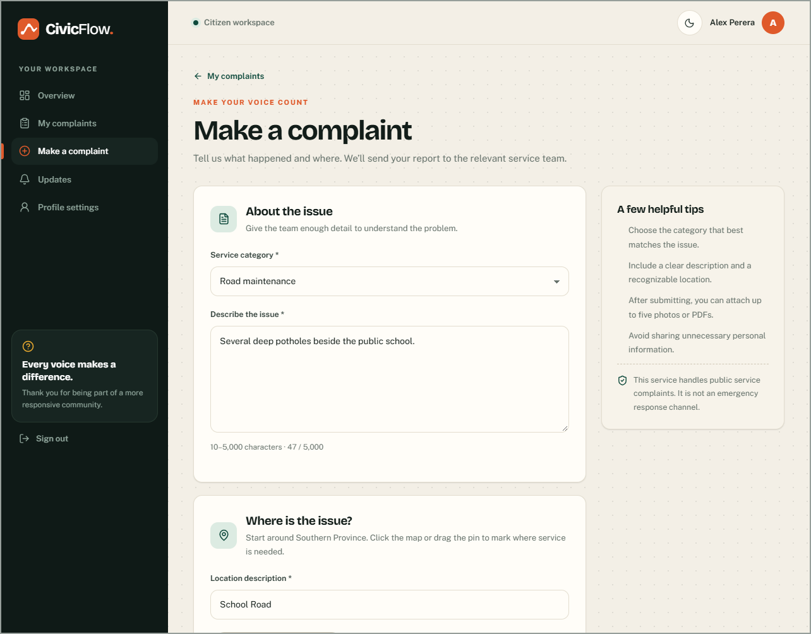
Figure 9.1: Citizen – Make a complaint (category, description, OpenStreetMap location, typed coordinates)
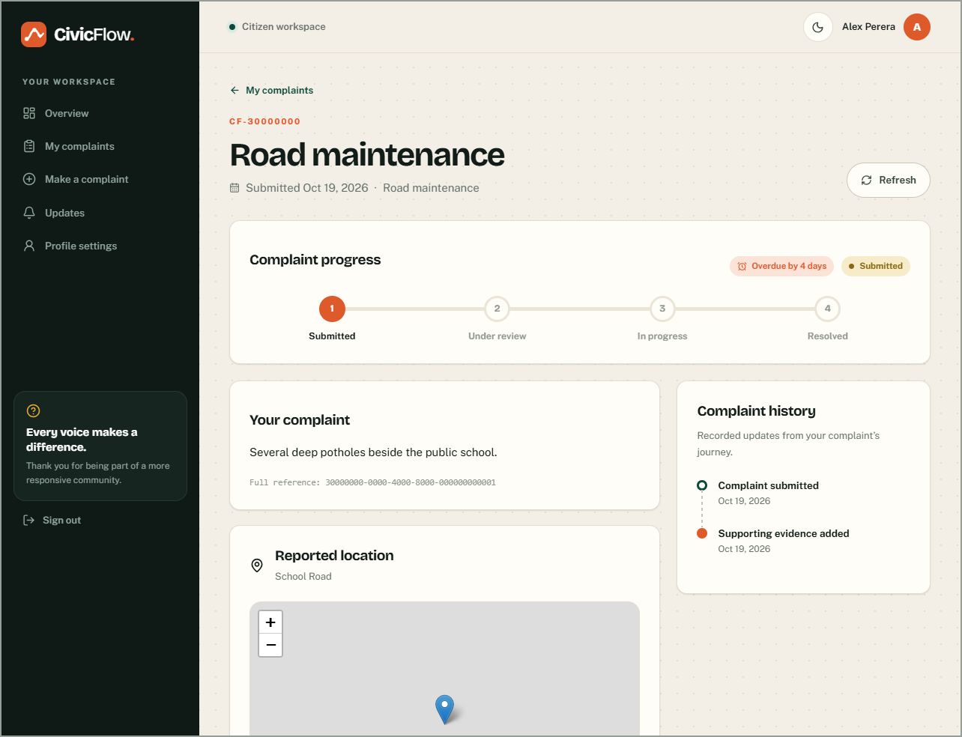
Figure 9.2: Citizen – complaint detail with transit-line progress, location, history and service-target badge
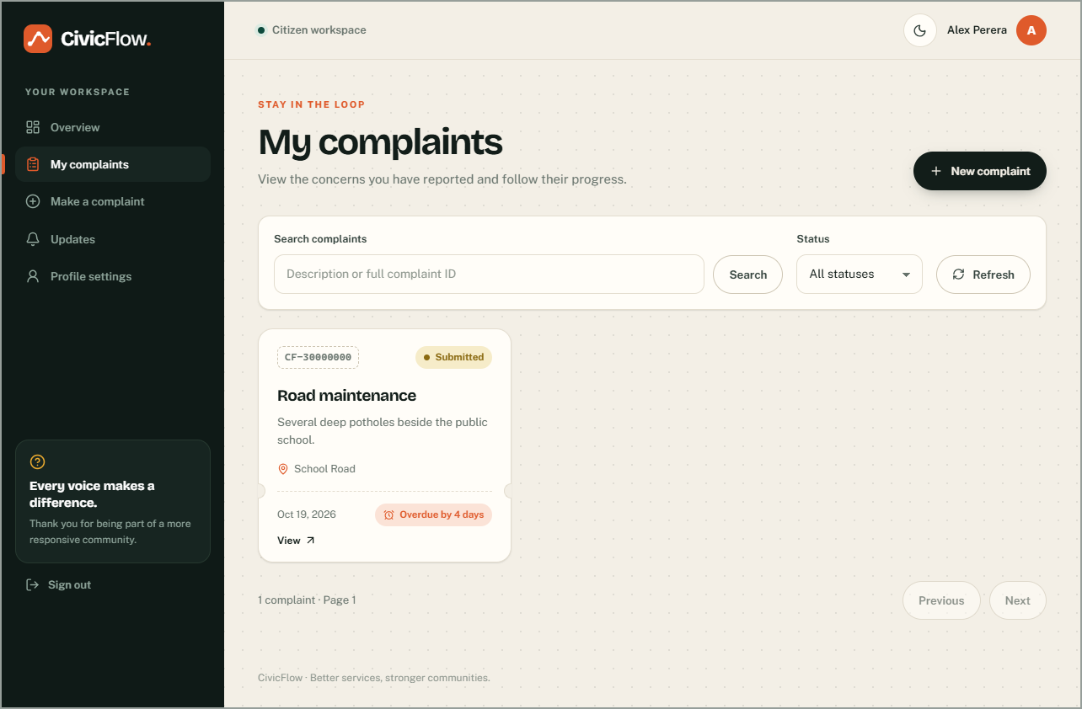
Figure 9.3: Citizen – My complaints: complaints shown as service tickets with status and due/overdue badges
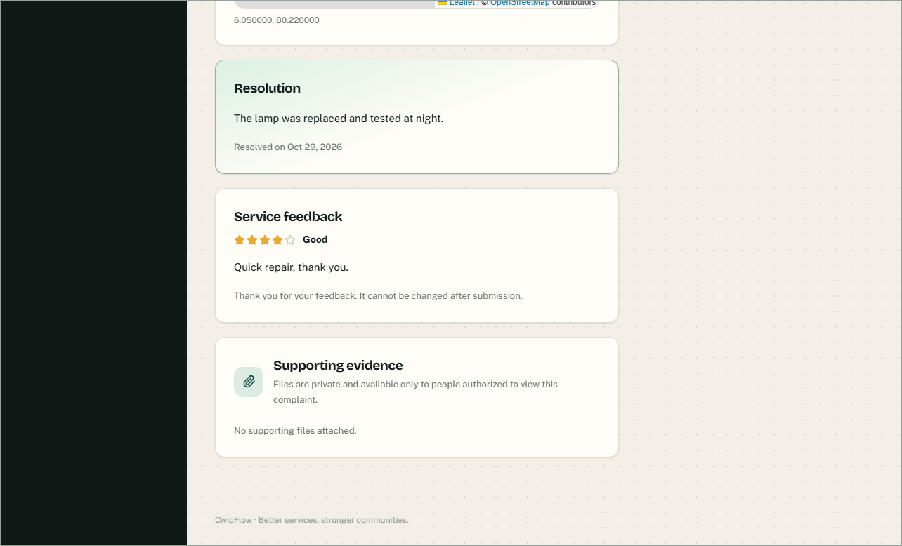
Figure 9.4: Citizen – resolution and one-time service feedback
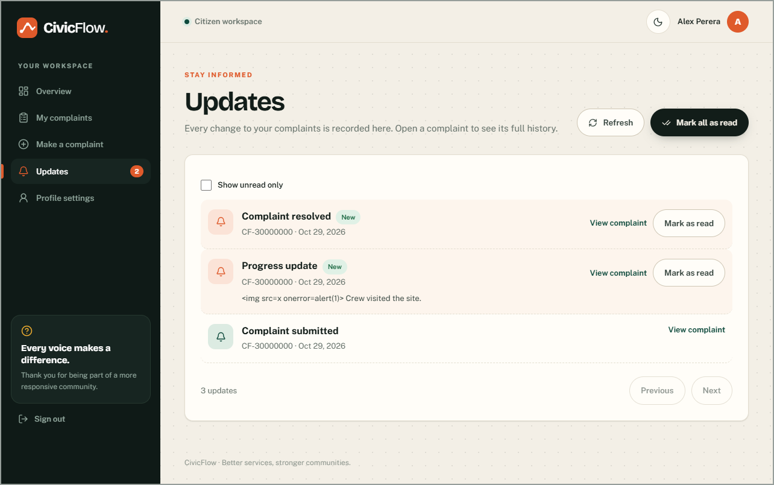
Figure 9.5: Citizen – Updates inbox with unread count and mark-as-read
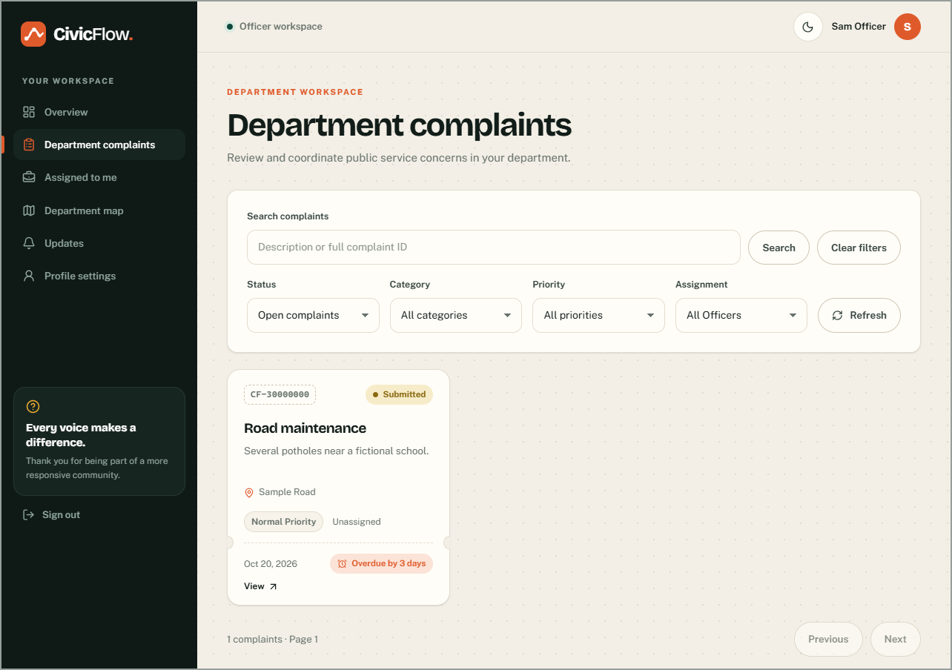
Figure 9.6: Officer – department queue with filters by status, category, priority and assignment
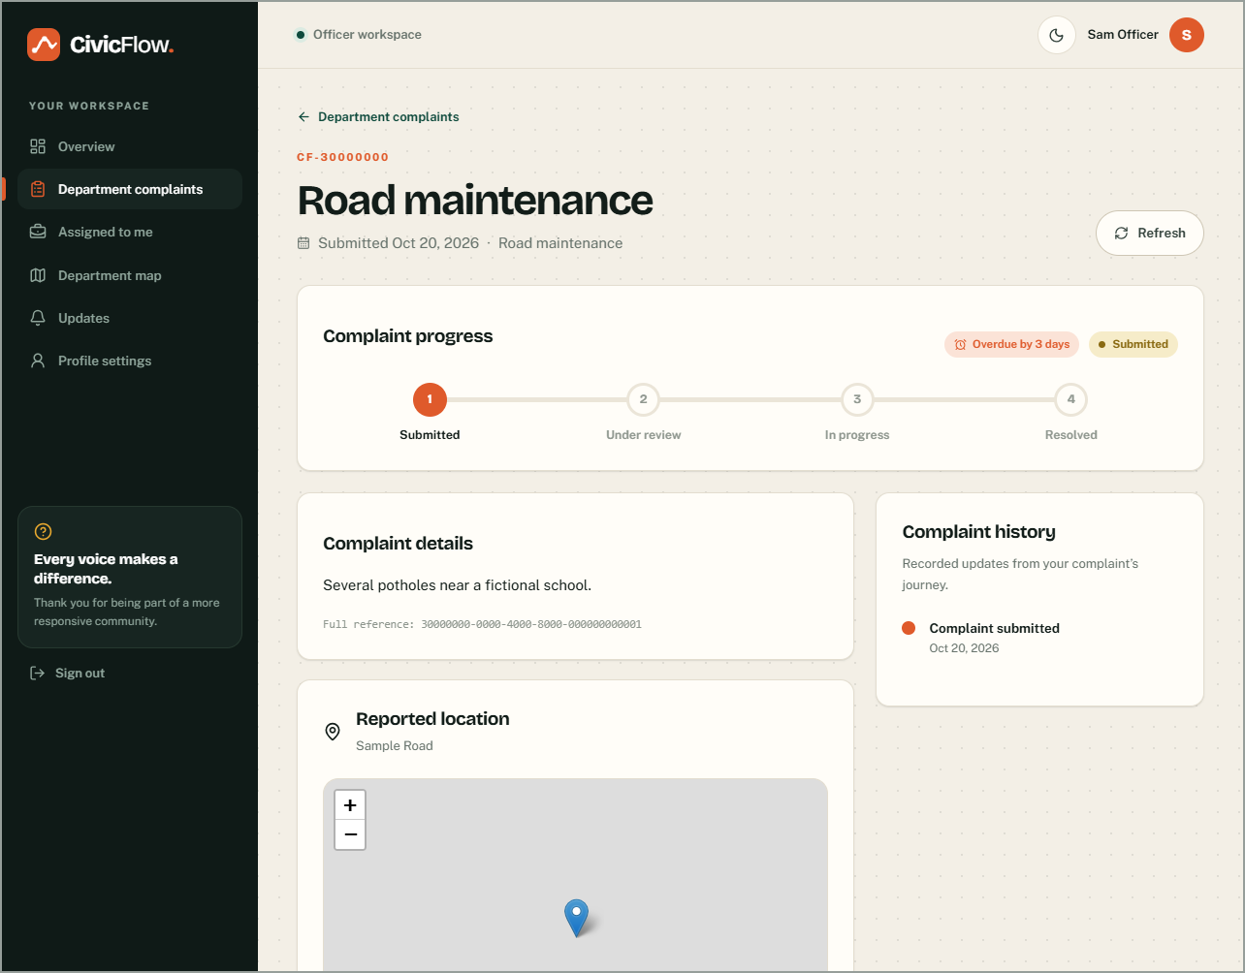
Figure 9.7: Officer – processing a complaint: only valid next actions are offered
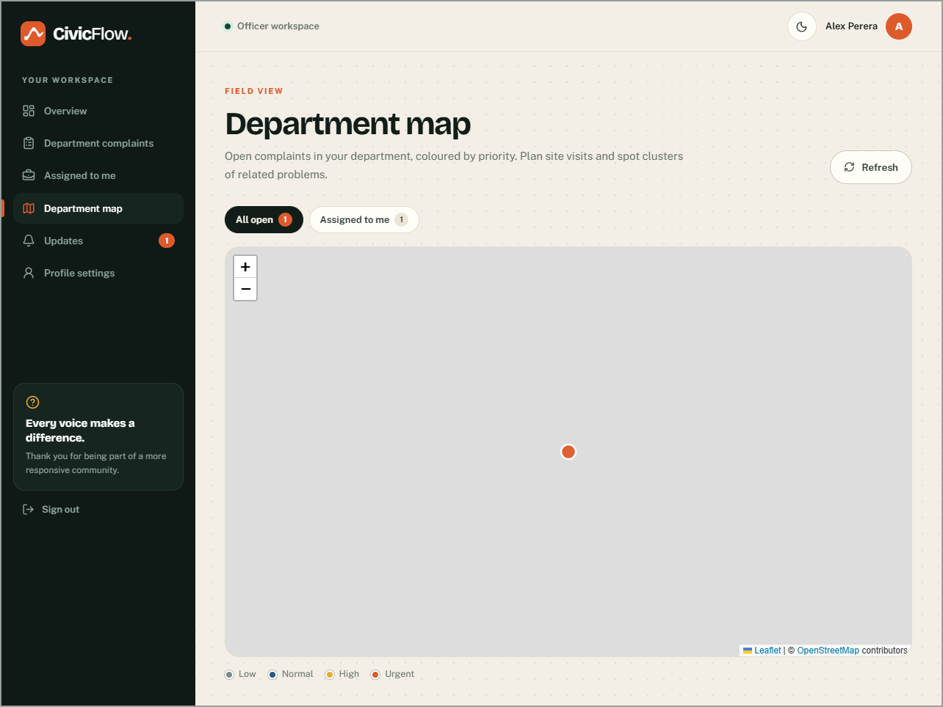
Figure 9.8: Officer – department map of open complaints
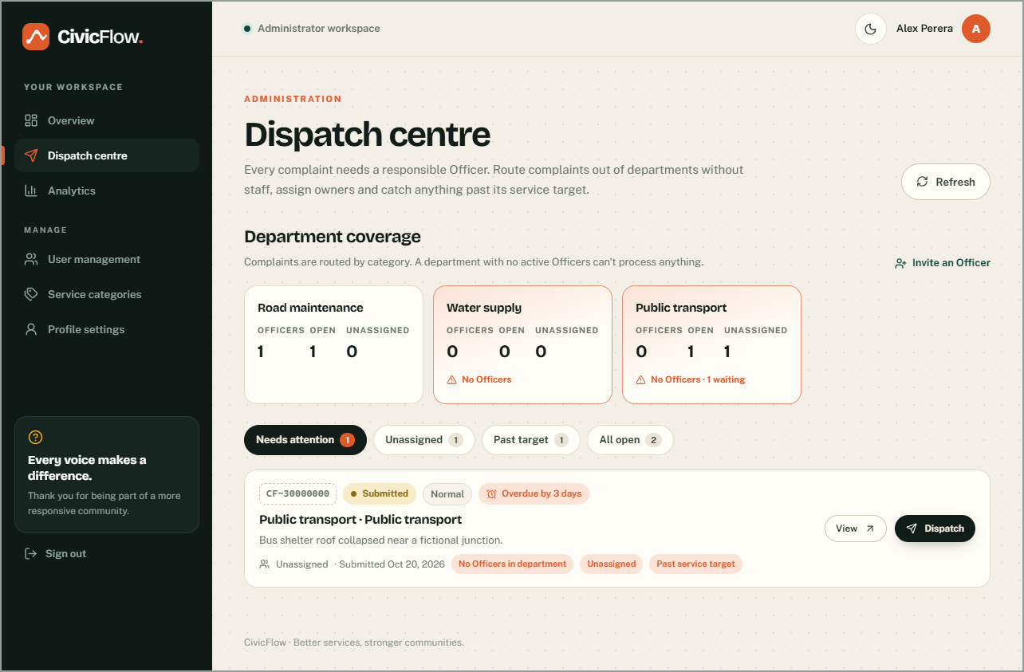
Figure 9.9: Administrator – dispatch centre showing department coverage and complaints that need attention
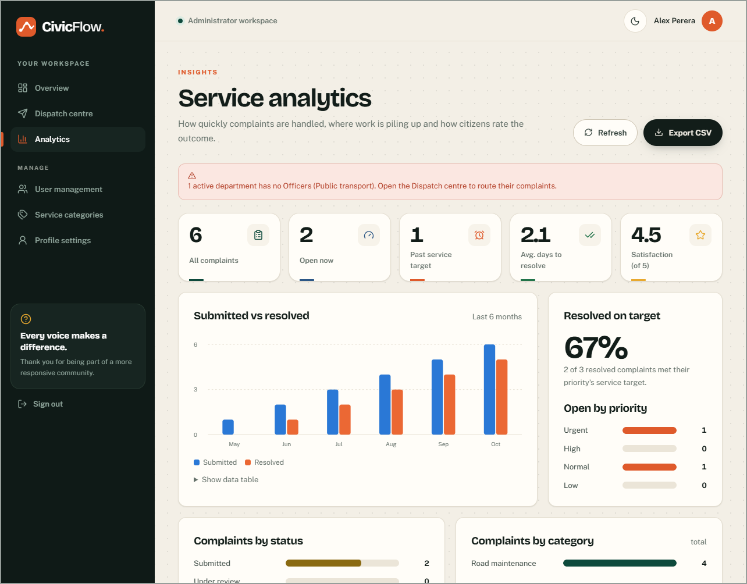
Figure 9.10: Administrator – service analytics: targets, coverage, workload, satisfaction and six-month trend with CSV export
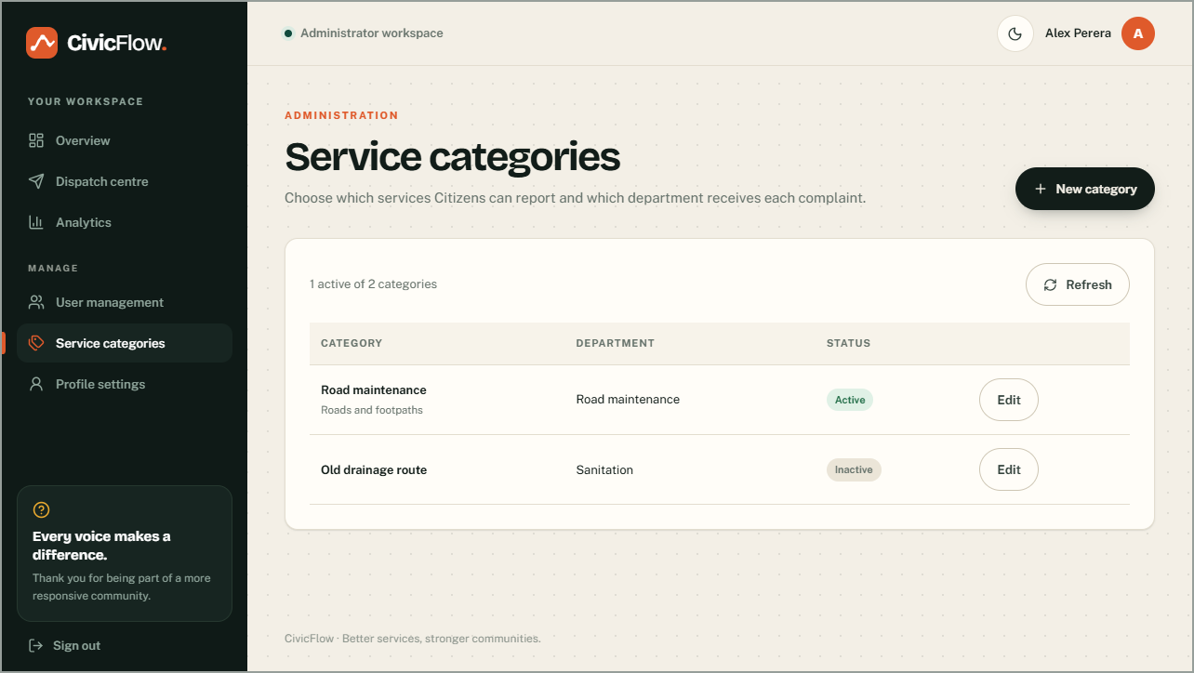
Figure 9.11: Administrator – service category management
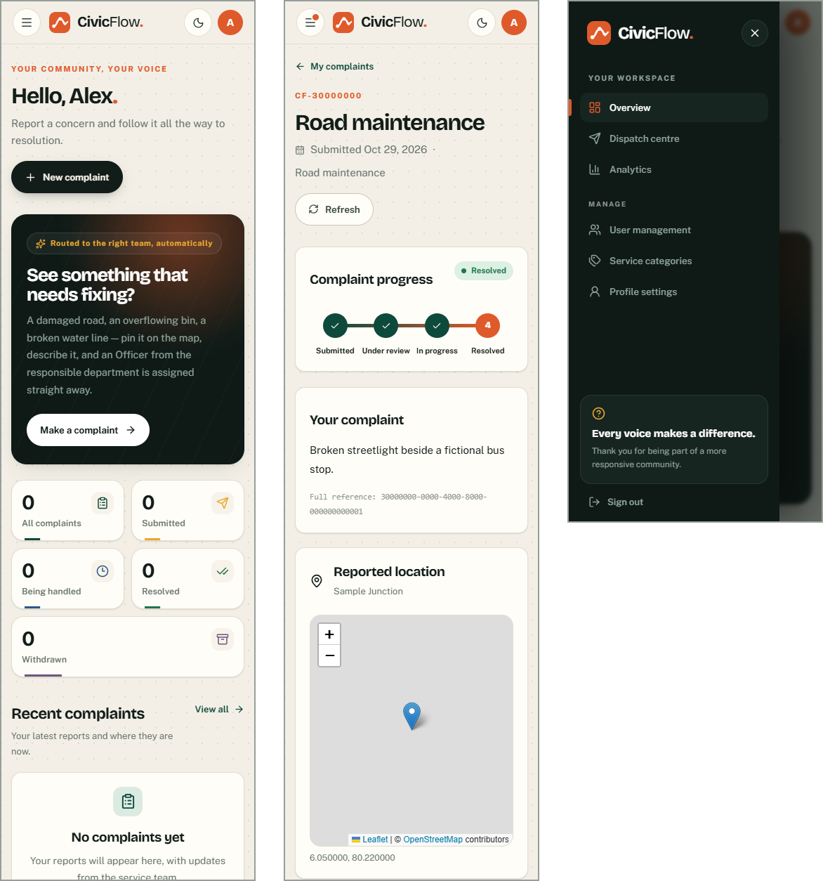
Figure 9.12: Responsive design – Citizen overview, feedback form and slide-out menu on a 360 px phone
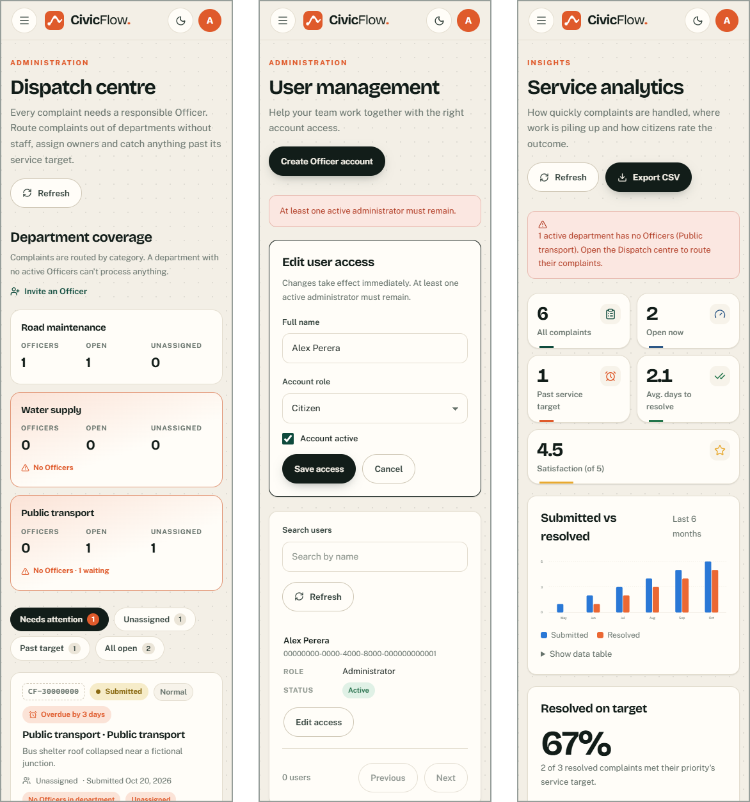
Figure 9.13: Responsive design – dispatch centre, user management and analytics on a 360 px phone

9.4 Input validation
Every input is validated twice: in the browser with Zod schemas for immediate feedback, and authoritatively in the database with CHECK constraints and function checks. Tests assert that both layers use the same limits.
Table 9.3: Input validation in two layers
Field | Client rule (Zod) | Database rule
Complaint description | trimmed, 10–5,000 | CHECK + RPC check
Location text | trimmed, 1–300 | CHECK + RPC check
Coordinates | finite, lat −90…90, lon −180…180 | CHECK + RPC check
Withdrawal reason | trimmed, 10–2,000, confirmation | RPC check + table constraint
Progress remark / resolution | 1–2,000 / 10–5,000 | RPC checks + CHECK
Evidence | JPEG/PNG/PDF magic bytes, ≤ 5 MiB, ≤ 5 files | Declared type/size CHECK, bucket MIME/size limits, quota under lock, stored metadata verified at finalize
Feedback | integer 1–5, comment ≤ 2,000 | RPC check + CHECK
Category | name 1–100, description ≤ 500, department required | RPC check + CHECK + unique name
Password | ≥ 12 characters at registration | Supabase Auth minimum length 12

9.5 Error handling
- Database functions raise stable error codes (for example not_authorized, invalid_input, stale_version, feedback_exists). Feature-specific translators turn them into plain-language messages; unknown errors show a generic message and never expose server details.
- A stale write (HTTP 409) keeps the user's input and asks them to refresh; it is never retried automatically.
- Lost responses on create and withdraw are safe to retry because of idempotency keys.
- Partial failures are reported honestly, for example "Your complaint is saved, but the file has not uploaded" with a Retry button.
- If a database migration is missing, an explanatory notice is shown instead of a crash, while authorisation errors still fail closed.

9.6 Coding standards and version control
- Strict TypeScript with no any; database types generated from the migrations and checked for drift in CI.
- ESLint with zero warnings; snake_case in SQL, camelCase/PascalCase in TypeScript; feature folders named after the domain.
- SQL functions are SECURITY DEFINER with an empty search_path, fully qualified names, explicit EXECUTE grants and stable error codes.
- No string-built HTML: all user text is rendered as text by React.
- Git history on GitHub (https://github.com/razim2003/civic-flow) with feature branches per increment (for example sprint-4/feedback-inbox-categories, sprint-5/dispatch-and-experience, ui/responsive-layout) merged to main only when CI is green. Applied migrations are never edited; fixes are new migrations.
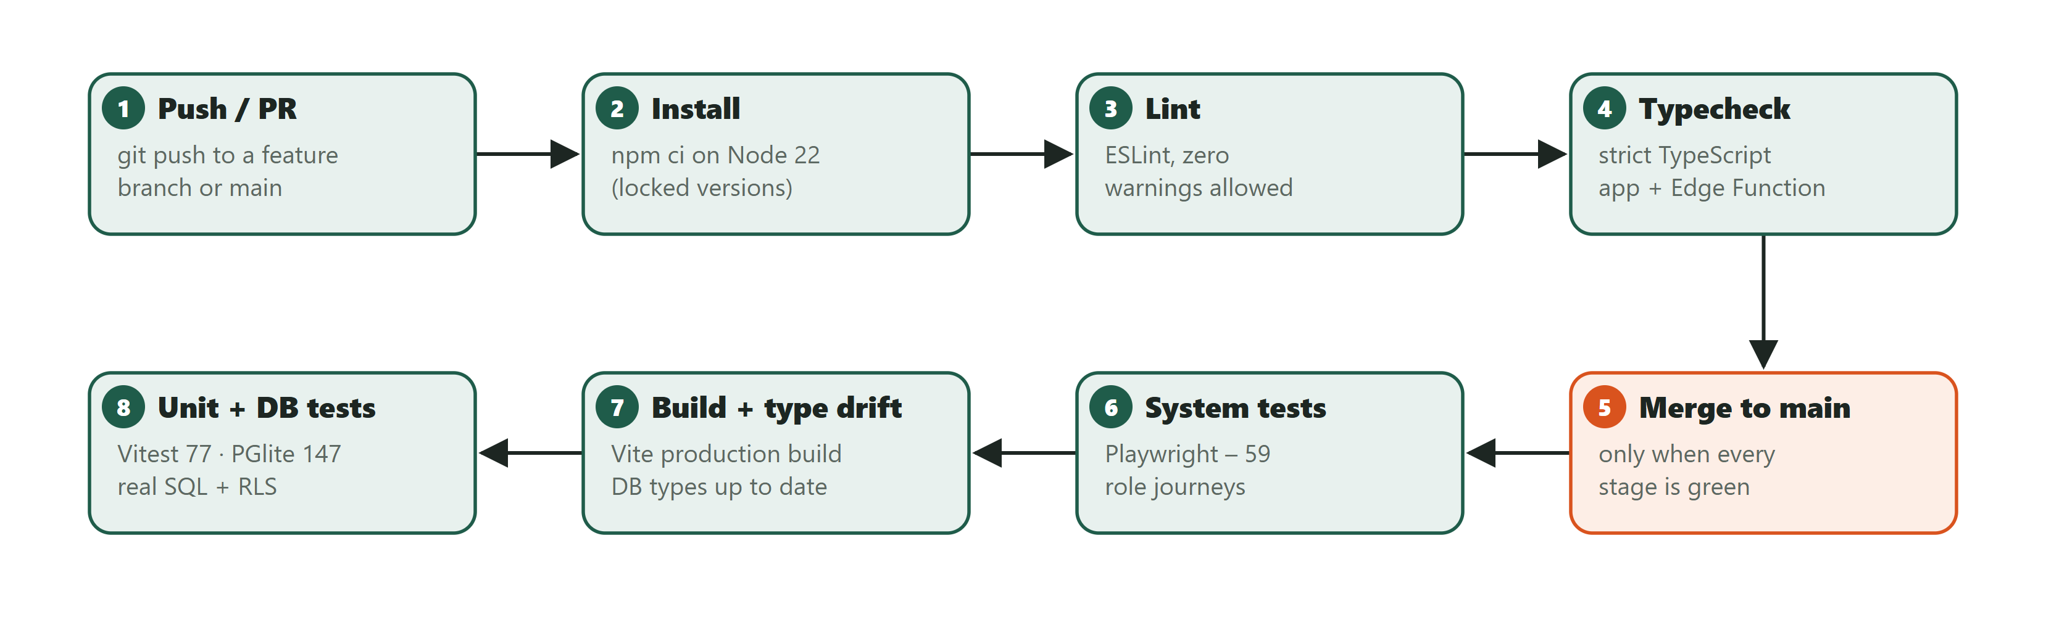
Figure 9.14: Continuous-integration pipeline that every commit must pass

10 Testing and Quality Assurance

10.1 Test plan
Objective: show that every requirement behaves as specified, that unauthorised users are refused by the backend (not just hidden in the UI), and that defects are corrected and re-tested. The approach is risk-based: the highest risks (privacy leakage between citizens and departments, workflow bypass, lost updates and invalid data) are tested at the database level with real SQL run as non-privileged roles, and again through the user interface.
Table 10.1: Test levels
Level | What is tested | Tool | Environment
Unit | Pure validation rules, error translation, service-level targets, analytics maths, session handling, Edge Function handler | Vitest | Node / jsdom
Integration (database) | All 15 migrations, grants, RLS, RPCs, constraints, rollbacks and concurrency, run as anon / authenticated users with fixture identities | Vitest + PGlite (PostgreSQL 17 in-process) | Fresh disposable database per test file
Integration (HTTP) | Real Supabase Auth JWTs + PostgREST + PostgreSQL in containers; concurrent race conditions | Node script + Docker | Disposable local containers
System | Complete role journeys through the real UI in a browser, with every backend response controlled | Playwright (Microsoft Edge / Chromium) | Local dev server
Acceptance | Acceptance criteria of the major user stories, checked by mapped system tests, plus a smoke test on the deployed system | Playwright + manual checklist | Local and deployed URL

Entry criteria: the code compiles and lint passes. Exit criteria: all automated suites pass, no open defect of high severity, and every Must requirement is traced to at least one passing positive and one negative test. Test data is always fictional (for example "Alex Perera", "Sample Road", @example.test addresses).

10.2 Execution results
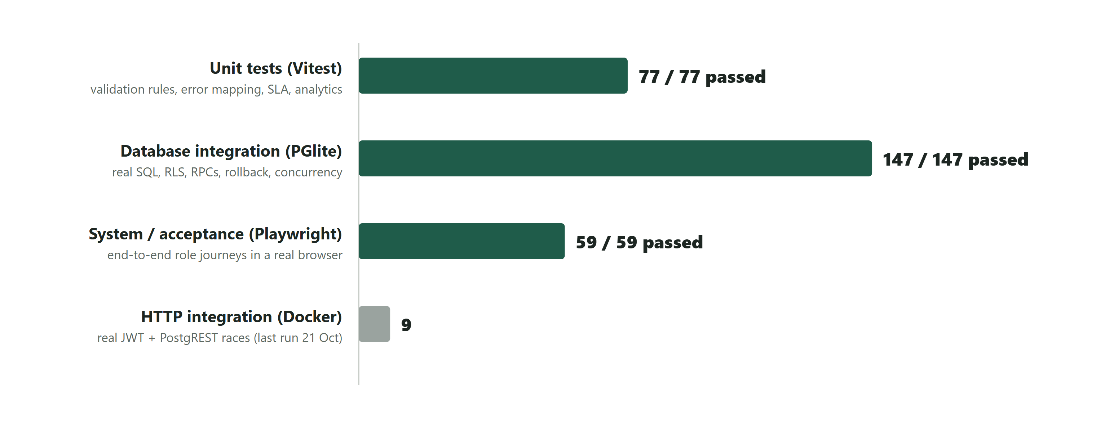
Figure 10.1: Automated test results by level (latest run, 30 October 2026)
Table 10.2: Execution summary
Suite | Files | Tests | Passed | Failed
Lint / typecheck / production build | — | — | ✔ | —
Unit (Vitest) | 13 | 77 | 77 | 0
Database integration (PGlite, 15 migrations + demo data) | 9 | 147 | 147 | 0
System (Playwright, Edge) | 5 | 59 | 59 | 0
HTTP integration (Docker) | 1 | 9 | 9 (21 Oct) | 0
Total executed in the latest run | 27 | 283 | 283 | 0

The documented test cases contain 139 entries, of which 57 include positive checks and 89 include negative (abuse or invalid-input) checks. A responsive-layout audit additionally re-rendered 24 key screens at 360, 414, 768 and 1280 px and checked automatically for sideways scrolling and overflowing content; after the fixes in Sprint 5 no issue remained.

10.3 Representative test cases
The table below shows a representative selection across all levels. The complete list of test cases, with preconditions, expected and actual results, is in Appendix B.
Table 10.3: Representative test cases
ID | Req | ± | Preconditions / input | Expected result | Actual | Status
TC-AUTH-02 | CF-01 | +/− | Submit an empty form, then valid data | Field errors first; signup request carries only display_name (no role); "Check your email" shown | As expected | Pass
TC-AUTH-04 | CF-03 | − | Citizen types /admin/users | "Administrator access required"; no admin data requested | As expected | Pass
TC-DB-FND-02 | CF-03, NFR-05 | + | Inspect catalog | RLS enabled on every application table | As expected | Pass
TC-SUB-01 | CF-04, 06, 16, 18 | + | Citizen submits a valid complaint; first upload fails, retry; download; open detail | Reference shown; request has no citizen_id/status; upload retry reuses the same key; private download; history shows "Supporting evidence added" | As expected | Pass
TC-SUB-02 | CF-04 | − | Blank coordinates; map tiles unavailable | Validation error; map click selects; numeric entry still works | As expected | Pass
TC-TRK-03 | CF-07, NFR-11 | − | Open another citizen's reference; description containing HTML | "Complaint unavailable"; HTML shown as text | As expected | Pass
TC-DB-EV-03 | CF-16 | − | Declared size 0 / > 5 MiB; MIME text/html | Rejected | As expected | Pass
TC-OFF-01 | CF-09–12 | + | Officer reviews, assigns, prioritises, starts, adds progress, resolves with confirmation | Each step "Complaint updated"; expected versions 1→6 sent; complaint closed with resolution text | As expected | Pass
TC-OFF-03 | NFR-06 | − | Another user changed the complaint (409) | Remark kept; "Refresh and review"; retry after refresh uses the new version | As expected | Pass
TC-DB-OFF-05 | CF-11, NFR-06 | − | Skip/repeat transitions; stale version; no-ops | invalid_transition; PT409 stale_version; no-op adds no event | As expected | Pass
TC-DB-OFF-08 | NFR-06 | − | Notification insert forced to fail during review | Status/version and history unchanged | As expected | Pass
TC-FB-02 | CF-19 | − | Server answers feedback_exists | "Feedback was already submitted…"; form stays; no false success | As expected | Pass
TC-NTF-01 | CF-13 | + | Two unread, one read update; mark one; filter unread; mark all | Badge "2 unread" → "1 unread" → none; HTML remark shown as text; exact RPC payloads | As expected | Pass
TC-CAT-02 | CF-20 | − | Server answers category_in_use | Explanation shown; input kept | As expected | Pass
TC-DSP-01 | CF-24 | +/− | Admin opens the Dispatch centre with a complaint in an unstaffed department; dispatches with no reason, then with a reason | Coverage card shows "No Officers"; row flagged unstaffed, unassigned and past target; reason error with no request; then exactly one RPC with version 1 and a success message | As expected | Pass
TC-UX-03 | NFR-03, NFR-04 | + | 1280 px, then 768 px and 360 px. Open the menu, press Escape, then open each admin page from the menu | Desktop shows the sidebar with no menu button. Tablet/phone hide the sidebar links behind Open menu (aria-expanded). Focus moves to Close menu and returns to the button on Escape. Choosing a page closes the menu. No page is wider than the screen | As expected | Pass
TC-DB-DSP-07 | CF-24 | − | Short reason, mismatched route, foreign/citizen assignee, stale/null version, withdrawn | reason_required, category_unavailable, invalid_assignee, PT409, invalid_input, complaint_closed | As expected | Pass

10.4 Acceptance testing
Table 10.4: Acceptance test summary
Story | Acceptance criteria | Result
US-04/05/06 Submit complaint | AC1–AC4 | Pass (TC-SUB-01…03, TC-DB-SUB-01…04)
US-07 Track complaint | AC1–AC3 | Pass
US-11 Update status | AC1–AC4 | Pass
US-12 Resolve | AC1–AC4 | Pass
US-13 Updates inbox | AC1–AC3 | Pass
US-14 Manage users | AC1–AC4 | Pass
US-18 Feedback | AC1–AC3 | Pass
US-19 Categories | AC1–AC4 | Pass
US-20 Withdrawal | AC1–AC2 | Pass
Manual UAT on the deployed system | Smoke checklist (Section 11.6) | S1–S3 passed on the live URL (30 Oct 2026); signed-in checks S4–S12 are run by the team before the demonstration

10.5 Defects identified and corrected
19 defects were recorded during the project. Each was analysed for its root cause, corrected and re-tested. The most important were DEF-01 (an endless retry loop under concurrent edits, found by the HTTP integration test), DEF-13 (complaints in departments with no Officers could never be handled, found during hosted use and corrected by change request CR-006), and DEF-16–19 (layout defects such as feedback options overflowing their boxes and tablets being squeezed by the sidebar, found by the responsive audit).
Table 10.5: Defect log
ID | Found | How found | Severity | Description | Root cause | Correction | Re-test
DEF-01 | Sprint 3 (2026-10-21) | HTTP integration test (concurrent review) | High | A stale-version conflict kept the request in an endless retry loop | PostgREST 14 automatically retries SQLSTATE 40001 | Raise PT409 (HTTP 409). A new corrective migration 20261021000100 replaced the withdrawal function; Officer helpers use PT409 | TC-INT-03/04, TC-DB-OFF-05 pass
DEF-02 | Sprint 2 (2026-10-19) | Hosted preflight / manual demo | High | Citizen category dropdown was empty | Category migration 006 not yet applied to the hosted DB | Applied the reviewed migration; added an explicit "missing setup" state instead of a silent empty list | TC-SUB-05 pass
DEF-03 | Sprint 2 | Playwright | Medium | Duplicate React sibling key warning in the history list | Two events rendered with the same key | Keys use stable event IDs | Browser suite pass
DEF-04 | Sprint 2 | Playwright | Medium | Race between refreshing a complaint and submitting a withdrawal could use an old version | Refresh and submit not serialised | Controls disabled while refreshing; in-flight guard | TC-WD-02 pass
DEF-05 | Sprint 1/3 | Operator review | Medium | supabase config push reset hosted Auth settings (TOTP, OTP length, email frequency) to defaults | CLI pushes the whole local config | Values restored immediately; local config.toml now records them | Verified by later push (no drift)
DEF-06 | Sprint 3 | Playwright | Low (test) | Officer return-navigation test clicked before the detail page loaded | Test timing | Test waits for the detail return link | TC-OFF-09 pass
DEF-07 | Sprint 3 | Playwright (cold start) | Low (test) | First redirect assertion exceeded 5 s on a cold Vite start | Test timeout too short for first compile | Wait for login readiness (15 s bound) | TC-AUTH-01 pass
DEF-08 | Sprint 3 | Unit run on Windows | Low (tooling) | Unit worker start-up timeouts | Too many jsdom workers | Pure tests run in Node; worker count bounded | Unit suite pass
DEF-09 | Sprint 4 (2026-10-29) | Production build warning | Medium | The app shell imported the notifications module both statically and lazily, pulling complaint pages into the first download | The unread-badge hook was in the same module as the inbox page | Separate lightweight notifications/badge entry and zod-free unread API | Build with no warnings; TC-NTF-01 pass
DEF-10 | Sprint 4 | Database regression suite | n/a (expected) | foundation.test.ts failed: feedback and notifications became readable | The guard intentionally asserted "closed until policies ship" | Guard updated to check authorised reads with writes still denied | 119/119 pass
DEF-11 | Sprint 4 | Local set-up | Low (environment) | vitest could not start: missing Rolldown native binding | Dependencies installed with Node 20 (project requires ≥ 22.18) | Reinstalled with Node 22; requirement documented | All suites pass
DEF-12 | Sprint 4 | Screenshot review | Low (test) | Inbox fixture showed "Date unavailable" | Malformed fixture timestamp T010:00 | Fixture fixed. The app's graceful fallback for bad dates is correct behaviour. | TC-NTF-01 pass
DEF-13 | Sprint 5 (2026-10-30) | Hosted use / read-only data check | High | 4 of 5 open complaints sat in departments with no Officers and could never be handled; the Administrator could not act | Routing assumed every department is staffed; no assignment at submission; Administrator was read-only | CR-006: auto-assignment, Administrator dispatch, coverage flags (migration 015) | TC-DB-DSP-01…10, TC-DSP-01 pass
DEF-14 | Sprint 5 | Screenshot review | Medium | Analytics bars below the fold stayed empty until scrolled into view, so printouts and screenshots under-reported data | Bars animated on scroll-into-view | Bars animate on mount; scroll reveals kept only for decorative sections | TC-DSP-02 pass; screenshots re-reviewed
DEF-15 | Sprint 5 | Screenshot review | Low | Sign-in route illustration clipped its end labels; ticket notches misaligned with the perforation | Coordinates too close to the viewBox edge; notch tied to card bottom | Route moved inward; notches anchored to the perforated line | Visual re-check
DEF-16 | Sprint 5 (2026-10-30) | User report + layout audit | Medium | Feedback rating options spilled out of their boxes at every width above 414 px | Rating cards had a 150 px minimum, narrower than the radio, five stars and label combined | One aligned option per row (radio, label, stars); stars drop below the label on very small phones | TC-FB-01, TC-UX-04
DEF-17 | Sprint 5 | Layout audit | Medium | On tablets the full sidebar stayed open, squeezing pages into ~500 px: two thin detail columns, stat cards cut off, long words breaking | The sidebar only collapsed below 760 px, and then into wrapped link chips | Below 1100 px the sidebar is an accessible slide-out menu opened from a sticky header. Detail pages use one column below 1180 px, and stat cards auto-fit | TC-UX-03, TC-UX-04
DEF-18 | Sprint 5 | Layout audit | Medium | User management and Service categories scrolled sideways on phones (up to 134 px) | Wide no-wrap tables | Admin tables become stacked, labelled rows on phones | TC-UX-03, TC-UX-04
DEF-19 | Sprint 5 | Layout audit | Low | Ticket notches extended outside the card; heading links ("Invite an Officer") were squeezed into a thin column on phones | Notches drawn as full circles and clipped; heading rows could not wrap | Half-circle notches drawn inside the card; heading rows wrap and their links do not | TC-UX-04

10.6 Limitations of the test evidence
- Browser tests control the backend responses: they prove UI behaviour and the exact requests sent. Authorisation is proven separately by the database suite with real SQL as anonymous and authenticated users.
- PGlite uses fixture Auth and Storage schemas; the Storage HTTP service (actual file bytes) was not integration-tested.
- The Docker HTTP suite last ran on 21 October 2026, before the Sprint 4–5 SQL; the same locking pattern is covered by the database suite.
- No testing with real citizens or Officers; usability was assessed by the team.

11 Deployment
CivicFlow is deployed and publicly reachable at https://civic-flow-rho.vercel.app. The frontend is a static build on Vercel's global CDN; the backend is the Supabase project xapqfnumcpjckhpdyuxz (PostgreSQL 17, Auth, Storage and one Edge Function).
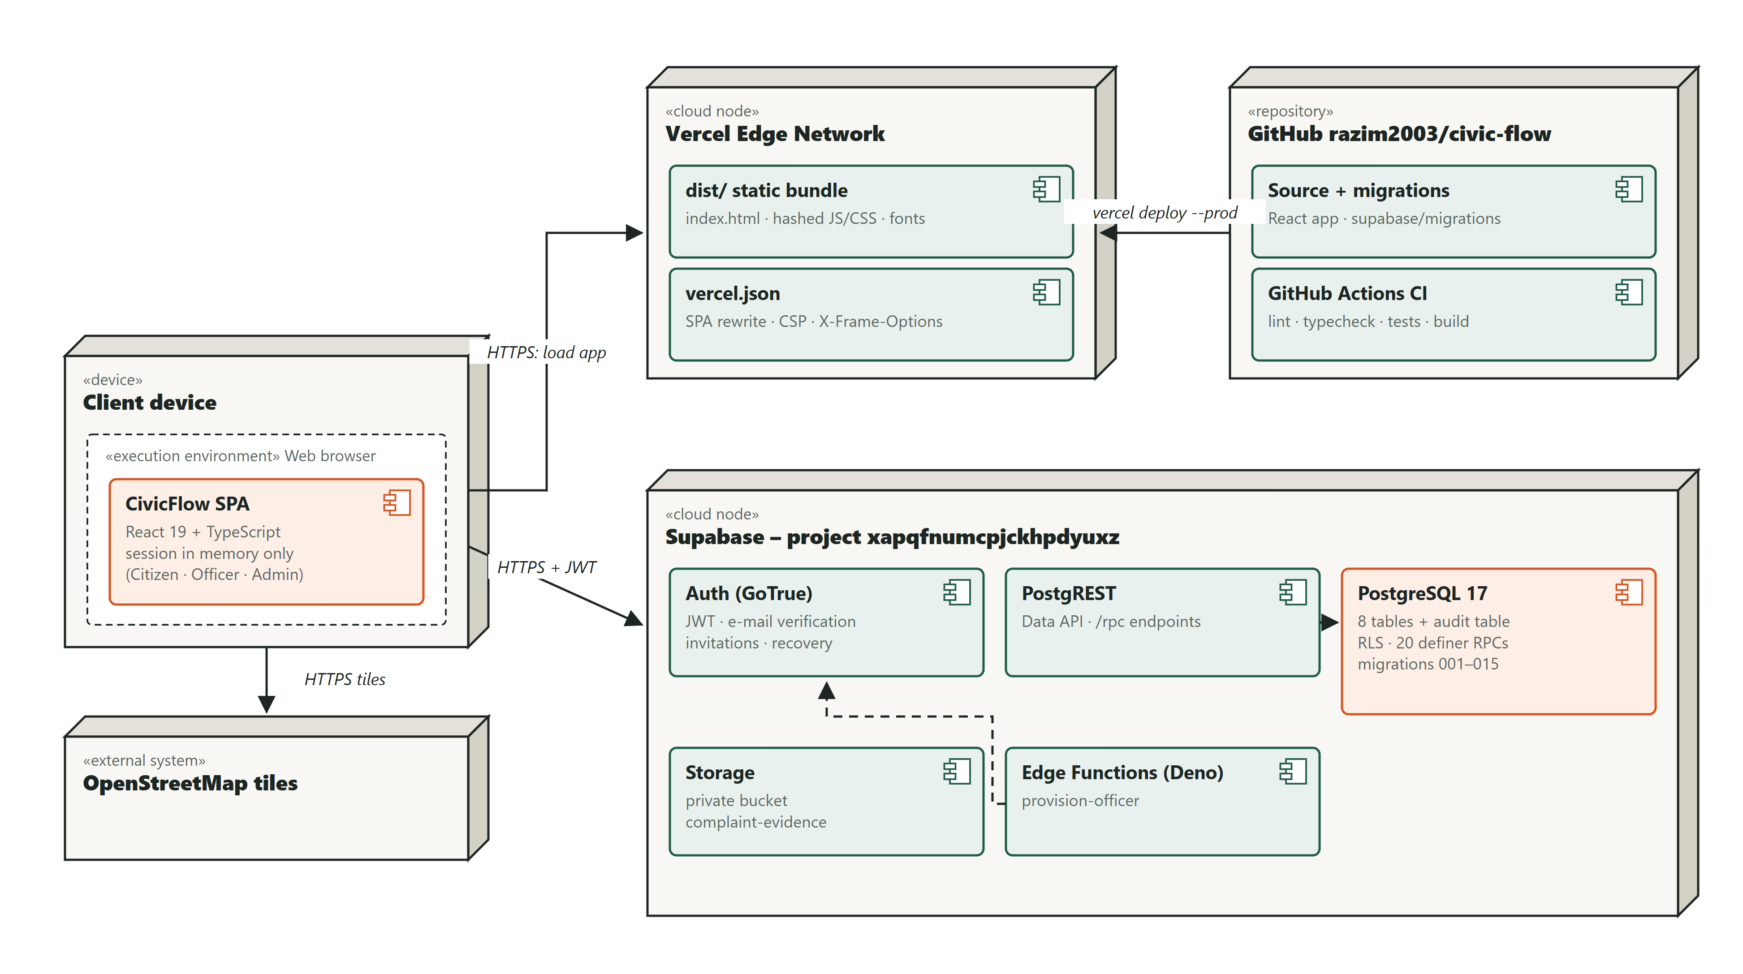
Figure 11.1: UML deployment diagram of the production system

11.1 Deployed architecture and database configuration
- Frontend: a static, hashed bundle served by Vercel. No server code runs on Vercel and no secret is present in the browser. vercel.json adds SPA deep-link rewrites and security headers (Content-Security-Policy, X-Frame-Options DENY, nosniff, Referrer-Policy).
- Backend: Supabase. The database schema is created only by the 15 version-controlled migrations; every hosted migration was applied after an explicit review of target, SQL, expected effects, validation and recovery, with data checksums taken before and after.
- Only two public values configure the browser: VITE_SUPABASE_URL and VITE_SUPABASE_PUBLISHABLE_KEY. Security comes from Row Level Security, not from hiding these values.
- The Officer-invitation Edge Function holds the only privileged key, server-side, and uses the CIVICFLOW_APP_URL secret so invitation links open the live site.

11.2 System requirements
Table 11.1: System requirements
Component | Requirement
End users | A current Chrome, Edge, Firefox or Safari; JavaScript enabled; internet access. Works on phones (≥ 375 px wide).
Developer machine | Node.js ≥ 22.18 with npm 10; Git; optional Docker Desktop (for test:integration) and the Supabase CLI
Hosting | A Vercel account linked to the GitHub repository; a Supabase project

11.3 Configuration
Table 11.2: Configuration settings
Setting | Where | Value / note
VITE_SUPABASE_URL | .env.local (local) / Vercel Environment Variables | https://xapqfnumcpjckhpdyuxz.supabase.co
VITE_SUPABASE_PUBLISHABLE_KEY | same | The project's publishable key (sb_publishable_…). Never use the secret or service-role key.
Auth → URL configuration | Supabase dashboard | Site URL = the deployed URL. Redirect allow-list: <deployed>/auth/callback, <deployed>/reset-password, <deployed>/accept-invite, plus the local 127.0.0.1:5173 equivalents.
Auth → providers | Supabase dashboard | Email with confirmation on; minimum password length 12; anonymous sign-ins off
CIVICFLOW_APP_URL | Supabase Edge Function secrets | The deployed origin, so Officer invitation links point to it
SMTP | Supabase Auth | Custom SMTP is required to invite Officers at arbitrary email addresses. The default sender only delivers to project-team addresses.
Security headers | vercel.json (already in the repo) | CSP, X-Frame-Options: DENY, nosniff, Referrer-Policy

11.4 Installation and deployment steps
- Local installation: git clone the repository, run npm ci (Node.js 22.18 or later), copy .env.example to .env.local and set the two public values, then npm run dev and open http://127.0.0.1:5173.
- Verification: npm run lint, npm run typecheck, npm run test, npm run test:db, npm run build and npx playwright test.
- Database: review each new migration, take a read-only baseline, apply it to the Supabase project only after approval, then verify grants, RLS, anonymous refusal and unchanged checksums.
- Frontend: create the Vercel project, add the two public environment variables for Production and Preview, and run vercel deploy --prod (or connect the GitHub repository for automatic deployments).
- Post-deployment: set the Supabase Auth Site URL and redirect URLs (/auth/callback, /reset-password, /accept-invite) and the CIVICFLOW_APP_URL secret to the production URL, then run the smoke test.

11.5 Deployment verification (smoke test)
Table 11.3: Smoke-test and acceptance checklist on the deployed URL
# | Check | Expected | Result
S1 | Open / and /workspace signed out | Redirect to sign-in | Pass 2026-10-30: / shows the landing page; /workspace redirects to /login
S2 | Deep link /complaints/new reloads | SPA loads (no 404) and asks to sign in | Pass 2026-10-30: HTTP 200, then redirected to sign-in; no console errors
S3 | Response headers | CSP, X-Frame-Options: DENY, nosniff present | Pass 2026-10-30: CSP, X-Frame-Options: DENY, nosniff and Referrer-Policy present
S4 | Register a demo Citizen; confirm email; sign in | Citizen workspace | Run by the team with the fictional demo accounts before the demonstration
S5 | Submit a complaint with a map location and a small PNG | Reference shown; file downloadable | Run by the team with the fictional demo accounts before the demonstration
S6 | Officer (demo) reviews, assigns, starts, adds progress, resolves | Each step in history | Run by the team with the fictional demo accounts before the demonstration
S7 | Citizen sees the Updates badge, opens the inbox, marks it read | Badge clears | Run by the team with the fictional demo accounts before the demonstration
S8 | Citizen gives feedback (rating 4) | Read-only feedback shown; Officer can see it | Run by the team with the fictional demo accounts before the demonstration
S9 | Admin creates a category; Citizen form shows it | Category appears | Run by the team with the fictional demo accounts before the demonstration
S10 | Admin overview counts | Match the demo data | Run by the team with the fictional demo accounts before the demonstration
S11 | Citizen opens another user's complaint URL | "Complaint unavailable" | Run by the team with the fictional demo accounts before the demonstration
S12 | Page load timing (DevTools, broadband) | NFR-02 targets met | Run by the team with the fictional demo accounts before the demonstration

A fictional Sri Lankan demonstration data set (ten citizens, Officers for unstaffed departments and 36 complaints in towns such as Nugegoda, Kandy, Jaffna, Galle and Trincomalee) was loaded into the hosted database through the real workflow functions, so every screen can be demonstrated with realistic data. The demo accounts cannot sign in, and the data can be removed with a tested script.

12 Maintenance and Change Request
After the first version was working, changes were handled as real maintenance tasks with a fixed process: record the request, analyse its impact, classify and estimate it, obtain approval, implement it on a branch with a new migration, run the full regression suite, update all affected artefacts and roll it out to the hosted system only after explicit approval.
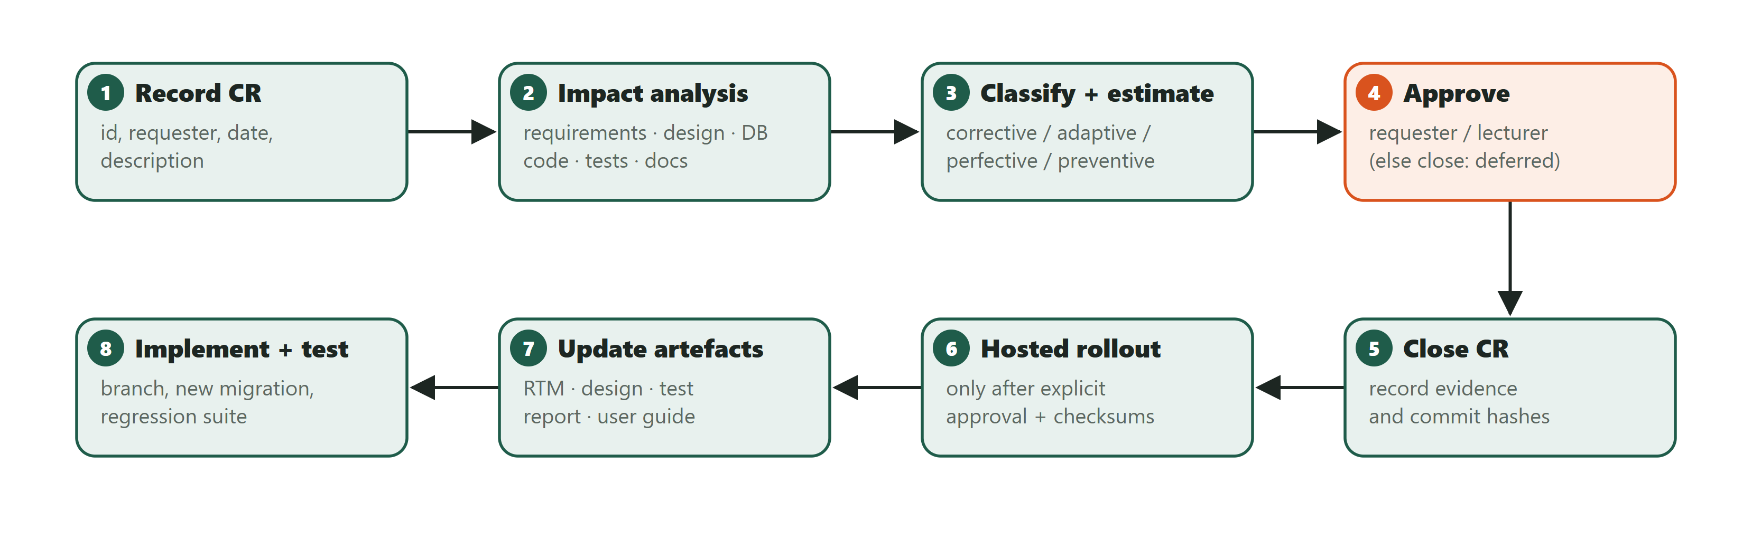
Figure 12.1: Maintenance process used for every change request

12.1 Change request register
Table 12.1: Change request register
CR | Title | Requested by / date | Type | Status
CR-001 | Citizen can withdraw an unresolved complaint (CF-22) | Project owner, 2026-10-19 | Perfective | Implemented, deployed to DB, tested
CR-002 | Stale-version conflicts must not loop (PT409) | Found by testing, 2026-10-21 | Corrective | Implemented, applied, tested
CR-003 | Administrator-created Officer accounts (CF-14) | Project owner, 2026-10-20 | Perfective (+ preventive security) | Implemented, applied, tested
CR-004 | "Use my current location" and closer default map (CF-04) | Project owner, 2026-10-21 | Perfective (usability) | Implemented, tested
CR-005 | Lecturer-provided change request | Lecturer, date | to classify | Awaiting request
CR-006 | Every complaint must reach a responsible Officer (auto-assignment, dispatch, service targets) and product completion/redesign | Project owner after hosted testing, 2026-10-30 | Corrective (coverage defect) + perfective | Implemented, applied to the hosted database, tested and deployed

12.2 Main change request: CR-006 – every complaint must reach a responsible Officer
Table 12.2: CR-006 change request
Field | Entry
Requested by / date | Project owner after hosted testing, 30 October 2026
Description of the change | Complaints were routed to a department by category and only that department's Officers could act. Departments without Officers silently collected complaints: the hosted data showed 4 of 5 open complaints stuck this way, and the Administrator could see them but had no permission to act. Every complaint must reach a responsible Officer.
Classification | Corrective for the coverage defect (the system failed its own objective O3, "enable officers to manage … complaints"); perfective for the service targets, analytics and dispatch tools added with it
Affected requirements | CF-09, CF-13, CF-21; new CF-23 (automatic assignment), CF-24 (Administrator dispatch), CF-25 (service-level targets); NFR-03
Affected stories and use cases | New US-22, US-23, US-24; new UC-15 Dispatch complaint and UC-16 Auto-assign Officer; UC-03 changed

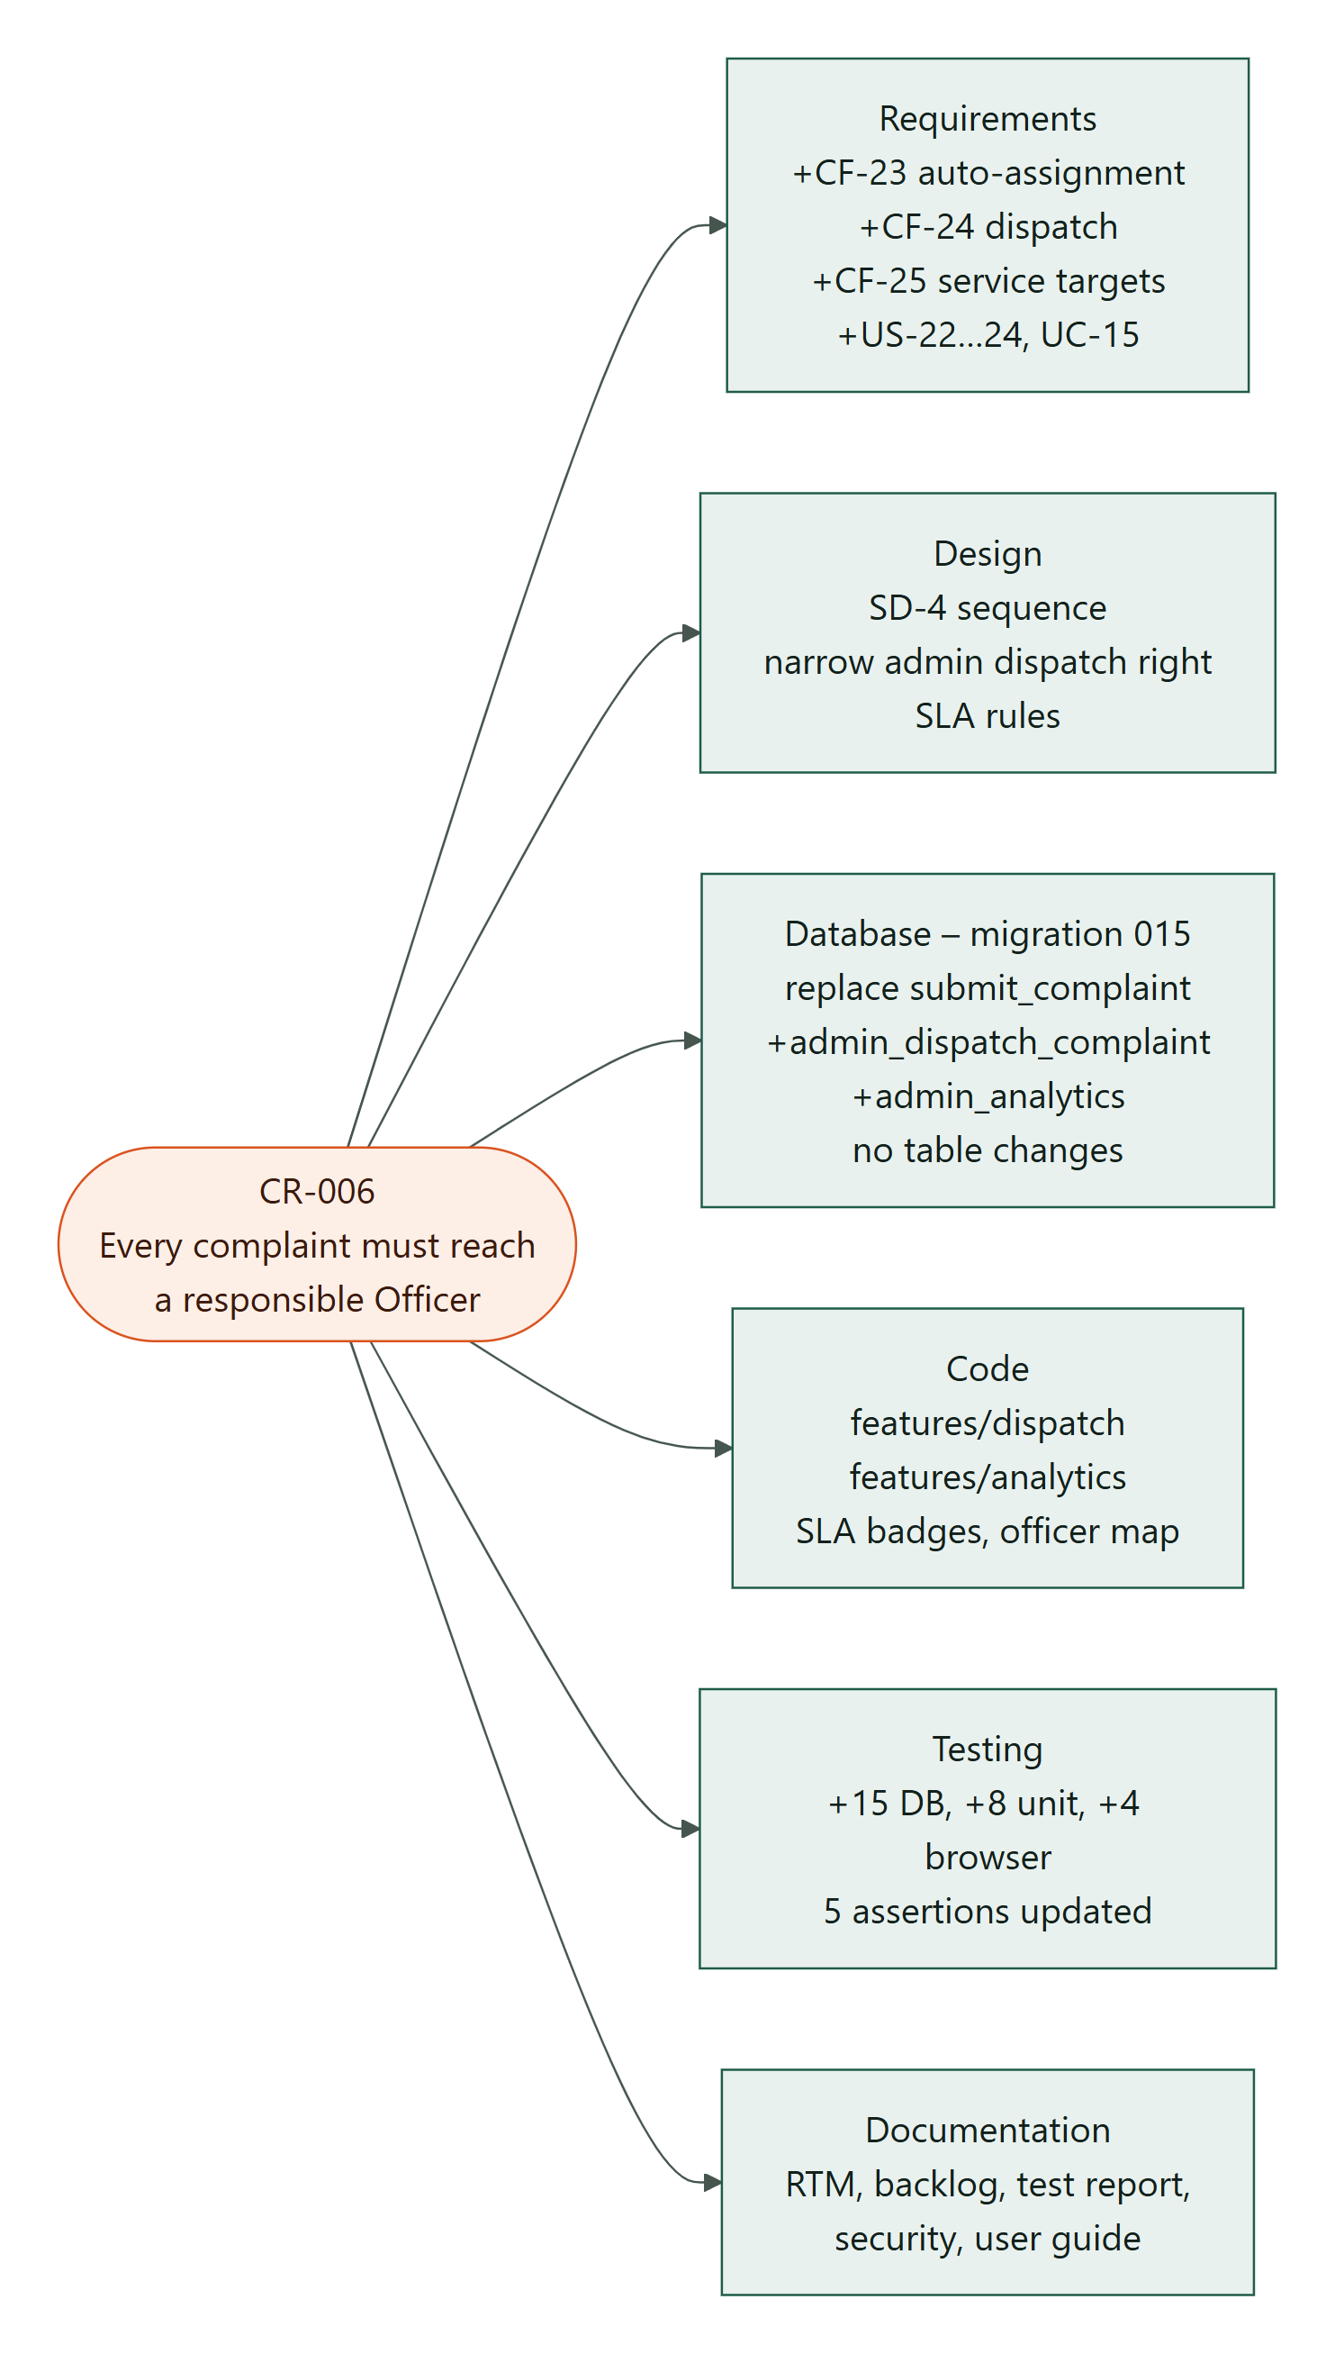
Figure 12.2: CR-006 impact across SDLC artefacts
Table 12.3: CR-006 impact analysis and estimate
Area | Affected items | Change made | Effort (pts)
Requirements | Backlog, FR list, user stories, use cases, RTM | 3 new functional requirements, 3 user stories, UC-15/16; RTM rows added | 2
Design | Architecture, sequence diagrams, UI | SD-3 sequence; Administrator gets a narrow, audited dispatch right (no processing rights); SLA rules; dispatch centre and analytics screens | 3
Database | submit_complaint, record_officer_event | Migration 015 (new, never editing applied ones): workload-balanced assignment, admin_dispatch_complaint, admin_analytics, community_impact; no table changes and no data changed at install | 6
Code | complaints, officer, admin | New dispatch and analytics features, SLA badges, Officer map | 6
Testing | Database, unit, browser suites | +15 database, +8 unit, +4 browser tests; 5 assertions updated because the assigned Officer is now also notified | 3
Documentation & security | Test report, security, user guide | Threat T11 and requirement SR-12 added; user guide and deployment record updated | 1
Total estimate |  | About one sprint for a pair of developers | 21

12.2.1 Modification plan and verification
- Create branch sprint-5/dispatch-and-experience.
- Write migration 015 and its 15 database tests first (test-first for the security-sensitive SQL).
- Implement the dispatch and analytics features, SLA badges and Officer notifications.
- Run the full regression suite: 77 unit, 138 database and 58 browser tests passed at that point, with CI green.
- Apply migration 015 to the hosted database after explicit approval. All existing data checksums were identical before and after, anonymous calls to the new functions were refused (HTTP 401), and the live analytics confirmed the three unstaffed departments.
- The four stuck complaints were not moved automatically: the Administrator dispatches them with a reason, so each citizen sees why their complaint moved.

12.2.2 Other change requests handled
- CR-001 Citizen withdrawal (perfective): a citizen can withdraw an unresolved complaint with a recorded reason; records, evidence and history are kept.
- CR-002 Non-retrying conflict code (corrective): the stale-version error was changed from SQLSTATE 40001 to PT409 (HTTP 409) after testing showed PostgREST retried 40001 indefinitely.
- CR-003 Administrator-created Officer accounts (perfective and preventive): Officers can no longer self-register; an audited invitation flow was added.
- CR-004 Location usability (perfective): an optional "Use my current location" button and a closer default map view.
- Responsive-layout maintenance (corrective, DEF-16–19): a slide-out menu for tablets and phones, an aligned feedback form and stacked admin tables.
Lecturer change request
The lecturer-provided change request (CR-005) had not been received when this report was prepared. When it arrives it will be handled with the same process and template: description, affected requirements, impact analysis across requirements, design, database, code, tests and documentation, an estimate, classification and the implementation and test evidence.

13 Security
CivicFlow holds personal data (names, e-mail addresses, complaint locations and descriptions, evidence files) and has three privilege levels, so security was designed in from Sprint 1 rather than added at the end.
Table 13.1: Assets and their sensitivity
Asset | Sensitivity
Citizen identity (name, email) and complaint location/description | Personal data: high
Evidence files (photos, PDFs) | Personal data, may show people or homes: high
Workflow integrity (status, assignment, resolution, history) | Accountability: high
Administrator/Officer privileges | Privilege: critical
Service configuration (categories, departments) | Medium

13.1 Threats and risk assessment
11 threats were identified using the STRIDE categories. Likelihood (L) and impact (I) are rated from 1 (low) to 3 (high); risk = L × I. The residual risk is the rating after the implemented controls.
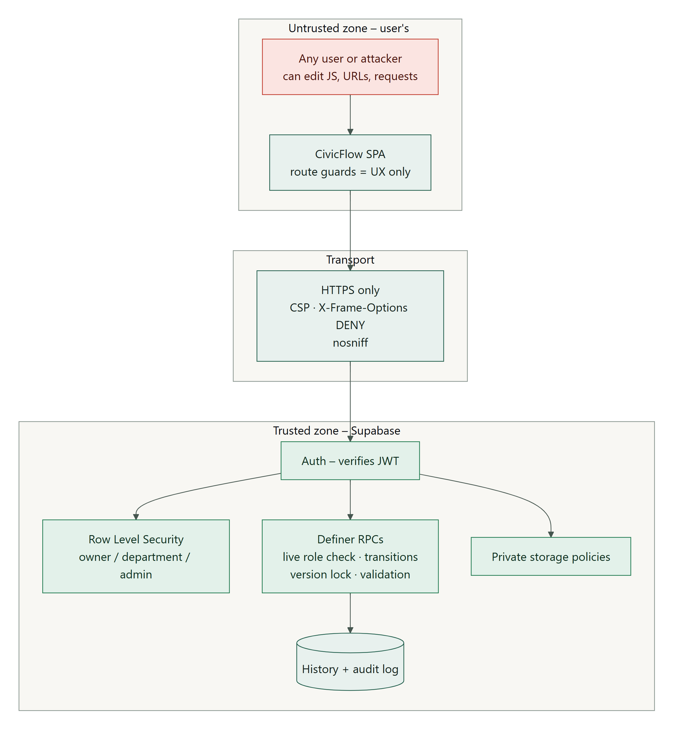
Figure 13.1: Trust boundary: every decision is made on the server side

Table 13.2: Threats and risk assessment
ID | Threat (STRIDE) | Scenario | L | I | Risk | Controls | Residual
T1 | Elevation of privilege | A Citizen sends role: administrator in signup metadata or runs UPDATE profiles SET role=… from the browser console | 3 | 3 | 9 | Signup trigger hard-codes Citizen; no browser UPDATE grant; role changes only through the audited admin RPC, which checks the live Administrator | 1
T2 | Information disclosure (IDOR) | A Citizen changes the complaint ID in the URL or REST query to read another person's complaint, history, evidence or feedback | 3 | 3 | 9 | RLS on every table via can_read_complaint (owner / same-department Officer / Admin); child tables inherit; Storage policies check the parent | 1
T3 | Tampering (workflow bypass) | An Officer or Citizen calls PostgREST directly to set status='resolved', skip steps or edit another department's complaint | 2 | 3 | 6 | Direct DML revoked; narrow RPCs with transition rules, department/assignee checks, row locks and expected version | 1
T4 | Spoofing / stale privilege | A deactivated or demoted user keeps using an unexpired JWT | 2 | 3 | 6 | Every policy and RPC re-reads the live profile (is_active, role, department); no authorisation from JWT claims | 1
T5 | Tampering / XSS | A malicious description, remark, filename or comment contains <script> or onerror to steal sessions | 2 | 3 | 6 | React text rendering only; no dangerouslySetInnerHTML; no string-built map popups; CSP script-src 'self'; sessions kept in memory | 1
T6 | Malicious upload / storage abuse | Upload of HTML/SVG/executables, huge files, overwriting someone else's file, or uploading to another path | 2 | 2 | 4 | Private bucket; MIME allow-list (JPEG/PNG/PDF) and 5 MiB limit in the bucket and RPC; server-reserved UUID paths; no UPDATE/DELETE policy; 5-file quota; stored metadata verified at finalize | 2 (content isn't malware-scanned)
T7 | Weak authentication | Short or reused passwords; account enumeration via recovery | 2 | 2 | 4 | 12-character minimum; email verification; generic recovery response; Supabase Auth rate limits | 2
T8 | Secret leakage | A service-role key or DB password bundled into the frontend or committed to Git | 1 | 3 | 3 | Only VITE_ public URL and publishable key; the env validator rejects sb_secret_ keys; .env* git-ignored; the service key only inside the Edge Function runtime | 1
T9 | Denial of service / spam | Mass complaint submission or repeated requests | 2 | 2 | 4 | Auth required for all writes; bounded inputs and pages; idempotent submission; platform rate limits | 3 (no app-level rate limit)
T11 | Tampering (CSV injection) / disclosure via analytics | A category name like =HYPERLINK(...) runs when an exported CSV is opened; non-admins call the analytics RPC | 1 | 2 | 2 | CSV cells are quoted and formula prefixes neutralised; admin_analytics checks a live active Administrator; community_impact returns aggregates only | 1
T10 | Repudiation | An Officer or Admin denies making a change | 2 | 2 | 4 | Append-only complaint_events with actor and time; private admin_audit_events with before/after values | 1

13.2 Security requirements
Table 13.3: Security requirements
ID | Requirement | Threats | Verified by
SR-01 | Every protected read and write requires an authenticated and active profile. | T4 | TC-DB-FND-03, TC-DB-ADM-04, TC-DB-NTF-04
SR-02 | Roles can only be changed by an active Administrator through an audited operation. Signup always creates a Citizen. | T1 | TC-DB-FND-01, TC-DB-FND-04, TC-DB-ADM-01, TC-INT-02
SR-03 | Citizens can read only their own complaints and children. Officers can read only their department's. | T2 | TC-DB-SUB-06, TC-TRK-03, TC-DB-FB-05, TC-INT-01
SR-04 | Browsers have no direct INSERT/UPDATE/DELETE on application tables. Business changes go only through validated RPCs. | T3 | TC-DB-OFF-03, TC-DB-FB-05, TC-DB-CAT-06
SR-05 | Workflow changes enforce valid transitions, assignee rules and optimistic locking. | T3 | TC-DB-OFF-02, TC-DB-OFF-05, TC-INT-04
SR-06 | User-supplied text is never interpreted as HTML. | T5 | TC-TRK-03, TC-NTF-01
SR-07 | Evidence is private, type- and size-limited, stored at server-chosen paths and never overwritten. | T6 | TC-DB-EV-01…06
SR-08 | Passwords are at least 12 characters, and email ownership is verified. | T7 | TC-U-AUTH-01, Auth configuration
SR-09 | No secret credential is present in source, the build or browser configuration. | T8 | TC-U-AUTH-01 ("rejects a secret key …"), .gitignore
SR-10 | All administrative and workflow changes are attributable. | T10 | TC-DB-ADM-02, TC-DB-CAT-01, TC-DB-OFF-01
SR-11 | The last active Administrator cannot be removed, even concurrently. | T1 | TC-DB-ADM-03, TC-INT-08
SR-12 | Dispatch is limited to active Administrators, is version-checked, audited and notified; analytics are Administrator-only; aggregates never identify citizens. | T1, T3, T11 | TC-DB-DSP-04…12, TC-U-ANL-01

13.3 Implemented security controls
The guidelines ask for at least three implemented controls; 8 are implemented, and each can be demonstrated.
Table 13.4: Implemented controls and how to demonstrate them
# | Control | Where | How to demonstrate
C1 | Row Level Security (role, ownership and department authorisation) | supabase/migrations/…0200, …0400, …200100 (can_read_complaint, read policies) | Sign in as Citizen B and open Citizen A's complaint URL: "Complaint unavailable". Run npm run test:db and show "isolates Citizens and departments…" passing.
C2 | Protected workflow RPCs (no direct DML; transitions, assignee, version) | …20261020000100_officer_processing.sql, …0200_officer_resolution.sql | Send PATCH /rest/v1/complaints?id=eq.<id> with a signed-in Officer's token (DevTools → Network → copy as cURL, change it to PATCH {"status":"resolved"}): 403 permission denied (also asserted by the HTTP integration test). A stale tab shows "This complaint changed while you were viewing it".
C3 | Private evidence storage | …0500_private_complaint_evidence.sql | A public object URL (/storage/v1/object/public/complaint-evidence/…) is refused because the bucket isn't public. The download works only when signed in as an authorised user.
C4 | Fail-closed live authorisation | private.active_role, checks in every RPC | Deactivate an Officer in User management: their next action is refused without signing them out.
C5 | Input validation in two layers | Zod model/*.ts + SQL CHECK/RPC | Submit a 5-character description: client error. The same request sent directly gets invalid_input.
C6 | XSS defences | React text rendering, CSP in vercel.json | A complaint containing <img src=x onerror=alert(1)> displays as text (TC-TRK-03, TC-NTF-01).
C7 | Secure session handling | shared/lib/supabase/client.ts (persistSession:false), AuthProvider | Reloading the page signs you out; no token is stored in localStorage (TC-AUTH-06).
C8 | Audit trails | complaint_events, private.admin_audit_events | Every step appears in the complaint history. Category changes write audit rows (TC-DB-CAT-01).

13.4 Security decisions
- Authorise in the database, not the UI. The browser is controlled by the user, so any check done only in React could be bypassed. All checks live in PostgreSQL; the UI only mirrors them.
- Definer functions are hardened: empty search_path, fully qualified names, no dynamic SQL, EXECUTE only for authenticated users and explicit live role checks, because definer functions bypass Row Level Security.
- The privileged service key is used in exactly one place, the invitation Edge Function, and only after it has verified that the caller is a live Administrator.
- Memory-only sessions trade convenience (signing in again after a refresh) for less token exposure on shared computers.
- Accepted residual risks for the prototype: no malware scanning of uploads, no application-level rate limiting beyond the platform's, and the default Supabase e-mail sender. Enabling Supabase leaked-password protection is recommended before public use.

14 Project Management and Individual Contributions

14.1 Team coordination
- Roles: each member owned one module end to end (Section 6.5) and reviewed another member's work at the end of each sprint.
- Ceremonies: sprint planning at the start of each sprint, short progress check-ins, and a sprint review and retrospective whose outcomes were recorded in the sprint documents (docs/sprint-*.md).
- Integration: modules integrate only through shared database contracts and small public feature interfaces, so members could work in parallel without breaking each other's code; CI protected main.
- Change control: database migrations and hosted rollouts required explicit approval; scope changes were recorded as change requests.

14.2 Individual contributions
Every member contributed to requirements, design, implementation and testing, not only to documentation or presentation, as required by Section 13 of the guidelines.
Table 14.1: Contribution matrix by SDLC activity
Member | Requirements | Design | Implementation | Testing
TG/2023/1761 M.S.M. Sharfan | Admin, data and coverage requirements (CF-14, 18, 20, 21, 23, 24); NFR-05/06 | ER and database design, access matrix, RLS policies, architecture, SD-3 | Migrations and protected functions; user and category management; admin dashboard and analytics; dispatch centre (CR-006); hosted database operations | Database integration suites (foundation, dispatch, sprint 4, demo data)
TG/2023/1731 H.M. Amadi Nethma | Stakeholder analysis; citizen FRs; user stories and acceptance criteria | Use case diagram; Citizen screens and wireframes | Registration, login, profile; complaint form with map; My complaints; withdrawal; Updates inbox and feedback UI | Authentication and citizen browser tests; validation unit tests
TG/2023/1710 M.F. Rishma | Category, priority, evidence and service-target requirements (CF-05, 06, 09, 10, 16, 25) | Class / domain model; SD-1 submit sequence; evidence storage design | Category routing; complaint details; private evidence upload (reserve → upload → finalize); assignment and priority rules; SLA badges | Complaint and evidence database tests; SLA unit tests
TG/2023/1757 N.M. Razim Mohamed | Officer use cases UC-05–07 and stories US-08–12 | Complaint state machine; activity diagram; SD-2 resolve sequence; Officer screens | Officer queues and filters; review, assign, priority, start, progress, transfer and resolve; Officer map; project repository set-up | Officer database tests; Officer browser journeys
TG/2023/1776 V. Kayaththiry | Non-functional and security requirements (NFR-01–11, SR-01–12) | Test plan; threat model and trust boundary; deployment architecture | Error handling and messages; security headers and environment validation; CI pipeline; Vercel deployment configuration | System and HTTP integration testing; defect log; responsive-layout audit; smoke test; CR impact analysis

14.3 Contribution log
Table 14.2: Contribution log (major tasks)
Sprint | Member | SDLC stage | Task completed | Evidence
Planning | All | Definition, Agile, requirements | Project proposal: problem, stakeholders, backlog, user stories, FR/NFR, use cases, RTM | grp15 proposal (Milestones 1–3)
1 | 1761, 1731 | Design / implementation | Database foundation with RLS; registration, login, roles; admin user management | Migrations 001–003; features/auth, features/admin
1 | 1776 | Implementation / testing | CI workflow, environment validation, test harness | .github/workflows/ci.yml; supabase/tests/harness.ts
2 | 1731, 1710 | Implementation / testing | Complaint form with map, categories and routing, idempotent submission, private evidence, withdrawal | Migrations 004–008, 011; features/complaints, features/evidence
3 | 1757 | Design / implementation / testing | Officer queues and the complete processing workflow with stale-write protection | Migrations 009–010; features/officer; officer.test.ts
3 | 1776 | Testing / maintenance | Found the PostgREST retry-loop defect with HTTP integration tests; drove CR-002 | scripts/test-postgres-http.mjs; DEF-01
4 | 1761, 1731 | Implementation / testing | Feedback, Updates inbox, category management, monitoring | Migrations 012–014; sprint4.test.ts; sprint4.spec.ts
5 | 1761, 1710 | Maintenance / implementation | CR-006 auto-assignment, dispatch centre, service targets, analytics | Migration 015; features/dispatch, features/analytics; dispatch.test.ts
5 | 1757, 1731 | Design / implementation | Redesign with motion and dark mode; Officer map; landing page | src/shared/ui, features/landing, sprint5.spec.ts
5 | 1776, 1757 | Testing / deployment / security | Responsive audit and fixes; security assessment; Vercel production deployment and smoke test | tests/e2e/capture.ts; vercel.json; DEF-16–19

14.4 Version-control evidence
All work is in the GitHub repository https://github.com/razim2003/civic-flow. The history shows the increments of every sprint, merged through feature branches (for example sprint-4/feedback-inbox-categories, sprint-5/dispatch-and-experience, demo/sri-lanka-data, ui/responsive-layout and release/vercel-production) with CI passing before each merge. A Git identity shows who pushed a commit, not necessarily who designed or wrote each part; where members worked together on one machine, each member's part is recorded in the contribution log above.

15 Conclusion
CivicFlow meets the goals set in the proposal. Citizens can report a public service problem once and watch it get fixed. Officers have a clear, protected workflow with service targets. Administrators can manage access and services, make sure no complaint is left without an owner, and measure performance.
The project demonstrated how artefacts flow from one SDLC stage to the next. Stakeholder needs became objectives and prioritised requirements; requirements became user stories with acceptance criteria and a traceability matrix; the design turned them into an architecture, UML models and a database whose security rules enforce the requirements; and the implementation was verified by 283 automated tests that trace back to the requirements. Real problems found in use, such as complaints stuck in unstaffed departments and layout defects on tablets, were handled as maintenance through change requests and defect corrections, with every affected artefact updated.

15.1 Lessons learned
- Putting authorisation in the database, and testing it as real users, made the security claims provable rather than assumed.
- Small, demonstrable sprints exposed problems early: the empty category list in Sprint 2, the retry loop in Sprint 3 and the coverage gap in Sprint 5.
- Testing on the hosted system with realistic data revealed a defect (CR-006) that unit tests alone could not, because it depended on how the system was staffed.
- Automated checks also work for user experience: the layout audit found problems that manual review had missed.

15.2 Future work
- Validate the system with real citizens and Officers, and measure page-load performance on the deployed system (NFR-02).
- Add e-mail or SMS notifications through a custom SMTP or SMS provider, and application-level rate limiting.
- Malware scanning of uploaded evidence and persistent "remember me" sessions after a security review.
- A public, privacy-preserving map of resolved issues and multilingual support (Sinhala and Tamil).

16 References
- Faculty of Technology, University of Ruhuna (2026) ICT2232 Software Engineering – Mini Project Guidelines.
- Group 15 (2026) Public Service Complaint & Resolution System – Mini Project Proposal. University of Ruhuna.
- Sommerville, I. (2016) Software Engineering. 10th edn. Harlow: Pearson.
- Pressman, R.S. and Maxim, B.R. (2020) Software Engineering: A Practitioner's Approach. 9th edn. New York: McGraw-Hill.
- Schwaber, K. and Sutherland, J. (2020) The Scrum Guide. Available at: https://scrumguides.org.
- Object Management Group (2017) Unified Modeling Language (UML) Specification, version 2.5.1.
- IEEE (1998) IEEE Std 830-1998: Recommended Practice for Software Requirements Specifications.
- OWASP Foundation (2021) OWASP Top 10. Available at: https://owasp.org/Top10/.
- Shostack, A. (2014) Threat Modeling: Designing for Security. Indianapolis: Wiley (STRIDE).
- Supabase (2026) Supabase documentation: Auth, Database, Row Level Security and Storage. Available at: https://supabase.com/docs.
- PostgreSQL Global Development Group (2026) PostgreSQL 17 Documentation. Available at: https://www.postgresql.org/docs/17/.
- Meta Open Source (2026) React documentation. Available at: https://react.dev.
- Vercel (2026) Vercel documentation. Available at: https://vercel.com/docs.
- Microsoft (2026) Playwright documentation. Available at: https://playwright.dev.
- OpenStreetMap Foundation (2026) Tile Usage Policy. Available at: https://operations.osmfoundation.org/policies/tiles/.

17 Appendices

17.1 Appendix A – User guide (summary)
Table 17.1: User guide by role
Role | How to use CivicFlow
Citizen | Create an account (name, e-mail, password of at least 12 characters) and confirm the e-mail. Choose Make a complaint, pick a category, describe the issue, mark the location on the map or type coordinates, and submit; attach photos or PDFs if needed. Follow progress in My complaints and the Updates inbox. Withdraw an unresolved complaint with a reason, or rate the service once it is resolved.
Officer | Accept the invitation e-mail and set a password. Use Department complaints and Assigned to me with filters. Open a complaint and use Process complaint: begin review, assign, set priority, start work, add progress and resolve. Due and overdue badges show the service target; the department map shows locations.
Administrator | Dispatch centre: see departments with no Officers and complaints that need attention, then dispatch with a reason. Analytics: service targets, coverage, workload, satisfaction and the six-month trend, with CSV export. User management: edit access or create Officer accounts. Service categories: add, edit, route and deactivate categories.
All users | On phones and tablets the menu is behind the ☰ button. You stay signed in only while the page is open. Use the moon/sun button to switch between light and dark themes.

17.2 Appendix B – Complete test cases
Legend: + positive, − negative/abuse. Actual results were observed in the automated runs recorded in the repository test report (docs/sdlc/07-test-report.md); each case names the automated test that re-runs it.

Table 17.2: Authentication and access (CF-01…03, CF-15)
ID | Req | ± | Preconditions / input | Expected result | Actual | Status
TC-AUTH-01 | CF-03 | − | No session; open /admin/users | Redirected to sign-in; no admin navigation | As expected | Pass
TC-AUTH-02 | CF-01 | +/− | Submit an empty form, then valid data | Field errors first; signup request carries only display_name (no role); "Check your email" shown | As expected | Pass
TC-AUTH-03 | CF-02, 03 | + | Sign in as Citizen, Officer, Administrator; sign out | Each lands in its own workspace; sign-out clears the workspace | As expected (3 cases) | Pass
TC-AUTH-04 | CF-03 | − | Citizen types /admin/users | "Administrator access required"; no admin data requested | As expected | Pass
TC-AUTH-05 | CF-03 | − | Signed-in account with no profile row | Fails closed with retry/sign-out; no workspace | As expected | Pass
TC-AUTH-06 | CF-02 | + | Sign in, reload page | Must sign in again (session in memory only) | As expected | Pass
TC-AUTH-07 | CF-02 | − | Password recovery; expired reset link | Generic response (no account enumeration); expired link can't set a password | As expected | Pass
TC-AUTH-08 | CF-15 | + | Change display name | Name updates; role unchanged | As expected | Pass
TC-U-AUTH-01 | CF-01, 02 | − | Short passwords, blank names, bad email, secret key as public key, insecure URL | Rejected by client rules | As expected | Pass
TC-U-AUTH-02 | CF-02 | − | A profile response arrives after sign-out or account switch | Late data discarded; fails closed on error | As expected | Pass
TC-DB-FND-01 | CF-01, 03 | − | Signup with metadata role=administrator | Profile created as active Citizen; metadata ignored | As expected | Pass
TC-DB-FND-02 | CF-03, NFR-05 | + | Inspect catalog | RLS enabled on every application table | As expected | Pass
TC-DB-FND-03 | NFR-04 | − | anon role reads tables / updates profiles | Permission denied | As expected | Pass
TC-DB-FND-04 | CF-03 | − | Citizen runs UPDATE profiles SET role='administrator', deletes, reads audit | Permission denied | As expected | Pass
TC-RBAC-01 | CF-03 | − | Citizen opens /admin/categories | "Administrator access required"; no nav link | As expected | Pass

Table 17.3: Complaint submission and tracking (CF-04…07, 16…18)
ID | Req | ± | Preconditions / input | Expected result | Actual | Status
TC-SUB-01 | CF-04, 06, 16, 18 | + | Citizen submits a valid complaint; first upload fails, retry; download; open detail | Reference shown; request has no citizen_id/status; upload retry reuses the same key; private download; history shows "Supporting evidence added" | As expected | Pass
TC-SUB-02 | CF-04 | − | Blank coordinates; map tiles unavailable | Validation error; map click selects; numeric entry still works | As expected | Pass
TC-SUB-03 | CF-06 | − | First submit response lost (503) | Form kept; retry sends the same request ID; one complaint | As expected | Pass
TC-SUB-04 | CF-05 | + | Open category dropdown | Six categories, Other last; real category UUID submitted | As expected | Pass
TC-SUB-05 | CF-05 | − | No categories configured | Explained; submission blocked; no fabricated IDs | As expected | Pass
TC-LOC-01 | CF-04 | + | Open the form; click "Use my current location" | Map opens over Southern Province with no pin; opt-in fix sets an editable pin and zooms in | As expected | Pass
TC-LOC-02 | CF-04 | − | Geolocation denied / unavailable / timeout / unsupported / cancelled / late | Chosen point preserved; submission allowed; late results ignored | As expected (6 cases) | Pass
TC-TRK-01 | CF-07, 17, NFR-03 | + | 11 complaints; paginate, search, filter; mobile width | Correct pages and filters; only own complaints; fits 375 px | As expected | Pass
TC-TRK-02 | CF-07, 12 | + | Open own resolved complaint | Progress steps, resolution text and date, history | As expected | Pass
TC-TRK-03 | CF-07, NFR-11 | − | Open another citizen's reference; description containing HTML | "Complaint unavailable"; HTML shown as text | As expected | Pass
TC-U-CMP-01 | CF-04 | − | Invalid field values; zero coordinates | Invalid values rejected; 0,0 accepted as a value | As expected | Pass
TC-U-EV-01 | CF-16 | − | Spoofed MIME, unsupported, empty, oversized files | Rejected client-side (usability, not malware safety) | As expected | Pass
TC-DB-SUB-01 | CF-04–06, 18 | + | Citizen calls submit_complaint | Trimmed values, routed department, status Submitted, version 1, event and notification created | As expected | Pass
TC-DB-SUB-02 | CF-06 | +/− | Same request ID twice; same ID with changed input | Same row returned; changed input → request_reused | As expected | Pass
TC-DB-SUB-03 | CF-04, NFR-07 | − | Description < 10 or > 5,000 characters; invalid/NaN/∞ coordinates | invalid_input | As expected | Pass
TC-DB-SUB-04 | CF-03, 04 | − | Officer, Administrator, inactive Citizen, anonymous | not_authorized / permission denied | As expected | Pass
TC-DB-SUB-05 | NFR-06 | − | Notification insert forced to fail | Complaint and event rolled back | As expected | Pass
TC-DB-SUB-06 | CF-07, 08 | − | Citizen B and a foreign-department Officer read Citizen A's complaint/history | 0 rows | As expected | Pass
TC-DB-SUB-07 | CF-05 | − | Inactive category or department | category_unavailable; historic reference still readable | As expected | Pass
TC-DB-EV-01 | CF-16, NFR-11 | + | Inspect bucket; reserve | Private bucket, 5 MiB, JPEG/PNG/PDF; server path citizen/complaint/evidence.ext | As expected | Pass
TC-DB-EV-02 | CF-16 | − | Foreign Citizen, Officer, Administrator, inactive reserve | Denied | As expected | Pass
TC-DB-EV-03 | CF-16 | − | Declared size 0 / > 5 MiB; MIME text/html | Rejected | As expected | Pass
TC-DB-EV-04 | CF-16 | − | Storage writes to foreign, unreserved or spoofed-owner paths | Denied by Storage policy | As expected | Pass
TC-DB-EV-05 | CF-16 | − | Sixth file | evidence_limit; expired reservations free slots | As expected | Pass
TC-DB-EV-06 | CF-16 | − | Upload after review began | Reserve, upload and finalize all refused | As expected | Pass

Table 17.4: Officer processing and resolution (CF-08…12)
ID | Req | ± | Preconditions / input | Expected result | Actual | Status
TC-OFF-01 | CF-09–12 | + | Officer reviews, assigns, prioritises, starts, adds progress, resolves with confirmation | Each step "Complaint updated"; expected versions 1→6 sent; complaint closed with resolution text | As expected | Pass
TC-OFF-02 | CF-08, 17 | + | "Assigned to me" with a priority filter | Scoped to the department and the Officer; filter narrows the list | As expected | Pass
TC-OFF-03 | NFR-06 | − | Another user changed the complaint (409) | Remark kept; "Refresh and review"; retry after refresh uses the new version | As expected | Pass
TC-OFF-04 | CF-09 | + | Transfer to Water supply | Officer returned to queue; old department loses access | As expected | Pass
TC-OFF-05 | CF-11 | − | Complaint assigned to another Officer | Start/progress/resolve not offered | As expected | Pass
TC-OFF-06 | CF-22, NFR-03 | − | Withdrawn complaint, mobile | Readable; all processing disabled | As expected | Pass
TC-OFF-07 | CF-08 | − | Workflow RPC missing vs. authorisation denied | Missing: read-only notice, activates after setup. Denied: fails closed. | As expected (2 cases) | Pass
TC-OFF-08 | CF-10 | + | Set an unchanged priority | "No change was needed"; no new history claimed | As expected | Pass
TC-OFF-09 | CF-17 | + | Search and filter, open a detail, go back | Filters preserved; Clear resets all | As expected | Pass
TC-U-OFF-01 | CF-09–12 | − | Missing reasons, short remarks, tampered URL filters | Rejected or bounded client-side | As expected | Pass
TC-DB-OFF-01 | CF-11, 12, 18 | + | Full lifecycle via RPCs | Versions 1→7; 7 events; Citizen notifications; last is resolution | As expected | Pass
TC-DB-OFF-02 | CF-03, 08 | − | Citizen, other Citizen, foreign Officer, inactive Officer, Administrator call 7 RPCs | not_authorized for all | As expected (5×7) | Pass
TC-DB-OFF-03 | NFR-05 | − | Anonymous RPC; direct UPDATE complaints; call private helper | Permission denied | As expected | Pass
TC-DB-OFF-04 | CF-09 | − | Assign to Citizen/foreign/inactive/Admin/null; roster contents | invalid_assignee; roster shows only active same-department IDs and names | As expected | Pass
TC-DB-OFF-05 | CF-11, NFR-06 | − | Skip/repeat transitions; stale version; no-ops | invalid_transition; PT409 stale_version; no-op adds no event | As expected | Pass
TC-DB-OFF-06 | CF-11, 12 | − | Empty/long progress; resolution < 10 or > 5,000 | progress_required / resolution_required; version unchanged | As expected | Pass
TC-DB-OFF-07 | CF-12, 22 | − | Any workflow RPC on a Resolved or Withdrawn complaint | complaint_closed | As expected | Pass
TC-DB-OFF-08 | NFR-06 | − | Notification insert forced to fail during review | Status/version and history unchanged | As expected | Pass
TC-DB-OFF-09 | CF-09 | +/− | Transfer with mismatched category, short reason, valid; after start | category_unavailable / reason_required / success with access moved / invalid_transition | As expected | Pass

Table 17.5: Withdrawal (CF-22)
ID | Req | ± | Preconditions / input | Expected result | Actual | Status
TC-WD-01 | CF-22 | + | Owner gives a reason and confirms | Status Withdrawn; reason in history; still searchable | As expected | Pass
TC-WD-02 | CF-22 | − | Stale page | Reason kept; refresh required | As expected | Pass
TC-WD-03 | CF-22 | − | Response lost | Same intent retried safely | As expected | Pass
TC-WD-04 | CF-22 | − | Resolved / withdrawn complaint | Withdraw not offered | As expected | Pass
TC-U-WD-01 | CF-22 | − | No reason / no confirmation / final states | Rejected | As expected | Pass
TC-DB-WD-01 | CF-22 | + | Withdraw from each open state | Reason, actor and time recorded; assignment released; event and notification atomic | As expected (3 states) | Pass
TC-DB-WD-02 | CF-22 | − | Foreign / non-Citizen / inactive / anonymous | Denied without revealing whether the complaint exists | As expected | Pass
TC-DB-WD-03 | CF-22 | − | Short reason; invalid/stale version; resolved | Rejected; records unchanged | As expected | Pass
TC-DB-WD-04 | CF-22 | + | Identical retry after a lost response | Returns the existing withdrawal; no duplicate history | As expected | Pass
TC-DB-WD-05 | NFR-06 | − | Notification failure | All withdrawal effects rolled back | As expected | Pass

Table 17.6: Sprint 4: feedback, inbox, categories, monitoring (CF-13, 19, 20, 21)
ID | Req | ± | Preconditions / input | Expected result | Actual | Status
TC-FB-01 | CF-19 | +/− | Submit with no rating; then "Good" + padded comment | "Choose a rating" and no request; then one call {rating 4, comment trimmed}; panel becomes read-only | As expected | Pass
TC-FB-02 | CF-19 | − | Server answers feedback_exists | "Feedback was already submitted…"; form stays; no false success | As expected | Pass
TC-U-FB-01 | CF-19 | − | Ratings 0, 6, 2.5, missing; comment 2,001 characters | Rejected; 1–5 and 2,000 accepted | As expected | Pass
TC-DB-FB-01 | CF-19 | +/− | Owner rates a resolved complaint; identical retry; different second attempt | Stored once (trimmed); retry returns it; second → feedback_exists | As expected | Pass
TC-DB-FB-02 | CF-19, NFR-07 | − | Ratings 0, 6, null; comment 2,001 characters; whitespace comment | invalid_feedback; whitespace stored as null | As expected | Pass
TC-DB-FB-03 | CF-19 | − | Complaint not resolved; withdrawn | feedback_closed | As expected | Pass
TC-DB-FB-04 | CF-19, CF-03 | − | Other Citizen, Officer, Administrator, inactive owner | not_authorized | As expected (4) | Pass
TC-DB-FB-05 | NFR-05 | − | Anonymous RPC; direct UPDATE/DELETE/INSERT; reads by each role | Denied; readable by owner, department Officer and Admin only | As expected | Pass
TC-NTF-01 | CF-13 | + | Two unread, one read update; mark one; filter unread; mark all | Badge "2 unread" → "1 unread" → none; HTML remark shown as text; exact RPC payloads | As expected | Pass
TC-U-NTF-01 | CF-13 | +/− | Event label and remark; missing event; unknown kind | Label used; fallback title; invalid kind rejected | As expected | Pass
TC-DB-NTF-01 | CF-13, NFR-11 | +/− | Owner and others list notifications; mark one | Owner sees 5 kinds in order; others see 0; one marked; re-marking is a no-op | As expected | Pass
TC-DB-NTF-02 | CF-13 | − | Mark another user's notification (by ID and "all") | 0 rows changed; target stays unread | As expected | Pass
TC-DB-NTF-03 | CF-13 | + | Mark all | All of the caller's unread rows set read | As expected | Pass
TC-DB-NTF-04 | CF-13 | − | Null/empty/101 IDs; null flag; inactive; anonymous; direct UPDATE/DELETE | invalid_input / not_authorized / permission denied | As expected | Pass
TC-DB-NTF-05 | CF-13 | − | Inactive recipient reads | 0 rows | As expected | Pass
TC-CAT-01 | CF-20 | +/− | Admin opens categories; creates with no name, then valid; edits an inactive one | Validation error; created and listed; inactive departments offered only for the existing route; exact RPC payloads | As expected | Pass
TC-CAT-02 | CF-20 | − | Server answers category_in_use | Explanation shown; input kept | As expected | Pass
TC-U-CAT-01 | CF-20 | − | Empty/long name, long description, missing department | Rejected | As expected | Pass
TC-DB-CAT-01 | CF-20 | + | Create, no-op, update | Two audit events (created, updated) with before/after; no-op not audited | As expected | Pass
TC-DB-CAT-02 | CF-20, NFR-10 | − | Inactive category | Hidden from Citizens; submission → category_unavailable | As expected | Pass
TC-DB-CAT-03 | CF-20 | − | Duplicate name (different case); bounds; unknown/inactive department | category_name_taken, invalid_input, department_unavailable | As expected | Pass
TC-DB-CAT-04 | CF-20 | − | Change department of a referenced category | category_in_use; rename still allowed | As expected | Pass
TC-DB-CAT-05 | CF-03 | − | Citizen, Officer, inactive Admin, anonymous | not_authorized / permission denied | As expected (4) | Pass
TC-DB-CAT-06 | NFR-05 | − | Direct UPDATE categories; read audit table | Permission denied | As expected | Pass
TC-MON-01 | CF-21 | + | Admin overview with 1 resolved complaint, ratings 5 and 4 | All 1, Open 0, Average 4.5; no processing buttons | As expected | Pass
TC-U-MON-01 | CF-21 | + | Counts and ratings | Open excludes final states; average to 1 decimal; none when no feedback | As expected | Pass
TC-UX-01 | NFR-03 | + | 375×812 viewport; detail and inbox | No horizontal overflow | As expected | Pass

Table 17.7: Dispatch, coverage and service targets (CR-006: CF-23, 24, 25, 21)
ID | Req | ± | Preconditions / input | Expected result | Actual | Status
TC-DSP-01 | CF-24 | +/− | Admin opens the Dispatch centre with a complaint in an unstaffed department; dispatches with no reason, then with a reason | Coverage card shows "No Officers"; row flagged unstaffed, unassigned and past target; reason error with no request; then exactly one RPC with version 1 and a success message | As expected | Pass
TC-DSP-02 | CF-21, 25 | + | Admin opens Analytics; exports CSV | Unstaffed warning; 67% on target; trend chart; CSV downloaded with dated name | As expected | Pass
TC-DSP-03 | CF-13, 23, 25 | + | Officer with an auto-assigned complaint | Updates badge "1 unread"; inbox link goes to the Officer detail path; map shows 1 marker; queue shows a "Due in" badge | As expected | Pass
TC-UX-02 | NFR-03 | + | Landing page; toggle theme | Hero and CTA shown; theme switches; no horizontal overflow | As expected | Pass
TC-UX-03 | NFR-03, NFR-04 | + | 1280 px, then 768 px and 360 px. Open the menu, press Escape, then open each admin page from the menu | Desktop shows the sidebar with no menu button. Tablet/phone hide the sidebar links behind Open menu (aria-expanded). Focus moves to Close menu and returns to the button on Escape. Choosing a page closes the menu. No page is wider than the screen | As expected | Pass
TC-UX-04 | NFR-03 | + | Layout audit of 24 screens × 4 widths | No horizontal scroll and no overflowing content (see 7.2) | As expected | Pass
TC-U-SLA-01 | CF-25 | +/− | Targets and states at fixed times | 24/72/168/336 h; on track / due soon / overdue; closed and invalid dates ignored | As expected | Pass
TC-U-DSP-01 | CF-24 | +/− | Attention flags; input bounds; messages | Unstaffed/unassigned/overdue flags; reason 10–2,000; refusals explained | As expected | Pass
TC-U-ANL-01 | CF-21, SR-12 | +/− | Summary maths; CSV with =HYPERLINK | Totals and rates correct; cells quoted; formula neutralised | As expected | Pass
TC-DB-DSP-01 | CF-23 | + | Two Officers; two submissions | One complaint each (balanced); assignee notified; event auto_assigned | As expected | Pass
TC-DB-DSP-02 | CF-23 | − | Only Officer inactive | Unassigned; citizen notified only | As expected | Pass
TC-DB-DSP-03 | CF-23 | + | Identical retry | Same row, same assignee, version 1 | As expected | Pass
TC-DB-DSP-04 | CF-13 | + | Officer assigns a teammate, then themselves | Teammate notified; self-assignment not notified | As expected | Pass
TC-DB-DSP-05 | CF-24 | + | Dispatch stuck complaint to Water supply with an Officer | Route, assignee and version 2; transferred event by admin with reason; citizen and Officer notified; Officer can read it | As expected | Pass
TC-DB-DSP-06 | CF-24 | + | Same-department reassignment; repeat | assigned event; repeat is a no-op | As expected | Pass
TC-DB-DSP-07 | CF-24 | − | Short reason, mismatched route, foreign/citizen assignee, stale/null version, withdrawn | reason_required, category_unavailable, invalid_assignee, PT409, invalid_input, complaint_closed | As expected | Pass
TC-DB-DSP-08 | CF-24 | − | In-progress complaint moved or unassigned | invalid_transition; Officer swap within the department allowed | As expected | Pass
TC-DB-DSP-09 | CF-24, CF-03 | − | Citizen, Officer, inactive Admin, anonymous | not_authorized / permission denied | As expected (4) | Pass
TC-DB-DSP-10 | NFR-06 | − | Notification failure during dispatch | Route and version unchanged | As expected | Pass
TC-DB-DSP-11 | CF-21, 25 | +/− | Analytics as admin; as citizen, Officer, inactive admin | Coverage, overdue, workload, 6-month trend; others refused | As expected | Pass
TC-DB-DSP-12 | CF-21, NFR-11 | +/− | Community impact as citizen, inactive, anonymous; private helper | Only 6 aggregate keys; inactive/anonymous refused; helper not executable | As expected | Pass

Table 17.8: Sri Lankan demonstration data (supabase/demo)
ID | Req | ± | Preconditions / input | Expected result | Actual | Status
TC-DB-DEMO-01 | NFR-11 | + | Empty database; run the seed | 10 Citizens and 6 Officers who cannot sign in (.test e-mail, no password); Other public services left unstaffed | As expected | Pass
TC-DB-DEMO-02 | CF-04…12, 19, 22, 23 | + | Seed through the workflow RPCs | 36 complaints: 21 resolved, 4 in progress, 3 under review, 5 submitted, 3 withdrawn; 1 transfer; 33 auto-assigned; 19 ratings; 3 unassigned in the unstaffed department | As expected | Pass
TC-DB-DEMO-03 | NFR-06 | + | Backdated history | Events 1..version with no gaps, in time order; first and last events match created/resolved/withdrawn times; every event notifies the citizen; times within 180 days; coordinates inside Sri Lanka; feedback after resolution | As expected | Pass
TC-DB-DEMO-04 | CF-21, 25 | + | Analytics after seeding; Officer reviews a seeded complaint | 6 months of submissions, overdue > 0, some late resolutions; seeded complaint still works with the normal RPC | As expected | Pass
TC-DB-DEMO-05 | NFR-06 | +/− | Existing Road Officer; re-run; remove while a real complaint is assigned to a demo Officer; remove again | Existing Officer used (no demo Road Officer); re-run changes nothing; removal refused with demo_data_in_use; then removes only demo rows and keeps real ones | As expected | Pass

Table 17.9: Administration (CF-14)
ID | Req | ± | Preconditions / input | Expected result | Actual | Status
TC-ADM-01 | CF-14 | − | Citizen opens Officer / Officer-provisioning routes | Refused | As expected | Pass
TC-ADM-02 | CF-14 | − | Demote the last admin | Backend refusal shown | As expected | Pass
TC-ADM-03 | CF-14 | +/− | Invite an Officer; email delivery refused | Department required; no password/role fields; refusal shown without false success or retry | As expected (2) | Pass
TC-U-INV-01 | CF-14 | − | Edge Function: no session, non-admin, foreign origin, bad input, inactive department, provider failures | Refused before any invitation; no promotion on partial failure | As expected (9) | Pass
TC-DB-ADM-01 | CF-14 | − | Non-admin calls admin_update_user | not_authorized | As expected | Pass
TC-DB-ADM-02 | CF-14 | + | Promote to Officer without and with a department | Requires an active department; audit row written | As expected | Pass
TC-DB-ADM-03 | CF-14 | − | Demote the last admin | last_administrator; change rolled back | As expected | Pass
TC-DB-ADM-04 | NFR-04 | − | Deactivate a user who has a valid claim | Reads and writes refused immediately | As expected | Pass

Table 17.10: HTTP integration with real JWTs (last executed 2026-10-21)
ID | Scenario (from the Officer verification record) | Result 2026-10-21
TC-INT-01 | Owner / department / inactive / role denial through PostgREST with real user JWTs | Pass
TC-INT-02 | Signup metadata privilege escalation through Auth | Pass
TC-INT-03 | Stale withdrawal returns HTTP 409 immediately (no retry loop) | Pass
TC-INT-04 | Concurrent review by two Officers: one succeeds, one gets 409 | Pass
TC-INT-05 | Resolution racing withdrawal: exactly one final state | Pass
TC-INT-06 | Transaction rollback through HTTP | Pass
TC-INT-07 | Transfer removes old-department access | Pass
TC-INT-08 | Two Administrators demote each other concurrently: at least one remains | Pass
TC-INT-09 | Only the assignee can start (403 for teammate); short resolution rejected (400); submission and owner reads work over HTTP | Pass

17.3 Appendix C – Repository, deployment and demonstration
Table 17.11: Key links and commands
Item | Value
Source code | https://github.com/razim2003/civic-flow
Deployed application | https://civic-flow-rho.vercel.app
SDLC evidence pack | docs/sdlc/ (README, 01–11, user guide, screenshots)
Run locally | npm ci, then npm run dev (Node.js ≥ 22.18)
Run all checks | npm run lint, npm run typecheck, npm test, npm run test:db, npm run build, npx playwright test
Layout audit | LAYOUT_AUDIT=<folder> npx playwright test
Demo data | supabase/demo/sri-lanka-demo.sql (remove with remove-sri-lanka-demo.sql)

Table 17.12: Demonstration script for the final evaluation
Step | What to show
1 | Problem and stakeholders (Chapters 2–3); backlog and one user story with acceptance criteria (Chapter 6)
2 | Scrum process and sprint history; architecture and sequence diagram SD-1 (Chapter 8)
3 | Live demo on the deployed URL: Citizen submits → auto-assigned Officer processes and resolves → Citizen sees the update and rates it → Administrator views analytics and dispatches a stuck complaint
4 | Run npm run test:db and show a database test refusing a direct UPDATE (Chapter 10)
5 | Change request CR-006 and its impact analysis (Chapter 12)
6 | Security: open another citizen's complaint URL and show the refusal; show a <script> description rendered as text (Chapter 13)

