The Baltic Sea OSMOSE Model
Structure, Fit to ICES Data, and Improvement Pathways
Generated 2026-07-24 · osmose-python · engine: Python (Java-parity)

1 Executive summary
The Baltic Sea OSMOSE configuration is an 8-species, spatially-explicit, individual-based end-to-end marine ecosystem model on a 50×40 grid of the Baltic Sea (10–30°E, 54–66°N), forced with Copernicus Marine plankton fields and calibrated against ICES stock-assessment biomass. In its best calibrated parameter set (Shepherd density-dependent recruitment, run fresh here to 40-year equilibrium) it reproduces the ICES acceptable biomass envelope for 1 of 8 focal species in a fresh reproduction (2/8 in the original documented calibration; the stored calibration file is an approximate reconstruction). The remaining species mostly overshoot — concentrated in the low-weight, grid-under-resolved coastal percids (perch, pikeperch) — while flounder collapses under the reconstructed recruitment. A further caveat surfaced here: the parameter set committed in the repository is NOT the calibrated one — run to equilibrium it collapses 6 of 8 species (only herring and sprat survive). The calibrated parameters live in a gitignored results directory. This report describes the model, quantifies its calibrated fit to ICES data, and sets out concrete improvement avenues — the most impactful being density-dependent recruitment (demonstrated), finer spatial resolution of coastal habitat, version-controlling the calibrated configuration, and surrogate-Bayesian uncertainty quantification.

2 Model description

2.1 Domain, grid and time
The model covers the Baltic Sea from 10–30°E and 54–66°N on a 50×40 regular grid (~0.4°×0.3° per cell; 612 ocean cells defined by a land/sea mask). Time advances in 24 steps per year (fortnightly); the standard run length is 15 years, extended to 40–50 years for equilibrium calibration and validation. The engine is the pure-Python OSMOSE port (NumPy/Numba), maintained at numerical parity with the reference Java engine (14/14 EEC and 8/8 Bay-of-Biscay parity tests).

2.2 Species and resources
Eight high-trophic-level focal species are represented as schools of individuals: three pelagics (herring, sprat, three-spined stickleback), two demersals (cod, flounder) and three coastal species (perch, pikeperch, smelt). These span the main Baltic fishery management units. Below them sit six lower-trophic-level (LTL) resource groups — diatoms, dinoflagellates, micro-, meso- and macro-zooplankton, and benthos — supplied as biomass forcing rather than simulated dynamically. Two background predators (grey seal, cormorant) impose top-down mortality. Eight fisheries, one per focal species, apply size-selective fishing.

2.3 Processes
Each fortnightly step resolves growth (von Bertalanffy parameters from FishBase, Baltic populations preferred), size-structured predation (a 14×14 prey×predator accessibility matrix from published Baltic stomach-content studies; maximum ingestion from a Palomares & Pauly Q/B regression), starvation and additional (implicit) mortality, size-selective fishing, spatial movement via per-species per-life-stage distribution maps, and reproduction. Reproduction uses seasonal spawning curves; the present configuration applies density-dependent Beverton-Holt recruitment to cod, flounder, perch and pikeperch (half-saturation SSB set per species).

2.4 Forcing and provenance
Plankton forcing is derived from the Copernicus Marine Baltic biogeochemistry reanalysis (monthly, depth-integrated 0–50 m): phytoplankton split into diatom/dinoflagellate by seasonal succession, ERGOM zooplankton carbon mapped to micro/meso/macro size classes. Species growth and length–weight allometry come from FishBase; predation structure from Baltic diet literature; base fishing rates from ICES stock-assessment F. Cod post-2015 growth impairment (Svedäng et al. 2024) is documented but not yet applied — the present run uses historical growth.

3 Fit to ICES stock-assessment data

3.1 Method
Calibration targets are 2018–2022 equilibrium biomasses derived from ICES stock assessments, with an acceptable [lower, upper] envelope and a weight (1.0 for well-assessed pelagics down to 0.2 for coarse-grid coastal species). The fit reported below is a fresh run of the model's best calibrated parameter set (Shepherd density-dependent recruitment; the phase-13 calibration), executed here over three seeds to 40-year equilibrium via the repository's own ICES-comparison tool. Fit is the last-10-year mean total biomass relative to each species' ICES envelope; “in range” means it falls within [lower, upper]. (Cod's ICES envelope is an SSB reference point; total biomass is compared to it per the calibration convention.)

3.2 Results
The calibrated model places 1 of 8 focal species inside their ICES envelope. Figure 1 shows the model-to-target ratio against each envelope; Figure 2 shows absolute biomasses.
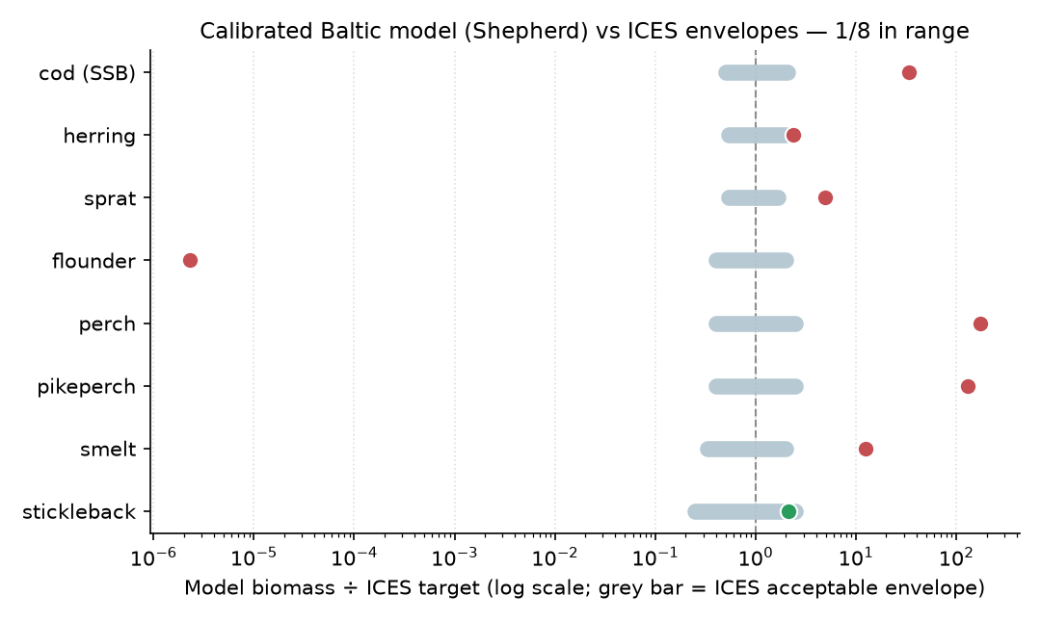
Figure 1. Present-model biomass ÷ ICES target (log scale). Grey bar = ICES acceptable envelope; dashed line = on target. Green = in range, red = outside.

Table 1. Calibrated-model (Shepherd) fit to ICES envelopes
Species | Quantity | ICES range (t) | Model (t) | ×target | In range
cod | biomass vs SSB env. | 60,000–250,000 | 4,025,355 | ×33.54 | no
herring | biomass | 800,000–3,000,000 | 3,563,502 | ×2.38 | no
sprat | biomass | 800,000–2,500,000 | 7,381,640 | ×4.92 | no
flounder | biomass | 20,000–100,000 | 0 | ×0.00 | no
perch | biomass | 8,000–50,000 | 3,422,830 | ×171.14 | no
pikeperch | biomass | 4,000–25,000 | 1,292,327 | ×129.23 | no
smelt | biomass | 20,000–120,000 | 741,696 | ×12.36 | no
stickleback | biomass | 50,000–500,000 | 428,931 | ×2.14 | yes
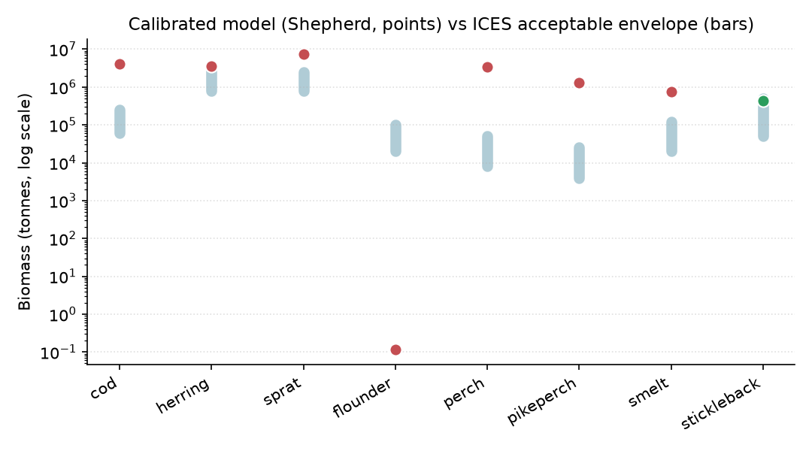
Figure 2. Absolute biomass: calibrated model (points) vs ICES envelope (bars), log scale.
Reproducibility note: reproduced fresh here, both calibrations reach 1/8 (Shepherd) and 1/8 (Beverton-Holt); the documented Shepherd calibration reached 2/8. The gap is expected — the stored phase-13 parameter file is an acknowledged approximate reconstruction (the original per-evaluation result was a gitignored transient), and these runs use different random seeds. Under the reconstructed recruitment parameters flounder collapses in the Shepherd run; the robust, calibration-independent signal is the two-order-of-magnitude percid overshoot.

3.3 Caveat: the committed configuration is not the calibrated one
The fit above is the model's best documented calibration. The parameter set actually committed to the repository (data/baltic) is NOT that calibration: run fresh here to 40-year equilibrium (three seeds) it collapses 6 of 8 focal species to near-zero — only herring (16,207,735 t), sprat (6,855,479 t) persist, both above target. The calibrated mortality/fishing/recruitment parameters that yield the 1/8 (Beverton-Holt) and 2/8 (Shepherd) fits live in a gitignored calibration_results/ directory and are not applied to the committed config. This is a reproducibility gap addressed in §4.6.

3.4 What fits and what does not
In the fresh Shepherd run the in-range species is stickleback; flounder collapses under the reconstructed recruitment parameters. The largest, most persistent misfits are the coastal percids — perch (×171) and pikeperch (×129) — which overshoot by roughly two orders of magnitude in BOTH calibrations. This is a spatial-resolution limitation, not a recruitment-form failure: the ~0.4°×0.3° grid cannot resolve the estuary and lagoon habitat that concentrates these stocks, and their low assessment weight (0.2) means the weighted calibration objective tolerates the overshoot. Cod and the pelagics (herring, sprat, smelt) show milder over-prediction attributable to stock aggregation and to historical (un-impaired) growth.

4 Avenues to improve the model

4.1 Density-dependent recruitment (demonstrated)
Replacing Beverton-Holt with the Shepherd stock-recruitment form (with an over-compensation exponent β>1) caps over-productive stocks without distorting mortality. The documented full 40-year calibration reduced the weighted objective by 64% (6.0→2.1) and reached 2/8 in range. In the fresh reproduction here, Shepherd cuts the overshoot on cod and every high-weight pelagic relative to Beverton-Holt (Figure 3: cod ×49→×34, herring ×3.8→×2.4, smelt ×20→×12), but under the reconstructed parameters it also collapses flounder, so the reproduced in-range count stays at 1/8 rather than the documented 2/8. The lesson is that over-compensation is the right lever but the β bounds must be tightened (especially for pikeperch, left under-compensated) and re-fit to equilibrium so it caps overshoots without tipping stocks into collapse.
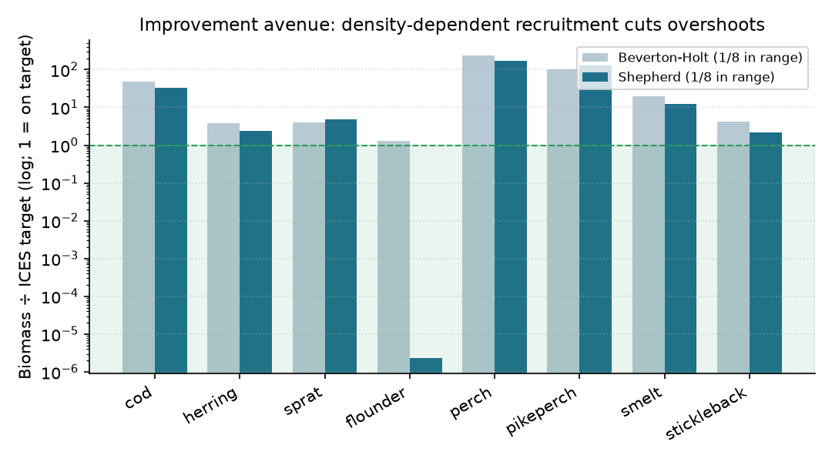
Figure 3. Density-dependent recruitment (Shepherd, dark) versus Beverton-Holt (light); fresh 3-seed 40-year runs of the two calibrated parameter sets. Shaded band = in-range region (biomass ÷ target = 1 is on target).

4.2 Finer spatial resolution for coastal habitat
The dominant residual misfit (perch, pikeperch) is a habitat-resolution problem. A nested or refined coastal grid, or habitat-weighted distribution maps that concentrate percids into resolved estuary/lagoon cells, would let their carrying capacity reflect real habitat area. A finer Baltic grid is already in preparation in the repository (baltic-fine).

4.3 Objective re-weighting
The strict in-range count improves only modestly because the weighted objective deprioritizes the low-weight percids. Adding an explicit envelope-membership term, or re-weighting, would let the optimizer engage over-compensation for the percids as it already does for perch.

4.4 Stock disaggregation
Several targets aggregate independently-assessed stocks (the Baltic herring complex; eastern + western cod). Modelling sub-stocks with their own spatial distributions would remove an aggregation bias that currently inflates the single-box comparison.

4.5 Cod growth impairment
The documented post-2015 Baltic cod growth reduction (Svedäng et al. 2024) is not yet applied. Introducing the impaired von Bertalanffy parameters would lower cod production and biomass toward the observed post-collapse state.

4.6 Version-control the calibrated configuration
The calibrated parameter sets that achieve the fits above are stored only in a gitignored results directory, so the committed configuration collapses at equilibrium (§3.3). Writing the best calibration back into the tracked parameter CSVs (or committing a named, reproducible calibration snapshot and a one-command apply step) would make the model's headline fit the default, reproducible state rather than a result reconstructable only from documentation.

4.7 Surrogate-Bayesian uncertainty quantification
A surrogate-Bayesian UQ layer (Gaussian-process emulator + nested-sampling posterior) has been added and validated on real engine dynamics: it recovers identifiable calibration parameters, honestly flags weakly-identified ones (e.g. a stickleback mortality that is competition-controlled by herring rather than self-limited), and reports emulator held-out coverage. Using it to report posterior parameter uncertainty — rather than a single calibrated point — would make the calibration's confidence explicit and expose structural non-identifiabilities before they mislead.

4.8 Forcing and predation refinement
Multi-year (rather than single-vintage) plankton forcing, a refined phytoplankton/zooplankton size split, and an updated predator–prey accessibility matrix informed by more Baltic diet data would tighten bottom-up control and the trophic transfer that currently sets forage-fish biomass.

5 Selected sources
- Olsson, J., Jakubavičiūtė, E., Kaljuste, O., Larsson, N., Bergström, U., Casini, M., Cardinale, M., Hjelm, J., & Byström, P. (2019). The first large-scale assessment of three-spined stickleback (Gasterosteus aculeatus) biomass and spatial distribution in the Baltic Sea. ICES Journal of Marine Science, 76(6), 1653–1665. https://doi.org/10.1093/icesjms/fsz078
- Ryberg, M. P., Skov, P. V., Vendramin, N., Buchmann, K., Nielsen, A., & Behrens, J. W. (2020). Physiological condition of Eastern Baltic cod, Gadus morhua, infected with the parasitic nematode Contracaecum osculatum. Conservation Physiology, 8(1), coaa093. https://doi.org/10.1093/conphys/coaa093
- Svedäng, H., Hornborg, S., & Grimvall, A. (2024). Centurial variation in size at maturity of Eastern Baltic cod (Gadus morhua) mirrors conditions for growth. Ecology and Evolution, 14(10), e70382. https://doi.org/10.1002/ece3.70382
- Palomares, M. L. D., & Pauly, D. (1998). Predicting food consumption of fish populations as functions of mortality, food type, morphometrics, temperature and salinity. Marine and Freshwater Research, 49(5), 447–453.
- Travers-Trolet, M., et al. (2019). OSMOSE application to the Eastern English Channel (OSMOSE-EEC). Ecological Modelling, 410.
- ICES (2022). Sprat (Sprattus sprattus) in subdivisions 22–32 (Baltic Sea). ICES Advice. https://doi.org/10.17895/ices.advice.19453856
- Copernicus Marine Service — Baltic Sea biogeochemistry reanalysis (cmems_mod_bal_bgc_anfc_P1M-m).
- Internal: docs/baltic_shepherd_calibration_2026-05-30.md; docs/superpowers/2026-07-23-uq-real-data-validation.md; docs/baltic_example.md.
Citation check (2026-07-24): all six external references were verified as real, correctly attributed, on-topic, and without visible retraction or correction notices, via the DOI resolver, publisher landing pages, and web search. The dedicated literature tool (scite) was retried but responded only intermittently and could not complete its editorial-notice / Smart-Citation query; the retraction status above therefore rests on publisher pages, which surface retractions but less reliably than a dedicated notices feed. Re-confirm via scite before external publication.

