
American International University-Bangladesh
Faculty of Engineering

Course Name: MICROPROCESSOR AND EMBEDDED SYSTEMS

Section: C
Experiment Number: 06
Experiment Name: Communication between two Arduino Boards using SPI.
Submitted to: MD. SHAORAN SAYEM

Submitted by: A K M Razin Raian
Group  04 | ID | Name | Department
Group  04 | 23-51249-1 | Afif Karim Ryan | CSE
Group  04 | 23-54485-3 | Swakkhor Kundu Raja | CSE
Group  04 | 23-54273-3 | Mohammad Hasan Ferdous | CSE
Group  04 | 23-54603-3 | A K M Razin Raian | CSE
Group  04 | 23-54637-3 | MD Ashiuqur Rahman | CSE

Date of Submission:

16 August 2026
Title: Communication between two Arduino Boards using SPI
Abstract:
This experiment demonstrates bidirectional communication between two Arduino Uno boards using the Serial Peripheral Interface (SPI) protocol. One Arduino is configured as the Master and the other as the Slave, each connected to a push button and an LED. The Master initiates communication by continuously polling its button and transmitting the corresponding logic value to the Slave using the SPI.transfer() function, while simultaneously receiving data sent back by the Slave through the same transfer cycle. On the Slave side, an interrupt-driven approach is used, where the SPI Serial Transfer Complete interrupt (ISR(SPI_STC_vect)) captures incoming data and updates its LED state accordingly, while also loading its own button status into the SPI Data Register (SPDR) for the next transfer. The experiment was implemented both physically on a breadboard and virtually using Proteus Design Suite, and the results from both environments were verified through LED states and Serial Monitor output. The outcomes confirm those pressing either board's button correctly turns on the LED on the opposite board, validating successful full-duplex SPI communication.

Objective:
The objectives of this experiment are to-
  - Familiarize with the SPI protocol used in Arduino.
  - Implement assembly language programming code for SPI communication with Arduinos.
  - Implement SPI protocol for communication between two Arduinos.
  - Implement a circuit for controlling the master side LED by the push button at the slave side and vice versa using the SPI serial communication protocol.
  - Familiarize with the working principles of the SPI used in Arduino.

Theory and Methodology:
SPI (Serial Peripheral Interface) is a synchronous, full-duplex serial communication protocol commonly used for short-distance communication between microcontrollers and peripheral devices. Unlike asynchronous protocols such as UART, SPI relies on a shared clock signal generated by a single Master device, which eliminates the need for baud rate matching between devices and allows for significantly higher data transfer speeds.
An SPI bus typically uses four signal lines:

1.SCK (Serial Clock): Generated by the Master; synchronizes data transfer between devices.
2.MOSI (Master Out Slave In): Carries data from the Master to the Slave.
3.MISO (Master In Slave Out): Carries data from the Slave back to the Master.
4.SS/CS (Slave Select / Chip Select): Controlled by the Master; pulled LOW to activate communication with a specific Slave device.

On the Arduino Uno (ATmega328P), these SPI lines are fixed to specific hardware pins: pin 13 (SCK), pin 11 (MOSI), pin 12 (MISO), and pin 10 (SS).
During each SPI clock cycle, one bit is shifted out from the Master's shift register (via MOSI) while simultaneously one bit is shifted in from the Slave's shift register (via MISO). This simultaneous exchange makes SPI a full-duplex protocol — both devices can send and receive data within the same transfer, unlike simplex or half-duplex communication methods.
On the Slave device, incoming data is captured in the SPI Data Register (SPDR). When a complete byte has been received, the SPI hardware automatically triggers the SPI Serial Transfer Complete interrupt, allowing the microcontroller to process the received byte without continuously polling the SPI status register, thereby improving responsiveness and efficiency.
Based on this working principle, the experiment was carried out in the following sequence:
1. Circuit Design
Two Arduino Uno boards were set up, each interfaced with one push button (digital input) and one LED (digital output) through a current-limiting resistor. The SPI pins of both boards (SCK, MOSI, MISO, SS) were wired directly to their corresponding pins on the other board to establish the shared SPI bus.

2. Firmware Development
Master firmware: Continuously reads the state of its push button and stores the result in a variable. The Master pulls the SS line LOW to begin communication, then uses SPI.transfer() to simultaneously send its button state to the Slave and receive the Slave's button state in return. Based on the received value, the Master updates its own LED accordingly.
Slave firmware: Configures the SPI hardware in Slave mode and enables the SPI interrupt using SPI.attachInterrupt(). Whenever the Master initiates a transfer, the interrupt service routine ISR(SPI_STC_vect) reads the incoming byte from SPDR and sets a flag indicating that new data has arrived. In the main loop, the Slave checks this flag, updates its LED based on the received value, reads its own button state, and loads the corresponding value into SPDR to be sent during the next SPI transfer.

3. Code Compilation
Both sketches were written and compiled separately using the Arduino IDE, generating separate HEX files for the Master and Slave firmware.

4. Hardware Implementation
The circuit was physically assembled on a breadboard using two Arduino Uno boards, LEDs, push buttons, and resistors, following the same wiring scheme used in the schematic design.

5. Simulation Verification
The same circuit was recreated in Proteus Design Suite. The compiled HEX files were loaded into the virtual Arduino components (Program File property), and the simulation was run to visually verify SPI communication through LED state changes triggered by button presses.

6. Result Comparison
The behavior observed in the physical hardware setup (LED states, Serial Monitor output) was compared against the Proteus simulation results to confirm consistency between the real and simulated implementations.

Apparatus
- Arduino IDE
- Arduino UNO (2)
- LED (2)
- Push Button (2)
- Resistors 10k, 2.2k (2+2)
- Breadboard
- Connecting Wires.
- Circuit Diagram

Experimental Setup:

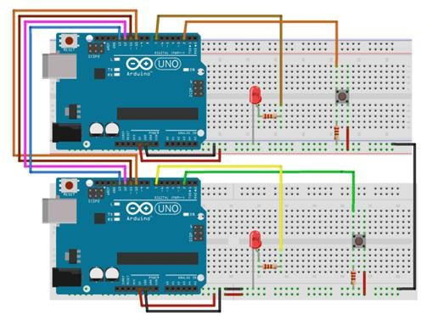

Figure 1: Connection diagram

MASTER Arduino Code:

#include<SPI.h> //Library for SPI #define LED 7
#define ipbutton 2 int buttonvalue; int x;
void setup (void){
Serial.begin(115200); //Starts Serial Communication at Baud Rate 115200 pinMode(ipbutton,INPUT); //Sets pin 2 as input pinMode(LED,OUTPUT); //Sets pin 7 as Output
SPI.begin(); //Begins the SPI communication SPI.setClockDivider(SPI_CLOCK_DIV8); //Sets clock for SPI communication at
// 8 (16/8 = 2 MHz)
digitalWrite(SS,HIGH); //Setting SS to HIGH do disconnect master from slave
}
void loop(void){
byte Mastersend, Mastereceive;
buttonvalue = digitalRead(ipbutton); //Reads the status of the pin 2

if(buttonvalue == HIGH) //Setting x for the slave based on input at pin 2
{
x = 1;
}
else
{
x = 0;
}
digitalWrite(SS, LOW); //Starts communication with Slave from the Master Mastersend = x;
Mastereceive = SPI.transfer(Mastersend); //Sends the Mastersend value to
//the slave and also receives value from the slave if(Mastereceive == 1) //To set the LED based on value received from slaveu
{
digitalWrite(LED,HIGH); //Sets pin 7 HIGH Serial.println("Master LED is ON");
}

else
{
digitalWrite(LED,LOW); //Sets pin 7 LOW Serial.println("Master LED is OFF");
}
delay(1000);
}

SLAVE Arduino code:
#include<SPI.h> #define LEDpin 7
#define buttonpin 2 volatile boolean received;
volatile byte Slavereceived, Slavesend; int buttonvalue;
int x;
void setup(){ Serial.begin(115200);
pinMode(buttonpin,INPUT); // Setting pin 2 as INPUT pinMode(LEDpin,OUTPUT); // Setting pin 7 as OUTPUT pinMode(MISO,OUTPUT); //Sets MISO as OUTPUT to send data to Master In SPCR |= _BV(SPE); //Turn on SPI in Slave Mode
received = false;
SPI.attachInterrupt(); //Interrupt ON is set for SPI communication
}
ISR(SPI_STC_vect) //Interrupt routine function
{
Slavereceived = SPDR; // Value received from Master stored in Slavereceived received = true; //Sets received as True
}
void loop() {
if(received) //To set LED ON/OFF based on the value received from Master
{
if (Slavereceived == 1)
{
digitalWrite(LEDpin, HIGH); //Sets pin 7 as HIGH to turn on LED
Serial.println("Slave LED is ON");
}
else
{
digitalWrite(LEDpin,LOW); //Sets pin 7 as LOW to turn off LED Serial.println("Slave LED is OFF");
}
buttonvalue = digitalRead(buttonpin); //Reads the status of the pin 2 if (buttonvalue == HIGH) //To set the value of x to send to Master
{
x = 1;
}
else
{ x=0;
}
Slavesend = x;
SPDR = Slavesend; //Sends the x value to the Master via SPDR delay(1000);
}
}

Experimental Results:

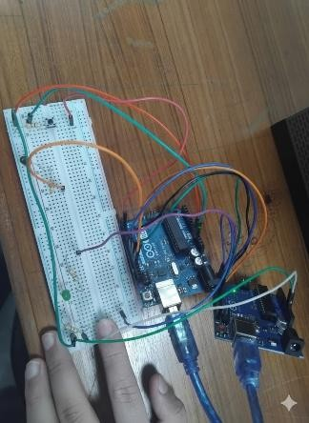  Fig2.1: Both LEDs are OFF in the SPI communication circuit when BUTTON is NOT PRESSED | 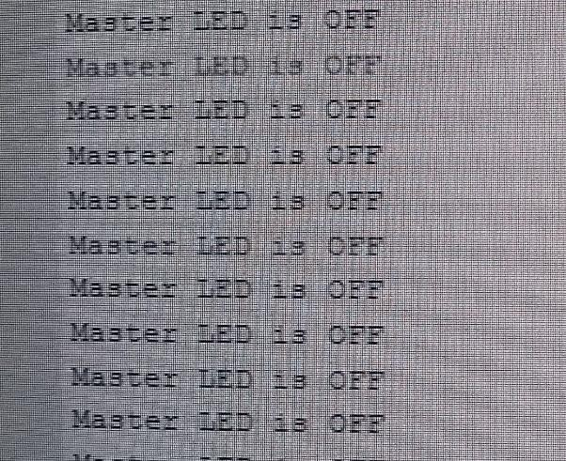  Fig2.2: Serial Monitor of Peripheral when not pressing Button
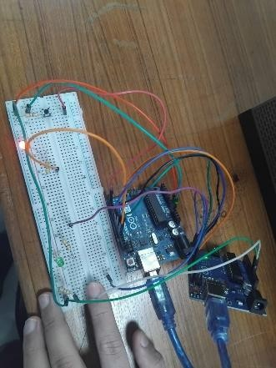  Fig2.3: LED connected to MASTER is ON when BUTTON connected to SLAVE is pressed | 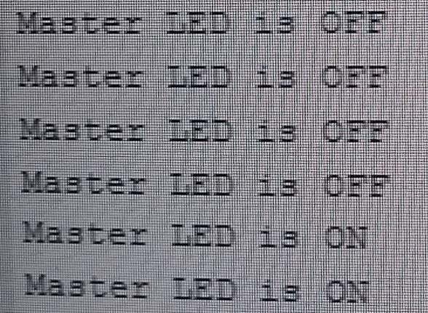  Fig2.4: Serial Monitor of Peripheral when pressing Button
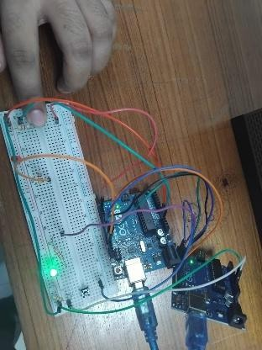  Fig2.7: LED connected to SLAVE is ON when BUTTON connected to MASTER is PRESSED | 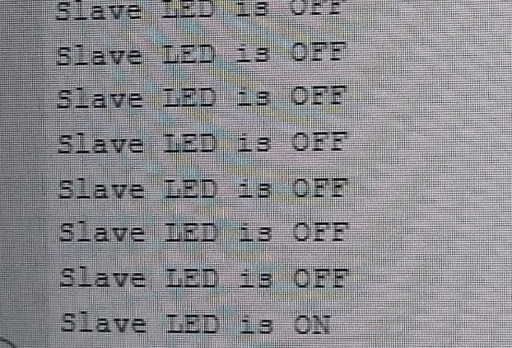  Fig2.8: Serial Monitor of Peripheral when pressing Button
Explanation:

In this experiment, there were two separate experimental outcomes. The first result was obtained when pressing the data transfer button on the Controller. Upon pressing the button, after a few

seconds, the LED on the Peripheral lit up. This indicates that the signal to turn on the LED was successfully transmitted from the Controller to the Peripheral via the SPI communication interface. The Serial Monitor of the Controller also displayed the message: “Slave LED is ON.” When the button on the Controller was released, the LED connected to the Peripheral turned off, confirming that the signal to turn off the LED was also transmitted correctly, with the Serial Monitor showing “Slave LED is OFF.”

The second result was obtained when pressing the data transfer button on the Peripheral. Upon pressing the button, after a few seconds, the LED on the Controller lit up, indicating that the data to turn on the Controller’s LED was sent from the Peripheral via SPI. The Serial Monitor of the Peripheral showed “Master LED is ON.” When the button was released, the LED on the Controller turned off, and the monitor displayed “Master LED is OFF,” confirming successful bidirectional communication.

Simulation Circuits And Result

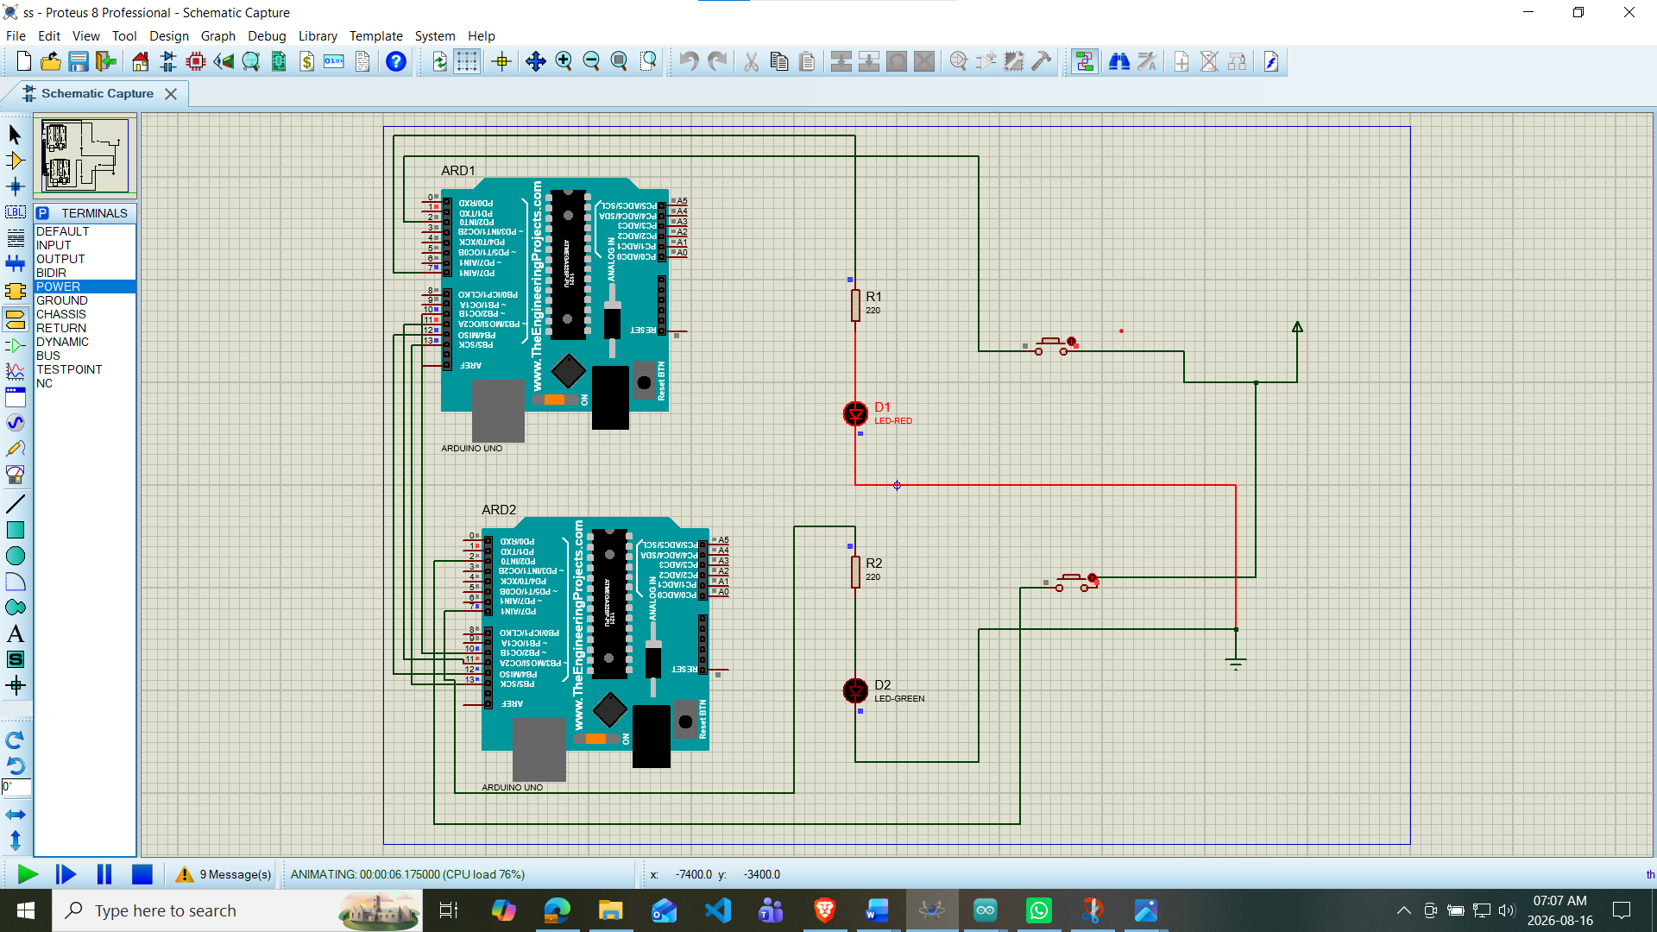

Fig3.1: Peripheral LED was ON in the SPI communication circuit simulation when pressing the button of Controller

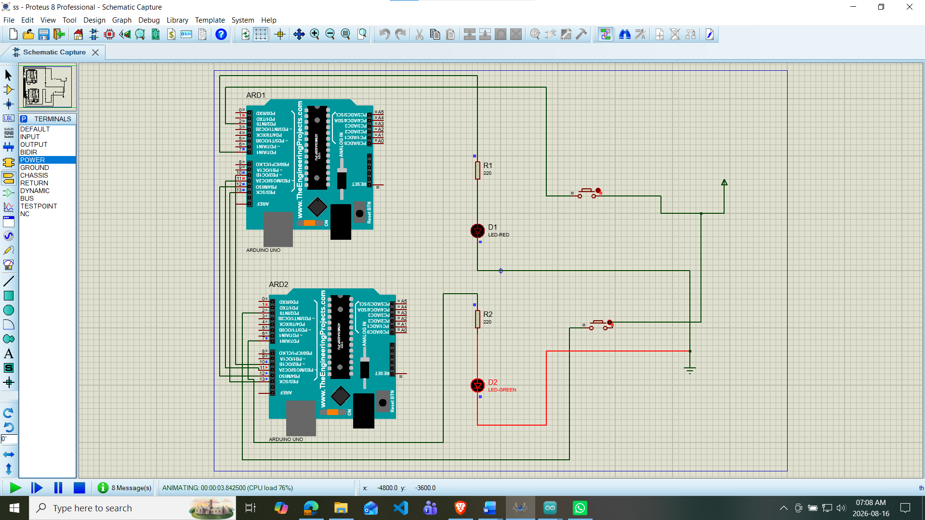

Fig3.2: Controller LED was ON in the SPI communication circuit simulation when pressing the button of Peripheral
Explanation:

In this simulation, two Arduino Uno boards, resistors, GREEN and RED LEDs, and push buttons were configured according to the wiring instructions provided in the commented Arduino code. The buttons used to transmit data from one microcontroller to the other were properly connected based on the circuit diagram and code logic. Both Arduino boards were linked using the SPI communication interface via pins 10 to 13.

The program for SPI communication was written and verified using the Arduino IDE. Upon successful verification, a HEX file was generated. This HEX file was then loaded into the Arduino modules in the Proteus simulation environment to control their behavior according to the programmed logic.

Once the simulation was run, the LEDs responded to the corresponding button presses, reflecting successful bidirectional SPI communication. The results observed in the simulation closely matched the outcomes of the hardware experiment, validating the correctness of both the circuit design and the SPI protocol implementation.

Discussion

This experiment successfully demonstrated the practical application of SPI (Serial Peripheral Interface) communication between two Arduino Uno boards. By connecting each board with an LED and a push button, we were able to verify the bidirectional data exchange using SPI, where each Arduino could send and receive signals simultaneously. The use of the SPI.transfer() function on the Controller and the SPI
interrupt on the Peripheral allowed real-time control of LEDs based on the button inputs from the opposite board.

The serial monitor readings provided further confirmation of successful communication. Messages such as "Master LED is ON" or "Slave LED is OFF" indicated that the data being transferred was correctly received and interpreted. The synchronization between hardware behavior and serial output confirmed that the SPI protocol was implemented and functioning properly. The accurate reflection of button states through the LEDs on both sides showed that SPI can be reliably used for fast, real-time communication in embedded systems.

Additionally, the simulation conducted using Proteus produced results consistent with the physical hardware implementation. This helped validate the code logic and circuit connections before actual deployment. Proper wiring of the SPI pins (MISO, MOSI, SCK, and SS) and careful setup of pull-up or pull-down resistors were crucial for stable communication. Overall, the experiment deepened our understanding of synchronous serial communication and highlighted SPI's effectiveness in simple but meaningful microcontroller-to-microcontroller interactions.

Answers to the Questions in the Lab Manual :

4.

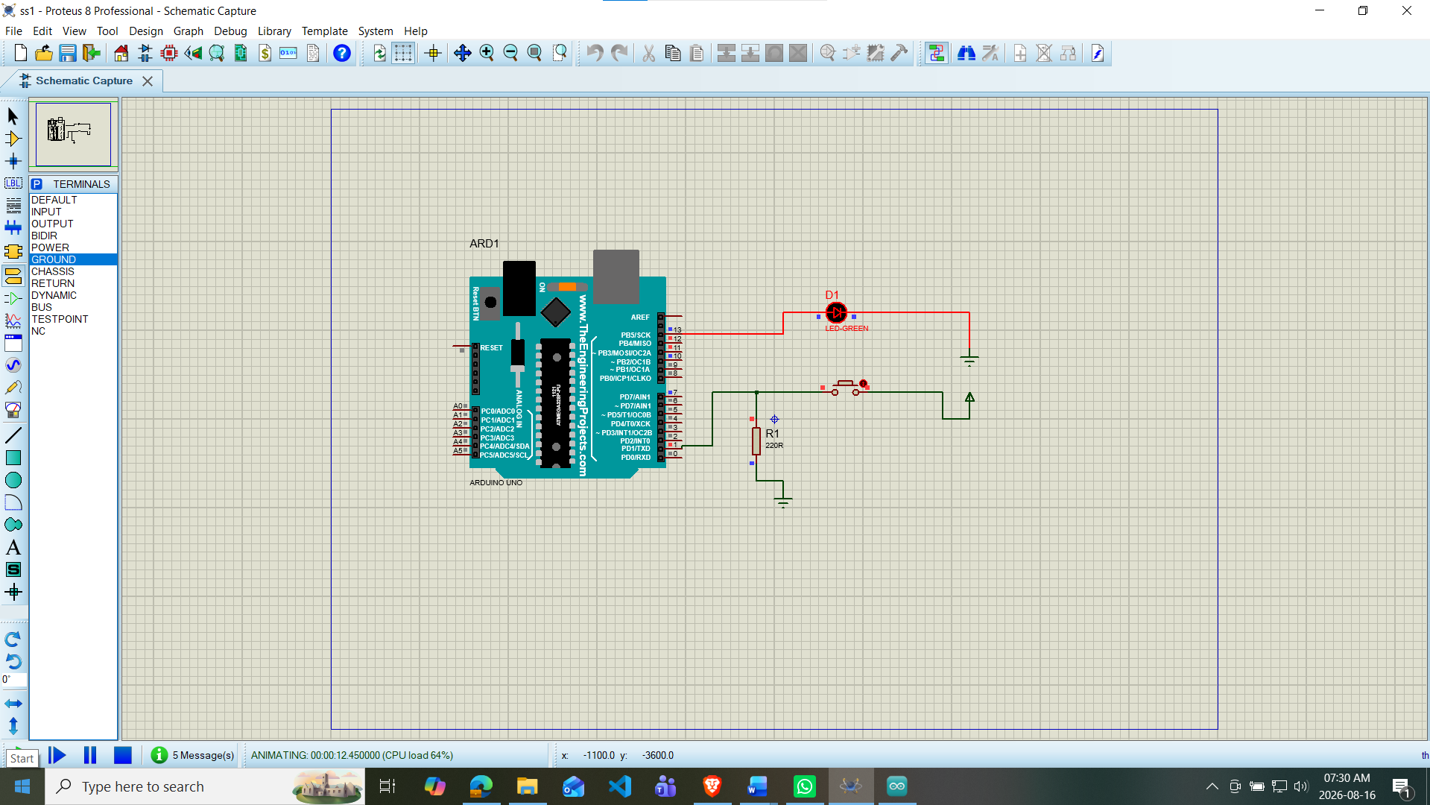
Simulation Methodology:
The simulation was carried out using Proteus 8 Professional, where an Arduino Uno, an LED with a 220Ω current-limiting resistor, and a push button were connected on the schematic capture workspace. Two separate Arduino programs were written in the Arduino IDE — one for simple LED blinking using digitalWrite() and delay(), and another for push-button-controlled LED operation using digitalRead() to sense the button state and control the LED accordingly. Each program was compiled to generate a .hex file, which was then loaded into the Arduino Uno component in Proteus via its Program File property. Running the simulation allowed real-time observation of the LED blinking at set intervals and responding correctly to button presses, with wire color changes (red/green) indicating HIGH/LOW logic states. This verified the correct functioning of both the circuit design and the firmware logic without requiring physical hardware.

Conclusion:
This experiment successfully established bidirectional communication between two Arduino Uno boards using the SPI (Serial Peripheral Interface) protocol. By configuring one board as the Master and the other as the Slave, and interfacing each with a push button and an LED, it was demonstrated that a button press on either board could reliably control the LED on the opposite board through synchronous serial data exchange. The Master's polling-based approach using SPI.transfer() combined with the Slave's interrupt-driven response via ISR(SPI_STC_vect) together confirmed the full-duplex nature of SPI, where data was transmitted and received simultaneously within a single clock cycle. The Serial Monitor outputs provided additional confirmation that the transmitted values were correctly interpreted on both ends. Furthermore, the close agreement between the physical hardware implementation and the Proteus simulation results validated both the circuit design and the correctness of the firmware logic. Overall, the experiment reinforced a practical understanding of synchronous serial communication and highlighted SPI's suitability for fast, reliable, short-distance data exchange between microcontrollers — a capability widely applicable in embedded systems involving multiple interconnected devices, such as sensor networks, peripheral control, and distributed data acquisition systems.

Reference
- “SPI Communication Between Two Arduino Boards,” Circuit Digest. [Online]. Available: https://circuitdigest.com/microcontroller-projects/spi-communication-between-two-arduino-boards [Accessed: May 5, 2025].
- Arduino, “SPI - Serial Peripheral Interface - Arduino Reference,” Arduino Documentation. [Online].
Available: https://www.arduino.cc/en/Reference/SPI [Accessed: May 5, 2025].
- Proteus Design Suite, “How to Simulate Arduino Projects in Proteus,” Labcenter Electronics. [Online]. Available: https://www.labcenter.com
[Accessed: May 5, 2025].
- Protik Parvez Sheikh, Lab Manual: Microprocessor and Embedded Systems Laboratory, American International University-Bangladesh (AIUB), Fall 2025-26.

