Fiuu Reload Handbook
Architecture, coding conventions, and GitLab-history synthesis
for the reload and reload_db projects

Generated 2026-09-06
Private / personal reference — not an official Fiuu document.

Table of Contents

Introduction 19
Fiuu Reload Handbook 19
Structure 19
Status 19
Source material 19
Architecture — reload 20
Topology: what's actually on disk vs. what we assumed 20
1. The headline finding: most "sibling folders" are empty 20
2. class-library: one repo, two checkouts, out of sync 21
3. Where the real applications actually live 21
4. The three-tier "shared library" pattern 23
5. Dead / removed folders (0 tracked files at HEAD) 24
6. reload_db 25
7. Database connectivity mechanism (names only, no values) 25
8. Git remotes (for reference) 25
Related 26
Reload application solution — overview 26
What this is 26
Components (all live inside the single reload repo) 26
Component / dependency diagram 27
Sequence diagrams 27
What wasn't traced in this pass 28
Related 28
console_app — a family of background-job apps, not one app 28
Per-module scheduler apps 28
Standalone one-off tools 29
Dead/removed: the old Applications/CEPP scheduler umbrella 30
Related 30
reload_portal — open question, not resolved 30
Status: unresolved, needs a human answer 30
Possible explanations (not verified — pick one with the team) 31
Related 31
terminal_application → Reloads/TerminalServer/Console (+ ControlPanel) 31
TerminalServer/Console — the socket server 31
Entry point / structure 31
Confirmed dependency on the shared business layer 32
TerminalServer/ControlPanel — the operator console 32
What this is NOT 33
Related 33
web_api → Reloads/Terminal/Api (+ BackOffice/Api) 33
Primary: Reloads/Terminal/Api 33
Entry points / public surface 33
Authentication 34
Dependencies (confirmed via .csproj) 34
External systems reached (confirmed by code, see sequence diagrams) 35
Databases touched 35
Secondary: BackOffice/Api 35
Note: a third, dead "BackOfficeAPI" 35
Related 35
web_app → BackOffice/Web 36
What it is 36
Entry points 36
Dependencies (confirmed via .vbproj) 36
What it does NOT appear to be 37
Databases / external systems touched 37
Related 37
AWSCore 37
What it's for 37
Structure 37
Why this matters for the rest of the handbook 38
Consumers 38
Related 38
CEPP 39
What it's for 39
Structure 39
Public surface (confirmed via EngineContext.Current.Resolve<T>() calls in 39
Known dependencies 40
Consumers 40
Related 40
Database (Fiuu.Database) 40
What it's for 41
Structure 41
What this confirms about the RMS_OFFLINE database 41
Consumers 42
Related 42
EInvoice 42
What it's for 42
Structure 42
Confirmed mechanism 43
Dependencies 43
Consumers 43
Related 43
Logging 43
What it's for 44
Structure 44
Consumers 44
Related 44
Lookup 44
What it's for 45
Structure 45
Consumers 45
Related 45
MasterFramework 45
What it's for 46
Structure (by subfolder) 46
Consumers 46
Related 47
Notification (bonus doc — not in the original module list, but named as a 47
Source location: not conclusively found 47
What the live Applications/Notification/* projects do 47
Consumers 48
Related 48
Provider 48
What it's for 48
Relationship to class-library/Database — unresolved ambiguity 48
Consumers 49
Related 49
Reloads.Pin (+ sibling Reloads.Pinless) 49
What it's for 49
Confirmed partner integrations (from actual Providers/ file names) 49
Structure (Pin) 50
Structure (Pinless) 50
Consumers 50
Related 50
Reloads.Restorify 51
Correction to the naming assumption: this is not a "restore failed transactions" module 51
Structure 51
Restorify/Api 52
Dependencies 52
Consumers 52
Related 52
Reloads/TNG and Reloads/Game (bonus doc — real class-library source modules, 52
Reloads/TNG 53
Reloads/Game 53
Related 53
Secure (Astro, Incomm, Telekom) 53
Astro 54
Incomm (ISO 8583) 54
Telekom 54
Consumers 55
Related 55
Sequence: EInvoice end-customer submission (scheduled batch job) 55
What's confirmed vs. inferred/unknown 55
Related 56
Sequence: INCOMM gift card — Initiate + Confirm (via Terminal API) 56
Two calls, two HTTP requests from the terminal 57
What's confirmed vs. inferred 57
Related 58
Sequence: TNG e-wallet card transaction (via Terminal API) 58
What's confirmed vs. inferred 58
Related 59
Architecture — reload_db 60
reload_db — Database Estate Overview 60
The database estate 60
Non-database MAINT folders 62
How MAINT maps to physical databases 63
The big picture 64
Where to go next 65
Related 65
BILL_PAYMENT 65
Per-biller schemas 65
TRANS — the shared payment-order workflow 66
Stored procedures 66
Relationships to other modules 66
Related 66
CEPP 66
Org hierarchy 67
Users & access 67
Product & service catalog 67
Commission & settlement 68
Banking, wallets, TNG/InComm hardware 68
Reference data 68
Stored procedures 68
Relationships to other modules 68
Drift vs. vault 69
Related 69
CONFIGURATION 69
Key tables 69
Relationships to other modules 69
Drift vs. vault 69
Related 70
DataWarehouse 70
Star schema 70
Stored procedures 70
Relationships to other modules 71
Related 71
EINVOICE 71
Tables (TRANS schema) 71
Stored procedures 72
Relationships to other modules 72
Open questions 72
Related 72
INCOMM_TRANS 73
Key tables 73
Stored procedures 73
Relationships to other modules 73
Related 73
INCOMM 73
Key tables 74
Stored procedures 74
Relationships to other modules 74
Related 75
INVENTORY_MASTER 75
Key tables 75
Relationships to other modules 75
Drift vs. vault 75
Related 75
INVENTORY 76
Key tables 76
Relationships to other modules 76
Drift vs. vault 76
Related 76
LOGGING 76
Key table 77
Relationships to other modules 77
Drift vs. vault 77
Related 77
MLookUp 77
Key tables 77
Relationships to other modules 78
Drift vs. vault 78
Related 78
NOTIFICATION 78
Key tables 78
Stored procedures — a real gap in the tracked source, not in the vault 78
Relationships to other modules 79
Related 79
MAINT patch-script conventions 79
Two different things live under MAINT/<Module>/ 79
Object-file naming inside a module 80
Ticket ID formats — four spellings, one tracker 80
The 00_/01_/NN_ step convention (ticket-numbered patch folders) 81
Excel-tracked patches 81
Releases 81
Deployment mechanism 82
Scheduled jobs are versioned the same way 82
Related 82
PREPAID 82
Key tables 82
Relationships to other modules 83
Drift vs. vault 83
Related 83
REPORTSUMMARY 83
Key tables 83
Stored procedures 84
Relationships to other modules 84
Reconciliation against live scripts 84
Related 84
RESTORIFY 84
dbo — projects, categories, subscriptions 85
STACS 85
TRANS — transactions 85
Stored procedures 85
Relationships to other modules 85
Related 86
RMS_OFFLINE 86
Consumer identity & partners 86
Catalog & transactions 86
Reward campaigns 86
CMS & support content 87
e-Invoicing 87
Stored procedures 87
Relationships to other modules 87
Drift vs. vault 87
Related 87
SAP 87
Tables (TRANS schema) 88
Stored procedures 88
Relationships to other modules 88
Open questions 88
Related 88
TICKET 89
Key tables 89
Relationships to other modules 89
Drift vs. vault 89
Related 89
TNG 89
Key tables 90
Stored procedures 90
Relationships to other modules 90
Related 90
TRANSACTION 91
dbo — the staging/orchestration core 91
Provider schemas 92
Sales, stock, void/return 92
Stored procedures 92
Relationships to other modules 92
Drift vs. vault 92
Related 93
Vault vs. live MAINT scripts — drift notes 93
1. Two entire databases are missing from the vault (the big one) 93
2. CEPP: one real table missing, and one description slightly stale 94
3. TRANSACTION: at least 6 provider integration schemas missing 94
4. NOTIFICATION: the vault is right, but for a subtler reason than it says 95
5. Two non-schema folders the vault doesn't mention at all 95
What wasn't re-verified 95
Related 96
BILL_PAYMENT — ER diagram 96
CEPP — ER diagrams 96
Org hierarchy 97
Users & access 99
Product & service catalog 99
Commission & settlement 100
Geography & reference (includes PublicHolidays, missing from vault) 100
Banking, wallets & TNG/InComm hardware 100
Sales & reporting ops 100
CONFIGURATION — ER diagram 100
Cross-module relationships 101
Reading this diagram 102
DataWarehouse — ER diagram 103
EINVOICE — ER diagram 103
INCOMM — ER diagram 105
INCOMM_TRANS — ER diagram 105
INVENTORY — ER diagram 105
INVENTORY_MASTER — ER diagram 107
LOGGING — ER diagram 107
MLookUp — ER diagram 108
NOTIFICATION — ER diagram 108
PREPAID — ER diagram 109
REPORTSUMMARY - ER diagram 111
RESTORIFY — ER diagram 111
RMS_OFFLINE — ER diagram 111
SAP — ER diagram 112
TICKET — ER diagram 114
TNG — ER diagram 114
TRANSACTION — ER diagrams 115
dbo — API staging (representative subset) 115
dbo — sales & orders 116
dbo — void & return 116
dbo — EOD/reconciliation (Bill Payment shown; Gift Card/Stock/MOLPay follow the identical shape) 116
dbo — stock & purchasing 117
dbo — TNG & MOLPay 117
Provider schemas (established + missing-from-vault) 117
Coding Conventions 119
Coding Conventions 119
Docs 119
Source sampled 119
Related 119
Comment / Documentation Style 119
XML doc comments are rare — roughly 1 in 10 files has any 120
SQL stored procedures: a consistent header block, but shallow 120
Patch scripts: header comments present for structured patches, absent for quick ones 120
Inline comments: sparse, but occasionally load-bearing when present 121
#region blocks used sparingly, mostly in older/AWS-adjacent code 121
TODO-style comments exist and are left in place 121
Related 122
Configuration & Secrets 122
1. Classic System.Configuration / app.config/web.config <appSettings> 122
2. A database-backed config table (CONFIGURATION DB / ConfigDetails) 122
3. AWS Secrets Manager, gated by an EventAppName/partner switch, cached in-process 123
4. Plain-text connection-string files on the local disk 124
Migration in progress: .NET Framework config vs. .NET 8 appsettings.json 125
Related 125
Data Access 125
Pattern 1 (most common in Reloads/* and Secure/*): SqlAccessor + ParameterCollection 126
Pattern 2 (the Database project): generic BaseProvider<T> over raw Dapper 127
Pattern 3 (Notification module): a Dapper singleton with one method per stored procedure 127
Connections and transactions 128
Everything is stored-procedure-only 128
Related 128
Error Handling 128
Dominant pattern: catch-all, log, return a sentinel/error-code — don't rethrow 129
Narrower pattern: catch a specific SQL error, translate to a status, rethrow otherwise 129
Custom exception types exist, but are thin and rarely propagated 130
A broken custom exception in production code 131
Surfacing to callers: response codes, not HTTP status / structured faults 131
Logging inside error handling never itself throws 131
Summary 132
Related 132
Known Patterns & Pitfalls 132
1. Per-module reinvention of the same plumbing 132
2. Errors swallowed into sentinel values, not surfaced 132
3. Broken/dead code that shipped anyway 133
4. Hungarian notation and idiomatic C# coexist, by author/module, not by era 133
5. Connection strings on local disk, not in config 133
6. Three parallel data-access styles, all valid, none deprecated 133
7. Ticket-reference formatting on SQL filenames has at least five spellings 133
8. Column/verb spelling drift in patch filenames 133
9. internal vs public on architecturally-identical Provider classes 133
10. NOLOCK on every read query 134
11. Mid-migration off classic .NET Framework, visible as runtime version-sniffing 134
12. @@IDENTITY used instead of SCOPE_IDENTITY() 134
13. Dense, under-commented business logic in validators 134
14. Empty consuming-application directories in this checkout 134
Related 134
Layering / Architecture 135
The dominant pattern: Model / Provider / Service, per feature module 135
Dependency registration is per-module, container-based, but hand-maintained 136
ServiceBase exists per-module and isn't shared 136
Template-method style base classes for protocol-heavy modules 136
No repository/unit-of-work abstraction, no ORM entities 137
Summary of the pattern's consistency 137
Related 137
Logging 137
No single logging mechanism — two underlying frameworks, three-plus hand-rolled wrappers 137
Common call-pattern: bracketed [Key: ref] >>> / <<< request/response logging 138
Errors are logged twice in some paths: file log + event log 139
What gets logged 139
Logging is defensively isolated from the transaction it's logging 140
Related 140
Naming Conventions 140
Classes, interfaces, methods, properties 140
Local variables and parameters — Hungarian notation is inconsistent across modules 141
Filename vs. class name casing mismatches 141
Database-lookup foreign keys: the M prefix 141
Stored procedure naming (see sql-conventions.md for full detail) 142
Access modifiers on Provider classes are inconsistent 142
Ticket-reference suffixes on SQL filenames (see sql-conventions.md) 142
Related 142
SQL-side Conventions (reload_db/MAINT) 143
Folder structure: one folder per database, one subfolder per object type 143
Objects are organized per-partner using SQL schemas, not just tables 143
Stored procedure naming: <Schema>.<Table>_<Verb>[_By_<Columns>] 143
Stored procedure body style 143
Column naming 144
Index naming: IX_/IXU_ prefix, <Table>_<Column(s)> body 144
Patch-script filenames: ticket references are wildly inconsistent 145
Multi-step migrations get their own numbered subfolder 145
One-off data patches sometimes ship with no ticket linkage and minimal explanation 146
Related 146
GitLab History & Synthesis 147
GitLab Analysis 147
Related 147
Reload — MR Review Checklist 148
A. What the human reviewer (khenggek) flags, repeatedly, across unrelated MRs 148
A1. Variable naming must carry a datatype prefix 148
A2. Blank-line / whitespace discipline between logic blocks 148
A3. Don't log-and-rethrow when the caller already logs 149
A4. Don't assume a partner/API's behavior — cross-check the actual spec or a sibling implementation 149
A5. Use the merchant/partner-supplied timestamp, never server "now" 149
A6. Log identifying keys, not just "an error happened" 149
A7. Don't leave report queries unbounded 149
A8. Remove dead code and confirm before deleting 150
A9. Don't repurpose a mismatched model — check if a better-fitting one exists first 150
B. What the automated reviewer (deepcode_ai, adopted ~June 2025) catches 150
B1. Type-widening migrations (int→long) risk stored-procedure/param mismatches 150
B2. LINQ chains that can return null before a member-access 150
B3. Refactors that leave stale references to removed parameters 150
B4. Duplicated logic that should call an existing function instead 151
B5. Copy-paste variable-name typos that would fail to compile or silently misbehave 151
B6. Secrets/encryption-key handling gets flagged whenever touched 151
C. Practical checklist (author or reviewer, before requesting/approving merge) 151
Coverage note 152
Related 152
Reload — Timeline 152
2022 — Project genesis 153
2023 — Steady operations, first CI/CD investment, first incident 153
2024 — Rebrand, first major security incident, feature expansion 154
2025 — Scale limits hit, AI code review adopted, first major stock-discrepancy incident 154
2026 — Continued consolidation, a major performance fix, ongoing compliance patching 155
Release cadence, at a glance 155
Coverage note 156
Related 156
Reload — Tribal Knowledge 156
1. The single most useful thing to know: where bugs actually live 156
2. Recurring bug classes, by root cause 157
2.1 Validators fire on fields the current user can't even see 157
2.2 Dropdown reset to its placeholder value isn't guarded before use 157
2.3 Pin-service and Pinless-service features/fixes ship independently and drift apart 158
2.4 Partner date/time and unit-format contracts are a recurring integration trap 158
2.5 Notification-URL / redirect double-update races cause duplicate transactions 158
2.6 Crypto/session-resource leaks show up as "gets slow over hours, a restart fixes it — for a while" 159
2.7 ID column capacity is a real, tracked risk — not theoretical 159
2.8 The double exception-logging anti-pattern is a recurring, explicitly-named review complaint 159
3. Incidents (all 8 in the dataset) 159
4. Ongoing architecture/tech-debt cleanup (2023–2026) 161
5. Module/domain glossary anchors seen in this data 162
Coverage note 163
Related 163
reload_db — MR Review Checklist 163
1. Query correctness & performance — the most repeated category 163
2. File & script hygiene 164
3. Structural/DDL safety on live tables 165
4. Deployment-note discipline 165
What a good "risk analysis" looks like in practice (not the official template) 165
Related 166
reload_db — Timeline 167
Volume by year 167
2022 — repo stood up 167
2023 — DB governance program launched 167
2023-12 → 2025-07 — the GIT#441 saga (Digi Bill Payment) 168
2025-06 — the bigint migration is proposed 168
2026-02-04 — the most severe recorded incident 168
2026-04 → 2026-08 — the bigint migration executes 168
2026 (recent) — pull cutoff 169
What's not in this timeline 169
Related 169
reload_db — Tribal Knowledge 169
Coverage 170
Which databases actually get patched/break most 170
Recurring bug/incident classes 171
1. Cross-database schema drift on mirrored tables 171
2. Running out of int — the bigint PK migration (2025-06 → 2026-08) 171
3. Long-lived feature branches drifting from Production, requiring a revert 172
4. Automated jobs targeting the wrong environment / wrong time 172
Gotchas — conventions that aren't written down anywhere else 173
What's not covered by this pull 174
Related 174
Glossary 175
Glossary 175
Index 175
Acronym quick-reference 175
What's not in this glossary 177
Status 178
Business & Partner Terms 178
Core integration terms 178
CEPP 178
TNG 178
INCOMM 179
INCOMM_TRANS 179
RESTORIFY 179
SAP 179
EINVOICE 180
PREPAID 180
BILL_PAYMENT 180
MLookUp 180
RMS_OFFLINE 181
TRANSACTION provider schemas (newly discovered — missing from the original vault) 181
Other partner/provider names you'll encounter 182
Shared transaction-lifecycle vocabulary 183
Company & product terms 184
Fiuu vs. RMS / Razer Merchant Services vs. MOLPay 184
RDS 184
BackOffice 185
TerminalServer 185
Unresolved / open questions carried over from the source docs 185
Process & Tooling Jargon 185
GitLab label & category taxonomy 186
Ticket-tracker prefix variants 186
deepcode_ai — the automated review bot 187
khenggek — the fixed human reviewer 187
MAINT patch-script conventions 188
Environments and release flow 189
Other shorthand seen in code, issues, and patch scripts 189
Coverage note 190

Introduction

Fiuu Reload Handbook
README.md
Personal knowledge base for the reload (application) and reload_db (database) projects at Fiuu. Built while working on the team, for my own reference and to eventually help onboard future engineers.
Private repo, personal use — not an official Fiuu deliverable.

Structure
Folder | Purpose
architecture/ | Traced architecture for reload and reload_db — components, data flow, diagrams
conventions/ | Coding patterns, standards, and approaches actually used in the codebase (reverse-engineered, not officially documented)
gitlab-analysis/ | Synthesis from full GitLab issue/MR history — recurring bug classes, review norms, tribal knowledge
glossary/ | Domain and module glossary (CEPP, TNG, INCOMM, RESTORIFY, etc.)
obsidian-vault/ | Vault entry point only (Home.md) — this whole repo is the Obsidian vault (open the repo root in Obsidian, not this folder); see its README
skills/ | SKILL.md-style docs so future Claude Code sessions on this project can load this as a skill
exports/ | Generated Word (.docx) documentation builds
website/ | Placeholder for a future w3schools-style teaching site: "How to become a Fiuu software engineer"

Status
Actively being built. See each folder's own README for what's done vs. pending.

Source material
- reload and reload_db repos (offline-teams/reload, offline-teams/reload_db on git2u.fiuu.com)
- Fiuu New Joiner Guide (Starter Guide, architecture diagram, Postman collection)
- Existing Obsidian DB vault (reload_schema.dbml, module notes)
- Full GitLab issue/MR history for both repos

Architecture — reload

Topology: what's actually on disk vs. what we assumed
architecture/reload/00-topology.md
This doc replaces assumption with verification. Everything below was checked directly against .git state, .gitmodules, git remote -v, git log, and folder diffs on 2026-09-05. Where something could not be confirmed, it says so.
All paths below are relative to the local workspace root (C:\git\fiuu_reload\ on the machine this was traced on — never written out, and irrelevant to the finding).

1. The headline finding: most "sibling folders" are empty
The starting assumption was that fiuu_reload/ contains several independent git checkouts side by side: reload, reload_db, class-library, web_api, web_app, terminal_application, console_app, power_bi, powershell, reload_portal.
Verified reality:
Folder | Has .git? | Contents | Verdict
reload/ | Yes (real repo) | Full working tree | Real, active repo
reload_db/ | Yes (real repo) | Full working tree (SQL patch scripts) | Real, active repo
class-library/ (top level) | Yes (real repo) | Full working tree, but stale (see §2) | Real repo, but a stale clone
web_api/ | No | 0 entries | Empty directory
web_app/ | No | 0 entries | Empty directory
reload_portal/ | No | 0 entries | Empty directory
terminal_application/ | No | 0 entries | Empty directory
console_app/ | No | 0 entries | Empty directory
power_bi/ | No | 0 entries | Empty directory
powershell/ | No | 0 entries | Empty directory

Confirmed with ls -la and find <dir> -mindepth 1 | wc -l on each — all seven report zero entries. These are not checked-out repos with content that was overlooked; they are genuinely empty placeholder directories (mkdir'd, never populated — likely reserved for future/expected clones that never happened, or a scaffold left over from planning this handbook's own folder layout). Nothing in this handbook can come from those seven folders. Every "application" the task asks about actually lives inside the reload/ repo itself (see §3).
This is the single most important correction to the brief: there is no separate web_api repo, no separate web_app repo, etc. They're one monorepo (reload/) with internal subfolders per application.

2. class-library: one repo, two checkouts, out of sync
reload/.gitmodules:
[submodule "class-library"]
path = class-library
url = https://git2u.fiuu.com/offline-teams/rmsreload/class-library
So reload/class-library is a git submodule of the reload superproject. Its .git file confirms this (gitdir: ../.git/modules/class-library).
The top-level class-library/ folder is also a full clone of the exact same remote (https://git2u.fiuu.com/offline-teams/rmsreload/class-library.git — confirmed via git remote -v in both locations), but it is a separate, independent checkout, not the submodule's working tree.
The two are at different commits:
Checkout | HEAD commit | HEAD date
reload/class-library (submodule, matches reload's recorded submodule pointer) | cfda1892… | 2026-09-04
class-library/ (top-level standalone clone) | bda8e5ec… | 2026-08-18

diff -rq between the two working trees shows real source differences (e.g. AWSCore/Enums/AppUserNames.cs, AWSCore/Enums/SecretsLabels.cs, AWSCore/Helpers/SecretsHelper.cs, most of Reloads/TNG/*, Secure/Incomm/*), plus the top-level clone is missing things the submodule has (Reloads/Game, some TNG/Services files, TNG/Exceptions/MissingMerchantSecretKeyException.cs) and vice versa (Reloads/TNG/app.config, a handful of Services files) — i.e. genuine divergent history, not just build artifacts.
Verdict: the top-level class-library/ is a stale, out-of-date standalone clone of the same repo the reload submodule points at. It is not consumed by anything (no .csproj in reload/ references paths under the top-level class-library/ — all ProjectReference/HintPath entries that mention class-library resolve relative to reload/class-library, the submodule). Treat reload/class-library as the source-of-truth checkout for everything in this handbook; the top-level class-library/ should be treated as a leftover/orphaned clone and ignored (or deleted) rather than documented as a second thing.

3. Where the real applications actually live
reload/ contains two important subtrees:
- reload/web/DEV/NET/Applications/ — every deployable application (web apps, REST APIs, Windows services/console jobs, one WinForms desktop tool).
- reload/web/DEV/NET/Components/ — shared source libraries consumed by those applications (see §4 for how this relates to class-library).
- reload/web/Libraries/NET/ — a large folder of vendored third-party and internal prebuilt DLLs, versioned by folder name (e.g. Fiuu.Logging.1.1.0/, Fiuu.MasterFramework.1.1.0/, AWSSDK.Core.3.7.5.7/) — a pre-NuGet-style local package drop that many .csproj/.vbproj files still reference via relative HintPath.
- reload/web/DEV/NET/Tools/ — build tooling (libz, VersionSmith) — not traced further, out of scope for this pass.
Mapping the brief's requested component names onto what's actually there:
Requested name | What was actually found | Confidence
web_api | web/DEV/NET/Applications/Reloads/Terminal/Api (Fiuu.App.Reloads.Terminal.Api) — the terminal-facing REST API. A second, smaller API (web/DEV/NET/Applications/BackOffice/Api, Fiuu.App.BackOffice.Api) also exists, serving the back-office web app. | Medium — "web_api" isn't a name used anywhere in the code; this is the best-fit mapping. See web-api.md.
web_app | web/DEV/NET/Applications/BackOffice/Web (Fiuu.App.BackOffice.Web) — the only traditional web-forms UI application found (374+ .aspx pages). | Medium — see caveat below and in web-app.md.
reload_portal | No separate codebase found. The only candidate is the same BackOffice/Web app used for web_app. | Low / unresolved — see reload-portal.md for the explicit open question.
terminal_application | web/DEV/NET/Applications/Reloads/TerminalServer/Console (Fiuu.App.Reloads.TerminalServer.Console) — a Windows console/service hosting a raw TCP socket server that legacy POS terminal hardware connects to, plus its companion Reloads/TerminalServer/ControlPanel WinForms monitor app. | Medium-high — this is a distinct, clearly terminal-hardware-facing app, unlike the REST API.
console_app | A family of ~12 independent Scheduler/background-job console apps (one per business module — BackOffice/Scheduler, EInvoice/Scheduler, EPay/Scheduler, Game/Scheduler, OnlineTopUp/Scheduler, Pinless/Scheduler, Reloads/Scheduler, Reports/Scheduler, Restorify/Scheduler, Ticket/Scheduler) plus standalone one-off tools (BulkUploadFile, SalesDiscrepancy, SAP, UploadStock). There is no single "console_app" project — it's a category, not one app. | Medium — see console-app.md.
class-library | reload/class-library (the submodule — see §2), plus reload/web/DEV/NET/Components/* (see §4). The brief's description of class-library's contents (AWSCore, Database, Reloads, Secure, plus prebuilt DLLs) matches the submodule exactly. | High.

Open question flagged for follow-up: the brief expected web_app and reload_portal to be two different things. Only one web-forms application (BackOffice/Web) was found in this checkout. Either (a) they're the same app under two names used by different people/docs, or (b) a genuine second portal exists but isn't present in this local checkout (wrong branch? not yet migrated into this monorepo? lives in a repo not present on this machine?). This needs a human answer — don't treat reload-portal.md as authoritative until that's resolved.

4. The three-tier "shared library" pattern
This codebase has three different places shared/common code can live, and they overlap in confusing ways. This was reverse-engineered from actual .csproj ProjectReference/Reference/HintPath entries, not assumed:
- *`reload/web/DEV/NET/Components/** — source-level shared projects that live *inside* the reload repo itself: CEPP, Logging, Lookup, MasterFramework, Provider, ReloadsPatching, UMobile. Consumed by Applications via <ProjectReference> (compiled together, same solution) — e.g. Reloads/Terminal/Api references ..\..\..\..\Components\CEPP\Fiuu.CEPP.csproj`.
- reload/class-library (submodule) — a mix of:
- source projects consumed via <ProjectReference>: AWSCore, Database, Reloads/TNG, Reloads/Game, Secure/Astro, Secure/Incomm, Secure/Telekom. Example: MOLReloads/Core/Fiuu.Reloads.csproj references ..\..\..\..\..\..\class-library\Reloads\TNG\Fiuu.Reloads.TNG.csproj.
- prebuilt binaries sitting at the repo root: Fiuu.CEPP.dll, Fiuu.EInvoice.dll, Fiuu.Logging.dll, Fiuu.Lookup.dll, Fiuu.MasterFramework.dll, Fiuu.Provider.dll, Fiuu.Reloads.Pin.dll, Fiuu.Reloads.Restorify.dll, MOL.Notification.Client.dll. These are consumed via <Reference><HintPath> pointing straight at class-library\Fiuu.*.dll (confirmed: e.g. Components/CEPP/Fiuu.CEPP.csproj references ..\..\..\..\..\class-library\Fiuu.Lookup.dll directly).
- Unresolved: the source for several of these prebuilt DLLs (CEPP, Logging, Lookup, MasterFramework, Provider) is not in class-library — it's in Components/* (tier 1) or in Applications/*/Core for Pin/Restorify/EInvoice/ Notification (tier 3 below). How the built DLL ends up committed into class-library's repo root was not confirmed — class-library/.gitlab-ci.yml only runs a SonarQube-scan template, with no visible build-and-publish job, and class-library/README.md is unedited GitLab scaffold boilerplate ("This is a simple pipeline example…"), not real documentation. Most likely explanation (unconfirmed): a developer builds the source project locally and manually commits the resulting DLL into class-library. Flagged as needs-follow-up.
- *`reload/web/Libraries/NET/** — an older, per-version vendored-DLL drop (Fiuu.Logging.1.1.0/Lib/net40/Fiuu.Logging.dll, Fiuu.MasterFramework.1.1.0/…, Fiuu.Lookup/…, MOL.Notification.Client.1.0.0/…). Several apps (e.g. BackOffice/Web, Reloads/Terminal/Api) reference **these** older copies via HintPath for Fiuu.Logging/Fiuu.Lookup/Fiuu.MasterFramework instead of the class-library root DLLs, while simultaneously using ProjectReference into class-library's Reloads/TNG/Reloads/Game/Database source. **Not every app has migrated to referencing class-library consistently** — this is a live, only partially-completed consolidation, not a clean layering. Treat any claim like "app X depends on class-library module Y" as meaning "verified via a specific ProjectReference/HintPath` in X's project file," documented per-app in the component docs — not as a blanket architectural rule.

5. Dead / removed folders (0 tracked files at HEAD)
Several folders under Applications/ exist on disk with real-looking content (NuGet packages/, .csproj.user files, Visual Studio .vs/ caches, publish profiles) but have zero files tracked in reload's git HEAD (git ls-tree -r HEAD -- <path> is empty), even though git log -- <path> shows historical commits touching them. This means the projects were removed from the repository at some past commit, and what remains locally is leftover build cruft from when a developer last had them checked out and building (nuget-restored packages/, IDE .user/.vs files — all conventionally gitignored, so git deleting the tracked source doesn't clean these up).
Confirmed dead (0 tracked files, local-only leftovers):
- Applications/BackOfficeAPI (both Api and Core subfolders)
- Applications/CEPP (the old per-module CEPP umbrella — BackOffice, BillPayment, OnlineTopUp, Ticket, SAPReporting, etc. subfolders; not the same thing as the live Components/CEPP, see §4)
- Applications/PGW
- Applications/UMobile (compare to the live Components/UMobile)
Do not treat these four as real, current applications anywhere else in this handbook. Their names resemble live things (Components/CEPP vs. dead Applications/CEPP; Components/UMobile vs. dead Applications/UMobile) — this looks like the result of a past reorganization that moved surviving code into Components/ and per-module Scheduler folders under Applications/, and deleted the old umbrella folders, without a corresponding local cleanup.

6. reload_db
reload_db/ is a real, independent git repo (remote: https://git2u.fiuu.com/server/offline/rds/reload.git). It is not a deployable application — it's a database change-management repo: MAINT/<DATABASE_NAME>/ holds patch/migration SQL scripts per database (BILL_PAYMENT, CEPP, CONFIGURATION, DataWarehouse, EINVOICE, INCOMM, INCOMM_TRANS, INVENTORY, INVENTORY_MASTER, LOGGING, MLookUp, NOTIFICATION, PREPAID, REPORTSUMMARY, RESTORIFY, RMS_OFFLINE, SAP, SQLAgentJob, TICKET), plus a couple of Console/ tools. This confirms the multi-database SQL Server estate referenced elsewhere (see the reload-db-schema skill / reload_schema.dbml). This repo was not traced further in this pass — application-to-database mapping in the component docs is based on connection-string alias names referenced from application code (see §7), not on reading reload_db itself.

7. Database connectivity mechanism (names only, no values)
No <connectionStrings> section was found anywhere under reload/web (repo-wide search). Instead, two separate mechanisms were found and confirmed by reading code:
- SQL Server connections (class-library/Database/Helpers/DBConnectionHelper.cs): connection strings are not in any config file. At runtime, DBConnectionHelper looks for a plain text file named <alias>.txt (e.g. RMS_Offline.txt, LOGGING.txt, Notification.txt) in d:\db\ or c:\db\ on the machine the app is deployed to, and reads the connection string out of that file's contents. The three aliases found in code: RMS_Offline, LOGGING, Notification — corresponding to the RMS_OFFLINE, LOGGING, and NOTIFICATION databases in the reload_db estate. Data access itself goes through Dapper (class-library/Database/Base/BaseProvider.cs) calling stored procedures.
- Partner/integration credentials (AWS Secrets Manager, via class-library/AWSCore): AWSCore/Services/SecretsManagerService.cs wraps the AWS Secrets Manager SDK; AWSCore/Helpers/SecretsHelper.cs preloads a dictionary of secrets for the current app (keyed by an EventAppName app setting mapped through AWSCore/Enums/AppUserNames.cs) using labels of the form PartnerName#FieldName defined in AWSCore/Enums/SecretsLabels.cs (e.g. TNG, InComm, Astro, Celcom, Digi, DTOne, EInvoice, EPay, JomPay, etc. — one label-set per partner). This is the mechanism for partner API keys/passwords; it is not used for the SQL Server connection strings above.
No literal connection strings, secrets, or file contents were read or are reproduced anywhere in this handbook — only the file/label naming mechanism, which is what makes this checkable later without exposing anything sensitive.

8. Git remotes (for reference)
Repo | Remote
reload | https://git2u.fiuu.com/offline-teams/reload.git
reload_db | https://git2u.fiuu.com/server/offline/rds/reload.git
class-library (submodule, and the stale top-level clone) | https://git2u.fiuu.com/offline-teams/rmsreload/class-library.git

At the time of this pass, reload's working tree had 3 uncommitted local modifications (class-library submodule pointer, BackOffice/Web/Web.config, BackOffice/Web/WebForms/ProductEdit.aspx) — noted for completeness, not treated as architecturally meaningful since it just reflects whoever's local dev state at the time.

Related
- Reload application solution — overview — the system-level summary built on top of this trace
- reload_portal — open question, not resolved — the open question this doc flags (§3) about a possible second portal codebase
- reload_db — Database Estate Overview — the reload_db estate referenced in §6
- Configuration & Secrets — expands on the connection-string/secrets mechanisms traced in §7

Reload application solution — overview
architecture/reload/01-overview.md
See 00-topology.md first — it corrects several assumptions about where things live and which folders are real repos. This doc summarizes what the system does and how the pieces fit together, based only on what was verified there.

What this is
Fiuu's "reload" system is a prepaid top-up / retail payment platform: physical and software point-of-sale terminals at dealers/stores submit transactions (telco airtime reload, e-wallet reload, gift cards, bill payment, etc.) which get validated, priced (commission/margin calculation), persisted, and routed out to the relevant external partner network, with a back-office web portal for merchant/dealer/product/commission administration and a family of scheduled jobs for reporting, reconciliation, and settlement.
Confirmed partner integrations (from actual code, not marketing material): TNG (Touch 'n Go e-wallet reload), INCOMM (gift cards), plus a large partner roster referenced only via AWS Secrets Manager label names (see 00-topology.md §7) that wasn't traced end-to-end: Astro, Celcom, Digi, DTOne, JomPay, ATX, AnyPay, IIMMPACT, IWK, Telekom, and others. EInvoice (Malaysia e-invoicing) and "Restorify" (carbon-offset subscription billing, despite the name — see class-library/reloads-restorify.md) are separate business lines living in the same monorepo.

Components (all live inside the single reload repo)
Doc | What it covers
web-api.md | Reloads/Terminal/Api — the terminal-facing REST API (and BackOffice/Api)
web-app.md | BackOffice/Web — the merchant/dealer back-office WebForms portal
reload-portal.md | Open question: no separate "portal" codebase found — see that doc
terminal-application.md | Reloads/TerminalServer/Console — the legacy TCP socket server for POS hardware, plus its ControlPanel monitor
console-app.md | The family of per-module Scheduler/background-job console apps
class-library/ | The shared submodule + Components/* source libraries — one doc per module (cepp, einvoice, logging, lookup, masterframework, provider, reloads-pin, reloads-restorify, awscore, database, secure, plus bonus docs notification and reloads-tng-game for two more real modules found along the way)

Component / dependency diagram
This reflects actually-observed ProjectReference/Reference+HintPath entries in .csproj/.vbproj files (see each component doc for the specific file citations), not an idealized layering. Dotted edges mark the legacy web/Libraries/NET vendored-DLL path (older, parallel to the class-library route for the same module names).
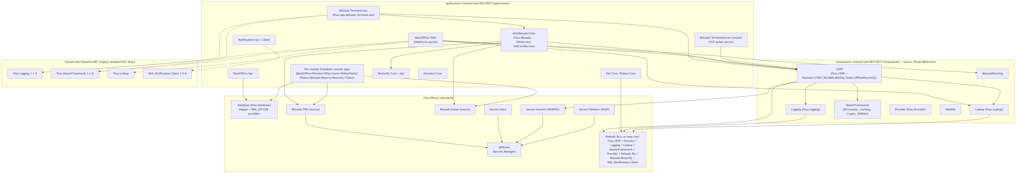
Reading this diagram: solid arrows are confirmed ProjectReference/direct source dependencies; dotted arrows are confirmed HintPath references to the legacy Libraries/NET vendored copies that coexist alongside (and are not fully replaced by) class-library. PrebuiltDlls is drawn as one node because multiple modules reference individual DLLs from that same class-library root directory (e.g. Fiuu.CEPP.csproj references class-library\Fiuu.Lookup.dll directly, on top of also depending on the Lookup component's source elsewhere) — see per-module docs for exactly which DLL each consumer references. TermSrv --> CEPP is a lower-confidence edge — the terminal socket server's dozens of VB MessageHandlers were not individually traced to confirm each one calls into the same CEPP/MOLReloads.Core services the REST API uses (see terminal-application.md for the caveat). Note that AWSCore is reached only through Reloads/TNG and the three Secure/* modules at the .csproj level — no application project (Restorify/Core, EInvoice/Core, etc.) references it directly, even though AWSCore/Enums/SecretsLabels.cs defines label groups for partners (EInvoice, EPay, and many more) with no confirmed ProjectReference path to them. See class-library/awscore.md for that open question.

Sequence diagrams
Traced end-to-end from real controller/service code (see each file for exact source citations):
- diagrams/tng-reload-flow.md — TNG e-wallet card transaction via the Terminal API.
- diagrams/giftcard-incomm-flow.md — INCOMM gift card initiate + confirm via the Terminal API.
- diagrams/einvoice-submission-flow.md — EInvoice end-customer submission — a scheduled batch job, not a live-transaction trigger (a correction to the natural assumption); fully traced except for the identity of the external gateway it calls, which isn't named anywhere in code.

What wasn't traced in this pass
- reload_db itself (schema, stored procedures) — out of scope; see the reload-db-schema skill for that.
- Every one of the ~60 MessageHandlers in the terminal socket server.
- The exact build/publish mechanism that turns Components/* and Applications/*/Core source into the prebuilt DLLs committed at class-library's repo root (see 00-topology.md §4).
- power_bi/ and powershell/ — confirmed empty, nothing to trace.
- Any second "reload_portal" codebase — see reload-portal.md.

Related
- Topology: what's actually on disk vs. what we assumed — the verification pass this overview is built on
- Reloads.Restorify — the carbon-offset product line mentioned above (naming correction)
- AWSCore — the partner-secrets mechanism behind the roster listed above
- reload_db — Database Estate Overview — the database estate this application talks to
- Reload — Tribal Knowledge — recurring bug classes across the components diagrammed here

console_app — a family of background-job apps, not one app
architecture/reload/console-app.md
See 00-topology.md §3. There is no single "console_app" project; this name best maps to a category of independent console executables, each scoped to one business module. They were not individually traced in depth in this pass — this doc records what exists and where, at breadth, per the brief's priority on covering every component rather than exhaustively reading each one.
Not covered here: Reloads/TerminalServer/Console, which is also technically a console app but is documented separately in terminal-application.md because it's a long-running socket server for terminal hardware, not a scheduled background job — a different category despite the shared "Console" folder name.

Per-module scheduler apps
Each of these is Applications/<Module>/Scheduler, its own .sln/.csproj, and (per the git ls-tree file counts in 00-topology.md) genuinely tracked, live code:
Module | Path | Project
BackOffice | Applications/BackOffice/Scheduler | Fiuu.App.BackOffice.Console.csproj
EInvoice | Applications/EInvoice/Scheduler | Fiuu.App.EInvoice.Console.csproj
EPay | Applications/EPay/Scheduler (+ Scheduler/Core) | Fiuu.App.EPay.Console.csproj / Fiuu.App.EPay.Core.csproj
Game | Applications/Game/Scheduler | Fiuu.App.Game.Console.csproj
OnlineTopUp | Applications/OnlineTopUp/Scheduler | (csproj not individually confirmed by name)
Pinless | Applications/Pinless/Scheduler | Fiuu.App.Pinless.Console.csproj
Reloads | Applications/Reloads/Scheduler | Fiuu.App.Reloads.Console.csproj
Reports | Applications/Reports/Scheduler | Fiuu.App.Reports.Console.csproj
Restorify | Applications/Restorify/Scheduler | Fiuu.App.Restorify.Console.csproj
Ticket | Applications/Ticket/Scheduler | Fiuu.App.Ticket.Console.csproj

Confirmed dependencies for a sample of these (via .csproj ProjectReference, see 00-topology.md §4 for the general pattern):
- Reports/Scheduler, Reloads/Scheduler, Game/Scheduler all reference class-library/Reloads/TNG/Fiuu.Reloads.TNG.csproj and class-library/Reloads/Game/Fiuu.Reloads.Game.csproj directly.
- The rest were not individually opened; assume the same shared-dependency pattern as their sibling Api/Core projects (documented in the relevant class-library docs) until confirmed otherwise.
Given the naming (BackOffice/EInvoice/EPay/Game/OnlineTopUp/Pinless/Reloads/Reports/ Restorify/Ticket), these are near-certainly scheduled jobs (report generation, reconciliation, settlement batches, expiry/cleanup) for their respective business module — but the specific jobs each one runs were not read in this pass (would require opening each Program.cs/job-scheduling code individually).

Standalone one-off tools
Smaller, don't fit the per-module Scheduler pattern:
- Applications/BulkUploadFile (Fiuu.App.BulkUploadFile.Console.csproj, 5 tracked files) — bulk file upload utility (product/stock data import, inferred from name; not confirmed).
- Applications/SalesDiscrepancy (Fiuu.App.SalesDiscrepancy.Console.csproj, 5 tracked files) — sales reconciliation discrepancy checker (inferred from name).
- Applications/SAP (Fiuu.App.SAP.Console.csproj, 27 tracked files, has its own Helper/, Model/, Providers/, Services/ subfolders) — SAP integration/export tool, presumably for financial posting to an SAP ERP system. Largest of the standalone tools; plausibly worth a deeper look in a future pass given its size relative to "one-off."
- Applications/UploadStock (Fiuu.App.UploadStock.Console.csproj, 5 tracked files) — stock upload utility (inferred from name).
- Applications/EPay/Recon/Cmd (+ Recon/Core) — a reconciliation command-line tool specific to EPay, separate from EPay/Scheduler.
- Applications/Notification/Client/Cmd — a command-line variant of the Notification client (see class-library/notification.md).
None of these had their Program.cs main logic read in this pass — only confirmed to exist and to have a real entry point file.

Dead/removed: the old Applications/CEPP scheduler umbrella
Applications/CEPP/ (the old umbrella, distinct from the live Components/CEPP) used to contain per-report console tools — AutoUploadStock, BulkUploadFile, MonthlySalesReport, MReloadSettlementReport, ProfitReport, ReversalBatch, SalesDiscrepancy, SAPReporting, Scheduler, SevenETelcoSales, StoreBulkUploadFile, TelcoSalesReport, TerminalReportScheduler, TerminalServer_VB, Ticket, UnsoldStockBalanceReport, UploadStockBackend — but this entire folder has zero tracked files at HEAD (confirmed dead, see 00-topology.md §5). The naming overlap with several of the standalone tools above (BulkUploadFile, SalesDiscrepancy, SAPReporting/SAP, Ticket) strongly suggests these were split out of the old CEPP umbrella into their current per-module homes under Applications/* directly, and the umbrella folder was deleted from git but not cleaned up locally. Treat the current per-module locations in the tables above as the live versions; do not reference Applications/CEPP/* as current anywhere.

Related
- Topology: what's actually on disk vs. what we assumed — the dead-folder verification (§5) behind the "don't reference Applications/CEPP/*" warning
- Reloads/TNG and Reloads/Game (bonus doc — real class-library source modules, — the Fiuu.Reloads.TNG/Fiuu.Reloads.Game dependency confirmed for several schedulers
- SAP — the database the standalone Applications/SAP tool most likely posts to

reload_portal — open question, not resolved
architecture/reload/reload-portal.md

Status: unresolved, needs a human answer
The brief asked for this to be documented as a distinct component from web_app. After searching the entire reload repo (the only place any application code actually lives — see 00-topology.md §1), no second web-forms / web-UI application was found. The only candidate is BackOffice/Web, which is already documented as the answer for web_app in web-app.md.
What was checked:
- find reload/web/DEV/NET/Applications -iname "*portal*" — the only hits are two model classes (Reloads/Terminal/Api/Models/Portal/PortalPinlessCheckAvailabilityResponse.cs, PortalStockCheckVoidedStatusResponse.cs) — these are just response DTOs named "Portal" inside the Terminal API, not a separate application.
- grep -ri "reload_portal\|ReloadPortal" across Applications/ — no matches.
- Every Applications/* subfolder was enumerated (see the table in 00-topology.md §3) — EPay, OnlineTopUp, MOLReloads, etc. each contain only Scheduler/Api/Core console-or-API projects, no additional WebForms or MVC UI project besides BackOffice/Web.
- The top-level reload_portal/ sibling folder (outside the reload repo) is confirmed empty — see 00-topology.md §1.

Possible explanations (not verified — pick one with the team)
- Same thing, two names. "reload_portal" and "web_app" both refer to BackOffice/Web, and the naming difference is just how different people/docs refer to the same deployable (e.g. internal team calls it "the portal," ops/infra calls it "web_app"). If so, this file should be merged into or made an alias of web-app.md.
- Doesn't exist yet here. A genuinely separate merchant/dealer self-service portal (as opposed to the internal-admin-flavored BackOffice/Web) exists in a different repo, branch, or hasn't been migrated into this monorepo yet.
- Planning artifact. The empty top-level reload_portal/ folder (like the other six empty siblings) may just be a placeholder created for this handbook's own scaffold or a future reorg, not evidence a real "reload_portal" codebase exists anywhere yet.
Recommendation: confirm with the team which of the three is true before writing anything more specific here. Until then, treat any reference to "the reload portal" elsewhere in this handbook as meaning BackOffice/Web (documented in web-app.md), with this ambiguity flagged.

Related
- web_app → BackOffice/Web — the BackOffice/Web app this open question centers on
- Topology: what's actually on disk vs. what we assumed — the full empty-sibling-folder verification this doc's evidence is drawn from

terminal_application → Reloads/TerminalServer/Console (+ ControlPanel)
architecture/reload/terminal-application.md
See 00-topology.md §3. No folder is literally named terminal_application; this is the best-fit mapping — a Windows console/service app that legacy POS terminal hardware connects to directly, as opposed to the modern REST API in web-api.md.

TerminalServer/Console — the socket server
- Path: reload/web/DEV/NET/Applications/Reloads/TerminalServer/Console
- Project: Fiuu.App.Reloads.TerminalServer.Console.vbproj / .sln
- Type: VB.NET console application (built as a Windows Service in production, based on ServerBase.vb/Program.vb structure — service-hosting specifics not further confirmed).
- Purpose: hosts a custom raw TCP socket server that physical POS terminal hardware (and/or terminal-side software) connects to directly, as an alternative transport to the REST API. This is clearly the older/legacy integration path — the REST API (Reloads/Terminal/Api) and a Reloads/Terminal/Simulator project (which tests calls against that REST API) exist alongside it, suggesting an in-progress or completed migration from socket-based to REST-based terminal integration, with the socket server kept running for hardware that hasn't/can't move.

Entry point / structure
- Program.vb → TerminalServer.vb / ServerBase.vb — startup and server lifecycle.
- Sockets/ConnectionListener.vb, ConnectionHandler.vb, ClientConnection.vb, ConnectionManager.vb, ConnectionMonitor.vb — the raw socket accept/dispatch layer.
- MessageHandlers/TerminalMessageManager.vb — routes an inbound message to the correct handler.
- MessageHandlers/*.vb — roughly 60 handler classes, one (or a few, versioned by suffix like 10403/10405/10408) per message type: TNG*Handler (Profile, Host Authentication, Online Card Validation, Blacklisted Card, Fund Request, Card Transaction, EndOfDay, EndOfShift, Summary Transaction, Audit Trail), InComm*Handler (Authorize Card, Profile, EndOfDay, EndOfShift), OfflinePayment*Handler (Address, EndOfDay, EndOfShift, Inquiry, Profile, QR Inquiry/Request, Refund, Reversal, Settlement, Transaction), BillPayment*Handler (Account Inquiry, EndOfDay, EndOfShift, Profile, PTPTN Account Query, Submission), Pinless*Handler (Check Transaction Status, Mobile Query, Sales, Submit Topup), Restock*Handler/ReStock*Handler/StockReturn*Handler, Sales*Handler/VoidSales*Handler, TerminalProfileHandler/TerminalContentHandler /TerminalAutoRestockHandler/TerminalAppVersionHandler, PackageSchemaHandler, PrepaidCardRegistrationHandler/PrepaidRegisterProductHandler, ReloadWalletHandler, WalletBalanceHandler, MOLPayEndOfDayHandler/ MOLPayEndOfShiftHandler/MOLPayProductHandler, EchoHandler, ServerTimeHandler, ErrorHandler/UnknownHandler.

Confirmed dependency on the shared business layer
Spot-checked MessageHandlers/TNGProfileHandler.vb — it directly Imports: Fiuu.CEPP, Fiuu.CEPP.Models, Fiuu.CEPP.Models.Interfaces, Fiuu.CEPP.Services, Fiuu.Reloads.TNG.Models, Fiuu.Reloads.TNG.Services, Fiuu.MasterFramework.Dependency. This confirms the socket server calls into the same Components/CEPP and class-library/Reloads/TNG source used by the REST API (see web-api.md and class-library/cepp.md).
Caveat: only one handler was read in full. It calls Fiuu.Reloads.TNG.Services directly rather than going through MOLReloads/Core's TNGService (the class the REST API's TNGController calls). This suggests the socket server and REST API may each build their own orchestration on top of the same lower-level CEPP/TNG source, rather than sharing one common orchestration service — i.e. possible logic duplication between the two terminal-facing entry points, not a clean shared-service architecture. The other ~59 handlers were not individually checked; this pattern was not confirmed across all of them. Flagged as a real follow-up item, not resolved here.

TerminalServer/ControlPanel — the operator console
- Path: reload/web/DEV/NET/Applications/Reloads/TerminalServer/ControlPanel
- Project: Fiuu.App.Reloads.TerminalServer.ControlPanel.vbproj
- Type: VB.NET WinForms desktop application (MainForm.vb).
- Purpose (inferred from name/pairing): an operator/ops desktop tool to monitor and/or control the TerminalServer/Console service (start/stop, view connections, etc.). Not traced further — MainForm.vb contents weren't read in this pass.

What this is NOT
Not to be confused with Reloads/Terminal/Api (the REST API — see web-api.md) or Reloads/Terminal/Simulator (a test harness for that REST API, not the socket protocol). All three live under the same Applications/Reloads/ parent but are separate deployables.

Related
- web_api → Reloads/Terminal/Api (+ BackOffice/Api) — the modern REST counterpart to this legacy socket server
- CEPP — the shared business layer both terminal-facing entry points call into
- Reloads/TNG and Reloads/Game (bonus doc — real class-library source modules, — the Fiuu.Reloads.TNG.Services confirmed called directly by TNGProfileHandler.vb
- Reload — Tribal Knowledge — the #1892 incident (unhandled exception silently stopping TNG sales overnight) on this same component

web_api → Reloads/Terminal/Api (+ BackOffice/Api)
architecture/reload/web-api.md
See 00-topology.md — there is no folder literally named web_api. This name is mapped onto the two REST APIs found in the repo. They are documented together here since the brief asked for one web-api.md; they are separate deployables.

Primary: Reloads/Terminal/Api
- Path: reload/web/DEV/NET/Applications/Reloads/Terminal/Api
- Project: Fiuu.App.Reloads.Terminal.Api.csproj / .sln
- Type: ASP.NET Web API (System.Web.Http), C#, .NET Framework
- Purpose: the production REST API that terminals (physical POS hardware via a gateway, software terminals, and third-party PGW integrators) call to perform reload transactions. This is the modern counterpart to the legacy TCP socket protocol served by Reloads/TerminalServer/Console (see terminal-application.md).

Entry points / public surface
Controllers under Controllers/ (all inherit RMSAuthController → BaseController unless noted), each mapped to [Route(...)] attributes:
- TNGController — tngreload/tngProfile, hostauthentication, onlinecardvalidation, blacklistedcard, fundrequest, cardtransaction (Touch 'n Go e-wallet reload).
- GiftCardController — giftcard/initiate, giftcard/confirm (INCOMM gift cards).
- TicketController, StockController, BillController, PinlessController, MOLPayController, OfflineController, MobileAppController, GameController, CarbonCalculatorController, CarbonOffsetController, ProfileController, ReconciliationController, CacheController, VersionController, DemoController, TestController — one controller per business capability; not individually traced in this pass.
- Controllers/Pgw/Pgw_*Controller — a parallel set of controllers (Pgw_BaseController, Pgw_BillController, Pgw_GiftCardController, Pgw_MOLPayController, Pgw_OfflineController, Pgw_PinlessController, Pgw_StockController, Pgw_TNGController) — appears to be a variant surface for a specific "PGW" (payment gateway) integration channel, distinct from the main controllers above. Not traced further; flagged as needs-follow-up to confirm the exact difference from the non-Pgw_ equivalents.
- RMSAuthController (Controllers/RMSAuthController.cs) — not a route itself; the shared base class providing AccessId and DealerType from the authenticated ClaimsPrincipal.

Authentication
Custom scheme, not ASP.NET Identity / OAuth. Verified in Infrastructure/Security/AuthenticationAttribute.cs:
- Every RMSAuthController-derived controller is decorated [Authentication] (an IAuthenticationFilter).
- Expects a standard Authorization HTTP header whose scheme name is looked up via a pluggable AuthenticationSchemeFactory, and whose parameter is base64(accessId):base64(signature).
- The resolved scheme's AuthenticateRequest(...) validates the accessId+signature pair and produces an IPrincipal; on success AccessId becomes available to controllers via RMSAuthController.AccessId. The exact signature-verification algorithm (which scheme classes exist, e.g. HMAC vs. something else) was not traced in this pass — AuthenticationSchemeFactory and its scheme implementations are a follow-up.

Dependencies (confirmed via .csproj)
From Fiuu.App.Reloads.Terminal.Api.csproj:
- ProjectReference → Components/CEPP/Fiuu.CEPP.csproj and Components/CEPP/Payment/BillPayment/Fiuu.Reloads.BillPayment.csproj
- ProjectReference → Applications/Restorify/Core/Fiuu.Reloads.Restorify.csproj
- ProjectReference → Applications/MOLReloads/Core/Fiuu.Reloads.csproj (the business logic layer — see below)
- ProjectReference → class-library/Reloads/TNG/Fiuu.Reloads.TNG.csproj and class-library/Reloads/Game/Fiuu.Reloads.Game.csproj
- HintPath (legacy) → web/Libraries/NET/Fiuu.Logging.1.1.0/... and Fiuu.MasterFramework.1.1.0/...
The controllers themselves are thin — they map request models, call into Applications/MOLReloads/Core (Fiuu.Reloads namespace) service classes (TNGService, GiftCardService, etc. — see class-library/cepp.md for how those services are composed), and map the resulting ErrorCode back to an HTTP response. All real business logic (terminal/store/dealer lookup, commission calculation, wallet debit, partner call, DB persistence) lives one layer down in MOLReloads/Core, not in the API project itself.

External systems reached (confirmed by code, see sequence diagrams)
- TNG — via class-library/Reloads/TNG source, called from MOLReloads/Core/Services/TNGService.cs. Wire protocol not traced.
- INCOMM — via Components/CEPP/Payment/INCOMM (InCommOperationService → InCommSecureProvider), which does a plain HTTPS JSON POST to a URL from AppSettings["GetInCommApiUrl"]. See diagrams/giftcard-incomm-flow.md.
- Everything else the controller list implies (Ticket, Stock, Bill, Pinless, MOLPay, Game, Carbon Calculator/Offset) was not traced end-to-end in this pass.

Databases touched
Via MOLReloads/Core → class-library/Database (Fiuu.Database, Dapper + RMS_OFFLINE stored procedures) and class-library/AWSCore (partner credentials from Secrets Manager). See 00-topology.md §7 for the exact mechanism — no literal connection strings exist in this repo to cite.

Secondary: BackOffice/Api
- Path: reload/web/DEV/NET/Applications/BackOffice/Api
- Project: Fiuu.App.BackOffice.Api.csproj (25 tracked files — much smaller than the Terminal API) + a Core sub-project (Fiuu.App.BackOffice.Core.csproj).
- Purpose (inferred from name and its consumer): a REST API backing BackOffice/Web (see web-app.md) for AJAX/JSON calls the WebForms portal makes. Not traced in depth in this pass — flagged as needs-follow-up if the portal's client-side behavior needs documenting.
- A repo-wide check found Fiuu.App.BackOffice.Core.csproj does not reference class-library/Database/Fiuu.Database.csproj directly (that direct reference exists only from Notification/Api/Core — see class-library/database.md). How BackOffice/Api reaches RMS_OFFLINE (prebuilt DLL? Fiuu.Provider? something else?) was not confirmed in this pass — flagged as follow-up rather than assumed.

Note: a third, dead "BackOfficeAPI"
Applications/BackOfficeAPI/ (capitalized differently, no space) also exists on disk but has zero tracked files at HEAD — it's removed/dead code with only leftover local build artifacts. See 00-topology.md §5. Do not confuse this with the live BackOffice/Api documented above.

Related
- CEPP — the Fiuu.CEPP/MOLReloads/Core business layer these controllers call into
- Sequence: TNG e-wallet card transaction (via Terminal API) and Sequence: INCOMM gift card — Initiate + Confirm (via Terminal API) — sequence diagrams traced through TNGController/GiftCardController
- terminal_application → Reloads/TerminalServer/Console (+ ControlPanel) — the legacy socket-server counterpart to this REST API
- Reload — MR Review Checklist — the merchant-timestamp and partner-spec review rules (§A4, §A5) that apply directly to these controllers

web_app → BackOffice/Web
architecture/reload/web-app.md
See 00-topology.md §3 — no folder is literally named web_app. The only traditional web-forms UI application found anywhere in this checkout is BackOffice/Web, so that's what this doc covers. See reload-portal.md for the open question of whether this is also what "reload_portal" refers to.

What it is
- Path: reload/web/DEV/NET/Applications/BackOffice/Web
- Project: Fiuu.App.BackOffice.Web.vbproj / .sln
- Type: ASP.NET Web Forms, VB.NET, .NET Framework
- Scale: 1,346 tracked files under this path (by far the largest single application in the repo) — 374+ files directly under WebForms/ alone.
- Purpose: the internal back-office administration portal — dealer, store, terminal, product, commission, and wallet management for the reload business, used by Fiuu staff and/or dealers (not confirmed which; the presence of both an AspNetSqlMembershipProvider/SqlRoleProvider config and BotDetect CAPTCHA handlers suggests it's exposed to external logins, not purely intranet-only, but this wasn't confirmed further).

Entry points
- Global.asax / Global.asax.vb — application startup.
- Default.aspx — landing page.
- WebForms/*.aspx(.vb) — the bulk of the UI (hundreds of pages; not enumerated individually in this pass — e.g. ProductEdit.aspx was seen as one of the few files with uncommitted local changes at the time of this trace).
- BackOffice.Master — the shared master page/layout.
- Helpers/ (BackofficeExtension.vb, ConverterHelper.vb, HelperFunction.vb, Lookup.vb) — page-level utility code.

Dependencies (confirmed via .vbproj)
- HintPath (legacy Libraries/NET) → Fiuu.Logging.1.1.0, Fiuu.Lookup, Fiuu.MasterFramework.1.1.0.
- ProjectReference → Components/CEPP/Fiuu.CEPP.csproj and Components/CEPP/Payment/BillPayment/Fiuu.Reloads.BillPayment.csproj.
- ProjectReference → Components/Lookup/Fiuu.Lookup.csproj.
- ProjectReference → Components/ReloadsPatching/Fiuu.Patching.csproj.
- ASP.NET membership/role providers configured against a connection string named ApplicationServices (AspNetSqlMembershipProvider, AspNetSqlProfileProvider, AspNetSqlRoleProvider in Web.config) — this is the standard ASP.NET membership schema, a separate connection-string name from the RMS_Offline/LOGGING/ Notification file-based aliases used elsewhere (see 00-topology.md §7). Where ApplicationServices itself is configured was not found as a literal <connectionStrings> entry in Web.config — likely supplied by a config transform or machine-level config not present in this checkout. Flagged as unknown.
- No direct ProjectReference/HintPath to class-library's Database or AWSCore projects was found in this .vbproj itself — any dependency on those is transitive through Components/CEPP (which does depend on class-library — see class-library/cepp.md).

What it does NOT appear to be
This is a WebForms admin console, not a customer-facing storefront. No shopping-cart or public checkout code was found under this path. If a consumer-facing "reload online top-up" web page exists, it wasn't found in this checkout — Applications/OnlineTopUp/ only contains a Scheduler (background job) component, no web front-end (confirmed via git ls-tree, see 00-topology.md §3 table). Flagged as a gap, not a confirmed absence of such a page somewhere else.

Databases / external systems touched
- RMS_OFFLINE (transitively, via Components/CEPP → class-library/Database).
- ASP.NET membership schema via the ApplicationServices connection string name (identity of the target database not confirmed — see above).
- No direct partner integration code was found in this project itself; any partner calls it triggers would go through Components/CEPP service classes, same as the API (see web-api.md).

Related
- reload_portal — open question, not resolved — the open question of whether "reload_portal" refers to this same app
- CEPP — the domain layer this portal's dealer/store/terminal admin pages sit on top of
- Lookup — the direct source-level Fiuu.Lookup dependency confirmed above
- Reload — Tribal Knowledge — the validator-scope bugs (§2.1, §2.2) specific to this WebForms portal

AWSCore
architecture/reload/class-library/awscore.md
Source: reload/class-library/AWSCore — a genuine class-library submodule module (not split out to Components/, unlike CEPP/Logging/Lookup/MasterFramework/ Provider — see ../00-topology.md §4).

What it's for
Centralizes access to AWS Secrets Manager for partner-integration credentials (API keys, login IDs, passwords — never database connection strings, which use a separate file-based mechanism, see database.md and ../00-topology.md §7).

Structure
- Services/SecretsManagerService.cs — thin wrapper around the AWS Secrets Manager SDK; ServiceBase.cs is its (and other AWSCore services') common base.
- Helpers/SecretsHelper.cs — a singleton (SecretsHelper.Instance) that, on first use, reads an EventAppName app setting, maps it through Enums/AppUserNames.cs to decide which partner's secret labels this particular running application needs, then eagerly fetches every matching label from Secrets Manager into an in-memory SecretsDictionary.
- Enums/SecretsLabels.cs — one nested static class per partner, each holding const string label names of the form "{Partner}#{Field}" (e.g. AnyPay.LoginId = "AnyPay#LoginId"). Confirmed partners with dedicated label groups (from actually reading this file): AnyPay, Astro, ATX, Celcom, Digi, DTOne, EInvoice, EPay, IIMMPACT, InComm, IWK, JomPay, and more not enumerated individually in this pass (the file continues past what was read).
- Enums/AppUserNames.cs — the per-application identity constants (AstroConsole, Astro, etc. seen referenced) that SecretsHelper switches on to decide which labels to preload — i.e. each deployed app only pulls the secrets it actually needs, not the whole partner roster.
- Providers/ConfigurationProvider.cs — not read in detail in this pass.
- Models/ — not enumerated in this pass.

Why this matters for the rest of the handbook
This is the reason no <connectionStrings>-style partner credential ever appears in any Web.config/App.config in this repo — anywhere a controller or service needs a partner API key/password, expect it to come from SecretsHelper.Instance or SecretsManagerService, not from config. This was confirmed as the mechanism, not inferred — but which specific classes call SecretsHelper for which partner integration was not individually traced for every partner (e.g. it wasn't directly confirmed that Pin/Core's AnyPaySecureProvider.cs calls SecretsHelper rather than reading ConfigurationManager.AppSettings the way EInvoiceSecureProvider.cs and InCommSecureProvider.cs do for their endpoint URLs — those two do use AppSettings for URLs, which is a different, non-secret piece of config).

Consumers
Confirmed via grep for AWSCore across every .csproj in the repo: only class-library's own sibling modules reference it via ProjectReference — Reloads/TNG/Fiuu.Reloads.TNG.csproj, Secure/Astro/Fiuu.Astro.Secure.Core.csproj, Secure/Incomm/Fiuu.InComm.Secure.Core.csproj, Secure/Telekom/Fiuu.Telekom.Secure.Core.csproj. *No application project (`Applications/) references AWSCore.csproj directly** — meaning any application that needs secrets gets them transitively through those four modules (e.g. through MOLReloads/Core → Reloads/TNG → AWSCore for TNG credentials), not by referencing AWSCore itself. This is narrower than initially assumed from the partner roster in SecretsLabels.cs (which lists many more partners than just TNG/Astro/Incomm/ Telekom) — either those other partners' secret-fetching code lives somewhere that reaches AWSCore some other way (e.g. via the prebuilt class-library DLLs rather than ProjectReference, which this grep wouldn't catch), or SecretsLabels.cs` defines labels for partners whose actual secret-fetching call site wasn't found in this pass. Flagged as a real follow-up, not resolved.

Related
- Configuration & Secrets — the full config/secrets picture this module is one mechanism of
- Reloads/TNG and Reloads/Game (bonus doc — real class-library source modules, — a confirmed AWSCore consumer (TNG merchant keys)
- Secure (Astro, Incomm, Telekom) — the three Secure/* modules (Astro/Incomm/Telekom) that also depend on AWSCore
- EInvoice — the same open question about how partner secrets reach modules with no direct AWSCore reference

CEPP
architecture/reload/class-library/cepp.md
Source: reload/web/DEV/NET/Components/CEPP (1,551 tracked files — by far the largest shared component). Prebuilt artifact: Fiuu.CEPP.dll sits at the root of the class-library submodule, but its source is here in Components/CEPP, not in class-library itself — see ../00-topology.md §4 for that split. The acronym "CEPP" is not expanded or explained anywhere in the code that was read; its meaning was not confirmed in this pass.

What it's for
The core retail/POS transaction engine shared by essentially every terminal-facing flow: terminal/store/dealer identity and lookup, wallet/store-account balance management, commission and margin-rate calculation, API transaction persistence, and per-partner payment sub-modules. Functionally this is the "domain layer" underneath both the REST Terminal API and the legacy terminal socket server (see ../web-api.md, ../terminal-application.md).

Structure
- Configuration/, Exceptions/, Helpers/, Models/, Properties/, Providers/, Services/ — the core CEPP domain (terminal, store, dealer, commission, transaction, maintenance-window services/providers).
- Payment/ — one sub-project per payment/partner channel, each its own .csproj:
- Payment/BillPayment (Fiuu.Reloads.BillPayment.csproj)
- Payment/INCOMM (Fiuu.Reloads.GiftCard.csproj) — the INCOMM gift-card integration; see ../diagrams/giftcard-incomm-flow.md.
- Payment/MOLPay (Fiuu.Reloads.FiuuCash.csproj)
- Payment/OfflinePayment (Fiuu.Reloads.OfflinePayment.csproj)
- Payment/Ticket (Fiuu.Reloads.Ticket.csproj)

Public surface (confirmed via EngineContext.Current.Resolve<T>() calls in
MOLReloads/Core/Services/GiftCardService.cs and TNGService.cs)
Interfaces resolved through the Autofac-based DI container (Fiuu.MasterFramework.Dependency — see masterframework.md): ITerminalService, IStoreService, IDealerService, IReconciliationService, ITerminalContentService, ITerminalContentProductService, IApiTransactionProvider, IStoreAccountService, ICommissionRatesService, ICommissionRateService, IScheduledMaintenanceService, IInCommOperationService, IInCommTransactionService, IInCommTerminalService, IInCommService, and (from class-library/Reloads/TNG) ITNGTerminalService/ITNGAccountsService/ITNGTerminalsService/ ITerminalOperationService/ITNGFundRequestsService/ITNGCardTransactionsService/ IBlacklistCardsService. A ServiceLocator static class is also used in places as an alternative to constructor/property DI (seen in GiftCardService).
Fiuu.CEPP.Models.Interfaces defines the domain model contracts (ITerminal, IStore, IDealer, IInCommProduct, ISalesCommissionMarginRates, IStoreAccount, ITerminalContent, ITerminalContentProduct, etc. — inferred from usage in GiftCardService.cs/TNGService.cs, not from reading the interface definitions directly).

Known dependencies
- class-library/Fiuu.Lookup.dll — direct HintPath reference from Fiuu.CEPP.csproj (confirmed).
- class-library/Secure/Incomm (ISO8583 framework) — used by the INCOMM payment sub-project's lower-level stand-in processing (class-library/Secure/Incomm/Services/ActivationStandInService.cs), while the live preauth/activation path (InCommOperationService → InCommSecureProvider) instead does a plain HTTPS JSON POST — see ../diagrams/giftcard-incomm-flow.md. The exact circumstances under which the ISO8583/stand-in path is used instead of the HTTP path were not confirmed — flagged as follow-up.
- Components/Logging, Components/MasterFramework (implied by nearly every class using Logger.WriteErrorToEventLogs(...) and EngineContext).

Consumers
- Reloads/Terminal/Api (direct ProjectReference) — see ../web-api.md.
- Reloads/TerminalServer/Console MessageHandlers/* (direct Imports of Fiuu.CEPP namespaces, confirmed in TNGProfileHandler.vb) — see ../terminal-application.md.
- BackOffice/Web (direct ProjectReference to Fiuu.CEPP.csproj and Fiuu.Reloads.BillPayment.csproj) — see ../web-app.md.
- MOLReloads/Core (Fiuu.Reloads — TNGService, GiftCardService) builds its orchestration directly on top of CEPP's services/providers.

Related
- CEPP — the CEPP database this component is the domain layer over
- Lookup — the Fiuu.Lookup.dll dependency confirmed above
- MasterFramework — the DI container (EngineContext) and logging plumbing this module builds on
- Sequence: INCOMM gift card — Initiate + Confirm (via Terminal API) — the INCOMM payment sub-project's traced sequence diagram

Database (Fiuu.Database)
architecture/reload/class-library/database.md
Source: reload/class-library/Database — a genuine class-library submodule module.

What it's for
The primary data-access layer for the RMS_OFFLINE SQL Server database, built on Dapper. This is the newer of the two parallel data-access layers found in this codebase — see provider.md for the older SqlAccessor-based one (Fiuu.Provider/Fiuu.MasterFramework.Database) that coexists with it.

Structure
- Base/BaseProvider.cs — generic BaseProvider<T>: takes a connection string in its constructor, exposes GetSingle, GetList, Update, Delete, Insert — all via Dapper.Query/Execute/ExecuteScalar against a stored procedure name passed in as a string (CommandType.StoredProcedure), using a fresh SqlConnection per call.
- Base/RMSOffineProvider.cs (sic — "Offine" is a typo in the actual class name) — RMSOffineProvider<T> : BaseProvider<T>, hardcodes the connection string to DBConnectionHelper.GetRMSOFFLINEConnectionString(). Every concrete provider in Providers/RMS_OFFLINE/ extends this.
- Base/LoggingProvider.cs — presumably the equivalent for the LOGGING database (not read in this pass, but DBConnectionHelper.GetLOGGINGConnectionString() exists alongside the RMS_OFFLINE one, so this is a reasonable inference).
- Helpers/DBConnectionHelper.cs — the connection-string mechanism. No <connectionStrings> config anywhere; instead, at runtime it looks for a plain text file named {alias}.txt (aliases seen in code: RMS_Offline, LOGGING, Notification) in d:\db\ or c:\db\ on the host machine, and reads the raw file contents as the connection string, caching it in a static field after first read. See ../00-topology.md §7 — this is described here as a mechanism only; no actual connection string value exists in this repo to expose.
- Providers/RMS_OFFLINE/* — over 30 concrete providers, one per table/entity area: AuditLogsProvider, ConfigProvider/ConfigDetailsProvider, CountryProvider, StateProvider, DevicesLoginTrailProvider, EInvoiceRequestProvider, FAQCategoryProvider/FAQDetailsProvider, FooterCategoryProvider/ FooterDetailsProvider, HomePageDetailsProvider, MaintenanceNoticeDetailsProvider, MiscellaneousDetailsProvider, OneTimePasswordProvider, PartnersProvider/ PartnerPurchaseProvider/PartnerServiceChargeProvider, PaymentOptionProvider/ PaymentTransactionsProvider, ProductProvider/ProductGroupProvider, RetryTransactionsProvider, RewardCampaignsProvider (+ Cap/CapBalance/ Platform/Product/Transaction variants), ServiceProvider, SupportCategoryProvider/SupportDetailProvider, TransactionDetailsProvider, UserExternalLoginsProvider, UsersProvider.
- Models/, Services/ — not enumerated in this pass.

What this confirms about the RMS_OFFLINE database
The provider list above is a reasonable proxy for what RMS_OFFLINE actually stores: users/auth, partners, products, payment transactions and options, reward campaigns, config/content (FAQ, footer, homepage, maintenance notices), audit logs, device login trails, and a queue of "retry transactions" (consistent with the retry-oriented service classes seen in Pinless/Core — see reloads-pin.md). This is not a full schema — see the reload-db-schema skill / reload_db repo for the authoritative schema.

Consumers
A repo-wide grep for Fiuu.Database.csproj across every .csproj/.vbproj found exactly one direct ProjectReference: Notification/Api/Core/Fiuu.App.Notification.Core.csproj (see notification.md). This is narrower than might be expected given RMS_OFFLINE is described elsewhere (partner secrets, config, transactions) as the central database — most other apps likely reach it through the prebuilt class-library DLL rather than a source-level ProjectReference (which a .csproj-text grep wouldn't catch), or through Fiuu.Provider/SqlAccessor instead (see provider.md) rather than Fiuu.Database/Dapper. Which apps use which data-access layer for RMS_OFFLINE was not exhaustively mapped in this pass — flagged as a real follow-up rather than assumed.

Related
- RMS_OFFLINE — the RMS_OFFLINE database this Dapper layer reads/writes
- Notification (bonus doc — not in the original module list, but named as a — the confirmed sole direct ProjectReference consumer
- Provider — the older, parallel SqlAccessor-based data-access layer
- Data Access — the three coexisting data-access patterns, including this one, documented in full

EInvoice
architecture/reload/class-library/einvoice.md
Source: reload/web/DEV/NET/Applications/EInvoice/Core (34 tracked files, Fiuu.EInvoice.csproj) — not inside class-library itself, despite the prebuilt Fiuu.EInvoice.dll living at class-library's repo root (see ../00-topology.md §4 for this source/artifact split, which applies to several modules, not just this one).

What it's for
Submits invoice data to an external e-invoicing gateway and checks submission status. The specific external system was not confirmed in code — no literal mention of "LHDN," "MyInvois," or "IRBM" (Malaysia's national e-invoicing mandate/authority) was found in Applications/EInvoice/. Given Fiuu operates in Malaysia and e-invoicing became a national compliance mandate there, LHDN/MyInvois is a plausible target, but this is inference, not a confirmed fact — flagged for follow-up. What's confirmed is the shape of the integration, not its identity.

Structure
- Models/ — Buyer, Supplier, TaxSummary, ReportEInvoice, EndCustomerEInvoiceRequest, and Models/SecureApi/ (InvoiceRequest, InvoiceItemRequest, SendSubmissionRequest, CheckSubmissionRequest, SubmissionResponse).
- Providers/ — ReportProvider, SubmissionProvider, and Providers/SecureApi/EInvoiceSecureProvider.cs (the actual outbound HTTP client).
- Services/ — ReportService, SubmissionService, ServiceLocator.
- Helpers/HttpClientHelper.cs — shared HTTP call helper.
- Templates/Email/EInvoice/Email.html — an email template, implying some notification-on-submission behavior (not traced further).

Confirmed mechanism
Providers/SecureApi/EInvoiceSecureProvider.cs:
- Reads a base URL from ConfigurationManager.AppSettings["EInvoiceApiUrl"].
- SendSubmision(...) → HTTP POST to {EInvoiceApiUrl}/Submission/Send.
- CheckSubmission(...) → HTTP POST to {EInvoiceApiUrl}/Submission/Check.
- Both send a JSON body and expect a JSON response containing a responseCode; a SubmissionStatusCode.IN_PROGRESS response code is treated as a successful send.
This is a call to a URL configured per-environment, not a hardcoded partner endpoint — consistent with either an internal middleware service that itself talks to LHDN/ MyInvois, or a direct partner integration. Not resolved further in this pass.

Dependencies
- Fiuu.EInvoice.csproj does not reference class-library/AWSCore directly (checked via grep — no match). class-library/AWSCore/Enums/SecretsLabels.cs does define an EInvoice label group (SecretKey, IVCode), so credentials for this module are clearly meant to flow through Secrets Manager — but the actual call site that uses those labels wasn't found in EInvoice/Core itself. Possibly reached through a DLL reference not visible to a ProjectReference grep, or through a project not yet checked. Flagged as unresolved, same open question noted in awscore.md.
- Fiuu.CEPP.Helpers, Fiuu.MasterFramework.Utilities (imported by EInvoiceSecureProvider.cs).

Consumers
- EInvoice/Scheduler (Fiuu.App.EInvoice.Console.csproj) — a scheduled job that presumably batches submissions/checks; not read in this pass. See ../console-app.md.
- Not confirmed whether Reloads/Terminal/Api or BackOffice/Web call into this module directly for real-time submission versus only the scheduler doing batch submission — flagged as follow-up.

Related
- EINVOICE — the EINVOICE database this module submits to
- Sequence: EInvoice end-customer submission (scheduled batch job) — the traced batch-submission sequence diagram
- AWSCore — the unresolved secrets-mechanism question also flagged here

Logging
architecture/reload/class-library/logging.md
Source: reload/web/DEV/NET/Components/Logging (39 tracked files, Fiuu.Logging.csproj). Prebuilt artifacts: both class-library/Fiuu.Logging.dll (newer) and the older, separately-versioned reload/web/Libraries/NET/Fiuu.Logging.1.1.0/Lib/net40/Fiuu.Logging.dll coexist — see ../00-topology.md §4. Many apps (e.g. BackOffice/Web, Reloads/Terminal/Api) still reference the older vendored copy via HintPath rather than the class-library one.

What it's for
A pluggable logging framework — the one visible in the API's own Web.config (<add name="Physical" type="Fiuu.Logging.Providers.FileProvider, Fiuu.Logging" filePath="C:\Logs\RMS\TerminalApi\" .../>), and referenced via a static Logger.WriteErrorToEventLogs(...) call pattern used throughout every other module documented in this handbook.

Structure
- LogManager.cs — the main entry point.
- Providers/ — FileProvider, EmailProvider/SmtpProvider, SqlDataProvider, Database.cs — pluggable log sinks.
- MongoDB/ (Models/, Providers/) — a MongoDB-backed log sink, alongside the SQL/file ones.
- Configuration/ (LoggingConfigurationSection, Provider/ProviderCollection, Filter/FilterCollection, Level/LevelCollection, ExceptionNotification/ExceptionEmailConfigurationElement) — a custom <configSection> design (config-driven, multiple named providers/filters/levels per app, similar in spirit to log4net's config model).
- Http/ (ExceptionLogger.cs, TraceMessageHandler.cs, Http/Filters/) — ASP.NET Web API integration (global exception logging, request tracing).
- Interfaces/ILogProvider.cs — the provider contract.
- Models/ExceptionInfo.cs, Models/Log.cs — the log record shape.

Consumers
Effectively every application and component documented in this handbook references either this or its legacy vendored equivalent — it is the most universally-depended-on module in the codebase (confirmed via the Logger.WriteErrorToEventLogs call sites seen across CEPP, TNGService, GiftCardService, EInvoiceSecureProvider, InCommSecureProvider, and the WebForms/console app config files).

Related
- Logging — the LogHelper wrapper patterns built on top of this component
- CEPP — one of the many confirmed Logger.WriteErrorToEventLogs call sites
- MasterFramework — the sibling cross-cutting technical module this one sits alongside

Lookup
architecture/reload/class-library/lookup.md
Source: reload/web/DEV/NET/Components/Lookup (32 tracked files, Fiuu.Lookup.csproj). Prebuilt artifacts: both class-library/Fiuu.Lookup.dll and the older reload/web/Libraries/NET/Fiuu.Lookup/Lib/net40/Fiuu.Lookup.dll coexist — see ../00-topology.md §4.

What it's for
Reference/lookup data shared across apps: countries, languages, regions, phone-book profiles, application registry, and wallet limits per account type.

Structure
- Models/ — CountryInfo, StateInfo, Language, CountryLanguage, Region, Application, AccountTypeWalletLimit, LookupCodes.
- Enums/ — MStatusEnum (a generic active/inactive/pending-style status enum used widely — seen referenced as EnumStatus elsewhere, e.g. in CEPP), PhoneBookProfileEnum.
- Services/ — LookupService, CountryService, LanguageService, RegionService, ApplicationService, PhoneBookService, WalletLimitService.
- Providers/LookupProvider.cs — data access.
- Caching.cs, DependencyRegistrar.cs — caching layer and Autofac module registration (see masterframework.md for the DI mechanism this plugs into).

Consumers
- Components/CEPP — direct HintPath reference to class-library/Fiuu.Lookup.dll (confirmed in Fiuu.CEPP.csproj) — i.e. CEPP depends on the prebuilt DLL rather than a ProjectReference to this source project.
- BackOffice/Web — direct ProjectReference to Components/Lookup/Fiuu.Lookup.csproj (source-level, not the DLL) — see ../web-app.md. So the same logical module is consumed two different ways by two different callers; not unified.

Related
- CEPP — the confirmed HintPath consumer of Fiuu.Lookup.dll
- MasterFramework — the DI/caching mechanism this module's DependencyRegistrar/Caching.cs plug into
Note: this module's LookupCodes/Region/Country models plausibly correspond to either CEPP.dbo.LookupCodes/Regions or the separate MLookUp database (see MLookUp, which explicitly warns these are physically distinct tables) — which one Fiuu.Lookup actually queries wasn't confirmed in this pass, so no link is asserted here to avoid guessing.

MasterFramework
architecture/reload/class-library/masterframework.md
Source: reload/web/DEV/NET/Components/MasterFramework (149 tracked files, Fiuu.MasterFramework.csproj). Prebuilt artifacts: both class-library/Fiuu.MasterFramework.dll and the older reload/web/Libraries/NET/Fiuu.MasterFramework.1.1.0/Lib/net40/...dll coexist — see ../00-topology.md §4.

What it's for
The cross-cutting technical framework underneath everything else — dependency injection, caching, config, crypto, data access helpers, and general utilities. This is not business logic (that's CEPP/Database/etc.) — it's plumbing that those modules and every application build on.

Structure (by subfolder)
- Dependency/ — the DI container. IContainerManager / AutofacContainerManager / ContainerManager wrap Autofac; AppDomainTypeFinder / WebAppTypeFinder / ITypeFinder do assembly scanning for auto-registration; IDependencyRegistrar is the per-module registration contract (implemented by DependencyRegistrar.cs files seen in Lookup, EInvoice, Restorify, Notification, etc.). This is the mechanism behind the EngineContext.Current.Resolve<T>() pattern used pervasively in CEPP/MOLReloads service classes (EngineContext itself lives in Fiuu.MasterFramework, confirmed by its using Fiuu.MasterFramework; import in GiftCardService.cs/TNGService.cs).
- Caching/ — caching abstraction (consumed by Lookup/Caching.cs, Notification/Api/Core/Caching.cs, Restorify/Core/Services/CacheService.cs, etc.).
- Configuration/ — config access helpers.
- Cookies/ — cookie helpers (web-app-specific).
- Cryptography/, Hashing/, RandomKeys/ — crypto/signature/token utilities (the AuthorizationHelper.NewToken(...) used in GiftCardService.cs to mint gift-card authorization tokens likely sits on top of this, though AuthorizationHelper itself wasn't located/read in this pass).
- Data/, Database/ — lower-level ADO.NET-style data access helpers (SqlAccessor, SqlResult, ParameterCollection, ReturnType — these are the types Components/Provider/ProviderBase.cs builds on; see provider.md). This is a different, older-style data-access layer from class-library/Database's Dapper-based one (see database.md) — the two coexist, not unified.
- Net/ — networking helpers (HTTP clients, likely what HttpClientHelper/HttpHelper classes seen in EInvoice/INCOMM providers build on, though not directly confirmed).
- Pipelines/, Procesors/ (sic — misspelled in the actual folder name) — some kind of processing-pipeline abstraction; not read in this pass.
- Utilities/ — grab-bag helpers (UtilHelper.GetConnectionTimeOutInMilliseconds() /GetConnectionTimeOutInSeconds() seen used in INCOMM/EInvoice providers live here, per the Fiuu.MasterFramework.Utilities namespace).
- Validator/ — validation helpers.
- WinRegistry/ — Windows registry access (suggests some on-prem/desktop deployment concern, consistent with the WinForms TerminalServer/ControlPanel and socket-server console apps).

Consumers
Universal — every application and nearly every other class-library/Components module either references Fiuu.MasterFramework directly or transitively depends on something that does. Confirmed direct references: BackOffice/Web, Reloads/Terminal/Api (both via legacy HintPath), CEPP, Lookup, Provider (via Fiuu.MasterFramework.Database), and every service class using EngineContext.

Related
- Layering / Architecture — the EngineContext/service-locator DI pattern this module implements
- Provider — the SqlAccessor/ParameterCollection data-access helpers that live in this module's Data/Database subfolder
- CEPP — the busiest confirmed consumer of this module

Notification (bonus doc — not in the original module list, but named as a
architecture/reload/class-library/notification.md
prebuilt class-library DLL)
Prebuilt artifact: class-library/MOL.Notification.Client.dll (root of the submodule). Also present as a separate, older vendored copy at reload/web/Libraries/NET/MOL.Notification.Client.1.0.0/.

Source location: not conclusively found
Unlike CEPP/Logging/Lookup/MasterFramework/Provider (whose source was found in Components/*) or Pin/Restorify/EInvoice (found in Applications/*/Core), the source for MOL.Notification.Client.dll specifically was not conclusively identified in this pass. There is a real, live Applications/Notification/Client project, but its assembly name is confirmed (via its .csproj) to be Fiuu.App.Notification.Client — not MOL.Notification.Client. So either:
- the MOL.Notification.Client.dll in class-library is a genuinely separate, older assembly (consistent with the "MOL" brand prefix — Fiuu was formerly MOLPay/ Razer Merchant Services — predating a rename to the Fiuu.App.* convention used everywhere else), whose source may not exist anywhere in this checkout at all, or
- there's a rename/rebuild relationship between the two that wasn't traced.
Flagged as an open question rather than guessed at further.

What the live Applications/Notification/* projects do
This part was traced directly and is solid:
- Notification/Api/Core (Fiuu.App.Notification.Core.csproj) — the notification service's domain layer: Models/Channel.cs, ChannelSetting.cs, Subscriber.cs, SubscriberChannel.cs, MessageRequest.cs, MessageResponse.cs, MessageAcknowledgement.cs, WhitelistedIp.cs, CallbackResponse.cs; services MessageService, EmailNotificationService, EtrackerSmsService, ApplicationService, CacheService; providers MessageProvider, ChannelProvider, ChannelCallbackIpProvider, SubscriberProvider, EtrackerSmsProvider. This confirms the service sends notifications over multiple channels (at least email and SMS via an "Etracker" SMS gateway) to registered subscribers, with IP whitelisting for inbound callbacks. This is the only project in this doc with a confirmed ProjectReference to class-library/Database/Fiuu.Database.csproj (see database.md) — i.e. it owns/reads the NOTIFICATION database directly (matching the NOTIFICATION connection-string alias and reload_db's MAINT/NOTIFICATION folder).
- Notification/Api — the REST API wrapping the above (Controllers/, Handlers/, Attributes/, App_Start/) — not individually read in this pass.
- Notification/Client (Fiuu.App.Notification.Client.csproj) — a client library for other applications to call the Notification API: NotificationProcessor.cs, Models/MessageRequest.cs/MessageResponse.cs/ MessageStatus.cs/BulkMessageResponse.cs, Enums/StatusCode.cs. Has a Cmd/ sub-tool (a command-line wrapper — see ../console-app.md).

Consumers
Not traced in this pass — which applications actually call Notification/Client/NotificationProcessor to send notifications wasn't confirmed by grep. Reasonable candidates based on other docs' content: the "fail to refund" email alert seen inline in GiftCardService.SendEmailReport(...) (Applications/MOLReloads/Core/Services/GiftCardService.cs) uses a different, simpler ad-hoc Mail class directly rather than this Notification module — suggesting the Notification service is not universally used even where an email alert is needed. Flagged as inconsistent usage, not confirmed as a rule.

Related
- NOTIFICATION — the NOTIFICATION database this service owns, confirmed via its Fiuu.Database ProjectReference
- Database (Fiuu.Database) — the Dapper data-access layer Notification/Api/Core consumes directly

Provider
architecture/reload/class-library/provider.md
Source: reload/web/DEV/NET/Components/Provider (only 6 files — Database.cs, ProviderBase.cs, Fiuu.Provider.csproj/.sln/.msbuild, Properties/AssemblyInfo.cs). Prebuilt artifact: class-library/Fiuu.Provider.dll — again, source lives in Components/, not in class-library (see ../00-topology.md §4).

What it's for
A small, generic base class (Fiuu.Provider.ProviderBase, abstract) for data-access provider classes: Create, CreateWithReturnId, Update, ExecuteNonQuery, Get<T>, GetList<T> — all implemented in terms of a dbAlias string + stored-procedure name + ParameterCollection, delegating to SqlAccessor.ExecuteProcedure(...) from Fiuu.MasterFramework.Database (see masterframework.md).

Relationship to class-library/Database — unresolved ambiguity
This module and class-library/Database (Fiuu.Database, see database.md) both provide a "base class for DB providers," but they are not the same thing and don't obviously build on each other:
 | Fiuu.Provider (this module) | Fiuu.Database
Underlying data access | SqlAccessor/SqlResult (Fiuu.MasterFramework.Database) | Dapper (SqlConnection + Dapper.Query<T>)
DB alias mechanism | Passed in as a dbAlias string parameter per call | Baked into the class hierarchy (RMSOffineProvider<T> hardcodes RMS_Offline)
Where it lives | Components/Provider (inside reload repo) | class-library/Database (submodule)

Which callers use Fiuu.Provider vs. Fiuu.Database was not traced in this pass — this needs a follow-up pass (likely: older code uses Fiuu.Provider + SqlAccessor, newer code uses Fiuu.Database + Dapper, as part of the same kind of incremental migration seen elsewhere in this codebase — see ../00-topology.md §4 — but that is inference, not confirmed).

Consumers
Not directly traced to specific callers in this pass beyond its inclusion in the overview dependency diagram as a class-library-adjacent module referenced by the general application layer.

Related
- Database (Fiuu.Database) — the newer, Dapper-based parallel data-access layer this doc contrasts itself with
- MasterFramework — the SqlAccessor/Fiuu.MasterFramework.Database this module delegates to
- Data Access — the full picture of all three coexisting data-access styles

Reloads.Pin (+ sibling Reloads.Pinless)
architecture/reload/class-library/reloads-pin.md
Source: reload/web/DEV/NET/Applications/Pin/Core (Fiuu.Reloads.Pin.csproj, 47 tracked files). Prebuilt artifact: class-library/Fiuu.Reloads.Pin.dll — source lives in Applications/Pin/Core, not in class-library (see ../00-topology.md §4).
A sibling module, Reloads.Pinless (Applications/Pinless/Core, Fiuu.Reloads.Pinless.csproj, 156 tracked files), is documented here too since it's the direct counterpart (pinless = direct top-up without a physical/e-PIN, as opposed to PIN-based reload) and shares the same partner-integration shape. It does not have a corresponding prebuilt DLL in class-library — its consumers must use ProjectReference directly.

What it's for
Both modules implement upstream prepaid supplier integrations — the "wholesale" side of reload, where Fiuu buys/redeems airtime credit or PINs from third-party aggregators/suppliers to fulfill a reload request, as opposed to CEPP's "retail" side (terminal/dealer/store/wallet). Each partner gets its own *SecureProvider.cs class.

Confirmed partner integrations (from actual Providers/ file names)
Pin (Applications/Pin/Core/Providers/): AnyPay (AnyPaySecureProvider), ATX (ATXSecureProvider), Giftee (GifteeSecureProvider), IIMMPACT (IIMMPACTSecureProvider), NPN (NPNSecureProvider), RazerGold (RazerGoldSecureProvider) — the last is notable since "Razer Gold" is Razer's own gaming-credit product, consistent with Fiuu's history as Razer Merchant Services.
Pinless (Applications/Pinless/Core/Providers/SecureApi/): AnyPay, CelcomDigi, Celcom, DTOne, IIMMPACT, MobilityOne, NPN, Panda, PayLink, PrepayNation, Richtech, UMobile, YTL.
Several of these partner names (AnyPay, ATX, Celcom, DTOne, IIMMPACT) also have dedicated secret-label groups in class-library/AWSCore/Enums/SecretsLabels.cs, confirming they're live, credentialed integrations rather than dead code — see awscore.md.
Response/error-code enums per partner exist under Pin/Core/Models/Enums/ (AnyPayResponseCode, ATXErrorCode, GifteeResponseCode, IIMMPACTResponseCode, NPNErrorCode, RazerGoldResponseCode), plus a shared ServiceProviderType enum and a RazerGoldCredentialsType enum.

Structure (Pin)
- Models/ — one request/response pair per partner operation (balance check, status check, reload/recharge, stock purchase, e-gift generation, PIN order submit/check).
- Providers/ — the *SecureProvider HTTP client classes.
- Helpers/ — HttpClientHelper, LogHelper, UtilHelper.

Structure (Pinless)
- Services/ — ApiPinlessService/IApiPinlessService, PinlessSalesService, RetryServiceProviderService (implies automatic retry-on-failure across supplier providers — consistent with having many redundant partners for the same telco), ReportService, PinlessCountryServiceLocator, ServiceLocator.
- Providers/ — ApiPinlessProvider, PinlessSalesProvider, ReportProvider, RetryServiceProviderProvider, Database.cs, plus the SecureApi/* partner clients listed above.

Consumers
Confirmed via grep for Fiuu.Reloads.Pin.csproj/Fiuu.Reloads.Pinless.csproj across all .csproj/.vbproj files — both are referenced (ProjectReference) by:
- MOLReloads/Core/Fiuu.Reloads.csproj — i.e. Reloads/Terminal/Api's PinlessController (see ../web-api.md) reaches Pin/Pinless transitively through MOLReloads/Core, not directly.
- BackOffice/Web/Fiuu.App.BackOffice.Web.vbproj — direct reference (see ../web-app.md).
- Pinless additionally referenced by Components/ReloadsPatching/Fiuu.Patching.csproj.
Pinless/Scheduler (see ../console-app.md) is the background job for this module; not confirmed whether it references Pinless/Core directly (not checked in this pass).

Related
- PREPAID — the legacy Prepaid/Pinless registration-tracking database (day-to-day sales actually live in TRANSACTION)
- AWSCore — the confirmed secret-label groups for several partners listed above (AnyPay, ATX, Celcom, DTOne, IIMMPACT)
- Reload — Tribal Knowledge — the Pin/Pinless drift pattern (§2.3) this module's split structure explains

Reloads.Restorify
architecture/reload/class-library/reloads-restorify.md
Source: reload/web/DEV/NET/Applications/Restorify/Core (Fiuu.Reloads.Restorify.csproj, part of 135 tracked files under Restorify/) + Applications/Restorify/Api (Fiuu.App.Restorify.Api.csproj) + Applications/Restorify/Scheduler. Prebuilt artifact: class-library/Fiuu.Reloads.Restorify.dll — source lives under Applications/Restorify, not in class-library (see ../00-topology.md §4).

Correction to the naming assumption: this is not a "restore failed transactions" module
The name "Restorify" reads like it should be about restoring/retrying failed reload transactions. The actual code says otherwise. The models under Restorify/Core/Models/ are: CalculatorCatalogue, CalculatorSubscriptionPlan, CalculatorDealerSubscriptionPlan, CalculatorDealerSubscriptionBalance, CalculatorDealerSubscriptionPlanCreditBalance, CalculatorBulkTransaction, CalculatorTransaction, CalculatorSubscriptionPayment, CalculatorSubscriptionNotification, CarbonCalculatorInfo, CarbonOffsetInfo, CarbonOffsetTransaction, PricingPackage, DealerVATPackage, Project, ProjectBatch, ProjectBatchBalance, ProjectBatchTransaction, ProjectType, plus a family of *WorkFlowContext classes implying an approval workflow, and report models (ReportCarbonCalculatorSubscriptionDetails/Summary, ReportCarbonCalculatorTransaction, ReportCarbonCreditMovement, ReportCarbonOffsetTransaction, ReportDailySAP, ReportPaymentEnquiry, ReportPOSAPIManualSubmission).
This is a carbon-credit / carbon-offset calculator and subscription-billing product ("Restorify" appears to be its product/brand name), not a reload-transaction-recovery engine: dealers subscribe to a carbon-offset pricing plan/package, run carbon calculations, accrue/consume a credit balance, and get billed, with VAT handling (DealerVATPackage) and SAP export (ReportDailySAP) alongside it. The StatusController in Restorify/Api does still handle an Acknowledge callback for MOLPayTransactionDetails (a MOLPay/Fiuu Cash payment gateway callback, judging by the field names tranId, orderid, status, domain, skey, appcode) — so subscription payments themselves likely flow through the main MOLPay/Fiuu Cash payment gateway, consistent with this being a billing/subscription product rather than a reload-retry mechanism.
This correction should be treated as reasonably confident (it's based on directly reading the actual model class names and one controller), but the business purpose narrative above (dealer carbon-offset subscription product) is a synthesis, not something stated explicitly in a comment anywhere — flagged as inference.

Structure
- Models/ — see above.
- Providers/ — ConfigurationProvider, Lookup, ReportProvider, TransactionProvider, WorkFlowProvider, Providers/SecureApi/ (not enumerated).
- Services/ — ApiService, AuditService, CacheService, ConfigurationService, CountryServiceLocator, OnlinePaymentService, ReportService, ServiceLocator, TransactionService, WorkFlowService.
- Exceptions/InvalidWorkFlowSwitchException.cs — confirms the workflow/state-machine design implied by the *WorkFlowContext models.
- Helpers/HttpClientHelper.cs.

Restorify/Api
- Controllers/StatusController.cs — Version() (health check) and Acknowledge(...) (MOLPay/Fiuu Cash payment callback handler, as described above). Only one controller was found under this API in this pass — a small, focused surface compared to the Terminal API.

Dependencies
- Reloads/Terminal/Api has a ProjectReference to Restorify/Core/Fiuu.Reloads.Restorify.csproj (confirmed) — so the Terminal API can call into Restorify's services directly, alongside its own CarbonCalculatorController and CarbonOffsetController (see ../web-api.md) — those two controllers are almost certainly the Terminal API's entry points into this module, though the controller bodies themselves weren't read in this pass to confirm.
- Not class-library/AWSCore directly — a grep for AWSCore across all .csproj files found no reference from Fiuu.Reloads.Restorify.csproj. See the same open question in awscore.md.

Consumers
- Reloads/Terminal/Api (CarbonCalculatorController, CarbonOffsetController — inferred from controller naming, not confirmed by reading their bodies).
- Restorify/Scheduler — background job (see ../console-app.md).

Related
- RESTORIFY — the RESTORIFY database this product line persists to
- Reload application solution — overview — the naming correction (this is a carbon-offset billing product, not a transaction-recovery module) summarized at the top level

Reloads/TNG and Reloads/Game (bonus doc — real class-library source modules,
architecture/reload/class-library/reloads-tng-game.md
not in the original module list)
Source: reload/class-library/Reloads/TNG (Fiuu.Reloads.TNG.csproj) and reload/class-library/Reloads/Game (Fiuu.Reloads.Game.csproj). These are genuine class-library submodule source modules (not prebuilt DLLs), consumed via ProjectReference — unlike CEPP/Logging/Lookup/MasterFramework/Provider, whose source lives outside class-library (see ../00-topology.md §4). Documented here because they're central to the one fully-traced sequence diagram for TNG (see ../diagrams/tng-reload-flow.md).

Reloads/TNG
- Structure: Cryptography/ (CryptographyBase.cs, LocalKeyStoreProvider.cs), Providers/ (ReportsProvider.cs, TNGFundRequestsProvider.cs, WalletProvider.cs), Services/ (CommissionRatesService.cs, TNGCardTransactionsService.cs, TNGFundRequestsService.cs, TNGTerminalOperationService.cs, WalletService.cs, and — per the topology diff — additional services present only in this (newer) submodule checkout: ISchedulerService, ISevenESettlementRptTNGService/ SevenESettlementRptTNGService, StatementSchedulerService), plus Exceptions/MissingMerchantSecretKeyException.cs, Dependency.cs/ DependencyRegistrar.cs.
- What it's for: the TNG (Touch 'n Go e-wallet) integration's lower-level services — merchant key storage/crypto (LocalKeyStoreProvider, MissingMerchantSecretKeyException implies each merchant/dealer needs its own TNG secret key provisioned), fund requests, wallet operations, card transaction recording, and "Seven-E" settlement reporting (7-Eleven, referenced elsewhere in this codebase as enumDefaultDealerId.Seven_Eleven — 7-Eleven is evidently a major/flagship dealer for TNG reload).
- Depends on: AWSCore (confirmed ProjectReference, see awscore.md) — TNG merchant credentials likely flow through Secrets Manager, consistent with the "MissingMerchantSecretKeyException" naming, though the exact call site wasn't traced.
- Consumed by: MOLReloads/Core/Services/TNGService.cs (direct Imports / EngineContext.Resolve<...> for ITNGTerminalService etc.), and directly by Reloads/TerminalServer/Console/MessageHandlers/TNGProfileHandler.vb (confirmed Imports Fiuu.Reloads.TNG.Services) — see ../terminal-application.md.

Reloads/Game
- Confirmed to exist (Fiuu.Reloads.Game.csproj) and to be referenced via ProjectReference from the same consumers as TNG (MOLReloads/Core, Reports/Scheduler, Reloads/Scheduler, Game/Scheduler — see the .sln/ .csproj grep results cited in reloads-pin.md's sibling research). Its internal structure was not read in this pass — flagged as a gap. Given the sibling Applications/Game/Scheduler app and GameController in the Terminal API, this is almost certainly the online-gaming-credit reload/top-up integration (a well-known reload product category — game credit top-ups), but that specific inference wasn't confirmed by reading Game's own source.

Related
- TNG — the TNG database this module's Providers/Services read and write
- Sequence: TNG e-wallet card transaction (via Terminal API) — the fully traced TNG e-wallet transaction sequence built on this module
- AWSCore — the confirmed AWSCore dependency (merchant secret keys)
- Reload — Tribal Knowledge — the crypto/session-resource leak incident (§2.6) traced to TNG's certificate handling

Secure (Astro, Incomm, Telekom)
architecture/reload/class-library/secure.md
Source: reload/class-library/Secure/{Astro,Incomm,Telekom} — three independent sub-projects (Fiuu.Astro.Secure.Core.csproj, Fiuu.InComm.Secure.Core.csproj, Fiuu.Telekom.Secure.Core.csproj), each a genuine class-library submodule module. All three reference AWSCore (confirmed — see awscore.md) — this is the "Secure" naming pattern: partner-integration modules that need credentials.

Astro
- Path: class-library/Secure/Astro
- Structure: Configuration/, Enums/, Helpers/, Models/, Providers/, Services/, plus Caching.cs and DependencyRegistrar.cs.
- Partner: Astro (Malaysian satellite TV / digital services provider — inferred from the name and the AWSCore.Enums.SecretsLabels.Astro label group (PartnerId, PartnerPassword)). Purpose beyond that wasn't traced — likely a reload/bill-payment product for Astro subscriptions, consistent with the reload business generally, but not confirmed by reading Astro-specific service code in this pass.

Incomm (ISO 8583)
- Path: class-library/Secure/Incomm
- Structure: Configuration/, Contracts/, CustomException/, Helpers/, Models/, Providers/, Services/, plus a full ISO8583/ subfolder: AMessage, Bitmap, Field/FieldDescriptor/IField/IFieldDescriptor, IMessage, Iso8583InComm, IsoConvert, ProcessingCode, Template, Utils, Validators, Adjuster/LambdaAdjuster, PanMaskDecorator.
- What it's for: a from-scratch ISO 8583 message building/parsing framework (the standard financial-transaction-card-originated message format used in card payment networks) for talking to INCOMM at a lower level than the plain-HTTP-JSON path used by the live gift-card preauth/activation flow (see ../diagrams/giftcard-incomm-flow.md). Services/ActivationStandInService.cs (confirmed to exist here) name suggests this handles stand-in processing — authorizing/queuing transactions when the live INCOMM host is unreachable, a common card-network resilience pattern. The exact trigger for when the ISO8583/stand-in path is used instead of the HTTP path in Components/CEPP/Payment/INCOMM was not confirmed in this pass.

Telekom
- Path: class-library/Secure/Telekom
- Structure: just SoapProxy.cs alongside the usual .csproj/app.config/ packages.config — much smaller than Astro/Incomm.
- Partner: Telekom (Malaysia — TM/Unifi, inferred from the name; no AWSCore.Enums.SecretsLabels.Telekom label group was directly confirmed in this pass, unlike Astro/InComm). SoapProxy.cs confirms this integration uses SOAP, not REST/JSON — notably different from every other partner integration traced in this handbook (INCOMM uses HTTP+JSON, EInvoice uses HTTP+JSON). Likely a bill-payment integration (Telekom/Unifi bill inquiry and payment), consistent with the BillPaymentAccountInquiryHandler/BillPaymentSubmissionHandler family seen in Reloads/TerminalServer/Console/MessageHandlers (see ../terminal-application.md) — but that link was not confirmed by tracing an actual call from a BillPayment*Handler into Fiuu.Telekom.Secure.Core.

Consumers
Not confirmed by a targeted grep in this pass for which application-layer code calls into these three modules (as opposed to AWSCore, where the reverse direction — these three depending on AWSCore — was confirmed). Given the naming, the most likely direct consumer is Components/CEPP/Payment/* (the per-partner payment sub-projects) and/or the terminal socket server's MessageHandlers, but this is inference, not a traced call chain.

Related
- AWSCore — the confirmed shared dependency behind the "Secure" naming pattern
- Sequence: INCOMM gift card — Initiate + Confirm (via Terminal API) — the live HTTP+JSON INCOMM path this module's ISO 8583 stand-in path is an alternative to
- CEPP — the INCOMM payment sub-project that plausibly consumes this module's ActivationStandInService

Sequence: EInvoice end-customer submission (scheduled batch job)
architecture/reload/diagrams/einvoice-submission-flow.md
Unlike the other two diagrams, this flow is not triggered by a live terminal request — it's a scheduled/batch job. This corrects an initial assumption that EInvoice submission would be triggered synchronously from a transaction. Sources, all read directly:
- reload/web/DEV/NET/Applications/EInvoice/Scheduler/Program.cs (read in full)
- reload/web/DEV/NET/Applications/EInvoice/Core/Services/ServiceLocator.cs (read in full)
- reload/web/DEV/NET/Applications/EInvoice/Core/Services/SubmissionService.cs (SubmitEndCustomerEInvoice() read in full)
- reload/web/DEV/NET/Applications/EInvoice/Core/Providers/SecureApi/EInvoiceSecureProvider.cs (read in full)

What's confirmed vs. inferred/unknown
- Confirmed: the console app is invoked with a numeric ScheduleType argument (something external — Windows Task Scheduler or equivalent — must supply this; the scheduler mechanism itself is outside this repo and wasn't found); it initializes the DI container (EngineContext.Initialize()), then dispatches to one of several EInvoiceServiceLocator.ApiService/ReportService methods based on that argument. SubmitEndCustomerEInvoice()'s full body was read: it pulls QUEUED requests from the database, validates each against a matching transaction/invoice item, builds an InvoiceRequest (with CurrencyCode.MalaysiaRinggit hardcoded — a strong signal this is a Malaysia-specific compliance flow), and posts it via EInvoiceSecureProvider.SendSubmision(...), updating the request's status in the database based on the result (and sending an alert email on failure).
- Unknown / not confirmed anywhere in code: the identity of the external gateway at AppSettings["EInvoiceApiUrl"]. No literal "LHDN"/"MyInvois"/"IRBM" string was found anywhere under Applications/EInvoice/ — see ../class-library/einvoice.md for that caveat. This diagram labels it generically as "EInvoice gateway (external)" rather than naming a specific national authority.
- Not traced: what actually enqueues a row with status QUEUED in the first place (i.e. which part of the system decides an end-customer invoice needs generating) — that producer side of the queue wasn't found in this pass.
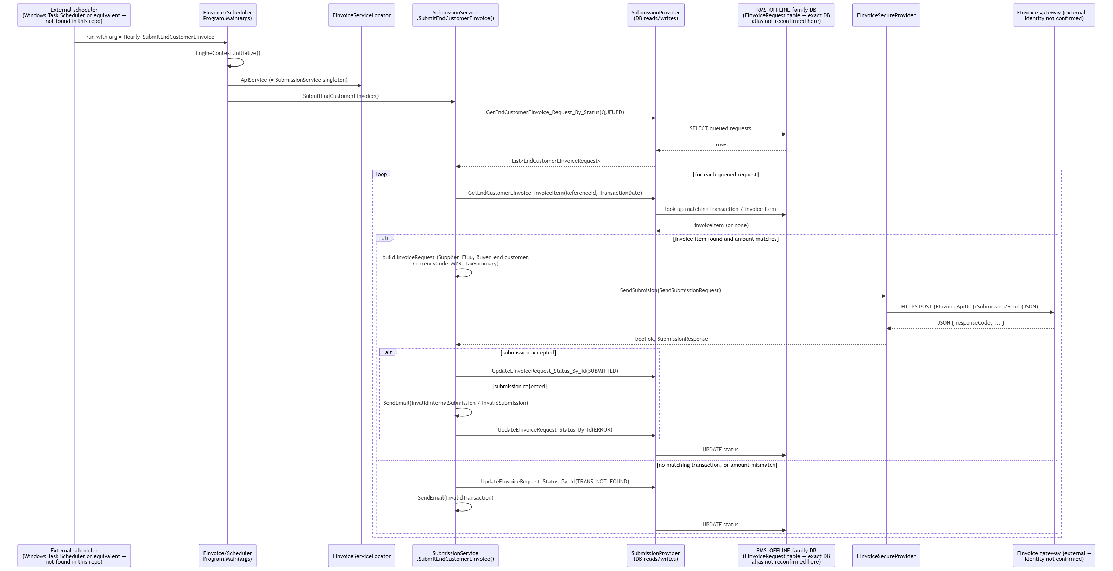
A separate scheduled operation, Hourly_EInvoiceRetry (EInvoiceServiceLocator.ApiService.Retry()), exists alongside this for retrying failed submissions — its body was not read in this pass, but its existence confirms there's a retry mechanism distinct from the initial submission path shown above.

Related
- EInvoice — the EInvoice/Core component this flow is built from
- EINVOICE — the EINVOICE database whose TRANS.Submissions/Invoices this flow writes to
- Reload — Tribal Knowledge — the ongoing monthly resubmission-patch pattern (§5) for this same integration

Sequence: INCOMM gift card — Initiate + Confirm (via Terminal API)
architecture/reload/diagrams/giftcard-incomm-flow.md
This is the most fully-traced flow in this handbook — every step below was read directly, not inferred. Sources:
- reload/web/DEV/NET/Applications/Reloads/Terminal/Api/Controllers/GiftCardController.cs
- reload/web/DEV/NET/Applications/MOLReloads/Core/Services/GiftCardService.cs (read in full)
- reload/web/DEV/NET/Components/CEPP/Payment/INCOMM/Services/InCommOperationService.cs
- reload/web/DEV/NET/Components/CEPP/Payment/INCOMM/Providers/InCommSecureProvider.cs (read in full)

Two calls, two HTTP requests from the terminal
INCOMM gift cards are a two-phase flow: giftcard/initiate (pre-authorize — checks wallet balance, calls INCOMM's PreAuthorization) followed by giftcard/confirm (commit — debits the wallet, calls INCOMM's Activation). Both are shown together since Confirm depends on state written during Initiate.

What's confirmed vs. inferred
- Confirmed, read in full: every step in the diagram below, including the exact external call (InCommSecureProvider.PreAuthorization/an equivalent Activation call, both plain HTTPS POST of JSON to {AppSettings["GetInCommApiUrl"]}/Activation or /Deactivation), the wallet debit/refund calls (StoreAccountService.UpdateStoreAccountRefNoBalance), and the transaction-status state machine (Pending → Inquiried/InquiryFailed → Processing → Success/Failed).
- Inferred: the exact ProcessActivation(...) internals past the point shown (its full body wasn't read — only ProcessPreAuthorization was read in full); the class-library/Secure/Incomm ISO8583/stand-in path exists as an alternative partner-communication mechanism (see ../class-library/secure.md) but this diagram reflects the plain-HTTP path, which is what InCommOperationService actually calls for this flow.
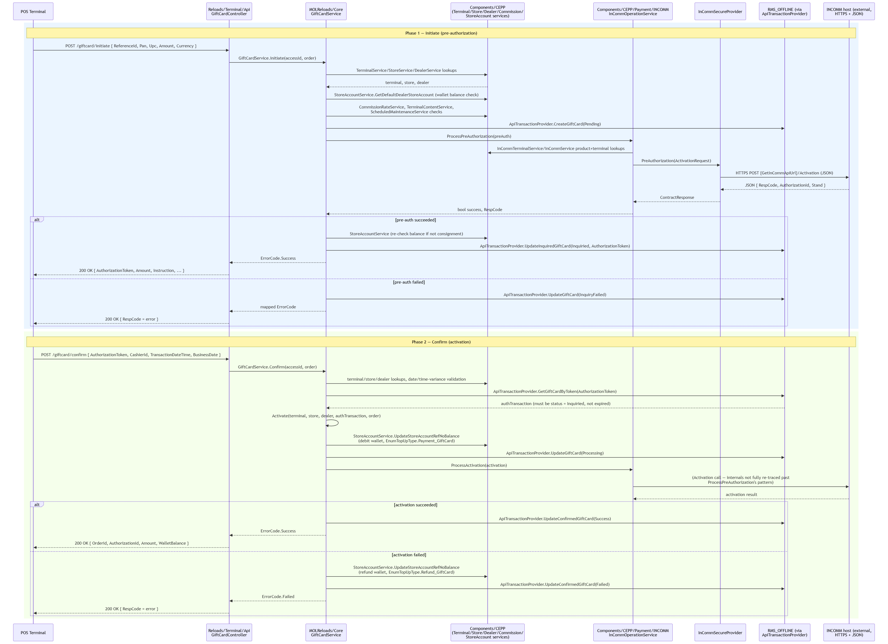

Related
- CEPP — the Payment/INCOMM sub-project (InCommOperationService/InCommSecureProvider) this flow is traced through
- Secure (Astro, Incomm, Telekom) — the alternative ISO 8583 stand-in path this diagram's plain-HTTP path bypasses
- web_api → Reloads/Terminal/Api (+ BackOffice/Api) — the GiftCardController entry point
Note: this diagram's DB participant is labeled RMS_OFFLINE (via ApiTransactionProvider) in the traced source, so no link to INCOMM/INCOMM_TRANS is asserted here — which physical database ApiTransactionProvider actually targets for gift-card transactions wasn't independently confirmed against reload_db in this pass.

Sequence: TNG e-wallet card transaction (via Terminal API)
architecture/reload/diagrams/tng-reload-flow.md
Traced from real code, not assumed. Primary sources:
- reload/web/DEV/NET/Applications/Reloads/Terminal/Api/Controllers/TNGController.cs
- reload/web/DEV/NET/Applications/Reloads/Terminal/Api/Controllers/RMSAuthController.cs
- reload/web/DEV/NET/Applications/Reloads/Terminal/Api/Infrastructure/Security/AuthenticationAttribute.cs
- reload/web/DEV/NET/Applications/MOLReloads/Core/Services/TNGService.cs
- reload/class-library/Reloads/TNG/* (referenced, not individually read beyond confirming its existence and structure — see ../class-library/reloads-tng-game.md)
Chosen because TNGController.TNGCardTransaction is a fully-readable, representative example of the controller → service pattern used by every TNG endpoint (TNGProfile, TNGHostAuthentication, TNGOnlineCardValidation, TNGBlacklistedCard, TNGFundRequest all follow the identical shape).

What's confirmed vs. inferred
- Confirmed: the HTTP entry point, the custom auth scheme shape, the controller → TNGService call, the ErrorCode → HTTP response mapping, and that TNGService resolves its dependencies (ITerminalService, ITNGTerminalService, etc.) through the Autofac-based EngineContext DI container.
- Inferred / not opened in this pass: the exact internals of TNGService. TNGCardTransaction(...) (only TNGProfile's first ~10 lines were read in full; the pattern shown for TNGCardTransaction in this diagram is extrapolated from that pattern plus the confirmed ApiTransactionProvider/CommissionRatesService/ WalletService dependencies present in TNGService's field list) — and the exact wire protocol class-library/Reloads/TNG's providers use to talk to the TNG host (not read in this pass; drawn here as a generic "TNG host" call).
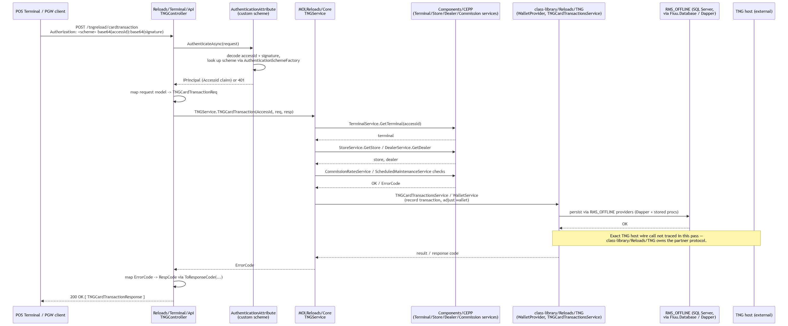

Related
- Reloads/TNG and Reloads/Game (bonus doc — real class-library source modules, — the class-library/Reloads/TNG component this flow calls into
- CEPP — the Terminal/Store/Dealer/Commission lookups this flow depends on
- web_api → Reloads/Terminal/Api (+ BackOffice/Api) — the TNGController entry point and custom auth scheme
- Reload — Tribal Knowledge — the TNG crypto/session-leak incident (§2.6) affecting this same transaction path

Architecture — reload_db

reload_db — Database Estate Overview
architecture/reload_db/00-overview.md
This is a from-source trace of the reload_db SQL Server estate: one instance, one database per business domain (not schemas-in-one-database). It starts from the existing Obsidian vault (Fiuu_Reload_DB_Vault_Code/) but every module below was cross-checked against the live patch scripts in reload_db/MAINT/<MODULE>/ — see vault-drift-notes.md for everywhere the two disagreed.
Headline correction to the vault's own framing: the vault's title claims "16 separate databases." Live MAINT/ has patch-script folders for at least 18 real databases — the vault's 16 plus EINVOICE and SAP, both of which are genuine, actively-patched databases (USE [EINVOICE] / USE [SAP] in their baseline scripts) with zero mentions anywhere in the vault, including the 260KB reload_schema.dbml. See vault-drift-notes.md for the evidence.

The database estate
Database | MAINT folder | Tables (vault count, uncorrected) | Role
CEPP | CEPP/ | 83 (+1 undercounted, see drift notes) | Master data & back-office admin hub: org hierarchy (Company → Dealers → Stores → Terminals), users/roles/permissions, product & service catalog, commission/settlement rules, shared reference data (LookupCodes, Country, Currency, Regions, States). The most cross-referenced database in the estate.
TRANSACTION | TRANSACTION/ | 144 (schema count undercounted, see drift notes) | Core transaction staging + EOD/EOS reconciliation + one integration schema per external payment/reload provider. Every terminal/API reload or payment request lands here first.
BILL_PAYMENT | BILL_PAYMENT/ | 54 | Bill-payment aggregator — one small schema per biller/partner (TNB, Telekom, Astro, Digi, IWK, UMOBILE, MBMB, Syabas, ATX, PayLink, MobilityOne, RazerPay, REDONE, EPay, Panda, IIMMPACT, AnyPay) plus a shared TRANS schema for orders/EOD/void.
REPORTSUMMARY | REPORTSUMMARY/ | 40 | Settlement & billing-report aggregation — downstream of TRANSACTION and the provider DBs, one *BillerReport/*SettlementReport table per channel.
RMS_OFFLINE | RMS_OFFLINE/ | 41 | Consumer-facing "Reload Offline" self-service web app: its own Users, Partners, Products, reward campaigns, payment transactions, CMS content (FAQ/Footer/HomePage), e-Invoice requests. Largely independent user base from CEPP.
TNG | TNG/ | 22 | Touch 'n Go eWallet / prepaid card integration: accounts, wallets, card & fund transactions, host authentications, terminal batches.
RESTORIFY | RESTORIFY/ | 22 | Carbon-offset / sustainability calculator product line: projects, batches, dealer subscription plans, calculator transactions, STACS carbon-checkout integration.
INCOMM | INCOMM/ | 14 | InComm gift-card/stored-value program integration: application requests, transaction/transfer-value processing, retailer exception handling.
INCOMM_TRANS | INCOMM_TRANS/ | 10 | Transaction-side companion to INCOMM: activation/deactivation, EOD/EOS, reversal operations.
EINVOICE | EINVOICE/ | 3 (missing from vault entirely) | Malaysia e-Invoicing (MyInvois/LHDN) integration: TRANS.Submissions / TRANS.Invoices / TRANS.InvoiceItems, plus a dbo schema of cross-database reporting stored procedures.
SAP | SAP/ | 2 (missing from vault entirely) | SAP Business One integration for e-Invoice document submission: TRANS.Submissions / TRANS.SubmissionItems, staged for SAP B1 posting (CardCode, DocEntry, U_EIV_* user-defined fields are SAP B1 vocabulary).
DataWarehouse | DataWarehouse/ | 11 | Reporting star-schema (DIM_DEALERS, DIM_PRODUCTS, DIM_SERVICEPROVIDER, DIM_WEEKS, FACT_DAILYSALES) fed from CEPP master data and daily sales facts.
NOTIFICATION | NOTIFICATION/ | 9 | Outbound messaging service: channels, subscribers, message delivery tracking. Unusually, has no StoredProcedure/ folder in MAINT at all — see notification.md.
INVENTORY_MASTER | INVENTORY_MASTER/ | 3 | Inventory master data (Stocks, UploadingStocks), referenced by TRANSACTION and CEPP.
MLookUp | MLookUp/ | 5 | Small shared lookup-code store, queried cross-database like CEPP for shared reference values (region/currency/phone-book/IP-to-country lookups).
PREPAID | PREPAID/ | 4 | Prepaid product registration/enrolment tracking. Legacy — day-to-day prepaid ("Pinless") sales actually live in TRANSACTION.dbo.
CONFIGURATION | CONFIGURATION/ | 3 | Shared runtime configuration key/value store (Config/ConfigDetails/CountrySettings) used across the platform.
TICKET | TICKET/ | 3 | Ticketing/voucher integration (Ticket2U) plus a shared TRANS schema for payment orders.
INVENTORY | INVENTORY/ | 2 | Stock/inventory staging tables supporting the stock-order flow in TRANSACTION.
LOGGING | LOGGING/ | 1 | Cross-application device/login audit trail (DevicesLoginTrail).

That's 20 real, currently-patched business databases, not 16.

Non-database MAINT folders
Two more folders live under reload_db/MAINT/ that are not business databases and are intentionally not documented as modules here:
- SQLAgentJob/ — not schema, but SQL Server Agent job definitions (msdb.dbo.sp_add_job scripts), named [HHMM]<Frequency>.<Job>_<Verb>.sql (e.g. [0130]Daily.SalesTransactionReport_Ins.sql fires EXEC [REPORTSUMMARY].[dbo].[SalesTransactionReport_Ins] at 13:00 daily). This is the orchestration layer that actually drives the TRANSACTION → REPORTSUMMARY → DataWarehouse batch flow shown below — worth knowing about even though it has no tables of its own. A rmsp-dw/ subfolder holds a handful of similar jobs specific to the data-warehouse sync server ([0200]DAILY.SALES.SYNC.sql, [30Mins]DAILY.STOCK.SYNC.sql).
- CICDTest/ — a scratch database used to validate the patch-deployment pipeline itself. Its Table/ folder literally contains tblLogin, tblLogin2, tblLogin3, tblLogin4 and bare SQLQueryN.sql files — developer smoke-test objects, not production schema. Mentioned here only so it isn't mistaken for a missed module.
Also present but out of scope for schema tracing: reload_db/Console/Offline and reload_db/Console/Reload are compiled SQLConsole.exe deployment tools (with matching NLog.config) — one per target environment — used to execute the MAINT scripts against a live database. They ship as binaries only in this checkout, so their internal apply-order logic wasn't reverse-engineered; see patch-script-conventions.md for what can be inferred about the release process from the script folders themselves.

How MAINT maps to physical databases
The mapping is almost entirely 1:1 by name: MAINT/<Name>/ patches the database literally called [<Name>] (confirmed via the USE [...] / CREATE TABLE [<Name>].[schema].[table] statements at the top of nearly every script). The only naming wrinkle is capitalization/spacing (EInvoice inside scripts vs EINVOICE as the folder/database name) and that a handful of modules use a non-dbo primary schema (TRANS for EINVOICE, SAP, TICKET, part of RESTORIFY/BILL_PAYMENT; Ticket2U/STACS for their respective partner schema).
Within a module folder, objects are organized by type, not by feature or release: Table/, StoredProcedure/, Function/, Index/, Type/, Schema/, Data/, DataReference/, Trigger/, View/. A single business change (e.g. "add a column and a proc to support it") therefore lands as two separate files in two separate folders, tied together only by a shared ticket number in the filename or header comment — see patch-script-conventions.md.

The big picture
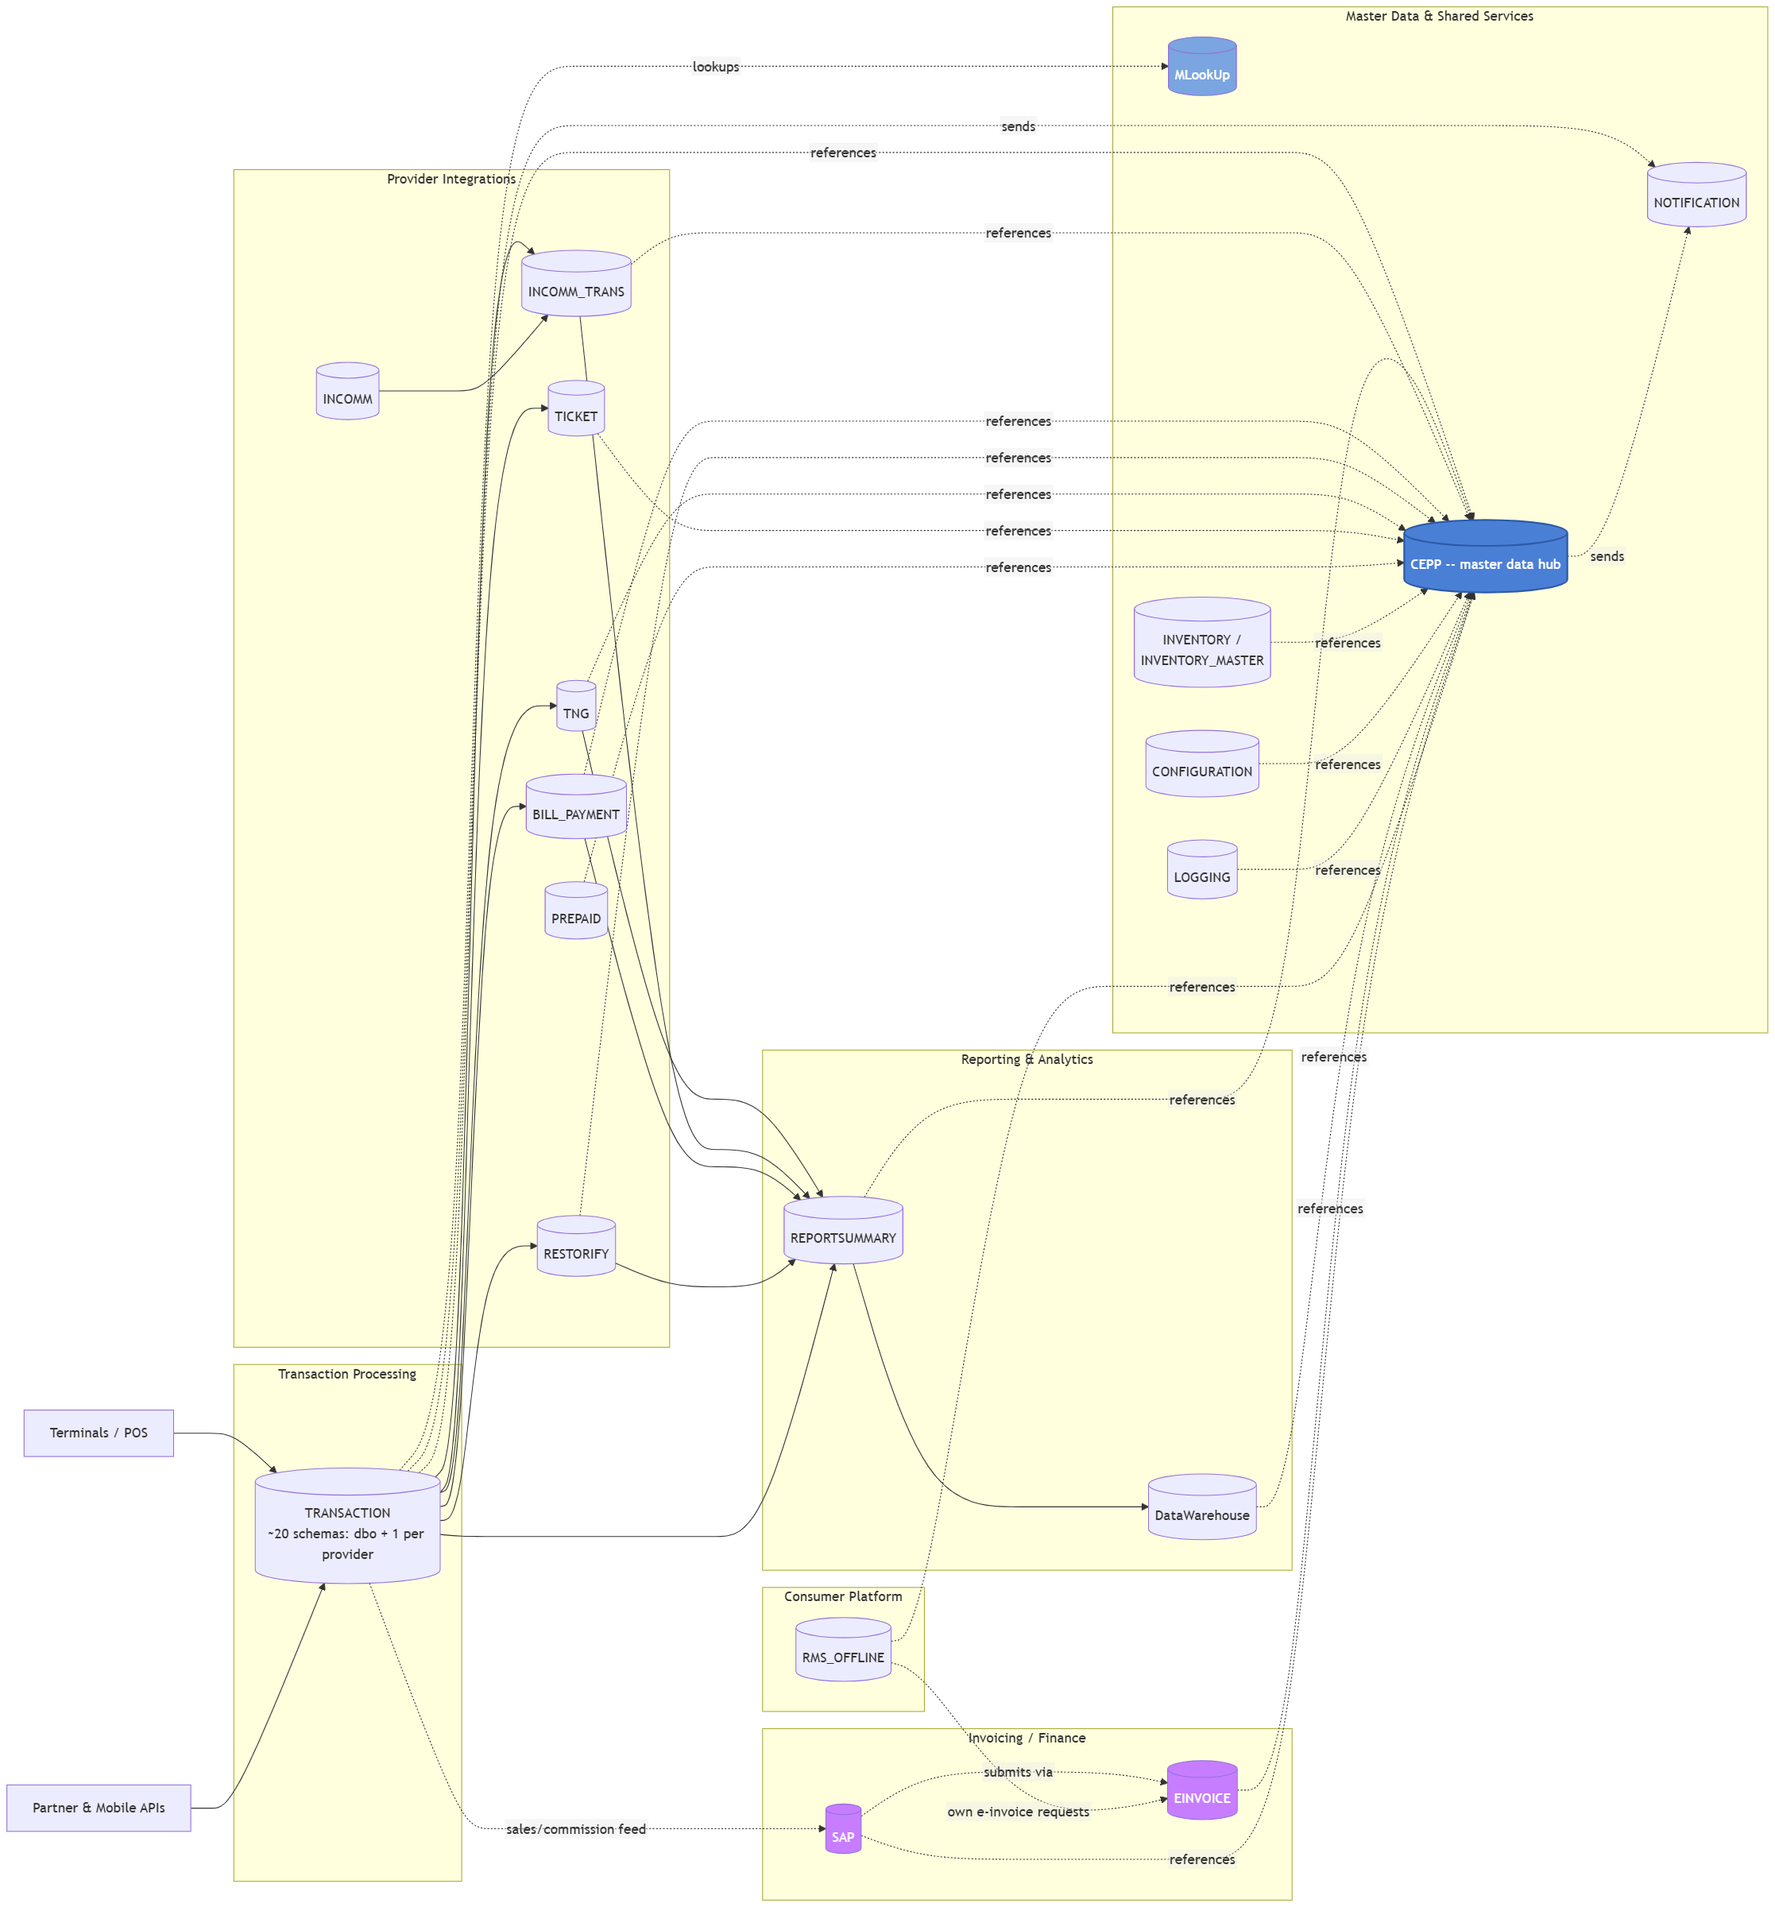
Reading it: same shape as the vault's original diagram, with EINVOICE and SAP added as a third downstream leg alongside reporting. The SAP → EINVOICE link is inferred from column vocabulary, not a proven FK: SAP's TRANS.Submissions looks like the SAP Business One posting payload (CardCode, DocEntry, NumAtCard, U_EIV_* user-defined fields are SAP B1's own naming convention for custom fields), and EINVOICE's TRANS.Submissions/TRANS.Invoices look like the actual MyInvois (Malaysia's LHDN e-Invoicing platform) submission record — same domain (statutory e-invoicing), two different downstream systems being fed from the same sales data. No stored procedure doing a live SAP.dbo... ↔ EINVOICE.dbo... cross-database join was found in either module's StoredProcedure/ folder in the time available to verify this — flag this relationship as inferred from naming/business-domain, not confirmed by code, if it matters for anything you're about to change.
Solid arrows are the transactional flow (a reload/payment request lands in TRANSACTION, gets routed to a provider-specific database, settlement rows land in REPORTSUMMARY, which feeds DataWarehouse). Dashed arrows are "references master/shared data in" — almost everything reads CEPP.

Where to go next
- patch-script-conventions.md — how MAINT scripts are versioned, named, and released.
- vault-drift-notes.md — every place the vault disagreed with the live scripts.
- One doc per module (cepp.md, transaction.md, ... — see this folder).
- diagrams/ — one Mermaid ER diagram per module, plus diagrams/cross-module-relationships.md for the handful of tables joined across module boundaries.

Related
- Vault vs. live MAINT scripts — drift notes — everywhere this estate diverges from the original Obsidian vault
- MAINT patch-script conventions — how the MAINT scripts summarized here are versioned/named
- CEPP — the master-data hub referenced throughout this overview
- Reload application solution — overview — the application side that reads/writes this estate
- reload_db — Tribal Knowledge — which of these databases actually break/get patched most

BILL_PAYMENT
architecture/reload_db/bill-payment.md
Database: BILL_PAYMENT · Schemas: 19 (TRANS + 18 biller/partner schemas) · Tables: 54 · Stored procedures: 210
Bill-payment aggregator: one small integration schema per biller/partner — ASTRO, ATX, AnyPay, Digi, EPay, IIMMPACT, IWK, MBMB, MobilityOne, Panda, PayLink, RazerPay, REDONE, Syabas, TELEKOM, TNB, UMOBILE, YTL — plus a shared TRANS schema for the provider-agnostic payment-order/EOD/void workflow. Schema list checked against reload_db/MAINT/BILL_PAYMENT/Schema/ and matches the vault exactly (19 schemas, no drift found here — contrast with TRANSACTION, which has the same per-provider-schema pattern but is missing several).

Per-biller schemas
Each biller schema is small and follows one of two shapes:
- AccountVerification + BillPayment (most billers: ASTRO, ATX, Digi, IIMMPACT, IWK, MBMB, MobilityOne, PayLink, Syabas, UMOBILE/AnyPay) — a pre-payment account/bill lookup, then the actual payment record.
- BillPayment only (EPay, Panda, REDONE) — no separate verification step modeled, or verification happens elsewhere.
ASTRO and TNB/TELEKOM additionally have BillPaymentRetries/ BillPaymentReturnCode tables — retry tracking and biller-specific return code lookups aren't universal across billers, only added where the partner's API apparently needed it. RazerPay stands out with a Configurations table of its own (MStatusId-gated) — the only biller schema with what looks like partner-specific runtime config stored alongside the transaction tables rather than in the shared CONFIGURATION database.

TRANS — the shared payment-order workflow
PaymentOrders → PaymentTransactions is the biller-agnostic order/transaction pair (mirrors the same pattern seen in TRANSACTION.dbo.SalesOrders/ SalesTransactions), with a full void sub-flow: PaymentVoidRequests → PaymentVoidRejectionRequests / PaymentVoidRepostRequests → PaymentVoidRepostTransactions, and PaymentVoidTransactions as the terminal void record. EOD/EOS (PaymentEndOfDays/PaymentEndOfDayDetails, PaymentEndOfShifts/PaymentEndOfShiftDetails) follows the same Details-child-of-Day/Shift-parent shape used everywhere else in the estate. PaymentOrders/PaymentTransactions both have _new_GIT1858 wide-key migration siblings, same as TRANSACTION.
Note: TICKET also has its own TRANS.PaymentOrders/TRANS.PaymentTransactions pair with identical columns — this TRANS shape is a cross-module convention for "generic payment order," reused independently per database rather than shared from one physical table.

Stored procedures
Standard <Table>_<Verb>[_By_X] CRUD, ~210 across 19 schemas — thin per biller (most billers have well under 10 procedures each), with the bulk concentrated in the shared TRANS schema.

Relationships to other modules
Receives from TRANSACTION (ApiBillPaymentTransactions is the staging row; BILL_PAYMENT.TRANS.PaymentTransactions is what actually got sent to the biller). Feeds REPORTSUMMARY (BillPaymentBillerReport/ BillPaymentSettlementReport, plus the per-biller report mirrors like REPORTSUMMARY.dbo.ASTROBillPayment). References CEPP for dealer/store/terminal/TerminalServiceProduct identity throughout.

Related
- TRANSACTION — the staging side (ApiBillPaymentTransactions) feeding this database
- REPORTSUMMARY — the settlement/billing reports this database feeds
- TICKET — the other module reusing the same TRANS.PaymentOrders/PaymentTransactions shape independently
- BILL_PAYMENT — ER diagram — the clustered ER diagrams for this module
- reload_db — Tribal Knowledge — BILL_PAYMENT's ranking (#4) by patch/MR traffic

CEPP
architecture/reload_db/cepp.md
Database: CEPP · Schema: dbo only · Tables: 84 current (83 per vault + PublicHolidays, see vault-drift-notes.md) · Stored procedures: 538+
The central master-data and back-office administration hub. Every other module in the estate reads from this database directly via three-part cross- database names ([CEPP].[dbo].[LookupCodes], [CEPP].[dbo].[Dealers], ...) — it's the single most-referenced database in the platform, and the vault's 734-relationship inference count puts TRANSACTION → CEPP alone at 243 links. "CEPP" as a name is never expanded anywhere in the scripts found; likely a legacy product/project codename predating the "Fiuu Reload" branding.

Org hierarchy
The backbone entity chain nearly everything else hangs off:
Company → Dealers → Stores → Terminals, with Users/Roles cutting across.
- Company — top-level legal entity.
- Dealers — the merchant/reseller account. Carries DealerGroupId, CompanyId, WalletId, MWalletTypeId, MAgencyTypeId, a SalesManagerUserId FK into Users, and workflow status fields (MStatusId, MWorkFlowStatusId) — dealer onboarding is a workflow, not a single insert.
- DealerGroups — groups dealers for commission/reporting rollups; also the join target for DealerGroupSAPItemCode (SAP item-code mapping per dealer group — a second, CEPP-side link into the SAP integration alongside the standalone SAP database, see sap.md).
- Stores — belongs to a Dealer, has its own MStatusId/ MWorkFlowStatusId and an IsSupportHybrid flag.
- Terminals — belongs to a Store. The physical/logical POS unit that everything in TRANSACTION traces back to via TerminalId.
- Contacts / CompanyContactPersons — polymorphic-ish contact records (Contacts.OwnerId + MOwnerTypeId — owner type is a discriminator, not a hard FK to one table).
- Departments — minimally modeled (only an Id), likely a lookup rather than a full entity.

Users & access
Users → Roles → RoleFunctions → Functions, plus scoping join tables (UserDealers, UserStores, UserSuppliers, UserCompany, UserBillers) that restrict which dealers/stores/suppliers/billers a back-office user can act on. Users.UserUId (a uniqueidentifier) is the value shared cross-database with RMS_OFFLINE.dbo.Users.Id and LOGGING.dbo.DevicesLoginTrail.UserId — the one place a CEPP user identity crosses into the consumer-facing and audit databases.

Product & service catalog
The pricing/catalog side, several layers deep:; ServiceProviders → ProductGroups → Products, with TerminalServices → TerminalServiceProducts as the per-terminal enablement layer (a store's terminal has to be provisioned with a TerminalService before its TerminalServiceProducts can be sold). MasterServices → MasterServiceProducts is a parallel, apparently newer catalog layer (MasterServiceProducts.RestorifyProjectId links straight into the RESTORIFY database's Projects table, and ServiceProviderId links the same row to a ServiceProviders row — this table looks like the newer unification point between legacy per-provider catalogs and RESTORIFY's carbon-offset product line).
InCommProductGroups/InCommProducts, OfflinePaymentProducts, TerminalServiceProductSettings (has a BillerId — bill-payment biller config sitting in CEPP rather than BILL_PAYMENT itself) round out the per-integration product tables.

Commission & settlement
The most structurally complex cluster: SaleCommissions → SaleCommissionMargins → SaleCommissionMarginRates (rates keyed by a wide combination of ServiceTypeId/GroupTypeId/ProductGroupId/ProductItemId/ MarginTypeId/CommissionTypeId/ProductOwnerId/PlatformId) is the general-purpose commission engine; DealerCommissionPackages and SaleCommissionRates apply it per dealer. Settlement configures how/when a dealer gets paid out (MFrequencyTypeId, MSettlementReportTypeId). SevenEProduct/SevenECommissionRate/SevenEChannelCommissionRate/ SevenEMaterial/SevenESAPAccount is a fully separate, parallel commission model for "7-Eleven" as a channel — enough dedicated tables that 7-Eleven is evidently treated as a first-class distribution channel, not just another dealer group.

Banking, wallets, TNG/InComm hardware
Wallets, BankAccounts, BankPaymentChannels, Banks, StoreAccounts back the dealer/store payout side. A separate cluster holds TNG-specific hardware/account registration that lives in CEPP rather than the TNG database itself: TNGAccounts, TNGTerminals, TNGLocations, TNGReaderModel/TNGReaderSerialNo, TNGSAMSerialNo, plus InComm's InCommTerminals and M2M SIM tooling (M2MServiceProvider/ M2MSIMCardSerialNo). This is a recurring pattern worth knowing: hardware provisioning and account registration for a provider integration lives in CEPP; the transaction/settlement data for that same provider lives in the provider's own database (TNG, INCOMM).

Reference data
LookupCodes (composite key LookupType+Code) is the shared enum table — referenced from nearly every module in the estate (INVOICE.dbo.InvoiceItems's column comments literally say "Refer to CEPP.dbo.LookupCodes.LookupType"). Country/Currency/Regions/States are the geography tree. PublicHolidays (new, see drift notes) is a flat HolidayDate PK table — likely used to exclude holidays from SLA/settlement date calculations, though no consuming stored procedure was inspected to confirm.

Stored procedures
Naming convention is strict and consistent: <Table>_<Verb>[_By_<Column(s)>], verbs Ins/Sel/Upd/Del plus variants (Upd_Activate, Upd_Suspend, Sel_By_Id, Sel_By_<OtherColumn>). No Report_* procedures found directly in CEPP (those live in the modules that actually produce reports — EINVOICE, DataWarehouse) — CEPP's own 538+ procs are essentially all CRUD for the tables above.

Relationships to other modules
CEPP is read cross-database by nearly every other module for its master data — dealer/store/terminal identity, product catalog, lookup codes. It does not generally read from other modules (it's the hub, not a spoke), the one partial exception being MasterServiceProducts.RestorifyProjectId, a CEPP-side column that reaches into RESTORIFY.dbo.Projects.

Drift vs. vault
See vault-drift-notes.md §1–2: PublicHolidays is missing from the vault; 5 filenames in CEPP/Table/ (Packages, PackageProducts, StorePackages, StoreServices, DealerProductGroups) are drop-scripts for already-removed tables and the vault correctly excludes them.

Related
- CEPP — the Fiuu.CEPP component that is the domain layer over this database
- CEPP — ER diagrams — the clustered ER diagrams for this module
- RESTORIFY — the MasterServiceProducts.RestorifyProjectId cross-database link
- SAP — the DealerGroupSAPItemCode SAP item-code mapping living in this database
- reload_db — Tribal Knowledge — CEPP's #2 ranking by patch/MR traffic in this estate

CONFIGURATION
architecture/reload_db/configuration.md
Database: CONFIGURATION · Schema: dbo only · Tables: 3 · Stored procedures: 6
Small shared runtime-configuration key/value store used across the platform.

Key tables
- Config → ConfigDetails — Config is the key/category (MStatusId-gated), ConfigDetails the actual value row(s) under it (ConfigID FK). A live patch inspected while researching patch conventions (00-PatchScript/GIT_1770/01_Config_ConfigDetails_Update.sql and 03_Config_ConfigDetails_Update_Exclude_Scheduler.sql, both dated 2026-08) shows this table being used to toggle behavior for a specific scheduler/job context — i.e. it's actively used as an operational feature- flag/toggle store, not just static settings.
- CountrySettings — per-CountryId configuration, separate from the generic Config/ConfigDetails pair.
Note: RMS_OFFLINE.dbo has its own, separately-defined Config/ ConfigDetails tables with the same names and a near-identical shape (ConfigId/bigint PK there vs. ID/int PK here) — a second instance of the "same table name, different physical table per database" pattern already seen with LookupCodes, Regions, and AutoNumbers.

Relationships to other modules
Read cross-database by other modules for shared runtime config (per the top-level architecture diagram's CONFIG -. references .-> CEPP edge — the direction there is CONFIGURATION referencing CEPP, e.g. CountryId FK-by-convention into CEPP.dbo.Country, rather than being read from CEPP).

Drift vs. vault
None found — table list and shapes matched the vault exactly.

Related
- Configuration & Secrets — mechanism #2, the AWSCore.Providers.ConfigurationProvider that reads this database by config-group name
- AWSCore — the module confirmed calling CONFIGURATION.dbo.ConfigDetails_Sel_ByConfigName
- RMS_OFFLINE — the separate, near-identical Config/ConfigDetails pair duplicated in that database

DataWarehouse
architecture/reload_db/datawarehouse.md
Database: DataWarehouse · Schema: dbo only · Tables: 11 · Stored procedures: 35
Reporting star-schema fed from CEPP master data and daily sales facts — the analytics layer at the end of the flow (TRANSACTION/provider DBs → REPORTSUMMARY → DataWarehouse).

Star schema
- FACT_DAILYSALES — the fact table: DealerId, ProductId, MerchantId, TransId, Productgroupid, ProductServiceId, StoreId. TEMP_DAILYSALES is a near-identical shadow table (same columns minus StoreId) — almost certainly a staging/ETL landing table the merge procedures load into before upserting FACT_DAILYSALES, given the DW_SYNC_DATA* procedure names below.
- DIM_DEALERS, DIM_PRODUCTS (IncommProductId/TerminalServiceId — a product dimension unified across at least the InComm and core terminal-service catalogs), DIM_SERVICEPROVIDER (keyed by DimIdTerminalservice, FK-ish columns TerminalServiceId/ ServiceProviderId), DIM_WEEKS/DIM_WEEKS_ACCUM (calendar dimension, plain vs. accumulated).
- pinless_storeid_20212021/reload_sto_reid2021 — year-stamped, oddly-named one-off tables (note the doubled "2021" in the first name). These read as ad-hoc historical backfill/migration artifacts from 2021 rather than part of the maintained schema — flagged rather than documented as if they were designed tables, since their purpose isn't otherwise inferable.
- UserPrivAudit/UserPrivAudit2 — UserPrivAudit2 has only generic column1/column2/column3 nvarchar columns, i.e. it was never properly typed/named. Ties to the [_MONTHLY].DBA.Report.GetUserPermission.sql job in SQLAgentJob/ — this looks like DBA-level SQL Server permission auditing (who has access to what), not business data, sitting in this database seemingly for lack of a better home.

Stored procedures
A distinctly different naming convention from the CRUD-proc modules: DW_SYNC_DATA (+ dated/environment variants _2018_2019, _OFFLINE, _REPORT_DB, _RETRY) and Dim_<Dimension>_Merge (+ _Prod/_PROD/ _Prod_Test variants) — ETL/merge procedures, not Ins/Sel/Upd/Del CRUD. The proliferation of _Prod/_PROD/_Test suffixed duplicates of the same logical procedure (Dim_Products_Merge, Dim_Products_Merge_Prod, Dim_Products_Merge_Prod_Test) suggests environment-specific copies were made ad hoc rather than parameterized — worth checking which one a given SQL Agent job actually calls before assuming the "clean" name is the live one.

Relationships to other modules
Fed from CEPP (dealer/product master data via the merge procedures) and REPORTSUMMARY/TRANSACTION (sales facts). Confirmed scheduled via SQLAgentJob/rmsp-dw/[0200]DAILY.SALES.SYNC.sql and [30Mins]DAILY.STOCK.SYNC.sql running on what looks like a dedicated data-warehouse sync server (the rmsp-dw subfolder name).

Related
- REPORTSUMMARY — the settlement/billing aggregation this star schema is fed from
- CEPP — the master-data source for the dimension tables
- reload_db — Database Estate Overview — where this database sits at the end of the transactional flow

EINVOICE
architecture/reload_db/einvoice.md
Database: EINVOICE · Schemas: TRANS (data), dbo (reporting procs only, no tables) · Tables: 3 · Stored procedures: 11+
Missing from the vault entirely — see vault-drift-notes.md §1. This whole module doc is written directly from reload_db/MAINT/EINVOICE/ since no vault note exists to start from or cross-check against.
Malaysia e-Invoicing integration — submission of invoices to the government e-Invoicing platform (LHDN's MyInvois system; inferred from domain vocabulary, not stated in the scripts). Oldest object found is dated 2024-08-15 under ticket GIT#1174, "[CR] eInvoicing API."

Tables (TRANS schema)
- Submissions — one row per submission batch: ReferenceId, Code (the platform's own submission code once accepted), Status (defaults to 'PENDING'), ErrorMessage, RetryCount.
- Invoices — one row per invoice within a submission (SubmissionId FK), holding the full bilingual supplier/buyer legal identity payload required for e-Invoicing: SupplierTIN/BuyerTIN (Tax Identification Number), SupplierIdType/BuyerIdType (1=NRIC, 2=Passport, 3=BRN, 4=Army — per an extended-property column comment on the table itself), SST registration numbers, full postal addresses, plus the monetary breakdown (TotalExcludingTax/TotalIncludingTax/ TotalTaxAmount/TotalPayableAmount, all decimal(20,4)). InvoiceCategoryId (1=Consolidated Gross Sales, 2=Consolidated Prepaid Dealer Commission, 3=End Customer e-Invoice, 4=Credit Note, 5=Debit Note) and InvoiceType (per column comment: 1=Invoice, 2=Credit Note, 3=Debit Note, 11=Self-billed Invoice, 12=Self-billed CN) together drive an AFTER INSERT trigger (TRG_Insert_Invoices) that auto-generates InvoiceNumber from one of six dedicated SQL SEQUENCE objects (SQ_Invoices_CGS/_CPDC/_C/_CN/_SBCN/_DN), formatted like INV-CGS0000000001. This is the only trigger-driven numbering scheme found in any module sampled — everywhere else, sequence/numbering logic lives in a stored procedure, not a table trigger.
- InvoiceItems — line items per invoice (InvoiceId FK), ServiceTypeId/SourceTypeId explicitly commented as referencing CEPP.dbo.LookupCodes.LookupType, Classification per MyInvois's own classification codes (004 = Consolidated e-Invoice, 008 = e-Commerce e-Invoice), MinOrderId/MaxOrderId (the underlying sales-order range a consolidated line item summarizes).

Stored procedures
- TRANS.Invoices_Ins/_Sel_By_InvoiceNumber/_Sel_By_SubmissionId/ _Upd_By_Id, TRANS.Submissions_Ins/_Sel_By_Code/_Sel_By_Id, TRANS.InvoiceItems_Ins/_Sel_By_InvoiceId — standard CRUD, same <Table>_<Verb> convention as every other module.
- *`dbo.Report_** — a distinct set of report-generation procedures with no backing tables of their own in this database: Report_ConsolidatedGrossSalesDebitNote_InvoiceItems, Report_ConsolidatedGrossSales_InvoiceItems, Report_ConsolidatedPrepaidDealerCommission_InvoiceItems, Report_CreditNoteSelfBilled_InvoiceItem, Report_CreditNote_InvoiceItem, Report_EInvoice_Customer_Monthly_Summary, Report_EInvoice_Excel, Report_EInvoice_Monthly_Summary, Report_EInvoice_Search, Report_EndCustomerInvoice_InvoiceItem, Report_PrepaidDealerCommission_InvoiceItems — these names map directly onto Invoices.InvoiceCategoryId`'s five categories, confirming this database's stored procedures are the actual reporting/query layer for MyInvois compliance reporting, not just a write-side integration log.

Relationships to other modules
InvoiceItems.ServiceTypeId/SourceTypeId reference CEPP.dbo.LookupCodes by explicit column comment. The dbo.Report_* procedures almost certainly join across to TRANSACTION/REPORTSUMMARY sales data and CEPP dealer data to build the consolidated-gross-sales and dealer-commission reports — this wasn't verified by reading the proc bodies, so treat it as a strong inference, not a confirmed join. See 00-overview.md for the (also inferred, not confirmed) relationship to SAP.

Open questions
- Whether EINVOICE.TRANS.Submissions/Invoices are populated by RMS_OFFLINE.dbo.EInvoiceRequests (the consumer-app-side e-invoice request table), by SAP.TRANS.Submissions, by both, or independently — not resolved from the schema alone. The two Submissions tables (this one and SAP's) look parallel rather than linked by any visible FK-by-convention column.

Related
- EInvoice — the EInvoice/Core application code that submits to this database
- Sequence: EInvoice end-customer submission (scheduled batch job) — the traced scheduled-batch submission sequence
- SAP — the parallel TRANS.Submissions table this doc's open question compares against
- Vault vs. live MAINT scripts — drift notes — this database's complete absence from the original vault (§1)

INCOMM_TRANS
architecture/reload_db/incomm-trans.md
Database: INCOMM_TRANS · Schema: dbo only · Tables: 10 · Stored procedures: 59
Not in the handbook task's original per-module filename list (only incomm.md was named) but documented separately here since it's a distinct physical database with its own tables — folding it into incomm.md would misrepresent it as part of the same database.
Transaction-side companion to INCOMM: activation/deactivation transactions, end-of-day/shift processing, reversal operations. Where INCOMM models the partner-API request/response envelope (ApplicationRequests, RTGRequests), this database models the terminal-facing side of an actual gift-card activation happening in a store.

Key tables
- ActivateTransactions → ActivationStandInTransactions/ ReActivateTransactions — the core activation flow, plus a "stand-in" variant (ActivationStandInTransactions, carrying its own RetailerId and AuthorizationId) for when the primary activation path is unavailable — a resilience/fallback pattern, not just a duplicate.
- DeactivateTransactions/ReversalTransactions/ReversalOperation — the undo side. ReversalOperation is the request/tracking row (MRequestStatusId), ReversalTransactions the executed result — same request/execution split seen elsewhere in the estate (e.g. TNG's FundAssignments/FundTransactions).
- EndOfDays/EndOfDayDetails, EndOfShifts/EndOfShitftDetails — note the typo in EndOfShitftDetails (missing an "f") — reproduced faithfully here because it's the actual live table name, not a transcription error in this doc.

Stored procedures
<Table>_<Verb>[_By_X], same convention as INCOMM.

Relationships to other modules
Tightly coupled to INCOMM (shared domain, same ProductId/DealerId/ StoreId/TerminalId shape, IncommProductId FK from EndOfDayDetails). Receives from TRANSACTION.dbo.ApiGiftCardTransactions. References CEPP for dealer/store/terminal/product identity throughout.

Related
- INCOMM — the tightly-coupled partner-API-side database
- TRANSACTION — the ApiGiftCardTransactions staging table this database receives from
- Sequence: INCOMM gift card — Initiate + Confirm (via Terminal API) — the traced initiate/confirm sequence this database's activation flow backs

INCOMM
architecture/reload_db/incomm.md
Database: INCOMM · Schema: dbo only · Tables: 14 · Stored procedures: 78
InComm gift-card / stored-value program integration: application requests, transaction and transfer-value processing, retailer exception handling. InComm is a US-based prepaid/gift-card processor; this database models the Fiuu-side of a fairly formal partner API (the ApplicationRequests / MRequestStageId / MRequestStatusId staged-workflow shape reads like it mirrors InComm's own API request lifecycle rather than being an internal design choice).

Key tables
- ApplicationRequests — the central staged request record (MActionTypeId, ApplicationId, MRequestStageId, MRequestStatusId). InCommTransactions FKs to it via ApplicationRequestId — this is one of only 6 real, database-enforced foreign keys in the entire estate (per the vault's methodology notes), everything else being inferred by naming convention. Worth remembering if you ever need a relationship you can actually trust without checking the proc.
- RTGRequests → RTGTransactions/RTGCancellations — a second, parallel request/transaction pattern ("RTG" — not expanded in the scripts found; likely "Real-Time Gift" given the gift-card domain, not confirmed). Same staged-workflow shape as ApplicationRequests (MPointOfServiceId, MActionTypeId, MRequestStageId).
- TransferValueRequests/TransferValueInCommTransactions/ TransferValueHistoryInquiries/TransferValueTransactionInquiries — a "transfer value" flow, distinct from the main activation transaction flow, with its own request/inquiry/history sub-tables. TransferValueInCommTransactions carries OriginStoreId/SpilId — cross-store transfer tracking.
- RetailerExceptionFiles → RetailerExceptionDetails — exception/error file processing from the retailer (Fiuu) side, batch-oriented (RetailerExceptionFileId parent, MActionTypeId per detail row).
- ApiSettings/HealthMonitor — integration-level config and a health- check table, both MStatusId-gated.
- LookupCodes — another module keeping its own local enum table rather than only reading CEPP.dbo.LookupCodes.

Stored procedures
<Table>_<Verb>[_By_X], notable for extensive _V1-suffixed duplicate procedures (ApplicationRequests_Ins/ApplicationRequests_Ins_V1, and the same _V1 pairing across Sel_ActivationStandIn, Sel_FastPinRevComparison, Sel_FastPinTOR, Sel_GiftCardRevComparison, Sel_GiftCardTOR, Sel_IsFastPinReversalExist) — a versioning pattern not seen this consistently in any other module sampled. Whether _V1 is the newer or older version, and whether callers still use the un-suffixed originals, wasn't determined from the script folder alone — check the calling C# code (Fiuu.CEPP / gift-card provider classes) before assuming either version is dead.

Relationships to other modules
Feeds/receives from INCOMM_TRANS (the activation/deactivation transaction side — see incomm-trans.md) and TRANSACTION.dbo.ApiGiftCardTransactions. Feeds REPORTSUMMARY.dbo.IncommBillerReport/IncommSettlementReport. References CEPP for product/dealer identity.

Related
- INCOMM_TRANS — the terminal-facing transaction-side companion database
- CEPP — the Payment/INCOMM sub-project (Fiuu.Reloads.GiftCard) built on top of this integration
- Sequence: INCOMM gift card — Initiate + Confirm (via Terminal API) — the fully-traced initiate/confirm sequence for this integration
- Secure (Astro, Incomm, Telekom) — the ISO 8583 stand-in processing alternative to this database's plain-HTTP request lifecycle

INVENTORY_MASTER
architecture/reload_db/inventory-master.md
Database: INVENTORY_MASTER · Schema: dbo only · Tables: 3 · Stored procedures: 16
Inventory master-data tables, referenced by TRANSACTION and CEPP. Despite the name suggesting it might be the authoritative "master" catalog, it actually holds live stock balances, not product definitions (those live in CEPP.dbo.Products/ProductGroups) — "master" here reads as "the master copy of stock levels," distinct from INVENTORY's staging role.

Key tables
- Stocks (+ Stocks_new_GIT1857 wide-key migration sibling, same pattern as the TRANSACTION/REPORTSUMMARY _new_GIT1857/_new_GIT1858 tables) — ProductId, DealerGroupId, SupplierId, GRNId (Goods Received Note — links to TRANSACTION.dbo.GoodReceivedNotes). This is the authoritative stock-on-hand table this module's name implies.
- UploadingStocks — a staging table for bulk stock uploads (ProductId), presumably the landing zone before rows are validated and merged into Stocks.

Relationships to other modules
Reads/writes alongside TRANSACTION.dbo's stock-order flow (PurchaseOrders/GoodReceivedNotes/RestockOrders/AllocationOrders) and INVENTORY.dbo.Stocks (a near-identical but separate table — see inventory.md for the distinction). References CEPP for product/dealer-group/supplier identity.

Drift vs. vault
None found — table list and shapes matched the vault exactly.

Related
- INVENTORY — the separate, near-identical Stocks table this database's copy is distinguished from
- TRANSACTION — the GoodReceivedNotes/stock-order flow this database's GRNId links back to
- reload_db — Tribal Knowledge — the recurring "Archive DB INVENTORY[_MASTER]" maintenance program behind this database's high issue count

INVENTORY
architecture/reload_db/inventory.md
Database: INVENTORY · Schema: dbo only · Tables: 2 · Stored procedures: 84
Stock/inventory staging tables supporting the stock-order flow in TRANSACTION. Despite having only 2 tables, this database has 84 stored procedures — by far the highest procedure-to-table ratio in the estate (42:1, vs. CEPP's ~6:1 or TRANSACTION's ~6:1). That ratio alone is a signal that Stocks here is queried/mutated through a wide variety of narrow, purpose-specific procedures rather than generic CRUD — consistent with stock being a high-contention, many-code-paths-touch-it table (restock, return, allocation, void, sale all move stock state).

Key tables
Stocks/Stocks_new_GIT1857 — same column shape and same _new_GIT1857 migration pattern as INVENTORY_MASTER.dbo.Stocks, but with more status columns: MStockStatusId, plus FK-by-convention columns tying a stock row back to whichever operation last moved it (ReStockOrderId, ReturnRequestId, AllocationOrderId). This looks like the actively- mutated staging/working copy of stock state that the stock-movement stored procedures operate against, with INVENTORY_MASTER.dbo.Stocks as a more stable "master" reference copy — the exact relationship between the two Stocks tables (which one is authoritative, whether one syncs to the other) wasn't determined from the schema alone; the 42:1 procedure ratio suggests this one is where the actual business logic runs.

Relationships to other modules
Tightly coupled to TRANSACTION.dbo's stock cluster (PurchaseOrders/RestockOrders/AllocationOrders/ReturnRequests/ VoidOrders, all of which appear as FK-by-convention sources on this table) and to INVENTORY_MASTER.dbo.Stocks.

Drift vs. vault
None found — table list and shapes matched the vault exactly.

Related
- INVENTORY_MASTER — the sibling "master" stock-balance database this one's working copy is compared against
- TRANSACTION — the PurchaseOrders/RestockOrders/AllocationOrders/ReturnRequests cluster this database's stock movements tie back to
- reload_db — Tribal Knowledge — the bigint PK migration (§2) applied to this database's Stocks table in lockstep with three others

LOGGING
architecture/reload_db/logging.md
Database: LOGGING · Schema: dbo only · Tables: 1 · Stored procedures: 4
The smallest database in the estate: cross-application device/login audit trail.

Key table
DevicesLoginTrail — DeviceId + UserId (uniqueidentifier — matches CEPP.dbo.Users.UserUId's type, not CEPP.dbo.Users.Id's int, so this table's UserId most plausibly ties to the UserUId GUID rather than the primary int identity — worth confirming against the calling code before relying on it, since it wasn't verified against a stored procedure body).

Relationships to other modules
References CEPP (user identity) per the top-level architecture diagram. Otherwise fully standalone — a single audit-log table with no other tables to relate to within its own database.

Drift vs. vault
None found — matches the vault exactly (trivially, given there's only one table).

Related
- CEPP — the Users.UserUId identity this table's UserId most plausibly ties back to
Note: this database is unrelated to the Fiuu.Logging application-logging component (Logging) despite the shared name — this one is a SQL Server audit-trail table, not the app's error/event logging framework. No link is drawn between the two here to avoid implying a connection that isn't real.

MLookUp
architecture/reload_db/mlookup.md
Database: MLookUp · Schema: dbo only · Tables: 5 · Stored procedures: 7
Small shared lookup-code store, queried cross-database like CEPP for shared reference values — but a distinctly different, more geography/telco- flavored set of lookups than CEPP.dbo.LookupCodes.

Key tables
- LookupCodes — the same composite LookupType+Code shape used everywhere else, but a physically separate table from CEPP.dbo.LookupCodes — modules that reference "MLookUp" in the top-level architecture diagram are reading this table, not CEPP's.
- Regions — a different Regions from CEPP.dbo.Regions: this one is keyed MRegionId+MCurrencyId (a composite, currency-scoped region), vs. CEPP's simple Id-keyed Regions. Don't conflate the two when tracing a RegionId column back to a source table — check which database the calling code actually targets.
- PhoneBooks — composite MRegionId+MProfileId key, MCountryId FK — looks like a country/region-scoped phone-number-format or dialing-profile lookup.
- IPAddressToCountries — IP-to-country geolocation mapping, presumably used for fraud/compliance checks elsewhere in the platform.
- AutoNumbers — a generic next-sequence-value table, same pattern as CEPP.dbo.AutoNumbers, again a separate physical table.

Relationships to other modules
Read cross-database by TRANSACTION and others for shared lookups (per the top-level diagram's TRANSACTION -. lookups .-> MLookUp edge) — smaller and more specialized than CEPP's reference-data role, not a competing copy of it.

Drift vs. vault
None found — table list and shapes matched the vault exactly.

Related
- CEPP — the physically separate LookupCodes/Regions tables this database's own copies are explicitly not the same as
- TRANSACTION — the main cross-database consumer of this database's shared lookups

NOTIFICATION
architecture/reload_db/notification.md
Database: NOTIFICATION · Schema: dbo only · Tables: 9 · Stored procedures: real, but not tracked in MAINT/ (see below)
Outbound messaging service: channels, subscribers/subscriber-channels, message delivery tracking. Small and single-purpose — this database exists to record what was sent, to whom, over which channel, and whether it was delivered.

Key tables
- Channels → ChannelSettings/ChannelCallbackIPs — a channel is a delivery method (MDeliveryMethodId — SMS/email/push, not enumerated in the schema itself), with per-channel settings and an allow-list of callback IPs (presumably for delivery-status webhooks).
- Subscribers → SubscriberChannels — a subscriber (identified how, exactly, isn't in the schema — MSecurityFlagId is the only distinguishing column) opts into one or more channels, each subscription independently status-gated (MStatusId on the junction table, not just the parent).
- Messages → MessageDeliveryTracks — the actual message (SubscriberReferenceId, MDeliveryStatusId) and its delivery-attempt history (ProviderReferenceId — the upstream SMS/email gateway's own tracking ID).
- LookupCodes — local copy of the shared enum pattern, same as several other modules.
- DailyTimestampLogs — minimal, likely a batch/job watermark table.

Stored procedures — a real gap in the tracked source, not in the vault
reload_db/MAINT/NOTIFICATION/ has no StoredProcedure/ folder at all — only Data/. Yet the application code genuinely calls real stored procedures here: class-library/Database/Notification/Context.cs (the Dapper data- access layer the vault's code-architecture note already flagged as "Dapper layer for Notification") calls, by name, with CommandType.StoredProcedure:
dbo.Messages_Ins, dbo.Messages_Sel, dbo.Messages_Sel_ByRefId, dbo.Messages_Upd, dbo.MessageDeliveryTracks_Ins, dbo.MessageDeliveryTracks_Sel_ChannelRefId, dbo.Subscribers_Sel, dbo.SubscriberChannels_SelDyn, dbo.Channels_Sel, dbo.ChannelSettings_Sel, dbo.ChannelCallbackIPs_Sel.
So the vault's claim that NOTIFICATION is "driven by stored procedures" is correct, but for a different reason than a reader would assume: these procedures are real and actively called, but their CREATE PROCEDURE definitions are not present anywhere under MAINT/. Either they were created directly against the database outside this script tree, or they live somewhere this pass didn't find. Don't expect to grep MAINT for a NOTIFICATION stored procedure's actual T-SQL body — it isn't there. This is flagged in vault-drift-notes.md §4 as a gap in the repository's own tracking, not a vault inaccuracy to fix.

Relationships to other modules
Receives message-send calls from TRANSACTION and CEPP per the top-level architecture diagram (both shown as "sends" rather than "references" in the vault's original diagram, consistent with NOTIFICATION being a write-mostly sink for outbound messages rather than a database other modules query for their own data).

Related
- Notification (bonus doc — not in the original module list, but named as a — the Notification/Api/Core service that owns this database
- Database (Fiuu.Database) — the Fiuu.Database/Dapper layer confirmed calling these stored procedures
- Vault vs. live MAINT scripts — drift notes — the missing-StoredProcedure/-folder finding (§4)

MAINT patch-script conventions
architecture/reload_db/patch-script-conventions.md
There is no migrations framework (no EF migrations, no Flyway/Liquibase, no version table). reload_db/MAINT/ is a flat folder-per-object-type tree of hand-written, hand-run SQL scripts, and the filenames and folder layout are the only versioning system that exists. This matters architecturally because it's also why the vault (and this handbook) can only ever reconstruct "latest known state" by reading every script and taking the most recent-looking version of each object — there's no single source of truth to just query.

Two different things live under MAINT/<Module>/
- Object baselines, organized by type: Table/, StoredProcedure/, Function/, Index/, Type/, Schema/, Data/, DataReference/, Trigger/, View/. Each file is meant to represent one database object.
- Ticket-numbered patch folders, at the top level of MAINT/, outside any module folder: 00-PatchScript/, 00-PatchScript-Global/, 00-Excel Patching/, 00-Excel Patching-Global/, 01-Release/. These are the actual "run this against prod" runbooks, cutting across modules.
These two views overlap in content but not in organization — a single change normally touches both (a new/altered object file under a module's Table/ or StoredProcedure/, and a step script under 00-PatchScript/GIT#nnnn/ that actually performs the ALTER/data-fix), tied together only by a shared ticket number in the filename or the header comment.

Object-file naming inside a module
- Baseline: <schema>.<ObjectName>.sql, e.g. CEPP/Table/dbo.Dealers.sql. Generated in the classic SSMS "Generate Change Script" shape: DROP TABLE IF EXISTS [...] immediately followed by the full CREATE TABLE [...]. This looks like a destructive script but isn't run as one against a live table with data — it's a point-in-time definition snapshot, most likely produced by a schema-compare tool at each release. Read it as "this is what the object looks like now," not as an instruction to actually drop-and-recreate.
- Incremental patch: <schema>.<ObjectName>_<Action>_<Ticket>.sql, e.g. CEPP/Table/dbo.Contacts_AlterColumn_GIT#1327.sql. <Action> is free text (AddColumn, DropColumn, AlterColumn, Add_Column, RemoveColumn, UpdateDescription, AddConstraint, Patching, ...) — no enum, no enforced vocabulary, sometimes with and sometimes without underscores between words. A table's real current shape is the baseline file plus every later-dated patch file for it, not the baseline alone — this is exactly the vault's own stated methodology and the reason CEPP/TRANSACTION (highest patch-file counts by far) are flagged as least reliable.
- True removals are rare and have a distinct, unambiguous shape: a short file whose header says Description: Drop table and whose body is only DROP TABLE IF EXISTS [Db].[dbo].[xxx_TableName] (note the xxx_ prefix — the convention is apparently rename-to-xxx_-prefix first, drop later). Only 5 such files exist in the entire estate, all in CEPP/Table/ (Packages, PackageProducts, StorePackages, StoreServices, DealerProductGroups — see vault-drift-notes.md).

Ticket ID formats — four spellings, one tracker
Filenames and header comments reference issue numbers in at least four punctuation styles, used inconsistently by different authors/years, all apparently pointing at the same GitLab issue tracker (gitlab-reload-fetch territory) plus an older RMSO- prefix:
- GIT#nnnn (e.g. GIT#1909)
- GIT-nnnn (e.g. GIT-197)
- GIT_nnnn (e.g. GIT_1687)
- RMSO-nnnn (e.g. RMSO-366) — looks like an older/parallel ticket prefix, seen concentrated in 00-PatchScript-Global/ and in bulk historical data patches; also appears combined as CR-RMSO-nnnn for what read like formal change requests.
No normalization was ever applied retroactively — don't assume a script without a recognizable ticket suffix has no ticket; check the header comment.

The 00_/01_/NN_ step convention (ticket-numbered patch folders)
Every 00-PatchScript/<Ticket>/ and 00-PatchScript-Global/<Ticket>/ folder that has more than one file follows the same shape, confirmed across many tickets (GIT#1358, GIT#1559, GIT-197, GIT_1687, GIT#1909, ...):
- 00_... (pre-check / preverify) — a SELECT that captures the before state, often with a hand-written comment recording the exact row count/IDs found at the time (-- total = 3 with ER.State = 'Not Applicable', -- id = 3, 273, 274). This is effectively a manual audit trail baked into the script itself, since there's no migrations table to record it.
- 01_... through NN-1_... (the actual patch) — one file per logical unit of change, named <Table>_<Verb> (Update_EInvoiceRequests_State, StoreAccountStatements_Upd, AuditLogs_Ins). Multiple files here run in numeric order when a ticket touches more than one table.
- NN_Verify (post-check) — re-runs the 00_ query and expects an empty or corrected result, again with the expected count hand-annotated in a comment (--Total = 0).
00-PatchScript-Global/ additionally numbers by dependency order rather than just sequence — e.g. RMSO-366/ seeds master data as 01-Regions_Insert → 02-States_Insert → 03-ProductTypes_Insert → 04-ServiceProviders_Insert → 05-ProductGroups_Insert → 06-Products_Insert → ... → 15-Dealers_Insert → 17-DealerProductGroups_Insert → 18-LookupCodes_Insert, mirroring the actual FK-by-convention chain documented in cepp.md. A _2 suffix on a step (05-ProductGroups_Insert_2) means a follow-up batch for the same step, not a retry-replaces-original.
Some tickets are a single file with no pre/post-check at all (GIT#1217/01_UMobile_SFTP_Migration.sql) — the 3-step shape is the norm for data-correction patches specifically, not a hard rule for every change.

Excel-tracked patches
00-Excel Patching/ and 00-Excel Patching-Global/ hold .xlsx files instead of .sql (e.g. RMSO-705/SupplierProducts_Patching_Script.xlsx, RMSO-705/Functions_Sequence_Patching_Script.xlsx) — used for patches whose "script" is really a large data-entry/verification checklist (bulk supplier product mappings, sequence renumbering) too unwieldy to review as raw SQL diffs. Not opened as part of this pass (binary spreadsheet content), but their existence is itself the point: not every schema/data change in this estate is a .sql file.

Releases
01-Release/ is thin and inconsistent — two .zip bundles named after features (CentralizedTransaction_20210923.zip, JobId.2.MonthlySales.RazerGold.CSVToSFTP_20210923.zip, both date-stamped YYYYMMDD) sitting next to one loose Rename_Table_GIT-870.sql. This does not look like a maintained release-packaging process (only two zips exist, both from 2021) so much as a one-off archive of what a couple of specific releases bundled at the time.

Deployment mechanism
reload_db/Console/Offline/ and reload_db/Console/Reload/ each contain a compiled SQLConsole.exe (with NLog.config for logging and Microsoft.Data.Tools.Sql.BatchParser.dll / Microsoft.SqlServer.ConnectionInfo.dll alongside it — i.e. it links SSDT's own batch-parsing/connection libraries, consistent with it being a DACPAC/SSDT-style script runner) — one console app per target environment (Offline = RMS_OFFLINE, Reload = the main estate). Only the compiled binaries are checked into this workspace, not source, so exactly how it walks the MAINT/ tree and in what order wasn't verified here — flagged as a genuine blocker if that logic ever needs to be relied on.

Scheduled jobs are versioned the same way
SQLAgentJob/ (see 00-overview.md) isn't schema, but follows an analogous convention: one file per job, named [HHMM]<Frequency>.<JobName>_<Verb>.sql or [DAILY.HHMM].<Category>.<Job>.sql, containing the full msdb.dbo.sp_add_job / sp_add_jobstep / sp_add_jobschedule script SSMS generates when you script out a SQL Agent job. Same pattern as Table/ baselines: a full definition snapshot, not a diff, re-generated whenever the job changes.

Related
- reload_db — Database Estate Overview — where MAINT/ sits in the overall estate
- Vault vs. live MAINT scripts — drift notes — the xxx_-prefix drop-table convention (§3 here) cross-checked against the vault
- SQL-side Conventions (reload_db/MAINT) — stored-procedure/index naming conventions inside each object file
- reload_db — MR Review Checklist — how reviewers enforce the numbering/environment-suffix conventions described here

PREPAID
architecture/reload_db/prepaid.md
Database: PREPAID · Schema: dbo only · Tables: 4 · Stored procedures: 16
Prepaid product registration/enrolment tracking. Smaller and legacy-leaning — the vault's own note that "most day-to-day prepaid ('Pinless') sales actually live in TRANSACTION.dbo" matches what's here: this database models registration, not the sale itself.

Key tables
- RegistrationProductGroups → RegistrationProducts — a small catalog specific to registration-eligible products, separate from CEPP's main product catalog.
- PrepaidRegistrations → PrepaidRegistrationAuditTrails — the registration record (DealerId/StoreId/TerminalId, MIdentityTypeId — likely NRIC/passport-type identity verification, consistent with telco prepaid SIM registration regulatory requirements in Malaysia) and its audit trail (MRegStatusId history).

Relationships to other modules
References CEPP for dealer/store/terminal identity. Not otherwise wired into the main TRANSACTION → provider → REPORTSUMMARY flow — this is a self-contained, smaller-scope database.

Drift vs. vault
None found — table list and shapes matched the vault exactly.

Related
- Reloads.Pin (+ sibling Reloads.Pinless) — the Reloads.Pinless/Reloads.Pin application code; day-to-day Pinless sales live in TRANSACTION, not here
- TRANSACTION — where the actual prepaid/Pinless sale transactions are recorded
- Reload — Tribal Knowledge — the Pin/Pinless drift pattern (§2.3) this legacy/day-to-day split reflects

REPORTSUMMARY
architecture/reload_db/reportsummary.md
Database: REPORTSUMMARY - Schema: dbo only - Tables: 40 - Stored procedures: 83
Downstream settlement and billing-report aggregation. One *BillerReport/*SettlementReport table per channel (TNG, MOLPay, Incomm, Pinless/PIN Reload, and each bill-payment biller), fed from TRANSACTION and the provider modules on a schedule (see SQLAgentJob in 00-overview.md - e.g. [0130]Daily.SalesTransactionReport_Ins.sql calls REPORTSUMMARY.dbo.SalesTransactionReport_Ins daily at 13:00). This is explicitly a reporting/aggregation layer, not a system of record - the underlying transaction rows live in TRANSACTION and the provider databases; REPORTSUMMARY reshapes them for billing and settlement output.

Key tables
- SalesOrders/SalesTransactions/SalesTransactionReport - a near-duplicate of TRANSACTION's own SalesOrders/SalesTransactions tables (same columns, same _new_GIT1857 migration pair), plus SalesTransactionReport as the actual reporting projection (SalesTransactionId FK back to SalesTransactions, denormalized with StateId/RegionId for geographic rollups).
- Per-channel settlement/biller pairs: TNGBillerReport/ TNGSettlementReport, MOLPayBillerReport/MOLPaySettlementReport, IncommBillerReport/IncommSettlementReport, PinlessSettlementReport, PINReloadBillerReport/PINReloadSettlementReport, OfflinePaymentBillerReport/OfflinePaymentSettlementReport, BillPaymentBillerReport/BillPaymentSettlementReport. "BillerReport" and "SettlementReport" are consistently two separate tables per channel - the former looks like the per-transaction detail feeding a biller-facing statement, the latter the aggregated dealer-facing settlement figure, but no report-consuming code was inspected to confirm the exact distinction.
- Per-biller raw transaction copies: ASTROBillPayment, ATXBillPayment, IWKBillPayment, MBMBBillPayment, PayLinkBillPayment, TELEKOMBillPayment, TNBBillPayment - mirrors of the corresponding BILL_PAYMENT.<Biller>.BillPayment tables, landed here for reporting rather than joined live cross-database.
- CardTransactions/CardTransactionBatches - a generic card-transaction shape (TerminalId/LocationId/SpId as char codes rather than CEPP FK ints) that also appears verbatim in TNG.dbo - looks like a shared card-network transaction format rather than something unique to either database.
- GoodReceivedNotes - the one stock/purchasing table that made it into this reporting database, presumably for GRN-based commission/settlement reporting.

Stored procedures
Standard <Table>_<Verb> CRUD plus report-generation procs invoked by the scheduled jobs in SQLAgentJob/ - SalesTransactionReport_Ins is confirmed directly via a live job script ([0130]Daily.SalesTransactionReport_Ins.sql, run once for 7-Eleven dealers, @DealerId=1, and once for everyone else, @DealerId=0 - the same 7-Eleven-as-special-channel pattern seen in CEPP's SevenE* commission tables shows up here too).

Relationships to other modules
Downstream consumer of TRANSACTION and every provider module (TNG, BILL_PAYMENT, RESTORIFY, INCOMM/INCOMM_TRANS) - reads their transaction data, writes its own aggregated report tables, and feeds DataWarehouse in turn. References CEPP for dealer/store/terminal/product identity like everything else. Populated on a schedule by SQL Agent jobs, not synchronously as part of the request path.

Reconciliation against live scripts
Table list and column shapes checked against a sample of reload_db/MAINT/REPORTSUMMARY/Table/*.sql matched what the vault and DBML already had - nothing to add here beyond 00-overview.md's headline finding that REPORTSUMMARY itself (unlike TRANSACTION/CEPP) wasn't where the gaps turned out to be.

Related
- TRANSACTION — the upstream system of record this database aggregates from
- DataWarehouse — the star schema this database feeds in turn
- BILL_PAYMENT — one of the per-channel *BillerReport/*SettlementReport sources
- reload_db — Tribal Knowledge — the cross-database schema-drift incident (§1) on this database's SalesTransactionReport columns

RESTORIFY
architecture/reload_db/restorify.md
Database: RESTORIFY · Schemas: dbo, STACS, TRANS · Tables: 22 · Stored procedures: 88
Carbon-offset / sustainability-calculator product line: dealers subscribe to a carbon-calculator plan, run purchase-weight/price-based calculations against a project's carbon credits, and optionally check out through STACS (a third-party carbon-registry/exchange integration). This is a notably newer, differently-shaped product line than the reload/prepaid core of the platform — its own project/batch/subscription model rather than the dealer-terminal-product shape used everywhere else.

dbo — projects, categories, subscriptions
- Projects → ProjectBatches → ProjectBatchBalances — a carbon-offset project is divided into batches, each batch tracking a remaining credit balance. Projects.UUID and ProjectTypeId suggest external registry identifiers and a typed classification (reforestation, renewable energy, etc. — not confirmed from the schema alone).
- CalculatorLevel1Categories → CalculatorLevel2Categories, with CalculatorSettingsPriceBased (keyed to Level1) and CalculatorSettingsWeightBased (keyed to Level2) — two different pricing models (by price paid vs. by item weight) applied at two different category granularities.
- CalculatorSubscriptionPlans → CalculatorDealerSubscriptionPlans → CalculatorDealerSubscriptionBalances — a dealer subscribes to a plan (SubscriptionPlanTypeId) and draws down a balance against it.
- DealerVATPackages — VAT handling per dealer, a compliance detail specific to this product line.
- ProjectTypePricingPackages — pricing tiers per project type.

STACS
CarbonCheckout — the single table for the external checkout integration: ProjectUuid, RMSMerchantId, CarbonCertificateId, and a refund pair (RefundRequestId/RefundUuid). STACS (Sustainable Trade Finance/carbon registry infrastructure — not independently confirmed beyond what the schema implies) appears to be where the actual carbon-credit certificate gets issued once a checkout completes.

TRANS — transactions
CalculatorTransactions (the actual calculator sale, FK to both CalculatorDealerSubscriptionPlanId and CalculatorLevel2CategoryId), CalculatorBulkTransactions (bulk-upload variant, FK to BulkUploadFileId — reusing CEPP.dbo.BulkUploadFiles'-style bulk upload tracking), CalculatorSubscriptionPayments (paying for the subscription itself, separate from buying offsets), CarbonOffsetTransactions (the STACS-integrated purchase path, carrying CarbonCertificateId and a refund reference directly on the transaction row), and ProjectBatchTransactions (the ledger entry against a specific project batch's balance).

Stored procedures
<Schema>.<Table>_<Verb>[_By_X], same convention as everywhere else — STACS.CarbonCheckout_Ins/_Sel_By_OrderId/_Upd_RefundStatus_By_OrderId/ _Upd_Status_By_OrderId is a clean example of the full lifecycle (create, look up by partner order id, then two independent status-update paths for the main flow vs. refunds).

Relationships to other modules
Receives from TRANSACTION.dbo (ApiCarbonCalculatorTransactions/ ApiCarbonOffsetTransactions). CEPP.dbo.MasterServiceProducts carries a RestorifyProjectId column pointing back into RESTORIFY.dbo.Projects — the one place CEPP reaches into a provider database rather than the other way around. Feeds REPORTSUMMARY per the top-level architecture diagram, though no RESTORIFY-specific report table was found in REPORTSUMMARY (unlike TNG/BillPayment/Incomm, which each have a named *Report table there) — worth treating as an open question rather than assumed-absent, since it wasn't exhaustively ruled out.

Related
- Reloads.Restorify — the Fiuu.Reloads.Restorify application code this database backs
- CEPP — the MasterServiceProducts.RestorifyProjectId cross-database link
- TRANSACTION — the ApiCarbonCalculatorTransactions/ApiCarbonOffsetTransactions staging tables this database receives from

RMS_OFFLINE
architecture/reload_db/rms-offline.md
Database: RMS_OFFLINE · Schema: dbo only · Tables: 41 · Stored procedures: 192
Powers the consumer-facing "Reload Offline" self-service web app: its own Users, Partners, Products, reward campaigns, payment transactions, CMS content (FAQ/Footer/HomePage/Maintenance-notice), and e-Invoice requests. Architecturally the odd one out in the estate — a separate consumer identity system, not an extension of CEPP's back-office user base.

Consumer identity & partners
- Users — Id is a uniqueidentifier, not an int identity like CEPP.dbo.Users.Id — a different identity scheme for a different user population (consumers, not back-office staff). PartnerId/CountryId FK out; UserExternalLogins (composite LoginProvider+ProviderKey PK) supports third-party/social login.
- Partners — external platforms this consumer app is embedded in or sold through (MOLPayMerchantId column ties a partner to a MOLPay merchant account). PartnerProducts/PartnerServiceCharges/ PartnerPurchase scope the product catalog and fee structure per partner.

Catalog & transactions
Services → ServiceTypes, ProductGroups → Products — a simpler, flatter catalog than CEPP's multi-layer one, scoped by CountryId directly on Products. PaymentTransactions → TransactionDetails is the core purchase record (MOLPayTransId, PaymentChannelId), with TransactionDetails carrying the actual product/service reference and linking to Users.Id. RetryTransactions handles failed-payment retry by ServiceTypeId.

Reward campaigns
A fully self-contained sub-domain: RewardCampaigns → RewardCampaignsCap → RewardCampaignsCapBalance (spend caps and running balance), RewardCampaignsChannels/RewardCampaignsCategories (classification), RewardCampaignsPlatform (per-partner activation, FK to PartnerId), and RewardCampaignsProduct/RewardCampaignsTransaction (which products qualify, and the actual reward payout transaction). This looks like a promotions/cashback engine layered on top of the base purchase flow.

CMS & support content
FAQCategory/FAQDetails, FooterCategory/FooterDetails, HomePageDetails, MaintenanceNoticeDetails, MiscellaneousDetails, SupportCategory/ SupportDetails, EmailTemplate — flat CMS content tables backing the public-facing site, unrelated to the transactional core.

e-Invoicing
EInvoiceRequests — this is a different table from anything in the EINVOICE database: it's the consumer-app-side request to have an invoice generated (ReferenceId), not the LHDN submission record itself. See einvoice.md's open question about whether this feeds EINVOICE.TRANS.Submissions directly. A live patch (00-PatchScript/GIT#1909/) fixing invalid State values on this exact table ('Not Applicable' → '17') was inspected while building patch-script-conventions.md — one of the few tables in this whole survey with a directly-observed real-world data-quality patch.

Stored procedures
<Table>_<Verb>[_By_X], 192 procedures — proportionally the second-heaviest module after TRANSACTION/BILL_PAYMENT, reflecting that this is a full consumer web app's entire backend, not just an integration log.

Relationships to other modules
Loosely coupled to CEPP (Partners.MOLPayMerchantId, Products.CountryId) — the vault's own framing that RMS_OFFLINE "only loosely touches CEPP" matched what was found here. Not otherwise linked into the TRANSACTION→provider→REPORTSUMMARY flow that the rest of the estate follows; this is a parallel, independent transactional path.

Drift vs. vault
None found in the sample checked — table list and shapes matched.

Related
- Database (Fiuu.Database) — the Fiuu.Database/Dapper layer that is this database's confirmed data-access component
- EINVOICE — the open question of whether this database's EInvoiceRequests feeds EINVOICE.TRANS.Submissions
- CONFIGURATION — the separately-defined but near-identical Config/ConfigDetails pair duplicated here
- MAINT patch-script conventions — the EInvoiceRequests data-quality patch example cited above

SAP
architecture/reload_db/sap.md
Database: SAP · Schema: TRANS · Tables: 2 · Stored procedures: 4
Missing from the vault entirely — see vault-drift-notes.md §1. This whole module doc is written directly from reload_db/MAINT/SAP/ since no vault note exists to start from or cross-check against.
SAP Business One integration, created 2025-02-03 under ticket GIT#2103 ("Create Submission table"). This looks like a staging area for documents destined to be posted into SAP Business One (SAP B1) — the column vocabulary is distinctively SAP B1's own (CardCode, DocEntry, DocType, U_EIV_* user-defined fields), not internal Fiuu naming.

Tables (TRANS schema)
- Submissions — one row per SAP B1 document submission: SubmissionType, DealerId/MasterServiceProductId/ServiceProviderId (linking back toward CEPP), a transaction date range (TransStartDate/TransEndDate) plus SAP B1's own document dating (DocDate/DocDueDate/TaxDate), CardCode (SAP B1's business-partner code), NumAtCard, DocCurrency, DocType, and three U_EIV_* user-defined fields (FreqSync, InvoiceType, OriRefNum, OriCode) — the EIV prefix almost certainly stands for "E-Invoice," tying this table directly to the EINVOICE database's domain even though no direct FK-by-convention column links them. DocEntry/StatusCode/ Message capture SAP B1's response once the document is actually posted.
- SubmissionItems — line items (SubmissionId FK): ItemCode, Quantity, ItemDescription, VatGroup, AccountCode, LineTotal, up to four CostingCode/CostingCode2/3/4 dimensions (SAP B1's multi-dimensional cost-center allocation), and its own U_EIV_TaxExemptDoc/U_EIV_Classification user-defined fields mirroring EINVOICE.TRANS.InvoiceItems.Classification.

Stored procedures
TRANS.Submissions_Ins, _Sel_By_DocDate, _Sel_By_NumAtCard, _Upd_By_Id — a minimal CRUD set, no SubmissionItems_* procedures found in the StoredProcedure/ folder at all (either items are inserted via a different path — e.g. bulk insert from the calling application, or a table-valued parameter into Submissions_Ins — or the procs exist uncaptured in MAINT/, the same gap pattern seen with NOTIFICATION's procedures; not resolved from the script folder alone).

Relationships to other modules
DealerId/MasterServiceProductId/ServiceProviderId on Submissions reference CEPP. The relationship to EINVOICE (both databases stage "submissions" for the same underlying sales data, one to LHDN/MyInvois and one to SAP B1, both carrying U_EIV_*-prefixed fields) is a strong naming/domain inference, not a verified join — flagged the same way in 00-overview.md and einvoice.md. No stored procedure doing a live cross-database SAP.dbo.../EINVOICE.dbo... query was found in either module's StoredProcedure/ folder in the time available.

Open questions
- Whether SAP and EINVOICE are two independent downstream systems fed from the same upstream sales/commission data (most likely, given the parallel-not-linked table shapes), or one feeds the other, is not settled by the schema alone — worth resolving from the C# integration code (Fiuu.CEPP or a dedicated SAP/EInvoice provider project) before building anything that assumes a specific direction.

Related
- EINVOICE — the parallel e-invoicing database this one's U_EIV_* fields point toward
- CEPP — the DealerGroupSAPItemCode mapping and DealerId/ServiceProviderId identity this database references
- Vault vs. live MAINT scripts — drift notes — this database's complete absence from the original vault (§1)

TICKET
architecture/reload_db/ticket.md
Database: TICKET · Schemas: Ticket2U, TRANS · Tables: 3 · Stored procedures: 24
Ticketing/voucher payment integration (Ticket2U — a Malaysian e-ticketing platform) plus the same shared TRANS payment-order shape used in BILL_PAYMENT.

Key tables
- Ticket2U.Transactions — the partner-integration transaction log (PartnerUserId, PaymentId).
- TRANS.PaymentOrders → TRANS.PaymentTransactions — identical shape (same column names, same MSourceTypeId/BPMTransStatusId/ CommissionTypeId) to BILL_PAYMENT.TRANS.PaymentOrders/ PaymentTransactions — this is the smallest, clearest example in the estate of the "generic payment order" table shape being reused as a pattern, independently defined per database, rather than a single shared physical table.

Relationships to other modules
Receives from TRANSACTION.dbo.ApiTicketTransactions. References CEPP for dealer/store/terminal/TerminalServiceProduct identity.

Drift vs. vault
None found — table list and shapes matched the vault exactly (smallest module surveyed, easiest to fully verify).

Related
- BILL_PAYMENT — the other module independently reusing the same TRANS.PaymentOrders/PaymentTransactions shape
- TRANSACTION — the ApiTicketTransactions staging table this database receives from

TNG
architecture/reload_db/tng.md
Database: TNG · Schema: dbo only · Tables: 22 · Stored procedures: 56
Touch 'n Go eWallet / prepaid card integration: accounts, wallets, card and fund transactions, host authentications, terminal batches. Note the split with CEPP: TNG hardware and account provisioning (TNGAccounts/TNGTerminals/TNGLocations/TNGReaderModel/ TNGReaderSerialNo/TNGSAMSerialNo) lives in CEPP.dbo, while this database holds the actual transactional/reconciliation data for accounts once provisioned — see cepp.md's "Banking, wallets, TNG/InComm hardware" section for the CEPP-side half.

Key tables
- Accounts — the TNG merchant account, MStatusId-gated. Everything else in this database hangs off AccountId.
- AccountBanks/AccountServiceProviders/AccountWallets — junction tables scoping an account to its bank, service provider (SpId, a char code rather than an int FK — TNG's own provider identifier scheme, not CEPP's ServiceProviders.Id), and wallet.
- CardTransactions/CardTransactionBatches/CardTransactionBatchSummary — the actual TNG card tap/reload transaction log, keyed by TerminalId/ LocationId/SpId (all char codes — TNG's card-network identifiers, not CEPP terminal/store IDs directly) plus an AccountId FK. The same CardTransactions shape reappears verbatim in REPORTSUMMARY.dbo — see reportsummary.md.
- FundTransactions/FundAssignments/ReloadFundRequests — the money movement side: assigning float to an account, reloading a wallet, and the request/approval trail for it (MFundPaymentTypeId, BankId). BalanceReconciliationLog ties a FundTransactionId to a WalletId for balance-drift tracking.
- BlacklistCards/BlacklistCardBatches — card blacklist/batch-export for fraud/risk handling, with Sel_AvailableForExport/Sel_BatchExport stored procedures suggesting a file-export flow to TNG or a fraud vendor.
- HostAuthentications — per-account host/terminal authentication attempts.
- LookupCodes — TNG keeps its own local copy of the shared enum-table pattern (composite LookupType+Code key) rather than only reading CEPP.dbo.LookupCodes — one of several modules that do this (also seen in RMS_OFFLINE, INCOMM, NOTIFICATION, MLookUp).

Stored procedures
<Table>_<Verb>[_By_X], with an unusually heavy SelOut_* variant (AccountServiceProviders_SelOut_SpId_By_AccountId, AccountWallets_SelOut_WalletId_By_AccountId) — a naming wrinkle not seen elsewhere in the modules sampled; likely denotes a proc whose primary purpose is returning a single output value/column rather than a full row-set, but this wasn't confirmed by reading the proc bodies.

Relationships to other modules
Receives from TRANSACTION.dbo (ApiTNGCardTransaction, ApiTNGFundRequest, and the TNGCardTransactions/TNGFundRequests/TNGFundAssignments tables that live directly in TRANSACTION.dbo alongside the Api* staging rows — TNG is one of the few provider integrations where the provider-database tables and TRANSACTION-side tables share near-identical names and shapes). Feeds REPORTSUMMARY (TNGBillerReport/TNGSettlementReport). References CEPP for the hardware/account registration side noted above.

Related
- Reloads/TNG and Reloads/Game (bonus doc — real class-library source modules, — the class-library/Reloads/TNG component that reads/writes this database
- Sequence: TNG e-wallet card transaction (via Terminal API) — the traced e-wallet card transaction sequence
- CEPP — the hardware/account-provisioning half of TNG (§"Terminal Hardware & TNG")
- reload_db — Tribal Knowledge — TNG's #3 ranking by patch/MR traffic
- Reload — Tribal Knowledge — the TNG crypto/session-resource-leak incident (§2.6)

TRANSACTION
architecture/reload_db/transaction.md
Database: TRANSACTION · Schemas: dbo + at least 19 provider schemas (vault says 14 — see vault-drift-notes.md §3) · Tables: 144 per vault, undercounted · Stored procedures: 822 (by far the most of any module)
The core transaction-processing and staging database. Every terminal or API reload/payment request is logged here first, then routed to a provider- specific database (TNG, INCOMM_TRANS, BILL_PAYMENT, RESTORIFY, TICKET) for the actual external call. End-of-day/end-of-shift reconciliation, void/return handling, and stock movement are also owned here. This is the busiest, most patched, and (per the vault's own admission and this pass's schema-count check) least completely documented database in the estate — treat anything here as a strong lead, verify before depending on it.

dbo — the staging/orchestration core
The Api* tables are the front door: one per product line, all following the same shape (Id, TerminalId/StoreId/DealerId, ReferenceId, CashierId/UserId, an MStatusId-family status, MSourceTypeId for channel). ApiBillPaymentTransactions, ApiGiftCardTransactions, ApiOfflineTransactions, ApiPinlessTransactions, ApiStockOrders/ ApiStockTransactions, ApiTicketTransactions, ApiTNGCardTransaction, ApiTNGFundRequest, ApiMOLPayTransactions, ApiCarbonCalculatorTransactions/ ApiCarbonOffsetTransactions (RESTORIFY-side). Several of these have a _new_GIT1857/_new_GIT1858-suffixed sibling table with a bigint identity instead of int — a live in-place migration to a wider key, both old and new table kept during the transition (check which one a given stored procedure actually targets before assuming it's the newer one).
Order/transaction pairs recur throughout: SalesOrders → SalesTransactions, MOLPayOrders → MOLPayTransactions, OfflineSalesOrders → OfflineSalesOrderItems, RestockOrders → ReStockTransactions/ ReStockOrderItems, PurchaseOrders → PurchaseOrderItems, AllocationOrders → AllocationOrderItems, VoidOrders → VoidTransactions, ReturnRequests/ReturnOrders → ReturnRequestItems/ReturnTransactions. The "order" row is the commercial envelope; the "transaction"/"item" rows are its line items — same pattern as SalesOrders/SalesTransactions repeated for every stock/return/void flow.
EOD/EOS reconciliation is its own dense cluster, one triplet per channel (EndOfDays/EndOfDayDetails, EodBillPaymentTransactions/ EodBillPaymentSummary/EodBillPaymentTransactionReconciliation, equivalents for GiftCard, Stock, MOLPay) — each Eod*Transactions table carries both a t_* (terminal-reported) and s_* (system-recorded) copy of ApiTransactionId/ReferenceId/CashierId, and the MVarianceTypeId column on the *Reconciliation tables is where a terminal-vs-system mismatch gets classified. TopupInfo/TopupPayments, StoreAccountStatements/ StoreAccountTransactions handle store-level bank top-up flows separate from customer-facing reloads.

Provider schemas
One schema per external service, each holding that provider's raw request/response transaction log — ATX, Celcom, DTOne, EPay, IIMMPACT, JomPay, LoadCentral, NPN, Panda, PayLink, Richtech, UMobile, YTL, plus AnyPay, CelcomDigi, Giftee, MobilityOne, PrepayNation, RazerGold (all six missing from the vault — see vault-drift-notes.md §3). Table shape per schema is consistently Transactions (or RequestTopUp/BillPayment/PinlessTransactions depending on the provider's own vocabulary) plus, for a few providers, AccountVerification as a separate pre-transaction check. IIMMPACT and PayLink both explicitly FK AccountVerification → Transactions via TransactionId.
RazerGold is worth calling out specifically: Fiuu was formerly Razer Merchant Services, and this schema is a direct-to-(former)-parent-brand prepaid/gift-card integration — architecturally it's just another provider schema, but it's a reminder that "provider" here includes Fiuu's own corporate family, not only arm's-length third parties.

Sales, stock, void/return
SalesDiscrepancies/SalesDiscrepanciesDetails and SaleSummaries support dealer-level sales reconciliation reporting. The stock/purchasing cluster (PurchaseOrders, GoodReceivedNotes, AllocationOrders, RestockOrders, DailyStockBalance) models the physical/virtual stock supply chain from supplier → dealer group → store, feeding INVENTORY/INVENTORY_MASTER's Stocks tables. StockVoucherRedemptions/ApiStockVoucherRedemptions is a separate voucher-redemption flow alongside standard stock sales.

Stored procedures
Same <Table>_<Verb>[_By_X] convention as CEPP, at roughly 5-6x the volume (822 vs CEPP's 538) — expected, given this database sits at the intersection of every product line. No further pattern beyond that was surveyed in depth given the volume; if hunting for a specific flow's procs, filter by the Api*/provider-schema table name first.

Relationships to other modules
TRANSACTION is the hub-and-spoke center of the transactional (as opposed to master-data) side of the platform: it receives from terminals/APIs, reads CEPP for dealer/store/terminal/product identity (the single largest inferred-relationship flow in the whole estate per the vault), reads MLookUp/CEPP.dbo.LookupCodes for status enums, and pushes settlement rows downstream into REPORTSUMMARY. It also hands off to every provider database (TNG, INCOMM_TRANS, BILL_PAYMENT, RESTORIFY, TICKET) — the Api* staging tables here are the request as the platform received it; the provider database holds what actually got sent externally.

Drift vs. vault
See vault-drift-notes.md §3 — 6 provider schemas (AnyPay, CelcomDigi, Giftee, MobilityOne, PrepayNation, RazerGold) exist live and are missing from the vault. A naive file-count also suggests more distinct table names than the vault's 144, but most of that gap is _Temp/_Del_Log staging copies the vault deliberately (and correctly) excludes.

Related
- CEPP — the largest single inferred-relationship flow in the estate (TRANSACTION → CEPP)
- REPORTSUMMARY — the downstream settlement/reporting aggregation this database feeds
- Vault vs. live MAINT scripts — drift notes — the 6 missing provider schemas (§3) documented here
- reload_db — Tribal Knowledge — TRANSACTION's #1 ranking by patch/MR traffic, and the bigint migration (§2) that touched it most heavily
- SQL-side Conventions (reload_db/MAINT) — the per-partner schema convention this database's provider schemas exemplify

Vault vs. live MAINT scripts — drift notes
architecture/reload_db/vault-drift-notes.md
The existing Obsidian vault (Fiuu_Reload_DB_Vault_Code/) is a solid, well-corroborated starting point — its own stated methodology (parse every CREATE/ALTER TABLE in ~4,700 scripts, cross-check relationships against real cross-database SQL in the app code) is sound and its caveats about its own weak spots (CEPP/TRANSACTION incompleteness, inferred-vs-enforced FKs) turned out to be accurate self-assessment. This file records everywhere a targeted verification pass against the live reload_db/MAINT/ scripts found it to actually be wrong, incomplete, or stale — not a full table-by-table re-audit of all ~470 tables (out of scope for the time available), but every concrete discrepancy found while writing the per-module docs.

1. Two entire databases are missing from the vault (the big one)
The vault's title and every summary claim 16 databases. Live MAINT/ has patch-script folders for EINVOICE/ and SAP/ in addition to the 16 the vault covers — both are real, actively-patched SQL Server databases:
- reload_db/MAINT/EINVOICE/Table/TRANS.Invoices.sql opens with USE [EINVOICE] and CREATE TABLE [EInvoice].[TRANS].[Invoices]. Oldest table script found is dated 2024-08-15 (GIT#1174, "[CR] eInvoicing API") — this database predates the vault's construction by well over a year, it isn't something that appeared after the vault was built.
- reload_db/MAINT/SAP/Table/TRANS.Submissions.sql opens with USE [SAP] and CREATE TABLE [SAP].[TRANS].[Submissions], dated 2025-02-03 (GIT#2103).
- reload_schema.dbml (the vault's own 260KB DBML export) has zero occurrences of EINVOICE or SAP. anywhere in the file — confirmed by direct grep, not just absence from the summary docs.
- Combined, this is 5 tables (EINVOICE.TRANS.Invoices/InvoiceItems/Submissions, SAP.TRANS.Submissions/SubmissionItems) and their stored procedures (11 in EINVOICE, 4+ in SAP) with no vault coverage at all. See einvoice.md and sap.md for what's actually in them.
This isn't explained by "these are brand new, built after the vault" — the EINVOICE database is over a year old. It looks like a genuine gap in the vault's original sweep (plausibly: the vault's script listing didn't include these two folders, or they were filtered out along with the DMS/temp-table noise it says it excluded).

2. CEPP: one real table missing, and one description slightly stale
- CEPP.dbo.PublicHolidays is missing. Created 2026-03-05 (reload_db/MAINT/CEPP/Table/dbo.PublicHolidays.sql, ticket GIT#2103 — same ticket as the SAP tables above, work landing in CEPP much later than the SAP side of the same ticket per the header dates, for whatever that's worth) — HolidayDate (PK) / HolidayDescription / CreatedDateTime. No Tables/CEPP.dbo.PublicHolidays.md note exists in the vault, and the vault's own CEPP table count (83) matches exactly the note-file count in Tables/ — i.e. this table was never picked up, not just under-described. Seeded via CEPP/Data/GIT_2103/PublicHolidays_Insert_Year_2026_And_2027.sql.
- The vault's stated CEPP table count (83) is otherwise accurate once you account for a wrinkle in the source material: CEPP/Table/ contains 5 files that look like current tables by filename (Packages, PackageProducts, StorePackages, StoreServices, DealerProductGroups) but are actually drop scripts — each file's entire body is DROP TABLE IF EXISTS [CEPP].[dbo].[xxx_<Name>], dated 2025-02-24 (four of them) and 2025-10-08 (DealerProductGroups). The vault correctly excludes all 5 — flagged here only because a naive "count files in Table/" pass over-counts CEPP by these 5, and because DealerProductGroups in particular is easy to mistake for a live table (it's referenced by name in the RMSO-366 master-data-seeding patch folder, 00-PatchScript-Global/RMSO-366/ 17-DealerProductGroups_Insert.sql, from when it still existed).

3. TRANSACTION: at least 6 provider integration schemas missing
The vault states TRANSACTION has 14 schemas (dbo + 13 named: ATX, Celcom, DTOne, EPay, IIMMPACT, JomPay, LoadCentral, NPN, Panda, PayLink, Richtech, UMobile, YTL). reload_db/MAINT/TRANSACTION/Schema/ has 19 schema-creation scripts (+ dbo = 20 total). The 6 missing from the vault, each confirmed to have both a Schema/<Name>.sql and at least one real table under Table/<Name>.*.sql:
Schema | Table found | What it looks like
AnyPay | Transactions | Another pinless/reload provider, same shape as Panda/LoadCentral
CelcomDigi | RequestTopUp | Post-merger combined Celcom+Digi telco integration (Malaysia's Celcom and Digi telcos merged in 2022) — likely superseding or running alongside the standalone Celcom schema
Giftee | Transactions | A gift-card/e-voucher provider integration
MobilityOne | Transactions | Also has its own BILL_PAYMENT.MobilityOne schema (that one is in the vault) — this is the TRANSACTION-side counterpart, missing
PrepayNation | Transactions | International prepaid/airtime aggregator
RazerGold | Transactions | Razer's own gift-card/prepaid brand — notable since Fiuu is the former Razer Merchant Services; this looks like a direct-to-parent-brand integration

This lines up with the vault's own caveat that CEPP/TRANSACTION are "almost certainly incomplete" — it called that about baseline-table completeness, but it turns out to extend to entire schemas. A provider integration typically means the same table pattern (AccountVerification/Transactions/RequestTopUp) gets stamped out per provider elsewhere in BILL_PAYMENT and TRANSACTION both — check bill-payment.md's schema list too before assuming a provider is fully covered by either module doc.
A naive file-count pass (dedupe baseline vs. patch filenames in TRANSACTION/Table/) suggests noticeably more distinct table names than the vault's 144, but most of the extra names resolve to _Temp / _Del_Log staging copies the vault's own methodology says it deliberately excludes (AWS DMS replication scaffolding) — consistent with the vault, not a second drift finding. The 6 missing schemas above are the real, verified gap.

4. NOTIFICATION: the vault is right, but for a subtler reason than it says
The vault's module note says NOTIFICATION is "Driven by stored procedures (Messages_Ins, Subscribers_Sel, Channels_Sel)." True — but reload_db/MAINT/NOTIFICATION/ has no StoredProcedure/ folder at all, only Data/. The procedure names the vault cites are real (confirmed via class-library/Database/Notification/Context.cs, which calls dbo.Messages_Ins, dbo.Subscribers_Sel, dbo.Channels_Sel, and 7 others via Dapper with CommandType.StoredProcedure) — so the app code genuinely calls stored procedures by those names. What's missing is any CREATE PROCEDURE script for them anywhere under MAINT/. Either they were created directly against the database outside this script tree, or they live in a location this pass didn't find. Worth knowing before assuming "grep MAINT for the proc" will work for this one module — it won't; see notification.md.

5. Two non-schema folders the vault doesn't mention at all
SQLAgentJob/ (scheduled batch job definitions) and CICDTest/ (a pipeline-validation sandbox database, not real schema) exist under MAINT/ with no vault coverage — reasonably, since the vault scoped itself to "database schema" and these are respectively orchestration and test noise. Flagged here only so a future pass doesn't mistake their absence for a gap. See 00-overview.md's "Non-database MAINT folders" section.

What wasn't re-verified
Time was spent proportional to modules with the most patch volume and the vault's own stated risk flags (CEPP, TRANSACTION). The 6 real enforced SQL foreign keys, the ~734 inferred-by-convention relationships, and the exact column lists for the remaining ~15 smaller modules were not independently re-derived from scratch — they were spot-checked against a sample of Table/*.sql baselines per module while writing each module doc, and matched what the vault/DBML claimed in every sample taken. Treat the vault's relationship data for those modules with the same "strong hint, not proof" confidence the reload-db-schema skill already recommends.

Related
- reload_db — Database Estate Overview — the corrected estate summary (20 databases, not 16)
- CEPP — the missing PublicHolidays table (§2)
- EINVOICE and SAP — the two databases missing from the vault entirely (§1)
- NOTIFICATION — the "no StoredProcedure/ folder" finding (§4)

BILL_PAYMENT — ER diagram
architecture/reload_db/diagrams/bill-payment-er.md
54 tables across 19 schemas. Per-biller schemas are structurally repetitive (AccountVerification → BillPayment, occasionally + BillPaymentRetries/ BillPaymentReturnCode) so three representative billers plus the shared TRANS workflow are shown; see bill-payment.md for the full schema list.
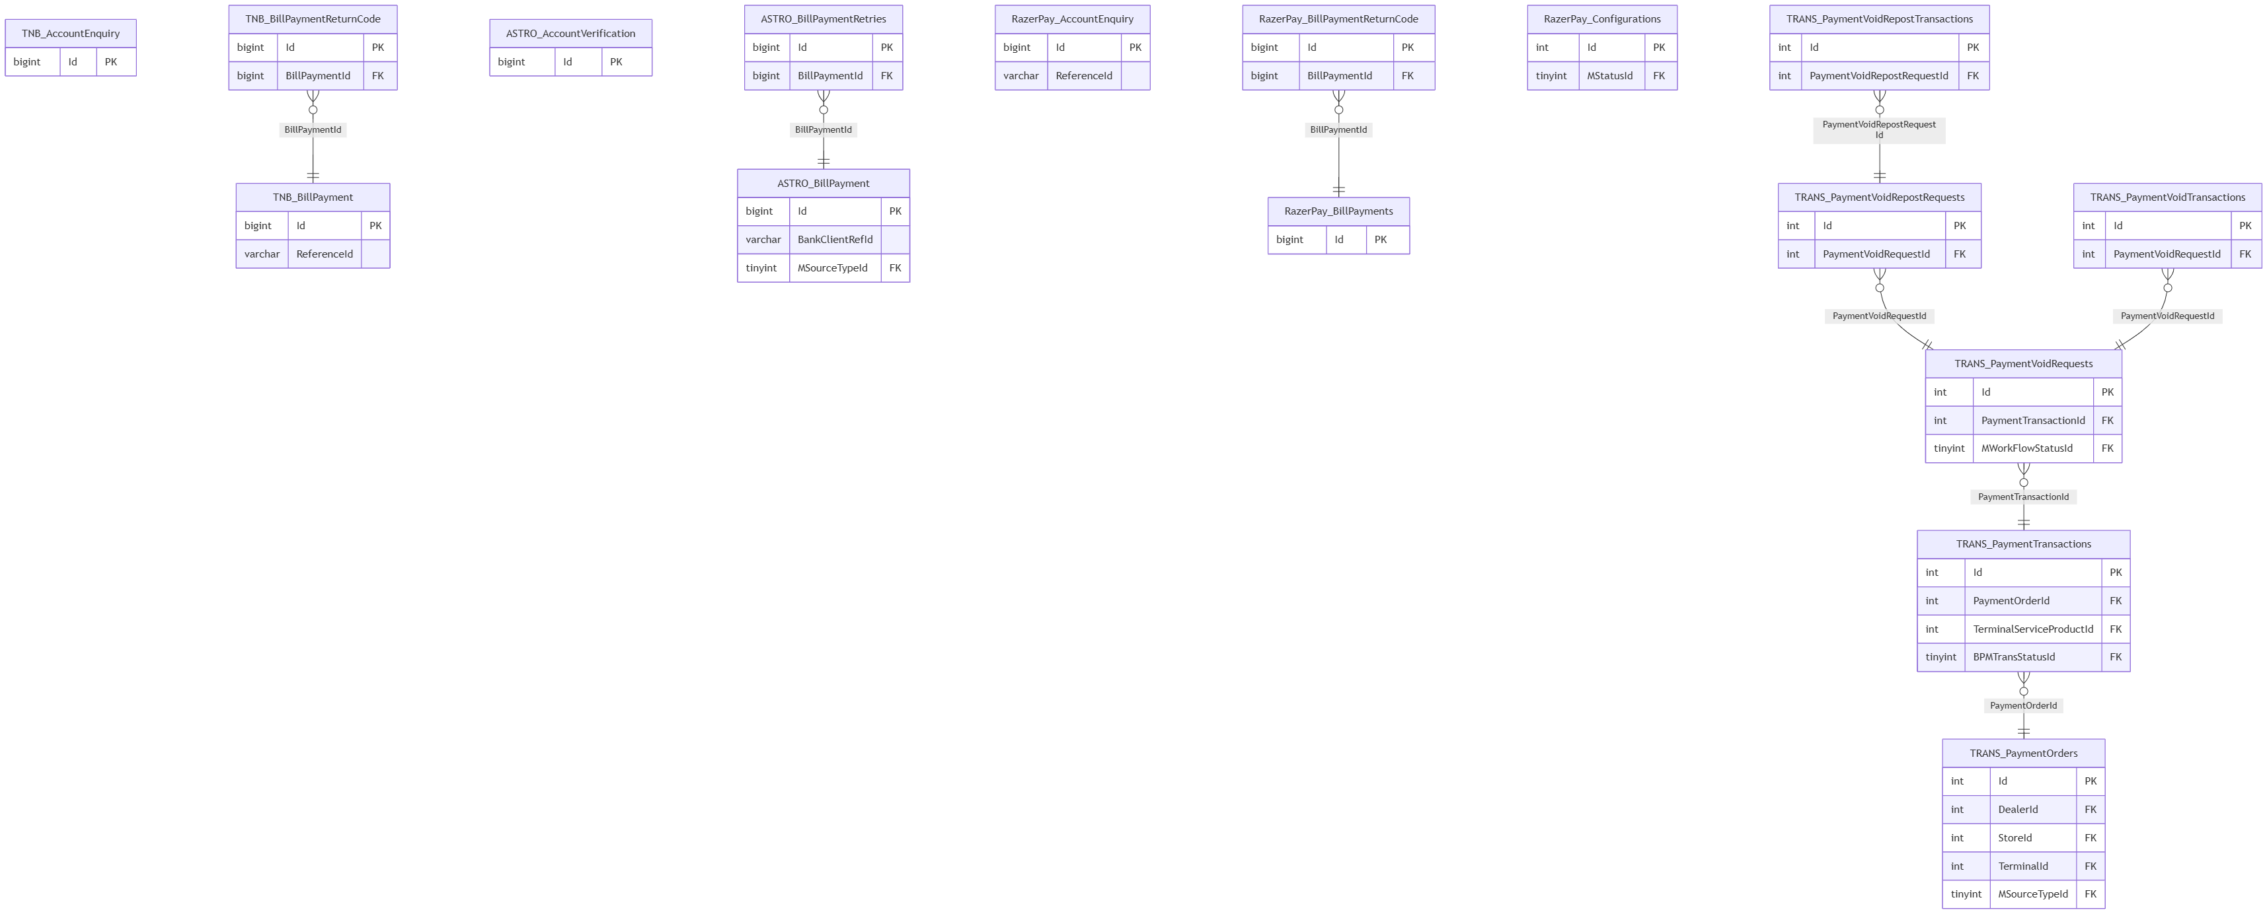
(Entity names are prefixed Schema_Table — Mermaid erDiagram doesn't allow dots in identifiers.)

CEPP — ER diagrams
architecture/reload_db/diagrams/cepp-er.md
CEPP has 84 tables (83 + PublicHolidays, missing from the vault — see vault-drift-notes.md) — too many for one legible diagram, so it's split into the same functional clusters used in cepp.md. All PK/FK annotations below were spot-checked against reload_db/MAINT/CEPP/Table/*.sql.

Org hierarchy
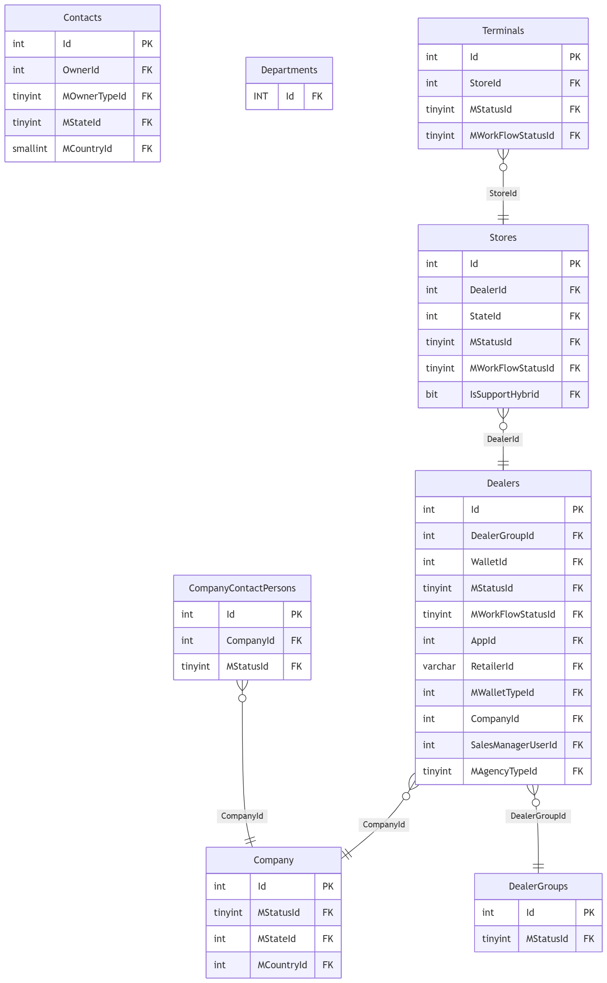

Users & access
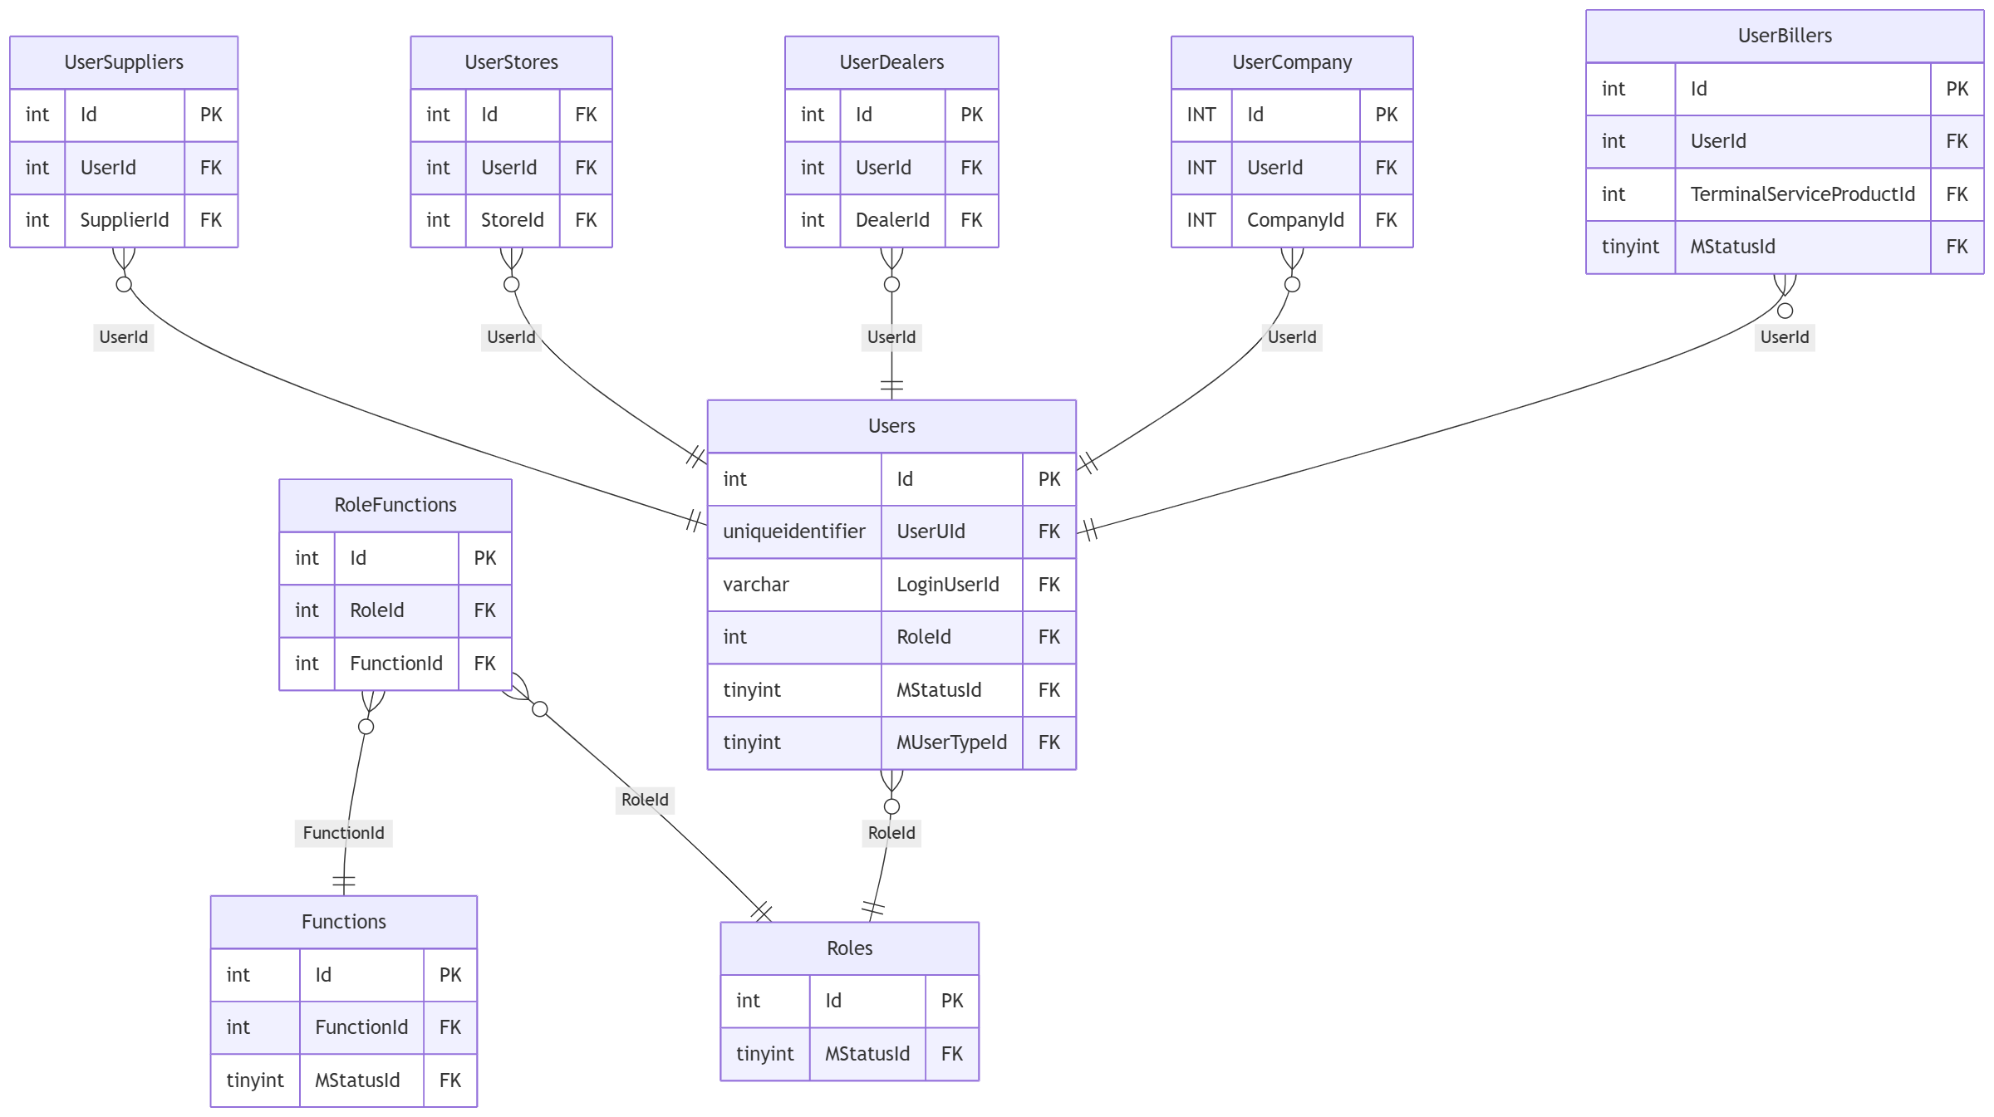

Product & service catalog
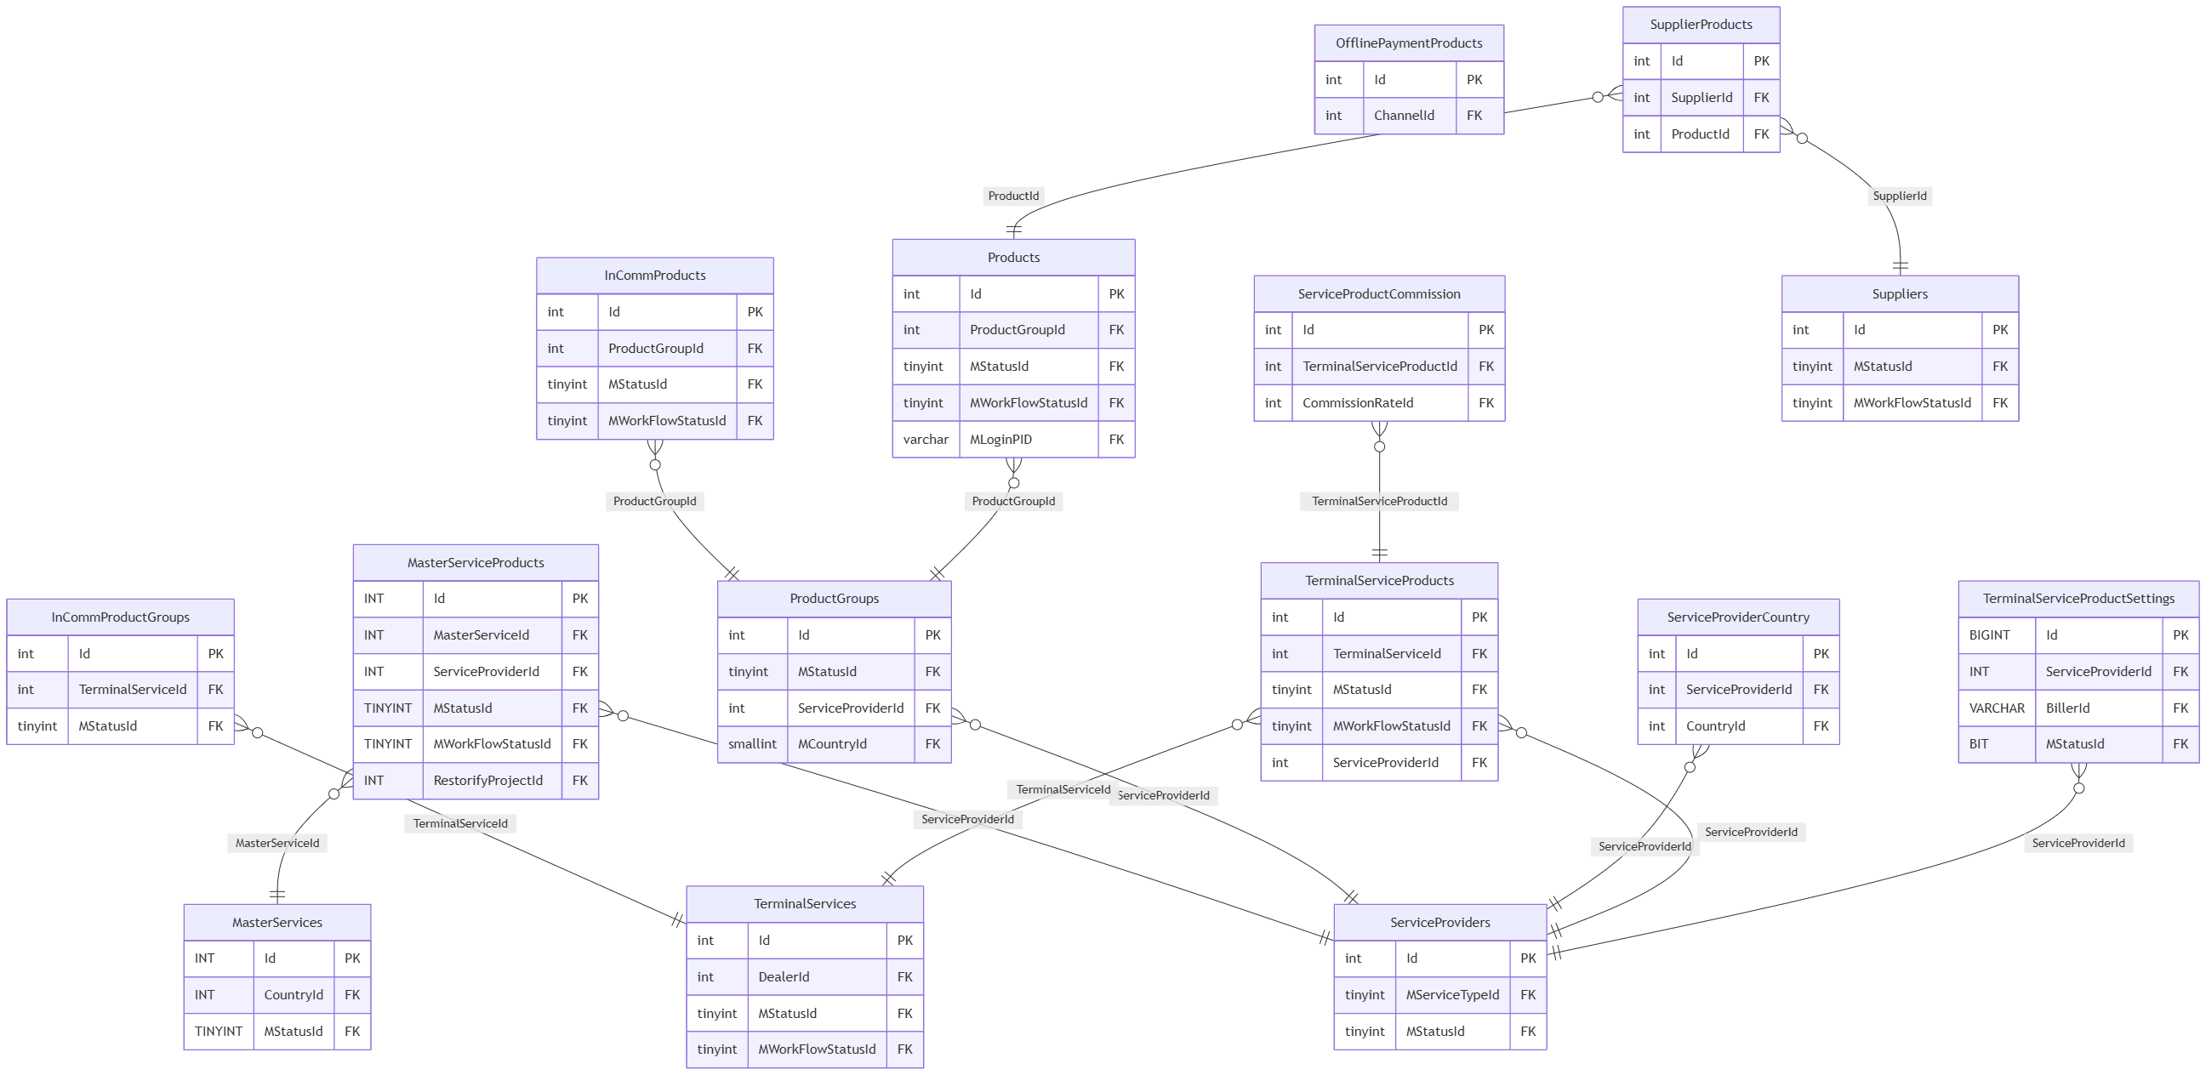
(MasterServiceProducts.RestorifyProjectId is the cross-database link into RESTORIFY.dbo.Projects — see diagrams/cross-module-relationships.md.)

Commission & settlement
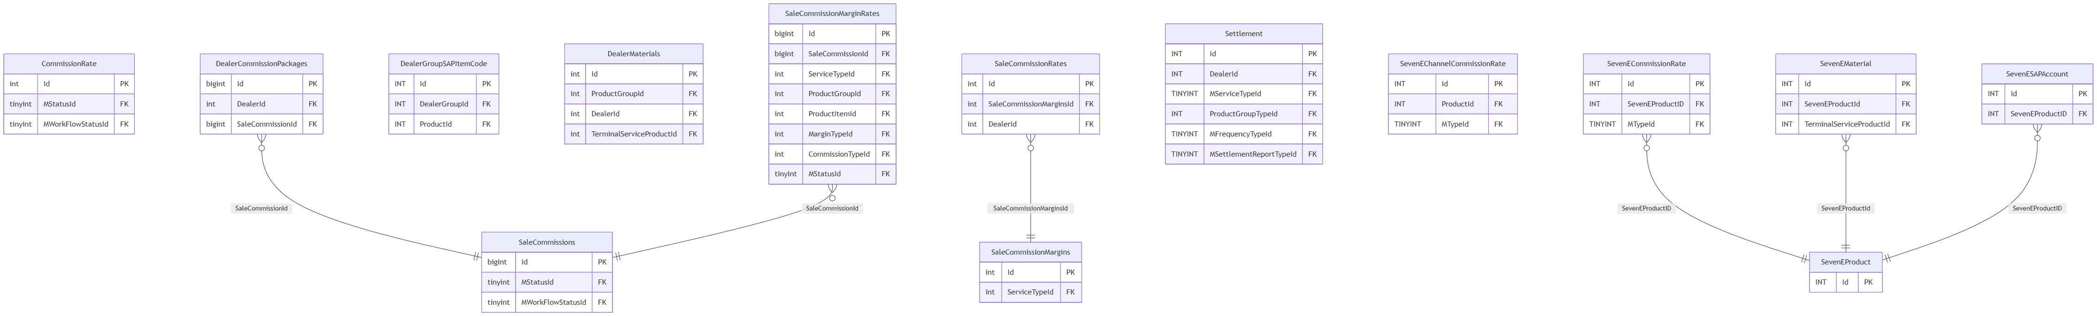

Geography & reference (includes PublicHolidays, missing from vault)
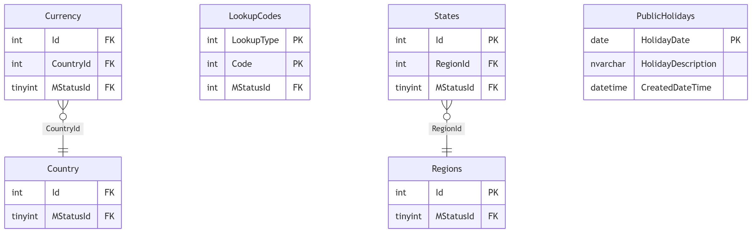

Banking, wallets & TNG/InComm hardware
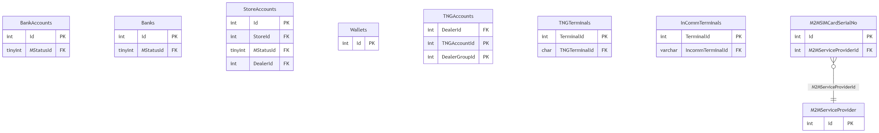

Sales & reporting ops
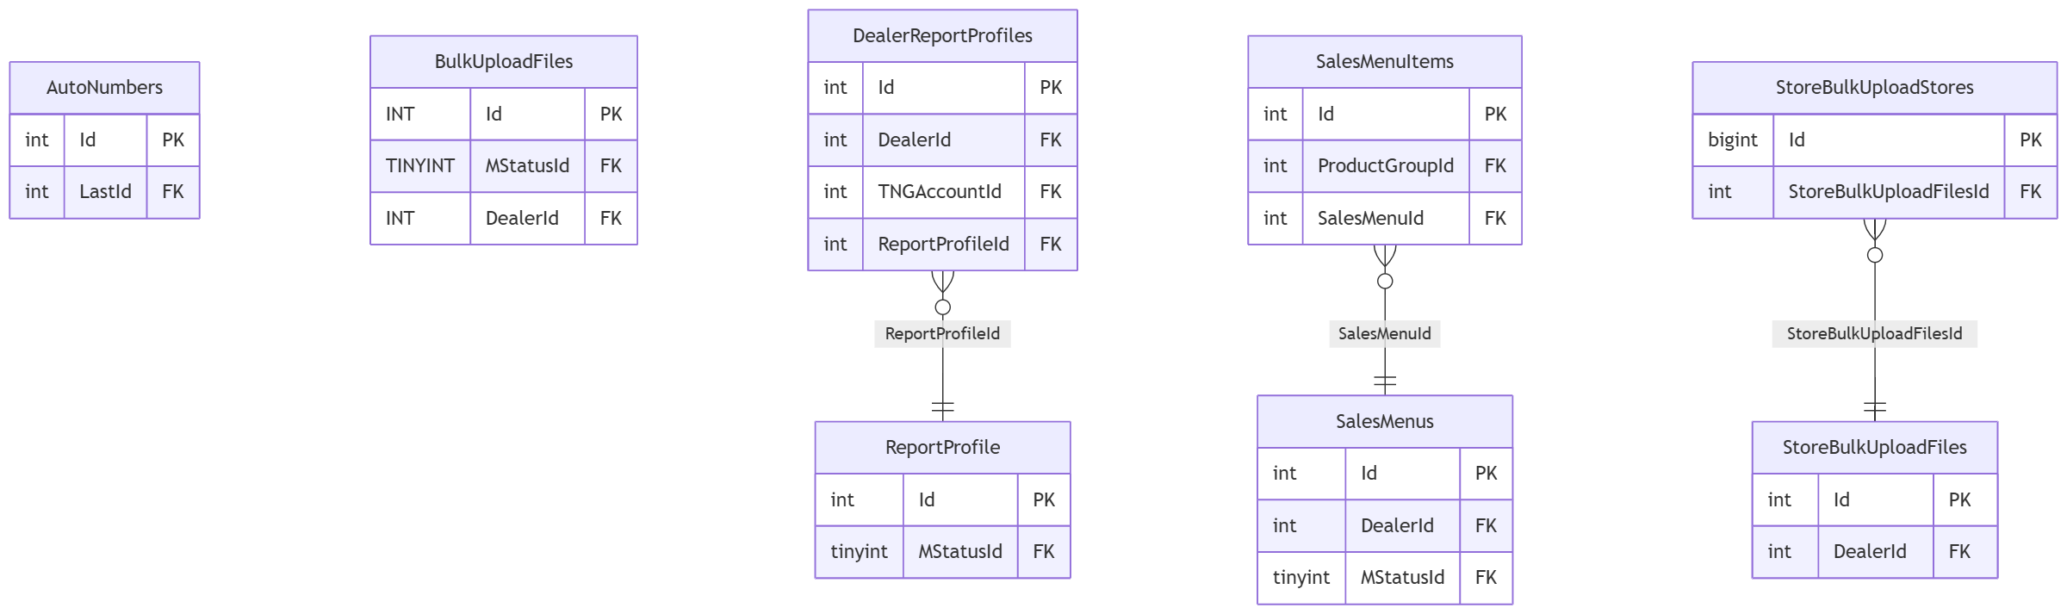

CONFIGURATION — ER diagram
architecture/reload_db/diagrams/configuration-er.md
3 tables, one dbo schema.
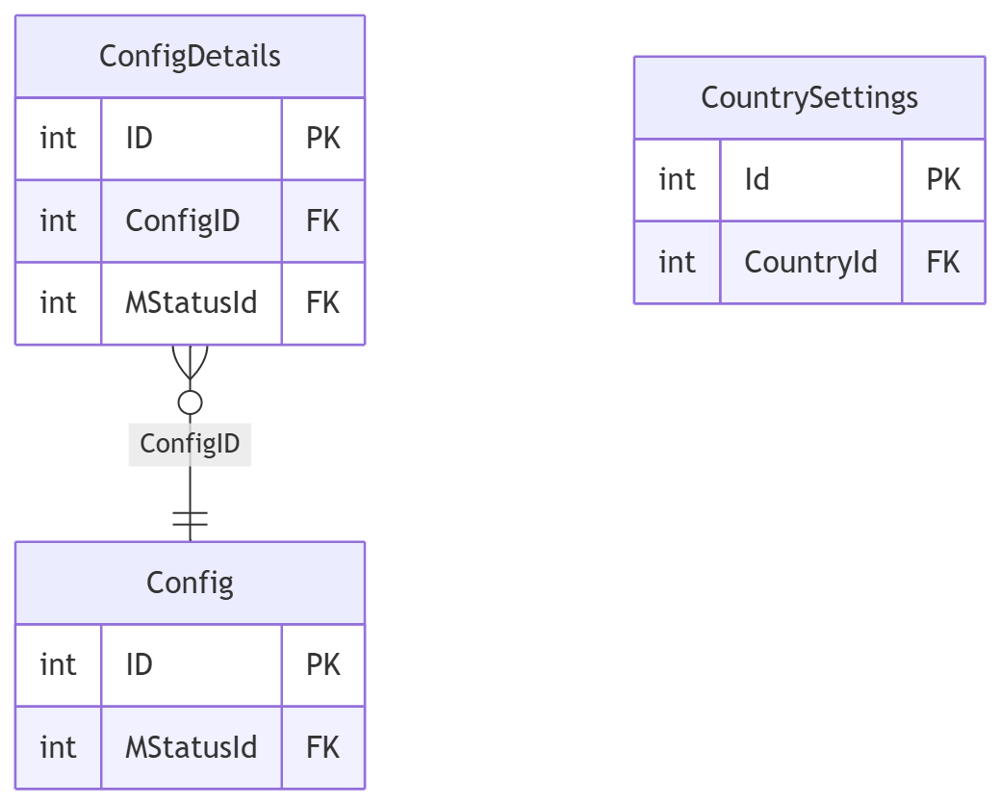
(RMS_OFFLINE.dbo has its own separately-defined Config/ConfigDetails pair with a near-identical shape — not the same physical tables. See configuration.md.)

Cross-module relationships
architecture/reload_db/diagrams/cross-module-relationships.md
The handful of tables that actually get referenced across database boundaries — as opposed to within a single module, which is what each module's own <module>-er.md diagram covers. Every arrow here is an inferred-by-naming-convention relationship (three-part cross-database SQL like [CEPP].[dbo].[LookupCodes]) unless marked (FK) for one of the 6 real, database-enforced foreign keys in the whole estate. Arrows point from the referencing table to the table it references.
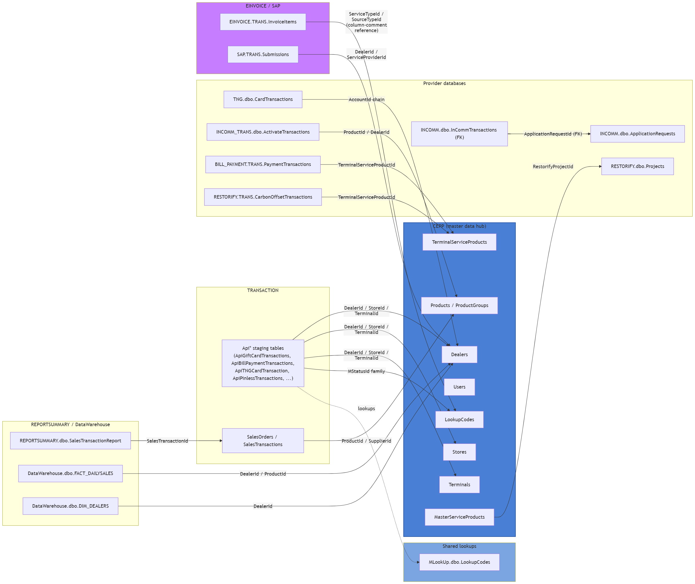

Reading this diagram
- Dealers/Stores/Terminals (all CEPP.dbo) are the single most cross-referenced entities in the estate — nearly every transaction/staging table in every module carries DealerId/StoreId/TerminalId columns pointing back at them. This diagram collapses that into one arrow per module rather than drawing every individual table, or it would be unreadable — see each module's own ER diagram for the full column-level detail.
- LookupCodes is deliberately shown twice — CEPP.dbo.LookupCodes is the primary shared enum table referenced from nearly everywhere, but several modules (TNG, RMS_OFFLINE, INCOMM, NOTIFICATION, MLookUp itself) keep their own separate, physically distinct LookupCodes table rather than only reading CEPP's. MLookUp.dbo.LookupCodes is shown here specifically because it's the one other module's copy that the top-level architecture diagram calls out as cross-referenced by TRANSACTION.
- INCOMM.dbo.InCommTransactions → ApplicationRequests is one of only 6 real, SQL-enforced foreign keys in the entire 470-table estate (per the vault's methodology notes) — everything else on this page, and in every module doc, is inferred from naming convention plus corroborating cross-database SQL found in the application code, not database-enforced.
- MasterServiceProducts.RestorifyProjectId → RESTORIFY.dbo.Projects is the one clear case of CEPP reaching into a provider database rather than the reverse — CEPP is the hub for almost everything else.
- SAP.TRANS.Submissions and EINVOICE.TRANS.Invoices/Submissions are not shown linked to each other here because no verified join was found between them — see 00-overview.md, einvoice.md, and sap.md for why they're suspected to be parallel, not chained.

DataWarehouse — ER diagram
architecture/reload_db/diagrams/datawarehouse-er.md
11 tables, one dbo schema — a star schema.
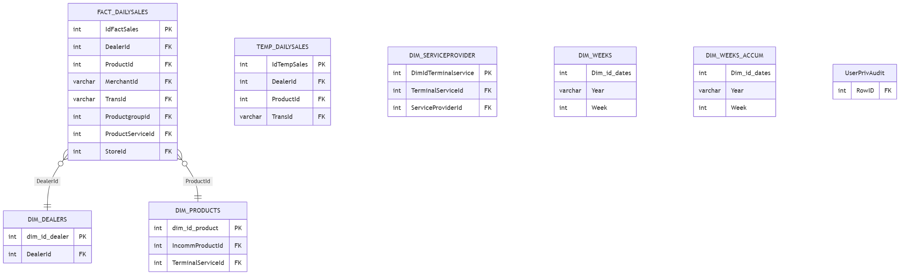
(TEMP_DAILYSALES is the ETL staging copy `DW_SYNC_DATA procedures load before merging into FACT_DAILYSALES — see datawarehouse.md. pinless_storeid_20212021/reload_sto_reid2021/UserPrivAudit2` are one-off/ad-hoc tables omitted here; flagged, not modeled, in the module doc.)*

EINVOICE — ER diagram
architecture/reload_db/diagrams/einvoice-er.md
3 tables, TRANS schema. Entirely missing from the vault — this diagram is built directly from reload_db/MAINT/EINVOICE/Table/*.sql, not adapted from any existing vault diagram. See einvoice.md and vault-drift-notes.md §1.
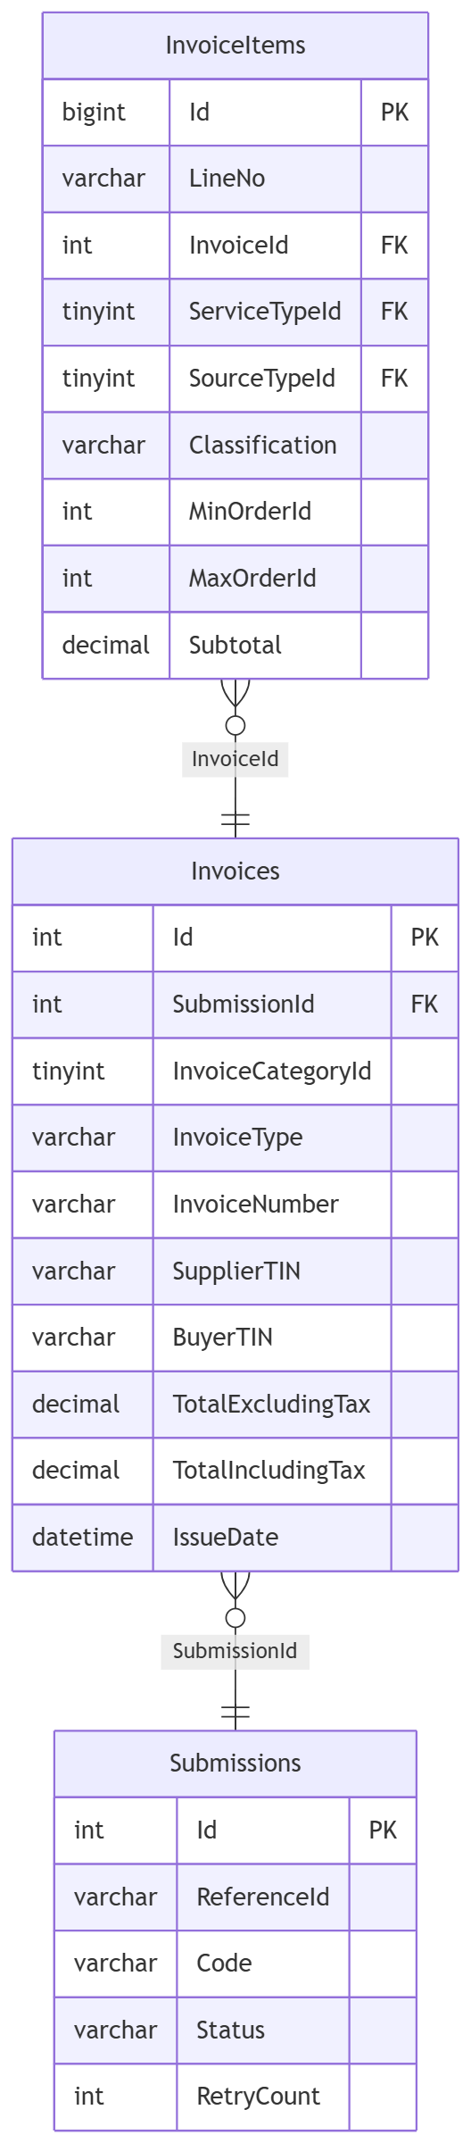
InvoiceItems.ServiceTypeId/SourceTypeId reference CEPP.dbo.LookupCodes by explicit column-level comment in the source script — the one confirmed cross-database link out of this database. Invoices.InvoiceNumber is computed by an AFTER INSERT trigger from InvoiceCategoryId+InvoiceType via 6 dedicated SQL SEQUENCE objects, not by application code — see einvoice.md for the full numbering scheme.

INCOMM — ER diagram
architecture/reload_db/diagrams/incomm-er.md
14 tables, one dbo schema.
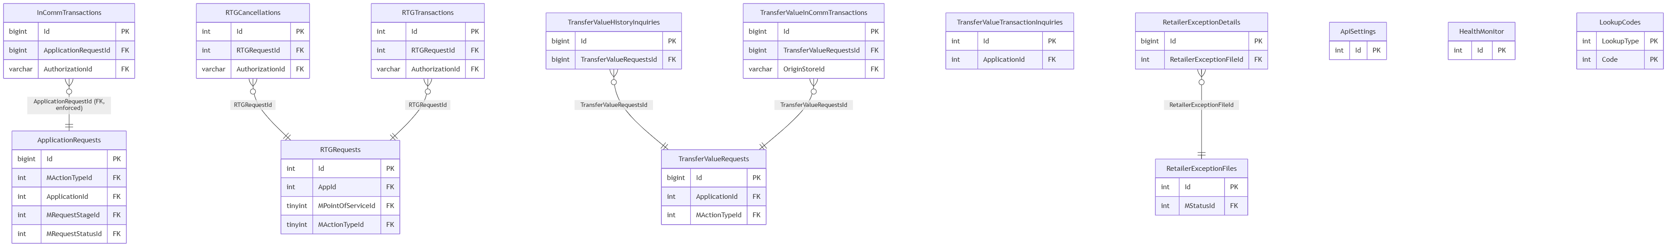
(InCommTransactions → ApplicationRequests is one of only 6 real, database-enforced foreign keys in the entire estate — everything else on this page is inferred by naming convention.)

INCOMM_TRANS — ER diagram
architecture/reload_db/diagrams/incomm-trans-er.md
10 tables, one dbo schema.
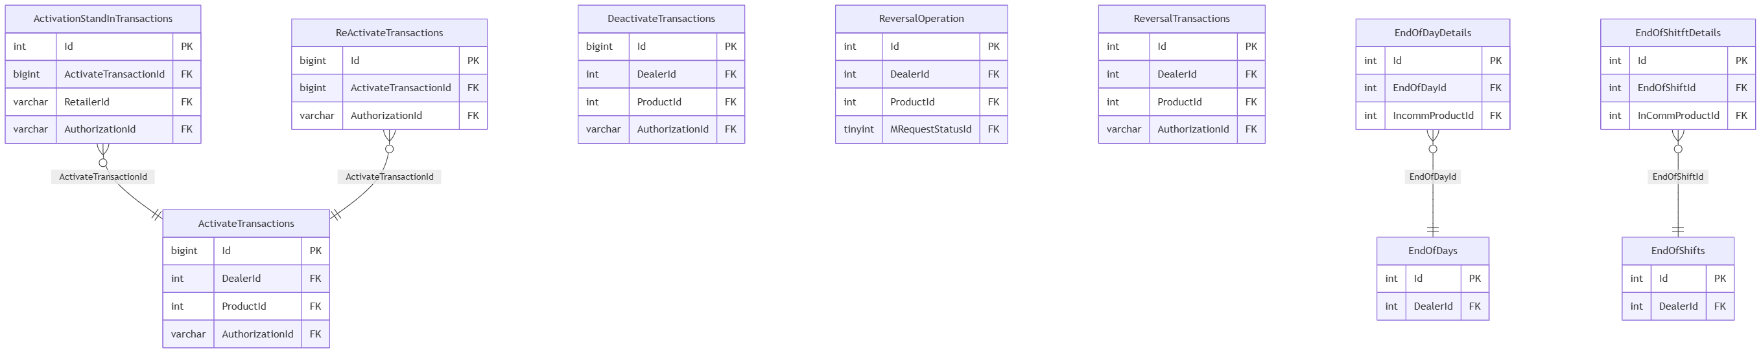
(EndOfShitftDetails is the actual live table name — typo reproduced faithfully, not a transcription error.)

INVENTORY — ER diagram
architecture/reload_db/diagrams/inventory-er.md
2 tables, one dbo schema.
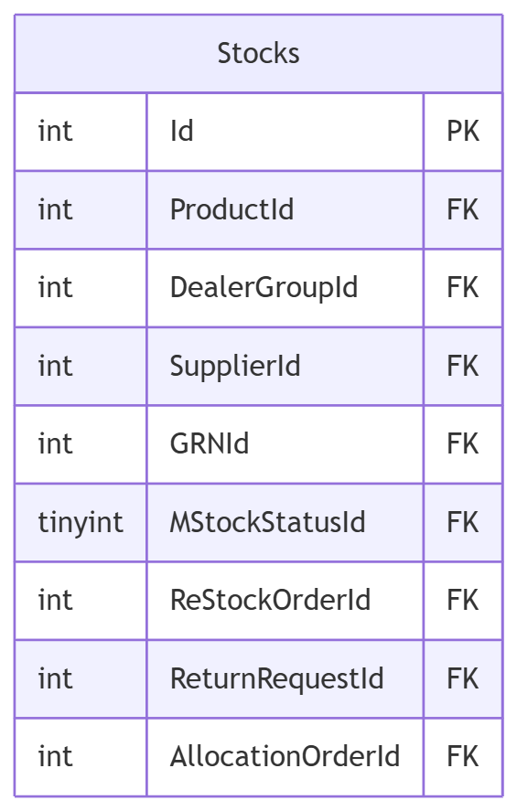
(A single table, but with 84 stored procedures against it — the highest procedure-to-table ratio in the estate. ReStockOrderId/ReturnRequestId/ AllocationOrderId all point at TRANSACTION.dbo tables — see inventory.md. Compare with the similarly-named but separate INVENTORY_MASTER.dbo.Stocks.)

INVENTORY_MASTER — ER diagram
architecture/reload_db/diagrams/inventory-master-er.md
3 tables, one dbo schema.
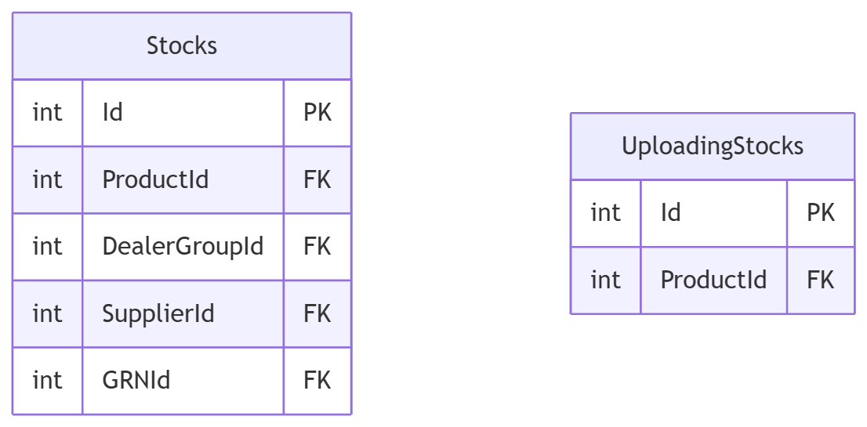
(No relationships found between Stocks and UploadingStocks themselves — UploadingStocks is a staging table that presumably feeds Stocks via application code, not a declared FK-by-convention link. See inventory-master.md for the distinction from INVENTORY.dbo.Stocks.)

LOGGING — ER diagram
architecture/reload_db/diagrams/logging-er.md
1 table, one dbo schema — the smallest database in the estate.
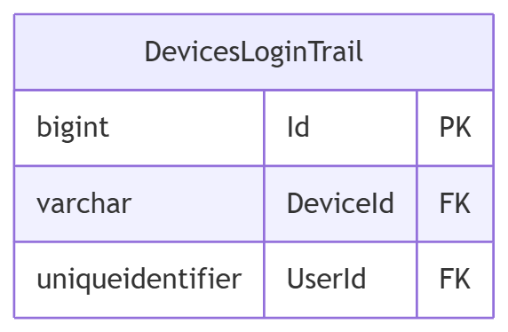
(UserId's type, uniqueidentifier, matches CEPP.dbo.Users.UserUId rather than CEPP.dbo.Users.Id — see logging.md.)

MLookUp — ER diagram
architecture/reload_db/diagrams/mlookup-er.md
5 tables, one dbo schema. No relationships between the tables — each is an independent lookup keyed on its own composite key.
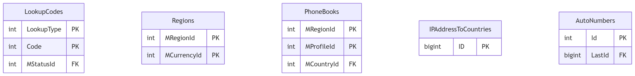
(This LookupCodes/Regions are physically separate tables from CEPP.dbo.LookupCodes/CEPP.dbo.Regions — same names, different databases. See diagrams/cross-module-relationships.md.)

NOTIFICATION — ER diagram
architecture/reload_db/diagrams/notification-er.md
9 tables, one dbo schema.
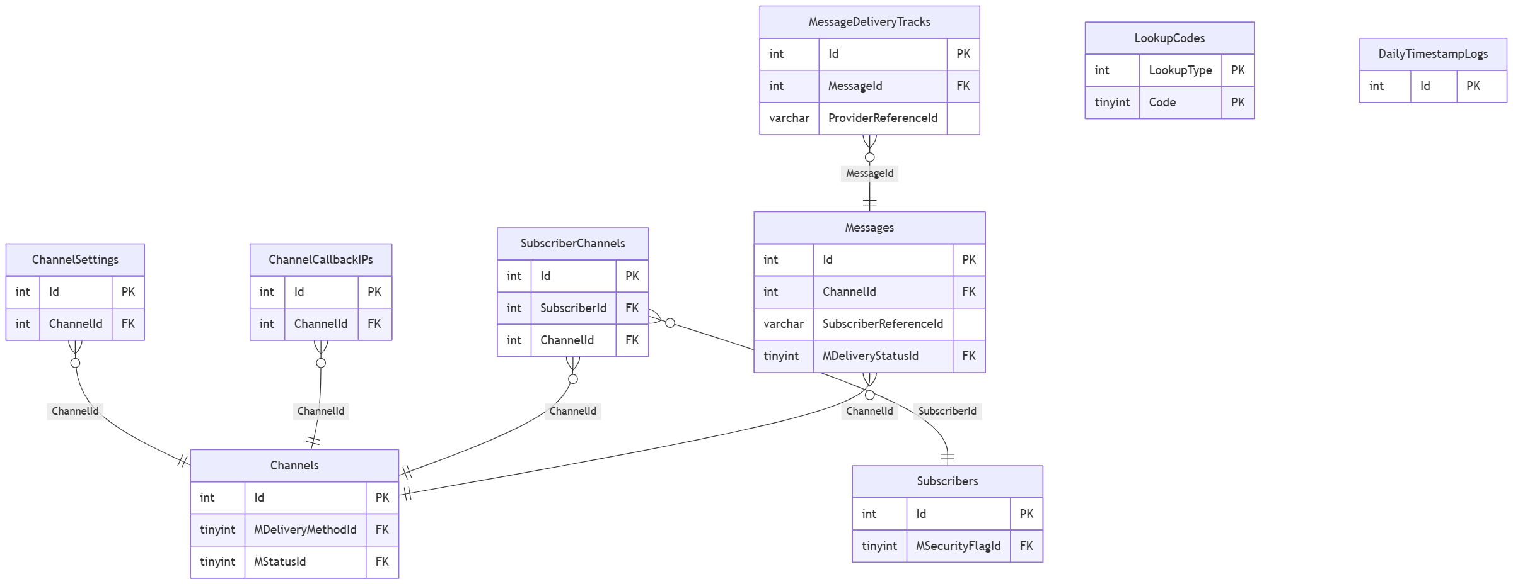
(No StoredProcedure/ folder exists for this module in MAINT/ even though real procedures back every table above — see notification.md and vault-drift-notes.md §4.)

PREPAID — ER diagram
architecture/reload_db/diagrams/prepaid-er.md
4 tables, one dbo schema.
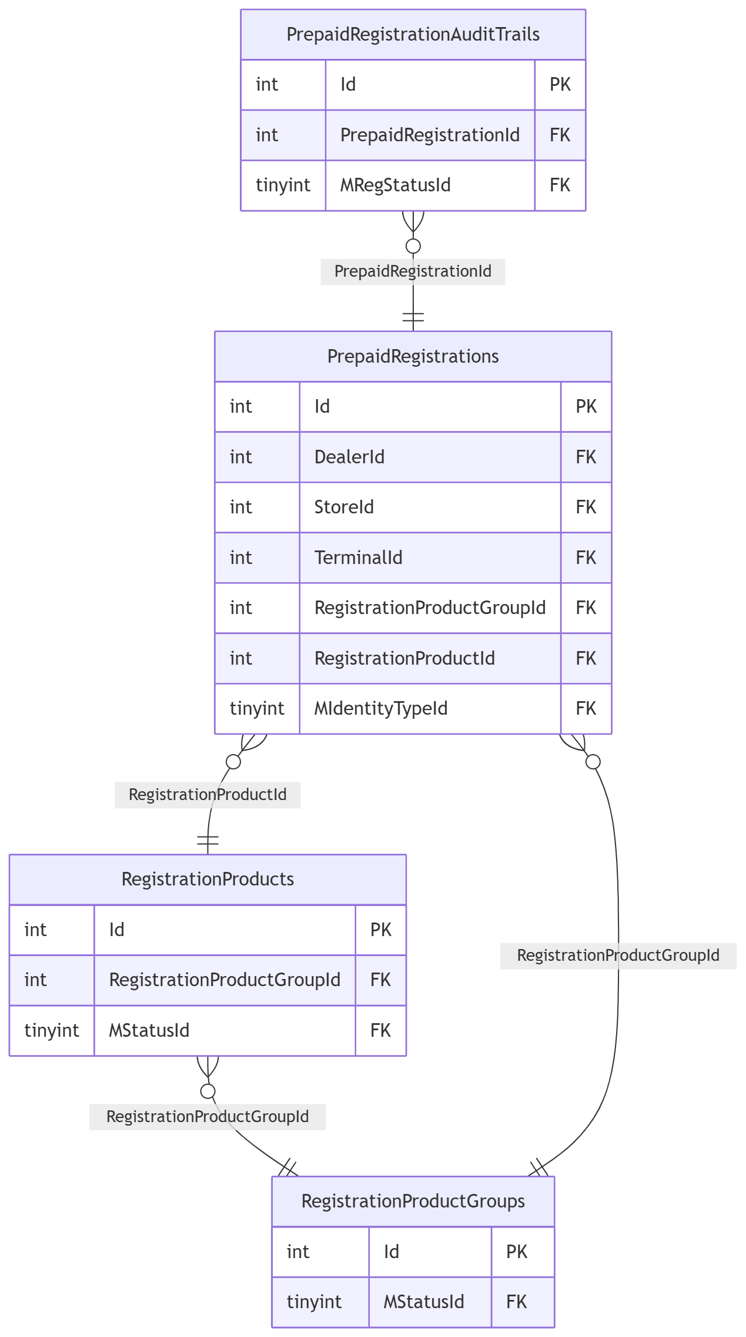

REPORTSUMMARY - ER diagram
architecture/reload_db/diagrams/reportsummary-er.md
40 tables, one dbo schema. Grouped by the channel/feature clusters used in the module doc.
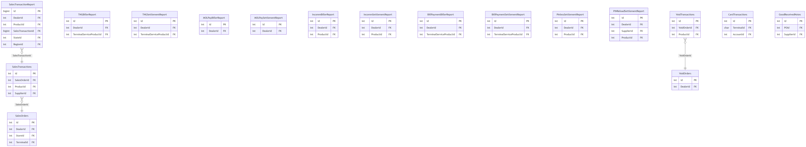

RESTORIFY — ER diagram
architecture/reload_db/diagrams/restorify-er.md
22 tables across dbo, STACS, TRANS.
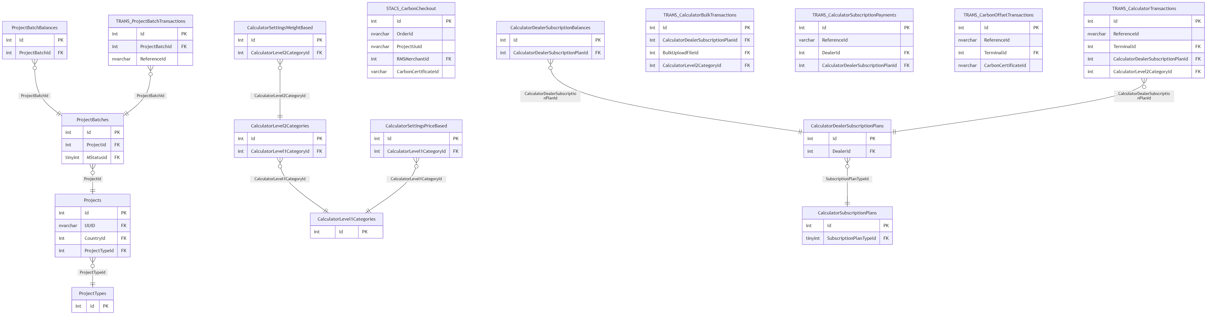
(Projects.Id is also the target of CEPP.dbo.MasterServiceProducts.RestorifyProjectId — the one place CEPP reaches into a provider database; see diagrams/cross-module-relationships.md.)

RMS_OFFLINE — ER diagram
architecture/reload_db/diagrams/rms-offline-er.md
41 tables, one dbo schema. Split by the functional clusters used in rms-offline.md.
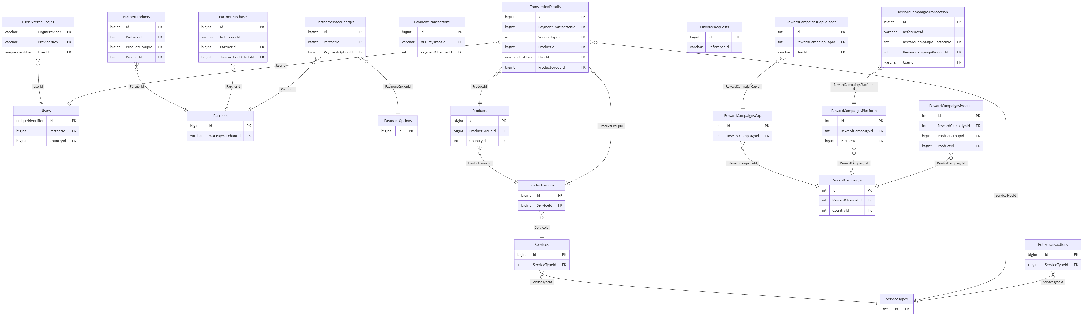
(CMS-only tables — FAQCategory/FAQDetails, FooterCategory/ FooterDetails, HomePageDetails, MaintenanceNoticeDetails, SupportCategory/SupportDetails, EmailTemplate — are omitted here as they carry no cross-table relationships; see rms-offline.md.)

SAP — ER diagram
architecture/reload_db/diagrams/sap-er.md
2 tables, TRANS schema. Entirely missing from the vault — this diagram is built directly from reload_db/MAINT/SAP/Table/*.sql, not adapted from any existing vault diagram. See sap.md and vault-drift-notes.md §1.
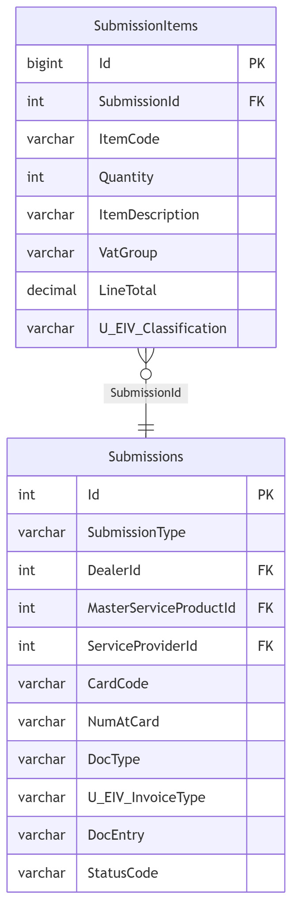
Submissions.DealerId/MasterServiceProductId/ServiceProviderId reference CEPP. The CardCode/DocEntry/U_EIV_* columns are SAP Business One's own vocabulary (business-partner code, SAP document entry number, and user-defined fields) — this table is staging data for a document to be posted into SAP B1, not a Fiuu-native design. See sap.md for the suspected (unconfirmed) relationship to the EINVOICE database's near-identical Submissions/U_EIV_* shape.

TICKET — ER diagram
architecture/reload_db/diagrams/ticket-er.md
3 tables across Ticket2U and TRANS schemas.
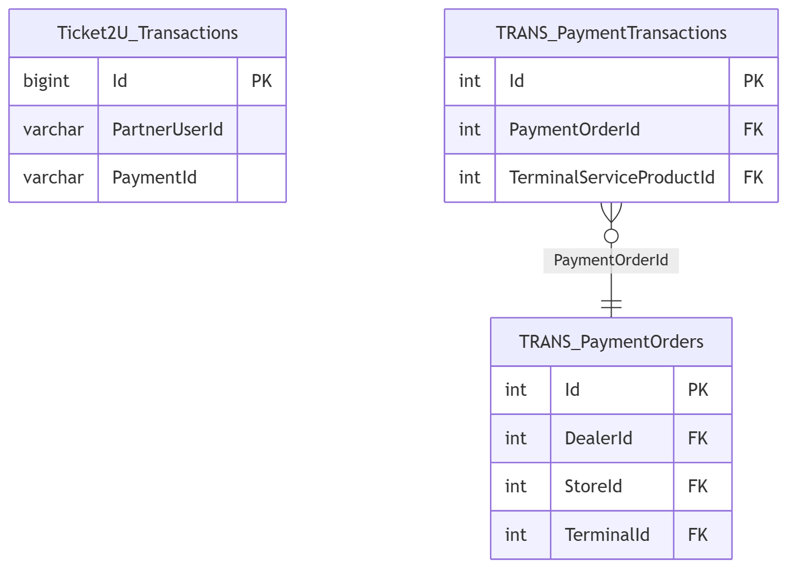
(Entity names prefixed Schema_Table — Mermaid erDiagram doesn't allow dots in identifiers. TRANS.PaymentOrders/PaymentTransactions here is the same reusable shape as BILL_PAYMENT.TRANS — independently defined, not a shared physical table.)

TNG — ER diagram
architecture/reload_db/diagrams/tng-er.md
22 tables, one dbo schema.
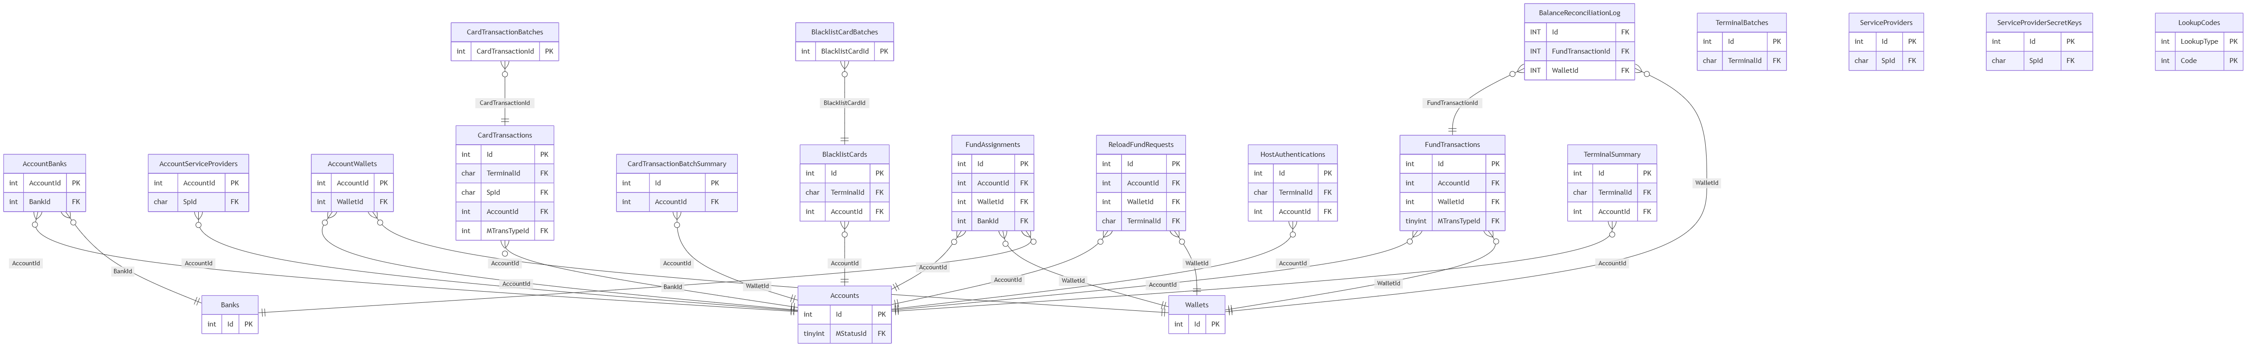
(TNG hardware/account-provisioning tables — TNGAccounts, TNGTerminals, TNGReaderModel, etc. — live in CEPP.dbo, not here. See cepp.md and diagrams/cepp-er.md's "Banking, wallets & TNG/InComm hardware" cluster.)

TRANSACTION — ER diagrams
architecture/reload_db/diagrams/transaction-er.md
144+ tables across 19+ schemas (vault says 144 tables / 14 schemas — both undercounts, see vault-drift-notes.md §3). Split by functional cluster; _new_GIT1857/_new_GIT1858 wide-key migration siblings are omitted from the diagrams below for legibility (same columns as their non-suffixed counterpart, bigint instead of int identity) — see transaction.md.

dbo — API staging (representative subset)
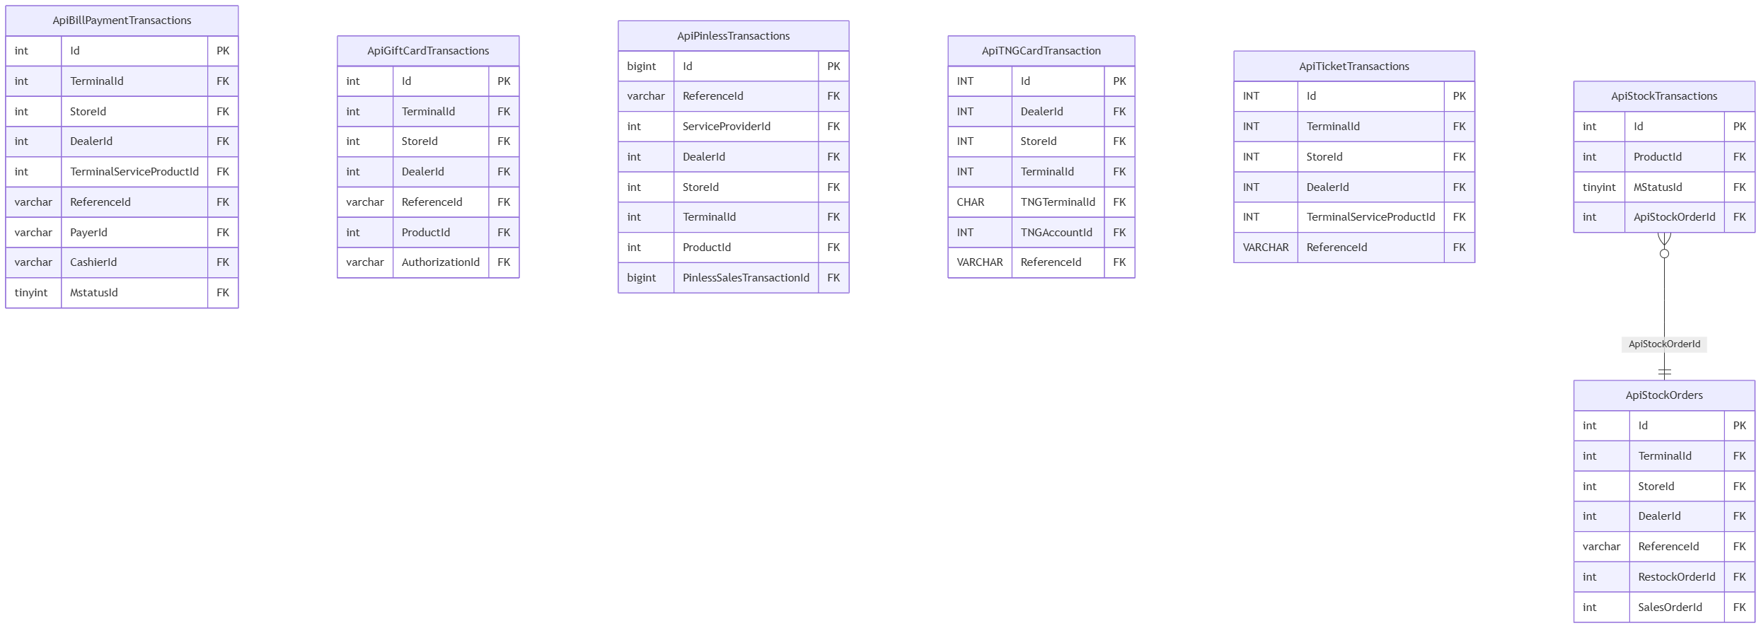

dbo — sales & orders
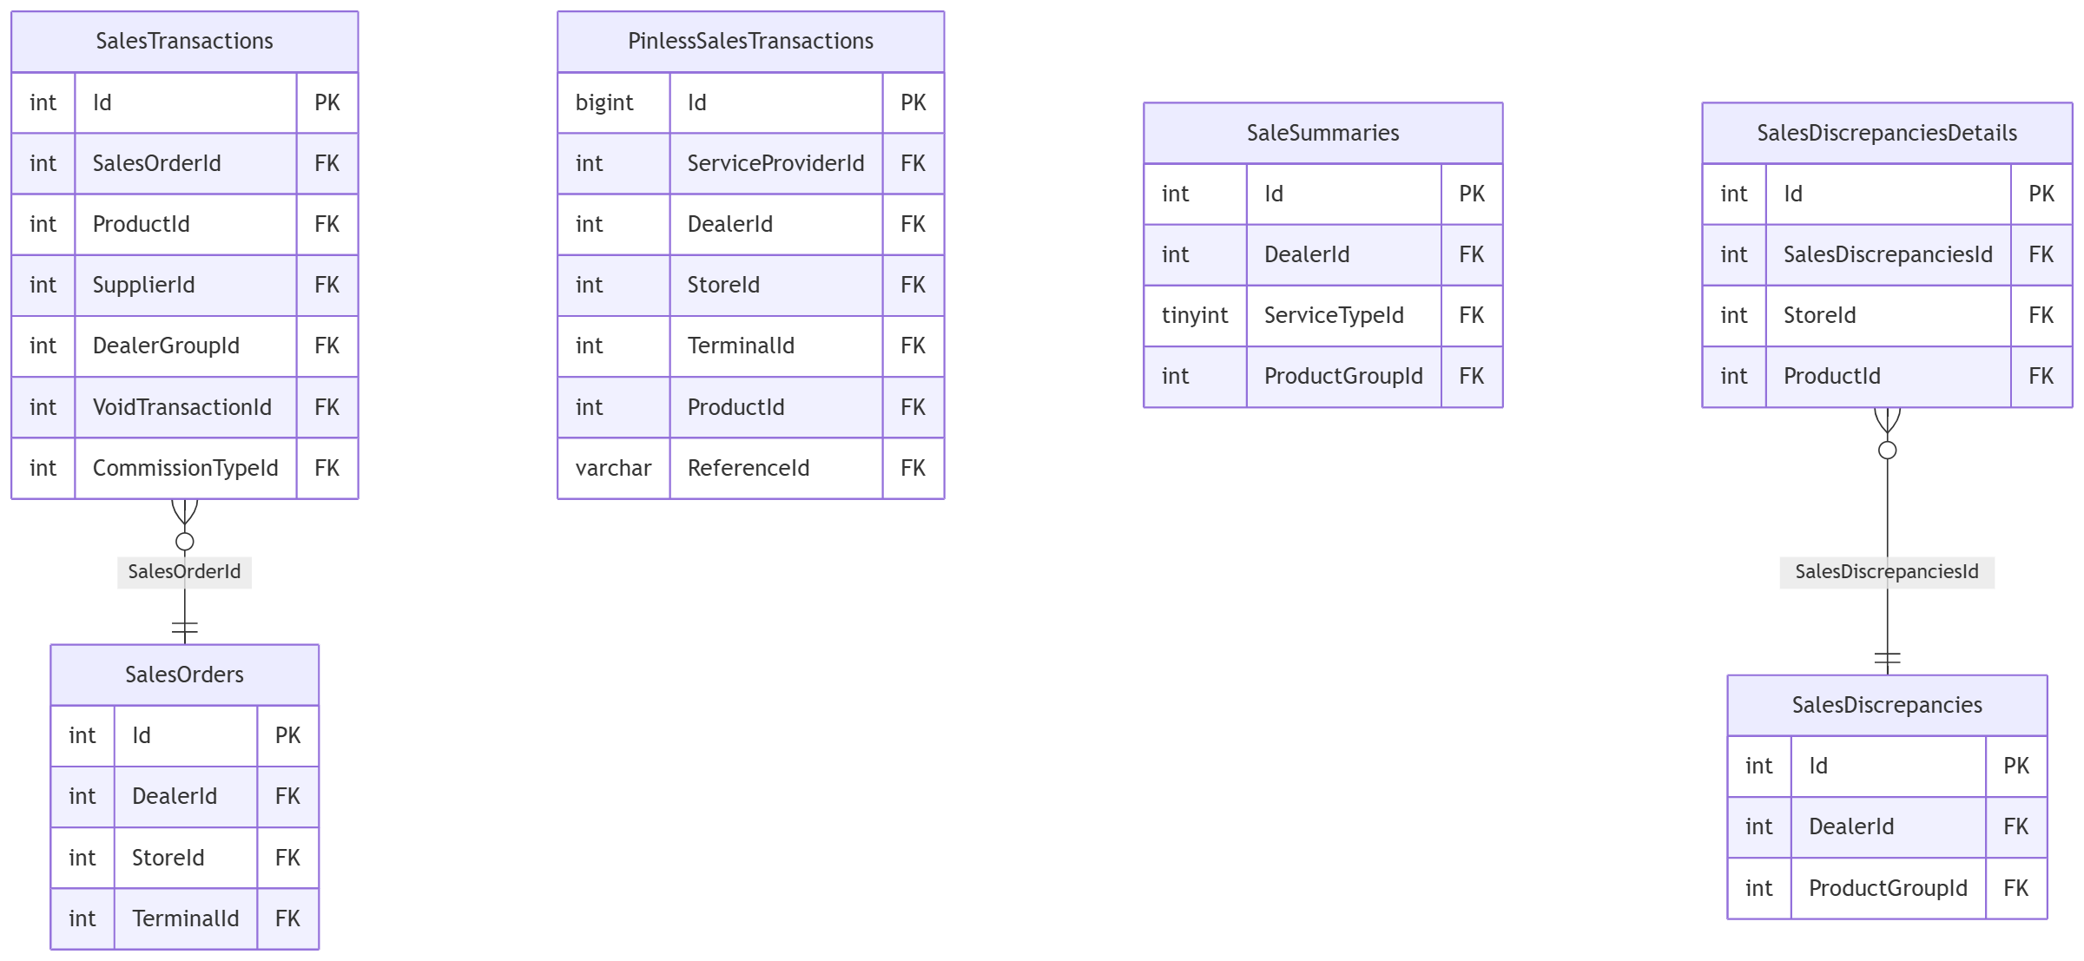

dbo — void & return
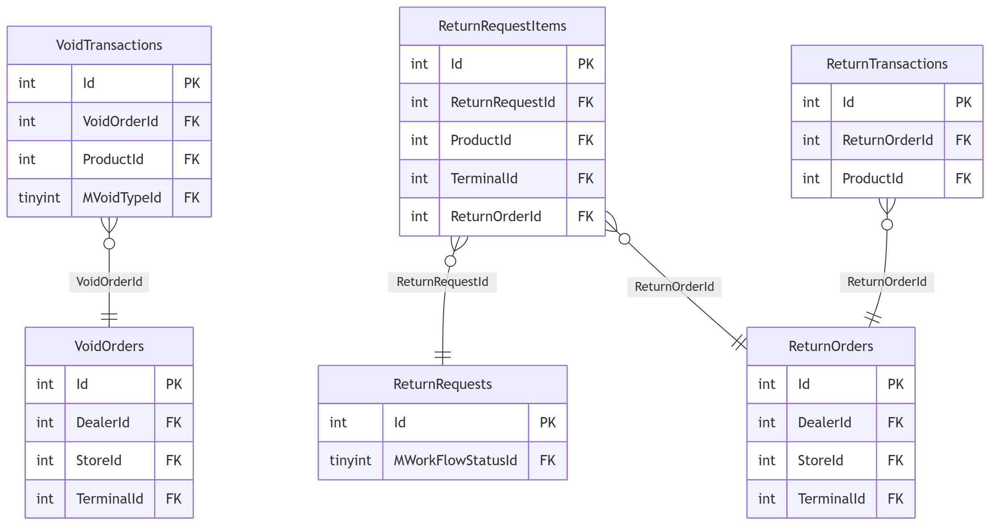

dbo — EOD/reconciliation (Bill Payment shown; Gift Card/Stock/MOLPay follow the identical shape)
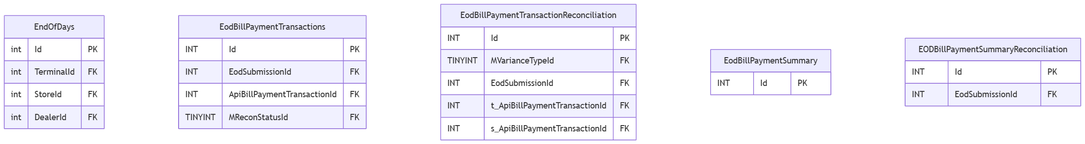
(`t_ = terminal-reported value, s_ = system-recorded value — a mismatch between the two is what MVarianceTypeId` classifies.)

dbo — stock & purchasing
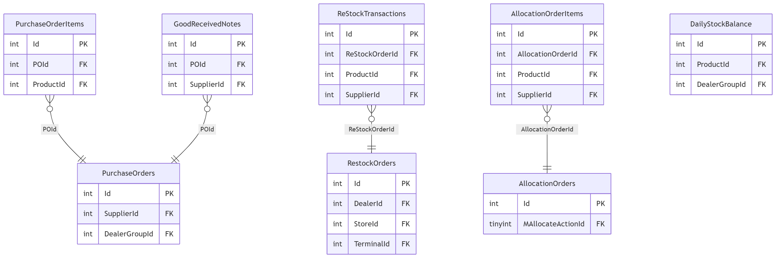

dbo — TNG & MOLPay
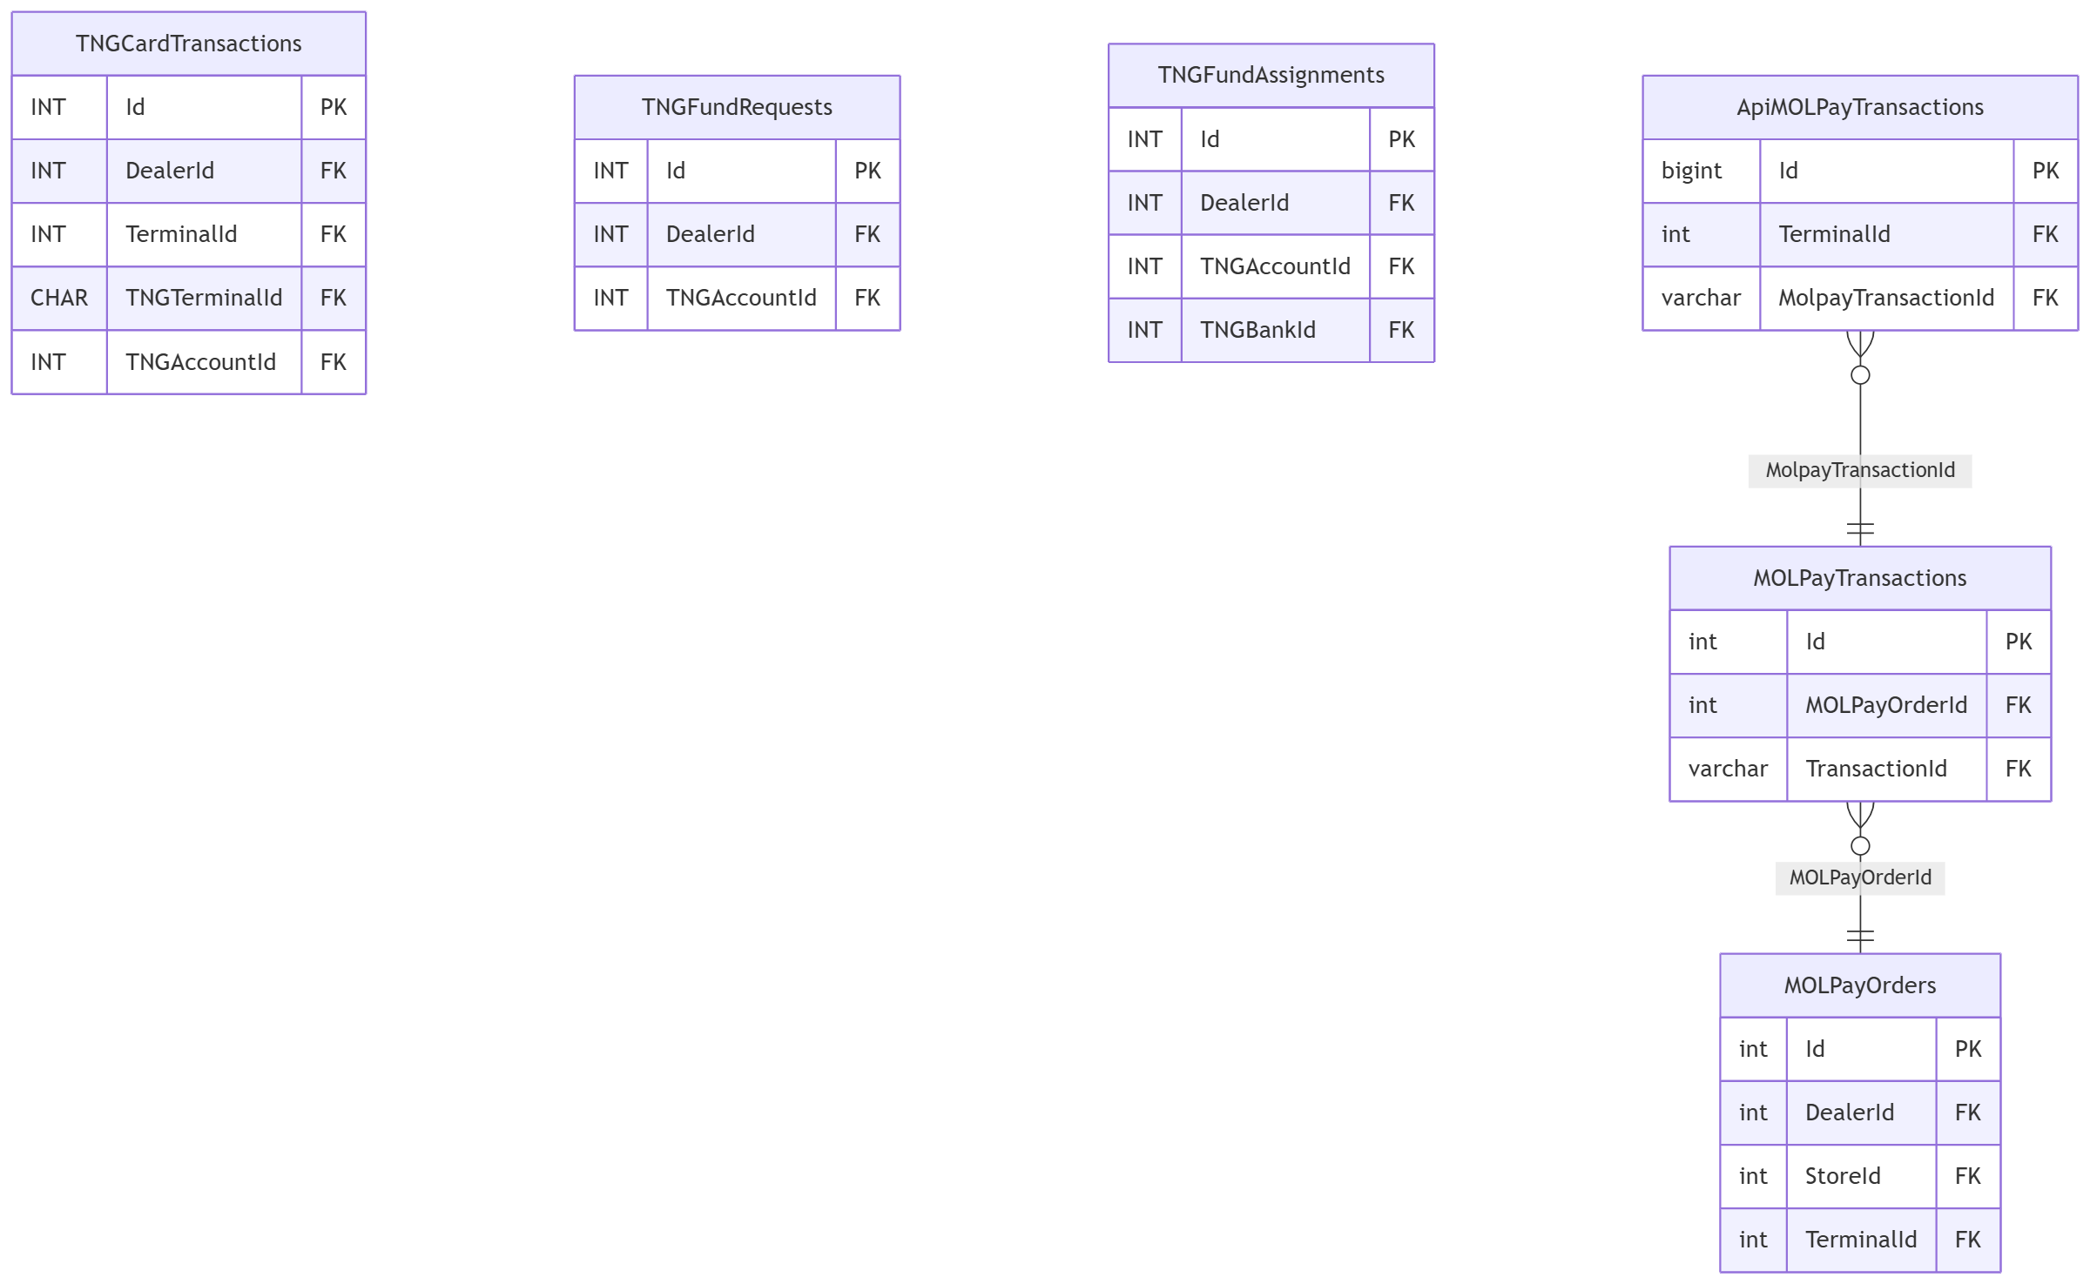

Provider schemas (established + missing-from-vault)
Every provider schema follows one of two shapes: a lone Transactions table, or AccountVerification → Transactions. Shown here: two schemas already in the vault (IIMMPACT, PayLink) alongside all 6 confirmed missing from the vault (vault-drift-notes.md §3) — real columns, taken directly from reload_db/MAINT/TRANSACTION/Table/*.sql.
Entity names below are prefixed Schema_Table purely because Mermaid's erDiagram doesn't allow dots in entity names — the schema is the prefix up to the first underscore, matching the section's file/column evidence (reload_db/MAINT/TRANSACTION/Table/<Schema>.<Table>.sql).
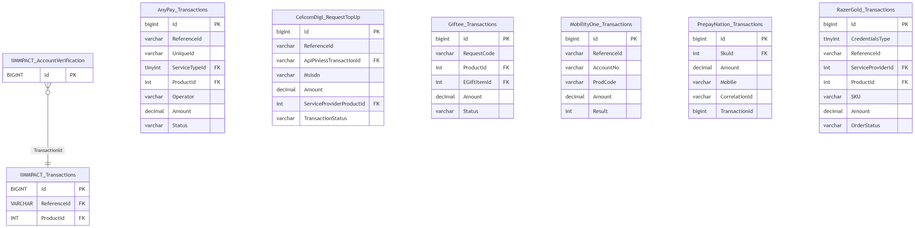
Dates confirmed from script headers: AnyPay 2024-05-14 (GIT-1067), MobilityOne 2024-09-21 (GIT#1338), PrepayNation 2024-12-05 (GIT#1009), CelcomDigi 2025-06-18, RazerGold 2025-07-09 — all real, established integrations, not recent/experimental additions.

Coding Conventions

Coding Conventions
conventions/README.md
Fiuu has no documented coding standard for this codebase (CONTRIBUTING.md in class-library is generic GitLab boilerplate). Everything here is reverse-engineered from the actual code, with real snippets and file:line citations as evidence — not idealized guidelines. Inconsistencies are called out explicitly rather than smoothed over.

Docs
- naming.md — classes/methods/vars, DB objects, and where naming drifts by module/author
- layering-and-architecture.md — the Model/Provider/Service pattern and its consistency
- error-handling.md — catch/log/swallow patterns, custom exceptions
- logging.md — the (multiple) LogHelper implementations and call patterns
- data-access.md — the three coexisting data-access styles, all stored-proc-only
- configuration-and-secrets.md — appSettings, DB-backed config, AWS Secrets Manager, flat-file connection strings (mechanisms only, no literal values)
- comment-style.md — how much/what kind of commenting actually exists
- sql-conventions.md — reload_db/MAINT structure, stored proc/index naming, patch script conventions
- known-patterns-and-pitfalls.md — recurring smells and tech debt worth watching for

Source sampled
reload/class-library (AWSCore, Database, Reloads/TNG, Reloads/Game, Secure/Astro, Secure/Incomm) and reload_db/MAINT (mainly TRANSACTION and CEPP). web_api, web_app, reload_portal, terminal_application, and console_app were empty directories in this checkout (no files) — claims here about how the consuming apps use class-library are necessarily speculative and flagged as such where they occur; revisit once those repos are populated.
Status: first sampling pass complete.

Related
- Known Patterns & Pitfalls — the recurring smells that tie all the docs above together
- Reload application solution — overview — the codebase these conventions were reverse-engineered from
- Reload — MR Review Checklist — what reviewers actually enforce, vs. what's documented here

Comment / Documentation Style
conventions/comment-style.md

XML doc comments are rare — roughly 1 in 10 files has any
Of 626 .cs files under class-library (excluding bin/obj), only 62 contain an XML doc comment (///) anywhere at all — and most of those files likely have just one or two, not comprehensive coverage. Public APIs (*Service, *Provider classes and their public methods) are overwhelmingly undocumented at the member level. Method and parameter names are expected to carry the meaning on their own (see naming.md), and mostly do — e.g. GetTerminalSummaryByTransNo(string transNo) — but there's no IntelliSense-visible description of behavior, edge cases, or failure modes for a consumer of the shared library.

SQL stored procedures: a consistent header block, but shallow
Nearly every stored procedure sampled opens with the same four-line comment block:
-- reload_db/MAINT/TRANSACTION/StoredProcedure/Celcom.Transactions_Ins.sql:9-14
-- =============================================
-- Author: Chee Hong
-- Create date: 2024-05-06
-- Description: Celcom Transactions
-- Used by: Celcom Pinless
-- =============================================
This is almost certainly a leftover from SSMS's built-in "Create Stored Procedure" template (the Author/Create date/Description field names are SSMS's defaults), kept as a convention rather than deliberately designed. The Description: line is frequently just the table name restated ("Celcom Transactions" for a proc that inserts into Celcom Transactions), not a description of behavior, pre/post-conditions, or callers — beyond the one-off Used by: line, it doesn't explain why the proc exists or what calls it.

Patch scripts: header comments present for structured patches, absent for quick ones
Multi-step or risk-bearing patches get a real explanatory comment describing sequencing/intent:
-- reload_db/MAINT/TRANSACTION/Data/GIT#1857/1.PROD_SalesTransactions_Patch_VoidTransactionId.sql:4-10
-- =============================================
-- Patch: SalesTransactions.VoidTransactionId
-- VoidTransactionId is one-way (NULL -> value only). Syncs rows copied during pre-deployment
-- where void occurred after the copy was taken.
-- Run AFTER rename table (downtime only).
-- Run AFTER pre-verify confirms PendingPatch count is as expected.
-- =============================================
But plenty of one-off data patches ship with no comment beyond the Author/date/description header (or none at all) and just the raw UPDATE/INSERT statements — see sql-conventions.md for the Dealers_Patching_RMSO-30.sql example, which has the header block but no explanation of why those specific rows needed patching, only what changed.

Inline comments: sparse, but occasionally load-bearing when present
Most methods have zero inline comments — the code is expected to read for itself. When an inline comment does appear, it's usually because the behavior is genuinely non-obvious and the author knew it:
// reload/class-library/Reloads/TNG/Validators/CardNumberValidator.cs:53-56
long subNumber = Int64.Parse(cardNumber.Substring(cardNumber.Length - 10, 9)); //last digit is serve as parity bit
long fileIndex = (subNumber - 1) / 2000000;
int cardIndex = (int)(subNumber % 2000000);
cardIndex = cardIndex == 0 ? 1999999 : cardIndex - 1; // Fix the index due to 2000000 should be last position

// reload/class-library/Reloads/TNG/Validators/CardNumberValidator.cs:66
else if (fileIndex < 25) //CBL6 -> CB25 are MyCard. Cannot be blacklisted.
This is representative of the codebase's comment philosophy in practice: comments explain domain magic numbers and business rules that can't be inferred from the code, not what the code is doing mechanically. The trade-off is that a file like CardNumberValidator.cs, which is dense with magic numbers (2000000, 60146400, fixed byte-array sizes), is still hard to follow even with the comments it has — there's no overview comment explaining the file format or the blacklist scheme as a whole.

#region blocks used sparingly, mostly in older/AWS-adjacent code
// reload/class-library/AWSCore/Services/SecretsManagerService.cs:18-28
#region Private Declaration
private const string AWS = "AWS";
...
internal static readonly CacheHelper<dynamic> CacheHelper = new CacheHelper<dynamic>();
#endregion
Not a universal convention — most files sampled outside AWSCore don't use #region at all.

TODO-style comments exist and are left in place
// reload/class-library/Database/Helpers/DBConnectionHelper.cs:61-63
foundFile = true;
break; // TODO: might not be correct. Was : Exit For
This particular one is also a tell that the file was mechanically ported from VB.NET ("Was: Exit For") rather than written fresh in C# — worth keeping in mind when reading Fiuu.Database code generally.

Related
- SQL-side Conventions (reload_db/MAINT) — the Dealers_Patching_RMSO-30.sql example referenced above
- Naming Conventions — how method/parameter names are relied on to carry meaning in place of doc comments
- MAINT patch-script conventions — the pre-check/patch/verify comment convention on ticket-numbered patches

Configuration & Secrets
conventions/configuration-and-secrets.md
Mechanisms only — no literal config values, connection strings, keys, or secrets are reproduced below, per handbook policy.
There isn't one configuration story here — at least four distinct mechanisms coexist, layered on top of each other depending on module and how old the code is.

1. Classic System.Configuration / app.config/web.config <appSettings>
The oldest and most universal mechanism. Every module reads simple non-secret settings via ConfigurationManager.AppSettings["Key"], resolved at runtime from whatever host application's config file is loaded (the class-library projects' own app.config files carry only assembly-binding redirects — no <appSettings> block — so the actual key/value pairs live in the consuming EXE/web app's config, not in this library):
// reload/class-library/Reloads/Game/Helpers/LogHelper.cs:20
DirFileLogs = ConfigurationManager.AppSettings["dirFileLogs"] ?? string.Empty;

// reload/class-library/AWSCore/Services/ServiceBase.cs:38-40
else
{
return ConfigurationManager.AppSettings[sConfigKey] ?? string.Empty;
}

2. A database-backed config table (CONFIGURATION DB / ConfigDetails)
Business/environment configuration (as opposed to log paths and app names) is pulled from a CONFIGURATION database via a stored procedure keyed by a config-group name, mapped into a generic KeyName/KeyValue model:
// reload/class-library/AWSCore/Providers/ConfigurationProvider.cs:13-26
internal List<ConfigDetails> GetConfigDetails(string sConfigName)
{
...
result = SqlAccessor.ExecuteProcedure(dbConnstringAlias: "CONFIGURATION",
procName: "CONFIGURATION.dbo.ConfigDetails_Sel_ByConfigName", param);
...
}

// reload/class-library/AWSCore/Models/ConfigDetails.cs
public class ConfigDetails
{
public int ConfigId { get; set; }
public string KeyName { get; set; }
public string KeyValue { get; set; }
}
The same ConfigDetails-shaped model/table pattern also exists independently under Database/Models/RMS_OFFLINE/ConfigDetailModel.cs — another instance of the same idea reimplemented per module rather than shared.

3. AWS Secrets Manager, gated by an EventAppName/partner switch, cached in-process
Actual credentials (partner usernames/passwords/API keys for each downstream integration) are fetched from AWS Secrets Manager, not from appSettings or the CONFIGURATION DB. The set of secret labels expected for the current host process is decided by a big switch on EventAppName (effectively "which partner/app am I"):
// reload/class-library/AWSCore/Helpers/SecretsHelper.cs:38-53 (labels only, no values)
private void SecretLabelMapper()
{
string sEventAppName = GetAppSetting("EventAppName");
switch (sEventAppName)
{
case AppUserNames.AnyPay:
SecretsDictionary.Add(SecretsLabels.AnyPay.LoginId, string.Empty);
SecretsDictionary.Add(SecretsLabels.AnyPay.Password, string.Empty);
SecretsDictionary.Add(SecretsLabels.AnyPay.ApiKey, string.Empty);
break;
...
SecretsHelper is a lazy singleton (Lazy<SecretsHelper>) that, on first use, resolves every label in that dictionary to its real value via SecretsManagerService.GetSecret(label):
// reload/class-library/AWSCore/Helpers/SecretsHelper.cs:24-36
private SecretsHelper()
{
SecretsDictionary = new Dictionary<string, string>();
SecretLabelMapper();
foreach (string sSecretLabel in SecretsDictionary.Keys.ToList())
{
SecretsDictionary[sSecretLabel] = _secretsManagerService.GetSecret(sSecretLabel) ?? string.Empty;
}
}
SecretsManagerService itself resolves which AWS Secrets Manager secret bundle to fetch (by name pattern — e.g. whether the current app is a "Bill" or "Backoffice" host) and caches the raw secret JSON blob in-process via a shared CacheHelper<T>, so repeated GetSecret(label) calls after the first don't re-hit AWS:
// reload/class-library/AWSCore/Services/SecretsManagerService.cs:56-63
string sCacheKey = AWS + "#SecretManager#" + SecretName;
var cachedResponse = CacheHelper.Get(sCacheKey);
...
IAmazonSecretsManager _client = new AmazonSecretsManagerClient(_accessKeyId, _secretKey, RegionEndpoint.GetBySystemName(_region));
Note the AWS access key/secret used to authenticate to Secrets Manager are themselves pulled from the CONFIGURATION DB (mechanism #2 above), not from appSettings or an environment variable — so mechanism 2 bootstraps mechanism 3.

4. Plain-text connection-string files on the local disk
Fiuu.Database's connection strings are not read from a config file's <connectionStrings> section at all. They're read from a flat text file named after the database alias, searched for across a fixed, hardcoded list of local directories:
// reload/class-library/Database/Helpers/DBConnectionHelper.cs:12-15
private static string[] CONNECTION_DIRECTORIES = new string[] {
"d:\\db",
"c:\\db"
};

// reload/class-library/Database/Helpers/DBConnectionHelper.cs:18-26
public static string GetRMSOFFLINEConnectionString()
{
if (!string.IsNullOrEmpty(_connectionString)) return _connectionString;
string fullPath = FindConnectionFileByAlias("RMS_Offline");
_connectionString = ReadFileContents(fullPath);
return _connectionString;
}
The file is looked up as {directory}\{alias}.txt (e.g. d:\db\RMS_Offline.txt, d:\db\LOGGING.txt), read as raw ASCII text, trimmed, and cached in a static field for the process lifetime. This is a materially different — and more fragile — mechanism than the rest of the codebase's config story: it assumes a specific drive letter/folder exists on whatever machine the app runs on, stores the connection string (which may itself embed a SQL login/password) in an unencrypted flat file on local disk, and has no fallback if the file is missing beyond throwing FileNotFoundException.

Migration in progress: .NET Framework config vs. .NET 8 appsettings.json
ServiceBase.GetAppSetting branches on the running CLR's major version to decide whether to read ConfigurationManager.AppSettings (.NET Framework) or parse appsettings.json directly (.NET 8+), rather than going through a Microsoft.Extensions.Configuration abstraction that would hide the difference:
// reload/class-library/AWSCore/Services/ServiceBase.cs:25-41
public static string GetAppSetting(string sConfigKey)
{
if (Environment.Version.Major >= 8)
{
//TO CATER FOR .NET VERSION 8 ONLY
string sAppSettingsFilePath = Path.Combine(AppDomain.CurrentDomain.BaseDirectory, "appsettings.json");
string json = File.ReadAllText(sAppSettingsFilePath);
JObject jObject = JObject.Parse(json);
return jObject[sConfigKey]?.ToString() ?? string.Empty;
}
else
{
return ConfigurationManager.AppSettings[sConfigKey] ?? string.Empty;
}
}
This is a clear signal the codebase is being ported off classic .NET Framework toward modern .NET incrementally, module by module, with runtime version-sniffing used as a stopgap rather than a configuration abstraction layer. See known-patterns-and-pitfalls.md.

Related
- AWSCore — the SecretsHelper/Secrets Manager mechanism detailed in full (§3 above)
- Topology: what's actually on disk vs. what we assumed — the same connection-string/secrets split traced independently (§7)
- Known Patterns & Pitfalls — the local-disk connection-string risk (§5) and .NET migration signal (§11) called out above

Data Access
conventions/data-access.md
Three distinct data-access patterns coexist in class-library, all stored-procedure-only (no inline ad hoc SQL text, no LINQ-to-SQL/EF entity mapping, no query builder) — but the plumbing to call those procedures differs by module/era.

Pattern 1 (most common in Reloads/* and Secure/*): SqlAccessor + ParameterCollection
A custom framework wrapper (Fiuu.MasterFramework.Database, compiled dependency, no source in this repo) around ADO.NET. Callers build a ParameterCollection, call SqlAccessor.ExecuteProcedure(returnType, dbAlias, procName, param), and get back a SqlResult with helpers (.IsEmptyRecord, .TableAdapter.DataTable, .GetParameterValue<T>(), .ScalarResult, .AffectedRecords).
// reload/class-library/Reloads/TNG/Providers/TerminalProvider.cs:12-33
public bool Insert(TerminalActivity activity)
{
var param = new ParameterCollection();
param.Add("@TerminalId", DbType.AnsiStringFixedLength, 8, activity.TerminalId);
...
SqlAccessor.ExecuteProcedure(ReturnType.NonQuery, Fiuu.Provider.Database.TNG.Alias,
Fiuu.Provider.Database.TNG.StoredProcedures.TerminalActivities_Ins, param);
return true;
}
Output parameters are pulled back the same way:
// reload/class-library/Reloads/TNG/Providers/TerminalProvider.cs:50-56
param.AddOutput("@Id", DbType.Int64, 8);
var result = SqlAccessor.ExecuteProcedure(ReturnType.NonQuery, ..., param);
summary.Id = result.GetParameterValue<long>("@Id");
Mapping a DataRow back to a model is always done by hand, field by field, via a shared Conversion.DBNullTo* helper family (DBNullToInt32, DBNullToString, DBNullToDateTime, DBNullToDecimal, DBNullToNullableDecimal, ...) — never a generic/reflection-based mapper:
// reload/class-library/Reloads/TNG/Providers/AccountProvider.cs:67-81
private static Account GetAccountModel(DataRow dr)
{
return new Account
{
Id = Conversion.DBNullToInt32(dr["Id"]),
Name = Conversion.DBNullToString(dr["Name"]),
Status = (Status)Conversion.DBNullToInt32(dr["MStatusId"]),
...
};
}
Databases and stored procedures are referenced through generated-looking constant holders (Fiuu.Provider.Database.TNG.Alias, Fiuu.Provider.Database.TNG.StoredProcedures.Accounts_Sel_By_Id) rather than magic strings — this part is consistently typed across modules.

Pattern 2 (the Database project): generic BaseProvider<T> over raw Dapper
Fiuu.Database's own base classes skip SqlAccessor entirely and use Dapper directly against a SqlConnection opened per call:
// reload/class-library/Database/Base/BaseProvider.cs:10-29
public class BaseProvider<T>
{
private string ConnectionString { get; set; }
public BaseProvider(string _connectionString) { ConnectionString = _connectionString; }
public T GetSingle(string spName, DynamicParameters parameters)
{
using (var connection = new SqlConnection(ConnectionString))
{
connection.Open();
return connection.Query<T>(spName, param: parameters, commandType: CommandType.StoredProcedure).FirstOrDefault();
}
}
Database-specific subclasses just fix the connection string:
// reload/class-library/Database/Base/LoggingProvider.cs:10-16
public class LoggingProvider<T> : BaseProvider<T>
{
public LoggingProvider() : base(DBConnectionHelper.GetLOGGINGConnectionString()) { }
}
// reload/class-library/Database/Base/RMSOffineProvider.cs:9-15
public class RMSOffineProvider<T> : BaseProvider<T>
{
public RMSOffineProvider() : base(DBConnectionHelper.GetRMSOFFLINEConnectionString()) { }
}

Pattern 3 (Notification module): a Dapper singleton with one method per stored procedure
Database/Notification/Context.cs is a sealed Lazy<Context> singleton where every stored procedure gets its own named method, each opening its own SqlConnection:
// reload/class-library/Database/Notification/Context.cs:39-50
public int MessageDeliveryTracks_Ins(int messageId, string providerReferenceId, string statusCode)
{
using (var connection = GetConnection())
{
var param = new DynamicParameters();
param.Add("MessageId", messageId, dbType: DbType.Int32, direction: ParameterDirection.Input);
...
return connection.Query<int>(MessageDeliveryTracksIns, param, commandType: CommandType.StoredProcedure).Single();
}
}
Note this uses Dapper's typed Query<Messages>/Query<ChannelSettings> directly against the domain model class — a lighter-weight mapping than Pattern 1's hand-written Conversion.DBNullTo* mapping, and closer to how a modern Dapper repository would normally be written.

Connections and transactions
- Every sampled call is a single stored-procedure call; there is no example anywhere in class-library of composing multiple writes into one ADO.NET transaction (SqlTransaction) or a unit-of-work spanning Provider calls. Multi-step consistency (e.g. "insert transaction row, then update balance") appears to rely on the stored procedure itself doing everything atomically server-side, or on the caller not needing atomicity across calls.
- Pattern 2 and 3 both open a brand-new SqlConnection per call inside a using block (correctly disposed, but no ambient connection pooling abstraction beyond ADO.NET's own pooling) — this is a couple of connection-open round trips per logical operation rather than one shared connection per request/unit-of-work.
- Connection strings themselves are not read from web.config connectionStrings — see the mechanism described in configuration-and-secrets.md.

Everything is stored-procedure-only
No inline dynamic SQL, no string-built SELECT/UPDATE statements, and no ORM entity graph anywhere sampled. This is consistent across all three patterns and across every module (TNG, Game, InComm, Astro, Notification, RMS_OFFLINE) — the one truly universal data-access rule in this codebase.

Related
- Database (Fiuu.Database) — the Fiuu.Database project implementing Patterns 2 and 3 above
- Configuration & Secrets — how the connection strings these patterns consume are actually resolved
- Naming Conventions — the M-prefix/DTO mapping convention used in Pattern 1's hand-written Conversion.DBNullTo* calls
- SQL-side Conventions (reload_db/MAINT) — the stored-procedure naming these Provider classes reference by constant

Error Handling
conventions/error-handling.md

Dominant pattern: catch-all, log, return a sentinel/error-code — don't rethrow
The most common shape at the Provider and Service layer is: wrap the whole method body in try { ... } catch (Exception ex) { log; return <safe default or error-code DTO>; }. The exception's information lives only in the log; the caller sees a false, -1, null, or a response object with an error response code — never the exception itself.
// reload/class-library/Reloads/Game/Providers/GameProvider.cs:15-46
public long AddGameSalesTransaction(GameSalesTransaction gameSalesTransaction)
{
long iId = -1;
...
try
{
...
iId = result.GetParameterValue<Int64>("@Id");
}
catch (Exception ex)
{
LogHelper.Error("AddGameSalesTransaction", gameSalesTransaction != null ? gameSalesTransaction.ReferenceId : null, "Unhandled exception.", ex);
}
return iId; // caller cannot tell "-1 because of an exception" from "-1 because that's a real id"
}

// reload/class-library/Secure/Astro/Services/BillPaymentService.cs:78-83
catch (Exception ex)
{
Logger.WriteErrorToEventLogs(ex, customMessage: string.Format("Payment: {0}", billPaymentRequest.ToJson()));
return new BillPaymentResponse { ResponseCode = ResponseCode.MOL_SYSTEM_ERROR };
}
This pattern is consistent across TNG, Game, Astro, and InComm — it's the de facto house style even though nobody wrote it down.

Narrower pattern: catch a specific SQL error, translate to a status, rethrow otherwise
Where duplicate-key detection matters for correctness (idempotency checks on retryable network calls), the code catches SqlException, checks the error number against known SQL Server constraint-violation codes, and only swallows that specific case — everything else is rethrown:
// reload/class-library/Reloads/TNG/Providers/TerminalProvider.cs:109-124
try
{
result = SqlAccessor.ExecuteProcedure(...);
auth.Id = result.GetParameterValue<long>("@Id");
}
catch (Exception ex)
{
if (ex is SqlException sqlEx && (sqlEx.Number == 2627 || sqlEx.Number == 2601))
{
auth.TransStatus = TransStatus.DuplicateTransNo;
auth.ResponseMessage = "Trans No has been used.";
return false;
}
throw;
}
The magic numbers 2601/2627 are also captured as a named enum elsewhere (Reloads/TNG/Enums/SqlExceptionNumber.cs: ViolationOfUniqueKeyConstraint = 2601, ViolationOfUniqueIndexConstraint = 2627), but TerminalProvider doesn't use that enum — it re-inlines the raw numbers. Two ways of expressing the same check coexist in the same module.

Custom exception types exist, but are thin and rarely propagated
// reload/class-library/Reloads/TNG/Exceptions/MissingMerchantSecretKeyException.cs:5-11
public class MissingMerchantSecretKeyException : Exception
{
public MissingMerchantSecretKeyException(string sMerchantLabel)
: base($"Merchant secret key not found at AWS Secret Manager for label: {sMerchantLabel}")
{
}
}

// reload/class-library/Secure/Incomm/CustomException/APIRequestException.cs:8-16
public class APIRequestException : ApplicationException
{
public int RequestStatus { set; get; }
public APIRequestException(int status)
{
RequestStatus = status;
}
}
APIRequestException is actually used — FastPinSaleService special-cases it in its catch block to preserve a request-status code (Secure/Incomm/Services/FastPinSaleService.cs:49-54). That's the exception being used the way an exception should be: to carry structured failure information back up through a catch. It's the exception here (pun intended) rather than the rule.

A broken custom exception in production code
TNGEODException is worth flagging directly since it demonstrates what "nobody reviews exception types closely" looks like in practice:
// reload/class-library/Reloads/TNG/Exceptions/TNGEODException.cs:14-33
public TNGEODException()
{
new TNGEODException(terminalId, businessDate, messageNo); // constructs and discards a second instance; does nothing to `this`
}
public TNGEODException(int terminalId, DateTime businessDate, string messageNo)
{
this.terminalId = terminalId;
this.businessDate = businessDate;
this.messageNo = messageNo;
}
public override string Message
{
get { return base.Message; } // overrides Message but doesn't do anything with terminalId/businessDate/messageNo
}
The parameterless constructor's body is a no-op bug (new TNGEODException(...) builds and throws away an unused object instead of chaining to this(...)), and the Message override exists but adds no value over the base implementation — the three private fields it stores are never surfaced anywhere. See known-patterns-and-pitfalls.md.

Surfacing to callers: response codes, not HTTP status / structured faults
Because web_api has no source in this checkout, how exceptions become HTTP responses could not be traced end-to-end. What's visible from class-library is that Services return domain response DTOs carrying an enum response code (ResponseCode.MOL_SYSTEM_ERROR, ResponseCode.MOL_TIME_OUT, RequestStatus.MOLServiceError) rather than throwing out of the Service layer — the presumed intent is that these get serialized straight into the API response body, with the exception detail staying server-side in the log only.

Logging inside error handling never itself throws
The one defensive pattern that recurs deliberately: logging code is wrapped so a logging failure can never mask or replace the real error:
// reload/class-library/Reloads/Game/Helpers/LogHelper.cs:66-71
LoggerDic[sKey].Log(sLogMessage);
...
catch
{
// Logging must never take down a transaction.
}

Summary
Situation | Pattern
Generic unexpected failure | catch Exception, log, return sentinel/error-code — swallow
Known SQL constraint violation | catch, check SqlException.Number, translate to business status, rethrow everything else
Cross-boundary failure needing a code | occasionally a custom Exception subclass, caught and translated one layer up
Logging itself failing | always swallowed silently, no rethrow, no fallback logger

Related
- Known Patterns & Pitfalls — the broken TNGEODException (§3) and swallowed-error (§2) patterns cited above
- Logging — where the exception detail actually ends up when it's swallowed
- Reload — MR Review Checklist — the "don't log-and-rethrow" review rule (§A3) that pushes back on this pattern

Known Patterns & Pitfalls
conventions/known-patterns-and-pitfalls.md
Recurring smells and tech-debt shapes worth knowing about before you go digging in this codebase. Framed descriptively — these are things to watch for, not indictments; a lot of this is exactly what you'd expect from a production fintech codebase that's been extended by many hands over many years without a documented standard.

1. Per-module reinvention of the same plumbing
LogHelper, ServiceBase, and the Model/Provider/Service triad are each reimplemented independently per module (TNG, Game, AWSCore, Astro, InComm) rather than shared from one place. Three unrelated LogHelper classes (Reloads/TNG/Helpers/LogHelper.cs, AWSCore/Helpers/LogHelper.cs, Reloads/Game/Helpers/LogHelper.cs) have different method signatures for conceptually the same job — see logging.md. Three unrelated ServiceBase classes exist for the same reason — see layering-and-architecture.md. If you're extending one module, don't assume a helper's behavior generalizes to another module; check the module-local copy.

2. Errors swallowed into sentinel values, not surfaced
The default error-handling shape (error-handling.md) is catch-log-return a safe default. This means a -1 id, a false, or a null can mean either "legitimately nothing found" or "an exception was thrown and swallowed" — the two are indistinguishable to the caller without checking the log. When debugging a "why did this silently not work" report, checking the relevant LogHelper/event log output first is usually the fastest path, since the return value alone won't tell you.

3. Broken/dead code that shipped anyway
TNGEODException's parameterless constructor doesn't actually chain to the parameterized one (it builds and discards a throwaway instance instead of this(...)), and its Message override is a no-op that never surfaces the three fields it stores (Reloads/TNG/Exceptions/TNGEODException.cs). Nothing appears to construct this exception anywhere sampled, which is probably why the bug was never noticed — worth treating as a signal that custom exception types in this codebase are not uniformly battle-tested just because they exist.

4. Hungarian notation and idiomatic C# coexist, by author/module, not by era
sMessage/iId/dtDate/lstXxx-style naming shows up in AWSCore, Game, and InComm; TNG and Astro use plain idiomatic naming for the same kind of code written around the same time. This isn't a legacy-vs-modern split — it's purely who wrote which module. See naming.md.

5. Connection strings on local disk, not in config
Fiuu.Database.Helpers.DBConnectionHelper resolves connection strings by reading a plaintext file named {alias}.txt from a hardcoded list of local paths (d:\db, c:\db) rather than through web.config/app.config <connectionStrings> or a secrets manager. This is a real operational dependency: a machine missing that file/drive throws FileNotFoundException at first use, and the string sits unencrypted on local disk. See configuration-and-secrets.md.

6. Three parallel data-access styles, all valid, none deprecated
SqlAccessor+ParameterCollection (framework wrapper), BaseProvider<T> (generic Dapper), and Context (Dapper singleton, one method per proc) all coexist in class-library with no comment anywhere marking one as old/replaced. If you're adding a new Provider, there's no single template to copy — pick based on which sibling Provider in the same module/database you're extending. See data-access.md.

7. Ticket-reference formatting on SQL filenames has at least five spellings
RMSO-nnn, GIT-nnn, GIT_nnn, GITnnnn, GIT#nnnn — sometimes multiple spellings for the same ticket across sibling files in the same patch (e.g. TRANSACTION/Data/GIT#1857/... next to TRANSACTION/Table/GIT1857/...). Don't assume you can grep for one format and find every patch related to a ticket — search for the bare number too. See sql-conventions.md.

8. Column/verb spelling drift in patch filenames
ADDColumn, AddColumn, Add_Column, ALTERColumn, AlterColumn, ALTER_Column all appear for the same two operations within one database's Table/ folder. Same caveat as above for searching — don't rely on one spelling when auditing what's already been patched on a table.

9. internal vs public on architecturally-identical Provider classes
No discernible rule decides whether a given *Provider class is internal or public — it appears to be per-author habit rather than an intentional encapsulation boundary. Don't infer "this Provider is meant to be used outside its Service" from its access modifier alone; check who actually references it.

10. NOLOCK on every read query
Every sampled Sel/read stored procedure uses WITH (NOLOCK) unconditionally. This is a deliberate, consistent choice (not an inconsistency), but it's a real trade-off — dirty reads are possible by design throughout this system. Worth knowing before you rely on read-after-write consistency from a different connection/procedure than the one that wrote the row.

11. Mid-migration off classic .NET Framework, visible as runtime version-sniffing
AWSCore.Services.ServiceBase.GetAppSetting branches on Environment.Version.Major >= 8 to decide between ConfigurationManager and hand-parsing appsettings.json, rather than using a configuration abstraction that would hide the difference (AWSCore/Services/ServiceBase.cs:25-41). If you're touching code that reads config, check whether it's already been "ported" this way or still assumes classic .config files only — the two styles currently coexist in the same class.

12. @@IDENTITY used instead of SCOPE_IDENTITY()
Celcom.Transactions_Ins.sql (and likely other similarly-templated insert procedures) returns the new row's id via SELECT @@IDENTITY, which can return an id from a trigger-fired insert rather than the statement's own insert if a trigger exists on the table. Worth checking for triggers before trusting @@IDENTITY-returning procedures blindly if you ever add one to a table that didn't have it before.

13. Dense, under-commented business logic in validators
CardNumberValidator.IsValid (Reloads/TNG/Validators/CardNumberValidator.cs) encodes a blacklist bitmap lookup scheme with several magic numbers (60146400, 2000000, fixed 250000-byte reads) and only sparse inline comments explaining why, no overview of the file format as a whole, and no visible unit tests. Treat changes to this class as high-risk without first reconstructing the file-format contract from wherever the blacklist files themselves are documented (not in this repo).

14. Empty consuming-application directories in this checkout
web_api, web_app, reload_portal, terminal_application, and console_app are present as directories but contain no files in this checkout. Everything in this handbook's conventions/ set is derived from class-library and reload_db/MAINT only — how the shared library's Service layer actually gets consumed (controller conventions, DI wiring at the host level, API response shaping, HTTP-level error handling) could not be verified and should be treated as an open question until a populated checkout of those repos is available.

Related
- Logging — the three unrelated LogHelper classes (§1)
- Error Handling — the catch-log-return-sentinel shape (§2)
- Data Access — the three coexisting data-access styles (§6)
- Naming Conventions — the Hungarian-notation/idiomatic split by module (§4)
- Layering / Architecture — the three parallel ServiceBase classes (§1)
- SQL-side Conventions (reload_db/MAINT) — ticket-reference and column/verb spelling drift (§7, §8)
- Topology: what's actually on disk vs. what we assumed — confirms the empty consuming-application directories noted in §14

Layering / Architecture
conventions/layering-and-architecture.md
Note: web_api, web_app, reload_portal, terminal_application, and console_app are present as empty directories in this checkout (no files under them at all) — this doc is based entirely on class-library, which is the only module with actual source. How the consuming apps wire into these services could not be observed directly and would need a populated checkout.

The dominant pattern: Model / Provider / Service, per feature module
Each business module under Reloads/<Module> and Secure/<Module> repeats the same three-layer shape:
- Models — plain DTOs/POCOs, no behavior (Reloads/TNG/Models/Account.cs).
- Providers — data access only, one class roughly per aggregate/table, talks to SQL via stored procedures (Reloads/TNG/Providers/TerminalProvider.cs).
- Services — business logic, implements an I<Name>Service interface, orchestrates one or more Providers plus other Services (Reloads/TNG/Services/TerminalService.cs).
// reload/class-library/Reloads/TNG/Services/TerminalService.cs:8-26
public class TerminalService : ITerminalService
{
private TerminalProvider _provider;
private TerminalProvider Provider
{
get { return _provider ?? (_provider = new TerminalProvider()); }
}
private IAccountService _accountCompo;
private IAccountService AccountCompo
{
get { return _accountCompo ?? (_accountCompo = EngineContext.Current.Resolve<IAccountService>()); }
}
Two things worth noting in that one snippet:
- The Provider is new'd up directly by the Service (no DI for the Provider layer — only Services are resolved through the container). This is the norm, not an exception; every Service sampled does this.
- Cross-Service dependencies go through a service locator (EngineContext.Current.Resolve<T>), lazily, via a backing-field/property pair — not constructor injection. This exact _field ?? (_field = ...) lazy-resolve idiom recurs in every Service that depends on another Service (19 files reference EngineContext.Current.Resolve across class-library).

Dependency registration is per-module, container-based, but hand-maintained
Each module ships its own DependencyRegistrar : IDependencyRegistrar registering its Service interfaces into a shared container abstraction (Fiuu.MasterFramework.Dependency, compiled dependency — no source in this repo):
// reload/class-library/Reloads/TNG/DependencyRegistrar.cs:6-30
public class DependencyRegistrar : IDependencyRegistrar
{
public void Register(IContainerManager container, ITypeFinder typeFinder)
{
container.Register<IAccountService, AccountService>();
container.Register<IBankService, BankService>();
...
This is consistent across modules (TNG, Astro, Game all have one), but it's a manual list someone must remember to update — nothing here auto-discovers implementations of IXxxService by convention.

ServiceBase exists per-module and isn't shared
AWSCore.Services.ServiceBase, Fiuu.Astro.Secure.Core.Services.ServiceBase, and Fiuu.InComm.Secure.Core.Services.ServiceBase are three unrelated classes with the same name and a similar purpose (give Services a shortcut to config/logging/shared plumbing), each hand-written for its own module rather than shared from a common base. E.g. AWSCore's version:
// reload/class-library/AWSCore/Services/ServiceBase.cs:11-23
public class ServiceBase
{
private ConfigurationProvider _configurationProvider { get; set; }
...
protected List<ConfigDetails> GetConfigDetails(string sConfigName)
{
return _configurationProvider.GetConfigDetails(sConfigName);
}
Astro's BillPaymentService : ServiceBase, IBillPaymentService uses its own module's ServiceBase for GetSystemConfig(), CreateBillPayment(...), etc. — same idea, independently implemented per module. See known-patterns-and-pitfalls.md for the duplication angle.

Template-method style base classes for protocol-heavy modules
The InComm module (ISO 8583 card-network messaging) goes one step further and uses an abstract base (InCommServiceBase) with overridable hook methods (ValidateParameters, FormatContractToModel, RetrieveExistingGiftCardResend) that concrete Services override — a genuine Template Method pattern, not just composition:
// reload/class-library/Secure/Incomm/Services/FastPinSaleService.cs:70-90
protected override ContractResponse RetrieveExistingGiftCardResend(ContractRequest request, int actionType) { ... }
protected override InCommTransaction FormatContractToModel(ContractRequest appReq, string processingCode, string messageTypeIdentifier) { ... }
protected override int ValidateParameters(ContractRequest appReq) { ... }
This is notably more structured than the TNG/Game modules, which don't use inheritance for variability at all — evidence that architecture rigor tracks the module/author, not a house standard.

No repository/unit-of-work abstraction, no ORM entities
There is no IRepository<T>, no DbContext-as-ORM (the one class literally named Context, in Database/Notification/Context.cs, is a thin Dapper wrapper singleton, not an EF context), and no transaction/unit-of-work abstraction spanning multiple Provider calls. Each Provider method opens (or is handed) a connection, executes one stored procedure, and returns. Composing multiple writes into one transaction is not a pattern seen anywhere sampled — see data-access.md.

Summary of the pattern's consistency
Aspect | Consistency
Model/Provider/Service split | Very consistent across all modules sampled
Interface-per-Service | Consistent
Provider access modifier (internal vs public) | Inconsistent (see naming.md)
Cross-service wiring (service locator vs DI) | Consistent use of service locator, but per-property boilerplate is hand-copied each time
Base-class reuse | Not shared across modules — duplicated per module
Inheritance/template-method for variability | Only in InComm; other modules use flat Services

Related
- Known Patterns & Pitfalls — the per-module ServiceBase duplication (§1) expanded on above
- Naming Conventions — the *Provider/*Service/*Model suffix convention this layering relies on
- Data Access — how Providers actually talk to the database within this layering
- MasterFramework — the Fiuu.MasterFramework.Dependency container this DI pattern is built on

Logging
conventions/logging.md

No single logging mechanism — two underlying frameworks, three-plus hand-rolled wrappers
There are two shared logging primitives that appear to come from Fiuu's internal framework libraries (compiled dependencies, Fiuu.Logging.dll and part of Fiuu.MasterFramework.dll — no source in this repo):
- Fiuu.MasterFramework.Utilities.Logger — a rolling file logger (new Logger(path, Encoding.UTF8, maxLines, maxFiles, bool)) plus a static Logger.WriteErrorToEventLogs(ex, ...) that writes to the Windows Event Log.
- Fiuu.Logging.LogManager / Fiuu.Logging.Models.Log — a structured logger taking a Log object with LogLevel, EventName, ReferenceId, ExceptionInfo, Detail, RemoteIp, Source.
Instead of one shared façade, at least three modules each define their own static LogHelper class wrapping these primitives differently:
// reload/class-library/Reloads/TNG/Helpers/LogHelper.cs:15-20
private readonly static Logger _logger = new Logger(
string.Format(ConfigurationManager.AppSettings["TNGAPILogFileName"], DateTime.Now.ToString("yyyyMMdd")),
Encoding.UTF8, 1000, 30, true);

// reload/class-library/AWSCore/Helpers/LogHelper.cs:20-41
static LogHelper()
{
EventAppName = GetAppSetting("EventAppName");
// ...reflects over AppUserNames constants to find a friendly app name for the log file...
string sLogFilePath = GetAvailableFileName(string.Format("{0}_{1}", sAppName, DateTime.Now.ToString("yyyyMMdd")));
_logger = new Logger(sLogFilePath, Encoding.UTF8, 1000, 30, true);
}

// reload/class-library/Reloads/Game/Helpers/LogHelper.cs:12-23
private static ConcurrentDictionary<string, Logger> LoggerDic;
...
static LogHelper()
{
DirFileLogs = ConfigurationManager.AppSettings["dirFileLogs"] ?? string.Empty;
LoggerDic = new ConcurrentDictionary<string, Logger>();
MultipleCountry = DirFileLogs.Contains("{0}"); // one log file per country code, keyed dynamically
}
Each of these three LogHelpers has a different method surface (Write/Error/Trace/Warn in TNG's; just Write in AWSCore's; Write/Error with an operation+referenceId overload in Game's), so code that logs in one module cannot be lifted into another without adapting calls. See known-patterns-and-pitfalls.md.

Common call-pattern: bracketed [Key: ref] >>> / <<< request/response logging
Independent of which LogHelper a module uses, outbound HTTP/API calls are logged with a recurring >>> (outgoing) / <<< (incoming) bracket convention, tagged with a correlation key:
// reload/class-library/Secure/Astro/Providers/RpnProvider.cs:93-97
LogHelper.Write(string.Format("[{0}] >>> [Key: {1}] {2}", config.AmdocsPaymentUrl, billPayment.BankClientRefId, request.ToJson()));
string response = HttpHelper.HttpPost(config.AmdocsPaymentUrl, request.ToJson(), MIMEType.TEXT_JSON, config.HttpRequestTimeout);
LogHelper.Write(string.Format("[{0}] <<< [Key: {1}] {2}", config.AmdocsPaymentUrl, billPayment.BankClientRefId, response));

// reload/class-library/AWSCore/Services/SecretsManagerService.cs:73-80
LogHelper.Write(string.Format("[{0}] >>> [Key: {1}] {2}", "GetSecret", sUniqueKey, request.ToJson()));
GetSecretValueResponse response = _client.GetSecretValue(request);
...
LogHelper.Write(string.Format("[{0}] <<< [Key: {1}] {2}", "GetSecret", sUniqueKey, "Secrets received successfully."));
This is genuinely a house convention — it recurs across unrelated modules (Astro, AWSCore) written presumably by different people, and it's the closest thing to a de facto logging standard in the codebase: full request/response bodies get logged (as JSON via a shared .ToJson() extension), correlated by a key that's usually the business reference id or a generated timestamp string.

Errors are logged twice in some paths: file log + event log
// reload/class-library/Reloads/Game/Helpers/LogHelper.cs:85-93
public static void Error(string sOperation, string sReferenceId, string sMessage, Exception ex)
{
string sFormatted = Format(sOperation, sReferenceId, sMessage);
Write(sFormatted + (ex != null ? " [System Error: " + ex.Message + "]" : string.Empty)); // file log
Logger.WriteErrorToEventLogs(ex, null, null, sFormatted); // Windows Event Log
}

What gets logged
- Full outbound request/response payloads (serialized via .ToJson()), including for payment/account-verification calls (Secure/Astro/Providers/RpnProvider.cs) — be mindful these payloads can carry account numbers and amounts; nothing in the sampled code redacts fields before logging.
- Exceptions, generally with a customMessage describing which operation failed and the serialized input that caused it (Logger.WriteErrorToEventLogs(ex, customMessage: ...)), so the log is the primary (often only) place the failure detail survives — see error-handling.md.
- Row-count/no-op conditions as informational writes rather than errors, e.g. LogHelper.Write("UpdateGameSalesTransactionStatus", sReferenceId, "GameSalesTransactions_Upd matched no row.") (Reloads/Game/Providers/GameProvider.cs:64).

Logging is defensively isolated from the transaction it's logging
// reload/class-library/Reloads/Game/Helpers/LogHelper.cs:25-71
public static void Write(string sMessage, string sCountryCode = "General")
{
try
{
...
}
catch
{
// Logging must never take down a transaction.
}
}
This try/swallow-everything wrapper around the logging call itself is deliberate and commented — it's the one place in the sampled code where a blanket empty catch is clearly intentional rather than incidental.

Related
- Known Patterns & Pitfalls — the per-module LogHelper reinvention pattern (§1)
- Error Handling — how the exception detail these logs carry is (or isn't) surfaced to callers
- Logging — the Fiuu.Logging component these LogHelper wrappers sit on top of

Naming Conventions
conventions/naming.md
Reverse-engineered from class-library (AWSCore, Database, Reloads, Secure) and reload_db/MAINT. No naming guide exists anywhere in the repo, so this is what's actually there — including where it contradicts itself.

Classes, interfaces, methods, properties
Standard .NET PascalCase for types, public methods, and properties is followed consistently everywhere sampled:
// reload/class-library/Reloads/TNG/Services/TerminalService.cs:8
public class TerminalService : ITerminalService
{
private TerminalProvider _provider;
public bool Login(Auth auth) { ... }
Interfaces are consistently I-prefixed (ITerminalService, IAccountService, IGameProvider, IBillPaymentService) — no exceptions found.
Layer suffixes are consistent and used as a de facto architecture signal: *Provider (data access), *Service (business logic), *Model/plain noun (DTOs), *Helper (static utility bag), *Validator (input validation), *Exception (custom exceptions). See layering-and-architecture.md.

Local variables and parameters — Hungarian notation is inconsistent across modules
This is the single biggest naming inconsistency in the codebase. Some modules (AWSCore, Game, InComm/Secure) use old-school Hungarian-style prefixes (s = string, i/l = int/long, dt = DateTime, lst = List, b = bool) on locals and parameters:
// reload/class-library/AWSCore/Helpers/LogHelper.cs:39
string sLogFilePath = GetAvailableFileName(string.Format("{0}_{1}", sAppName, DateTime.Now.ToString("yyyyMMdd")));
// reload/class-library/Reloads/Game/Providers/GameProvider.cs:48
public bool UpdateGameSalesTransactionStatus(string sReferenceId, string sStatus, string sReceiptNo, DateTime? dtTransactionDateTime)
Other modules (TNG, Astro) use plain idiomatic C# naming with no prefixes for the same kind of code:
// reload/class-library/Reloads/TNG/Providers/TerminalProvider.cs:60
public TerminalSummary GetTerminalSummaryByTransNo(string transNo)
// reload/class-library/Secure/Astro/Providers/RpnProvider.cs:31
public AccountVerificationResponse CheckAccountExists(RpnConfig config, string accountNo)
This tracks by module/author, not by age or layer — TNG and InComm/Secure are both "Secure"/Reloads peers, one uses Hungarian notation heavily, the other doesn't at all. Treat this as author-driven, not a deliberate architectural distinction.

Filename vs. class name casing mismatches
Acronym casing drifts between the file name and the class it contains:
reload/class-library/Reloads/TNG/Helpers/FTPHelper.cs:13
internal class FtpHelper // file says FTP, class says Ftp

Database-lookup foreign keys: the M prefix
Any column that's a foreign key into a lookup/master/status table is prefixed M (for "Master") in both C# models and SQL, regardless of module:
// reload/class-library/Reloads/TNG/Models/TerminalActivity.cs:14
public TransType TransType { get; set; }
public TransStatus TransStatus { get; set; }
...
// but the raw DB-facing param name in the Provider is the M-prefixed form:
// reload/class-library/Reloads/TNG/Providers/TerminalProvider.cs:20-21
param.Add("@MTransTypeId", DbType.Int32, activity.TransType);
param.Add("@MTransStatusId", DbType.Int32, activity.TransStatus);

// reload/class-library/Reloads/TNG/Models/CommissionRate.cs:29
public EnumStatus MStatusId { get; set; }
Seen across unrelated modules (MServiceTypeId, MSourceTypeId, MDeliveryStatusId, MRequestStageId), so this is a genuine cross-cutting convention, not module-local. Note the model property itself sometimes drops the M and exposes a friendly enum name (TransStatus) while the DB parameter/column keeps MTransStatusId — the mapping is manual, done by hand in the Get*Model(DataRow dr) methods (see data-access.md).

Stored procedure naming (see sql-conventions.md for full detail)
C# code references stored procedures through generated/constant name holders like Fiuu.Provider.Database.TNG.StoredProcedures.TerminalActivities_Ins, mirroring the actual SQL object name <Schema>.<Table>_<Verb>[_By_<Columns>], e.g. Celcom.Transactions_Sel_By_ServiceTypeId_ReferenceId (reload_db/MAINT/TRANSACTION/StoredProcedure/Celcom.Transactions_Sel_By_ServiceTypeId_ReferenceId.sql). Verbs are always abbreviated: Ins, Sel, Upd, Del.

Access modifiers on Provider classes are inconsistent
Some *Provider classes are internal (AccountProvider, RpnProvider, TransactionProvider), others are public (TerminalProvider, GameProvider) for what is architecturally the same role (a data-access class never meant to be consumed outside its owning Service). No pattern by module or by age was found — appears to be per-author habit.
// reload/class-library/Reloads/TNG/Providers/AccountProvider.cs:8
internal class AccountProvider
// reload/class-library/Reloads/TNG/Providers/TerminalProvider.cs:10
public class TerminalProvider

Ticket-reference suffixes on SQL filenames (see sql-conventions.md)
RMSO-nnn, GIT#nnnn, GITnnnn, GIT_nnnn all appear as the ticket-tag suffix convention on patch script filenames, with no single format winning out.

Related
- Layering / Architecture — the *Provider/*Service/*Model layer suffixes referenced above
- Data Access — where the M-prefix DB-facing naming gets mapped to friendly enum properties
- SQL-side Conventions (reload_db/MAINT) — the stored-procedure naming and ticket-suffix conventions on the SQL side
- Reload — MR Review Checklist — the datatype-prefix rule (§A1) reviewers enforce by hand

SQL-side Conventions (reload_db/MAINT)
conventions/sql-conventions.md

Folder structure: one folder per database, one subfolder per object type
Every database under MAINT/ (TRANSACTION, CEPP, LOGGING, INVENTORY, etc.) follows the same internal shape: Data/, Function/, Index/, Schema/, StoredProcedure/, Table/, Type/. This is consistent across every database folder sampled.

Objects are organized per-partner using SQL schemas, not just tables
Rather than one flat dbo schema with partner-prefixed table names, many databases give each integration partner its own SQL schema (Celcom, ATX, AnyPay, DTOne, Giftee, IIMMPACT, JomPay, ... — see reload_db/MAINT/TRANSACTION/Schema/*.sql, one file per schema), and partner-specific tables/procs live inside that schema:
-- reload_db/MAINT/TRANSACTION/StoredProcedure/Celcom.Transactions_Ins.sql:28
INSERT INTO [Transaction].[Celcom].[Transactions] (...)
Generic/shared tables stay in dbo (dbo.SalesTransactions, dbo.PurchaseOrders, dbo.AuditLogs).

Stored procedure naming: <Schema>.<Table>_<Verb>[_By_<Columns>]
Verbs are always the same four abbreviations: Ins, Sel, Upd, Del. Column-qualified selectors are suffixed _By_<Column>[_<Column>...]:
Celcom.Transactions_Ins
Celcom.Transactions_Sel_By_ServiceTypeId_ReferenceId
Celcom.Transactions_Upd
Celcom.Transactions_Upd_IsGenerated_By_ReferenceId
dbo.AllocationOrderItems_Del_By_AllocationOrderId
This naming is load-bearing — the C# side references procedures through generated constant holders whose member names mirror it exactly (Fiuu.Provider.Database.TNG.StoredProcedures.TerminalActivities_Ins, see data-access.md), so the SQL object name and the C# constant name are kept in lockstep by convention, not by any codegen step visible in this repo.

Stored procedure body style
-- reload_db/MAINT/TRANSACTION/StoredProcedure/Celcom.Transactions_Ins.sql
USE [TRANSACTION]
GO
SET ANSI_NULLS ON
GO
SET QUOTED_IDENTIFIER ON
GO
-- Author/Create date/Description/Used by header (see comment-style.md)
CREATE OR ALTER PROCEDURE [Celcom].[Transactions_Ins]
@MServiceTypeId INT
, @ReferenceId VARCHAR(50)
...
AS
BEGIN
SET NOCOUNT ON;
...
END
GO
Consistent elements across every procedure sampled: CREATE OR ALTER PROCEDURE (not CREATE PROCEDURE guarded by an IF EXISTS DROP), leading comma parameter lists, SET NOCOUNT ON; as the first statement in the body, and SELECT/read procedures using WITH (NOLOCK) on every table reference:
-- reload_db/MAINT/TRANSACTION/StoredProcedure/Celcom.Transactions_Sel_By_ServiceTypeId_ReferenceId.sql:30
FROM [Transaction].[Celcom].[Transactions] WITH (NOLOCK)
NOLOCK on every read is universal in the sampled procedures — a deliberate throughput-over-consistency choice for a high-volume transactional system, worth knowing about if you ever need to reason about read consistency.

Column naming
- PascalCase columns throughout (ReferenceId, TransactionDateTime, ResponseStatus, AmountInCents).
- Foreign keys into lookup/status tables use the M-prefix convention described in naming.md (MServiceTypeId, MWorkFlowStatusId, MSourceTypeId).
- Audit columns (CreatedDateTime, CreatedBy, ModifiedDateTime, ModifiedBy) recur on most transactional tables.
- Id as the PK column name is standard; @@IDENTITY (not SCOPE_IDENTITY()) is used to return the new row's id in at least one sampled insert procedure (Celcom.Transactions_Ins.sql:49) — worth flagging since @@IDENTITY can return an id from a trigger-inserted row rather than the row you just inserted, which SCOPE_IDENTITY() avoids.

Index naming: IX_/IXU_ prefix, <Table>_<Column(s)> body
-- reload_db/MAINT/TRANSACTION/Index/IXU_PurchaseOrders_PONo_CountryId_RMSO-366.sql:13
CREATE UNIQUE NONCLUSTERED INDEX [IXU_PurchaseOrders_PONo_CountryId] ON [dbo].[PurchaseOrders]
IXU_ = unique index, IX_ = non-unique — consistent across the Index/ folders sampled. Ticket suffixes on the index name itself are not used (the ticket only appears in the filename), so IXU_PurchaseOrders_PONo_CountryId is the actual object name in both the "AWSQA" and prod variants of that patch — only the filename distinguishes them (see below).

Patch-script filenames: ticket references are wildly inconsistent
Looking at TRANSACTION/Table/*.sql alone (274 files), the "add/alter a column" scripts encode the same two operations under at least six different spellings:
ApiPinlessTransactions_ADDColumn.sql (no ticket at all)
dbo.AllocationOrders_AddColumn_GIT-790.sql (AddColumn, GIT-nnn)
dbo.AllocationOrderItems_Add_Column_GIT_1382.sql (Add_Column, GIT_nnn)
dbo.ApiStockOrders_Add_Column_RMSO-219.sql (Add_Column, RMSO-nnn)
dbo.GoodReceivedNotes_AddColumn_RMSO-366-AWSQA.sql (AddColumn, RMSO-nnn, +env suffix)
ApiGiftCardTransactions_ALTER_Column_RMSO-2315.sql (ALTER_Column)
dbo.ApiTicketTransactions_ALTER_Column_GIT1858.sql (ALTER_Column, GITnnnn no separator)
PinlessSalesTransactions_ALTERColumn.sql (ALTERColumn, no ticket)
dbo.GoodReceivedNotes_AlterColumn_MWorkFlowStatusId_RMSO-2106.sql (AlterColumn + column name)
dbo.ReconMOLPayDetails_Temp_Alter_Column_GIT#1114.sql (Alter_Column, GIT#nnnn)
At least four ticket-tag spellings are in simultaneous use: RMSO-nnn, GIT-nnn, GIT_nnn, GITnnnn (concatenated), and GIT#nnnn. Some scripts (mostly the oldest/simplest ones) carry no ticket reference at all. There is no single "correct" format — whichever the individual author used at the time stuck for that file, and no later cleanup pass unified them.

Multi-step migrations get their own numbered subfolder
For patches large enough to need staged execution (create new table, then indexes, then rename), the convention is a subfolder named after the ticket with numerically-prefixed step folders:
TRANSACTION/Table/GIT1857/1.CreateNewTable/dbo.ApiStockOrders_CREATE_Table_GIT1857.sql
TRANSACTION/Table/GIT1857/2.CreateIndexes/dbo.ApiStockOrders_CREATE_Index_GIT1857.sql
TRANSACTION/Table/GIT1857/3.RenameTable/dbo.ApiStockOrders_RENAME_GIT1857.sql
and similarly for data patches:
TRANSACTION/Data/GIT#1857/0.PROD_SalesTransactions_PreVerify_VoidTransactionId.sql
TRANSACTION/Data/GIT#1857/1.PROD_SalesTransactions_Patch_VoidTransactionId.sql
TRANSACTION/Data/GIT#1857/2.PROD_SalesTransactions_Verify_VoidTransactionId.sql
This numbered pre-verify/patch/verify sequencing (see the VoidTransactionId example under error-handling.md's sibling docs) is a genuinely good, repeatable pattern for staged production patches — it just isn't formalized anywhere outside these ad hoc folder names, and the ticket-tag format still drifts between GIT#1857 (this folder) and GIT1857 (the sibling Table/GIT1857/ folder for the same ticket) even within the same piece of work.

One-off data patches sometimes ship with no ticket linkage and minimal explanation
-- reload_db/MAINT/CEPP/Data/00-GLOBAL/Dealers_Patching_RMSO-30.sql:1-9
-- =============================================
-- Author: Yusairi Yap
-- Create date: 2021-08-17
-- Description: Patch all dealers with RetailerId in production
-- =============================================
UPDATE [CEPP].[dbo].[Dealers]
SET PINStoreAppName = '...', PINStoreAppCode = '...'
WHERE RetailerId = '18538'
The header names an author and date but the "why these specific dealers" context lives only in the linked ticket (RMSO-30, from the filename) — the script itself is not self-explanatory, and there's no corresponding rollback script alongside it.

Related
- MAINT patch-script conventions — the folder-level (MAINT tree) versioning story this doc's per-object-file naming sits inside
- Naming Conventions — the M-prefix and C#-side naming this SQL naming mirrors
- Data Access — how the C# side calls these stored procedures by generated constant
- Comment / Documentation Style — the SSMS-template header block seen on nearly every procedure here
- reload_db — MR Review Checklist — how reviewers actually enforce (or don't) these naming conventions

GitLab History & Synthesis

GitLab Analysis
gitlab-analysis/README.md
Synthesis from the full issue/MR history of offline-teams/reload and reload_db.
Docs — offline-teams/reload (application repo):
- reload-tribal-knowledge.md — recurring bug classes / modules that break in predictable ways, with issue citations
- reload-mr-review-checklist.md — MR review checklist derived from what reviewers (human lead + the deepcode_ai bot, adopted ~Jun 2025) actually flag repeatedly, with MR citations
- reload-timeline.md — chronological timeline of milestones, incidents, and architectural shifts, with issue/MR citations
Docs — reload_db (database repo):
- reload_db-tribal-knowledge.md — recurring bug classes, which DB modules break/get patched most, incident root causes, gotchas
- reload_db-mr-review-checklist.md — practical review checklist from what reviewers actually flag, plus what a real risk-analysis section looks like vs. the official template
- reload_db-timeline.md — chronological major DB changes, migrations, incidents
Raw API pulls are cached under raw/ (gitignored — regenerable, and may contain sensitive ticket detail that shouldn't be committed even to a private repo).
Status:
- offline-teams/reload (the application repo, project id 747): full history pulled, 2,604 issues + 1,963 MRs, 2022-07-15 → 2026-09-05. Three synthesis docs above are done, based on full metadata + a discussion-weighted sample of 24 MRs' full/near-full thread content plus all 8 incident issues (see each doc's coverage note).
- reload_db (actual path: server/offline/rds/reload, project id 684 — see the tribal-knowledge doc's project-path note, offline-teams/reload_db does not exist on this GitLab instance): full history pulled, 792 issues + 1,835 MRs, 2022-08-30 → 2026-09-04. Three synthesis docs above are done, based on full metadata + a discussion-weighted sample of ~30 MRs' full thread content (see each doc's coverage note).

Related
- Reload — Tribal Knowledge and reload_db — Tribal Knowledge — the two per-repo synthesis docs
- README — the traced architecture these findings sit on top of
- Coding Conventions — coding conventions vs. what reviewers actually enforce

Reload — MR Review Checklist
gitlab-analysis/reload-mr-review-checklist.md
Grounded in actual reviewer comments pulled from the 24 highest-discussion merge requests in offline-teams/reload's full history (out of 1,963 total MRs) — 3,620 substantive (non-system, >15 character) review comments were read across these 24 threads. This is not a generic best-practices list: every item below is backed by a real, cited comment. Where a pattern is common but I only cite one or two examples, treat the MR numbers as pointers to go read the actual thread, not as the full extent of the pattern.
Two distinct reviewer voices show up in this data:
- A human lead reviewer, khenggek (Kheng Gek Goh, Manager – Software Development — confirmed via incident report #1221) — reviews essentially every MR in this dataset from project start (2022) onward, and is also the mandatory reviewer per the team's own onboarding SOP (gitlab-reload-mrs §9: "Reviewer = @Khenggek"). 1,398 of the 3,620 sampled comments are theirs.
- An automated AI review bot, deepcode_ai — first appears 13 June 2025 (on !1304) and is still active as of the most recent sampled MR (!1762, 27 April 2026). This is a real, dateable process change: sometime around June 2025 the team added automated AI code review to the MR pipeline, alongside (not instead of) khenggek's manual review. 1,090 of the 3,620 sampled comments are deepcode_ai's.
The two catch different classes of problems — see §A and §B. §C is a compressed, actionable checklist combining both.

A. What the human reviewer (khenggek) flags, repeatedly, across unrelated MRs

A1. Variable naming must carry a datatype prefix
"Please help to rename the variable name with datatype prefix." — !970 "Please add prefix for the variable name. lstReportData" — !317 "Please remember to always name variable with datatype prefix." — !844
This matches conventions/naming.md's documented (if inconsistently-applied) Hungarian-notation convention (s, i/l, dt, lst, b prefixes). It is flagged often enough across independent MRs that it should be treated as a hard house rule for new code, even in modules where existing code doesn't follow it.

A2. Blank-line / whitespace discipline between logic blocks
"Please remove this empty line." (repeated 5+ times in a single thread) — !1065 "Please add new line gap before and after this line. Please remember to add new line gap to break between distinct logic." — !317 "Be consistent. either both with open close brackets or both no need brackets as both are single line." — !844
This is a genuinely strict, mechanically-enforced formatting convention — one blank line to separate distinct logical steps, no stray blank lines inside a single logical block, and consistent brace/bracket style within a file. It's the single most frequently repeated nit-level comment in the sampled data.

A3. Don't log-and-rethrow when the caller already logs
"Please check whether the reference will write to event viewer. There is no point in writing to viewer and throw the same exception again. This will cause it to write to event viewer twice for the same error and will be misleading. Either do not throw..." — !844 "Please always check the method reference. Is there try catch at the reference? If yes, you should not put try catch here as you are just logging and throwing exception again and causing double writing to event viewer..." — !470
Rule: before adding a try/catch that logs an exception and rethrows, check whether the calling method also catches and logs. If so, log in exactly one place — either let it propagate unlogged to the caller's handler, or catch and handle it here without rethrowing to a handler that will log it again.

A4. Don't assume a partner/API's behavior — cross-check the actual spec or a sibling implementation
"There is no mentioned of such success code in the ATX API spec. Please do not assume and just follow billpayment service." — !470 "This logic is wrong. You should check against whether the status is success or queriable(processing etc)... Please recheck and compare with other existing pinless service provider." — !836
When implementing or modifying a partner/service-provider integration, the review expectation is explicit: check the actual API spec document and/or how an existing, already-shipped, similar integration handles the same case — don't infer partner behavior from what seems logical.

A5. Use the merchant/partner-supplied timestamp, never server "now"
"You should always use the transactiondatetime from merchant. Not current datetime." — !613
This exact mistake recurs seriously enough elsewhere that it's also its own CR (#2328, "Transaction datetime from Merchant different with Server datetime") — see the tribal-knowledge doc §2.4. Treat this as a hard rule, not a style preference, for any code that records or displays a transaction timestamp.

A6. Log identifying keys, not just "an error happened"
"Should log the terminalContents.FirstOrDefault().Id as well as the RequestedAmount. As those are the key infos that points to which exact record is empty." — !613 "Missing Key value in the log for easy log search. Double check all places." — !334
Any new log line for a failure/edge case should include whatever identifier(s) (reference ID, terminal ID, dealer ID) someone would need to find the specific record later — a generic message without a key is treated as an incomplete fix, not just a nice-to-have.

A7. Don't leave report queries unbounded
"Dont set unlimited. Still need a max limit, as it will hold the db otherwise. Use the same default limit as all other reports for this scheduler will do." — !317
A report/query change that removes or skips a row-limit is flagged as a DB-load risk, not just a data-completeness question — match the existing default limit convention used by sibling reports rather than defaulting to "no limit."

A8. Remove dead code and confirm before deleting
"This function seems not being used anywhere. Please confirm and remove accordingly." — !660
Unused functions introduced or exposed incidentally by a change are expected to be cleaned up in the same MR, not left for later — but the reviewer wants confirmation of non-use, not a guess.

A9. Don't repurpose a mismatched model — check if a better-fitting one exists first
"Please check is it better to use a separate model more relevant to voucher or not instead of reusing the model where most of the fields are irrelevant." — !749
Reusing an existing DTO/model where most fields don't apply to the new use case is treated as a design smell worth raising, even when it "works."

B. What the automated reviewer (deepcode_ai, adopted ~June 2025) catches
Its comments are much longer (structured "# Deepcode Review / ## Overall Summary" write-ups per diff), but the specific, actionable findings cluster around:

B1. Type-widening migrations (int→long) risk stored-procedure/param mismatches
"Make sure your DB and SPs expect Int64 for @Id here, otherwise calls will fail at runtime." — !1762 "Id field in BillPaymentOrder is now Int32 instead of Int64; ensure upstream/downstream compatibility." — !1762
Flagged repeatedly and specifically on the two int→bigint primary-key migration MRs (!1727, !1762 — see tribal-knowledge §2.7 for the underlying issue, #1857/#1858). Any MR changing an ID column's underlying type needs every call site — stored procedure parameter types, DTO properties, API contracts — checked for the same width, not just the column and the immediate C#/VB property.

B2. LINQ chains that can return null before a member-access
"If lstStocks.FirstOrDefault(...) Is Nothing, this will throw a NullReferenceException; add a null check before accessing .CancellationReason." — !1325 "PatchNormalBillPayment references services and list items without null checks, which may raise runtime exceptions." — !1475

B3. Refactors that leave stale references to removed parameters
"Same as above: param.Add("@Status", DbType.Int32, DBNull.Value) references an argument that no longer exists — remove or refactor." (flagged multiple times across one MR) — !1475
A recurring finding specifically on large refactor MRs: when a method's parameter list changes, grep the whole file (not just the signature) for leftover references to the removed parameter name.

B4. Duplicated logic that should call an existing function instead
"This function duplicates logic for checking service maintenance — reuse the existing IsUnderServiceMaintenance function instead of duplicating..." — !1578
Same principle as A9, caught mechanically instead of by a human noticing.

B5. Copy-paste variable-name typos that would fail to compile or silently misbehave
"Typo: variable 'iinCommProduct' is not defined; should be 'inCommProduct' (see rest of code for naming, likely copy-paste error)." — !1425

B6. Secrets/encryption-key handling gets flagged whenever touched
"Storing multiple encryption keys in app.config in JSON can be risky; ensure this file is secured and not accessible publicly, and always rotate keys when necessary." — !1654
The bot consistently raises a security note on any MR touching encryption-key storage or config-based secrets — worth treating as a prompt to double check the change matches the AWS-Secret-Manager migration direction the team is already moving in (tribal-knowledge §4), not a reason to dismiss the comment as boilerplate.

C. Practical checklist (author or reviewer, before requesting/approving merge)
Style/convention (what khenggek catches by hand — do these yourself first):
- ☐ Every new local variable has a datatype-indicating prefix, matching the surrounding file's existing convention.
- ☐ Exactly one blank line separates distinct logical steps; no stray blank lines inside one logical block; brace/bracket style is consistent within the file.
- ☐ No method both logs an exception and rethrows it to a caller that will also log it — pick exactly one place to log.
- ☐ Any new/changed partner-facing behavior (response codes, field formats) is checked against the actual API spec or an existing sibling integration — not inferred.
- ☐ Any transaction timestamp uses the merchant/partner-supplied value, never DateTime.Now/server time.
- ☐ Any new failure/edge-case log line includes the record's key identifier (reference ID, terminal ID, dealer ID) — not just a generic message.
- ☐ Any new/changed report or list query has a row limit matching sibling reports' convention — never "unlimited."
- ☐ Any function made unreachable by this change is removed (after confirming it's genuinely unused), not left in place.
- ☐ A reused model/DTO actually fits the new use case — if most fields would be irrelevant, a purpose-built model is preferred.
Correctness/safety (what deepcode_ai catches mechanically — check these even if the bot will also flag them):
- ☐ An int→long/bigint (or any type-widening) change has every call site checked — stored procedure parameter types, DTO properties, and any external API contract — not just the column/property itself.
- ☐ Any FirstOrDefault()/similar nullable-returning LINQ call has a null check before the result is dereferenced.
- ☐ After changing a method's parameter list, the whole method body (not just the signature) is checked for stale references to removed parameters.
- ☐ New logic that duplicates an existing helper/service method is replaced with a call to that existing method instead.
- ☐ Renamed variables are checked across the whole file/method for leftover references to the old name (a common source of copy-paste typos that either fail to compile or silently misbehave).
- ☐ Any change touching encryption keys or secrets is checked against the AWS Secret Manager migration direction, not left in config/static properties.
Process note: a merge request going through many (Revision N) cycles (seen up to Revision 17 on !403/chain and Revision 13 on the RMSO-1397 chain) is common in this project and is not automatically a signal of poor initial code quality — a large share of revision churn here reflects evolving business requirements discovered mid-review (new phases, new edge cases named by BD/Ops), not repeated review rejection of the same code. Don't read revision count alone as a quality signal without checking what actually changed between revisions.

Coverage note
Grounded in 24 of 1,963 MRs (the highest-discussion ones by user_notes_count), capped at 300 notes per MR for the three busiest threads (!970 truncated from 998 total notes at fetch time, !1065 from 762, !1762 from 522) — the patterns above are drawn from the earliest ~300 comments on those three, not their full threads. The other 21 MRs' threads were pulled in full or nearly full. This is a real, cited sample, not an exhaustive read of every review comment in the project's history.

Related
- Naming Conventions — the datatype-prefix convention khenggek enforces (§A1)
- Known Patterns & Pitfalls — the double-exception-logging pattern (§A3) also called out there
- Reload — Tribal Knowledge — the underlying bugs/incidents behind several of these review comments (§A5, §B1)

Reload — Timeline
gitlab-analysis/reload-timeline.md
Chronological reconstruction from the full issue/MR history of offline-teams/reload (2,604 issues, 1,963 merge requests, 2022-07-15 through 2026-09-05). Dates are the GitLab created_at of the cited issue/MR unless otherwise noted. Release cadence and headline dates are from the [Release] category (252 issues) and main-branch merge requests (218 MRs); everything else is reconstructed from [CR]/Enhancement/Incident issue titles and descriptions.

2022 — Project genesis
- 15 Jul 2022 — #6, "Push Reload Team DEV Source Codes to Git", is the earliest-dated issue in the dataset — predates the project's own recorded creation date (7 Nov 2022) and the first merge request, suggesting an administrative/backdated entry tracking the initial code push.
- 7–8 Nov 2022 — The offline-teams/reload GitLab project is created; !1 ("Draft: Add source code") through !5 land the initial codebase on main the same day. This is the effective start of Reload's life as a GitLab-tracked project.
- 15 Dec 2022 — #68, the first [Release] Deploy to production issue in the dataset — production releases begin on a roughly weekly-to-biweekly cadence from here on (252 [Release] issues total through Sep 2026).

2023 — Steady operations, first CI/CD investment, first incident
- Throughout 2023 — Heavy [CR]/Patch Request/Variance volume (792 issues created in 2023 alone, the single busiest year in the dataset) as the team works through partner reconciliation reports, commission-package patches, and reporting change requests for 7-Eleven, TNG, IIMMPACT, and POSA/Gift Card partners.
- 12 Jan 2023 — #97, the first incident report in the dataset (an eWallet-partner API-contract mismatch, ~336 transactions affected).
- 11 Jul 2023 — #433/#434, [CI/CD] — GitLab Runner setup and a formal CI/CD architecture review for Reload, the project's first dedicated DevOps/pipeline investment.
- 2 Aug 2023 — #491, [CI/CD] Blackduck — security/dependency scanning tooling added to the pipeline.
- 29 Dec 2023 — A large batch of ~30 issues (#842–#872) is created the same day, each tagged "Jira ticket migration - RMSO-xxxx" — this is the point where the team's pre-existing Jira backlog (tracked under an RMSO- prefix) was consolidated into git2u GitLab issues. The batch itself is a significant tech-debt backlog, including:
- Move file uploads to S3 directly (#842); move DB connection strings and later other credentials to AWS Secret Manager (#843 — the start of a pattern that continues through at least #2609 in 2026)
- Standardize on NLog for logging (#845); consolidate per-server log streams (#840, and later #1091–1093, #1354)
- Adopt Dapper ORM (#846)
- Upgrade to .NET Framework 4.8 (#849)
- Replace 3DES with AES on terminal encryption, per terminal model (#852–854) — a security-driven crypto upgrade across the terminal fleet

2024 — Rebrand, first major security incident, feature expansion
- Feb–Mar 2024 — The RMS → Fiuu rebrand lands across the codebase and tooling: RMS Offline Portal → Fiuu Offline Portal (#1000), RMS BackOffice → Fiuu BackOffice (#1007), terminal receipt logo change (#1008), Razer → Fiuu email addresses (#1023), Power Automate sender/recipient rename (#1027) — continuing as late as Aug 2025 with #1978 ("change 'MOL' and 'RMS' to Fiuu").
- 20 Jun 2024 — #1221, a man-in-the-middle attack against the Offline Portal — the project's first (and only, to date) fraud/security incident formally logged with the full Incident Response Report template, discovered incidentally while checking an unrelated exception email and contained within roughly two hours.
- 2024 — Multiple partner-integration CRs land as standalone efforts: AnyPay (#1067), Digi Pinless Direct (#873), Prepay Nation (#1009), Giftee (#991), RGDH Webshop API (#1128), Umobile SFTP Migration (#1217) — reinforcing the per-partner, per-product-shape integration pattern noted in the tribal-knowledge doc.
- 21 May 2024 (issue filed) / May 2024 onward — eInvoicing API integration begins in earnest: #1129 (new BackOffice fields for e-invoicing), #1174 (eInvoicing API), #1358 (Phase 1.1, Aug 2024) — the start of what becomes a long-running, still-active compliance integration (see the monthly resubmission-patch pattern in 2025–2026 below).
- 8 Nov 2024 — #1483, Online TopUp duplicate-transaction incident — root-caused to a Notification-URL/browser-redirect double-update race; fixed by disabling the Notification URL path.

2025 — Scale limits hit, AI code review adopted, first major stock-discrepancy incident
- 14 Apr 2025 — #1736, SAP-Warehouse stock discrepancy incident — traced to a dealer-model migration (Prepaid → Consignment) executed without a matching balance-reset control.
- 9 Jun 2025 — #1857/#1858, filed the same day: several Pin-service transaction tables found approaching the 32-bit integer primary -key limit (some at 60%+ of max), triggering a bigint migration across both Pin-service and non-Pin-service transaction tables (and their REPORTSUMMARY snapshots) — the project's first hit of a genuine scale ceiling. Corresponding MRs !1727/!1762 are among the most heavily reviewed in the dataset (402 and 522+ comments respectively).
- 13 Jun 2025 — First appearance of the deepcode_ai automated code -review bot, commenting on !1304 — from this point on, MRs in this dataset are reviewed by both the long-standing human lead reviewer and an automated AI reviewer running on every diff. This is the most significant process change visible in the review data (see reload-mr-review-checklist.md).
- 25 Jun 2025 — #1892, TNG sales-reduction incident over a weekend — a Terminal Server exception silently reduced then stopped incoming sales with no alert firing; an alert mechanism was added and verified working the following week.
- 28 Aug 2025 — #2018, "Refactoring Codebase for Functional Clarity and Separation of Concerns" — removal of several unused/legacy applications and projects (MOLPayTransactionGenerator, CodeGenerator, PinImporter, TestPOC, IncommFramework) and retirement of the MOL.Reload.Sdk project.
- 13 Oct 2025 / 29 Oct 2025 — #2103/#2123, SAP B1 Auto Posting integration for BackOffice — a new accounting-system integration effort.
- 10 Dec 2025 — #2214, Shopee/Umobile Pinless transaction-variance incident (covering a Jun–Jul 2025 period, only surfaced when the partner asked about it in September) — a reconciliation-detection-lag incident.
- 8 Jan 2026 — #2257, a second 7-Eleven Middleware error-rate incident (covering a Dec 2025 period) — same alert class as #1525 (Dec 2024), over a year apart.

2026 — Continued consolidation, a major performance fix, ongoing compliance patching
- Throughout 2025–2026 — A steady stream of "Consolidate X for easier maintenance" enhancement tickets: similar scheduler applications (#1770, #2373), BackOffice reports (#1779), Power BI reports (#1825), Terminal Server handler versions (#2504), stored procedures (#2513) — an ongoing, multi-year effort to reduce duplication across near-identical components built incrementally over the project's life.
- Monthly, ongoing from Feb 2025 — A recurring [Patch Request] "EInvoice Consolidated Gross Sales Invoice Resubmissions" ticket appears essentially every month (#1624, #1701, #2396, #2402, #2442, #2462, #2465, #2482, #2539) — the eInvoicing integration (started 2024) still requires manual monthly resubmission handling as of mid-2026, not a one-time integration cost.
- 23 May 2026 — #2468, "Move Core Modules to Class Library Repository Aligned with Functional Boundaries" — a significant structural move, relocating Provider, Logging, Lookup, MasterFramework, CEPP, Patching, EInvoice, and the Reloads product-module tree out of the application repo's Components folder and into the separate Class Library repository.
- 24 Aug 2026 — #2592, "Cache decrypted session keys to fix PFX/RSA handle leak causing TNG transaction latency" — a significant performance fix for a crypto-resource leak that had been causing TNG reload transactions to take up to two hours to complete under sustained load (see tribal-knowledge §2.6 for the full root-cause writeup).
- 5 Sep 2026 (today) — #2609, most recent issue in the dataset, continuing the AWS Secret Manager credential-migration pattern started in Dec 2023 (#843) — now applied to a newer partner integration (XOX).

Release cadence, at a glance
Year | Issues created | MRs created | main-branch (production) MRs
2022 (from Jul) | 80 | 42 | 20
2023 | 792 | 531 | 46
2024 | 701 | 522 | 70
2025 | 667 | 501 | 53
2026 (through Sep) | 364 | 367 | 29

2024 saw both the highest main-branch (production release) MR count and heavy feature-expansion activity (rebrand + eInvoicing + multiple partner integrations) — the busiest single year for shipped production changes in the dataset, even though 2023 had more total issues filed.

Coverage note
This timeline is built from full metadata across all 2,604 issues and 1,963 MRs (title/date/category scan), plus full-description reads of every issue cited by number above. It is a curated selection of what looked, from that full scan, like the most significant recurring themes and one-off shifts — not a claim that these are the only notable events in the project's history. Milestone/label data beyond category-bracket and a handful of targeted keyword searches (architecture/migration/consolidation-related terms) was not exhaustively mined for additional timeline entries.

Related
- Reload — Tribal Knowledge — the recurring bug classes and incidents behind these milestones
- reload_db — Timeline — the parallel database-side timeline (bigint migration, GIT#441 saga)

Reload — Tribal Knowledge
gitlab-analysis/reload-tribal-knowledge.md
Synthesized from the full issue history of offline-teams/reload on git2u.fiuu.com (project id 747): 2,604 issues, created 2022-07-15 through 2026-09-05 (today). Every issue's full metadata (title, description, labels, milestone, author, dates) was pulled and scanned. Deep-dive (full discussion threads) was done for: all 8 Incident-labeled issues, all issues carrying Type::bug with notable discussion, and a keyword-clustered sample of the Patch Request/Variance categories (the two largest categories by volume). The Patch Request/Variance root-cause claims below are pattern-level (grounded in dozens of title-level citations each), not a line-by-line read of all 650 of those tickets — treat the specific issue numbers cited as representative examples, not an exhaustive list.
No customer PII, credentials, card/PIN serials, or literal transaction/phone numbers from ticket bodies are reproduced here — patterns are described, with issue numbers as the pointer back to the original (internal-only) detail.

1. The single most useful thing to know: where bugs actually live
Only 27 of 2,604 issues (about 1%) carry the Type::bug label. If you go looking for "what breaks in this system" by filtering on that label, you will find almost nothing — and conclude, wrongly, that this is a very stable system.
In reality, defects in Reload overwhelmingly surface as one of:
- A plain [Issue]-titled ticket with no Type::bug label at all (many of the Type::bug tickets that do exist are also titled [Issue] ... — the bracket category and the label are applied inconsistently by whoever files it).
- A Patch Request — a one-off data-fix ticket asking IT to run a script against production data to correct the symptom of a bug (a stuck transaction, a missing record, a wrong status) without necessarily following up with a code fix. This is the single largest category in the whole project: 445 of 2,604 issues (17%).
- A Variance ticket — a reconciliation mismatch between Reload's own records and a partner/service-provider's records, discovered during monthly settlement. 205 of 2,604 issues (8%).
Together, Patch Request + Variance + un-labeled [Issue] tickets vastly outnumber formally-labeled bugs. A new engineer should search by category bracket and by keyword, not by Type::bug label, when trying to understand what actually goes wrong in this system.

2. Recurring bug classes, by root cause

2.1 Validators fire on fields the current user can't even see
WebForms mandatory-field validation is wired per-page, not per-visible-tab/role, so a validator on a field in a tab a given role never opens still blocks Save:
- #2454 — Finance-only users (who only see the "SAP Settings" tab on Edit Dealer) were blocked from saving because mandatory-field validators for fields on other, hidden tabs still fired. Fix: check the user's role and only run the validators relevant to what they can see.
- #2168 — Creating a Consignment Dealer threw a false "please fill up mandatory fields" popup (the save still succeeded after dismissing it) because a Wallet Type validator meant only for Prepaid Dealers was also being applied to Consignment Dealers.
Same underlying shape both times: a validator's scope (which fields/roles/dealer types it should apply to) drifts from what the page actually shows. When adding a new tab, role, or dealer type to an existing multi-purpose form, check every validator on that page, not just the fields you're adding.

2.2 Dropdown reset to its placeholder value isn't guarded before use
- #2190 ("Exception 43") — PurchaseOrderCreate.aspx.vb: selecting a supplier then changing the dropdown back to -Please Select- and saving throws Conversion from string "" to type 'Integer' is not valid — the placeholder's empty string flows straight into an Integer conversion with no guard.
This is the same general anti-pattern the codebase has elsewhere (unguarded TextBox/dropdown value flowing into a strictly-typed property) — see StockAllocationEdit.aspx/StockEnquiryList.aspx.vb for other known instances. Any new dropdown-driven page should be checked for a guard against the placeholder/default option, not just against blank text input.

2.3 Pin-service and Pinless-service features/fixes ship independently and drift apart
Reload treats "Pin" (physical/downloadable pin) and "Pinless" (direct API credit) as separate implementations of conceptually the same product line, and fixes to one routinely don't get mirrored to the other:
- #2108 — Refund transactions for both Pin and Pinless share the same EnumTopUpType.Refund enum value internally, but the Monthly Statement Report's Pinless dropdown never included that refund type — Pinless refunds were invisible in reporting while Pin refunds worked fine.
- #1857 / #1858 — The int→bigint primary-key migration (see §4) was filed and executed as two separate tickets, "PIN Service" and "Non-Pin Service", specifically because Pinless tables had already been migrated to bigint independently while Pin tables hadn't (#1858 notes ApiPinlessTransactions/PinlessSalesTransactions were already bigint).
- Numerous CRs integrate a partner's Pinless product as a standalone effort separate from that partner's existing Pin integration (e.g. Umobile Pinless Direct #1102, Umobile Pinless migrating to a new eRecharge platform #1684, Digi Pinless Direct #873, CelcomDigi Pinless #1511) — each is its own multi-week integration, not a shared code path extension.
When touching a Pin-service feature or fixing a Pin-service bug, check whether the Pinless equivalent has (or needs) the same treatment, and vice versa — the two are close enough in concept that reviewers and reporters routinely assume parity that the code doesn't actually have.

2.4 Partner date/time and unit-format contracts are a recurring integration trap
- #2551 — 7-Eleven's staging UAT rejected an otherwise-successful topup response because Reload's expiry-date field included a time component; Fiuu's own POS API spec says expiry should be date-only. Fix was purely format-truncation, not logic.
- #2346 — JomPay topup confirmation emails showed amounts 100x too large (e.g. an intended "MYR 30000.00" render as "MYR 3000000.00") because the amount arrives from the API in cents (integer) and wasn't divided by 100 before formatting as decimal. The same ticket also found the email is sent before the balance is updated, so the "new balance" shown is actually the pre-topup balance.
- CR #2328 ("Transaction datetime from Merchant different with Server datetime") and reviewer khenggek's recurring comment on merge requests (e.g. !613: "You should always use the transactiondatetime from merchant. Not current datetime.") — using DateTime.Now instead of the merchant/partner -supplied transaction timestamp is a repeat mistake serious enough to be both a standing review comment and its own CR to fix after the fact.
*Whenever a change touches a value that crosses a partner boundary (amount, date, timestamp), check the unit/format the partner expects, not just what's convenient internally* — cents vs. ringgit and date-only vs. datetime are both real, previously-shipped bugs here.

2.5 Notification-URL / redirect double-update races cause duplicate transactions
- #1483 — Online TopUp had duplicate transaction records because both the webhook-style Notification URL callback and the browser's redirect-back both independently updated payment status, racing each other. Root-cause fix: disable the Notification URL update path and rely solely on the browser redirect. (683 affected records had to be identified and manually reversed by Finance/Procurement.)
This is a classic payment-integration idempotency gap: any flow with two independent "payment completed" signals (webhook + redirect, or two different partner callbacks) needs one of them to be authoritative, or a dedupe/idempotency key, not "whichever arrives" logic.

2.6 Crypto/session-resource leaks show up as "gets slow over hours, a restart fixes it — for a while"
- #2592 — TNG reload transactions crept up from normal to as long as two hours to complete. Root cause: every transaction opened a .pfx certificate file from disk and RSA-decrypted a session key from scratch, twice per reload, and never released the handle. Windows serializes access to crypto key material, so as unreleased handles piled up, each lookup got slower — and because this happened inside a per-account lock, the slowdown queued behind itself. A restart cleared the in-memory handles, which is why the symptom would disappear and then slowly return.
If a fix for a "things get slow over time, restart fixes it" report is being scoped, check for exactly this shape — a per-request open-and-never-release of an OS-level or crypto resource inside a hot path, especially anything gated by a per-account/per-resource lock (the lock is what turns "slightly slower" into "multi-hour queue").

2.7 ID column capacity is a real, tracked risk — not theoretical
- #1857 — As of June 2025, several Pin-service transaction tables (ApiStockTransactions, ReStockTransactions, SalesTransactions, etc.) had int primary keys already at roughly 30–65% of the 32-bit signed max (2,147,483,647) — ReStockOrderItems alone was at ~947 million (~44%). Resolved by migrating all Pin-service tables (plus their REPORTSUMMARY snapshot counterparts) to bigint.
- #1858 — the matching migration for non-Pin-service tables, done as a second, separate effort.
Before adding a new high-write-volume feature on an existing int identity column, check current max(id) against int32 max — this system has genuinely hit that ceiling before, twice, on different table families.

2.8 The double exception-logging anti-pattern is a recurring, explicitly-named review complaint
Reviewer khenggek flags this same shape repeatedly across otherwise-unrelated MRs (!844, !470, !334): a method catches an exception, writes it to the event viewer/log, and rethrows — but the caller also has its own catch-log-rethrow, so the same error gets logged twice under different call-stack framing, which is actively misleading during incident triage ("There is no point in writing to viewer and throw the same exception again... This will cause it to write to event viewer twice for the same error and will be misleading."). See §3 in the review checklist for the concrete rule.

3. Incidents (all 8 in the dataset)
# | Date | Component | Root cause (nature, not amount)
#97 | Jan 2023 | eWallet payment API | Wrong enum value (authorizationcodeType) sent to a service provider vs. what their API expected — a partner API-contract mismatch, ~336 transactions affected
#1221 | Jun 2024 | Offline Portal | Man-in-the-middle attack detected via an unrelated exception email; portal services were disabled within ~2 hours of discovery
#1525 | Dec 2024 | 7-Eleven Middleware (PGW) | Elevated error-rate alert; traced to the payment gateway/partner side, not Reload's own API — first of two similar alerts (see #2257)
#1736 | Apr 2025 | SAP B1 ↔ BackOffice sync | A dealer-group migration request (moving a merchant between Prepaid and Consignment models) wasn't executed with a matching balance-zeroing control, producing a large stock/balance discrepancy discovered during monthly reconciliation
#1772 | Apr 2025 | BackOffice (dealer config) | Same class as #1736 on a smaller scale — a prepaid-to-consignment model switch requested by email/GIT approval without a financial-loss event
#1892 | Jun 2025 | Terminal Server (Windows app) | Unhandled exception silently reduced then stopped incoming TNG sales overnight over a weekend with no alert firing; alerting gap was found and closed afterward
#2214 | Dec 2025 (reported; period was Jun–Jul 2025) | Terminal API (Shopee/Umobile Pinless) | Transaction-count/amount variance against a partner's own records, only surfaced when the partner asked about it — a reconciliation-detection lag, not a live incident
#2257 | Jan 2026 (reported; period was Dec 2025) | Terminal API / 7-Eleven Middleware | Same alert class as #1525, over a year apart — see note below

Pattern worth flagging on its own: the 7-Eleven middleware integration (#1525, #2257) has triggered the same class of "error statistic" alert twice, over a year apart, both requiring the same triage playbook (CloudWatch, DB-record cross-check against the partner). If working on this integration, check whether the earlier incident's remediation (a Telegram/T-gateway alert mechanism was requested after #1525) actually caught #2257 sooner, or whether the monitoring gap reopened.
Also note: two of the eight incidents (#1736, #1772) are not system defects at all — both stem from a business-side dealer-model change (Prepaid ↔ Consignment) being actioned without the matching balance-reset step. If you handle one of these change requests, treat "zero out / reconcile the balance" as a mandatory paired step, not an optional cleanup.

4. Ongoing architecture/tech-debt cleanup (2023–2026)
A cluster of Enhancement-category tickets, all filed the same day (2023-12-29, part of a bulk Jira-to-GitLab ticket migration, original Jira ids RMSO-xxxx), recorded a tech-debt backlog that has been worked down gradually since:
- Move file uploads from local-disk-then-sync to direct S3 (#842)
- Move DB connection strings and later service-provider credentials and encryption keys into AWS Secret Manager (#843, #1279, #2298, #2080) — this is a recurring, still-active migration pattern; the most recent instance in the dataset is #2609 (Sep 2026, XOX credentials)
- Standardize logging onto NLog (#845), consolidate per-server log streams (#840, #1091–1093, #1354)
- Adopt Dapper ORM (#846); move inline SQL to stored procedures (#1423)
- Upgrade to .NET Framework 4.8 (#849)
- Replace 3DES with AES on terminal encryption, per terminal model (#852–854)
More recent structural moves:
- #2018 (Aug 2025) — removed several unused applications/projects (Reload, MOLPayTransactionGenerator, CodeGenerator, PinImporter, TestPOC, IncommFramework) and began retiring the MOL.Reload.Sdk project.
- #2468 (May 2026) — moving core modules (Provider, Logging, Lookup, MasterFramework, CEPP, Patching, EInvoice, Reloads and its sub-modules) out of the application repo's Components folder and into the separate Class Library repository, aligned to functional boundaries.
- A steady stream of 2025–2026 "Consolidate X for easier maintenance" tickets (schedulers #1770/#2373, BackOffice reports #1779, Power BI reports #1825, Terminal Server handler versions #2504, stored procedures #2513) — the team is actively working down duplication across similar-but-separately-built components.
If you're extending a Scheduler, a report, or a Terminal Server handler, check the relevant consolidation ticket first — there's a good chance the "canonical" version is meant to absorb the one you're about to copy-paste from.

5. Module/domain glossary anchors seen in this data
(Cross-reference with glossary/README.md and architecture/README.md once populated — these are the terms that showed up constantly across issues.)
- CEPP — the core BackOffice application namespace (MOL.Apps.CEPP.BackOffice, Fiuu.CEPP) — most [Issue]-titled bugs are CEPP BackOffice pages.
- TNG — Touch 'n Go eWallet integration; also its own fund-pool, missing -transaction, and reconciliation-report ecosystem (154+ issues reference it).
- IIMMPACT — a bill-payment/pinless service-provider integration; recurring source of failed-transaction reprocessing patch requests.
- Restorify — a carbon-offset/certificate-issuance product line, built out in phases from 2023 through at least mid-2025 (#178, #197, #700, #906, #1113, #1280, #1281, #1872).
- PINLESS / SOFTPIN / POSA — the three broad reload-product shapes; each partner (Digi, Celcom, Umobile, 7-Eleven, 99Speedmart, etc.) tends to need its own integration/report/patch pattern per product shape.
- SAP (B1) — merchant finance/accounting system now integrated for auto-posting (#2103, #2123, #2428) — a 2025-era integration, still maturing (see #1736 incident above).
- eInvoice / eInvoicing — Malaysian e-invoicing compliance integration, rolled out in phases from mid-2024 (#1129, #1174, #1358) with an ongoing monthly "Consolidated Gross Sales Invoice Resubmissions" patch pattern still running as of mid-2026 (#1624, #1701, #2396, #2402, #2442, #2462, #2465, #2482, #2539) — expect this integration to keep needing manual resubmission patches for the foreseeable future rather than treating any one fix as final.

Coverage note
Full metadata: all 2,604 issues. Deep content (discussion threads): all 8 incidents, ~15 Type::bug/high-severity issues. Patch Request (445) and Variance (205) analysis is keyword/title-pattern-based across the full set, not a full read of every ticket body — the citations above are representative examples pulled from those patterns, not the complete list of every occurrence.

Related
- Reloads.Pin (+ sibling Reloads.Pinless) — the Pin/Pinless split behind §2.3
- Reloads/TNG and Reloads/Game (bonus doc — real class-library source modules, — the TNG crypto/session-leak incident, §2.6
- Reloads.Restorify — the carbon-offset product line named in §5
- Reload — MR Review Checklist — the double-exception-logging complaint (§2.8) traced to specific MRs
- Reload — Timeline — chronological view of the same incidents and migrations

reload_db — MR Review Checklist
gitlab-analysis/reload_db-mr-review-checklist.md
Derived from what reviewers actually flagged, repeatedly, across a discussion-weighted sample of reload_db (server/offline/rds/reload) merge requests — not from the official template's checklist, which is mostly generic ("I have performed a self-review...", per gitlab-reload-mrs §6.2). See reload_db-tribal-knowledge.md for the project-path note and pull-coverage caveats; the same caveats apply here.
One reviewer, @khenggek, personally left the large majority of the substantive (non-"updated"/non-system) comments across the highest- discussion MRs sampled here (!425, !759, !921, !924, !1074, !1628, !1649, and the incident MR !93) — consistent with gitlab-reload-mrs §9's documented convention that @Khenggek is the fixed reviewer assignment. The patterns below are effectively "what @khenggek checks for," reverse- engineered from his own comments.

1. Query correctness & performance — the most repeated category
- WITH (NOLOCK) hints on read queries against high-traffic tables. Flagged repeatedly and independently across unrelated MRs (!759, !1074, !222 — "missing nolock" ×2 in one MR alone). If a new/changed SELECT-heavy stored procedure reads from a busy table and doesn't have it, expect this comment.
- LEFT JOIN where the actual semantics require INNER JOIN. Recurring exact phrasing: "Use INNER JOIN instead" (incident MR !93, reviewer khenggek); "Cannot left join instead? Please compare the performance" (!1628). If a join's right-hand side is filtered on in the WHERE clause (making the outer join pointless) or the relationship is actually mandatory, expect pushback toward INNER JOIN.
- DISTINCT used to paper over a join problem. "What is the reason to add distinct? If there is duplicate records, by right is due to insufficient joining condition. You will need to check and resolve, not by using distinct." (!427). A DISTINCT added to make row counts look right, without explaining why duplicates exist, will get questioned.
- Filter placement — filter at the join/source, not in an outer wrapper query. "You should direct filter by active and approved directly... at main query" / "Please filter for active and approved for all the tables that you are using... if the table has mstatusid/mworkflowstatusid, please filter them" (!427). Status/workflow filters (MStatusId, MWorkflowStatusId) are expected on every joined table that has them, applied where the join happens, not bolted on afterward.
- ID vs. Name lookup mismatches. "How come check against 'ServiceProviderName' but you are adding 'ServiceProviderId'?" / "Code is 30 but name is 35?" (!759). When mapping a new provider's lookup codes, double-check the ID and the display Name actually correspond to the same row — this specific class of typo recurs whenever a new service provider/product is being onboarded into CEPP.
- Prefer INNER JOIN over multiple repeated subqueries against the same table; consider a temp table for repeated cross-referencing (MR !93, the incident's own follow-up report query — "Try put main table query results into temp table and query from the temp table instead of querying multiple times from the main table for different service provider and compare performance result"). When asked to justify a join strategy change, be ready to produce a before/after timing table (row count, duration before, duration after) — this is exactly what was produced and accepted in !1628 (BillPaymentBillerReport_Ins: 15s → 3s, -80%).

2. File & script hygiene
- File path must match the actual object type's folder (e.g. an index script belongs in Index/, not wherever it was dropped) — flagged in !222.
- File extension and exact filename must be correct — .sql missing, or a filename in the description not matching the actual committed file (an s missing from a filename, per !425) will get caught before merge.
- The GIT#nnnn embedded in a script's filename must match the actual issue being worked, not a different, nearby issue number — "Why is this script file name for GIT-870? Not GIT#862?" (!924). Copy-pasting a patch script from a related MR and forgetting to rename it is a real, recurring mistake.
- Environment-scoped files need an unambiguous suffix — "These are using production data id for patching? The file name should have _Production etc to indicate is for production db only. You should also need to have similar patching file for Dev/QA db" (!921). A script that is implicitly production-only but not named as such will be flagged, and the reviewer will also ask where its DEV/QA counterpart is.
- Explicit execution-order numbering on multi-script patches — "Your scripts no need numbering to define the order of execution for the same table? Kindly check carefully and plan according as it would be executed in production" (!1649); confirmed convention: "The scripts already in a numbered folder following DBA Deployment Kit" is an accepted answer. Multiple scripts touching the same object need numeric prefixes (1., 2., 3....) establishing execution order, mirrored in the MR description's own script list.
- Don't delete pre-existing comments inside a SQL script — "You should not delete old comments. It is a logging." (!1074). Historical comments in a stored procedure/script are treated as an audit trail.
- Descriptive stored-procedure/object names, not abbreviations — "Please use full name. It is not obvious SP is meant for what. Why so conservative with the name?" (!1628).

3. Structural/DDL safety on live tables
- Renaming/altering an existing table's structure must preserve the final name, constraints, and indexes exactly as before — "Kindly ensure end result of the table (name, constraints, indexes) remain as existing. You should rename the existing table/constraints etc to a different name instead." (!1649). The accepted pattern is: create the new table → create its indexes → rename tables to swap → (optionally) rename the old table out of the way — never alter the live object's identity in place. See tribal-knowledge doc's bigint-migration writeup for the full multi-database example.
- Default constraints block naive column drops — a drop-column script failed in SIT because of an undetected default constraint on the target column, requiring a DBA to manually intervene and re-run (!924). If a patch drops or alters a column, check for a default constraint on it first (sys.default_constraints) rather than assuming the column drops cleanly.
- Destructive DDL (drop column, etc.) gets its own MR, deployed in a later release, not bundled into the feature/patch MR — deliberate pattern seen in GIT#441 (see tribal-knowledge doc §3).

4. Deployment-note discipline
- "Deployment Notes" is present in 86% of all MRs sampled — treat its absence as unusual, not the default. Even "Not available" (used routinely on simple Patch Request MRs) is the expected explicit value when there's genuinely nothing to call out — don't leave the section blank.
- *Any file that must not run in a given environment needs to be named explicitly in Deployment Notes*, not just implied by its filename suffix — the two are meant to reinforce each other (dozens of MRs do both, e.g. !551, !1167).
- A DDL change expected to lock a busy table gets an explicit DOWNTIME NEEDED marker in the MR title, plus a Scheduled Release Date in the description with an accompanying "DO NOT merge to Production until release date" note (!1649, !1664, !1806, !1807). If a change will require an exclusive lock or a long-running rebuild on a live table, flag it this way rather than letting it ship in an ordinary release batch.

What a good "risk analysis" looks like in practice (not the official template)
reload_db ships a formally rigorous Merge Request.md template with a quantified Risk Score = Asset Value × Impact × Likelihood section (see gitlab-reload-mrs §6.2). Checking the full MR corpus: essentially no real MR in this repo's history fills it out. Searching all 1,835 MR descriptions for Risk Analysis/Risk Score/Asset Value matches exactly one MR — the one that originally added the template file itself (!2). Zero MRs use the quantified scoring in practice.
What actually substitutes for a risk analysis, and shows up consistently instead:
- A Total = N record-impact count on every patch-style MR (present on 564 of 1,835 MRs, ~31%) — the de facto "how much does this touch" signal, taken from the simpler Patch Request.md template rather than the risk-scored one.
- A per-database, per-object-type script inventory with counts, e.g. Database: BILL_PAYMENT [5] → StoredProcedure [5] → the 5 files listed — used on every consolidated main/release MR (!941, !1183, !1706, etc.). This is the practical stand-in for "list all the web page, functions or features that involve in this MR" from the official template's Asset Value prompt — except scoped to DB objects, which is what this repo actually controls.
- A paired ..._Verify.sql script proving the patch's effect can be checked mechanically post-deployment (97% of one-off patches do this — see tribal-knowledge doc). This is the closest real analogue to a documented mitigation for "what if this patch is wrong."
- Explicit environment-scoping and a DOWNTIME NEEDED / Scheduled Release Date flag in place of a qualitative Impact/ Likelihood narrative — the real signal for "this is risky" in this repo is operational (which environments, how much downtime, when) rather than a written likelihood/impact judgment.
- Execution logs attached as evidence, not just claimed — e.g. !736's review thread has actual Checklog_*.txt/ErrorLog_*.txt files attached per verification step, with timing per step, before the reviewer signs off. For a patch touching production data, attaching the actual execution/verification log (not just "ran successfully") is the real bar being applied, even though no template field asks for it.
Recommended checklist for a genuinely risky reload_db MR (schema change, cross-DB touch, or anything the author suspects deserves the formal template): fill in the official Risk Analysis section if it's a schema/logic change (not a one-off data patch — use Patch Request.md for those per gitlab-reload-mrs §6.1), and additionally provide, because these are what reviewers actually check regardless of which template was used:
- ☐ Total = N (or per-database [N] counts) so the blast radius is a number, not a description.
- ☐ Every script named with an unambiguous environment scope, and every production-only file called out by name in Deployment Notes.
- ☐ A paired verification script for every patch/data script.
- ☐ If altering a live/high-traffic table's structure: the swap-table pattern (§3 above), not an in-place ALTER, and explicit before/after confirmation that name/constraints/indexes match.
- ☐ If the change can lock a busy table or needs a maintenance window: DOWNTIME NEEDED in the title + a Scheduled Release Date + "do not merge to Production before this date."
- ☐ If a join/query strategy changed for performance reasons: a before/after timing comparison, not just an assertion that it's faster.

Related
- reload_db — Tribal Knowledge — the bigint migration (§2) and GIT#441 saga (§3) these review patterns come from
- MAINT patch-script conventions — the file-naming/numbering conventions behind §2's findings
- SQL-side Conventions (reload_db/MAINT) — NOLOCK, stored-procedure naming, and other DB-side conventions referenced throughout

reload_db — Timeline
gitlab-analysis/reload_db-timeline.md
Chronological reconstruction from the full issue/MR metadata pull of reload_db (server/offline/rds/reload, project id 684) — see reload_db-tribal-knowledge.md for the project-path note and what this pull does/doesn't cover. Dates are UTC+8 (git2u.fiuu.com server time) as returned by the API.

Volume by year
Year | Issues created | MRs created
2022 (from Aug 30) | 20 | 30
2023 | 222 | 486
2024 | 231 | 531
2025 | 203 | 460
2026 (through Sep 4) | 116 | 328

2026's partial-year count is already on pace to be comparable to prior full years, consistent with the large multi-database bigint migration (see below) running through most of it.

2022 — repo stood up
- 2022-08-30 / 2022-09-01: repo created and issue/MR trackers seeded. Issue #1 ("Push Reload MY Database Files from SVN to Git") and MR !1 ("Transfer Reload MY Database Files from SVN to Git") record the migration off Subversion.
- 2022-09-02: MR !2, "add issue and merge request template" — the official templates (including the formal Risk-Analysis Merge Request.md template) are added to .gitlab/. Notably, per the review checklist doc, this MR is the only one in the repo's entire history whose description actually contains the words "Risk Analysis"/"Risk Score" — the template was added but essentially never filled out again.

2023 — DB governance program launched
- 2023-01-10 → 2023-01-17: a cluster of recurring operational milestones all start within one week of each other — "Archive DB TRANSACTION", "Archive DB INVENTORY", "Archive DB INVENTORY_MASTER", "Database Audit Log Review", and "Database User Access Review" (plus the first "Release" milestone issue). This reads as a formal DB governance/compliance program launched company-wide in January 2023, not organic one-off requests — these five milestones alone account for 108 of the repo's 792 issues.
- 2023-04-13: Issue #93, the repo's only Type::bug-labeled issue — a column-truncation failure in SQL Agent jobs feeding ReportSummary reporting tables, traced back to a schema change made seven months earlier (September 2022, RMSO-2193) that was never mirrored onto the reporting-side copy of the same table. See tribal-knowledge doc §1 for the full cross-database-drift pattern this exemplifies.
- 2023-04-25: "RDS Monthly Backup Review and Restoration Testing" milestone begins (ran through 2024-04, later resumed as "...2025"/"...2026" dated variants).
- 2023-05-06: Issue #330, incident — a daily index-rebuild job scheduled for 04:15 fired at ~06:00 instead, locking SalesTransactions during peak hours for over an hour before a DBA identified and killed the session. See tribal-knowledge doc §4.

2023-12 → 2025-07 — the GIT#441 saga (Digi Bill Payment)
An 18-month, ~18-MR effort to integrate Digi's new Bill Payment API, including a mid-flight production revert. Full account in tribal-knowledge doc §3; headline dates:
- 2024-01-15: first SIT merge (!551).
- 2024-03-19: a "Drop column" MR (!680) deliberately closed/deferred out of the release.
- 2024-05-10: the main production MR is closed — "postpone to further notice".
- 2025-03-21 → 2025-03-26: work resumes (Revision 3 merges; Revision 4 is abandoned).
- 2025-04-02 → 2025-04-16: DEV/QA have drifted from Production by this point; a dedicated GIT#441-revertToProd MR (!1167, !1185) resyncs them, followed by a v1_v2_combination MR (!1168) that actually lands the feature; two more attempted variants (-version2, -v2postdeployment) are opened and abandoned.
- 2025-04-16 → 2025-05-19: the fix ships to production across three consolidated release MRs (!1183, !1207, !1227).
- 2025-07-16: final standalone production MR for GIT#441 merges (!1293) — saga closed.

2025-06 — the bigint migration is proposed
- 2025-06-09: reload issues #1857 ("...PIN Service") and #1858 ("...Non-Pin Service") opened — proposing to widen primary keys from int to bigint across INVENTORY, INVENTORY_MASTER, REPORTSUMMARY, and TRANSACTION ahead of projected identity-range exhaustion. This becomes the single largest body of related MRs in the repo's history (see below and tribal-knowledge doc §2).

2026-02-04 — the most severe recorded incident
- Issue #713 — "PIN service disruption due to table/data corruption". A SQL Agent job intended for a restored copy instead executed against production Inventory/Inventory_Master, corrupting data. Recovery required a live point-in-time-recovery + database rename with PIN sales suspended for roughly 5 hours (07:45–12:45). Full 5-Whys RCA on file; headline root cause: no mandatory pre-run target validation or peer approval existed for production-data-modifying jobs before this incident. See tribal-knowledge doc §4 for the full chronology.

2026-04 → 2026-08 — the bigint migration executes
- 2026-04-06 → 2026-04-17: first SIT MRs for #1857/#1858 open (!1633, !1649, !1658, !1664); !1649 and !1664 are explicitly titled "DOWNTIME NEEDED".
- 2026-04-17 (in !1649's description): a tentative Scheduled Release Date of 2026-08-12 is set, with an explicit "DO NOT merge to Production until release date" hold.
- 2026-05 → 2026-07: repeated SIT/UAT revisions (up to Revision 6 on SIT, Revision 4 on UAT) as the swap-table DDL is refined across all four databases; interim consolidated main MRs (!1698, !1706, !1772) bundle #1857/#1858 alongside many unrelated tickets as part of ordinary release trains while the downtime-gated piece stays held back.
- 2026-08-05: !1649 itself (the SIT "DOWNTIME NEEDED" MR) finally merges.
- 2026-08-12: MR !1808, [main] {RDS} GIT#1857, GIT#1858, merges to production — matching the tentative date set four months earlier in April. Migration complete.

2026 (recent) — pull cutoff
- 2026-09-02: reload issue #2354 ("Bill Payment - Included Late Submit Transactions to All Batch File") closes after 4 SIT/UAT revision rounds (MRs !1751–!1802) — the most recently closed multi-revision item at pull time.
- 2026-09-04 17:06 (pull cutoff): latest MR in the dataset, Draft: [SIT] {RDS} GIT#2415 (!1835) — still open/draft, i.e. active work in flight as of this pull.

What's not in this timeline
This reconstructs DB-repo-visible history only. Milestones like "Database Audit Log Review" and "Database User Access Review" are recurring compliance cadences (quarterly/periodic reviews), not one-off events — they're noted above at their start date but recur throughout the whole period at roughly the cadence implied by their issue counts (14–32 issues each over ~3.5 years). Any architectural narrative from the reload (application) side that isn't reflected in a reload_db MR/issue is out of scope for this doc.

Related
- reload_db — Tribal Knowledge — full detail on the bigint migration and GIT#441 saga summarized here
- Reload — Timeline — the parallel application-side timeline
- reload_db — Database Estate Overview — the estate this timeline tracks changes against

reload_db — Tribal Knowledge
gitlab-analysis/reload_db-tribal-knowledge.md
Synthesized from the full issue and merge-request history of the reload_db project on git2u.fiuu.com, pulled 2026-09-05.
Project path correction. The task that produced this doc assumed the project lives at offline-teams/reload_db. That path does not exist on this GitLab instance. The actual DB-side sibling of offline-teams/reload is server/offline/rds/reload (project id 684, description "reload under RDS (for database script)", default branch SIT) — confirmed both by the GitLab API (no offline-teams/reload_db project exists in the offline-teams group's 87 projects) and by the local clone's own git remote (C:\git\fiuu_reload\reload_db → origin → https://git2u.fiuu.com/server/offline/rds/reload.git). Everything below is pulled from that project. Wherever "GIT#nnnn" appears in an MR/issue title in this repo, it refers to an issue in offline-teams/reload (project 747), not an issue in this repo's own tracker — this repo's own issues are almost all [Release]/[Patch Request] operational tickets, and cross-references confirmed the numbers don't line up with local iids (e.g. this repo's own issue #441 is an unrelated [release] ticket, while "GIT#441" in dozens of MR titles here means reload issue #441).

Coverage
- 792 issues (782 closed / 10 open), created 2022-08-30 → 2026-09-02.
- 1,835 merge requests (1,762 merged / 62 closed / 11 open), created 2022-09-01 → 2026-09-04.
- Full metadata (title, description, state, labels, milestone, author, dates, branches) pulled for all of the above — see raw/reload_db/issues.json and raw/reload_db/merge_requests.json.
- Deep content (discussion threads) pulled for a representative sample of ~30 MRs, weighted toward the highest-discussion, highest-revision, and incident/rollback items identified from the metadata scan below — not every MR's discussion was read. Two full incident reports were read in full. This doc's claims about "what reviewers flag" are drawn from that sample and should be read as strong recurring patterns, not an exhaustive catalogue.

Which databases actually get patched/break most
Ranked by mention count across all 1,835 MR titles+descriptions (a proxy for "how much patch/schema-change traffic this database sees"):
Database (MAINT folder) | MR mentions | Issue mentions
TRANSACTION | 1,064 | 167
CEPP | 555 | 23
TNG | 275 | 31
BILL_PAYMENT | 222 | 26
CONFIGURATION | 201 | 10
REPORTSUMMARY | 195 | 4
INCOMM | 162 | 29
INVENTORY | 152 | 114
TICKET | 129 | 5
RMS_OFFLINE | 115 | 4
INCOMM_TRANS | 99 | 23
EINVOICE | 90 | 2
RESTORIFY | 78 | 6
SAP | 73 | 3
INVENTORY_MASTER | 55 | 50
PREPAID | 51 | 6
NOTIFICATION | 19 | 2
LOGGING | 13 | 2
DataWarehouse | 8 | 0
MLookUp | 3 | 4

TRANSACTION and CEPP dominate by a wide margin — every new payment service-provider integration (Digi, MobilityOne, UMobile, IWK, YES, DTOne, Celcom, ATX, ...) touches both: CEPP for the service/product/lookup catalog, TRANSACTION for the actual transaction tables (usually one partner-owned SQL schema per provider — see conventions/sql-conventions.md). INVENTORY/INVENTORY_MASTER mentions in issues are disproportionately high relative to MR mentions — most of that is the recurring "Archive DB INVENTORY[_MASTER]" maintenance program (see timeline), not bugs.

Recurring bug/incident classes

1. Cross-database schema drift on mirrored tables
Several core entities are physically duplicated across databases — e.g. SalesTransactions/SalesOrders exist in both TRANSACTION and REPORTSUMMARY, and Stocks exists in both INVENTORY and INVENTORY_MASTER. Nothing enforces that a column change in one copy propagates to the other.
- Issue #93 (the only issue in this repo carrying Type::bug): a SQL Agent job (Daily.SalesTransactionReport_Ins) started failing in April 2023 with String or binary data would be truncated, because a column-width increase to a TRANSACTION-side source table (via a release referencing RMSO-2193, done September 2022) was never mirrored onto the corresponding ReportSummary.dbo.SalesTransactionReport / MOLPayTransactions columns (SoldBy, StaffId, still varchar(20)). The bug didn't surface for ~7 months — until real data finally exceeded 20 characters.
- The eventual fix for outgrowing int primary keys (see #2 below) required near-identical DDL across four databases in lockstep (INVENTORY, INVENTORY_MASTER, REPORTSUMMARY, TRANSACTION — MR !1649/!1658 etc.) specifically because the same logical tables are duplicated across all four.
Takeaway: when changing a column's type/width on any of SalesTransactions, SalesOrders, Stocks, or similar core tables, check the mirrored copy in the sibling database before assuming the change is self-contained.

2. Running out of int — the bigint PK migration (2025-06 → 2026-08)
Issues #1857 and #1858 (reload project) — "increase table ID Primary Key column size from int to bigint... PIN Service" / "...Non-Pin Service" — tracked a company-wide migration once transaction volume threatened to exhaust 32-bit identity ranges. This produced the single largest, longest-running body of MRs in the sample:
- 6 SIT revisions + 4 UAT revisions for #1857 alone, plus parallel revisions for #1858, spanning MRs !1633 → !1826 (April–August 2026).
- The agreed technique, driven by reviewer pushback (see checklist doc), was create-new-table → create-indexes → rename-table ("swap table"), never an in-place ALTER COLUMN on a live high-traffic table — applied identically across INVENTORY, INVENTORY_MASTER, REPORTSUMMARY, and TRANSACTION (24 table-touching scripts in TRANSACTION alone in MR !1649).
- IIQ note: an in-place ALTER COLUMN was attempted first historically (see #4 below re: index-rebuild locking) — the swap-table method is the lesson learned from that class of pain, not the starting point.
- MRs were explicitly labeled "DOWNTIME NEEDED" (!1649, !1664, !1806, !1807) and carried a Scheduled Release Date field locking them from premature production merge ("DO NOT merge to Production until release date"). The production rollout (MR !1808) merged on 2026-08-12, matching the tentative date set back in April.
Takeaway: an int identity column on a high-volume table is a known, already-hit capacity wall in this schema, not a hypothetical one. If a new table's expected volume is large, consider bigint from the start rather than repeating this migration.

3. Long-lived feature branches drifting from Production, requiring a revert
GIT#441 ("Digi Bill Payment New API Integration", reload issue #441) ran for 18 months (Jan 2024 → Jul 2025) across at least 18 MRs in this repo and is the clearest rollback story in the history:
- 2024-01/04: initial SIT/UAT merge + Revision 2 (credential update).
- 2024-03: a separate "Drop column" MR (!680) is deliberately closed, not merged — "do not include this MR same with the midnight release. Only deploy in next release." Destructive DDL kept out of the main patch batch on purpose.
- 2024-05: the main/production MR is closed as "postpone to further notice" — the release itself stalls.
- 2025-03: work resumes — Revision 3 merges, but Revision 4 (!1156) is closed/abandoned.
- 2025-04: by now DEV/QA have drifted from Production (extra fields/columns that only exist non-prod). A dedicated GIT#441-revertToProd MR (!1167, !1185) is merged specifically to resync DEV/QA schema back to match Production, followed by a GIT#441-v1_v2_combination MR (!1168) to actually roll the feature forward correctly. Two more attempts (-version2, -v2postdeployment) are opened and closed without merging.
- One MR in this saga (!1169) was closed because, per the author's own comment, "I did not update the store procedure but mess up this MR after resolve the conflict" — a botched conflict resolution, not a design change.
- 2025-04 → 2025-07: the fix finally ships to production across three more consolidated main MRs (!1183, !1207, !1227) before a final standalone production MR (!1293, merged 2025-07-16).
Takeaway: when a CR's SIT/UAT branch sits unmerged to production for months, DEV/QA can silently diverge from Production in ways that aren't visible until someone tries to finish the release — budget for a "revert-to-prod-baseline" pass before resuming, not just a "continue where we left off."

4. Automated jobs targeting the wrong environment / wrong time
Two full incident reports exist in this repo (both use the strict [Incident]-titled template — see gitlab-reload-issues §3.7):
- Issue #713 — "PIN service disruption due to table/data corruption – 04 February 2026". A SQL Agent job intended for a restored copy of the Inventory/Inventory_Master databases instead executed against production, corrupting data and forcing a live point-in-time-recovery (PITR) + database rename under a 5-hour emergency-maintenance window (07:45–12:45). The recorded 5-Whys root cause: "The job was connected to the production instance and the target database was not verified before execution... there was no mandatory pre-run validation or peer approval for data-modifying jobs." One attempted shortcut mid-incident (recreate the table schema instead of waiting for PITR) was tried and explicitly walked back because it would have dropped indexes.
- Issue #330 — "AWS.TerminalAPI.EventLogMonitor... 06 May 2024". A daily index-rebuild job scheduled for 04:15 (low-traffic) instead fired at ~06:00 (start of peak traffic), locking SalesTransactions for reads/writes for over an hour before a DBA identified and killed the index-rebuild session.
Takeaway: the two recorded incidents are both "a scheduled/automated job touched the wrong target (environment, or time-of-day)," not application bugs. If reviewing a new SQL Agent job or scheduled maintenance task, the two questions worth asking explicitly are "what stops this from ever running against production by accident?" and "what stops this from running outside its intended window?" — issue #713's own preventive action item was exactly "require peer review and approval for any production data-modifying change before execution," which had not existed before.

Gotchas — conventions that aren't written down anywhere else
- Scripts are frequently split and named per environment (01_DEV_X.sql, 01_QA_X.sql, 01_PRODUCTION_X.sql), with the MR description explicitly calling out which files must not be run in Production (very common — dozens of MRs, e.g. !551, !718, !740, !1168, !1169). Reviewers (see checklist doc) will flag a script that doesn't carry this suffix when its data is clearly environment-specific (production-only lookup IDs, real credentials, etc.).
- Unused columns get renamed with an xxx_/similar prefix before they get dropped, and dropping happens in its own later MR, not bundled with the feature change (GIT#441 Revision 3: "add prefix xxx_ to unused column"; the standalone "Drop column" MR !680 was deliberately deferred out of a release). Treat "add prefix to deprecate" + "drop later" as the house pattern for retiring a column, not an immediate DROP COLUMN.
- Structural changes to a live table use the create-new / create-indexes / rename-table "swap" pattern, not in-place ALTER COLUMN, once the table is high-traffic (see bigint migration above). A reviewer will explicitly ask "why not rename the existing table/constraints instead of altering in place" for anything touching indexes/constraints on a busy table (MR !1649 discussion).
- Nearly every one-off Patch Request MR ships with a paired ..._Verify.sql — 507 of 524 MRs (97%) that used the Run DB Patching Scripts section paired at least one patch script with a verification script. Treat "patch script with no accompanying verify script" as the exception needing justification, not the norm.
- Reporting queries against a separate RPT instance need their own, separately-granted permissions — ALTER/CREATE/DROP procedure and table-level DELETE grants on the RPT copies of BILL_PAYMENT, REPORTSUMMARY, TRANSACTION had to be requested mid-review on MR !1628 before the change could even be tested; don't assume dev access to the primary instance implies access to the reporting instance.
- New payment-provider integrations that touch money movement build a rollback flag into the schema up front — e.g. MobilityOne's integration (GIT#1338) shipped ..._Upd_IsRollback stored procedures and an IsRollback-style column alongside the initial Ins/Upd procedures, not added after an incident.
- SQL script comments are treated as an audit trail, not scratch space — a reviewer explicitly blocked deleting old comments in a script ("You should not delete old comments. It is a logging.", MR !1074). Don't clean up/remove prior comments in a patch script even if they look stale.
- The formal "Risk Analysis" MR template (Asset Value × Impact × Likelihood) is essentially never used in practice — see the review checklist doc for what actually substitutes for it. Don't assume a quantified risk score will be present on a real MR just because the official template has one.

What's not covered by this pull
- This doc covers reload_db (server/offline/rds/reload) only, per scope. The GIT#nnnn issues referenced throughout live in offline-teams/reload and were only fetched individually, for context, for the ~20 highest-signal issue numbers identified from the MR-churn scan — not the full reload issue history.
- Discussion threads were read for ~30 of 1,835 MRs (the highest-discussion and highest-revision ones, by user_notes_count and revision-number in title) plus the 2 full incident reports — not every MR's thread.
- RMSO-nnnn-numbered items referenced in some MR titles are an external Jira ticket system this pull had no access to; those references are reproduced as-is where seen but not independently verified.

Related
- reload_db — Database Estate Overview — the database estate this doc ranks by patch/break volume
- CEPP and TRANSACTION — the two heaviest-traffic databases (§"Which databases actually get patched/break most")
- MAINT patch-script conventions — the naming/ticket-format conventions behind the "Gotchas" section
- reload_db — Timeline — the bigint migration and GIT#441 saga in full chronological detail
- reload_db — MR Review Checklist — the review patterns behind these same MRs

Glossary

Glossary
glossary/README.md
A fast lookup layer on top of the deeper docs in architecture/, conventions/, and gitlab-analysis/ — not a duplicate of them. Every entry here links back to the doc(s) it was drawn from; read this when you hit an unfamiliar term mid-task, read the linked doc when you need the full picture.
Compiled entirely by mining what those three doc sets had already established (component/module docs, convention write-ups, and GitLab issue/MR history synthesis) — no new research was done to build this layer, and no definition here goes beyond what those docs support. Where a term's meaning is genuinely unresolved in the source material, it's marked unresolved here too, not guessed at.

Index
- business-and-partner-terms.md — what CEPP, TNG, INCOMM, RESTORIFY, SAP, EINVOICE, PREPAID, BILL_PAYMENT, MLookUp, RMS_OFFLINE, and the six newly-discovered TRANSACTION provider schemas (AnyPay, CelcomDigi, Giftee, MobilityOne, PrepayNation, RazerGold) actually are as business/partner concepts — plus the Fiuu/RMS/MOLPay rebrand history, RDS, BackOffice, and TerminalServer.
- process-and-tooling-jargon.md — GitLab label/category taxonomy, the four-spelling ticket-prefix mess (GIT#/GIT-/GIT_/RMSO-), the deepcode_ai review bot, khenggek (the fixed human reviewer), and the MAINT patch-script conventions (baseline vs. patch files, the 00_/NN_Verify step pattern, the swap-table pattern, DOWNTIME NEEDED, and more).

Acronym quick-reference
Acronym / term | Full name or expansion | One-line meaning | Detail
CEPP | (never expanded anywhere in the code) | Master-data/back-office hub database + shared retail-POS transaction engine | business terms
TNG | Touch 'n Go | Malaysia e-wallet integration — reload, card, fund transactions | business terms
INCOMM | InComm | US-based gift-card/stored-value processor integration | business terms
INCOMM_TRANS | (INCOMM transaction-side companion) | Terminal-facing activation/deactivation/reversal ledger for INCOMM | business terms
RESTORIFY | (brand name, not an acronym) | Carbon-offset/sustainability-calculator subscription product — not a transaction-recovery module | business terms
SAP | Systems, Applications & Products (here: SAP Business One / SAP B1) | ERP/accounting integration for financial posting | business terms
EINVOICE | e-Invoice(ing) | Malaysia statutory e-invoicing submission integration (LHDN/MyInvois inferred, unconfirmed) | business terms
PREPAID | (plain word) | Legacy prepaid-product registration/enrolment tracking, not the sale itself | business terms
BILL_PAYMENT | (plain phrase) | Bill-payment aggregator, one schema per biller/partner | business terms
MLookUp | Master LookUp | Small shared geography/telco lookup-code store, physically separate from CEPP's | business terms
RMS_OFFLINE | Razer Merchant Services — "Reload Offline" | Consumer-facing self-service top-up web app + its database | business terms
RMS | Razer Merchant Services | Fiuu's former corporate name (pre-rebrand) | business terms
MOLPay | (legacy payment-gateway brand; not confirmed as a literal acronym) | Fiuu's former payment-gateway brand, now called "Fiuu Cash" internally | business terms
Fiuu | (current brand name) | The company's current name — rebrand from RMS/MOLPay, landed Feb–Mar 2024 | business terms
RDS | (unresolved — not expanded anywhere in the mined docs) | Appears in reload_db's GitLab project path/description and MR title tags | business terms
BackOffice | (plain phrase) | The internal admin portal application (BackOffice/Web + /Api) | business terms
TerminalServer | (plain phrase) | Legacy TCP socket server for physical POS terminal hardware | business terms
AnyPay / CelcomDigi / Giftee / MobilityOne / PrepayNation / RazerGold | (partner/brand names) | Six TRANSACTION-database provider schemas missing from the original schema vault | business terms
GRN | Goods Received Note | Stock-receipt record linking TRANSACTION's stock flow to INVENTORY_MASTER | business terms
EOD / EOS | End of Day / End of Shift | Recurring reconciliation-cycle pattern across nearly every provider database | business terms
ISO 8583 | International message-format standard for card-payment networks | Implemented from scratch for INCOMM's lower-level "stand-in" processing path | business terms
TIN | Tax Identification Number | Supplier/buyer identity field on e-Invoicing records | business terms
SST | Sales and Service Tax | Malaysian tax-registration field on e-Invoicing records | business terms
PGW | Payment Gateway | A parallel controller/client surface in the Terminal API, distinct purpose not fully traced | process/tooling
Type::bug | GitLab label | Used on only ~1% of issues in both repos — most real defects surface elsewhere (see Patch Request/Variance) | process/tooling
GIT# / GIT- / GIT_ / GITnnnn | Ticket-prefix spelling variants | Four spellings, all referencing offline-teams/reload issue numbers | process/tooling
RMSO-nnnn | Legacy Jira ticket ID | Pre-GitLab ticket system, bulk-migrated into GitLab issues on 2023-12-29 | process/tooling
deepcode_ai | Automated review bot account name | AI merge-request reviewer, adopted ~13 June 2025, runs alongside the human reviewer | process/tooling
khenggek | Reviewer account (Kheng Gek Goh) | The fixed human lead reviewer across virtually every MR in both repos | process/tooling
MAINT | Maintenance (scripts) | reload_db's root folder of hand-written SQL patch scripts — the only versioning system that exists | process/tooling
SIT / UAT | System Integration Testing / User Acceptance Testing | Pre-production environment stages referenced in reload_db MR titles | process/tooling
PITR | Point-In-Time Recovery | SQL Server recovery technique used in the Feb 2026 PIN-service data-corruption incident | process/tooling
NOLOCK | WITH (NOLOCK) SQL Server locking hint | Applied unconditionally on nearly every read stored procedure in the estate | process/tooling

What's not in this glossary
- Anything the source docs themselves flag as unresolved is repeated here as unresolved, not resolved by guessing — see the "Unresolved / open questions" section at the bottom of business-and-partner-terms.md.
- No literal secrets, connection strings, or credentials — none exist in the source docs, and none were introduced here.
- Full architectural detail, code citations, and file:line evidence — that stays in architecture/ and conventions/. This glossary only pulls the one-paragraph "what is this" layer out of those docs for fast lookup.

Status
Done — first full pass, compiled 2026-09-06 from the completed architecture/, conventions/, and gitlab-analysis/ docs (the reload/ broad pass, the reload_db/ overview + all module docs, all conventions docs, and all five gitlab-analysis synthesis docs). Revisit if any of those source docs get a second pass that changes a term's meaning (e.g. if reload-portal.md's open question is ever resolved).

Business & Partner Terms
glossary/business-and-partner-terms.md
One paragraph per term: what it actually is as a business/partner concept (not just "a database" or "a folder"), which app/module implements it, and which doc has the full detail. See process-and-tooling-jargon.md for internal GitLab/patch-script jargon instead.

Core integration terms

CEPP
The central master-data and back-office administration hub — org hierarchy (Company → Dealers → Stores → Terminals), users/roles, product/service catalog, commission and margin-rate calculation, settlement rules, and shared reference data (LookupCodes, Country, Currency, Regions, States). It's the single most cross-referenced database in the whole estate (84 tables, 538+ stored procedures). It's also the name of the largest shared class-library source component (Components/CEPP, 1,551 tracked files) — the core retail/POS transaction engine (terminal/store/dealer lookup, commission calculation, per-partner payment sub-modules for BillPayment/INCOMM/MOLPay/ OfflinePayment/Ticket) consumed by the Terminal REST API, the legacy terminal socket server, and the BackOffice web portal alike. The acronym itself is never expanded anywhere in the code or scripts read — treat "CEPP" as an opaque legacy project codename, not a literal abbreviation. Detail: architecture/reload_db/cepp.md, architecture/reload/class-library/cepp.md.

TNG
Touch 'n Go — Malaysia's dominant e-wallet/prepaid-card brand. As a business integration, this covers e-wallet reload and card transactions initiated at terminals. The integration is split across two layers: hardware/account provisioning (TNG terminals, card readers, SAM serial numbers) lives inside the CEPP database, while the transactional/reconciliation ledger (accounts, wallets, card/fund transactions, host authentications, blacklists) lives in the standalone TNG database and the class-library/Reloads/TNG source module (merchant-key crypto, fund requests, card-transaction recording, and "7-Eleven" settlement reporting — 7-Eleven is treated as a flagship TNG dealer/channel throughout the codebase). Implemented by Reloads/Terminal/Api's TNGController → MOLReloads/Core's TNGService → class-library/Reloads/TNG, and also called directly from the legacy terminal socket server's TNGProfileHandler. Detail: architecture/reload_db/tng.md, architecture/reload/class-library/reloads-tng-game.md, architecture/reload/diagrams/tng-reload-flow.md.

INCOMM
InComm — a US-based prepaid/gift-card processor. The Fiuu-side integration mirrors InComm's own formal, staged request/response API lifecycle (ApplicationRequests → MRequestStageId/MRequestStatusId) for gift-card activation, deactivation, and transfer-value operations, plus a separate "RTG" request/transaction pattern (not expanded in the scripts — plausibly "Real-Time Gift," unconfirmed). Two Fiuu-side databases split the role: this one (INCOMM) holds the partner-API request/response envelope; INCOMM_TRANS (below) holds the terminal-facing activation/deactivation/reversal ledger. Implemented in code by Components/CEPP/Payment/INCOMM (Fiuu.Reloads.GiftCard, exposed via GiftCardController/GiftCardService) for the live plain-HTTPS-JSON path, and by class-library/Secure/Incomm for a from-scratch ISO 8583 card-message framework used for lower-level "stand-in" processing when the live host is unreachable — exactly when each path is used was not confirmed in the source docs. Detail: architecture/reload_db/incomm.md, architecture/reload/class-library/secure.md, architecture/reload/diagrams/giftcard-incomm-flow.md.

INCOMM_TRANS
The transaction-side companion database to INCOMM (above): activation/ deactivation transactions, a "stand-in" fallback activation path for when the primary path is unavailable, reversal operations, and end-of-day/end-of-shift processing. Where INCOMM models the partner-API envelope, INCOMM_TRANS models what actually happens at a store when a gift card gets activated. Tightly coupled to INCOMM (same ProductId/DealerId/StoreId/TerminalId shape) and receives from TRANSACTION.dbo.ApiGiftCardTransactions. Detail: architecture/reload_db/incomm-trans.md.

RESTORIFY
Despite the name, RESTORIFY is not a transaction-recovery/retry mechanism — that's a naming trap the source docs explicitly correct. It's the brand name for Fiuu's carbon-offset / sustainability-calculator product line: dealers subscribe to a plan, run carbon-offset purchase calculations against a project's carbon credits, and optionally check out through STACS (a third-party carbon-registry/exchange integration) to have a carbon certificate issued, with VAT handling and SAP export built in. Implemented by Applications/Restorify/Core + /Api + /Scheduler (prebuilt as Fiuu.Reloads.Restorify.dll) and the RESTORIFY database (dbo/STACS/ TRANS schemas). Subscription payments themselves appear to route through the main MOLPay/Fiuu Cash payment gateway (see the Fiuu/RMS/MOLPay entry below), not a bespoke payment path. Detail: architecture/reload/class-library/reloads-restorify.md, architecture/reload_db/restorify.md.

SAP
SAP — the German enterprise-software vendor; here specifically SAP Business One (SAP B1), Fiuu's back-office accounting/ERP system. The SAP database (added 2025, missing from the original schema vault) is a staging area for documents (Submissions/SubmissionItems, using SAP B1's own field vocabulary — CardCode, DocEntry, DocType, U_EIV_* user-defined fields) destined to be posted into SAP B1 for financial reconciliation. The U_EIV_ field prefix almost certainly stands for "E-Invoice," tying this database to EINVOICE's domain even though no confirmed cross-database join exists between the two — they're a strong naming/domain inference of two parallel downstream systems fed from the same sales data, not a proven one-feeds-the- other relationship. Also see CEPP.dbo.DealerGroupSAPItemCode (a second, CEPP-side SAP item-code mapping) and Applications/SAP (a standalone console export tool). Detail: architecture/reload_db/sap.md, architecture/reload_db/00-overview.md.

EINVOICE
Malaysia's national e-Invoicing compliance mandate — submitting invoice data to a government e-invoicing platform. The EINVOICE database (also missing from the original vault) holds Submissions/Invoices/InvoiceItems (with an AFTER INSERT trigger auto-generating formatted invoice numbers from six dedicated SQL sequences) plus a set of Report_* stored procedures for MyInvois-style compliance reporting (Consolidated Gross Sales, Prepaid Dealer Commission, Credit/Debit Notes, End-Customer invoices). The specific external gateway (LHDN/MyInvois/IRBM) is an unconfirmed inference — no literal mention of any of those names was found anywhere in the EInvoice/Core source that submits to it (only a generically-configured EInvoiceApiUrl app setting). Implemented by Applications/EInvoice/Core + /Scheduler — a recurring, still-active monthly resubmission patch pattern ("EInvoice Consolidated Gross Sales Invoice Resubmissions") has run every month since Feb 2025 with no sign of becoming a one-time integration cost. Whether RMS_OFFLINE.dbo.EInvoiceRequests (the consumer-app-side request) feeds EINVOICE.TRANS.Submissions directly is unresolved. Detail: architecture/reload/class-library/einvoice.md, architecture/reload_db/einvoice.md, architecture/reload/diagrams/einvoice-submission-flow.md.

PREPAID
A smaller, legacy-leaning database modeling prepaid-product registration/enrolment — a dedicated registration-eligible product catalog plus a registration record carrying an identity-verification field (MIdentityTypeId, consistent with Malaysia's telco prepaid-SIM registration requirements) and its audit trail. This is not the day-to-day prepaid ("Pinless") sale itself — that lives in TRANSACTION.dbo. Self-contained; not wired into the main TRANSACTION → provider → REPORTSUMMARY settlement flow. Detail: architecture/reload_db/prepaid.md.

BILL_PAYMENT
The bill-payment aggregator database: one small integration schema per biller/partner (ASTRO, ATX, AnyPay, Digi, EPay, IIMMPACT, IWK, MBMB, MobilityOne, Panda, PayLink, RazerPay, REDONE, Syabas, TELEKOM, TNB, UMOBILE, YTL — 18 in total) plus a shared TRANS schema for the biller-agnostic payment-order/void/EOD workflow. That TRANS shape (PaymentOrders → PaymentTransactions) is a cross-module convention, not a shared physical table — TICKET has an independently-defined TRANS schema with identical column names for the same purpose. Detail: architecture/reload_db/bill-payment.md.

MLookUp
A small, separate shared lookup-code database. Despite the superficial similarity to CEPP.dbo.LookupCodes, MLookUp.dbo.LookupCodes is a physically different table — modules that reference "MLookUp" in the top-level architecture diagram are reading this table, not CEPP's. It's more geography/telco-flavored than CEPP's: a currency-scoped Regions table (keyed MRegionId+MCurrencyId, distinct from CEPP's simple Regions), PhoneBooks dialing-profile lookups, and IPAddressToCountries geolocation (presumably for fraud/compliance checks). The "M" follows the same Master-lookup FK-naming convention used throughout the codebase (see MStatusId, MWorkFlowStatusId, etc.). Detail: architecture/reload_db/mlookup.md, conventions/naming.md.

RMS_OFFLINE
Powers the consumer-facing "Reload Offline" self-service web app: its own separate consumer identity system (GUID-keyed Users, not CEPP's int-keyed back-office Users), a simpler/flatter product catalog, a full reward- campaign/cashback engine, payment transactions, CMS content (FAQ/Footer/ HomePage), and e-invoice requests. Architecturally the "odd one out" in the estate — only loosely coupled to CEPP (Partners.MOLPayMerchantId, Products.CountryId), and not part of the main TRANSACTION → provider → REPORTSUMMARY flow the rest of the platform follows. Also the connection- string alias (RMS_Offline) used by Fiuu.Database's Dapper data-access layer, and the database the standalone Notification/Api/Core project reads/ writes directly. The "RMS" in the name is a fossil of the company's former brand — see the Fiuu/RMS/MOLPay entry below. Detail: architecture/reload_db/rms-offline.md, architecture/reload/class-library/database.md.

TRANSACTION provider schemas (newly discovered — missing from the original vault)
TRANSACTION gives one SQL schema per external reload/payment provider (see architecture/reload_db/transaction.md and architecture/reload_db/vault-drift-notes.md §3). Six of these schemas exist live but were absent from the original Obsidian schema vault entirely:
Schema | What it is
AnyPay | A reload/pinless provider (same table shape as Panda/LoadCentral). Broadly integrated — also has its own BILL_PAYMENT.AnyPay schema, a Pin/Core AnyPaySecureProvider, a Pinless/Core secure provider, and its own AWS Secrets Manager label group — not a one-off.
CelcomDigi | The post-merger combined telco integration for Celcom + Digi (Malaysia's Celcom and Digi telcos merged in 2022). Likely supersedes or runs alongside the pre-existing standalone Celcom schema.
Giftee | A gift-card/e-voucher provider integration; also has a dedicated GifteeSecureProvider and response-code enum in Pin/Core.
MobilityOne | Has a schema in both BILL_PAYMENT (already in the vault) and TRANSACTION (missing from it) — the TRANSACTION-side schema is this integration's transaction-side counterpart to the bill-payment side.
PrepayNation | An international prepaid/airtime aggregator; also a Pinless/Core secure provider.
RazerGold | Razer's own gaming-credit/gift-card brand. Notable because Fiuu was formerly Razer Merchant Services — this is a direct-to-former-parent-brand integration, not an arm's-length third party (also present as a Pin/Core RazerGoldSecureProvider with its own credentials-type enum).

Other partner/provider names you'll encounter
These aren't individually called out in the task brief but recur constantly across TRANSACTION, BILL_PAYMENT, Pin/Pinless, and class-library/Secure — worth a one-line translation so they don't read as noise:
Name | One-line meaning | Where it shows up
ATX | A pinless/reload and bill-payment provider | TRANSACTION, BILL_PAYMENT, Pin/Core
Astro | Malaysian satellite TV / digital services provider (bill-payment/reload) | BILL_PAYMENT, class-library/Secure/Astro
DTOne | An international telco/airtime aggregator | TRANSACTION, Pinless/Core
Digi | A Malaysian telco (see also CelcomDigi post-merger) | BILL_PAYMENT, Pinless/Core
IIMMPACT | A bill-payment/pinless service provider; a recurring source of failed-transaction reprocessing patch requests per the GitLab history | TRANSACTION, BILL_PAYMENT, Pin/Core
JomPay | A Malaysian bill-payment/e-payment rail | TRANSACTION, AWS secret labels
PayLink | A bill-payment provider | TRANSACTION, BILL_PAYMENT
Panda | A pinless/reload provider | TRANSACTION, BILL_PAYMENT
Richtech, UMobile, YTL | Telco/reload providers | TRANSACTION, Pinless/Core
LoadCentral, NPN | Reload/pinless aggregators | TRANSACTION, Pin/Core
EPay, REDONE, Syabas, TNB, TELEKOM, MBMB, IWK | Malaysian billers (utilities, telco, municipal) | BILL_PAYMENT
RazerPay | A biller schema with its own runtime Configurations table (unusual — most partner config lives in the shared CONFIGURATION database instead) | BILL_PAYMENT
Ticket2U | A Malaysian e-ticketing/voucher platform | TICKET database
STACS | Third-party carbon-registry/exchange infrastructure where a carbon certificate is actually issued | RESTORIFY.STACS schema
7-Eleven / "SevenE" | Treated as a first-class distribution channel with its own dedicated commission tables (SevenEProduct, SevenECommissionRate, etc.) and its own report-generation parameter (@DealerId=1), not just another dealer | CEPP, REPORTSUMMARY, class-library/Reloads/TNG
PGW | "Payment gateway" — a parallel controller surface (Pgw_*Controller) in the Terminal API alongside the main controllers; exact difference from the non-Pgw_ equivalents wasn't traced | Reloads/Terminal/Api

Shared transaction-lifecycle vocabulary
- EOD / EOS — End of Day / End of Shift. A recurring reconciliation-cycle pattern (EndOfDays/EndOfDayDetails, or provider-specific variants like PaymentEndOfDays/PaymentEndOfShifts) that appears in nearly every provider database (TRANSACTION, BILL_PAYMENT, INCOMM_TRANS) — it's how a terminal's reported totals get reconciled against the system's own records at the end of a business day/shift, with MVarianceTypeId classifying any mismatch found.
- GRN (Goods Received Note) — the record of physical/virtual stock arriving from a supplier; INVENTORY_MASTER.dbo.Stocks.GRNId links back to TRANSACTION.dbo.GoodReceivedNotes.
- ISO 8583 — the international standard message format for card-payment- network transactions. Implemented from scratch in class-library/Secure/Incomm for INCOMM's lower-level "stand-in" processing path (see the INCOMM entry above); not used by the plain-HTTP path other integrations use.
- TIN / SST — Tax Identification Number and Sales and Service Tax: identity/registration fields required on every e-Invoicing record (EINVOICE.TRANS.Invoices.SupplierTIN/BuyerTIN, SST registration numbers).
- Order/transaction pair pattern — a recurring shape across the whole estate: a commercial "order" row (SalesOrders, PaymentOrders, MOLPayOrders, AllocationOrders, ...) paired with a "transaction"/"item" child (SalesTransactions, PaymentTransactions, ...). See architecture/reload_db/transaction.md.

Company & product terms

Fiuu vs. RMS / Razer Merchant Services vs. MOLPay
The company operating this platform has rebranded twice, and all three names persist as fossils throughout the codebase, database, and ticket history:
- RMS (Razer Merchant Services) — the company's identity before the current rebrand. Visible today in RMS_OFFLINE (the database/connection alias), RMSAuthController (the Terminal API's auth base class), the RMSO-nnnn legacy ticket-prefix (see process-and-tooling-jargon.md), and the RazerGold/RazerPay partner integrations (a direct-to-former-parent-brand relationship, not arm's-length).
- MOLPay — an earlier payment-gateway brand name (predating even "RMS" as the everyday name used in code): MOLPayOrders/MOLPayTransactions tables, the MOLPayMerchantId column on RMS_OFFLINE.dbo.Partners, the MOLReloads/Core application folder, and the MOL.Notification.Client.dll/ MOL.Reload.Sdk artifacts (the "MOL" prefix predates the Fiuu.App.* naming convention used everywhere else). The Restorify/Api StatusController.Acknowledge callback still handles a "MOLPay/Fiuu Cash" payment-gateway callback — i.e. MOLPay is now referred to internally as Fiuu Cash.
- Fiuu — the current brand. The rebrand timeline shows it landing across the codebase and tooling in Feb–Mar 2024: "RMS Offline Portal" → "Fiuu Offline Portal" (#1000), "RMS BackOffice" → "Fiuu BackOffice" (#1007), terminal receipt logo change (#1008), Razer → Fiuu email addresses (#1023) — with cleanup tickets renaming remaining "MOL"/ "RMS" references continuing as late as Aug 2025 (#1978). Current prebuilt-artifact naming (Fiuu.CEPP.dll, Fiuu.Logging.dll, etc.) and the git2u.fiuu.com GitLab host reflect this final name.
Rule of thumb: if you see "RMS" or "MOL" anywhere in code, config, a database name, or a ticket prefix, it's a pre-rebrand fossil referring to the same company now called Fiuu — not a different, separate entity. Detail: gitlab-analysis/reload-timeline.md ("2024 — Rebrand" section).

RDS
Appears in the reload_db repo's actual GitLab project path (server/offline/rds/reload) and project description ("reload under RDS (for database script)"), and as a {RDS} tag in reload_db MR titles (e.g. [main] {RDS} GIT#1857, GIT#1858). What "RDS" itself stands for is not expanded anywhere in the mined docs — it plausibly refers to Amazon RDS (the databases are AWS-adjacent, per the AWS Secrets Manager integration documented in awscore.md) or is simply the DB team's internal grouping name for "the database repo/estate." Flagged as unresolved rather than guessed further. Detail: gitlab-analysis/reload_db-tribal-knowledge.md.

BackOffice
The internal admin portal application — BackOffice/Web (a large ASP.NET WebForms VB.NET app, 1,346 tracked files, the biggest single application in the repo) for dealer/store/terminal/product/commission/wallet administration, plus a smaller BackOffice/Api serving its AJAX/JSON calls. This is the application this handbook maps the brief's requested "web_app" name onto — see the open question about whether a separate "reload_portal" exists in architecture/reload/reload-portal.md. Detail: architecture/reload/web-app.md, architecture/reload/web-api.md.

TerminalServer
Reloads/TerminalServer/Console — a VB.NET Windows console/service hosting a custom raw TCP socket server that physical POS terminal hardware connects to directly, as the older/legacy alternative to the modern REST Terminal API. Roughly 60 MessageHandlers classes route inbound socket messages by type (TNG, InComm, OfflinePayment, BillPayment, Pinless, Restock, Sales, etc.). Its companion TerminalServer/ControlPanel is a WinForms operator console for monitoring/controlling the socket-server service. A confirmed cause of at least one incident (#1892 — TNG sales silently stopped overnight with no alert firing). Detail: architecture/reload/terminal-application.md.

Unresolved / open questions carried over from the source docs
Per handbook policy, these are flagged here rather than guessed at:
- reload_portal — no separate codebase distinct from BackOffice/Web was found; genuinely unresolved pending a human answer. See architecture/reload/reload-portal.md.
- CEPP — the acronym is never expanded anywhere in code or scripts.
- RDS — see above; not expanded in the mined docs.
- EINVOICE's external gateway identity — LHDN/MyInvois/IRBM is a strong but unconfirmed inference; no such string appears in the submitting code.
- RTG (an INCOMM request/transaction pattern) — plausibly "Real-Time Gift," not confirmed.
- MOL.Notification.Client.dll's source — not conclusively located; may be a genuinely separate, older assembly with no source in this checkout.
- SAP ↔ EINVOICE relationship direction — parallel-not-linked is the working assumption, not a confirmed fact.

Process & Tooling Jargon
glossary/process-and-tooling-jargon.md
Internal GitLab conventions, ticket-tracking quirks, review-process jargon, and patch-script vocabulary — the stuff that makes issue/MR history and reload_db/MAINT scripts unreadable to someone new until it's translated. See business-and-partner-terms.md for partner/domain vocabulary instead.

GitLab label & category taxonomy
- Type::bug — the one GitLab label confirmed in the mined docs. It is used on only 27 of 2,604 offline-teams/reload issues (~1%) and on exactly 1 of 792 reload_db issues (#93) — searching by this label alone will make the system look far more stable than it is. Most real defects instead surface as an unlabeled [Issue]-titled ticket, a Patch Request, or a Variance (see below) — see gitlab-analysis/reload-tribal-knowledge.md §1. Note: the mined docs only confirm this one Type:: label value. A fuller Type:: taxonomy (e.g. other values beyond bug) is not detailed anywhere in the architecture/conventions/gitlab-analysis docs this glossary draws from — don't assume additional Type::* values exist or mean something specific without checking GitLab directly.
- Category brackets — issue titles are conventionally prefixed with a bracketed category rather than relying solely on labels:
- [CR] — Change Request (a planned, requested change, as opposed to a reported defect).
- [Release] — a production-deployment tracking ticket (252 of these in reload, roughly weekly-to-biweekly cadence since Dec 2022).
- [Issue] — the de facto "something is broken" bracket, used far more consistently than the Type::bug label itself.
- [Incident] — the formal Incident Response Report template, reserved for the 8 (reload) / 2 (reload_db) most serious events in the datasets.
- Patch Request — the single largest category in reload (445 of 2,604 issues, 17%): a one-off request for IT to run a script against production data to fix the symptom of a bug, not necessarily followed by a code fix.
- Variance — a reconciliation mismatch between Reload's own records and a partner/service-provider's records, discovered during settlement (205 of 2,604 issues, 8%).
- Enhancement — non-bug improvement/tech-debt work (e.g. the 2023-12-29 bulk migration batch of tech-debt tickets).
- Milestones as recurring compliance programs, not one-off tickets — names like "Archive DB TRANSACTION", "Archive DB INVENTORY[_MASTER]", "Database Audit Log Review", "Database User Access Review", and "RDS Monthly Backup Review and Restoration Testing" are periodic operational cadences (quarterly/monthly reviews), launched as a formal DB-governance program in Jan 2023 — not individual incidents or feature requests. These five milestones alone account for 108 of reload_db's 792 issues. Detail: gitlab-analysis/reload_db-timeline.md.

Ticket-tracker prefix variants
At least four spellings reference the same issue tracker (offline-teams/reload, project id 747), used inconsistently by different authors/years:
Format | Example
GIT#nnnn | GIT#1909
GIT-nnnn | GIT-197
GIT_nnnn | GIT_1687
GITnnnn (no separator) | GIT1858

Plus an older, parallel prefix:
- RMSO-nnnn — a legacy Jira ticket ID, predating this GitLab tracker. On 29 Dec 2023, a batch of ~30 GitLab issues (#842–#872) was created in a single day, each tagged "Jira ticket migration - RMSO-xxxx" — the point where the old Jira backlog was consolidated into git2u GitLab issues. RMSO- references still appear standalone in reload_db patch filenames and are also seen combined as CR-RMSO-nnnn for formal change requests.
Critical gotcha: these are not normalized against each other. The same ticket can appear with different spellings across sibling files in the same patch (e.g. TRANSACTION/Data/GIT#1857/... next to TRANSACTION/Table/GIT1857/...). Don't assume grepping for one format finds every reference — search for the bare number too. Also: GIT#nnnn inside a reload_db MR/issue title always refers to an issue in the reload project (747), never to reload_db's own issue tracker (whose own numbers are unrelated and mostly [Release]/ [Patch Request] tickets). Detail: architecture/reload_db/patch-script-conventions.md, conventions/sql-conventions.md, gitlab-analysis/reload_db-tribal-knowledge.md.

deepcode_ai — the automated review bot
An automated AI code-review bot that first appears on 13 June 2025 (commenting on !1304) and is still active as of the most recent sampled MR. This marks a real, dateable process change: from mid-2025 on, every MR in offline-teams/reload gets reviewed by both the long-standing human lead reviewer (khenggek, below) and this bot. Its comments are long, structured "Deepcode Review / Overall Summary" write-ups that cluster around mechanical correctness issues: int→long type-widening risks on stored-procedure parameters, unguarded FirstOrDefault()/null-dereference chains, stale references left after a parameter-list refactor, duplicated logic that should call an existing helper, copy-paste variable-name typos, and a standing security note whenever a diff touches encryption-key/secrets handling. Detail: gitlab-analysis/reload-mr-review-checklist.md §B.

khenggek — the fixed human reviewer
Kheng Gek Goh (Manager, Software Development) reviews essentially every MR in both reload and reload_db's history from project start (2022) onward, and is the team's documented mandatory-reviewer assignment. If you see the same reviewer handle across nearly every MR thread regardless of module, this is who it is — not an accident of sampling. What they flag by hand (naming prefixes, blank-line discipline, log-and-rethrow duplication, partner-spec cross-checks, NOLOCK/join-shape correctness on the DB side) is the practical, unwritten review standard for both repos. Detail: gitlab-analysis/reload-mr-review-checklist.md §A, gitlab-analysis/reload_db-mr-review-checklist.md.

MAINT patch-script conventions
reload_db/MAINT/ has no migrations framework (no EF migrations, no Flyway/Liquibase, no version table) — filenames and folder layout are the only versioning system that exists.
- MAINT/<Database>/<ObjectType>/ — object baselines, one file per database object, organized by type (Table/, StoredProcedure/, Function/, Index/, Type/, Schema/, Data/, DataReference/, Trigger/, View/).
- Baseline vs. incremental patch filenames — <schema>.<Object>.sql is a full point-in-time definition snapshot (looks like a destructive DROP+CREATE but isn't run as one against live data); <schema>.<Object>_<Action>_<Ticket>.sql is an incremental patch. A table's real current shape is the baseline plus every later-dated patch file, never the baseline alone.
- 00_/01_.../NN_Verify step convention — inside a ticket-numbered patch folder, 00_ is a pre-check SELECT capturing the before state (often with a hand-annotated expected row count), 01_ through NN-1_ is the actual patch (one file per logical change unit), and the final NN_ (commonly named ..._Verify) re-runs the pre-check query and expects an empty/corrected result. This is a manual audit trail baked into the script itself, standing in for a migrations table that doesn't exist.
- Ticket-numbered patch folders (top level of MAINT/, outside any module folder): 00-PatchScript/, 00-PatchScript-Global/ (also numbers by dependency order for master-data seeding, e.g. Regions before States before Dealers), 00-Excel Patching/ and 00-Excel Patching-Global/ (.xlsx files instead of .sql, for patches too unwieldy to review as raw SQL diffs), and 01-Release/ (loosely-maintained release-bundle archives).
- xxx_ prefix — the "deprecate before drop" convention: a column/table gets renamed with an xxx_ (or similar) prefix first, and the actual DROP happens later in its own separate MR, not bundled with the feature change. Only 5 true table-drop files exist in the entire CEPP estate.
- "Swap table" pattern — the accepted technique for structural changes to a live, high-traffic table: create the new table → create its indexes → rename tables to swap, never an in-place ALTER COLUMN. This is the lesson learned from earlier in-place-ALTER-caused locking incidents (see the index-rebuild-locking incident, #330), and was the mandated approach for the 2026 bigint migration across four databases at once.
- _new_GIT1857 / _new_GIT1858 — sibling-table suffixes marking the in-place int→bigint primary-key migration (issues #1857/#1858): both the old (int) and new (bigint) table are kept side-by-side during the transition — check which one a given stored procedure actually targets before assuming it's the newer one.
- Environment-suffixed scripts — 01_DEV_X.sql, 01_QA_X.sql, 01_PRODUCTION_X.sql (also seen as a bare -AWSQA suffix); reviewers expect production-only scripts to be named unambiguously and will ask where the DEV/QA counterpart is if one isn't provided.
- DOWNTIME NEEDED — an explicit MR-title marker for DDL expected to lock a busy table, paired with a Scheduled Release Date field in the description and a "DO NOT merge to Production until release date" hold.
- "Deployment Notes" — an MR description section present on ~86% of sampled reload_db MRs; even "Not available" is the expected explicit value on a simple patch MR, not a blank section.
- The formal "Risk Analysis" template (Asset Value × Impact × Likelihood) is essentially never used — across all 1,835 reload_db MRs, only the MR that originally added the template file itself actually contains the words "Risk Analysis"/"Risk Score." What substitutes for it in practice: a Total = N record-impact count (on ~31% of MRs), a per-database/ per-object-type script inventory with counts, a paired verify script, an explicit DOWNTIME NEEDED/environment-scoping flag, and attached execution/ verification logs — operational signals instead of a qualitative impact/likelihood narrative.
- IX_ / IXU_ — SQL index-name prefixes: non-unique vs. unique nonclustered index, consistently applied.
- SQLAgentJob naming — [HHMM]<Frequency>.<JobName>_<Verb>.sql (e.g. [0130]Daily.SalesTransactionReport_Ins.sql), a full job-definition snapshot re-generated whenever the job changes, same philosophy as the Table/ baselines.
- CICDTest — a scratch database under MAINT/ used only to validate the patch-deployment pipeline itself; not real production schema.
Detail: architecture/reload_db/patch-script-conventions.md, conventions/sql-conventions.md, gitlab-analysis/reload_db-mr-review-checklist.md, gitlab-analysis/reload_db-tribal-knowledge.md.

Environments and release flow
- SIT / UAT — System Integration Testing / User Acceptance Testing, the pre-production stages an MR moves through before a production (main- branch) merge. reload_db's default branch is literally named SIT. MR titles carry [SIT]/[UAT]/[main] prefixes accordingly (e.g. [main] {RDS} GIT#1857, GIT#1858).
- main-branch MR — shorthand for "this is the actual production release merge," as opposed to an SIT/UAT-stage MR for the same ticket.
- Revision N — a merge request's revision-cycle counter (seen up to Revision 17 in reload, Revision 6+ in reload_db). A high revision count is not automatically a quality signal — a lot of it reflects evolving business requirements discovered mid-review, not repeated rejection of the same code.
- PITR (Point-In-Time Recovery) — the SQL Server recovery technique used during the Feb 2026 PIN-service data-corruption incident (#713) after a scheduled job ran against production by mistake.

Other shorthand seen in code, issues, and patch scripts
- class-library vs. Components/ — a recurring source of confusion: some shared modules (AWSCore, Database, Reloads/TNG, Reloads/Game, Secure/*) live as source inside the separate class-library git submodule/repo, while others with the exact same "shared library" role (CEPP, Logging, Lookup, MasterFramework, Provider) have their source inside the reload repo's own Components/ folder but are also distributed as a prebuilt DLL sitting at class-library's repo root. Don't assume "it's in class-library" means the source is there — it might only be the compiled artifact. Detail: architecture/reload/00-topology.md §4.
- EngineContext / Autofac service locator — the EngineContext.Current.Resolve<T>() pattern used pervasively for cross-service dependencies (as opposed to constructor injection); the underlying DI container is Autofac, wrapped by Fiuu.MasterFramework.Dependency. Detail: conventions/layering-and-architecture.md.
- SqlAccessor / ParameterCollection — the older of two coexisting data-access styles (a custom ADO.NET wrapper), as opposed to Fiuu.Database's newer Dapper-based BaseProvider<T>. Seeing one or the other in a file doesn't indicate age by itself — it tracks module/author. Detail: conventions/data-access.md.
- _V1 suffix — a versioned-duplicate stored-procedure naming pattern seen heavily in INCOMM (e.g. ApplicationRequests_Ins vs. ApplicationRequests_Ins_V1); which version is canonical/still-called wasn't determined from the script folder alone.
- SelOut_ — a stored-procedure naming variant seen in TNG (e.g. AccountServiceProviders_SelOut_SpId_By_AccountId), likely denoting a single-output-value proc rather than a full row-set — not confirmed by reading proc bodies.
- M prefix — any column/property that's a foreign key into a lookup/ status/master table (MStatusId, MWorkFlowStatusId, MSourceTypeId) — "M" for "Master." A genuine cross-cutting convention, not module-local. Detail: conventions/naming.md.
- NOLOCK — the WITH (NOLOCK) hint applied unconditionally to essentially every Sel/read stored procedure in the estate — a deliberate throughput-over-consistency choice; dirty reads are possible by design. Detail: conventions/known-patterns-and-pitfalls.md.
- GIT#441-revertToProd-style branch naming — an ad hoc suffix convention for a branch whose purpose is to resync a drifted DEV/QA schema back to match Production before resuming a stalled feature, seen in the 18-month GIT#441 (Digi Bill Payment) saga. Detail: gitlab-analysis/reload_db-tribal-knowledge.md §3.
- PGW — "Payment Gateway"; see business-and-partner-terms.md for the controller-level detail.

Coverage note
Everything above is grounded in what the architecture/conventions/gitlab-analysis docs actually document or cite (issue/MR numbers, file paths, or direct quotes). Where a term's meaning was flagged as inferred-not-confirmed in the source doc (e.g. SelOut_, _V1), that uncertainty is carried over here rather than resolved by guessing.

